Prevalence of gastrointestinal parasites in sheep, goats and zoonotic helminths in Maekel region, Eritrea

ABSTRACT
Aim: To determine the prevalence of GIT parasites in sheep and goats and zoonotic helminths from slaughter house in the Maekel region, Eritrea.
Study design: The study involved firstly a cross-sectional study which screened 384 sheep and goats for GIT parasites from four study villages of Maekel region and a questionnaire survey on risk factors associated with GIT parasite infections. Secondly, retrospective data (2022,2023) on zoonotic helminths was also collected from slaughter house in Maekel region.
Place and duration of study: Maekel region of Eritrea between January 5,2024 to December 11,2024.
Methodology: A total of 384 feacal samples were collected from sheep and goats to determine the prevalence of gastrointestinal parasites. Fresh fecal samples were collected and transported to National Animal and Plant health laboratory (NAPHL) in Eritrea, for analysis using floatation and sedimentation techniques for microscopic examination. Questionnaire survey was also carried out on 40 farmers to determine the risk factors associated with helminth infections in the region.
Results: Parasites identified included of Haemonchus sp. (27.2%), Eimeria sp (19.79%), Cooperia sp. (15.9%), Strongylus sp. (11.9%), Monezia species (7.8%),Ascaris sp(5.5%), Dictyocaylus filarial(5.2%), Paramphistomum cervi (5.2%), Oesophagostomum columbianum (3.7%), Chabertia ovina (3.7%), Trichuris globulosa (3.4%), among others. The risk factors associated with GIT parasites included poor housing, mixed housing, sharing of water sources with other livestock, irregular deworming and illiteracy. Zoonotic parasites reported from slaughter house included hydatid cysts, Strongyloides, Trichuris, Ascaris, Paraphastumun, Dictyocaulus filarial, Haemonchus sp and Faciola sp.
Conclusion: Maekel region had high prevalence of parasitic helminths in sheep and goats which negatively impact on the small ruminants’ production. Most importantly are the zoonotic NTDs including Echinococcosis, Strongyloides, Trichuris, Ascaris, Paraphastumun, Dictyocaulus filarial, Haemonchus sp and Faciola sp which indicates that the animals could be reservoir hosts and play role of reinfection to humans.

Key words: Zoonotic NTDs, Sheep and goats, Gastrointestinal parasites, Risk factors

1.INTRODUCTION
Small ruminants are the most essential animals among small-scale farmers in the livestock production industries worldwide. Sufficient production of small ruminants including sheep and goats, support farmers as a means of generating income and important animal derived products (milk, meat, food security, manure, skin, medicine, gifts, hair (Hiwot et al., 2020). Gastrointestinal parasites are one of the major sources of economic loss in small ruminant farming (Win et al., 2020). Most governments in Africa haven’t invested in disease control for small ruminants. This coupled with high illiteracy levels among pastoralist farmers impacts negatively on their productivity. The gastrointestinal parasites include helminths and protozoa most of which are known to cause malnutrition to the animals (Dogo et al., 2017). This is a similar situation in Eritrea hence the current study aimed to determine the prevalence of gastrointestinal parasites in sheep and goats, associated risk factors and zoonotic helminths in Maekel region of Eritrea. The outputs from the study could provide insights into better control measures for the parasites put in place by the relevant authorities.

2.MATERIALS AND METHODS
2.1 Study area
The study was carried out in four villages of Maekel region (Adi Abieto, Adi Segudo, Kushet and Godaif-Sembel), of Eritrea (Figure 1) of Eritrea. Maekel region lies at an elevation of 2,325 meters above sea level. It receives about 518mm of precipitation annually and average humidity of 51%. Long rainy season extends from June to September while short rainy season occurs from March to May. December to February are typically driest (Metrology units’ ministry of Agriculture Eritrea, 2023)..
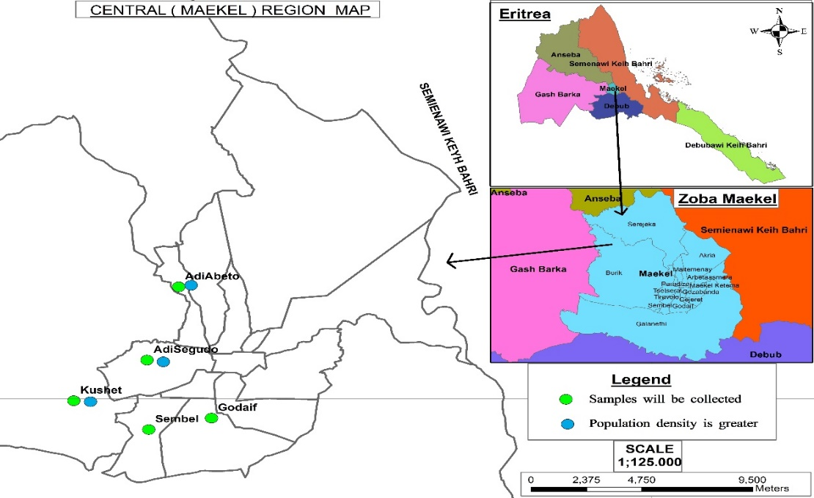
Fig.1 Map of Maekel region, Eritrea (Map and information unit of Maekel administration region, state of Eritrea, 2023)

2.2 Study animals, Sample size and Study design
Study was conducted among 40 small-scale farmers who keep sheep and goats under traditional practice managements systems from four villages (Adi Abieto, Adi Segudo, Kushet and Godaif-Sembel) in Maekel region, Eritrea. Homesteads were selected randomly for sampling of the animals (sheep and goats). In this study, total sample of 384 animals (96 from each village) of both sheep and goats at different ages and sexes were used for assessing intestinal parasitic infections. Fecal samples were collected from both sheep and goats for the laboratory analysis of GI-parasites using microscopy techniques. In addition, sampling was also carried out in the slaughter house of Maekel region and retrospective data on zoonotic helminths in the past two years (2022, 2023).

2.3 Sample collection and analysis
Fresh fecal samples of approximately 10g were collected from the rectum of selected animals, using a gloved finger after wetting with water for lubrication. Collected samples were placed in 3oml plastic bottles with waterproof screw cap in order to keep the samples fresh. Sample bottles were labeled and then transported in a cool box to the National Veterinary Parasitology Laboratory unit in Eritrea. The flotation technique was used to detect and identify eggs of nematodes, cestodes and protozoa parasites, while sedimentation technique was used for detecting trematodes eggs as described by Janina and Mathew, (2021).
2.4 Data management and statistical analysis
Data analysis was done using STATA version 12. One-Way Analysis of Variance (One-Way ANOVA) was used to compare the prevalence rates of GIT parasites among the villages. The P values for significance was set at 95%
3.RESULTS

3.1 Prevalence of gastrointestinal parasitic infections among sheep and goats in Maekel region, Eritrea
Overall the prevalence of GIT parasites in sheep and goats in the whole Maekel region was 91.41% (351/ 384). There was no significant difference in the prevalence of parasites among the four villages (p = 0.69). However, there was a significant difference between the different species (p = 0.0001) with Haemonchus contortus (26%) being the most abundant while the Ostertagia circuncineta (0.5%) was the least common (Table 1). Among the parasites reported include Strongyloidess, Hemonchus, Eimeria spp among others (Table 1, Figure 2)
Table 1: Prevalence of GI-parasites in Maekel region, Eritrea.
Region |  | Adi-abeito (n=96) | Kushet (n=94) | Adi-segdo (n=97) | Sembel-Godaif  (n=97) | Overall prevalent rate (Maekel region) | ratio | p-value
Infection status | Positive | 91(94.79 %) | 87(92.55 %) | 88(90.72 %) | 85(87.63 %) | 351(91.41%) | t=40.827 | 0.0001
Gastrointestinal Parasite |  |  |  |  |  |  | Mean prevalence (%)
Haemonchus contortus |  | 54 (56.3%) | 23 (24.5%) | 16 (16.5%) | 11 (11.2%) | 104 (27.2%) | 26
Eimeria species |  | 28 (29%) | 21 (22.3%) | 11 (11.3%) | 16 (16.3%) | 76 (19.79%) | 19
Cooperia species |  | 22 (29.7%) | 17 (18.1%) | 9 (9.3%) | 13 (13.3%) | 61 (15.9%) | 15.25
Strongylus species |  | 14 (14.6%) | 9 (9.6%) | 10 (10.3%) | 13 (13.3%) | 46 (11.9%) | 11.5
Moniezia Benedini |  | 8 (8.3%) | 7 (7.5%) | 7 (7.2%) | 8 (8.2%) | 30 (7.8%) | 7.5
Ascaris species |  | 4 (4.2%) | 8 (8.5%) | 6 (6.2%) | 3 (3.1%) | 21 (5.5%) | 5.25
Trichuris globulosa |  | 3 (3.2%) | 0 (0%) | 5 (5.2%) | 5 (5.1%) | 13 (3.4%) | 3.25
Dictyocaylus filarial |  | 5 (5.3%) | 2 (2.1%) | 8 (8.3%) | 5 (5.1%) | 20 (5.2%) | 5
Osophagostomu Columbianum |  | 1 (1.1%) | 2 (2.1%) | 5 (5.2%) | 6 (6.1%) | 14 (3.7%) | 3.5
Paramphistomum cervix |  | 2 (2.1%) | 3 (3.2%) | 8 (8.3%) | 7 (7.1%) | 20 (5.2%) | 5
Bunostomum trigunocephelu |  | 2 (2.1%) | 0 (0%) | 0 (0%) | 6 (6.1%) | 8 (2.1%) | 2
Chabertia ovina |  | 2 (2.1%) | 0 (0%) | 7 (7.2%) | 5 (5.1%) | 14 (3.7%) | 3.5
Nematodirus species |  | 0 (0%) | 2 (2.1%) | 5 (5.2%) | 0 (0%) | 7 (1.8%) | 1.75
Ostertagia circuncineta |  | 0 (0%) | 2 (2.1%) | 0 (0%) | 0 (0%) | 2 (0.5%) | 0.5
Aggregated |  |  |  |  |  | 91.33%

Key: n= number of samples tested

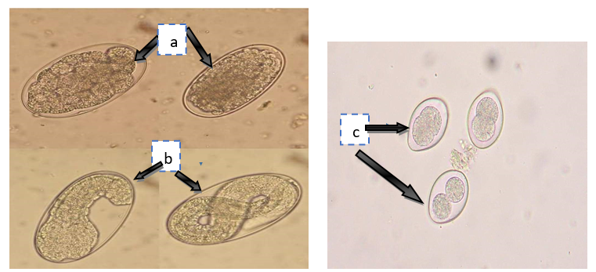
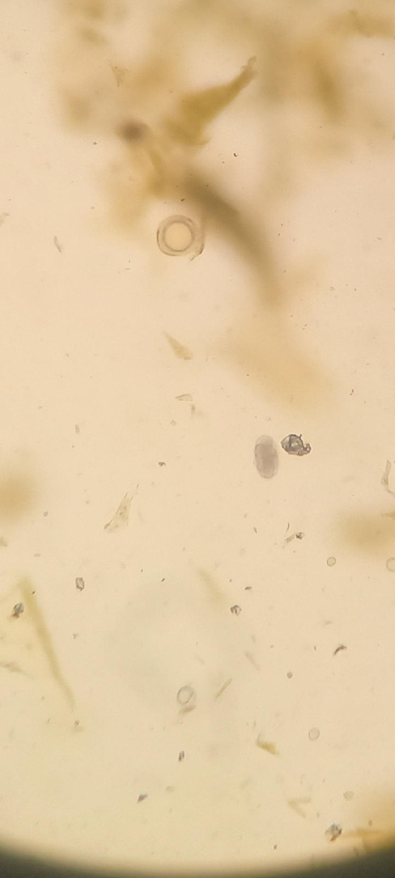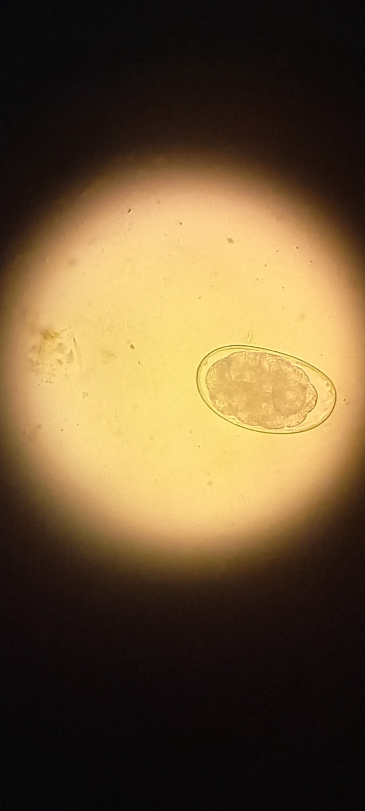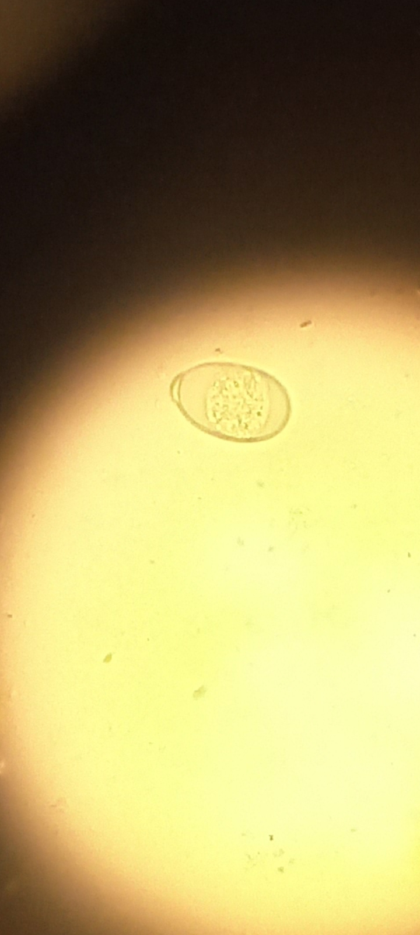
d
e
f

Figure 2: Different species of gastrointestinal parasites (a-f) detected during diagnosis a) Strongyl eggs b) Strongyloides eggs c) Eimeria d) Ascaris egg (X10) e) Haemonchus contortus of sheep (X40), f) Eimmeria spp (magnification X40)

3.2 Risk factors of gastrointestinal parasitic infections
Risk factors associated with helminth infections assessed included frequency of cleaning animal’s houses, water sources for the animals, knowledge of the farmers, checking parasites and deworming frequencies in relation to GI-parasites prevalence and explained below.

3.2.1 Water sources
Only 2.5% out of the farmers provided drinking water in a designated area, whereas 27.5% out of the participants did not avail water in a designated area for their animals. In addition, majority of the farmers (70 %) took their animal to dams for drinking (Figure 3).
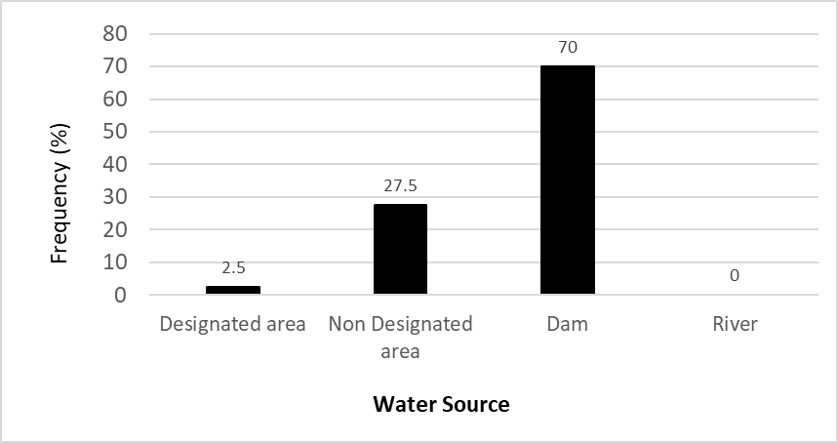

Figure 3: Sources of water for sheep and goats

3.2.2 Animal House cleaning frequency
Only 5.0% of the farmers cleaned their animal houses regularly (the regularity was some of them in days and others in weeks), while 27.5% of the farmers were cleaning their animals’ houses daily. Again, the results indicated the majority of the farmers (62.5%) were cleaning their animals’ houses weekly, as 2.5% out of the farmers were cleaning monthly and 2.5% confirmed that the farmers were cleaning their animal houses annually (Figure 4).
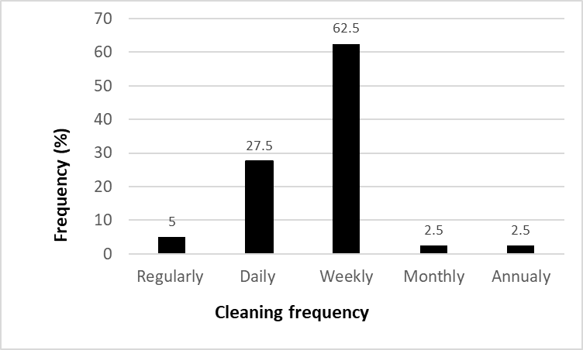
Figure 4: Cleaning frequency as a possible risk factor for parasite infections

3.2.3 Knowledge of gastro intestinal parasites by the farmers
Majority of the farmers (70.0%) had only elementary knowledge concerning GIT parasites, as 30% of these farmers had secondary level and none of the farmers from that area had beyond that level.

3.2.4 Frequency of deworming for sheep and goats by farmers
The analysis on the frequency of deworming for the small ruminants showed that only 5% of the farmers dewormed their animals every three months while 12.5% of them dewormed every biannually. Many farmers (42.5%) dewormed their sheep and goats annually whereas 35.0% attested that they dewormed their small ruminants irregularly while 5.0% of the farmers didn’t deworm at all (Figure 5).

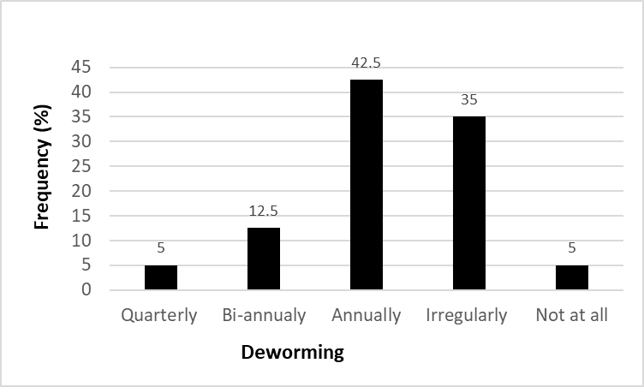
Figure 5: Frequency of deworming for sheep and goats by farmers

3.2.5 Other risk factors
The results indicated that most of the farmers 57.5% provided housing for their animals (Figure 5). Thirty two (32%) of the farmers indicated to that they mixed housing of small ruminants with other livestock (Figure 5). In addition, the majority of the farmers (97.5%) had earthen floor type of housing for their sheep and goats while only 2.5% had concrete floor type. Conversely, only 17.5% out of the farmers frequently screened their animals for GIT parasites hence most of them were not aware of the infection status of their livestock (Figure 6).
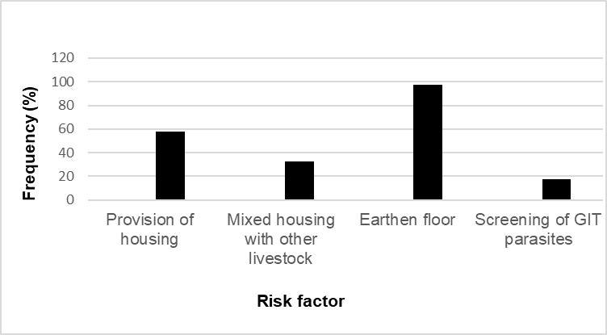
Figure 6: Other risk factors (housing provision, mixed housing, eartehn floor type, screening of GIT parasites)

3.4 Detection of zoonotic helminths from slaughter house of Maekel region, Eritrea
The results of parasite infections were included Strongyloides, Ascaris, hydatid cysts, Haemonchus, Eimeria spp, among the others. The result of parasite infection rates for males was 8.38% in 2022, 8.56% in 2023, and 12.96 % in 2024, while 11.42 % in 2022, 11.25 % in 2023, and 14.09 % in 2024 were the females’ parasitic infections. Based on age groups, 4-8 months had an infection rate of 8.99 % in 2022, 9.28 % in 2023 and 9.03 % in 2024. Animals of ages 1-3 months’ of age had an infection rate of 14.83 % in 2022, 11.79 % in 2023 and 14.04 % in 2024. Animals of ages 9 months up to 6 years’had an infection rate of 8.71 % in 2022, 9.07% in 2023 and 16.08 % in 2024 (Figure 7 and Table 2).
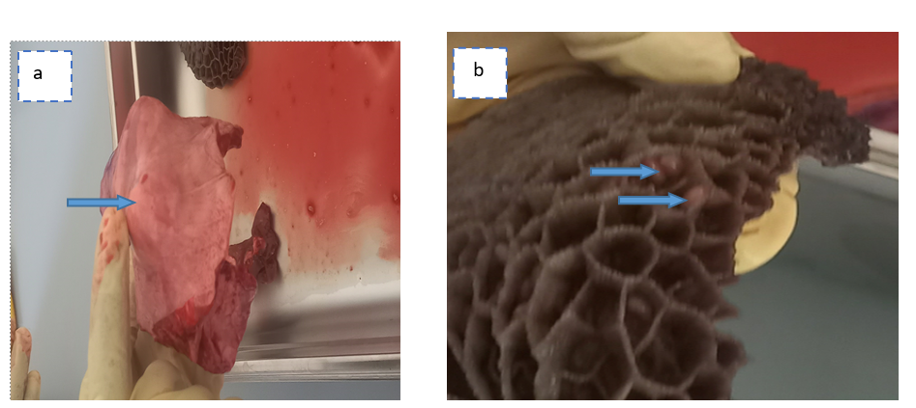
Figure 7: Organs of sheep and goats, which infected with zoonotic helminths. a) Hydatid cyst in lung of sheep (blue arrow), b) Paraphastumun egg from the stomach (reticulum) of sheep.

Table 2: Zoonotic helminths parasites recorded in slaughter house of Maekel region, Eritrea within 2022, 2023, and a half year of 2024.
Years | Variables |  | Records |  |  | Parasites detected
Years | Category | Type | Slaughtered | Infected | (%)
Years | Category | Sheep and goats | 2,182 | 205 | 9.40 | hydatid cysts, Paraphastumun, Strongyloides, Ascaris, Eimeria sp.
2022(January-December) | Sex | Male | 1455 | 122 | 8.38 | Strongyloides, Ascaris, hydatid cysts, Haemonchus
2022(January-December) | Sex | Female | 727 | 83 | 11.42 | Strongloid, Faciola spp,  Moniezia benedini
2022(January-December) | Age range | 1-3 months | 209 | 31 | 14.83 | hydatid cysts, Haemonchus, Paraphastumun
2022(January-December) | Age range | 4-8 months | 745 | 67 | 8.99 | Trichuris, Paraphastumum,  Dictyocaulus filarial, Ascaris
2022(January-December) | Age range | 9months-6years | 1228 | 107 | 8.71 | Hydatid cysts, Strongloid, Ascaris
2023(January-December) |  | Sheep and goats | 1,892 | 179 | 9.46 | Eimeria spp, Strongloid, Faciola spp, Ascaris, Paraphastumun, Haemonchus, Dictyocaulus filarial, hydatid cysts, Moniezia benedini
2023(January-December) | Sex | Male | 1261 | 108 | 8.56 | Strongyloides, Ascaris, Fasciola sp.
2023(January-December) | Sex | Female | 631 | 71 | 11.25 | Trichuris, Paraphastumun,  Dictyocaulus filarial
2023(January-December) | Age range | 1-3 months | 229 | 27 | 11.79 | Hydatid cysts, Haemonchus,  Eimeria sp., Strongyloides
2023(January-December) | Age range | 4-8 months | 528 | 49 | 9.28 | Strongloid, Moniezia benedini
2023(January-December) | Age range | 9months-6years | 1135 | 103 | 9.07 | Faciola sp. Strongyloides, Eimeria sp., Hydatid cysts, Strongyloides
2024(January-May) |  | Sheep and goats | 743 | 98 | 13.19 | Eimeria sp, Strongyloides, Faciola sp, Ascaris, Paraphastumun, Haemonchus, Dictyocaulus filarial
2024(January-May) | Sex | Male | 594 | 77 | 12.96 | Strongyloids, Ascaris, Haemonchus
2024(January-May) | Sex | Female | 149 | 21 | 14.09 | Eimeria spp, Paraphastumun,  Dictyocaulus filarial
2024(January-May) | Age range | 1-3 months | 57 | 8 | 14.04 | Strongloid, Haemonchus, Trichuris
2024(January-May) | Age range | 4-8 months | 288 | 26 | 9.03 | Faciola spp, Moniezia benedini
2024(January-May) | Age range | 9months-6years | 398 | 64 | 16.08 | Ascaris, Strongyloides, Paraphastumun, Eimeria sp, Dictyocaulus filarial

4.DISCUSSIONS
The most dominant species of the parasites Haemonchus contortus while Ostertagia circuncineta had the lowest prevalence. The present study also indicated that female animals had a higher prevalence than male ones similarly reported by Singh et al., (2017) and Islam et al., (2017). This is attributable to the fact that the females are prone to more stressors such as pregnancy and lactation hence weaker immunity during these periods. Another study however reported the opposite indicating high male susceptibility to parasites who attributed this to the genetic predisposition and differential susceptibility owing to hormonal control (Zvinorova et al., 2016). Similarly, the majority of the animals were positive with multiple parasites co-infections (Paul et al., 2020). Gastrointestinal parasites in sheep and goats are associated with diverse adverse effects including, reduced reproduction rate, low weight, low quality of animal products and even death (VanHoy, 2024)

In the current study, there were several risk factors that would contribute to gastrointestinal parasitic infections among sheep and goats. These included lack of provision of housing, mixed housing of small ruminants with other livestock, common water points-dams shared with other animals, irregular deworming, low screening rate by farmers, and low awareness among farmers with regard to GIT parasites. Proper housing of small ruminants is very key in improving animal health and shielding the animals from extreme weather conditions which would work negatively against animal general health. This coupled with concrete flooring would greatly increase control of parasites due to easy management of animal waste. Most of the farmers sourced or watered their small ruminants in dams. Unclean water sources would be a risk factor for animal infections due to faecal contamination of water from contaminated environments following run offs (Abayomi et al., 2018) as well as direct contamination during watering (Titcomb et al., 2021).
Given that the watering points were also shared with other animals also increases the infection risks. This is due to the fact that there are also shared GIT infections from other livestock. In pastoralist communities such watering points are also used by humans hence compounding the transmission especially the zoonotic parasites (Wardrop et al., 2018). several of which were reported in this study.

Irregular cleaning causes accumulation of animal waste which contributes to good development ground for parasites including helminth eggs and larvae contributing to maintenance of parasites cycles. The same waste is likely to contaminate nearby grazing grounds (Waktole et al., 2023). Most farmers in rural communities in Africa have low levels of education. This also limits them to the literacy in control of parasitic infections in livestock (Roshan et al., 2021). Despite small ruminant farming contributing greatly to economy of the several countries, there is limited investment by governments in provision of disease control measures including extension services and sensitization as compared to other livestock like cattle. In addition, small ruminant farmers don’t invest in food security for their livestock and almost entirely depend on grazing hence malnutrition is a major setback in small ruminant farming. It has been shown that increasing community awareness has a great impact in control of GIT parasites (Solomon et al., (2021). Poor management/husbandry has been reported to contribute to high prevalence of GIT parasites (Dogo et al., 2017).

Most farmers, especially pastoralists are also known to self-prescribe and treat their livestock by themselves. For conventional drugs such as dewormers, this leads to abuse of drugs due to issues of either underdose or overdose and persistent use of few classes of antihelminth. This is a major contributor to antihelminth resistance (Antunes, 2022). However, farmers especially pastoralists are also known to use herbs for deworming (Hafiz et al., 2021). On a positive note, small ruminants especially goats are also known to self-medicate by feeding on herbs which makes them more resistant to helminths compared to other livestock.

Zoonotic parasites reported include Strongyloides, Ascaris, hydatid cysts, Haemonchus, Fasciola and Eimeria species among the others. These are both helminths and one protozoa Eimeria though other studies have also reported several protozoan zoonoses in goats including Cryptosporidium and Giardia among others (Ikpe et al., 2022, Roshan et al.,2021). Sheep and goats therefore serve as reservoir hosts for most human helminths (Karshima et al., 2018) such as hydatidosis and other soil transmitted helminths. The zoonotic transmission potential is also contributed by the complex interaction of animals, man and their environment which is sometimes pose a challenge to control (Andernice et al., 2021).

The reported high prevalence of sheep and goats with zoonotic parasites is worrying because these animals form the most preferred source of meat for the local communities. In addition, in several communities it has been reported that people consume raw meat, milk (Ngoshe et al., 2022) and blood. This practice is a major source of zoonotic parasite transmission (Kiani et al., 2021) and can also contribute to the high prevalence in the study site as the parasite cycles are well maintained. One health approach would be a key approach in controlling such parasitic infections (Rushton and Bruce, 2017, Deiana et al., 2024). There have been efforts by WHO through Ministries of health in introducing one health approach in controlling NTDs.. However, the uptake is still low since most NTDs control program officers are not well vast with the are not well vast with the process. This is due to the fact that initially, human diseases control programs was very independent from livestock diseases programs yet humans and livestock inhabit same environment. In addition, despite many control measures in the human population including several rounds of mass deworming (Fenwick, 2011) water sanitation and hygiene (WASH) activities, there has still been new cases reported. If the livestock and environmental control measures are not well instituted, then livestock would continue being sources of transmission of zoonotic parasites to humans. Collaboration between livestock, medical and other professionals in control of GIT parasites is inevitable.

CONCLUSIONS
There were several GI-parasitic infections in sheep and goats in the Maekel region including Haemonchus sp, Eimeria sp, Cooperia sp. Strongylus sp., Monezia sp, Ascaris, Trichuris, Dictyocaulus filarial, Oesophagostomun colunbianum, Paramphistomum cervi, Bunostomum trigunocephelum, Chabertia ovina, Nematodirus, Ostertagia circuncineta. The risk factors associated with gastrointestinal parasitic infections included poor housing, mixed housing with other animals, dam or common water supply with other livestock, irregular deworming and poor knowledge of farmers on parasitic helminths. Several zoonotic parasites were reported from slaughter house including hydatid cysts, Strongyloides, Trichuris, Ascaris, Fasciola sp, Paraphastumun, Dictyocaulus filarial, Haemonchus sp.

ETHICAL APPROVAL and Consent:
The study was approved by Maekel administration state of Eritrea (Ref No. 02/3/1245/24). The participation of farmers was through informed consent and voluntary. They were informed of their right withdraw at any time. Any information obtained from the participants were kept strictly confidential. During sampling, animals were restrained following standard procedure to minimize discomfort and ensure animal welfare. Fecal samples were collected by trained animal health technicians and veterinary professionals while applying recommended precautions and safety procedures

Disclaimer (Artificial intelligence)
Option 1:
Author(s) hereby declare that NO generative AI technologies such as Large Language Models (ChatGPT, COPILOT, etc.) and text-to-image generators have been used during the writing or editing of this manuscript.
Option 2:
Author(s) hereby declare that generative AI technologies such as Large Language Models, etc. have been used during the writing or editing of manuscripts. This explanation will include the name, version, model, and source of the generative AI technology and as well as all input prompts provided to the generative AI technology
Details of the AI usage are given below:
1.
2.
3.
REFERENCES
Hiwot Desta Wodajo, Biruk Alemu Gemeda, Wole Kinati, Annet Abenakyo Mulem, Anouka van Eerdewijk, Barbara Wieland (2020) Contribution of small ruminants to food security for Ethiopian smallholder farmers Small Ruminant Research; 184 106064
Win SY, Win M, Thwin EP, Htun LL, Hmoon MM, Chel HM, Thaw YN, Soe NC, Phyo TT, Thein SS, Khaing Y, Than AA, Bawm S. (2020), Occurrence of Gastrointestinal Parasites in Small Ruminants in the Central Part of Myanmar. J Parasitol Res. Nov 25; 2020:8826327. doi: 10.1155/2020/8826327. PMID: 33294216; PMCID: PMC7714589.
Dogo, G. I., Abraham1, Karaye, P., Gloria1, Patrobas, M.G.1, Galadima, M.3 and Gosomji, I.J. (2017). Prevalence of Gastrointestinal Parasites and their impact in Domestic animals in Vom, Nigeria. Department of Veterinary Parasitology and Entomology, University of Jos, Plateau State, Nigeria, Saudi Journal of Medical and Pharmaceutical Sciences,3(3) :211-216
Metrology unit staff, (2022). Annual work report on metrological records. Metrology unit, under Agricultural extension department. Public relations ministry of agriculture Eritrea, annual report magazine 2021.
Janina., M.-D. and Matthew, P. (2021). Evaluating methods for conducting fecal egg count reduction tests in sheep using McMaster technique, Mini-FLOTAC and pooled counts. Australian Wool Innovation Limited. Published by Australian Wool Innovation Limited, 6: 68.
Singh E., Kaur P., Singla, L. D. and Bal, M. S. (2017). Prevalence of gastrointestinal parasitism in small ruminants in western zone of Punjab. India. Vet World. 10(1):61–66.
Islam, M. S., Hossain, M. S., Dey, A. R., Alim, M. A., Akter, S. and Alam, M. Z. (2017). Epidemiology of gastrointestinal parasites of small ruminants in Mymensingh, Bangladesh. J Adv Veterinary Animal Research, 4 (4): 356–362.
Zvinorova P.I., Halimani T.E. ^{c}, Muchadeyi F.C. ^{d}, Matika O. ^{e}, Riggio V. ^{e}, Dzama K. (2016) Prevalence and risk factors of gastrointestinal parasitic infections in goats in low-input low-output farming systems in Zimbabwe. Small Ruminant Research; 143, 75-83
Paul, B. T., Jesse, F. F. A., Chung, E. L. T., Che’Amat, A., & Mohd Lila, M. A. (2020). Risk Factors and Severity of Gastrointestinal Parasites in Selected Small Ruminants from Malaysia. Veterinary Sciences, 7(4), 208. https://doi.org/10.3390/vetsci7040208
VanHoy G. (2024) Common Gastrointestinal Parasites of Small Ruminants
https://www.msdvetmanual.com/digestive-system/gastrointestinal-parasites-of-ruminants/common-gastrointestinal-parasites-of-small-ruminants
Abayomi, E. A., Temitope, T. S., Azonchi, A. H., Folakemi, O. K. and Dana’an, A. D. (2018). Parasitic contamination of some vegetables sold at two major markets in Jos-Nigeria. University of Sindh. Journal of Animal Sciences, 2(3): 01-09.
Titcomb, G., Mantas, J.N., Hulke, J. et al. (2021). Water sources aggregate parasites with increasing effects in more arid conditions. Nat Commun 12, 7066 https://doi.org/10.1038/s41467-021-27352-y
Wardrop NA, Hill AG, Dzodzomenyo M, Aryeetey G, Wright JA. (2018). Livestock ownership and microbial contamination of drinking-water: Evidence from nationally representative household surveys in Ghana, Nepal and Bangladesh. Int J Hyg Environ Health. Jan;221(1):33-40. doi: 10.1016/j.ijheh.2017.09.014. Epub 2017 Oct 3. PMID: 29031736; PMCID: PMC5739303.
Waktole, T., Bersissa, K., Dinka, A., Anna, M., Cinzia, T. and Rudi, C. (2023). Epidemiology of Gastrointestinal Parasites of Cattle in Three Districts in Central Ethiopia. Department of Veterinary Science, School of Veterinary Medicine, Mamo Mezemir Campus, University of Ambo. Animals, 13: 285.
Roshan, B. A., Rajendra, P. P, Mahendra, M., Tirth, R. G. (2021). Prevalence and risk factors of gastrointestinal parasites in the Chepangs in Nepal. Central Department of Zoology, Tribhuvan University, Kathmandu, Nepal, Annals of Parasitology, 67(3), 387–405.
Solomon, G., Biruk, A., Hiwot, D., Tadiwos, A., Tesfaye, M., Mesfin, M., Asrat, A.and Barbara, W. (2021). Community-based approach for the control of gastrointestinal parasites under smallholder sheep farming systems. European union, Research program on livestock. International Livestock Research Institute (ILRI), Ethiopia, Component 2 of the HEARD project.
Antunes MI, Lima MS, Stilwell G, Romeiras MI, Fragoso L, Madeira de Carvalho LM (2022). Anthelmintic Efficacy in Sheep and Goats under Different Management and Deworming Systems in the Region of Lisbon and Tagus Valley, Portugal. Pathogens. 2022 Dec 1;11(12):1457. doi: 10.3390/pathogens11121457. PMID: 36558791; PMCID: PMC9782797
Hafiz, M. R., Muhammad, S. S., Asim, S., Haider, A., Abdu, Q., Mahvish, M., Muhammad, A. M., Zubaria, S. A. (2021). Sheep parasitism and its control by medicinal plants: A review. Section of Parasitology, Department of Pathobiology, College of Veterinary and Animal Sciences, Narowal, parasitologists united journal,2(14): 1687-7942.
Ikpe, R.T., Agbendeh, L.N., Akinsuyi, O.S. (2022). Prevalence study of zoonotic gastrointestinal parasitic infections in goats in Makurdi Metropolis, Nigeria. Department of Medical Microbiology and Parasitology, University of Ilorin, Nigeria, Journal of Zoonotic Diseases, 6 (1): 11-16.
Karshima SN, Maikai BV, Kwaga JKP. (2018). Helminths of veterinary and zoonotic importance in Nigerian ruminants: a 46-year meta-analysis (1970-2016) of their prevalence and distribution. Infect Dis Poverty. 7(1):52. doi: 10.1186/s40249-018-0438-z. PMID: 29807540; PMCID: PMC5972411.
Andernice, S. Z., Lucas, F. D., Marta, S.M.A., Herakles, A. G., Daniel, M. A., Omar, A. E. and Antonio, F. M. (2021). Diversity and prevalence of intestinal parasites of zoonotic potential in animal hosts from different biomes in central region of Brazil. Faculty of Agricultural and Biological Sciences, University of Mato Grosso, Brazil, Annals of Parasitology, 67(1): 95–105.
Ngoshe YB, Etter E, Gomez-Vazquez JP, Thompson PN. (2022). Knowledge, Attitudes, and Practices of Communal Livestock Farmers regarding Animal Health and Zoonoses in Far Northern KwaZulu-Natal, South Africa. Int J Environ Res Public Health;20(1):511. doi: 10.3390/ijerph20010511. PMID: 36612830; PMCID: PMC9819478.
Kiani, B., Budke, C.M., Shams Abadi, E. et al. (2021). Evaluation of zoonotic platyhelminth infections identified in slaughtered livestock in Iran, 2015–2019. BMC Vet Res 17, 185 https://doi.org/10.1186/s12917-021-02888-9
Rushton J, and Bruce M. (2017). Using a One Health approach to assess the impact of parasitic disease in livestock: how does it add value? Parasitology. 2017 Jan;144(1):15-25. doi: 10.1017/S0031182016000196. Epub 2016 Apr 4. PMID: 27040969.
Deiana, G., Arghittu, A., Dettori, M., & Castiglia, P. (2024). One World, One Health: Zoonotic Diseases, Parasitic Diseases, and Infectious Diseases. Healthcare, 12(9), 922. https://doi.org/10.3390/healthcare12090922
Fenwick A. (2011). The neglected tropical diseases: current status of control and the UK contribution. In: Institute of Medicine (US) Forum on Microbial Threats. The Causes and Impacts of Neglected Tropical and Zoonotic Diseases: Opportunities for Integrated Intervention Strategies. Washington (DC): National Academies Press (US); 2011. A4. Available from: https://www.ncbi.nlm.nih.gov/books/NBK62509/

.

