A COMPARATIVE COVID-19 STABILITY ANALYSIS USING A SIR EPIDEMIOLOGICAL MODEL AMONGST THE KENYAN POPULATION FOR THE PERIODS BEFORE AND AFTER VACCINATION

Abstract

In this paper, the study focused on carrying out a stability analysis on the SIR model for the COVID-19 pandemic for the period before the vaccination roll out in Kenya. Earlier, in a related study using a modified SIVR that focused on the period after the vaccination roll out, has heavily been relied on by this current study. This study therefore aimed at drawing a comparison between the pre and post-vaccination stability analyses The eventual intention is to show that whereas there existed a form of herd immunity amongst the Kenyan people attributed to the people’s way of life, transmission dynamics during the pre-vaccination period show that the disease spread was largely uncontrolled. In contrast, the earlier study on post vaccination analysis by Mocheche GM, [10] revealed that the infections drastically reduced to near zero after vaccination except for a few isolated cases that were and still continue to exhibit mild symptoms to none at all. Accordingly, this was attributed to the development of the vaccine which upon a massive campaign by the Kenyan government, led into a significant portion of the population being vaccinated. It is believed this vaccination drive enhanced herd immunity amongst the population. This development has had a significant effect in the control of more recent COVID-19 variants like JN-1 that have remained largely mild and undetected in the country. Arising from this revelation and from the cultural beliefs that discourage the populace against conventional vaccinations, results from this comparative analysis will inform policy makers that there is considerable need for deliberate civic education for the Kenyan people to embrace vaccination as a means to protecting themselves against future COVID-19 and other infectious diseases of a similar nature.

Key words
SIR model, Vaccination, Herd Immunity, Local Stability, Global Stability.

1.0 Introduction

1.1 Background of COVID - 19
COVID – 19 named as such by the World Health Organization (WHO), is a disease caused by a virus that belongs to a family of Coronaviruses (CoVs) that cause respiratory and intestinal illnesses in humans and animals. A number of these viruses have been identified before, with COVID-19 first identified in the Wuhan province of china in December 2019 [14]. The virus gets transmitted from human to human through body fluids. Patients infected with COVID-19 range from those who don’t exhibit clinical symptoms (referred to as Asymptomatic patients) to those having such common symptoms as fever, cough, sore throat, general body weakness, fatigue, muscular pains etc.

The first case of COVID-19 in Kenya was confirmed on 12th March, 2020 in Nairobi city. Ever since, the disease continued to spread exponentially in nearly all the regions until the roll out of vaccination upon the discovery of the vaccine. In his study, Mocheche GM, [10], its revealed that the massive roll out of vaccination amongst the Kenyan people drastically reduced infections to near zero attributed to enhanced herd immunity arising from the vaccination exercise. Elsewhere in India, Piu S, et al [12], in their study established that COVID-19 had precipitated a major global crisis, with 968,117 total confirmed cases, 612,782 total recovered cases and 24,915 deaths in India as of July 15, 2020. At this rate, it was very necessary that every effort had to be put in place to curb the disease, including but not limited to researching on it to understand every aspect of its dynamics. Piu S. et al [12] in their study further found out that in the absence of any effective therapeutics or drugs and with an unknown epidemiological life cycle, predictive mathematical models can aid in the understanding of both the coronavirus disease control and management.

One of the greatest challenges that exists especially in rural set ups amongst the Kenyan people is the belief that vaccination of any kind is against their cultural beliefs and therefore prohibited. On the onset of the COVID-19 pandemic, particularly before the development of the vaccine, the government put in place such measures as quarantining, lock downs, observance of hygienic practices, social distancing, etc. but still, the pandemic resulted in significant deaths of Kenyans since its first occurrence in the country in March 2020.

In a study carried out by Iyaya C. W. et al. [7], an investigation was carried out on the effects of novel coronavirus pandemic to people above 58 years of age in Kenya. Using data from Kenya’s ministry of health, a $R_{0}$ value of 5.434 was obtained. Together with the simulations within the first 100 days, this showed that individuals living with underlying medical conditions such HP and Diabetes amongst others had a very high rate of infection when exposed to COVID-19. This is despite an advisory by the WHO [15] that the elderly and people with underlying medical conditions such as high blood pressure, heart problems, diabetes etc. are at greater risk of serious illness from COVID-19 although to them, vaccination would do much more harm than good. In their conclusion, the study recommended intervention strategies such as vaccination in mass to curb the spread of the disease. Besides the deaths, the pandemic also stalled economic progress for many people most of whom had no formal employment and rely on day-to-day casual jobs to make ends meet. It was therefore evidently difficult to lock up travels due to the pandemic. Some Kenyans blatantly opined, “we’d better die of COVID-19 while looking for food for our households than die locked up in the house due to starvation.”

Re-infection of unvaccinated people was very confusing. This was due to the fact that it wasn’t clear whether or not the infected and recovered had acquired everlasting or partial protective immunity. In the works of Bendadavid E., et al, [2], they pointed out that at the time, researchers believed, that the infected acquired ‘passport’ immunity and therefore required to be allowed to relax COVI-19 containment measures, including the freedom to mingle freely with the general public.

Edridge A.W.D., et al, [4]), in a further research on serological testing for seasonal Human Coronavirus (HCoV-229E), found that the majority of patients lost 50% of the acquired antibodies after six months, 75% after a year and completely returned to baseline after four years pointing out to the need for a more reliable prevention mechanism such as the development of a vaccine for the disease.

This study sought to demonstrate that indeed vaccination controls the spread of COVID 19 and other infectious diseases by carrying out a pre vaccination stability analysis, then compare its results with those of a post vaccination stability analysis carried out in an earlier study to show that COVID 19 transmission dynamics drastically reduced after the vaccination roll out. With this in mind, there is a justified need for a robust debate regarding people’s mind set on their cultural orientations regarding vaccinations.

1.2 Model Formulation
In this study, the focus was first on carrying out a pre vaccination stability analysis whose results will form a basis for comparison with those of a post vaccination one, already documented in another article. According to Diekmann O., et al, [3], supported by Mocheche G.M., [10], mathematical modeling of transmission trends of infectious diseases has extensively been studied. These models have been used by many researchers to understand and predict transmission dynamics of infectious diseases. This study proposed a deterministic modified SIR ordinary differential equation model that captured the COVID-19 dynamics, a member of the family of novel coronavirus or SARS-CoV-2.

The study classified the Kenyan human population into a simple model of three compartments, namely susceptible individuals (S), infected individuals (I), and Recovered individuals (R) to formulate, the SIR (susceptible or uninfected (S) → infected individuals (I) →Recovered individuals (R) model. The total size of the population is N(t) = S(t) + I(t) + R(t). The study presupposed that only interactions between the infected and the susceptible caused the transmission of the viruses.

The proposed SIR model for the Kenyan COVID-19 transmission dynamics whose SIR model initials stand for: Susceptible, Infected, and Removed. The diagrammatic flow in the SIR model is depicted in figure 1.

S I R.
Ʌ $β$ $γ$

$μ$ $μ$ $μ$
Figure 1. Diagrammatic Representation of the SIR Model.

At any given time, individuals in a population, depending on their current status are placed into these model compartments of the SIR Structure. A Basic Reproduction Number in a population is determined which is then used to determine the Herd Immunity Threshold. Kermack W.O., et al, [8] formulated a mathematical theory of the epidemic processes whose basis was this simple deterministic SIR model. Many other models have been extended from it to date.

1.2.1 Differentia Equations
The compartmental SIR model above yields the following differential equations

$\frac{dS}{dt}=Ʌ-βSI-μS$
$\frac{dI}{dt}=$ $βSI-μI-γI$
$\frac{dR}{dt}=γI-μR$
with N = S + I + R

1.2.2 Description of Variables and Parameters used in the model.

S: The fraction of susceptible individuals.  I: The fraction of infectious individuals.  R: The fraction of recovered individuals.  N: The total population size. | Λ: Per-capita entry rate.  β: Disease transmission rate.  γ: Per- capita recovery rate.  µ: Per-capita removal rate.

1.2.3 Assumptions
The following assumptions hold:
1. Closed population size, N.
2. Transmission and removal rates are regarded constant
3. A well-mixed population i.e. one where any susceptible individual can get infected.

1.3 Local and Global Stability
Local stability means that all solutions of the system that have initial values within a particular domain of the feasible region approach the equilibrium point. Global stability on the other hand means that all solutions of the system approach the equilibrium point independent of the initial values. The case where both eigenvalues are real, negative, and distinct produces a phase portrait that shows all trajectories tending toward the equilibrium point as t → ∞, the value of x(t) gets small, so it is a globally stable equilibrium point.

1.4 Herd Immunity.
In their brief history on vaccines [15], the World Health Organization defines vaccination as a simple, safe, and effective way of protecting an individual against harmful diseases before they come into contact with them. For centuries, people have looked for ways of protecting themselves against diseases and infections. Vaccination has stood the test of time as an effective method. In earlier times, this was done by exposing healthy people to the infection, as in the case of smallpox in the 15th century, in the hope that they would develop immunity against the pathogens. However, with time, proper vaccines for different diseases have been developed, and proper trials done to ascertain their suitability before administering them to humans. Herd immunity is defined as the immunity developed by the majority of a population against contagious diseases.

The term herd immunity was first used by Topley W., et al, [14]. It has since helped to serve as the bedrock for vaccines and their applications, vaccination programs, cost analysis, and eradication of diseases such as smallpox.
Acquired immunity is developed at the individual level either through vaccination or via natural infection with a pathogen, Randolph H., et al, [13]. Herd immunity stems from the effects of individual immunity to that of the entire population of a particular region. As such, as long as a sizable percentage of a population has been vaccinated, immunity is rolled out to the entire population, even those who have not been vaccinated. This population-level effect aims to establish a population immunity so that individuals who cannot be vaccinated such as the young and immunocompromised are still protected against the disease.

The herd immunity threshold depends on a single parameter known as the Basic Reproduction number, $R_{0}$. The $R_{0}$ refers to the average number of secondary infections caused by a single infectious individual introduced into a completely susceptible population. If a pathogen with an $R_{0}$ of 3 is considered for example, it means on average, one infected person is capable of infecting three others on average during the infectious period.

In his book, Murray J. [11], The basic reproduction number, $R_{0}$, is a necessary parameter when dealing with an epidemic under control with vaccination. One of the ways to reduce the reproduction rate of a disease is to reduce the number of susceptible in a population. Vaccination is the best way of achieving this. For example, according to Anderson R., et al, [1] it was successful in eradicating smallpox in the world in 1979. Similarly, substantial progress has been made through vaccination to reduce and eventually eliminate polio in the world. In 1988, polio paralyzed an estimated 350,000 individuals per year in more than 125 countries. However, by 2019, according to the European Union Centre for Disease Control [5], 125 cases caused by wild poliovirus were reported globally.

Recently, in their findings, Isaac M.W., et al, [6] found that re-infection with COVID-19 lead into an increase in the cumulative deaths. Further, they found that the comparison on the impact of non-pharmaceutical interventions such has treatment and/or vaccination on curbing the spread of the disease, suggested that the wearing of face masks reduced COVID 19 prevalence compared with social/physical distancing. Their study revealed that early detection of asymptomatic cases through contact tracing, testing and isolating drastically reduced the disease surge.

1.5 Epidemiology
Epidemiology is the study of the distribution and determinants of disease prevalence in humans, Ma S., et al, [9].

In his book, Murray J. [11], Susceptible, Infected, and Removed model’s equations form a dynamical system. Since all three variables vary over time. Analyzing stability helps us to establish whether or not we have constant solutions, whether these solutions near the constant move towards or away from the constant solutions, how the solutions behave as time, t, approaches infinity and if any of the solutions oscillate.

The constant solution is generally referred to as equilibrium. The phase portraits of the dynamical system will either show the solutions having vectors moving towards the equilibrium value or away from the equilibrium value. If the solutions tend toward the equilibrium value, such point will be considered stable or an attractor. In dynamical systems, an attractor refers to a set of states towards which a system tends to evolve, for a wide variety of starting conditions of the system. The system solutions get close enough to the attractor values and remain close even if slightly disturbed.

On the other hand, if the solutions of the system near the equilibrium value all tend away from the value, such point is said to be unstable, or a repelling equilibrium point.
We may have a situation where both phenomena happen i.e. some values tend towards the equilibrium point while some move away from it. This is called a saddle point. It is generally unstable.

1.6 Study Population
The sample data used in the study as obtained from the Ministry of Health, and the World statistics [17] Kenya, was distributed across the country. The population of Kenya as of the year 2022 was approximately 54, 027, 487. However, for this study sample population used in our study period indicated was 2, 926,470 people that covers statistics for both before and after the vaccination roll out. The pandemic did not affect the country uniformly; urban areas were adversely affected compared to rural areas where it was believed people had a form of unexplained immunity attributed to their ways of life.

The sample data in use for this study as obtained from the Ministry of Health, Kenya is distributed from all over the country. It is not restricted to the rural or urban areas as such.

Table 1.a: A snapshot of COVID-19 Data for the first twenty days before Vaccination |  |  |  |  |  |  | Table 1.b: COVID-19 Data for the first twenty days in Kenya after the introduction of the Vaccination
Day | Date | Total | Infect | Dis | Deaths |  | Day | Date | Total | Infected | Dis | Deaths
1  2  3  4  5  6  7  8  9  10  11  12  13  14  15  16  17  18  19  20 | 19-Mar-20  24-Mar-20  26-Mar-20  28-Mar-20  29-Mar-20  30-Mar-20  31-Mar-20  01-Apr-20  02-Apr-20  03-Apr-20  04-Apr-20  05-Apr-20  07-Apr-20  09-Apr-20  10-Apr-20  11-Apr-20  12-Apr-20  13-Apr-20  14-Apr-20  15-Apr-20 | 173  82  74  81  69  260  234  380  662  362  372  530  696  308  504  491  766  674  694  803 | 7  9  3  7  4  8  9  22  29  12  4  16  14  5  5  2  6  11  8  9 | 0  0  1  0  0  0  0  2  0  0  0  0  3  4  1  0  2  1  1  5 | 0  0  0  1  0  0  0  0  2  1  1  0  0  1  0  0  0  1  0  1 |  | 1  2  3  4  5  6  7  8  9  10  11  12  13  14  15  16  17  18  19  20 | 03-Apr-21 04-Apr-21 05-Apr-21 06-Apr-21 07-Apr-21 08-Apr-21 09-Apr-21 12-Apr-21 13-Apr-21 14-Apr-21 15-Apr-21 16-Apr-21 17-Apr-21 18-Apr-21 19-Apr-21 20-Apr-21 22-Apr-21 23-Apr-21 24-Apr-21 25-Apr-21 | 7139  6045  2753  2923  7423  11352 7300  2989  6417  7529  5958  7753  7184  3664  2515  5832  5673  7036  9316  4194 | 1184  911  460  394  1523  1698  1091  486  991  981  1091  1041  1024  366  241  629  904  773  1153  469 | 220  533  178  2217  616  456  533  115  370  655  392  343  382  280  636  1560  88  762  191  304 | 20  18  20  14  18  16  17  20  26  26  4  19  20  18  20  18  20  23  20  19
Key: Infect –Infected, dis – Discharged
Source: Ministry of Health, Kenya
.

2.0 Findings
To arrive at these findings, the COVID-19 data from march 2020 to April 2020, is readily available in the Kenyan Ministry of Health website.

2.1.1 Pre-Vaccination Findings
From the above data, $β , γ$ and $μ$ can easily be calculated to determine the reproductive number, ($R_{0}$ number). For example, using the first 20 days of data on table 1.a above, we have;
The total number of people tested (susceptible) was 7615, the infected people were 92 while discharged and deaths were 20 and 8 respectively for that given period.

From the above statistics, the following parameters for the first 20 days are calculated as follows; $β$ , rate of infection is given by $\frac{92}{7615 }=0.01208, γ,$ recovery rate = $\frac{20}{92}$= 0.21739 and $μ,$ removal rate = $\frac{8}{7615}=0.0010505.$ As days passed by, the figures above changed. For instance, COVID-19 pre-vaccination data between March 2020 to March 2021 was simulated using computer software and average parameters necessary for calculating the $R_{0}$ obtained.

For the number of days captured in the table 2.a below, the following average results were obtained; $β=0.0394399$, $γ=0. 0275976$ and $μ=2.7372* {10}^{-3}$ and are as summarized as below
.
Here $R_{0}$ = $\frac{β}{γ+ μ}=1.30015$

From the formula for determining Herd Immunity Threshold, $HIT=1- \frac{1}{R_{0}}$ = 1 - $\frac{1}{1.30015}$ = 0.230858.

Whereas the numbers kept changing, for the period under review, a HIT value of 0.230858 meant 23.09% of the population needed to be vaccinated to control the spread of the virus in the country. This of course kept changing with the change in transmission dynamics Also determined were the $R_{0}$ numbers after each month for the said period of time as summarized in table 2.a.

2.1.2 Post-Vaccination Findings

According to Mocheche, G.M., [10] in his post vaccination stability analysis, data from Kenya’s ministry of health website for the period between April 2021 to March 2022 was used as fed into the software for computation $R_{0}$, and HIT at intervals of 30 days to give a summary shown in table 2.b;

From table 1.b, an average value of $R_{0}$ was calculated and determined as 1.080045 and an average HIT value of 0.07, correct to two decimal places. Applying the formulae, $HIT=1- \frac{1}{R_{0}}$ , with $R_{0}$ = 1.080045, HIT is obtained as 0.07, correct to two decimal places which agrees with the table average value.

The value of $R_{0}$ is obtained as; $R_{0}$ = 1.08, and an HIT value of 0.07, both correct to two decimal places. This implied that only a paltry 7% of the total Kenyan population needed to be vaccinated to bring the disease to a halt.

Table 2.a: $R_{0}$ and Herd Immunity Before Vaccination |  |  |  |  | Table 2.b: $R_{0}$ and Herd Immunity Threshold of COVID-19 during Vaccination.
S/no: | Period (Days) | $$R_{o}$$ | HIT (1-1/$R_{o}$) |  | S/no | Period (Days) | $$R_{0}$$ | HIT (1-1/$R_{0}$)
1  2  3  4  5  6  7  8  9 | 30  60  90  120  150  180  210  240  270 | 1.4504 2.7061 1.7015 1.6337 2.4101 1.7256 1.4738 1.4607 1.421 | 0.3105  0.6305  0.4123  0.3879  0.5851  0.4205  0.3215  0.3154  0.2963 |  | 1  2  3  4  5  6  7  8  9  10  11 | 30  60  90  120  150  180  210  240  270  300  330 | 1.0914 1.0389 1.0391 1.0581 1.0787 1.0719 1.0722 1.1241 1.1743 1.0708 1.061 | 0.0837  0.0374  0.0376  0.0549  0.0729  0.0671  0.0673  0.1104  0.1484  0.0661  0.0575

3.1 Local Stability of the System
3.1.1 Pre–vaccination Local Stability of the System
From our model, we had the following system of equations;

$\frac{dS}{dt}=Ʌ-βSI-μS$
$\frac{dI}{dt}=$ $βSI-μI-γI$ [1]
$\frac{dR}{dt}=γI-μR$
with the initial conditions: S(0) ≥ 0, I(0) ≥ 0 and R(0) ≥ 0
with just two variables are listed in the system of equations, we consider the first two equations only i.e.:

$\frac{dS}{dt}=Ʌ-βSI-μS$
$\frac{dI}{dt}=$ $βSI-μI-γI$ [2]

The following set is positively invariant for the above system of equations: ɸ $\left\{\left(S\left(t\right), I\left(t\right)\right)∈ R_{+}^{2}, S\left(t\right)I\left(t\right)≤1\right\}$
To obtain the equilibrium points, we set the equations (1) and (2) above equal to zero and solve the system for S and I. In this model, there are two equilibrium points; Disease Free Equilibrium Point, $E_{0} (S=1$and I = 0) and the

Endemic equilibrium point, $E^{*}\left(S= \frac{μ+γ}{β}, I= \frac{βɅ- μ(μ+γ)}{β(μ+γ)}\right)$
Solving for I from equation (1), we obtain the positive solution
I = $\frac{Ʌ- μS}{βS}$ [3]
Putting 3) into 2), at the equilibrium point we obtain
$βIS- μI-γI=0$ [4]
Replacing I with $\frac{Ʌ- μS}{βS}$ as shown in 3), we have
$β\left(\frac{Ʌ- μS}{βS}\right)S- μ\left(\frac{Ʌ- μS}{βS}\right)-γ\left(\frac{Ʌ- μS}{βS}\right)=0$ [5]
Which on simplifying yields
Ʌ - $μS-\frac{γɅ}{βS}+\frac{γμ}{β}- \frac{μɅ}{βS}+ \frac{μ^{2}}{β}=0$ [6]
Multiplying all through by –S, equation 6) we obtain
-ɅS + $μS^{2}+\frac{γɅ}{β}-\frac{γμS}{β}+ \frac{μɅ}{β}- \frac{{Sμ}^{2}}{β}=0$ [7]
replacing Ʌ with $μ$ in 7), we have
-$μ$ S + $μS^{2}+\frac{γμ}{β}-\frac{γμS}{β}+ \frac{μμ}{β}- \frac{{Sμ}^{2}}{β}=$ 0 [8]
rearranging the equation, we have
$μS^{2}- μ S -\frac{γμS}{β} - \frac{{Sμ}^{2}}{β}+\frac{γμ}{β}+ \frac{μ^{2}}{β}=$ 0 [9]
or $μ$ $\left(S^{2}- S -\frac{γS}{β} - \frac{Sμ}{β}+\frac{γ}{β}+ \frac{μ}{β}\right)=$ 0 [10]
yielding
$S^{2}-\left(1+ \frac{γ}{β}+ \frac{μ}{β}\right)S+\frac{γ}{β}+ \frac{μ}{β}=0$ [11]
or $S^{2}- \left(1+ \frac{1}{R_{0}}\right)S+ \frac{1}{R_{0}}=0$ [12]
From 12), the discriminant D is obtained as $D= {\left(1+ \frac{1}{R_{0}}\right)}^{2}-\frac{4}{R_{0}}$ whose positive solution $D ≥0$ is given as
${\left(1+ \frac{1}{R_{0}}\right)}^{2}-\frac{4}{R_{0}} ≥ 0$
or ${\left(1+ \frac{γ}{β}+ \frac{μ}{β}\right)}^{2}-4\left(\frac{γ}{β}+ \frac{μ}{β}\right)$ $≥0$
Analyzing the linear stability by applying the Jacobian,
$J\left(S,I\right)= \left[\begin{matrix}\frac{∂}{∂S}(Ʌ-βSI-μS) & \frac{∂}{∂I}(Ʌ-βSI-μS) \\ \frac{∂}{∂S}(βSI-μI-γI) & \frac{∂}{∂I}(βSI-μI-γI)\end{matrix}\right]$ [13]
$J\left(S,I\right)= \left[\begin{matrix}-βI-μ & -βS \\ βI & βS-γ-μ\end{matrix}\right]$ [14a]
where from Isaac, M.W et, al [6], the parameters used are as estimated by Kenya’s ministry of health and world Health Organization data that is freely available.

3.1.2 Post–vaccination Local Stability of the System
According to Mocheche G. M., [10] a study already carried out on post vaccination stability analysis, the following was obtained
$J\left(S, I, V\right)= \left(\begin{matrix}-βI-μ & -βS & 0 \\ βI & βS-μ-γ & 0 \\ ρ & 0 & -τ\end{matrix}\right)$ [14b]

3.2 Disease Free Equilibrium Point
3.2.1 Pre-vaccination Disease Free Equilibrium Point
Resolving the Jacobian matrix at the initial conditions $E_{0}, S=1$and I = 0
i.e. $J\left(I, 0\right)= \left(\begin{matrix}-μ & -β \\ 0 & β-μ-γ\end{matrix}\right)$ whose corresponding characteristic equation is

$\left|\begin{matrix}-μ-λ & -β \\ 0 & β-μ-γ-λ\end{matrix}\right|=0$ [15]
simplifying, yields
$λ_{1}= -μ$ and $λ_{2}= β-μ-γ$ [16]

Applying the parameters as obtained and summarized in section 2.1 above, ( $β=0.0394399$, $γ=0. 0275976$ and $μ=2.7372* {10}^{-3} and R_{0}$ = $\frac{β}{γ+ μ}=1.30015$), its observed that;
$λ_{1}<0$ and for $λ_{2}$, if $β-μ-γ$ < 0, then $β<μ+γ$, which implies that $\frac{β}{μ+γ}<1$ or $R_{0}<1$,

This shows that both eigenvalues are negative, hence the DFE point is locally asymptotically stable, interestingly implying that the disease could have died out on its own from the population. Otherwise the disease free equilibrium would have been unstable if $β-μ-γ$ > 0.

For the values obtained, $β-μ-γ$ = ($0.0394399-$ $0. 0275976$ - $0.0027372)$ = 0.009105, thus $β-μ-γ$ > 0 and $R_{0}$ = $\frac{β}{γ+ μ}=1.30015$.

3.2.2 Post-vaccination Disease Free Equilibrium Point
According to Mocheche G. M., [10] a study already carried out on post vaccination stability analysis, the following was obtained

$J\left(S, I, V\right)= \left(\begin{matrix}-μ & -β(1-ρ) & 0 \\ 0 & β(1-ρ)-μ-γ & 0 \\ ρ & 0 & -τ\end{matrix}\right)$ [17]
The characteristic equation corresponding to [17] is

$\left|\begin{matrix}-μ-λ & -β(1-ρ) & 0 \\ 0 & \left(β(1-ρ)-μ-γ\right)-λ & 0 \\ ρ & 0 & -τ-λ\end{matrix}\right|$ $=0$ [18]

Simplifying and solving for $λ$, we obtain the eigenvalues $λ_{1}= -μ$, $λ_{2}= \left(β(1-ρ)-μ-γ\right)$, and $λ_{3}= -τ$.
From the results above, it’s clear $λ_{1}$ and $λ_{3}$ are negative.

From $λ_{2}= \left(β(1-ρ)-μ-γ\right)$, there are two possibilities depending on the value of $\left(β(1-ρ)-μ-γ\right)$

- If $\left(β(1-ρ)-μ-γ\right)>0$, then
$R_{v}= R_{0}\left(1-ρ\right)>1$
$R_{v}>1$
The interpretation is that the DFE point is not asymptotically stable

- If $\left(β(1-ρ)-μ-γ\right)<0$, then
$R_{v}= R_{0}\left(1-ρ\right)<1$
$R_{v}<1$

The interpretation is that the DFE point is asymptotically stable and the trajectories will approach the disease-free
equilibrium point. This meant that the disease would have died out and there would have be no epidemic.
3.3 Endemic Equilibrium Point
3.3.1 Pre-vaccination Endemic Equilibrium Point

We now consider the Jacobian matrix

$J\left(S,I\right)= \left(\begin{matrix}-βI-μ & -βS \\ βI & βS-μ-γ\end{matrix}\right)$ (19)

At the Endemic Equilibrium point $E^{*}$, $S= \frac{μ+ γ}{β}$ and $I= \frac{βɅ- μ(μ+γ)}{β(μ+γ)}$ and as earlier shown, that $Ʌ= μ$, we have $I= \frac{βμ- μ(μ+γ)}{β(μ+γ)}$ or $I= \frac{μ(β-μ-γ)}{β(μ+ γ)}$

Factoring these into 17), we have

$J\left(S,I\right)= \left(\begin{matrix}-β\left(\frac{μ(β-μ-γ)}{β(μ+ γ)}\right)-μ & -β\left(\frac{μ+ γ}{β}\right) \\ β\left(\frac{μ(β-μ-γ)}{β(μ+ γ)}\right) & β\left(\frac{μ+ γ}{β}\right)-μ-γ\end{matrix}\right)$
which simplifies to
$J\left(S,I\right)= \left(\begin{matrix}-\frac{μβ}{μ+ γ} & -(μ+ β) \\ \frac{μ(β-μ-γ)}{(μ+ γ)} & 0\end{matrix}\right)$ (20)

whose characteristic equation is
$\left|\begin{matrix}-\frac{μβ}{μ+ γ}-λ & -(μ+ β) \\ \frac{μ(β-μ-γ)}{(μ+ γ)} & 0-λ\end{matrix}\right|$ (21)
Expanding and solving 19), we have

$λ^{2}+ \left(\frac{μβ}{μ+ γ}\right)λ+ μ\left(β-μ-γ\right)=0$ (22)

which on simplifying yields

λ = $\frac{1}{2}\left\{-\frac{μβ}{μ+ γ} ± {〈{\left(\frac{μβ}{μ+ γ}\right)}^{2}-4μ\left(β-μ-γ\right)〉}^{\frac{1}{2}}\right\}$

or λ = $\frac{1}{2}\left\{-μR_{0} ± {〈μ^{2}R_{0}^{2}-4μ\left(β-μ-γ\right)〉}^{\frac{1}{2}}\right\}$ (23)
where $R_{o}= \frac{β}{γ+ μ}$

Using the WHO parameter values for the Kenyan situation, both coefficients in equation (21) above are positive, meaning that the value of the discriminant under the square root is either smaller or greater than $μ^{2}R_{0}^{2}$.

If $μ^{2}R_{0}^{2}<4μ\left(β-μ-γ\right)$, then the eigenvalues are complex with the real part $-μR_{0}$, a negative value.
If $μ^{2}R_{0}^{2}>4μ\left(β-μ-γ\right)$, where $β=0.0394399$, $γ=0. 0275976$ and $μ=2.7372* {10}^{-3} and R_{0}$ = $\frac{β}{γ+ μ}=1.30015$, then the absolute value of the discriminant under the must be less than $μ^{2}R_{0}^{2}$but with a negative real part.

Given that both vales are less than zero, The Endemic equilibrium point is considered stable. The populations in the first two compartments will survive in either of the cases with a stabilization towards the Endemic Equilibrium point.

3.3.2 Post-vaccination Endemic Equilibrium Point

From [14b], the resulting characteristic equation in Mocheche G.M., (2024) was obtained as,

$\left|\begin{matrix}\frac{μ\left(β\left(1-ρ\right)\right)}{(μ+ γ)}-λ & -\left(μ+ γ\right) & 0 \\ \left(\frac{μ\left(β\left(1-ρ\right)-μ-γ\right)}{(μ+ γ)}\right) & 0-λ & 0 \\ ρ & 0 & -τ-λ\end{matrix}\right|$ = 0 [24]

Solving [17] for the eigenvalues $λ,$ we obtain,

$-\left(τ+ λ \right)\left\{λ^{2}- \left(\frac{μβ(1-ρ)}{μ+ γ}\right)λ+ μ\left[(β\left(1-ρ\right)-μ-γ)\right] \right\}$ = 0 [25]

Solving [18] for the eigenvalues, we obtain,

$λ_{1}= τ$

$λ_{2}= -\frac{μ\left(β\left(1-ρ\right)\right)}{\left(μ+ γ\right)} ±{\left\{ \frac{μ^{2}\left(β^{2}{\left(1-ρ\right)}^{2}\right)}{{\left(μ+ γ\right)}^{2}}-4μ\left[β\left(1-ρ\right)-μ-γ\right]\right\}}^{\frac{1}{2}}$ which reduces to,

$λ_{2}= -μR_{v} ±{\left\{μ^{2}R_{v}^{2}-4μ(μ+γ)(R_{v}-1)\right\}}^{\frac{1}{2}}$ [26]

Given that $\frac{\left(β\left(1-ρ\right)\right)}{\left(μ+ γ\right)}=R_{v}\left(1-ρ\right)= R_{v}$ and given that $μ\left(β\left(1-ρ\right)-μ-γ\right)$ is positive, $μ^{2}R_{v}^{2}-4μ(μ+γ)(R_{v}-1)$ i.e. either greater or smaller than $μ^{2}R_{v}^{2}$.

which solutions are complex if greater than $μ^{2}R_{v}^{2}$ with −µR as the real part. The real part of the eigenvalue will still be negative if it is smaller in value than $μ^{2}R_{v}^{2}$.
Mocheche G.M., [10] in his conclusion stated that since $λ_{1}$ and both real parts of the eigenvalues from [26] are negative, the Endemic Equilibrium point is locally stable, implying that both the susceptible and the infected persons survived in either case.

4.0 Analysis of Global Stability of the System
We analyze the global stability of the disease-free equilibrium and Endemic Equilibrium using the Lyapunov function.
Definitions:
A function v(x,y) is positive definite on a region $ɸ$ containing the origin if ∀(x, y)$≠$0, v(x, y) > 0.
A function v(x,y) is negative definite on a region $ɸ$ containing the origin if ∀(x, y)$≠0$, v(x, y) < 0.
A function v(x,y) is said to be a Lyapunov Function on an open region $ɸ$ if the function is continuous, positive definite, and has a continuous first Order Partial Derivatives on $ɸ$.
LaSalle’s Invariance Principle is a criterion for the asymptotic stability of an autonomous dynamical system. The autonomous systems to which LaSalle’s Invariance Principle is applicable should be of the form:

$x=f\left(x\right),$ $f\left(0\right)=0$ [27]
Theorem.
Let x = 0 be an equilibrium point for the autonomous system [27] above. Let V: $ɸ$ →R be a continuously differentiable positive definite function on a domain $ɸ ∈R^{n}$ containing the origin, such that (x(t)) ≤ 0 in $ɸ$Let S = {x ∈ $ɸ$ ,V(x) = 0} and suppose that no other solution can stay in S, other than the trivial solution x(t) ≡ 0. Then, the origin is locally asymptotically stable. If, in addition, V(x) is radially unbounded, then the origin is globally asymptotically stable
4.1 Disease Free Equilibrium Point
4.1.1 Pre-vaccination Disease Free Equilibrium Point
To Analyze the global stability of the Disease Free Equilibrium point, the Lyapunov function is used.
Theorem If $R_{o}$ < 1, then the Disease Free Equilibrium point of the system is globally asymptotically stable on $ɸ$.

Proof.
We construct the following Lyapunov function v : $ɸ$ →R, where V(S,I) = I(t). The time derivative of V is
$\frac{dv}{dt}\left(S,I\right)= \frac{dI}{dt}$
$\frac{dv}{dt}\left(S,I\right)= βSI-μI-γI$
$\frac{dv}{dt}\left(S,I\right)= βSI-(μ+γ)I$
$\frac{dv}{dt}\left(S,I\right)= I\{βS-\left(μ+γ\right)\}$
$\frac{dv}{dt}\left(S,I\right)= I(μ+γ)\left\{\frac{β}{μ+γ} S-1\right\}$ , but from $R_{0}= \frac{β}{μ+γ}$ , we have,

$\frac{dv}{dt}\left(S,I\right)= I(μ+γ)\left\{R_{0} S-1\right\}$ (28)

For $R_{0}≤1,$ $\frac{dv}{dt}\left(S,I\right)≤0$, Besides,
if $R_{0}<1$, then $\frac{dv}{dt}\left(S,I\right)=0$, given that I(t) = 0 at DFE
if $R_{0}=1$, then $\frac{dv}{dt}\left(S,I\right)=0$, given that S(t) = 1 at DFE
hence by LaSalle’s principle, DFE point is asymptotically stable.

4.1.2 Post-vaccination Disease Free Equilibrium Point
In analyzing the global stability of the Disease Free point, apply the following Lyapunov function L: ɸ →R and L (S, I, V) = S(t) + I(t) + V(t), Mocheche G.M., (2024) obtained the following derivative,

$\frac{dL}{dt}\left(S,I,V\right)= μ(1-S)-\left(μ-γ\right)I- τV$ [28]

or $\frac{dL}{dt}\left(S,I,V\right)= μ(1-S)- τV-\left(μ+γ\right)I$ [29]

or $\frac{dL}{dt}\left(S,I,V\right)= \left(μ+γ\right)\left\{\frac{\left(1-S\right)μR_{0}}{β}-\frac{τR_{0}V}{β}-I\right\}$ [30]

or $\frac{dL}{dt}\left(S,I,V\right)= \frac{ \left(μ+γ\right)}{β} \left\{\left[\left(\left(1-S\right)μR_{0}\right)-τR_{0}V\right]-I\right\}$ [31]

or $\frac{dL}{dt}\left(S,I,V\right)= \frac{ \left(μ+γ\right)}{β} \{R_{0}\left[μ\left(1-S\right)-τV\right]-βI\}$ [32]

Implication,
If $R_{0}<0,$ then $\frac{dL}{dt}\left(S,I,V\right)<0$

The interpretation that the Disease Free Equilibrium is globally asymptotically stable.

4.2 Endemic Equilibrium point
4.2.1 Pre-vaccination Endemic Equilibrium point

Theorem
The Endemic Equilibrium point E*(S*, I*) of the system is globally asymptotically stable on $ɸ$.

Proof.
Applying the Lyapunov function V : $ɸ_{+} →R$ →R, where $ɸ_{+}= \left\{S\left(t\right), I\left(t\right), ∈ ɸ \right\}$ such that $S\left(t\right)>0$ and $I\left(t\right)>0$. The function V is given by
$V\left(S, I\right)= ϑ\left[S- S^{*}\ln\left(\frac{S}{S^{*}}\right)\right]+ φ\left[I- I^{*}\ln\left(\frac{I}{I^{*}}\right)\right]$ [33]
where$ϑ$ and $φ$ are constants. Differentiating (33) with respect to time, t, we obtain,
$\frac{dV}{dt}= \frac{∂V}{∂S}\frac{dS}{dt}+ \frac{∂V}{∂I}\frac{dI}{dt}$ [34]
$\frac{dV}{dt}= ϑ\left\{\left(I- \frac{S^{*}}{S}\right)\left(Ʌ-βSI-μS\right)\right\}+φ\left\{\left(I- \frac{I}{I^{*}}\right)\left(βSI-μI-γI\right)\right\}$ [35]
$\frac{dV}{dt}= ϑ\left\{\left(I- \frac{S^{*}}{S}\right)*S\left(\frac{Ʌ}{S}-βI-μ\right)\right\}+φ\left\{\left(\frac{I-I^{*}}{I}\right)*I\left(βS-μ-γ\right)\right\}$ [36]
$\frac{dV}{dt} =ϑ\left\{\left(S-S^{*}\right)\left(\frac{μ}{S}-βI-μ\right)\right\}+ φ\left\{\left(I-I^{*}\right)\left(βS-μ-γ\right)\right\}$ [37]

At the equilibrium point
$μ= \frac{Ʌ}{S^{*}}- βI^{*}$ and $μ+ γ= βS^{*}$ yielding
$\frac{dV}{dt}= β\left(S- S^{*}\right)\left(I-I^{*}\right)\left(ϑ-φ\right)-μϑ\frac{{\left(S- S^{*}\right)}^{2}}{SS^{*}}$ [38]

Putting $ϑ= φ=1,$ we have, $\frac{dV}{dt} = - μϑ\frac{{\left(S- S^{*}\right)}^{2}}{SS^{*}} ≤0$ and if $S= S^{*}$, then $\frac{dV}{dt} = 0$

The Endemic Equilibrium Point is globally asymptotically stable, by LaSalle’s Invariance principle
Making these substitutions, we have, real part for both eigenvalues is negative, hence the Endemic Equilibrium point is linearly stable as claimed from the theoretical results that if R₀ > 0 then the Endemic Equilibrium Point is linearly stable.

4.2.2 Post-vaccination Endemic Equilibrium point
In the same post- vaccination stability analysis study already carried out , the following results were determined,

$\frac{dL}{dt}= -μϑ\left(1-ρ\right)\left(\frac{{\left(S-S^{*}\right)}^{2}}{SS^{*}}\right)+β\left(ϑ-φ\right)\left(I-I^{*}\right)\left(S-S^{*}\right)-τω{\left[\left(V-V^{*}\right)\right]}^{2}$ [39]

Additionally,

If $ϑ= φ+ω=1$,

then $\frac{dL}{dt}= μϑ\left(\frac{{\left(S-S^{*}\right)}^{2}}{SS^{*}}\right)-τω{\left[\left(V-V^{*}\right)\right]}^{2}≤0$ and if $S= S^{*}$ , $V= V^{*}$, $\frac{dL}{dt}=$ 0

By LaSalle’s Invariance Principle, the Endemic Equilibrium Point is globally asymptotically stable, since, both eigenvalues are real, negative, and distinct producing a phase portrait that shows all trajectories tending toward the equilibrium point as t → ∞, the value of x(t) gets small, with the study concluding that it is a globally stable equilibrium point.

5 Projections
The results of model both before and after the vaccination roll out have been simulated using Python’s Mat Plot function to display the relationship between the Susceptible population, the Infected population, and the Removed for some 200 days after the pandemic was reported and a similar number of days after the vaccination roll out in the country. The sample data collected from the Ministry of Health was fed into the Python program at an interval of 50 days for the said period and the observation was noted.

5.1 Simulations for Period Before and after Vaccinations
5.1.1 Simulations for Period Before
At inception, we have the Disease Free Equilibrium where S = 1 and I = 0. This automatically implies that R = 0 also. This when run in Python, produces the graph in figure 3 shown below. For the first month since the inception of COVID-19, the calculated parameters are: β = 0.01208, γ = 0.21739, µ = 0.0010505 and $R_{o}$ = 1.30015
The endemic equilibrium points for the first four months are shown in table 3.
Observation. The susceptible population decreases due to the presence of infections whereas the infected population rises because of infections. The linear stability for both points is calculated. Using equation [16] eigenvalues the disease-free equilibrium are given by: λ₁ = 0 while λ₂ = 2.142857.

This implies that upon simulation, say for 200 days, R₀ = 2.142857 > 0. Hence the trajectories do not approach the disease-free equilibrium point. Using the equation (20), the characteristic equation for the Endemic Equilibrium Point is given by: λ₂ + 0.0019λ + 0.00002 = 0
Its eigenvalues are: λ₁ = −0.00095 + 0.00437i while λ₂ = −0.00095 −0.00437i.

5.1.2 Simulations for Period after vaccination
For post vaccination projection dynamics, the parameters as illustrated on the flow diagram are used. The Endemic Equilibrium Points, E∗ corresponding to the first five months after the inception of the vaccination drive in Kenya are given in table 3.

Table 3: Endemic Equilibrium Points, E*(S,I,V) for the first five months after commencement of COVID-19 Vaccination drive in Kenya.
Month | Endemic Equilibrium Point E*( S I V)
1  2  3  4  5 | E* (0.946022 0.001599 0.0031)  E* (0.745570 0.062665 0.0170)  E* (0.768893 0.046577 0.0200)  E* (0.756590 0.040811 0.0290)  E* (0.756967 0.037387 0.0348)

The data used to simulate the results shown in the graphs depicted in the figures was obtained from Kenya’s Ministry of Health (MoH) website and depict a comparison of scenarios both before and after vaccinations. The same was therefore readily available as was captured and tabulated by the Ministry of Health officials on a daily basis.

Graphs
The graphs below were obtained from the data captured from the Kenyan Ministry of Health as cited elsewhere in this study. Whereas both are simulations of the same data, those for post-vaccination data are directly sourced from the study in Mocheche G.M., [10]

The graphs in figures 2, 3, 4, and 5 depict the trends in Susceptible, Infected, vaccinated and Recovered classes in the Kenyan population for the first 200 days since the first case of COVID-19 was reported and after the vaccination roll out.

Pre-vaccination | Post-vaccination
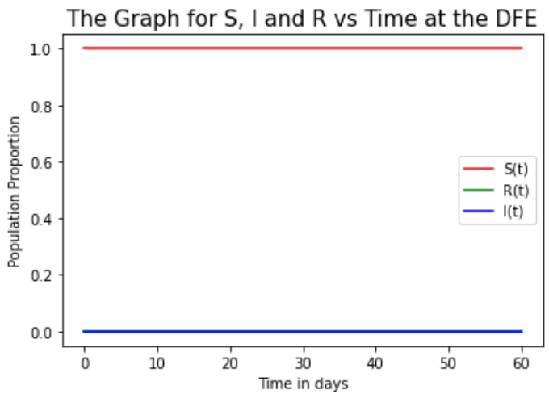 | 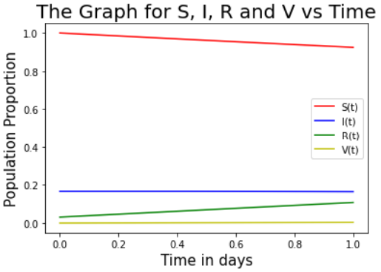
Figure 2(a): S I R relationship at DFE | Figure 2(b): S, I, R and V relationship at DFE  (Values of Days $×100$)

Figure 2(a), depict a situation where only infections are shown whereas figure 2(b), the period after vaccination, for an almost similar number of days, there is some level of variations in the number of susceptibles, Infected, vaccinated and recovered (or removed) depicted.

Pre-vaccination | Post-vaccination
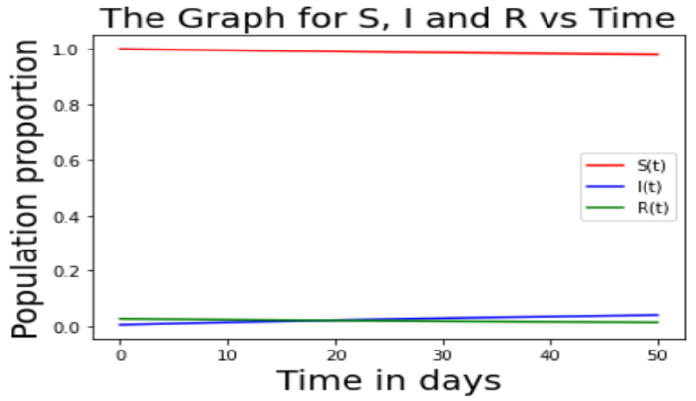 | 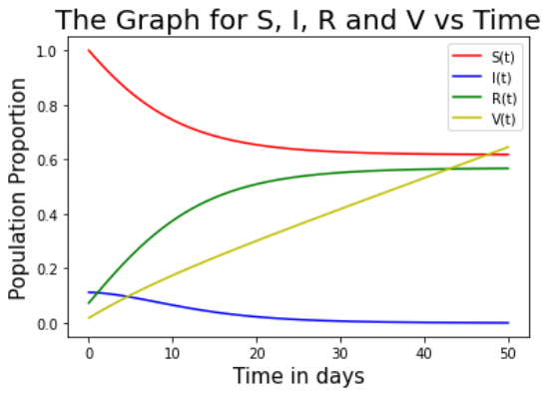
Figure 3(a): S I R relationship after 50 days. | Figure 3(b): S I R and V relationship after 50 days.

Figure 3(a) depict an all high number of susceptibles before vaccination whereas figure 3(b), the period during (or after vaccination) show a consistent decline in the number of susceptibles and the infected, and an increase in the number of the vaccinated and the recovered.

Pre-vaccination | Post-vaccination
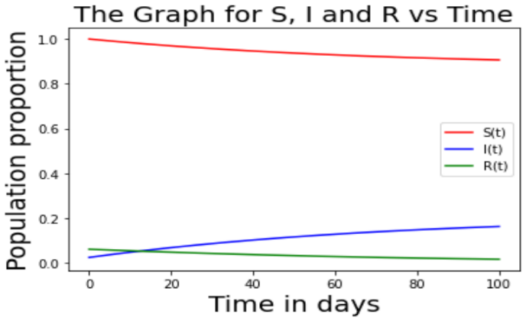 | 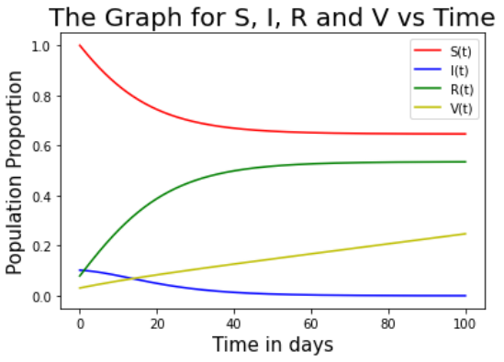
Figure 4(a): S I R relationship after 100 days. | Fig 4(b): S I R and V relationship after 100 days

Figures 4(a) for the period before vaccination, show an increase in the number of infections with a somewhat number of stabilization in the number of the recovered. Figure 4(b) above show a similar trend as is depicted in figure 3(b) with the only difference being a slowed down rate of vaccination.

Pre-vaccination | Post-vaccination
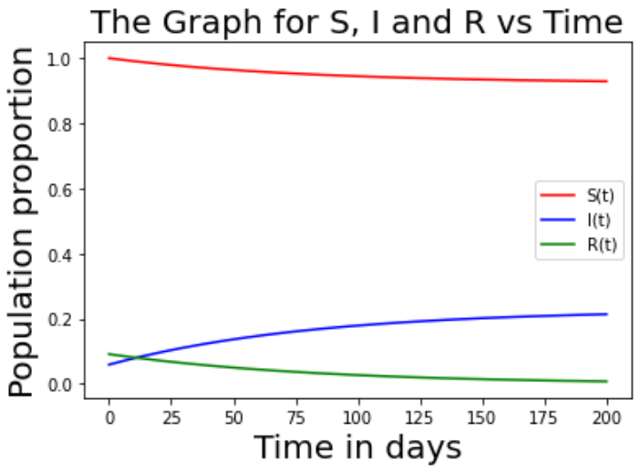 | 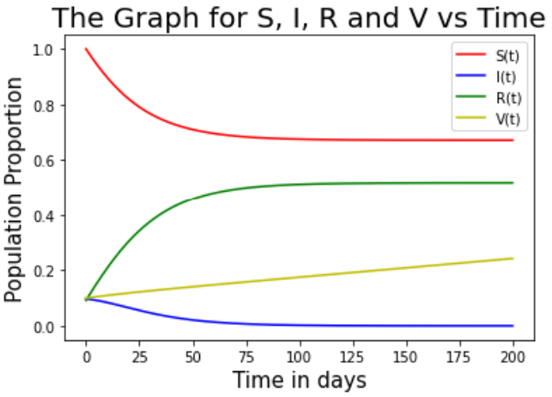
Figure 5(a): S I R relationship after 200 days. | Fig 5(b): S I R and V relationship after 200 days.
Figure 5(a) above, show a trend of increased infections with no much changes in the numbers of the susc eptibles and recovered, while the number of recovered is increasing significantly in 5(b) compared to 5(a) where the number remained fairly constant throughout the period in question. These numbers are seen stabilizing at some point. On the other hand, the infected numbers remain low, post vaccination.

5.2 Conclusions and Recommendations
5.2.1 Conclusions
From equation [16], for the period before vaccination, results show, that $β-μ-γ=$ 0.009105, a value that is greater than 0. Thus, the DFE Point will be unstable since β −γ −µ > 0 and the disease will not die out on it’s own from the population even with its low rate of spread amongst the people especially living in rural set ups and the informal settlements in urban areas.
Further, with $R_{0}$ = $\frac{β}{γ+ μ}=1.30015,$ it meant the disease continued to spread with one infected person averagely infecting 2.

Further from [21], the Concept behind the linear stability of the equilibrium points, it’s clear arising from the above results that the disease-free equilibrium and Endemic Equilibrium points cannot exist simultaneously. Further, since the reproduction number, R₀ > 0, the trajectories do not approach the disease-free equilibrium point, then the Disease Free Equilibrium point is unstable. All indications are that the disease continued to surge before vaccination.

In comparison, the period after vaccination gave an estimated $R_{o}$ value approaching 1.08, translating into a Herd Immunity Threshold of 0.07, implied that the population that needed to be vaccinated to keep the pandemic under control was a paltry 7%. This was a huge milestone achieved in containing the spread of the disease. This is believed to be attributed to the herd immunity obtained either through vaccination. or naturally. From the post vaccination stability analysis carried out, it can be concluded that vaccination significantly contributed to the acquisition of herd immunity

Upon vaccination, results show that the susceptible population gradually decreased and that of the infected population declined steadily as shown by the infection rate, β. The reverse is true for the period before vaccination. This disparity is believed to be a result of enhanced herd immunity due to the robust vaccination roll out.

5.2.2 Recommendations
From the findings of the study, its determined that a comparative stability analyses for the periods both before and after vaccination showed significant variations in the disease dynamics. Indeed, it can be concluded that vaccination significantly contributed in controlling of the disease spread and is therefore highly recommended that going forward, people be sensitized to embrace vaccination as one of the effective interventions managing the pandemic and/or any other disease of a similar nature.

It is further recommended that stability analyses be carried out amongst people of different age groups with a view to determining which group is most vulnerable. It’s not lost on the study that a large portion of Kenyans never got vaccinated due to their cultural beliefs, yet they continue to exhibit characteristics of herd immunity, pointing out to the fact that a large portion acquired natural herd immunity upon infection. It might be necessary to determine, if possible, which between, natural immunity or one acquired due to vaccination is more effective in curbing the spread of COVID-19 and other similar pandemics and how the same can be enhanced.

Disclaimer (Artificial intelligence)
Option 1:
Author(s) hereby declare that NO generative AI technologies such as Large Language Models (ChatGPT, COPILOT, etc.) and text-to-image generators have been used during the writing or editing of this manuscript.
Option 2:
Author(s) hereby declare that generative AI technologies such as Large Language Models, etc. have been used during the writing or editing of manuscripts. This explanation will include the name, version, model, and source of the generative AI technology and as well as all input prompts provided to the generative AI technology
Details of the AI usage are given below:
1.
2.
3.

Declaration
I declare that NO generative AI technologies such as Large Language Models (ChatGPT, COPILOT, etc.) and text-to-image generators have been used during the writing or editing of this manuscript.

References

[1] Anderson R, May R. Vaccination and Herd Immunity to Infectious Diseases, Nature. 1991;318.

[2] Bendadavid EB, Mulaney B, Sood N. et al., ‘Covid-19 antibody seroprevalence in Santa Clara county, California;
2020.
Available:https://www.medrxiv.org/content/10.1101/2020.04.14.20062463v2

[3] Diekmann O, Heesterbeek JAP, Wiley; New York: Mathematical epidemiology of infectious diseases: model
building, analysis and interpretation; 2000.

[4] Edridge AWD, Kaczorowska J, Hoste ACR. et al., ‘Coronavirus protective immunity in shortlasting’,
Available:https://www.Medrxiv.org/content/10.1101/2020.05.11.20086439v2

[5] European Centre for Disease: COVID-19. Accessed April 18, 2022 from
Available:https://www.ecdc.europa.eu/en/coronavirus.

[6] Isaac MW, Stanley S, Kimathi G, Wainaina M, Ketetu V, Kaluki W. Mathematical Modeling of COVID-19
Transmission in Kenya: A model with Re-infection transmission Mecchanism, Computational and Mathematical
Methods in Medicine; 2021. Article ID 5384481,
Available:https://doi.org10.1155/2021/5384481.

[7] Iyaya C.W, Mocheche G.M., Sitawa I.W., A Covid-19 SEIR model for people living with underlying medical
conditions in Kenya, International Journal of Statistics and Applied Mathematics. 2022;7(3):115-122.

[8] Kermack O. W., McKendrick A.G. (1927). A contribution to the Mathematical theory of Epidemics.
https://doi.org/10.1098/rspa.1927.0118

[9] Ma S, Xia Y, Hethcote H. Mathematical Understanding of Infectious Disease Dynamics, National University of
Singapore; 2008.

[10] Mocheche G.M. . A Modified SIVR Mathematical Model of Covid-19 Post-vaccination Stability Analysis in
Kenya. Asian Research Journal of Mathematics , Volume 20, Issue 9, Page 151-165, 2024; Article
no.ARJOM.123321 ISSN: 2456-477X

[11] Murray J. Mathematical Biology, Volume I: Interdisciplinary Applied Mathematics, Springer-Verlag; 2003.

[12] Piu S, Mondal J, Khajanchi S. A mathematical model for COVID- 19 transmission dynamics with a case study
of India, Chaos, Solitons & Fractals, Elsevier. 2020;40(C).

[13] Randolph H, Barreiro L. Herd Immunity: Understanding Covid-19, Journal of Math. Cellpress Immunity Primer.
2020;52.

[14] Topley W, Wilson G. The Spread of Bacterial Infection. The Problem of Herd Immunity, Epidemiol. Infect.
1923;21:243-249.

[15] World Health Organization: A Brief History of Vaccines,
Available:https://www.who.int/news-room/spotlight/history of vaccination/a brief history of
vaccination

[16] World Health Organization’s Website:
Available:https:// covid19.who.int

[17] World Statistics: www.worldometers. Info

