Original Research Article
Evaluating the Socio-Economic Impact of Wildlife Hunting on the Livelihood of the Ethnic Garo Tribe in Madhupur, Bangladesh

.
ABSTRACT

Biodiversity is essential for maintaining ecosystem balance, providing food, medicine, and economic benefits, and supporting climate regulation. However, the destruction of flora and fauna harms the natural ecosystem, which impacts the country both economically and culturally. This study aims to find out the impacts of wildlife hunting on the livelihoods of the Garo Tribe, drawing on socio-economic and ecological perspectives. A total of 150 Garo people voluntarily participated in a well-structured questionnaire from different villages surrounding the Madhupur National Forest (MNF), where the majority (51.33%) lived on a low income. Therefore, they indirectly depend on forests for food and fuel. This study found 79 species of 19 orders under 55 families of Amphibians (6.33%), Reptiles (12.66%), Aves (63.29%), and Mammals (17.72%) which covered 8.58% of the total wildlife populations in Bangladesh. Historically, wildlife hunting has served as a fundamental means of food security and cultural expression for the Garo; however, unsustainable hunting practices have led to a decline in wildlife populations. As a result, 17 species of under 15 families of Mammals, Aves, and Reptiles were found to be regionally extinct in MNF. Threats to the biodiversity of the MNF highlight the importance of local conservation efforts. Understanding the consequences, the Garo people are now focusing on alternative livelihood strategies that mitigate the environmental impact. Strengthening partnerships between governments, NGOs, and indigenous communities can co-develop conservation policies that tackle wildlife hunting's root causes while promoting socio-economic resilience and cultural preservation.
Keywords: Biodiversity; conservation; Garo Tribe; hunting and wildlife
1. INTRODUCTION

Wildlife plays a crucial role in human society, providing economic, nutritional, cultural, and ecological benefits (Gomez et al., 2022; Barkat et al., 2021). Wild animals supply food such as protein and fat, medicine, clothing, tools, ornaments, and are involved in rituals and trade (Stearman & Redford, 1995; Chaachouay & Zidane 2024). However, excessive hunting for food and other resources has led to wildlife depletion (Parker et al., 2023). Hunting is a significant global threat to wildlife and a major cause of species extinction (Harrison et al., 2016).
The Garo Tribe is one of the major indigenous Ethnic groups in Bangladesh, primarily inhabiting the northern districts of Bangladesh, including Mymensingh, Tangail, Sunamganj, Gazipur, Netrokona, and Sherpur (Haque, 2006). They stand as a vibrant and culturally rich community. The Garo Tribe, also known as Achik Mande, possesses a distinct cultural identity, characterized by their language, customs, and rituals (Marak, 2014). Their traditional attire, adorned with colorful fabrics and intricate designs, reflects their deep-rooted connection to their heritage. The population of Garo people in Bangladesh is 120000 whereas 56.02% identify as Christians, 40.07% as Hindus, and 3.71% are Songsarek practitioners (Muhammed et al., 2011). Most Garos live in poverty (Rokonuzzaman et al., 2022). Their primary job is farming, and many work there as day laborers. Notable for their honesty and diligence, Garos are frequently hired by non-governmental organizations. Some are employed by the government, in hospitals, and educational institutions. Approximately 80% possess some literacy level, and the proportion of Garos pursuing higher education steadily rises (Imtiaz & Hassan, 2016).
In Bangladesh, the Garo tribe, inhabiting the forested regions of the country, has a long-standing tradition of hunting wildlife for subsistence and cultural purposes (Kubi, 2012). However, as Bangladesh faces escalating threats to its biodiversity, including habitat loss, poaching, and illegal wildlife trade, effective wildlife conservation processes are imperative (Shawon et al., 2025; Datta, 2022). This research aims to investigate the biodiversity, wildlife hunting, and conservation efforts which interpret the cultural significance, economic implications, and ecological consequences in Madhupur National Forest.
2. material and methods

The data were collected from the Madhupur forest area during 2021-22 through a well-structured questionnaire with 150 Garo people which were selected randomly, and a review of secondary sources including scholarly articles, government reports, and NGO publications. The observation and data collection methods used for different groups of wildlife are described in direct field observation by Daniel (1963), Husain & Rahman (1978), Sarker & Sarker (1988), Khan (2008), and Monirujjaman & Khan (2018). Data on the various species found in the research locations were collected via line-transect sampling. Counting was carried out along the roadways in communities and on agricultural land. Plot counting methods were utilized to study the amphibians. In the study area, each 300 m × 300 m plot was chosen and subdivided into several mini transect lines to study amphibians. For lizards and snakes, both plot counting and line-transect methods, along with data gathered from a questionnaire, were used. The questionnaire provided information on the presence and abundance of species. For bird data collection, only the line-transect method was employed. Each transect line measured 500 m in length and 30 m in width. Some bird species, although rarely seen, were identified by their calls and songs. For mammals, a combination of line-transect, plot counting, and questionnaire methods were used. The plot counting method was primarily used for counting species like rats, mice, monkeys, and shrews. The qualitative data was systematically analyzed to identify common themes and patterns. On the other hand, quantitative data were subjected to data analysis by Microsoft Excel (Microsoft, U.S.A.) to quantify the extent of wildlife hunting and its socio-economic impact. The study area is shown in Figure 1.
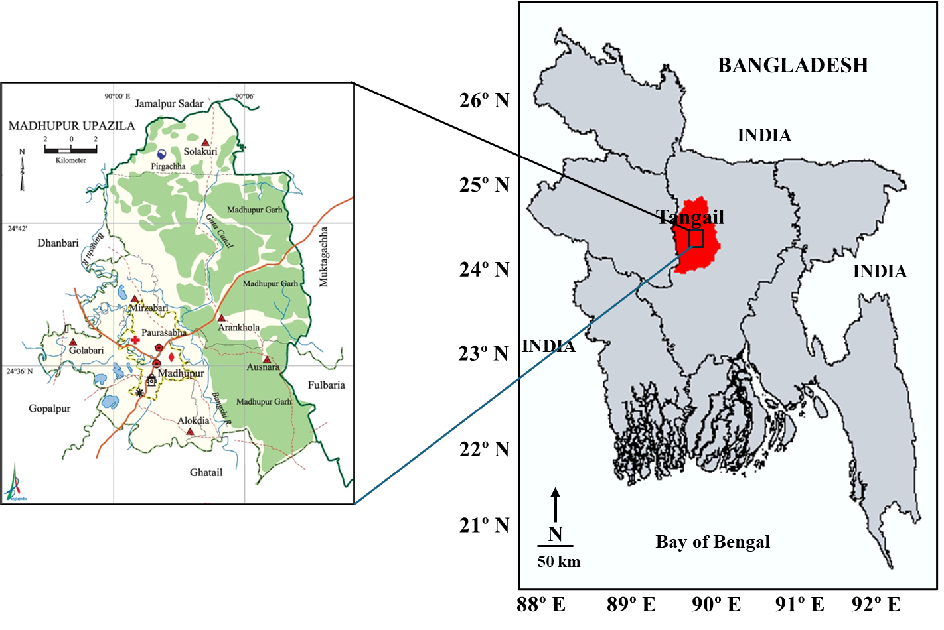
Fig. 1. Wildlife area of Madhupur National Forest, Bangladesh.

3. results and discussion

3.1 Socio-demographic characteristics of Garo people

The present study identified the wildlife diversity and conservation knowledge among the Garo people through a set of questionnaires. 150 responders were selected randomly from several localities around Madhupur National Forest in Bangladesh. According to socio-economic data, 60% were male and most of them were adults. More than 60% of the respondents were educated, although the majority were poor. So, they were indirectly dependent on the forest to earn their livelihood.
Table 1. Socio-demographic characteristics of Garo people
Characteristics | Frequency | Percentage (%)
Gender
Male | 90 | 60.00
Female | 60 | 40.00
Age (Years)
11 - 20 | 15 | 10.00
21 - 30 | 40 | 26.67
31 - 40 | 60 | 40.00
Above 40 | 35 | 23.33
Education
No institutional education | 30 | 20.00
Primary | 40 | 26.67
Secondary | 35 | 23.33
Higher Secondary | 25 | 16.67
Graduation or above | 20 | 13.33
Monthly Income (BDT)
10,000-20,000 | 77 | 51.33
20,000-30,000 | 45 | 30.00
Above 30,000 | 28 | 18.67
This study focused on wildlife diversity and conservation in Madhupur National Forest. Therefore, 83.33% of the responders believed that biodiversity conservation is essential to protect the Madhupur National Forest. It was alarming that 100% of the participants noticed major changes in Madhupur National Forest over the last 20 years and most of them think deforestation is the major cause. Sometimes They also want to identify the different threats to biodiversity. More than 60% of the Garo people observed the negative impact of wildlife hunting on the ecosystem, although it has a great economic impact on the local market to earn their livelihood. Garo people agree that the Wildlife Security and Protection Act is necessary for biodiversity conservation. Nevertheless, local conservation activities like seminars or workshops are more effective at safeguarding wildlife. More than 50% of the respondents thought that eco-tourism could help wildlife conservation and achieve the sustainable development goal of Bangladesh.
Table 2. Assessment of the wildlife diversity and conservation knowledge of Garo people in Madhupur National Forest
Statements | Response (n=150)
 | Strongly Agree (%) | Agree (%) | Neutral (%) | Disagree (%) | Strongly Disagree (%)
1. Do you think wildlife knowledge is essential for biodiversity conservation? | 50  (33.33%) | 90  (60.00%) | 10  (6.67%) | 0  (0.00%) | 0  (0.00%)
2. Do you agree that wildlife or habitats have significantly changed in the last 20 years? | 100  (66.67%) | 50  (33.33%) | 0  (0.00%) | 0  (0.00%) | 0  (0.00%)
3. Is it important to know the different threats to wildlife diversity? | 40  (26.67%) | 80  (53.33%) | 20  (13.33%) | 10  (6.67%) | 0  (0.00%)
4. Do you think deforestation is the major cause of wildlife extinction? | 30  (20.00%) | 60  (40.00%) | 30  (20.00%) | 20  (13.33%) | 10  (6.67%)
5. Does wildlife hunting have any ecological consequences? | 20  (13.33%) | 80  (53.33%) | 40  (26.67%) | 10  (6.67%) | 0  (0.00%)
6. Do you agree that wildlife hunting and trading affects the local livelihoods? | 10  (6.67%) | 80  (53.33%) | 40  (26.67%) | 20  (13.33%) | (0.00%)
7. Do you believe that regular field workshops or seminars will accelerate wildlife conservation? | 40  (26.67%) | 80  (53.33%) | 20  (13.33%) | 10  (6.67%) | 0  (0.00%)
8. Do you think the Wildlife Protection and Security Act is necessary for conservation? | 40  (26.67%) | 60  (40.00%) | 50  (33.33%) | 0  (0.00%) | 0  (0.00%)
9. Does Eco-Tourism play a vital role in biodiversity conservation in Bangladesh? | 20  (13.33%) | 70  (46.67%) | 40  (26.67%) | 20  (13.33%) | 0  (0.00%)
10. Do you agree wildlife conservation can contribute to the sustainable development of Bangladesh? | 40  (26.67%) | 50  (33.33%) | 50  (33.33%) | 10  (6.67%) | 0  (0.00%)

3.2 Common wildlife in Madhupur National Forest
3.2.1 Amphibians
Five species of anuran amphibians under 4 families (Bufonidae, Dicroglossidae, Ranidae, and Microhylidae) were found in Madhupur National Forest (Table 3). Of the recognized species 1 (20%) was a toad and 4 (80%) were frogs. Frogs play a vital role in the food web of birds, fish, and snakes.
Table 3. Amphibians observed in the Madhupur National Forest
SL No. | Common Name | Scientific Name | Order | Family
1. | Common Asian Toad | Duttaphrynus melanostictus  (Schneider, 1799) | Anura | Bufonida
2. | Skipper Frog | Euphlyctis cyanophlyctis  (Schneider, 1799) |  | Dicroglossidae
3. | Indian Bull Frog | Hoplobatrachus tigerinus  (Daudin, 1803) |  | Dicroglossidae
4. | Indian Balloon Frog | Uperodon globulosus  (Gunther, 1864) |  | Microhylidae
5. | Cope’s Frog | Hylarana leptoglossa  (Cope, 1868) |  | Ranidae
3.2.2 Reptiles
Ten species of reptiles under 2 orders (Squamata and Serpentes) and 7 families (Agamidae, Gekkonidae, Scinidae Varanidae, Colubridae, and Typhlopidae) were observed (Table 4). Of the recognized species 1 (10%) was monitor, 2 (20%) were lizards, 2 (20%) were skinks and 5 (50%) were snakes. Many reptiles, particularly snakes and lizards, significantly contribute to biological pest management by digesting crop-damaging insects and rodents.
Table 4. Reptiles observed in the Madhupur National Forest
SL No. | Common Name | Scientific Name | Order | Family
1. | Common Garden  Lizard | Calotes versicolor  (Daudin, 1802) | Squamata | Agamidae
2. | Common House  Gecko | Hemidactylus frenatus  (Schlegel, 1836) |  | Gekkonidae
3. | Keeled Grass Skink | Mabuya carinata  (Schneider, 1801) |  | Scincidae
4. | Bronze Grass Skink | Mabuya macularia  (Blyth, 1853) |  | Scincidae
5. | Bengal Monitor | Varanus bengalensis  (Daudin,1802) |  | Varanidae
6. | Common Smooth  Water Snake | Enhydris enhydris  (Schneider, 1799) | Serpentes | Colubridae
7. | Common Vine Snake | Ahaetulla nasuta  (Lacépède, 1789) |  | Colubridae
8. | Checkered Keel | Xenochrophis piscator (Schneider, 1799) |  | Colubridae
9. | Diard’s Blind Snake back | Typhlops diardii  (Schlegel, 1839) |  | Typhlopidae
10. | Jerdon’s Blind Snake | Typhlops jerdoni (Boulenger, 1890) |  | Typhlopidae
3.2.3 Aves
Fifty species of birds under 11 orders (Galliformes, Piciformes, Coraciformes, Cuculiformes, Psittaciformes, Upupiformes, Apodiformes, Strigiformes, Columbiformes, Ciconiiformes, and Passeriformes) and 31 families were recognized (Table 5). Birds are natural enemies of pests, fruit pollinators, seed transporters, and balance the ecosystem.
Table 5. Aves observed in the Madhupur National Forest
SL No. | Common Name | Scientific Name | Order | Family
1. | Red Junglefowl | Gallus gallus  (Linnaeus, 1758) | Galliformes | Phasianidae
2. | Rufous Woodpecker | Celeus brachyurus  (Vieillot, 1818) | Piciformes | Picidae
3. | Greater Flameback | Chrysocolaptes guttacristatus  (Tickell, 1833)
4. | Grey-capped Pygmy Woodpecker | Dendrocopos canicapillus  (Blyth, 1845)
5. | Fulvous-breasted  Woodpecker | Dendrocopos macei  (Vieillot, 1818)
6. | Black-rumped  Flamback | Dinopium benghalense  (Linnaeus, 1758)
7. | Indian Roller | Coracias benghalensis  (Linnaeus, 1758) | Coraciformes | Coraciidae
8. | Common Kingfisher | Alcedo atthis  (Linnaeus, 1758) |  | Alcedinidae
9. | White-throated Kingfisher | Halcyon smyrnensis  (Linnaeus, 1758) |  | Halcyonidae
10. | Stork-billed  Kingfisher | Pelargopsis capensis  (Linnaeus, 1758)
11. | Green Bee-eater | Merops orientalis  (Latham, 1801) |  | Meropidae
12. | Asian Koel | Endynamys scolopaceus  (Linnaeus, 1758) | Cuculiformes | Cuculidae
13. | Lesser Coucal | Centropus bengalensis  (Gmelin, 1788) | Cuculiformes | Centropodidae
14. | Greater Coucal | Centropus sinensis  (Stephens, 1815)
15. | Red-breasted  Parakeet | Psittacula alexandri (Linnaeus,1758) | Psittaciformes | Psittacidae
16. | Rose-ringed Parakeet | Psittacula krameria  (Scopoli, 1769)
17. | Common Hoopoe | Upupa epops  (Linnaeus, 1758) | Upupiformes | Upupidae
18. | Asian Palm Swift | Cypsiurus balasiensis  (J.E. Gray, 1829) | Apodiformes | Apodidae
19. | Barn Owl | Tyto alba  (Scopoli, 1769) | Strigiformes | Tytonidae
20. | Rock Pigeon | Columba livia  (Gmelin, 1789) | Columbiformes | Columbidae
21. | Spotted Dove | Streptopelia chinensis  (Scopoli, 1768)
22. | Yellow-footed Green Pigeon | Treron phoenicoptera  (Latham, 1790)
23. | Brahminy Kite | Haliastur indus  (Boddaert, 1783) | Ciconiiformes | Accipitridae
24. | Black Kite | Milvus migrans  (Boddaert, 1783)
25. | Gray Heron | Ardea cinerea  (Linnaeus, 1758) | Ciconiiformes | Ardeidae
26. | Indian Pond Heron | Ardea cinerea  (Linnaeus, 1758)
27. | Little Heron | Butorides striatus  (Linnaeus, 1758)
28. | Cattle Egret | Bubulcus ibis  (Linnaeus, 1758)
29. | Great Egret | Ardea alba  (Linnaeus, 1758)
30. | Little Egret | Egretta garzetta  (Linnaeus, 1766)
31. | Long-tailed Shrike | Lanius schach  (Linnaeus, 1758) | Passeriformes | Laniidae
32. | Common Iora | Aegithina tiphia  (Linnaeus, 1758) | Passeriformes | Corvidae
33. | Large-billed Crow | Corvus macrorhynchos  (Wagler, 1827)
34. | House Crow | Corvus splendens  (Vieillot, 1817)
35. | White-rumped Shama | Copsychus malabaricus  (Scopoli, 1788) | Passeriformes | Muscicapidae
36. | Oriental Magpie  Robin | Copsychus saularis  (Linnaeus, 1758)
37. | Jungle Myna | Acridotheres fuscus  (Wagler, 1872) | Passeriformes | Sturnidae
38. | Bank Myna | Acridotheres ginginianus  (Latham, 1790)
39. | Common Myna | Acridotheres tristis  (Linnaeus, 1766)
40. | Asian Pied Starling | Gracupica contra  (Linnaeus, 1758)
41. | Chestnut-tailed  Starling | Sturnus malabarica  (Gmelin, 1789)
42. | Common Tailorbird | Orthotomus sutorius  (Pennant, 1769) | Passeriformes | Sylviidae
43. | Jungle Babbler | Turdoides striata  (Dumont, 1823)
44. | Purple Sunbird | Cinnyris asiaticus  (Latham, 1790) | Passeriformes | Nectariniidae
45. | Purple-rumped  Sunbird | Leptocoma zeylonica  (Linnaeus, 1766)
46. | Black-headed Munia | Lonchura atricapilla  (Vieillot, 1807) | Passeriformes | Passeridae
47. | Scaly-breasted Munia | Lonchura punctulate  (Linnaeus, 1758)
48. | Paddyfield Pipit | Anthus rufulus  (Vieillot, 1818)
49. | House Sparrow | Passer domesticus  (Linnaeus, 1758)
50. | Baya Weaver | Ploceus philippinus  (Linnaeus, 1766)
3.3.4 Mammals
Twelve species of mammals under 5 orders (Artiodactyla, Rodentia, Carnivora, Chiroptera, and Primates), and 11 families were recognized in Madhupur National Forest (Table 6). Mammals serve a vital role in ecosystems by dispersing seeds, pollinating, managing insect populations, and minimizing disease transmission.
Table 6. Mammals observed in the Madhupur National Forest
SL No. | Common Name | Scientific Name | Order | Family
1. | Indian Boar | Sus scrofa | Artiodactyla | Suidae
2. | Barking Deer | Muntiacus muntjac |  | Cervidae
3. | Irrawaddy Squirrel | Callosciurus pygerythrus  (I. Geoffroy Saint Hilaire, 1832) | Rodentia | Sciuridae
4. | Asiatic Long Tailed  Climbing Mouse | Vandeleuria oleracea  (Bennett, 1832) | Rodentia | Muridae
5. | Greater Bandicoot rat | Bandicota indica  (Bechstein, 1800)
6. | Large Indian Civet | Viverra zibetha  (Linnaeus, 1758) | Carnivora | Viverridae
7. | Jangle Cat | Felis chaus  (Schreber, 1777) |  | Felidae
8. | Fishing Cat | Prionailurus viverrinus  (Bennett, 1833)
9. | Small Indian  Mongoose | Herpestes auropunctatus  (Hodgson, 1836) |  | Herpestidae
10. | Golden Jackal | Canis aureus  (Linnaeus, 1758) |  | Canidae
11. | Indian Flying Fox | Pteropus giganteus  (Brünnich, 1782) | Chiroptera | Pteropodidae
12. | Indian Pipistrelle | Pipistrellus coromandra  (Gray, 1838) |  | Vespertilionidae
13. | Rhesus Macaque | Macaca mulatta  (Zimmermann, 1780) | Primates | Cercopithecidae
14. | Capped Langur | Trachypithecus pileatus  (Blyth, 1843)
Commonly 79 species of 19 orders under 55 families of Amphibians (6.33%), Reptiles (12.66%), Aves (63.29%), and Mammals (17.72%) were recorded in this study. Sometimes some uncommon and rare species of birds and animals are also found in the Madhupur National Forest. The present study area represented 8.58% of all wildlife species in Bangladesh. Husain and Haque (1977) recorded 170 species from the Madhupur forest in Tangail and Mymensingh districts. Khan (2008) investigated the taxonomy and ecology of Tangail's birds and discovered 216 species of birds classified into 48 families, accounting for roughly one-third of all bird species found in Bangladesh. According to Khan and Ahsan (2011), Madhupur National Park contains 115 bird species classified into 12 orders, 36 families, and 87 genera. Monirujjaman and Khan (2018) reported 151 animal species (Amphibians, Reptiles, Birds, and Mammals) belong to 23 orders under 62 families in Madhupur National Park. All previous studies by Husain and Haque (1977), Husain (1991), Khan (1998), Khan and Ahsan (2011), and Monirujjaman and Khan (2018) observed a dramatic decline in wildlife population in Madhupur National Forest.
3.4 Hunting Practices of the Garo Tribe
The Garo tribe, an indigenous community residing primarily in the northeastern region of Bangladesh, has a rich cultural heritage deeply intertwined with the forest and its wildlife. Hunting has been a fundamental aspect of Garo's livelihood and cultural identity for generations, providing sustenance, income, and spiritual significance (De Maaker, 2021). Understanding the hunting practices of the Garo tribe sheds light on their socio-economic dynamics and relationship with the environment. Traditionally, the Garo people employ various hunting techniques passed down through oral traditions. These methods often involve deeply understanding the forest ecosystem and animal behavior. Garo hunters construct traps and snares using locally available materials such as bamboo, vines, and ropes. These traps are strategically placed along game trails or near water sources to capture small to medium-sized animals such as deer, wild boar, and small mammals.
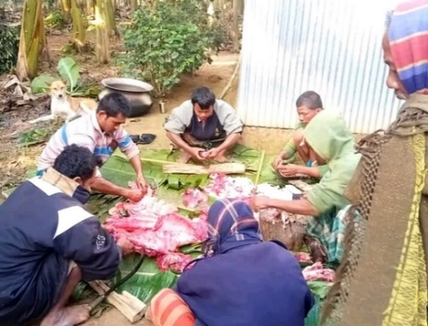  a) | 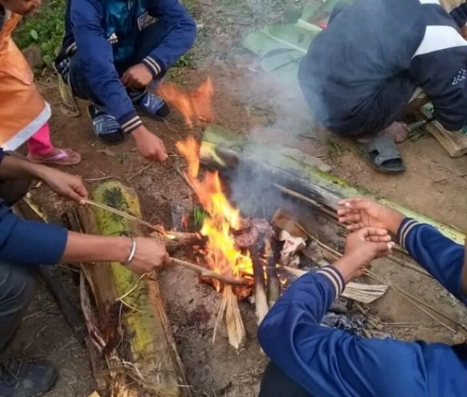  b)
Fig. 2. Processing of wild boar after hunting (a) and (b)
3.5 Ecological Impacts
While hunting has been an integral part of Garo culture, the practice has also raised concerns regarding its ecological impact. Overexploitation of wildlife resources, driven by increasing market demand and population pressures, has led to population declines in certain species (Kirkland et al., 2020). Additionally, indiscriminate hunting practices and habitat destruction threaten biodiversity and ecosystem stability in Garo-inhabited areas. Table 7 shows Regionally extinct (RE) wildlife from Madhupur National Forest.
Table 7. Regionally extinct (RE) wildlife from Madhupur National Forest in Bangladesh (IUCN 2015)
SL No. | Wildlife category | Name | Scientific Name | Family Name
1. | Mammals | Bengal Tiger | Panthera tigris tigris | Felidae
 |  | Leopard | Panthera pardus
 |  | Indian Rhinoceros | Rhinoceros unicornis | Rhinocerotidae
 |  | Asian Elephant | Elephas maximus | Elephantidae
 |  | Wild buffalo | Bubalus bubalis | Bovidae
 |  | Sambar Deer | Rusa unicolor | Cervidae
 |  | Hog Deer | Axis porcinus
 |  | Asian Black Bear | Ursus thibetanus | Ursidae
 |  | Indian Pangolin | Manis crassicaudata | Manidae
 |  | Hispid Hare | Caprolagus hispidus | Leporidae
 |  | Malayan Porcupine | Hystrix brachyura | Hystricidae
2. | Avian | Indian Peafowl | Pavo cristatus | Phasianidae
 |  | Bengal Floricans | Houbaropsis bengalensis | Otididae
 |  | Indian Grey Hornbills | Ocyceros birostris | Bucerotidae
 |  | White-rumped Vulture | Gyps bengalensis | Accipitridae
3. | Reptiles | Python | Python molurus | Pythonidae
 |  | Cobra | Naja naja | Elapidae
3.6. Socio-economic Impacts
Wildlife hunting plays a pivotal role in the socio-economic livelihoods of Garo communities, providing food security, income generation, and cultural sustenance. However, the economic benefits derived from hunting are often overshadowed by its long-term ecological consequences, including declines in wildlife populations and ecosystem degradation (Shawon et al., 2025). Furthermore, disparities in access to resources and market opportunities exacerbate socio-economic inequalities within Garo communities, underscoring the need for equitable and inclusive conservation approaches.
3.7. Challenges and Conservation Efforts
Changes in environmental conditions, socio-economic dynamics, and conservation policies challenge the sustainability of traditional hunting practices among the Garo tribe. Efforts to balance conservation objectives with the socio-economic needs of Indigenous communities have led to the implementation of various conservation initiatives in Garo-inhabited areas. These include establishing protected areas, community-based conservation projects, and awareness campaigns promoting sustainable hunting practices and biodiversity conservation.

3.8. Policy Implications and Recommendations
Policy interventions to reconcile wildlife conservation objectives with indigenous rights should prioritize community-based conservation initiatives, sustainable resource management practices, and capacity-building efforts. Strengthening partnerships between government agencies, non-governmental organizations, and indigenous communities can facilitate the co-development of conservation policies and implementation strategies that address the root causes of wildlife hunting while fostering socio-economic resilience and cultural preservation. Additionally, enhancing enforcement mechanisms, raising awareness about the importance of wildlife conservation, and promoting alternative livelihood opportunities are essential components of effective conservation strategies in Bangladesh.
4. Conclusion

Wildlife hunting by the Garo tribe presents complex challenges and opportunities for wildlife conservation in Bangladesh. By recognizing the socio-cultural significance of Garo hunting practices, integrating Indigenous perspectives into conservation processes, and promoting collaborative approaches that prioritize sustainability and equity, conservation objectives can be achieved while respecting Indigenous rights and cultural diversity. This research underscores the importance of adaptive and inclusive conservation strategies that foster coexistence between humans and wildlife, thereby ensuring the long-term survival of Bangladesh's rich biodiversity for future generations.

Acknowledgements
The authors greatly acknowledge the Garo people who willingly participated in the questionnaire and the official staff of different Madhupur National Forest ranges, in Bangladesh.
Competing interests
All authors have declared that there are no competing interests regarding the publication of this research.
Authors’ Contributions
This work was carried out in collaboration among all authors. Author IJS finalized the study conception and design, conducted data collection and curation, wrote the original draft, and reviewed the manuscript. Authors IJS and JHR collected literature, performed data analysis, edited the manuscript, and checked for plagiarism. Authors MJH and MMR reviewed the English grammar and revised and edited the manuscript. All authors read and approved the final manuscript.
DISCLAIMER (ARTIFICIAL INTELLIGENCE)

The author(s) confirm that no generative AI technologies, including Large Language Models (e.g., ChatGPT, Copilot) or text-to-image generators, were utilized in the writing or editing of this manuscript.

References

Barkat, A. I., Liza, F. T., Akter, S., Shome, A. R., & Rabbe, M. F. (2021). Wildlife hunting practices of the Santal and Oraon communities in Rajshahi, Bangladesh Journal of Threatened Taxa, 13(11), 19484-19491.
Chaachouay, N., & Zidane, L. (2024). The importance of animals in sacrificial rituals and socio-religious occasions practised by the indigenous communities of Morocco and strategies to conserve them from extinction. Biologia, 79(3), 753-773.
Daniel, J. C. (1963). A Field Guide of the Amphibians of Western India Part-1. Journal of Bombay Natural Historical Society, 60(2), 415-438.
Datta, A. K. (2022). Status of Illegal Bird Hunting in Bangladesh: Online news portal as the source. Human Dimensions of Wildlife, 27(2), 183-192.
De Maaker, E. (2021). Aloof but not abandoned: Relationality and the exploitation of the environment in the Garo hills of India. In Environmental Humanities in the New Himalayas (pp. 135-151). Routledge.
Gomez, J., van Vliet, N., & Canales, N. (2022). The values of wildlife revisited. Ecology and Society, 27(4).
Harrison, R. D., Sreekar, R., Brodie, J. F., Brook, S., Luskin, M., O'Kelly, H., ... & Velho, N. (2016). Impacts of hunting on tropical forests in Southeast Asia. Conservation Biology, 30(5), 972-981.
Hoque, A. (2006). Radio and indigenous peoples. The role of radio in the sustainable livelihoods of indigenous peoples: A case study of the Rakhaing and the Garo people in Bangladesh (Master's thesis, Universitetet i Tromsø).
Husain, K. Z., & Haque, M. N. (1977). The avifauna of the Madhupur forest. Proceedings First Bangladesh National Conference on Forestry, Dhaka. pp. 381-392.
Husain, K. Z., Rahman, M.K., & Haque, M. N. (1991). Wildlife diversity of the Jamuna Multipurpose Bridge area (a folder). Wildlife Society of Bangladesh, Department of Zoology, University of Dhaka, Dhaka
Hussain, K. Z., & Rahman, M. M. (1978). The amphibian fauna of Bangladesh. Bangladesh J. Zool, 6(2), 157-158.
Imtiaz, M., & Hassan, A. (2016). The urges of language adaptation for economic development within the Garos of Bangladesh. In Indigenous People and Economic Development. Routledge, 1st Edition pp. 307-324. ISBN 9781315588346.
IUCN- Bangladesh. 2015. Red List of Bangladesh. Vol. 1: Summary. IUCN- Bangladesh, Dhaka, Bangladesh. https://portals.iucn.org/library/sites/library/files/documents/RL-549.3-003-v.1.pdf
Khan, M. M. H. (1998). Taxonomy and Ecology of Birds of Tangail. M.Sc. Dissertation (Unpublished), Jahangirnagar University, Savar.
Khan, M. M. H. (2008). Protected Areas of Bangladesh- A Guide to Wildlife. Nishorgo Program. Bangladesh Forest Department. pp. 10-29.
Khan, S. I., & Ahsan, M. F. (2011). Birds of the Madhupur National Park, Bangladesh. Bangladesh Journal of Zoology, 39(1), 49-63.
Kirkland, M., Eisenberg, C., Bicerra, A., Bodmer, R. E., Mayor, P., & Axmacher, J. C. (2020). Sustainable wildlife extraction and the impacts of socio-economic change among the Kukama-Kukamilla people of the Pacaya-Samiria National Reserve, Peru. Oryx, 54(2), 260-269.
Kubi, H. H. (2012). Forest Dwelling Ethnic People and Conservation Process of Forest: A Study on Modhupur Sal Forest. Master's Thesis, Department of General and Continuing Education North South University, Bangladesh.
Marak, Q. (2014). Food politics: Studying food, identity and differences among the Garos. Cambridge Scholars Publishing. Lady Stephenson Library, Newcastle upon Tyne, NE6 2PA, UK.
Monirujjaman., & Khan, M. M. H. (2018). Wildlife Diversity of Madhupur National Park, Bangladesh. Jahangirnagar University Journal of Biological Sciences, 7(1),1-13.
Muhammed, N., Chakma, S., Masum, M. F. H., Hossain, M. M., & Oesten, G. (2011). A case study on the Garo ethnic people of the Sal (Shorea robusta) forests in Bangladesh. International Journal of Social Forestry, 4(2), 197-211.
Parker, B. G., Khanyari, M., Ambarlı, H., Buuveibaatar, B., Kabir, M., Khanal, G., ... & Farhadinia, M. S. (2023). A review of the ecological and socioeconomic characteristics of trophy hunting across Asia. Animal Conservation, 26(5), 609-624.
Redford, K. H., Godshalk, R., & Asher, K. (1995). What about the wild animals. Wild Animal Species in Community Forestry in the Tropics (Food and Agriculture Organization, Rome, 1995).
Rokonuzzaman, M., Shimul, M. T. N., Hasan, S. S., Khan, M. A. R., Rana, J., & Bhuiyan, M. A. (2022). Study on the Causes and impact of migration in garo people lifestyle. Turkish Journal of Agriculture-Food Science and Technology, 10(6), 1026-1033.
Sarker, S. U., & Sarker, N. J. (1988). Wildlife of Bangladesh, A Systematic list. The Rico Printers.
Shawon, R. A. R., Rahman, M. M., Dandi, S. O., Agbayiza, B., Iqbal, M. M., Sakyi, M. E., & Moribe, J. (2025). Knowledge, Perception, and Practices of Wildlife Conservation and Biodiversity Management in Bangladesh. Animals, 15(3), 296.

