Assessment of Land Cover Changes and fragmentation of mining landscape using Geospatial Technology

Abstract
Mining plays an important role in economic development of Jharkhand, India. Simultaneously, it also has significant negative impacts on the environment, ecology, and society. Geospatial technology enables the identification, delineating, and monitoring of change in the mining landscape in spatial and temporal scale. The aim of this work was to evaluate the quantitative change in the mining landscape using multi-temporal Landsat datasets of 2004 and 2024. The study showed that mining areas have increased rapidly during the study period, and the growth has occurred by depleting the agricultural and forest land. In 2004 agriculture land covered 36.41% of the study area, but by 2024, it had decrease to 19.68%. Further, the study assessed the dynamics of mining patches and their characteristics through spatial metrics analysis. %. It has been observed that number of patches (NP) and patch density (PD)has increase whereas the largest patch index (LPI) has decreased. Dense and open forest has also been decreased in this period. The rapid expansion of mining areas over the past decade has raised serious ecological concerns.
Key words: Landsat data, mining activity, Geospatial technology, LULC change

Introduction
Mining is a widespread activity conducted in nearly every country globally. In the early 20th century,
global mining production increased significantly to meet the growing population's demands.This growth has led to an extension of acceptable limits for mining operations, largely due to the socio-economic benefits these activities provide (Ettler 2016; Mishra b2005; Maconachie 2012). Despite its importance in the growth and development of a nation's economy, it poses many challenges, including deforestation, soil erosion, pollution, displacement of communities, and harm to water sources (Erener 2011; Ganvir and Guhey 2021; Singh, VB 2023; Papadkar et al 2024;Zhang et al. 2020).
India is the highest energy-consuming country in the world because of its population and economic growth where coal is the main source of energy. It is second-largest producer and consumer of coal in the world with a total production of 997.83 million tonnes in 2023-24 which was 893.19 million tonnes of coal in 2022-2023, 778.19 million tonnes of coal in 2021-2022, 716.08 million tonnes of coal in 2020-2021 and 730.35 million tonnes of coal in 2018-19 (Ministry of Coal, Govt. of India 2024). Jharkhand State Mineral Development Corporation Ltd. states that Jharkhand is one of the world’s richest mineral regions, holding approximately 40% of India’s mineral reserves and 29% of its coal reserves. This abundance of natural resources has made mining and mineral extraction are the major industries of the state. With the increase in demand for minerals due to the industrial revolution, illegal and unplanned mining, also increased in this area. Earlier work has demonstrated the wide-ranging impacts of mining in Jharkhand, including deforestation, loss of agricultural land, land subsidence, water pollution, and significant environmental and socio-economic consequences (Chatterjee et al. 2010; Chatterjee et al. 2015; Joy et al. 2024; Kumar et al. 2018; Karanam et al. 2021; Pandey et al. 2016).
To overcome these challenges continuous monitoring and mapping of the dynamic changes in land use land cover patterns will be helpful for proper management and developing mitigation strategies. Quantitative studies on mine expansion and related human-induced changes are vital for evaluating the environmental impact of mining activities. Many previous studies have quantified the change in mining landscape using geospatial technologies (Anderson 2020; Charou et al. 2010; Ngounouno et al. 2023; Ngueyep et al. 2024; Patra et al 2022; Zhang et al. 2019). This study aims to evaluate changes in the mining landscape using multi-temporal satellite-based datasets and FRAGSTATS software to quantify the changes.
- Study Area
Pakri Barwadih (Block: Barkagaon) is a village in Hazaribagh district of Jharkhand is approximately 1,982 feet above the sea level and enjoys tropical climate i.e., it stays hot in summer and moderately cool in winter. The study area is located at coordinates between longitude 85°14'11.625"E and 85°15'51.487"E and latitude 23°51'19.523"N and 23°54'26.444"N, covering an area of 447.9km². Hazaribagh town lies on Chota Nagpur plateau. A handful of small hills Sitagarha, Bamanbere and Canary Hill surround the city. The road to Hazaribagh passes through thick forests. The city is famous for its Coal and Mica reserves. It has the second largest coal reserve in Jharkhand. The study area has rich forest resources mainly dominated by Shorea robusta and bamboo tree. Other species are Madhuca longifolia, Beutea monosperma, Semal, Mahua, Palas, Kend and Asian pear. Mainly two types of soil are found in Pakri Barwadih. Due to the presence of iron, soil of Hazaribagh is Red in color. Presence of Mica gives the soil a little pink color. Lower layer of soil is yellowish. Sandy loam soil is found around the Damodar River basin. The color of soil is a little red, brown & yellow. Total population of study area as according to population census 2011 is about 11,689, of which 5,666 females and 6,023 males and a literacy rate of 71.9%. The majority population of the village is Hindi speaking. Santhali is a language of the tribal people of Hazaribagh.
Fig. 1: Location Map of Study Area
- Material and Method
3.1 Data Used
Satellite data of Landsat 5/TM and Landsat 8/OLI images were downloaded from USGS; http://www.usgs.gov/in. The Landsat image of 2004 and 2024 with spatial resolution of 30m has been used in this study. In this study Landsat 5/ TM band 1-4 i.e. blue, green, red and NIR bands and Landsat 8/ OLI band 2-5 i.e. blue, green, red and NIR bands has been used. Only four bands have been used to reduce the data redundancy.
Table 1 Details of satellite images
Satellite/ Sensor | Year/date | Path/row | Bands used | Spatial Resolution(m)
Landsat5/TM | 7th March 2004 | 140/44 | 1,2,3,4 | 30
Landsat 8/ OLI | 26th January 2024 | 140/44 | 2,3,4,5 | 30

3.2 Land use and Land cover classification
Land Use and Land Cover (LULC) maps were generated using the Supervised Classification method, incorporating training samples and the Maximum Likelihood Decision Rule. Training samples are known areas used to classify the remaining part of the image (Jensen 1996). Nine LULC classes were prepared (Agricultural land, Open Forest, Dense Forest, Dry riverbed, Barren land, Waterbody, Riverbed, Settlement, Mining area) to understand the change in 20 years. To prepared LULC maps Satellite data of different years (Table1) were used in this study with ArcGIS Pro software.

3.3 Landscape metrics analysis
Landscape metrics have been used to observe variability and the impacts of fragmentation. Various studies have already shown the importance of landscape matrices which can be used to understand the spatial arrangement of LULC and monitor the spatio-temporal changes (Gabril et al.2019; Herzog and Lausch, 2001; Mahato et al. 2021; Singh et al. 2018; Wei et al. 2020; Zheng et al.1997). However, selecting the most appropriate matrix is essential to avoid redundancy in the landscape metrics. Several studies explain the importance of selected matrix for quantifying of landscape (Cain et al. 1997; Cushman et al 2008; Griffith et al 2000; Hargis et al 1998; Linke and Franklin 2006; Riitters et al. 1995). In this study landscape matrix includes the Number of Patches (NP), Patch Density (PD), Largest Patch Index (LPI), Inter-juxtaposition Index (IJI) and MESH were used which is shown in the table 2.

Table 2: Metrics used at the class level to quantify fragmentation (Kumar et al.2018; Mc Garigal and Marks, 1995).
Metrics and Units
NP = Total number of patches in this class | NP = 𝑛𝑖  n𝑖= number of patches in the landscape of patch type (class) i.
PD- (per unit per ha) Ratio of the number of patches and the area of investigated | PD = 𝑛𝑖 /𝐴 (10,000)(100) n𝑖 = number of patches in the landscape of patch type (class) i.  A = total landscape area (𝑚2).
LPI –Ratio of largest patch area to investigated area | LPI = max(𝑎𝑖𝑗) 𝑗=1 /𝐴 (100)  a𝑖𝑗= area (𝑚²) of patch ij.  A =total landscape area (𝑚2)
IJI- Interspersion-juxtaposition index Degree of interspersion of patches of this class, with all other classes
MESH, ha (Effective Mesh Size) | MESH= ∑ 𝑎𝑖𝑗2 𝑛 𝑗=1/𝐴 ( 1/10,000 ) a𝑖𝑗 = area (𝑚2) of patch ij.  A = total landscape area (𝑚2).

- Result and discussion
4.1 Land use Land cover change analysis
The landuse maps and statistics of the study area which are generated from satellite data using supervised classification is shown in Table 3 and Fig. 2. In the 2004 satellite image, agricultural land emerged as the dominant land cover class, covering approximately 350.29 hectares (ha), or 36.41% of the total area. Dense Forest was the second most prevalent class, spanning about 339.93 ha, or 34.54%. Open Forest covered approximately 200.88 ha, representing 20.41% of the total land area. In comparison, the other land cover classes were significantly smaller. The Dry Riverbed covered 3.69% of the area, Barren Land accounted for 0.45%, Waterbody made up 0.16%, Riverbed comprised 1.68%, and Settlement occupied 2.66% of the total land cover.
However, the 2024 satellite image shows that agricultural land cover has decreased dramatically and became 193.68 hectares (19.68%). The Dence forest in the study area has also decreased but to a lesser extent. Significant decrease of open forest has been observed only 151.11 hectares (15.35%), down from 200.88 hectares in 2004. The other land cover classes i.e. Dry Riverbed occupied 0.18 ha (0.02%), Barren Land comprised 4.59 ha (0.47%), Waterbodies covered 17.28 ha (1.76%), Riverbed accounted for 4.23 ha (0.43%) and the Settlement covered 82.71 ha (8.40%) which was only 26.19 ha (2.66%) of total study area. A new land cover class that is Mining Area has been identify in 2024 satellite data covering the second-largest area of 207.9 hectares (21.12%).
Over the last two decades mining industry expanded significantly, resulting in a substantial reduction of agricultural land by 2024. This shift in land use has had profound effects on the region's topography, leading to increased surface instability and damage water drainage pattern. This alteration could ultimately disrupt crop health and productivity. Many previous studies discuss the impact of mining on soil structure and hydrology which ultimately change the overall productivity and sustainability of agriculture productivity and health of crops (Hu et al., 1997; Lechner et al., 2014; Moffat and McNeill, 1994)
Table 3: Area Statistics of Land Use and Land Cover (LULC) Changes in different Years
LU/LC Class | 2004 |  |  | 2024
 | Area (ha) | Area (%) | Area (ha) |  | Area (%)
Agriculture Land | 350.29 | 36.41 | 193.68 |  | 19.68
Open Forest | 200.88 | 20.41 | 151.11 |  | 15.35
Dense Forest | 339.93 | 34.54 | 322.47 |  | 32.77
Dry Riverbed | 36.36 | 3.69 | 0.18 |  | 0.02
Barren Land | 4.141 | 0.45 | 4.59 |  | 0.47
Waterbody | 1.53 | 0.16 | 17.28 |  | 1.76
Riverbed | 16.56 | 1.68 | 4.23 |  | 0.43
Settlement | 26.19 | 2.66 | 82.71 |  | 8.40
Mining Area | 0.00 | 0.00 | 207.9 |  | 21.12
Total Area | 984.15 | 100 | 984.15 |  | 100

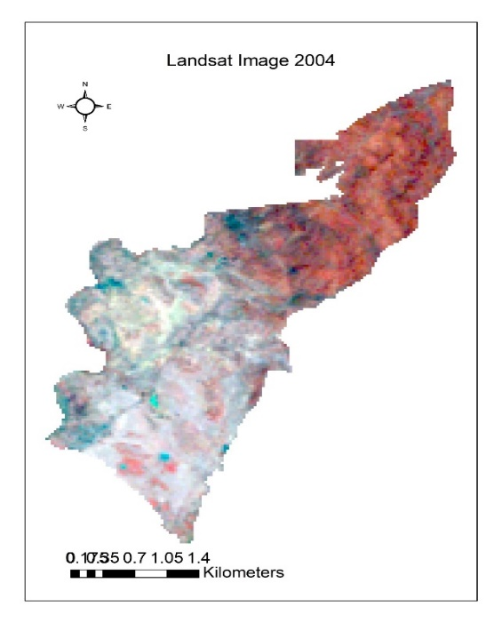 | 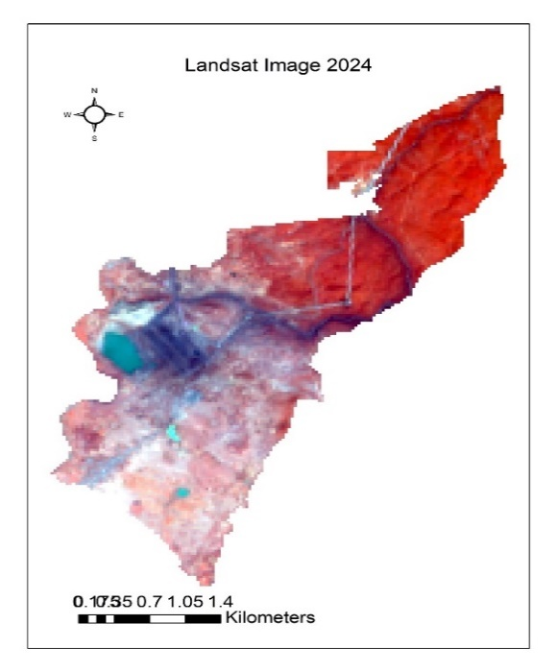
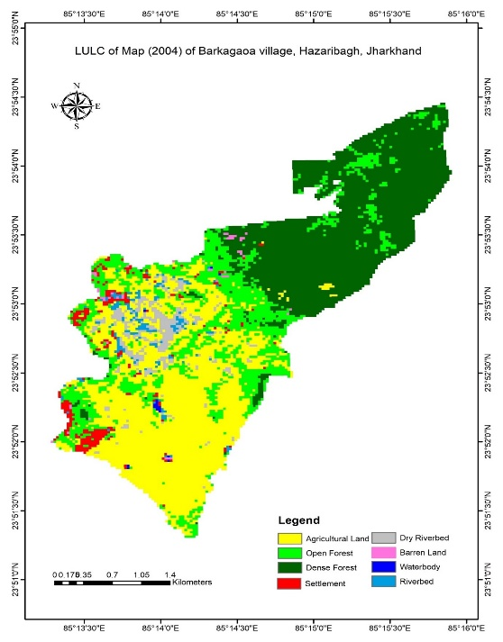 | 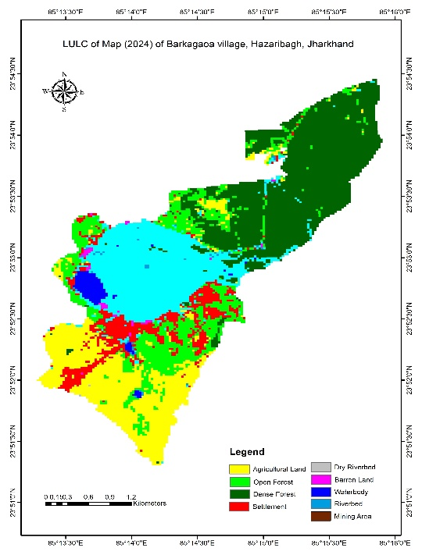

Fig 2. land use land cover map of study area
4.2 LULC fragmentation and its impact because of mining
Land use land cover of the study area changed in the period of 2004 to 2024 in terms of landscape fragmentation is shown in the Table4. The landscape metrics-based analysis of the two different years by LULC classes provided information regarding how land cover classes fragmented and changed over time.
The Number of patches for dense and open forest decreased from 34 to 28 and 128 to 92 respectively in studied period. Patch density of the dense and open forests also decrease and, accordingly, LPI decreased, i.e. the larger was the number of patches, the larger became the patch density and the bigger

the largest patches index. The Increase of IJI in 2024 compare to 2004 for dense and open forest is from 42.4778 to 61.275 and 61.6081 to 69.1808 indicating that patched were well interspersed and equally adjacent to all other patch type. Percentage of agriculture land was observed to be dramatic changes in studied period due to mining activities. Decrease in agriculture land with increase in number of patches and decrease LPI indicate the higher fragmentation. A large change can also be observed in case of MESH which decreased to 6.6171ha in 2024 which was 44.3098ha in year 2004.
Settlements formed another important variable patch type, which had a continuous increasing trend with a very high rate. The NP of settlements increased from 64 to 68 and PD increase from 2.4563 per 100 ha to 2.6099 per 100 ha between 2004 and 2024. The decrease of IJI in 2024 compare to 2004 for settlement indicting that patches are not well interspersed or are not equally adjacent to all other patch types.

Table 4 Class-Level Landscape Metrics
Year | Class | NP | PD | LPI | IJI | MESH
2004 | Agriculture | 50 | 1.919 | 13.0397 | 62.9261 | 44.3098
2004 | Open Forest | 128 | 4.9127 | 3.6166 | 61.6081 | 3.6857
2004 | Dence Forest | 34 | 1.3049 | 12.6045 | 42.4778 | 41.4011
2004 | Settlement | 64 | 2.4563 | 0.266 | 66.8621 | 0.0288
2004 | Mining Area | 0 | 0 | 0 | 0 | 0
2024 | Agriculture | 73 | 2.8018 | 4.6805 | 63.4569 | 6.6171
2024 | Open Forest | 92 | 3.531 | 2.2245 | 69.1808 | 1.6686
2024 | Dence Forest | 28 | 1.0746 | 11.9965 | 61.2751 | 37.5011
2024 | Settlement | 68 | 2.6099 | 1.6891 | 63.7092 | 0.8401
2024 | Mining Area | 59 | 2.2644 | 7.4231 | 85.2584 | 14.3606

CONCLUSION
The study examined the spatial-temporal change and fragmentation in LULC of the Pakri Barwadih village in Hazaribagh, Jharkhand using satellite data. In this study Landsat image of year 2004 and 2024 data were used. It was found that in year 2004 does not have mining area whereas year 2024 data shows the mining area. The study reveals that the total area under opencast mines in 2024 was found to be 207.9 ha which is 21.12 percentage of total study area. When comparing the LULC maps of the of 2004 and 2024 it has also been observed that the mining area replaced huge portions of agricultural and forest Lands which was dominated in 2004. FRAGSTATS analysis shows that Forest and agriculture class has become more fragmented and is characterized by increase in human activity during the study period.
Increase settlement, infrastructure development and mining activities have significantly increased pressure on remaining landscapes. The mining activity took over the agriculture/open forest lands showing large destruction. Therefore, if the forest landscape continues to follow the trend, biodiversity of this area likely to decrease. Such change and fragmentation of landscape may disturb soil structure, water quality, ground water and river system of the region. This study will guide policymakers in understanding landscape structure and planning for sustainable development.

Disclaimer (Artificial intelligence): No AI technologies have been used in this manuscript.

Option 1:
Author(s) hereby declare that NO generative AI technologies such as Large Language Models (ChatGPT, COPILOT, etc.) and text-to-image generators have been used during the writing or editing of this manuscript.
Option 2:
Author(s) hereby declare that generative AI technologies such as Large Language Models, etc. have been used during the writing or editing of manuscripts. This explanation will include the name, version, model, and source of the generative AI technology and as well as all input prompts provided to the generative AI technology
Details of the AI usage are given below:
1.
2.
3.

References

Anderson, P.R, Vinicius AS, Alex MS, Ana CFX, Otto CRF, Jorge AM (2020) Impact of mining activities on areas of environmental protection in the southwest of the Amazon: a GIS and remote sensing-based assessment. J Environ Manage 263:110392. https://doi.org/10.1016/j.jenvman.2020.110392
Cain, D.H, Riitters K, Orvis K (1997) A multi-scale analysis of land scape statistics. Landscape Ecol 12:199–212. https:// doi. org/ 10. 1023/A:1007938619068
Charou, E., Stefouli, M., Dimitrakopoulos, D., Vasiliou, E., Mavrantza, O. D. (2010) Using remote sensing to assess impact of mining activities on land and water resources. Mine Water Environ., v.29, pp.45–52.
Chatterjee, R.S., Lakhera, R.C., Dadhwal, V.K., 2010. InSAR coherence and phase information for mapping environmental indicators of opencast coal mining: A case study in Jharia Coalfield, Jharkhand, India. Can. J. Remote Sens. 36, 361–373. https://doi.org/10.5589/m10-047.
Chatterjee, R.S., Thapa, S., Singh, K.B., Varunakumar, G., Raju, E.V.R.R., 2015. Detecting, mapping and monitoring of land subsidence in Jharia Coalfield, Jharkhand, India by spaceborne differential interferometric SAR, GPS and precision levelling techniques. J. Earth Syst. Sci. 124, 1359–1376. https://doi.org/10.1007/ s12040-015-0606-5.
Cushman, S.A, McGarigal K, Neel MC (2008) Parsimony in land scape metrics: strength, universality, and consistency. Ecol Indic 8:691–703. https:// doi. org/ 10. 1016/j. ecoli nd. 2007. 12. 002
Erener, A. (2011) Remote sensing of vegetation health for reclaimed areas of Seyitömer open cast coal mine. Int J Coal Geol. 86(1):20–6. https://doi.org/10.1016/j.coal.2010.12.009.
Ettler, V (2016) Soil contamination near non-ferrous metal smelters: a review. Appl Geochem 64:56–74. https://doi.org/10.1016/j.apgeochem.2015.09.020
Gabril EMA, Denis DM, Nath S, Paul A, Kumar M (2019) Quanti fying LULC change and landscape fragmentation in Prayagraj district, India using geospatial techniques. Pharma Innov J 8(5):670–675.
Ganvir PS, and Guhey R, An Implication of Enhanced Rock Weathering on the Groundwater Quality: A Case Study from Wardha Valley Coalfields, Central India. Weathering and Erosion Processes in the Natural Environment, 2023:215-242. https://doi.org/10.1002/9781394157365.ch9
Griffith JA, Martinko EA, Price KP (2000) Landscape structure analysis of Kansas at three scales. Landsc Urban Plan 52:45–61. https://doi.org/10.1016/S0169-2046(00)00112-2
Hargis CD, Bissonette JA, David JL (1998) The behavior of land scape metrics commonly used in the study of habitat fragmen tation. Landscape Ecol 13:167–186. https:// doi. org/ 10. 1023/A: 1007965018633
Herzog F, Lausch A (2001) AAementing land-use statistics with landscape metrics: some methodological considerations. Environ Monit Assess 72:37–50. https:// doi. org/ 10. 1023/A: 10119 49704308
Johnson, L.B., Richards, C., Host, G., Arthur, J.W., 1997. Landscape influences on water chemistry in midwestern streams. Freshw. Biol. 37, 209–217.
Joy, A.S., Jha, P., Yadav, P.K., Bansal, T., Rawat, P., Begam, S (2024). Forest fragmentation and forest cover dynamics: Mining induced changes in the West Singhbhum District of Jharkhand. Remote Sensing Applications: Society and Environment. Volume 36, 101350, https://doi.org/10.1016/j.rsase.2024.101350.
Karanam, V., Motagh, M., Garg, S., Jain, K (2021). Multi-sensor remote sensing analysis of coal fire induced land subsidence in Jharia Coalfields, Jharkhand, India. International Journal of Applied Earth Observation and Geoinformation, Volume 102, 102439.
Kumar M, Denis DM, Singh SK, Szabó S, Suryavanshi S (2018) Landscape metrics for assessment of land cover change and fragmentation of a heterogeneous watershed. Remote Sens Appl Soc Environ 10:224–233. https:// doi. org/ 10. 1016/j. rsase. 2018.04.002
Kumar, D.K.V., Martha, D.T.R., Roy, P., 2018. Delineation of surface coal fire and land subsidence in the Jharia Coalfield, Dhanbad. Jharkhand From Remote Sensing Data, Dehradun.
Linke J, Franklin SE (2006) Interpretation of landscape struc ture gradients based on satellite image classification of land cover. Can J Remote Sens 32:367–379. https:// doi. org/ 10. 5589/ m06-031
Maconachie R (2012) Diamond mining, urbanization and social transformation in Sierra Leone. J Cont Afr Stud 30(4):705–723. https://doi.org/10.1080/025890 01.2012.724872
Mahato LL, Kumar M, Kumar J, Nath S, Lal D (2021) Forest changes and fragmentation analysis of Hazaribagh district of Jharkhand, India using Geospatial technology. Pharma Innov J SP-10(1):222-227
McGarigal, K., Marks, B.J., 1995. Spatial pattern analysis program for quantifying land scape structure.General Technical Report PNW-GTR-351. US Department of Agriculture, Forest Service. Pacific Northwest Research Station.
Ministry of Coal, Govt. of India, (2018) https://coal.nic.in/sites/upload_files/ coal/files/coalupload/Activites-moc-2018-19.pdf
Mishra PP. Mining and environmental problems in the Ib valley coalfield of Orissa, India. Geol Soc London Spec Publ. 2005;250(1):141–7. https://doi.org/10.1144/gsl.sp.2005.250.01.14.
Ngounouno NM, Sridevi S, Yamgouot F, Karthikeyan R, Ngounouno I (2023) Assessment of the environmental impacts of gold mining activities at Ngankombol (Adamaoua Cameroon) using Leopold matrix Fecteau grid and remote sensing approach. J Afr Earth Sc 16. https://doi.org/10.1016/j. jafrearsci.2023.105050
Ngueyep, M., Leroy, L., Blanche, M.F., Dairou, A.A., Juscar, N., Fride, O.M., Romarice, Arsène, M., & Bernard, T.L. Assessment of land cover degradation due to mining activities using remote sensing and digital photogrammetry. (2024) 13:41 , https://doi.org/10.1186/s40068-024-00372-5
Pandey, J., Kumar, D., Singh, V.K., Mohalik, N.K., 2016. Environmental and Socio- Economic Impacts of Fire in Jharia Coalfield, Jharkhand, India: An Appraisal. Curr. Sci. 110, 1639. https://doi.org/10.18520/cs/v110/i9/1639-1650.
Riitters KH, O’neill RV, Hunsaker CT, Wickham JD, Yankee DH, Timmins SP, Jones KB, Jackson BL (1995) A factor analysis of landscape pattern and structure metrics. Landscape Ecol 10:23 39. https://doi.org/10.1007/BF00158551
Riitters KH, O’neill RV, Hunsaker CT, Wickham JD, Yankee DH, Timmins SP, Jones KB, Jackson BL (1995) A factor analysis of landscape pattern and structure metrics. Landscape Ecol 10:23 39. https://doi.org/10.1007/BF00158551
Singh SK, Laari PB, Mustak SK, Srivastava PK, Szabó S (2018) Modelling of land use land cover change using earth obser vation data-sets of Tons River Basin, Madhya Pradesh. India. Geocarto Int 33(11):1202–1222
Singh, V. B., Madhav, S., Pant, N. C., & Shekhar, R. (Eds.). (2023). Weathering and Erosion Processes in the Natural Environment. John Wiley & Sons.
Wei L, Luo Y, Wang M, Su S, Pi J, Li G (2020) Essential fragmentation metrics for agricultural policies: Linking landscape pat tern, ecosystem service and land use management in urban izing China. Agric Syst 182:102833
Zhang M, Wang J, Feng Y (2019) Temporal and spatial change of land use in a large-scale opencast coal mine area: A complex network approach. Land Use Policy, v.86, pp.375–386. DOI: 10.1016/j.landusepol.2019.05. 020
Zhang W, Long J, Zhang X, Shen W, Wei Z. Pollution and ecological risk evaluation of heavy metals in the soil and sediment around the HTM Tailings Pond, Northeastern China. Int J Environ Res Public Health. 2020;17(19):7072.
Zheng D, Wallin DO, Hao Z (1997) Rates and patterns of land scape change between 1972 and 1988 in the Changbai Moun tain area of China and North Korea. Landsc Ecol 12:241–254. https://doi.org/10.1023/A:1007963324520

