*Original Research Article*

Effects of Biostimulants on Growth and Biochemical Composition of *Amaranthus dubius*

.

ABSTRACT

|  |
| --- |
| The study aimed to evaluate the effects of different biostimulants on the growth, yield, biochemical properties, and economic viability of *Amaranthus dubius* and identify the most effective biostimulant or combinations for improving crop performance and profitability while providing an eco-friendly alternative to traditional practices.The experiment was arranged in a randomized block design over two seasons with 11 treatments involving single or combined applications of Moringa leaf extract (MLE), seaweed extract (SWE), salicylic acid (SA), and humic acid (HA). The statistical evaluation of the datasets used one-factor analysis utilizing OPSTAT software obtaining relevant results at a 5% significance level against values of F-test. Key results revealed that T3 (SWE 6%) and T8 (HA 0.4%) were the most cost-effective treatments, with benefit-cost ratios (B:C) of 2.44 and 2.30, respectively, driven by high yields (163.73 kg/5 cents and 155.23 kg/5 cents) and moderate input costs. While T11 (combined MLE 3% + SWE 8% + SA 200 ppm + HA 0.4%) exhibited superior biochemical performance—highest chlorophyll *a* (3.173 mg/g), total chlorophyll (3.387 mg/g), carotenoids (1.391 mg/g), and leaf/stem ratio (1.07)—its B:C ratio (1.35) was suboptimal due to high costs. T10 (combined MLE 2% + SWE 6% + SA 100 ppm + HA 0.2%) showed balanced performance, with a B:C ratio of 1.88 and significant yield (147.66 kg/5 cents). Physiological parameters highlighted T10 and T11 as top performers in membrane stability (42.63% and 47.60%, respectively) and oxalic acid reduction (0.0218 mg/g in T10). Growth metrics identified T3 and T7 (HA 0.2%) as leaders in leaf area (62.03 mm²) and root length (9.23 cm). Statistical analysis grouped treatments into distinct economic and biochemical efficacy tiers, with T3 and T8 outperforming others in profitability. The study underscores the potential of SWE 6% and HA 0.4% as economical biostimulants for enhancing *Amaranthus dubius* growth, yield, and productivity. |

*Keywords: Biostimulant. Amaranthus dubius. Moringa leaf extract. Seaweed extract. Ascophyllum nodosum. Salicylic acid. Humic acid*

1. INTRODUCTION

In Tamil Nadu and Kerala, *Amaranthus dubius* is the principal green leafy vegetable. It is cultivated as a grain crop, for leafy green (Hoidal et al., 2019), and for ornamentation (Artemyeva, 2021; Ruth 2021). Since the growth cycle is short, responsive to fertilizers, the yield is high (Bang et al., 2021), easy to grow (Ruth et al., 2021), and adaptable to different conditions (Hoang et al., 2019), farmers want to cultivate Amaranthus; however, the crop is short-lived and gets damage and wilts quickly because of short shelf life (Nighita & Mathew, 2019) and vulnerability to pests (Seni, 2018). Vegetable farmers are increasingly applied plant biostimulants to increase crop productivity, nutritional efficiency, quality, stress resistance, and environmental safety.

Biostimulants are of biological origin and are large groups of biochemical compounds or microorganisms that can stimulate the biological processes to improve nutrient uptake, tolerance to stress factors, yield quality and environmental health. Some of these might reduce the deleterious effects of chemical fertilizers (Calvo et al., 2014; Posmyk and Szafranska, 2016; Van Oosten et al., 2017). This mainly includes increasing applications in agriculture and more controlled agricultural settings to promote yield and quality of crops for vegetables, thereby contributing to sustainable agriculture.

Moringa Leaf Extract (MLE) is one of the most promising biostimulants, which is found in nutrient-rich, phytohormone-dense, and bioactive *Moringa oleifera* leaves, enhancing growth and increasing tolerance to stress and improving crop yield and quality (Yuniati et al., 2023). MLE has been shown to enhance seed germination, increase root growth, and stimulate plant vigor under normal and stress conditions (Khan et al., 2022; Yuniati et al., 2023). Application of MLE could be an eco-friendly alternative to synthetic fertilizers (Mashamaite et al., 2022).

Seaweed extract (SWE) of *Ascophyllum nodosum*, a brown alga, enhances plant growth, root development, and tolerance against drought, salinity, and pathogen stresses. Abundance of cytokinins and auxins that stimulate plant growth regulators enhances nutrient uptake and improves yield (Ali et al., 2019). The bio-stimulant being a natural alternative to synthetic fertilizers ensures healthier crops (Kumari et al., 2023).

Salicylic Acid (SA) is an essential signaling molecule in plants which confers increased tolerance towards several biotic and abiotic stresses, thereby enabling a plant to thrive and grow more in challenging environmental conditions (Jayakannan et al., 2015; Emamverdian et al., 2020). It increases salt tolerance in barley (Fayez & Bazaid, 2014) and drought tolerance in faba beans (Abdelaal, 2015). It increases the growth, yield, and quality of vegetables. It increases the available nutrients and their uptake for garden thyme (Haghighi et al., 2014).

Humic acid (HA) is an organic substance resulting from the degradation of plant and animal residues, which has been acknowledged as a powerful biostimulant in agriculture. It has been naturally beneficial in promoting plant growth, nutrient absorption, and yield enhancement, as well as in pollution tolerance of various crop species.

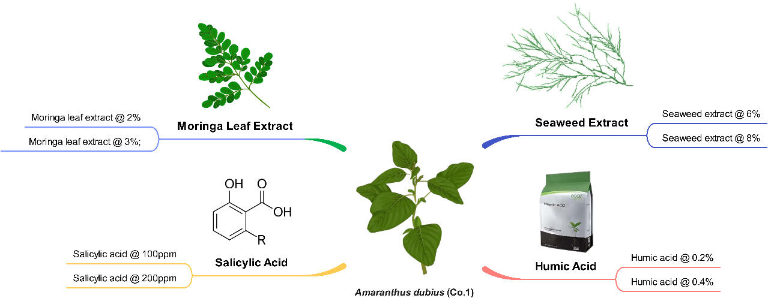

**Fig.1 Schematic representation of treatments applied to *Amaranthus dubius* (Co-1). The study involved the application of MLE (at 2% and 3%), SWE (at 6% and 8%), SA (at 100 ppm and 200 ppm), and HA (at 0.2% and 0.4%).**

The impact of MLE, SA, HA, and SWE and also their interactivity (Fig.1) on Amaranthus plant growth, yield, biochemical contents, and shelf life is discussed in the present study.

2. methodology

Field experiments were conducted during two distinct seasons under shade net house conditions at Chozhapandi, Mannargudi district, Tamil Nadu (latitude 10°36′22.7″N, longitude 79°29′02.0″E; 29 meters above mean sea level) from October to November 2021 and March to April 2022, following a randomized block design (RBD) with three replications. The treatment details used in field experiments are: T1-MLE @ 2%; T2-MLE @ 3%; T3-SWE @ 6%; T4-SWE @ 8%; T5-SA @ 100ppm; T6-SA @ 200ppm; T7-HA @ 0.2%; T8-HA @ 0.4%; T9-Control; T10- Combination (T1+T3+T5+T7); T11- Combination (T2+T4+T6+T8).

Biostimulant concentrations selected were based on potential efficacy shown in previous studies in enhancing plant growth, yield and biochemical properties. The phytohormone content present in MLE at 2% and 3% has been proved effective in improving growth parameters in crops like cabbage and peas (Hoque, 2020; Merwad, 2017). Auxins and cytokinins in SWE at 6% and 8% enhance stress tolerance and yield in tomatoes and strawberries (Ali et al., 2019; Bajpai et al., 2019). Chlorophyll content and stress tolerance improvement in faba beans and soybeans is found from SA at 100 ppm and 200 ppm (Abdelaal, 2015; Kuchlan & Kuchlan, 2021). At concentrations of 0.2 and 0.4%, HA significantly increases root growth and nutrient uptake by leafy vegetables such as spinach (Shuqin, 2008; Dunoyer et al., 2022). At the same time, combination treatments that exploit synergistic effects of these biostimulants for maximum plant performance and minimal risks of phytotoxicity (Toscano et al., 2021).

**2.1 Seed material and biostimulants**

Amaranthus seed was of the CO1 (TNAU) variety (D. Thilokchand Seeds, Chennai), Seaweed extract BIO VITA (PI Industries, India), and Salicylic acid (Sisco Research Laboratories Pvt. Ltd., India), and Humicil (Corteva Agrisciences, India) were used in the study. Additionally, MLE was prepared in laboratory (Fig.2) by dehydrating and grinding Moringa leaves and soft parts and mixing with distilled water. This mixture was autoclaved at 121 °C, 15 psi for 20 min, filtered and cooled to 4 °C, was centrifuged and the supernatant was collected as 100% MLE, as per Rama Rao (1990) and Yasmeen (2011) method. The extract was diluted in distilled water to 2% and 3% concentrations. The application of field foliar sprays including all the biostimulants was performed on the 7th and 14th days after seeding.

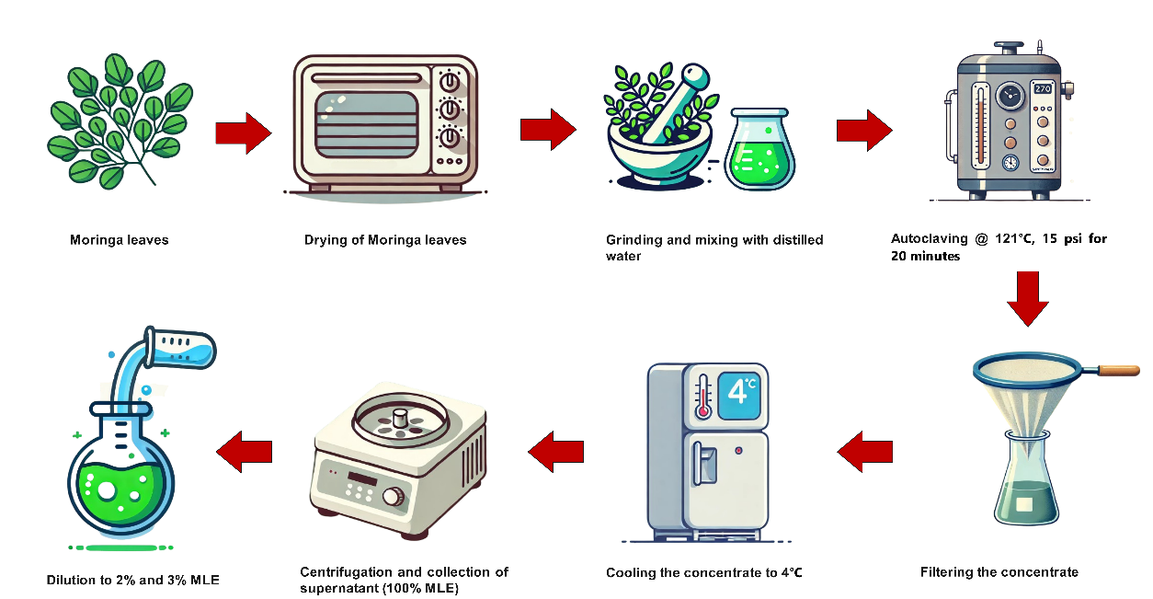

**Fig. 2 Illustration of the preparation of MLE and dilution to desired concentration**

**2.2 Observations**

**2.2.1 Growth and yield parameters:** Plant height (cm), number of leaves per plant, leaf area (cm2), number of branches per plant, root length (cm), stem girth (cm), leaf/stem ratio, fresh weight of leaves per plant (g/plant), and yield per plot (g) were measured.

**2.2.2 Physiological parameters**

*2.2.2.1 Relative water content (%):*The leaves, shoots, and roots were washed and weighed immediately after harvest (Fresh Weight- FW). The plants were dried in a hot air oven at 80°C for 24 h to find out dry weight (Dry Weight- DW). Relative water content was calculated from weights obtained as described by Barr (1962).

$$Water Content \left(WC\right)=\left(\frac{\text{FW}-\text{DW}}{\text{FW}}\right)×100$$

*2.2.2.2 Physiological loss in weight (PLW):*The weight of the plants lost cumulatively was recorded and expressed as percentage physiological loss of weight (Srivastava and Tandon, 1968). PLW was measured on days 2, 4, and 8 of storage for all treatments.

$$\text{Physiological Loss in Weight (PLW)}=\left(\frac{P_{0}-P_{1}}{P_{0}}\right)×100$$

Where P0 - Initial Weight; P1 - Final Weight

*2.2.2.3 Membrane stability Index (MSI):*MSI was determined by modifying the method of Khongwir et al. (2015). Leaf samples (5g) were placed in 100 ml of double-distilled water for each treatment. One set was refrigerated at 4°C for 30 minutes and their electrical conductivity (C1) was measured using a Hanna Instruments E.C. & pH meter (model: HI5222). The other set, after a 15-minute 100°C water bath, had their electrical conductivity (C2) measured. The MSI of the samples was then calculated using the below formula,

$$\text{MSI \%}=\left(1-\frac{C_{1}}{C_{2}}\right)×100$$

*2.2.2.4 pH:*After MSI analysis, the samples (C1) of all treatments are macerated and filtered in a beaker to measure the pH using the E.C & pH meter (Hanna instruments model: HI5222).

**2.2.3 Biochemical parameters**

*2.2.3.1 Total Phenolic Content:* A modified Singleton and Rossi (1965) method was used to determine the total phenolic content of Amaranthus leaf extracts. Leaf samples (1 g) were dried and powdered, and dried and powdered leaf samples (1 g) were extracted with 10 ml methanol for 30 minutes in an ultrasonic bath, filtered through Whatman filter paper No. 1. A reaction mixture was prepared by mixing 0.5 mL of the extract with 2.5 mL of Folin-Ciocalteu reagent (diluted 1: 10) and incubating at room temperature for 5 minutes. Then after 30 minutes, the mixture was kept in the dark with 2 mL of 7.5% sodium carbonate solution. UV-Vis spectrophotometer was used to measure absorbance at 765 nm, methanol as the blank. A calibration curve was prepared with gallic acid, and expressed as milligrams of gallic acid equivalents per gram of dry weight (mg GAE/g DW) to quantify total phenolic content.

*2.2.3.2 Oxalic Acid Content:* The amount of oxalic acid in *Amaranthus dubius* leaves was determined by the permanganometric titration method. Fresh leaf samples (40 g) were washed with distilled water and boiled in 400 mL of distilled water for 3.5 min and cooled. Thereafter, the boiled leaf extract was transferred into a 100 mL volumetric flask (2.5 mL) and made up to 100 milliliters (mL) with distilled water and mixed properly. A volume of 10 mL diluted extract was placed into the conical flask, where 5 mL 1 M sulphuric acid (H₂SO₄) was subsequently added. Then, 0.3 ml of sample solution (0.1 ml twice) was added to the mixture; the mixture was titrated against standard 0.01N KMnO₄ till the production of faint pink color developed, which indicates the end-point. The calculation of oxalic acid content was done by using the formulae:

Normality of oxalic acid

$$V_{{\text{KMnO}}_{4}}×N_{{\text{KMnO}}_{4}}=V_{H_{2}C_{2}O_{4}}×N_{H_{2}C_{2}O_{4}}$$

Mass of oxalic acid

$$\text{Mass of oxalic acid (mg)}=\frac{V_{H_{2}C_{2}O_{4}}×N_{H_{2}C_{2}O_{4}}}{\text{Equivalent weight of oxalic acid}}$$

Oxalic acid content

$$\text{Oxalic acid content (mg}\text{/}\text{g)}=\frac{\text{Mass of oxalic acid (mg)}}{\text{Weight of sample (g)}}$$

Equivalent weight of oxalic acid is 63 (Lestari & Dewi*,* 2020)

*2.2.3.3 Chlorophylls:*Chlorophyll a, chlorophyll b, and total chlorophyll content were determined using a UV-Vis spectrophotometer. A leaf sample (0.1 g) was ground with the help of a mortar and pestle and dissolved in 10ml of 80% acetone. The extract was filtered with a Whatmann Filter Paper No. 3, then absorbance of the extract was measured using the  UV-Vis spectrophotometer at 663 nm and 646 nm. Chlorophyll a, chlorophyll b and total chlorophyll content were calculated using the below formula:

$$Chlorophyll a\left(mg/g\right)=\left(12.3×A_{663}-0.86×A_{646}\right)×\frac{V}{1000×W}$$

$$Chlorophyll b\left(mg/g\right)=\left(19.3×A_{646}-3.6×A_{663}\right)×\frac{V}{1000×W}$$

$$Total Chlorophyll=\left(17.3×A_{646}+7.18×A_{663}\right)×\frac{V}{1000×W}$$

Where,

V= volume of chlorophyll extract in 80% acetone

W= fresh weight of leaf sample (Harbone *et al.,* 1987)

Where A663​, and A646​ represent the absorbance values at their respective wavelengths, V is the extract volume (i.e., 10 mL), W is the sample weight (i.e., 0.1 g), and 1000 is a factor for unit conversion to mg/g. The coefficients constituting (12.3, 0.86, 19.3, 3.6, 17.3 and 7.18) are empirical constants obtained from standard calibration studies to estimate chlorophyll a, chlorophyll b and total chlorophyll with great accuracy.

Indeed, the method takes into consideration the possible interaction between the chlorophyll pigments by applying specific absorbance coefficients. All steps are performed under controlled conditions (e.g., under dim light) to minimize photooxidation of the pigments. This approach provides a consistent measurement of chlorophyll a, chlorophyll b, and total chlorophyll in the leaf samples.

*2.2.3.4 Total Carotenoids:*Carotenoids were estimated as per the extraction procedure for estimating chlorophyll. Fresh leaf tissue (0.1 g) was macerated by mortar and pestle, and 10 mL of 80% acetone was added to extract the pigments. The extract was passed through Whatman filter paper No. 3 in order to record the absorbance of the chlorophyll's filtrate at 470 nm (carotenoids), 663 nm (chlorophyll a) and 646 nm (chlorophyll b) using a UV-Vis spectrophotometer. The blank for calibration was the solvent (80% acetone). Total carotenoids were calculated based on the following formula:

$\text{ Total Carotenoids}\left(\text{mg}\text{/}\text{g}\right)=\frac{\left(1000×A_{470}\right)-\left(2.05×A_{663}\right)-\left(114.8×A_{646}\right)×V}{1000×W}$ (Lichtenthaler & Wellburn, 1983).

where A470​, A663​, and A646 represent the absorbance values at their respective wavelengths, V is the extract volume (e.g., 10 mL), W is the sample weight (e.g., 0.1 g), and 1000 is a factor for unit conversion to mg/g. The coefficients (2.05 and 114.8) are empirically determined constants that correct for interference from chlorophyll a and chlorophyll b at 470 nm. The denominator value 198 is another empirical constant derived from calibration studies to ensure accurate estimation.

Since chlorophyll pigments could interfere with measurements in the assay, the procedure is utilized to minimize any potential interference from these pigments and all steps are performed in dim light to avoid photooxidation of carotenoids. This approach allows for an accurate quantification of total carotenoids visible in the leaf extracts.

**2.2.4 Benefit-Cost Ratio (B:C ratio)**

The Benefit-Cost Ratio (B:C ratio) was calculated to evaluate the economic feasibility of biostimulant treatments. The cost of cultivation (Rs.) for each treatment was recorded, and the yield (kg) was multiplied by the market price (Rs. 30/kg) to calculate the gross income:

$$\text{Gross Income (Rs.)}=\text{Yield (kg)}×\text{Market Price (Rs.}\text{/}\text{kg)}$$

The B:C ratio was then determined as:

$$\text{B:C Ratio}=\frac{\text{Gross Income (Rs.)}}{\text{Cost of Cultivation (Rs.)}}$$

This ratio was used to compare the profitability of the treatments, where values >1 indicate profitability.

**2.3 STATISTICAL ANALYSIS**

The statistical evaluation of the datasets used one-factor analysis utilizing OPSTAT software obtaining relevant results and at a 5% significance level against values of F-test.

3. results and discussion

3.1 Influence of biostimulants and their impact on growth parameters

~~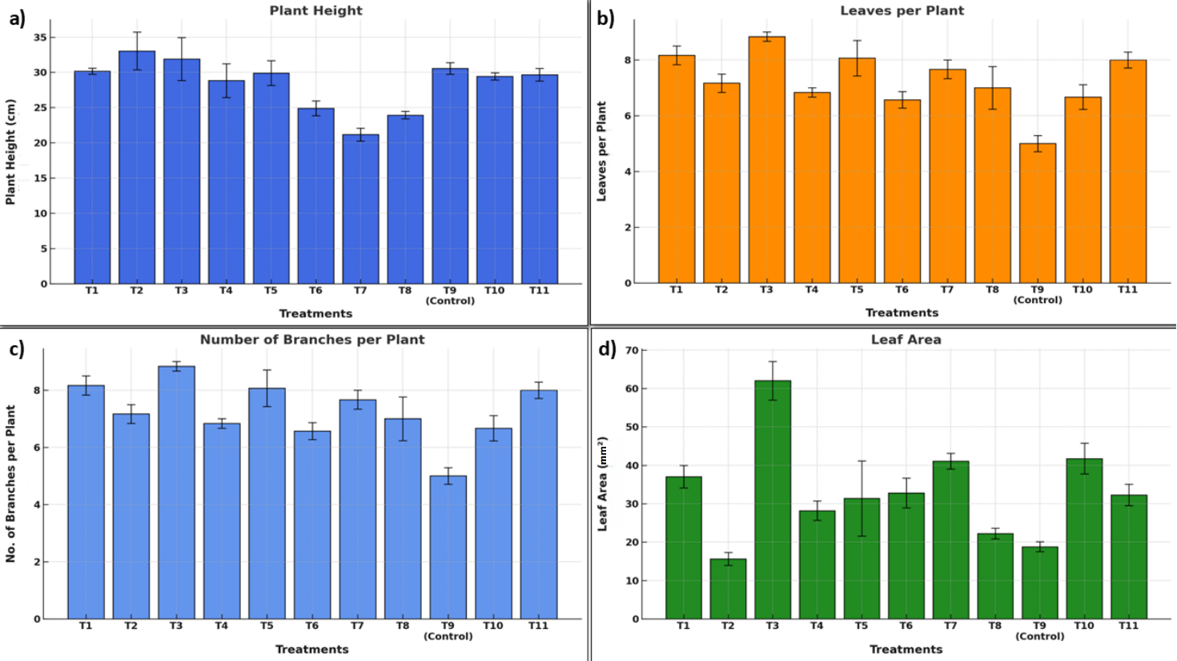~~

**Fig. 3 Effect of various treatments (T1 to T11, including control) on growth parameters of *Amaranthus* plants. (a) Plant height (cm), (b) Number of leaves per plant, (c) Number of branches per plant, and (d) Leaf area (mm²). Data are presented as mean ± standard error (SE) for each treatment.**

All growth parameters were significantly different in this experiment. Table 1 illustrates the effect of biostimulants on growth parameters. Foliar spray of MLE enhanced the plant height. The data indicates that the maximum plant height was recorded in MLE @ 3% (T2) with 33.03 cm (Fig. 3a) Foliar spray of SWE at 6% (T3) showed the highest number of leaves (8.83) (Fig.3b), branches (8.83) (Fig.3c), and leaf area (62.03 mm2) (Fig.3d). HA @ 0.2% (T7) increased stem girth (5.33 mm) (Fig.4a) and root length (9.23 cm) (Fig.4b).

**Table 1 Effect of biostimulants on growth parameters of Amaranthus**

|  |  |  |  |  |  |  |  |
| --- | --- | --- | --- | --- | --- | --- | --- |
| **Treatment** | **Plant Height (cm)** | **Leaves per Plant** | **Branches per Plant** | **Leaf Area (mm²)** | | **Stem Girth (mm)** | **Root Length (cm)** |
| T1 | 30.16 ± 0.44b | 8.17 ± 0.33a | 8.16 ± 0.33a | 37.05 ± 2.91b | 4.13 ± 0.48b | | 8.60 ± 0.36a |
| T2 | 33.03 ± 2.68a* | 7.17 ± 0.33b | 7.17 ± 0.33b | 15.62 ± 1.69f | 3.37 ± 0.62d | | 7.47 ± 0.58c |
| T3 | 31.90 ± 3.06a | 8.83 ± 0.17a* | 8.83 ± 0.17a* | 62.03 ± 5.00a* | 4.23 ± 0.12b | | 8.47 ± 0.32b |
| T4 | 28.83 ± 2.40c | 6.83 ± 0.17b | 6.83 ± 0.17b | 28.18 ± 2.53c | 4.00 ± 0.50b | | 7.93 ± 0.35c |
| T5 | 29.90 ± 1.76b | 8.07 ± 0.64a | 8.07 ± 0.64a | 31.37 ± 9.78c | 3.03 ± 0.69d | | 5.77 ± 0.14d |
| T6 | 24.90 ± 1.07d | 6.57 ± 0.30b | 6.57 ± 0.30b | 32.80 ± 3.88c | 2.83 ± 0.24e | | 9.17 ± 0.93a |
| T7 | 21.16 ± 0.93e | 7.67 ± 0.33b | 7.67 ± 0.33b | 41.10 ± 2.04b. | 5.33 ± 0.88a * | | 9.23 ± 0.20a * |
| T8 | 23.93 ± 0.52d | 7.00 ± 0.76b | 7.00 ± 0.76b | 22.20 ± 1.40e | 2.80 ± 0.15e | | 5.87 ± 0.19d |
| T9 | 30.56 ± 0.81b | 5.00 ± 0.29c | 5.00 ± 0.29c | 18.80 ± 1.30f | 2.03 ± 0.26f | | 5.33 ± 0.17d |
| T10 | 29.43 ± 0.52b | 6.67 ± 0.44b | 6.67 ± 0.44b | 41.78 ± 4.03b | 4.80 ± 0.17a | | 5.57 ± 0.14d |
| T11 | 29.66 ± 0.88b | 8.00 ± 0.29a | 8.00 ± 0.29a | 32.30 ± 2.80c | 3.63 ± 0.19c | | 8.47 ± 0.09b |

*Values in the table are averages of two seasons. Values are presented as mean ± standard error (S.E.). Values followed by the same letter within a column are not significantly different at p < 0.05. Asterisks (*) denote treatments with the best result for a given parameter.*

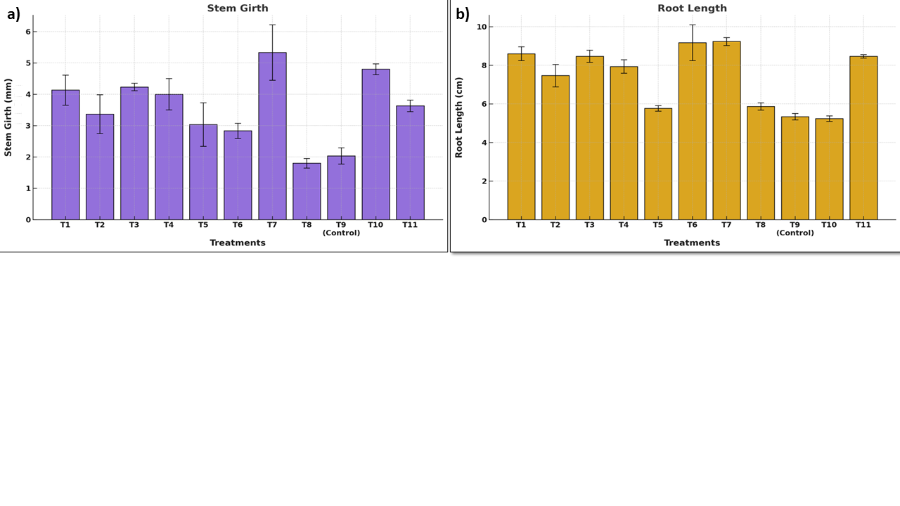

**Fig. 4 Influence of various treatments (T1 to T11, including control) on stem girth and root length of *Amaranthus* plants. (a) Stem girth (cm) and (b) Root length (cm) under different treatments. Data are shown as mean ± standard error (SE).**

It has been discovered that 4% MLE foliar spray on California Capsicum, the phytochemicals like zeatin, carotenoids, ascorbates, phenols, potassium, and calcium in the extract helped wonder pepper seedlings grow better (Hala et al. 2017; Chattha et al. 2018). SWE spray on saline-irrigated amaranth plants reduced salt stress and increased leaf number, possibly due to cytokinins such as trans-zeatin riboside (Saravanan et al. 2003). HA, which lacks rooting hormones, prevents their oxidation and prolongs IAA activity, affecting the acid growth mechanism and the H+ pump, according to Canellas et al. (2002) and Zandonadi et al. (2007), making root growth faster after application.

**3.2 Influence of biostimulants and their impact on yield parameters**

Table 2 and Fig.5 depicts the impact of biostimulants on yield parameters. The leaf/stem ratio was highest with 0.2% HA at 1.07 (T7) (Fig.5a), while 0.90 with 2% MLE at T1 was the second. Karakurt et al. (2009) reported that foliar spray of humic compounds enhances growth, yield, and quality across species. Ugur et al. (2013) also reported that an increase in cress, rocket, and sorrel yields was brought about by 0.8% HA. The functional groups of HA attach to K+, Ca+, and Mg2+ to aid *Gerbera jamesonii* L. in nutrient uptake (Nikbakht et al. 2008). It also activates bacteria in the soil responsible for producing auxin, cytokinin, and gibberellins that enhance plant growth (Rahni, 2012).

**Table 2 Influence of biostimulants and their impact on yield parameters of Amaranthus**

|  |  |  |  |
| --- | --- | --- | --- |
| **Treatment** | **Leaf/Stem Ratio** | **Fresh Weight of Leaves per Plant (g)** | **Yield per Plot (kg)** |
| T1 | 0.90 ± 0.09b | 2.30 ± 0.22a | 4.97 ± 0.77d |
| T2 | 0.72 ± 0.01c | 0.95 ± 0.06c | 6.05 ± 0.98b |
| T3 | 0.57 ± 0.01d | 2.70 ± 0.07a* | 8.95 ± 1.80a* |
| T4 | 0.64 ± 0.01c | 1.33 ± 0.11b | 4.31 ± 1.48d |
| T5 | 0.61 ± 0.01c | 1.38 ± 0.14b | 4.46 ± 0.70d |
| T6 | 0.70 ± 0.01c | 1.02 ± 0.10c | 4.91 ± 1.08d |
| T7 | 1.07 ± 0.12a* | 1.67 ± 0.13b | 5.03 ± 0.35c |
| T8 | 0.58 ± 0.01d | 0.69 ± 0.02d | 6.91 ± 1.81b | |
| T9 | 0.30 ± 0.00e | 1.21 ± 0.17c | 4.06 ± 0.72d | |
| T10 | 0.45 ± 0.01d | 1.98 ± 0.17b | 6.57 ± 0.64b | |
| T11 | 0.53 ± 0.01d | 2.02 ± 0.04a | 5.42 ± 1.22c | |

*Values in the table are averages of two seasons. Values are presented as mean ± standard error (S.E.). Values followed by the same letter within a column are not significantly different at p < 0.05. Asterisks (*) denote treatments with the best result for a given parameter.*

The maximum fresh weight of leaves per plant was 2.70 g (Fig.5b) with 6%, SWE (T3), followed by 2.30g with 2% MLE (T1) and 2.02g with a combination treatment (T11). SWE and MLE were more beneficial than other treatments, supporting the findings of Chrysargyris et al. (2018) on lettuce. SWE boost plant nutrition and growth hormone uptake (Gupta et al. 2021). Best yield per plot (8.95 kg) was with SWE @ 6% (T3) (Fig.5c). Zeatin, a cytokinin hormone, in MLE boosts cabbage growth, yield, and nutrient content, according to Hoque et al. (2020). Moringa leaves are rich in nutrients that boost agricultural output (Busani et al. 2011).

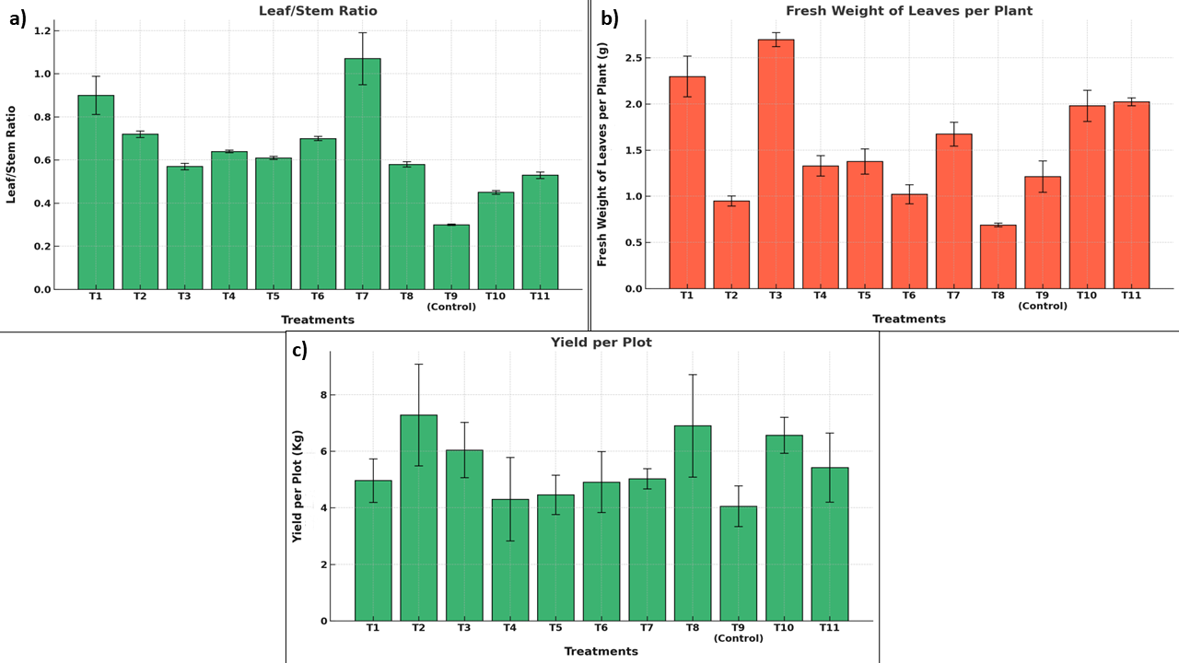

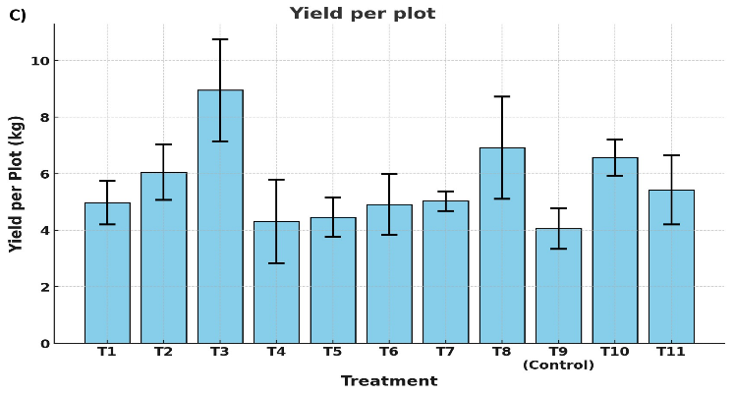

**Fig. 5 Impact of various treatments (T1 to T11, including control) on yield-related parameters of *Amaranthus* plants. (a) Leaf-to-stem ratio, (b) Fresh weight of leaves per plant (g), and (c) Yield per plot (kg). Data are expressed as mean ± standard error (SE).**

**3.3 Influence of biostimulants and their impact on physiological and biochemical parameters**

Biostimulants considerably affect physiological and biochemical characteristics (Table 3 & Table 4). MLE, SWE, SA, and HA (T10) had a greater relative water content (93.33%) (Fig.6a), whereas T9-92.83% and other treatments were equal. Merwad (2015) discovered that spinach (*Spinacia oleracea* L.) plants treated with aqueous and ethanolic MLE (1, 2, 3, and 4%) had more moisture. Higher dry matter in these plants. Seed soaking in SA and foliar spraying with MLE raised plant dry weight of *Phaseolus vulgaris* L. to the highest (Rady et al. 2015). Haghighi and Najafi (2020) observed that 500 mg of HA increases, chlorophyll, fresh weight, and dry weight at 25% field capacity. *A. nodosum* biostimulants may increase leaf antioxidant activity (Pacheco et al. 2019). Hamza et al. (2001) demonstrated that high antioxidant levels increase shoot and root growth, preserve leaf moisture, and reduce disease incidence under optimal growing circumstances and environmental stress. HA retains 80–90% water, which may have resulted in higher relative water content (Rahni et al. 2012).

**Table 3. Influence of biostimulants and their impact on Relative Water Content, Physiological Loss in Weight, Membrane Stability Index & Total Phenol Content**

|  |  |  |  |  |
| --- | --- | --- | --- | --- |
| **Treatment** | **Relative Water Content (%)** | **Physiological Loss in Weight (%)** | **Membrane Stability Index (%)** | **Total Phenol Content (mg/100g)** |
| T1 | 90.59 ± 0.07b | 16.23 ± 1.12c | 16.28 ± 0.09ᵈ | 165.78 ± 1.06a* |
| T2 | 89.98 ± 0.21c | 12.12 ± 0.72e | 23.05 ± 0.09ᶜ | 101.55 ± 0.61d |
| T3 | 92.38 ± 0.04a | 31.94 ± 1.08a | 38.11 ± 0.15ᵇ | 109.41 ± 0.60c |
| T4 | 90.38 ± 0.12b | 15.06 ± 0.99d | 44.92 ± 0.15ᵃ | 119.68 ± 0.47b |
| T5 | 91.17 ± 0.10b | 20.95 ± 0.69b | 38.90 ± 0.15ᵇ | 134.97 ± 0.57b |
| T6 | 90.18 ± 0.17c | 14.09 ± 0.99d | 26.49 ± 0.15ᶜ | 72.72 ± 0.92e |
| T7 | 92.04 ± 0.02a | 28.91 ± 1.09a | 12.09 ± 0.09ᵈ | 140.95 ± 0.78b |
| T8 | 92.06 ± 0.07a | 28.02 ± 1.00a | 16.58 ± 0.09ᵈ | 70.64 ± 0.60e |
| T9 | 92.83 ± 0.16a | 34.65 ± 0.93a* | 19.51 ± 0.09ᶜ | 135.58 ± 0.27b |
| T10 | 93.33 ± 0.21a* | 30.95 ± 1.14a | 42.63 ± 0.10ᵃ | 140.25 ± 0.45b |
| T11 | 92.27 ± 0.01a | 31.49 ± 1.31a | 47.60 ± 0.15ᵃ* | 130.74 ± 0.15c |

*Values in the table are averages of two seasons. Values are presented as mean ± standard error (S.E.). Values followed by the same letter within a column are not significantly different at p < 0.05. Asterisks (*) denote treatments with the best result for a given parameter.*

MLE @ 3% (T2) caused the lowest physiological weight reduction (12.12%) (Fig.6b). MLE prevents *Amaranthus dubius* leaf respiration, minimizing physiological weight loss and preserving produce freshness.

MLE, SWE, SA, and HA (T11) exhibited the highest membrane stability index (47.60%) (Fig. 6c). Batool et al. (2020) observed that foliar MLE at 3% increased seedling membrane stability index by 45% above the control group. Due to their mineral nutrient and phytohormone concentration, MLE components may have improved chlorophyll fluorescence and osmoprotectant production by stimulating leaf photosynthetic pigment biosynthesis. Translocating MLE osmoprotectants such soluble sugars and free proline to plant vitals could have also raised their levels. Higher photosynthetic activitydue to MLE might have also enhanced membrane integrity, increasing cell health and turgidity (Abd El-Mageed et al. 2017).

MLE @ 2% (T1) had the highest total phenolic content (165.78 mg /100g) (Fig.6d). This is consistent with Toscano et al. (2021), who found that MLE increased *Brassica* phenolic content. MLE's vitamins, minerals, amino acids, and antioxidants possibly enhanced phenolic content (Hanafy, 2017).

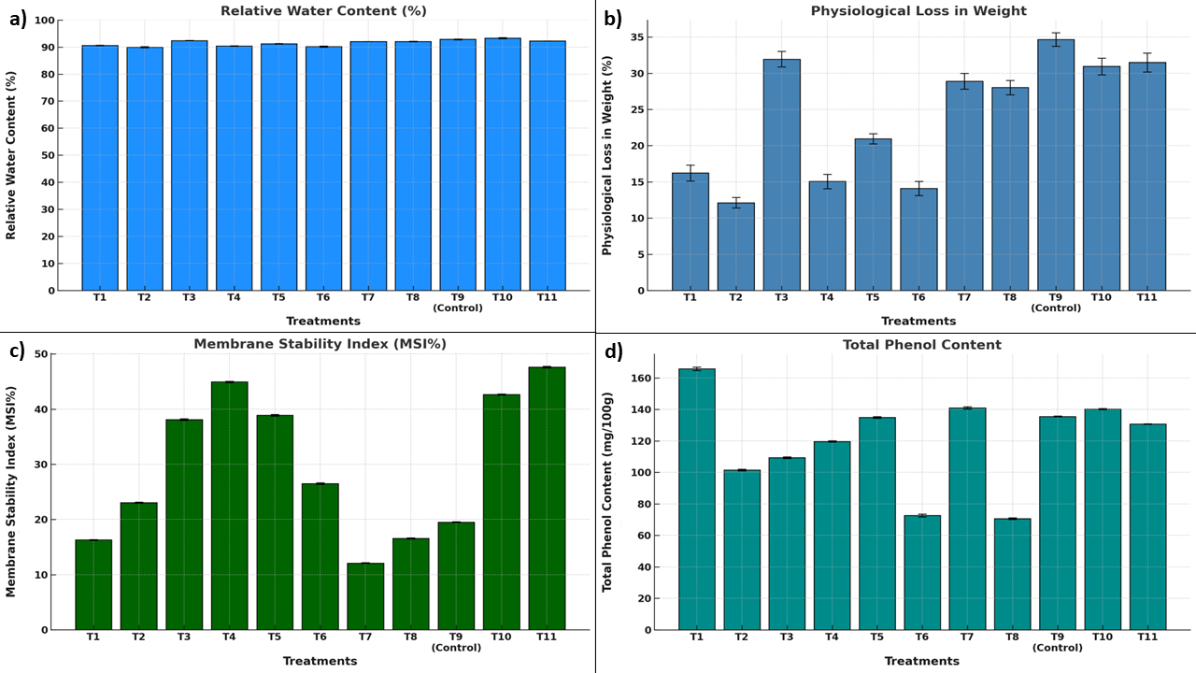

**Fig. 6 Effect of various treatments (T1 to T11, including control) on physiological and biochemical parameters of *Amaranthus* plants. (a) Relative water content (%), (b) Physiological loss in weight (%), (c) Membrane stability index (MSI %), and (d) Total phenol content (mg/100g). Data are presented as mean ± standard error (SE).**

The treatments had a significant impact on the chlorophyll content in Amaranthus, enhancing both chlorophyll 'a', chlorophyll 'b', and total chlorophyll levels compared to the control (T9).

Highest chlorophyll a was in the treatment T11 (3.173 mg/g) (Fig.7a) in experience with MLE + SWE + SA + HA. This combination is effective for the biosynthesis of photosynthetic pigments, possibly due to the combined effects of phytohormones, antioxidants, and mobilization of nutrients. Treatment T10 (2.857 mg/g) at lower concentration of them bio-stimulants was the second-best treatment in enhancing chlorophyll a content. The control (T9) reported significantly lower chlorophyll a content (1.427 mg/g) compared to the treatments, highlights the role of biostimulants in improving photosynthetic efficiency. Supporting evidence from research demonstrates the efficacy of biostimulants such as SWE and MLE to increase chlorophyll a levels through nutrient uptake and photosynthetic efficiency (Soliman et al., 2020).

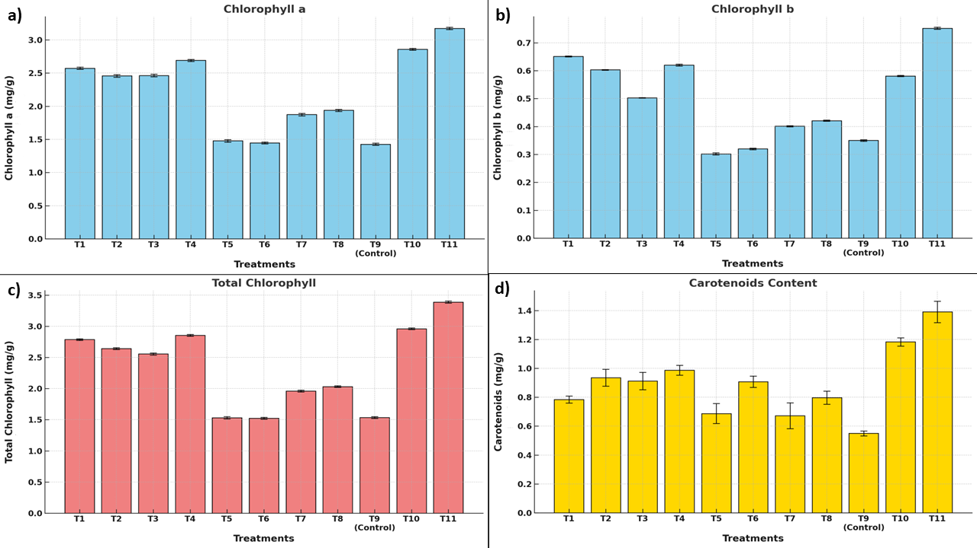

**Fig. 7 Effect of various treatments (T1 to T11, including control) on photosynthetic pigment content in *Amaranthus* plants. (a) Chlorophyll a (mg/g), (b) Chlorophyll b (mg/g), (c) Total chlorophyll (mg/g), and (d) Carotenoids content (mg/g). Data are represented as mean ± standard error (SE)**

For chlorophyll b, the highest record was being treated under T11 (0.752 mg/g) (Fig.7b) while the second was T10 (0.581 mg/g). Chlorophyll b is important for broadening the light absorption spectrum and increasing the energy transfer efficiency. The lowest was obtained by the control treatment (T9) (0.350 mg/g), which highlights the influence of treatments involving biostimulants on maintaining pigments. MLE is established to improve chlorophyll levels, owing to the high levels of phytohormones and antioxidants in it (Abdalla, 2014).

A similar trend was observed in the total chlorophyll content where T11 with the value of 3.387 mg/g and T10 with the value of 2.960 mg/g enhanced other treatments (Fig.7c). These outcomes highlight the possibility of interaction of various biostimulants regulating combined pigment synthesis in plants. The control treatment, T9 had the least total chlorophyll content (1.534 mg/g) which corresponded to least activity of photosynthesis in plants which were not treated. As reported in earlier literature, SWE and HA used as plant growth factor has a positive impact on chlorophyll biosynthesis specially when the stress conditions are prevailed (Kavipriya & Boominathan, 2018). Total chlorophyll content in the T11 and T10 can also be explained on the basis of multiple biostimulants working synergistically for biosynthesis and non-degradability of pigments as discussed by Orlov et al. (2005). It is postulated that MLE, SWE, SA and HA may influence membrane stability and oxidation thereby stabilizing chlorophyll molecules. This accounts for the variation in total chlorophyll values across the treatments in relation to the control treatment.

**Table 4. Influence of biostimulants and their impact on Chlorophyll a, Chlorophyll b, Total Chlorophyll, Carotenoids, pH & Oxalic Acid Content**

|  |  |  |  |  |  |  |
| --- | --- | --- | --- | --- | --- | --- |
| **Treatment** | **Chlorophyll a (mg/g)** | **Chlorophyll b (mg/g)** | **Total Chlorophyll (mg/g)** | **Carotenoids**  **(mg/g)** | **pH** | **Oxalic Acid Content (mg/g)** |
| T1 | 2.573 ± 0.015ᵃ | 0.651 ± 0.002ᵃ | 2.785 ± 0.013ᵉ | 0.784 ± 0.024ᶜ | 4.49 ± 0.007ᵉ | 0.0303 ± 0.0000ᶜ |
| T2 | 2.457 ± 0.020ᵇ | 0.603 ± 0.001ᵇ | 2.642 ± 0.016ᵉ | 0.935 ± 0.059ᵇ | 4.97 ± 0.017ᵇ | 0.0254 ± 0.0020ᵉ |
| T3 | 2.463 ± 0.020ᵇ | 0.503 ± 0.001ᶜ | 2.554 ± 0.016ᵈ | 0.913 ± 0.060ᵇ | 5.37 ± 0.067ᵃ* | 0.0275 ± 0.0010ᵈ |
| T4 | 2.690 ± 0.015ᵃ | 0.620 ± 0.003ᵃ | 2.855 ± 0.015ᵈ | 0.987 ± 0.034ᵇ | 4.38 ± 0.009ᵉ | 0.0314 ± 0.0000ᵇ |
| T5 | 1.477 ± 0.019ᵉ | 0.302 ± 0.004ᵉ | 1.531 ± 0.019ᶜ | 0.687 ± 0.069ᶜ | 4.90 ± 0.010ᶜ | 0.0329 ± 0.0020ᵇ |
| T6 | 1.447 ± 0.015ᵉ | 0.320 ± 0.003ᵉ | 1.523 ± 0.014ᵇ | 0.908 ± 0.039ᵇ | 4.62 ± 0.010ᵈ | 0.0342 ± 0.0010ᵃ |
| T7 | 1.873 ± 0.018ᵈ | 0.401 ± 0.002ᵈ | 1.960 ± 0.016ᵇ | 0.672 ± 0.089ᶜ | 5.32 ± 0.040ᵃ | 0.0237 ± 0.0000ᵉ |
| T8 | 1.937 ± 0.015ᵈ | 0.421 ± 0.002ᵈ | 2.032 ± 0.013ᵇ | 0.797 ± 0.046ᶜ | 5.16 ± 0.020ᵇ | 0.0268 ± 0.0010ᵈ |
| T9 | 1.427 ± 0.017ᵉ | 0.350 ± 0.003ᵉ | 1.534 ± 0.014ᵃ | 0.550 ± 0.017ᵈ | 4.54 ± 0.010ᵉ | 0.0368 ± 0.0010ᵃ |
| T10 | 2.857 ± 0.015ᵇ | 0.581 ± 0.002ᵇ | 2.960 ± 0.013ᵃ | 1.183 ± 0.029ᵃ | 4.80 ± 0.010ᶜ | 0.0218 ± 0.0000ᵉ* |
| T11 | 3.173 ± 0.018ᵃ* | 0.752 ± 0.004ᵃ* | 3.387 ± 0.017ᵃ* | 1.391 ± 0.074ᵃ* | 4.75 ± 0.007ᶜ | 0.0283 ± 0.0020ᶜ |

*Values in the table are averages of two seasons. Values are presented as mean ± standard error (S.E.). Values followed by the same letter within a column are not significantly different at p < 0.05. Asterisks (*) denote treatments with the best result for a given parameter.*

HA also may have increased chlorophyll production. HA speeds respiration and photosynthesis by changing mitochondrial and chloroplast processes (Orlov et al. 2005). Hidangmayum and Sharma (2017) found that 0.55% SWE produced the maximum carotenoid content in onion. Additionally, micronutrients like Cu, Mn, and Zn are cofactors of antioxidant enzymes and play a role in metabolic processes (Grotz and Guerinot, 2006).

Carotenoids, essential for photoprotection and antioxidant activity, showed a similar trend, with T11 achieving the highest levels (1.391 mg/g) (Fig.7d). The second-best treatment was T10 (1.183 mg/g). The control (T9) had the lowest carotenoid content (0.550 mg/g), indicating the inability of untreated plants to enhance their photoprotective mechanisms. Biostimulants like SWE and HA have been shown to boost carotenoid content, improving stress tolerance and enhancing overall plant health (Sherinlincy et al., 2020).

The pH of plant tissues is an important indicator of metabolic processes, nutrient uptake, and health of the plant as a whole. The highest leaf pH was recorded in T3 (SWE at 6%) with a pH of 5.37 compared to the control (T9-4.54) (Fig.8a). Higher pH recorded in T3 reveals that SWE helps in keeping a balanced cellular environment, which is necessary for enzyme activities and nutrient absorption. Higher pH will increase the uptake of nutrients like nitrogen, phosphorus, and potassium that are essential for plant growth and yield. Moreover, SWE contains bioactive compounds and minerals, which may help to regulate pH by neutralizing acidity in plant tissues (Whapham et al., 1993). Maintenance of an optimal pH level also strengthens the plant to cope with environmental stresses, hence promoting overall plant health. The results indicate that the T3 treatment optimally adjusts the physiological conditions in *Amaranthus* that assure maximum nutrient uptake and metabolic processes, which in turn increase the yields and quality.

Oxalic acid is one of the important anti-nutritional factors in Amaranthus, which reduces the bioavailability of essential minerals such as calcium and magnesium (Shyfa & Dewi, 2021). The treatments in this study showed a significant influence on oxalic acid content under different biostimulant applications. The lowest amount of oxalic acid was found in the treatment T10 at 0.0218 mg/g (Fig.8b), which proves that the combination of these biostimulants helps to reduce the accumulation of oxalic acid in plant tissues. This reduction is very vital in improving the nutritional quality of the leaves to make them safer for consumption.

Compared to the control (T9-0.0368 mg/g), T10 has a reduced content of oxalic acid by approximately 41%. The other treatments that also exhibited a lower oxalic acid content are T7, which was at SWE @ 8%, and T2, which was 2% MLE at 0.0237 mg/g and 0.0254 mg/g, respectively. The reduction of oxalic acid is due to the facts that the bio-stimulants applied to the plants causes a higher metabolical rate and efficient nutrient adsorption as well as better photosynthesis, stress tolerance absorptions give rise to a decreased concentration of oxalates as a stress product (Lestari & Dewi, 2020).

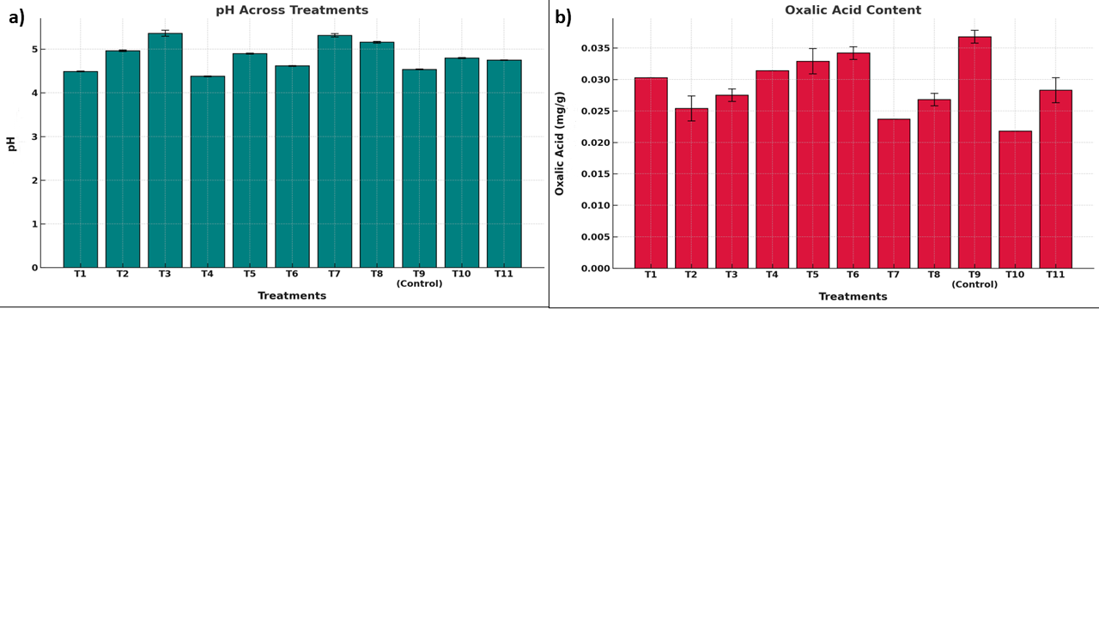

**Fig. 8 Influence of various treatments (T1 to T11, including control) on pH and oxalic acid content in *Amaranthus* plants. (a) pH levels across treatments and (b) Oxalic acid content (mg/g). Data are shown as mean ± standard error (SE).**

The reduction in oxalic acid is particularly important because high oxalic acid levels can form insoluble complexes with calcium, reducing its bioavailability and leading to calcium deficiency in humans. Therefore, T10 appears to be the most effective treatment in reducing oxalic acid content, improving the nutritional quality and edibility of Amaranthus leaves. This aligns with the findings of Halliwell and Gutteridge (2015), who reported that reducing oxalate levels can enhance the mineral content of leafy vegetables. In summary, the biostimulant treatments significantly reduced oxalic acid levels, with T10 being the most effective, followed by T7 and T2. These results highlight the potential of biostimulants in improving the health benefits of Amaranthus by reducing anti-nutritional factors.

Specifically, reducing oxalic acid levels has major benefits because high oxalic acid levels form insoluble complexes with calcium rendering it bioavailable to humans and leaving them susceptible to calcium deficiency. T10 is therefore the most effective reducing oxalic acid content, improving the nutritional quality and edible of Amaranthus leaves. This is in line with what Halliwell and Gutteridge (2015) found, who said that in some cases reducing the oxalate level of leafy vegetables might boost their mineral composition. Overall, biostimulant treatments significantly reduced oxalic acid levels with the lowest at T10, then T7 and finally T2. These results suggest that biostimulants may enhance the health benefits of Amaranthus by removing anti-nutritional factors.

**3.4. Cost-Benefit ratio**

Table 5 highlights the economic performance of various biostimulant treatments applied to *Amaranthus dubius* cultivation over 5 cents, showing variation in cost, yield, gross income, and the Benefit-Cost Ratio (B:C ratio). T3 (SWE @ 6%) emerged as the most profitable treatment with the highest yield (163.73 kg) and a B:C ratio of 2.44, followed by T8 (0.4% HA) with a B:C ratio of 2.30. In contrast, T4 (8% SWE) and T11 (Combination Treatment) had the lowest B:C ratios of 1.11 and 1.35 respectively, due to high input costs and relatively lower yields.

**Table 5 Cost of benefit ratio of the treatments**

|  |  |  |  |  |  |
| --- | --- | --- | --- | --- | --- |
| **Treatment** | **Cost of Cultivation (Rs.) for 5 cents** | **Yield Obtained (kg) in 5 cents** | **Price of 1 kg (Rs.)** | **Gross Income (Rs.)** | **Benefit-Cost Ratio (B:C Ratio)** |
| T1 | 2005 | 126.97ᵇ | 30 | 3808.98ᵇ | 1.90ᵇ |
| T2 | 2010 | 135.91ᵇ | 30 | 4077.42ᵇ | 1.77ᵇ |
| T3 | 2307.5 | 163.73ᵃ | 30 | 4911.81ᵃ | 2.44ᵃ* |
| T4 | 2615 | 96.83ᶜ | 30 | 2904.85ᶜ | 1.11ᵈ |
| T5 | 2034.5 | 100.20ᶜ | 30 | 3005.89ᶜ | 1.48ᶜ |
| T6 | 2069 | 110.45ᵇ | 30 | 3313.41ᵇ | 1.60ᵇ |
| T7 | 2012 | 113.00ᵇ | 30 | 3390.03ᵇ | 1.68ᵇ |
| T8 | 2024 | 155.23ᵃ | 30 | 4656.84ᵃ | 2.30ᵃ |
| T9 (Control) | 2000 | 91.22ᶜ | 30 | 2736.60ᶜ | 1.37ᶜ |
| T10 | 2359 | 147.66ᵃ | 30 | 4429.71ᵃ | 1.88ᵇ |
| T11 | 2718 | 121.91ᵇ | 30 | 3657.25ᵇ | 1.35ᶜ |

*Values in the table are average of two seasons. Values followed by the same letter within a column are not significantly different at p < 0.05. Asterisks (*) denote treatments with the best result for a given parameter.*

The control treatment (T9) resulted in the lowest gross income and a B:C ratio of 1.37, emphasizing the economic benefits of biostimulant applications. T2 and T8 show the most optimal cost effectiveness. Therefore, these are better candidates for larger scale application, while expensive ones such as T4 and T11 need optimization further.

4. Conclusion

The foliar spray of biostimulants effectively influences Amaranthus's growth, yield, and biochemical attributes. SWE @ 6% was seen to surpass all other treatments, while the MLE @ 2% influenced most of the parameters after the treatment (T3). The use of these biostimulants resulted in notable improvement in the key parameters, such as photosynthetic pigments, relative water content, and phenolic content, and simultaneously reduced anti-nutritional factors like oxalic acid, thus enhancing the nutritional and market value of the crop. The findings highlight the potential of biostimulants as eco-friendly alternatives to synthetic fertilizers; however, further research is necessary to optimize their use. Future research must focus on the identification of the best combinations and dosages of biostimulants, determine their long-term impact under different environmental conditions, and examine their effect on soil health and microbial dynamics. Additionally, it would be valuable to determine the effect of biostimulants on post-harvest quality and combine these compounds with precision agriculture strategies to enhance their efficacy. Apart from this, the use of economic feasibility studies and farmer training programs will be critical in inducing large-scale implementation of these strategies. With these comprehensive measures, biostimulants can play a key role in inducing sustainable agricultural practices and addressing the pressing global concerns of food security and environmental sustainability.

**Disclaimer (Artificial intelligence)**

Authors hereby declare that NO generative AI technologies such as Large Language Models (ChatGPT, COPILOT, etc.) and text-to-image generators have been used during the writing or editing of this manuscript.

References

Abd El-Mageed TA, Semida WM, Rady MM. Moringa leaf extract as biostimulant improves water use efficiency, physio-biochemical attributes of squash plants under deficit irrigation. *Agric Water Manage.* 2017; 193:46-54. <https://doi.org/10.1016/j.agwat.2017.08.004>.

Abdalla MM. The potential of *Moringa oleifera* extract as a biostimulant in enhancing the growth, biochemical and hormonal contents in rocket (*Eruca vesicaria subsp. sativa)* plants. *Int J Plant Physiol Biochem.* 2013; 5:42–49. <https://doi.org/10.5897/IJPPB2012.026>.

Abdelaal KA. Effect of salicylic acid and abscisic acid on morpho-physiological and anatomical characters of faba bean plants (*Vicia faba L.)* under drought stress. *J Plant Prod.* 2015;6(11):1771-1788. <http://dx.doi.org/10.21608/jpp.2015.52096>.

Ali O, Ramsubhag A, Jayaraman J. Biostimulatory activities of *Ascophyllum nodosum* extract in tomato and sweet pepper crops in a tropical environment. *PLOS ONE.* 2019;14(5): e0216710. <https://doi.org/10.1371/journal.pone.0216710>

Arnon DI. Copper enzymes in isolated chloroplasts. Polyphenoloxidase in *Beta vulgaris.* *Plant Physiol.* 1949;24(1):1-15. <https://doi.org/10.1104/pp.24.1.1>.

Bajpai S, Shukla PS, Asiedu S, Pruski K, Prithiviraj B. A biostimulant preparation of brown seaweed *Ascophyllum nodosum* suppresses powdery mildew of strawberry. *Plant Pathol J.* 2019;35(5):406–416. <https://doi.org/10.5423/PPJ.OA.03.2019.0066>.

Bang J, Lee K, Jeong W, Han S, Jo I, Choi S, Cho H, Hyun T, Sung J, Lee J, So Y, Chung J. Antioxidant activity and phytochemical content of nine *Amaranthus* species. *Agronomy.* 2021;11(6):1032. <https://doi.org/10.3390/agronomy11061032>.

Barr HD, Weatherley PE. A re-examination of the relative turgidity technique for estimating water deficit in leaves. *Aust J Biol Sci.* 1962; 15:413-428. <http://dx.doi.org/10.1071/BI9620413>.

Batool S, Khan S, Basra SMA. Foliar application of *Moringa* leaf extract improves the growth of *Moringa* seedlings in winter. *South Afr J Bot.* 2020; 129:347-353. <https://doi.org/10.1016/j.sajb.2019.08.040>.

Busani M, Patrick JM, Arnold H, Voster M, Moyo B, Masika P. Nutritional characterization of *Moringa oleifera* L. leaves. *Afr J Biotechnol* . 2011; 10:12925-12933. <http://dx.doi.org/10.5897/AJB10.1599>.

Calvo P, Nelson L, Kloepper JW. Agricultural uses of plant biostimulants. *Plant Soil.* 2014; 383:3-41. <https://doi.org/10.1007/s11104-014-2131-8>.

Canellas LP, Olivares FL, Okorokova-Façanha AL, Façanha AR. Humic acids isolated from earthworm compost enhance root elongation, lateral root emergence, and plasma membrane H⁺ ATPase activity in maize roots. *Plant Physiol.* 2002; 130:1951-1957. <https://doi.org/10.1104/pp.007088>.

Chattha MU, Imran K, Hassan MU, Chattha MB, Muhammad N, Asif I, Khan NH, Naveed A, Muhammad U, Mina K, Ullah MA. Efficacy of extraction methods of *Moringa oleifera* leaf extract for enhanced growth and yield of wheat. *J Basic Appl Sci.* 2018; 14:131-135. <https://doi.org/10.6000/1927-5129.2018.14.19>.

Chrysargyris A, Xylia P, Anastasiou M, Pantelides I, Tzortzakis N. Effects of *Ascophyllum nodosum* seaweed extracts on lettuce growth, physiology and fresh-cut salad storage under potassium deficiency. *J Sci Food Agric.* 2018;98(15):5861-5872. <https://doi.org/10.1002/jsfa.9139>.

Dunoyer A, Castillo F, Camargo J. Effect of humic acid on the growth of seedling tomato (*Solanum lycopersicum)* and melon (*Cucumis melo)*. *Ambiente e Agua - An Interdisciplinary Journal of Applied Science.* 2022. <https://doi.org/10.4136/ambi-agua.2808>.

Emamverdian A, Ding Y, Mokhberdoran F. The role of salicylic acid and gibberellin signaling in plant responses to abiotic stress with an emphasis on heavy metals. *Plant Signaling & Behaviour.* 2020. Available: [https://www.semanticscholar.org/paper/eaa67040fe3dc2941d694bdd246b10c10fc2dec9](https://www.semanticscholar.org/paper/eaa67040fe3dc2941d694bdd246b10c10fc2dec9%20) .

Fayez K, Bazaid S. Improving drought and salinity tolerance in barley by application of salicylic acid and potassium nitrate. *J Saudi Soc Agric Sci.* 2014; 13:45-55. <https://doi.org/10.1016/j.jssas.2013.01.001>.

Grotz N, Guerinot ML. Molecular aspects of Cu, Fe and Zn homeostasis in plants. *Biochim Biophys Acta-Mol Cell Res.* 2006;1763(7):595-6. <https://doi.org/10.1016/j.bbamcr.2006.05.014>.

Gupta S, Stirk WA, Plačková L, Kulkarni MG, Doležal K, Van Staden J. Interactive effects of plant growth-promoting rhizobacteria and a seaweed extract on the growth and physiology of *Allium cepa* L. (onion). *J Plant Physiol.* 2021; 262:153437. <https://doi.org/10.1016/j.jplph.2021.153437>.

Haghighi M, Najafi H. The effect of humic acid on alleviating drought stress effects in tomato (*Lycopersicum esculentum* Mill.). *J Vegetables Sci.* 2020;3(2):147-158. <https://doi.org/10.22034/iuvs.2020.63701.1016>.

Hala H, El-Noor A, Ewais NA. Effect of *Moringa oleifera* leaf extract (MLE) on pepper seed germination, seedlings improvement, growth, fruit yield and its quality. *Middle East J Agric Res.* 2017; 6:448-463.

Hamza B, Suggars A. Biostimulants: myths and realities. *Turf Grass Trends.* 2001; 8:6-10.

Hanafy R. Using *Moringa oleifera* leaf extract as a bio-fertilizer for drought stress mitigation of *Glycine max* L. plants. *Egyptian J Bot.* 2017;57(2):281-292. <https://doi.org/10.21608/ejbo.2017.596.1027>.

Hidangmayum A, Sharma R. Effect of different concentrations of commercial seaweed liquid extract of *Ascophyllum nodosum* as a plant bio stimulant on growth, yield and biochemical constituents of onion (*Allium cepa* L.). *J Pharmacogn Phytochem.* 2017;6(4):658-663.

Hoang L, Guzman C, Cadiz N, Tran D. Physiological and phytochemical responses of red amaranth (*Amaranthus tricolor* L.) and green amaranth (*Amaranthus dubius* L.) to different salinity levels. *Legume Res Int J.* 2019;43(2):206-211. <https://doi.org/10.18805/LR-470>.

Khongwir L. *Post-harvest studies in Polianthes tuberosa Linn. cultivars.* Ph.D. Dissertation, Indian Agricultural Research Institute, New Delhi, India; 2015.

Kuchlan P, Kuchlan MK. Effect of salicylic acid on plant physiological and yield traits of soybean. *Legume Res Int J.* 2023;43(2):206-211. <https://doi.org/10.18805/LR-4527>.

Kumari S, Sehrawat K, Phogat D, Sehrawat A, Chaudhary R, Sushkova S, et al. *Ascophyllum nodosum* (L.) Le Jolis, a pivotal biostimulant toward sustainable agriculture: A comprehensive review. *Agriculture.* 2023.

Lestari F, Dewi K. Effects of humic acid on vegetative growth, yield, oxalic acid, and betacyanin content of red amaranth (*Amaranthus tricolor* L.). *Proceedings of the AIP Conference;* 16 September 2020. p. 030011. <https://doi.org/10.1063/5.0015774>.

Mashamaite CV, Ngcobo BL, Manyevere A, Bertling I, Fawole OA. Assessing the usefulness of *Moringa oleifera* leaf extract as a biostimulant to supplement synthetic fertilizers: A review. *Plants.* 2022;11(17):2214. <https://doi.org/10.3390/plants11172214>.

Merwad AMA. Effect of *Moringa oleifera* extracts on the growth, yield, and nutrient uptake of spinach (*Spinacia oleracea* L.). *Greener J Soil Sci Plant Nutr.* 2015;2(1):16-22. <https://doi.org/10.15580/GJSSPN.2015.1.021615032>.

Merwad AR. Using *Moringa oleifera* extract as a biostimulant to enhance the growth, yield, and nutrient accumulation of pea plants. *J Plant Nutr.* 2017;41. <https://doi.org/10.1080/01904167.2017.1384012>.

Nikbakht A, Kafi M, Babalar M, Xia Y, Luo A, Etemadi N. Effect of humic acid on plant growth, nutrient uptake, and postharvest life of Gerbera. *J Plant Nutr.* 2008;31. <https://doi.org/10.1080/01904160802462819>.

Orlov DS, Sadovnikova LK. Soil organic matter and protective functions of humic. In: *Use of humic substances to remediate polluted environments: from theory to practice.* 2005. p. 37.

Pacheco AC, Sobral LA, Gorni PH, Carvalho MEA. *Ascophyllum nodosum* extract improves phenolic compound content and antioxidant activity of medicinal and functional food plant *Achillea millefolium* L. *Austral J Crop Sci.* 2019;13(3):418-423. <https://doi.org/10.21475/ajcs.19.13.03.p1342>.

Posmyk MM, Szafrańska K. Biostimulators: a new trend toward solving an old problem. *Front Plant Sci.* 2016; 7:748. <https://doi.org/10.3389/fpls.2016.00748>.

Rady MM, Mohamed GF, Abdalla AM, Ahmed YH. Integrated application of salicylic acid and *Moringa oleifera* leaf extract alleviates the salt-induced adverse effects in common bean plants. *Int J Agric Technol.* 2015;11(7):1595-1614.

Rahni NM. Efek fitohormon PGPR terhadap pertumbuhan tanaman jagung (*Zea mays)*. *CEFARS: J Agribisnis dan Pengembangan Wilayah.* 2012;3(2):27-35. Indonesian.

Ruth O, Unathi K, Nomali N, Chinsamy M. Underutilization versus nutritional-nutraceutical potential of the *Amaranthus* food plant: A mini-review. *Appl Sci.* 2021; 11:56879. <https://doi.org/10.3390/app11156879>.

Saadallah K, Drevon JJ, Abdelly C. Nodulation et croissance nodulaire chez le haricot (*Phaseolus vulgaris)* sous contrainte saline. *Agronomie.* 2001;21(6-7):627-634. <https://doi.org/10.1051/agro:2001154>. French

Saravanan S, Thamburaj S, Veeraragavathatham D, Subbiah A. Effect of seaweed extract and chlormequat on growth and fruit yield of tomato (*Lycopersicon esculentum* Mill.). *Indian J Agric Res.* 2003;37(2):79-87.

Seni A. Insect pests of *Amaranthus* and their management. *Int J Environ Agric Biotechnol* . 2018; 3:264379. <https://doi.org/10.22161/IJEAB/3.3.50>.

Sherinlincy A, Rafeekher M, Sarada S. Evaluation of biostimulants in growbag culture of organic *Amaranthus* (*Amaranthus tricolor* L.). *Int J Curr Microbiol Appl Sci.* 2020; 9:2916-2922. <https://doi.org/10.20546/IJCMAS.2020.912.346>.

Shuqin L. Effect of humic acid on nitrate accumulation in leaf vegetables. *J Northeast Agric Univ* . 2008. <http://dx.doi.org/10.9734/IJPSS/2024/v36i64603>.

Shyfa C, Dewi K. Growth, oxalate, and vitamin C content of red amaranth (*Amaranthus tricolor* L.) treated with salicylic acid. *Indones J Agric Sci.* 2021. <https://doi.org/10.4308/hjb.28.1.23>.

Singleton VL, Rossi JA. Colorimetry of total phenolics with phosphomolybdic-phosphotungstic acid reagents. *Am J Enol Vitic.* 1965;16(3):144-158. <https://doi.org/10.5344/ajev.1965.16.3.144>.

Soliman W, Zakria Y, Abdel-Rahman S, Salaheldin S. Effect of salicylic acid, *Moringa* leaves extract, and seaweed extract on growth, yield, and quality of roselle (*Hibiscus sabdariffa* L.) under Aswan conditions. *Sustainable Agriculture Research Journal.* 2020. [https://doi.org/10.21608/svuijas.2020.52563.1061](https://doi.org/10.21608/svuijas.2020.52563.1061?spm=5aebb161.23e75741.0.0.359ac921dE1NhU&file=svuijas.2020.52563.1061) .

Srivastava MP, Tandon RN. Influence of temperature on *Botryodiplodia* rot of Citrus and Sapodilla. *Indian Phytopath* . 1968;21(2):195–197.

Toscano S, Ferrante A, Branca F, Romano D. Enhancing the quality of two species of baby leaves sprayed with *Moringa* leaf extract as a biostimulant. *Agronomy.* 2021;11(7):1399. <https://doi.org/10.3390/agronomy11071399>.

Ugur A, Demirtas B, Caglar S, Zambi O, Turkmen M. Effect of humic acid application on yield and quality in green vegetables. *Proceedings of the 24th International Scientific-Expert-Conference of Agriculture and Food Industry;* 25-28 September 2013; Sarajevo, Bosnia and Herzegovina. p. 381-385.

Van Oosten MJ, Pepe O, De Pascale S, Silletti S, Maggio A. The role of biostimulants and bioeffectors as alleviators of abiotic stress in crop plants. *Chem Biol Technol Agric.* 2017;4(1):1-12. <https://doi.org/10.1186/s40538-017-0089-5>.

Wellburn AR. The spectral determination of chlorophylls *a* and *b,* as well as total carotenoids, using various solvents with spectrophotometers of different resolution. *J Plant Physiol* . 1994;144(3):307-313. <https://doi.org/10.1016/S0176-1617(11)81192-2>.

Whapham CA, Blunden G, Jenkins T, Hankins SD. Significance of betaines in the increased chlorophyll content of plants treated with seaweed extract. *J Appl Phycol* . 1993; 5:231-234. <https://doi.org/10.1007/BF00004023>.

Yuniati N, Kusumiyati K, Mubarok S, Nurhadi B. Assessment of biostimulant derived from *Moringa* leaf extract on growth, physiology, yield, and quality of green chili pepper. *Sustainability.* 2023;15(9):7113. <https://doi.org/10.3390/su15097113>.

Zandonadi DB, Canellas LP, Façanha AR. Indolacetic and humic acids induce lateral root development through a concerted plasmalemma and tonoplast H⁺ pumps activation. *Planta.* 2007;225(6):1583-1595. <https://doi.org/10.1007/s00425-006-0454-2>.