Review Article
A Review of Current Challenges, Influential Factors, and Advancements in Goat Semen Cryopreservation

Abstract
Goat semen cryopreservation plays a crucial role in the management and improvement of breeding programs, but it is accompanied by numerous challenges that hinder its success. The high cryo-sensitivity of goat sperm, particularly due to their lipid-rich membranes, makes them susceptible to damage during freezing and thawing processes. Additionally, the composition of seminal plasma, seasonal variations, and breed-specific differences further complicate semen preservation. This review highlights the key factors that influence the cryopreservation of goat semen, including the role of cryoprotectants, antioxidants, and the freezing-thawing protocols. Advances in techniques such as vitrification, freeze-drying, and the use of nanotechnology are discussed, as they offer promising solutions to improve post-thaw sperm quality. Furthermore, the application of bio- stimulants and novel extenders has shown potential in enhancing sperm survival and functionality. Despite the progress made, further improvements are necessary to address issues such as oxidative stress, cryodamage, and environmental factors. By addressing the challenges and limitations in the existing preservation methods, this article seeks to provide valuable insights for researchers, practitioners, and the broader livestock industry involved in goat breeding and reproduction.
Keywords: antifreeze proteins, cryopreservation, goat, semen and vitrification

Introduction
Goat breeding has become increasingly important in the context of sustainable agriculture, genetic improvement, and the conservation of valuable breeds. Globally, the goat population is estimated to be over 1 billion, with goats being raised for meat, milk, and fibre in various parts of the world. India is home to the 2nd largest goat population in the world, with approximately 148.88 million goats as of recent estimates (20th Livestock Census, 2019). Goats are integral to the livelihood of millions of farmers, particularly in rural areas, where they provide a source of income and nutrition. In India, a significant portion of this population i.e. around 63.5% comprises non-descript goats, which are not of any specific breed (20th Livestock Census, 2019). A major limitation in goat breeding is the lack of suitable breeding programs, unlike large animals (cattle and buffalo) where artificial insemination (AI) has played a vital role in grading up and maintaining of breed purity in indigenous animals (Sathe, 2021). Nevertheless, for the past few years, the Government of India has been focusing on schemes to promote artificial insemination (AI) in small ruminants. The implementation of AI technology in goats heavily relies on the success rate of semen cryopreservation. However, the outcome of semen cryopreservation varies significantly depending on the species, method of preservation, media used, and the processing techniques employed (Lv et al., 2019). Each of these factors plays a critical role in determining the viability and fertility potential of the preserved semen. However, despite significant progress in semen preservation techniques over the years, several challenges persist, particularly regarding semen quality post-preservation and the impact of preservation methods on fertility outcomes. In recent years, advancements in cryobiology and cryopreservation methods, such as the use of cryoprotectants and optimized storage conditions, have opened new avenues for improving the success rates of preserved semen.
A. Challenges in goat semen cryopreservation: The sperm preservation has been started since Lazarro Spallanzani experiment that sperm cells can be stored under low temperature condition, however truly the cryopreservation started with the discovery of cryoprotectant effect of glycerol by Polge et al., 1949 (Lovelock & Polge, 1954). Since then, cryopreservation has been started a number of domestic and wild animals for the purpose of genetic improvement and conservation respectively. However, the success rate of cryopreservation is not same in all species the first and foremost factor is the composition of semen like pH, volume, concentration, present of antioxidant factors, seminal plasma etc. Some of the important challenge in caprine semen cryopreservation which are observed are discussed here.
- Egg yolk-coagulating enzyme: Tris based extender containing egg yolk and glycerol is the choice of extender in majority of animals for semen freezing, however in goats egg yolk-coagulating enzyme secreted by bulbourethral gland causes the coagulation of egg yolk. This enzyme hydrolyzes egg yolk lecithin into fatty acid and lysolecithin, which makes sperm membrane more susceptible for capacitation like changes and may trigger premature acrosomal reaction. Therefore, to prevent the adverse reaction associated with this enzyme either egg yolk free extender could be used. Second strategy to prevent this damage is to remove seminal plasma by centrifugation, however this may cause some adverse effect on sperm cells plasma membrane (Purdy, 2006). Studies investigating the impact of centrifugation regimes on caprine semen have shown that longer centrifugation result in a decrease in sperm motility, plasma membrane integrity, and acrosomal integrity, ultimately negatively affecting cryopreservation success rates (Daramola, 2017; Chakravarty et al., 2023). However, although removal of seminal plasma enhances the cryo-survival of goat spermatozoa, some essential components naturally included in seminal plasma are also lost. These components in seminal plasma are essential for spermatozoa metabolism, function, survival, and movement in the female reproductive tract (Juyena & Stelletta, 2012).
- Seminal plasma composition: The composition of goat seminal plasma presents several challenges that impact semen quality, fertility, and cryopreservation success. One of the main challenges is the cryo-susceptibility of goat sperm, as the lipid-rich membranes of goat spermatozoa are highly vulnerable to damage during freezing and thawing. The high lipid content in the seminal plasma exacerbates this cryo- sensitivity, making it difficult to preserve sperm viability post-thaw (Jia et al., 2021). Additionally, while seminal plasma contains antioxidants like vitamin C and glutathione, an imbalance between antioxidants and reactive oxygen species (ROS) can lead to oxidative stress, damaging sperm DNA and reducing motility (Kumar et al., 2024). Another challenge is the viscosity of goat seminal plasma, which can complicate both semen collection and processing, particularly when dealing with the gel-like consistency that some goats produce after ejaculation. This high viscosity can interfere with accurate sperm concentration measurements and semen handling, which are critical for AI and cryopreservation (Medeiros et al., 2002). Furthermore, the composition of seminal plasma is influenced by seasonal factors, as goats tend to experience reduced fertility during hot weather due to heat stress, which affects sperm quality and seminal plasma composition (Mohamed et al., 2023). Finally, the buffering capacity of seminal plasma can affect sperm survival during semen processing. If the pH of the seminal plasma is not maintained correctly, it can compromise sperm motility and capacitation, essential processes for successful fertilization (Medeiros et al., 2002).
- Cryosusceptibility: Goat semen tends to exhibit greater cryo-susceptibility compared to semen from other livestock species like cattle or sheep. This increased sensitivity to freezing can lead to poor post-thaw motility, lower sperm viability, and reduced fertilizing potential. Several factors contribute to the cryosusceptibility of goat semen, including the membrane composition of goat sperm cells, which are more sensitive to ice crystal formation and osmotic stress. Goat sperm membranes are less stable and more prone to rupture during freezing and thawing (Darin-Bennett & White, 1977). Additionally, the higher lipid content in goat sperm membranes makes them more vulnerable to oxidative stress and cryodamage. As a result, post-thaw motility and fertility are often lower in goats compared to other species, making it more challenging to achieve successful insemination outcomes using frozen semen.
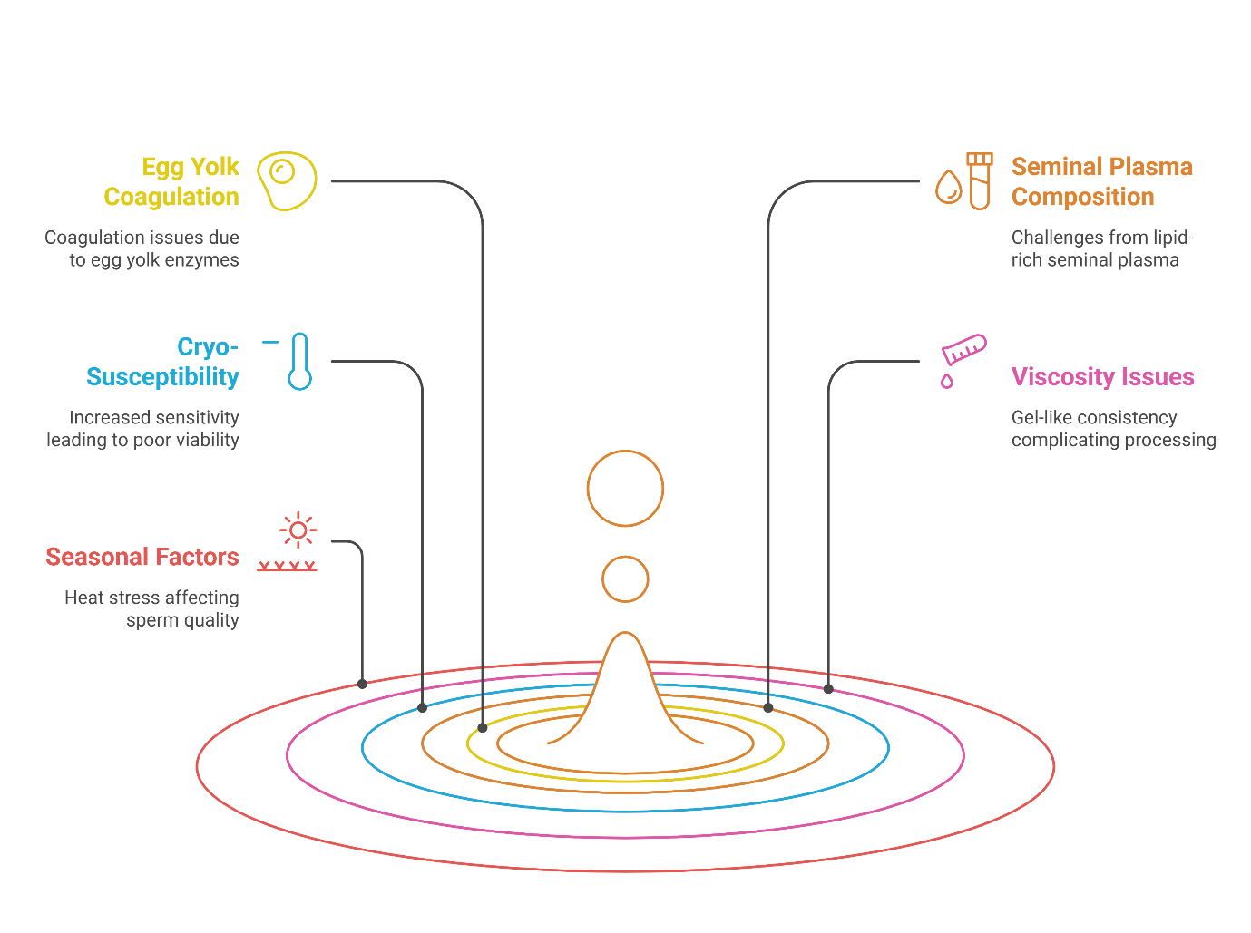Figure: 1 Pictorial representation of different challenges observed in goat semen cryopreservation
B. Factors affecting success rate of cryopreservation in goats:
1. Animal, managmental and environmental factors: These factors — breed, age, season, feeding regimen, and body condition score — all play significant roles in influencing semen quality and fertility in goats, particularly in relation to artificial insemination and semen cryopreservation. Here’s how each of these factors affects goat semen quality:
- Age: Age is an important determinant of sperm quality in male goats. Generally, young bucks, around 1 to 3 years old, produce semen with better motility, higher sperm concentration, and more consistent quality compared to older bucks, whose semen may exhibit reduced motility, lower sperm concentration, and increased morphological abnormalities. Older bucks, typically those over 5 years of age, often have decreased reproductive efficiency, with lower semen quality and poorer response to cryopreservation (Holt, 2000). Similarly in Saanen and Tuggenburg goats a signifcant difference in sperm concentration was reported between young (1–2 years) and adult (3–6 years) goats (Gore et al. 2020). Likewise, in Majorera bucks in-vitro semen parameters showed that male age affected sperm volume and concentration but no effect on its preservation ability (Iusupova et al., 2022). Therefore, age must be considered when selecting bucks for semen collection, as younger animals typically yield better results for artificial insemination and cryopreservation.
- Season: Seasonality significantly affects semen quality in goats, as their reproductive function is often influenced by photoperiod and environmental factors. Semen quality tends to be higher during the breeding season, which typically corresponds to cooler months, whereas summer or hotter months can lead to lower semen quality. High ambient temperatures, especially in tropical regions, can result in heat stress, which negatively impacts sperm motility, sperm count, and overall semen quality. In Andaman and Nicobar Island goats it was observed that during summer season their sexual behaviour and endocrinological profile were altered compared to rainy season (Ponraj et al., 2022). The photoperiod (day length) also affects the production of reproductive hormones, with goats being seasonal breeders, often experiencing peak semen production during shorter day lengths. Similarly in alpine goats’ variations exist in testicular biometry, seminal parameters (such as volume and concentration), hormone levels, and sexual behaviour during breeding seasons in tropical climates, however it should not be seen as a barrier to using these animals for year-round breeding (Dias et al., 2017).
- Feeding Regimen: The nutritional status of bucks plays a critical role in semen quality and reproductive performance. A well-balanced diet that meets the animal’s nutritional requirements — including adequate protein, vitamins, and minerals like zinc, selenium, and vitamin E — is essential for maintaining healthy semen production and sperm quality. Deficiencies in essential nutrients, especially antioxidants, can lead to oxidative stress, sperm membrane damage, and lower sperm motility, significantly reducing the success of cryopreservation (Mayasula et al., 2021). Higher feeding level allowed a better sexual behaviour in Payoya bucks in late spring (Zarazaga et al., 2009). Similarly, in saanen male goats’ inclusion of up to 12% flaxseed in the diet of male goats improved post-thaw semen quality, enhancing motility, vigor, and acrosomal integrity (Souza et al., 2019).
- Body Condition Score (BCS): The body condition score (BCS), which is a visual and tactile assessment of the body fat and muscle stores of an animal, is an important indicator of reproductive health and semen quality. Bucks with a moderate BCS (around 3 to 3.5 on a 5-point scale) tend to have optimal semen quality, as adequate fat and muscle stores are essential for hormonal balance and energy reserves. Bucks with either low BCS (indicating poor nutrition or illness) or high BCS (associated with excessive fat deposition, especially in overfed bucks) may experience reduced sperm motility, lower sperm concentration, and overall reduced fertility. Proper nutrition and maintaining an ideal body condition score are crucial for improving semen quality, both for natural breeding and artificial insemination (Akpa et al., 2013). Semen traits like volume, concentration, live-to-dead ratio, and body measurements such as body weight, condition score, and heart girth can be used to assess semen quality in bucks, helping to identify unqualified animals for breeding (Ambali et al., 2013). Similarly in Arabian bucks, age significantly influences body and testicular measurements, with body condition score (BCS) serving as a reliable indicator of testicular and epididymal traits for selection in breeding (Ouchene-Khelifi et al., 2021).
2. Handling factors
- Method of collection: Semen can be collected using artificial vagina or electric stimulation. Using artificial vagina for semen collection in goats the temperature of AV should be around 42-45⁰C (Sharma et al., 2020), lesser temperature is used in young animals whereas high temperature is required for old bucks. For semen collection using electro ejaculator electrical pulses should be applied for 4–5 s alternated with periods when there were not stimulations of approximately 2 s, beginning with 10 pulses of 2 V, and increasing 1 V in each series of 10 pulses until ejaculation ended (Ungerfeld et al., 2021). Ejaculation responses should be considered to have ended when there is no additional semen released after two electrical pulses. The last pulse that induced ejaculation of semen should be considered for calculations. However, it should be noted that electric stimulation may not be effective for the goat because it can alter the components of seminal plasma, consequently reducing the capability of spermatozoa to tolerate cryoinjury. Since in this procedure there is release of more amount of accessory sex gland secretions which may induce damage to sperms, besides there can be contamination with urine during collection. Therefore, it is highly pertinent to ensure the quality of collected semen, seminal composition and urine contamination for better cryopreservation outcomes. Further, it has been found out that spermatozoa collected by AV method has more cryoresistance compared to those collected by electroejaculator (Jiménez-Rabadán et al., 2016).
- Effect of centrifugation: Centrifugation is commonly used in semen processing to separate spermatozoa from seminal plasma and other cellular components, enhancing sperm quality for artificial insemination or cryopreservation. In buck semen, centrifugation helps concentrate viable sperm while removing impurities, such as dead cells or debris, that could negatively impact sperm motility and fertility potential. However, the centrifugation process can be stressful for sperm, potentially leading to membrane damage or a decrease in motility, especially if not optimized for the specific species. Studies have shown that the centrifugation force, time, and temperature must be carefully adjusted to minimize damage and maximize sperm viability (Yusoff et al., 2011). In some cases, centrifugation can be followed by the addition of cryoprotectants when preparing semen for freezing, which further protects sperm cells during the freezing and thawing processes. Understanding these effects is crucial for optimizing buck semen processing techniques to ensure higher fertilization success rates.
- Extender used: Extenders play a crucial role in preserving buck semen for artificial insemination or cryopreservation by providing nutrients, buffers, and cryoprotectants to maintain sperm viability. Common types of extenders include Tris-based extenders, which are often supplemented with egg yolk and glycerol to protect sperm membranes during freezing. These extenders have shown good success in maintaining motility and fertility, but the glycerol concentration must be carefully controlled, as too high a concentration can cause membrane damage (Rasad et al., 2017). Egg yolk-based extenders are widely used due to the lipoproteins in egg yolk that stabilize sperm membranes during cryopreservation, but excessive egg yolk can negatively impact motility and cause post-thaw damage, especially in buck semen (Sun et al., 2020). As an alternative, soybean lecithin-based extenders have gained attention for their effectiveness in preserving sperm without the risk of egg yolk contamination, although their performance can vary depending on the semen quality (Chelucci et al., 2015). Despite their effectiveness, extenders are not without limitations; improper freezing or thawing protocols and unsuitable extender compositions can lead to sperm membrane damage, reducing motility and fertilizing potential post-thaw (Bustani & Baiee, 2021).
- Cryoprotectant: cryoprotectant is a key component of semen extenders and play significant role in reducing cryodamage. Therefore, studies have been done to find out the right cryoprotectant for goat semen extender. Broadly based on their mechanism of action these are divided into two categories penetrating and non-penetrating. To determine ideal extender, different membrane-permeable cryoprotectants (Glycerol, Dimethyl Sulfoxide, Ethylene Glycol, and Propylene Glycol) and their combinations have been tested at different concentrations with buck semen (Leboeuf et al., 2000; Purdy, 2006; Gangwar et al., 2016; Rasad et al., 2017). Glycerol, however, remains the most frequently used penetrating cryoprotectant in goats.
- Sperm concentration: Sperm concentration plays a critical role in the success of cryopreservation in goats, influencing sperm quality, motility, and overall fertilizing ability after thawing. The concentration of sperm in the semen sample can impact the effectiveness of cryopreservation by affecting the ability of cryoprotectants to penetrate sperm cells, as well as influencing the osmotic pressure during freezing and thawing. Research has shown that optimal sperm concentration is essential for achieving high post-thaw motility and fertility rates in goats. Typically, sperm concentrations between 100 million to 200 million sperm/mL are considered ideal for freezing goat semen. At this concentration, spermatozoa have enough viable cells to withstand the cryopreservation process while avoiding excessive aggregation or clumping, which can negatively impact thawing results (Akçay et al., 2012). If the sperm concentration is too high, it can lead to an increased risk of sperm agglutination or clumping, which makes it more difficult to separate sperm cells during the thawing process, reducing motility and fertilization potential. Furthermore, research has demonstrated that sperm concentration can influence the effectiveness of cryoprotectants. For example, in higher concentrations of sperm, the amount of cryoprotectant required may need to be adjusted to ensure proper cellular protection, as overly concentrated sperm may interfere with cryoprotectant uptake, leading to increased cell damage during freezing (Bustani & Baiee, 2021).
- Equilibration time: During cryopreservation, equilibration refers to the period after semen is mixed with the cryoprotectant (usually glycerol or other cryoprotectants), allowing sperm to acclimatize to the subzero temperature before freezing. Typically, equilibration times of 1 to 2 hours at 4°C are recommended, allowing sperm to stabilize and facilitate the gradual diffusion of cryoprotectants into the sperm cells (Ahmed et al., 2015). If equilibration time is too short, sperm may not absorb the necessary amount of cryoprotectant, leading to poor protection during freezing and subsequent damage during thawing. On the other hand, excessive equilibration time more than 3 hours can lead to overexposure to cryoprotectants, which may cause toxicity or membrane disruption, resulting in lower sperm motility and fertility after thawing (Ramachandran et al., 2015).
- Freezing and thawing rate: The freezing and thawing rates of goat semen are pivotal factors influencing the success of cryopreservation, directly impacting sperm survival, motility, and fertilizing ability post-thaw. The freezing rate refers to how quickly semen is cooled to subzero temperatures during cryopreservation. It is critical for preventing the formation of large ice crystals inside the sperm cells, which can puncture cell membranes and lead to irreversible damage. In general, for semen cryopreservation in goats a slow freezing rate is preferred from 5 to -100⁰ C, typically around 0.5 to 1°C per minute as it allows sperm to adjust to lower temperatures gradually, reducing the risk of intracellular ice formation. Faster freezing rates can cause severe damage to sperm, especially to the sperm membrane and acrosome, due to the rapid formation of intracellular ice crystals. Studies have shown that optimal freezing rates, along with the right concentrations of cryoprotectants, significantly enhance sperm motility and fertilization rates after thawing (Üstüner et al., 2015). Besides this, thawing too slowly can result in damage from osmotic shock, while rapid thawing may cause a sudden disruption in the cryoprotectant's ability to protect sperm from thermal shock. Rapid thawing, generally at around 37°C to 42°C for 30 to 60 seconds, is typically recommended for goat semen, as it helps quickly restore sperm membrane integrity and reduce the chances of oxidative stress (Bezerra et al., 2012).
- Method of freezing: There are several methods used for the cryopreservation of goat semen, each with its own advantages and limitations. Manual or static freezing is one of the traditional techniques, where semen straws are frozen in liquid nitrogen vapor, by keeping them 3-4 cm above the liquid nitrogen level for 7-15 minutes and thereafter plunged into liquid nitrogen (Sharma et al., 2020). This method is simple and cost-effective but can lead to variable results due to less precise temperature control, which may result in sperm membrane damage and reduced motility post-thaw (Khalil Ur Rehman et al., 2016)). In contrast, programmable freezing uses automated freezers to control the cooling process more precisely, with cooling rates typically around 0.3 to 0.5°C per minute. This method reduces the risks associated with ice crystal formation and provides more consistent results in terms of post-thaw motility and fertility, making it a preferred option in research and commercial applications, though it comes with higher costs and requires specialized equipment (Gillis, 2022).
- Additives in semen – antioxidants, herbal, vitamin and mineral: Additives in semen extenders, such as antioxidants, herbal compounds, vitamins, and minerals, play a significant role in enhancing the quality of goat semen during cryopreservation and improving post-thaw sperm motility and fertilizing ability. Antioxidants, including vitamin E, vitamin C, and glutathione, are commonly used to reduce oxidative stress during the freezing and thawing processes, which can otherwise lead to sperm membrane damage and decreased motility. These antioxidants neutralize free radicals and protect sperm cells from lipid peroxidation, which is a primary cause of cryodamage (Bucak et al., 2008). Herbal additives like Moringa oleifera aqueous extract supplemented groups showed significant enhancement in sperm viability, sperm motility, acrosomal integrity and plasma membrane integrity (Gangwar et al., 2024). Vitamins, particularly vitamin C (Lukusa, 2019) and vitamin E (Dewry et al., 2015), are essential for maintaining sperm cell function during preservation. Vitamin E, a potent antioxidant, protects against membrane lipid peroxidation, while vitamin C aids in the regeneration of other antioxidants and supports sperm motility. Minerals such as zinc, selenium, and magnesium are crucial for sperm motility, membrane integrity, and overall sperm function. Zinc, for example, plays a key role in stabilizing sperm membranes, while selenium enhances sperm motility and protects against oxidative damage (Rahman et al., 2014). The addition of these supplements in semen extenders has been shown to improve sperm quality during cryopreservation, leading to better fertility outcomes in goat artificial insemination programs.
- Packaging material: The choice of packaging material and container type plays a crucial role in the cryopreservation of goat semen, influencing sperm motility, viability, and fertilizing ability after thawing. Semen straws are the most commonly used packaging material due to their practicality, ease of handling, and ability to provide uniform cooling during freezing (Maxwell et al., 1995). The most commonly used straw sizes are 0.25 mL, 0.5 mL, and 1.0 mL, with smaller straws, such as the 0.25 mL straw, being preferred for their rapid cooling rates, which help prevent ice crystal formation and reduce sperm damage. However, smaller straws contain fewer sperm, which could potentially lower fertility outcomes if the semen quality is not optimal (Bezerra et al., 2012). Larger straws, such as the 1.0 mL variety, hold more sperm, which can be beneficial when sperm quality is high, but their slower freezing rate increases the risk of cryodamage if not properly controlled. Another method of packaging is the use of ampoules, which are sealed glass containers offering the advantage of protection against contamination. While ampoules maintain sterility and are ideal for storing smaller volumes of semen, they are less commonly used for large-scale goat semen cryopreservation due to the difficulty in thawing and the potential for osmotic shock when thawing in water baths (Gangwar et al., 2016). Another alternative is pellet freezing, where semen is stored in small, disc-shaped containers, offering compact storage and quicker thawing compared to ampoules. However, pellet freezing requires precise control of the freezing rate to avoid sperm damage, and it is not as widely used as semen straws in commercial applications (Khalifa et al., 2006). Furthermore, the choice between closed and open systems for packaging affects semen quality; closed systems, such as ampoules and sealed straws, are preferred for their ability to prevent contamination, while open systems expose semen to environmental factors that could compromise its quality.
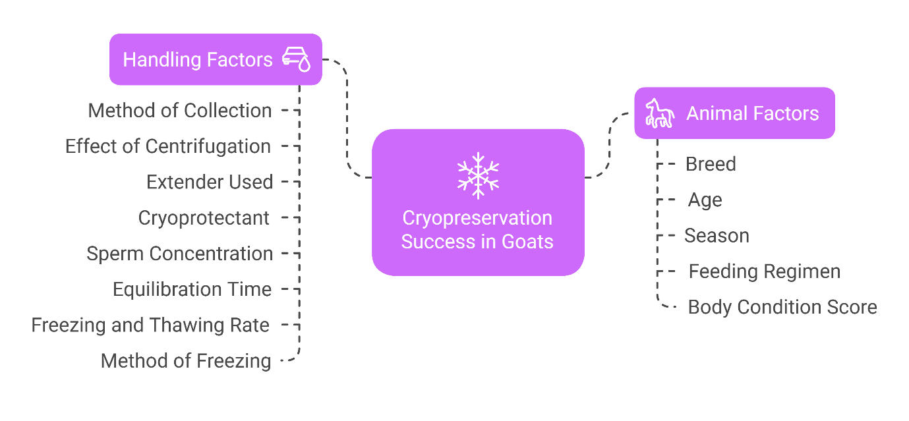Figure: 2 Pictorial representation of different handling and animal factors affecting semen cryopreservation in goats
C. Advances in goat semen cryopreservation: Advancements in goat semen cryopreservation have significantly improved the quality of stored semen, enhancing post-thaw motility, viability, and fertilizing ability. Key innovations in this area include biostimulation, nanopurification, nano-based extenders, vitrification, freeze-drying, and the use of antifreeze proteins, each of which offers unique advantages in improving semen quality during the cryopreservation process.
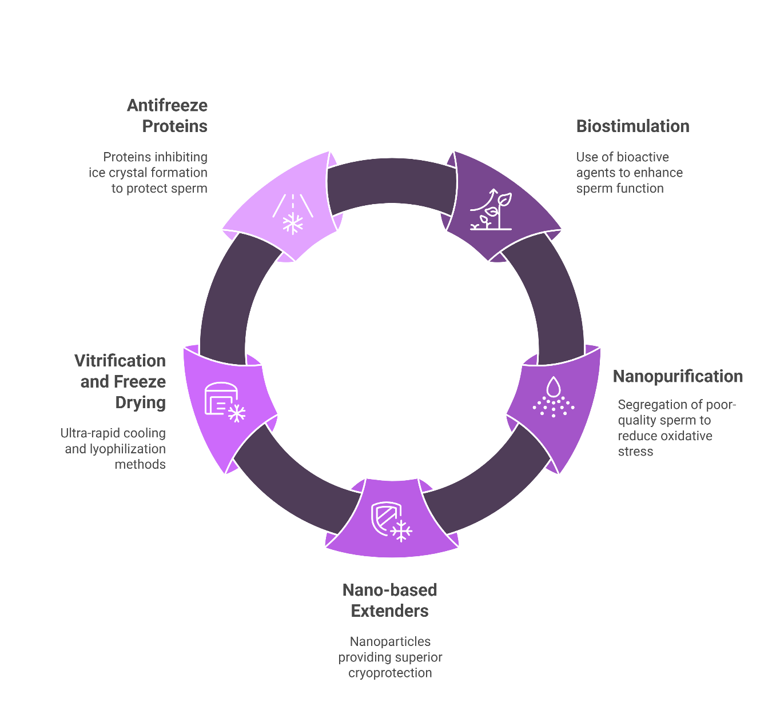
Figure: 3 Pictorial representation of advances in semen cryopreservation in goats
- Biostimulation: Biostimulation involves the use of specific bioactive agents such as hormones, growth factors, and other signaling molecules to enhance sperm function before and after cryopreservation. This method aims to optimize sperm quality by improving mitochondrial function, reducing oxidative stress, and enhancing sperm motility and capacitation. Studies have shown that biostimulants like hormones (Ungerfeld et al., 2018) and growth factors (Kumar et al., 2020) can increase sperm motility and acrosome integrity in goat semen, improving the post-thaw fertility potential. Additionally, melatonin, a potent antioxidant, has been used as a biostimulant to reduce oxidative damage and enhance sperm quality during cryopreservation (Cardenas-Padilla et al., 2024). The use of biostimulation is a promising area for enhancing the success rates of cryopreserved goat semen.
- Nanopurification: The sperm purification technique involves the segregation of poor-quality spermatozoa from the ejaculate. The depletion of these subpopulations in the ejaculate is of utmost importance, as they are a source of oxidative stress compromising the fertility of the semen significantly (Falchi et al., 2017). Conventional semen purification techniques like sephadex filtration, swim up, density gradient (albumin, percoll and bovipure) were time-consuming and relatively less efficient technologies, besides causing damage to treated spermatozoa from long duration centrifugation procedures (Andrei et al., 2024In angora goats, nano-purification have shown that buck semen can be successfully nanopurified using iron oxide nanoparticles coated with Annex-in-V, PSA, and silica, both at 37°C and 21°C, resulting with the selection of highly motile and acrosome intact sperm population (Alemdar & Tırpan, 2022).
- Nano-based Extender: The development of nano-based extenders is another significant advancement in cryopreservation. These extenders are typically composed of nanoparticles (such as lipid nanocarriers or polymer-based nanostructures) that provide superior cryoprotection and enhance the survival of sperm cells during freezing and thawing. Nano-based extenders also provide better sperm membrane stabilization and increased motility, making them a promising tool for improving goat semen cryopreservation. The use of a Tris-based extender containing 2% nanoparticles of soybean lecithin for goat semen cryopreservation seems to be advantageous. The performance of this extender was superior to any of the tested soybean lecithin suspensions and the 15% egg yolk extender, for which 2% NL could be a suitable replacement (Nadri et al., 2019). Similarly, lecithin nanoliposome extender can be a beneficial alternative extender to protect ram sperm during cryopreservation without any adverse effects. It was also observed that regarding pomegranate concentration, PE5 can improve the quality of ram semen after thawing (Mehdipour et al., 2017).
- Vitrification and freeze drying: Vitrification is a cutting-edge technique that involves ultra-rapid cooling of semen to avoid ice crystal formation, thus reducing the damage caused by freezing. In contrast to traditional freezing methods, which involve the formation of ice crystals that can rupture sperm membranes, vitrification allows semen to transition into a glass-like, amorphous state without forming ice (Liebermann et al., 2002). This method has been shown to significantly improve post-thaw sperm quality, particularly in species with delicate sperm membranes, like goats The first report of goat sperm vitrification is in the Iberian ibex (Capra pyrenaica), also known as Spanish wild goat (Pradiee et al., 2018). However, it requires careful optimization of cryoprotectant concentrations and rapid cooling equipment to avoid sperm toxicity and ensure maximum fertility potential after thawing. Freeze-drying (lyophilization) is another novel approach being explored for goat semen cryopreservation. This method involves removing water from semen by freezing it and then subjecting it to a vacuum, causing the frozen water to sublimate directly into vapor. Freeze-drying preserves sperm by preventing the formation of ice crystals during the freezing process. Although freeze-drying allows for long-term storage at room temperature, it presents challenges such as reduced sperm motility and fertility post-thaw due to potential damage during the drying process. Nevertheless, these sperms can be used in ARTs like intrcytoplasmic sperm injection (ICSI). Recently a study by Thiangthientham et al., 2023 has shown that freeze dried epididymal spermatozoa maintain fertilisation potential following freeze drying.
- Antifreeze Proteins: The use of antifreeze proteins (AFPs) has emerged as a novel strategy in cryopreservation to protect sperm from the damage caused by ice formation during freezing. AFPs, derived from cold-water fish, insects, and plants, work by inhibiting ice crystal formation, thus reducing the likelihood of mechanical damage to sperm cells. In goat semen cryopreservation, AFPs have shown the ability to enhance sperm motility, reduce oxidative damage, and improve post-thaw fertility. The integration of AFPs with traditional cryoprotectants is a promising area of research aimed at improving the efficiency and success of goat semen cryopreservation. The addition of AFPIII to the freezing extender @ 1 μg/mL improved the post-thaw quality of goat semen. Lv et al. (2021) and Akhondzadeh et al. (2023) concluded that the addition of 5 μg/mL AFP in combination with 5% glycerol in freezing extender improves the post-thaw quality, structure, and function parameters for buck spermatozoa. Similarly in rams, the use of AFP, predominantly type I, may increase sperm cell protection during cryopreservation, with no adverse effect on potential fertilization capacity or increase in reactive oxygen species (Correia et al., 2021). However, more no of studies with other antifreeze proteins and ice recrystallisation inhibitors is needed to reduce the ice crystal damage during cryopreservation.

Conclusion
The challenges associated with goat seminal plasma composition, including its high cryosusceptibility, antioxidant imbalance, seasonal variability, and breed-specific differences, pose significant obstacles to successful semen preservation and fertility management. However, existing strategies such as the use of cryoprotectants, antioxidants, and optimized freezing protocols have made strides in mitigating some of these issues, improving post-thaw sperm viability and motility. Recent advancements, including the use of nano-based extenders, biostimulation, and vitrification techniques, have shown promise in enhancing cryopreservation success and reducing the adverse effects of freezing on goat semen. Additionally, the development of more efficient antioxidant supplements and sperm membrane stabilizers continues to improve the quality of preserved sperm. Despite these advancements, challenges remain, particularly with maintaining the balance of seminal plasma components and mitigating the effects of heat stress and seasonal variation. Looking forward, the focus will likely shift towards more personalized approaches based on breed-specific and individual characteristics, and the integration of cutting-edge technologies like genomic editing and biomolecular profiling of seminal plasma to further optimize semen quality and enhance fertility outcomes. In the future, improving the precision of cryopreservation techniques and developing more robust strategies for managing sperm functionality in varied environmental conditions will be key to enhancing the success rates of artificial insemination and expanding the use of cryopreserved goat semen in breeding programs.
Disclaimer (Artificial intelligence)
Option 1:
Author(s) hereby declare that NO generative AI technologies such as Large Language Models (ChatGPT, COPILOT, etc.) and text-to-image generators have been used during the writing or editing of this manuscript.
Option 2:
Author(s) hereby declare that generative AI technologies such as Large Language Models, etc. have been used during the writing or editing of manuscripts. This explanation will include the name, version, model, and source of the generative AI technology and as well as all input prompts provided to the generative AI technology
Details of the AI usage are given below:
1.
2.
3.
References
20th Livestock Census. The Department of Animal Husbandry & Dairying under Ministry of Fisheries, India, 2019.
Akçay, E., Kulaksız, R., Daşkin, A., Çebi, Ç., & Tekin, K. (2012). The effect of different dilution rates on post-thaw quality of ram semen frozen in two different egg-yolk free extenders. survival, 9(10), 11.
Akhondzadeh, S., Farshad, A., Rostamzadeh, J., & Sharafi, M. (2023). Effects of antifreeze protein type I and glycerol in diluents on cryopreserved goat epididymal sperm. Biopreservation and Biobanking, 21(1), 65-73.
Akpa, G. N., Ambali, A. L., & Suleiman, I. O. (2013). Body conformation, testicular and semen characteristics as influenced by age, hair type and body condition of Red Sokoto goat. New York Science Journal, 6(7), 44-58.
Alemdar, H., & Tırpan, M. B. (2022). A novel approach to sperm selection: Nanoparticle-based purification improves quality of Angora cryopreserved buck’s semen. Journal of the Hellenic Veterinary Medical Society, 73(4), 4881-4890.
Ambali, A. L., Akpa, G. N., & Suleiman, I. O. (2013). Relationships between sperm morphology, semen characteristics, testicular measurements and body conformation traits in Red Sokoto Goat. International Journal of Advanced Biological and Biomedical Research, 3(3), 348-353.
Andrei, C. R., Posastiuc, F. P., Constantin, N. T., & Mitrea, I. L. (2024). New insights into semen separation techniques in buffaloes. Frontiers in Veterinary Science, 10, 1347482.
Bezerra, F. S. B., Castelo, T. D. S., Santos, É. A. A. D., Dantas, T. D. C., Simão, B. R., & Silva, A. R. (2012). Assessment of the interaction between straw size and thawing rate and its impact on in vitro quality of post-thaw goat semen. Revista Brasileira de Zootecnia, 41, 592-597.
Bucak, M. N., Ateşşahin, A., & Yüce, A. (2008). Effect of anti-oxidants and oxidative stress parameters on ram semen after the freeze–thawing process. Small ruminant research, 75(2-3), 128-134.
Bustani, G. S., & Baiee, F. H. (2021). Semen extenders: An evaluative overview of preservative mechanisms of semen and semen extenders. Veterinary World, 14(5), 1220.
Cardenas-Padilla, A. J., Jimenez-Trejo, F., Cerbon, M., Chavez-Garcia, A., Cruz-Cano, N. B., Martinez-Torres, M., ... & Medrano, A. (2024). Sperm melatonin receptors, seminal plasma melatonin and semen freezability in goats. Theriogenology, 225, 98-106.
Chakravarty, H., Sinha, S., Borpujari, D., Deka, B. C., Biswas, R. K., Dutta, M., & Borah, B. (2023). Effect of centrifugation regime on cryopreservation of Beetal buck semen. Indian Journal of Animal Research, 57(2), 178-183.
Chelucci, S., Pasciu, V., Succu, S., Addis, D., Leoni, G. G., Manca, M. E., ... & Berlinguer, F. (2015). Soybean lecithin–based extender preserves spermatozoa membrane integrity and fertilizing potential during goat semen cryopreservation. Theriogenology, 83(6), 1064-1074.
Correia, L. F. L., Espírito-Santo, C. G., Braga, R. F., Carvalho-de-Paula, C. J., da Silva, A. A., Brandão, F. Z., ... & Souza-Fabjan, J. M. (2021). Addition of antifreeze protein type I or III to extenders for ram sperm cryopreservation. Cryobiology, 98, 194-200.
Daramola, J. O. (2017). Effect of centrifugation on motility, sperm capacitation and acrosome reaction in soy bean and avocado seed milk extenders of cryopreserved goat spermatozoa. Agricultura Tropica Subtropica, 50(1), 13-18.
Darin-Bennett, A., & White, I. G. (1977). Influence of the cholesterol content of mammalian spermatozoa on susceptibility to cold-shock. Cryobiology, 14(4), 466-470.
Sharma, G. A., Sood, P., & Chaudhary, J. K. (2020). Effect of different concentrations of glycerol in cryopreservation of Gaddi goat semen. Journal of Veterinary Andrology, 5(1), 01-06.
Dewry, R. K., Deka, B. C., Bhuyan, D., Biswas, R. K., Sinha, S., Hussain, Z., ... & Hazarika, S. B. (2015). Effect of vitamin E on the quality of frozen buck semen. Indian Journal of Small Ruminants (The), 21(2), 343-346.
Dias, J. C. O., Veloso, C. M., Santos, M. C. D. R., Oliveira, C. T. S. A. M. D., Silveira, C. O., Iglesias, E., ... & Sanglard, L. M. P. (2017). Seasonal variation in the reproductive activity of male goats raised under tropical climate conditions. Revista Brasileira de Zootecnia, 46(3), 192-201.
Falchi, L., Khalil, W. A., Hassan, M., & Marei, W. F. (2018). Perspectives of nanotechnology in male fertility and sperm function. International Journal of Veterinary Science and Medicine, 6(2), 265-269.
Gangwar, C., Kharche, S. D., Kumar, S., & Jindal, S. K. (2016). Cryopreservation of goat semen: status and prospects. Indian Journal of Small Ruminants (The), 22(1), 1-10.
Gangwar, C., Kumar, A., Gururaj, K., Mishra, A. K., Ranjan, R., Kumar, M., ... & Mittal, N. (2024). Impact of varying doses of Moringa leaf extract supplementation in the cryopreservation media on sperm quality, antioxidant capacity and antimicrobial activity of frozen-thawed buck spermatozoa. The Indian Journal of Animal Sciences, 94(4), 362-368.
Gillis, J. D. (2022). Investigating the Biophysical Properties of Directional Freezing and its Application to Nondomestic Species (Doctoral dissertation, University of Nottingham).
Gore, D. L. M., Muasya, T. K., Okeno, T. O., & Mburu, J. N. (2020). Comparative reproductive performance of Saanen and Toggenburg bucks raised under tropical environment. Tropical Animal Health and Production, 52, 2653-2658.
Holt, W. V. (2000). Basic aspects of frozen storage of semen. Animal reproduction science, 62(1-3), 3-22.
Iusupova, K., Batista‐Arteaga, M., Martín‐Martel, S., Díaz‐Bertrana, M. L., & Rodríguez‐Lozano, O. (2022). Effect of the donor's age and type of extender (egg yolk versus clarified egg yolk) over the sperm quality of Majorera bucks preserved at 4 C: In vitro results and fertility trials. Reproduction in Domestic Animals, 57(5), 524-531.
Jia, B., Liang, J., Lv, C., Memon, S., Fang, Y., Wu, G., & Quan, G. (2021). The characteristics of proteome and metabolome associated with contrasting sperm motility in goat seminal plasma. Scientific Reports, 11(1), 15562.
Jiménez-Rabadán, P., Soler, A. J., Ramón, M., García-Álvarez, O., Maroto-Morales, A., Iniesta-Cuerda, M., ... & Garde, J. J. (2016). Influence of semen collection method on sperm cryoresistance in small ruminants. Animal reproduction science, 167, 103-108.
Juyena, N. S., & Stelletta, C. (2012). Seminal plasma: an essential attribute to spermatozoa. Journal of andrology, 33(4), 536-551.
Khalifa, T. A. A., & El-Saidy, B. E. (2006). Pellet-freezing of Damascus goat semen in a chemically defined extender. Animal Reproduction Science, 93(3-4), 303-315.
Khalil Ur Rehman, H., Andrabi, S. M. H., Ahmed, H., & Shah, S. A. H. (2017). Programmable fast‐freezing method improves the post‐thaw motion dynamics, integrities of plasmalemma, mitochondrial transmembrane, DNA and, acrosome, and in vivo fertility of water buffalo (Bubalus bubalis) spermatozoa. Andrologia, 49(8), e12733
Kumar, A., Prasad, J. K., Kumar, N., Anand, M., Verma, S., Dhariya, R., ... & Gattani, A. (2024). Quercetin in semen extender curtails reactive oxygen and nitrogen species and improves functional attributes of cryopreserved buck semen. Cryobiology, 116, 104931.
Kumar, A., Singh, G., Jerome, A., Kumar, P., Arjun, V., Bala, R., ... & Sharma, R. K. (2021). IGF-1 supplementation in semen affects mitochondrial functional and calcium status of buffalo sperm following cryopreservation. Animal Reproduction Science, 231, 106783.
Leboeuf, B., Restall, B., & Salamon, S. (2000). Production and storage of goat semen for artificial insemination. Animal reproduction science, 62(1-3), 113-141.
Liebermann, J., Nawroth, F., Isachenko, V., Isachenko, E., Rahimi, G., & Tucker, M. J. (2002). Potential importance of vitrification in reproductive medicine. Biology of reproduction, 67(6), 1671-1680.
Lovelock, J. E., & Polge, C. (1954). The immobilization of spermatozoa by freezing and thawing and the protective action of glycerol. Biochemical Journal, 58(4), 618.
Lukusa, K. (2019). Dietary supplementation of selenium and addition of vitamin C and E in extender to enhance semen cryopreservation and reproductive performance of Saanen goats. University of Pretoria (South Africa).
Lv, C., Larbi, A., Memon, S., Liang, J., Fu, X., Wu, G., & Quan, G. (2021). The effects of antifreeze protein III supplementation on the cryosurvival of goat spermatozoa during cryopreservation. Biopreservation and Biobanking, 19(4), 298-305.
Lv, C., Wu, G., Hong, Q., & Quan, G. (2019). Spermatozoa cryopreservation: state of art and future in small ruminants. Biopreservation and biobanking, 17(2), 171-182.
Maxwell, W. M. C., Landers, A. J., & Evans, G. (1995). Survival and fertility of ram spermatozoa frozen in pellets, straws and minitubes. Theriogenology, 43(7), 1201-1210.
Mayasula, V. K., Arunachalam, A., Babatunde, S. A., Naidu, S. J., Sellappana, S., Krishnan, B. B., ... & Bhatta, R. (2021). Trace minerals for improved performance: a review of Zn and Cu supplementation effects on male reproduction in goats. Tropical Animal Health and Production, 53, 1-8.
Medeiros, C. M. O., Forell, F., Oliveira, A. T. D., & Rodrigues, J. L. (2002). Current status of sperm cryopreservation: why isn't it better?. Theriogenology, 57(1), 327-344.
Mehdipour, M., Kia, H. D., Nazari, M., & Najafi, A. (2017). Effect of lecithin nanoliposome or soybean lecithin supplemented by pomegranate extract on post-thaw flow cytometric, microscopic and oxidative parameters in ram semen. Cryobiology, 78, 34-40.
Mohamed, R. H., Mohamed, R. S., ABD EL-HAMID, I. S., Madkour, F. A., SALLAM, A. M., ALI, F., & HUSSEIN, H. A. (2023). Semen quality, testicular characteristic, biochemical profile and histopathology of testes of goats under heat stress conditions. Assiut Veterinary Medical Journal, 69(176), 76-87.
Nadri, T., Towhidi, A., Zeinoaldini, S., Martínez-Pastor, F., Mousavi, M., Noei, R., ... & Sangcheshmeh, A. M. (2019). Lecithin nanoparticles enhance the cryosurvival of caprine sperm. Theriogenology, 133, 38-44.
Ouchene-Khelifi, N. A., & Ouchene, N. (2021). Relationships between age, body measurements, and testicular measurements in Arabia bucks in Algeria. Tropical animal health and production, 53, 1-9.
Ponraj, P., Sunder, J., De, A. K., Alyethodi, R. R., Mishra, P. C., Bhowmick, S., & Bhattacharya, D. (2022). Season modulates endocrinological profiles and sex behavioural characteristics in indigenous male goats under tropical humid island ecosystem. Asian Pacific Journal of Reproduction, 11(4), 183-192.
Pradiee, J., Sánchez-Calabuig, M. J., Castaño, C., O'Brien, E., Esteso, M. C., Beltrán-Breña, P., ... & Rizos, D. (2018). Fertilizing capacity of vitrified epididymal sperm from Iberian ibex (Capra pyrenaica). Theriogenology, 108, 314-320.
Purdy, P. H. (2006). A review on goat sperm cryopreservation. Small ruminant research, 63(3), 215-225.
Rahman, H. U., Qureshi, M. S., & Khan, R. U. (2014). Influence of dietary zinc on semen traits and seminal plasma antioxidant enzymes and trace minerals of b eetal bucks. Reproduction in Domestic Animals, 49(6), 1004-1007.
Ramachandran, N., Yadav, S., Sikarwar, A. K. S., Saraswat, S., Ranjan, R., & Jindal, S. K. (2015). Effect of equilibration periods on post-thaw semen quality of Jamunapari bucks. Indian Journal of Small Ruminants (The), 21(2), 234-237.
Rasad, S. D., Soeparna, N., Setiawan, R., & Widyastuti, R. (2017). Effect of Glycerol Level in Two Different Extenders on Post Thawed Sperm Quality of Crossbreed Etawah Goat. Journal of Animal and Veterinary Advances, 16(8-12), 87-91.
Sathe, S. (2021). Cryopreservation of semen. Bovine reproduction, 986-999.
Sharma, A. and P. Sood. 2020. Caprine semen cryopreservation and the factors affecting it: An overview. Veterinary Sciences: Research and Reviews, 6(1): 46-57.
Souza, R. S., Barbosa, L. P., Aguiar, C. S., Vieira, R. L. A., Ribeiro, M. O., Araújo, R. C. D. S. A. D., ... & Santana, A. L. A. (2019). Cryopreservation of semen from goats fed a diet supplemented with flaxseed. Revista Brasileira de Saúde e Produção Animal, 20, e0112020.
Sun, L., Fan, W., Wu, C., Zhang, S., Dai, J., & Zhang, D. (2020). Effect of substituting different concentrations of soybean lecithin and egg yolk in tris-based extender on goat semen cryopreservation. Cryobiology, 92, 146-150.
Thiangthientham, P., Kallayanathum, W., Anakkul, N., Suwimonteerabutr, J., Santiviparat, S., Techakumphu, M., ... & Tharasanit, T. (2023). Effects of freeze-drying on the quality and fertilising ability of goat sperm recovered from different parts of the epididymis. Theriogenology, 195, 31-39. Amirat, L., et al. (2004). Theriogenology.
Ungerfeld, R., Casuriaga, D., Giriboni, J., Freitas-de-Melo, A., Silveira, P., & Brandão, F. Z. (2018). Administration of cloprostenol and oxytocin before electroejaculation in goat bucks reduces the needed amount of electrical stimulation without affecting seminal quality. Theriogenology, 107, 1-5.
Ungerfeld, R., Viera, M. N., Freitas-de-Melo, A., Giriboni, J., Casuriaga, D., & Silveira, P. (2021). Seasonality of the stress response in goat bucks when there is use of electroejaculation for semen collection. Animal Reproduction Science, 226, 106719.
ÜSTÜNER, B., Nur, Z., Alcay, S., TOKER, M. B., SAĞIRKAYA, H., & Soylu, M. K. (2015). Effect of freezing rate on goat sperm morphology and DNA integrity. Turkish Journal of Veterinary & Animal Sciences, 39(1), 110-114.
Yusoff, R., Bakar, M. Z. A., Sarsaifi, K., Bukar, M. M., Thein, M., Kyaw, T., & San, M. M. (2011). Effect of seminal plasma removal, washing solutions, and centrifugation regimes on Boer goat semen cryopreservation. Pertanika J. Trop. Agric. Sci, 34(2), 271-279.
Zarazaga, L. A., Guzmán, J. L., Domínguez, C., Pérez, M. C., & Prieto, R. (2009). Effects of season and feeding level on reproductive activity and semen quality in Payoya buck goats. Theriogenology, 71(8), 1316-1325.

