**Application of Rice Husk Ash as a Partial Substitute for Fine Aggregate in Concrete**

**ABSTRACT:**

Throughout the building era, concrete—a composite material made by humans—was mostly utilized as a binding element for structures. One of the industries in India that is growing the fastest is the building sector. Traditional building resources like bricks, cement, sand, and wood are becoming more and more limited as a result of the rapid rate of growth and the growing demand for buildings. Researchers have been forced to create a range of novel and inventive building materials due to the requirement for high-quality building materials to replace conventional ones as well as the necessity for fairly priced and long-lasting materials for affordable housing. In order to optimize the use of locally available resources, this study examined the effects of replacing fine aggregate with rice husk in terms of weight on the workability, bulk density, and compressive strength of concrete. In M-20 grades of concrete, the suitability of using rice husk at 5%, 10%, 15%, 20%, and 25% as a partial substitute for fine aggregate was also evaluated. The concrete's compressive strength is influenced by the kind and amount of curing that is done before to the test. Experiments show that after 28 days, the strength is higher than after 7 days. Strength levels are higher for M20 with 10% replacement than for M20 with 15% replacement. This demonstrates that the strength value falls as the proportion rises.

**Keywords:** Rice husk ash, waste , concrete, compressive strength and Building materials

1. **INTRODUCTION:**

During the construction era, concrete, a composite man-made substance, was mostly employed as building binding material. One of India's industries with the quickest rate of growth is the construction sector. Traditional building resources like bricks, cement, sand, and wood are in limited supply as a result of the rapid construction activity and rising demand for homes In addition to being a major employer, the manufacturing of concrete contributes significantly to societal advancement.

Pollution and waste management issues have historically been brought on by industrial and agricultural waste. Nonetheless, there are both practical and financial benefits to using industrial and agricultural wastes in addition to other conventional building materials. Since the wastes are locally accessible, their transportation costs are low, and they typically have no commercial value. Utilizing waste materials in building helps to preserve the environment and conserve natural resources. Several waste materials with pozzolanic qualities, such as fly ash, silica fume, volcanic ash, and corn cob, have been investigated for use in blended cements. Waste products from the rice business, including rice husks, are typically discarded in the open, harming the environment and providing no financial advantages.

Burning the outer shells of rice grains, known as rice husks, produces rice husk ash (RHA). Being a pozzolanic substance, it can combine with calcium hydroxide when water is present to create compounds that strengthen and prolong the life of concrete. Because of its advantages for the environment and ability to enhance concrete's qualities, RHA has been researched and utilized more frequently as a partial replacement for fine aggregate (sand) in concrete.

To optimize the utilization of locally accessible resources, this study examined the effects of replacing fine aggregate with rice husk in terms of weight on concrete's workability, bulk density, and compressive strength. Additionally, it evaluated the suitability of using rice husk at 5%, 10%, 15%, 20%, and 25% as a partial substitute for fine aggregate in M-20 grades of concrete.

1. **MATERIAL USED:**

**2.1 Cement**

Lime and clay are ground into a powder and then combined with water to make mortar or with sand, gravel, and water to make concrete. In the production of cement, common ingredients include silica sand, iron ore, shale, clay, slate, limestone, shells, and chalk or marl. The silicates and aluminates of lime derived from clay and limestone make up the majority of cement. Calcination is the process of heating the materials mentioned above to 1450 °C in a kiln to create cement. This produces a hard material known as clinker, which is then processed into a powder with a tiny bit of gypsum to create OPC, the most widely used kind of cement (also referred to as OPC). OPC, Portland Pozzolana Cement, Rapid Hardening Portland Cement, Portland Slag Cement, Hydrophobic Portland Cement, Low Heat Portland Cement, and Sulphate Resisting Portland Cement are the many cement kinds as defined by the Bureau of Indian Standards (BIS). The basic portland cement, OPC, works best in conventional concrete building where the soil and ground water are not exposed to sulphates. Compared to other cements, this one is clearly manufactured in greater quantities. Depending on the cement's compressive strength after 28 days, OPC is divided into three grades: 33, 43, and 53. In this investigation, OPC 43 grade was utilized.

**Table 1. Chemical properties of cement.**

|  |  |
| --- | --- |
| **Oxide composition** | **% by weight** |
| **SiO2** | **20.60** |
| **CaO** | **63.19** |
| **MgO** | **4.10 to 5.0** |
| **Fe2O3** | **4.20** |
| **Al2O3** | **4.10** |
| **SO3** | **1.88-2.5** |
| **Loss on ignition** | **2.45 -4.0** |
| **Insoluble residue** | **1.31 -1.5** |
| **Time saturation factor** | **0.91** |
| **C3S** | **50.02** |
| **C2S** | **26.23** |
| **C3A** | **4.40** |

**Table 2. Physical properties of cement.**

|  |  |  |
| --- | --- | --- |
| **Physical properties** | **Test result** | **Limit of Iraqi**  **specification No. 5/1984 [4]** |
| **Specific surface area (Blaine method), m2/kg** | 332.9 | 230 (min.) |
| **Setting time (Yicale's method):** | | |
| **Initial setting, hrs: min** | 2:0 | 00:45 (min.) |
| **Final setting, hrs: min** | 4:1 | 10:00 (max.) |
| **Compressive strength, MPa:** |  |  |
| **Three days** | 21.20 | 15.00 (min.) |
| **Seven days** | 30.10 | 23.00 (min.) |

**Table 3. Particle size gradation of sand.**

|  |  |  |
| --- | --- | --- |
| **Passing (%) by weight** | | |
| **Sieve size, mm** | **Specimen** | **(I.O.S. 45/1984)**  **limitations for**  **zone no. 3 [5]** |
| **4.75** | 96 | 90-100 |
| **2.36** | 87 | 85-100 |
| **1.18** | 76 | 75-100 |
| **0.60** | 60 | 60-70 |
| **0.30** | 14 | 12-40 |
| **0.15** | 4 | 0-10 |

**Table 4. Physical and chemical properties of fine aggregate.**

|  |  |  |
| --- | --- | --- |
| **Physical properties** | **Test Result** | **Limit of Iraqi**  **specification No.45/1984 [5]** |
| **Specific gravity** | 2.60 | **-** |
| **Sulphate content** | 0.0 61% | 0.5 % (max.) |
| **Absorption** | 0.75% | **-** |

**2.2 Aggregates:**

The aggregates in this mixture serve to both limit the amount of space that the cement paste takes up and to provide a stiff skeletal framework. The ratios of various coarse aggregate sizes will fluctuate based on the specific mix needed for each end. There is no doubt that the aggregates have a significant impact on the different qualities and properties of concrete only by making up 70–80% of its volume. Aggregates are often divided into three categories: regular weight, light weight, and heavy weight. Natural and manufactured aggregates are two additional classifications for normal weight aggregates.

On the basis of their size, aggregates can also be divided into two categories: coarse and fine

.

* 1. **Rice Husk Ash**

Rice husk, an agricultural byproduct, when utilized as fuel, partially produced burnt husk from milling mills also contributes to pollution. To address this issue, attempts are being undertaken to use the material as sand and cementing material. It has been discovered that variations in paddy type, crop year, climate, and geographic location affect the chemical makeup of rice husk in different samples.About 22% of the paddy's weight is obtained as husk during the milling process. About 75% of its weight is made up of organic volatile stuff, which burns up during the firing process. The remaining 25% of the husk's weight is turned into ash, a process known as Rice Husk Ash (RHA). It is produced through combustion and has a highly reactive character.

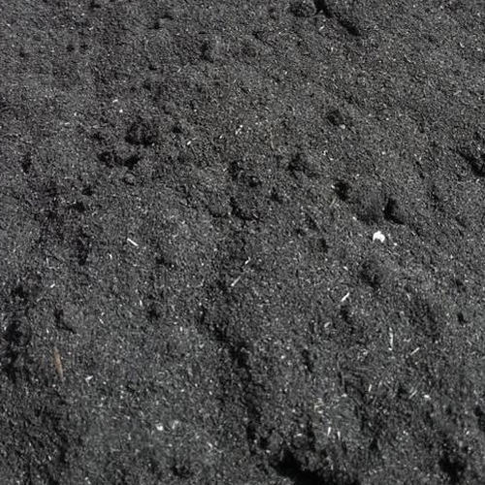

**Figure 1:Rice Husk Ash**

It's a component of waste ash. Because waste ashes aren't used for anything other than construction, their disposal in landfills has an adverse effect on the environment. As a greenhouse agent, it negatively intensifies the greenhouse effect and loses its eco-friendliness. Numerous studies had been conducted to determine its solution. RHA is used to lower the temperature of mass concrete with high strength. Higher substitution levels result in lower water absorption values, and the inclusion of RHA increases the compressive strength. RHA with a finer particle size than OPC also improves the characteristics of concrete.

**3. Methods of concrete mix design**

The mix design for this study was completed using the Bureau of Indian Standards (BIS) mix design approach, which is based on BIS: 10262-2009.

**3.1** **Compressive strength of concrete as per BIS: 516 -1959**

For every batch (with different percentages of RHA and fine aggregates) were weighed individually. First, a dry, homogenous mixture of cement and RHA was made. This combination was combined with dried fine aggregates. After ensuring that the coarse aggregates were evenly distributed throughout the batch, water was added. After that, a mechanical mixer was used to fully combine all of the ingredients for three to four minutes. Concrete cubes of 100 mm by 100 mm by 100 mm were used to calculate the concrete's compressive strength. After cleaning, oil was sprayed to the cube molds. The cube molds were then filled with concrete. Concrete molds were vibrated to guarantee adequate compaction. Using a trowel, the concrete's surface was leveled with the mold's top. As seen in the illustration, the completed specimens were allowed to solidify in the air for a whole day. After a day of casting, the specimens were taken out of the molds and put in the laboratory's water tank, which was filled with drinkable water, as seen in the image.

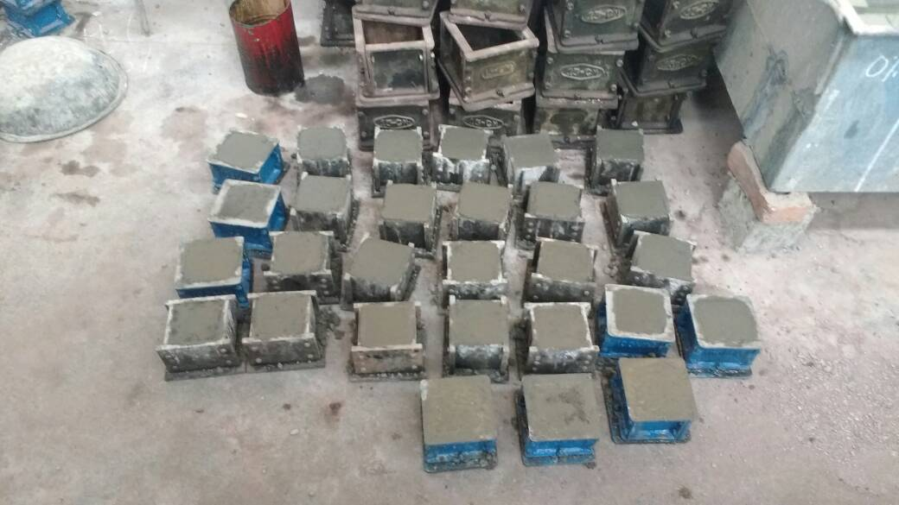

**Figure 2: Casted cube specimens**

At 14 and 28 days of age, specimens were removed from the curing tank. Specimens were removed from the curing tank, surface water was cleaned off, and testing started right away.

As seen in the figure, concrete cubes' compressive strength was evaluated using a Universal Testing Machine (UTM). The compressive strength of concrete cubes was determined by applying the load gradually and without shock until the specimen failed.

**4. Results and Discussion:**

The following ratios apply S1 (0%), S2(5%), S3(10%), S4 (15%), S5 (20%) and S6(25%) of RHA when added to M20 grade concrete once fine aggregate is substituted with RHA.

**Table 5: Test results for compressive strength**

|  |  |  |  |
| --- | --- | --- | --- |
| **Mix** | **RHA** | **Avg.(14D) MPa** | **Avg.(28D) MPa** |
| S1 | 0% | 27.2 | 32.32 |
| S2 | 5% | 22.93 | 24.1 |
| S3 | 10% | 19.92 | 21.38 |
| S4 | 15% | 14.72 | 17.25 |
| S5 | 20% | 10.3 | 12.93 |
| S6 | 25% | 6.12 | 8.19 |

Rice Husk Ash can help boost compressive strength at modest replacement levels (up to 20% of fine aggregate). RHA has reduced permeability and provide denser concrete by filling up mix voids. Depending on additional variables like the curing conditions and the RHA's fineness, the concrete may exhibit a little drop in compressive strength or an increase at moderate replacement levels (more than 20%). The concrete's compressive strength may decline with high replacement levels (over 20%). RHA has a lower density than natural fine aggregates, therefore replacing too much of it could make the concrete weaker, particularly if the ash is not treated correctly or doesn't have pozzolanic reactivity.

**Figure 3: Comparison of Compressive strength of concrete with replacement of fine aggregate with 10% RHA**

It’s found that compressive strength values of M20 with 5% replacement of RHA are higher than those of M20 with 10% replacement. RHA contains silica (SiO₂), which can help generate more calcium silicate hydrate (C-S-H) gel when activated by water. This increases the strength and durability of concrete. The RHA's fineness and carbon content, however, determine how much of this benefit is realized (unburned material can diminish the reactivity).

Concrete's compressive strength can be increased by substituting rice husk ash (RHA) for fine aggregates, particularly when the RHA is ground fine and utilized in moderate amounts (10–20%). Concrete's compressive strength may suffer from excessive RHA use. To get the greatest strength-to-durability ratio, the replacement percentage must be optimized. Achieving positive outcomes also depends on managing the curing procedure and the mix design as a whole.

**5. CONCLUSIONS**

Based on the study, it can be concluded as follows

1. The type and quantity of curing that is done before to the test affect the concrete's compressive strength. According to experiments, strength after 28 days is greater than that after 7 days.

2. The strength values of M20 with 5% replacement of RHA are higher than those of M20 with 10% replacement.

3. Compared to M20 with 15% replacement, M20 with 10% replacement exhibits greater strength values. This indicates that the strength value falls as the proportion rises.

Disclaimer (Artificial intelligence)

Option 1:

Author(s) hereby declare that NO generative AI technologies such as Large Language Models (ChatGPT, COPILOT, etc.) and text-to-image generators have been used during the writing or editing of this manuscript.

Option 2:

Author(s) hereby declare that generative AI technologies such as Large Language Models, etc. have been used during the writing or editing of manuscripts. This explanation will include the name, version, model, and source of the generative AI technology and as well as all input prompts provided to the generative AI technology

Details of the AI usage are given below:

1.

2.

3.

**REFERENCES**

1. BIS: 10262-2009: Recommended guidelines for concrete mix design, Bureau of Indian Standard, New Delhi-2004
2. BIS: 1199-1959 (Reaffirmed 2004): Methods of Sampling and Analysis of Concrete, Bureau of Indian Standard, New Delhi-1999
3. BIS: 2386 (Part I)-1963 (Reaffirmed 2002): Methods of Test for Aggregates for Concrete, Bureau of Indian Standard, New Delhi-1963
4. BIS: 456-2000 (Reaffirmed 2005) : Code of practice- plain and reinforced concrete, Bureau of Indian Standard, New Delhi-2000
5. BIS: 516-1959 (Reaffirmed 2004): Methods of tests for strength of concrete, Bureau of Indian Standard, New Delhi-2004
6. BIS: 4031 (Part 4, 5&6)-1988: Methods of Physical Tests for Hydraulic Cement, Bureau of Indian Standard, New Delhi-1988
7. Chandrasekhar S, Satyanarayana K G. Pramada N, Raghavan P and Gupta N (2023) Review Processing, properties and applications of reactive silica from rice husk. *Mat Sci* **38**:3159–168
8. Chandraul K , Singh M K, Saxena A K and Arora T. R. (2015) Experimental Study of RHA Concrete.*Res App Sci & Engg Tech* **3**:77-82.
9. Chindaprasirt P and Rukzon S (2018) Strength, porosity and corrosion resistance of ternary blend Portland cement, rice husk ash and fly ash mortar.Const & Buld Matr**22**: 1601–1606.
10. Ghosal S and Moulik S (2015) Use of Rice Husk Ash as Partial Replacement with Cement In Concrete. *Engg Res***4**: 506-09.
11. Hossain T, Sarker K S and Basak C (2021) Utilization potential of rice husk ash as a construction material in rural areas. *Civ Engg* **2**: 175-88.
12. Kachwala A, Pamnani and Raval A (2023) Effect of Rice Husk Ash as a Partial Replacement of Ordinary Portland cement in Concrete.*Intl Res Engg & Tech* **2:**175-77.
13. Tuana N, Yea G, Breugela V K, Fraaija A and Buib D (2021) The study of using rice husk ash to produce ultra-high performance concrete. *Const & Build***25**:2030–35.