Case report

SYSTEMIC COMPLICATIONS RESULTING FROM ODONTOGENIC INFECTION: CASE REPORT

.
ABSTRACT

Intensive Care Units (ICUs) aim to meet the care needs of patients requiring continuous observation by an interdisciplinary and multidisciplinary team, with the dentist playing a key role in adapting to the patient's needs, prioritizing their healing process and well-being according to their condition. This is particularly relevant in cases of periapical infection, the most common form of odontogenic infection, which, though often localized, can spread and lead to serious complications such as Mediastinitis, an inflammation of the mediastinum in the loose connective tissue.This report aims to present the hospital management of the treatment of a dental-origin infection, starting in the lower left third molar, which affected the mediastinum, thus highlighting the importance of having a dentist in ICUs. It was conducted at the Dr. Carlos Alberto Studart Gomes Hospital in Messejana (HM), where a female patient, without comorbidities, was admitted with a history of a dental abscess affecting the oral space, along with fever, tachycardia, intense dyspnea, edema, and other symptoms. She presented persistent toxemia (marked leukocytosis of 22,400 mm³ and elevated CRP of 22.90), thrombocytosis, and a marked edematous syndrome in the lower limbs. A combined surgery between Dentistry and Cardiac Surgery was indicated, which performed a pericardiostomy. The dental team extracted the tooth involved, performed an extraoral puncture of the affected facial space, submandibular drainage, and installed a drain. Fifteen days post-operatively, the patient showed good healing, with no signs or symptoms of inflammation or persistent infection. Laboratory tests also showed significant improvement (leukocytes 12,000 mm³ and CRP 9 mg/L), and she was discharged from the hospital.

Keywords: Mediastinitis. Hospital Dental Team. Third molar.

- INTRODUCTION

Intensive Care Units (ICUs) aim to meet the care needs of patients whose condition requires continuous observation by an interdisciplinary and multidisciplinary team. The presence of a dentist in ICUs becomes important, as the patients admitted there have immunosuppression and complex health conditions, making them more susceptible to oral and/or systemic infections, which can aggravate their general condition (Santana et al., 2021).
Dentists perform a variety of activities in hospitals, such as providing oral hygiene guidance, relining prostheses, performing restorations, tooth extractions and surgical treatments for multiple trauma patients, in addition to diagnosing complications resulting from treatments or complex systemic diseases, performing biopsies and exfoliative cytology, and treating oral pathologies, such as infections of odontogenic origin, both in the hospital bed and in surgical centers. Hospital Dentistry was officially recognized as a specialty in 2023 in Brazil. This role of dentists requires adapting to existing conditions,both in terms of patients and the work environment (Barros et al.,2019; Lemos; Piccinin, 2020; Veras et al.,2024)
Periapical infection is the most common form of odontogenic infection, with contamination by bacteria via the root canals and periodontal tissues, through the apical foramen, inducing an inflammatory process that can lead to the formation of an abscess (Ogle, 2017). Ventilator-Associated Pneumonia (VAP) or Nosocomial Pneumonia is a very common infection in the ICU environment. The endotracheal tube acts as a communicator of microorganisms from the oropharynx to the lower respiratory tract, which are then the etiological agents of VAP (Vidal, 2017; Veras et al., 2024).
Infectious processes can remain localized, but they are also capable of reaching great distances, leading to serious complications such as sinusitis, mediastinitis, involvement of the pleura or pericardium, brain abscess, and even death (Alphonse et al., 2017; Barbosa et al., 2020).
The lower third molars are the dental elements most frequently found in inclusion, which may be bony or submucosal and even semi-inclusion (Madeira, 1995) and when infections originating in these teeth reach the physiological spaces, such as the anterior, middle and posterior mediastinal space, they can cause mediastinitis (Soylu et al., 2019).
Mediastinitis corresponds to an inflammation of the mediastinum, in the connective tissue loose that composes it. The mediastinum consists of a thoracic cavity that contains the heart, the thymus, some lymph nodes, aorta, part of the esophagus, thyroid and parathyroid glands (Silva, 2017). Descending Necrotizing Mediastinitis (DNM) represents the acute type of infection that reaches the mediastinum through the cervical anatomical spaces (Ayvaci; Gokdag, 2022).
The anatomical spaces are responsible for being direct communicators of the cervical region with the mediastinum, structuring themselves in pathways that facilitate the collection of purulent matter, benefiting the proliferation of microorganisms due to the fact that they are poorly vascularized (Silva et al., 2017), in three ways: paratracheal route to the anterior mediastinal space, lateral route of the pharynx to the medial mediastinal space and retropharyngeal route to the posterior mediastinal space (Soylu, 2019). The most common oropharyngeal infection found is odontogenic infection with abscess in the lower second or third molar (Nobuaki et al., 2017).
DNM is a serious and rare condition that systematically compromises the patient, who often presents with fever, dyspnea, cervical and pharyngeal edema, dysphagia, odynophagia, hyperemia and pain (Weise et al., 2019; Ayvaci; Gokdag, 2022).
The relevance of the dentist as a fundamental member of the hospital team is highlighted, monitoring the progression of the case and demonstrating his active and essential participation in the surgical center. The poor prognosis is due to late and inadequate diagnosis. Therefore, the aim of this study is to report the hospital management of an odontogenic infection originating from the lower left third molar, which extended to the mediastinum, resulting in mediastinitis.

2. methodology

This is a case report. The study was approved by the ethics committee of the Dr. Carlos Alberto Studart Gomes Hospital de Messejana (HM) under opinion 4,792,042. HM is a reference institution for the North and Northeast regions and provides care for patients with heart and lung diseases. Patient MSDA, a 25-year-old female resident of Maracanaú, with no previous comorbidities, classified as ASA I, was admitted to the hospital with a history of dental abscess affecting the left buccal space on May 10, 2021 (Figure 1).
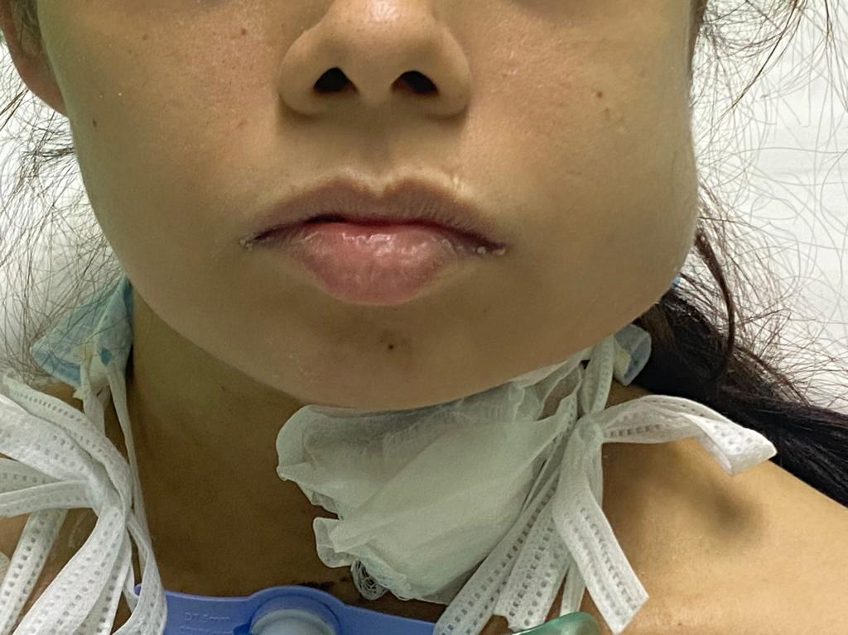
Fig 1: Dental abscess affecting the left buccal space
Physical examination revealed fever of 38.5°C, tachycardia, severe dyspnea, left cervicofacial edema and erythema, dysphonia, dysphagia, generalized malaise, marked trismus, foul odor in the oral cavity, headache, intense facial pain and toothache. The patient had undergone cervical drainage in another hospital service, evolving with subsequent recurrence of the abscess, together with antibiotic therapy for three days with Meropenem and one day with Vancomycin, but without regression of the general condition and presenting worsening of the clinical condition. Her chest tomography showed a large mass with fluid content, suggestive of an anterior mediastinal abscess with absolute indication for emergency cardiac surgery. Therefore, the patient was promptly referred to the emergency department of the cardiopulmonary referral hospital in the city of Fortaleza. Upon admission, a nasopharyngeal swab (RT-PCR) antigen test for COVID-19 was performed, which resulted in undetectable results. It is worth mentioning that the patient presented a Simplified Acute Physiology Score III (index used in ICU admissions to predict hospital mortality) with a value of 63, presenting a 55.4% mortality rate.
A new chest tomography scan was performed at the hospital, which revealed, in addition to the anterior mediastinal abscess, bilateral pleural effusion (Figure 2). 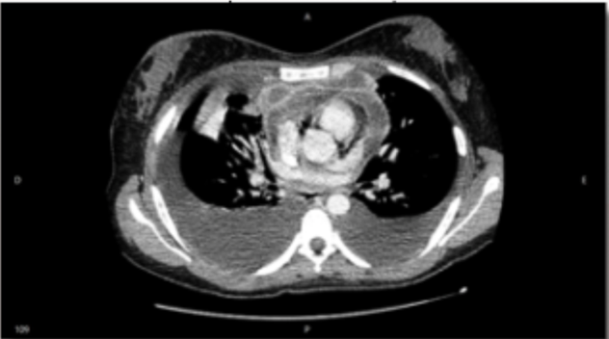(a) 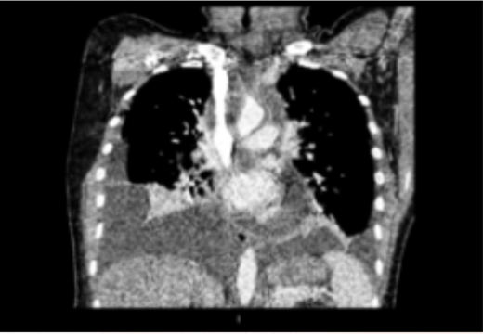 (b)
Fig 2: Computed tomography in axial (a) and coronal (b) slices.

Emergency surgical treatment was performed by video- assisted thoracoscopy, with right lung decortication, left pleuroscopy, bilateral closed pleural drainage and tracheostomy. At this time, a low cervical abscess exploration was also performed. On the second postoperative day, an echocardiogram was performed, which showed pericarditis and significant pericardial effusion with engorged vena cava, secondary to the infectious process of the anterior mediastinum. A facial tomography was performed which showed infection of the buccal and submandibular spaces left, related to the ipsilateral lower third molar, tooth 38 (Figura 3).
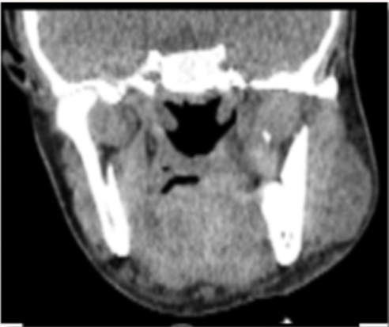 (a) 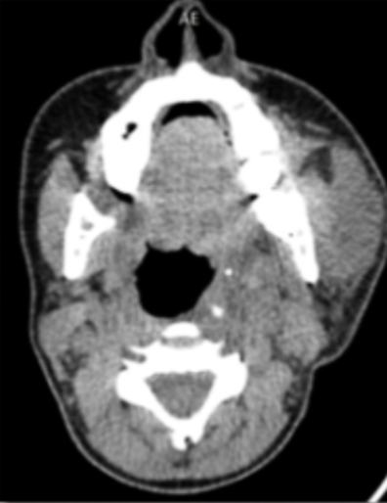 (b)
Figura 3: Facial tomography in axial (a) and coronal (b) slices

At that time, she presented persistent toxemia (marked leukocytosis of 22,400 mm3 and elevated CRP of 22.90), thrombocytosis and marked edematous syndrome in the lower limbs. Combined surgery between Dentistry and Cardiac Surgery was indicated, which performed pericardiostomy.
The dentistry team performed extraction of the tooth involved in the extraoral puncture of the affected facial space, submandibular drainage and installation of a drain. In order to reduce the chances of trans- or postoperative hemorrhage, the antiplatelet therapy (Acetylsalicylic Acid, 2g per day) was suspended (figure 4).
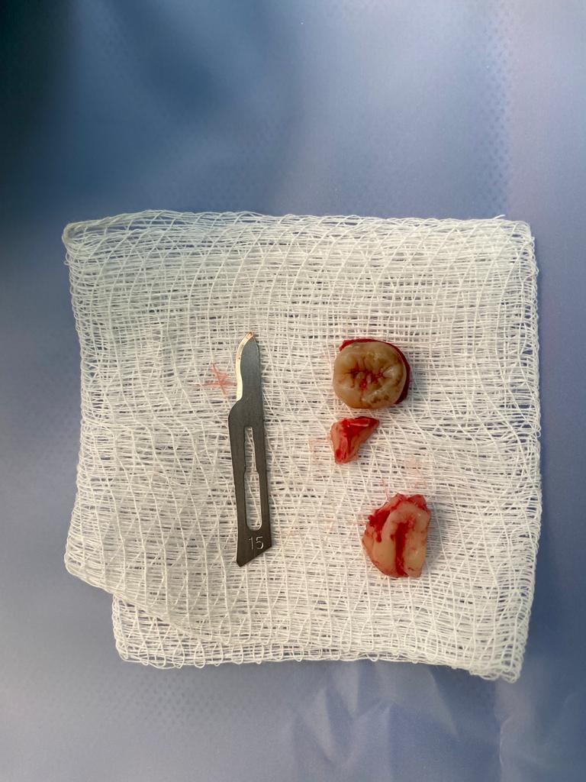
Fig 4: Extraction of the tooth
The patient was kept in the Intensive Care Unit (ICU) in the postoperative period with ventilatory support, adequate nutritional support and drug therapy indicated to stabilize the condition. As antibiotic therapy, intravenous use of Vancomycin 500 mg every 8 hours and Meropenem 1g every 8 hours was maintained to cover gram-negative and gram-positive bacteria. Physiotherapy was started on the third postoperative day to reduce trismus, which showed a good response, thus favoring greater acceptance of oral diet, with consequent improvement in nutritional status. Seven days after the extraction and facial drainage, the extraoral drain was removed and sutured. On this occasion, manual drainage was performed in which a considerable amount of purulent blood collection was removed by extraoral access and intraoral access, with spontaneous drainage via the alveolus.
After 15 days postoperatively, the patient presented good healing, with no signs or symptoms of inflammation or persistent infection, in addition to the laboratory tests showing significant improvement (leukocytes 12,000 mm3 and CRP 9 mg/L), and was discharged from hospital ( Figure 5).

Fig 5: After 15 days postoperatively

- results and discussion

The role of the dentist in a hospital environment is important, as it integrates the care of patients hospitalized in ICUs, minimizing the risk of complications from pathogens in the oral cavity that cause systemic problems (Amaral et al., 2012) such as the case reported in this study.
The patient was admitted to the hospital with a leukocyte count of 22,400 mm3, which according to Rosenfeld et al (2019), would be extremely above the reference values for adult women, where the limit would be 2,883 mm3 to 12,000 mm3. Leukocytes constitute markers against infections of the body, whether bacterial or viral. After the patient's tooth extraction, that is, after the removal of the infectious focus, her leukocyte levels stabilized and normalized.
The human neck has structures that are surrounded by superficial and deep cervical fasciae that segment the neck into different compartments (Ucisik-Keser et al.,2019). The compartment formed together with a fascia is the fascial space, which is divided into three large groups. In the case of the patient, the space involved was the buccal area, affected by a dental abscess, which facilitated the spread of the purulent infection to the mediastinum. Odontogenic infections combined with bacterial virulence, decreased immunity of the host and late adequate treatment can lead the patient to hospitalization with the appearance of serious complications, being subjected to invasive procedures and surgical treatments, such as tooth extraction, extraoral drainage, cervicotomy and mediastinal drainage (Pucci et al, 2023).
Patients with mediastinitis undergo thoracotomy, which ensures exposure and cleaning of the mediastinum and pleural cavity (De Palma et al.,, 2022) followed by cervicotomy as a standardized initial approach (Parara et al, 2020), in addition to cervical drainage and removal of the infectious focus, in this case, tooth extraction later. The aforementioned patient in the case received video-assisted thoracoscopy, pleuroscopy, pleural drainage and tracheostomy as primary emergency treatment, in addition to exploration of the cervical abscess, emergency procedures caused by the odontogenic condition.
The diagnosis is made through clinical examination and mainly through computed tomography and complemented with laboratory tests, analyzing the number of leukocytes and C-reactive protein, which are indicative of infections. The patient had marked leukocytes and elevated CRP of 22.90 mg/L (reference value below 10). The main tomographic findings of a dental infection are pericoronal or periapical shadows of the tooth in question and soft tissue abscess with or without gas formation. In mediastinitis, it is possible to see the presence of liquid collections or abscesses, pleural or pericardial effusions, emphysema, lymphadenopathy, and venous thrombosis (Hassanein et al, 2020).
Antibiotic therapy should always be initiated as soon as possible, starting with a mixed microbiota, and readjusted based on the results of culture and antibiogram (Silva et al, 2017). As discussed in the reported case, the drug Meropenem was used, an antibiotic that acts against gram-positive and gram- negative bacteria, in addition to Vancomycin Hydrochloride, which acts against strains of Staphylococcus aureus and other gram-positive microorganisms.
The case presented here illustrated how an infection originating from a third molar affected the mediastinum, exacerbating the patient's condition. In view of this, this study emphasizes how the presence of a dentist in the multidisciplinary team in an Intensive Care Unit contributes significantly to the prevention, diagnosis, and treatment of oral conditions that can directly impact health. Rapid resolution was crucial for the favorable prognosis, highlighting the importance of additional studies that demonstrate the role of the dentist in the hospital context, especially in the resolution of cases of odontogenic origin.

4. Conclusion

We can conclude from this case report that the presence of the dentist in the Intensive Care Units are essential. This professional not only takes care of health patients' oral cavity, but can also prevent systemic complications resulting from infections odontogenic complications that can lead to death. By preventing and treating such complications, CD contributes significantly reducing the length of hospital stay and a favorable prognosis.

Consent

All authors declare that ‘written informed consent was obtained from the patient (or other approved parties) for publication of this case report and accompanying images. A copy of the written consent is available for review by the Editorial office/Chief Editor/Editorial Board members of this journal.

Ethical approval

All authors hereby declare that all experiments have been examined and approved by the appropriate ethics committee and have therefore been performed in accordance with the ethical standards laid down in the 1964 Declaration of Helsinki.

DISCLAIMER (ARTIFICIAL INTELLIGENCE)
Author(s) hereby declare that NO generative AI technologies such as Large Language Models (ChatGPT, COPILOT, etc.) and text-to-image generators have been used during the writing or editing of this manuscript.
references

Alphonse MM, Fidele NB, Dany KM, Olivier NK, Augustin MM, Rubina S. Management of Odontogenic Abscess in Patients with Sickle Cell Anemia: 5 Case Reports. J. Adv. Med. Med. Res. [Internet]. 2017 Mar. 20 [cited 2025 Feb. 28];20(6):1-5. Available from: https://journaljammr.com/index.php/JAMMR/article/view/25

Ayvaci, BM, Gokdag, E (2022). A rare case: descending necrotizing mediastinitis. Turkish journal of emergency medicine, v. 22,4, p. 230-232.

Hassanein, AG, Mohamed, EEH, Hazem, M, Sayed, AESME (2020). Assessment of prognosis in odontogenic descending necrotizing mediastinitis: a longitudinal retrospective study. Surgical infections, v. 21, n. 00, p. 709-715

Madeira, M.C. (1995) Anatomia da face: Bases anatofuncionais para a prática odontológica. (8a ed.). Editora Rocco.

Ochi, N, Wakabayashi, T, Urakami, A, Tomoki, Y, Ikemoto, N, Nagasaki, Y, Nakagawa, N (2018). Descending necrotizing mediastinitis in a health young adult. Therapeutics and clinical risk management, v. 14.

Ogle, O (2017). Odontogenic Infections. Dental Clinics of North America, v. 61, n. 2, p. 235-252.

Palma, A, Cantatore, MG, Gennaro, F, Signore, F, Panza, T, Brascia, D. et al (2022). Multidisciplinary approach in the treatmente of descending necrotizing mediastinitis: twentyyear single-center experience. Antibiotics, v. 11, n. 5, p.664.

Parara, E, Krasadakis, C, Toursounidis, I, Tsekoura, K, Mourouzis, C, Rallis, G (2021). Multidisciplinary approach in the treatmente of descending necrotizing mediastinitis: twentyyear single-center experience. Antibiotics, v. 11, n. 5, p.664.

Pucci, R, Cassoni, A, Carlo, DD, Bartolucci, P, Monaca, MD, Barbera, G (2023). Odontogenic-related head and neck infections: from abcess to mediastinitis: our experience, limits, and perspectives- a 5 year survey. International journal of environmental research and public health, v. 20, n. 4, p. 3469.

Rosenfeld, LG, Malta, DC, Szwarcwald, CL, Bacal, NS, Cuder, MAM, Pereira, CA. et al (2019). Valores de referência para exames laboratoriais de hemograma da população adulta brasileira: Pesquisa Nacional de Saúde. Revista Brasileira de Epidemiologia, v. 22.

Santana, MTP, Fernandes, VDG, Alencar, JAS, Lima, FO, Araújo, AS, Silva, QP et al (2021). Hospital dentistry: a brief review. Research, Society and Development, v. 10, n. 2, e4310212171.

Silva, KT, Júnior, EAG, Magro-Ernica, N, Griza, GL, Tomazi, FHS (2017). Mediastinite necrosante descendente após exodontia de terceiros molares. Revista Faculdade de Ciências Médicas de Sorocaba, v. 19, n. 4.

Soylu, E, Erdil, A, Sapmaz, E, Somuk, BT, Akbulut, N (2019). Mediastinitis as complication of odontogenic infection: A case report. Nigerian journal of clinical pratice, v. 22,6, p. 869-871.

Veras, P. M. O., Sampaio, E. F., Cetira Filho, E. L., Matos, Y. R., Carvalho, A. R., Henrique, I. F., ... & Feitosa, A. P. O. P. (2024). Assessment of pneumonia rates associated with mechanical ventilation in a covid-19 unit after insertion of the dentist into the multidisciplinary team. Brazilian Journal of Implantology and Health Sciences, 6(2), 56-70.

Vidal, CFL, Vidal, AKL, Monteiro, JGMM, Cavalcanti, A., Henriques, APC, Oliveira, M. et al (2017). Impact of oral hygiene involving toothbrushing versus chlorhexidine in the prevention of ventilator-associated pneumonia: a randomized study. BMC Infect Dis, 31;17(1):112.

Weise H, Naros A, Weise C, Reinert S, Hoefert S. Severe odontogenic infections with septic progress–a constant and increasing challenge: a retrospective analysis. BMC oral health. 2019 Dec;19:1-6.

