*Original Research Article*

**Knowledge Gaps and Educational Needs on Sexually Transmitted Infections Among Public School Students in Paudalho, PE**

.

**ABSTRACT**

|  |
| --- |
| Adolescence is a transitional phase into adulthood, marked by biological, cognitive, emotional, and social changes that make young people vulnerable to various risk situations, this vulnerability is exacerbated by a lack of adequate sexual education, increasing the risk of sexually transmitted infections (STIs). The aim of this study is to assess students’ knowledge gaps and misconceptions about STIs, among students at a public state school. The research was conducted with students from the Monsenhor Landelino Barreto Lins Reference High School (EREM-MLBL) in the municipality of Paudalho, Pernambuco, Brazil. The inclusion criteria for this study encompassed students who were regularly enrolled at EREM-MLBL and who voluntarily agreed to participate in the evaluative questionnaire. The evaluation questionnaire, created on the Google Forms platform, and administered individually ensuring the privacy of participants' information was made available after obtaining the Free and Informed Consent Form (TCLE). As a result, a total of 61 students responded to the questionnaire, with 52.5% identifying as male, 45.9% as female, and 1.6% as non-binary. Regarding the results, although students demonstrated knowledge about more common STIs, such as HIV, HPV, and hepatitis, there were significant gaps in their understanding of less well-known infections. Additionally, many students were unaware of the various modes of transmission of these infections. While 90.2% of the students recognized condoms as the safest method for preventing STIs, only 63.3% reported having used a condom during their first sexual encounter. Another notable finding is that, in the case of suspected infection, most students would turn to their parents or guardians, but few felt comfortable discussing sexuality openly, reflecting a communication barrier between young people and their families. Thus, there is a need for quantitative and qualitative improvements in interventions in the field of sexual education within both family and school settings. The lack of communication and adequate knowledge about STIs leaves adolescents vulnerable, underscoring the urgency of educational actions that provide clear and accurate information about sexual and reproductive health. |

*Keywords: Adolescence; High School; Questionnaire; Sexual Education; Vulnerability.*

**1. INTRODUCTION**

Adolescence is a transitional stage to adulthood, characterized by multiple changes in biological, cognitive, emotional, and social aspects, along with the adoption of new habits and behaviors (Sehnem et al., 2019). These changes create an intrinsic condition that makes young individuals more vulnerable to various risk situations (Amoras et al., 2015). Risky behaviors commonly adopted during puberty significantly contribute to the high prevalence of sexually transmitted infections (STIs) within this age group (Santarato et al., 2022; Costa & Nunes, 2017).

Sexually transmitted infections (STIs) encompass a group of infectious diseases primarily transmitted through sexual activity. According to the World Health Organization (WHO), STIs rank among the most prevalent diseases worldwide, constituting a major public health concern with negative consequences in the healthcare, social, and economic domains. The difficulty in early diagnosis complicates timely intervention, potentially leading to severe complications such as infertility, fetal loss, ectopic pregnancy, and premature death (Silva et al., 2017).

Each year, it is estimated that approximately 357.4 million new cases of the four most common and curable STIs occur globally: chlamydia (130.9 million cases), gonorrhea (78.3 million), syphilis (5.6 million), and trichomoniasis (142.6 million) (Rowley et al., 2019). Regarding STIs with only treatment options available but no cure, their prevalence is observed in both developed and developing countries, influenced by various socioeconomic, political, and cultural factors (Toledo et al., 2011). In Brazil, data indicate that 355,868 cases of Human Immunodeficiency Virus (HIV) infection were reported between 2010 and 2021, with the Northeast region accounting for the highest percentage in regional analysis (20.67%) (Matos & Zollner, 2022). Human papillomavirus (HPV), on the other hand, is a group of intracellular parasites capable of triggering squamous epithelial tumors in various anatomical sites (Morshed et al., 2014). Among STIs, HPV stands out as the most prevalent and is the primary risk factor for cervical cancer, which ranks as the third most common cancer among women. In Brazil, the estimated number of new cases for 2023 is 17,010, representing an incidence rate of 13.25 cases per 100,000 women (INCA, 2022).

These infections are a growing concern for researchers and healthcare professionals. Initially, STIs were predominantly observed in specific population groups; however, a shift in incidence dynamics has been noted, with adolescents aged 13 to 19 becoming increasingly affected. This demographic now represents a significant portion of reported cases, with a notably high morbidity rate (Soares et al., 2020). This scenario has emerged due to the earlier initiation of sexual activity among young individuals, often associated with improper or absent condom use and an increasing number of sexual partners throughout life (Magalhães et al., 2021).

Public health initiatives aimed at STI prevention, particularly those implemented within the school environment, have proven to be valuable tools in curbing the spread of these infections among the target population (Costenaro et al., 2020). According to Furlanetto et al. (2018), the Brazilian Ministry of Education addresses topics such as sexual orientation in a limited manner within the National Curriculum Parameters (PCN). These guidelines recommend that the topic be integrated transversely across different areas of basic education and approached through educational and pedagogical activities.

From this perspective, it is essential to enhance emancipatory educational interventions for adolescents, providing them with the necessary knowledge to make critically informed and responsible decisions, both individually and collectively, ensuring their well-being and that of their partners. Additionally, in-depth investigations into the various factors influencing young people's sexual health are necessary to develop contextually appropriate and sensitive interventions tailored to their specific needs (Campos et al., 2018; Barros et al., 2022).

Thus, the primary objective of this study was to identify and analyze gaps and domains of knowledge among students in a state public school, employing a semi-structured questionnaire via the Google Forms platform for data collection and subsequent tabulation.

**2. material and methods**

This study is characterized as a qualitative and descriptive research, conducted with students enrolled at Escola de Referência em Ensino Médio Monsenhor Landelino Barreto Lins (EREM-MLBL). The school is located in the Zona da Mata Norte region of Pernambuco, in the municipality of Paudalho, approximately 37 km from the state capital, Recife.

A dialectical approach was employed to deepen the understanding of the research problem. The choice of this methodological framework was driven by the need to comprehend the studied reality in its entirety, considering its multiple determinants and mediations within a broader context. This approach values the interconnectedness of different elements. Thus, the active participation of the research subjects was encouraged, not only at specific moments but throughout the entire investigative process.

The inclusion criteria for this study encompassed students who were regularly enrolled at EREM-MLBL and who voluntarily agreed to participate in the evaluative questionnaire. Given the above, the method used was convenience sampling, which is commonly employed in descriptive qualitative studies as it allows for the collection of detailed information from a specific group. Throughout the study, ethical principles were rigorously followed. Both the legal guardians of the adolescent participants and the students themselves were fully informed about the objectives, methodology, and benefits of the research. Prior to any procedures, they signed the Free and Informed Consent Form (TCLE), ensuring ethical compliance.

Initially, the research team engaged in discussions with the school administration and faculty to present the project and obtain an official endorsement, securing the institution’s commitment as a co-participant in the study. Subsequently, the research objectives, methodological procedures, potential risks, and benefits were clearly and accessibly communicated to the students.

The evaluative questionnaire was made available exclusively after obtaining the TCLE, ensuring that participation was voluntary. The semi-structured questionnaires were designed using the Google Forms platform and administered individually ensuring the privacy of participants' information. on prearranged dates over a 15-day period. The entire process was meticulously planned to avoid disruptions to the school’s academic routine, ensuring both the well-being of the participants and the quality of the collected data. The data underwent statistical analysis using frequency and proportion distribution, which was employed to describe the characteristics of the sample. This method was appropriate since the study was based on a limited sample, without comparisons with other groups.

**3. results and discussion**

Based on the questionnaire administered to assess the students' level of knowledge, it was possible to identify a wide variety of responses, highlighting different levels of understanding on the topic. This diversity of perceptions reflects both existing gaps and aspects well assimilated by the participants, contributing to a more comprehensive and detailed analysis of the investigated theme. Upon reviewing the responses, areas of strong understanding were identified, as well as others that required greater attention and clarification. In total, 61 students were interviewed, with 52.5% identifying as male, 45.9% as female, and 1.6% as non-binary. All participants in this study were regularly enrolled in high school, aged between 15 and 19 years, and were residents of the municipality of Paudalho/PE.

When students were asked about which STIs they were aware of, they were allowed to select more than one option. Among the results obtained, 43 students stated they knew about HIV/AIDS, 37 indicated knowledge of HPV, 22 mentioned Hepatitis B and Hepatitis C, 20 cited syphilis, 19 pointed to gonorrhea, and 18 mentioned genital herpes. Additionally, in smaller numbers, 4 students reported knowledge of trichomoniasis, and only 3 mentioned chlamydia. It is noteworthy that even for the most frequently selected options, there was still a significant number of respondents who were unaware of certain infections, as well as a substantial lack of knowledge about less common but potentially dangerous infections.

Similar findings were described in the study by Gomes et al. (2022), where the most significant percentages were related to widely known STIs, specifically HIV, HPV, and hepatitis in general, while the same young target audience demonstrated less knowledge about syphilis and herpes, or even claimed to be unaware of all of them. Genz et al. (2017), in turn, when investigating which infections 532 students from the final years of elementary school and high school claimed to know, reported that over 90% of both groups mentioned AIDS/HIV, while more than 60% indicated HPV. On the other hand, as in the present study, trichomoniasis and chlamydia were the least cited, appearing in less than 10% of all groups analyzed. These data underscore the urgent need to disseminate information about lesser-known STIs, given that the core of sexual education is knowledge applied preventively.

In the following question, students were asked to select the options that presented examples of STI transmission routes. In response, 51 indicated that the primary route of transmission is unprotected sexual relations, 19 reported contact with infected bodily fluids, and 16 pointed to sharing contaminated objects. In smaller numbers, only 11 mentioned vertical transmission, and 10 cited contact with infected mucosa. Among the incorrect options available, 6 students mentioned transmission through insect or animal bites, and only 1 cited airborne transmission. Although the primary and most intuitive route is indeed through unprotected sexual relations, individuals can come into contact with these microorganisms through other less frequently mentioned routes, indicating a critical flaw in the participants' understanding. In their study, Genz et al. (2017) emphasize the low level of knowledge about transmission routes, exposing vulnerabilities that adolescents could face as a result. The results of both studies align with the conclusions described by Alves & Aguiar (2020) in their integrative review, where they define the knowledge young people possess as insufficient and report harmful intimate behaviors to their health.

Next, students were asked whether STIs could be transmitted even if both partners were virgins (Fig. 1), where 59% stated that transmission could indeed occur, 21.3% were unsure, and 19.7% indicated that transmission could not occur in this way. In this case, unsatisfactory responses account for nearly half of the total percentage, given that there are certain situations, especially when the transmission routes mentioned in the previous question are involved, where STI infection occurs outside of sexual relations. A simple understanding of the term "sexually transmitted" is not enough to prevent infection by these pathogens, making it necessary to clarify the role of secretions and bodily fluids, such as blood, pre-ejaculate, breast milk, and even saliva, in the transmission process. Thus, it is essential to give greater emphasis to indirect transmission routes when discussing effective prevention (Spindola et al., 2019).

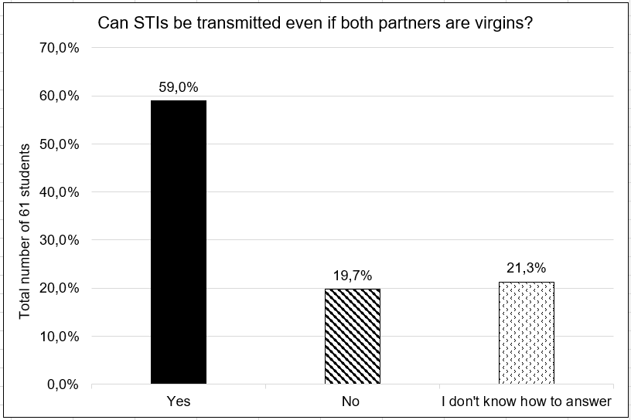

**Fig. 1. Percentage of students' responses regarding the possibility of STI transmission between virgin partners**

When the volunteers were asked whether it was possible to contract an STI through mouth kissing (Fig. 2), 47.5% responded affirmatively, while 37.7% answered negatively, and 14.8% stated they were unsure. These figures align with those previously reported and highlight widespread misconceptions among adolescents that need to be promptly addressed. The relevance of this question lies in the fact that even among young adults, there is a lack of accurate knowledge about this mode of transmission. In the study conducted by Orlandi et al. (2021), 61.7% of the total target audience claimed to be unaware of the possibility of contracting an STI through contact with saliva, kissing, and/or sharing utensils.

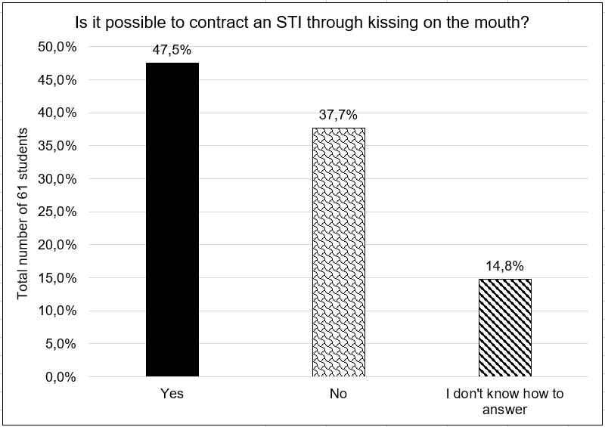

**Fig. 2. Data regarding students' responses on the possibility of contracting STIs through mouth kissing, expressed as percentages**

Subsequently, when asked whether the safest way to have sexual intercourse is by using a condom, 90.2% responded affirmatively, 6.6% were unsure, and only 3.2% stated that it was not the safest method. Here, a significantly positive result is observed regarding the participants' knowledge, indicating that this information is adequately reaching the target audience. However, understanding the indispensability of condoms for the protection of both parties is not enough, as it does not necessarily translate into their use during intimate moments. According to data from the Brazilian Institute of Geography and Statistics (IBGE) (2021), published in the National School Health Survey (PeNSE), only 63.3% of school-age adolescents reported using a condom during their first sexual intercourse; this number further decreases to 59.1% when asked about condom use during their last sexual encounter. These results remained largely unchanged compared to the previous census conducted in 2015, indicating stagnation in terms of STI prevention and awareness of the importance of safe sex among young people nationwide.

When respondents were asked to select examples of STI prevention methods, 53 students indicated condom use as the most frequently chosen option, followed by vaccination and sexual education through awareness campaigns, each receiving 28 selections. Additionally, among the incorrect options, 18 students selected hormonal contraception methods, which do not protect against invasive microorganisms, and 4 even pointed to the consumption of alcohol or illicit drugs before intercourse. In this case, the most concerning finding from this question lies in the completely misguided knowledge about emergency contraception, a fact also described by Souza et al. (2022), where 41.8% of respondents stated that the morning-after pill prevents STIs, while 27.8% did not respond or were unsure. It is emphasized that incomplete and erroneous information represents one of the main obstacles to the effectiveness of preventive actions and awareness about sexual and reproductive health, as it reinforces risky behaviors among misinformed individuals.

When asked if they knew about rapid tests for STI screening (Fig. 3), 59% indicated they were unaware of the tests, 29.5% stated they knew only some of them, and 11.5% claimed to know most of them. A clear communication gap is evident, as it is crucial for young people to be aware of the necessary methods to identify a potential infection, including knowing which tests to take in case of suspicion. To maintain safe sexual practices, not only should condom use be reinforced, but individuals should also know their partners' serological status, undergo regular testing, and, when necessary, implement pre- and post-exposure prophylaxis (Pereira et al., 2022).

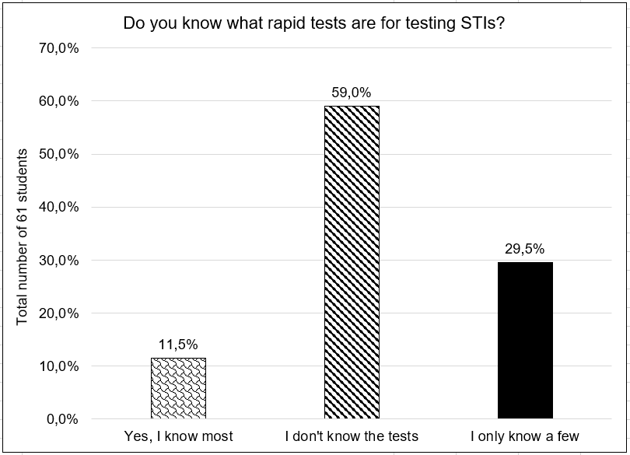

**Fig. 3. Percentage data on students' knowledge regarding rapid tests for STI detection**

In another question, students were asked who they would turn to first in case of a suspected STI (Fig. 4). The results revealed that 57.4% indicated parents or guardians as the first to be informed, 23% stated they would seek a Primary Health Care Unit (UBS), 13.1% pointed to going to a hospital, 4.9% mentioned informing the school, and only 1.6% indicated friends or peers.

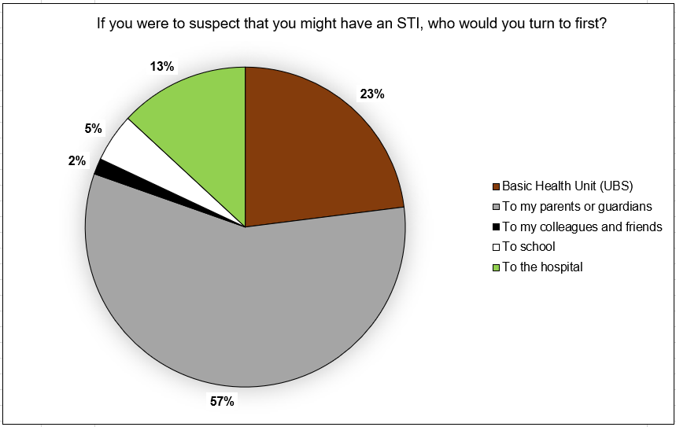

**Fig. 4. Students' responses regarding who they would turn to first in case of suspected STI infection, expressed as percentages**

Additionally, in the following question, students were asked whether they felt comfortable discussing topics related to sexuality, such as STIs, openly with their families and teachers (Fig. 5). 31.1% chose the option "I do not feel comfortable discussing this with any of them," 29.5% selected "I feel comfortable discussing this only with my family," 26.2% indicated "I feel comfortable discussing this with both," and only 13.1% stated "I feel comfortable discussing this only with the school."

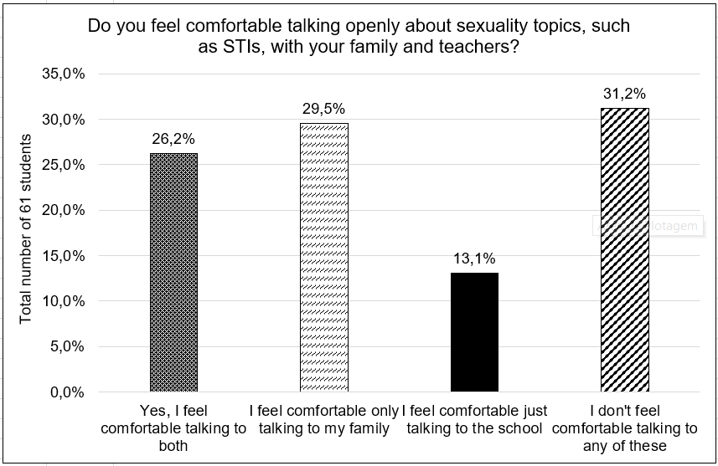

**Fig. 5. Percentage of students' responses regarding their level of comfort in discussing topics of sexuality, such as STIs, with family members or teachers**

By correlating the previous questions, it becomes possible to identify an incongruence in the perceptions of the interviewed students. In an emergency situation, more than half of these adolescents would inform their guardians about the possibility of infection, yet only one-third stated they have open communication and feel comfortable enough to discuss the mentioned topics, highlighting significant barriers in family communication. In the study conducted by Souza et al. (2022), 41.8% of the interviewed adolescents reported that their guardians had never discussed topics such as sexual relations, pregnancy, and STIs, and 57.1% stated they did not feel comfortable asking about these same subjects.

According to Almeida et al. (2017), most students agree that sexual education should be a shared responsibility between schools and families, although they recognize that the family’s role in this regard remains insufficient. This occurs due to the stigma surrounding this topic, which is considered taboo, leading parents — even those interested in promoting their children’s sexual and reproductive health — to feel hesitant to engage in open dialogue. Additionally, there are limitations in parents’ knowledge about human sexuality, as well as the details of STI transmission and prevention (Moreira et al., 2021). When there is a lack of conversations about sexuality at home, adolescents tend to engage in risky sexual behaviors, such as initiating sexual activity prematurely and engaging in unprotected relations, increasing the risk of contracting STIs and/or facing unintended pregnancies (Grossman et al., 2022). In light of this, Moizés and Bueno (2010) posit that:

Dialogue is the fundamental tool in the process of educating about sexuality. Some children and adolescents ask many questions, others ask nothing, and still others need an encouraging environment to raise questions. All should be considered as sexual beings and, therefore, should have access to informative materials about sexuality and age-appropriate literature. Dialogue is the natural exercise for developing adult relationships and fostering connections between people. Schools need to reassume the role of sexual education, not to reprimand but to change distorted or denied views of sexuality, without replacing the family, because children do not arrive at school without ideas but already carrying various impressions about sex. (Moizés & Bueno, 2010, p. 206)

Finally, in the last question, students were asked to evaluate the following statement: "Schools should provide better education on sexual health." In response, 55.7% fully agreed, 27.9% partially agreed, 11.5% were unsure, and only 4.9% partially disagreed. Thus, there is a clear interest among students in engaging in open dialogue with the school community, particularly with teachers and other professionals integrated into the health education process, who can provide specialized support and appropriate guidance.

Expanding the field of debate on sexual and reproductive health stimulates self-care practices and more responsible decision-making, as it helps address questions with scientifically grounded explanations. Therefore, by creating educational interventions that are socially and culturally contextualized, aiming to transform schools into safe spaces for discussions and promote the active participation of young people and their families, it becomes feasible not only to reduce STI cases but also to prevent adolescent pregnancy, foster ethical and respectful behaviors toward differences, and address sexual violence (Barbosa & Folmer, 2019; Pereira et al., 2022).

**4. Study limitations**

The present study, by reporting the perceptions of a portion of students from a school community regarding Sexually Transmitted Infections (STIs) and their general aspects, highlights the lack of knowledge among young people and the need for pedagogical interventions to address the identified challenges. Furthermore, it is important to note that the small number of students for simple random sampling represents a limitation in terms of generalizing the results. Nevertheless, the collected data still provide valuable insights into educational health deficits. This underscores the importance of expanding sexual and reproductive health initiatives within schools to promote informed and responsible behaviors among adolescents.

**5. Conclusion**

The analysis of the questionnaires revealed significant gaps in students' knowledge about STIs (Sexually Transmitted Infections), particularly regarding less common infections and non-traditional modes of transmission. While most students recognize the use of condoms as a preventive method, there are deficiencies in their understanding of other prevention strategies, such as rapid testing, and indirect modes of transmission. The lack of open communication about sexuality with both family members and schools also contributes to a limited learning environment. Therefore, it is imperative to expand educational initiatives on sexual health, addressing these issues in a more comprehensive and effective manner to promote preventive and responsible behaviors among young people. Schools provide an ideal setting for the development of such educational practices; however, it is essential to consider the target audience and adopt an appropriate language to effectively address this topic with young individuals.

Ethical Approval:

As per international standards or university standards written ethical approval has been collected and preserved by the author(s).

Consent

As per international standards or university standards, Participants’ written consent has been collected and preserved by the author(s).

Disclaimer (Artificial intelligence)

Option 1:

Author(s) hereby declare that NO generative AI technologies such as Large Language Models (ChatGPT, COPILOT, etc.) and text-to-image generators have been used during the writing or editing of this manuscript.

Option 2:

Author(s) hereby declare that generative AI technologies such as Large Language Models, etc. have been used during the writing or editing of manuscripts. This explanation will include the name, version, model, and source of the generative AI technology and as well as all input prompts provided to the generative AI technology

Details of the AI usage are given below:

1. The generative AI technology used was ChatGPT, which is based on large language models (LLMs) developed by OpenAI. The applied version is the most recent in the series, belonging to the GPT-4 (Generative Pre-trained Transformer 4) family. All of the generative artificial intelligence behind ChatGPT was developed and trained by OpenAI.
2. The technology was used strictly to assist in the translation of the manuscript from Brazilian Portuguese to English for the purpose of publication in the current journal. After the translation, the text was reviewed again by team members to identify and correct any potential translation errors.
3. The input prompt used was: ‘‘Translate the text from Portuguese to English, without altering the meaning of the sentences’’.

**References**

Sehnem, G. D., Crespo, B. T. T., Lipinski, J. M., Ribeiro, A. C., Wilhelm, L. A., & Arboit, J. (2019). Sexual and reproductive health of adolescents: perceptions of nursing professionals. Avances in Nursing, 37(3), 343-352.

Amoras, B. C., Campos, A. R., & Beserra, E. P. (2015). Reflections on the vulnerability of adolescents to sexually transmitted infections. PRACS: Electronic Journal of Humanities of the Social Sciences Course of UNIFAP, 8(1), 163-171.

Santarato, N., Barbosa, N. G., Silva, A. L. C., Monteiro, J. C. dos S., & Gomes-Sponholz, F. A. (2022). Characterization of adolescents' sexual practices. Latin American Journal of Nursing, 30(spe), e3712.

Costa, I. D., Nunes, N. N. S. (2017). Adolescents' understanding of the prevention and transmission of sexually transmitted infections in schools in the city of Presidente Médici, Rondônia, Brazil. Acta Biomedica Brasiliensia, 8(1), 12-23.

Silva, L. M., Cortez, E. A., Santo, J. N. E., & Cordeiro, B. C. (2017). Action research: promoting health education with adolescents about sexually transmitted infections. UFPE on Line Journal of Nursing, 11(9), 3642-3649.

Rowley, J., Vander Hoorn, S., Korenromp, E., Low, N., Unemo, M., Abu-Raddad, L. J., …& Taylor, M. M. (2019). Chlamydia, gonorrhoea, trichomoniasis and syphilis: global prevalence and incidence estimates, 2016. Bulletin of the World Health Organization, 97(8), 548.

Toledo, M. M., & Takahashi, R. F. (2011). Elements of individual vulnerability of adolescents to HIV/AIDS. Brazilian journal of nursing, 64, 370-375.

Matos, A. F. M., & Zollner, M. S. A. (2022). Epidemiology of HIV infections between 2010 and 2021 in Brazil. The Brazilian Journal of Infectious Diseases, 26, 102614.

Morshed, K., Polz-Gruszka, D., Szymański, M., & Polz-Dacewicz, M. (2014). Human papillomavirus (HPV)–structure, epidemiology and pathogenesis. Otolaryngologia Polska, 68(5), 213-219.

José Alencar Gomes da Silva National Cancer Institute (2022). 2023 Estimate: Incidence of Cancer in Brazil. Rio de Janeiro: INCA, (1), 11-155.

Soares Costa, I. V., et al. (2020). Interprofessionality in health: Experience of the interface between the School Health Program and the Expanded Family Health Center from the perspective of PET-Saúde. Brazilian Journal of Surgery & Clinical Research, 30(2).

Magalhães, E. F., dos Santos, F. G. B., de Barros, N. B., & Souza, L. F. B. (2021). Young adolescents: The factors of risk of sexually transmitted infections and protective factors. Brazilian Journal of Development, 7(12), 114491-114491.

Cosenaro, R. G. S., de Jesus, M. I. A., de Oliveira, P. P., Roos, M. D. O., Stankowski, S. S., Teixeira, D. A., …& de Souza, M. H. T. (2020). Sexual Education with adolescents: promoting health and socializing good social and family practices. Brazilian Journal of Development, 6(12), 100544-100560.

Furlanetto, M. F., Lauermann, F., Costa, C. B. D., & Marin, A. H. (2018). Sexual education in Brazilian schools: a systematic literature review. Research Notebooks, 48, 550-571.

Campos, H. M., de Paiva, C. G. A., de Araújo Mourthé, I. C., Ferreira, Y. F., Assis, M. C. D., & Fonseca, M. D. C. (2018). Dialogues with adolescents about sexual rights in public schools: emancipatory educational interventions!. Psychosocial Research and Practices Journal, 13(3), 1-16.

Barros, M. C., Monteiro, E. M. L. M., Farias, A. C. N., Neto, W. B., Araújo, E. C., Goes, P. S. A., … & Bushatsky, M. (2022). Empowerment of adolescents in vulnerable contexts through health education interventions. Revista Paulista de Enfermagem, 33(1).

Gomes, M., Sa, M. E. C. T., Dantas, M. C. B., Sampaio, M. S. N., Cavalcante, M. F. V., Flôres, P. R. F., ... & Benevides, B. (2022). Approach to STIs and teenage pregnancy in UBS in Ceará. APS EM REVISITA, 4(2), 149-155.

Genz, N., Meincke, S. M. K., Carret, M. L. V., Corrêa, A. C. L., & Alves, C. N. (2017). Sexually transmitted diseases: knowledge and sexual behavior of adolescents. Text & Context-Nursing, 26, e5100015.

Alves, L. S., & Aguiar, R. S. (2020). Sexual health and sexually transmitted infections in adolescence: an integrative review. Nursing (São Paulo), 23(263), 3683-3687.

Spindola, T., Oliveira, C. S. R., Santana, R. S. C., Sodré, C. P., André, N. L. N. O., & Brochado, E. D. J. (2019). Sexual practices, knowledge and behavior of university students in relation to Sexually Transmitted Infections. Rev Fund Care Online, 11(5), 1135-1141.

Orlandi, L. E., Rodrigues, A., & Garcia, N. G. (2021). Assessment of knowledge of young university students regarding sexually transmitted infections. Research, Society and Development, 10(9), e31210918077-e31210918077.

Brazilian Institute of Geography and Statistics (IBGE). (2021). Sexual and Reproductive Health. In: National School-Based Health Survey (PeNSE). Rio de Jane iro, RJ, (1), 83-89.

Souza, A. D., Gloria, M. S., Santos, G. P., Pereira, V. P., Sá, A. C. M., Marques, A. B. B., ... & Leite, L. F. A. (2023). Sexual education: assessment of the knowledge of adolescents at a school in the Jequitinhonha Valley-MG. ELO Magazine–Dialogues in Extension, 12.

Pereira, L. M., Leite, P. L., Torres, F. A. F., Lima, M. R. L., de Vasconcelos, M. N., Machado, L. D. S., & da Silva, M. R. F. (2022). Knowledge and attitudes of school adolescents about sexual and reproductive health. Hu Journal, 48, 1-10.

Almeida, R. A. A. S., Corrêa, R. D. G. C. F., Rolim, I. L. T. P., Hora, J. M. D., Linard, A. G., Coutinho, N. P. S., & Oliveira, P. D. S. (2017). Adolescents' knowledge related to sexually transmitted diseases and pregnancy. Brazilian Journal of Nursing, 70, 1033-1039.

Moreira, G. B. C., Silva Martins, G. B. B., Péret, I. S. A., Souza Pires, L. C., Carvalho Ribeiro, L. F., & Santos, L. I. (2021). Adolescents and sexually transmitted infections: risk behaviors and contextual factors that contribute to the increased incidence in Brazil. Interdisciplinary journal of medical sciences, 5(1), 59-66.

Grossman, J. M., DeSouza, L. M., Richer, A. M., & Lynch, A. D. (2021). Father-teen talks about sex and teens’ sexual health: The role of direct and indirect communication. International Journal of Environmental Research and Public Health, 18(18), 9760.

Moizés, J. S., & Bueno, S. M. V. (2010). Understanding of sexuality and sex in schools according to elementary school teachers. Journal of the USP School of Nursing, 44, 205-212.

Barbosa, L. U., & Folmer, V. (2019). Facilities and difficulties of sexual education at school: perceptions of basic education teachers. Education Journal of the Federal University of the São Francisco Valley, 9(19), 221-243.