**Co(II) and Zn(II) Complexes of New Aminopyrimidine Derived Schiff Base Ligand: Synthesis, Characterization of Spectral, Thermal And Biological Investigations**

______________________________________________________________________________

**Abstract:**

The new Heterocyclic Schiff base ligand Co(II) and Zn(II) complexes. The Schiff base ligand derived from 2-amino-4-hydroxy-6-methylpyrimidine and 2-Hydroxy-5-chlorobenzaldehyde to form Schiff base (L) was synthesized and characterized by IR and electronic spectroscopy, melting points, percentage metal analysis, conductance, and magnetic susceptibility measurements. The IR spectra indicated that the Schiff base (L) coordinated with the metal ions using the N donor atom of mine and the O donor atom of the naphthalene moieties. The percentage metal analysis,room temperature magnetic moment, and electronic spectroscopy showed that the complexes assumed an octahedral geometry. The molar conductance measurements in DMSO confi rmed the non- ionic nature of the complexes. The in-vitro antibacterial & antifungal acclivity indicated that the Schiff base and their heteroleptic metal complexes exhibited excellent antifungal and antibacterial activity against against *Aspergillus niger, Penicillium chrysogenum, Fusarium moneliforme and Aspergllus flavus* and *Escherichia coli, Salmonella typhi, Staphylococcus aureus, B. subtilis.* The result indicated that the complexes exhibited good antifungal and antibacterial activities.

**Keywords:** Heterocyclic Schiff bases, 2-amino-4-hydroxy-6-methylpyrimidine, 2-Hydroxy-5-chlorobenzaldehyde, Biological Activity.

______________________________________________________________________________

**Introduction:**

Schiff bases are an interesting group of compounds that play an important role in various fields of chemistry due to their promising properties. Due to the C=N group in Schiff bases structures, they show the potential ligand feature. One of the most characteristic features of the C=N bond is that it forms a complex with metals [1]. Due to many properties of Schiff bases such as thermal durability, liquid crystal feature, conductivity and chelate formation, their interest in scientific circles and their importance in our practical life is increasing day by day. This interest has accelerated the synthesis of new Schiff base and metal complexes with different properties and the expansion of their application areas [2]. Studies that initially focused on the synthesis of new compounds have now shifted towards expanding their usage areas. The liquid crystal feature seen in some metal complexes is used in the aircraft industry, television and computer screens, displays of digital clocks and many other industries.

One of the most interesting research topics for both chemists and physicists is the use of metal complexes in the manufacture of electrical and photoelectric devices such as diodes, transistors, sensors, photo detectors, and solar cells. Due to their potential use with flexible substrates, ease of production in continuous printing, large area application and significant environmental and economic benefits, they are considered alternatives to conventional semiconductor materials. Knowing and understanding the electrical and optical properties of inorganic complexes has led to their use in making inexpensive and efficient electronic and optical devices [3]. Organic semiconductors are commonly used in electronics and optoelectronic technology as materials, due to their interesting electrical and optical properties in recent years. Because organic semiconductor materials have easy film forming, low cost production and interesting electrical and optical properties.

The Schiff base ligands were studied notably because of artificial flexibility, selectivity, and sensitivity in the direction of the transition metallic ions. The architectural splendor of those coordination complexes arises because of the thrilling ligand structures containing distinct donor web websites in heterocyclic rings. In the remaining decades, Schiff bases have obtained a great deal of notable interest, especially due to their extensive utility in synthesis and catalysis [4]. Similarly, heterocyclic ligands containing nitrogen atoms are drawing a notable deal of interest in Coordination chemistry and homogeneous Catalysis [5]. Two or greater ability donor centers of amino heterocycles perform a critical position inside the comparative reactivity of bidentate ligand structures [6]. Furthermore,transition metallic complexes containing pyrimidine ligands are usually discovered in organic research and play critical roles in processes, which include catalysis of drug interplay with biomolecules [7]. A tumid variety of Schiff base ligands and metallic complexes are of big sake and interest due to their organic hobby inclusive of anti-tumor, antibacterial,fungicidal, and anti-carcinogenic properties [8]. Several complexes coordinated via the Schiff base ONNO donors were studied as oxygen service and they're beneficial fashions for bioinorganic processes [9]. The cobalt(II) and manganese(II) complexes with tetradentate Schiff base which coordinate via N2O2 donor atoms were notably researched as oxygen providers and additionally as catalysts for water-splitting structures [10].

The Schiff bases and their metallic complexes have had greater signifi cance recently [11] due to their utility as an organic, biochemical, analytical, antimicrobial, anticancer, antibacterial, antifungal, and anti-tumor hobby. They were studied as a category of ligands [12,13] and are acknowledged to coordinate with metallic ions via the azomethine nitrogen atom. The synthesis of transition metallic complexes with Schiff base ligands is studied because of sensitivity, selectivity, and artificial flexibility in the direction of metallic atoms [14,15]. They are used as catalysts, in medication like antibiotics and anti- inflammatory marketers, and inside the enterprise as anti-corrosion [16].

The search of the literature reveals that no work has been done on the transition metal complexes of the Schiff bases derived from 2-amino-4- hydroxy-6-methylpyrimidine and 2-Hydroxy-5-chlorobenzaldehyde. In this communication we report the synthesis of bidentate Schiff bases formed by the condensation of 2-amino-4-hydroxy-6-methylpyrimidine and 2-Hydroxy-5-chlorobenzaldehyde (Fig.5). The solid complexes of Co (II) and Zn(II) with these ligands have been prepared and characterized by different physicochemical methods.

**Materials And Methods:**

**Reagents and solvents:**

The 2-amino-4-hydroxy-6-methylpyrimidine (Aldrich sigma), 2-Hydroxy-5-chlorobenzaldehyde, metal nitrate of (AR grade) was used for the synthesis of ligand and metal complex.

**Synthesis of ligand:**

The The ligand was prepared by modifying a known method [17-19]. The Schiff base ligand was prepared by refluxing a mixture 0.01 mole (1.4057 g) 2-hydroxy-5-chlorobenzaldehyde and 0.01 mole (1.2513 g) 2-amino-4- hydroxy-6-methylpyrimidine in ultra-dry ethanol refluxed for about 4 h. The Schiff base thus formed was cooled to room temperature, collected by filtration, then recrystallized in ethanol and dried under vacuum over anhydrous calcium chloride (yield: 76%).

**Synthesis of metal complexes:**

A hot ethanol solution (25 ml) of ligand (2 molecules) and (25 ml) of metal nitric acid (1 mol) was added with constant stirring. The pH of the reaction mixture was set to 7-8, 10% alcohol ammonia solution was added, and the refluxed for about 3 hours. The precipitated solid metal complexes were filtered hot, washed with high-temperature ethanol, and dried over calcium chloride with a vacuum desiccators. (Yield: 73%)

**Physical Measurement:**

The IR spectra were recorded on FTIR (ATR)-BRUKER -TENSOR37 spectrometer using KBr pellets in the range of 4000-400 cm-1. 1H- NMR Varian mercury 300MHZ spectra of ligand were measured in CDCl3 using TMS as an internal standard. X-RD was recorded on BRUKER D8 Advance. TGA- DTA was recorded on Shimadzu. The carbon, hydrogen, and nitrogen contents were determined on the Elemental model vario EL-III. The UV-visible spectra of the complexes were recorded on model UV-1800, SHIMADZU spectrometer. The molar conductance of complexes was measured on an Elico CM 180 conductivity meter using 10-4 M solution in DMSO. Magnetic susceptibility measurements of the metal chelates were done on a Guoy balance at room temperature using Hg[Co(SCN)4] as a calibrate.

**Results And Discussion:**

The Schiff bases of 2-amino-4-hydroxy-6-methylpyrimidine and its complexes have a lot of programs inclusive of biological, medical, and analytical. The coordinating opportunity of 2-amino-4-hydroxy-6-methylpyrimidine has been advanced through condensing with a lot of carbonyl compounds. A try has been made to synthesize Schiff bases 2-amino-4-hydroxy-6-methylpyrimidine with 2-Hydroxy-5-chlorobenzaldehyde. Physical characteristics, microanalytical, and molar conductance records of ligand and steel complexes are given in (Tables 1 and 2). The analytical records of complexes reveal a 2:1 molar ratio (ligand: steel) and correspond properly with the overall formula [ML(H2O)2] in which M= Co(II) and Zn(II). The magnetic susceptibilities of Co(II) and Zn(II) complexes at room temperature are regular with excessive spin octahedral shape with water molecules coordinated to steel ion. The presence of coordinated water molecules was shown through TG-DTA analysis. The steel chelate answers in DMSO display low conductance and help their non-electrolyte nature. (Table 1)

**1H-NMR spectra of ligand:**

The 1H-NMR. Spectra of free ligand at room temperature show the following signals. 2.49 δ (s, 3H, Methyl hydrogen bonded to pyrimidine ring), 3.77 δ (s, 2H, Phenolic (OH) hydrogen of pyrimidine ring), 5.86 δ(s, 1H, Hydrogen bonded to pyrimidine ring ), 7.99 δ (s, 1H, hydrogen bonded to azomethine carbon), 7.5-7.8 δ (D,4H, Aromatic Ha, Hb, protons of phenyl ring).

**IR Spectra:**

The IR spectra of the complexes are compared with that of the ligand to decide the modifi cations that could have taken location for the duration of the complexation. The bands at 3583, 1670 1589, 1387, and 1225 cm-1 assignable to OH (intramolecular hydrogen-bonded), C=C(aromatic), C=N (azomethine), C- N (aryl azomethine) and C-O (phenolic) stretching modes respectively [18-20]. The absence of a vulnerable vast band inside the 3200-3400 cm-1 region, inside the spectra of the steel complexes shows deprotonation of the intramolecular hydrogen-bonded OH organization on complexation and next coordination of phenolic oxygen to the steel ion. This is similarly supported with the aid of using a downward shift in υ C-O (phenolic) with admire to lose ligand [21]. On complexation,the (C=N) band is shifted to decrease wave range with respect to free ligand, denoting that the nitrogen of azomethine organization is coordinated to the metal ion [22]. The C-N band is shifted to decrease wave range with admire to lose ligand, The IR spectra of steel chelates confirmed new bands in among the 500-800 and 400-500 cm-1 areas which may be assigned to M-O and M-N vibrations respectively [23]. The IR spectra of Co(II) and Zn(II) display a robust band inside the 3100-3600 cm-1 region, suggesting the presence of coordinated water in those steel complexes. The presence of coordinated water is similarly shown with the aid of using the advent of the non-ligand band in the 830-840 cm-1 region, assignable to the rocking mode of water. The presence of coordinated water is likewise set up and supported with the aid of using TGA/DTA evaluation of those complexes. Hence it's far concluded that the coordination takes location through phenolic oxygen and azomethine nitrogen of ligand molecules.

**Thermogravimetric analysis:**

The Dynamic TGAs with mass loss rates at different steps were recorded. Simultaneous TGA/DTA analysis of Co(II) examined α-Al2O3 as a reference from ambient temperatures up to 1000°C and as a reference to the nitrogen atmosphere. Analysis of the complex thermograms showed that the Co(II) complex of ligand L5 (Fig. 1) exhibited two-step decomposition. First weight loss between temperatures 5.69%. 60-1330C can correlate with two grid water losses (calculated by 6.15%). Water-free connections do not remain stable at high temperatures, but learn rapid decomposition in the range of 130-660°C,thereby learning a mass loss of 81.89% of the complex decomposition (calculated. 82.75%) in the second step. The decomposition is complete, leading to the formation of stable residues in the metal oxide CoO obs. 12.32% (calculated. 13.09%). The Tg curve of the Zn(II) complex of ligand L5 (Fig. 2) shows two steps. First weight loss between temperatures 5.98%. 75-1800C can correlate with two grid water losses (calculated by 6.15%). Water-free connections do not remain stable at high temperatures, but learn rapid decomposition in the 180-585°C range,thereby learning a mass loss of 65.81% of the complex decomposition (calculated. 66.87%) in the second step. The decomposition is complete, leading to the formation of stable residues in the metal oxide ZnO obs. 26.95% (calculated. 27.29%). Motion and thermodynamics, namely the changes in energy (EA),frequency coeffi cient (Z), entropy change (-S), and free energy (G) of non-isothermal decomposition of the complex, were determined using the Horowitzmetzger method. Degradation of complexes. A negative value for activated ropy indicates that the activated complex was slowly sorted more than the reaction. Ordered species can be attributed to polarization of binding in the activated state and can be caused by charge transfer transitions [25].

**Magnetic Measurements And Electronic Absorption Spectra:**

The electronic absorption spectrum of the L5 Co(II) complexes shows bands at 13567 cm-1 and 24881 cm-1 are assigned to 6A1g→ and 4T2g and charge transfer transitions. The Co(II) complexes were paramagnetic in nature indicating octahedral geometry [26,27]. The electronic absorption spectrum of the L5 Zn(II) complexes shows bands at 29329 cm-1. These transitions may be assigned to charge transfer transitions. The Zn(II) complexes were paramagnetic in nature indicating octahedral geometry [28-30]. All the Co(II) and Zn(II) complexes were paramagnetic in nature.

**Molar Conductivity Measurements:**

The metal Co(II) and Zn(II) complexes were dissolved in DMSO and the molar conductivity of 10-4M of their solution at room temperature was measured. The lower conductance values of the complexes support the non-electrolytic nature of the compounds.

**Table 1. Physical characterization, analytical and molar conductance data of compounds**

|  |  |  |  |  |  |
| --- | --- | --- | --- | --- | --- |
| Compound | Mol.Wt. | M.P. Decomp temp. 0C | Colour | μeff  B.M. | Molar Conduc. Mho. Cm2mol-1 |
| L5 | 263.70 | 142 | Yellow | -- | ---- |
| Co-L5 | 588.40 | >300 | Dark yellow | 4.57 | 61.82 |
| Zn-L5 | 591.41 | >300 | Faint yellow | 7.70 | 51.30 |

**Table 2. Elemental Analysis of Mn(II) and Fe(III) Complex:-**

|  |  |  |  |  |
| --- | --- | --- | --- | --- |
| Compound | Found (Calculated) | | | |
| C | H | N | M |
| L5 | 58.18 (59.18) | 4.14 (4.17) | 17.77 (17.89) | - |
| Co-L5 | 49.16 (50.10) | 4.13 (4.16) | 14.32 (14.44) | 9.32 (9.45) |
| Zn-L5 | 49.11 (49.88) | 4.10 (4.14) | 14.41 (14.51) | 9.31 (9.45) |

**Powder X-Ray Diffraction:**

The X-ray trackgrams of the Co(II) and Zn(II) complexes of L5 were scanned in the 20-80° range at a wavelength of 1.550 Å (Figs. 3, 4). The diffraction imaging and associated data show 2θ values for each peak,relative intensity, and inter planar distance (d value). The diffraction imaging of the Co(II) complex in L5 had Maxima and ten reflections at 2θ = 6.62°, which corresponds to a d value of 6.66 Å. The diffraction imaging of the Zn(II) complex in L5 had a reflection with a maximum value of thirteen reflections at 2θ = 6.64° corresponding to a d value of 6.68 Å. X-ray-based patterns of these complexes associated with key peaks of relative intensities greater than 10% were indexed using computer programming [31]. The above indexing method also introduces Miller Indices (hkl), unit cell parameters, and unit cell volume. The unit cells of the Co(II) complex in L5 resulted in values of grid constants of a = 9.55 Å, b = 10.35Å, c = 17.46 Å, and unit cell volume v = 1700.71859 Å3. Following these cellular parameters, we tested conditions such as A≠b≠C and α=β=γ= 900 required for orthorhombic samples and found them to be satisfactory. Therefore, it is concluded that the Co(II) complex has a orthorhombic crystal system. The unit cells of the Zn(II) complex in L5 resulted in values of grid constants of a = 10.31 Å, b = 9.98 Å, c = 19.31 Å, and unit cell volume v = 1959.38953 Å3. According to these cell parameters, conditions such as A≠b≠c and α=β=γ= 900 are required for orthorhombic samples. Therefore, it can be concluded that the Co(II) and Zn(II) complexes of L5 have a orthorhombic crystal system. Experimental density values for the complexes were determined using specific gravity methods [32,33] and found in Co(II) or Zn(II) complexes as 1.0768 and 1.0382 gcm-3. The number and volume of unit cells from Avogadro were calculated by using experimental density values, and molecular weight of the complex. The number of molecules per cell in a unit was calculated using the equation ρ = nM/NV and the Co(II) and Zn(II) complex. Theoretical densities were calculated with these values and were found in the 1.0649 and 1.0284 gcm-3 complexes,respectively. A comparison of experimental and theoretical densities shows good agreement within the limits of experimental error [34].

**Table: 3 The kinetic and thermodynamic parameters for decomposition of metal complexes**

|  |  |  |  |  |  |  |  |  |
| --- | --- | --- | --- | --- | --- | --- | --- | --- |
| **Complex** | **Step** | **Decomp. Temp.** (0C) | **n** | **Ea**  (kJmole-1) | **Z**  (S-1) | **ΔS**  (JK-1mole-1) | **ΔG**  (kJmole-1) | **Correl -ation coeffici-**  **Ent** |
| Co-L5 | I | 330 | 0.6 | 10.44 | 1.99 ×104 | -168.50 | 22.66 | 0.939 |
| Zn-L5 | I | 170 | 0.4 | 3.76 | 1.89 ×103 | -185.49 | 13.64 | 0.948 |
| II | 450 | 0.8 | 15.01 | 2.86 ×104 | -167.00 | 29.53 | 0.981 |

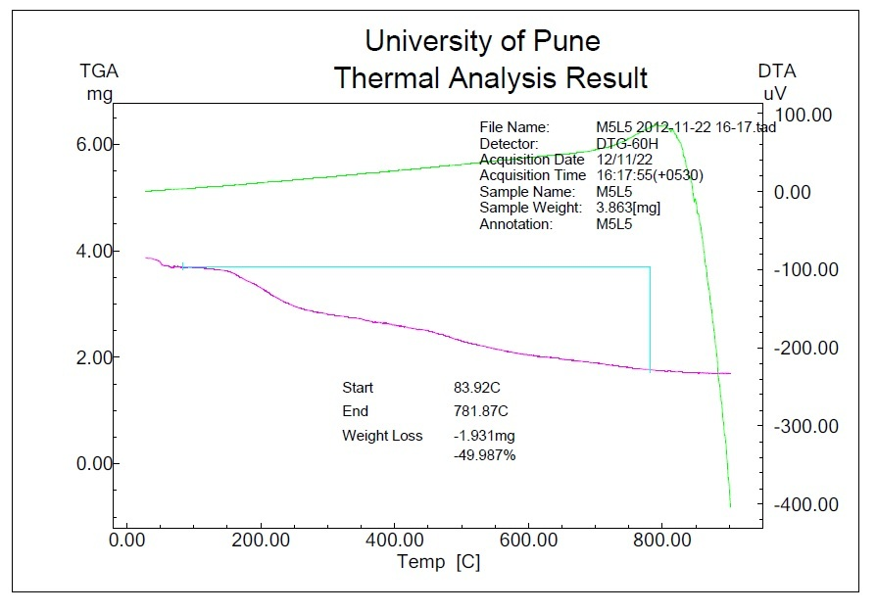

**Fig. 1 TGA-DTA Curve of Co (II) Complex of Ligand L5**

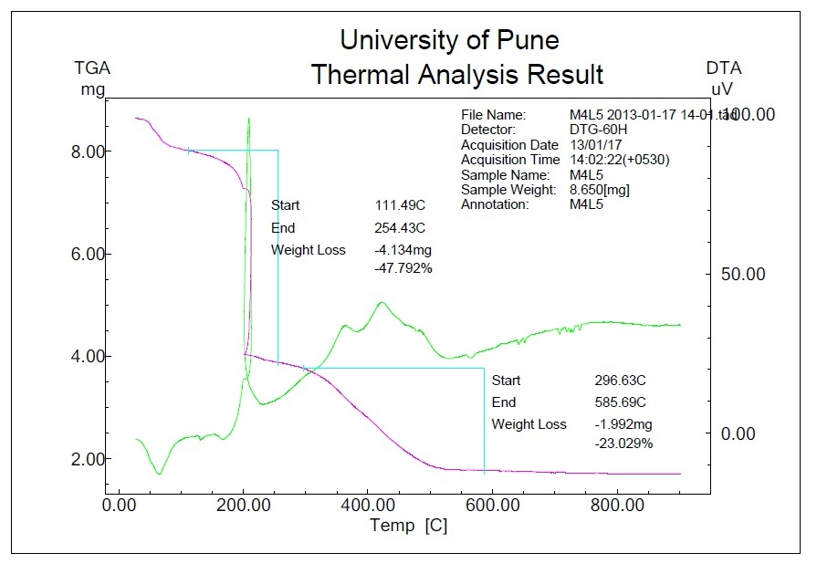

**Fig. 2 TGA-DTA Curve of Zn (II) Complex of Ligand L5**



**Fig.3 X-Ray Diffractogram of Co (II) complex of L5**



**Fig.4 X-Ray Diffractogram of Zn (II) complex of L5**

**Antibacterial activity:**

The Antifungal activity and Antibacterial activity of the ligand and metallic complexes have been examined in vitro in opposition to fungal including *Aspergillus niger, Penicillium chrysogenum, Fusarium moniliform, Aspergillus flavus,* and microorganisms including *E. Coli, B.Subtilis, S. aureus, And Bacillus subtlis* through paper disc plate method [35-38] The compounds have been examined on the concentrations 1% and 2% in DMSO and comparison with recognized antibiotics viz *Griseofulvin* and *Penicilin*. (Tables 4 and 5), it's miles determined that the inhibition through metallic chelates is better than that of a ligand and consequences are inappropriate settlement with preceding findings with admire to comparative pastime of loose ligand and its complexes [39-41]

**Table 4****Antifungal activity of ligands**

|  |  |  |  |  |  |  |  |  |
| --- | --- | --- | --- | --- | --- | --- | --- | --- |
| **Test Compound** | **Antigungal growth** | | | | | | | |
| ***Aspergillus***  ***Niger*** | | ***Penicillium***  ***chrysogenum*** | | ***Fusarium***  ***moneliforme*** | | ***Aspergillus***  ***flavus*** | |
| **1%** | **2%** | **1%** | **2%** | **1%** | **2%** | **1%** | **2%** |
| L5 | -ve | +ve | -ve | -ve | -ve | -ve | -ve | +ve |
| Co- L5 | +ve | -ve | -ve | -ve | -ve | -ve | +ve | -ve |
| Zn- L5 | -ve | -ve | -ve | -ve | -ve | -ve | +ve | -ve |
| **+ve control** | +ve | +ve | +ve | +ve | +ve | +ve | +ve | +ve |
| **-ve control (Griseofulvin)** | -ve | -ve | -ve | -ve | -ve | -ve | -ve | -ve |

*Ligand & Metal : +ve – Growth ( Antifungal Activity absent )*

*-ve - Growth ( Antifungal Activity present )*

**Table 5 Antibacterial activity of ligands and their metal complexes**

|  |  |  |  |  |  |  |  |  |
| --- | --- | --- | --- | --- | --- | --- | --- | --- |
| **Test Compound** | **Diameter of inhibition zone (mm)** | | | | | | | |
| ***E. Coli*** | | ***Salmonella***  ***typhi*** | | ***Staphylococcu***  ***saureus*** | | ***Bacillus***  ***subtlis*** | |
| **1%** | **2%** | **1%** | **2%** | **1%** | **2%** | **1%** | **2%** |
| L5 | 16mm | 19mm | 13mm | 17mm | 22mm | 28mm | 17mm | 24mm |
| Co- L5 | 15mm | 18mm | 14mm | 19mm | 16mm | 19mm | 13mm | 20mm |
| Zn- L5 | 13mm | 19mm | 15mm | 22mm | 12mm | 18mm | 15mm | 23mm |
| **DMSO** | -ve | -ve | -ve | -ve | -ve | -ve | -ve | -ve |
| **Penicillin** | 16mm | 16mm | 19mm | 19mm | 32mm | 32mm | 22mm | 22mm |

*Ligand & Metal: - ve - No Antibacterial Activity*

*Zone of inhibition - --mm*



**Figure 5. Structure of ligand**



**Figure 6. The Proposed Structure of the complexes**

**When M=Co(II) and Zn(II).**

**Conclusion:**

In light of the above discussion, we have proposed octahedral geometry for Co(II) and Zn(II) complexes. Based on the physicochemical and spectral data discussed above, one can assume that the ligand behaves as dibasic, NO bidentate, coordinating via phenolic oxygen and imino nitrogen as illustrated in Fig.6. The complexes are biologically active and show enhanced antimicrobial activities compared to the free ligand. Thermal study reveals thermal stability of complexes. The X-ray study suggests a orthorhombic crystal system for Co(II) and Zn(II) complexes.

**References:**

[1]. D.T.Sakhare,Synthesis, Spectroscopic Characterization And Biological Evaluation of Transition Metal Complexes of Novel Schiff Base Ligand,World Journal of Pharmacy and Pharmaceutical Sciences, 2025,14(3),775-788.

[2]. D. T. Sakhare, Synthesis, Characterization and Antimicrobial Activity of Schiff Base Derived from 2-Hydroxybenzaldehyde with 2-Amino-4,6- Dimethylpyrimidine And Their Transition Metal Complexes, GIS Science Journal, 2022, 9(4), 82-94.

[3]. N. Raman, V. Muthuraj, V. Ravichandran, S. Kulandaisamy, Journal of Chemical Sciences, 115, (2003) 161 – 167.

[4]. D.T. Sakhare, Synthesis, Characterization and Biological Activity of New Pyrimidine Schiff Base and Its Cu(II), Ni(II) Complexes, Asian Journal of Chemical Sciences, 2025,15(1),138-147.

[5]. D.T.Sakhare, Copper Metal Complexes of a Pyrimidine Based Schiff Base Ligand Synthesis, Characterization and Biological Activity, Journal of Xidian University, 2022, 16(3), 191-201.

[6]. B.T. Thaker., P.K. Tnadel, A.S. Patel, C.J. Vyas, M.S. Jesani and D.M. patel., Indian. J. Chem., 44 A, ( 2005) 265.

[7]. D.T.Sakhare, Synthesis, Characterization And Biological Studies of Aminopyrimidine Schiff Bases And Their Transition Metal Complexes, Dickensian Journal, 2022,22(4),65-77.

[8]. D.T. Sakhare, Synthesis, Characterization, Thermal and Antimicrobial Studies of Novel Schiff Base Ligand and its Ni(II) and Zn(II) Complexes,International Journal of Advanced Research in Chemical Science,2025,12(1),12-20.

[9]. D.T. Sakhare, Synthesis, characterization and biological activities of new bidentate Schiff base ligand and their Co (II) metal complexes, 2024, Materials Today: Proceedings, online.

[10]. D.T. Sakhare, Synthesis, Characterization, And In-Vitro Biological Activities of Novel Bidentate Schiff Base Ligand And Their Cobalt (II) Complexes. Juni Khyat,2023, 13(07), No.03, 134-143.

[11]. D.T. Sakhare, Synthesis, Characterization of Spectral, Thermal and Antimicrobial Studies of Aminopyrimidine Schiff Base Ligand and Their Cr(II) and Fe(III) Complexes, International Journal of Science and Research, 2025,14(2), 1345-1351.

[12]. D.T. Sakhare, Synthesis, Characterization And Biological Activity of New Schiff Bases 1-(((4,6-Dimethylpyrimidin-2-Yl)Imino)Methyl)Naphthalen-2-ol And Their Fe (III) Complexes, Juni Khyat,2024,14,9(2),101-111.

[13]. G.G. Mohamed, M.M. Umar, A.M.M. Spectrochim, Actapart A 62, (2005) 1140.

[14]. D.T.Sakhare, Synthesis, Characterization and Antimicrobial Activity of Cu(II) Complexes Derived from Heterocyclic Schiff Bases Ligands, Asian Journal of Organic & Medicinal Chemistry, 2022, 7(2),41-47.

[15]. N. Raman, S. Thalamuthu, J. Dhaveethuraja, M.A. Neelakandan, S.J. banerjee. Chil. Chem. Soc.53, (2008) 21.

[16]. P.G. Baraldi, M.G. Pavani, N. Nunes, P. Brigidi, B. Vitali, R. Gambari, R. Romagnoli, Arch. Pharm. 10, (2002) 449.

[17]. D.T. Sakhare, Synthesis, Spectral, Thermal And Antimicrobial Activities of Mn (II) And Fe (III) Schiff Base Metal Complexes. International Journal of Current Research In Chemistry And Pharmaceutical Sciences, 2(7), (2015), 1-8.

[18]. S.M. Sondhi, M. Johar, S. Rajvanshi, S.G. Dastidar, R. Shukla, R. Raghubir, J.W. Lown, Aust. J. Chem. 54, (2001) 69.

[19]. D.T. Sakhare, Synthesis, Characterization of some Cu (ii) complexes of bidentate Schiff base and their antimicrobial studies, Journal of Medicinal Chemistry and Drug Discovery, 2016, 2(1), 583-597.

[20]. D.T. Sakhare, Synthesis, Characterization, Spectroscopic Study of Schiff Base Ligand With Some Transition Metal Complexes And Evaluation of Biological Activity, Asian Journal of Research in Chemistry,2025; 18(1):10-16.

[21]. M. Sonmeza, M. C¸ elebib, A. Leventb, I˙. Berberc, Z. S¸ enturkb, J. Coord. Chem. 63, (2010) 1986.

[22]. D.T. Sakhare, Synthesis, Characterization And Antimicrobial Studies of Some Transition Metal Complexes of Schiff Bases, International Journal of Current Research In Chemistry And Pharmaceutical Sciences, 2015, 2(6), 28– 34.

[23]. Osowole1 A A, Kempe R , Schobert R 3and Balogun S A candian journal of pure and applied sciences 4(2), (2010), 1169-1178.

[24]. D. T. Sakhare, (2015), Syntheses, characterization of some transition metal complexes of bidentate Schiff base and their antimicrobial activities, Der Chemica Sinica, 6(6):1-6.

[25]. Osowole A.A and Akpan E.J. European Journal of Applied Sciences 4 (1), 2012, 14-20.

[26]. D.T.Sakhare, .Synthesis, Characterization And Antimicrobial Studies On Schiff Base Derived From 2-Amino 4,6- Dihydroxypyrimidine And Benzaldehyde And Its Cobalt Complexes, International Journal of Food And Nutrition Science, 11(S1), 2022, 970-982.

[27]. Singh V. and Singh U. Synthesis and Spectroscopic Studies of Schiff Base and Its Divalent and Trivalent Metal Complexes, Asian Journal of Chemistry, 2013; 25 (14):8195-8198.

[28]. D.T. Sakhare, Synthesis, Characterization and Biological Evaluation of Schiff Base Ligand and their Fe (III) Complexes. International Journal of Advanced Science and Engineering, 2024,11(1), 3788-3797.

[29]. Osowole A.A. and Yoade R. O. Scientifi c Journal Of Applied Research 4, (2013), 101-106.

[30]. D.T. Sakhare, Synthesis, Characterization And Spectroscopic Study of New 3-{[(4,6-Dihydroxy Pyrimidin-2-yl) imino]methyl}Napthalen-2-ol Schiff-Base Ligand And It's Transition Metal Complexes., International Journal of Scientifi c Research in Chemical Sciences, 11(1), 2024, 3788-3797.

[31]. Usharani M. Akila, E. And Rajavel R. International Journal of Recent Scientifi c Research Vol. 4( 9), (2013), 1385- 1390.

[32]. D.T. Sakhare, Synthesis, Characterization and Antimicrobial Activities of Aminopyrimidine Schiff Base Ligand and their Complexes of Cu(II) and Mn(II), Nigerian Research Journal of Chemical Sciences, 2025,13(1), 18-31.

[33]. Avaji P. G., Reddy B. N. and Patil S. A., Trans. Met. Chem., (2006), 31, 842.

[34]. Pargathi M. and Reddy K. H., Indian J.of Chem., (2013), 52A, 845-853.

[35]. D.T. Sakhare, Synthesis, Characterization and Biological Activity of New Schiff Bases Derived from Aminopyrimidine and Their Metal Complexes, International Journal of Scientifi c Research in Science and Technology, 2022, 9(17), 160-173.

[36]. D.T. Sakhare, Synthesis, characterization and in-vitro biological activities of Co (II) complexes of 2-(4-Methaylbenzylideneamino) Pyrimidine-4, 6-Diol. , Current Pharma Research. 2019, 9(4), 3335-3344.

[37]. Despande V.G., Shaha S, Despande M.M., Habib S.I., Kulkarni P.A.Asian Journal of Biochemical Pharmaceutical Research 1(3), (2013),63-70.

[38]. D.T. Sakhare, Synthesis, Characterization and Antimicrobial Activity of Novel 2-Amino-4, 6- Dimethylpyrimidine and 2- Hydroxy-5- Nitrobenzaldehyde Schiff Base Ligand and Their Transition Metal Complexes, International Journal of Advance and Applied Research 5(40),2024, 35-44.

[39]. D.T. Sakhare, Synthesis, Spectroscopic Characterization, In-Vitro & Antimicrobial Activities of Some Metal (II) Complexes of 5-choloro-2-(((4,6- Dimethoxypyrimidin-2-yl) Imino) Methyl) Phenol, International Journal of Scientific Research in Chemistry, 2025; 9 (6): 01-09.

[40]. D.T. Sakhare, Synthesis, characterization and antimicrobial activities of some transition metal complexes of biologically active bidentate ligands, Inorganic Chemistry An Indian Journal, 2015,10(4), 142-147.

[41]. D.T. Sakhare, Green Synthesis, Characterization And Biological Evaluation of Divalent Transition Metal Complexes of Substituted Aminopyrimidine Novel Schiff Base Ligand, Science Journal of Chemistry, 2025, 13(1), 1-10.