Journal Name: | Ophthalmology Research: An International Journal
Manuscript Number: | Ms_OR_132405
Title of the Manuscript: | FACTORS ASSOCIATED WITH REFRACTIVE ERROR AMONG PRIMARY SCHOOL GOING CHILDREN IN MOLEPOLOLE, BOTSWANA
Type of the Article | Original Research Article

PART 1: Comments

 | Reviewer’s comment  Artificial Intelligence (AI) generated or assisted review comments are strictly prohibited during peer review. | Author’s Feedback (Please correct the manuscript and highlight that part in the manuscript. It is mandatory that authors should write his/her feedback here)
Please write a few sentences regarding the importance of this manuscript for the scientific community. A minimum of 3-4 sentences may be required for this part. | The study addresses an important public health issue specially in the region where eye care resources are limited.
Is the title of the article suitable?  (If not please suggest an alternative title) | yes
Is the abstract of the article comprehensive? Do you suggest the addition (or deletion) of some points in this section? Please write your suggestions here. | No suggestion
Is the manuscript scientifically, correct? Please write here. | Manuscript appears to be scientifically sound but require some clarification and discussion to make is impactful.
Are the references sufficient and recent? If you have suggestions of additional references, please mention them in the review form. | - Yes, the references Are sufficient but there are few which should be added--- Holden et al., 2016 (or later updates from the Brien Holden Vision Institute): These reports provide global estimates of myopia and other refractive errors and are often cited in prevalence studies.  - Relevant articles from journals like Ophthalmic Epidemiology, Investigative Ophthalmology & Visual Science (IOVS), and PLOS One. Search for recent articles focusing on refractive error prevalence and associated factors in African or LMIC (low- and middle-income countries) populations.
Is the language/English quality of the article suitable for scholarly communications? | yes
Optional/General comments | - While the introduction mentions the impact of uncorrected refractive errors (UREs), it could be strengthened by providing more specific examples of the impact on academic performance, psychosocial development, and economic productivity in the Botswana context.  - Sample size is very low.  - Please mention what question have been asked also mention, As the children were minor then how the are capable to answer your questions.  - Justify the choice of using median and interquartile range (IQR) for continuous variables.  - Mention how cycloplegia was considered or if it was not used, justify why?  - 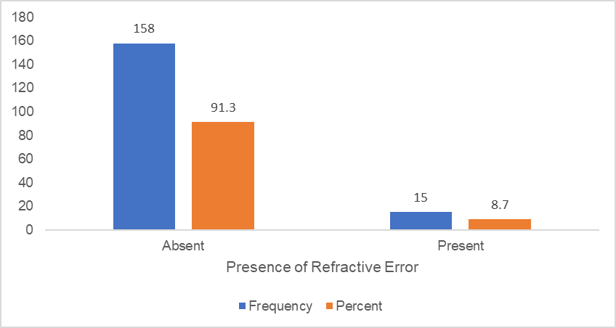 is not clear, improve clarity of figure1.  - In discussion compare with other studies logistics – prevalence and pattern of refractive errors.  - Elaborate how the results can be used in the development of school eye health programs and interventions in Botswana?  - Mention limitations of the study.  - While the study mentions socioeconomic status in the introduction, it doesn't appear to be directly assessed in the data collection. Consider how socioeconomic factors might influence access to eye care and refractive error correction.

PART 2:

 | Reviewer’s comment | Author’s comment (if agreed with reviewer, correct the manuscript and highlight that part in the manuscript. It is mandatory that authors should write his/her feedback here)
Are there ethical issues in this manuscript? | (If yes, Kindly please write down the ethical issues here in details)

Reviewer details:

Simi Afroz, Vision and Vitality Center, India

