**"Isolation and Characterization of Salt and Temperature-Tolerant *Pusillimonas* sp. STT-K15 with Biocontrol Potential first time reported from** **Tomato Rhizosphare soil "**

**Abstract**

The present study focused on the isolation, selection, and characterization of salt and temperature-tolerant rhizobacteria Isolated from the rhizosphere soil of tomato. A total of 138 isolates were obtained from the rhizosphere of tomato plants grown in the laboratory of the Department of Agricultural Microbiology, MPKV, Rahuri, Maharashtra, between 2020 and 2023, using Ashby’s Mannitol agar, King’s B and Nutrient Agar media. STT-K15 examined in Transmission Electron Microscope and found that Rod shaped, 3-3.5µm in size. Gram negative, Endospore forming, Motile in nature. Out of that STT-K15 was subjected to varying concentrations of NaCl, MgCl2, and different pH levels to evaluate their tolerance to salt and temperature stress in King’s B media. STT-K15 isolates demonstrated promising salt tolerance up to 25% NaCl concentration. Furthermore, STT-K15 showed growth at 4.0% MgCl2. Regarding to pH tolerance, STT-K15 thrived at pH 9.0. Among these, STT-K15 exhibited temperature tolerance up to 65°C. The bacterial cultures were sent to National Centre for Microbial Research Pune (India) for sequencing. Received forward and reverse sequences were merged and FASTA format sequences were further subjected to nucleotide BLAST. After identification STT-K15 was found *Pusillimonas* sp. Furthermore sequence was submitted to NCBI and found accession number OR432559. Pusillimonas sp. STT-K15 maximum percentage inhibition (72.5 %) against *Fusarium oxysporum* and 46.66% against *Pestalotiopsis psidii*. These findings indicate that these *Pusillimonas* sp. have the potential to Control *Fusarium oxysporum,* so it can be used as a Biocontrol agent in extreme saline and high-temperature stress condition.

**Keywords:** Rhizobacteria, salt tolerance, temperature tolerance, *Fusarium oxysporum*, , *Pestalotiopsis psidii, Pusillimonas* sp.

**Introduction**

About 40% of the Earth's surface is affected by salinity, which poses a serious agricultural challenge in arid and semiarid regions (Rao and Sharma, 1995). According to Egamberdiyeva *et al*. (2007), salt has a negative effect on irrigated soils, reducing soil and water quality, impeding crop growth, and even forcing the abandonment of agricultural holdings. The agricultural sector is currently experiencing a constant increase in the frequent use of pesticides, which contaminates agricultural products that humans consume and causes a number of diseases in humans. The rhizosphere of the soil around plant roots and the soil that the roots occupy provide support for biocontrol agents, which are sizable active bacterial communities, under these difficult circumstances. Rangarajan *et al* (2003) have studied rhizobacteria that stimulate plant growth, they are known to decrease soil-borne illnesses at the root surface and quickly colonies the rhizosphere. The plant itself benefits from this capacity to promote plant growth (Bloemberg and Lugtenberg, 2001).

The direct use of microbes to enhance plant growth and deter pests is a rapidly developing topic. *Pseudomona*s spp. is commonly regarded as prime instances of root-colonizing bacteria (Lugtenberg *et al*., 2001). A deeper comprehension of the microbial interactions causing PGPR is necessary to increase the success rate of field applications (Farzana *et al*., 2009). It is noteworthy that PGPR, which are bacteria that colonies roots, can affect plant growth in a number of ways, both directly and indirectly. Environmental factors that affect nitrogen fixation in plants include salt, water stress, temperature, pH of the soil, and heavy metals (Kucuk and Kivanc, 2008; Singleton *et al*., 1982). The genus *Pusillimonas*, belonging to the class Beta proteobacteria and family Alcaligenaceae, has been isolated from oil reservoirs and oil-polluted environments in both aquatic and terrestrial ecosystems. It can break down petroleum components and oxidise thiosulphate by forming tetrathionate as an intermediary. A bio-control agent, *Pusillimonas* works against specific infections. Stolz *et al* . (2005) made the initial proposal for *Pusillimonas* ~~(2005)~~. At the time of writing, the genus comprised only three species with validly published names: *Pusillimonas ginsengisoli*, *Pusillimonas soli* and *Pusillimonas noertemannii*. *P.noertemannii* BN9T was isolated from the River Elbe in Germany (Stolze *et al*., 2005), and *P. ginsengisoli* DCY25T and *P.soli* MJ07T were isolated from soil from aginseng field and a farm, respectively, in South Korea (Srinivasan *et al*., 2010), indicating that members of the genus *Pusillimonas* may have a diverse habitat range. Typical features of the genus *Pusillimonas* are: the presence of ubiquinone Q-8; C17:0 cyclo, C16:0 and C19:0 cyclo ꟺ8c as major fatty acids; and phosphatidylethanolamine (PE), phosphatidylglycerol (PG) and diphosphatidylglycerol (DPG) as major polar lipids. Coastal seashores are maritime habitats that are home to important biological resources including marine animals and microorganisms that are essential to ecosystem function. Numerous members of the bacterial community have been described during a series of research examining the microbial communities that live along the coasts of coastal seas (Kim *et al*., 2010a, b; Jin *et al*., 2011; Jung *et al*., 2011; Lee *et al*., 2011). This article describes the taxonomic characterization of anovel *Pusillimonas* species that was isolated from South Korean beach sand in the Yellow Sea. A Nikon light microscope (magnification 61000) was used to examine the morphology and motility of cells from colonies that were 3 days old and cultured on R2A agar at 30°C. The Gram-staining approach was used when conducting Gramme reactions. Oxidation of 1% p-aminodimethylaniline oxalate was used to measure oxidase activity. Bubble formation from a 3% (v/v) hydrogen peroxide solution was used to measure catalase activity (Cappuccino & Sherman, 2002). In broth, growth was measured at 50, 55, 60, and 65 degrees Celsius and pH values of 7.0, 8.0, 8.5, and 9.0.

**Material and methods**

**Collection of rhizosphere soil samples of tomato**

In order to identify salt- and temperature-tolerant rhizobacteria, a total of 138 rhizosphere soil samples were gathered from the saline tract of four districts in Western Maharashtra, India: Ahmednagar, Nashik, Pune, and Satara. Based on eye observation, the field was divided into various homogenous units, and soil samples were randomly taken from each site. The surface debris was removed from the sampling site. The soil sample was taken after the auger was pushed to a plough depth of 15 cm. Each field yielded ten samples, which were then put in a polythene bag. Roots, stones, pebbles, and debris were removed, and the soil samples were properly mixed. Spreading a mona clean surface and letting the soil samples air dry without direct sunlight and excessive heat. The samples were completely mixed into four equal parts, reducing their mass to one kilogramme. The remaining two quarters were remixed after two opposing quarters were eliminated. To obtain the necessary sample size, the procedure was repeated multiple times. The last sample was gathered in a polythene bag or a sterile towel. Relevant details including the farmer's name, the farm's address, the survey number, the current crop, the crop that would be cultivated in the upcoming season, the date of collection, and the sampler's name were all written on the bag.

**Serial dilution**

Samples of rhizosphere soil were transported in sterile plastic bags directly to the Plant Pathology and Agricultural Microbiology laboratory at Mahatma Phule Krishi Vidyapeeth in Rahuri, Ahmednagar, Maharashtra. The samples were serially diluted after 1 g of each soil sample was dissolved in 9 mL of sterile deionised water. To create a 10-1 dilution, 100 µL of the stock solution and 900 µL of sterile distilled water were combined . Until a dilution of 10–6 was achieved, the process was repeated. A 100 µL sample was then used to plate each dilution onto King's B. Before autoclaving, the initial media's pH was brought to 7.00. The plates were inspected to confirm the colony's growth following a two-day incubation period at 28±2 oC. A subset of isolated rhizobacteria were cleaned, preserved, and chosen for further studies.

**Assessment of salt tolerant rhizobacteria at different NaCl level.**

Rhizobacteria isolates were tested with different concentrations of NaCl salt to confirm their resistance to temperature and salt, and they were categorized using the Cardoso *et al*. (2015) salt tolerance method. 0.15, 0.3, 0.6, 0.9, 3.0, and 6.0, 9.6, 10.8, 16.0, and 25 percent NaCl were added as supplements to King's B medium. King's B medium plates with greater than usual NaCl concentrations were streaked with the rhizobacterial isolates. For two to seven days, the plates were then incubated at 280C. The development of rhizobacterial isolates that could withstand both temperature and salt was observed after the incubation time. The isolates were graded as follows: +++ for full growth, ++ for little growth, + for growth, and - for no growth. For additional research, the rhizobacterial isolates with complete development were chosen.

**Assessment of salt tolerant Rhizobacteria on different MgCl2 concentration.**

Testing the rhizobacterial isolates against different concentrations of MgCl2 salt confirmed their resistance to salt. For this, 0.5, 1.0, 2.0, 3.0, and 4.0 percent MgCl2 were added to King's B Medium . After streaking 46 isolates of salt-tolerant rhizobacteria with doses higher than MgCl2, the plates were cultured for two to seven days at 28 °C. Following the incubation period, the growth of the salt-tolerant rhizobacterial isolates was assessed and categorized as +++: full growth, ++: insufficient growth, +: growth, and -: no growth. The full growth rhizobacteria isolates were selected for further investigation.

**Assessment of salt tolerant rhizobacteria on different pH level.**

The salt-resistant rhizobacterial isolates were confirmed by adjusting the medium's pH to 7.5, 8.00, 8.50, and 9.00 using HCl and NaOH . Each isolate of salt-tolerant rhizobacteria was streaked onto King's B agar plates with the appropriate pH levels, and the plates were then incubated at 28oC for two to seven days. Upon completion of the incubation period, the salt-tolerant rhizobacterial isolates were observed to grow, and were graded as follows: +++ for full growth, ++ for little growth, + for growth, and - for no growth. The rhizobacterial isolates with complete development were selected for further investigation.

**Assessment of salt and temperature tolerant rhizobacteria on different temperature range**.

Their capacity to withstand heat stress was also evaluated in order to illustrate temperature tolerance. One millilitre of a 24-hour-old bacterial culture was poured into ten millilitres of King's B broth medium in six test tubes. One of the test tubes was kept as a control, and the other five were tested for temperature tolerance by putting the test tube in a water bath for ten minutes at various temperatures of forty-five, fifty, fifty, sixty, and sixty-five degrees Celsius. After that, the test tube was placed in an incubator set at 28 degrees Celsius for 48 hours. One millilitre of each temperature test tube broth is then taken and grown on King's B agar media as a result of the culture colour shift that was seen at the selection temperature and observed growth by spreading each strain on King’s B agar medium and then plates were incubated in incubator at 28±2oC for 48 hour.

**Morphological and biochemical characterization of bacterial isolate**

1. **Gram’s staining**

Firstly bacterial thin smear(s) of were prepared. ~~The slides were heat-fixed using a low-temperature burner. The smear was gently saturated with crystal violet (C.V.) and allowed to dry for one minute. The slide was then tilted, gently cleaned with tap water, and dried. After that, the smear or smears were inundated with Gram's iodine and tilted slightly for a minute so that tap water could be used to rinse them. On the slides, the smear showed up as a purple circle. Now, apply 95% concentrated alcohol drop by drop for 30 seconds, then rinse with water right away and pat dry. After 30 seconds of being inundated with safranin as a counter-stain, the slides were gently rinsed with tap water while being tilted slightly until the effluent showed no colour, and they were then dried with absorbent paper~~. The slides were observed under the microscope using oil immersion and results recorded accordingly .

(**ii) Endospore staining**

~~Following the preparation of a thin smear or smears of bacterial isolates and their gentle heating, the slides were flooded with aqueous malachite green and steam-fixed for approximately five minutes without drying. The slides were then gently rinsed with tap water, counter-stained with aqueous safranin (0.5%) for thirty seconds, rinsed again with tap water, and dried before being examined under a microscope and the results were noted.~~

**(iii) Biochemical test(s)**

Biochemical test(s) were performed by using the biochemical test kits (HiMedia, Mumbai). Pure cultures (OD 1.0 at 600 nm) of STT-K15 isolates were placed in a specific area for the test, and the kits were stored in the BOD incubator for 24 hours. For the Indole test, 1-2 drops of Kovac's red reagent were added, and colour differentiation was seen within 10 seconds; for the Methyl Red test, 1-2 drops of methyl red (MR) reagent were added, and the red colour was seen; and for the Vogesproskauer's test, two drops of baritt reagent A and two drops of baritt reagent B were added, and the results were recorded based on colour differentiation.

**Biocontrol agent activity of salt and temperature tolerant Rhizobacteria**

The dual culture approach was used to examine the in vitro antagonistic capabilities of the effective salt and thermotolerant Rhizobacterial STT-K15 against the soil-borne fungal plant diseases, Fusarium oxysporum and Pestalotiopsis psidii. These pathogens were isolated from plant disease samples that were gathered from the M.P.K.V., Rahuri Department of Plant Pathology and Agricultural Microbiology. Dual culture plate techniques were used to detect the rhizobacteria's biocontrol activity (Jasim *et al*., 2016).

A Petri plate was filled with thirty millilitres of potato dextrose agar that had been autoclaved at 15 psi for fifteen to twenty minutes. The agar was then left to solidify. Using a loop, a tiny loopful of the corresponding fungal isolate cultures was put in the middle of the petri plate . The rhizobacterial isolate was streaked 2.2 cm from the phytopathogen in a circular pattern using sterile toothpicks to draw thin lines, while the actively growing mycelial disc (5 mm diameter) of each isolate of mycelial plug cut with a sterile cork borer was positioned in the middle of the Petri plate. The control plates had no bacterial streaks on them. After the plates were incubated in a BOD incubator at 30 degrees Celsius, they were monitored every 24 hours. Four days later, the percentage suppression of mycelial growth was determined using the following formula:

I = 100 (C - T) / C

Where,

I = Per centage inhibition of mycelial growth,

C = Growth of pathogen (fungus) in control Plate (mm) and

T = Growth of pathogen (mm) in dual cultures in tested condition.

**Molecular characterization of salt and temperature tolerant rhizobacteria by16S rRNA**

For sequencing, the bacterial cultures were delivered to the National Centre for Microbial Research (India) in Pune. After the forward and reverse sequences that were received were combined, the FASTA format sequences underwent nucleotide BLAST. To determine the sequence homology within one's own bacterial strains, nucleotide sequences are analyzed using the NCBI data bank. based on phylogenetic research and sequence homology using the Ribosomal Database Project (RDP). Using the CLUSTAL-W program of MEGA software version 10.0, the forward (F 27) and reverse (R1492) gene sequences of closely related strains were obtained from a server using BLAST (Tamura *et al*., 2007). Based on the findings from BLAST, the Neighbor-Joining approach (Saitou and Nei, 1987) was used to infer the evolutionary dendrogram.

**Result and Discussion**

**Assessment of salt tolerance rhizobacteria from rhizosphere soil of tomato on different NaCl concentrations.**

**Table1: Effect of NaCl concentration on STT-K15**

|  |  |  |  |  |  |  |  |  |  |  |  |
| --- | --- | --- | --- | --- | --- | --- | --- | --- | --- | --- | --- |
| **Isolate No.** | **Salt tolerance limit (NaCl%)** | | | | | | | | | | **Class** |
| **0.15** | **0.3** | **0.6** | **0.9** | **3.0** | **6.0** | **9.6** | **10.8** | **16.0** | **25.0** |  |
| STT-K15 | +++ | +++ | +++ | +++ | +++ | +++ | +++ | +++ | +++ | +++ | Extremely  tolerant |

Extremely tolerant: tolerance limit more than 5.40% salt(Cardoso *et al.*,2014).

The STT-K15 isolates were very salt tolerant (more than 5.4% salt tolerance limit) (Table 1). According to the salt tolerance limit, rhizobacteria were categorised. Kumar *et al*. (2014) found that some bacterial strains were able to withstand high salinity (up to 7% NaCl). Additionally, Pseudomonas species had a lower stress tolerance than Bacillus strains, primarily because the Bacillus isolates were able to produce endospores. In a related study, Patel *et al*. (2017) discovered that 29 (44.0%) of the isolates tested were able to thrive The findings concur with those of a study by Damodarachari *et al*. (2018), which discovered that five isolates (BS 1, BS 3, BS14, BS18, and BS42) showed resistance to NaCl concentrations ranging from 1.5% to 20%. Comparable outcomes were also obtained by Sharma *et al*. in 2021. With a peak tolerance at 10% salt concentration, isolates HB6P2 and HB6J2 showed the highest level of salt tolerance in their investigation. Isolates HB4A1, HB4N3, and HB8P1 came next, and they too showed a remarkable resistance to salts. Similar results were reported by Kumari *et al*., 2022 , in their study from. They found isolates E-2, T-2, and T-1, which grew at 7%, 6%, and 6% concentrations of salt (NaCl), respectively. Similar results were found in investigations of several scientists Patil *et al*. 2014; Kumari and Khanna 2015 ~~and~~ Khan *et al*., 2019; Satyam, *et al*., 2023.

**Assessment of rhizobacteria for salt tolerance on different MgCl2 concentration and different pH on medium.**

**Table 2: Effect of different MgCl2 concentration and pH range.**

|  |  |  |  |  |  |  |  |  |  |
| --- | --- | --- | --- | --- | --- | --- | --- | --- | --- |
| **Isolate No.** | **Mgcl2 cocentration (%)** | | | | | **pH** | | | |
| **0.5** | **1.0** | **2.0** | **3.0** | **4.0** | **7.0** | **8.0** | **8.5** | **9.0** |
| STT-A46 | ++ | ++ | ++ | ++ | ++ | ++ | ++ | ++ | ++ |

Growth was observed in STT-K15 isolates (Table 2) up to 4.0 percent MgCl2 concentration. Results are consistent with Pagare *et al*. (2018) observations. Twenty of the thirty-three isolates grew at a MgCl2 concentration of 0.75 percent, four at a 0.50 percent concentration, and nine at a 0.40 percent concentration on the MgCl2 test. Similar finding reported by Satyam, *et al*., (2023).

At pH 9.0, the salt-tolerant rhizobacterial isolates STT-K15 (Table 2) grew. Damodarachari *et al*. (2018) found that four isolates (BS 1, BS 3, BS 14, and BS 18) out of forty-four were able to grow across a pH range of 4 to 12. The results are consistent with their observations.   
 The growth of rhizobacteria on different pH has been reported by many scientists (Tsegaye *et al*., 2019; Jianyang *et al.*, 2020; Satyam, *et al*., 2023 ).

**Assessment of salt and temperature tolerance rhizobacteria at different temperature ranges.**

**Table 3. Effect of different temperature range on STT-K15**

|  |  |  |  |  |  |  |
| --- | --- | --- | --- | --- | --- | --- |
| **Isolates** | **Temperature** | | | | | |
| **Control** | **50oC** | **55oC** | **60oC** | **65oC** | **Colour developing**  **temperature** |
| STT-K15 | +++ | +++ | +++ | +++ | +++ | No difference |

The STT-K15 isolates that were chosen for additional temperature tolerance research (Table 3) demonstrated temperature tolerance up to 65 °C. Similar finding reported by Satyam, *et al*., 2023. Kumar *et al*. (2014) found that some bacterial strains demonstrated tolerance to high temperatures (up to 50 °C). In a related study by Patel *et al*. (2017), 40 isolates (58.20 %) demonstrated the ability to tolerate high temperatures, withstanding up to 70 °C. These findings are consistent with a study by Damodarachari *et al*. (2018), which discovered that six isolates (BS 10, BS 14, BS 18, BS 27, BS 37, BS 43) demonstrated tolerance to temperatures ranging from 20 °C to 50 °C.

**Morphological characterization of salt and temperature tolerant rhizobacteria**

STT-K15 examined in Transmission Electron Microscope and found that Rod shaped, 3-3.5µm in size. Gram negative, Endospore forming, Motile and Aerobic in nature (Fig 1 and 2).

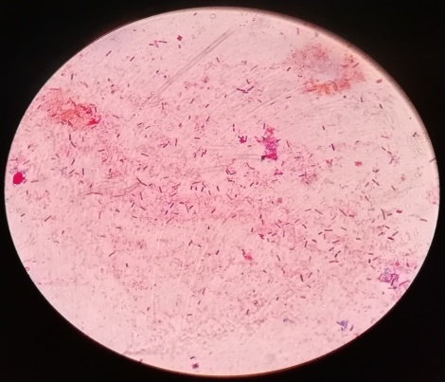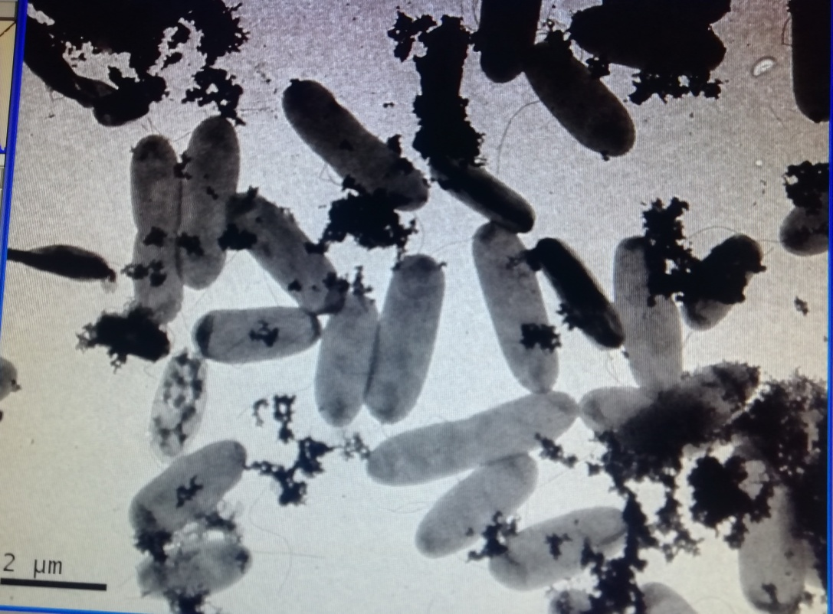

**Fig 2. Transmission Electron microscopic view of *Pusillimonas* sp. STT-K15**

**Fig 1. Gram staining view of *Pusillimonas* sp. STT-K15**

**Biochemical characterization of salt and temperature tolerant rhizobacteria**

**Table 4: Biochemical test**

|  |  |  |
| --- | --- | --- |
| **Sr. No.** | **Characteristics** | **Rhizobacteria** |
| *Pusillimonas* sp. |
| **1.** | Indole | -ve |
| **2.** | Urease | -ve |
| **3.** | Catalase | +ve |
| **4.** | Oxidase | +ve |
| **5.** | Hydrolysis of Starch | -ve |
| **6.** | Gelatin Liqueficati on | -ve |
| **7.** | Methyl red | -ve |
| **8.** | Vogesproskaur | +ve |
| **9.** | Production of H2S | -ve |
| **10.** | Citrate Utilization | +ve |
| **11.** | KOH test | +ve |
| **12.** | Gram’s staining | -ve |
| **13.** | Endospore staining | +ve |
| **14.** | Phosphate solubilization | +ve |

*Pusillimonas* sp. STT-K15 showed positive test for Oxidase and negative for Indole, Urease, Starch hydrolysis, Gelatin liquefaction, Citrate utilization test, Methyl red, Voges-proskaur and H2S production(Table 4). Jianyang *et al*., (2020) reported similar results for *Pusillimonas* oxidase and catalase positive.

**Assesment of salt and temperature tolerant *Pusillimonas* sp. rhizobacteria as biocontrol agent.**

**Table 5: Biocontrol activity of STT-K15**

|  |  |  |  |  |
| --- | --- | --- | --- | --- |
| Treatment | ***Fusarium oxysporum*** | | ***Pestalotiopsis psidii*** | |
|  | Diameter (cm) | % inhibition | Diameter (cm) | % inhibition |
| ***Pusillimonas*** sp. STT-K15 | 2.2 | 72.5 | 1.6 | 46.66 |
| control | 8.0 | 0 | 3.0 | 0 |
| C.D. at 5 % | 0.23 |  | 0.09 |  |
| S.E(m). + | 0.08 |  | 0.03 |  |
| S.E.(d) | 0.11 |  | 0.05 |  |
| C.V. | 4.56 |  | 4.59 |  |

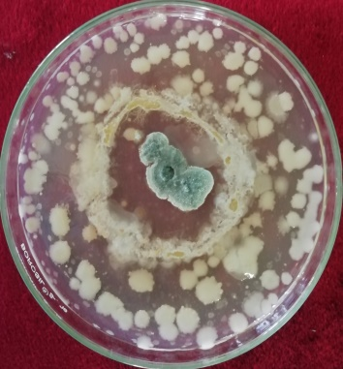

**Fig; 3 Biocontrol activity of *Pusillimonas* sp. against *Fusarium oxysporum*.**

The maximum percentage inhibition of *Pusillimonas* sp. STT-K15 was 72.5% against *Fusarium oxysporum* and 46.66% against *Pestalotiopsis psidii* ( Fig 3). Satyam *et al*., (2023) reported similar results regarding the percentage inhibition of *Fusarium oxysporium* and *Pestalotiopsis psidii* by different rhizobacteria, which were consistent with the findings of Meena *et al*. (2022) that, using the dual culture method, demonstrated similar biocontrol activity results against *Colletotrichum falcatum*, *Fusarium oxysporum* f sp. ciceri, *Helminthosporium maydis, F. oxysporum* f. sp. lycopersici, *Aspergillus niger*, *Mucor* sp., *Helminthosporium oryzae*, and *Rhizoctonia solani*.

**Molecular characterization of salt and temperature tolerant *Pusillimonas* sp STT-K15**

The bacterial cultures used in this investigation were sequenced by the National Centre for Microbial Resources (NCMR) in Pune. A phylogenetic tree was created by merging the forward primer (F27-5'AGAGTTTGATCCTGGCTCAG-3') and reverse sequencing primer (R1492-5'GGTTACCTTGTTACGACTT-3') using the internet tools. The resulting FASTA format sequences were then put via nucleotide BLAST( Fig 4). Sequence report submitted to NCBI and get accession number OR432559.

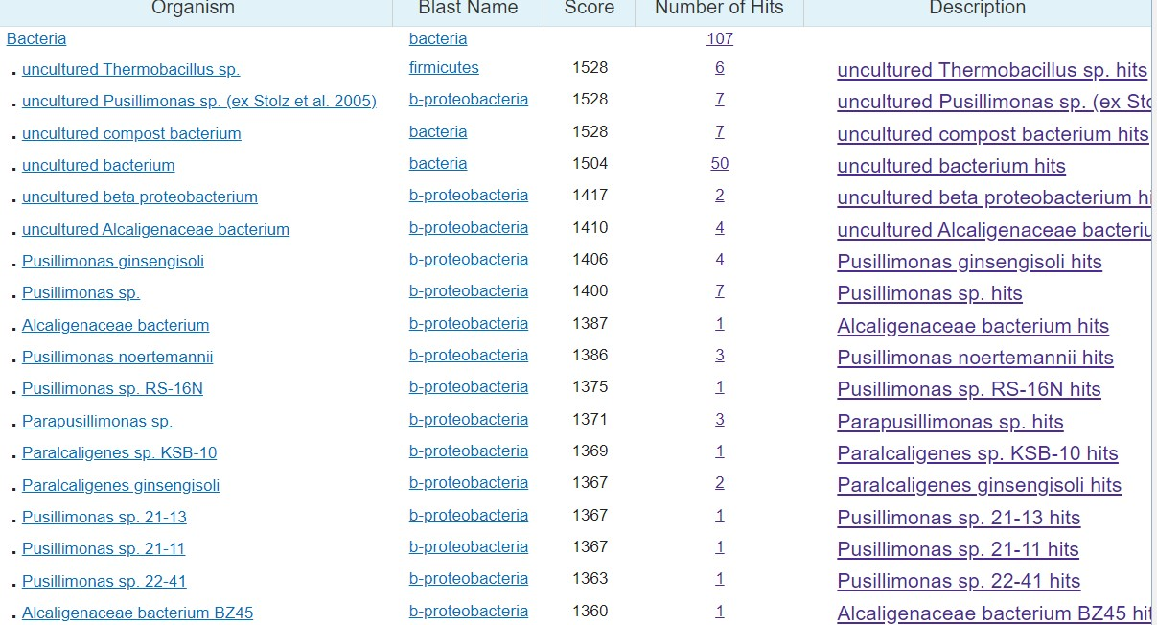

A

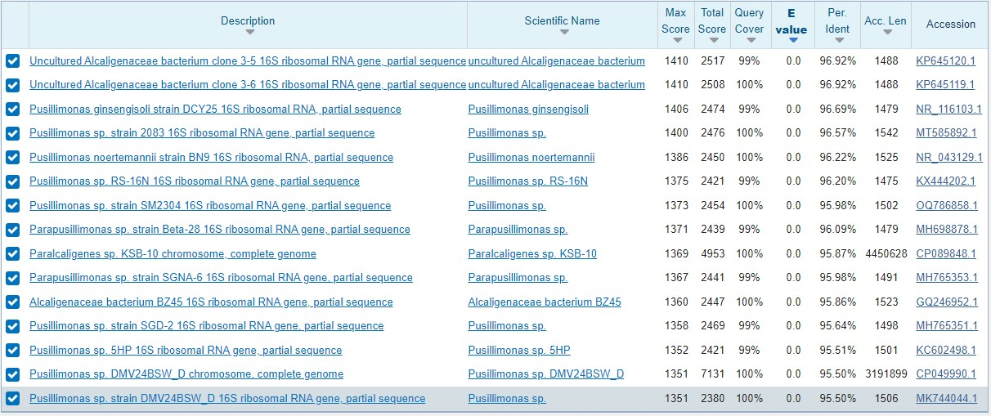

B

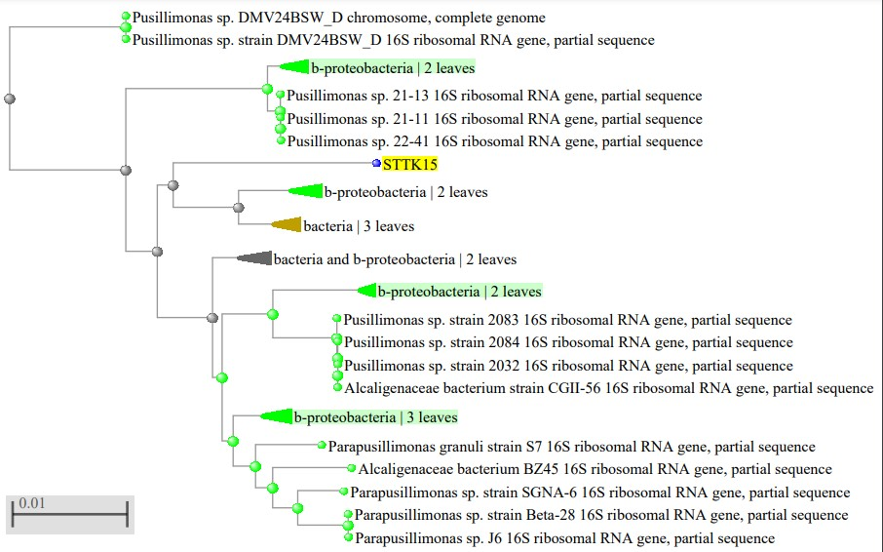

C

**Figure 4: (A) Ribosomal Database project (RDP) results; (B) nucleotide BLAST and (C) Phylogenetic tree data of bacterial isolate STT-K15 identified as *Pusillimonas sp.***

These results are in agreement with finding 50 isolates were gathered by Ilyas *et al*. (2020) from the rhizosphere of plants that grew in Pakistan's salt range. From this group, four isolates were selected based on their ability to withstand salt and traits that promote plant growth. These isolates (SR1, SR2, SR3, and SR4) were identified as *Bacillus* sp. (KF719179), *Azospirillum brasilense* (KJ194586), *Azospirillum lipoferum* (KJ434039), and *Pseudomonas stutzeri* (KJ685889) through analysis of the 16S rDNA gene sequence. The positive impact of rhizospheric bacteria isolated from maize and soybean plants was also investigated by Fasusi *et al*. (2021). Based on their 16S rRNA molecular characterisation, these rhizobacterial isolates with several potentials to promote plant growth were identified as *Bacillus* sp (80.77%), *Rhodocyclaceae bacterium* (3.85%), *Enterococcus* sp (3.85%), *Massilia* sp (3.85%), and *Pseudomonas* (7.69%) species.

*Pusillimonas* sp. STT-K15 is a salt and temperature-tolerant rhizobacteria that has been isolated, selected, and characterised in this study. According to the study's findings, isolates of *Pusillimonas* sp. STT-K15 can withstand pH 9.0, 25% NaCl, 4% MgCl2, and a temperature tolerance limit of 65°C. The maximum percentage inhibition of *Pusillimonas* sp. STT-K15 against *Fusarium oxysporum* was 72.5%, while the maximum percentage inhibition against *Pestalotiopsis psidii* was 46.66%. The conclusion drawn from this study's findings is that *Pusillimonas* sp., which can withstand extremely high temperatures and saline soil, can be employed as a biocontrol agent to combat plant diseases.

REFERENCES

Bloemberg G V, and Lugtenberg B J. 2001. Molecular basis of plant growth promotion and biocontrol by rhizobacteria. *Current opinion in plant biology*, 4(4), 343- 350.

Cappuccino, J. G. & Sherman, N. (2002). Microbiology: a Laboratory Manual, 6th edn. Menlo Park, CA: Benjamin/Cummings.

Cardoso P, Freitas R, and Figueira E. 2015. Salt tolerance of rhizobial populations from contrasting environmental conditions: understanding the implications of climate change. *Ecotoxicology*, **24**, 143-152.

Damodarachari K, Reddy R S, Triveni S, Rani C H and Sreedhar M. 2018. Isolation and Molecular Characterization of Abiotic Stress Tolerant Plant Growth Promoting *Pseudomonas* spp. from Different Rhizospheric Soils of Telangana State, India. *International Journal of Bio-resource and Stress Management*, **9**(5), 611-619.

Egamberdiyeva D, Garfurova I, and Islam K. 2007. Salinity effects on irrigated soil chemical and biological properties in the Aral Sea basin of Uzbekistan. Climate Change and Terrestrial Carbon Sequestration in Central Asia, 147.

Farzana Y, Radziah O, Saad S, and Kamaruzaman S. 2009. Growth and storage root development of sweet potato inoculated with rhizobacteria under glasshouse conditions. *Australian Journal of Basic and Applied Sciences*, 3(2), 1461-1466

Fasusi, O. A., Amoo, A.E. and Babalola, O.O. 2021. Characterization of plant growth promoting rhizobacterial isolates associated with food plants in South Africa. *Antonie Van Leeuwenhoek*, 114(10) : 1683-1708.

Ilyas, N., Mazhar, R., Yasmin, H., Khan, W., Iqbal, S., Enshasy, H. E. and Dailin, D.J. 2020. Rhizobacteria isolated from saline soil induce systemic tolerance in wheat (*Triticum aestivum* L.) against salinity stress. *Agronomy*., 10(7) : 989

Jasim, B., Sreelakshmi, K. S., Mathew, J., & Radhakrishnan, E. K. (2016). Surfactin, iturin, and fengycin biosynthesis by endophytic *Bacillus* sp. from Bacopa monnieri. *Microbial Ecology*, 72(1), 106-11

Jianyang Li, Mingming Qi, Qiliang Lai, Chunming Dong, Xiupian Liu, Guangyi Wang, and Zongze Shao. 2020. *Pusillimonasmaritima* sp. nov., isolated from surface seawater. *International Journal of Systematic and Evolutionary Microbiology*, **70**(5), 3483-3490.

Jin, H. M., Lee, H. J., Kim, J. M., Park, M. S., Lee, K. & Jeon, C. O. (2011). Litorimicrobium taeanense gen. nov., sp. nov., isolated from a sandy beach. *International Journal of Systemic and Evolutionary Microbiology,* 61, 1392–1396.

Jung, J. Y., Kim, J. M., Jin, H. M., Kim, S. Y., Park, W. & Jeon, C. O. (2011). Litorimonas taeanensis gen. nov., sp. nov., isolated from a sandy beach. *International Journal of Systemic and Evolutionary Microbiology*, 61, 1534 1538.

Khan M A, Asaf S, Khan A L, Adhikari A, Jan R, Ali S, Imran M, Kim K M, and Lee I J. 2019. Halotolerant rhizobacterial strains mitigate the adverse effects of NaCl stress in soybean seedlings. *Bio Med Research International*, 2019.

Kim, J. M., Jung, J. Y., Chae, H. B., Park, W. & Jeon, C. O. (2010b). Hwanghaeicola aestuarii gen. nov., sp. nov., a moderately halophilic bacterium isolated from a tidal flat of the Yellow Sea. *International Journal of Systemic and Evolutionary Microbiology*, 60, 2877–2881.

Kim, J. M., Lee, S. H., Jung, J. Y. & Jeon, C. O. (2010a). *Marinobacterium lutimaris* sp. nov., isolated from a tidal flat. *International Journal of Systemic and Evolutionary Microbiology*, 60, 1828–1831.

Kucuk C, and Kivanc M. 2008. Preliminary characterization of *Rhizobium* strains isolated from chickpea nodules. *African Journal of Biotechnology*, **7**(6).

Kumar G P, Ahmed M H, Desai S K, Amalraj L D, and Rasul A. 2014. In vitro Screening for Abiotic Stress Tolerance in Potent Biocontrol and Plant Growth Promoting Strains of *Pseudomonas* and *Bacillus* spp. *International Journal of Bacteriology*. 2014, **6**.

Kumari M, Swarupa P, and Kumar A. 2022. Validation and Evaluation of Plant Growth Promoting Potential of Rhizobacteria towards Paddy Plants. *Journal of Pure and Applied Microbiology*, **16**(2).

Kumari P, and Khanna V. 2015. ACC-deaminase and EPS production by salt tolerant rhizobacteria augment growth in chickpea under salinity stress. *International Journal of Bio-resource and Stress Management*, **6**(5), 558-565.

Lee, S. H., Shim, J. K., Kim, J. M., Choi, H.-K. & Jeon, C. O. (2011). *Henriciella litoralis* sp. nov., isolated from a tidal flat, transfer of Maribaculum marinum ~~Lai~~ *~~et al~~*~~. 2009~~ to the genus *Henriciella* as *Henriciella aquimarina* nom. nov. and emended description of the genus Henriciella. *International Journal of Systemic and Evolutionary Microbiology*, 61, 722–727.

Lugtenberg B J J, Dekkers L, and Bloemberg G V, 2001. Molecular determinants of rhizosphere colonization by *Pseudomonas*. *Annual. Review of Phytopathology*. **39**:461–490.

Meena, K. R., Satyam, S., Singh, A., Jaiswal, A., & Rai, D. (2022). Benchmarking of different microbes for their biosurfactants antifungal action against plant pathogens. *Indian Journal of Experimental Biology (IJEB)*, *60*(12), 931-938.

Pagare K A, Navale A, Deokar C, and Awale A. 2018. Isolation, selection and characterization of salt tolerant *Rhizobium*. *Journal of Pharmacognosy and Phytochemistry*, **7**(6), 1976-1982.

Patel K S, Naik J H, Chaudhari S, and Amaresan N. 2017. Characterization of culturable bacteria isolated from hot springs for plant growth promoting traits and effect on tomato (*Lycopersicon esculentum*) seedling. *Comptes Rendus Biologies*, **340**(4), 244- 249.

Patil S M, Patil D B, Patil M S, Gaikwad P V, Bhamburdekar S B, and Patil P J. 2014. Isolation, characterization and salt tolerance activity of *Rhizobium* sp. from root nodules of some legumes. *International Journal of Current Microbiology and Applied Science*, **3**, 1005.

Rangarajan S, Loganathan P, Saleena L M, and Nair S. 2003. Diversity of *Pseudomonas* isolated from three different plant rhizospheres. *Journal of Applied. Microbiology*. **91**(4):742–749.

Rao D L N, and Sharma P C. 1995. Effectiveness of rhizobial strains for chickpea under salinity stress and recovery of nodulation on desalinization. *Indian Journal of Experimental Biology*, **33**(7), 500-504.

Saitou, N. & Nei, M. (1987). The neighbor-joining method: a new method for reconstructing phylogenetic trees. Mol Biol Evol 4, 406 425.

Satyam, (2023). Isolation, selection and characterization of salt and temperature tolerant plant growth promoting rhizobacteria .

Satyam, A. M., Kolase, S. V., Narute, T. K., Kale, A. A., Chandanshive, A. V., Durgude, A. G., & Barge, M. S. (2023). Salt and temperature tolerant rhizobacteria: A comprehensive study on biochemical profiling and biocontrol potential. *The Pharma Innovation Journal* 2023; 12(9): 249-255.

Sharma A, Dev K, Sourirajan A, and Choudhary M. 2021. Isolation and characterization of salt-tolerant bacteria with plant growth-promoting activities from saline agricultural fields of Haryana, India. *Journal of Genetic Engineering and Biotechnology*, **19**(1), 1-10.

Singleton P W, Swaify S A, and Bohlool B B. 1982. Effect of salinity on *Rhizobium* growth and survival. *Applied and Environmental microbiology*, **44**(4), 884-890.

Srinivasan, S., Kim, M. K., Sathiyaraj, G., Kim, Y.-J. & Yang, D.-C. (2010). *Pusillimonas ginsengisoli* sp. nov., isolated from soil of a ginseng field. *International Journal of Systemic and Evolutionary Microbiology*, 60, 1783-1787.

Stolz, A., Bu ¨rger, S., Kuhm, A., Ka ¨mpfer, P. & Busse, H.-J. (2005). *Pusillimonas noertemannii* gen. nov., sp. nov., a new member of the family Alcaligenaceae that degrades substituted salicylates. *International Journal of Systemic and Evolutionary Microbiology*, 55, 1077–1081

Tamura, K., Dudley, J., Nei, M., & Kumar, S. (2007). MEGA4: molecular evolutionary genetics analysis (MEGA) software version 4.0. *Molecular biology and evolution,* 24(8), 1596-1599.

Tsegaye Z, Gizaw B, Tefera G, Feleke A, Chaniyalew S, Alemu T, and Assefa F. 2019. Isolation and biochemical characterization of Plant Growth Promoting (PGP) bacteria colonizing the rhizosphere of Tef crop during the seedling stage. *Journal of Plant Science and Phytopathology*, **3**(1), 013-027.