**Impact of tractor operated round paddy straw baler in Uttar Bastar district of Chhattisgarh**

**Abstract:**

At present rice is major crop in Kanker district of Chhattisgarh cultivated over 2 lak ha including kharif and summer season. The cost of the straw gathering is increasing because of increased use of combine harvesters. High labour cost and scarcity of labour make manual collection unfeasible that also encourages the burning of straw in the field after combine harvesting. Burning of a straw causes pollution, increased greenhouse gas emission and loss of opportunities to worth straw value addition. In the present study impact of tractor operated round paddy straw baler machine for collection of rice straw was conducted on combine harvested field. During the field testing data on the straw parameter, machine parameter and bale parameter were recorded. The actual field capacity , cost of operation and time required for baling was found to be 0.61 ha/hr, 1240 Rs/ha and 1.59 hr/ha respectively with moisture content between 19 to 22 per cent and maximum speed of operation 2.4 km/ha. Cost of baling was found less as compared to manually collection method. Baling operation is easy, time consuming and more economical as well as exclude the hazardous effects of burning of crop residues.

______________________________________________________________________________

**Keywords:** Round rice straw baler, burning of a straw, cost of baling and seed of operation

**Introduction:**

Rice is a major crop is Uttar Bastar also known as Kanker district of Chhattisgarh state, cultivated around 2.30 lakh ha area including kharif and summer seasons. According to the statistics available with the department of Agriculture (2019-20) per ha production of rice is about 2500 kg kharif season and 3565 kg in summer season and nearly 4 to 6 t/ha of straw is produced which shows that a huge amount of residue is available for disposal every year. Collection and management of rice straw is a major challenge for the environmental and economic reasons. Collecting this huge amount of straw manually is a major challenge for the farmers because due to labour shortage as well as its bulkiness. Also create problem to store it for fodder. Because of the mechanization in rice, when the rice is harvested by combine harvester, it leaves a significant length of straw in the field. For the preparation of the land for the next season and in a hurry to prepare the land for the next crop farmers find it easy to burn the straw. Increasing labour cost is another reason farmers prefer setting fire to their rice fields after harvesting the crop.

Rice crop residue if left as it is in the field create problem during sowing of rabi seasons crops. So there is a need to manage the rice straw in an economic and environmentally safe way. For managing the rice straw farmers burning the straw in the field and some incorporating the straw in the field. If rice straw is not burnt or incorporated in the soil then baling operation may provide an attractive, economical and environmentally safe option. There are wide usages of the straw in Gothan for animal feed, for mushroom cultivation, paper mills for cardboard manufacturing, for packaging the materials, for burning in boilers, so baling the straw and compacting it into small (120-135 kg/m3), transportable size and shapes is required. The rice baler has been recently introduced in India for recovery of the straw from the field. As an solution to above said these challenges, Krishi Vigyan Kendra, Kanker introduced, round paddy straw baler machine in the farmers field under front line demonstration (FLD) on mechanization of rice from 2021-22 to 2022-23 with the objectives to study the extent of adoption of rice baler, to reduce the drudgery of farmers and farm women in manual collection and easily disposal of rice straw

**Materials and methods**:

On 150 ha of land of farmers from Kanker district were selected consecutively during 2021-22 and 2022-23 for the study. This area was purposively selected because major area comes under rice cultivation. Front line demonstration were conducted on 105 farmers’ field having different land holding categories of the cultivators for mechanization in rice, using the baler to popularize the baling of rice straw and increase level of mechanization in the district. The moisture content was determined by the standard oven method. The oven was in the range of 0-250 ˚C. The bulk density of straw was determined by standard oven method by putting a known weight of respective sample into an empty graduated jar (1000 ml) and the volume occupied by the sample was noted (Mohsenin, *et al* 1980) [6]. The treatment selected was moisture content in the ranges of 19-22% and speed of operation 2.4 km/h along with the manual collection method of straw with 5 replications as shown in Table 1 The round baler has four major units, the first unit is for picking the windrow straw from the field and then moved through conveying unit (screw type) to compaction unit where the straw is compacted within aluminum ribbed rollers having rotational speed from PTO of tractor equip in the bale chamber to provide the round shape of the bale. Then, a knotter unit is provided to wind up the bales tightly. The weight of bale varied depending upon the moisture content of straw.

The experiment was conducted for evaluating the performance of tractor-operated round Paddy straw baler in the farmers field of Kanker Disrtict of Chhattisgarh State during the year 2021-22 and 2022-23. The experiment was conducted in combine harvested fields for harvesting rice crop. Before the field experiments, variety of crop, average stubble height (cm), average loose straw length (cm), average width of loose straw heaped (cm), weight of straw collected from MS frame of 1 m2 and loose straw moisture content (%), and bulk density of loose straw (kg/m3) were recorded at random 10 different locations of the field. During the field evaluation, working width (cm), forward speed (km/h), total time taken and time taken between 2 consecutive bale (min), fuel consumption (l/h), size of bale (cm), and weight of bale (kg) were recorded (NRFMTTI, 2014) [8]

**Results and Discussion:**

The maximum actual field capacity was found to be 0.061ha/h in case of T1 having moisture content range 19-22% and the speed of operation was 2.4 km/h respectively. The theoretical field capacity was observed 0.312 ha/h when. From Table 2 the fuel consumption was found to be 3.78 l/h in case of round paddy straw baler machine and it was inconsiderable in case of manual collection. i.e.T2. The field efficiency has been calculated less i.e. 6.27 per cent as compared T1 in case of manually collection method of rice straw.

The time required was minimum 1.59 h/ha in case of round paddy straw baler machine and maximum 33.3 man-h/ha in T2 which was manual collection method.

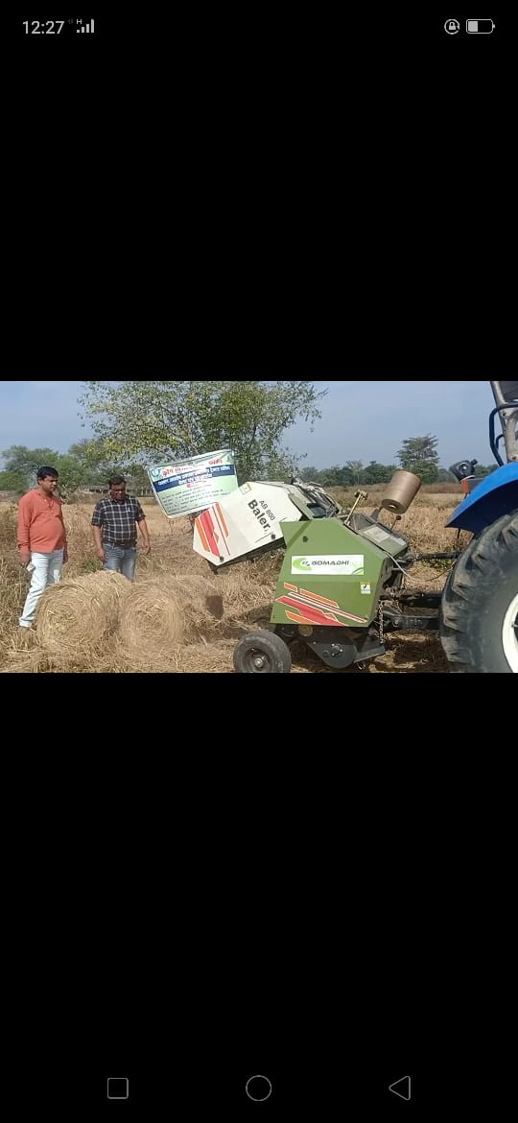

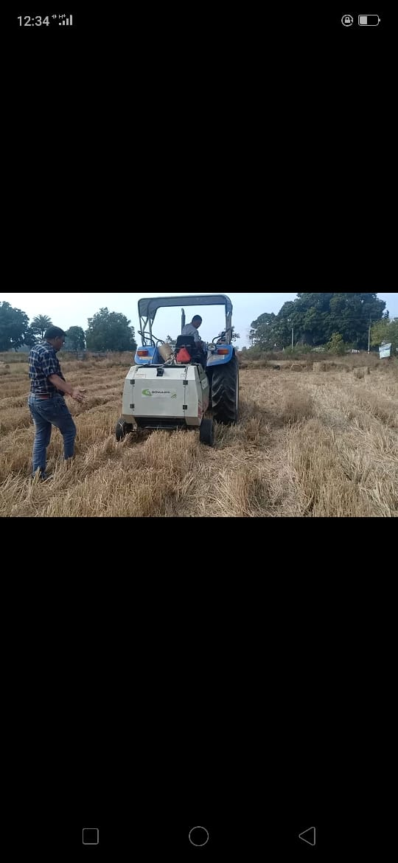

**Fig. 1 Baler machine during operations for collection of round paddy straw and make a bales**

**Table 1: Field operational parameters of tractor-operated round rice straw baler**

**S. No. Particulars Value**

1. Variety of crop MTU 1010

2. Average stubble height, cm 27.5

3. Average loose straw length, cm 52.5

4. Average weight of straw collected from MS frame of 1 m2, kg 0.521

6. Average moisture content of loose straw (M2), % 19-22

7. Gear used L-1, L-2, L-3

8. PTO speed 540 (Standard)

9. Working width of baler, cm 130

10. Average size of bale (diameter × height), cm 61.00 × 62.50

**Table 2: Field performance parameter of round rice straw baler**

|  |  |  |  |
| --- | --- | --- | --- |
| **S. No** | **Particular Treatments** | **T1 (Baler Machine)** | **T2 (Manually Collection)** |
| 1 | Average speed (km/h) | 2.4 | - |
| 2 | Fuel consumption (l/h) | 3.8 | - |
| 3 | Actual field capacity (ha/h) | 0.61 | 0.03 |
| 4 | Straw recovery (%) | 93 | 95 |
| 5 | Bale output (No of bale/h) | 43 | - |
| 6 | Bale output (q/h) | 10.53 | 1.39 |
| 7 | Bulk density of bale (kg/m3) | 109 | - |
| 8 | Bale weight (kg) | 24.50 | 9.30 |
| 9 | Time required between 2 bale (sec) | 83 | - |
| 10 | Time required (h/ha) | 1.59 | 33.3 |

**Bale parameters and Economic analysis:**

Bale weight, the heaviest bale was found to be 24.50 kg with the maximum density 109 kg/m3 of bale was observed in case of T1 and the weight of bale was found to be only 9.30 kg in manual collection method. The maximum bale output recorded 43 bales/h in case of round Paddy straw baler having the moisture content range 19- 22% and highest speed 2.4 km/h respectively. The bale output in case of T1 was found to be 10.53 q/ ha as compared to T2 i.e.1.39 q/h respectively.

Percentage saving in volumetric space was maximum in case of T1 and minimum in case of T2 which was found to be only 16.01% manual collection method with respect to T1during operation for collection of rice straw and make a bale as shown in Fig 1. Bale size was found 2.001 ft x 2.050 ft (Diameter to Height) as shown in Fig 2. and bale weight is 163 % less as compared to round rice straw baler. The labour requirement was also found to be maximum i.e. 33.33 man-h/ha in case of T2 which was manual collection method and minimum i.e. 2.09 man-h/ha obtained through round Paddy straw baler machine in T1.

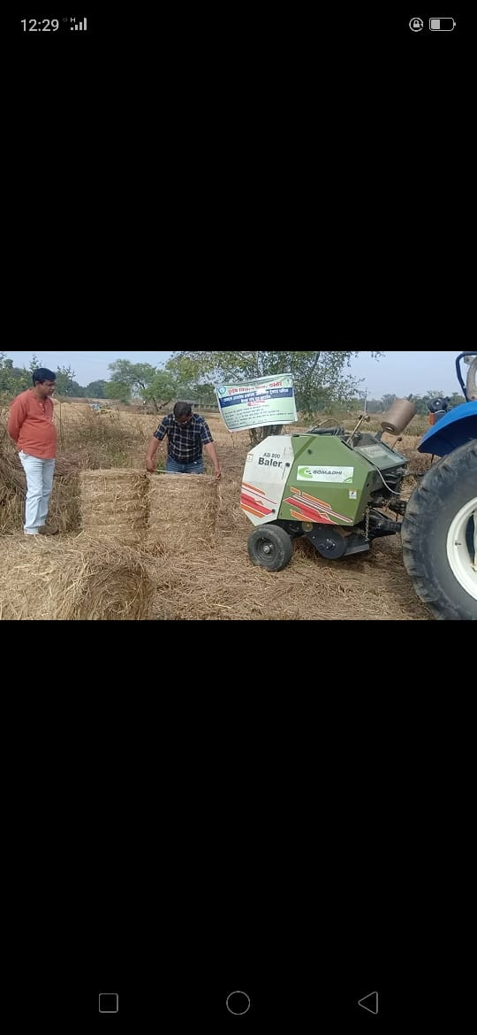

**Fig 2: Measuring parameters of straw bale**

**Conclusion:**

On the basis of study it can be concluded that the cost of operation was 91.93 percent more in manual collection method i.e. Rs 1240 per ha in case of tractor operated rice baler machine and maximum Rs 2380 per ha in manual collection method. Data reveled that tractor drawn round straw baler for baling of rice crop give better performance with tractor operated as compared to manually collection of rice straw and need to introduce round paddy straw baler in rice growing areas as one of the components of cutom hiring center.

**References:**

1. GoI. Annual report. Ministry of New and Renewable energy, New Delhi, 2016.

(http://mnre.gov.in).[http://www.erewise/current-affairs/biomass](http://www.erewise/current-affairs/biomass-)

1. Agricultural Magazine. The scientific face to the black cloud towards best investment of

The agricultural Residues, 1999, 17-20.

1. Gautam AK, Shrivastava A, Samaiya RK, Jha A. Design and development of tractor

drawn seed cum pressurized aqueous fertilizer drill. Indian Journal of Agricultural Research, 2018, 52(3).

1. Kepner RA, Bainer R, Barger EL. Principle of farm machinery. AVI Publishing Company Inc. USA, 1978, 341-366.
2. Kumudhini Verma, Atul Shrivastava and Avinash Kumar Gautam. Performance evaluation of tractor drawn round straw baler for rice. The Pharma Innovation Journal 2019, 8(6):846-849
3. Mohsenin NN. Physical properties of plant and animal materials. Gordon and Breach

Science Publishers. London, 1980.

1. Mouneshwari R Kammar, Vidyavathi G Yand Amaresh Y S. Effect of demonstration on

use of paddy straw baler in raichur district. J of Krishi Vigyan 2017,6(1)224-226

1. NRFMTTI. Commercial test report (April) Baler NSE SB 622. NRFMTTI tractor nagar,

sirsa road, Hisar, Haryana, 2014, 1-35.