***Original Research Article***

**~~A~~ ~~s~~Statistical standpoint on scientometrics in horticultural domain with special reference to fruits and vegetables**

**Abstract**

The goal of the study was to examine the trends in recent years by analysing publications on major fruits and vegetables article published in Scopus data base in for 11 years period 2012 - 2022. In this case, the Scopus database was scanned under the heading with the term “Mango” OR “*Mangifera indica*” AND "Banana" OR "*Musa paradisiaca*" OR "*Musa acuminata*" OR "*Musa balbisiana*" AND "Grape" OR "*Vitis vinifera*" "AND "Papaya" OR "*Carica papaya*” AND "oranges" OR "*Citrus sinensis*" OR "*Citrus reticulata*" for fruits and "Tomato" OR "*Lycopersicon esculentum*" AND "onion" OR "*Allium cepa*" AND "Potato" OR "*Solanum tuberosum*" AND "Brinjal" OR "*Solanum melongena*" OR "Cauliflower" OR "*Brassica oleracea* var. *botrytis*" for vegetables, and bibliometric information was gathered. The number of publications, activity index, publication kinds, reference analyses, total citations per year, most common words, collaboration between counties most often cited local authors, most pertinent affiliations, and most pertinent sources were all examined in relation to the research. According to the findings, Indian Journal of Horticulture, Potato journal, Materials Today: Proceedings, Indian Journal of Agricultural Sciencesare the journals that publish the most papers on major fruits and vegetables. India and USA had the largest level of collaboration. The phrases genetics. plant breeding, convolutional neural networks, deep learning which are trending topics in horticulture

Keywords: Bibliometric Analysis, R-Studio, *Musa balbisiana, Mangifera indica, Solanum melongena* and *Brassica oleracea* var. *botrytis.*

**1. Introduction**

Horticulture is gaining recognition as a booming sector since it has the capacity to boost agricultural income, offer a reliable source of livelihood, and generate foreign currency through export prospects. India is capitalizing on its extensive agricultural heritage to transform horticulture into a thriving industry that is on a path of substantial economic expansion. The diverse agro-climatic conditions and rich diversity in crops and genetic resources enable India to produce a wide range of horticultural crops round the year (Girish *et al*., 2019). Over the last decade, the area under horticulture grew by 2.1% per annum and annual production increased by 3.9%. During 2020-21, the production of horticultural crops was 334.60 million tonne (MT) from an area of 27.74 Million Hectare (MH). The production of vegetables has increased from 156.33 MT to 200.45 (MT) since 2011-12 to 2020-21 and production of fruits has increased from 76.42 MT to 102.48 MT over the same period. The percentage share of total horticultural crops in the country remains highest for vegetables (58 – 61%) followed by fruits (29 - 32%) and Plantation crops (5 – 6%) over the last ten years (Horticultural Statistics at a Glance, 2021).___________________________________The main objective of bibliometric analysis is to assess the productivity of scientific outputs in a quantitative manner. Bibliometrics includes several descriptive statistics of citation data, and network analysis of authors, journals, universities, countries, and keywords based on citations and frequency analysis techniques. It offers insights into current research interests, facilitates the comprehension of research clusters, and highlights trends for new subjects in an area. According to Ren *et al.* (2021) bibliometrics method of review presents a novel way to create relationship networks between publications and implicitly assess recent advancements.____

Bibliometric analysis is the statistical examination of scientific research papers and is an effective approach for assessing how an area of study begins and evolves (Zhang *et al*., 2016). Such analysis helps writers, especially new researchers, choose themes, methodologies, and subjects for future works, advancing academia. They can also identify patterns, research gaps, future topics, and academic influence. Evaluations might also reveal research paradigm shifts (Strandber *et al*., 2018). Bibliometric analysis gained popularity after eminent English scientist Allen Richard coined the word "bibliometrics" instead of "statistical bibliography" in 1969 (Liao *et al*., 2018). Bibliometric approaches may be used to statistically predict the character and direction of scientific communication in scientific publications based on citations of other sources and the bibliography of the work.________

The objective of this study was to determine the predominant areas of research in the field of horticulture, specifically focusing on fruits and vegetables, during the last decade. This study is expected to provide a beneficial contribution to the existing literature by shedding light on the research about the use of multiple modes in horticulture crop production.

**2. Methodology**

**2.1 Data collection**

A case study was conducted to explore potential scenarios in horticulture, with a focus on fruits and vegetables. The study used the Scopus database, a comprehensive repository of peer-reviewed literature widely used for similar research, as highlighted by studies like Bar-Ilan (2010), Martín-Martín (2018), Sigala et al. (2021), and Singh et al. (2021). All searches and data downloads were performed in March 2024.

The analysis followed a four-step process:

* Defining search criteria and selecting the database.
* Conducting bibliometric citation analysis.
* Performing network analysis to identify trends, influential journals, studies, institutions, and authors; and
* Synthesizing the findings to uncover potential future research directions.

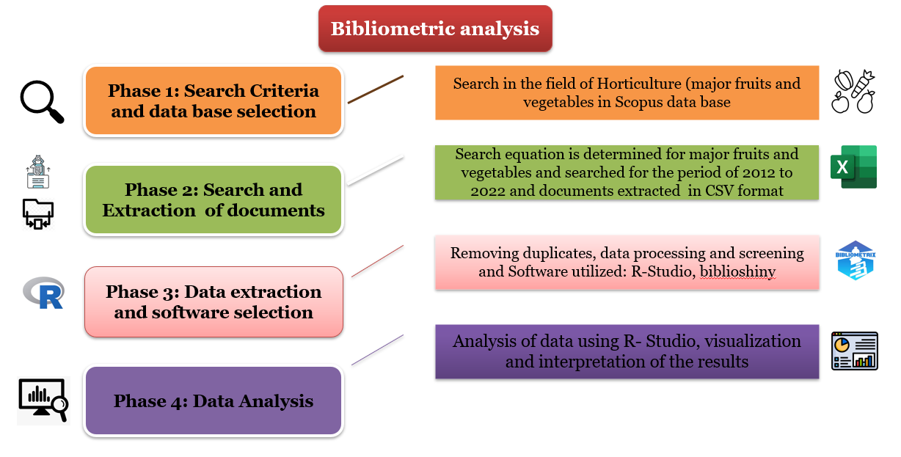Figure 1 illustrates the methodology used in the bibliometric analysis. The study focused on five major fruit crops (mango, banana, papaya, oranges~~,~~ and grapes) and five major vegetable crops (tomato, onion, potato, brinjal~~,~~ and cauliflower), selected based on area and production.

**Figure 1: Methodology for bibliometric analysis**

The search formula “*Mangifera indica*” AND "Banana" OR "*Musa paradisiaca*" OR "*Musa acuminata*" OR "*Musa balbisiana*" AND "Grape" OR "*Vitis vinifera*" " AND "Papaya" OR "*Carica papaya*” AND "oranges" OR "*Citrus sinensis*" OR "*Citrus reticulata*" for fruits and "Tomato" OR "*Lycopersicon esculentum*" AND "onion" OR "*Allium cepa*" AND "Potato" OR "*Solanum tuberosum*" AND "Brinjal" OR "*Solanum melongena*" OR "Cauliflower" OR "*Brassica oleracea* var. *botrytis*" for vegetables was used. The search was carried out on the title, abstract, and keywords and was limited to India, the publication time range from 2012 to 2022, the document types to articles or reviews and the document language to English. The search yielded a total of 11584 publications. Data about these articles such as title, keywords, authors, institutions, countries, publication year, publishing journals were considered for further analysis. Consistency with the topic under consideration was verified by reading the titles, the abstracts and, in some cases, the articles to avoid errors and unrelated articles creeping in. This process removed almost one hundred documents from the initial database, leading to a final data set of 11484 documents (both fruits and vegetables).

The anlysis was conducted with the R programming language-based “bibliometrix” tool. The open-source nature of R makes it easy to obtain support from the users' community, which consists mainly of distinguished statisticians. This characteristic enables Bibliometrix to be flexible and quickly upgraded, as well as integrated with other statistical R-packages. These features make Bibliometrix valuable in bibliometrics, which is a constantly changing scientific field (Aria & Cuccurullo, 2017).

**2.2 Status of Major Fruits and Vegetables Production in India**

India has established itself as a leading producer of various fruits and vegetables. In the fruit category, mango production in India reached 2.47 million tonnes (Mt), contributing 4.5 per cent to the global production. For bananas, India produced 31.50 Mt, accounting for a significant 26.29 per cent of the world’s banana production. Grape production stood at 14.84 Mt, (19.02 % of global production), while papaya production was 6.01 Mt, making up 43.27per cent of the world’s output. Oranges were also a major contributor, with India producing 16.7 Mt, or 22.13 per cent of global production.In comparison, other top countries in fruit production include Indonesia, China, Mexico, and Brazil. For instance, Indonesia produced 0.36 Mt of mangoes (0.66 % of global production) and 11.87 Mt of bananas (9.91 %). China was a notable contributor with 8.18 Mt of bananas (6.83 %) and 6.82 Mt of grapes (8.74 %).

In the vegetable category, India’s production levels are equally impressive. The country produced 64.87 Mt of tomatoes, contributing 34.72 per cent of the world’s supply. Onion production was at 237.27 Mt (28.67 %), and potatoes at 78.24 Mt (21.79 %). India also led in cauliflower production, contributing 9.56 Mt or 37.45 per cent globally, and in brinjal production with 36.59 Mt, which is 64.62 per cent of the world’s output. Other major vegetable-producing countries include Indonesia, China, Mexico, and Pakistan. Indonesia contributed 20.57 Mt of tomatoes (11.01 %), while China produced 209.94 Mt of onions (25.36 %) and 20.84 Mt of potatoes (5.8 %).

**2.3 Activity index**

Activity index was used to identify the emerging areas in the different countries under consideration. Activity Index (AI) is the ratio of the country’s share in world’s publication output in the given field (sub-domain) to the country’s share in world’s publication output in all science fields (sub-domains), considering a domain. For analysis of activity index, we have selected major countries in this segment viz., India, China, USA, Mexico, Turkey, Indonesia and Brazil.

$$AI=\left\{\frac{(\frac{N_{ij}}{N_{io}})}{(\frac{N_{oj}}{N_{oo}})}\right\}*100$$

$N_{ij}$: Number of publications of country i in a sub-domain j

$N_{io}$: Number of publications of country i in all the sub-domains

$N_{oj}$: Number of publications of all countries in a sub-domain j

$N_{oo}$: Number of publications of all countries in all the sub-domains

* If AI = 100, then country’s research effort in the given field is at par with the world average
* If AI > 100, then it reflects higher than average activity in this field
* If AI < 100, then lower than average effort by the country in the particular field

**3. Results and discussion**

A total of 11,484 items (Table 1), encompassing both fruits and vegetables, had been found in the Scopus database. The following table provides an overview of the primary information about the documents analysed, offering a comprehensive picture of the data.

**Table 1: Essential information about the data**

|  |  |  |
| --- | --- | --- |
| Description | **Results** | |
| **Major fruits** | **Major vegetables** |
| Timespan | 2012-2022 | 2012-2022 |
| Sources (Journals, Books) | 1612 | 1270 |
| Documents | 5779 | 5705 |
|  | | |
| Article ***Document types*** | 4805 | 4811 |
| Review | 95 | 167 |
| Others | 879 | 727 |
| Annual Growth Rate % | 11.03 | 11.55 |
| Document Average Age | 6.17 | 6.16 |
| Average citations per document | 16.55 | 13.29 |
| ***Document contents*** | | |
| Keywords Plus (ID) | 20730 | 15030 |
| Author's Keywords (DE) | 13044 | 11863 |
| ***Authors*** | | |
| Authors | 13249 | 11892 |
| Single-authored documents | 147 | 152 |
| Co-Authors per documents | 4.23 | 4.55 |
| International co-authorships % | 13.5 | 14.28 |

**3.1 Publication information**

Among the 99,250 worldwide entries in the Scopus database in March 2024, 11,484 were from India. The growth rates for publications on fruits and vegetables are 11.03% and 11.55%, respectively.

There were 700 research articles published in five key fruit crops and 811 articles in five major vegetable crops during 2022 (Figs. 2 and 3). This suggests that horticultural research on fruit crops is gaining momentum. According to a comprehensive review of studies published from 2017 to 2022, Plant breeding, disease resistance, climate change, horticulture robots, deep learning, and convolutional neural networks were all heavily explored.

**Table 2: Number of Articles Published in Major Countries (2012-2022)**

|  |  |  |  |  |  |  |  |  |  |
| --- | --- | --- | --- | --- | --- | --- | --- | --- | --- |
|  | **India** | **China** | **USA** | **Mexico** | **Brazil** | **Indonesia** | **Turkey** | **Total** | **World** |
| **Fruits** | | | | | | | | | |
| **Mango** | 1300 | 570 | 336 | 320 | 538 | 181 | 24 | 3269 | 5600 |
| **Banana** | 1793 | 1204 | 450 | 157 | 917 | 733 | 85 | 5339 | 8684 |
| **Grapes** | 677 | 3173 | 1595 | 112 | 992 | 65 | 615 | 7229 | 14984 |
| **Papaya** | 523 | 250 | 259 | 191 | 476 | 228 | 10 | 1937 | 2870 |
| **Oranges** | 1486 | 4349 | 1596 | 287 | 925 | 281 | 332 | 9256 | 14873 |
| **Vegetables** | | | | | | | | | |
| **Tomato** | 2246 | 5247 | 3014 | 689 | 1433 | 379 | 626 | 13634 | 23981 |
| **Onion** | 931 | 672 | 670 | 70 | 400 | 193 | 207 | 3143 | 5796 |
| **Potato** | 1644 | 4503 | 2490 | 193 | 779 | 623 | 334 | 10566 | 20243 |
| **Brinjal** | 606 | 155 | 32 | 8 | 9 | 27 | 30 | 867 | 1187 |
| **Cauliflower** | 278 | 198 | 61 | 3 | 58 | 13 | 19 | 630 | 1032 |
| **Total** | 11484 | 20321 | 10503 | 2030 | 6527 | 2723 | 2282 | 55870 | 99250 |

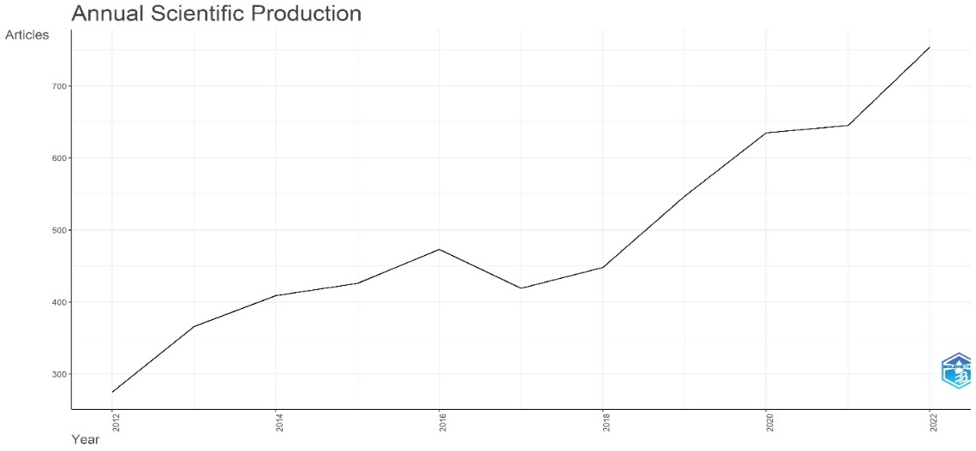

**Figure 2: Annual scientific production of fruits**

**Figure 3: Annual scientific production of Vegetables**

**3.1.1 Activity index**

Activity index (see session 2.2) of major horticultural crops in major countries were compared (Table 3), highest activity index for India is for Brinjal (340) followed by Mango (194). Among the other countries, Mexico for mango (269), Brazil for papaya (210) and Turkey for Grapes (208) were having values higher than 200.

**Table 3: Activity Index for the years 2012-2022**

|  |  |  |  |  |  |  |  |
| --- | --- | --- | --- | --- | --- | --- | --- |
| **Sub-domain** | **India** | **China** | **USA** | **Mexico** | **Brazil** | **Indonesia** | **Turkey** |
| **Fruits** | | | | | | | |
| **Mango** | 194 | 47 | 54 | 269 | 140 | 113 | 17 |
| **Banana** | 163 | 62 | 44 | 80 | 147 | 281 | 38 |
| **Grapes** | 45 | 120 | 117 | 42 | 117 | 18 | 208 |
| **Papaya** | 131 | 35 | 71 | 271 | 210 | 241 | 12 |
| **Oranges** | 78 | 129 | 91 | 85 | 85 | 62 | 87 |
| **Vegetables** | | | | | | | |
| **Tomato** | 80 | 105 | 117 | 139 | 89 | 57 | 112 |
| **Onion** | 144 | 58 | 113 | 61 | 108 | 125 | 161 |
| **Potato** | 75 | 117 | 125 | 50 | 63 | 120 | 77 |
| **Brinjal** | 340 | 49 | 19 | 25 | 9 | 63 | 84 |
| **Cauliflower** | 214 | 84 | 51 | 13 | 78 | 42 | 74 |

**3.2 Most preferred journals**

**3.2.1 Fruits**

Analysis was carried out to identify the most preferred journals based on the number of articles published. Based on article count, Indian Journal of Horticulture has the most publications with 150 (Fig. 4). That was followed by Materials Today: Proceedings (146 papers). Acta Horticulturae contained 100 articles. Indian Journal of Agricultural Sciences (96 articles), Journal of Food Science and Technology (88 articles), Plant Archives (71 articles), Journal of Natural Fibres (57 articles), AIP Conference Proceedings (50 articles), Journal of Food Processing and Preservation (45 articles)~~,~~ and Scientia Horticulturae (48 articles) ranked in the top 10.

**3.2.2 Vegetables**

The Potato Journal had the most papers published with 210. Plant Archives had 172 articles, placing it third, and the Indian Journal of Agricultural Sciences had 201 articles (Fig. 5), placing it second. There are 138 articles in the Indian Journal of Horticulture. Indian Phytopathology and the Indian Journal of Entomology each had 63 papers published, while the Journal of Entomological Research had 65 articles, Vegetos had 61 articles, Pestology had 60 articles, and Acta Horticulturae had 54 articles. These journals are among the top ten in terms of article output.

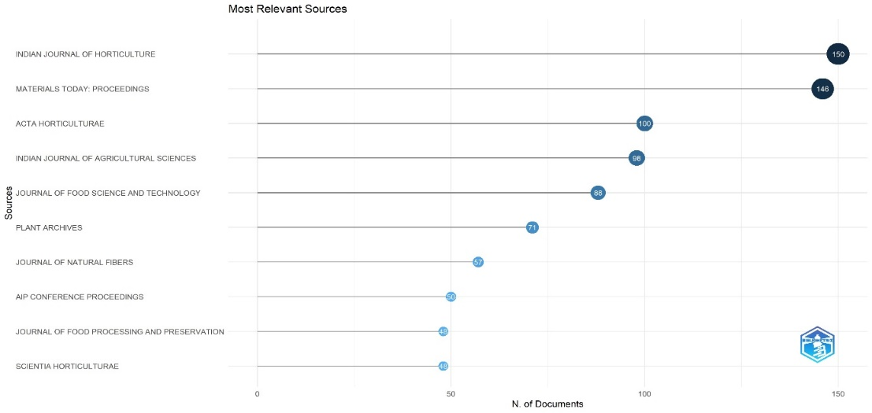

**Figure 4: Most relevant sources with respect to major fruits in India**

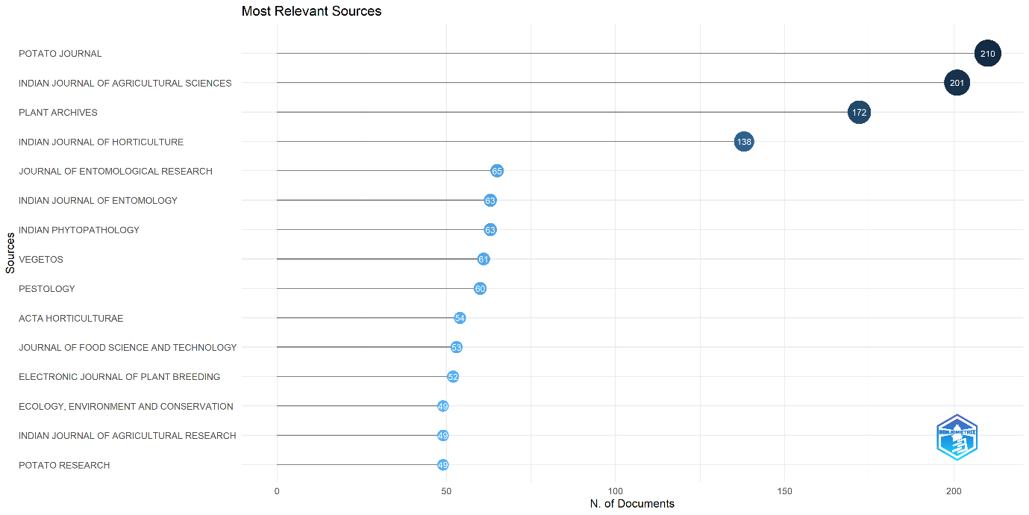

**Figure 5: Most relevant sources with respect to major vegetables in India**

**Sources’ Local Impact**

This section uses multiple metrics to assess the impact and productivity of scientific sources in horticulture. The **h-index** proposed by Jorge Hirsch in 2005, measures the cumulative impact of an individual’s publications by counting the number of papers with at least h citations. The **g-index** extends the h-index by focusing on the top g articles that together have received at least g² citations, emphasizing significant contributions. The **m-index** evaluates a researcher’s productivity and impact by considering the median number of citations across all papers, offering a more balanced view of their overall citation influence.

**Major fruits**: “The Journal of Food Science and Technology” recorded the highest h-index (26), g index (40) and total citations (2049) in major fruit crops. “Materials Today: Proceedings” has highest m index (2.33) and second-highest index (21) and total citations (1782) (Table 4)

**Major vegetables**: Journal “Scientific Reports”has Highest h index (21), g index (39), total citation (1551). After that, “Journal of Food Science and Technology” has second-highest citation number (1465)~~,~~ and g index (37) (Table 5).

**Table 4: Local impact of sources with respect to major Fruits.**

|  |  |  |  |  |  |  |
| --- | --- | --- | --- | --- | --- | --- |
| **Sources** | **h_index** | **g_index** | **m_index** | **TC** | **NP** | **PY_start** |
| Journal Of Food Science and Technology | 26 | 40 | 2.16 | 2049 | 88 | 2013 |
| Materials Today: Proceedings | 21 | 33 | 2.33 | 1782 | 146 | 2016 |
| International Journal of Biological Macromolecules | 20 | 34 | 1.81 | 1573 | 34 | 2014 |
| Journal Of Natural Fibers | 19 | 29 | 1.58 | 1002 | 57 | 2013 |
| Plos One | 19 | 23 | 1.46 | 897 | 23 | 2012 |
| Journal Of Luminescence | 18 | 27 | 1.63 | 776 | 29 | 2014 |
| Rsc Advances | 18 | 28 | 1.50 | 1679 | 28 | 2013 |
| Scientia Horticulturae | 18 | 30 | 1.38 | 1067 | 48 | 2012 |
| Journal Of Molecular Liquids | 17 | 20 | 1.41 | 1320 | 20 | 2013 |
| LWT | 17 | 23 | 1.41 | 840 | 23 | 2013 |

|  |  |  |  |  |  |  |
| --- | --- | --- | --- | --- | --- | --- |
| **Sources** | **h_index** | **g_index** | **m_index** | **TC** | **NP** | **PY_start** |
| Journal Of Food Science and Technology | 21 | 37 | 1.61 | 1465 | 53 | 2012 |
| Scientific Reports | 21 | 39 | 1.61 | 1551 | 47 | 2012 |
| Frontiers In Plant Science | 20 | 32 | 1.53 | 1109 | 42 | 2012 |
| Scientia Horticulturae | 19 | 31 | 1.58 | 1063 | 44 | 2013 |
| Plant Physiology and Biochemistry | 18 | 28 | 1.38 | 1038 | 28 | 2012 |
| Biotech | 16 | 26 | 1.6 | 785 | 42 | 2015 |
| International Journal of Biological Macromolecules | 15 | 21 | 1.36 | 1167 | 21 | 2014 |
| LWT | 14 | 20 | 1.16 | 752 | 20 | 2013 |
| Plos One | 14 | 22 | 1.16 | 652 | 22 | 2013 |
| Archives Of Phytopathology and Plant Protection | 13 | 19 | 1.00 | 472 | 49 | 2012 |

**Table 5: Local impact of sources with respect to major Fruit.**

The total number of citations (TC), the number of publications (NP), and the year of first publication (PY-start)

**3.3** **Most Relevant authors (in India)**

**3.3.1 Major Fruits**

The present study identified 13,249 authors who collectively authored 5,779 publications in major fruits. Based on the number of publications from 2012 to 2022, Kumar S is the top-ranked author with 90 articles. Kumar ~~A~~ and Gupta ~~SK~~  (year….) followed with 77 and 76 articles respectively. The writers depicted in Figure 6 are the ones who made the most frequent contributions in the field of fruits. This output is of great significance to scholars seeking references or prospects for collaboration. Figure 7 clearly illustrates the changes in the production of well-known authors throughout time. The diameter of the circle represented the count of publications, while its darkness indicated the total number of citations received annually.

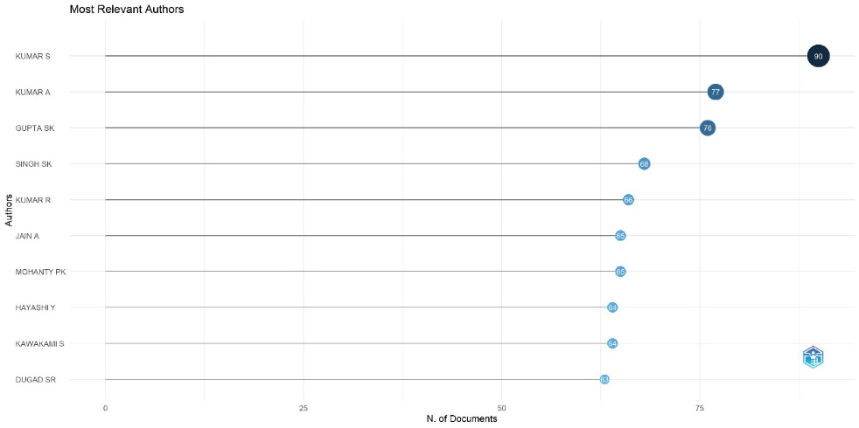

**Figure 6: Most relevant authors with respect to major fruits in India**

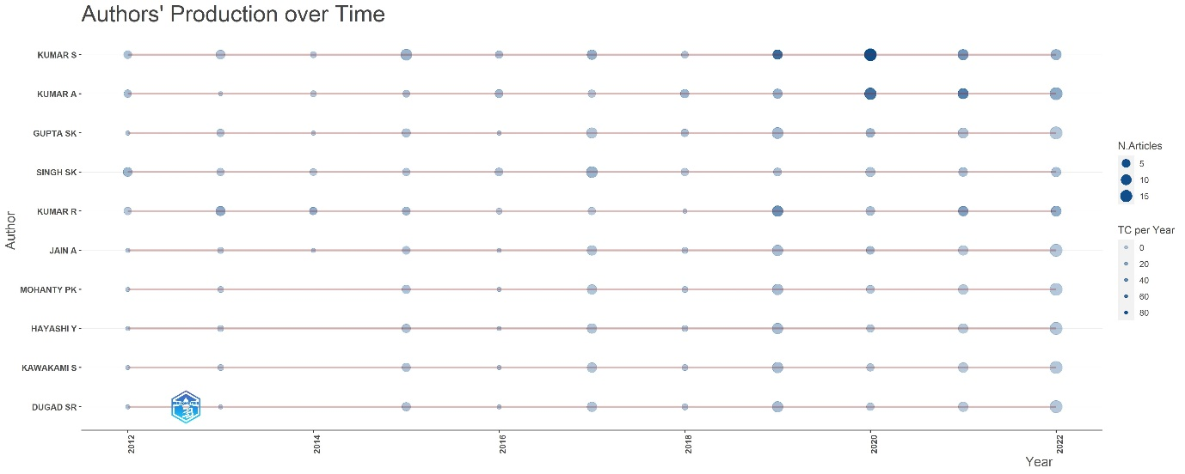

**Figure 7: Authors’ production over time with respect to fruits**

**3.3.2. Major Vegetables**

The study examined the most prolific authors in prominent vegetables and identified a total of 11,892 authors who collectively authored 5,705 publications between 2012 and 2022. Kumar (year…..) ~~A~~ emerged as the highest-ranked author with 200 articles, followed by Sharma ~~S~~ and Kumar ~~R~~ (year…..) with 197 articles, and 184 articles respectively. The authors depicted in Figure 8 are the ones who make the most frequent contributions to “major vegetable crops”.

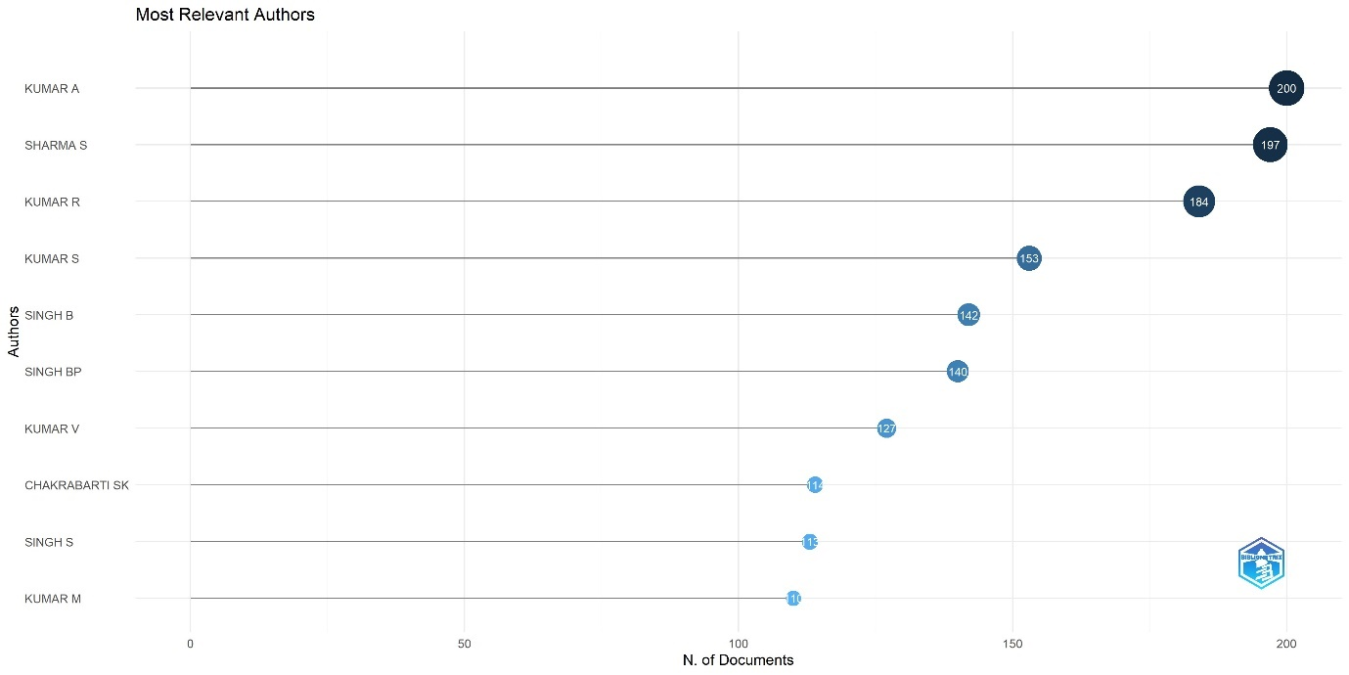

**Figure 8: Most relevant authors with respect to major vegetables in India**

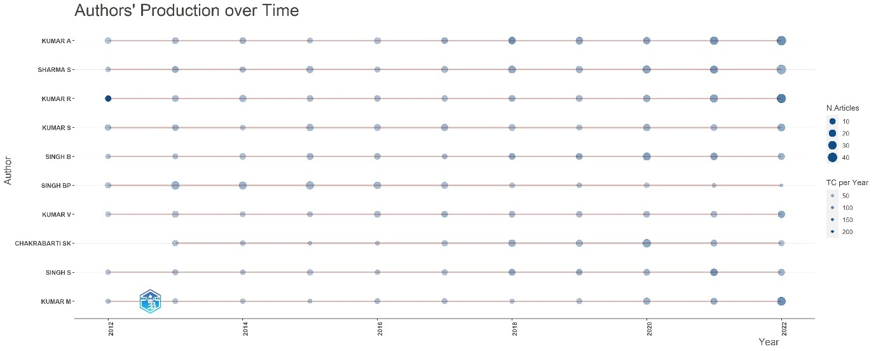

**Figure 9: Authors’ production over time with respect to vegetable crops**

**3.4 Authors’ collaboration network**

**3.4.1 Major Fruits:**

Analyzing the collaboration network of a subject is crucial in understanding its social structure. This type of analysis can help identify various structures, including regular research groups, hidden groups of scholars, and influential authors. Fig. 10 shows the author collaboration network map. Collaboration networks between writers and periodicals were facilitated by social networks. The (author x author) adjacency matrix, which is based on co-publication frequency, is used to analyse author-based collaborative networks. Two clusters were identified using network structure analysis. In this network, each colour stood for a cooperative author group. Since the writers were cluster nodes, the frequency of their collaborations was represented in the thickness of their links. The impact of authors is shown in the network’s node expansion.

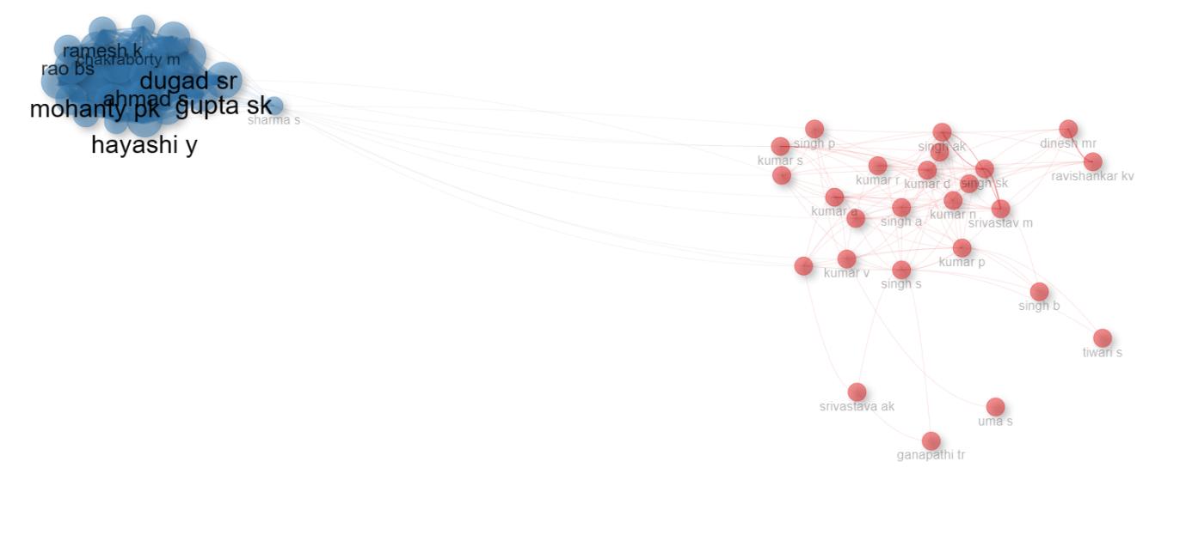**Figure 10: Collaboration network of authors of major fruits**

**3.4.2 Major Vegetables**

In the case of vegetables, the author network is composed of four distinct clusters (as shown in Figure 11), indicating a strong collaboration between different research groups. The red, blue, green clusters are interconnected, suggesting that the authors in these groups work together frequently. Some authors, such as Kumar V, Kumar R, Sharma S and Singh BP have published papers more frequently within their network. Other active authors in their collaboration structure include Singh S, Singh RK and Kumar M. Overall, the collaboration network analysis provides insight into the social structure of the horticulture community (majorly vegetables) and its collaborative tendencies.

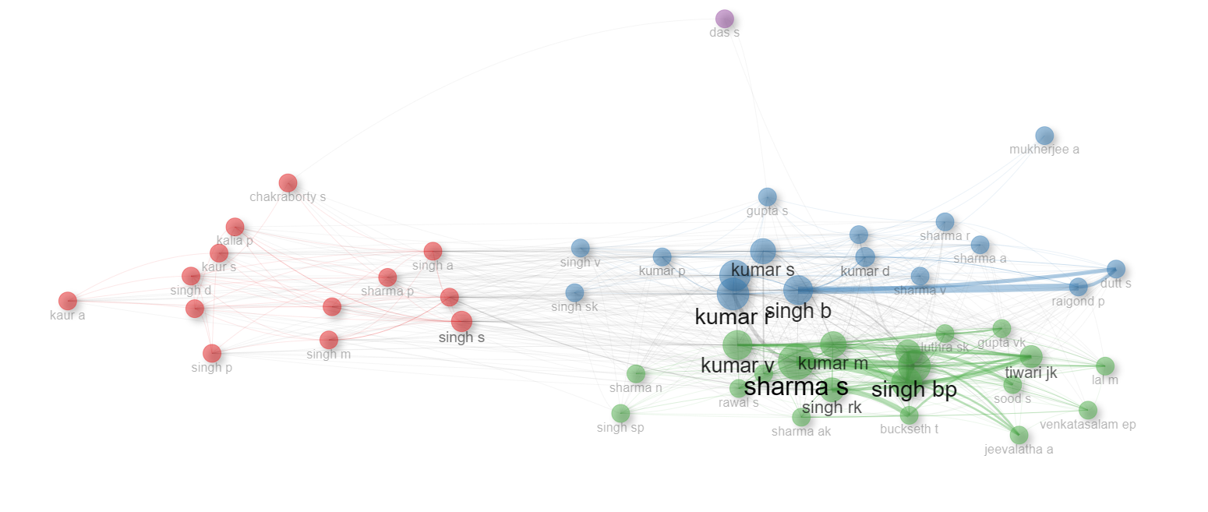

**Figure 11: Collaboration network of authors major vegetables**

**3.5 Most globally cited document**

**3.5.1 Major fruits:**

Citation count is a measure of a scientific publication’s effect, quality, influence, utility, and scientific performance (Chen *et al.,* 2022). Table 6 shows the documents that have the greatest impact. The article titled "Studies on banana fruit quality and maturity stages using hyperspectral imaging" by Rajkumar P (Dept. of Food & Agrl. Process Engineering, AEC & RI, TNAU, Coimbatore, India), published in the "Journal of Food Engineering" in 2012, has received the most number of citations, with a total of 313 which is followed by the article "AI-powered banana diseases and pest detection published" by Selvaraj MG (International Centre for Tropical Agriculture, Colombia) in 2019 in the journal "Plant Methods" with 219 citations, and "Total phenolics, antioxidant activity, and functional properties of Tommy Atkins mango peel and kernel as affected by drying methods" by Sogo DS (Guru Nanak Dev University Amritsar, India) in 2013 in the "Food Chemistry" journal with 201 citations.

**Table 6: Top cited papers in Scopus data base with reference to major fruits**

|  |  |  |
| --- | --- | --- |
| **Paper** | **Total Citations** | **Total citations per Year** |
| Rajkumar ~~P~~, 2012, J. Food Eng. | 313 | 24.08 |
| Selvaraj ~~MG~~, 2019, Plant Methods | 219 | 36.5 |
| Sogi ~~DS~~, 2013, Food Chem. | 201 | 16.75 |
| Ajila CM, 2013, J. Funct. Foods | 201 | 16.75 |
| Ghag ~~SB~~, 2014, Plant Biotechnol J. | 172 | 15.63 |
| Gohain ~~M~~, 2017, Ind Crops Prod. | 149 | 18.63 |
| Stella Mary ~~G~~, 2016, Int J Recycl Org Waste Agric. | 149 | 16.55 |
| Singh ~~Z~~, 2013, Crit Rev Plant Sci. | 147 | 12.25 |
| Sreedharan ~~S~~, 2013, Plant Biotechnol J. | 141 | 11.75 |
| Krishnaswamy ~~K~~, 2013, Food Bioprocess Technol. | 134 | 11.16 |

**3.5.2 Major Vegetables**

Table 7 illustrates the most prominent documents that have received a higher number of citations in relation to main vegetables. The article titled "The tomato genome sequence provides insights into fleshy fruit evolution" published by Sato S (Department of Environmental Life Sciences, Tohoku University, Japan) in 2012 in the journal "Nature" has received the greatest number of citations, with a total of 2406. The next article is titled "Tomato crop disease classification using pre-trained deep learning algorithm" by Rangarajan AK (Department of Bioscience Engineering, Ghent University, Belgium) (2018) in the journal "Procedia Computer Science" with 348 citations. Following that is the article "Beneficial phytochemicals in potato - a review" by Ezekiel R (Department of Physiology, Osun State University, Nigeria) (2013) in the journal "Food Research International" with 326 citations.

**Table 7: Top cited papers in Scopus data base with reference to major vegetables.**

|  |  |  |
| --- | --- | --- |
| **Paper** | **Total Citations** | **Total citations per Year** |
| Sato ~~S~~, 2012, Nature | 2406 | 183.00 |
| Rangarajan ~~AK~~, 2018, Procedia Comput Sci. | 348 | 49.71 |
| Ezekiel ~~R~~, 2013, Food Res Int. | 326 | 27.16 |
| Aflitos ~~S~~, 2014, Plant J. | 290 | 26.36 |
| Saharan ~~V~~, 2015, Int J Biol Macromol. | 280 | 28 |
| Karthik ~~R~~, 2020, Appl Soft Comput J. | 276 | 55.20 |
| Zhang ~~Y~~, 2015, Nat Commun. | 251 | 25.10 |
| Faisal ~~M~~, 2013, J. Hazard Mater | 246 | 20.50 |
| Agarwal ~~M~~, 2020, Procedia Comput Sci. | 245 | 49.00 |
| Abbas ~~A~~, 2021, Comput Electron Agric. | 242 | 60.50 |

**3.6 Most relevant Keywords**

Analysing the evolution of the main keywords used in major fruits and vegetables research can help us understand the literature’s focus and core issues, hotspots and topics of interest during a specific period. The most frequently used keywords in the journals included in the Scopus database during 2012 to 2022 are presented in Figs. 12 and 14. The top words (or parts of keywords) used in the published article about major fruits and vegetables are shown in Figure 13and 15. The total number of occurrences for the keywords is shown by the size of each word.

**3.6.1 Major fruit crops**

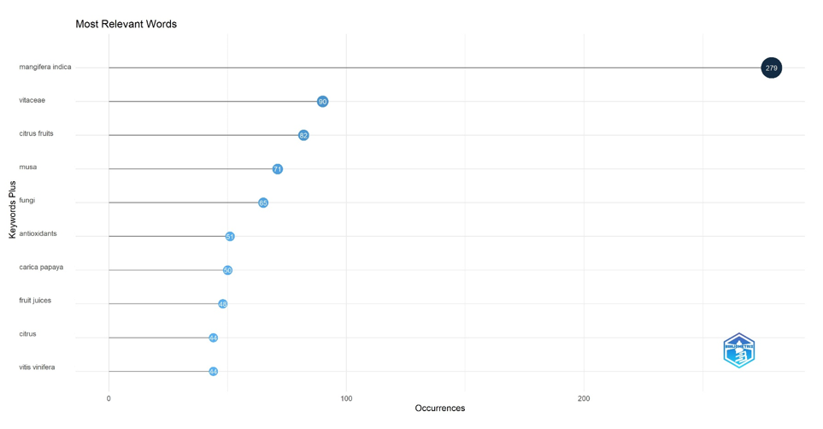As seen in Fig. 12, the most frequently used expressions in publications on the subject were "*Mangifera indica*", "vitiaceae" and "citrus fruits". These expressions were used 279, 90, and 82 times in the studies, respectively. These expressions were followed by the words musa (n = 71), fungi (n = 65), plant antioxidants (n = 51), and *carica papaya* (n = 50. The findings of a word cloud analysis conducted for the most popular terms are depicted in Fig. 13.

**Figure 12: Most relevant keywords of major fruits**

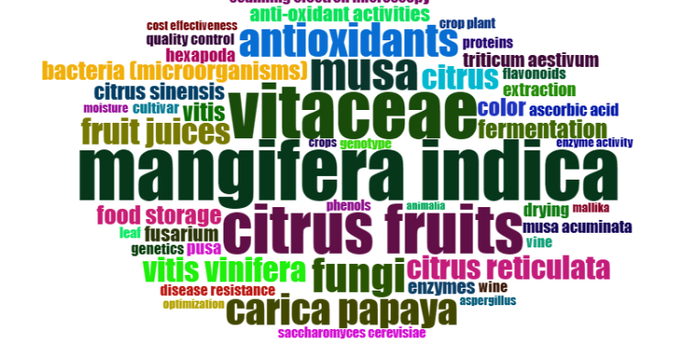

**Figure 13: Word cloud of major fruits**

**3.6.2 Major vegetables**

The most frequently used words in publications on the subject were "*Lycopersicon esculentum*", tomato and "*Solanum tuberosum*" (Fig 15). These expressions were used 1262, 1126, and 760 times in the studies, respectively. These expressions were followed by the word’s metabolism (748), potato (681), genetics (665), and fruits (n = 636) respectively. The findings of a word cloud analysis conducted for the most popular terms are depicted in Fig. 14. When [Fig](https://www.sciencedirect.com/science/article/pii/S2405844024021108?ref=pdf_download&fr=RR-2&rr=87a5f9f30c929a8f#fig7) 15  was observed, it revealed that the majority of the words were domain specific. The most used keyword was “*Lycopersicon esculentum*”. “Tomato” was the second most used keyword.

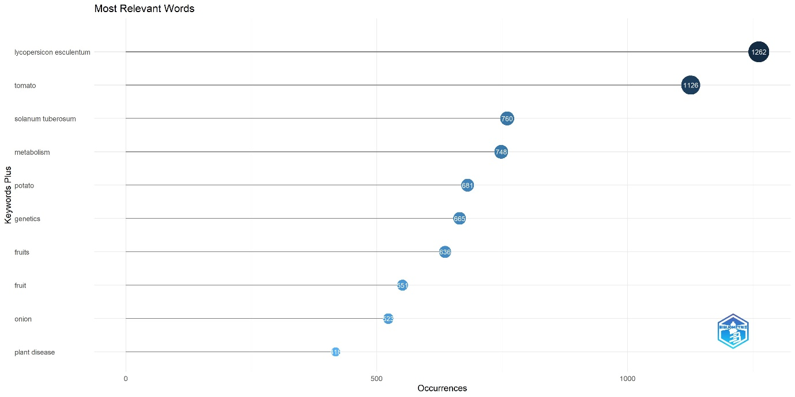

**Figure 14: Most relevant keywords of major vegetables**

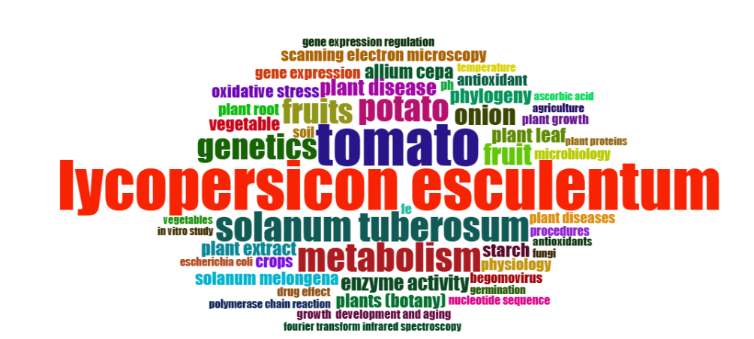

**Figure 15: Word cloud of major vegetables**

Based on the word cloud of keywords shown in Figures 13 and 15, it was observed that the previously mentioned authors’ keywords appeared frequently. However, since the word cloud only provides a visual representation of keyword frequency, it was not considered sufficient on its own. Therefore, a trend topic analysis was conducted to examine the popularity of keywords over time. This analysis tracks the evolution and influence of concepts in the literature.

Figures 16 and 17 show the logarithmic frequencies of various keywords, with recent topics depicted on the right-hand side. For major fruits (Fig. 16), keywords like Carica papaya, Mangifera indica, musa, fungi~~,~~ and vitacea were popular in the past, while more recent keywords include antioxidants, genetics, plant breeding~~,~~ and disease resistance. For major vegetables (Fig. 17), past popular keywords included Lycopersicon esculentum, ~~tomato,~~ Solanum tuberosum, agricultural research, residue analysis~~,~~ and Solanum melongena, while recent keywords focus on deep learning, climate change, convolution, agricultural robots~~,~~ and convolutional neural networks.

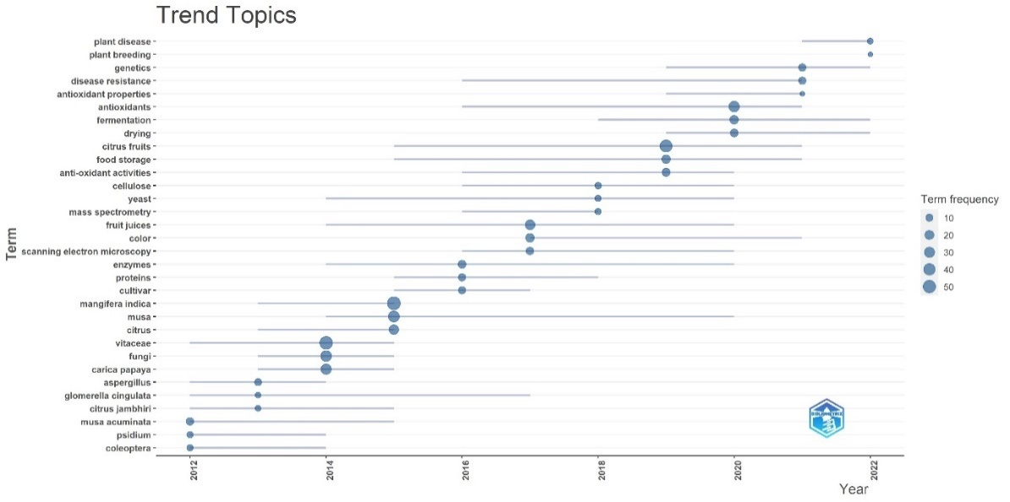

**Figure 16: Trending topic or word with respect to major fruits**

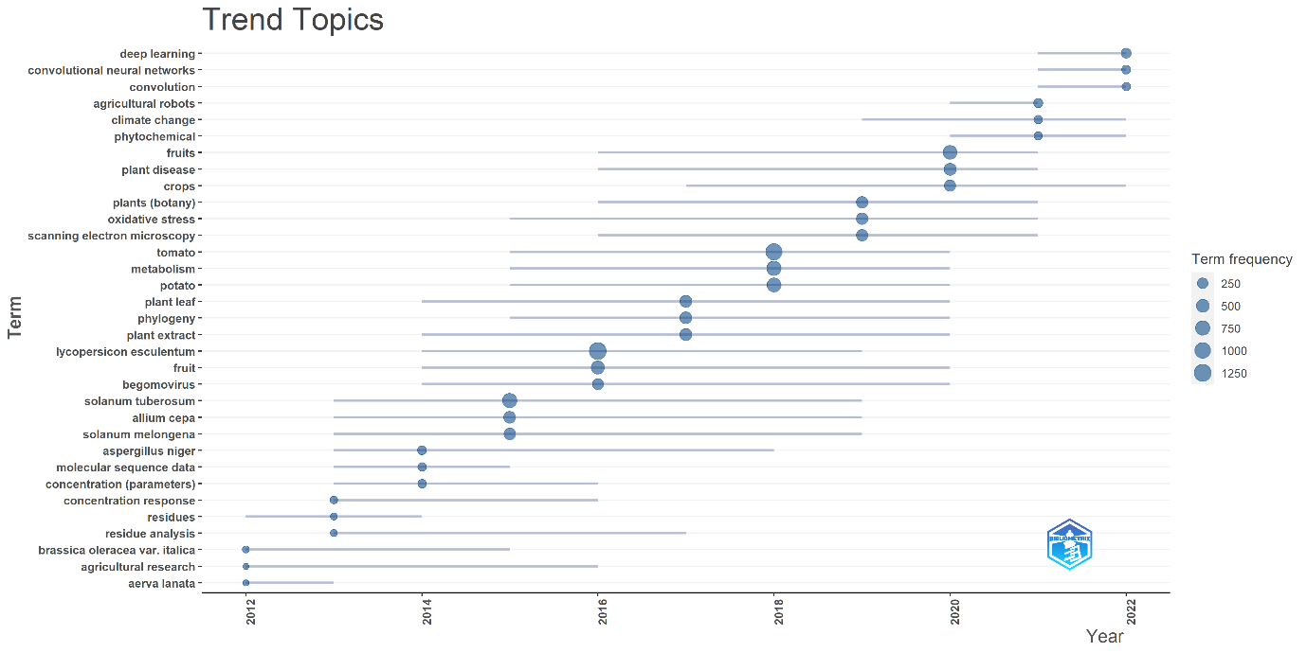

**Figure 17: Trending topic or word with respect to major vegetables**

**3.7~~-~~Co-occurrence network of keywords**

The co-occurrence network of the high frequency terms was displayed in Fig. 18, 19 using the R software, which is called Bibliometrix. The co-occurrence network’s clusters significantly overlapped, demonstrating their tight relationship in terms of study themes. The co-occurrence network’s lines that connect two circles show the connections between two keyworks. Generally speaking, the closer the link between two keyworks is, the thicker the line is, and the stronger their association (Van Nunen et al., 2018).

**3.7.1 Major fruits**

A social network analysis was conducted on phrases that are interconnected by at least two links and consist of 50 nodes that meet the specified criteria. Figure 18 depicts the network of phrases that co-occur. The intensity of the association between the keywords is shown by the color, size of the circles, text size, and thickness of the connecting lines. Cluster 1 (red) had the highest frequency of the keyword "Mangifera indica". This cluster was associated with topics such as antioxidants, ascorbic acid, citrus, food storage, plants (botany), drying, moisture, quality control, juices, enzyme activity, physiochemical property, proteins, anti-oxidants, enzymes, flavonoids, ethylene, morphology, ripening, and antioxidant. The keyword "Musa" was the most frequently used in cluster 2 (blue), which was associated with genetics, gene expression, gene expression regulation, physiology, and phylogeny. The keyword "Vitaceae" was most frequently used in Cluster 3 (green), which was associated with crop production, cultivation, and biochemical composition.

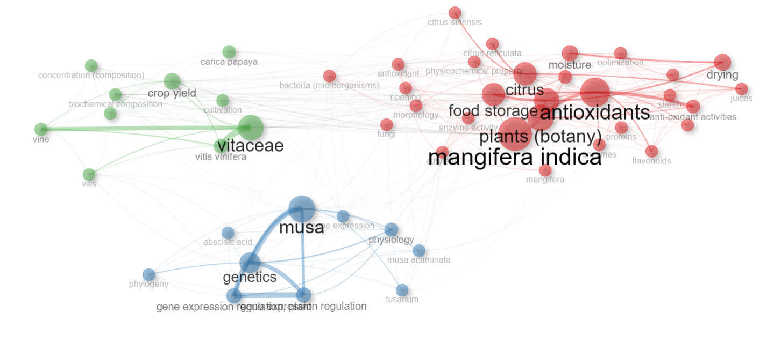

**Figure 18: Co-word network of fruits**

**3.7.2 Major vegetables**

In Fig. 9, Subjects of the same color formed strong relationships with each other. In cluster 1 (green), “Lycopersicon esculentum” was the most often used keyword, this cluster was relating to metabolism, genetics, physiology, transgenic plant, genetically modified, gene expression, plant diseases, fungi. In cluster 2 (blue), “Solanum tuberosum” was the most often used keyword, this cluster was relate to potato, starch, food storage, ascorbic acid.

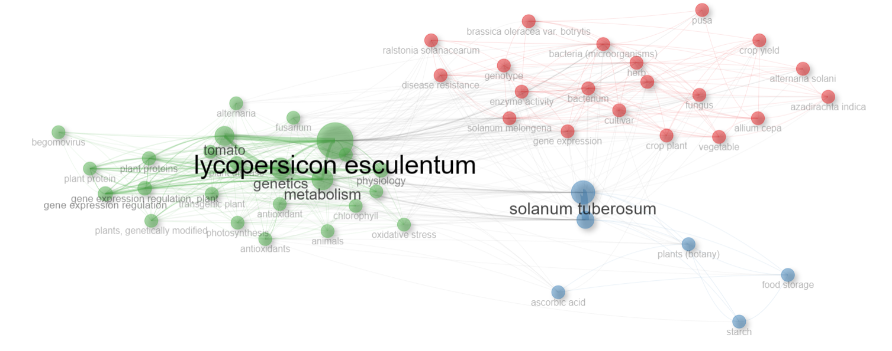

**Figure 19: Co-word network of vegetables**

**3.8 Relevant affiliations**

**3.8.1 Major fruit**

The "ICAR-Indian Agricultural Research Institute" had the most publications among Indian institutions with 394 articles. The "Punjab Agricultural University" ranked second with 233 published publications, followed by the "Tamil Nadu Agricultural University" (198). Figure 20 shows information on this and other major institutions. This shows that authors from these universities have produced many documents.

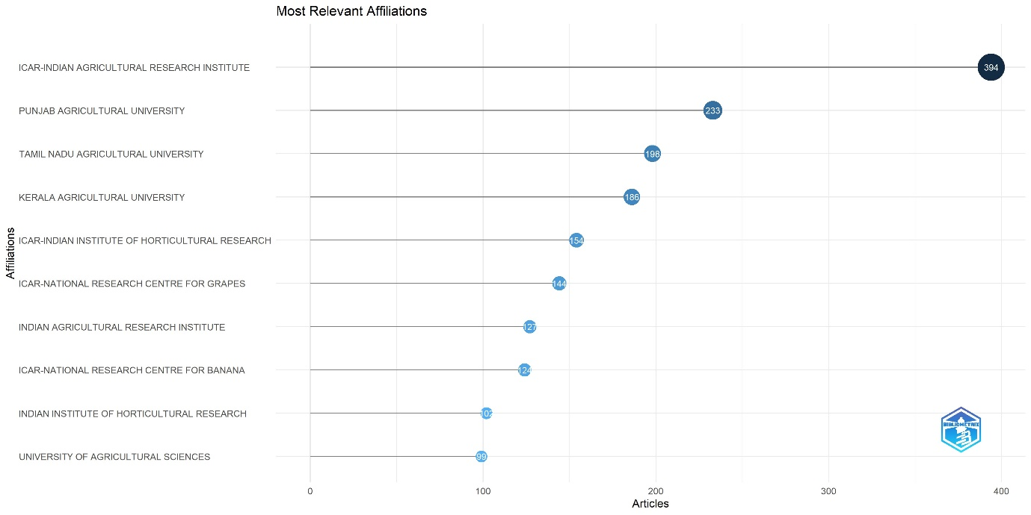

**Figure 20: Most relevant affiliations in India with respect to major fruits**

**3.8.2 Major Vegetables**

With respect to major vegetables, highest number of publications in India was “ICAR- Central Potato Research Institute” with 1167 publications. This was followed by “Punjab Agricultural University” with 608 publications and “ICAR- Indian Agricultural Institute with 485 publications”. Information about this and other important institutions are presented in Fig 21.

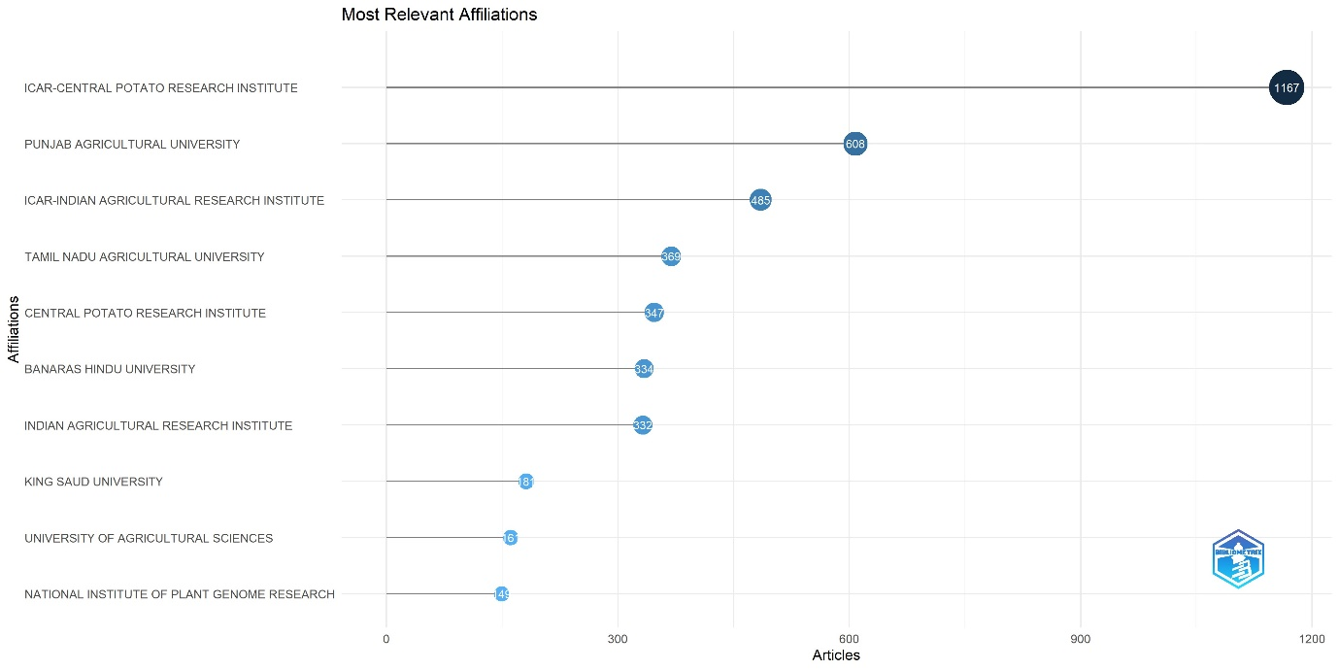

**Figure 21: Most relevant affiliations in India with respect to major vegetables**

**3.9. Number of authors per paper**

Upon analyzing articles published during the years 2012, 2017 and 2022, it was consistently observed that the majority featured between two to five authors. However, the prevalence of papers with this range of authors was notably highest in 2022, compared to the earlier years. In 2012 and 2017, while the distribution across different authorship ranges was similar, 2022 stood out with a significant increase in papers featuring two to five authors. This trend underscores a shift towards collaborative research practices over the years, as depicted in Figure 22, 23. The graph clearly illustrates the rise in multi-author papers in 2022, suggesting an evolving landscape of academic collaboration in recent years.

**Figure 22: Trends in number of authors per paper in major fruits**

**Figure 23: Trends in number of authors per paper in major vegetables**

**Discussion**

Focused bibliometric studies are essential for presenting the trend analysis of research in a certain topic or research area and for giving key bibliometric indexes like the most prolific authors, journals, and nations over time (Donthu et al., 2021). In the current investigation, bibliometric methods were utilized through R 4.2.1 to investigate articles that were associated with horticulture (fruits and vegetables included). The trend in the volume of literature that is published over a period is a reflection, to some extent, of the amount of research that was conducted in a specific topic during that time period. The research on major fruits and vegetables has been through three stages in terms of publication volume: a slow development stage (2017-2018, 2020-21 of fruit crops), a rapid growth stage (2018-2020, 2021-22 of major fruits; 2019-2022 of major vegetables), and a steady development stage (2016-2018 of major vegetables). The overall trend in the publication volume of literature was upward, which indicated that the study content linked to fruits and vegetables was continuously rising. This was the case because the volume of literature was increasing.

Author collaboration should be prioritized since it adds to scholarly advancement (Wang *et al*., 2022). Highly collaborative conduct was increased in recent years and has become a typical practice in most scientific areas (Kiser *et al*., 2018). It is worth mentioning that the USA had the largest level of collaboration.The trending topic/word were examined in order to better grasp the research topic. It was identified that keywords such, genetics, plant breeding, disease resistance, deep learning, climate change, convolution, agricultural robots, convolutional neural networks have been more widely used in the recent years. Additionally, new biotechnology techniques have been widely applied in horticultural crops for plant breeding and disease resistance because to the rapid advancement of molecular biology. The most cited articles “Studies on banana fruit quality and maturity stages using hyperspectral imaging” by Rajkumar ~~P~~ (2012); “AI-powered banana diseases and pest detection published” by Selvaraj ~~MG~~ (2019); “The tomato genome sequence provides insights into fleshy fruit evolution” by Sato ~~S~~ (2012); “Tomato crop disease classification using pre-trained deep learning algorithm” by Rangarajan ~~AK~~ (2018) are related to plant breeding, convolutional neural networks, deep learning which are trending topics in horticulture also.

The analysis of the horticulture (major fruits and vegetable) research area from a bibliometric perspective in this study will have management implications for academics and researchers and may aid in researchers’ efforts to get a comprehensive grasp of this field in the face of the challenge of more papers being published, might aid researchers in this endeavour (Yang *et al*., 2022). Researchers were able to find out the countries in this area as well as the most prestigious journals, important authors, study trends, and hotspots in this area. The results also showed that experts can quickly find the data they need. For example, the analysis of the journal may help researchers choose a good journal for them to send their work, and the analysis of the author may help writers find a possible co-author. Researchers can also quickly find study hotspots that could help them guide their work. That being said, this work could be used as a general resource by researchers. There are some problems with this study that need to be thought about. For starters, only journal pieces from the Scopus database are used for the analysis. Scopis is one of the world's biggest databases, but it doesn't have all the papers that are about vegetables and fruits. For another thing, this study wasn't meant to look at the specifics in great detail; instead, it was meant to show a broad view of the area.

**Conclusion**

As part of the study, bibliometric analysis of Scopus database using papers on major fruits and vegetables in horticulture was done. There were 11484 publications in the Scopus database covering the years 2012–2022, of which their distribution research areas, institutions, citations, journals, and keywords were examined. Furthermore, a word analysis of publications in the area revealed that the most often used words include *Mangifera indica*, vitiaceae, citrus fruits, *Lycopersicon esculentum*, tomato and *Solanum tuberosum*. This study also identified that the institution with the most research on Horticultural Crop in India was ICAR-Indian Agricultural Research Institute, ICAR- Central Potato Research Institute for major fruits and vegetables respectively. The cooperative structure of exceptional works, journals, and authors of major fruits and vegetables may be thought of as a roadmap that will serve as a starting point for future study. Bibliometric analysis is an important research method used to evaluate the impact of scholarly publications and the networks of authors and journals in a particular field.

**References**

1. Abdi, N. Idris, R.M. Alguliyev, R.M. Aliguliyev, Bibliometric analysis of IP&M journal (1980–2015), Journal of Scientometric Research 7 (1) (2018) 54–62.
2. Aria, M., & Cuccurullo, C. (2017). bibliometrix: An R-tool for comprehensive science mapping analysis. Journal of informetrics, 11(4), 959-975.
3. Bar-Ilan, J. (2010). Citations to the “Introduction to informetrics” indexed by WOS, Scopus and Google Scholar. Scientometrics, 82(3), 495-506.
4. Belmonte-Ureña, L.J., Garrido-Cardenas, J.A. & Camacho-Ferre, F. 2020 Analysis of world research on grafting in horticultural plants *HortScience* 55 1 112 120.
5. Cobo, M. J., López‐Herrera, A. G., Herrera‐Viedma, E., & Herrera, F. (2011). Science mapping software tools: Review, analysis, and cooperative study among tools. Journal of the American Society for information Science and Technology, 62(7), 1382-1402.
6. Dalla Via, J. & Baric, S. 2012 Tree fruit growing-research and production in Germany: A statistical and bibliometric analysis of the period 1950–2010 *Erwerbs-Obstbau* 54 1 11 30 doi: [10.1007/s10341-011-0155-2](https://doi.org/10.1007/s10341-011-0155-2)
7. Garner, R.M.; Hirsch, J.A.; Albuquerque, F.C.; Fargen, K.M. Bibliometric indices: defining academic productivity and citation rates of researchers, departments and journals. Journal of NeuroInterventional Surgery, v.10, n.2, p.102-106, 2018. http://dx.doi.org/10.1136/ neurintsurg-2017-013265
8. Girish, k. J., Suresh, A., Bhoopesh P., & Supriya, P. (2019) Growth of horticulture sector in India: Trends and prospects. Indian Journal of Agricultural Sciences 89 (2): 314–321.
9. H. Liao, et al., A bibliometric analysis and visualization of medical big data research, Sustainability 10 (166) (2018) 1–18.
10. Hirsch, J. E. (2005). An index to quantify an individual's scientific research output. Proceedings of the National academy of Sciences, 102(46), 16569-16572.
11. J. Wang, H. S. Zhang Cross-cultural learning: a visualized bibliometric analysis based on bibliometrix from 2002 to 2021. Mobile Inf. Syst., 2022 (2022), pp. 1-11,
12. Jamali, H.R., Steel, C.C. & Mohammadi, E. 2020 Wine research and its relationship with wine production: A scientometric analysis of global trends *Austral. J. Grape Wine Res.* 26 2 130 138 doi: [10.1111/ajgw.12422](https://doi.org/10.1111/ajgw.12422)
13. K. van Nunen, J. Li, G. Reniers, K. Ponnet Bibliometric analysis of safety culture research. Saf. Sci., 108 (2018), pp. 248-258, [10.1016/j.ssci.2017.08.011](https://doi.org/10.1016/j.ssci.2017.08.011)
14. Karolien van Nunen, Jie Li, Genserik Reniers, Koen Ponnet. Bibliometric analysis of safety culture research, Safety Science, Volume 108,2018, Pages 248-258
15. Kolle, S.R., Shankarappa, T.H. & Ho, Y.S. 2017 Highly cited articles in science citation index expanded – subject category of horticulture: A bibliometric analysis *Erwerbs-Obstbau* 59 2 133 145 doi: [10.1007/s10341-016-0308-4](https://doi.org/10.1007/s10341-016-0308-4)
16. Kolle, S.R., Shankarappa, T.H. & Manjunatha Reddy, T.B. 2018 Trends in mango research as seen through Science Citation Expanded Index of Web of Science *Erwerbs-Obstbau* 60 3 261 270 doi: [10.1007/s10341-018-0367-9](https://doi.org/10.1007/s10341-018-0367-9)
17. Kulak, M., Ozkan, A. & Bindak, R. 2019 A bibliometric analysis of the essential oil-bearing plants exposed to the water stress: How long way we have come and how much further? *Scientia Hort.* 246 418 436 doi: [10.1016/j.scienta.2018.11.031](https://doi.org/10.1016/j.scienta.2018.11.031)
18. Liao, G.K. No more first authors, no more last authors if we really want transdisciplinary research, we must ditch the ordered listing of authors that stalls collaborative science, says. Nature, 561 (2018), p. 435, [10.1038/d41586-018-06779-2](https://doi.org/10.1038/d41586-018-06779-2)
19. M. Aria, C. Cuccurullo, bibliometrix: an R-tool for comprehensive science mapping analysis, Journal of Informetrics (2017), [https://doi.org/10.1016/j. joi.2017.08.007](https://doi.org/10.1016/j.%20joi.2017.08.007).
20. M.A. Koseoglu, Growth and structure of authorship and co-authorship network in the strategic management realm: evidence from the strategic management journal, BRQ Business Research Quarterly 19 (3) (2016) 153–170.
21. M.A. Martinez, M.J. Cobo, M. Herrera, E. Herrera-Viedma, Analyzing the scientific volution of social work using science mapping, Res. Soc. Work. Pract. 25 (2) (2015) 257–277.
22. Martín-Martín, A., Orduna-Malea, E., & Delgado López-Cózar, E. (2018). Coverage of highly-cited documents in Google Scholar, Web of Science, and Scopus: a multidisciplinary comparison. Scientometrics, 116(3), 2175- 2188.
23. Meira, D., Woyann, L.G., Bozi, A.H., Milioli, A.S., Beche, E., Panho, M.C., Madella, L.A., Barrionuevo, F., Marchioro, V.S. & Benin, G. 2020 Asian soybean rust: A scientometric approach of Phakopsora pachyrhizi studies *Euphytica* 216 8 133 doi: [10.1007/s10681-020-02667-x](https://doi.org/10.1007/s10681-020-02667-x)
24. Mongeon, P. & Paul-Hus, A. 2016 The journal coverage of Web of Science and Scopus: A comparative analysis *Scientometrics* 106 213 228
25. N. Donthu, S. Kumar, D. Mukherjee, N. Pandey, W.M. Lim. How to conduct a bibliometric analysis: an overview and guidelines. J. Business Res., 133 (2021), pp. 285-296,
26. Pritchard, Statistical bibliography or bibliometrics, J. Doc. 25 (4) (1969) 348–349.
27. Raparelli, E. & Lolletti, D. 2020 Research, innovation and development on Corylus avellana through the bibliometric approach *Intl. J. Fruit Sci.* 20 sup3 S1280 S1296 doi: [10.1080/15538362.2020.1784076](https://doi.org/10.1080/15538362.2020.1784076)
28. Ren M, Yu X, Mujumdar AS, Yagoub AEGA, Chen L, Zhou C. Visualizing the knowledge domain of pulsed light technology in the food field: A scientometrics review. Innov Food Sci Emerg Technol. 2021;74:102823.
29. Sigala, M., Kumar, S., Donthu, N., Sureka, R., & Joshi, Y. (2021). A bibliometric overview of the Journal of Hospitality and Tourism Management: Research contributions and influence. Journal of Hospitality and Tourism Management, 47, 273-288.
30. Singh J (2014) Basic Horticulture. Kalyani publishers, Ludhiana
31. Singh, V. K., Singh, P., Karmakar, M., Leta, J., & Mayr, P. (2021). The journal coverage of Web of Science, Scopus and Dimensions: A comparative analysis. Scientometrics, 126, 5113-5142.
32. Strandberg, C., Nath, A., Hemmatdar, H., & Jahwash, M. (2018). Tourism research in the new millennium: A bibliometric review of literature in Tourism and Hospitality Research. Tourism and hospitality research, 18(3), 269-285.
33. Subbarayudu S, Sureshreddy S (2015) Risk management in horticulture: a case study in Anantapuramu district. Academicia 5:177–186.
34. Sun, J. & Yuan, B.Z. 2020a Mapping of the world rice research: A bibliometric analysis of top papers during 2008–2018 *Annals of Library and Information Studies* 67 1 56 66
35. Sun, J. & Yuan, B.Z. 2020b Bibliometric mapping of top papers in Library and Information Science based on the Essential Science Indicators Database *Malays. J. Libr. Inf. Sci.* 25 2 61 76 doi: [10.22452/mjlis.vol25no2.4](https://doi.org/10.22452/mjlis.vol25no2.4)
36. Sun, J. & Yuan, B.Z. 2020c Mapping of top papers in the subject category of Water Resources based on the Essential Science Indicators *Annals of Library and Information Studies* 67 2 90 102
37. Sun, J. & Yuan, B.Z. 2021 Trend and research status of agronomy based on the Essential Science Indicators during 2009–2019 *Agron. J.* 113 2 2184 2194 doi: [10.1002/agj2.20628](https://doi.org/10.1002/agj2.20628)
38. Tatry, M.V., Fournier, D., Jeannequin, B. & Dosba, F. 2011 Tools for analyzing and mapping scholarly publications not indexed by the Web of Science: The case of fruit and vegetable publications by the French National Institute for Agricultural Research (INRA) *Fruits* 66 2 131 140 doi: [10.1051/fruits/2011022](https://doi.org/10.1051/fruits/2011022).
39. Velasco-Muñoz, J.F., Aznar-Sánchez, J.A., Belmonte-Ureña, L.J. & López-Serrano, M.J. 2018a Advances in water use efficiency in agriculture: A bibliometric analysis *Water* 10 4 377 doi: [10.3390/w10040377](https://doi.org/10.3390/w10040377)
40. W. Yang, X. He, Z. Wang, L. Lu, G. Zhou, J. Cheng, X. Hao. Research focus and theme trend on fulminant myocarditis: a bibliometric analysis Front. Cardiovasc. Med., 9 (2022), Article 935073, [10.3389/fcvm.2022.935073](https://doi.org/10.3389/fcvm.2022.935073)
41. Wang, Y.P., Liu, W.Z., Li, G., Yan, W.M. & Gao, G.Y. 2019 A bibliometric analysis of soil and water conservation in the loess tableland-gully region of China *Water* 11 1 20 doi: [10.3390/w11010020](https://doi.org/10.3390/w11010020)
42. X.D. Li, M.N. An, Z.H. Xia, X.J. Bai, Y.H. Wu. Transcriptome analysis of watermelon (*Citrullus lanatus*) fruits in response to *Cucumber green mottle mosaic virus* (CGMMV) infection Sci. Rep., 7 (2017), Article 16747, [10.1038/s41598-017-17140-4](https://doi.org/10.1038/s41598-017-17140-4)
43. Yeung, A.W.K., Tzvetkov, N.T., Zengin, G., Wang, D.D., Xu, S.W., Mitrovic, G., Brncic, M., Dall’Acqua, S., Pirgozliev, V., Kijjoa, A., Georgiev, M.I. & Atanasov, A.G. 2019 The berries on the top *J. Berry Res.* 9 1 125 139 doi: [10.3233/JBR-180357](https://doi.org/10.3233/JBR-180357)
44. Yuan, B.Z. & Sun, J. 2019 Bibliometric and mapping of top papers in the subject category of green and sustainable science and technology based on ESI *COLLNET Journal of Scientometrics and Information Management* 13 2 269 289 doi: [10.1080/09737766.2020.1716643](https://doi.org/10.1080/09737766.2020.1716643)
45. Yuan, B.Z. & Sun, J. 2020a Bibliometric analysis of research on the maize based on top papers during 2009–2019 *COLLNET Journal of Scientometrics and Information Management* 14 1 75 92 doi: [10.1080/09737766.2020.1787110](https://doi.org/10.1080/09737766.2020.1787110)
46. Yuan, B.Z. & Sun, J. 2020b Mapping the scientific research on maize or corn: A bibliometric analysis of top papers during 2008–2018 *Maydica* 65 2 M7
47. Yuan, B.-Z., Bie, Z.-L. & Sun, J. 2021 Bibliometric analysis of global research on muskmelon (Cucumis melo L.) based on Web of Science *HortScience* 56 8 867 874 doi: [10.21273/HORTSCI15827-21](https://doi.org/10.21273/HORTSCI15827-21)
48. Zhang, X., H. Chen, W. Wang, P. Ord´o˜ nez de Pablos, What is the role of IT in innovation? A bibliometric analysis of research development in IT innovation, Behav. Inf. Technol. 35 (12) (2016) 1130–1143.