Mineralogical Characterization of Iron Ore Overburden: Sustainable Soil Remineralization through Circular Mining

Reviewed text by the reviewer

.

ABSTRACT

|  |
| --- |
| **Aims:** This research investigates the potential use of mining overburden from iron ore extraction as soil remineralizers—an environmentally sustainable solution to the waste generated by mining and a means to reduce dependence on imported fertilizers.  **Study design:** This proposal, based on circular economic principles, seeks to transform waste into agricultural inputs, fostering sustainable farming. The study characterizes compact shale, phyllite, and dolomitic itabirite overburden to evaluate their feasibility as soil remineralizers according to legal criteria.  **Place and Duration of Study:** The study was conducted in Minas Gerais state, Brazil, with sample collection from the Itabira Complex and Pico Mine. The research was carried out over a defined period, including field sampling, laboratory processing, and data analysis.  **Methodology:** Samples were collected from Itabira Complex and Pico Mine, processed, and subjected to particle size distribution, chemical, and crystallographic analyses.  **Results:** Particle size distribution results showed a high proportion of fine particles, supporting gradual nutrient release, improved soil structure, porosity, and water retention. Crystallographic analysis identified minerals like chlorite, calcite, albite, and quartz in compact shale, while dolomitic itabirite had high hematite and quartz concentrations. Compact phyllite featured quartz and mica (muscovite) with significant potassium content. Chemical analysis revealed that compact shale meets the Ministry of Agriculture, Livestock, and Supply (MAPA) criteria for K2O+CaO+MgO concentration, indicating potential agricultural use. However, high quartz content in all samples limits their effectiveness as soil correctives, as quartz does not neutralize soil acidity. Despite this, iron ore overburden can improve soil structure, retain water, and support essential biogeochemical processes, particularly in conservation agriculture. Heavy metal levels in samples are within MAPA’s safety limits for agricultural use.  **Conclusion:** The study concludes that iron ore overburden, especially compact shale, holds potential as soil remineralizers, though complementary practices are needed for optimal effectiveness. |

*Keywords: Mineralogy, metamorphic rocks, sustainability, circular economy, iron ore waste rock.*

1. INTRODUCTION

Tropical soils ~~have~~ always required nutrient supplementation and pH correction to achieve high productivity (Mello Prado, 2021). Brazil consumes approximately 38 million tons ~~per year~~ of soil correctives and 40 million tons of fertilizers annually, out of which about 85% are imported, generating a cost of approximately 16 billion ($ or ? clarify) realis for importers. This cost is primarily passed on to farmers at the end of the agricultural input value chain (ABRACAL, 2023). The chemical depletion of agricultural soil and the environmental liabilities generated by mining are intrinsic challenges to economic activities and demand urgent ~~and~~ effective solutions. The circular economy emerges as a sustainable alternative, proposing a development model that enables the reuse and recycling of materials, reorders waste generation, and promotes environmental, economic, and social sustainability (Saviour, 2012).

In this context, transforming mining waste into useful resources for other sectors, such as agriculture, is a promising strategy (Wolff, 2009). The use of mining waste as soil remineralizers in agriculture is an innovative, conservation-oriented, and sustainable approach that can partially help to mitigate the environmental impacts of mining and neutralize the natural acidity of tropical soils (Campe et al., 2022). Soil remineralizers are materials that enhance fertility by providing essential nutrients to plants and improving soil structure. Studies indicate that mining waste, especially those rich in minerals such as calcium, magnesium, potassium, and micronutrients can be effectively used as remineralizers, promoting the recovery and rejuvenation of degraded soils while increasing agricultural productivity (Swoboda et al., 2022). Iron ore mining generates environmental liabilities due to the large volume of waste and overburden materials produced. These wastes include rocks, saprolites, topsoil, ~~and,~~ as an initial residue; vegetation, as described by (Shingo, 2021). These materials are discarded during the extraction process of iron ore. Overburden rocks pose an environmental challenge due to the large amounts generated during mining process and consequently the negative impact they cause through accumulation and stacking. The improper disposal and management of large volumes of mining waste can lead to the underutilization of natural areas??, present geotechnical risks, and hinder future mineral extraction (Agboola et al., 2020; Gyebuni et al., 2024).

The circular approach not only contributes to the sustainable management of mining waste but also promotes lasting agriculture by conserving natural resources, improving soil quality, and maintaining long-term agricultural sustainability. The adoption of conservation agriculture practices using remineralizers derived from mining waste can transform an environmental liability into an agricultural asset, closing the production and consumption cycle in an ecologically sound manner (Hilmi et al., 2023). The use of rock powders for soil remineralization can reduce dependence on imported materials, as they can be used both in mixtures and in their pure form (Abraham Armah, 2021).

Produced domestically, remineralizers offer a more economical logistical chain (Yakovleva et al., 2021) and provide multiple benefits, including neutralizing soil Al3+ (Gorchs, 2015; Rodrigues et al., 2024), plant nutrition, promoting macro and microfauna (Ramos et al., 2022), and increasing soil carbon stocks (Martins et al., 2020). However, there is a need for further studies on the characterization and description of different lithotypes forming the waste materials used as remineralizers or soil conditioners. The chemical quality of rock powders used as remineralizers is intrinsically linked to their lithotypes, meaning there is chemical composition variation across different rock types. Therefore, ~~this~~ present research aims to discuss the mineralogical, chemical, and crystalline characteristics of rock waste and evaluate its potential use as remineralizers or raw material for agricultural soil conditioners.

2. material and methods

~~The study on S shale, P phyllite, and I itabirite (banded quartz hematite/ hematite schist) began with the collection of 800 kg of each rock, which were sent to the laboratory for crushing, granulometric classification, homogenization, and quartering, ensuring the appropriate mass and particle size distribution for testing (Sampaio et al. 2007). Samples of D dolomitic I itabirite, C compact S shale, and C compact P hyllite were collected from the Itabira Complex (19º41'30" S, 43º18'38" W), and D dolomitic P phyllite was collected from the Pico mine (20º13'43" S, 43º51'45"W).~~

~~After receipt, identification, and weighing, all the samples were homogenized and crushed to 100% in <3.35 mm size using a jaw crusher. Each of the crushed sample was homogenized into a conical pile, and aliquots were quartered for particle size distribution analysis. The remainder remained sample was ground in a pilot circuit aimed at P100 0.106 mm in a Furlan ball mill (90x60 cm, overflow discharge, 50 kg/h, 30 RPM). The ground product was homogenized, and new aliquots were quartered for further particle size distribution and chemical analyses.~~

All words and sentences repeated under subheding 2.1 Sample Preparation

**2.1 Sample Preparation**

The study on ~~S~~ shale, ~~P~~ phyllite, and ~~I~~ itabirite (banded quartz hematite/ hematite schist) began with the collection of 800 kg of each rock, which were sent to the laboratory for crushing, granulometric classification, homogenization, and quartering, ensuring the appropriate mass and particle size distribution for testing (Sampaio et al. 2007). Samples of ~~D~~ dolomitic ~~I~~ itabirite, ~~C~~ compact ~~S~~ shale, and ~~C~~ compact ~~P~~ phyllite were collected from the Itabira Complex (19º41'30" S, 43º18'38" W), and ~~D~~ dolomitic ~~P~~ phyllite was collected from the Pico mine (20º13'43" S, 43º51'45"W).

After receipt, identification, and weighing, all the samples were homogenized and crushed to 100% in <3.35 mm size using a jaw crusher. Each of the crushed sample was homogenized into a conical pile, and aliquots were quartered for particle size distribution analysis. The ~~remainder~~ remained sample was ground in a pilot circuit aimed at P100 0.106 mm in a Furlan ball mill (90x60 cm, overflow discharge, 50 kg/h, 30 RPM). The ground product was homogenized, and new aliquots were quartered for further particle size distribution and chemical analyses.

**2.2 Particle Size Distribution**

The particle size distribution was carried out according to the internal procedure, using a suspended dry sieving machine and following the protocol of ABNT NBR ISO 7181:2018 (ABNT- Brazilian Association of Technical Standards 2018). The results were expressed in spreadsheets, showing the relationship between the “% passing” and grain diameter in % ~~percentage,~~ with two decimal places. Distribution curves were plotted on graphs with the ordinate axis on an arithmetic scale (percentages) and the abscissa axis on a logarithmic scale (grain diameter). The materials retained and passed through the used meshes (ranging from 1.00 mm to <0.045 mm by laser) were dried at 105°C, weighed, and recorded in Excel spreadsheets.

Pile, and aliquots were quartered for particle size distribution analysis. The remainder was ground in a pilot circuit aimed at P100 0.106 mm in a Furlan ball mill (90x60 cm, overflow discharge, 50 kg/h, 30 RPM). The ground product was homogenized, and new aliquots were quartered for ?????

**2.3 Determination of Crystalline Phases**

To determine the crystalline phases, the samples were subjected to semiquantitative analyses by X-ray Diffraction (XRD), using a PANalytical Diffractometer with CuKα radiation and a graphite monochromator crystal. The analysis method was based on comparing the interplanar distances and the intensities of the peaks in the diffractograms of the samples with a reference sample, following the PDF-2 database of the ICDD (International Centre for Diffraction Data) to identify the crystalline phases present. The identified crystalline phases are listed in Table 1.

**Table 1 Crystalline phases used for comparison and identification in all lithotypes.**

|  |  |
| --- | --- |
| **Identified Crystalline Phases** | **Formula** |
| Quartz | SiO₂ |
| Chlorite | (Mg, Fe)₃(Al, Si)₄O₁₀(OH)₂ · (Mg, Fe)₃(OH)₆ |
| Albite | (Na, Ca) AlSi₃O₈ |
| Amphibole (cordierite) | (Mg, Fe)₂Al₄Si₅O₁₈ |
| Calcite | Ca(CO₃) |
| Hematite | Fe₂O₃ |
| Mica (muscovite) | KAl₂(Si₃Al)O₁₀(OH, F)₂ |

**2.4 X-ray Diffraction (XRD) Method**

The method of investigating solid crystalline substances by X-ray Diffraction (XRD) is based on the refraction of X-rays on crystallographic planes defined by the arrangement of atoms. It allows the identification of crystalline phases, estimation of their content, and determination of crystallographic parameters such as the unit cell. Diffraction occurs according to Bragg's Law (nλ=2dsinθ), which relates the diffraction angle to the distance between crystalline planes. The analysis was performed on powdered samples of crystalline material using X-ray radiation to identify mineral species present in proportions greater than 5% by weight.

**2.5 Chemical Analyses**

All tests were validated using certified standards, repeatability, and stoichiometric closure. The total iron content was determined according to NBR ISO 8577:2011 (ABNT- Associação Brasileira de Norma Técnicas 2011a), using titration with potassium dichromate and tin (II) chloride, with repeatability of 0.17%. The Fe²⁺ content followed ABNT NBR 9035:2007 (ABNT-Associação Brasileira de Norma Técnicas 2007), with repeatability of 0.12%. Loss on ignition (LOI) was performed by gravimetry, calcining the sample at 1000ºC, with repeatability of 0.07%. For ICP analyses, a procedure based on NBR ISO 11535:2011 (ABNT- Associação Brasileira de Norma Técnicas 2011b) was used, involving sample fusion and dissolution with HCl, followed by the analysis of ~~elements such as~~ SiO₂, Al₂O₃, and CaO using the SPECTRO ARCOS® equipment. Certified standards were used to ensure the accuracy of the results, which were validated by repeatability and statistical control.

3. results and discussion

**3.1 Particle size distribution**.

Overall, particle size distribution analysis indicated that the samples have a high proportion of fine particles, passing through the 0.106 mm sieve. Figure 1 shows the particle size distribution curve of the fine material obtained through grinding, with an average of 99.4% of the material passing through the 0.3 mm sieve and 97.46% passing through the 0.106 mm sieve. According to the nomenclature for rock powder granulometry, the material is classified as powder, based on MAPA's classification (2016). The particle size distribution of the material used in the research was 99% passing through the 0.106 mm sieve.

**Figure 1: Sample Particle Size Distribution of lithologies**

The results highlight the efficiency of the grinding processes for each type of lithology analyzed. The 0.72% mass loss during the sieving process can be considered minimal, suggesting high efficiency in the recovery of sieved material.

A key characteristic of remineralizers to be considered is the particle size of the product at the end of the process. Given that remineralizers are rocks that have undergone grinding, and that reactivity is highly dependent on this factor, it is recommended to primarily adopt the specification of powder form. However, depending on the type of soil and other characteristics to be tested, physical specifications as outlined in Annex I of IN 05, March 10, 2016, may be used. For remineralizers in powder form, the fraction passing through ABNT sieve no. 50 (with 0.30 mm mesh opening) has a theoretical reactivity of 100%, considering a period of 12 to 36 months.

Particles with diameters between 0.30 and 0.84 mm (passing through ABNT sieve no. 20 but retained on sieve no. 50) exhibit 60% reactivity within the same period, while coarser particles, with diameters between 0.84 and 2.00 mm (retained on ABNT sieve no. 20 but passing through sieve no. 10), have a reactivity of 20%. Finally, particles larger than 2.00 mm have no effect within this period.

Considering that most minerals constituting remineralizers have low water solubility, comminution is a practical, though expensive, method of increasing it. When finely ground, minerals are broken down, increasing the contact surface area between particles and soil. In the case of acidity correctives, particles smaller than 0.053 mm (passing through ABNT sieve no. 270) react completely within less than a month, whereas particles between 2.00 and 0.84 mm (retained on ABNT sieve no. 20 but passing through sieve no. 10) require more than 60 months for complete reaction. If immediate responses are not necessary, coarser particle sizes may be used; otherwise, finer particle sizes (<0.053 mm) are recommended.

This particle size profile indicates efficient grinding, achieving adequate particle release for subsequent processes, such as mineralization or leaching (Teixeira 2021).  
For agricultural use, the particle size distribution obtained allows the estimation of the material behavior in mineralization processes, the formation of secondary minerals, and soil carbon capture. Finer particles inherent to lithology can be advantageous, as they increase the specific surface area available for chemical reactions, which are important for accelerating biogeochemical processes in the soil.

The use of pulverized material can improve soil structure by increasing porosity and water retention capacity (Martins et al. 2023). The application of soil remineralizers with finer particle size, lower than filler, tends to accelerate chemical weathering processes. An example is magnesium (Mg), which is present in the crystalline structure of minerals but whose release depends on soil acidity, thus allowing for cation exchange (Silva Souza et al. 2017).

**Table 2: Identified Crystalline Phases in the X-ray Diffraction Patterns of compact shale, dolomitic itabirite, compact phyllite, and dolomitic phyllite.**

|  |  |  |
| --- | --- | --- |
| **Rock Sample** | **Crystalline phases** | **%** |
| Compact Schist | Chlorite | 38,4 |
| Dolomite | 9,8 |
| Albite | 17,2 |
| Quartz | 11,5 |
| Amphibole | 3,8 |
| Calcite | 19,3 |
| Dolomitic Itabirite | Quartz | 45,4 |
| Hematite | 52 |
| Chlorite | 2,6 |
| Compact Phyllite | Quartz | 56,5 |
| Mica (Muscovite) | 30,2 |
| Hematite | 11,2 |
| Chlorite | 2,1 |
| Dolomitic Phyllite | Quartz | 12,9 |
| Kaolinite | 54,1 |
| Goethite | 20,7 |
| Anatase | 2 |
| Hematite | 6,8 |
| Gibbsite | 3,5 |

The mineralogical analysis of the studied mining waste reveals that the predominance of minerals such as quartz, chlorite, mica (muscovite), and hematite, each with distinct agronomic relevance. Quartz, present in all samples, has high chemical stability and low reactivity in the soil, contributing more to structure than to fertility (Sposito, 2008).

Chlorite, found in compact shale and dolomitic itabirite, is a layered silicate with the potential to release magnesium and iron cations in acidic soils, though it has low solubility (Bailey, 1988). In the mineral composition of compact shale, chlorite has a 2:1:1 structure, consisting of two layers of silicon and aluminum tetrahedrons, linked to an octahedral layer of magnesium and iron cations. This stable structure may limit the solubility of these cations in the soil. Magnesium cations, strongly bound to oxygens and hydroxyls in the mineral structure, exhibit low mobility in neutral pH but are released at pH < 5, especially in the presence of organic acids, resulting in minimal leaching (Silva et al., 2023). The percentage of chlorite in the rock suggests that agronomically, it may play a structural role, particularly in clayey soils, enhancing water retention.

Mica (muscovite), predominant in compact phyllite, contains potassium, but its release is slow and requires chemical weathering for plant uptake (Tisdale et al., 1985). When using phyllite powder, muscovite can transform into vermiculite or smectite, minerals with high water retention capacity, contributing to the physical and chemical recovery of the soil in the medium and long term (Silverol and Filho, 2006). Hematite, predominant in dolomitic itabirite, is resistant to weathering and releases iron slowly, limiting its immediate contribution to soil fertility (Faivre, 2016).

Cordierite, present in compact shale, is an orthorhombic silicate resistant to chemical alteration. Experimental studies show that its dissolution rate is very low, indicating high stability. Cation release mainly occurs through incongruent dissolution, forming new secondary minerals such as clay minerals and iron oxides (Blum and Stillings, 1995).

Finally, the semi quantification of crystalline phases in dolomitic phyllite showed kaolinite (abundant), goethite (moderate), quartz (minor), and low proportions of hematite, gibbsite, and anatase. Kaolinite, due to its low cation exchange capacity and stable structure, contributes more to soil structure than to plant nutrition (Vitorino et al., 2003).

**3.~~1~~2 Difratometria de raios X**

The X-ray diffractograms of the analyzed samples reveal distinct mineralogical compositions that reflect different geological contexts and formation processes. The presence of phases such as chlorite, quartz, hematite, and kaolinite, among others, provides insights into thermodynamic conditions, alteration environments, and potential industrial applications.

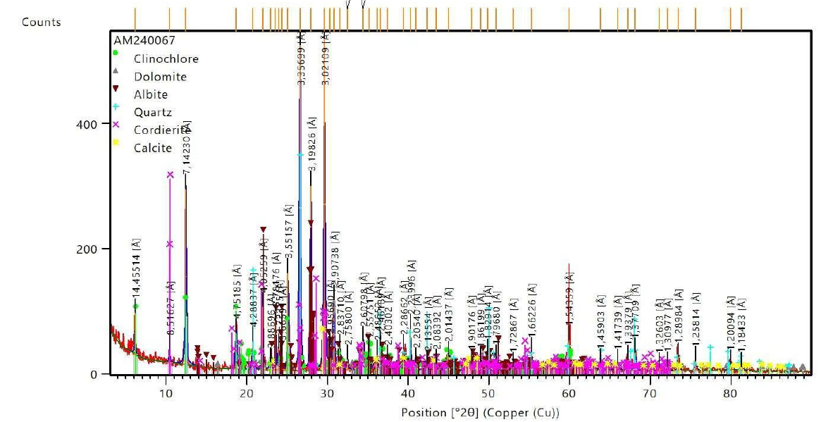

**A**

In sample Compact Schist, which is dominated by chlorite (38.4%) and calcite (19.3%), the results suggest an environment of hydrothermal alteration or low-grade metamorphism. Chlorite, an Fe–Mg phyllosilicate, is commonly found in shear zones or in iron-rich metamorphic rocks, while calcite indicates the influence of carbonate fluids. The presence of albite (17.2%) and quartz (11.5%) further points to an origin associated with igneous or intermediate metamorphic rocks (Bish & Post, 1993).

In sample Dolomitic Itabirite, the predominance of hematite (52%) and quartz (45.4%) indicates an oxidizing environment typical of banded iron formations (BIFs) or lateritic deposits. Hematite, an iron oxide, forms under conditions of high oxygenation, whereas quartz represents the residual silica after chemical weathering. The low concentration of chlorite (2.6%) suggests a limited contribution from ferromagnesian minerals (Cornell & Schwertmann, 2003).

In sample Compact Phyllite, the association of quartz (56.5%) and muscovite mica (30.2%) indicates a geological context related to felsic rocks such as granites or mica schists. Muscovite, a mineral typical of regional metamorphism, is stable under medium to high pressure conditions. The residual hematite (11.2%) may result from the oxidation of primary minerals like biotite (Deer et al., 2013).



**B**

The Dolomitic Filite sample from Mina do Pico shows a dominance of kaolinite (54.1%) and goethite (20.7%), reflecting intense chemical weathering under acidic and humid conditions typical of lateritic profiles. Kaolinite, a 1:1 clay mineral, forms through the leaching of alkali and alkaline earth cations, while goethite (FeO(OH)) is a product of the oxidation of sulfides or iron oxides. The presence of gibbsite (3.5%) further supports an environment characterized by high rainfall in tropical regions (Dixon & Weed, 1989).

It is important to note that the detection limit of XRD (1–2%) implies that trace phases, such as anatase (2%) in the filite sample, may be underrepresented. Complementary techniques, such as SEM-EDS, are essential for identifying microstructures and elements present in low concentrations (Klug & Alexander, 1974). Moreover, while the semi-quantification by the Rietveld method is robust, it depends critically on the quality of the reference database (ICDD PDF-2).

In practical terms, the high hematite content in sample Dolomitic Itabirite suggests potential utilization in the steel industry. In agriculture, kaolinite and chlorite, due to their cation exchange capacity, may be beneficial as soil remineralizers. Additionally, goethite and

hematite are relevant for studies on the remediation of soils contaminated with heavy metals.

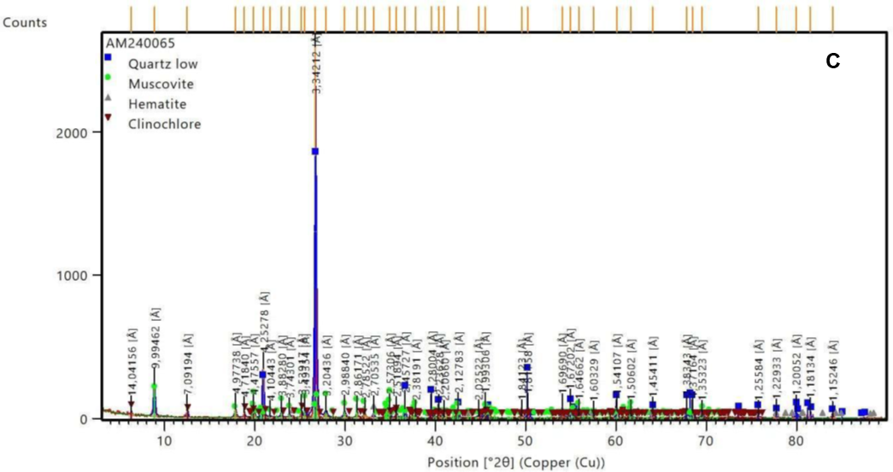

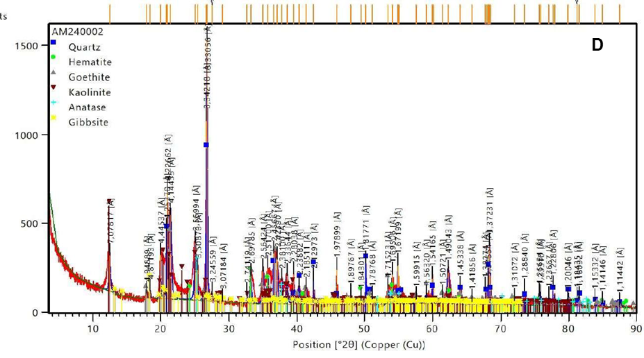

Figure 2: X‐ray diffractogram of the samples of A-Compact Schist, B-Dolomitic Itabirite, C-Compact, Phyllite, D-Dolomitic Phyllite.

In sample A-Compactschist, which is dominated by chlorite (38.4%) and calcite (19.3%), the results suggest an environment of hydrothermal alteration or low-grade metamorphism. Chlorite, an Fe–Mg phyllosilicate, is commonly found in shear zones or in iron-rich metamorphic rocks, while calcite indicates the influence of carbonate fluids. The presence of albite (17.2%) and quartz (11.5%) further points to an origin associated with igneous or intermediate metamorphic rocks (Bish & Post, 1993).

In sample B-Dolomitic itabirite, the predominance of hematite (52%) and quartz (45.4%) indicates an oxidizing environment typical of banded iron formations (BIFs) or lateritic deposits. Hematite, an iron oxide, forms under conditions of high oxygenation, whereas quartz represents the residual silica after chemical weathering. The low concentration of chlorite (2.6%) suggests a limited contribution from ferromagnesian minerals (Cornell & Schwertmann, 2003).

In sample C-Compact phyllite, the association of quartz (56.5%) and muscovite mica (30.2%) indicates a geological context related to felsic rocks such as granites or mica schists. Muscovite, a mineral typical of regional metamorphism, is stable under medium to high pressure conditions. The residual hematite (11.2%) may result from the oxidation of primary minerals like biotite (Deer et al., 2013).

The Dolomitic ~~Filite~~ phyllite sample from Mina do Pico shows a dominance of kaolinite (54.1%) and goethite (20.7%), reflecting intense chemical weathering under acidic and humid conditions typical of lateritic profiles. Kaolinite, a 1:1 clay mineral, forms through the leaching of alkali and alkaline earth cations, while goethite (FeO(OH)) is a product of the oxidation of sulfides or iron oxides. The presence of gibbsite (3.5%) further supports an environment characterized by high rainfall in tropical regions (Dixon & Weed, 1989).

It is important to note that the detection limit of XRD (1–2%) implies that trace phases, such as anatase (2%) in the ~~filite~~ phyllite sample, may be underrepresented. Complementary techniques, such as SEM-EDS, are essential for identifying microstructures and elements present in low concentrations (Klug & Alexander, 1974). Moreover, while the semi-quantification by the Rietveld method is robust, it depends critically on the quality of the reference database (ICDD PDF-2).

In practical terms, the high hematite content in sample D-Dolomitic phyllite suggests potential utilization in the steel industry. In agriculture, kaolinite and chlorite, due to their cation exchange capacity, may be beneficial as soil remineralizers. Additionally, goethite and hematite are relevant for studies on the remediation of soils contaminated with heavy metals.

**3.~~2~~ 3 Chemical Analyses**

The materials chemical analysis, aimed at agricultural use, revealed that only Compact shale - Itabirite meets most of the criteria established by MAPA, particularly concerning the content of K₂O + CaO + MgO.

The high quartz content in all analyzed materials compromises their efficiency as soil correctives, as demonstrated by (Egerić et al., 2019), indicating that quartz does not contribute to soil acidity neutralization and may dilute the effectiveness of correctives.

**Table 3 Chemical and mineralogical composition of different rock types compared to MAPA criteria for soil remineralizers.**

|  |  |  |  |  |  |
| --- | --- | --- | --- | --- | --- |
| **Element/Oxide** | **MAPA Criteria** | **Compact ~~Shale~~ schist** | **Compact phyllite** | **Dolomitic itabirite** | **Dolomitic phyllite** |
| K2O+CaO+MgO (%) | >9% | 17,65 | 6,9 | 1,4 | 0,351 |
| Cd (ppm) | <10 ppm | nd | nd | nd | nd |
| Pb (ppm) | <200 ppm | nd | nd | nd | nd |
| As (ppm) | <15 ppm | nd | nd | nd | nd |
| Hg (ppm) | <0,1 ppm | nd | nd | nd | nd |
| K2O (%) | >1% | 0,2 | 4,0 | 0,004 | 0,223 |
| Quartz (%SiO2) | <25% (vol) | 50,4 | 70,8 | 50,2 | 40,19 |
| Quartz (DRX) |  | 11,5 | 56,5 | 45,4 | 12,9 |
| PRNT (%) | >45% | 23,6 | 5,2 | 5,8 | 9,2 |
| RE (%Reactivity) |  | 99,1 | 99,1 | 99,7 | 82,1 |
| PN |  | 23,8 | 5,3 | 5,8 | 11,2 |
| P2O5 (total) | >1% | 0,3 | 0,2 | 0,2 | <0,1 |
| Al2O3 |  | 11,04 | 11,7 | 0,65 | 23,07 |

Decreasing PRNT values in all materials, combined with high quartz content, suggest that these materials would be more suitable for use in soils with moderate correction needs or as a supplement to more efficient correctives. Additionally, the presence of Al₂O₃, especially in Dolomitic Phyllite from Pico, indicates that, despite its low reactivity, the material can contribute to soil structure improvement, although its effect on acidity neutralization is modest.

Soil conditioners with low PRNT values do not preclude their use for pH correction or soil nutrition. The strategy to overcome the apparent low efficiency is to produce rock powders with a granulometry between 0.106 mm and 0.045 mm (MAPA, 2020; Silveira et al., 2019). This is because finer particle size distribution increases the surface area.

According to the document from Silveira et al (2019) and MAPA, silicate materials with 0.106 mm granulometry tend to react in the soil solution within 90 days, while those with 0.045 mm granulometry react in about 30 days, in the presence of moisture.

Another important aspect concerns the determination of the application doses. Since these materials release nutrients gradually, and the values used for dose calculation are based on total content, it is suggested that the initial dose provides 100% of the soil's needs (based on soil analysis) and the crop's requirements (considering historical data and expected productivity). However, given that nutrient release is gradual, subsequent doses can be 200%, 300%, 400%, or even 500% of the recommended rate.

The naturally low reactivity of remineralizers necessitates the application of high doses of soil remineralizers. This is justified by the need to supply enough nutrients to sustainably correct deficiencies and improve soil fertility. Studies show that finer granulometry (less than 0.106 mm) increases the contact surface area between minerals and soil, accelerating chemical weathering processes and the gradual release of essential nutrients such as potassium, calcium, magnesium, and phosphorus (Martins et al., 2023).

Finer particle reactivity facilitates interaction with humic substances and organic acids in the soil, promoting better nutrient absorption by plants and contributing to the formation of new mineral phases with high cation exchange capacity (Silveira et al., 2019). Therefore, the combination of high doses and fine particle size enhances the agronomic benefits of remineralizers, resulting in more fertile and productive soils in the long term (MAPA, 2016).

The MAPA criterion for K₂O + CaO + MgO content above 9% favors materials as correctives or fertilizers due to their capacity to provide essential potassium, calcium, and magnesium for plant growth. Compact shale from itabirite stands out with 17.65%, exceeding the MAPA criterion even when adjusted for other mineral products (19.44% - Ouro Preto Mineração (OPM), suggesting potential agricultural applications with chemical effects. In contrast, other materials, particularly Dolomitic Itabirite and Dolomitic Phyllite from Pico, show significantly lower values, limiting their direct use as nutrient sources or pH neutralizers in the soil.

Heavy metals ~~contents~~ such as Cd, Pb, As, and Hg content in all materials are below the limits established by MAPA, indicating no risk of contamination by these elements, which is important for ensuring safe agricultural use. At first glance, the potassium content (4.0%) in the compact phyllite sample would suggest promising agricultural use.

However, the element in question is difficult to release due to its chemical stability, which hinders short-term solubility. The quartz content, measured by both volume and X-ray diffraction (XRD), frequently exceeds the 25% limit established by MAPA. This indicates lower solubility and reactivity of these materials in the soil, which may reduce the immediate availability of nutrients to plants but does not necessarily disqualify these materials as long-term soil conditioners due to their ability to alter soil physical properties.

PRNT (Relative Total Neutralizing Power) and reactivity (RE) are critical indicators of the effectiveness of a material as a soil acidity corrective. In this context, compact shale and compact phyllite exhibit low (PRNT) and Neutralization Potential (PN) values, with compact shale showing very high reactivity (99.1%). This suggests that while these materials may not quickly raise soil pH, they are solubilized over time. This can be useful in specific applications where immediate pH correction is not required but maintaining soil reactivity is desired.

4. Conclusion

The present research revealed that iron ore overburden, particularly compact shale, has the potential to be used as soil remineralizers, contributing to a circular and sustainable solution for managing waste generated by mining activities. Mineralogical and chemical analyses demonstrated that these materials contain essential nutrients for agriculture, such as calcium, magnesium, and potassium. Although the high quartz content limits their effectiveness as soil correctives, their application can benefit soil structure, increasing porosity and water retention capacity—key factors in conservation agriculture practices.

Compact shale stood out to meet some of the criteria established by MAPA for remineralizers, suggesting promising agricultural use. However, dolomitic itabirite and compact phyllite showed chemical limitations that reduce their potential as soil correctives, requiring further studies and possibly adjustments in their application.

Chemical analyses indicated that the gradual release of nutrients from iron ore overburden could be advantageous, especially for degraded soils that require long-term improvements. The study also showed that the heavy metal contents in the samples are within the safety limits established by the Ministry of Agriculture, Livestock, and Supply (MAPA), ensuring the safe agricultural use of these materials.

However, to enhance the effectiveness of waste materials as remineralizers, their use should be combined with other soil management practices. The low reactivity of minerals like quartz, and the stability of minerals such as chlorite and cordierite, suggest that while these materials may not be immediately effective in neutralizing soil acidity or providing plant nutrition, they can offer long-term structural soil improvements when applied in larger quantities

Ethical approval

The authors declare the following financial interests and/or personal relationships which may be considered potential competing interests: Adalgisa de Jesus Pereira: Received administrative support, equipment, supplies, and travel funding from the Research and Development Department of Agera. Olmede Celestino Santos Filho, Mariana Lacerda Figueira Menezes, Fabio Terra Passos Duarte: Have affiliations with the Research and Development Department of Agera, including employment, non-financial support, and travel reimbursement.

References

ABNT- Brazilian Association of Technical Standards, 2018. ABNT NBR Soil-Grain size analysis. Brazilian Association of Technical Standards, Rio de Janeiro.

ABNT- Brazilian Association of Technical Standards, 2011a. ABNT NBR 8577:2011 Iron ores — Determination of total iron content by dichromatometry. ABNT - Brazilian Association of Technical Standards, Rio de Janeiro.

ABNT- Brazilian Association of Technical Standards, 2011b. ABNT NBR ISO 11535:2011. Iron ores — Determination of various elements — Inductively coupled plasma atomic emission spectrometry method. ABNT - Brazilian Association of Technical Standards, Rio de Janeiro. ABNT-Brazilian Association of Technical Standards, 2007. Iron ores - Determination of acid-soluble iron (II) content - Volumetric method. ABNT/CB-041 Iron Ores, Rio de Janeiro.

ABRACAL, 2023. Brazilian Association of Agricultural Limestone Producers.

Abraham Armah, 2021. The use of rock dust as a natural media amendment for the production of horticultural crops in controlled environments (Doctoral dissertation). Memorial University of Newfoundland, Grenfell.

Agboola, O., Babatunde, D.E., Isaac Fayomi, O.S., Sadiku, E.R., Popoola, P., Moropeng, L., Yahaya, A., Mamudu, O.A., 2020. A review on the impact of mining operation: Monitoring, assessment and management. Results in Engineering. https://doi.org/10.1016/j.rineng.2020.100181

Bailey, S.W., 1988. Chlorites: structures and crystal chemistry. Rev Mineral Geochem 19, 347–403.

Bish, D. L., & Post, J. E. (1993). Modern Powder Diffraction. Reviews in Mineralogy, 20.

Blum, A.E., Stillings, L.L., 1995. Feldspar dissolution kinetics. Reviews in mineralogy, in: Chemical Weathering Rates of Silicate Minerals. U.S. Geological Survey, Menlo Park, CA, pp. 291–352.

Cornell, R. M., & Schwertmann, U. (2003). The Iron Oxides: Structure, Properties, Reactions, Occurrences and Uses. Wiley-VCH.

Deer, W. A., Howie, R. A., & Zussman, J. (2013). An Introduction to the Rock-Forming Minerals (3rd ed.). Mineralogical Society.

Dixon &Weed (1989) ??? Details ???????

Campe, J., Mejbel, M., Patskowski, D., Nilson, A., Filho, Z., 2022. Remineralization for a Healthy Planet Remineralize the Earth. New York.

Egerić, M., Smičiklas, I., Dojčinović, B., Sikirić, B., Jović, M., Šljivić-Ivanović, M., Čakmak, D., 2019. Interactions of acidic soil near copper mining and smelting complex and waste-derived alkaline additives. Geoderma 352, 241–250. https://doi.org/10.1016/j.geoderma.2019.06.015

Faivre, D., 2016. Iron Oxides- From Nature to Applications, in: Damien Faivre (Ed.), Iron Oxides. Wiley, Mühlenberg-Germany, pp. 591–598. https://doi.org/10.1002/9783527691395.index

Gorchs, G.V., 2015. Effect of micro-coagulation by FeCl3 in organic fouling in ultrafiltration membranes: Study using fluorescence emission-excitation techniques and application water treatment plant of Sant Joan Despí (Bachelor’s thesis). Universitat Politècnica de Catalunya, Catalunya.

Gyebuni, R., Kunkyin-Saadaari, F., Anaman, I.E., 2024. Innuendoes of Sterilization Drilling in Surface Mining Operations&amp;#8212;A Case Study. International Journal of Geosciences 15, 458–477. https://doi.org/10.4236/ijg.2024.155025

Hilmi, N., Sutherland, M., Farahmand, S., Haraldsson, G., van Doorn, E., Ernst, E., Wisz, M.S., Claudel Rusin, A., Elsler, L.G., Levin, L.A., 2023. Deep sea nature-based solutions to climate change. Frontiers in Climate. https://doi.org/10.3389/fclim.2023.1169665.

Klug, H. P., & Alexander, L. E. (1974). X-ray Diffraction Procedures (2nd ed.). Wiley.

MAPA, 2020. REGULATORY INSTRUCTION No. 53, OF OCTOBER 23, 2013. MINISTER OF STATE FOR AGRICULTURE, LIVESTOCK AND SUPPLY, Brasília.

MAPA, 2016. REGULATORY INSTRUCTION No. 5, OF MARCH 10, 2016. Ministry of Agriculture, Livestock and Supply, Brasília, BR.

Martins, E. de S., Hardoim, P.R., Martins, É. de S., 2023. Effect of the application of remineralizers in the soil. Agricultural Report 44, 1–8.

Martins, É. de S., Martins, E. de S., Hardoim, P.R., 2023. Geochemical, mineralogical and biological principles of soil remineralizer management. Agricultural Report 44, 26–39.

Martins, L.F.B.N., Troian, D., Rosset, J.S., Silva Souza, C.B., 2020. Soil carbon stock in different uses in the southern cone of Mato Grosso do Sul. Revista de Agricultura Neotropical 7, 86–94.

Mello Prado, R., 2021. Mineral nutrition of tropical plants, Mineral Nutrition of Tropical Plants. Springer International Publishing. https://doi.org/10.1007/978-3-030-71262-4

Ramos, C.G., Hower, J.C., Blanco, E., Oliveira, M.L.S., Theodoro, S.H., 2022. Possibilities of using silicate rock powder: An overview. Geoscience Frontiers 13. https://doi.org/10.1016/j.gsf.2021.101185

Rodrigues, M., Bortolini, P.C., Neto, C.K., de Andrade, E.A., dos Passos, A.I., Pacheco, F.P., Nanni, M.R., de Melo Teixeira, L., 2024. Unlocking higher yields in Urochloa brizantha: the role of basalt powder in enhancing soil nutrient availability. Discover Soil 1, 4. [https://doi.org/10.1007/s44378-02 4-00006-3](https://doi.org/10.1007/s44378-02%204-00006-3)

Sampaio, J.A., França, S.C.A., Braga, P.F.A., 2007. Mineral Treatment: Laboratory Practices, 1st ed. CETEM/MCT, Rio de Janeiro.

Salvador, M.N., 2012. Environmental Impact of Soil and Sand Mining: A Review.

Shengo, L.M., 2021. Review of Practices in Mineral Waste Management: The Case of Waste Rocks and Mining Tools. Water Soil Pollution. <https://doi.org/10.1007/s11270-021-05198-w>

Silva, C.J., Campos, S.F.B., Santos, L.P., Oliveira, L.F.M., Silva, M.A.S., Moraes, E.R., Peixoto, J.V.M., 2023. Cultivation of BRS platina banana trees fertilized with mica schist powder. Brazilian Journal of Development 9, 21925–21938. <https://doi.org/10.34117/bjdv9n7-051>

Silva Souza, F.N., Oliveira, C.G., Martins, É. de S., Alves, J.M., 2017. Conditioning and Nutritional Effect of a Soil Remineralizer Obtained from Mining Waste. Journal of Agri-Environmental Sciences 3, 1–12.

Silveira, C.A.P., Bamberg, A.L., Martinazzo, R., Pillon, C.N., Martins, É. of S., Piana, C.F. de B., Ferreira, L.H.G., Pereira, I. dos S., Stumpf, L., 2019. PROTOCOL FOR EVALUATION OF AGRONOMIC EFFICIENCY OF SOIL REMINERALIZERS - FIRST VERSION. Brasilia-BR.

Silverol, A.C., Filho, L.M., 2006. Use of Mining Tailings and Dara Rock Alteration Layers: Soil Fertilization Through the Rocking Technique. Geographers 1–10.

Sposito, G., 2008. The Chemistry of Soils, 2nd ed. Berkeley.

Swoboda, P., Döring, TF, Hamer, M., 2022. Remineralizing soils? The agricultural usage of silicate rock powders: A review. Total Environmental Science. <https://doi.org/10.1016/j.scitotenv.2021.150976>

Teixeira, B.T., 2021. BASALT ROCK POWDER FOR USE AS A SOIL REMINERALISER IN Zea mays L. CULTIVATION (Course Conclusion Work). Federal University of Pampa, Caçapava do Sul.

Tisdale, S.L., Nelson, W.L., Beaton, J.D., 1985. Soil fertility and fertilizers, 1st ed. Collier Macmillan Publishers, London-UK.

Vitorino, A.C.T., Ferreira, M.M., Curi, N., Lima, J.M. de, Silva, M.L.N., Motta, P.E.F. da, 2003. Mineralogy, chemistry and stability of silt-sized aggregates from soils in the Southeast Region of Brazil. Brazilian Agricultural Research 38, 133–141. https://doi.org/10.1590/S0100-204X2003000100018

Wolff, A.P., 2009. Characterization of Iron Ore Tailings from Vale Mines (Dissertation). Federal University of Ouro Preto, Ouro Preto.

Yakovleva, N., Chiwona, A.G., Manning, D.A.C., Heidrich, O., 2021. Circular economy and six approaches to improve the potash life cycle for global crop production.