UPSCALING OF BARNYARD MILLET (pls write scientific name), through popularization of variety MDU 1 IN SOUTHERN PART OF TAMILNADU, INDIA FOR UPLIFTMENT OF FARMERS LIVELIHOOD

Please revise title and write scientific name of barnyard millet in the text also as its scientific name is missing throughout the manuscript.

Abstract

The Krishi Vigyan Kendras (KVK) is of national importance which would help in accelerating the agricultural production and also in improving the socio-economic conditions of the farming community. Demonstrations and training of farmers is a critical input for the rapid transfer of agriculture technology. Demonstrations are generally conducted by the Krishi Vigyan Kendras for farmers to introduce new varieties to the farmers. An experiment was conducted during the rabi seasons of 2017-18 and 2018-19 on Barnyard millet variety MDU 1 at the farmers’ field at Virudhunagar,Tamil Nadu, India. Major part of Virudhunagar district comes under rainfed and choice of crops is very limited. Farmers used to cultivate millets during the rabi season and 2000 ha area is under barnyard millet in Virudhunagar District. The farmers cultivate traditional / local varieties whose yield potential is very low. Therefore, to enhance the production and income per unit area, it was proposed to introduce Barnyard millet variety, MDU1, which will result in an increased production besides enhancing the income of farmers. Barnyard millet variety, MDU 1 has recorded 16.61 per cent higher yield than that CO (KV) 2. The increased yield resulted in higher gross return (Rs.24,222/ha), net return (Rs.13,569/ha) and BCR (2.28) over CO (KV) 2 under rainfed ecosystem.

Keywords: Barnyard millet, MDU 1, Yield and Net return

Introduction

Barnyard millet belonging to the family Poaceae is a commonly grown millet crop in the arid and semiarid regions of the world. Barnyard millet originated in central Asia and it spread from central Asia to Europe and America (Vanetha, 2021). It has been cultivated in China for more than 2000 years. There is a mention of barnyard millet in ancient literature of India. Barnyard millet is grown in India, China, Japan, Malaysia and East Indies. It is also cultivated to some extent in Africa and United States of America. In India, it is grown in the states of Madhya Pradesh, Uttar Pradesh, Tamil Nadu, Andhra Pradesh, Karnataka, Maharashtra and Bihar. Please provide area, production, productivity data of barnyard millet in Tamilnadu, India and the world. Plant grows up to a height of 60 to 120 centimetres. It is a grain crop which is highly drought tolerant but is also capable of withstanding water logging conditions. The crop is largely grown in harsh and fragile environments, with minimal use of agricultural inputs due to its remarkable ability to withstand erratic rainfall and varying weather conditions (Rawat et al., 2019). It is generally grown as a rainfed crop. In Tamil Nadu, Barnyard millet forms a main stay of agricultural diet and cultural system of people in this region (Kumar et al., 2007). The high nutritional value of barnyard millet can make it doubly valuable as food for farming families and a potential source of income. Barnyard millet rich in dietary fiber, iron, zinc, calcium, protein, magnesium, fat, vitamins, and some essential amino acids, and ideal for anaemic patients, High amounts of dietary fiber reduce the risk of colon cancer. Phosphorous helps in bone growth and development in kids (Kumar et al., 2021). In Tamil Nadu, barnyard millet is cultivated in the Districts of Virudhunagar, Madurai, Ramnad and Thirunelveli. Millets are underutilized and neglected crops owing to their lower preference driven by affluence, longer time and efforts involved in processing and the lower cooking quality. Cropping in Virudhunagar is mainly rainfed and the crop failures are common in view of climatic variations viz., delayed onset, intermittent dry spell and early withdrawal of monsoon. Hence, crops that can withstand extreme weather conditions need to be recommended. Barnyard millet is one such climatic resilient crop which can withstand drought and flooded situations and occupy 2000 ha in Virudhunagar district (year?). Farmers used to raise conventional barnyard millet varieties which were replaced by CO (KV) 2 till 2017. The yield of CO (KV) 2 was 1200 kg/ha with oval shaped brownish grey coloured grains. Low yield was attributed to the less number of productive tillers and small panicles. The milling percentage was less (60%), in view of its small grains. While, barnyard millet variety, MDU 1 released during 2017, was a high yielder having larger panicles with appealing whitish grain. The milling percentage was higher (70%) in view of bigger grains. Hence, it was proposed to scale up MDU 1 among Virudhunagar district farmers.
MDU 1 Barnyard millet was released from Agricultural College and Research Institute, Madurai. This variety has a short duration of 95-100 days and is reported to have better cooking quality in terms of whitish grain, high iron content (16 mg / 100g of grain).
Special features of Barnyard Millet, MDU 1

List 1: Special features of MDU 1 Barnyard Millet

Parentage | : | Pure line selection from Aruppukottai local
Duration | : | 95-100 days
Season | : | Suitable for Kharif, rabi and summer seasons of Tamil Nadu
Yield | : | Grain: Rainfed – 1500-1700 kg/ha & Irrigated - 2200-2500 kg/ha  Fodder: 3000-3300 kg/ha
Special features | : | Early maturing and high yielding; high iron content (16 mg/100g of grain); resistant to shoot fly, stem borer and smut

Materials and methods

KVK, Virudhunagar has organized on campus and off campus trainings to create awareness on the special features of Barnyard millet, MDU 1 during 2017-18and 2018 -19 to the farming community. Lectures on ICM techniques and preparation of value added products to realise increased productivity and augment income respectively.

List 2: Number of benefited farmers
S. No | Year | Farmers benefited (Nos.)
1. | 2017-18 | 150
2. | 2018-19 | 210
Total |  | 360

The FLD has made interventions in terms of variety as well as package of practices. Ten farmers each were selected from Melathulukankulam, Gopalapuram. W.Pudupatti, Agathakulam and Melakallankulam villages and FLDs on ICM for Barnyard Millet, MDU 1 during the rabi seasons of 2017-18 and 2018-19. Barnyard millet variety MDU 1 was demonstrated in comparison with traditionally used local varieties and CO (KV) 2. The farmers were also taught about the package of practices from sowing to harvest and value addition. The yield data was recorded from demonstrated as well as control (Farmers’ practice) fields.
List 3 : Front Line Demonstrations (FLD) Conducted during the rabi seasons of the years

S. No | Year | Number of FLD | Area (ha)
1. | 2017-18 | 10 | 4
2. | 2018-19 | 10 | 4
Total |  | 20 | 8

Good practices for upscaling of Barnyard millet, MDU 1
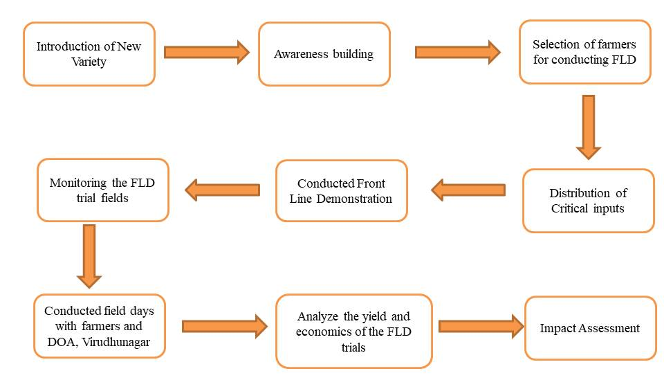

Image .1 Illustrating a good practice strategy for upscaling of Barnyard millet, MDU 1

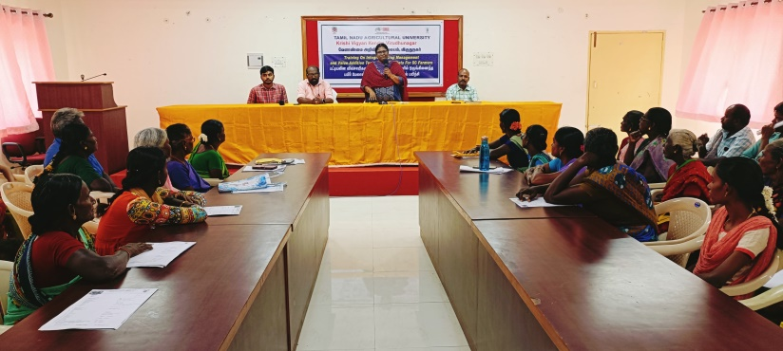

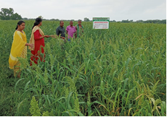 | 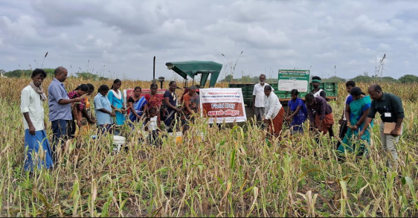
Image 2. The Training programs

Result and Discussion

Pre training and post training scores were computed for all the sub-components of barnyard millet (Table 1). In pre-evaluation test, the knowledge range of different participants was 7.0 per cent regarding the special features of MDU 1, demerits of local varieties (10.0 %) and value addition (17.0 %). It was noticed that pre training knowledge score was not much satisfactory for all the aspects of training programme. However, the knowledge score gained by participants after training was more satisfactory in all aspects. Sufficient gain in knowledge regarding special features of MDU 1 (93.0), demerits of local varieties (90.0 %) and value addition (83.0 %) (Table1). It may therefore, be concluded that respondents succeeded in acquiring knowledge after exposure to training on Barnyard millet. The results were similar to the findings reported by Roy Ranjan et al.(2013) and Nagaraj et al. (2017) that exposure to training increased the knowledge of farmers. Thus, it can be inferred that exposure to training had increased the knowledge regarding all the subcomponents of barnyard millet MDU 1 and Value addition. The reason behind the satisfactory gain in knowledge might be well educational background of participant also having keen interest of participants on barnyard millet training.

The Barnyard millet variety MDU 1 performed better in demonstration plots owing to best management practices like integrated nutrient management, weed management, irrigation and pest management practices. The data regarding performance of Barnyard millet variety MDU 1 in front line demonstration is presented in Table 2 & 3. The new variety of barnyard millet, MDU 1 has made a decisive positive impact on income of the barnyard millet growing farmers. This variety of barnyard millet has turned out to be technically feasible and economically viable among the resource poor farmers in rain fed ecosystem. The FLD has opened up the scope for horizontal spread of this variety among the neighbourhood farmers. Many farmers have been visiting the KVK to comprehend the technical-know how of this variety. The indirect employment generation is expected to increase for value addition, processing, marketing, transport etc., involving extra labour in proportion to higher productivity and production. Barnyard millet variety, MDU 1 with complete technology package was given to the farmers through trainings and Front Line Demonstrations in farmer’s fields. The variety, MDU 1 has recorded 16.61 per cent higher yield than that CO (KV) 2. The increased yield resulted in higher gross return (Rs.24,222/ha), net return (Rs.13,569/ha) and BCR (2.28) over CO (KV) 2 under rainfed ecosystem. The trainings and frequent visits of KVK team provided timely technological backstopping to the FLD farmers in realizing increased returns which led to increased area under Barnyard millet, MDU 1 in Virudhunagar district from 959 ha to 2060 ha. (Fig.1).
These findings are similar with the findings of Selvarani et al. (2020) in Barnyard millet, Sunitha et al.(2020) in Foxtail Millet, Thakur et al. (2017) in small millets. The increase in yield in demonstration over control plots was due to new short duration variety, integrated nutrient management. This finding is also similar with the findings of Nikulsinh. M. Chauhan (2012) this reference is missing behind in references section. Better to delete it as its more than 10 years old. that the Front Line Demonstration conducted in gram at farmer’s fields in Tapi district of Gujarat revealed that the farmers can get increased gram yield by following the recommended package of practices.

Table 1. Impact of trainings on Barnyard millet, MDU 1

Sl. No. | Knowledge on | Pre training |  | Post training |  | % Increase
Sl. No. | Knowledge on | No. | Per cent | No. | Per cent
1 | Special features of MDU 1 | 2 | 7 | 28 | 93 | 86
2 | Demerits of traditional varieties | 3 | 10 | 27 | 90 | 80
3 | Value addition | 5 | 17 | 25 | 83 | 66

Table 2.Performance of Barnyard millet, MDU 1

Year | Name of the Variety |  | No. of Farmers | Area  (ha) | Yield (q/ha) |  |  |  | % Increase
Year | Demo | Check | No. of Farmers | Area  (ha) | Demo |  |  | Check | % Increase
 |  |  |  |  | High | Low | Average | Check | % Increase
2017-18 | MDU 1 | CO (KV) 2 / local | 10 | 4 | 15.63 | 14.90 | 15.19 | 13.03 | 16.57
2018-19 | MDU1 | CO (KV) 2/local | 10 | 4 | 16.52 | 15.25 | 15.69 | 13.45 | 16.65
Mean |  |  |  |  | 16.08 | 15.08 | 15.44 | 13.24 | 16.61

Table 3.Economic output of Barnyard millet, MDU 1

Year | Economics of demonstration (Rs./ha) |  |  |  | Economics of check (Rs./ha)
Year | Gross  Cost | Gross  Return | Net Return | BCR | Gross  Cost | Gross  Return | Net Return | BCR
2017-18 | 10107 | 23340 | 13233 | 2.31 | 9905 | 20844 | 10939 | 2.10
2018-19 | 11200 | 25104 | 13904 | 2.24 | 10835 | 21520 | 10685 | 1.99
Mean | 10654 | 24222 | 13569 | 2.28 | 10370 | 21182 | 10812 | 2.05

Fig 1.Varietal spread of Barnyard millet MDU 1

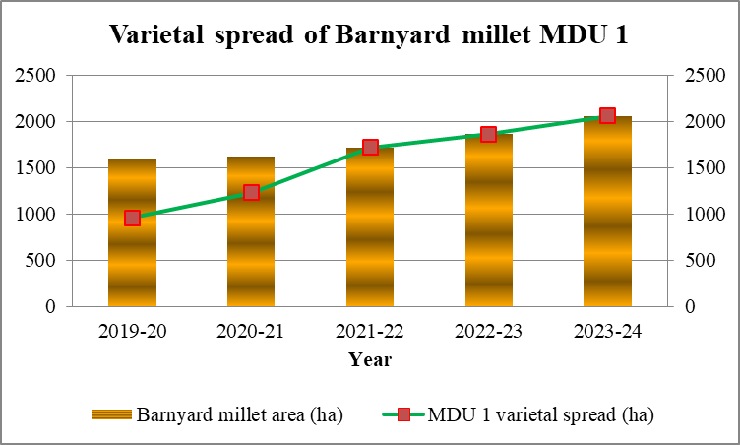
Seed production
Having achieved 100 per cent of barnyard millet area under MDU 1, KVK Virudhunagar initiated seed production in barnyard millet MDU 1 through farmers’ participatory mode during 2023-24. Please provide the source of this data about 100 percent coverage of barnyard area under cultivation by variety MDU 1. Trainings were given to the selected farmers about seed production and certification. Quality seeds produced by the farmers were procured by the KVK, Virudhunagar through KVK Revolving Fund as detailed below;
List 4: Quality seeds produced by the farmers and their overall profits mentio year

Sl. No. | Name of the farmer | Variety | Class | Area (ha) | Seed  Qty (kg) | Gross income as seed (Rs.) | Gross income as grain (Rs.) | Profit margin  (Rs.)
1. | Rajendren , Valaiyankulam | MDU 1 | FS* | 1.0 | 1180 | 60180 | 37760 | 22420
2. | Thirupathi,  Valaiyankulam | MDU 1 | CS* | 0.6 | 825 | 40425 | 26400 | 14025
3. | Katarkarai, Kallumadam | MDU 1 | TFL* | 1.0 | 1500 | 70500 | 48000 | 22500
4. | Karuppasami, Othaiyal | MDU 1 | TFL* | 0.6 | 800 | 37600 | 25600 | 12000
 | Mean |  |  | 3.2 | 1076 | 52176 | 34440 | 17736
*FS-Foundation Seed, CS-Certified Seed, TFL-Truthfully Labelled Seed

Conclusion
KVK Virudhunagar has made all possible interventions viz., trainings, Front Line Demonstrations and field days to upscale barnyard millet, MDU 1 among the farmers of Virudhunagar district. Consequent to this, farmers and traders got convinced by the variety in view of its yield potential and preferable milling qualities respectively. All these factors jointly resulted in replacement of traditional and CO (KV) 2 varieties of barnyard millet to the tune of 100 per cent in a time span of five years (2019-2023). Please provide the source of this data about 100 percent coverage of barnyard area under cultivation by variety MDU 1. Besides, seed production is taken up in farmer’s field through participatory mode to augment profit margin of farmers to sustain the variety in the seed chain.
Reference
Kumar, A., Tripathi, M.K., Joshi, D and Kumar, V. 2021. Millets and Millet Technology. In Millets and Millet Technology (Issue July 2022). https://doi. org/10.1007/978-981-16-0676-2
Kumar, J., Kumar, B and Yadav V.K. 2007. Small millet Research. G. B. Pant University of Agriculture and Technology. Hill campus, Rainchuri, Uttarkhand 58 very old reference
Nagaraj, K.H., Kamala Bai and Lata R Kulkarni.2017. Technology Dissemination and Impact of KVK Activities in the District of Ramanagara, India. Int J Current Microbiol and Appl Sci 6(7):3931-3939.
Rawat, L., Prasad, S., Bisht, T.S., Naithani, D.C., and Tiwari, A.2019 An Impact Assessment of Front Line Demonstrations on Yield and Economics of Finger Millet and Barnyard Millet under Rainfed Conditions of Uttarakhand, Int. J. Pure App. Biosci. 7(2): 408-414. doi: http://dx.doi.org/10.18782/2320-7051.7459
Roy Ranjan, Shivamurthy M and Radhakrishna Rama B.2013. Impact of Value Addition raining on Participants of Farmers Training Institutes. World Applied Sci J 22 (10) : 1401- 1411.
Selvarani, G., Anandhi, K and ChelviRamessh.2020. Impact of MDU 1 Barnyard Millet training programme imparted by Krishi Vigyan Kendra in Madurai District, International Journal of Agriculture Sciences 12, no. 1:9400-9401.
Sunitha, N.H., Hanumanthppa Shrihari and Manjunath Banuvally.2020. An Impact Assessment of Front Line Demonstrations on Yield and Economics of Foxtail Millet under Rainfed Conditions of Hadagali Taluka. Int.J.Curr.Microbiol.App.Sci. 9(01): 2216-2223. doi: https://doi.org/10.20546/ijcmas.2020.901.251
Thakur, A. K., Kumar P. and Yadav, S.C. 2017. Impact of Front Line Demostration (FLD) on the Yield and Economics of Small Millet on Bastar District of Chhattisgarh, India. Int.J.Curr.Microbiol.App.Sci. 6(9): 1489-1497
Vanetha, K.P.2021. Impact of Frontline Demonstration on Banyard millet variety MDU 1 in Madurai District of Tamil Nadu. International Advanced Research Journal in Science, Engineering and Technology 812): 252-253.

