Original Research Article
Trap Nest preference of Solitary bees (Hymenoptera: Apoidea) in Tamil Nadu, India
This is informal writing
Abstract
Solitary bees play crucial role in pollination. Artificial traps were used to study conservation of solitary bees at Agricultural College and Research Institute, Madurai, Tamil Nadu, India. We recorded small carpenter bee, Ceratina binghami C. preferred Peltophorum pterocarpum as nesting site with an average of 26% in a period of 21.2±9.1 days. Megachile sp., preferred papaya petioles with an average 8% of occupancy in 18±11.74 days. On an average of 3% trap occupancy was recorded in Ipomea reeds by Lithurgus sp. and Coelioxyx capitata S. in a period of 36.5±2.5 days, respectively. Vertically tied bundles of P. pterocarpum preferred by C.binghami taken less duration to occupy the nest compared to the horizontally tied bundles. In contrast, leaf cutter bees like Megachile sp., and Lithurgus sp. was preferred more in horizontally tied bundles viz., Carica papaya L. and Ipomoea carnea L. comparative to P.pterocarpum bundles which is erected vertically less preferred by the leaf cutter bees. Many nests were recorded, where the rich source of vegetation is available Clepto-parasitic bee, Coelioxys capitata S. nesting biology and different life stages were studied. The life cycle of cleptoparasite was completed in 22.2±3.64 days. This study will serve as a baseline for future studies and conservation programs of cavity-nesting bees in India.
Keywords: Solitary bees, Conservation, Peltophorum pterocarpum, Ceratina binghami, Meghachile sp., Lythurgus sp., Papaya petiole and Ipomea reeds.
Introduction
Solitary bees play an important role in pollination in cultivated, uncultivated and wild plants (Kumar and Kumaranag, 2018). Solitary bees construct the nest unlike social bees. Each nest is constructed by the single female. Nest infrastructure varies among the solitary bees, which use varieties of materials like leaves, resin, mud, substrates like pruned branches, and wood (Batra, 1984). Small carpenter bee, Ceratina binghami construct simple linear nest in hollow and pruned pithy stems like Sesbania bispinos, Cashew (Yogi and Khan, 2014, Kaliaperumal, 2019). Large carpenter bee nests in wooden structures, hollow stems, pithy stems of Calotropis procera bamboo culms (Hannan et al., 2012; Hongjamrassilp and warrit, 2014). Leaf cutter bee, Megachile sp., built their nest in preexisting cavities, dead empty snail shells, holes in concrete walls, old trunks of trees (Michener, 2007). However, Parasites like chalcid wasp, Pteromalus apum parasitizes Alfalfa leaf cutter bees, Megachile rotundata drastically reduces the bee population eventually effect on the bee population and pollination (Sheffield, 2017). Furthermore, In Southern part of India, leaf cutter bees heavily parasitized by parasitoid, Melittobia sp., highly preferred in artificial trap. Trap nests, being excellent nesting site for the bees and also may attract to the parasites (Veeresh Kumar et al., 2015).
Pollinators decline is a global crisis attribute to various anthropogenic activities like agricultural intensification, pesticides usage, deforestation and habitat fragmentation. In the absence of pollinators, the flowers remain unfertilized (Raju and Rao, 2006) resulting in reduction in the reproductive success of flowering plants. Hence, there is an overwhelming need for protection and conservation of natural habitats.
Materials and Methods:
Petioles of papaya, Carica papaya L., Copper pod tree, Peltophorum pterocarpum DC., bamboo sticks, Bambusa vulgaris L.and Ipomea carnea J. were collected from the local sites and the leaves were removed, allowed to dry for two days, cut with secateurs up to 15 cm in length and tied into bundles using a thread, each bundle with ten sticks replicated with ten times. The trap nests were installed at the Agricultural College and Research Institute, Madurai in the college orchard, hostel premises, college garden area, central farm area and indoor stadium during 2018-2020. The P. pterocarpum stick bundles were tied vertically, papaya petioles, Bambusa vulgaris L. sticks and Ipomea reeds were tied horizontally. The installed traps were monitored at weekly intervals to record the occupancy of bee species viz., Ceratina binghami and Megachile sp. the number of days taken to accept the nest and number of nests occupied were also recorded. The trap nest occupancy rate was worked out by taking the ratio of number of nests occupied by the total number of supplied nests.

Results and Discussion
The installed nesting substrates were occupied by the small carpenter bees like Ceratina binghami and leaf cutter bees like Megachile sp., Lithurgus sp., Coelioxys sp., and wasps. P.pterocarpum sticks were highly preferred by C.binghami for nest construction (Fig 1.A-B) with the highest average percentage of occupancy of 26% in a period of 21.2±9.1 days. Megachile sp., preferred papaya petioles (Fig 1.E) with an average 8% of occupancy in 18±11.74 days. On an average of 3% trap occupancy was recorded in Ipomea reeds by Lithurgus sp. (Fig 1.D) and Coelioxyx capitata S. in a period of 36.5±2.5 days, respectively. The mud wasp preference was also observed in C. papaya petioles with 1.4% occupancy rate and duration taken to occupy the nest was 58.33± 7.63 days. However, The present findings are in agreement with the findings of Amala et al. (2019) M. laticeps S. with 64.70% of nest occupancy to the papaya petioles an average 10.5± 3.50 days was required to occupy the nest.
Vertically tied bundles of P. pterocarpum preferred by C.binghami taken less duration to occupy the nest compared to the horizontally tied bundles. In contrast, leaf cutter bees like Megachile sp., and Lithurgus sp. was preferred more in horizontally tied bundles viz., C.papaya and I.carnea (Fig 1.C) comparative to P.pterocarpum bundles which is erected vertically less preferred by the leaf cutter bees (Fig 1.F).
Many nests were recorded, where the rich source of vegetation is available and which is very nearer to the nesting site. No nests occupancy was observed in fewer sources of floral available and far away to the nesting location. Non insects like lizards, spiders were also observed in installed traps.
Clepto-parasitic bee, Coelioxys capitata S. nesting biology and different life stages (Fig 2) were studied. Egg was laid on the top of the pollen mass and the egg stage was completed in a time period of 5.20±0.84 days. The hatched curved larva fed voraciously on the pollen and completed the larval stage in a time period of 4.5±0.7 days. The mature larva transformed into pupa 5±1.4 days. The adult bee emerged from the pupa in a time span of 7.5± 0.7 days (Table 1) with a marked melanisation progressing from the head towards the thoracic region. The adults on emergence tear apart the brood cells with its powerful mandibles. Chaudhary and Jain (1978) observed the Megachile lanata F. showing preference to the artificially installed castor leaf stalks, drilled wooden blocks and castor stems. Clepto parasitic bee, Coelioxys capitata S. preference was observed more towards Ipomea carnea (Jacq) reeds. Other non megachilid bees preferred artificial trap nests with 1.4%. However, Amala and Shivalingaswamy, 2018 also observed that the Coelioxys sp. preference to the artificially installed bamboo sticks. Kumar and Belavadi (2015) supports the present investigation, they have also observed the parasites infestation with 85.5% in the artificially installed Ipomea reeds may be the reason parasites more preferred to bundles with as many as sticks. Parasites are more attracted to the artificially installed bee hotels (MacIvor et al., 2014). However, Sachin (2016) who also recorded that Ipomea carnea sticks had the highest preference percentage by Megachile sp. with 30.89% for nest making. Whereas, Megachile lanata F. mortlity was also recorded with 30.37% due to natural enemies like parasites Melittobia sp. and Psocids infestation in the artificial trap nest made of Ipomea carnea J. Both sides open ended sticks allows the more preference of the predators and parasites (Dar et al., 2017).

Table: 1. Nesting biology of leaf cutter cuckoo bee, Coelioxys capitata S. in Ipomea reeds (Temperature 28±2⁰C and RH 75±5%).
Life stage | Mean± SD (Days)
Egg | 5.20±0.84
Larvae | 4.5±0.7
Pupae | 5±1.4
Adult | 7.5±0.7
Total duration | 22.2±3.64
No. of bees emerged | 3
No. of males emerged | 3

Table: 2. Preference of solitary bees towards artificial nests.
Material used | Preference of solitary bees/ other insects | Average percentage of occupancy  (%) | Average duration taken to occupy the nest per bundle (days)
Ipomea reeds | Lithurgus sp. & Coelioxys capitata | 3 | 36.5±2.5
Papaya petioles | Megachile sp. | 8 | 18±11.74
 | Wasps | 1.4 | 58.33±7.63
Peltophorum  pterocarpum | C. binghami | 26* | 21.2±9.1
*Highest % of artificial nest occupancy
REFERENCES
Amala, U, and TM Shivalingaswamy. (2018). "Trap-nest diameter preference of Megachile lanata (Hymenoptera: Megachilidae)." Journal of Entomological Science 53 (1):96-98.
Amala, U, T M Shivalingaswamy, V Kumar, and M Pratheepa. (2019). "Pruned petioles of papaya as nesting sites of the leafcutting bee, Megachile laticeps Smith and its pollen fidelity." Journal of Apicultural Research 58 (5):660-664.
Batra, S.W. (1984). "Solitary bees." Scientific American 250 (2):120-127.
Chaudhary, J., and J. Jain. (1978). "Nesting and foraging behaviour of a mason bee Megachile lanata Lepel (Megachilidae: Hymenoptera)." Indian Journal of Entomology 40 (4):405-411.
Dar, SA, GM Lone, SH Parey, I Hassan, and Bashir AR .(2017). Insect pollinators and their conservation. Journal of Entomology and Zoology Studies. 5(3): 1121-1131.
Hannan, M A, A S Alqarni, A A Owayss, and M S Engel. (2012). "The large carpenter bees of central Saudi Arabia, with notes on the biology of Xylocopa sulcatipes Maa (Hymenoptera, Apidae, Xylocopinae)." ZooKeys (201):1-14.
Hongjamrassilp, W, and N Warrit. (2014). "Nesting biology of an oriental carpenter bee, Xylocopa (Biluna) nasalis Westwood, 1838, in Thailand (Hymenoptera, Apidae, Xylocopinae)." Journal of Hymenoptera Research 41:75-94.
Kaliaperumal, V. (2019). "Nest Structure, Development and Natural Enemies of Ceratina hieroglyphica Smith, A Stem Nesting Bee Colonizing Cashew Trees in Hilly Terrains." Journal of Apicultural Science 63 (2):223-231.
Kumar, V, and KM Kumaranag. (2018). "Diversity and conservation of leaf cutter bees (Hymenoptera: megachilidae)." Plants & Agriculture Research 8 (1):53-54.
Kumar, V, and VV Belavadi. (2015). "Taxonomic studies on leaf cutter bees (Hymenoptera: Megachilidae) of karnataka." Ph.D, Department of Entomology, University Of Agricultural Sciences GKVK, Bengaluru.
MacIvor, JS, JM Cabral, and L Packer. (2014). "Pollen specialization by solitary bees in an urban landscape." Urban Ecosystems 17 (1):139-147.
Michener, CD. (2007). “The bees of the World” 2nd edition. The Johns Hopkins University Press, Baltimore, Maryland, 1-953.
Raju, AJ S, and S P Rao. (2006). "Nesting habits, floral resources and foraging ecology of large carpenter bees (Xylocopa latipes and Xylocopa pubescens) in India." Current Science 90 (9):1210-1217.
Sachin, H. (2016). "Nesting Sites, Nesting Biology and Trap Nesting of Leaf Cutter Bees (Hymenoptera: Megachilidae)." Ph.D, Department of Entomology, University Of Agricultural Sciences GKVK, Bengaluru.
Sheffield, CS.(2017). Unusual nesting behavior in Megachile (Eutricharaea) rotundata (Hymenoptera: Megachilidae). Journal of Melittology.69:1–61.
Yogi, M K, and MS Khan. (2014). "Nesting biology of the small carpenter bees Ceratina propinqua and Ceratina simillima (Hymenoptera: Apidae)." Animal Biology 64 (2):207-216.

Figure.1 Artificial nest preferences by Solitary bees
Caesalpinia pulcherrima and Ipomea carnea preferred by Ceratina binghami and Leafcutter bee’s.
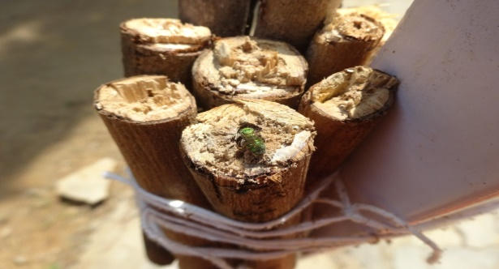 | 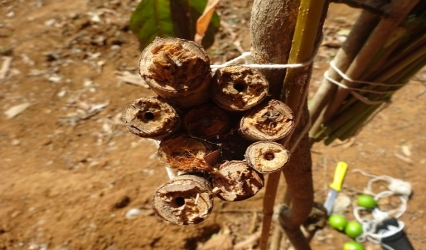
A. Preference of Ceratina binghami C. to Peltophorum pterocarpum D. | B. Preference of Ceratina binghami C. to numerous sticks of Peltophorum pterocarpum D
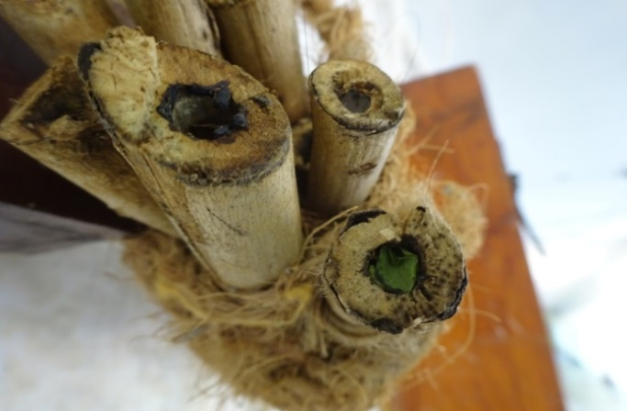 | 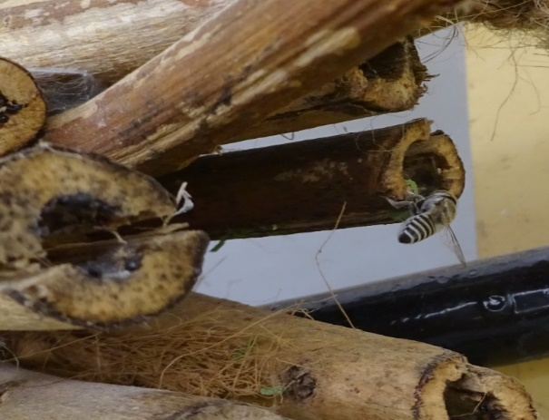
C. Ipomea carnea reeds as nesting site by Megachiliid sp. | D. Lithurgus sp. preference to Ipomea reeds
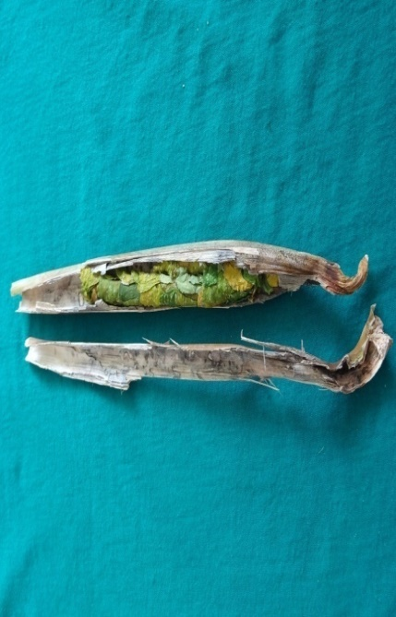 | 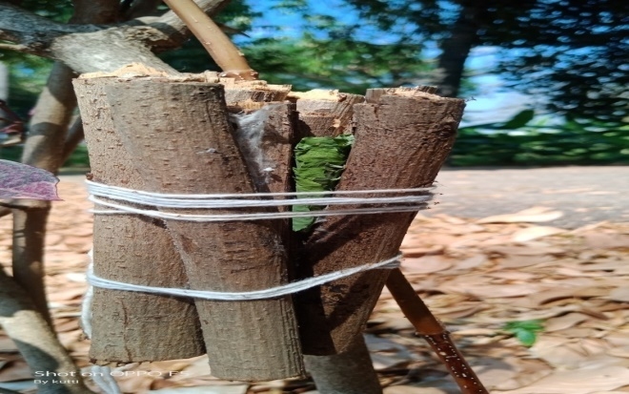
E. Papaya petiole C. papaya L. as nesting site by Megachiliid sp. | F. Nesting site of Megachile sp., to Peltophorum

Figure. 2 Nesting biology of leaf cutter bee (Clepto-parasite), Coelioxys capitata S.
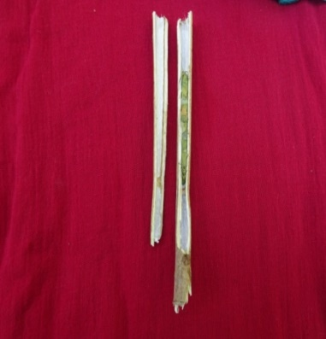  - Ipomea carnea reeds | 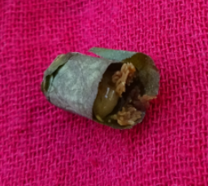  - Larva | 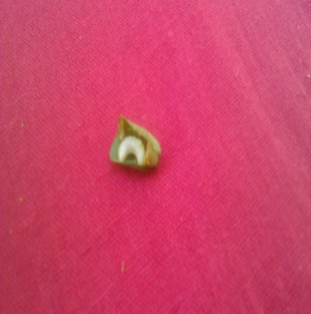  - Grub
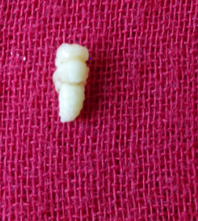  - Pupa | 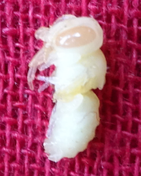  - White eyed pupa | 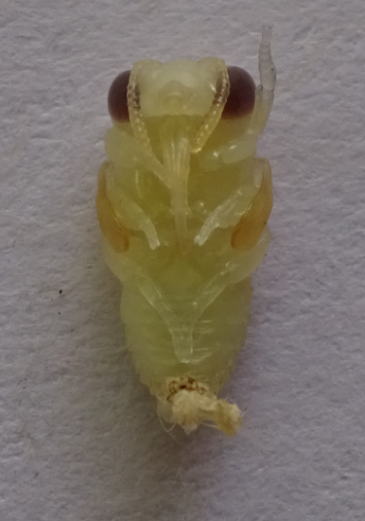  - Brown eyed Pupae
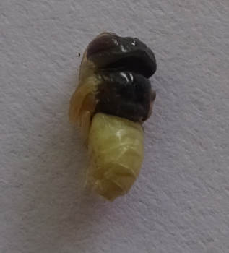  G. Head and Thorax region  with black | 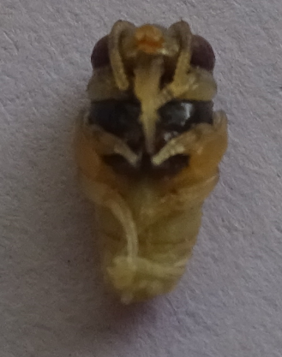  H. Ventral view | 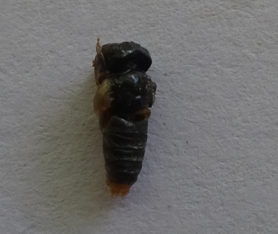  - Complete body black
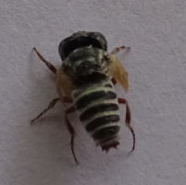  - adult with wing buds | 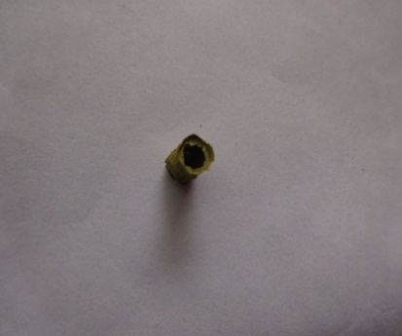  - Brood cell exit hole | 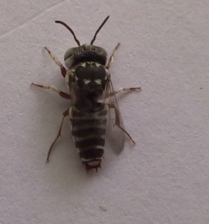  - Fully developed adult

