Original Research Article

Protective Effects of Flavonoid-Rich and Saponin-Rich Fractions from Cyperus esculentus and Phoenix dactylifera on Aluminum Chloride-Induced Testicular Damage in Male Wistar Rats

ABSTRACT
Background: Testicular toxicity represents a significant concern in male reproductive health, with various environmental toxins, such as aluminum chloride, contributing to compromised testicular function and fertility. This study investigates the potential protective effects of flavonoid and saponin extracts from two natural sources, Cyperus esculentus (tigernut) and Phoenix dactylifera (date fruit), against aluminum chloride-induced testicular damage in male Wistar rats.
Method: A controlled experimental study design was employed, involving twenty-four male Wistar rats that were randomly assigned to five groups for a treatment duration of 14 days. The groups consisted of a control group receiving a standard diet and water, an aluminum chloride-treated group, and three experimental groups that received aluminum chloride alongside one or both of the plant extracts. The extracts were administered daily for the 14-day period. Histological assessments were performed to analyze testicular architecture, while sperm parameters—including motility, viability, and morphology—were evaluated following the treatment. Additionally, hormonal assessments for testosterone, follicle-stimulating hormone (FSH), and luteinizing hormone (LH) were conducted to evaluate the restoration of hormonal levels.
Results: Histological analysis indicated significant testicular damage in the group treated with aluminum chloride, which exhibited degeneration of seminiferous tubules. Conversely, treatment with extracts from C. esculentus and P. dactylifera provided varying degrees of protective effects, with the combination extract demonstrating the most pronounced restorative effects. Improvements in sperm parameters, including motility, viability, and morphology, were notably observed in the groups treated with plant extracts, especially in the combined extract group, which showed results comparable to the control group. Hormonal assays revealed restored levels of testosterone, FSH, and LH in the extract-treated groups, particularly in those receiving the combined extracts (p < 0.05).
Conclusions: The findings of this study indicate that flavonoid and saponin extracts derived from Cyperus esculentus and Phoenix dactylifera exhibit significant protective effects against testicular toxicity induced by aluminum chloride. These extracts appear to enhance testicular architecture, improve sperm quality, and restore hormone levels, suggesting their potential role in addressing reproductive health issues associated with environmental toxin exposure. Further research is warranted to explore the underlying mechanisms and potential clinical applications of these natural products.
Keywords: Flavonoids, Saponins, Cyperus esculentus, Phoenix dactylifera, Aluminum chloride, Testicular damage, Reproductive toxicity, Male rats.

1. INTRODUCTION
Aluminum, a widely distributed environmental contaminant, gained increasing attention due to its potential harmful effects on human health, particularly regarding the male reproductive system. Exposure to aluminum could occur through various routes, including dietary intake, occupational hazards, and the use of aluminum-containing products (1). Previous studies indicated that aluminum exposure led to significant testicular toxicity, characterized by structural and functional impairments, potentially resulting in reduced fertility and adverse reproductive outcomes (2). The toxicological effects of aluminum were often attributed to oxidative stress and the resultant damage to cellular components, including lipids, proteins, and DNA (3). Furthermore, research showed that aluminum could disrupt hormonal balance by affecting the hypothalamic-pituitary-gonadal (HPG) axis, leading to decreased levels of testosterone and other reproductive hormones essential for normal spermatogenesis (4).
Given the widespread exposure to aluminum, there emerged a pressing need to explore effective strategies for mitigating its adverse effects on reproductive health. Natural products, particularly medicinal plants, gained traction in recent years for their potential therapeutic applications in improving male fertility and protecting against environmental toxins. Among these, Cyperus esculentus (tigernut) and Phoenix dactylifera (date fruit) were recognized for their rich phytochemical profiles, which include flavonoids and saponins known for their antioxidant, anti-inflammatory, and cytoprotective activities (5; 6; 7).
Flavonoids are polyphenolic compounds that possess potent antioxidant properties, capable of scavenging free radicals and reducing oxidative stress. Such actions were considered crucial in combating the oxidative damage associated with aluminum toxicity (8). Saponins, on the other hand, were reported to enhance immune responses and possess protective effects on reproductive tissues (9). The combined effect of these phytochemicals provided a novel approach to counteracting aluminum-induced reproductive toxicity, promoting testicular health and restoring hormonal balance.
Research exploring the protective effects of herbal extracts on male reproductive health garnered considerable interest. The role of oxidative stress in aluminum-induced toxicity had been well-documented. Studies conducted on rodents indicated that aluminum exposure led to histopathological changes in testicular tissue, including degeneration of germinal epithelium and impaired spermatozoa development (10; 11). Such findings highlighted the critical need for effective intervention strategies that could reverse or mitigate the damage caused by aluminum.
Cyperus esculentus is a plant species noted for its high nutritional value and medicinal benefits. Rich in nutrients such as vitamins, minerals, and essential fatty acids, tigernuts had been utilized in traditional medicine for various ailments, including reproductive dysfunctions (12). Studies suggested that extracts from tigernuts exhibited strong antioxidant properties, capable of protecting testicular tissues from the harmful effects of free radicals generated during oxidative stress (13). However, comprehensive investigations remained limited.
Similarly, Phoenix dactylifera had been employed in traditional medicine for its health benefits, particularly in enhancing reproductive health. The date fruit was known for its rich content of phytochemicals, including flavonoids and polyphenols, that exhibited antioxidant and anti-inflammatory properties (14). Research indicated that extracts from date fruits could positively influence sperm parameters and hormonal levels in male reproductive models exposed to oxidative stress (15).
The synergistic use of both Cyperus esculentus and Phoenix dactylifera provided a multifaceted approach to addressing aluminum-induced reproductive toxicity. The premise of this study was to evaluate the combined protective effects of these plant extracts on testicular structure and function in the context of aluminum exposure. Through a comprehensive analysis of histopathological alterations, sperm parameters, and hormonal assays, this investigation aimed to delineate the therapeutic potential of these plant-based interventions.
In conclusion, the current study aimed to bridge the gap in the literature regarding the effectiveness of combined herbal treatments against aluminum toxicity and to contribute to the growing body of evidence supporting the use of natural products in safeguarding reproductive health. As environmental exposure to heavy metals continued to pose significant challenges, investigating such natural remedies became increasingly relevant in the pursuit of innovative and sustainable solutions to enhance male fertility and overall well-being.
2. material and methods
2.1 Study Design
The study utilized a controlled experimental layout involving twenty-four male albino Wistar rats, which were divided into five distinct groups to evaluate the effects of aluminum chloride on testicular toxicity and the potential protective role of plant extracts from Cyperus esculentus and Phoenix dactylifera. Each group received specific treatments over a 28-day period, including a control group that received a standard diet and distilled water, and various experimental groups exposed to aluminum chloride alone or in combination with the plant extracts. The experimental design included rigorous ethical consideration and environmental control, ensuring proper acclimatization and care of the animals throughout the study. At the end of the treatment, tissues, blood samples, and semen were collected for comprehensive analysis, including histological examination and assessments of sperm parameters and hormone levels. Statistical analysis was performed to determine significant differences among groups, providing insights into the impact of the treatments administered.
2.2 Animal Model
Twenty-four (24) male albino Wistar rats, weighing between 150 and 250 grams, were obtained from the animal house of the Physiology Department at the University of Calabar for this study. Wistar rats are widely recognized for their calm demeanor and homogeneity in genetic background, making them suitable for various biomedical research applications. Prior to the initiation of the experiment, ethical approval was obtained from the Institutional Animal Care and Use Committee, ensuring that all procedures adhered to ethical guidelines for the care and use of laboratory animals, with a focus on minimizing discomfort and distress. The rats were housed in groups of four in individual cages under standard laboratory conditions, maintaining a temperature of approximately 27°C-30°C, humidity levels around 45-55%, and a 12-hour light/dark cycle. They were acclimatized in this environment for two weeks before the treatment commenced. A standard animal pellet diet from Vita Feed Nigeria Limited was provided ad libitum, alongside continual access to fresh distilled water, ensuring the rats’ nutritional needs were met to support their health and well-being throughout the study.
2.3 Chemicals and Reagents
Seeds of Cyperus esculentus (tiger nut) and Phoenix dactylifera (date fruit) were procured from Bogobiri market in Calabar, Cross River State. Their identification and authentication were conducted by a taxonomist from the Department of Botany at the University of Calabar, which assigned voucher numbers Bot/Herb/UCC/570 for tiger nut and Bot/Herb/UCC/013 for date fruit. Aluminum chloride of analytical grade was obtained from a reputable chemical supplier to ensure high purity and minimize potential impurities that could affect the results. The other reagents used in the experiments included distilled water, formaldehyde, ethanol (analytical grade), Giemsa stain, and eosin-nigrosin stain. Additionally, the testosterone concentration was measured using a Rapid Lab kit, which utilized anti-testosterone, calibrators, and a conjugate. For the hormonal assays of follicle-stimulating hormone (FSH) and luteinizing hormone (LH), Monobind Inc. kits were employed. To facilitate sperm parameter assessments, an improved Neubauer hemocytometer, capillary tubes, and surgical instruments were utilized. Tissue processing involved 10% phosphate-buffered formalin, xylene, and paraffin wax. Histological staining was performed using hematoxylin and eosin (H&E) solution, and the final mounting was carried out with dibutyl phthalate polystyrene xylene (DPX). All reagents were selected based on their compatibility with the intended assays and adherence to established protocols in the field of biomedical research.
2.4 Preparation of Plant Extracts
2.4.1 Extraction of Flavonoids
To extract flavonoids, 100g of samples were subjected to reflux in a Soxhlet extractor with ether at 60°C for 8 hours to remove any oils, followed by air-drying for 12 hours. After evaporating the ether, the residues were ground and sifted to isolate particles ranging from 20-mesh (0.84 mm) to 28-mesh (0.6 mm). These particles were then packed into a silica gel column measuring 400 × 2.5 cm. Once the solution was fully absorbed, the column was rinsed with distilled water to elute the flavonoids. The collected eluate, rich in flavonoids, was concentrated at 40°C using a rotary evaporator (RE52A, Shanghai Ya Rong Biochemistry Instrument Company, China) until solid residue formed. The final vacuum-dried product yielded 62.7g of flavonoids from Cyperus esculentus tubers (16).
2.4.2 Extraction of Saponins
To extract saponins, 100g of powdered Phoenix dactylifera fruit was heated for 4 hours at 55°C. The extract was filtered, and the remaining residue was re-extracted. The filtrate was then concentrated in a water bath until the volume decreased to 200 ml, after which it was combined with 100 ml of diethyl ether in a separating funnel. The mixture was shaken vigorously and allowed to settle, leading to the collection of the aqueous layer and the discarding of the diethyl ether layer. Subsequently, 80 ml of n-butanol was added to the aqueous fraction, mixed, and treated with 10 ml of 5% NaCl solution. This solution was concentrated on a water bath, ultimately yielding 43.5g of saponin fractional extract (16).
2.5 Induction of Testicular Toxicity
In the study, aluminum chloride was administered at a dosage of 0.5 mg/kg to the experimental groups of Wistar rats. The administration method involved using an orogastric tube for oral delivery of the substance once daily, after reconstitution in distilled water. The treatment regimen lasted for a duration of 28 days.
2.6 Experimental Design
1. Control Group (Group A): Recieved standard diet and distilled water.
2. Aluminum Chloride-Treated Group (Group B): Recieved 0.5 mg/kg of aluminum chloride.
3. Aluminum Chloride + Cyperus esculentus Extract Group (Group C): Recieved 0.5 mg/kg of aluminum chloride + 500 mg/kg body weight of Cyperus esculentus extract.
4. Aluminum Chloride + Phoenix dactylifera Extract Group (Group D): Recieved 0.5 mg/kg of aluminum chloride + 500 mg/kg body weight of Phoenix dactylifera extract.
5. Combined Extract Treatment Group (Group E): Recieved 0.5 mg/kg of aluminum chloride + 500 mg/kg body weight of Cyperus esculentus extract + 500 mg/kg body weight of Phoenix dactylifera extract.
All groups, except the control, were subjected to the same 28-day treatment duration with aluminum Chloride. The dosages were based on previous research conducted by Njoku et al. (17).
2.7 Termination of Experiment and Samples Collection
At the conclusion of the 28-day treatment regimen, the experimental animals were humanely sacrificed using the chloroform inhalation method. To facilitate the collection of tissues and bodily fluids, an incision was made in the anterior abdominal wall utilizing surgical instruments, including a surgical blade, scissors, and scalpel.
Blood samples were collected from the animals through cardiac puncture of the left ventricle, ensuring minimal trauma to the tissues. These blood samples were subsequently stored in heparinized bottles for hormonal assays.
Following blood collection, the testes was excised. The excised tissues were preserved in 10% phosphate-buffered formalin to ensure they remained suitable for further analysis. Tissue processing was performed using the routine Haematoxylin and Eosin (H & E) staining method, which is essential for histological examination.
In addition, semen was extracted from the caudal epididymis for subsequent semen analysis, allowing the evaluation of reproductive parameters following the treatment. This comprehensive approach ensured the collection of vital samples necessary for assessing the impact of the administered substances on testicular toxicity and reproductive health.
2.8 Tissue Processing
The testes were initially fixed in 10% phosphate-buffered formalin for a duration of 48 hours. This fixation process served to preserve the tissues, maintaining their original shape, color, and structure as closely as possible to their living state. Following fixation, the tissues underwent a comprehensive processing regimen that included dehydration, where water was removed by passing the tissues through ascending grades of alcohol. Specifically, the tissues were subjected to two changes each of 70% alcohol for one hour, followed by 95% alcohol for one hour, and finally 100% absolute alcohol for one hour.
Once dehydrated, clearing was performed to remove all traces of alcohol from the tissues by immersing them in xylene for two changes, also lasting one hour each. Following this, the tissues entered the infiltration phase to replace the clearing agent (xylene) with molten paraffin wax, accomplished by transferring the tissues into the wax at a temperature of 60°C, with two changes lasting one hour each. To ensure that the tissues remained firm for sectioning, the embedding process utilized fresh molten paraffin wax. The tissues were oriented to optimize visibility of their luminal structures, and the wax was poured into molds and cooled in cold water to produce solid blocks.
For sectioning, a rotary microtome set to a thickness of 5 µm was utilized to create delicate ribbons of tissue sections, which were collected onto plain slides. To mitigate wrinkling and ensure the integrity of the sections, slides were first strengthened with 10% ethanol and subsequently gently lowered into a warm water bath. The floated sections were then mounted on albutinized slides and dried in an oven at 60°C for one hour to prepare them for staining.
The staining procedure involved the Hematoxylin and Eosin (H&E) staining method, following the protocol established by Harris (1990). The slides were incubated to de-wax the tissues, cleared in xylene for two minutes, and dehydrated through descending grades of alcohol (95% and 70%). The tissues were stained with hematoxylin, rinsed in running tap water, differentiated in 1% alcohol, and washed in water. Following this, sections were counterstained with eosin for three minutes and subsequently dehydrated in ascending grades of alcohol (70%, 95%, and 100%) for one minute each. Each section was once again cleared in xylene for two minutes and finally mounted with DPX (dibutyl phthalate polystyrene xylene).
For microscopy, the prepared slides were examined under a light microscope, and photomicrographs were captured to document the histological features of the tissues. The microscopy settings were optimized to ensure clear visualization and accurate representation of the tissue architecture, enabling thorough analysis of the histological changes induced by the experimental treatments.
2.9 Sperm Parameter Assessment
The semen samples were obtained by dissecting the epididymis, which was then placed in physiological saline at a ratio of 1:10 weight (g) to volume (ml). The epididymal tissue was macerated using a surgical blade to release the sperm cells into the saline solution. Following maceration, the suspension was filtered through an 80 µm stainless mesh after pipetting to achieve a homogeneous sperm suspension suitable for further analysis.
The key sperm parameters evaluated included motility, viability, and morphology, each assessed through specific methodologies:
1. Sperm Motility (%): The evaluation of sperm motility involved placing two drops of the sperm suspension on a clean, labeled microscope slide, which was then covered with a coverslip. The slide was examined under a light microscope, and the number of motile sperm cells was counted in relation to the total number of sperm cells observed. The percentage of motile sperm was calculated by dividing the number of motile cells by the total sperm count and multiplying by 100. This method provided a direct assessment of the motility of the sperm, essential for evaluating their function.
2. Sperm Viability (%): To assess sperm viability, the eosin-nigrosin staining technique (18) was employed. An equal volume of eosin-nigrosin stain was mixed with the sperm suspension, after which the mixture was smeared onto glass slides and allowed to dry. When examined under a microscope, live sperm cells that excluded the stain appeared lightly colored, while dead sperm took up the stain and appeared pink. The viability percentage was calculated by counting the live sperm and dividing this number by the total sperm count, followed by multiplying by 100. This staining technique allows for a clear differentiation between viable and non-viable sperm cells.
3. Sperm Morphology: Sperm morphology assessment was conducted using a similar staining method, often employing Giemsa stain to highlight structural features of the spermatozoa. After mixing the sperm suspension with the stain, it was smeared onto a glass slide and allowed to dry before being observed under a light microscope. Specific morphological characteristics such as head shape, tail structure, and overall integrity were evaluated based on established criteria for normal morphology. Analysts counted the number of sperm with normal morphology compared to the total number assessed to determine the morphology percentage.
4. Sperm Count (x10^6/ml): Sperm concentration was measured using an improved Neubauer hemocytometer. A capillary tube was used to pipette the sperm suspension into the counting chamber. The hemocytometer was placed on a light microscope, and sperm cells were counted under high magnification. The sperm concentration was calculated by multiplying the number of cells counted by the dilution factor and the hemocytometer volume (19). This measurement provided a quantitative assessment of sperm density, critical for evaluating fertility potential.
2.10 Hormonal Assays
Serum was prepared by allowing the blood to clot and then centrifuging it to separate the serum. The resultant serum was stored appropriately at -20°C, until analysis was performed. Prior to the assays, serum samples were brought to room temperature to ensure accurate readings.
Testosterone: The serum concentration of testosterone was estimated using the Rapid Lab kit (United Kingdom). The assay employed a competitive inhibition ELISA method. Reagents such as anti-testosterone, calibrators, conjugate, TMB substrate, and stopping reagents were prepared according to kit instructions. Twenty-five microliters (25µl) of blank, calibrators, or serum samples were added to wells followed by the addition of 100µl conjugate. The plates were incubated, washed, and subsequently treated with TMB substrate. The reaction was stopped with stopping reagents, and absorbance was measured at 450 nm. A calibration curve was created to determine the testosterone concentration in the serum.
Follicle Stimulating Hormone (FSH): The concentration of FSH in serum was estimated using assay kits from Monobind Inc. The procedure involved dispensing 50µl of standards, specimens, and controls into designated wells. FSH enzyme reagent (100µl) was added, and the mixture was incubated at room temperature. After washing the wells, a working substrate solution (100µl) was added, and the reaction was stopped with a stop solution (50µl). Absorbance was read at 450 nm (with a reference wavelength of 620-630 nm) using a microplate reader, and a calibration curve was plotted to quantify serum FSH levels.
Luteinizing Hormone (LH): Similar to FSH, the serum concentration of LH was measured using Monobind Inc kits. The assay followed the same procedural steps as the FSH assay, with the addition of LH enzyme reagent and substrate solution. The absorbance was measured in the same manner at 450 nm to determine the concentration of LH in the serum samples.
2.11 Statistical Analysis
The data obtained from the experiment were analyzed using One-Way Analysis of Variance (ANOVA) to assess differences among groups, utilizing SPSS version 26.0 for Windows for statistical analysis. Results were presented as mean ± standard error of the mean (SEM), with statistical significance set at p < 0.05. Following the ANOVA, Duncan post hoc test was employed for multiple comparisons to determine which specific group means were significantly different from one another.

3. results and discussion
3.1 Results
Histological Observations
The findings, illustrated in Figure 1, provide a comprehensive view of the histopathological alterations across different experimental groups. The control group (Group A) exhibited normal testicular architecture with intact seminiferous tubules and mature spermatocytes, serving as a baseline for evaluation. In contrast, the aluminum chloride-treated group (Group B) demonstrated significant morphological damage, including degeneration of the seminiferous tubules, disrupted germinal epithelium, and evident vascular congestion, indicating severe testicular injury due to aluminum exposure. Treatment with Cyperus esculentus (Group C) showed some preservation of the germinal epithelium, suggesting a partial protective effect, while the group treated with Phoenix dactylifera (Group D) revealed a restoration of normal morphological characteristics similar to the control group. Notably, the combined therapy of both plants (Group E) resulted in healthy seminiferous tubules, normal interstitial cells, and the absence of lesions, highlighting a synergistic protective effect against aluminum-induced damage.
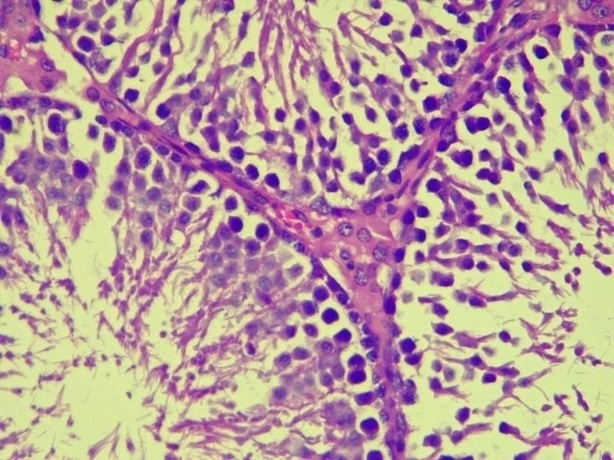

I

L

Plate 1 shows a section from the control group (Group A), revealing healthy seminiferous tubules at different developmental stages (long arrow), with interstitial spaces containing Leydig cells (I). The germinal cell layers are intact, and the lumen is filled with mature spermatocytes (I) (L), reflecting normal testicular architecture with no pathological changes. H&E x400 magnification. (arrow head indicating what ?)
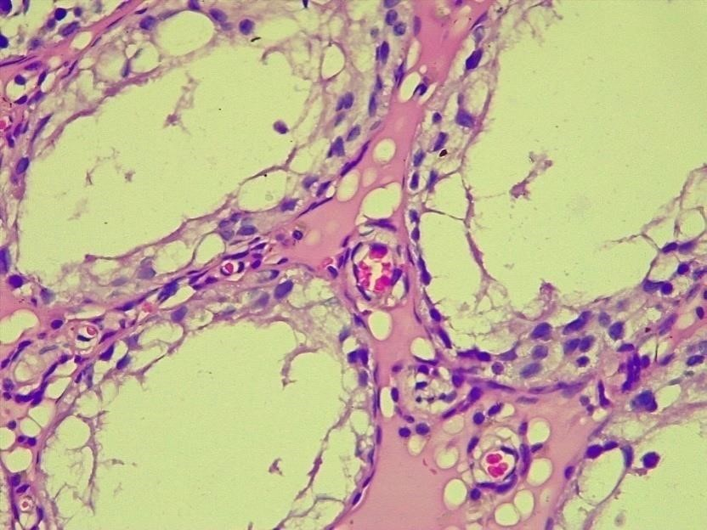

CV

*

Plate 2 represents the aluminum chloride-treated group (Group B), demonstrating severe degeneration of the seminiferous tubules, including deteriorating germinal epithelium (red arrowhead). Notable features include diffused hyaline degeneration within the interstitial spaces (I) ???, indicated by an asterisk, and congested blood vessels (CV). H&E x400 magnification.
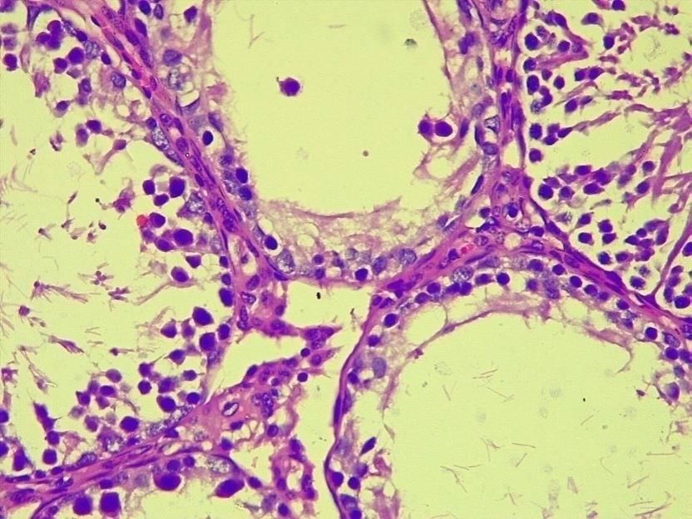

Plate 3 depicts testicular tissue from group C, which received treatment with Cyperus esculentus. Although sporadic degeneration of the seminiferous tubules is evident, with some developing germinal epithelium showing degeneration (red arrowhead), the basal primordial epithelial cells are partially preserved (thin arrow), and the interstitial spaces appear normal. H&E x400 magnification.
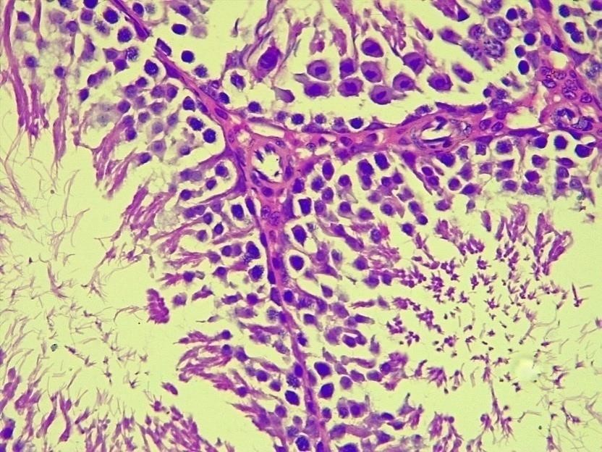

I

L

Plate 4 presents the results for group D, treated with Phoenix dactylifera. Similar to the control group, healthy seminiferous tubules (long arrow are observed along with interstitial cells (I) and mature spermatocytes filling the lumen (L), indicating a restoration of normal morphology without pathological findings. H&E x400 magnification.
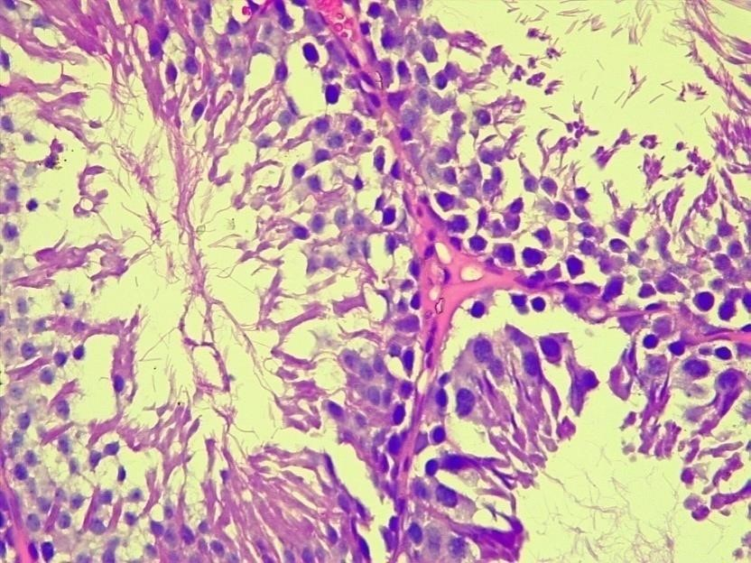

I

L

Plate 5 illustrates the combined therapy group (Group E), where sections of testicular tissue exhibit healthy seminiferous tubules at various stages of maturity (long arrow), along with interstitial cells (I). The findings reveal no lesions. H&E x400 magnification.
Figure 1: H&E Staining Observations of Testicular Damage Induced by Aluminum and Treated with Flavonoid and Saponin Fractions from Cyperus esculentus and Phoenix dactylifera. Where the fig.?

Sperm Parameters
As outlined in Table 1, the findings revealed significant alterations in ten critical sperm parameters across the various experimental groups. Group B, which received aluminum chloride treatment, exhibited a substantial decline in the percentage of motile sperm cells, while non-motile sperm cells increased significantly, indicating severe impairment of sperm function. Additionally, viable sperm cell percentages were markedly lower, with a corresponding rise in non-viable sperm cells, demonstrating the toxic effects of aluminum exposure. Rapid progressive movement of sperm cells was also severely affected, reflected in diminished percentages compared to the control group.
While groups C (aluminum + C. esculentus extract) and D (aluminum + P. dactylifera extract) showed improvements in motility, viability, and rapid progressive movement, these parameters remained significantly lower than the control group (A). Group E, which received combined extracts, demonstrated the most significant recovery, with sperm motility, viability, and count nearing control values, while also reducing non-motile and non-viable sperm cell percentages. In terms of morphological assessment, parameters such as sperm head, middle, and tail defects were significantly higher in group B compared to the control. However, treatments in groups C, D, and E exhibited no significant differences in these defects relative to group A, highlighting their potential to mitigate structural abnormalities induced by aluminum.
Groups | Motile cells  (%) | Non-Motile  cells  (%) | Viable cells  (%) | Non-Viable  cells  (%) | Rapid prog.  Movement  (%)
A  B  C  D  E | 67.50 ± 2.50  10.00 ± 2.00*  20.00 ± 2.00^{*b}  22.50 ± 2.50^{*a}  32.00 ±  1.00^{*a} | 32.50 ± 2.50  90.00 ± 4.00*  80.00 ±  5.00^{*b}  77.50 ± 2.50*  65.50 ±  1.50^{*a} | 90.00 ± 2.00  30.00 ± 5.00*  37.50 ± 2.50*  32.50 ± 2.50^{*b}  51.00 ±  1.00^{*a} | 10.00 ± 3.00  75.00 ± 5.00*  62.50 ± 2.50*  67.50 ± 2.50^{*b}  48.00 ±  1.00^{*a} | 20.00 ± 2.00  1.50 ± 0.50*  4.50 ± 0.50^{*b}  4.00 ± 1.00^{*b}  12.50 ± 0.50^{*a}
Groups | Count (10^6/ml) | Total Defect  (%) | Head Defect  (%) | Middle Defect  (%) | Tail Defect  (%)
A | 61.50 ± 1.50 | 4.50 ± 0.50 | 0.50 ± 0.50 | 1.50 ± 0.50 | 1.50 ± 0.50
B | 14.70 ± 0.70* | 11.00 ± 1.00* | 3.50 ± 0.50* | 7.50 ± 0.50* | 5.50 ± 0.50*
C | 26.15 ± 0.65^{*ab} | 6.00 ± 1.00ª | 1.50 ± 0.50 | 4.00 ± 0.00ª | 3.00 ± 0.00
D | 29.70 ± 1.80^{*ab} | 6.50 ± 0.50ª | 1.50 ± 0.50 | 3.50 ± 0.50ª | 2.50 ± 0.50ª
E | 39.65 ± 0.55^{*a} | 8.50 ± 0.50 | 1.00 ± 0.00 | 2.50 ± 0.50ª | 2.50 ± 0.50ª

Table 1: Sperm Parameters in Aluminum-Induced Testicular Toxicity Treated with Flavonoid and Saponin Extracts from Cyperus esculentus and Phoenix dactylifera
Values are expressed as Mean ± SEM, n=5. *p<0.05 vs A, ªp<0.05 vs B, ^{b}p<0.05 vs E.
(Using One-Way Analysis of Variance). A: Control; B: Administered Aluminum chloride; C: Administered Aluminum chloride and C.esculentus extract; D: Administered Aluminum chloride and P.dactylifera extract; E: Administered Aluminum chloride and combined extracts of C.esculentus and P.dactylifera.

Hormonal Assay
As summarized in Table 2, the hormonal assays revealed significant changes in hormone concentrations across the different experimental groups.
For testosterone levels, the aluminum chloride-treated group (Group B) exhibited a significant decrease compared to the control group (Group A), underscored by an asterisk. Treatments with C. esculentus extract (Group C) and P. dactylifera extract (Group D) also showed significantly lower testosterone levels compared to the control group, with Group C additionally lower than Group B. However, combined therapy in Group E resulted in significantly higher testosterone levels than Group B while remaining lower than Group A, suggesting a protective effect of the combined extracts.
In terms of follicle-stimulating hormone (FSH), Group B again demonstrated a significant reduction when compared to the control group. Interestingly, Group C's FSH levels were not significantly different from those of the control but were higher than Group B, indicating some recovery. Group D showed lower FSH levels than Group A but higher than Group B, while Group E mirrored Group C, presenting FSH concentrations similar to the control.
Lastly, regarding luteinizing hormone (LH), Group B indicated a stark decrease in levels compared to Group A. Group C also reported significantly lower LH levels than both Groups A and B. Conversely, Groups D and E showed LH levels that were significantly lower than the control but higher than Group B, signifying a partial recovery with treatment.
Groups | Testosterone  (ng/ml) | Luteinizing Hormone  (mIU/ml) | FSH  (mIU/ml)
A | 0.615 ± 0.006 | 5.04 ± 0.098 | 3.18 ± 0.09
B | 0.243 ± 0.014* | 2.94 ± 0.088* | 1.86 ± 0.12*
C | 0.350 ± 0.011^{*ab} | 3.57 ± 0.064^{*ab} | 2.73 ± 0.06ª
D | 0.384 ± 0.006^{*ab} | 3.77 ± 0.072^{*a} | 2.60 ± 0.01^{*a}
E | 0.446 ± 0.007^{*a} | 4.13 ± 0.132^{*a} | 2.81 ± 0.10ª

Table 2: Hormonal Concentrations in Aluminum-Induced Testicular Toxicity Treated with Cyperus esculentus and Phoenix dactylifera Extracts
Values are expressed as Mean ± SEM, n=5. *p<0.05 vs A, ªp<0.05 vs B, ^{b}p<0.05 vs E.
(Using One-Way Analysis of Variance). A: Control; B: Administered Aluminum chloride; C: Administered Aluminum chloride and C.esculentus extract; D: Administered Aluminum chloride and P.dactylifera extract; E: Administered Aluminum chloride and combined extracts of C.esculentus and P.dactylifera.

3.2 DISCUSSION
The present study explored the protective effects of flavonoid and saponin fractions from Cyperus esculentus (tigernut) and Phoenix dactylifera (date fruit) against aluminum chloride-induced testicular toxicity in male Wistar rats. The findings indicate that both plant extracts possess significant protective properties, as evidenced by histological observations, sperm parameter evaluations, and hormonal assays.
Histological analysis revealed marked differences across experimental groups. The control group (Group A) exhibited normal testicular architecture with intact seminiferous tubules (20). In contrast, the aluminum-treated group (Group B) displayed extensive damage, including degenerative effects on the seminiferous tubules and vascular congestion. These findings are consistent with other studies that report aluminum-induced testicular toxicity characterized by structural abnormalities (2; 21). Treatments with Cyperus esculentus (Group C) resulted in some preservation of the germinal epithelium, indicating a partial protective role. The results align with previous research suggesting the cytoprotective effects of flavonoids on testicular morphology (22; 23).
Meanwhile, Phoenix dactylifera (Group D) treatment nearly restored the normal morphological characteristics observed in the control group. The most significant improvement was seen in Group E, which received combined therapies, reflecting a potential synergistic effect of the extracts (24; 7). This suggests that the phytochemicals present in Cyperus esculentus and Phoenix dactylifera can work collaboratively to counteract aluminum-induced damage, indicating a promising avenue for therapeutic intervention in toxic exposures.
Sperm analysis revealed drastic changes in sperm motility and viability across experimental groups. Group B exhibited a significant decline in motile sperm and an increase in non-motile sperm cells, aligning with studies reporting aluminum’s detrimental impact on spermatogenesis (25). The treatment with Cyperus esculentus (Group C) and Phoenix dactylifera (Group D) produced improvements in motility and viability, although these parameters did not reach control levels. This suggests that while the extracts can ameliorate some of the toxic effects of aluminum, they may not fully restore normal function (7).
Interestingly, Group E displayed the most substantial recovery in sperm parameters, indicating the effectiveness of combined treatments. This is critical because effective male fertility relies on high sperm motility and viability (26). The reduction in morphological defects in sperm following treatment (Groups C, D, and E) suggests that these extracts may enhance sperm structure, reducing the incidence of abnormalities typical of toxic exposure (27).
Hormonal analysis revealed significant endocrine changes in response to aluminum exposure. Group B showed a marked reduction in testosterone, follicle-stimulating hormone (FSH), and luteinizing hormone (LH) levels compared to the control. These findings support previous literature linking heavy metals to hormonal disruption and impaired reproductive function (28). The lower testosterone levels directly correlate with compromised spermatogenesis and impaired reproductive health (29).
While treatments with Cyperus esculentus and Phoenix dactylifera (Groups C and D) improved hormone levels, they remained significantly lower than controls, indicating incomplete restoration of normal endocrine function. This partial recovery aligns with earlier observations reporting that phytonutrients can positively influence reproductive hormones, but may not completely reverse toxic effects (30). Notably, Group E demonstrated a significant increase in testosterone levels, suggesting a meaningful protective effect of combined therapy against aluminum’s endocrine-disrupting properties.
The results emphasize the potential of Cyperus esculentus and Phoenix dactylifera as protective agents against aluminum-induced reproductive toxicity. Given the structural preservation observed in histological data and the improvements in key sperm parameters and hormonal levels, these plant extracts could offer a viable supplementary treatment for mitigating heavy metal toxicity in male reproductive health.
Future studies should aim to delineate the individual and combined mechanisms of action of these extracts at the molecular level. Additionally, exploring the effects of these phytonutrients in human models could validate their therapeutic potential. In conclusion, the findings present a promising strategy for counteracting aluminum toxicity, highlighting the need for further research into plant-based remedies for toxicological challenges in reproductive health.

4. Conclusion
The findings of this study demonstrate that flavonoid and saponin fractions from Cyperus esculentus (tigernut) and Phoenix dactylifera (date fruit) exhibit significant protective effects against aluminum chloride-induced testicular toxicity in male Wistar rats. Histological evaluations indicated that these extracts help preserve testicular architecture, with notable improvements observed in spermatogenesis and sperm parameters. Additionally, treatment with these plant extracts led to partial restoration of critical reproductive hormones, including testosterone, FSH, and LH, which are essential for maintaining reproductive function.
The observed protective effects suggest that both Cyperus esculentus and Phoenix dactylifera may offer beneficial therapeutic strategies for mitigating the adverse effects of environmental toxins such as aluminum. Moreover, the synergistic effect of the combined extracts underscores the importance of exploring multi-component herbal therapies in combating reproductive toxicity.
Overall, these results provide a foundation for future investigations into the mechanisms underlying the protective effects of these natural products, and they highlight the therapeutic potential of plant-based interventions in addressing reproductive health issues associated with heavy metal exposure. Further research, including clinical studies, is warranted to fully elucidate the efficacy and applicability of these extracts in human populations.

DECLARATIONS
Ethical Approval
Approval was obtained for all experimental procedures from the Faculty Animal Research Ethics Committee of the Faculty of Basic Medical Sciences, University of Calabar, Calabar, Cross River State, Nigeria. Approval number (221ANA2423).
Consent for Publication
The authors of the manuscript titled "Protective Effects of Flavonoid-Rich and Saponin-Rich Fractions from Cyperus esculentus and Phoenix dactylifera on Aluminum Chloride-Induced Testicular Damage in Male Wistar Rats" hereby express their consent for publication in the Journal of Biomedical Science. This study enhances the understanding of testicular health by investigating the protective effects of flavonoid-rich and saponin-rich extracts from tiger nut (Cyperus esculentus) and date fruit (Phoenix dactylifera) against testicular damage induced by aluminum chloride. The findings aim to provide insights into potential natural therapeutic strategies for mitigating testicular toxicity and promote overall reproductive health.
Availability of Data
The data supporting the study are available upon reasonable request from the corresponding author. The datasets include histological evaluations, hormonal measurements, and raw data generated during the study.
References
- Klotz, K., Weistenhöfer, W., Neff, F., Hartwig, A., van Thriel, C., & Drexler, H. (2017). The health effects of aluminum exposure. Dtsch Arztebl Int, 114 (39), 653-659. https://doi.org/10.3238/arztebl.2017.0653
- Cheraghi, E., Golkar, A., Roshanaei, K., & Alani, B. (2017). Aluminium-induced oxidative stress, apoptosis and alterations in testicular tissue and sperm quality in Wistar rats: Ameliorative effects of curcumin. Int J Fertil Steril, 11 (3), 166-175. https://doi.org/10.22074/ijfs.2017.4859
- Rahimzadeh, M. R., Rahimzadeh, M. R., Kazemi, S., Amiri, R. J., Pirzadeh, M., & Moghadamnia, A. A. (2022). Aluminum poisoning with emphasis on its mechanism and treatment of intoxication. Emerg Med Int, 2022, 1480553. https://doi.org/10.1155/2022/1480553
- Chao, H. H., Zhang, Y., Dong, P. Y., Gurunathan, S., & Zhang, X. F. (2023). Comprehensive review on the positive and negative effects of various important regulators on male spermatogenesis and fertility. Front Nutr, 9, 1063510. https://doi.org/10.3389/fnut.2022.1063510
- Mohammed, A., Sanusi, K., & Haruna, U. Y. (2022). Tiger nut (Cyperus esculentus L.) and date palm (Phoenix dactylifera L.) fruit blend mitigates hyperglycemia, insulin resistance and oxidative complications in type-2 diabetes models. J Food Biochem, 46 (12), e14423. https://doi.org/10.1111/jfbc.14423
- Odanibe, M. H., & Ibezute, A. C. (2023). Ameliorative ability of Cyperus esculentus (Tiger Nut) and Phoenix dactylifera (Date Palm) fruits on blood haematology and film of Wistar rats in titanium dioxide nanoparticles ingestion episode. Journal of Applied Sciences and Environmental Management, 27 (4), 647-655. Retrieved from https://www.ajol.info/index.php/jasem and http://www.bioline.org.br/ja
- Agim, Agaba, Eric, Ujah, Williams Oche, Enang, Kingsley Bassey, Fischer, Victor A, Emmanuel I. Odom, and Adie, Christopher Utsu. (2025). “Protective Effects of Flavonoids-Rich and Saponins-Rich Extracts from Tiger Nuts and Date Fruits on Prostate Histoarchitechture in Aluminum-Exposed Wistar Rats”. Journal of Complementary and Alternative Medical Research 26 (1):1-11. https://doi.org/10.9734/jocamr/2025/v26i1610.
- Hassanpour, S. H., & Doroudi, A. (2023). Review of the antioxidant potential of flavonoids as a subgroup of polyphenols and partial substitute for synthetic antioxidants. Avicenna J Phytomed, 13 (4), 354-376. https://doi.org/10.22038/AJP.2023.21774
- Chen, K., Wang, N., Zhang, X., Wang, M., Liu, Y., & Shi, Y. (2023). Potentials of saponins-based adjuvants for nasal vaccines. Front Immunol, 14, 1153042. https://doi.org/10.3389/fimmu.2023.1153042
- Hamdi, H. (2020). Testicular dysfunction induced by aluminum oxide nanoparticle administration in albino rats and the possible protective role of the pumpkin seed oil. Journal of Basic and Applied Zoology, 81, 42. https://doi.org/10.1186/s41936-020-00178-8
- Behairy, A., Hashem, M. M., Abo-El-Sooud, K., El-Metwally, A. E., Hassan, B. A., & Abd-Elhakim, Y. M. (2022). Quercetin abates aluminum trioxide nanoparticles and lead acetate induced altered sperm quality, testicular oxidative damage, and sexual hormones disruption in male rats. Antioxidants, 11 (11), 2133. https://doi.org/10.3390/antiox11112133
- Yu, Y., Lu, X., Zhang, T., Zhao, C., Guan, S., Pu, Y., & Gao, F. (2022). Tiger nut (Cyperus esculentus L.): Nutrition, processing, function and applications. Foods, 11(4), 601. https://doi.org/10.3390/foods11040601
- Udefa, A. L., Amama, E. A., Archibong, E. A., Nwangwa, J. N., Adama, S., Inyang, V. U., Inyaka, G. U., Aju, G. J., Okpa, S., & Inah, I. O. (2020). Antioxidant, anti-inflammatory and anti-apoptotic effects of hydro-ethanolic extract of Cyperus esculentus L. (tigernut) on lead acetate-induced testicular dysfunction in Wistar rats. Biomed Pharmacother, 129, 110491. https://doi.org/10.1016/j.biopha.2020.110491
- Al-Shwyeh, H. A. (2019). Date Palm (Phoenix dactylifera L.) fruit as potential antioxidant and antimicrobial agents. J Pharm Bioallied Sci, 11 (1), 1-11. https://doi.org/10.4103/jpbs.JPBS_168_18
- Ubah, S., Agbonu, O., Columbus, K., Abah, K., Chibuogwu, I., Abalaka, S., Bankole, A., Enem, S., Ejiofor, C., Ajayi, I., & Ubah, S. (2021). Effects of date fruit (Phoenix dactylifera) on sperm cell morphology and reproductive hormonal profiles in cypermethrin-induced male infertility in Wistar rats. Scientific African, 11, e00713. https://doi.org/10.1016/j.sciaf.2021.e00713
- Zeb, A., Sadiq, A., Ullah, F., Ahmad, S., & Ayaz, M. (2014). Phytochemical and toxicological investigations of crude methanolic extracts, subsequent fractions and crude saponins of Isodon rugosus. Biological Research, 47(1), 57. https://doi.org/10.1186/0717-6287-47-57
- Njoku, V. O., Obi, C., & Onyema, O. M. (2011). Phytochemical constituents of some selected medicinal plants. African Journal of Biotechnology, 10, 15020-15024. https://doi.org/10.5897/AJB11.1948
- Björndahl, L., Söderlund, I., & Kvist, U. (2003). Evaluation of the one-step eosin-nigrosin staining technique for human sperm vitality assessment. Human Reproduction, 18(4), 813-816. https://doi.org/10.1093/humrep/deg199
- Ikpeme, E., Ekei, I., Udensi, O., Ekaluo, U., Uyoh, E., Asuquo, B. O., Udoh, F., & Udoh, P. B. (2007). Effect of crude extract of Carica papaya seeds on the reproductive efficiency of male albino rats. Global Journal of Pure and Applied Sciences, 13. https://doi.org/10.4314/gjpas.v13i3.16719
- Sun, P., Liu, M., Zhou, S., Yang, L., Xie, S., Riaz, H., Huo, L., & Liang, A. (2024). Maternal exposure to DON during lactation induces testicular toxicity in pubertal and adult offspring mice. Ecotoxicology and Environmental Safety, 279, Article 116468. https://doi.org/10.1016/j.ecoenv.2024.116468
- Olanrewaju, J. A., Akinpade, T. G., Olatunji, S. Y., Owolabi, J. O., Enya, J. I., Adelodun, S. T., Fabiyi, S. O., & Desalu, A. B. (2021). Observable protective activities of quercetin on aluminum chloride-induced testicular toxicity in adult male Wistar rat. Journal of Human Reproductive Sciences, 14 (2), 113-120. https://doi.org/10.4103/jhrs.jhrs_190_20
- Wang, B., Wang, Y., Chen, Y., Sun, X., Xu, J., Zhu, J., & Zhang, Y. (2023). Red-fleshed apple flavonoids extract alleviates male reproductive injury caused by busulfan in mice. Nutrients, 15 (15), 3288. https://doi.org/10.3390/nu15153288
- Uno, V., Nwangwa, J., Umoh, E., Raymond, A.-E., Asuquo, J., Otu, E.-E., & Beniangba, M. (2024). Morphology and cyto-architecture of the testis and assessment of selected biochemical parameters associated with male fertility following the consumption of Tom Brown weaning diet in albino Wistar rats. Natural Product Communications, 19, Article 10.1177/1934578X241237923. https://doi.org/10.1177/1934578X241237923
- Odinga, T.-B., Lemii, C. B., Daka, I. R., Gabriel-Brisibe, C. U., Enebeli, S. K., Austin-Asomeji, I., & Edward, F. U. (2023). Synergistic mixture of Cyperus esculentus, Phoenix dactylifera and Cocos nucifera aqueous extract: Its liver and kidney benefits in male albino rat model. Journal of Biosciences and Medicines, 11 (10), Article 10.4236/jbm.2023.1110007. https://doi.org/10.4236/jbm.2023.1110007
- Ali, F. E. M., Badran, K. S. A., Baraka, M. A., Althagafy, H. S., & Hassanein, E. H. M. (2024). Mechanism and impact of heavy metal-aluminum (Al) toxicity on male reproduction: Therapeutic approaches with some phytochemicals. Life Sciences, 340, Article 122461. https://doi.org/10.1016/j.lfs.2024.122461
- Dcunha, R., Hussein, R. S., Ananda, H., Kumari, S., Adiga, S. K., Kannan, N., Zhao, Y., & Kalthur, G. (2022). Current insights and latest updates in sperm motility and associated applications in assisted reproduction. Reproductive Sciences, 29 (1), 7-25. https://doi.org/10.1007/s43032-020-00408-y
- Al-Shaikh, M., Abdul Wahab, T., Kareem, S., & Hamoud, S. R. (2013). Protective effect of Chufa tubers (Cyperus esculentus) on induction of sperm abnormalities in mice treated with lead acetate. *International Journal of Drug Development and Research, 5, 387-392.
- Lin, J., Lin, X., Qiu, J., You, X., & Xu, J. (2023). Association between heavy metals exposure and infertility among American women aged 20-44 years: A cross-sectional analysis from 2013 to 2018 NHANES data. Frontiers in Public Health, 11, 1122183. https://doi.org/10.3389/fpubh.2023.1122183
- Rehman, S., Usman, Z., Rehman, S., AlDraihem, M., Rehman, N., Rehman, I., & Ahmad, G. (2018). Endocrine disrupting chemicals and impact on male reproductive health. Translational Andrology and Urology, 7 (3), 490-503. https://doi.org/10.21037/tau.2018.05.17
- Rietjens, I. M. C. M., Louisse, J., & Beekmann, K. (2017). The potential health effects of dietary phytoestrogens. British Journal of Pharmacology, 174 (11), 1263-1280. https://doi.org/10.1111/bph.13622

Definitions, Acronyms, Abbreviations
Definitions
1. Aluminum Chloride: A chemical compound (AlCl₃) commonly used in various industrial processes, noted for its potential toxicity to biological systems, particularly affecting reproductive health.
2. Cytoprotective: Referring to substances that protect cells from harmful agents.
3. Flavonoids: A class of plant secondary metabolites known for their antioxidant properties; they offer protective effects against cellular damage.
4. Saponins: Compounds found in various plants recognized for their ability to enhance immune responses and protect reproductive tissues.
5. Histopathological alterations: Changes in tissue structure observed through microscopic examination, usually indicative of disease or damage.
6. Testicular architecture: The structural organization and integrity of the testes, essential for normal reproductive function.
7. Oxidative stress: An imbalance between free radicals and antioxidants in the body, which can lead to cellular and tissue damage.
8. Spermatogenesis: The process of sperm cell development and maturation.
9. Reproductive health: Overall health concerning the reproductive system and its functions.

Acronyms
1. HPG Axis: Hypothalamic-Pituitary-Gonadal Axis - a complex set of interactions between the hypothalamus, pituitary gland, and gonads (testes in males) that regulate reproductive functions.
2. H&E Staining: Hematoxylin and Eosin Staining - a commonly used staining method in histology to visualize tissue structure.
3. ELISA: Enzyme-Linked Immunosorbent Assay - a plate-based assay technique used for detecting and quantifying proteins, hormones, and antibodies.
4. SEM: Standard Error of the Mean - a statistical measure that describes the accuracy with which a sample represents a population.
5. ANOVA: Analysis of Variance - a statistical method used to compare means among three or more groups.
Abbreviations
1. g: Grams
2. kg: Kilograms
3. mIU: Milli-International Units
4. ng/ml: Nanograms per milliliter
5. °C: Degrees Celsius
6. PBS: Phosphate-buffered Saline
7. DPX: Dibutyl Phthalate Polystyrene Xylene - a mounting medium used in microscopy.
8. TMB: Tetramethylbenzidine - a substrate used in enzyme-linked immunosorbent assays.
9. NaCl: Sodium Chloride
10. H2O: Water (aqua)

