**Observed Zonal Labyrinth Trophoblastic Proliferations with Reduced Placental Efficiency from Early intake of Toxic drugs in Wistar Rats**

**Abstract:**

This study investigates the effects of early exposure to tetrahydrocannabinol (THC) and cannabidiol (CBD) on maternal and fetal development in Wistar rats. Female rats (90-120 g) were administered 150 mg/kg of cannabis extract (THC, CBD, or their combination) from gestational day 6 to day 19, with feed and water provided ad libitum. Cannabis extracts were prepared through ethanol extraction followed by rotary evaporation to isolate THC and CBD. The effects on body weight, placental morphology, and trophoblast cell count were assessed. Results showed that THC exposure during gestation significantly reduced fetal body weight on gestational day (GD) 19 and postnatal day (PND) 1, with the Early THC group showing a 27.7% reduction in weight at GD 19 and a 17.5% reduction at PND 1. CBD exposure resulted in a similar but less pronounced effect, with a 23.04% reduction in fetal weight at GD 19 and 18.2% at PND 1. The combination of THC and CBD resulted in a fetal weight reduction of 24.5% on GD 19 and 21.39%, falling between the reductions observed for THC and CBD alone. Placental weight and thickness were significantly altered in the THC and CBD groups, with a reduction in fetal-to-placenta weight ratio in all cannabis-exposed groups, indicating compromised placental efficiency. Histological analysis revealed significant reductions in cell counts in the labyrinth zone of the placenta, suggesting impaired trophoblast proliferation. These findings underscore the potential developmental disruptions caused by THC and CBD exposure, with significant effects on placental function and fetal growth. Further investigation is needed to understand the underlying mechanisms and long-term implications of cannabis exposure during pregnancy.

**Keywords:** Delta-9-tetrahydrocannabinol (THC), cannabidiol (CBD), labyrinth zone, fetal weight, feto-maternal ratio.

**1. INTRODUCTION**

*Cannabis sativa*, also known as weed or hemp, defined as an annual dioecious plant with psychoactive and medicinal properties, has been utilized for centuries in various cultural, therapeutic, and industrial contexts [1]. The medicinal use of *Cannabis sativa* was first documented in the ancient Chinese pharmacopeia, Shen Nong Ben Cao Jing (The Divine Farmer’s Materia Medica) [2]. This is attributed to the mythical emperor Shen Nong (Chen Nung), who is believed to have lived around 2737 BCE and is revered as a pioneer of herbal medicine in Chinese tradition [3]. Initially passed down orally through generations, the knowledge was eventually compiled into written form, with the earliest surviving versions dated no later than 221 BCE. Researchers have also attributed its origin to central Asia (primarily), southern Caspian region, Siberia or the Himalayas [4]. In recent times, research on Cannabis sativa is expanding rapidly, driven by its therapeutic potential and the increasing legalization of cannabis worldwide [5]. Due to its anti-inflammatory properties and demonstrated in-vitro antiviral activity against severe acute respiratory syndrome coronavirus 2 (SARS-CoV-2), cannabidiol (CBD) has been suggested as a potential therapeutic option for managing coronavirus disease 2019 (COVID-19) [6]. Cannabis was described in many literature for its therapeutic properties, including pain relief, anti-inflammatory effects, and its use in treating various ailments, such as rheumatism and malaria [7]. *Cannabis sativa* plant contains over 550 natural components, with more than 120 of these being identified as "cannabinoids," which are unique to this plant [8,9]. It is a plant characterized by its active compounds, notably tetrahydrocannabinol (THC) and cannabidiol (CBD), it interacts with the endocannabinoid system to influence neurodevelopment and physiological functions [10]. While it holds promise for medical use, its effects during critical periods, such as pregnancy, remain a subject of concern. Prenatal exposure to *Cannabis sativa* may disrupt normal development, particularly in the brain and placenta, necessitating immediate research to elucidate its safety and long-term consequences [11]. Tetrahydrocannabinol (THC) is the primary compound in cannabis responsible for the psychoactive effects, commonly referred to as the "high" experienced after use [12], while CBD, the main non-psychoactive component, has anxiolytic, antipsychotic, and anticonvulsant properties [13]. Both THC and CBD bind to the Endocannabinoid system to induce their effects. THC has been responsible for various neurodegenerative disorder and CBD has been shown to be ameliorative to THC induced disorders [14]. The growing nature of cannabis use among pregnant women is alarming though it is influenced by a wide range of reasons such as, mental health status, socioeconomic status, age and ethnicity [15]. [16]stated that there is a need for a clear message to the entire populace about the dangerous nature of cannabis. For example, one study found that out of 100 postpartum women, 11% disclosed cannabis use, whereas 14% tested positive by urinalysis and 28% by hair analysis [17]. In Spain, the typical age of first cannabis use is 18.3 years, emphasizing the urgent need to raise awareness among younger generations about its use [18]. Growing bodies of literatures have linked cannabis use during pregnancy to a range of potential adverse effects on the mother and fetus. [19] stated that some pregnant women presented cannabis as an alternative for treating pregnancy related illnesses such as morning sickness. Though peer influence is another reason for cannabis use among pregnant women [20]. Its effects on the fetus is an increased risk of preterm birth, where babies are born earlier than expected, which can lead to various health complications[21]. Additionally, infants exposed to cannabis in utero (via placenta) are more likely to experience low birth weight, which can pose challenges for early development and increase vulnerability to infections and other health issues [22]. Fetal growth restriction (FGR), which occurs in over 10% of pregnant individuals, is a frequent pregnancy complication linked to a higher likelihood of stillbirth, premature birth, and negative outcomes for the newborn [23]. This growth restrictions have been linked to deterred placental development in new born with mechanisms that are not well understood [24]. Another significant concern is the potential for neurodevelopmental issues. [25] identified links between prenatal marijuana exposure and reduced performance in areas such as memory, impulse control, problem-solving, quantitative reasoning, verbal development, and visual analysis. Conversely, improved performance was observed in attention and global motion perception tests. Prenatal cannabis exposure (PME) is associated with attention deficits, behavioral problems, and a higher risk of ADHD. It may also affect brain connectivity, with lasting impacts on memory and executive functioning [26]. The placenta itself may also be affected by cannabis use, as THC can impair placental function, increasing fetal to placenta weight ratio, placenta weight, and labyrinth layer which can hinder fetal growth [24]. The placenta is a disposable organ, functioning only during pregnancy. It is divided into maternal and fetal parts [27]. The labyrinth zone, basal zone (also referred to as the junctional zone), and yolk sac are components of the fetal part of the placenta, while the decidua and metrial gland are components of the maternal part of the placenta [28]. The labyrinth zone (LZ) is the primary site for maternal-fetal exchange of oxygen, nutrients, and waste products, which are critical for fetal growth and development [28]. It lies on the wide, flat chorionic plate and forms a dense vascular layer that connects to the umbilical cord. It consists of maternal sinusoids, trophoblastic septa, and fetal capillaries [28] Alterations in the structure or function of the LZ often have direct and measurable impacts on fetal health, making it a crucial area for understanding placental efficiency [29] Generally, research on the placenta is limited, and the evidence suggests that studies on cannabis' effects on placental health are even more scarce. These gaps highlight the need for further investigation into how cannabis impacts the placenta and its role in mediating fetal development. In the present work, we have analyzed the adverse effects of tetrahydrocannabinol (THC), cannabidiol (CBD), and their combination on fetal weight and placental health. We also investigated the individual and synergistic impacts of these cannabinoids on neurodevelopmental and morphological parameters, using ImageJ software to assess cell proliferation. These findings underscore the importance of understanding the implications of prenatal cannabis exposure on placental function and fetal development.

**2.0 METHODOLOGY**

**2.1 PROCUREMENT OF RAT**

A total of 24 female Wistar rats and 12 male Wistar rat, weighing between 90 -120 g, were used for the experiment. The animals were obtained from Peter’s Farm (Nig.) enterprises in Ibadan.

**2.2 HOUSING**

The animals were kept in wire mesh plastic cages of size (40 cm × 60 cm × 20 cm) in the animal house of the Department of Anatomy, Olabisi Onabanjo University, Sagamu campus, Ogun state, Nigeria. This was done under standard laboratory conditions on a 12-hours light/dark cycle. The animals were left to acclimatize for two weeks before the commencement of the experiment. The animals were given pellet feeds and water (Jafel Agro service, Sagamu, Ogun state) ad libitum. Animals were mated in ratio 1:2 under standard conditions.

**2.3 PREPARATION OF EXTRACT**

*Cannabis sativa* was acquired through the National drugs law and enforcement agency (NDLEA); the extract was prepared from the dried leaves of the plant. The identification was done by the NDLEA with reference number NDLEA/SD/2024/2170. The cannabis leaves were dried and its weight was obtained. A mechanical miller was used to grind the leave into powder. The powdered leaves were then soaked in ethanol for 72 hours or 3 days [30]. This process increased the surface area, facilitating better penetration of the 100% alcohol solvent during the maceration procedure. Solvent-based Agitation was performed manually with paddles and stirrer to increase the contact between the solvent and the cannabis materials [31]. It was then filtered using a filter paper and then taken to the department of pharmacognosy, Olabisi Onabanjo University for solvent-solvent extraction using a rotary evaporator [31] and thin layer chromatography (TLC) procedures. The percentage yield was calculated using this formula Final $\frac{Final Weigt}{Initial Weight} X 100$. The initial weight of the Cannabis leaves before extraction was 3300g, and the final weight of the extracted material was 278.64. As much as 8.44% was obtained as the percentage yield through the process of preparation. Reference values gotten for the THC and CBD were compared with journal articles online [32].

* 1. **EXPERIMENTAL DESIGN**

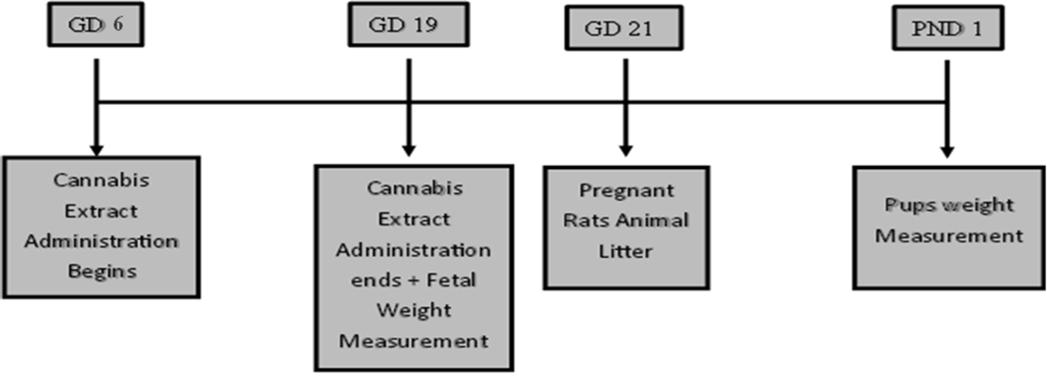A total of 36 rats including 12 males were used during the experiment. The study was conducted with two treatments: Control and Experimental groups (receiving THC, CBD and THC/CBD combination.

Figure 1: Procedural Timeline for the experiment

* **Control Groups:** A total of 6 female Wistar rats were used as controls, provided with feed and water ad libitum. They were further divided into two subgroups (n=3): one observed from gestational day 6 to day 19, and the other monitored until gestational day (GD) 21.
* **Early THC Group (E THC):** Six female Wistar rats were provided with feed, clean water, and a 150 mg/kg dose of THC for specific durations of gestational days based on the subgroup. One subgroup (n=3) was observed from gestational day 6 to day 19, while the other subgroup (n=3) was monitored until birth.
* **Early CBD Group (E CBD):** Six female Wistar rats which were subdivided into two, n=3. They were provided with feed, clean water, and a 150 mg/kg dose of CBD for specific durations of gestational days based on the subgroup, GD6 to GD19 and until birth respectively.
* **Early THC/CBD (E THC/CBD) Group:** Six female Wistar rats were provided with feed, clean water, and a 150 mg/kg dose of THC/CBD from gestational day 6 to day 19. One subgroup (n=3) was monitored until birth, while the other subgroup (n=3) was observed from GD 6 to 19.

The doses were selected based on previous evaluations in rats [33]. At day GD 19, three animals from each group were sacrificed and placentae were extracted for macro-morphometric calculations and morphological analysis. The remaining three (3) animals in the groups were allowed to litter and their pups were allowed to grow (Figure 1).

**Feed used:** Top line finisher pellet.

**2.5 PHOTOMICROGRAPHY**

Image acquisition and analysis: A light microscope (10 - 40x magnification objective) used. Digital camera – AmScope MD500A attached to P.C - HP used. Java Application Software.

* 1. **DATA ANALYSIS**

Statistical analyses were conducted using GraphPad Prism. Comparisons between groups were performed using Student’s t-test for two-group comparisons and one-way ANOVA for multiple groups. Data are expressed as Mean ± S.E.M. For image-based analysis, six images per placenta were

taken at 10× magnification, and quantitative analysis of the images was performed using GraphPad Prism. Statistical significance was set at p < 0.05.

**3.0 RESULT AND ANALYSIS**

**3.1 Mean Body Weight Reduction at Gestational day 19 and Post Natal Day 1**

Notably, cannabis extracts, particularly CBD and THC, both individually and in combination, caused a significant reduction in the body weight of the offspring. Figure 2A shows a significant decrease in fetal body weight on GD 19 in the Early THC group (2.48 ± 0.15 g, p < 0.001) compared to the control group (3.42 ± 0.48 g). It has been previously proven that THC at gestational day 19.5 caused an increase in fetal weight, which is not consistent with our findings [24]. On PND 1, the control group had an average pup weight of 4.63 ± 0.075 g, compared to Early THC (3.82 ± 0.81 g, p < 0.001). Though results at PND 1 from previous studies were consistent with this article, it was confirmed that THC significantly caused a reduction in fetal weight at PND 1 [34], [35]. This is due to the fact that THC can either penetrate the placenta or bind to receptors prenatally [36]. Postnatally, recent studies support our findings by showing that rat pups from cannabis-induced mothers have lower birth weights. However, after being fed by control mothers, there was an increase in weight, indicating that THC can also penetrate breast milk to impair the fetus [37]. In [38], 30 mg/kg of THC caused a significant weight decrease in mice which corresponds to the findings from this work. Regarding the other groups, the Early CBD group (2.64 ± 0.15 g, p < 0.05) experienced a slight significant decrease in weight on gestational day 19. This finding contrasts with previous studies, such as [39], where CBD was shown to increase weight in a sex-specific manner but tallies with [40] where CBD caused a reduction in fetal weight. It is also important to note that CBD, via the mechanism of THC explained above, can affect the placenta. Early CBD group (3.79 ± 0.83 g, p < 0.001) at PND 1 experienced a significant decrease in weight indicating that cannabis effects persist postnatally. Debates in the research community suggest that THC might retain its efficacy and could be utilized for weight reduction, as it has demonstrated similar effects [41]. The combination of THC with the indirect antagonist CBD has been shown to enhance THC's effect in reducing body weight gain [41]. Adolescent rats treated with an equal concentration of THC and CBD maintained the reduced body weight even after a 21-week washout period [41,42]. The Early THC/CBD group (2.59 ± 0.13 g, p < 0.001) at gestational day 19 displayed fetal weight outcomes that lay between the extremes observed in the Early THC and Early CBD groups, suggesting a minor effect of THC alongside a potential ameliorating effect of CBD when administered in combination though there are limited research on the combined use of THC and CBD. Early THC/CBD has a weight of (3.64 ± 0.98 g, p < 0.001) at PND. So, in summary, the weight reduction on GD 19 was 23.04% in the Early CBD group, 27.7% in the Early THC group, and 24.5% in the Early THC/CBD group. The weight reduction on PND 1 was 18.2% in the Early CBD group, 17.5% in the Early THC group, and 21.39% in the Early THC/CBD group.

**Figure 2:** (A) Fetal weight at gestational day 19 (GD 19), Each bar represents Mean ± S.E.M, with a significant difference at p < 0.05 (*) and p< 0.001 (***) compared with the control. (B) weight at postnatal day 1 (PND 1). Each bar represents Mean ± S.E.M, with a significant difference at p < 0.01 (**) and p< 0.0001 (****) compared with the control.

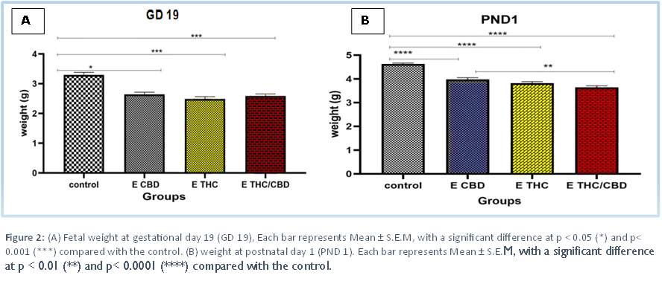

**Figure 3:** Statistical analysis of placental morphometric parameters among four groups. All values are expressed as mean ± SEM. Statistical significance was determined using one-way ANOVA, with a P-value < 0.05 considered significant. Significant differences were observed in all groups except for placental weight and length in the ETHC/CBD group.

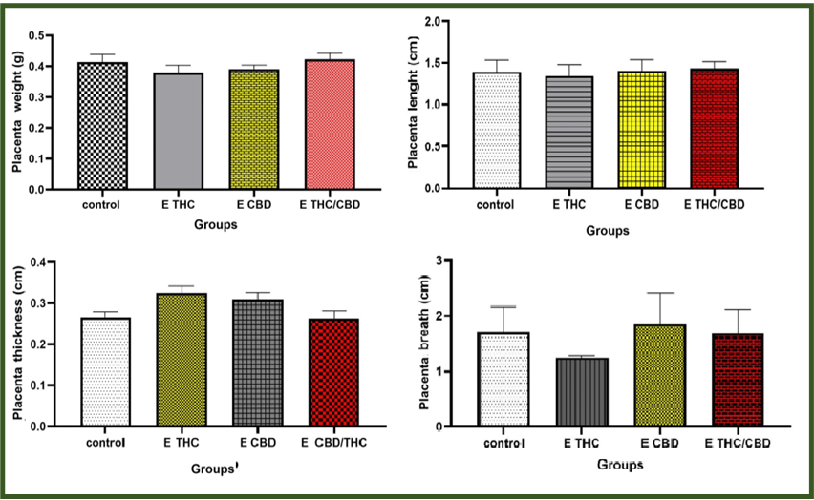

**D**

**B**

**A**

**C**

**3.2 Placental Morphometric Calculations in Induced Wistar Rat.**

Placental morphometric parameters, including weight, length, thickness, and breadth, have been utilized as indicators to recognize fetal growth restriction [43]. The impact of tetrahydrocannabinol (THC) on placenta weight and development is a significant concern in maternal-fetal health. Research indicates that THC exposure during pregnancy can lead to reduced placenta weight and compromised placental function, which may adversely affect fetal growth and development. Although comparison bars are not displayed for the data in figure 3, statistical analysis revealed significant differences. In figure 3a, a slight decrease in placental weight was observed in the Early THC (0.38 ± 0.035 g) and Early CBD (0.39 ± 0.023 g) groups compared to the control (0.41 ± 0.036 g). However, placental weight in the Early THC/CBD group (0.42 ± 0.009 g) was similar to the control. These reductions were statistically significant except the ETHC/CBD group where significance was not attained. Interestingly, marijuana use has been reported to increase placental weight in some studies [44]. Some studies observed a slight decrease in placenta weight [45] while others reported an increase due to THC, which has been linked to fetal growth restriction[46]. [47] further highlighted that FGR can occur via placental insufficiency, implying adverse effects on placental function and development. A recent study reported that CBD exposure led to a reduction in placental weight, which aligns with our findings demonstrating a similar placental weight reduction caused by CBD [48]. It has been suggested that THC and CBD, acting through TRPV2 receptors, can induce weight loss in both the placenta and fetus [36]. Figure 3b showed significant difference in placental length among groups except ETHC/CBD group. Values were as follows: control (1.40 ± 0.040), Early THC (1.34 ± 0.056), Early CBD (1.41 ± 0.010), and Early THC/CBD (1.43 ± 0.033). Placental thickness (figure 3c) was significantly increased in the Early THC (0.32 ± 0.059) and Early CBD (0.31 ± 0.043) groups compared to the control (0.26 ± 0.022). The Early THC/CBD group (0.26 ± 0.024) exhibited a similar thickness to the control which was not statistically significant. In figure 3D, no significant differences in placental breadth were observed among groups: control (1.71 ± 0.547), Early THC (1.25 ± 0.455), Early CBD (1.86 ± 0.152), and Early THC/CBD (1.69 ± 0.019). However, the Early THC group exhibited a markedly lower breadth compared to the control, suggesting the possibility of a significant difference. Generally, placental thickness was significantly increased in the Early THC (0.32 ± 0.059) and Early CBD (0.31 ± 0.043) groups compared to the control (0.26 ± 0.022). This suggests that early exposure to THC and CBD leads to structural adaptations, possibly due to changes in trophoblast function or vascular development. In contrast, the Early THC/CBD combination group (0.26 ± 0.024) showed no significant difference, indicating a potential neutralizing effect between the two cannabinoids. These findings contrast with [49], where decrease in placental thickness was observed, possibly due to variations in dosage, timing, or species.

**3.3 Fetal to Placenta Weight Ratio**

Placenta weight alone is not a sufficient proof of placenta efficiency [43,44,50]. The fetal-to-placental weight ratios were significantly reduced in the cannabis-exposed groups, indicating compromised placental efficiency and nutrient transfer to developing fetuses [51]. Fetoplacental weight is a true indicator of placenta dysfunction[46,52]. A study reported a trend toward lower feto-placental weight ratio (FPR) among marijuana-exposed pregnancies, particularly in term stillbirths (6.84 vs. 7.8, p < 0.001). However, multivariable analysis from their study showed no significant association (p = 0.09), and no differences in placental histology were identified between exposed and non-exposed groups [53]. Results from [54] have shown that cannabis generally causes a reduction in the feto-placental weight ratio. These results are Specifically, [46] demonstrates that THC can reduce the feto-placental weight ratio, a finding that is consistent with the data presented in Table 1 below.

**Table 1:** The feto-placental weight ratios in pregnancies exposed to Δ9-THC.

|  |  |  |
| --- | --- | --- |
| ***Control Group*** | **E THC** | ***P < 0.05*** |
| *8.30 ± 0.52* | *6.36 ± 0.166* | *0.040\** |

*The data are displayed as mean ± standard error. Asterisks indicates significant difference (P <0.05).*

CBD was shown to cause a reduction in the feto-placental weight ratio in the study by [48]. Similarly, Table 2 demonstrates a reduction in the feto-placental weight ratio.

**Table 2**: The feto-placental weight ratios in pregnancies exposed to CBD.

|  |  |  |
| --- | --- | --- |
| ***Control Group*** | ***E CBD*** | ***P < 0.05*** |
| *8.30 ± 0.52* | *6.95 ± 0.59* | *0.002\** |

*The data are displayed as mean ± standard error. Asterisks indicates significant difference (P <0.05).*

The fetoplacental weight ratio in the combined THC/CBD effect (Table 3) is much lower, despite the ameliorative influence of CBD on THC, as described by [55]. However, it cannot be definitively concluded that CBD fully mitigates the negative effects of THC on the fetoplacental ratio. While CBD has shown potential in reducing some of THC's adverse effects, the overall impact of their combination may still lead to disruptions in placental function or fetal development, as indicated by the reduced fetoplacental weight ratio. Further studies would be needed to clarify the precise interactions between THC and CBD in this context. Though, the dose dependency was address by [56], where a high dose of CBD reduced the intoxicating effects of THC, a low dose of CBD combined with THC enhanced the intoxicating effects of CBD, this interaction does not appear to be directly related to the fetoplacental weight ratio. While the dose of CBD influences the effects of THC on maternal and fetal outcomes, it seems that the fetoplacental weight ratio is not significantly impacted by these combined doses of THC and CBD in the manner observed in other developmental markers. Further research is necessary to explore the complex relationships between these compounds and placental function.

|  |  |  |
| --- | --- | --- |
| ***Control Group*** | ***ETHC/CBD*** | ***P < 0.05*** |
| *8.30 ± 0.52* | *6.17 ± 0.143* | *0.018\** |

**Table 3**: The feto-placental weight ratios in pregnancies exposed to THC/CBD.

*The data are displayed as mean ± standard error. Asterisks indicates significant difference (P <0.05).*

**3.3 Cell Counts**

Exposure to 150 mg/kg of CBD, THC, and a combination of CBD/THC from early gestational day 6 to day 19 resulted in a significant reduction in the cell count of the Labyrinth Zone (LZ) of the placenta compared to the control group. Image analysis of the control group showed a mean LZ cell count of 1663 ± 213.25. In contrast, the group exposed to CBD had a mean count of 552.7 ± 7.45, with a p-value of 0.007, indicating a significant reduction in trophoblast cell count (Figure 4). A similar significant reduction was observed in the THC-exposed group (Figure 5), which had a mean count of 361.67 ± 54.69 (p-value = 0.004). The combined CBD/THC group (Figure 6) also exhibited a significant reduction, with a mean count of 637.67 ± 17.57 (p-value = 0.013). A general reduction was observed

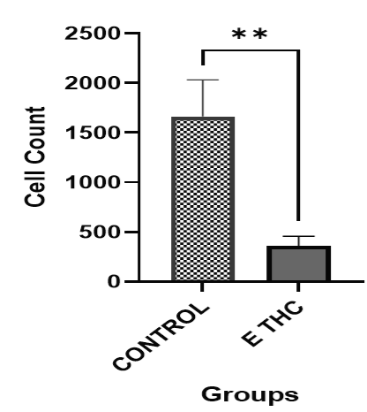

**Figure 4:** Statistical analysis of the l labyrinth zone cell counts in the placenta of rats between the control and E THC groups. All values are expressed as mean ± SEM. Statistical significance was determined using an independent t-test, with a P-value < 0.05 considered significant.

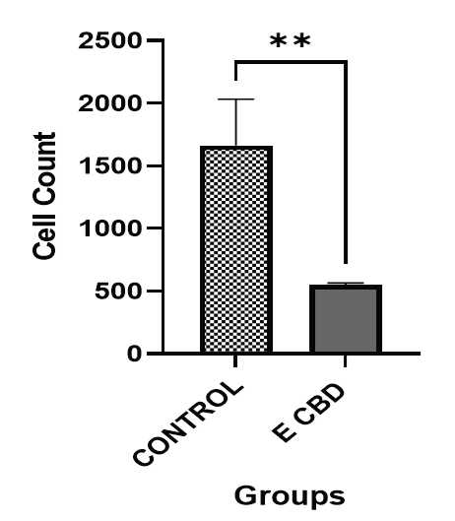

**Figure 5:** Statistical analysis of the labyrinth zone cell counts in the placenta of rats between the control and E CBD groups. All values are expressed as mean ± SEM. Statistical significance was determined using an independent t-test, with a P-value < 0.05 considered significant.

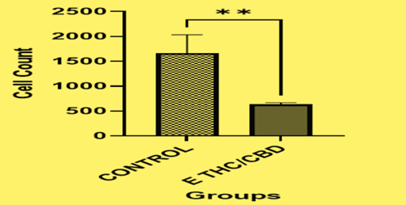

**Figure 6:** Statistical analysis of the labyrinth zone cell counts in the placenta of rats between the control and E CBD/THC groups. All values are expressed as mean ± SEM. Statistical significance was determined using an independent t-test, with a P-value < 0.05 considered significant.

Cannabis active constituents, including THC and CBD, have been linked to trophoblast proliferation at both the cellular and molecular levels [57]. The Labyrinth Zone (LZ) is the primary site for maternal-fetal exchange of oxygen, nutrients, and waste products, which are critical for fetal growth and development. Alterations in the structure or function of the LZ often have direct and measurable impacts on fetal health, making it a crucial area for understanding placental efficiency. The observation of a general reduction in cell count aligns with findings by [46], who reported that THC exposure led to an increase in labyrinth area but a reduction in EpCAM expression. EpCAM is a marker for trophoblast progenitors, and its reduced expression indicates impaired renewal and differentiation of these progenitor cells.

Together, these findings suggest a specific disruption in labyrinth development due to THC exposure. [48] reported that CBD exposure did not affect the expression of markers for labyrinth progenitors (EpCAM) or junctional zone progenitors (Ascl2) and suggested that trophoblast progenitor populations were maintained. However, our data reveal a reduction in trophoblast cell count, highlighting a disconnect between gene expression stability and cellular population outcomes. In addition, [48] reported that in utero exposure to 3 mg/kg CBD resulted in reduced populations of labyrinth endothelial cells and SynTII cells at E19.5, a critical time point in placental and fetal development. This is in line with our findings because we observed a decrease in trophoblast cell count, particularly in the labyrinth zone, suggesting that CBD exposure adversely affects trophoblast differentiation and function.

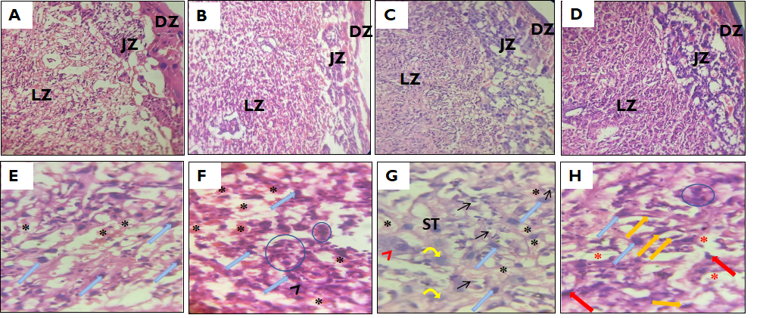

**Figure 7:** Representative photomicrographs of hematoxylin and eosin-stained placental sections of the experimental groups showing;[A]: Three-layered placenta structure showing an intact junctional zone (JZ), labyrinth zone (LZ), and decidual zone (DZ) of the control group (X100 magnification). [B]: Three-layered placenta structure from the THC induced group, showing a distorted decidual zone, with alterations in the labyrinth and junctional layers (X100 magnification). [C]: Three-layered placenta structure from the CBD group, showing the three zones, with alterations in the labyrinth and junctional layers. [D]: The placenta section from the ETHC/CBD group, showing the junctional zone (JZ), labyrinth zone (LZ), and decidual zone (DZ) of the placenta (X100 magnification). [E] The control group of the placenta shows normal labyrinth cell morphology, characterized by giant trophoblast cells (blue arrows) and intact blood vessels (asterisks) (X400 magnification). [F] The labyrinth zone of THC induced group features visible maternal spaces containing blood cells with loss of blood compartmentalization (asterisks). Giant trophoblast cells (blue arrows) are present, with basophilic cytoplasm (black arrowhead). Blue circles indicate clusters of cells with tiny nuclei and basophilic cytoplasm (X400 magnification). [G] Photomicrographic section of the labyrinth zone of the CBD-induced group: Spongiotrophoblast cells exhibit highly vacuolated cytoplasm and darkly stained nuclei (ST). The giant trophoblast cells display prominent nuclei (thick blue arrow), lightly stained nuclei (curved yellow arrow), nuclear vacuolations (arrowhead), and disrupted plasma membranes (arrowhead). Glycogen-filled cells with shrunken nuclei are indicated by thin black arrows (X400 magnification). [H] This section of the labyrinth zone, treated with a combined dose of THC and CBD, contains spongiotrophoblast cells with basophilic cytoplasm (red arrow) and giant trophoblast cells (blue arrows), including flat giant trophoblast cells (orange arrows). Irregular maternal blood spaces lack blood cells (red asterisks), and clusters of cells with basophilic cytoplasm are visible (blue circle) (X400 magnification).

**3.4 PLACENTA MORPHOLOGY**

The photomicrographs in Figure 4 illustrate notable histological changes in placental morphology across experimental groups treated with THC, CBD, or their combination. The control group displays a normal three-layered structure with intact labyrinth cell morphology, suggesting efficient maternal-fetal exchange and healthy placental function. In the THC group, the decidual layers show distortion, indicating structural disruptions that may impair nutrient and gas exchange. Maternal spaces containing blood cells remain visible, but abnormalities like loss of blood compartmentalization similar to the lipid peroxidation caused by aspartame [58]. Both aspartame and THC can induce oxidative stress and lipid peroxidation, but their impacts on blood compartmentalization and mechanism of action in the placenta differ [59]. At GD 19.5, the presence of proliferating cells is typically low; however, proliferation can be altered in response to placental stress, potentially leading to changes in cell division and tissue development. We observed a decrease in cell count, which may indicate impaired cellular proliferation due to such stress [60]. In the CBD group, less pronounced cellular stress is observed in spongiotrophoblast cells, likely due to improved blood compartmentalization. However, some histological changes, such as vacuolated cytoplasm, nuclear vacuolations, and glycogen-filled cells with shrunken nuclei, may indicate localized metabolic dysfunction and possible compromises in placental efficiency[61]. Additionally, a reduction in cellular proliferation was noted, as reflected in the cell count data. These results suggest that while CBD may alleviate some stress through enhanced vascular dynamics, it does not completely prevent cellular and metabolic disturbances in the placenta. The THC group contains numerous plasma cells, indicative of neuroinflammation. A gradual decrease in plasma cells is observed in the CBD group, with a complete absence in the THC/CBD combination group. Given that CBD is known for its anti-inflammatory properties [62], its presence in combination with THC might have mitigated any potential inflammatory response, thus preventing the accumulation of blood cells in the placental tissue [63]. These findings suggest a compounded impact on placental structure, likely reducing its ability to support normal fetal development.

The disruptions to the fetal micro-environment from maternal factors can negatively impact these processes and impair fetal brain development, leading to prenatal programming of neurodevelopmental disorders [64], as THC or CBD can penetrate the placenta barrier and reach fetus [52]. Overall, the observed histological changes highlight the detrimental effects of cannabinoid exposure on placental integrity, with potential consequences for fetal growth and development.

We might raise the question as to why the oral route was chosen for cannabis administration when intravenous (IV) administration offers 100% bioavailability. We selected the oral route because it is the most commonly used method, especially among people in Nigeria. The oral route reflects real-world patterns of cannabis consumption, making it more relevant for studies aiming to understand typical use and its effects on health [65]. Since the oral route of administration, despite being affected by first-pass metabolism, resulted in similar plasma concentrations of THC in the treated animals, it emphasizes the importance of simulating a more human-like environment in animal studies. This approach would help to ensure that the results more accurately reflect the human experience of cannabis use[66].

**CONCLUSION**

This study demonstrates that cannabis (THC, CBD or its combination) exposure during early gestation significantly impairs fetal weight, reduces placental efficiency, and disrupts trophoblast cellular proliferation in the labyrinth zone of the placenta. The findings of this study unequivocally underline the detrimental effects of prenatal cannabis exposure on fetal weight and placental health. Both THC and CBD, independently and in combination, were shown to result in a significant reduction in fetal growth and adverse changes in placental morphology and function. These outcomes suggest possible disruptions in nutrient transfer, cellular proliferation, and overall placental efficiency, which are critical for healthy fetal development. The research highlights the urgent need for further comprehensive studies to elucidate the mechanisms of cannabis-induced developmental perturbations and their long-term consequences. A deeper understanding is critical for informing public health policies and clinical guidelines concerning cannabis use during pregnancy, aiming to mitigate risks and safeguard maternal and fetal health.

**REFERENCES**

1. Bonini SA, Premoli M, Tambaro S, Kumar A, Maccarinelli G, Memo M, et al. Cannabis sativa: A comprehensive ethnopharmacological review of a medicinal plant with a long history. J Ethnopharmacol. 2018 Dec;227:300–15.

2. Xie Z, Mi Y, Kong L, Gao M, Chen S, Chen W, et al. Cannabis sativa: origin and history, glandular trichome development, and cannabinoid biosynthesis. Hortic Res. 2023 Sep 4;10(9):uhad150.

3. The first Materia Medica: The Shen Nong Ben Cao Jing [Internet]. [cited 2024 Nov 29]. Available from: https://www.researchgate.net/publication/320146361_The_first_Materia_Medica_The_Shen_Nong_Ben_Cao_Jing

4. Fordjour E, Manful CF, Sey AA, Javed R, Pham TH, Thomas R, et al. Cannabis: a multifaceted plant with endless potentials. Front Pharmacol. 2023 Jun 15;14:1200269.

5. Turland N, Wiersema J, Barrie F, Greuter W, Hawksworth D, Herendeen P, et al., editors. International Code of Nomenclature for algae, fungi, and plants [Internet]. Koeltz Botanical Books; 2018 [cited 2024 Jul 24]. (Regnum Vegetabile; vol. 159). Available from: https://www.iapt-taxon.org/nomen/main.php

6. Crippa JAS, Pacheco JC, Zuardi AW, Guimarães FS, Campos AC, Osório FDL, et al. Cannabidiol for COVID-19 Patients with Mild to Moderate Symptoms (CANDIDATE Study): A Randomized, Double-Blind, Placebo-Controlled Clinical Trial. Cannabis Cannabinoid Res. 2022 Oct 1;7(5):658–69.

7. Baron EP. Medicinal Properties of Cannabinoids, Terpenes, and Flavonoids in Cannabis, and Benefits in Migraine, Headache, and Pain: An Update on Current Evidence and Cannabis Science. Headache J Head Face Pain. 2018 Jul;58(7):1139–86.

8. Rock EM, Parker LA. Constituents of Cannabis Sativa. In: Murillo-Rodriguez E, Pandi-Perumal SR, Monti JM, editors. Cannabinoids and Neuropsychiatric Disorders [Internet]. Cham: Springer International Publishing; 2021 [cited 2024 Dec 19]. p. 1–13. (Advances in Experimental Medicine and Biology; vol. 1264). Available from: https://link.springer.com/10.1007/978-3-030-57369-0_1

9. Wishart DS, Hiebert-Giesbrecht M, Inchehborouni G, Cao X, Guo AC, LeVatte MA, et al. Chemical Composition of Commercial Cannabis. J Agric Food Chem. 2024 Jan 5;72(25):14099.

10. De Camargo RW, De Novais Júnior LR, Da Silva LM, Meneguzzo V, Daros GC, Da Silva MG, et al. Implications of the endocannabinoid system and the therapeutic action of cannabinoids in autism spectrum disorder: A literature review. Pharmacol Biochem Behav. 2022 Nov;221:173492.

11. Navarrete F, García-Gutiérrez MS, Gasparyan A, Austrich-Olivares A, Femenía T, Manzanares J. Cannabis Use in Pregnant and Breastfeeding Women: Behavioral and Neurobiological Consequences. Front Psychiatry. 2020 Nov 2;11:586447.

12. Kroon E, Kuhns L, Hoch E, Cousijn J. Heavy cannabis use, dependence and the brain: a clinical perspective. Addiction. 2020;115(3):559–72.

13. De Camargo RW, De Novais Júnior LR, Da Silva LM, Meneguzzo V, Daros GC, Da Silva MG, et al. Implications of the endocannabinoid system and the therapeutic action of cannabinoids in autism spectrum disorder: A literature review. Pharmacol Biochem Behav. 2022 Nov;221:173492.

14. Boggs DL, Nguyen JD, Morgenson D, Taffe MA, Ranganathan M. Clinical and Preclinical Evidence for Functional Interactions of Cannabidiol and Δ9-Tetrahydrocannabinol. Neuropsychopharmacology. 2018 Jan;43(1):142–54.

15. Montgomery L, Dixon S, Mantey DS. Racial and Ethnic Differences in Cannabis Use and Cannabis Use Disorder: Implications for Researchers. Curr Addict Rep. 2022 Jan 5;9(1):14–22.

16. Grant KS, Petroff R, Isoherranen N, Stella N, Burbacher TM. Cannabis Use during Pregnancy: Pharmacokinetics and Effects on Child Development. Pharmacol Ther. 2018 Feb;182:133–51.

17. Towobola A, Towobola B, Nair B, Makwana A. The ethics and management of cannabis use in pregnancy following decriminalisation and licensing for medical use: narrative review. BJPsych Bull. 2023 Feb;47(1):28–37.

18. Roncero C, Valriberas-Herrero I, Mezzatesta-Gava M, Villegas JL, Aguilar L, Grau-López L. Cannabis use during pregnancy and its relationship with fetal developmental outcomes and psychiatric disorders. A systematic review. Reprod Health. 2020 Dec;17(1):25.

19. Mulligan MK, Hamre KM. Influence of prenatal cannabinoid exposure on early development and beyond. Adv Drug Alcohol Res. 2023 Feb 28;3:10981.

20. Cameron LD, Fleszar-Pavlović SE, Yepez M, Manzo RD, Brown PM. Beliefs about marijuana use during pregnancy and breastfeeding held by residents of a Latino-majority, rural region of California. J Behav Med. 2022 Aug;45(4):544–57.

21. Andrade C. Maternal Cannabis Use During Pregnancy and Maternal and Neonatal Adverse Outcomes. J Clin Psychiatry. 2024 Oct 30;85(4):57493.

22. Avalos LA, Oberman N, Alexeeff SE, Croen LA, Davignon MN, Adams SR, et al. Early Maternal Prenatal Cannabis Use and Child Developmental Delays. JAMA Netw Open. 2024 Oct 18;7(10):e2440295.

23. Bligard KH, Odibo AO. Fetal Growth Restriction. In: Spong CY, Lockwood CJ, editors. Queenan’s Management of High‐Risk Pregnancy [Internet]. 1st ed. Wiley; 2024 [cited 2024 Oct 22]. p. 392–8. Available from: https://onlinelibrary.wiley.com/doi/10.1002/9781119636540.ch44

24. Natale BV, Gustin KN, Lee K, Holloway AC, Laviolette SR, Natale DRC, et al. Δ9-tetrahydrocannabinol exposure during rat pregnancy leads to symmetrical fetal growth restriction and labyrinth-specific vascular defects in the placenta. Sci Rep. 2020 Jan 17;10(1):544.

25. Sharapova SR, Phillips E, Sirocco K, Kaminski JW, Leeb RT, Rolle I. Effects of prenatal marijuana exposure on neuropsychological outcomes in children aged 1‐11 years: A systematic review. Paediatr Perinat Epidemiol. 2018 Nov;32(6):512–32.

26. Vishnubhotla RV, Ahmad ST, Zhao Y, Radhakrishnan R. Impact of prenatal marijuana exposure on adolescent brain structural and functional connectivity and behavioural outcomes. Brain Commun. 2024 Mar 1;6(2):fcae001.

27. Peng S, Li C, Xie X, Zhang X, Wang D, Lu X, et al. Divergence of Iodine and Thyroid Hormones in the Fetal and Maternal Parts of Human-Term Placenta. Biol Trace Elem Res. 2020 May;195(1):27–38.

28. Furukawa S, Tsuji N, Sugiyama A. Morphology and physiology of rat placenta for toxicological evaluation. J Toxicol Pathol. 2019;32(1):1–17.

29. Abnormal labyrinthine zone in the Hectd1-null placenta. Placenta. 2016 Feb 1;38:16–23.

30. Rashid S, Majeed LR, Nisar B, Nisar H, Bhat AA, Ganai BA. Phytomedicines: Diversity, extraction, and conservation strategies. In: Phytomedicine [Internet]. Elsevier; 2021 [cited 2024 Dec 16]. p. 1–33. Available from: https://linkinghub.elsevier.com/retrieve/pii/B9780128241097000091

31. López-Olmos C, García-Valverde MT, Hidalgo J, Ferrerio-Vera C, Sánchez De Medina V. Comprehensive comparison of industrial cannabinoid extraction techniques: Evaluation of the most relevant patents and studies at pilot scale. Front Nat Prod. 2022 Nov 28;1:1043147.

32. Liu Y, Victoria J, Wood M, Staretz ME, Brettell TA. High Performance Thin-Layer Chromatography (HPTLC) data of Cannabinoids in ten mobile phase systems. Data Brief. 2020 Aug;31:105955.

33. Chan P. Toxicity and Carcinogenicity of Δ9-Tetrahydrocannabinol in Fischer Rats and B6C3F1 Mice. Fundam Appl Toxicol. 1996 Mar;30(1):109–17.

34. Gillies R, Lee K, Vanin S, Laviolette SR, Holloway AC, Arany E, et al. Maternal exposure to Δ9-tetrahydrocannabinol impairs female offspring glucose homeostasis and endocrine pancreatic development in the rat. Reprod Toxicol. 2020 Jun;94:84–91.

35. Moore BF. Prenatal Exposure to Cannabis: Effects on Childhood Obesity and Cardiometabolic Health. Curr Obes Rep. 2024 Mar 1;13(1):154–66.

36. Rokeby ACE, Natale BV, Natale DRC. Cannabinoids and the placenta: Receptors, signaling and outcomes. Placenta. 2023 Apr;135:51–61.

37. Fried PA. Short and long-term effects of pre-natal Cannabis inhalation upon rat offspring. Psychopharmacology (Berl). 1976;50(3):285–91.

38. Eitan A, Gover O, Sulimani L, Meiri D, Schwartz B. The Effect of Orally Administered Δ9-Tetrahydrocannabinol (THC) and Cannabidiol (CBD) on Obesity Parameters in Mice. Int J Mol Sci. 2023 Sep 7;24(18):13797.

39. Iezzi D, Caceres-Rodriguez A, Chavis P, Manzoni OJJ. In utero exposure to cannabidiol disrupts select early-life behaviors in a sex-specific manner. Transl Psychiatry. 2022 Dec 5;12(1):501.

40. Allen S, Natale BV, Ejeckam AO, Lee K, Hardy DB, Natale DRC. Cannabidiol Exposure During Rat Pregnancy Leads to Labyrinth-Specific Vascular Defects in the Placenta and Reduced Fetal Growth. Cannabis Cannabinoid Res. 2024 Jun 1;9(3):766–80.

41. Klein C, Karanges E, Spiro A, Wong A, Spencer J, Huynh T, et al. Cannabidiol potentiates Δ9-tetrahydrocannabinol (THC) behavioural effects and alters THC pharmacokinetics during acute and chronic treatment in adolescent rats. Psychopharmacology (Berl). 2011 Nov;218(2):443–57.

42. Le Foll B, Trigo JM, Sharkey KA, Strat YL. Cannabis and Δ9-tetrahydrocannabinol (THC) for weight loss? Med Hypotheses. 2013 May;80(5):564–7.

43. Salavati N, Smies M, Ganzevoort W, Charles AK, Erwich JJ, Plösch T, et al. The Possible Role of Placental Morphometry in the Detection of Fetal Growth Restriction. Front Physiol. 2019 Jan 8;9:1884.

44. Metz TD, Allshouse AA, Pinar H, Varner M, Smid MC, Hogue C, et al. Maternal Marijuana Exposure, Feto-Placental Weight Ratio, and Placental Histology. Am J Perinatol. 2022 Apr;39(05):546–53.

45. Roberts VHJ, Schabel MC, Boniface ER, D’Mello RJ, Morgan TK, Terrobias JJD, et al. Chronic prenatal delta-9-tetrahydrocannabinol exposure adversely impacts placental function and development in a rhesus macaque model. Sci Rep. 2022 Nov 24;12(1):20260.

46. Natale BV, Gustin KN, Lee K, Holloway AC, Laviolette SR, Natale DRC, et al. Δ9-tetrahydrocannabinol exposure during rat pregnancy leads to symmetrical fetal growth restriction and labyrinth-specific vascular defects in the placenta. Sci Rep. 2020 Jan 17;10(1):544.

47. Lee K, Hardy D. Metabolic Consequences of Gestational Cannabinoid Exposure. Int J Mol Sci. 2021 Sep 2;22(17):9528.

48. Allen S, Natale BV, Ejeckam AO, Lee K, Hardy DB, Natale DRC. Cannabidiol Exposure During Rat Pregnancy Leads to Labyrinth-Specific Vascular Defects in the Placenta and Reduced Fetal Growth. Cannabis Cannabinoid Res. 2024 Jun 1;9(3):766–80.

49. Ortigosa S, Friguls B, Joya X, Martinez S, Mariñoso ML, Alameda F, et al. Feto-placental morphological effects of prenatal exposure to drugs of abuse. Reprod Toxicol. 2012 Aug;34(1):73–9.

50. Christians JK, Grynspan D, Greenwood SL, Dilworth MR. The problem with using the birthweight:placental weight ratio as a measure of placental efficiency. Placenta. 2018 Aug;68:52–8.

51. Wolters VERA, Lok CAR, Gordijn SJ, Wilthagen EA, Sebire NJ, Khong TY, et al. Placental pathology in cancer during pregnancy and after cancer treatment exposure. Placenta. 2021 Aug;111:33–46.

52. Benevenuto SG, Domenico MD, Martins MAG, Costa NS, De Souza ARL, Costa JL, et al. Recreational use of marijuana during pregnancy and negative gestational and fetal outcomes: An experimental study in mice. Toxicology. 2017 Feb;376:94–101.

53. Metz TD, Allshouse AA, Pinar H, Varner M, Smid MC, Hogue C, et al. Maternal Marijuana Exposure, Feto-Placental Weight Ratio, and Placental Histology. Am J Perinatol. 2022 Apr 1;39(5):546–53.

54. Metz TD, Allshouse AA, Pinar H, Varner M, Smid MC, Hogue C, et al. Maternal Marijuana Exposure, Feto-Placental Weight Ratio, and Placental Histology. Am J Perinatol. 2022 Apr;39(05):546–53.

55. Freeman AM, Petrilli K, Lees R, Hindocha C, Mokrysz C, Curran HV, et al. How does cannabidiol (CBD) influence the acute effects of delta-9-tetrahydrocannabinol (THC) in humans? A systematic review. Neurosci Biobehav Rev. 2019 Dec;107:696–712.

56. Solowij N, Broyd S, Greenwood L marie, Van Hell H, Martelozzo D, Rueb K, et al. A randomised controlled trial of vaporised Δ9-tetrahydrocannabinol and cannabidiol alone and in combination in frequent and infrequent cannabis users: acute intoxication effects. Eur Arch Psychiatry Clin Neurosci. 2019 Feb;269(1):17–35.

57. Maia J, Midão L, Cunha SC, Almada M, Fonseca BM, Braga J, et al. Effects of cannabis tetrahydrocannabinol on endocannabinoid homeostasis in human placenta. Arch Toxicol. 2019 Mar;93(3):649–58.

58. Shalaby AM, Ibrahim MAAH, Aboregela AM. Effect of aspartame on the placenta of adult albino rat. A histological and immunohistochemical study. Ann Anat - Anat Anz. 2019 Jul;224:133–41.

59. Choudhary AK, Sundareswaran L, Sheela Devi R. Aspartame induced cardiac oxidative stress in Wistar albino rats. Nutr Clin Métabolisme. 2016 Mar;30(1):29–37.

60. Natale BV, Gustin KN, Lee K, Holloway AC, Laviolette SR, Natale DRC, et al. Δ9-tetrahydrocannabinol exposure during rat pregnancy leads to symmetrical fetal growth restriction and labyrinth-specific vascular defects in the placenta. Sci Rep. 2020 Jan 17;10(1):544.

61. Akison LK, Nitert MD, Clifton VL, Moritz KM, Simmons DG. Review: Alterations in placental glycogen deposition in complicated pregnancies: Current preclinical and clinical evidence. Placenta. 2017 Jun;54:52–8.

62. Atalay S, Jarocka-Karpowicz I, Skrzydlewska E. Antioxidative and Anti-Inflammatory Properties of Cannabidiol. Antioxidants. 2019 Dec 25;9(1):21.

63. Kim CJ, Romero R, Chaemsaithong P, Kim JS. Chronic inflammation of the placenta: definition, classification, pathogenesis, and clinical significance. Am J Obstet Gynecol. 2015 Oct 1;213(4, Supplement):S53–69.

64. Shallie PD, Naicker T. The placenta as a window to the brain: A review on the role of placental markers in prenatal programming of neurodevelopment. Int J Dev Neurosci. 2019 Apr;73(1):41–9.

65. Dumbili EW, Hanewinkel R, Hannah M., Degge, Ezekwe EC, Nnajiofor M. Cannabis use motivations: a study of young adults in Nigeria. Drugs Educ Prev Policy. 2021 Nov 2;28(6):585–94.

66. Eitan A, Gover O, Sulimani L, Meiri D, Schwartz B. The Effect of Orally Administered Δ9-Tetrahydrocannabinol (THC) and Cannabidiol (CBD) on Obesity Parameters in Mice. Int J Mol Sci. 2023 Sep 7;24(18):13797.