***Original Research Article***

High Voltage Direct Current (HVDC) Transmission: Advancing Renewable Energy Integration and Long-Distance Power Transfer

*Abstract*— Focus on development of renewable energy in UK and some few advanced countries is driving a major shift in the characteristics and control requirements of the electricity grid.

Currently, attention is shifting away from traditional load generators near consumers and towards more decentralized suppliers, particularly wind farms and hydropower plants located far from areas of consumption.

An additional paradigm shift in Europe is the pursuit to establish a single European energy market, which will make it simple and effective to trade electricity across international borders.

Long-distance transmission is now required because of the distance between energy resources and load centers.

However, the transition to a single energy market, which necessitates effectively transporting electricity across numerous borders and over vast distances, will be nearly impossible without a major upgrading to the current AC grid infrastructure to make it more durable and adaptable.

Modernizing existing AC grids with HVDC grid technology can provide the adaptability and resilience necessary to absorb increasingly intermittent renewable energy sources by the grid and over long-distance transmission using HVDC converters, which is the basis for this work.

*keywords*—AC Grids, Converters, Electricity, Intermittent, High voltage DC transmission, long distance, renewable Energy, Transmission.

# **Introduction**

THERE is a recent global warning by World Meteorological Organization in 2024 that over the next five years, it is anticipated that the global temperature will momentarily surpass 1.5°C over its pre-industrial level. This rise in temperature is enough to cause frequent catastrophic weather events like floods and droughts as well as levels of global instability, conflict, and human migration that are unheard of in any recent experience. This can also lead to heat waves, droughts hitting the UK. To escape this scourge, average worldwide temperatures must stay below 2°C to prevent the most serious effects of climate change, which means global emissions must start declining to at least 50% below 1990 levels by 2050.

Hence the UK is exemplifying this further targeted action that is needed by completely supporting the growth of renewable energy generation and transmission by testing new technologies and setting standards to cut emissions from cars, machines and other products. (HM Goverment,15th July 2009) After the battle of current was over, HVAC became the predominant mode of power transmission due to the ease of voltage stepping using transformer and fault isolation. This is not the case with DC power transmission where the fault current from gradual upsurge jump to astronomical rise. (Stenberg, 2013).

For short distance transmission, HVDC technology is more expensive due to power electronic converters. However, for longer distances, HVAC becomes more expensive due to line cost as compared to cost of DC line. (Daware, 2023)

In addition, HVAC long distance power transmission suffer from line reactive power issue. The issue escalates as line length increases, eventually, all the line capacity is occupied by its reactive current. The problem is more critical with subsea cables due to larger cable capacitance, where power flow decreases as line length increases. DC has not such an issue, as it possesses zero frequency, hence no impact of capacitance and inductance. Arrillaga, J., & Arnold, C. P. (1990)

On a positive note, the first VSC multi-terminal project in the European continent located in Scotland was completed in 2024 (www.ssen-transmission) which will see implementation of an HVDC link which connects Shetland to the Caithness Moray HVDC link (The National HVDC Centre).

HVDC is helping to create a more robust, intelligent, and environmentally friendly grid and accelerate the shift to renewable energy sources by permitting grid interconnections and enabling the transfer of electricity across borders with no negative influence on the environment. It can assist Europe in developing a dependable and sustainable transmission infrastructure that is powered by renewable energy.

Under a contract with Scottish and Southern Electricity Networks (SSEN) Transmission, a division of SSE plc, Hitachi ABB Power Grids supplied a portion of Shetland's renewable energy potential generation and commissioned a cutting-edge HVDC Light system and allowed for flexible power transfer in multiple directions based on supply and demand with minimal power losses just as published by Peter Lundberg. (Peter Lundberg HVDC Hitachi ABB Power Grids, 2021)

Another hopeful project is Siemens Energy and the Neu Connect consortium who have signed a contract for the supply of a turnkey 1.4GW of electricity via High-Voltage Direct Current (HVDC) transmission system for the first power link between two of Europe's largest energy markets (Germany and UK). The energy is planned to be transported through British, Dutch and German waters via a 720km-long HVDC submarine cable system from Prysmian. (Ellis, 2022)

In both projects mentioned above, the converter station on one side of the link converts AC voltage to DC voltage so that the energy can be transmitted with minimal loss as possible. In the other converter station, the direct current is converted back into alternating current and fed into the national grid, which brings the energy to the sockets of the consumers via step-down transformers. Other projects currently running on HVDC include but not limited to the 2,000MW England–France interconnector linking the British and French transmission systems and the 1,000MW BritNed interconnector between Britain and The Netherlands. (Deaney, June 2022)

HVDC has advantages for long transmission distances since, unlike AC, there is no technological limit on the length of cable or overhead line that can be employed in HVDC connections. (Nationalgrid.com)

Despite this advantages, HVDC transmission has its short comings which include challenges of fault isolation, DC voltage stepping, higher capex because of power electronic converter and other ancillaries, lower reliability of HVDC because of power electronic switches), converters are full of IGBTs with varying degree of challenges from voltage sensitivities to sizing etc., Harmonic injection to AC grid because of converters is another challenge worth mentioning. It’s also worthy of note that the end signal of converters has chopped signal and therefore will require filters.

This paper will demonstrate the modelling of steady state operation of HVDC transmission system incorporating generating source, converters, transmission system using MATLAB/Simulink. Point to point connection will be discussed in this report. Meanwhile for better energy security in transmission, multi-terminal DC grid should be adopted. The topology ideally can be achieved using VSC technology though cannot still be isolated from DC fault.

The circuit used is adapted from the VSC and LCC HVDC transmission system on MathWorks. (Mathworks, n.d.) (Source). A three-phase programmable voltage source is used to represent power generated from a wind turbine as renewable source which is integrated into the grid via a HVDC link tested and validated via a detailed dynamic simulation.

The converter control angles in the case of LCC will be utilized for maximizing the performance of electronic systems. Controlling the rectifier and inverter firing angles (α and

) helps to have an oversight capability on power flow based on grid needs and requirements.

1. **TECHNICAL OVERVIEW OF HVDC**

In Figure 1 below, a simplified version of a typical HVDC system is displayed. Typically, and for an AC source, such as the wind power as generated in this study, a converter at the sending terminal serves as a rectifier which transforms the AC power into DC. Meanwhile, at the receiving terminal, a converter transforms the DC electricity into AC where the converter system act as an inverter. A cable, overhead line, or both may be used to link these converters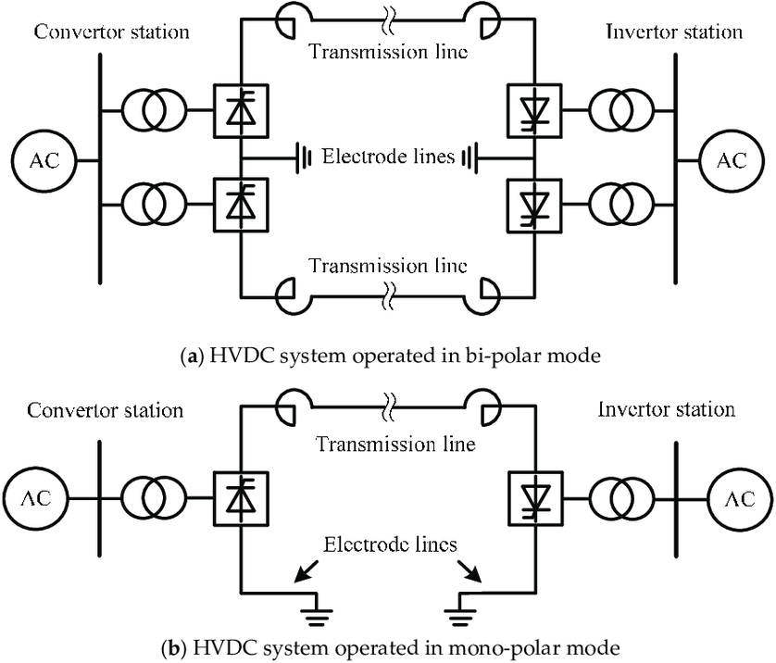

Figure 1-HVDC system- (Xiandong Li et al 2018)

*A. HVDC converter technologies*

Current source and voltage source converters (CSCs & VSCs) are the two primary converter technologies that are widely discussed. The network structure of both converters is the same: point-to-point (PTP) (only two terminals) for bulk power transfer. For PTP and despite being an established technology, PTP has a low dependability rating. For example, the system does lose ability to transmit power when a portion of it is unavailable. Fault management is one of HVDC's weak points, and a good way to improve it is by carrying out intervention on the grid's AC side using an AC circuit breaker, which is also a proven technology. Due to the challenge of PTP, the trend is now moving towards multi-terminal HVDC with two or more terminals which could be a power loop to boost reliability and avoid total loss of power when a section of the grid malfunctions. (Sun, June 2021)

1. Current source converters (CSC) *-* Since the 1950s, current source converters have been widely applied commercially. The CSC type is the most common form of HVDC system currently in use, and the technology is very well-established. By altering the polarity of the voltage, power reversal can also be achieved. Below is a simplified example of a typical current source converter (CSC) electrical diagram::

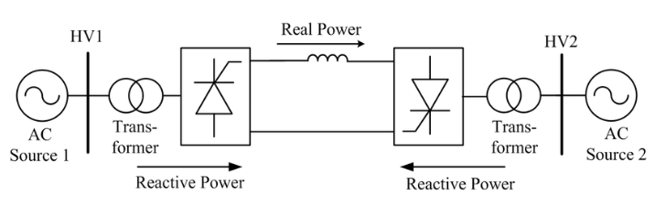

Figure 2- LCC HVDC system- (Imdadullah et al, 2019)

*B.*  Insulated gate bipolar transistor (IGBT) valves are used in VSC converters. Because the gadget is self-commutating, the converter can function properly without relying on the AC system voltage. By reversing the direction of current, power can be reversed. Examine the schematic below:

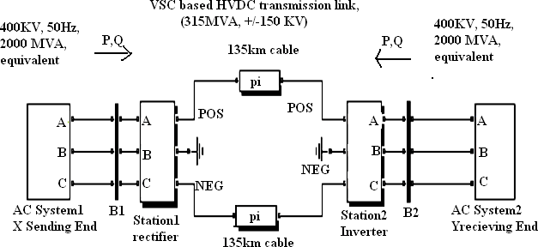

Figure 3-VSC HVDC system- (Shri harsha J et al 2012).

1. **HVDC COMPONENTS AND TERMINOLOGIES**
2. AC Filters

By absorbing the harmonic currents produced by the HVDC converter, they lessen the effect that the harmonics have on the AC system that is linked. They also supply reactive power to the converter station.

1. Capacitor Banks

These are employed to supply the converters' valves with reactive power. They are made up of several capacitors that are linked to the transformer in parallel.

1. Circuit Breakers

The HVDC link can be cut off and transformer defects can be fixed using the circuit breakers on the converter transformer's AC side. The purpose of converter control is to clear DC side issues.

1. Converter Transformer

Between the AC and DC sides, the converter transformer acts as a galvanic isolator. It adjusts the voltage to the converter valves' ideal and suitable level. They are typically single-phase, three-winding, but they can be organized differently according on the rated power and transportation needs.

1. Thyristor Valves

Since they perform the conversion from AC to DC and vice versa, they are the converter station's most crucial parts. Depending on the manufacturer and the intended use, there are various ways to construct thyristor valves. The thyristor improves control; if diodes are used in its place, the converter will be labelled uncontrolled, which is outside the scope of this work..

* 1. Smoothing Reactors

Each pole is connected in series with these enormous inductances. Its primary duties include limiting the DC fault current and lowering the harmonic current brought on by overhead line interruptions.

* 1. DC Filters

Harmonics are produced by HVDC converters in every operating state. Communication and transmission networks may experience disruptions due to these harmonics. Therefore, DC filters are employed to lessen disruptions.

* 1. Auxiliary Systems

These consist of the internal station power supply with battery backup, the control and communication systems, and the transformer cooling systems. Because an outage could cause significant damage to the valves, the valve cooling system is particularly important..

* 1. Long Distance Bulk Power Transmission:

Even though converter stations cost more than AC stations, HVDC transmission is the recommended choice for delivering significant power across long distances (> 600 km). This is the so-called break-even distance, which is roughly 50 km for submarine cables and maybe 600–800 km for overhead cables. Beyond this point, the cheaper HVDC electrical conductors are more cost-effective than the electronics. HVDC cable losses are also as low as 0.7-8 percent per converter station. (Nationalgrid.com)

j) Long Interconnection of Asynchronous HVAC Grids: Sharing of spinning reserves is made possible by interconnections. For AC systems, however, connecting separate systems operating at different frequencies presents a challenge. HVDC Back-to-Back stations can easily fix this problem because DC eliminates all stability and control limitations..

k) Long Limitation of Faults

Interconnections allow disturbances to spread when AC is present. HVDC technology offers a firewall against disruptions in high voltage networks because faults that cause voltage depression on power swings cannot get through a DC barrier..

1. Voltage Control

For controlling voltage, HVDC cables are also helpful. Depending on its control angle, the converter absorbs reactive power, which is often offset by filters and/or capacitor banks. Reactive power demand can be utilized for independent voltage control at both connection points by increasing the control angle, working range (to a lower voltage), and extra capacitor banks (to raise voltage) in conjunction with a fast-acting transformer tap-changer..

1. Ease of controllability

Today's advanced semiconductor technology, utilized in both The sophisticated semiconductor technology of today, which is used in power thyristors and microprocessors for the control system, has greatly increased the control flexibility of HVDC transmission systems. Some HVAC systems were installed at least 80 years ago before these sophisticated semiconductor chips were accessible. Effective power trading between regions is made possible by the ease with which power flows can be controlled. S. Kouro.

1. AC Support System

The angle difference between voltage rectors in various network segments determines the flow of AC load. This angle is dependent on the power balance and cannot be directly changed. Additionally, a change in load demand or power generation will result in a change in system frequency, which must be corrected by adjusting generation. Frequency restoration is extremely sluggish because the generator speed controls handle this work. By using the energy from the distant network, HVDC systems may complete this duty more quickly. HVDC may feed (or reduce) active power into the disturbed system to regulate the frequency significantly faster than a regularly managed generator since it can change the operating point almost instantly. (Chijioke Joe-Uzuegbu, 2011).



Figure 4- Schematic Diagram of an HVDC System with components- (Chijioke Joe-Uzegbu 2011)

1. HVDC CONTROL- VSC & LLC CONVERTERS

The AC side voltage is regarded as unchanged. The current flows through the link to ground when the DC line malfunctions and the impedance drops to zero. In accordance with the topography shown in Figure 5, the fault current's magnitude can be managed by lowering the DC link's voltage.

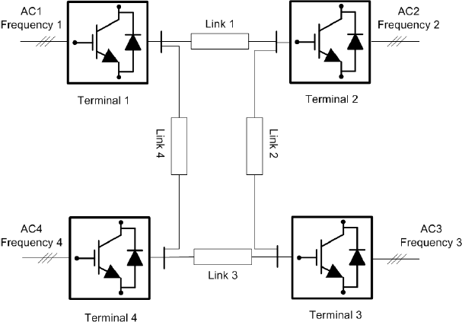

Figure 5-AC-DC Link- (Raheel Muzzammel et al 2023)

The converter can reduce the DC side voltage is by changing the firing angle in LCC. Note that while also discussing VSC, this report place some emphasis on LCC for correlation and aid reader’s understanding. By increasing the firing angle, the DC voltage of the converter is reduced as shown by the equation below:

$V_{dc }=\frac{3\sqrt{{6V}_{ac-ph}}}{π}$ $Cos\left(α+\frac{μ}{2}\right)Cos\frac{μ}{2}$

If the firing angle is significantly increased close to 900 degrees in one arm, and firing angle is reduced from the second arm of the converter in the HVDC link to a value close to 900, the cosine of the value will be close to zero leading to the reduction of the fault current.

This control is peculiar to LCC-HVDC. VSC-HVDC controls the current direction instead. For VSC-HVDC, an additional component such as circuit breaker will be required to block the fault. This pitch LCC-HVDC at an advantage. However, LCC-HVDC is limited only to PTP HVDC systems application and No Multi-terminal HVDC or DC grid). This is because power reversal can be achieved by changing the voltage polarity which ultimately affect all the network as shown in the figure below:

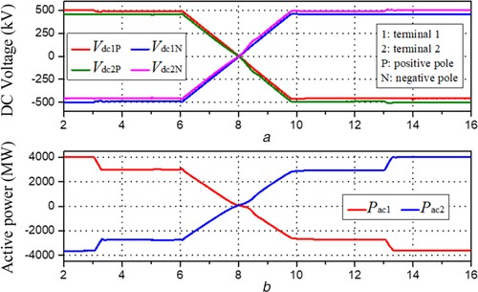

Figure 6- DC Voltages and delivered power during power reversal (IET Generation, Transmission & Distribution Volume 14, Issue 7 p. 1344-1352

a) LCC-HVDC POWER TRANSMISSION Consider two points, terminal 𝑋 & 𝑌

i. Power flow from X to Y

𝑉𝑥 > 𝑉𝑦 by controlling the firing angles.

Current $I_{d}$ = $\frac{(Vx-Vy)}{R}$

Power @ 𝑃𝑥 = 𝑉𝑥 ∗ 𝐼𝑑

Power @ 𝑃y = 𝑉y ∗ 𝐼𝑑

$V_{dc }=\frac{3\sqrt{{6V}_{ac-ph}}}{π}$ $Cos\left(α+\frac{μ}{2}\right)Cos\frac{μ}{2}$

ii. Power flow from Y to X

𝑉𝑦 < 𝑉𝑥 <0 (Achieved by controlling the firing angle)

Current 𝐼𝑑= $\frac{(Vx-Vy)}{R}$

Power @ 𝑃𝑥 = 𝑉𝑥 ∗ 𝐼𝑑 & Power @ 𝑃y = 𝑉y ∗ 𝐼𝑑

However, 𝑉𝑑𝑐 of one terminal is positive and the second arm will be negative to work in inversion and rectification mode which translate to firing angle of one converter below 900 and another above 900.

1. Converter Bridge Angles (Firing angle, Overlap angle & Extinction in HVDC Power System)

These angles, which are based on steady state without harmonics and using Lackovic's idealised three phase commutation voltage model, are measured on the three phase valve side voltages.. They are applicable to both inverters and rectifiers. (Velimir Lackovic’Principles of HVDC’)

**Firing angle α,** is the amount of time expressed as an electrical angular measure between the idealized sinusoidal changing voltages’s zero crossing and the forward current conduction's beginning point. If this angle is less than 90°, the converter bridge is a rectifier; if it is greater than 90°, it is an inverter. This angle is regulated by the gate firing pulse. Sometimes, this angle is referred to as the delay angle.

**Advance angle β**, is the amount of time, expressed in electrical angular units, that passes between the first instant of forward current conduction and the subsequent zero crossing of the perfect sinusoidal commutating voltage. It is possible to represent the angle of advance β in relation to the angle of delay (firing angle) by:

𝛽 = 180 − 𝛼 (1)

**Overlap angle μ**, The presence of commutation between two converter valve arms expressed as an electrical angular measure is sometimes referred to as the commutation interval..

**Extinction angle γ**, is the amount of time from the termination of current conduction to the subsequent zero crossing of the ideal sinusoidal commutating voltage, expressed as an electrical angle.

Extinction angle γ is impacted by the angle of advance β and the overlap angle and is calculated with the following formula:

𝛾 = 𝛽 − 𝜇 (2)

Substituting equation (1) into (2)

𝛾+𝛼+𝜇 =180 (1,2)

Special Effects & General Deduction: From above, when there is no overlap angle, 𝜇=0, it implies that the frequency at the AC side is also equal to zero and therefore there is no inductance.

Also, if firing angle 𝛼 is above 90 degrees, the converter will work in inversion mode as shown in the preceding equation of section (IV) above (1,2)

Where 𝛼 = $\frac{{{(Cos}^{-1} πd}_{C2} ) }{3√6Vacph2}$

When there is inductance, there will be overlap angle.

Relationship between firing angle and overlap angle:

𝜇= 𝛼+ ${Cos}^{-1}$ (cos 𝛼)− $\frac{2Xac2Il}{√6Vac_ph2}$

**Commutation collapse:** The extinction angle γ, above which the valve becomes forward biassed, is the amount of time the valve stays negatively biassed. Commutation collapse occurs if forward blocking fails and conduction is initiated without a firing pulse. As the D.C. line current returns to the valve that was transferring before and has collapsed to maintain forward blocking, this also results in a quick collapse to maintain current in the subsequent converter arm.

1. **HVDC SIMULINK MODELS ADOPTED**

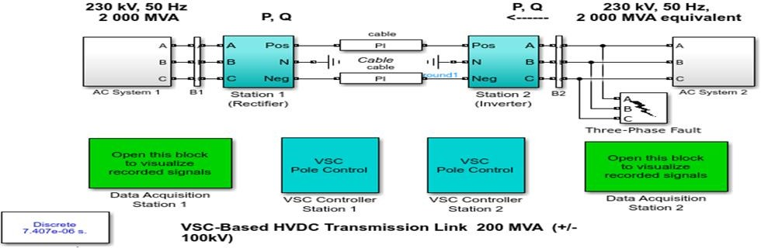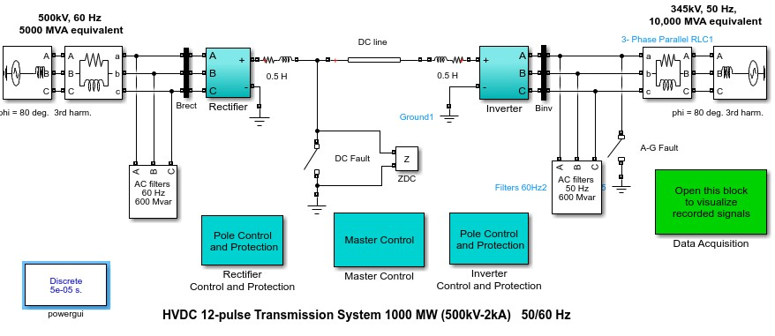

# Figure 7 VSC based HVDC transmission link (mathworks.com/

# Figure 8 VSC Based HVDC Transmission Link -Adopted

# (www.mathworks.com/)

**DEMONSTRATION AND SIMULATION RESULTS**

The example VSC HVDC and LCC HVDC link was adapted from MathWorks, and the schematic are as shown in fig 7 &8. The system was designed to start and achieve steady state. Power reversal was observed on the VSC HVDC system as shown in fig 9(a) and fig. 9(b). Note that the figures show the rectifier and inverter operations of the HVDC network.

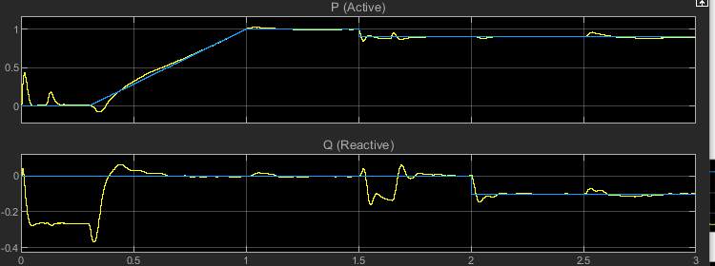

Fig 9 (a) Active power, P. (b) Reactive power, Q. Both Schematics are on the Rectifier side of the network

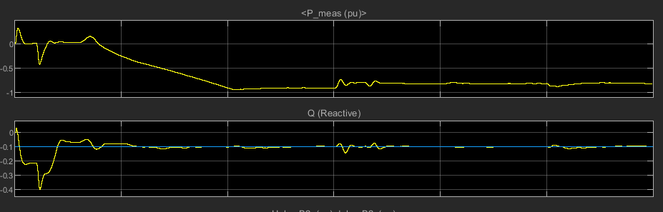

Fig 10 (a) Active power, P. (b) Reactive power, Q. Both Schematics are on the inverter side of the network

Figure 11(c) and 12(c) show the range of firing angle at the rectifier and inverter side of the network. After achieving steady state, the firing angles for the rectifier and inverter sides of the network is seen to be in the range 0-49o and 140- 143o respectively. The steady state response can be observed from fig. 11(a) and fig. 12(a) for the rectifier and inverter side of the network respectively. The system voltage and current achieved steady state at approximately 0.3s and 0.6s respectively. This is consistent with transient and steady state responses of HVDC network. (Gao, 2018)

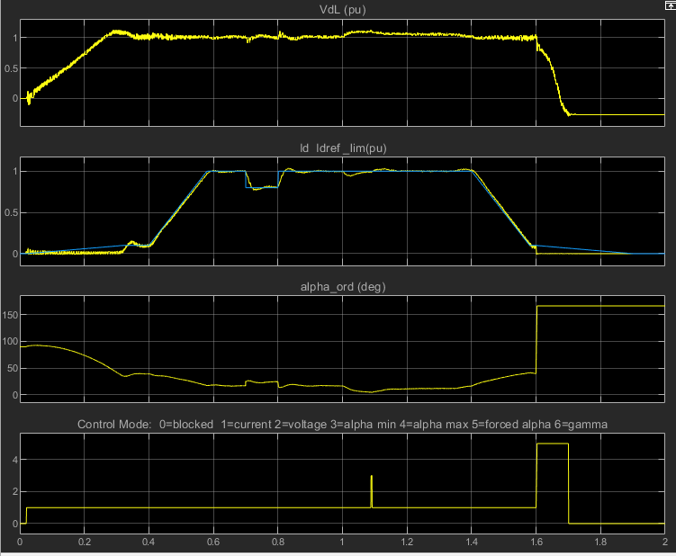

Fig. 11(a) Rectifier DC voltage (b) DC current (c) Firing angle

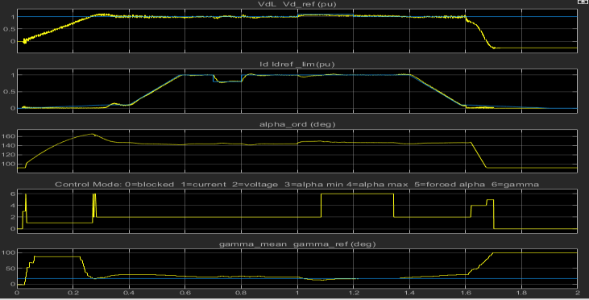

Fig. 12(a) Inverter DC voltage (b) DC current (c) Firing angle

**Conclusion**

HVDC transmission system is effective for large amount and long-distance wheeling of power. This is an advantage of the system over HVAC systems. Studies show efficient steady state and transient response of the system which makes HVDC suitable for large scale integration of renewable energy sources. Power reversal using modulation techniques or adjustments in firing angles that are depictive of the rectifier and inverter mode of transmission is a characteristic feature of HVDC network.

1. **REFERENCES**

Arrillaga, J. Arnold, C. P. (1990). Computer Analysis of Power Systems. John Wiley & Sons. Page 56-57

Chijioke Joe-Uzuegbu, M. a. ( 2011). *High Voltage Direct Current (HVDC) Technology: An Alternative Means Of Power Transmission.*

Daware, K. (2023, April 20). *HVDC Vs. HVAC Transmission*. Retrieved from [www.electricaleasy.com.](http://www.electricaleasy.com/)

Deaney, A. (June 2022). Electricity interconnectors in the UK since 2010. *Energy Trends collection* , 30.

Ellis, D. (2022, April 11). First electricity link between UK and Germany in mid 2020s. *Energy Digital magazine*.

Gao, S. Z. (2018). *Modelling and simulation analysis of Hybrid Bipolar HVDC system based on LCC-HVDC and VSC-HVDC.* IAEAC.

HM Goverment (15th July 2009). *The UK Low Carbon Transition Plan- National Startegy for climate and Energy.* UK Government.

IET Generation, Transmission & Distribution Volume 14, Issue 7 p. 1344-1352

Imdadullah et al, A Comprehensive Review of Power Flow Controllers in Interconnected Power System Networks. 2019, 5-29

Mathworks.(n.d.).

https://uk.mathworks.com/help/sps/ug/vsc- https[://ww](http://www.nationalgrid.com/sites/)w.n[ationalgrid.com/sites/](http://www.nationalgrid.com/sites/) 18th April 2023

Peter Lundberg HVDC Hitachi ABB Power Grids, g. p. (2021, February 2). *modernpowersystems*.

Raheel Muzzammel, et al, Wavelet multiscale principal components and traveling waves enabled machine learning technique for protection of MT-HVDC systems, Energy Reports, Volume 9,2023

Shri harsha J et al, Voltage Source Converter Based HVDC Transmission, International Journal of Engineering Science and Innovative Technology (IJESIT) Volume 1, Issue 1, September 2012, 101

S. Kouro, M. Hassaine, J. Rodriguez, L. G. Franquelo, K. Bin, and B. Wu, "Advanced Multilevel Converters *Multi-Terminal HVDC Systems.* Sydney, NSW, Australia.

<https://www.ssen-transmission.co.uk/projects/project-map/shetland/> 13th December,2024

The National HVDC Centre. (n.d.). *Caithness-Moray HVDC Project During Delivery.* Scotland.

Velimir Lackovic, C. E. (n.d.). *Principles of HVDC Transmission.* Woodcliff Lake:

Xiandong Li, ,Hua Li, et al- Insulation Coordination of Arcing Horns on HVDC Electrode Lines: Protection Performance Evaluation, Influence Factors and Improvement Method, 2018, 2-3

**Reviewer’s comments**

1. **The manuscript contains a very good topic.**
2. **There are minor grammatical errors.**
3. **Topic is well-explained and presented with the help of diagrams and accurate calculations.**