***Original Research Article***

**Assessment of Indigenous Knowledge associated with Identification of germplasm, Production, Utilization and Conservation of Anchote ((*Coccinia abyssinica*(Lam.) Cogn.)) in Western and South Western Ethiopia**

ABSTRACT

Aim: Anchote is an underutilized indigenous root crop in Ethiopia but potentially produced as a food, socio-economic, cultural and medicinal crop in western and south western parts of Ethiopia. The study was conducted by using an ethno-botanical survey to assess and document the indigenous knowledge on germplasm identification, utilization and conservation of anchote on 200 household respondents using both quantitative and qualitative methods. Studyarea and duration: The survey was conducted in seven western and southwestern districts of Ethiopia in 2020 for three consecutive months. Results: Most of the respondents had sufficient experiences and knowledge on producing and utilizing anchote. Socio-economic status of the households was found to be an important factor affecting the use, management and conservation while the difference in level of education had no impact. Anchote producers, mainly women households, identify the white and red fleshed genotypes by the color and size of their leaves; light green and/or lager leaf as white fleshed and deep green and/or medium sized leaf as red root fleshed anchote. It is produced as a sole crop in western areas (87.1%), but intercrop with maize (94.1%) at south western parts. The solely responsible for anchote conservation were women (99 %) especially elders and about 1 % were youth who use anchote as cash crop for their personal expenses of education and consumables. Majority of the producers (86%) use the root as main consumable part and plant it every year (81%); for food (98%), income source (87.5%), medicinal (97%) and cultural (97.5%) crop, respectively, and for animal fattening and feed dairy cows mainly as a calcium source (14%). Even though it is a highly valued cultural and medicinal crop, 74.1% of the respondents consume itas food more than once a week mainly during harvest seasons. Women conserve anchote seeds for the next planting period by treating with ash and store it in a closed container. The best roots are selected while harvesting depending on flesh colors and planted in a hole to serve as a seed source for seven to fifteen years at backyard, locally called ‘*Baachoo/ Guboo*’. Conclusion: The indigenous knowledge exhibited in this study on germplasm identification, production, conservation and utilization could be a significant step in bringing this underutilized root crop to the broader science arena.

**Key words**: Anchote, Baachoo/Guboo, Conservation, Germplasm Identification, Indigenous Knowledge, Utilization,

1. **INTRODUCTION**

Indigenous knowledge (IK) refers to ideas, beliefs, values, norms, and rituals, which are native and embedded in the minds of people and unique to a given culture or society acquired by local people through the accumulation of experiences, informal experiments and intimate understanding of the environment in a given culture (Warren, 1995; Warren and Rajasekaran, 1993). Local people, including farmers are the guardians of IK systems as they are knowledgeable about their own situations, resources, what works and what doesn’t work, and how one change impacts other parts of their system.

For centuries, farmers have planned agricultural production and conserved natural resources by adopting indigenous knowledge as management of natural environment, has been a matter of survival to the people who generated indigenous knowledge (Akullo *et al*., 2007).Anchote ((*Coccinia abyssinica***(Lam.) Cogn.))**  is an Ethiopian species of *Coccinia,*a tuberous root crop belongs to the order *Cucurbitales,* family *Cucurbitaceae* (Abera, 1995)and was first described by Jean-Baptiste Lamarck, a French biologist and academician. The genus *Coccinia* includes about 30 species, of which 8 occur in Ethiopia (PGRC, 1995). *Coccinia abyssinica* is the only species cultivated for its edible tuberous roots and leaves (Desta *et al*., 2011). It is specifically widely cultivated and used in Jimma, Illu- Abba Bora and Wollega areas of the Oromia Regional State even though cultivated in different vernacular names in other parts of Ethiopia as *Shushe, Ushushe* (Dawuro), Anchote (Oromo), *Ajjo*(Kaffa), *Wouchich* (Tigray), and *Ususe*(Wolaita) (Schweinfurth,1867, 1048; Abera, 1995; Amare, 1973; Fufa and Urga,1997 and W. Kuls, 681). Among the native root and tuber crops to Ethiopia, anchote is believed to have enormous genetic diversity as it is indigenous and long-stayed in western and south western parts of Ethiopia produced and conserved mainly by women farmers (Girma and Hailu, 2007; Desta *et al*., 2017).

As the major food security challenges in Ethiopia are population growth, nutrient deficiencies, diseases, environmental degradation, drought and climatic change (Abdela *et al*., 2017), anchote is used as a subsistence crop commonly produced to fill food and nutritional gaps during the hunger months, June to September (Girma and Dereje, 2015). In addition to its nutritional and medicinal values, anchote has economic and socio-cultural importance. The production of anchote has strong cultural ties with Oromo as cultural food during the findings of true cross; *Meskel Festival*, for lactating mothers, elderly and during birth giving of women as the main calcium source for bone and joint strength. Anchote dish, owing to its contribution to good health is getting popular and demand is increasing. Due to its attachment to customs and tradition of the people in the region, the revival in the society is affecting and will continue to influence anchote culture (Habtamu, 2011). It is mainly grown for its storage root yield and leaf also used as a vegetable among the growers. As a food, it is a rich source of carbohydrate, vitamins, minerals, protein and calcium as compared to other root crops (Amsalu *et al*., 2008; Habtamu, 2011).

It is adapted well to south and south western parts of the country between 1300 to 2800 m above sea level, prefers soil pH of 4.5 to 7.5, mean minimum and maximum temperature of 12 ℃and 28 ℃ and rain fall ranging from 800 to 1200 mm/year (Amare, 1973; BARC, 2004; Desta *et al*., 2011). In average every farmer in Western Wollega usually allocate 400 to 600 square meters of land for anchote production primarily for home consumption, income generation, rural employment, securing food and nutritional access (Abera,1995; Mengesha *et al.* 2012; Desta *et al*., 2021).

Its productivity may varies based on genotypes, soil fertility level, location and cultural practices and ranges 20 - 30 tha-1 (Abera, 1995; BARC, 2004). However, under research condition it has a potential to yield up to 73 tha-1 (Desta *et al*., 2011) and 76.45 tha-1 (Mengesha *et al*., 2012). The national average total yield of anchote is 150-180 quintals/hectare, which is in the range of total yield of sweet potato and potato (IAR, 1986).

Habitually, its storage root is served as a side dish with cereals as; ‘*kitifo’,’lanqaxaa’* (finely grounded tuberous root), ‘wot’, soup, and ’*murmura*’ (boiled tuber cut in pieces). Similarly, the leaf also primed as “Wot‟ and served as a side dish with bread or ‘*injera*’ (Abera, 1995). Moreover, traditional practitioners use anchote to treat different type of diseases such as diabetes, gonorrhea, tuberculosis, asthma and cholesterol lowering (Amare, 1973).

Whenever increased anchote production, smallscale market producer participation and its multi-dimensional usage got a policy attention as a means of poverty reduction and food and nutritional security enhancements in Ethiopia, it will get research and development attention in production and wider utilization. The study was conducted to assess and document the indigenous knowledge available on germplasm identification, production, conservation and utilization of anchote at selected major producing areas of Ethiopia.

1. **MATERIALS AND METHODS**
   1. **Description of the study area**

This study was conducted in seven western and southwestern districts of Ethiopia; West Wollega, East Wollega, Kellem Wollega, Horro Guduru Wollega, Iluababor, Buno Bedelle, and Jimma zones of Oromia Regional State (Figure 1). The study areas were selected in consultation with Agricultural Development offices of each zones considering potential of the districts in anchote production, utilization and conservation.

* 1. **Methodology**

The respondents were selected based on the information obtained from Development Agents (DA’s) and other knowledgeable local farmers through the study tour. In each district, woreda agricultural experts, kebele managers and agricultural experts working in each kebele assisted the researcher in creating the list of farmers growing anchote and in facilitating the questionnaire interviews. The informants were selected randomly and interviewed out of 400 farmers, key informants and knowledgeable persons of the society based on their willingness and practical knowledge on production and use through repeated questioning to make the information reliable that describes an existing phenomenon on anchote.

Data were collected in 2020 for continuous three months; February, March and April on 200 respondents in western and southwestern parts of Ethiopia, 40 woredas and 127 kebeles, using questionnaire prepared in English and translated to ‘*Afan Oromo*’, Oromo people’s language, using both quantitative and qualitative methods. Each interviewee has been introduced to the purpose and subject of the study and covered different topics such as information about the study area, landholding capacity per household, root crops commonly grown and specific information on the utilization, production, conservation and germplasm preference and identification of anchote. Climatic conditions of the study area include all topographies; lowland, mid-land and highland, agro-ecological zones; from arid to humid (396-3300 m a.m.), and the minimum and maximum annual temperature of the study areas were 12℃ and 35℃ respectively, with mean annual rainfall ranges from 800 to 2000 mm.

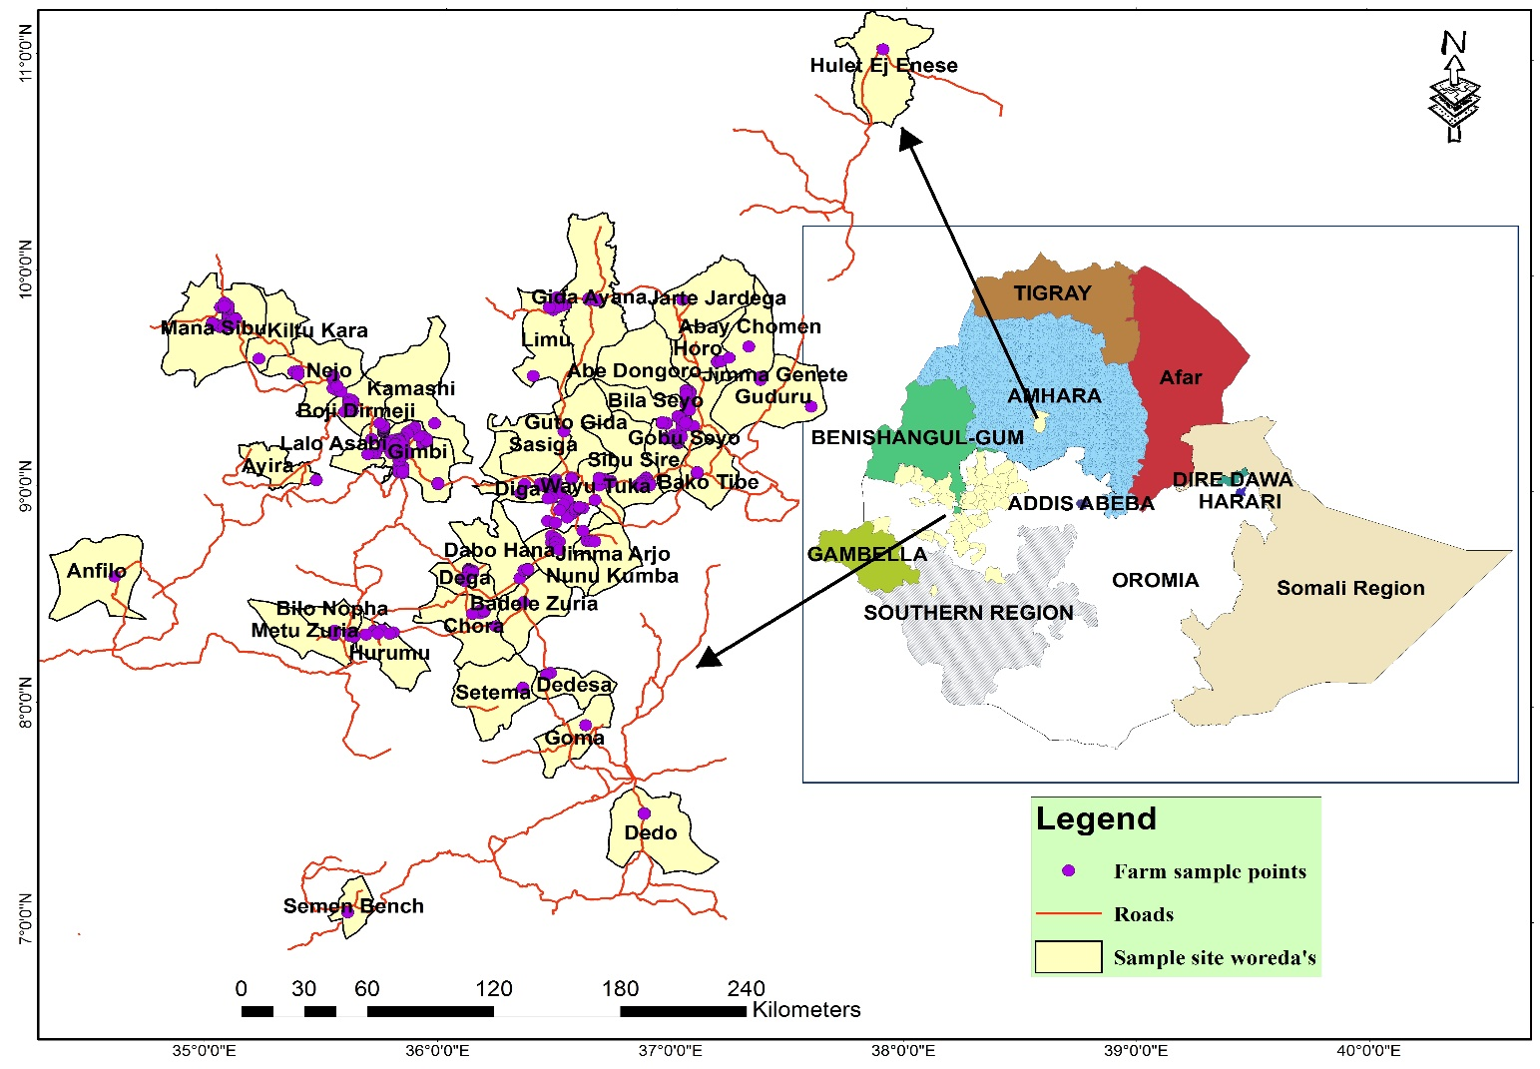

Figure 1. The seven zones of anchote indigenous knowledge study

The detailed information was focused on cultural practices, cultivation types and growing frequencies, seed production and sources, agricultural inputs, the parts and types of food prepared, and traditional use values of anchote. The respondents were also asked about the storage and associated problems, conservation practices, the local cultivars with their typical characteristics such as date and method of planting, maturity days, shelf life, taste, market price, crop rotation, production per hectare, response to disease and insect pest, land holding size per household, seasons of production, and production status (from Zonal Agri. Offices). Conservation practices, cultivar selection, food preparation and seed preparation were a gender-specific questions, mainly women farmers. The respondents were also asked whether there is extension system applied to production, conservation and utilization of anchote to magnify its role in attaining food and nutritional security of the households.

* 1. **Data analysis**

The quality of the data was ensured through careful coding and verification and analyzed using IBM SPSS software 26.0, presented using descriptive statistics and percentage.

1. **RESULTS AND DISCUSSION**

The survey was aimed to study the indigenous knowledge of the society on germplasm identification, production, utilization and conservation of anchote in the study area. West Wollega was the main producing zone under rainfed condition though East Wollega has better productivity than the other major producing zones. Due to the lack of extension service from zonal and woreda agricultural offices of the respective study areas, data on area coverage under irrigation was scanty, though almost comparable with the production under rainfed condition (Table 1).

Table 1. Anchote area coverage and productivity in the study zones

|  |  |  |  |
| --- | --- | --- | --- |
| **Administrative Zones** | **Area coverage** | | **Productivity(q/ha)** |
|  | **Rainfed** | **Irrigation** |  |
| East Wollega | 1096 | 2915 | 88 |
| West Wollega | 1170.5 | NA | 60 |
| Kellem Wollega | 378.5 | 278 | 71 |
| Horro Guduru Wollega | 173 | 165 | 55 |
| Iluababor | 725 | NA | 60 |
| Buno Bedelle | 542 | NA | 50 |
| Jimma | NA | NA | NA |
| **Total** | **4085** | **3358** |  |

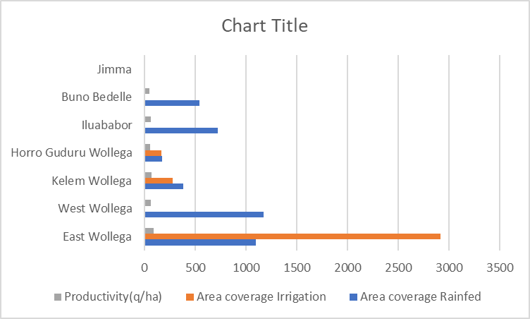

NA- data not available

The sampled and interviewed households and key informants vary considerably in resourcefulness, knowledge and geographical factors. A total of 200 respondents were interviewed, out of which 90 (45%) and 110 (55%) were men and women farmers, respectively and all were farmers including the key informants (more knowledgeable and elderly) (Table 2).

Table 2. Study zones and number of respondents

|  |  |  |
| --- | --- | --- |
| Study Zone | Number | Percent |
| East Wollega | 30 | 15 |
| West Wollega | 50 | 25 |
| Buno Bedele | 20 | 10 |
| Illubabor | 20 | 10 |
| Horro Guduru Wollega | 30 | 15 |
| Kellem Wollega | 50 | 25 |
| Total | 200 | 100 |
| Male | 110 | 0.55 |
| Female | 90 | 0.44 |

Most of the respondents (60%) have involved in cultivatinganchote for more than 30 years and above and 40% were cultivating for more than 15 years. Most of the growers (81%) plant anchote every year regularly and 19% of them produce occasionally. According to the respondents, the principal purpose of growing anchote is for its roots (86%), roots and leaves (7.5%), and all parts; roots, leaves and fruits (6.5%). Those who are interested in producing all parts are the elderly and women; mainly for conserving the seeds for next planting, for income generation, and conservation of the crop (Figure 2).

Figure 2. Interest of farmers producing anchote for different purposes

The average land holding capacity per household was 1.22 hectares; with minimum (0.25 ha) and maximum (5 ha) of which 0.5 ha is left for grazing and barn area. Even though land shortage limits the types of crops to grow and land allocation to each crop, all the farmers growing anchote did not see it as a major challenge as it is mainly grown at backyards on small area of plot and under the fence along the line for stalking purpose. Anchote growers prefer to plant at the vicinity of their home as wild animals such as porcupine attack the plant starting from root formation to the maturity.

Among the major crops growing in the study areas, anchote (11.5%) was the fifth major crop grown under rainfed conditions after maize (20%), tef (15%), wheat (14%) and sorghum (11.5). wheat (14%), Barely (9%) and other root and tuber crops (9%) production comes after anchote. Under irrigation condition, anchote was the major crop grown (28%) as compared to potato (21.5%) and other vegetable crops due to its higher demand by the consumers and better market value for the growers (Figure 3).

Figure 3. Major crops growing in the study areas and the anchote with other vegetable crops under irrigation condition

Even though anchote is preferably produced by most of the growing respondents, all of them were considered and categorized as a minor and underutilized crop by many respondents but very important crop mainly due to the lack of attention from the agricultural development and extension services of the government and other development organizations. Among most anchote producers, the primary purposes for which they produce were for food, income generation, medicinal, and cultural aspects. The discrepancies from the primary purposes of production were the share of younger generations and few elderly respondents of which most of them produce solely for income generation from its roots and the seed (Figure 4). The results of this study agree with results of Masarat (2018) on three zones (Kellem, West and East Wollega) of 6 districts on 72 respondents and with Abera (1995).

Figure 4. Purposes of anchote production among the growers in the study areas

The price of anchote seed is one of the most expensive than all cereals and other vegetable crops at the study areas. The price of one cup (*birchiko*) anchote seed differs from place to place across the study areas and ranged from 48 to 105 birr with average of 71.5 birr. The higher demand for anchote seed by the growers, the smaller number of seed producers; elderly and women, and the rush to sale the roots as soon as it matures are the reasons behind for the higher seed price. The seed rate to plant on 200 m2 of land at backyard; which is the average land area allocated for anchote per household at the study areas, was 4 to 90 grams with the average of 41.7 grams of seed. The respondents reported that they harvest 0-40 cups(*sini*) of seed and the average was 7.75 cups from their produce per season.

Anchote growers barely use artificial fertilizers at most of the areas but about 5% of the respondents, mainly those produce as an income source, the younger generation, use up to 200 kg/ha Urea and DAP with an average of 51.9 kg/ha. The average root yield per hectare of the study areas was 160.3 quintal which agrees with the results of Girma and Dereje (2015), Masarat (2018), and Yeshitila and Temesgen (2015). The average root conveyed for sale each harvest season was 472.5 kg.

The respondents’ preference for the white and red fleshed anchote root was quit boldly differentiated where 92.5% prefer white fleshed anchote for food and to produce, 10% red fleshed, and 2.5% prefer both types (Figure 5). The results of this study agree with Negasa *et al*., (2020). In contrary, when asked for medicinal and animal feed (fattening and hypocalcemia treatment) purpose, 90% of the respondents prefer red fleshed over the white one. The segregation in root flesh color could ignite the industrial use of anchote and the present result agrees with Adugna *et al*., (2021).

Figure 5. Respondents’ preference of anchote root flesh for food purpose

Across all the study areas, the indigenous knowledge in identifying the germplasms of the two major root flesh colors; white and red was quite similar. All respondents identify the white and red fleshed colored cultivars by the size of their leaf, root shape, root size, and maturity (Table 3).

Table 3. Germplasm identification among the anchote producers

|  |  |  |
| --- | --- | --- |
| **Traits** | **Root flesh color** | |
|  | **White** | **Red** |
| Leaf size | large | Small, medium |
| Root shape | round | Longitudinal |
| Root size | Larger | Small, Medium |
| Cookability | Easier | Takes longer time/difficult |
| Drought resistance/tolerance | Medium | Resistant/tolerant |
| Maturity | Early | Late |
| Insect resistance/tolerance | Medium | Resistant/tolerant |
| Market demand | High | Medium to high* |

\**red fleshed anchote root demand depends on the purpose it intends; for medicinal and animal feed the demand of red fleshed anchote is higher*

Women farmers conserve anchote in seed and mother plant, called ‘*Baachoo/Guboo*’. The seeds are extracted from matured fruits ,washed thoroughly, treated with ash and let to dry. After drying under shade, it will be kept in closed container for the next growing season though it could stay up to two years.The mother plants are planted from selected roots while harvesting depending on root flesh color; preferably white, and planted in a hole for seed production purpose only and could serve as a seed source for seven to fifteen years.

1. **CONCLUSION AND RECOMMENDATION**

Among the major root and tuber crops, anchote is a potential crop produced in western and south western parts of Ethiopia with scanty information and attention from research and development. The indigenous knowledge of the producers at the major producing areas have retained its production, utilization, and conservation for many years back from its domestication as a valuable crop. In addition to its potential as a food and nutritional security crop, its socio-economic, cultural and medicinal values for the farming communities is far reaching. Germplasm identification methods of the farmers accurately concedes with scientific findings reported so far. The indigenous knowledge and traditional farming system of the farmers that contributed for the present results need to be developed for future research inputs and developments in anchote diversity studies, production, utilization and conservation. Moreover, farmers of anchote should be supported to retain their indigenous knowledge on anchote utilization and conservation through on farm trainings and extension services.

Policy makers, development organizations and researchers should give attention to;

* Strengthening extension services to enhance the production and productivity of anchote farmers in the study area in order to improve their livelihood through improving their food and nutritional security, income generation and preserving the conservation practices they follow on anchote without any scientific information on the crop at the study areas.
* Government intervention needed to improve the marketing infrastructures for improved linkages and fair participations.
* Policy issues targeted on extension systems on preserving the indigenous knowledge of the farmers and the women role at study areas and linking to science and technology for improved production, utilization and conservation of anchote through research and development.

Consent (where ever applicable)

# We, the authors, give our consent for the publication of identifiable details in this manuscript to be published in the [Journal of Experimental Agriculture International](https://www.journaljeai.com/index.php/JEAI/index).

1. **REFERENCES**

.Warren, D. Michael, L. Jan Slikkerveer, & David Brokensha, (eds.) (1995). The Cultural Dimension of Development: Indigenous Knowledge Systems. London: Intermediate Technology.

2. Warren, D.M. & Rajasekaran, B. (1993). Putting local knowledge to good use. International Agricultural Development, 13 (4), 8-10.

3. Akullo Diana, Rogers Kanzikwera, Pauline Birungi, Winnie Alum, Lucy Aliguma, and Margaret Barwogeza. (2007). Indigenous Knowledge in Agriculture: A case study of the challenges in sharing knowledge of past generations in a globalized context in Uganda. World Library and Information Congress: 73rd Ifla General Conference And Council 19-23 August 2007, Durban, South Africa.

4. Abera, H. (1995). Anchote: An Endemic Tuber Crop. Jimma College of Agriculture. Jimma, Oromia, Ethiopia.

5. Plant Genetic Resource Center (PGRC / E). (1995). Plant genetic resources conservation.

6. Schweinfurth G. A., (1867). Beitrag zur Flora Aethiopiens. Georg Reimer, Berlin, Germany, 311.

7. Amare Getahun. (1973). Developmental Anatomy of “tuber”s of Anchote: A potential Dry land Crop. In: Acta Horticulturae, Technical Communication of ISHS, 51–63.

8. Fufa H, Urga K . (1997). Nutritional and anti-nutritional characteristics of anchote (*Coccinia abyssinica*). Ethiop. J. Health Dev, 11(2), 163 -168.

10. Girma Abera and Hailu Gudeta. (2007). Response of Anchote (*Coccinia abyssinica*) to Organic and Inorganic Fertilizers Rates and Plant Population Density in Western Oromia, Ethiopia. East African Journal of Sciences, 1(2),120–126.

11. Desta Fekadu, Derbew Belew, and Amsalu Ayana. (2017). Genetic Diversity and Traits Inheritance in Anchote [*Coccinia abyssinica* (Lain.) Cogii] Accessions of Ethiopia, SEBIL Vol.16. Addis Ababa, Ethiopia.

12. Abdela Negash, Midekso Boru, Jabir Jemal, and Abdela Wezir. (2017). Knowledge, attitudes and practices towards rabies in Dedo district of Jimma zone, southwestern Ethiopia: A community based cross-sectional study. International Journal of Medicine and Medical Sciences, 9(5),61-71.

13. Girma Abera and Dereje Haile. (2015). Yield and nutrient concentration of Anchote [*Coccinia abyssinica*(Lam.) Cogn.] affected by harvesting dates and in-situ storage. African Journal of Crop Science ISSN 2375-1231 Vol. 3 (5),156-161.

14. Habtamu Shebabaw. (2011). Effect of Processing on Physicochemical and Antinutritional Factors of “Anchote”(*Coccinia Abyssinica*) and Development of Value Added Biscuit, a PhD thesis, Addis Ababa University.

15. Amsalu Nebiyu, Weyessa Garedew, Assefa Tofu, Wubishet Abebe, Asfaw Kifle and Edosssa Etisa. (2008). Variety development of taro, cassava, yam, and indigenous root and tuber crops of ethiopia. pp.303- 315. In: Gebremedhin Woldegiorgis, Endale Gebre and Berga Lemaga (Eds). Root and tuber crops: the untapped resources. EIAR, Addis Ababa, Ethiopia.

16. BARC. ( 2004). Progress report for 2003, OARI, Ethiopia.

17. Desta Fekadu. (2011). Phenotypic and nutritional characterization of Anchote (*Coccinia abyssinica* (Lam.) Cogn.) accessions of Ethiopia. MSc thesis, Jimma Uiversity, Jimma.

18. Mengash,D, Belew, D, Gebresilasie, W, and Sori, W. (2012). Growth and yield performance of Anchote [*Coccinia abyssinica* (Lam.) Cogn.] in response to Contrasting Environment. Asian J. Plant Sci. 11(4): 172–181.

19. Desta Fekadu, Sentayehu Alamerew, Kebebew Aseffa, Mandefro Nigussie. (2021). Biochemical and Mineral Composition of Anchote (*Coccinia abyssinica* (Lam.) Cogn.) Accessions from Ethiopia. Ethiop. J. Crop Sci. Vol 9(1).

20. IAR. (1986). Department of Horticulture. Roots and Tubers team progress report for the period 1978/79. Addis Ababa. 1986,1-9.

21. Masarat Elias Duresso. (2018). Study on ethnobotany and phenotypic diversity in anchote (*Coccinia abyssinica* (Lam.) Cogn.) Landraces in Western Ethiopia. International Journal of Agricultural Sciences ISSN 2167-0447 Vol. 8 (2), pp. 1404-1427.

22. Yeshitila Mekbib and Temesgen Deressa. (2015). Exploration and collection of root and tuber crops in East Wollega and Iluababora zones: Rescuing declining genetic resources. Indian Journal of Traditional Knowledge,vol 15(1), pp.86-92.

23. Negasa T., Mitiku A., Bekele Y. (2020). Determinants and Level of Smallholders’ Anchote Market Participation in Gimbi District of Southwestern Ethiopia: Heckman Two Stage Analysis. Agricultural Socio-Economics Journal, 20(2), 159-166 DOI: <http://dx.doi.org/10.21776/ub.agrise.2020.020.2.8>.

24. Adugna Mosissa Bikila, Yetenayet Bekele Tola, Tarekegn Berhanu Esho, Sirawdink Fikreyesus Forsido, and Desta Fekadu Mijena. (2021). Starch composition and functional properties of raw and pretreated anchote (*Coccinia abyssinica* (Lam.) Cogn.) tuber flours dried at different temperatures. Foof Science and Nutrition (WILEY). DOI: 10.1002/fsn3.2687.