**DISEASE SCORING AND EVALUTION FOR LATE LEAF SPOT RESISTANCE WITH YIELD AND YIELD COMPONENTS IN GROUNDNUT (*Arachis hypogaea* L.)**

**ABSTRACT**

Groundnut (*Arachis hypogaea* L.) is an important oil seed crop being adversely affected by foliar fungal disease *viz*., late leaf spot. The objective of this study is to identify genotypes with high yield and yield component traits along with resistance to late leaf spot disease (LLS). Based on the *per se* performance, the genotypes *viz*., TCGS-2485, TCGS-2493, TCGS-2498, TCGS-2501, TCGS-2500, TCGS-2528, TCGS-2486, TCGS-2520, TCGS-2502 and TCGS-2519 were found to be promising genotypes and these genotypes could be further utilized as parents for improvement of yield and its related characters in the breeding programmes. By analysing the LLS disease score at 75 DAS and 90 DAS, five advance breeding lines *viz*., TCGS-2501, TCGS-2528, TCGS-2500, TCGS-2519 and TCGS-2526 were classified under resistant at 75 DAS and moderately resistant at 90 DAS and showed less disease severity along with superior performance in most of the yield contributing traits. Hence, these advance breeding lines could be utilized as donors in LLS resistance breeding programmes of groundnut.

**Key words:** Late leaf spot, foliar fungal disease, advanced breeding lines and groundnut

**INTRODUCTION**

Groundnut (*Arachis hypogaea* L.) is an important oil seed crop in the world. It is an allotetraploid with somatic chromosome number of 2n = 4x = 40 (AABB). It belongs to the subfamily Papilionaceae of the family Leguminosae, possess highly self-pollinated nature due to its closed flower structure. It is popularly known as “King of Oil Seeds”. It is also called as peanut, earthnut, monkey nut, manila nut, goober nut and panda nut. Groundnut is a rich source of oil (45–50 %) which contains high amount of unsaturated fatty acids (80 %) that is good for health. Due to the presence of tocopherol, groundnut oil has high stability even after 10 hours of heating, without losing its original properties. It also contains 25 % of proteins especially globulin proteins like arachin and conarachin (87 % of total proteins). Besides these two, it also contains 8–14 % of carbohydrates and vitamins like vitamin A and B–complex, especially thiamine and niacin. It contains high amount of resveratrol (15.04 μg/g and 3.66 μg/g in Spanish and Virginia types, respectively) which is an anti-cancerous component. It is also used as feed for the livestock, either in a fresh or dried stage or by preparing hay or silage.

The productivity of groundnut varies from year to year and season to season. It is limited by the influence of both biotic (pests and diseases) and abiotic stress conditions. Among the biotic stresses, Late Leaf Spot (LLS) (caused by *Phaeoisariopsis personata* Berk. and M.A. Curtis) is major foliar fungal disease results in yield loss. LLS disease is common wherever groundnuts are grown; however, the incidence and severity of this disease varies by location and season (Subrahmanyam *et al*., 1984). It appears at 35 DAS and can be identified by circular dark brown to black spots surrounded with bright yellow halo on upper surface of the leaves and halo is not seen on the lower surface. The conidiophores and conidia are produced in concentric rings in the lower surface which are black in colour. These spores are disseminated by wind and infect new leaves. Prolonged high relative humidity coupled with low temperatures (25–30°C) are highly favourable for the disease incidence and spread. The pathogen can survive from season to season in infected leaves as dormant mycelium (Subrahmanyam and McDonald, 1983). Under severe conditions the leaves will dry up and leads to heavy defoliation results in the loss of photosynthetic area. Lesions can also be seen on the stem, petiole and pegs.

LLS disease infects the leaves which are the major sources of the photosynthates, result in heavy defoliation under severe incidence, there by reduction in the yields takes place. The yield loss due to LLS reaches up to 50% based on the severity of its incidence (Subrahmanyam *et al*., 1995; Mau and Ndiwa 2018). In this context, it is essential to develop new varieties with resistance to LLS along with high yield.

Yield loss due to LLS have been estimated at around 10% where fungicide application is normally practiced (Jackson and Bell, 1969). In semi-arid tropics where the fungicide application is normally prohibitive, yield loss in excess of 50% are in common (Gibbons, 1980). LLS disease can be controlled by certain chemicals but, because of the environmental pollution, hazardous effects and increase in the cost of cultivation by their use in disease control, genetic resistance sounds economic and environmentally safe. The adoption of resistant cultivars minimizes losses at the farm level, reduces the input cost and maintains good product quality which in turn increases the profitability of the farmers. For effective management of LLS in groundnut, breeding work could be focused on utilization of the resistant sources that were available in the gene pool for crossing programmes to develop elite varieties with high yield and yield components along with LLS resistance in a short span of time.

**MATERIAL AND METHODS**

Thirty one genotypes of groundnut were sown in a Randomized Block Design (RBD) with three replications during *kharif* 2023. Each genotype was sown in 2 rows of 3 m length with a spacing of 30 cm between rows and 10 cm between plants within the row. The crop was raised under irrigated conditions and recommended dose of chemical fertilizers at the rate of 20 kg of N, 40 kg of P2O5 and 50 kg K2O ha-1 in the form of urea, single super phosphate, murate of potash, respectively were applied during final ploughing operation and gypsum was added at the rate of 500 kg ha-1 at peak flowering stage followed by one hand weeding to remove weeds and to mix the gypsum properly in the soil. Apart from these cultural operations, need based plant protection measures were taken to control insect pests.

Observations were recorded for all the genotypes separately on randomly chosen five competitive plants in each genotype in each replication for all the characters except for days to 50% flowering and days to maturity which were recorded on plot basis. Data were recorded for 15 characters *viz*., days to 50% flowering, days to maturity, plant height at harvest, number of primary branches plant-1, number of secondary branches plant-1, number of mature pods plant-1, number of immature pods plant-1, pod yield plant-1, dry haulm yield plant-1, harvest index per cent, shelling per cent, kernel yield plant-1, sound mature kernel per cent, hundred kernel weight, disease scoring of late leaf spot disease at 75 DAS and 90 DAS.

Disease scoring of the selected advanced breeding lines and checks was done under natural field conditions during *kharif*, 2023 at Regional Agricultural Research Station, ANGRAU, Tirupati which is hot spot for LLS disease especially in *kharif* season. To increase the inoculum load and disease pressure, sprinkler irrigation was given during evening hours depending on necessity to maintain sufficient humidity in the field. Disease scoring was done at 75 and 90 DAS for LLS by using modified 9-point scale developed by Subrahmanyam *et al*. (1995) (Table 1., Plate 1.) and classified as resistant, moderately resistant, susceptible and highly susceptible according to Sudini *et al*. (2015) (Table 2.).

**RESULTS AND DISCUSSION**

The *per se* performance of thirty one groundnut genotypes for yield, yield components and resistance to late leaf spot are furnished in Table 3. Mean values for days to 50% flowering ranged from 25.33 days (TCGS 1694) to 29.67 days (TCGS 2496).But, eighteen genotypes flowered earlier than the general mean (27.14 days). Mean values for days to maturity ranged from 90 days (TAG 24) to 103.33 days (TCGS 2486). Fifteen genotypes came to maturity earlier than the general mean (99.46 days). Mean values for plant height ranged from 24.50 cm (TAG 24) to 50.47 cm (K 1812). Eighteen genotypes recorded lower *per se* performance (Table 3.) than general mean (34.80 cm). Mean values for number of primary branches plant-1 varied from 3.23 (TAG 24) to 6.27 (TCGS 2528). Fourteen genotypes showed significantly higher performance as compared to best check *viz*., Visista. Mean values for number of secondary branches plant-1 varies from 1.17 (TCGS 2526) to 5.50 (TCGS 2489). Sixteen genotypes showed significantly higher performance as compared to best check *viz*., TAG-24. Thirteen genotypes recorded higher values in contrast to the general mean (2.40). Mean values for number of mature pods plant-1 ranged from 8.40 (TCGS 2489) to 19.43 (TCGS 1694). Fifteen genotypes recorded higher values in contrast to the general mean (11.58). Mean values for number of immature pods plant-1 varies from 1.70 (TAG 24) to 4.80 (TCGS 2493). Fifteen genotypes recorded lower values when compared to the general mean (3.08). Mean values for pod yield plant-1 ranged from 10.47 g (TAG 24) to 23.20 g (TCGS 2485). All of the genotypes reported significantly higher performance as compared to high yielding check *viz*., Visista. Mean values for dry haulms yield plant-1 ranged from 9.03 g (TAG 24) to 32.73 g (TCGS 2488). Twenty three genotypes recorded significantly higher performance as compared to best check *viz*., Visista. Mean values for harvest index ranged from 38.04% (TCGS 2488) to 55.70% (TCGS 2486). Eighteen genotypes recorded significantly higher performance as compared to best check *viz*., TAG-24. Average values for shelling percent ranged from 52.37% (TCGS 2529) to 79.73% (K 1812). Thirteen genotypes recorded significantly higher performance as compared to best check *viz*., K-1812. Mean values for kernel yield plant-1 ranged from 6.50 g (TAG 24) to 14.40 g (TCGS 2528). Nineteen genotypes recorded significantly higher performance as compared to best check *viz*., Visista. Mean values for sound mature kernels varies from 62.33% (TCGS 2517) to 92.33% (K 1812). Only one genotype i.e. TCGS-2498 recorded significantly higher performance as compared to best check *viz*., K-1812. Mean values for hundred kernel weight varies from 34.00g (TCGS 2500) to 86.67 g (TCGS 2519). Twenty one genotypes recorded significantly higher performance as compared to best check *viz*., K-1812. Mean values for LLS score (75 DAS) 1-9 scale ranged from 1 (K 1812 and TCGS 1694) to 6 (TCGS 2492). Sixteen genotypes recorded lower *per se* performance than general mean (3.53). Mean values for LLS score (90 DAS) 1-9 scale ranged from 1.33 (K 1812) to 7.17 (TCGS 2492). None of the genotypes reported significantly lower disease score as compared to LLS resistant check *viz*., Visista and K-1812. Eighteen genotypes recorded lower *per se* performance than general mean (4.76).

Based on the *per se* performance, top five best performing genotypes pertaining to each character were identified and are listed in Table 4 and also list of promising genotypes were also identified for different traits and are given in Table 5. Therefore, utilization of these genotypes in hybridization programme for improvement of characters found to be successful.

None of the genotypes mature significantly early compared to early check *viz*., TAG-24, whereas the genotypes TCGS-2492 and TCGS-2498 matured early compared to other genotypes. Significantly higher yield were reported by all the genotypes studied compared to high yielding check *viz*., Visista. Top yielders were TCGS-2485, TCGS-2493, TCGS-2498, TCGS-2501 and TCGS-2500. The genotypes *viz*., TCGS-2501, TCGS-2528, TCGS-2500, TCGS-2519 and TCGS-2526 classified under resistant (1 to 3 score) at 75 DAS and moderately resistant (score 4 to 5) at 90 DAS (Table 6.) are considered as promising ones for LLS resistance. The genotypes *viz*., TCGS-2501 and TCGS-2500 showed high yield along with LLS resistance. Hence, these genotypes could be promoted to multilocation testing to test their suitability.

Therefore, the genotypes *viz*., TCGS-2485, TCGS-2493, TCGS-2498, TCGS-2501, TCGS-2500, TCGS-2528, TCGS-2486, TCGS-2520, TCGS-2502 and TCGS-2519 were identified as promising genotypes for most of the characters studied. So, selection for improvement of yield and its related traits by utilizing them as a donors in the crop improvement programme is effective.

Classification of 27 advanced breeding lines along with two resistant *viz*., K 1812 and Visista (TCGS 1694) and two susceptible checks *viz*., TAG 24 and K-6 for reaction to LLS disease was done by recording the disease scores at 75 DAS and 90 DAS by using modified 9-point scale developed by Subrahmanyam *et al*. (1995) and classified as resistant, moderately resistant, susceptible and highly susceptible as described in materials and methods (Table 3) and the results are presented in Table 6. In resistant checks, the disease spread and progress was very low for LLS. The susceptible checks *viz*., TAG 24 and K-6 scored 5.33 and 4.33, respectively for LLS disease reaction at 75 DAS (Table 6.). As the weather conditions were favourable with progressive relative humidity i.e. from 68.00 to 72.00% during 60-90 DAS for spore production and disease spread, both the susceptible checks *viz*., TAG 24 and K-6 scored 7 and 6, respectively for LLS disease reaction at 90 DAS, eventually fall under the category of ‘susceptible for LLS’.

Results revealed that all the advanced breeding lines showed varied disease reactions like resistant to highly susceptible reaction for LLS (Table 6.) at 90 DAS. Thus, as reported by earlier researchers *viz*., Varshney *et al*. (2014), Chaudhari *et al*. (2017) and Kolekar *et al*. (2017) disease scores of 90 DAS can be considered as appropriate to classify the genotypes. As reported by Muhammad *et al*. (2019) the response of genotypes gradually increased from susceptible to highly susceptible at later stages of crop growth. So, during 75 DAS many genotypes classified under resistant category but during 90 DAS no ABLs classified under 1 to 3 score (Table 6.).

Overall, nineteen ABLs were found to be moderately resistant (score 4 to 5) for LLS disease at 90 DAS (Table 6.). Out of these nineteen ABLs, five ABLs *viz*., TCGS-2528, TCGS-2500, TCGS-2501, TCGS- 2519, TCGS-2520 classified under resistant at 75 DAS (Table 6.) and showed less disease severity along with superior performance in most of the yield contributing traits. Hence, these ABLs could be utilized as donors in LLS resistance breeding programmes of groundnut.

**CONCLUSION**

Based on the *per se* performance, genotypes *viz*., TCGS-2485, TCGS2493, TCGS-2498, TCGS-2501, TCGS-2500, TCGS-2528, TCGS-2486, TCGS-2520, TCGS-2502, TCGS-2519 were identified as promising genotypes for yield and most of the other characters studied. So, selection for improvement of yield and its related traits by utilizing them as a donors in the crop improvement programme is effective.

Classification of 27 advanced breeding lines along with two resistant *viz*., K 1812 and Visista (TCGS 1694) and two susceptible checks *viz*., TAG 24 and K-6 for reaction to LLS disease was done by recording the disease scores at 75 DAS and 90 DAS out of these, five advanced breeding line *viz*., TCGS-2501, TCGS-2528, TCGS-2500, TCGS-2519 and TCGS-2526 classified under resistant (1 to 3 score) at 75 DAS and moderately resistant (score 4 to 5) at 90 DAS and showed less disease severity along with superior performance in most of the yield contributing traits. Hence, these advanced breeding lines could be utilized as donors in LLS resistance breeding programmes of groundnut.

#### Table 1. Modified 9-point scale (Subrahmanyam *et* *al.*, 1995) used for field screening of 27 advanced breeding lines along with four checks for reaction to LLS resistance

|  |  |  |
| --- | --- | --- |
| **Disease**  **score** | **Description** | **Disease**  **Severity\*** **(%)** |
| 1 | No Disease | 0 |
| 2 | Lesions present largely on lower leaves; no  defoliation | 1-5 |
| 3 | Lesions present largely on lower leaves, very few on middle leaves; defoliation of some  leaflets evident on lower leaves | 6-10 |
| 4 | Lesions on lower and middle leaves but severe on lower leaves; defoliation of some leaflets is  evident on lower leaves | 11-20 |
| 5 | Lesions present on all lower and middle leaves;  over 50% defoliation of lower leaves | 21-30 |
| 6 | Severe lesions on lower and middle leaves; lesions present but less severe on top leaves; extensive defoliation of lower leaves; defoliation of some leaflets evident on middle  leaves | 31-40 |
| 7 | Lesions on all leaves but severe on top leaves;  defoliation of all lower and some middle leaves | 41-60 |
| 8 | Defoliation of all lower and middle leaves; severe on top leaves; some defoliation of top  leaves evident | 61-80 |
| 9 | Almost all leaves defoliated, leaving bare stems; some leaflets may remain, but show severe leaf spots | 81-100 |

**Table** **2. Classification** **of** **advanced** **breeding** **lines** **for** **reaction** **to** **LLS**

|  |  |  |
| --- | --- | --- |
| **Disease** **severity** **(%)** | **Disease** **Severity** **score** | **Genotype** **Reaction** |
| 0 to 10 | 1 to 3 | Resistant |
| 11 to 30 | 4 to 5 | Moderately Resistant |
| 31 to 60 | 6 to 7 | Susceptible |
| 61 to 100 | 8 to 9 | Highly Susceptible |

**Table** **3. *Per se* performance for yield, yield components and resistance to late leaf spot in groundnut genotypes**

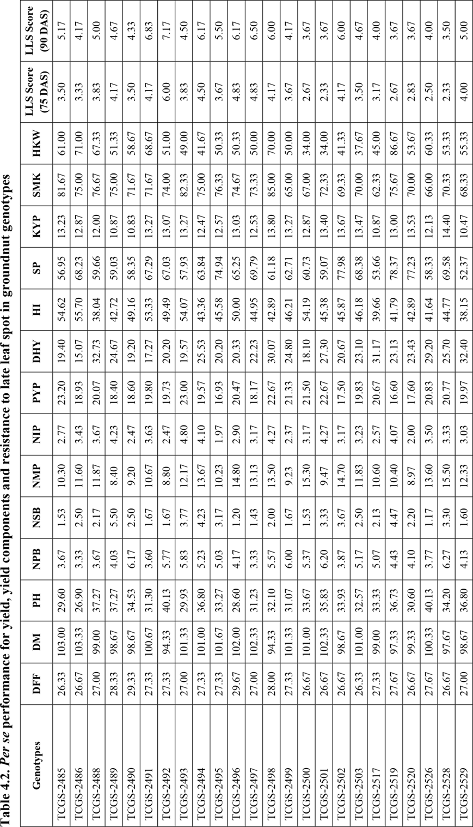

C:\Users\SAIGRAPHICS\OneDrive\Desktop\xx\3.tif

**Table** **4. List of top five best performing groundnut genotypes based on *per se* performance**

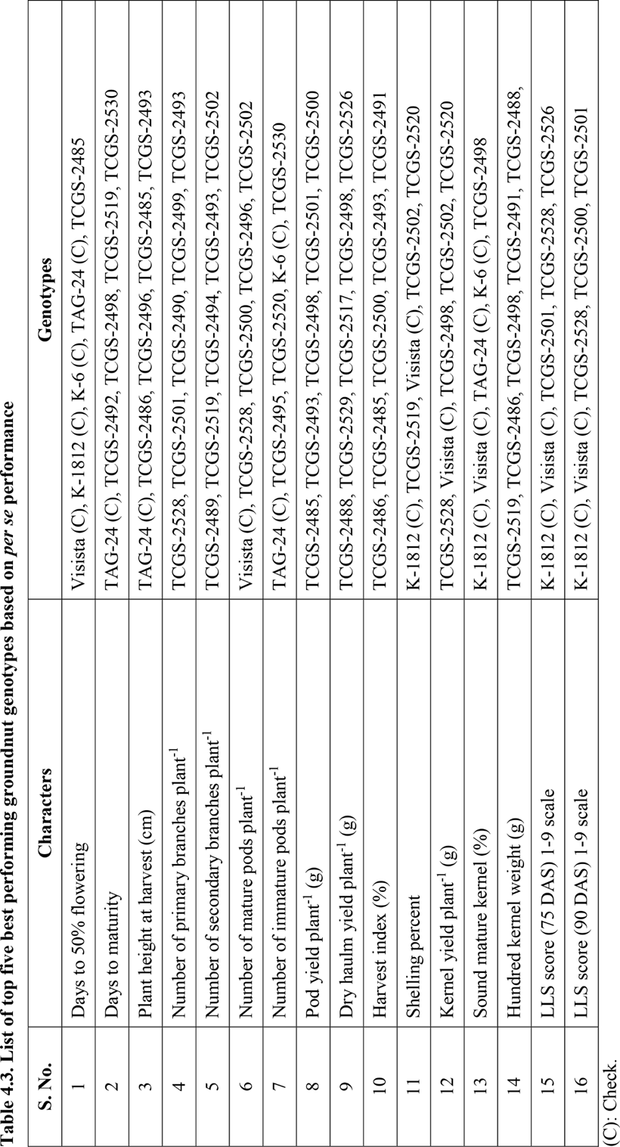

**Table** **5. List of promising groundnut genotypes for yield, yield components and resistance to LLS**

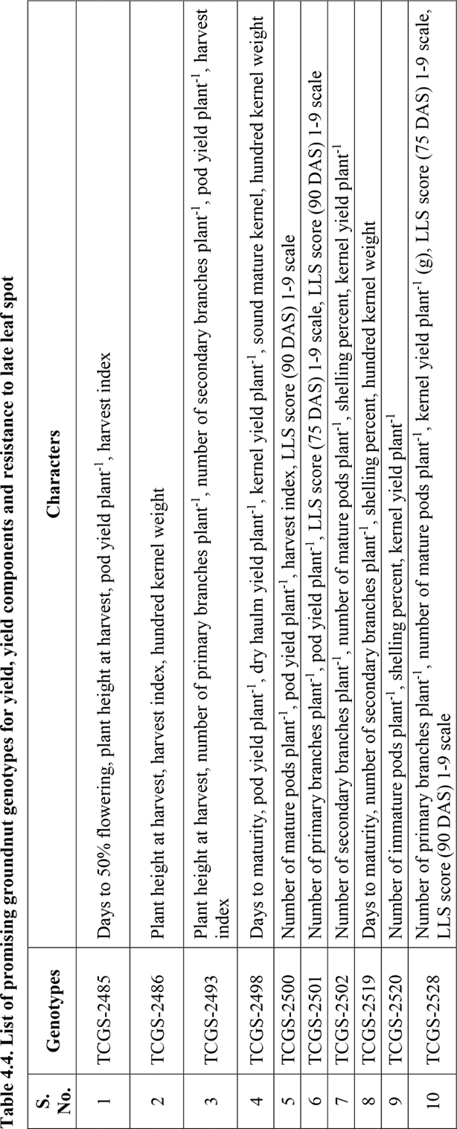

**Table** **6. Classification** **of** **advanced** **breeding** **lines** **for** **reaction** **to late leaf spot based** **on** **disease** **scores** **at** **75 DAS and** **90** **DAS**

|  |  |  |  |  |  |
| --- | --- | --- | --- | --- | --- |
| **Genotype** **Reaction** | **Disease** **Severity** **(%)** | **Disease** **Score** | **Number** **of** **ABLs** | **List** **of** **ABLs at 75 DAS** | **List** **of** **ABLs at 90 DAS** |
| **Resistant** | 0 to 10 | 1 to 3 | 11 (75 DAS) | TCGS-2501, TCGS-2528, TCGS-2526, TCGS-2500, TCGS-2519, TCGS-2520, TCGS-2517, TCGS-2530, TCGS-2531, TCGS-2486, TCGS-2532. | - |
| **Moderately** **Resistant** | 11 to 30 | 4 to 5 | 15 (75 DAS)  and  19 (90 DAS) | TCGS-2585, TCGS-2490, TCGS-2503, TCGS-2495, TCGS-2499, TCGS-2488, TCGS-2493, TCGS-2529, TCGS-2489, TCGS-2491, TCGS- 2498, TCGS-2502,  TCGS- 2494, TCGS-2596, TCGS- 2497. | TCGS-2528, TCGS-2500, TCGS-2501, TCGS-2519, TCGS-2520, TCGS-2517, TCGS-2526, TCGS-2486, TCGS-2499, TCGS-2531, TCGS- 2490, TCGS-2493, TCGS- 2489, TCGS-2503, TCGS- 2530, TCGS-2532, TCGS- 2488, TCGS-2529, TCGS- 2485. |
| **Susceptible** | 31 to 60 | 6 to 7 | 1 (75 DAS)  and  8 (90 DAS) | TCGS- 2492 | TCGS-2495, TCGS-2498, TCGS-2502, TCGS-2494, TCGS-2496, TCGS-2497, TCGS-2491, TCGS-2492. |
| **Highly** **Susceptible** | 61 to 100 | 8 to 9 | - |  | - |

**Plate 1. Modified 9-point scale (Subrahmanyam *et al*., 1995) used for field screening of 27 advanced breeding lines along with four checks for reaction to LLS resistance**

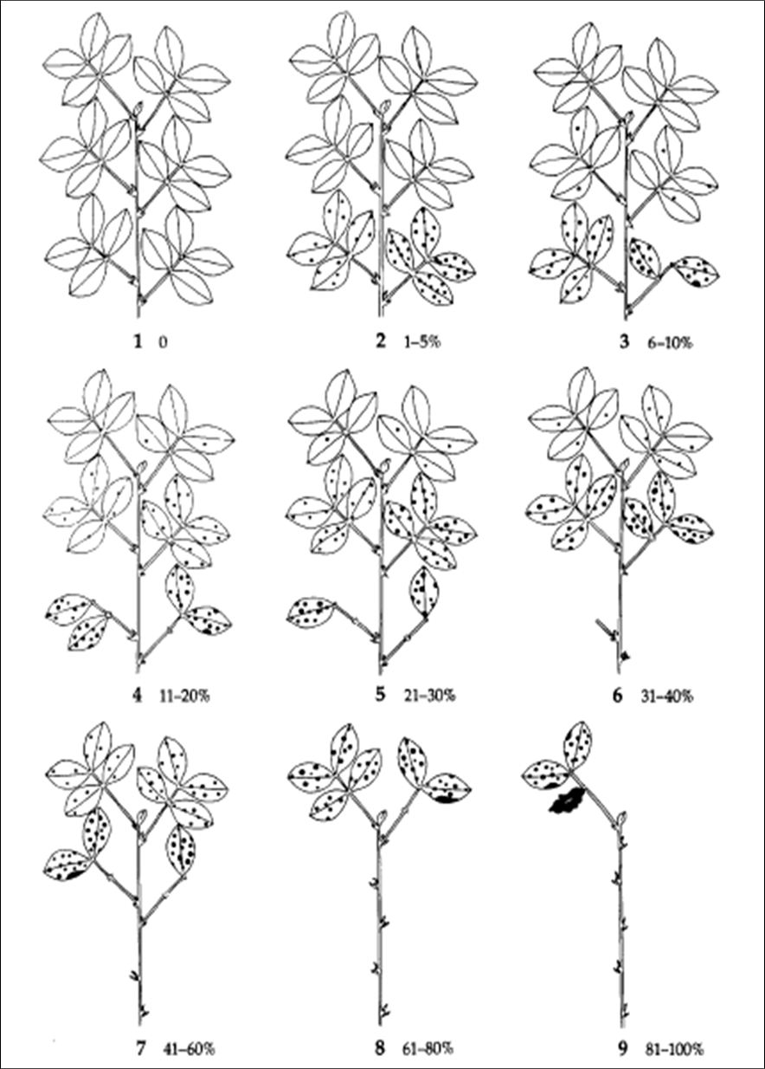

*Conflict of interest statement*. On behalf of all authors there is no conflict of interest.

**REFERENCES**

Chaudhari, S., Khare, D., Sundravadana, S., Variath, M.T., Manohar, S.S and Janila, P. 2017. Genetic analysis of foliar disease resistance, yield and nutritional quality traits in groundnut. *Electronic Journal of Plant Breeding*. 8(2): 485-493.

Gibbons, R.W. 1980. Groundnut improvement research technology for the semi-arid tropics. *In Proceedings of the international symposium on development and transfer of technology for rainfed agriculture and the SAT farmer, ICRISAT Center Patancheru, India. 24 August-1 September 1979*. 27-37.

Jackson, C.R and Bell, D.K. 1969. Diseases of peanut (groundnut) caused by fungi. *Diseases of peanut (groundnut) caused by fungi.* 56(1): 137- 144.

Kolekar, R.M., Sukruth, M., Shirasawa, K., Nadaf, H.L., Motagi, B.N., Lingaraju, S., Patil, P.V and Bhat, R.S. 2017. Marker assisted backcrossing to develop foliar disease‐resistant genotypes in TMV 2 variety of peanut (*Arachis hypogaea* L.). *Plant Breeding*. 136(6): 948-953.

Mau, Y.S and Ndiwa, A.S.S. 2018. Field evaluation of late leaf spot and leaf rust resistance and the associated yield losses in Indonesian groundnut genotypes. *Asian Journal of Plant Sciences.* 17(3): 134- 141.

Muhammad, I., Shah, Izhar-ul-Haq, S.R.A and Afzal, A. 2019. Relationship between components of resistance to late leaf spot in groundnut botanical genotypes. *Pakistan Journal of Agricultural Research.* 32(2): 390.

Subrahmanyam, P and McDonald, D. 1983. Rust disease of groundnut. *Rust Disease of Groundnut*. 13(1): 15.

Subrahmanyam, P., McDonald, D., Waliyar, F., Reddy, L.J., Nigam, S.N., Gibbons, R.W., Rao, V.R., Singh, A.K., Pande, S., Reddy, P.M and Rao, P.S. 1995. Screening methods and sources of resistance to rust and late leaf spot of groundnut. *Information Bulletin no. 47*.

Subrahmanyam, P., Williams, J.H., McDonald, D and Gibbons, R.W. 1984. The influence of foliar diseases and their control by selective fungicides on a range of groundnut (*Arachis hypogaea* L.) genotypes. *Annals of Applied Biology*. 104(3): 467-476.

Sudini, H., Upadhyaya, H.D., Reddy, S.V., Mangala, U.N., Rathore, A and Kumar, K.V.K. 2015. Resistance to late leaf spot and rust diseases in ICRISAT’s mini core collection of peanut (*Arachis hypogaea* L.). *Australasian Plant Pathology*. 44(5): 557-566.

Varshney, R.K., Pandey, M.K., Janila, P., Nigam, S.N., Sudini, H., Gowda, M.V.C., Sriswathi, M., Radhakrishnan, T., Manohar, S.S and Nagesh, P. 2014. Marker-assisted introgression of a QTL region to improve rust resistance in three elite and popular varieties of peanut (*Arachis hypogaea* L.). *Theoretical and Applied Genetics*. 127: 1771- 1781.