Effect of Shading Factors and Irrigation Regimes on Cost Economics of Tomato Production under Different Shade Net House Cultivation

Abstract
The experiment was conducted during rabi seasons of Nov 2013-2014 at Dr. Annasaheb Shinde College of Agricultural Engineering and Technology, Mahatma Phule Krishi Vidyapeeth, Rahuri. To study effect of shading factors and irrigation regimes on cost economics of tomato production under different shade net house cultivation. Three different percentages of shade net house, each of 360 m² area, viz, 75% shading, 50% shading and 35% shading were performed by conducting the field experiments under different shade net house and open field at the Instructional Farm of Department of Irrigation and Drainage Engineering, Dr. Annasaheb Shinde College of Agricultural Engineering and Technology, Mahatma Phule Krishi Vidyapeeth, Rahuri during rabiseasons of Nov 2013-14. The control of experiment i.e, 0% shading (no shading) was conducted in open field of 360 m² area. Green colourshadenet houses were used for the experiments.Under Shadenet house, the maximum gross income was found due to T₁ (75% x 0.95 ETc) treatment i.e. ₹ 2, 54,551/- followed by T₂ (75% x 0.75 ETc) treatment i.e. ₹ 2, 52,369/-. The maximum net income was due to the treatment T₁ (75% x 0.95 ETc)i.e. ₹ 1, 62,885/- followed by T₂ (75% x 0.75 ETc) i.e. ₹ 1, 60,703/-. The average maximum B: C ratio (₹ 2.77) was due to T₁ (75% x 0.95 ETc) under shadenet house cultivation. These experiments state that the best practice found in different environmental conditions (75% of shadenet house) can be adopted for maximum economic returns from tomato cultivation. 75% of shadenethouse tomato cultivation was found best alternative tomato cultivation during rabi season to obtain maximum yield, net return and benefit:cost ratio.
KEYWORDS: ShadenetCultivation, Cost Economics, NPV, Benefit-Cost Ratio
1.Introduction
Tomato (Solanumlycopersicum L.) belongs to the familySolanaceae is one of the most popular and nutritious vegetable crops all over the world. Because they can adapt to a variety of agro climaticconditions, grown all over the world for both consumption and processing (Cammarano, 2022, Raj et al., 2018, Walia et al., 2017). Crops produced in open fields are frequently subject to varying amounts of rainfall, temperature, humidity, wind flow, etc. due to the unpredictable nature of the weather, which eventually has a negative impact on crop output (Ramesh and Sandeep, 2017, Kotilainen, et al., 2018). Among vegetables, tomato is crop grown in greenhouses worldwide. It is easy to grow as compared to peppers and cucumbers, and fruit yield can be very high under protection (Rao et al., 2023).Demand for tomatoes is usually strong due to vine-ripe nature and general overall high level of eating quality. There are two main types of tomato: (i) determinate or ‘bush’ tomato and (ii) indeterminate or ‘vine’ tomato. Determinate cultivars are used mainly for processed food while indeterminate cultivars have been largely developed for greenhouse systems. Tomato is a warm season plant (Costa and Heuvelink, 2018). It can withstand with severe frost conditions. Temperature and light intensity affect germination (Angmoetet al., 2019, Shukla and Kumar, 2024), vegetative growth, fruit set, pigmentation and nutritive value of these fruits (Kabiret al., 2024). The minimum temperature for germination of seeds from 8⁰ to 10⁰C. The night temperature is the critical factor in fruit setting with the optimum range of 16⁰C to 22⁰C fruits fail to set at 12⁰C or below (Singhet al., 2017, Sotelo-Cardona et al., 2021).
Shade nets facilitate vegetable cultivation during the hot spring and summer months in tropical and subtropical regions globally, which would otherwise be unfeasible (Harishaet al., 2019). Shade nets mitigate elevated temperatures caused by excessive sun radiation and higher air and soil temperatures (Kabiret al., 2020; Díaz-P´erez,2014),this thus reduces agricultural water requirements and enhances irrigation water use efficiency (Kabiret al., 2022). A micro-environment is a specific location within a habitat that is markedly dissimilar from its immediate surrounds due to environmental characteristics such as light, temperature, soil moisture, humidity, vapor pressure deficit (VPD), and wind speed (Denney et al., 2020). Protected cultivation techniques including net house technology provide optimum environmental medium for better crop growth(Kommanaet al., 2020)to gain maximum yield and high quality products(Ahemedet al., 2016, Ilicet al., 2017, Rao et al., 2022). These require comparatively lessland area for agricultural production system resulting in increased land productivity and facilitate year round production of crops(Singh,2017). Many studies were reported on tomato cultivation under greenhouse/ nethouseconditions with different advantages(Statuto and Picuno, 2017,Zhanget al.,2022,Gowthamand Mohanalakshmi, 2018)
The cost of the shadenet house structure plays the decisive factor for adoption(Maughanet al., 2017) and sustainability of tomato production. The cost of a shadenet mainly depends on the quality of materials used for the structure and glazing and others like drip and mist systems(Sahuetal., 2018). Against this background the present study was taken up to examine the economic viability of production of tomato under different shadenet cultivation and open field condition. The specific objectives were: to estimate cost and returns and to study the constraints in tomato production under protected condition.
2.Materials and Methods
The field experiment was conducted at the Instructional Farm of Department of Irrigation and Drainage Engineering, Dr. Annasaheb Shinde College of Agricultural Engineering and Technology, Mahatma Phule Krishi Vidyapeeth, Rahuri. Geographically the farm lies at 74⁰ 38’ 00”E longitudes and 19⁰ 20’ 00”N latitude at 557 m above the mean sea levels in the central campus of Mahatma Phule Krishi Vidyapeeth, Rahuri.
2.1. Experiment under different shadenet house cultivation
Shade net house is a framed structure covered with UV stabilized shading net as a cladding material, large enough to grow crops under controlled environmental conditions and also large enough to allow a person to walk within it and carryout cultural operations to get optimum growth and productivity. Shade net house protects crop from excessive sunlight, temperatures, winds, dust and also helps in increasing humidity to a certain extent. Shadenets used for cladding are of different types depending upon the shading percentages, imparting different light wavelengths on the crop grown underneath. There are many shading percentage of shadenet available in the market. Hence, it is necessary to evaluate proper shading percentages for optimum crop yield and recommended to the farmers. Four different percentages of shadenet were selected for the study. The shadenet was provided with the foggers to protect the crop from excessive heat and to control humidity.
Response of tomato was studied under different shading percentages and irrigation regimes under shadenet house condition. Three different percentages of shade net house, each of 360 m² area, viz,. 75 % shading, 50 % shading and 35 % shading were constructed. The control of experiment i.e, 0 % shading (no shading) was conducted in open field of 360 m² area. The size of each shadenet house was 20 x 18 m². Type of shadenet house was round top (dome shape) with tapenet type of shadenet. The orientation of shadenet houses was North-South direction. Green colourshadenet houses were used for the experiments.
This experiment was carried out in split plot design with sixteen treatments based on different combinations of the shading percentages and irrigation levels.
Silver - black polyethylene mulch was used commonly in all the treatments under shadenets and open field.
2.1.1list 1 : Treatment details:
Sr.No. | Factor A : Shading percentage | Factor B: Irrigation levels
1. | S₁ = 75 % shading | I₁ = 0.95 ETc
2. | S₂= 50% shading | I₂ = 0.75 ETc
3. | S₃= 35% shading | I₃ = 0.55 ETc
4. | S₄= 0% shading i.e.  (Open field) | I₄ = 0.35 ETc
2.1.2. list 2 : Experiment Details of the Shade net house and Open Field cultivation.
Experimental design | Split plot design
No. of treatments | Sixteen
No. of replications | Six
Plant spacing | 60 x 45cm²
Plot size | 4.5 x 1m²
Height of bed | 0.45 m
No. of rows /bed | 2
No. of plants/bed | 20
No. of plants/treatment | 20
Total number of plants in experiment | 20 x 6 x 16 =1920
The silver - black polyethylene mulch of 25 micron thickness was used commonly in all the treatments.
2.2 Cost economics
2.2.1 Cost of production
The cost of production was worked out for each treatment on the basis of 1008 m² area which is commonly used by farmers for erecting the Shadenet houses, under Government subsidy scheme. The economics of tomato under open field conditions was also worked on 1008 m² area for comparison purpose. The cost includes paid out cost on structure, hired human labor, seeds, fertilizers, water charges, interest on working capital, interest on fixed capital, depreciation, repair and maintenance of water supply system irrigation system.
Depreciation
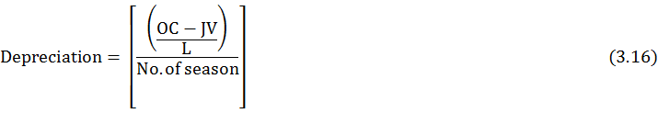
Where,
OC - Original cost
JV – Junk value (10 % of OC)
L- Life span
2.2.2Gross monetary returns
The gross monetary returns per hectare were worked out by considering the yield from different treatments and the prevailing market price of tomato.
2.2.3Net income
The net income was worked out by subtracting the cost of production from the gross monetary returns in each treatment.
2.2.4Benefit-cost ratio
The benefit-cost ratio was worked out by dividing the gross monetary returns to cost of production in each treatment under study. (Poornima 2016)
3.Results and Discussion
3.1. Cost economics of tomato production under shadenet houses
The data regarding cost of cultivation, gross income, net income and benefit:cost ratio of tomato as influenced by different treatments under Shadenet Houses of 1008 m² area for the year 2031-14 and 2014-15 are presented in Tables 1.
3.1.1. Cost of cultivation
The data on cost of cultivation including the cost of soluble fertilizers, drip irrigation system components, insecticides and pesticides,etc.,for 1008 m² area of different shadenethouse for both the years. The cost of cultivation was maximum (₹89,448/-) and (₹93,884/-) for the year 2013-14 and 2014-15 under 75% shading (S₁) due to maximum crop period of 172 days and 209 days over other shading percentages.(Figure.1).
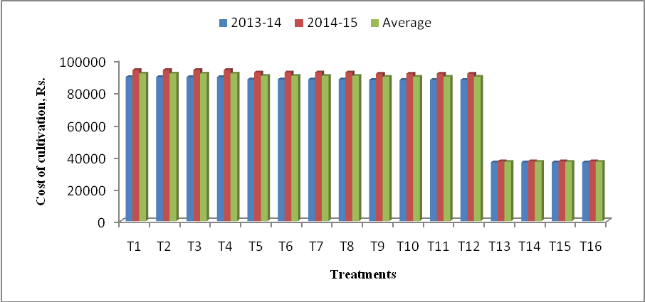
Figure1:Cost of cultivation of tomato for 1008 m² area as influenced by different treatments under shadenet houses.
3.1.2 Gross income
The gross income of tomato from 1008 m² area of different shadenet house was obtained for each replicated plots. The average gross income under each treatment is reported in Table. 1 for the respective years. The average gross income ranged from (₹15,052/- to₹2,54,551/-). The maximum gross income was found due to T₁ (75% x 0.95 ETc) treatment i.e. ₹2,54,551/- followed by T₂ (75% x 0.75 ETc) treatment i.e. ₹2,52,369/- .The varied gross income of tomato under different treatments was due to not only yield differences, but also due to market selling prices as per quality of tomato fruits in both the years. The data on gross income thus obtained were analyzed year wise and pooled over years to study the effect of shading percentages and irrigation levels (Table.1) and (Figure. 2). Results are inline with Firake (2016).
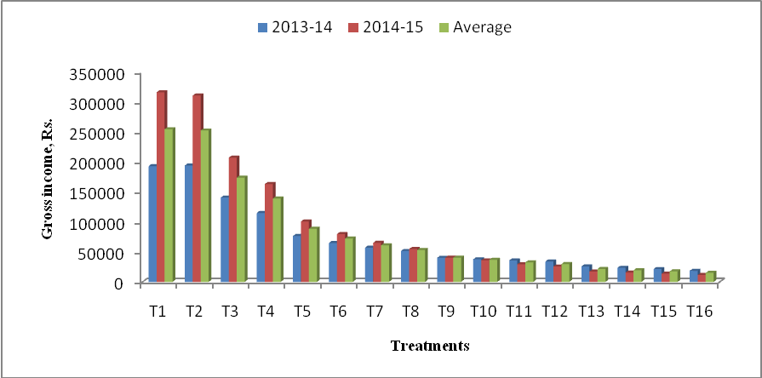
Figure 2: Gross income of tomato for 1008 m² area as influenced by different treatments under shadenet houses
3.1.3 Net income
The net income of tomato from 1008 m² area of different shadenet houses was obtained for each replicated plots. The maximum net income was due to the treatment T₁ (75% x 0.95 ETc) i.e. ₹1, 62,885/-followed by T₂ (75% x 0.75 ETc) i.e. ₹1, 60,703/- . The treatments T₅ to T₁₆ resulted into negative net income indicating that the tomato production under these treatments is not economically viable. (Table.1) and (Figure. 3).
3.1.4B: C Ratio
The B:C ratio of tomato from 1008 m² area of different shadenet houses was obtained for each replicated plots. The average B: C ratio under each treatment is reported in Table 1 for the respective years. The B: C ratio ranged from (₹0.51 to ₹2.16) and (₹0.31 and ₹ 3.37) for the year 2013-14 and 2014-15. The average maximum B: C ratio (₹ 2.77) was due to T₁ (75% x 0.95 ETc) (Figure. 4). The average B: C ratios of two years under different treatments indicate that the treatments T₁ to T₄ only are economically viable. Results are inline with Firake (2016).

Table1. Economics of tomato production for shadenet house area of 1008 m² as affected by different treatments for the year 2013-14, 2014-15
Treatments | Cost of cultivation, Rs. |  |  | Gross income, Rs. |  |  | Net income, Rs. |  |  | B:C ratio
Treatments | 2013-14 | 2014-15 | Average | 2013-14 | 2014-15 | Average | 2013-14 | 2014-15 | Average | 2013-14 | 2014-15 | Average
T₁ (75% x 0.95 ETc) | 89448 | 93884 | 91666 | 192915 | 316186 | 254551 | 103467 | 222302 | 162885 | 2.16 | 3.37 | 2.77
T₂ (75% x 0.75 ETc) | 89448 | 93884 | 91666 | 194021 | 310717 | 252369 | 104573 | 216833 | 160703 | 2.17 | 3.31 | 2.74
T₃ (75% x 0.55 ETc) | 89448 | 93884 | 91666 | 140609 | 207058 | 173834 | 51161 | 113174 | 82168 | 1.57 | 2.21 | 1.89
T₄ ( 75% x 0.35 ETc) | 89448 | 93884 | 91666 | 114865 | 163167 | 139016 | 25417 | 69283 | 47350 | 1.28 | 1.74 | 1.51
T₅ ( 50% x 0.95 ETc) | 88035 | 92384 | 90210 | 76484 | 100680 | 88582 | -11551 | 8296 | -1628 | 0.87 | 1.09 | 0.98
T₆ ( 50% x 0.75 ETc) | 88035 | 92384 | 90210 | 64893 | 79634 | 72264 | -23142 | -12750 | -17946 | 0.74 | 0.86 | 0.80
T₇ ( 50% x 0.55 ETc) | 88035 | 92384 | 90210 | 57037 | 65073 | 61055 | -30999 | -27312 | -29156 | 0.65 | 0.70 | 0.68
T₈ ( 50% x 0.35 ETc) | 88035 | 92384 | 90210 | 51564 | 54826 | 53195 | -36471 | -37558 | -37015 | 0.59 | 0.59 | 0.59
T₉ ( 35% x 0.95 ETc) | 87685 | 91592 | 89639 | 40215 | 40298 | 40257 | -47470 | -51294 | -49382 | 0.46 | 0.44 | 0.45
T₁₀ ( 35% x 0.75 ETc) | 87685 | 91592 | 89639 | 37673 | 35915 | 36794 | -50013 | -55677 | -52845 | 0.43 | 0.39 | 0.41
T₁₁ ( 35% x 0.55 ETc) | 87685 | 91592 | 89639 | 35815 | 29388 | 32602 | -51871 | -62204 | -57038 | 0.41 | 0.32 | 0.37
T₁₂ ( 35% x 0.35 ETc) | 87685 | 91592 | 89639 | 33924 | 25655 | 29790 | -53761 | -65937 | -59849 | 0.39 | 0.28 | 0.34
T₁₃ ( 0% x 0.95 ETc) | 36472 | 37181 | 36827 | 25717 | 17393 | 21555 | -10755 | -19788 | -15272 | 0.71 | 0.47 | 0.59
T₁₄ (0% x 0.75 ETc) | 36472 | 37181 | 36827 | 23485 | 15499 | 19492 | -12987 | -21682 | -17335 | 0.64 | 0.42 | 0.53
T₁₅ (0% x 0.55 ETc) | 36472 | 37181 | 36827 | 21357 | 13755 | 17556 | -15115 | -23426 | -19271 | 0.59 | 0.37 | 0.48
T₁₆ ( 0% x 0.35 ETc) | 36472 | 37181 | 36827 | 18475 | 11629 | 15052 | -17997 | -25552 | -21775 | 0.51 | 0.31 | 0.41

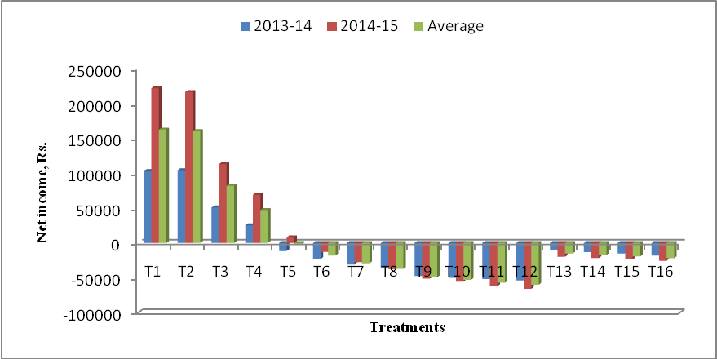
Figure 3: Net income of tomato for 1008 m² area as influenced by differenttreatments under shadenet houses.
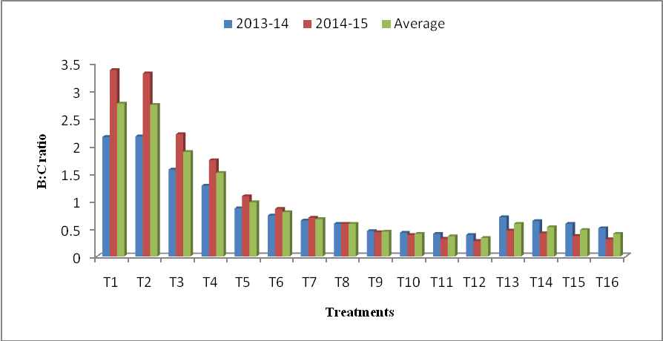
Figure 4: B:C ratio of tomato for 1008 m² area as influenced by different treatments under shadenet houses.

4. Conclusions
It wasconclude thatcost of cultivation, the gross income, Net income and average B : C ratio was found to be maximum in75% shading (S₁) with 0.95 ETc for the year 2013-14 and 2014-15 due to maximum crop period of 172 days and 209 days over other shading percentages and it was followed by T₂treatment (75% x 0.75 ETc).
6.References
Ahmed, H.,Abdulelah A., Ahmed M., 2016. Shading greenhouses to improve the microclimate, energy and water saving in hot regions: A review. ScientiaHorticulturae 201, 36–45, ISSN 0304–4238, https://doi.org/10.1016/j.scienta.2016.01.030.
Costa, J.M.,Heuvelink, E, 2018. The Global Tomato Industry. In Tomatoes; CABI Publishing: Wallingford, UK, 276–313.
Díaz-P´erez, C., 2014. Bell pepper (Capsicum annum L.) crop as affected by shade level: fruit yield, quality, and postharvest attributes, and incidence of phytophthora blight (caused by Phytophthoracapsici Leon.). HortScience 49(7), 891–900.
Denney, A., Jameel, I., Bemmels, B., Rochford, E., Anderson, T., 2020. Small spaces, big impacts: contributions of micro-environmental variation to population persistence under climate change. AoB Plants 12(2), plaa005.
Firake, N., 2016. Response of capsicum (Capsicum annuum L.) to different irrigation regimes under protected cultivation. Unpub.Ph.D. Thesis, MPKV,Rahuri, pp.1-683.
Gowtham, T., Mohanalakshmi, M., 2018. Influence of growingenvironment on growth and yield parameters of corianderunder shade net and open field condition. Madras Agricultural Journal 105 (7/9), 332–335. https://doi.org/10.29321/ MAJ.2018.000155.
Harisha, N., Tulsiram, J., Meti, S., Chandargi, D., Joshi, A., 2019. Extent of adoption of tomato cultivation practices among farmersunder shade nets in Kolar district of Karnataka. Indian Journal of Extension Education 55(1), 28–33.
Ilic, Z., Milenkovic, L., Šunić, L., Barać, S., Mastilović, J., Kevrešan, Ž.,Fallik, E., 2017. Effect of shading by coloured nets on yield and fruit quality of sweet pepper. Zemdirbyste-Agriculture 104, 53–62. 10.13080/z-a.2017.104.008.
Kabir, M., Savithri, U., Nambeesan, J., Carlos, D., 2024. Shade nets improve vegetable performance, ScientiaHorticulturae 334, 113326.
Kabir, Y., Nambeesan, U., Bautista, J., Díaz-P´erez, C., 2022. Plant water status, plant growth, and fruit yield in bell pepper (Capsicum annum L.) under shade nets. ScientiaHorticulturae 303, 111241 https://doi.org/10.1016/j.scienta.2022.111241.
Kabir, Y., Díaz-P´erez, C., Nambeesan, U., 2020. Effect of shade levels on plant growth, physiology, and fruit yield in bell pepper (Capsicum annuum L.). In: XI International Symposium on Protected Cultivation in Mild Winter Climates and I International Symposium on Nettings and 1268, 311–318.
Kommana, P., Jena, C., Vani, D., 2020. Cultivation Technology of Tomato in Greenhouse. In: Protected Cultivation and Smart Agricultureedited by SagarMaitra, Dinkar J Gaikwad and Tanmoy Shankar © New Delhi Publishers, New Delhi:121-129, ISBN: 978-81-948993-2-7, DOI: 10.30954/NDP-PCSA.2020.1210.30954/NDP-PCSA.2020.12.
Kotilainen, T., Robson, T.M., Hernández, R.,2018. Light quality characterization under climate screens and shade nets for controlled-environment agriculture. PLoS ONE 13(6), e0199628. [Google Scholar] [CrossRef] [PubMed].
Maughan, T., Drost, D., Black, B., Day, S., 2017. Using Shade for fruit and vegetable production. Horticulture/Fruit/2017-02Paper 1654. https://digitalcommons.usu.edu/extension.curall/1654.
Poornima, 2016. Yield response of drip irrigation cucumber to mulch and irrigation regimes under different shading nets. An unpublished M.tech thesis submitted to Mahatma Phule Krishi Vidyapeeth Rahuri.
Raj, T., Bhardwaj, L., Pal, S., Kumari, S., Dogra, K., 2018. Performance of tomato (SolanumlycopersicumL.) hybrids for yield and its contributing traits under mid-hill conditions of Himachal Pradesh. International Journal of Bio-resource and Stress Management 9(2), 282–286.

.
Ramesh, K., Sandeep, K., 2017. Effect of irrigation levels and frequencies on growth, yield and economics of capsicum production under naturally ventilated polyhouse. Vegetable Science 44(1), 107–112.
Rao, K., Suchi, G., Pushplata, A., Deepika, Y., 2023. Effect of shadenet color and its intensity on tomato crop performance. Emirates Journal of Food and Agriculture 35(1), 86–90.
Rao, K., Saxena, C., Singh, C., Kumar, S., Suchi, G., 2022. Water productivity of capsicum and tomato under different growing environments. Indian Journal of Ecology 49(3), 763–767.
Shukla, M., Kumar, R., 2024. Impact of shade nets on tomato output and quality in temperate region of Kashmir Valley. Journal of Global Agriculture and Ecology 16(2), 1–13. https://doi.org/10.56557/jogae/2024/v16i28580.
Sotelo-Cardona, P., Mei-Ying, L., Ramasamy, S., 2021. Growing tomato under protected cultivation conditions: overall effects on productivity, nutritional yield, and pest incidences. Crops 1(2), 97–110. https://doi.org/10.3390/crops1020010.
Singh, S., Sharda, R., Lubana, P.,Singla. C., 2011. Economic evaluation of drip irrigation system in bell pepper (Capsicum annuumL. var. grossum). Progressive Agriculture43, 289 – 293.
Singh, S., 2017. An Economic Analysis of shade net cultivation in ChhattishgarhPlain.M.B.A. (ABM) Project Report. Department of Agri-Business and Rural Management College of Agriculture Faculty of AgricultureIndira Gandhi Krishi Vishwavidyalaya Raipur (C. G.).
Statuto, D., Picuno, P., 2017. Micro-climatic effect of shading plastic nets for crop protection in Mediterranean areas. 45. Symposium “Actual Tasks on Agricultural Engineering”. Opatija, Croatia, 557–566.
Walia,K., Rajinder, R., Manish, K., Sharma, L., 2024. Integrated pest management strategies for controlling tutaabsoluta and enhancing tomato seed yield and quality. International Journal of Bio-resource and Stress Management 15(9), 01–06. HTTPS://DOI.ORG/10.23910/1.2024.5537.
Zhang, Q., Bi, G., Li, T., Wang, Q., Xing, Z., LeCompte, J., Harkess, L., 2022. Color shade nets affect plant growth and seasonal leaf quality of Camellia sinensis grown in Mississippi, the United States. Frontiers in Nutrient 9, 1–13. doi.org/10.3389/fnut.2022.786421

