**ANALYSIS OF AGRICULTURAL LAND CAPABILITIES IN THE SPATIAL PLAN OF THE BERAU DISTRICT 2016 – 2036**

**ABSTRACT**

An analysis of the carrying capacity of agricultural land needs to be carried out to determine the land's ability to provide food to meet the needs of the population in an area within a certain time. Land capability is a component used to determine the suitability of land potential for its land use. Land use that is not in accordance with its capabilities has the potential to experience land degradation. The aim of the research is to determine the condition of agricultural land specified in the Berau Regency Regional Spatial Plan based on land capacity. The research was carried out in the Berau Regency area, East Kalimantan Province, especially in agricultural areas consisting of plantation areas, wetland agriculture and dry land agriculture. This research uses a spatial descriptive method, namely an approach used to describe and analyze phenomena related to a particular space or location. The research data used is secondary data obtained from local government agencies, data provider websites and the Geospatial Information Agency (BIG). The data analysis used to determine land capability is carried out using Weight factor matching, namely determining the land capability class based on the heaviest class of parameters in each map unit and for land suitability analysis of the land capability class of agricultural areas based on suitability resulting from evaluations that refer to land characteristic criteria. The results of the research show that the total land area that was declared appropriate was 501.475,28 hectares (76.11%) and the land area that was temporarily declared inappropriate was 119.792,57 hectares (23.89%). This land unsuitability occurs on land with land capability classes V, VI, and VIII.

**Keywords: Agricultural Land Capability, Regional Spatial Planning, Berau Regency**

**1. INTRODUCTION**

Indonesia has a large area of ​​land that can be used by the community as a source of livelihood [1]. Agricultural land is land intended for agricultural activities. Agricultural land resources have many benefits for humans [2]. Land use must meet the necessary requirements so that the land can produce and not be damaged for an unlimited period of time [3].

The concept of sustainable agriculture can be realized by regional planning based on natural resources in a particular area. The concept of planning has an important meaning in national development because planning is a systematic preparation process for a series of activities to be carried out in an effort to achieve a certain goal. Development planning which includes who and how to achieve the goals as best as possible according to the conditions and potential of the resources they have so that the implementation of development can run more effectively and efficiently [4].

Regional structuring planning is the process of carrying out regional structuring as a direction for the use or utilization of the territory, including controlling the use of the territory as outlined in the Regional Spatial Plan (RSP) which is used as a reference basis for regional and national development planning. Spatial planning as outlined in the Regional Spatial Plan is divided into spatial patterns and structures. The Spatial Pattern divides the territory into areas according to the regional resource capabilities which are divided into protected areas, cultivation areas and strategic areas. Cultivation areas are divided into production forest areas, agricultural areas, fisheries areas, mining areas, industrial areas, tourism areas, residential areas and coastal areas.

Regional Spatial Planning (RSP) based on Law No. 26 of 2007 concerning Spatial Planning is the use of space to achieve safe, comfortable, productive and sustainable land use. Therefore, spatial planning must be in accordance with land capabilities [5].

Land capability is a component used to determine the suitability of potential for land use. Land use that is not in accordance with its capabilities has the potential to experience land degradation [6]. Land use is a form of human intervention on land to fulfill their life needs, both material and spiritual. Land use can be grouped into two large groups, namely agricultural land use and non-agricultural land use.

In terms of planning land use in an area, land capacity is an important input for determining alternative land uses. Evaluation of the spatial pattern in the RTRW is part of the steps in spatial management so that the necessary steps for improvement can be prepared. Spatial structure is the arrangement of residential centers and a network system of infrastructure and facilities that function to support socio-economic activities of the community which hierarchically have functional relationships [7].

Berau Regency is part of East Kalimantan Province, with an administrative area of ​​36,962.38 km², consisting of 22,232.53 km² of land and 14,729.85 km² of sea. The Regional Spatial Planning (RTRW) of Berau Regency for 2016 - 2036 determines the area designated as agricultural land covering an area of ​​501,475.28 ha which will be used as plantation land and food farming land or wetland farming and dry land farming. However, current land use is only 165,120.36 ha [8].

Based on the results of observations, there is still land that has not been utilized in accordance with spatial planning directions, especially on land in agricultural areas, so it is necessary to know the problem of land that has not been utilized in accordance with the directions of the Regional Spatial Planning (RSP). Therefore, it is necessary to observe and research the capability or suitability of the land that has been determined in the RSP.

Is the determination of the Regional Spatial Planning (RSP) for agricultural land purposes in accordance with the capabilities and suitability of the land? To find out the condition of agricultural land specified in the RSP of Berau Regency based on land capacity.

It is hoped that the results of this research will provide information to the Berau Regency government that in determining the RSP of an area, capacity classes are taken into account, especially the determination of agricultural areas.

**2. RESEARCH METHODS**

**2.1. Research Location**

This research was conducted in Berau Regency which is part of the East Kalimantan Province region which is geographically located between 10° N – 20° S and 116° E – 119° E. Especially in agricultural areas consisting of plantations, wetland agriculture and dry land agriculture which can be seen in Figure 1.

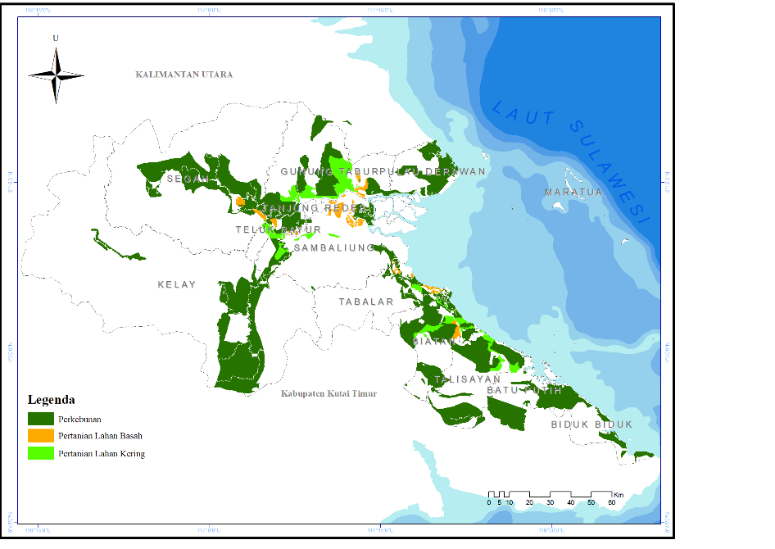

Figure 1. Location of the Research

In this research, Land Map Units (SPL) are used, namely the units used for mapping. This mapping can be determined directly in the field. The Land Map Unit in this research is composed of the results of cutting land system maps with agricultural areas in Berau Regency. The cutting results produced 18 units consisting of Bakunan, Beriwit, Gunung Baju, Juloh, Kahayan, Kajapah, Kapor, Lawanguawang, Liangpram, Maput, Mendawai, Okki, Pedreh, Sebatik Island, Siumpu Island, Sebangau, Teweh Baru and Teweh which are presented in Figure 2.

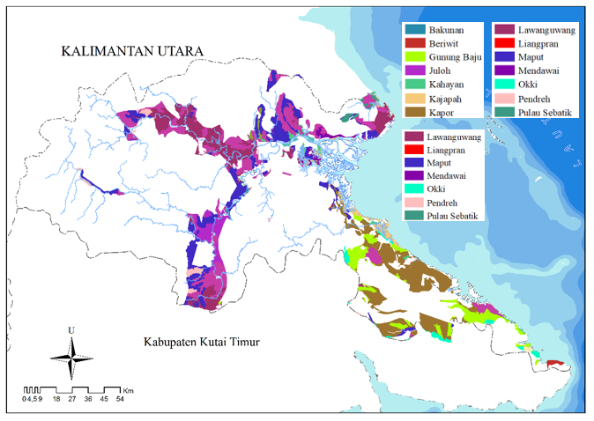

Figure 2. Land Map Units

**2.2. Method of Collecting Data**

This research uses a spatial descriptive method. Spatial descriptive is an approach used to describe and analyze phenomena related to a particular space or location. In this research, the data used is secondary data in the form of spatial data obtained from local government agencies, data provider websites and the Geospatial Information Agency (BIG). Details of secondary data and data sources used in this research are presented in Table 1.

Table 1. Research Data

|  |  |  |  |  |  |  |  |  |  |  |  |  |  |
| --- | --- | --- | --- | --- | --- | --- | --- | --- | --- | --- | --- | --- | --- |
| **No** | | **Purpuse** | | **Data Type** | | **Source** | | **Scale/ Resolution** | | **Analysis Techniques** | | **Yield** | |
| 1 | | Making Land Map Units | | District Spatial Pattern Map. Berau 2016-2036 | | Department of Public Works and Public Housing | | 1: 50.000 | | *Clip* | | Land Map Units | |
| Land System | | BIG 2023 | | 1: 50.000 | |
| 2 | | Analysis of Slope Slopes in Berau Regency | | *Digital Elevation Model* (DEM) | | Geospatial Information Agency  (BIG) | | 8 m | | *Slope* | | Slope Data | |
| 3 | Soil Texture and Rock/Gravel Analysis | | Spatial Data | | *Soil Grid* | |  | | *Zonal Statistics* | | Soil Texture Data and Rock/gravel Data | |
| 4 | Effective depth, Drainage, Permeability, Erosion and Flood Threa | | Spatial Data | | Land System in 2023 | | 1:50.000 | | *Join attribute* | | Data on effective depth, drainage, permeability, erosion rate and flood threat | |

**2.3. Data Analysis Methods**

**2.3.1. Analysis of land capability classes and land suitability**

Land capability analysis was carried out using Weigh factor matching. Weight factor matching is determining classes based on the heaviest class of parameters in each map unit. The data obtained is processed to obtain land capability classes based on limiting factors for each parameter on each land unit. Then a nonconformity evaluation is carried out, the land is classified into eight classes. Classes I to IV are suitable for agricultural cultivation with different levels of constraints, while Classes V to VIII are more suitable for non-cultivation activities such as forestry, conservation or environmental protection. The classification of land capability classes is presented in Table 2.

Table 2. Land Capability Classification

| Inhibiting Factors | Land Capability Class | | | | | | | |
| --- | --- | --- | --- | --- | --- | --- | --- | --- |
| **I** | **II** | **III** | **IV** | **V** | **VI** | **VII** | **VIII** |
| Surface slope  (%) | A | B | C | D | A | E | F | G |
| Erosion Rate | e0 | e1 | e2 | e3 | (**) | e4 | e5 | ( * ) |
| Soil depth | k0 | k1 | k2 | k3 | (*) | (*) | (*) | (*) |
| Soil texture topsoil | t1/t2/t3 | t1/t2/t3 | t1/t2/t3/t4 | t1/t2/t3/t4 | (*) | t1/t2/t3/t4 | t1/t2/t3/t4 | t5 |
| Soil texture subsoil | sda | sda | sda | sda | (*) | sda | sda | t5 |
| Permeability | P2, P3 | P2, P3 | P2, P3 | P2, P3 | P1 | (*) | (*) | P5 |
| Drainage | d1 | d2 | d3 | d4 | d5 | (**) | (**) | d0 |
| Gravel/rocks | b0 | b0 | b1 | b2 | b3 | (*) | (*) | b4 |
| Flood Threat | O0 | O1 | O2 | O3 | O4 | (**) | (**) | (*) |

Information:

(*): can have any properties, (**): not valid; sda: same as above, A: 0-3%, B: 3-8%, C: 8-15%, D: 15-30%, E: 30-45%, F: 45-65%, G: >65%; e0: No erosion, e1: mild, e2: moderate e3: somewhat severe, e4: severe, e5: very severe; k0: >90 cm, k1: 50-90 cm, k2: 25-50 cm, k3: >25 cm; t1: fine, t2: somewhat fine, t3: medium, t4: somewhat coarse, t5: coarse; P1: slow, P2: somewhat slow, P3: moderate, P4: somewhat fast, P5: fast; d0: excessive, d1: good, d2: somewhat good, d3: somewhat bad, d4: bad, d5: very bad; b0: none, b1: 15-50%, b2: 50-90%, b3: >90%, b4: very much; O0: never, O1: sometimes, O2: moderately, O3: often, O4: very often

**2.3.2. Land Suitability Analysis**

This analysis is basically related to evaluation for certain land uses. The analysis carried out is based on the function of the area which refers to the Land Research and Development Center, Bogor. This analysis uses land capability class parameters. Analysis of area suitability for agricultural area land capability classes, especially plantation land, wetland agriculture and dry land agriculture based on suitability resulting from evaluations that refer to land characteristic criteria.

**3. RESULTS AND DISCUSSION**

**3.1. Land Characteristics**

The results of research and observations on the Berau Regency Spatial Planning Plan, especially on agricultural land, show that there are 18 Land Map Units which provide information regarding the nature and characteristics of each unit. The SPL consists of Bakunan, Beriwit, Gunung Baju, Juloh, Kahayan, Kajapah, Kapor, Liangpran, Luwanguwang, Mendawai, Maput, Okki, Pedreh, Sebatik Island, Siumpu Island, Sebangau, Teweh Baru, and Teweh. The characteristics of each land map unit provide information about the nature and characteristics of the land. The details are presented in Table 3.

The Bakunan Land Map Unit (SPL-BKN) with an area of ​​1,014.88 hectares has a slope of 9.04% with a moderate level of erosion, as well as deep soil depth and a slightly smooth top layer texture. Although the soil in this area has slow permeability and poor drainage, the risk of flooding is considered moderate.

The Beriwit Land Map Unit (SPL-BRW with an area of ​​2157.92 hectares has a slope of 26.54% with a moderate level of erosion. The soil depth is quite smooth with a smooth bottom layer texture. Fast permeability and good drainage reduce the risk of waterlogging, while the threat of flooding never occurs

The Mount Baju Land Map Unit (SPL-GBJ) has a slope of 20.30%, with a moderate level of erosion and very shallow soil depth. The texture of the top layer is quite smooth and the permeability is fast and the drainage is good. The threat of flooding has also never occurred on an area of ​​42,924.47. this hectare. However, shallow soil depth can limit the types of plants that can be planted.

The Juloh Land Map Unit (SPL- JLH) shows a slope of 24.11% with very shallow soil depth and the same top layer texture as GBJ. Fast permeability and good drainage are also beneficial, with the threat of flooding remaining unlikely. The land area reaches 19,502.07 ha, offering potential for agricultural use although the depth of the soil must be taken into account.

The Kahayan Land Map Unit (SPL-KHY) with a slope of 6.92%, is classified as a light slope category and has a very shallow soil depth. Even though the soil texture is fine and the permeability is moderate, this 6,743.18 ha land occasionally faces the threat of flooding. Therefore, careful management is needed to prevent potential damage due to waterlogging.

The Kajapah Land Map Unit (SPL-KJP) has a slope of 5.57% and a moderate erosion rate. The depth of the soil is also very shallow with a fine texture. Slow permeability and rather poor drainage increase the risk of waterlogging, so that the threat of flooding often occurs on an area of ​​15,509.83 ha.

The Kapor Land Map Unit ((SPL-KPR) has a slope of 8.82%, with very shallow soil depth, slow permeability, and very poor drainage. This 99,282.45 ha of land faces the threat of periodic flooding, so it requires intensive management to reduce the risk of further damage.

The Lawanguawang Land Map Unit (SPL-LWG) has a slope of 9.06% with a moderate level of erosion and a fairly smooth soil depth. Very fast permeability and good drainage help reduce the risk of waterlogging, although the threat of flooding occasionally occurs on an area of ​​78,621.98 ha.

The Liangpran Land Map Unit (SPL-LPR) has a slope of 20.83% and a fine soil depth and fine top layer texture. The SPL LPR has fast permeability and good drainage. The threat of flooding has never occurred on an area of ​​116.77 ha.

The Maput Land Map Unit (SPL-MPT) has a slope of 20.72% with very shallow soil depth, slow permeability and poor drainage. The level of erosion on this land is classified as moderate. There is never a threat of flooding on this land, with a land area of ​​87,605.83 ha.

The Mendawai Land Map Unit (SPL-MDW) has a slope of 7.14% with medium soil depth and fine texture. Permeability is moderate and drainage is also moderate; The threat of flooding often occurs on an area of ​​6,121.38 ha.

The Pedreh Land Map Unit (SPL-PDH) has a slope of 30.22%, with medium soil depth and a slightly smooth top layer texture. Fast permeability and good drainage reduce the risk of flooding, and the 8,861.52 ha area does not face the threat of flooding.

The Sebatik Island Land Map Unit (SPL-PSB) has a slope of 7.04%, with very shallow soil depth, fast permeability and good drainage. However, the threat of flooding occasionally occurs on an area of ​​4,557.04 ha

The Siumpu Island Land Map Unit (SPL-PSP) has a slope of 34.42%, with very shallow soil depth, as well as slow permeability and poor drainage, which increases the risk of waterlogging. However, the threat of flooding has never occurred on an area of ​​1,165.51 ha.

The Sebangau Land Map Unit (SPL-SBG) has a slope of 6.92%, with deep soil depth and a slightly smooth top layer texture. Very fast permeability causes the threat of flooding to be classified as moderate, with an area reaching 1,345.23 ha.

The New Teweh Land Map Unit (SPL-TWB) has a slope of 16%, deep soil depth, and a fine layer texture. Fast permeability and good drainage reduce the risk of waterlogging, so that the threat of flooding is classified as moderate in an area of ​​2,575.98 ha.

The Teweh Land Map Unit (SPL-TWH) has a slope of 12.48%, moderate erosion levels, and moderate soil depth, making it quite ideal for agriculture. With fast permeability and good drainage, the threat of flooding is also classified as moderate in an area of ​​113,901.03 ha.

Overall, analysis of limiting factors such as slope slope, erosion rate, soil depth, top/bottom layer texture and permeability and drainage conditions shows that each SPL has unique characteristics that influence its potential use for agricultural or other purposes. Proper management will be the key to maximizing productivity while minimizing the risk of environmental damage due to erosion or waterlogging.

Table 3. Land Characteristics in Land Map Units in the Berau Regency RTRW 2016-2036

|  |  |  |  |  |  |  |  |  |  |  |  |
| --- | --- | --- | --- | --- | --- | --- | --- | --- | --- | --- | --- |
| **No** | **SPL** | **Slope (%)** | **Erosion Rate** | **Depth Soil** | **Texture of Topsoil** | **Texture of subsoil** | **Permeability** | **Drainage** | **Rocks/**  **Gravels** | **Flood threat** | **Areas (ha)** |
| 1 | BKN | 9,04 | moderate | Deep | Quite fine | Fine | Slow | Bad | Few | Currenlty | 1014,88 |
| 2 | BRW | 26,54 | moderate | Currently | Quite fine | Fine | Fast | Good | Few | Never | 2157,92 |
| 3 | GBJ | 20,30 | moderate | Very shallow | Quite fine | Fine | Fast | Good | Few | Never | 42924,47 |
| 4 | JLH | 24,11 | moderate | Very shallow | Quite fine | Fine | Fast | Good | Few | Never | 19502,07 |
| 5 | KHY | 6,92 | light | Very shallow | Fine | Fine | Currently | Currently | Few | Sometimes | 6743,18 |
| 6 | KJP | 5,57 | light | Currently | Fine | Fine | Slow | Kinda bad | Few | Often | 15509,83 |
| 7 | KPR | 8,82 | moderate | Very shallow | Quite fine | Fine | Slow | Very bad | Few | Sometimes | 99282,45 |
| 8 | LWG | 9,06 | moderate | Currently | Quite fine | Fine | Very fast | Good | Few | Sometimes | 78621,98 |
| 9 | LPR | 20,83 | moderate | Currently | Fine | Fine | Fast | Good | Few | Never | 116,77 |
| 10 | MPT | 20,72 | moderate | Very shallow | Quite fine | Fine | Slow | Bad | Few | Never | 87605,83 |
| 11 | MDW | 7,14 | light | Currently | Fine | Fine | Currently | Currently | Few | Often | 6121,38 |
| 12 | OKI | 27,31 | moderate | Very shallow | Fine | Fine | Slow | Kinda bad | Few | Never | 9468,21 |
| 13 | PDH | 30,22 | moderate | Currently | Quite fine | Fine | Fast | Good | Few | Never | 8861,52 |
| 14 | PSB | 7,04 | light | Very shallow | Fine | Fine | Fast | Good | Few | Sometimes | 4557,04 |
| 15 | PSP | 34,42 | moderate | Very shallow | Quite fine | Fine | Fast | Bad | Few | Never | 1165,51 |
| 16 | SBG | 6,92 | light | Deep | Quite fine | Fine | Very fast | Good | Few | Currenlty | 1345,23 |
| 17 | TWB | 16,00 | moderate | Deep | Fine | Fine | Fast | Good | Few | Currenlty | 2575,98 |
| 18 | TWH | 12,48 | moderate | Currently | Fine | Fine | Fast | Good | Few | Currently | 113901,03 |

Source: Results of Research Data Analysis, 2024

Description: SPL: Land map units, BKN: Bakunan, BRW: Beriwit, GBJ: Gunung Baju, JLH: Juloh, KHY: Kahayan, KJP: Kajapah, KPR: Kapor, LPR: Liangpran, LWG: Luwanguwang, MDW: Mendawai, MPT: Maput, OKI: Okki, PDH: Pedreh, PSB: Pulau Sebatik, PSP: Pulau siumpu, SBG: Sebangau, TWB: Teweh baru, TWH: Teweh

**3.2. Classification of Agricultural Land Capability Classes**

Land capacity classification is a systematic assessment of land by grouping it into several categories based on characteristics that constitute potential and obstacles to its use. The parameters used to determine the land capability class in this research refer to the land capability guidelines [8]. The classification of land capability classes helps the use and interpretation of land maps. Land capability classes have different levels of limiting factors in each class so that land use will vary. In relation to regional spatial planning (RTRW) and land use, the higher the land capability class level, the fewer types of land use will be selected and vice versa. Based on the results of land capability analysis which combines several limiting factors including soil texture, soil depth, slope, drainage, flood hazard, permeability, rock/gravel and erosion, the land capability class unit area is presented in Table 4 and Figure 3.

Table 4. Land Capability Classes in the Berau Regency RTRW 2016-2036

| **SPL** | **Land Capability Class** | **Region** | **Ability**  **Land** | **Area (Hectare)** |
| --- | --- | --- | --- | --- |
| BKN | V-p | Plantation | No Suitable | 1.014,10 |
| Dryland Farming | 0,78 |
| BRW | IV-l | Plantation | Suitable | 2.157,92 |
| GBJ | IV-l | Plantation | Suitable | 39.288,02 |
| Wetland Farming | Suitable | 15,20 |
| Dryland Farming | Suitable | 3.621,25 |
| JLH | IV-l | Plantation | Suitable | 19.502,07 |
| KHY | III-k | Plantation | Suitable | 2.392,61 |
| Wetland Farming | Suitable | 2.206,44 |
| Dryland Farming | Suitable | 2.144,13 |
| KJP | IV-d,b | Plantation | Suitable | 12.198,30 |
| Wetland Farming | Suitable | 2.572,19 |
| Dryland Farming | Suitable | 739,35 |
| KPR | VIII-p | Plantation | No Suitable | 87.949,03 |
| Wetland Farming | 2.576,12 |
| Dryland Farming | 8.757,30 |
| LWG | III-l | Plantation | Suitable | 69.858,41 |
| Wetland farming | Suitable | 4.855,10 |
| Dryland farming | Suitable | 3.908,47 |
| LPR | IV-l | Plantation | Suitable | 116,77 |
| MPT | IV-l,k,d | Plantation | Suitable | 77.491,11 |
| Wetland farming | Suitable | 580,80 |
| Dryland farming | Suitable | 9.533,91 |
| MDW | IV-b | Plantation | Suitable | 5.589,87 |
| Wetlad Farming | Suitable | 531,51 |
| OKI | V-p | Plantation | No Suitable | 9.247,59 |
| Dryland Farming | 220,62 |
| PDH | VI-l | Plantation | No Suitable | 8.861,52 |
| PSB | IV-k | Plantation | Suitable | 4.557,04 |
| PSP | VI-l | Plantation | Tidak Sesuai | 1.165,51 |
| SBG | III-b | Plantation | Suitable | 665,68 |
| Wetland farming | Suitable | 289,48 |
| Dryland farming | Suitable | 390,07 |
| TWB | IV-l | Plantation | Suitable | 1.430,10 |
| Dryland Farming | Suitable | 1.145,88 |
| TWH | III- l.e,b | Perkebunan | Suitable | 93.610,24 |
| Wetland farming | Suitable | 3.986,80 |
| Dryland farming | Suitable | 16.303,99 |

Source: Results of Research Data Analysis, 2024

Description: SPL: Land map units, BKN: Bakunan, BRW: Beriwit, GBJ: Gunung Baju, JLH: Juloh, KHY: Kahayan, KJP: Kajapah, KPR: Kapor, LPR: Liangpran, LWG: Luwanguwang, MDW: Mendawai, MPT; Maput, OKI: Okki, PDH: Pedreh, PSB: Pulau Sebatik, PSP: Pulau Siumpu, SBG: Sebangau, TWB: Teweh Baru, TWH: Teweh

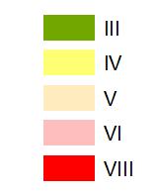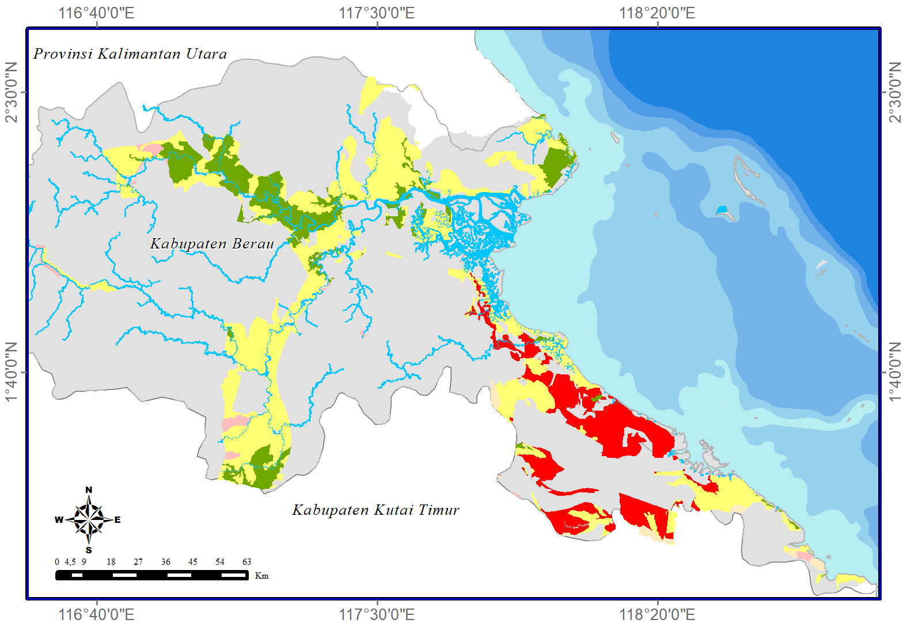

Figure 3. Land Capability Class

The results of data analysis show that the land capability class is dominated by class IV with a total area of ​​214,761.25 ha. The limiting factors for each SST are influenced by slope slope, erosion rate, soil depth, permeability, drainage and threat of flooding.

Inappropriate land use (Land capability classes V, VI, and VIII are found in SPL (BKN, KPR, OKI, PDH, and PSP) with a total area of ​​119792.57 ha, so there is a need for recommendations to change land use to suit land capabilities and apply conservation technology according to land needs so that land damage does not occur and the land can be used sustainably.

Soils in class III have severe constraints that reduce use options or require special conservation measures or both. Constraints on land in class III land include limiting the time of use for annual crops, processing time, choice of plants or a combination of these constraints. Obstacles and threats of damage on land in class IV are greater than on land in class III, and crop choices are also more limited. Slope (topography) is one of the factors that drives land erosion. The steepness of the slope influences the amount of surface flow and water transport energy on soil particles. If the slope is greater, the number of soil grains that are splashed down by the impact of raindrops will increase [9].

In the analysis of Land Map Units (SPL) which have Capability Class V-p, consisting of SPL-BKN and SPL-OKI are divided into two areas, namely plantations and dry land agriculture. This discrepancy is caused by heavy soil permeability factors. Permeability is classified as slow (less than 0.5 cm/hour) [9]. This class of land is not threatened by erosion, but has other obstacles that are impractical to remove and is therefore only suitable for grass crops, pastures, production forests, protected forests or nature reserves. Soils in this class have obstacles that limit the choice of uses and plants, and hinder the cultivation of land for annual crops.

In the analysis of SPL-PDH and SPL-PSP which are included in land capability class VI-l, this area is only in plantation areas. The main factor causing this mismatch is the condition of steep slopes, which increases the risk of erosion and land degradation if used for activities. Steep areas used for agriculture are areas that are very prone to landslides [11]. Soils in this class have heavy obstacles, making this land unsuitable for agricultural land use, and limited to perennial crops and forests [10].

Land capability class VI must be avoided from use for agricultural land because permanent barriers are very heavy and most of the land has steep slopes. Class VI can be managed for use in continuously rejuvenated grasslands, production forests, protected forests or nature reserves [12]. Therefore, this area requires more careful management or a change in designation that is more in line with existing biophysical conditions in order to maintain environmental sustainability. Erosion is one of the factors that causes a decrease in soil fertility, disrupts plant growth and reduces crop yields. Controlling soil erosion means reducing the influence of these erosion factors, so that the process can be hampered or reduced [10].

In the SPL-KPR analysis which is included in Capability Class VIII-p. Land in capacity class VIII has inhibiting factors such as very fast soil permeability and steep slopes so that its use is not suitable for agricultural land. As Capability Class VIII, this area has very high limitations and is more suitable to be used as a conservation area to maintain its ecological function and prevent environmental damage. Class VIII land is ideally not permitted or prohibited for agricultural activities, and should be left in its natural state.

Land capacity classes III to IV are still suitable for agricultural businesses, while land capacity classes V to VIII should be put to other uses.

3.3. Land Suitability Evaluation

The results of land suitability evaluation based on land capability classes are presented in Table 5 and Figure 4.

Table 5. Evaluation of Conformity Based on Land Capability Class

| **No** | **Evaluation of Land Capability** | **Land Map Unil**  **(SPL)** | **Areas** | |
| --- | --- | --- | --- | --- |
| **(hectares)** | **(%)** |
| 1 | Suitable | BRW, GBJ, JLH, KHY, KJP, LWG, LPR, MPT, MDW, PSB, SBG, TWH, TWB | 381.682,71 | 76.11 |
| 2 | No Suitable | BKN, KPR, OKI, PDH, PSP | 119.792,57 | 23.89 |
| **Total** | | | 501.475,28 | 100 |

Source: Results of Research Data Analysis, 2024

The evaluation results show that there are two areas of land that are suitable and that are not suitable, namely the total area of ​​land that is declared suitable is 501.475,28 hectares (76.11%) and the area of ​​land that is temporarily declared unsuitable is 119.792.57 hectares (23.89%). This situation shows that the majority of land evaluated has capabilities that correspond to the specified capability class. This is very important in managing natural resources, because a proper understanding of land capabilities can increase the efficiency of its use and maintain environmental stability. Handling of unsuitable land must be taken seriously to increase the added value of the land and reduce the risk of environmental damage.

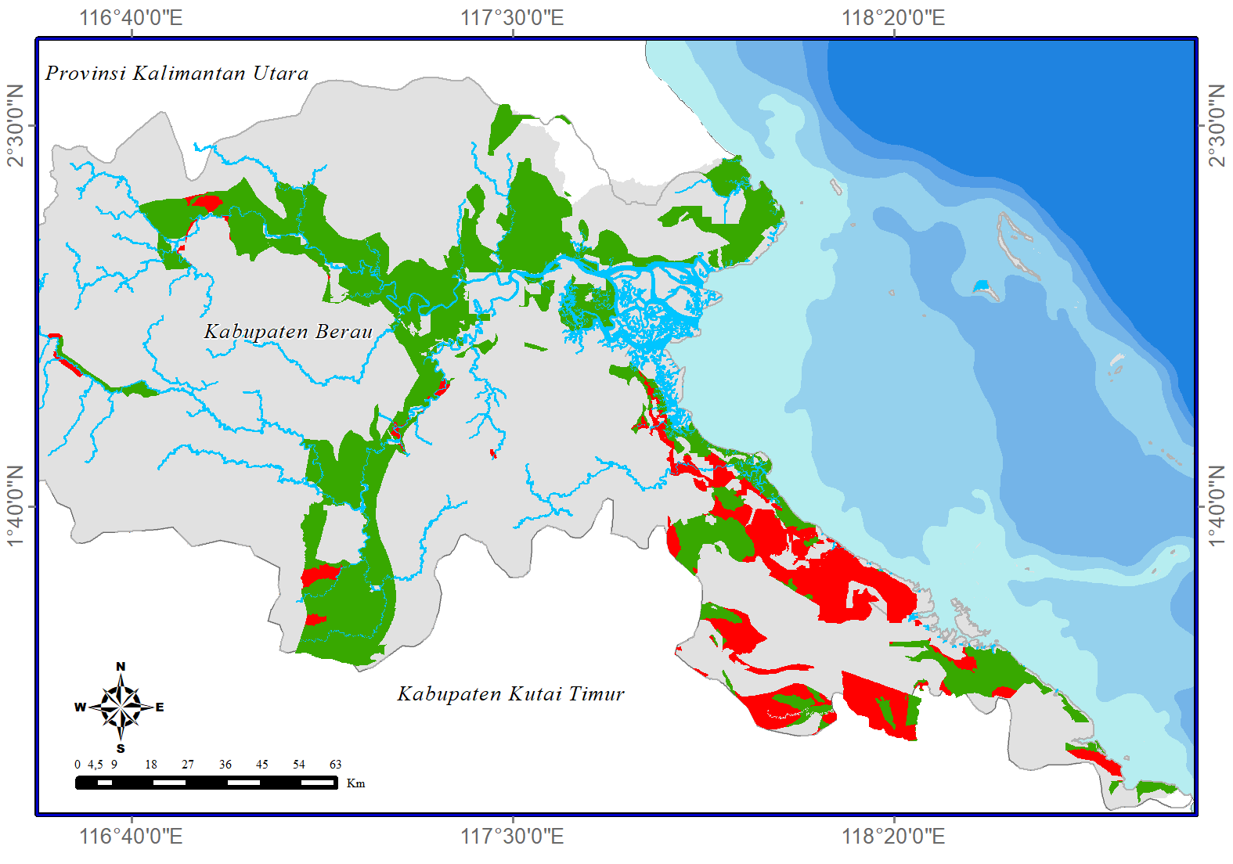

Figure 4. Suitability of Agricultural Land Based on Land Capability Class

**4. CONCLUSIONS AND RECOMMENDATIONS**

**4.1. Conclusion**

Based on the results of the research and discussion, it is concluded that:

1. The total area of ​​land that is declared appropriate is 501,475.28 hectares (76.11%) and the area of ​​land that is temporarily declared non-compliant is 119,792.57 hectares (23.89%).

2. This non-conformity occurs on land with land capability classes V, VI and VIII.

**4.2. Suggestion**

Areas that are not suitable for agriculture should be recommended for other land uses.

**REFERENCES**

[1] Andrie, B. A. and Novianty, A. 2021. Optimizing Red Chili Farmers' Income with Farming Diversification. Journal of Community Thinkers with Agribusiness Insights. 7(1):254–266.

[2] Hendrawan, F. J. T., and Dewi, R. M. 2016. Analysis of the Impact of Converting Agricultural Land to Residential Areas on Farmers' Income in Puncel Hamlet, Deket Wetan Lamongan Village. J. Educator. Econ. 4(3): 1–10.

[3] Sitorus, S. R. P. 1985. Evaluation of Land for Non-Agricultural Uses. Land Resource Evaluation. 155–165. Bandung.

[4] Kusumaningrum, S. I. 2019. Utilization of the Agricultural Sector to Support Indonesian Economic Growth. J. Transactions. 11(1):80-89.

[5] Republic of Indonesia Financial Audit Agency. 2007. Law Number 26 concerning Spatial Planning. Jakarta

[6] Osok, R. M., Talakua, S. M., and Supriadi, D. 2018. Determination of Land Capability Classes and Directions for Land Rehabilitation in the Wai Batu Merah River Basin, Ambon City, Maluku Province. J. Agrologia. 7(1). doi: 10.30598/a.v7i1.355.

[7] Presidential Regulation of the Republic of Indonesia number 60 of 2020 concerning Spatial Planning for Urban Areas in Jakarta, Bogor, Depok, Tangerang, Bekasi, Puncak, and Cianjur, vol. 2003, no. 1. 2020, p. 1–5.

[8] Central Statistics Agency. 2024. Berau Regency in Numbers. Berau Regency.

[9] Arsyad, S. 2010. Soil and Water Conservation, 2 ed. Bogor: IPB Press.

[10] Harjianto, M., Sinukaban, N., Tarigan, S. D., and Haridjaja, O. 2016. Evaluation of land capacity for land use direction in the Lawo watershed, South Sulawesi. J. Researcher. Forestry. Wallacea. 5(11): 1–11.

[11] Fadilah, N., Arsyad, U., and Soma, A.S. 2019. Analysis of Landslide Susceptibility Level Using the Frequency Ratio Method in the Bialo River Watershed. J. Perennial.15(1):42, 2, doi: 10.

[12] Eraku, S.S., and Permana, A.P, 2020. Analysis of Land Capability and Suitability in the Alo River Watershed, Gorontalo Province. Jukung (Environmental Tech Journal). 6(1): 86–99, doi: 10.20527/jukung.v6i1.8243.