**Impact of PSB formulations in enhancing Phosphorous Use Efficiency in Blackgram**

**Abstract**

Blackgram the leguminous plant obtains atmospheric nitrogen through its root nodules. The availability of phosphorus to legume crop is a key constraint for its production due to growth and development of roots. Therefore, the experiment was aimed to find the effect of PSB formulations in enhancing phosphorus use efficiency in blackgram. The results revealed that application of 37.5 kg/ha P2O5 with PSB @ 4 ml/kg seeds resulted in increased phosphatase activity (72.31 μg PNP/g of soil/hr), which in turn resulted in higher PUE (30.42 %) and thereby uptake of nitrogen (120.05 kg/ha), phosphorus (11.41 kg/ha) and potassium (37.51 kg/ha) in plant was high in the main plot, sub plot and interacted plots compared to carrier-based formulation (CBF). Thus, Liquid based bio-fertilizer (LBF) is promising and updated technology than the conventional carrier-based bio-fertilizer. Additionally, The study shows that the liquid formulation @4 ml/kg seed suits best over carrier formulation and among other liquid formulations when compared with the recommended nutrient dose.

**Key words:** PSB, phosphatase activity, PUE and blackgram

**Introduction**

Blackgram (*Vigna mungo*) is an important pulse crop known for its nutritional value and contribution to soil fertility through nitrogen fixation. India is one of the largest producers and consumers of pulses, with blackgram accounting for 10-12% of total pulse production. It is cultivated across different seasons (kharif, rabi, and summer) and is a major component of traditional diets, especially in the form of fermented foods like idli, dosa, and papad. The crop is widely grown in India, with Andhra Pradesh, Rajasthan, Maharashtra, Odisha, Uttar Pradesh, Bihar, Punjab, Tamil Nadu, Karnataka, Gujarat, and Madhya Pradesh being the major producing states. In India, blackgram is cultivated on 3.129 million hectares, producing 1.829 million tons, with an average productivity of 655 kg/ha. In Karnataka, it is grown on 1.02 lakh hectares, yielding 0.5 lakh tons, with an average productivity of 206 kg/ha (Anonymous, 2016). Despite its importance, the productivity of blackgram remains low due to several agronomic constraints, including traditional cultivation practices and nutrient deficiencies, particularly phosphorus (P). Phosphorus is a vital macronutrient required for plant growth, root development, and nodulation in legumes. However, its availability in soil is often limited due to fixation in insoluble forms. The excessive or imbalanced use of chemical phosphorus fertilizers can lead to reduced bioavailability, disrupting microbial activity in the rhizosphere and ultimately affecting plant growth and yield (Singh et al., 2008). Phosphate-solubilizing bacteria (PSB) play a crucial role in enhancing phosphorus availability by converting insoluble forms into plant-accessible forms through mineralization, solubilization, and enzymatic activity. The integration of PSB with phosphorus fertilization has been shown to improve phosphorus uptake, enhance root growth, and increase productivity in leguminous crops, including blackgram. Studies indicate that PSB inoculation can save up to 50% of the phosphorus fertilizer requirement, making it an economically and environmentally viable alternative to chemical fertilizers (Bhattacharyya and Kumar, 2002; Brar et al., 2012). However, traditional carrier-based bio-fertilizers (CBF) have several limitations, including short shelf life, low microbial viability, and reduced moisture retention, making them less effective under field conditions. The moisture-retaining capacity of CBFs is low, leading to a decline in microbial populations over time. Additionally, bulk sterilization techniques often fail to ensure microbial viability, leading to contamination issues and limiting their widespread adoption by farmers (Singleton et al., 2002). Liquid-based bio-fertilizers (LBF) have emerged as a promising alternative to traditional carrier-based formulations. LBFs offer several advantages, such as higher microbial viability, ease of application, extended shelf life, and better adaptability to environmental conditions. Unlike CBFs, LBFs remain viable for a longer duration, ensuring effective colonization of plant roots and enhancing phosphorus uptake. Studies have demonstrated that LBFs improve soil microbial activity, boost phosphorus availability, and contribute to sustainable blackgram production (Deaker et al., 2004). The University of Agricultural Sciences, Dharwad, has recommended nutrient management practices involving the application of farmyard manure (FYM) at 5 t/ha along with 25 kg N and 50 kg P₂O₅/ha under rainfed conditions in Karnataka. Despite these advancements, research on the combined effects of different levels of phosphorus and PSB formulations, particularly in liquid form, on blackgram productivity remains limited. Therefore, this study was conducted to evaluate the effectiveness of different PSB formulations in improving phosphorus use efficiency and yield performance of blackgram in the Northern Transition Zone of Karnataka. The study aims to identify the optimal combination of phosphorus levels and PSB application methods to enhance blackgram productivity while maintaining soil health and sustainability. The findings are expected to provide insights into effective nutrient management strategies that can benefit farmers and contribute to the broader goals of sustainable agriculture.

**Materials and Methods**

**Experimental Site and Design**

The field experiment was conducted at the Main Agricultural Research Station, University of Agricultural Sciences, Dharwad, during the Kharif season of 2018. The site is geographically located at 15º30’6” N latitude and 74º59’12.4” E longitude, with an altitude of 678 m above mean sea level. The experiment was laid out in a split-plot design with three replications​.

**Climatic Conditions**

The meteorological data recorded during the cropping period showed an annual rainfall of 892.2 mm, compared to the 68-year average of 718.23 mm. The maximum mean monthly temperature recorded was 28.8°C in June and 29.6°C in September, while the minimum temperature ranged from 21°C (June) to 18.9°C (September). Relative humidity was highest in July (87.55%) and August (87.2%). (Fig.1)

**Experimental Treatments**

The treatments comprised of four main plots (No P - fertilizer to crop, 25 kg of P2O5/ha, 37.5 kg of P2O5/ha and 50 kg of P2O5/ha) and three sub plots [(PSB @ 4 ml/kg seeds (Liquid formulation), PSB @ 8 ml/kg seeds (Liquid formulation) and PSB @ 500 g/ha seeds (Carrier formulation)].Prior to sowing, the seeds were treated with *Rhizobium* @200g/ha whereas FYM was applied @5t/ha to

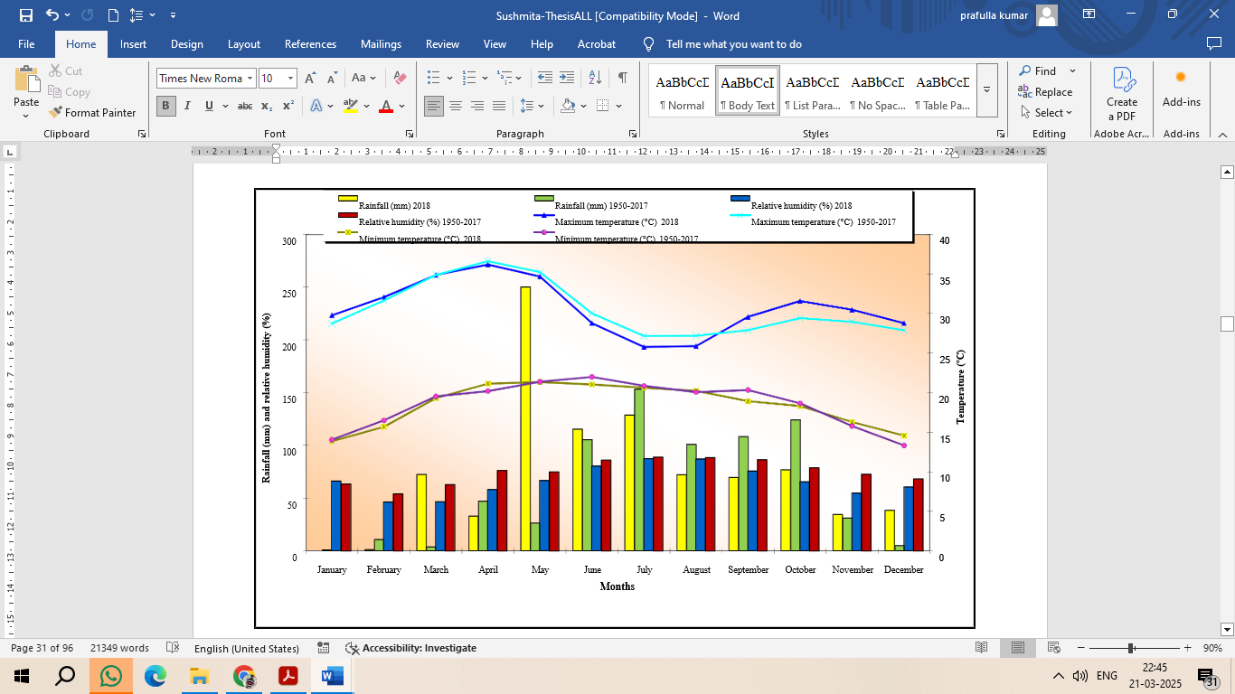

**Figure 1. Monthly meteorological data during crop growth period (2018) and the average of 68 years (1950-2017) at the Main Agricultural Research Station, Dharwad**

soil. Initially, pH, organic carbon, available nitrogen, phosphorous of the soil corresponds 6.67, 0.57%, 209 kg/ha and 22.4 kg/ha respectively (M. L. Jackson, 1973; Walkley and Black, 1934; B. V. Subbaiah, 1956; Olsen *et al*.,1954). The seeds were sown @ 15kg/ha in 30 × 10cm2. Plant samples were collected and analyzed for NPK uptake while soil was sampled for available NPK at harvesting stage and for phosphatase enzyme at peak flowering stage (M. L. Jackson, 1973; Eivazi and Tabatabai, 1977). Phosphorous use efficiency was calculated as [α]. In addition, the data was also recorded for seed yield.

$Phosphorus Use Efficiency \left(\%\right)=\frac{P taken by the crop}{P applied to plant}×100$....[α]

**Statistical Analysis**

The experimental data were analyzed using Analysis of Variance (ANOVA) as per Gomez and Gomez (1984) at a 5% significance level (P=0.05). Treatment means were compared using Duncan’s Multiple Range Test (DMRT). The data was analyzed for LSD and the correlation study was also carried outusing excel sheet.

**Result and Discussion**

The data in Table 1 clearly indicate that the application of 37.5 kg P₂O₅/ha with 4 ml/kg PSB in liquid-based formulation (LBF) significantly enhanced nutrient uptake, enzymatic activity, and yield components of blackgram. The nitrogen uptake was highest at 120.05 kg/ha in the interactive plot (M3L1), whereas phosphorus and potassium uptake were 11.41 kg/ha and 37.51 kg/ha, respectively. This might be due to the more expansion and surface area of roots, which gave more room for plant-microbe interaction resulting in increased nutrient content in root zone. The system in which higher dry matter is produced will remove more nutrients than the one producing less dry matter. Nitrogen uptake in particular is also influenced by *Rhizobium* inoculation, which might have helped in increased enzymatic activity for more available nitrogen. PSB are reported to facilitate the phosphorus availability to plant by solubilizing insoluble phosphorus by production of organic acids and results in better phosphorus uptake by blackgram. (Swaminathan et al., 2023). The increased uptake of phosphorus (8.83–11.41 kg/ha) and potassium (29.40–37.51 kg/ha) in the M3L1 treatment suggests that phosphorus application at an optimal level (37.5 kg/ha) facilitated better root expansion and nutrient availability (Figure 2) PSB plays a crucial role in solubilizing phosphorus from unavailable forms into plant-accessible forms, thereby improving phosphorus use efficiency (PUE) (Goud *et al*., 2010).

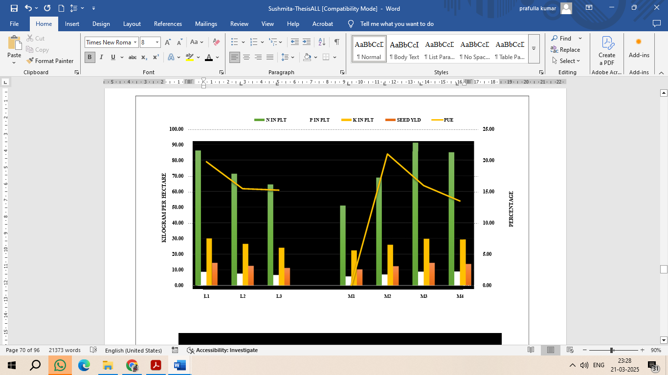

**Figure 2. Effect of PSB formulations and Phosphorus levels on nutrient uptake, PUE and yield**

Phosphatase enzymes play a crucial role in phosphorus mineralization and availability in soil. The highest phosphatase activity (72.31 μg PNP/g of soil/hr) was recorded in the M3L1 treatment, reinforcing the role of PSB in facilitating phosphorus mobilization. The lower phosphatase activity in carrier-based formulations (CBF) compared to LBF suggests that liquid formulations provide a better microbial environment, ensuring prolonged bacterial viability and activity. Reddy et al. (2020) postulated that phosphatase activity is directly influenced by microbial biomass and nutrient competition, which could explain the relatively lower activity in CBF. The synergistic effect of phosphorus and PSB resulted in improved root development and rhizospheric nutrient enrichment. The expansion of root surface area in M3L1 treatment provided a larger contact zone for plant-microbe interactions, enhancing nutrient absorption. Similar results were reported by Reddy et al. (2020), who observed that phosphorus solubilization by PSB leads to increased nitrogen and phosphorus availability in the root zone, thereby improving crop performance​. Microbial population recorded in the rhizosphere soil at flowering stage indicated significant increase due to application of liquid based PSB, which resulted in increased values of phosphatase activity, which in turn resulted in 55.2 per cent higher phosphorus use efficiency and there by the phosphorus uptake in the plant and the available phosphorus in the soil was also found to be higher than the recommended practice. This had pronounced effect and contributed in obtaining 24.3 per cent higher yields (Figure 3). This is due to application of liquid based biofertilizers at sowing and after six weeks will enhance higher number of cells in the rhizosphere, which will compete with the nature genera and also soil application of FYM will result in higher multiplication and sustenance of cells due to availability of carbon and energy sources. (Panwar *et al*., 2003). The high impact of combined application might be due to the expansion of surface area of roots giving more room for plant-microbe interaction resulting in increased nutrient content in root zone (Reddy *et al*., 2020). Nitrogen uptake especially influenced by *Rhizobium* inoculation while phosphorous activity is influenced by PSB inoculation which might have helped in increasing the enzymatic activity for more available nitrogen and phosphorus availability to plant by solubilizing insoluble phosphorus by production of organic acids by blackgram (Janati *et al*., 2022). Increased PUE (30.42%) resulted in higher uptake of nutrients in plants and thereby recorded higher yield. The results confirm that the application of 37.5 kg P₂O₅/ha with PSB at 4 ml/kg seeds in liquid formulation (M3L1) is the most effective strategy for enhancing nutrient uptake, improving phosphorus use efficiency, and increasing blackgram yield (Keteku *et al.,* 2022). This approach promotes sustainable agricultural practices by minimizing excessive fertilizer usage and optimizing plant-microbe interactions in the rhizosphere.

|  |  |  |  |  |  |  |
| --- | --- | --- | --- | --- | --- | --- |
| **Table – 1: Nutrient uptake by plant, phosphorous use efficiency, phosphatase activity and seed yield** | | | | | | |
| **Treatments** | **N** | **P** | **K** | **PUE** | **PA** | **Y** |
| **Main plots: Phosphorus levels** | | | | | | |
| **M1** | 51.00 | 5.80 | 22.37 | 0.00 | 45.80 | 1026 |
| **M2** | 68.80 | 7.00 | 26.06 | 28.00 | 55.07 | 1231 |
| **M3** | 91.20 | 8.83 | 29.40 | 21.30 | 68.57 | 1447 |
| **M4** | 85.03 | 9.00 | 29.40 | 18.00 | 64.27 | 1379 |
| LSD @ 5% | 12.79 | 1.09 | 3.71 | 2.99 | 2.53 | 157 |
| **Sub-plots: PSB** | | | | | | |
| **L1** | 86.19 | 8.67 | 30.01 | 19.74 | 59.53 | 1441 |
| **L2** | 71.38 | 7.61 | 26.59 | 17.18 | 59.20 | 1254 |
| **L3** | 64.44 | 6.69 | 24.13 | 15.21 | 56.57 | 1117 |
| LSD @ 5% | 7.51 | 0.49 | 1.737 | 1.08 | 1.57 | 75 |
| **Interaction** | | | | | | |
| **M1L1** | 56.23 | 6.24 | 23.95 | 0.00 | 45.35 | 1107 |
| **M1L2** | 49.43 | 5.73 | 21.99 | 0.00 | 47.98 | 1021 |
| **M1L3** | 47.36 | 5.48 | 21.19 | 0.00 | 44.03 | 950 |
| **M2L1** | 74.42 | 7.23 | 26.87 | 28.92 | 55.15 | 1280 |
| **M2L2** | 66.09 | 6.91 | 25.66 | 27.65 | 56.06 | 1226 |
| **M2L3** | 65.90 | 6.84 | 25.65 | 27.35 | 53.94 | 1188 |
| **M3L1** | 120.05 | 11.41 | 37.51 | 30.42 | 72.31 | 1873 |
| **M3L2** | 80.26 | 8.19 | 27.47 | 21.85 | 65.97 | 1294 |
| **M3L3** | 73.23 | 6.92 | 24.46 | 18.44 | 67.46 | 1174 |
| **M4L1** | 94.09 | 9.80 | 31.73 | 19.61 | 65.32 | 1506 |
| **M4L2** | 89.72 | 9.63 | 31.22 | 19.26 | 66.76 | 1474 |
| **M4L3** | 71.25 | 7.52 | 25.23 | 15.05 | 60.77 | 1156 |
| LSD @ 5% | 15.01 | 0.98 | 3.48 | 2.16 | 3.14 | 151 |
| Where N, P, K - Nitrogen, Phosphorous, Potassium uptake (Kg/ha), PUE - Phosphorus use efficiency (%); PA - Phosphatase activity (μg PNP g-1 of soil hr-1); Y – Seed yield (Kg/ha). | | | | | | |

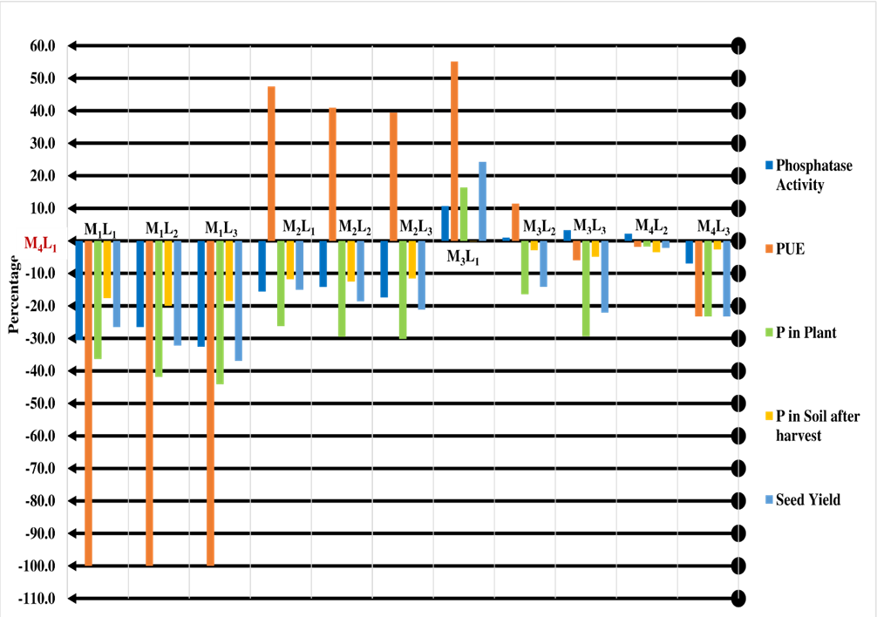

**Fig 3: Percent comparison of phosphorous balance and yield in blackgram as influenced by different phosphorous level and PSB formulation with recommended dose**

**Conclusion**

The findings of this study highlight the significant impact of integrating phosphorus fertilization with phosphate-solubilizing bacteria (PSB) in liquid formulation on blackgram productivity. The application of 37.5 kg P₂O₅/ha along with PSB at 4 ml/kg seeds (M3L1) resulted in enhanced nutrient uptake, higher phosphorus use efficiency (PUE), and increased seed yield compared to other treatments. This combination facilitated better root proliferation, microbial activity, and enzymatic phosphorus solubilization, leading to improved availability of essential nutrients such as nitrogen, phosphorus, and potassium. The study also demonstrated that liquid-based biofertilizers (LBF) were more effective than carrier-based formulations (CBF) in enhancing phosphatase activity and microbial populations in the rhizosphere. The increased phosphorus availability and root-microbe interactions led to 24.3% higher yields and 55.2% greater phosphorus use efficiency than conventional fertilization practices. The economic analysis further confirmed that this integrated approach provides a cost-effective and sustainable alternative to excessive chemical fertilizer use. Overall, the study underscores the importance of optimizing phosphorus application and promoting biofertilizer-based nutrient management to enhance blackgram yield while maintaining soil health. These findings support the adoption of integrated nutrient management strategies that reduce environmental risks, lower input costs, and improve agricultural sustainability. Future research should focus on long-term field trials and the potential role of multi-strain microbial consortia to further enhance nutrient cycling and crop resilience in different agro-climatic conditions.

**References**

1. Bhattacharyya, P. and Kumar, R., 2002, Liquid bio-fertiliser current knowledge and future prospect. Proc. of the national seminar on development and use of bio-fertilizers, bio-pesticides and organic manures, Bidanchandra Krishi Vishwa Vidyalaya, November 10-12, 2000, B. C. K. V., Kalyani, West Bengal :10 - 21.
2. Brar, S. K., Sarma, S. J. and Chaabouni, E., 2012, Shelf-life of bio-fertilizer, an accord between formulation and genetics. *J. Biofertil. Biopestic*., 3(5): 1-2.
3. Deaker, R., Roughley, R. J. and Kennedy, I. R., 2004, Legume seed inoculation technology review. *Soil Biol. Biochem*., 36: 1275-1288.
4. Eivazi, F, & Tabatabai, M A (1977). Phosphatases in soils. *Soil biology and biochemistry*, *9*(3), 167-172.<https://doi.org/10.3389/fagro.2021.637196>
5. Goud, V.V., Kale, H.B and Patil, A.N., 2010, Performance of organically grown mungbean under rainfed condition in vertisol. *Journal of Food Legumes*. 23: 218-222.
6. Jackson M. L (1973). Soil chemical analysis. Englewood Cliffs, N. J. New Delhi, India: Prentice-Hall, Inc
7. Janati W, Benmrid B, Elhaissoufi W, Zeroual Y, Nasielski, J & Bargaz A (2022). Will Phosphate Bio-Solubilization Stimulate Biological Nitrogen Fixation in Grain Legumes. Maximizing *Nitrogen Fixation in Legumes as a Tool for Sustainable Agriculture Intensification*.
8. Keteku, A. K., Yeboah, S., Agyemang, K., Amegbor, I., Danquah, E. O., Amankwaa-Yeboah, P., ... & Frimpong, F. (2022). Evaluation of carrier-and liquid-based bioinoculant as a promising approach to sustain black gram (Vigna mungo L.) productivity. *International Journal of Plant Production*, *16*(4), 741-754.
9. Olsen S R., Cole C V, Watanabe F S, and Dean L (1954). Estimation of available phosphorus in soils by extraction with sodium bicarbonate. USDA Circular 939. U.S. Government Printing Office, Washington D.C.
10. Panwar, A. S., Yadav, D. S., & Bhatt, J. C. (2003). Effect of phosphorus levels and phosphate solubilizing bacteria on yield and phosphorus uptake of blackgram (Vigna mungo) under mid-hill conditions of northwest Himalayas. *Indian Journal of Agricultural Sciences, 73(3), 147-149.*
11. Quintana M, Sanchez, Colmenarejo E M. F, Barrera J, Garcia, G, & Borja R. (2005). Kinetics of phosphorus removal and struvite formation by the utilization of by-product of magnesium oxide production. Chemical Engineering Journal, 111(1), 45-52.
12. Reddy Priya P & Gopalaswamy G (2020). Impact Assessment of Mixed Biofertilizers on Soil Physico-biochemical Properties under Pot Culture Studies. *International Journal of Microbiology Research*, 12(7), 1858-1861.
13. Singh, R.P., Gupta, S.C and Yadav, A.S., 2008, Effect of levels and sources of phosphorus and PSB on growth and yield of blackgram (*Vigna mungo* L.). *Legume Res*., 31: 139-141.
14. Singleton, P. W., Keyser, H. H. and Sande, E. S., 2002, Development and Evaluation of liquid inoculants and Nitrogen fixation of legumes in Vietnam (ed) D. Herridge. *AICAR Proceedings*. 109: 52-66.
15. Subbaiah B V (1956). A rapid procedure for estimation of available nitrogen in soil. *Curr. Sci.*, *25*, 259-260.
16. Swaminathan, C., Surya, R., Subramanian, E., & Arunachalam, P. (2023). Challenges in pulses productivity and agronomic opportunities for enhancing growth and yield in blackgram [Vigna mungo (L.) Hepper]: a review. *Legume Research-An International Journal*, *46*(1), 1-9.
17. Walkley, A., & Black, I. A. (1934). An examination of the Degtjareff method for determining soil organic matter, and a proposed modification of the chromic acid titration method. *Soil science*, *37*(1), 29-38.