**Original Research Article**

**Thoracic Radiographical Changes In Respiratory Tract Infection In Dog.**

**ABSTRACT:**

This research was undertaken from October, 2022 to June, 2023 to study the thoracic radiographical interpretation in thirty dogs suffered from respiratory tract infection.Dogs were equally divided into three groups, viz. Group B, Group C and Group D and were treated with doxycycline hydrochloride, enrofloxacin, ceftriaxone sodium respectively along with other supportive therapy.By using Type-ME 0610M (Tech-60. KV-100) X-ray machine thoracic radiographs were taken on each dog of different treatment groups on the 0th day (pre-treatment) and the 10th day (post-treatment). Two (lateral and ventro-dorsal) views of thoracic radiographs were taken from each suspected dogs. The result of thoracic radiographical interpretation revealed highly significant difference in the bronchial and alveolar pattern, but not in the pleural effusion pattern between 0th day and 10th day within eachtreatment groups.

*Keywords:Alveolar pattern, Bacterial infection,Bronchial pattern, Dog, Thoracic radiography*

**1. INTRODUCTION:**

Dog (*Canisfamiliaris*) is the first domesticated animal and has interaction with human beings (Freedman and Wayne, 2017). In a research study by Pescini et al*.* (2019) explained that dogs as well as human both release oxytocin and they inferred that oxytocin is the main reason for creating a strong social bond between human being and pet animal. Anatomically respiratory tract is broadly classified into upper respiratory tract (nose, nasal sinus, larynx) and lower respiratory tract (trachea, bronchi, bronchiole, alveoli and lungs) (Chakrabarti, 2014). Dogs are affected by both infectious as well as non-infectious diseases. Rabies, leptospirosis, scabies, dermatophytosis, yersiniosis, cryptosporidiosis, MRSA etc. are a few zoonotic diseases which can be transmitted from dogs to humans and cause serious life threatening illness in personnel with specific medical conditions like immunodeficiency, chronic illness, pregnancy etc. In canine practice, among the various causes of respiratory tract infections (RTI) bacterial involvement is one of the common reasons. Qekwana et al. (2020) found that

in RTI of dogs, various kind of bacteria are involved *viz. Staphylococcus* spp., *Streptococcus* spp., *Escherichia coli*, *Pasteurella* spp., *Klebsiella* spp*., Pseudomonas* spp*., Bordetella bronchiseptica* etc. Since dogs are living with human in close contact, they are quite frequently exhibiting respiratory tract infections. Hence, to render proper treatment, accurate diagnosis is highly recommended to attain a significant recovery. Diagnosing RTI in dogs includes advanced imaging techniques like thoracic radiography is very much helpful apart from the PCR to identify specific infectious agents; culture of upper respiratory secretion, nasal swab and trans tracheal wash; antibiotic sensitivity test and complete blood count etc. are also play significant role.In thoracic radiography, alveolar and bronchial infiltrates are found in bacterial pneumonia (Viitanenet al.,2017).Considering the importance, present study was undertaken to determine the thoracic radiographical changes in bacterial respiratory tract infection in dogs.

**2. MATERIALS AND METHODS:**

**2.1. Place of work and source of animal:**Dogs (n=30) presented to the Veterinary Clinical Complex (VCC), College of Veterinary Science, Assam Agricultural University, Khanapara from different parts of Assam and neighbouring states of the North-Eastern Region during the period from October, 2022 to June, 2023 were considered for the study. The work was approved by the Institutional Animal Ethics Committee.

**2.2. Physical examination, grouping and treatment of suspected dogs:**Dogs presented in the VCC with a history of coughing, sneezing, presence of nasal discharge, respiratory distress including clinical symptoms *viz.* pattern of nasal discharge, types of coughing, rectal temperature, sneezing, auscultation of lungs etc. were recorded during clinical examination.Dogs were equally divided into three groups, viz. Group A, Group B and Group C and were treated with doxycycline hydrochloride (10 mg/kg body weight i/v or orally) daily for 10 days, enrofloxacin (5 mg/kg body weight i/m or s/c or orally), ceftriaxone sodium (20 mg/kg body weight i/vly) respectively along with other supportive therapy (nebulization, proteolytic enzymes, mucolytic, diuretics, anti-inflammatory dugs, anti allergic drug etc.) for 10 days. Supportive therapy was given based on the requirements of the affected animals.

**2.3. Thoracic radiography:** Thoracic radiographs were taken by using Type-ME 0610M (Tech-60. KV-100) X-ray machine (Siemen-Healthcare Pvt. Ltd., Mumbai 400079)from the selected clinical cases (n=30) on 0th day and after treatment (10th day). Each case was assessed by the scoring system according to Kogan *et al*. (2008), the score was given on the basis of severity of the lung fields. For the bronchial pattern scoring system used was mild =1, moderate=2and severe=3 and for the alveolar pattern, mild=4, moderate=5 and severe=6.The presence of pleural effusion in the thoracic radiography was scored as absent=0, mild=1, moderate=2 and severe=3 based on the severity according to Lynch *et al*. (2012).Based on Vertebral Heart Score, the cardiac size of selected clinical cases was assessed and evaluated for cardiovascular disorder according to Buchanan and Bucheler (1995).

**3. RESULTS AND DISCUSSION:**

**3.1 Bronchial Pattern and alveolar pattern:**The radiographic interpretation of clinical cases revealed bronchial patterns in the lateral and ventro-dorsal view of the thoracic radiograph which is shown in Table 1and Fig.1. In Group B (pre-treatment of Doxycycline) moderate bronchial pattern was found in six dogs and a severe bronchial pattern was found in four dogs. In Group B (post-treatment of Doxycycline), there was the absence of a bronchial pattern in six dogs, a mild bronchial pattern in two dogs and a moderate bronchial pattern in one dog. The highly significant difference (*P*<0.01) was found within Group B *i.e.* pre and post- treatment with Doxycycline. In Group C (pre-treatment of Enrofloxacin), there was a mild bronchial pattern in two dogs, a moderate bronchial pattern in four dogs and severe bronchial pattern in four dogs. In Group C (post-treatment of Enrofloxacin), there was the absence of a bronchial pattern in five dogs, a mild bronchial pattern in two dogs and a moderate bronchial pattern in two dogs. The highly significant difference (*P*<0.01) was found within Group C *i.e*pre and post-treatment of clinically affected dogs with Enrofloxacin. In Group D (pre-treatment of Ceftriaxone), there was the presence of a mild bronchial pattern in one dog, a moderate bronchial pattern in three dogs and a severe bronchial pattern in six dogs. In Group D (post-treatment of Ceftriaxone), there was the absence of a bronchial pattern in eight dogs, a mild bronchial pattern in one dog and a severe bronchial pattern one dog. The highly significant difference (*P*<0.01) was found within Group D pre and post-treatment of clinically affected dogs with Ceftriaxone.

The radiographic interpretation of clinical cases revealed an alveolar pattern in the lateral and ventro-dorsal view of the thoracic radiograph which is shown in Table 2 and Fig.2. In Group B (pre-treatment of Doxycycline) moderate and severe alveolar pattern was found in six and four dogs respectively. In Group B (post-treatment of Doxycycline), there was the absence of alveolar pattern in six dogs, a mild alveolar pattern in two dogs and a moderate alveolar pattern in one dog. The highly significant difference (*P*< 0.01) was found within Group B *i.e.* pre and post-treatment with Doxycycline. In Group C (pre-treatment of Enrofloxacin), there was the absence of alveolar pattern in one dog, mild alveolar pattern in two dogs, moderate alveolar pattern in three dogs and severe alveolar pattern in four dogs. In Group C (post-treatment of Enrofloxacin), there was absence of an alveolar pattern in seven dogs and a mild alveolar pattern in two dogs. The highly significant difference (*P*< 0.01) was found within Group C *i.e*. pre and post-treatment of clinically affected dogs with Enrofloxacin. In Group D (pre-treatment of Ceftriaxone), there was absence of alveolar pattern in one dog, mild alveolar pattern in two dogs, moderate alveolar pattern one dog and severe alveolar pattern six dogs. In Group D (post-treatment of Ceftriaxone), there was absence of alveolar pattern in five dogs, mild alveolar pattern in four dogs and severe alveolar pattern in one dog. The significant difference (*P*< 0.05) was found within Group D *i.e.* pre and post-treatment of clinically affected dogs with Ceftriaxone.

On the 0th day, lateral and ventro-dorsal views of the thoracic radiograph revealed increased bronchial and alveolar patterns in Group B, Group C and Group D. On the 10th day after rendering treatment bronchial and alveolar patterns significantly reduced in all the groups.Similar findings were obtained by Peeters et al. (2000), Foster et al.(2004), Elgalfy et al. (2022) and Menard et al. (2022) who found the presence of alveolar and bronchial patterns in the respiratory tract of infected dogs. Wayne et al. (2017) also found a resolution of radiographic pattern in a bacteria-associated pneumonia affected dog after the administration of antibiotics. In the present study, the bronchial pattern was revealed due to the infiltration of cells and fluids in the bronchial wall or the replacement of peri-bronchial cells by inflammatory cells or fluids. The alveolar pattern is revealed when the inspired air is present in the alveoli of the lung which later on is replaced by exudate or transudate (Spasov et al., 2018).

**3.2. Pleural effusion:**The radiographic observations of clinical cases revealed pleural effusion in the lateral and ventro-dorsal view of the thoracic radiograph which is shown in the Table3 and Fig.3.In Group B (pre-treatment of Doxycycline), there was the absence of pleural effusion and severe pleural effusion in eight and two dogs respectively. In Group B (post-treatment of Doxycycline), there was absence of pleural effusion in seven dogs and mild pleural effusion in two dogs. No significant difference (*P*>0.05) was found within Group B *i.e.* pre and post-treatment with Doxycycline. In Group C (pre-treatment of Enrofloxacin), there was the absence of pleural effusion in four dogs, mild pleural effusion in two dogs and severe pleural effusion in four dogs. In Group C (post-treatment of Enrofloxacin), there was the absence of pleural effusion in nine dogs. In Group D (pre-treatment of Ceftriaxone), there was the absence of pleural effusion in eight dogs, mild pleural effusion in one dog and severe pleural effusion in one dog. In Group D (post-treatment of Ceftriaxone), there was the absence of pleural effusion in nine dogs and severe pleural effusion in one dog. No significant difference (*P*>0.05) was found within Group D *i.e.* pre and post-treatment of clinically affected dogs with Ceftriaxone**.**

These present finding were in accordance to the report of Burnotte et al.(2023) who found pleural effusion present in the dogs which were suffered from bacteria-associated pneumonia. Pleural effusion may develop due to inflammation of the pleura which in turn increases the permeability of vascular endothelium (Yang et al., 2017) or may be due to a cardiac issue (left-sided heart failure, dilated cardiomyopathy) or hypoalbuminemia (Sherding and Birchard, 2006) or may be secondary to bacterial pneumonia.

**3.3. Cardiomegaly:**The radiographic observations of clinical cases also revealed cardiomegaly in the lateral and ventro-dorsal views of thoracic radiographs in three out of thirty dogs showing the percentage of cardiomegaly as 10.00% (Fig.4.). Guglielmini et al*.* (2009) reported that the dogs having cough with cardiac and mixed origin had a higher vertebral heart score than the dogs having cough with non-cardiac origin. The incidence of cardiomegaly is more in dilated cardiomyopathy (Martin and Pereira, 2013).

**Table 1. Bronchial pattern of affected dogsin pre and post-treatmentdays**

|  |  |  |  |  |  |  |  |  |  |
| --- | --- | --- | --- | --- | --- | --- | --- | --- | --- |
| **Attributes** | | | **Absent** | **Mild** | **Moderate** | **Severe** | **Total score** | **Average score** | **Z-value** |
| Assigned score  Groups | | | 0 | 1 | 2 | 3 | - | - | **-** |
| **B** | **Doxycycline**  **(Pre-treatment)** | Frequency | 0 | 0 | 6 | 4 | - | - | **8.76\*\*** |
| Score | 0 | 0 | 12 | 12 | 24 | 2.40 |
| **Doxycycline**  **(Post-treatment)** | Frequency | 6 | 2 | 1 | 0 | - | - |
| Score | 0 | 2 | 2 | 0 | 4 | 0.44 |
| **C** | **Enrofloxacin**  **(Pre-treatment)** | Frequency | 0 | 2 | 4 | 4 | - | - | **8.18\*\*** |
| Score | 0 | 2 | 8 | 12 | 22 | 2.20 |
| **Enrofloxacin**  **(Post-treatment)** | Frequency | 5 | 2 | 2 | 0 | - | **-** |
| Score | 0 | 2 | 4 | 0 | 6 | 0.67 |
| **D** | **Ceftriaxone**  **(Pre-treatment)** | Frequency | 0 | 1 | 3 | 6 | - | - | **8.96\*\*** |
| Score | 0 | 1 | 6 | 18 | 25 | 2.50 |
| **Ceftriaxone**  **(Post-treatment)** | Frequency | 8 | 1 | 0 | 1 | - | - |
| Score | 0 | 1 | 0 | 3 | 4 | 0.40 |

\*\*: *P*<0.01 (highly significant); \*: *P*<0.05 (significant), NS: *P*>0.05 (non-significant)

**Table 2. Alveolar pattern of affected dogsin pre and post-treatment days**

|  |  |  |  |  |  |  |  |  |  |
| --- | --- | --- | --- | --- | --- | --- | --- | --- | --- |
| **Attributes** | | | **Absent** | **Mild** | **Moderate** | **Severe** | **Total score** | **Average score** | **Z- value** |
| Assigned score  Groups | | | 0 | 4 | 5 | 6 | - | - | **-** |
| **B** | **Doxycycline**  **(Pre-treatment)** | Frequency | 0 | 0 | 6 | 4 | - | - | - |
| Score | 0 | 0 | 30 | 24 | 54 | 5.40 | **3.49\*\*** |
| **Doxycycline**  **(Post-treatment)** | Frequency | 6 | 2 | 1 | 0 | - | - |
| Score | 0 | 8 | 5 | 0 | 13 | 1.40 |
| **C** | **Enrofloxacin**  **(Pre-treatment)** | Frequency | 1 | 2 | 3 | 4 | - | - | **3.53\*\*** |
| Score | 0 | 8 | 15 | 24 | 47 | 4.70 |
| **Enrofloxacin**  **(Post-treatment)** | Frequency | 7 | 2 | 0 | 0 | - | - |
| Score | 0 | 8 | 0 | 0 | 8 | 0.90 |
| **D** | **Ceftriaxone**  **(Pre-treatment)** | Frequency | 1 | 2 | 1 | 6 | - | - | **2.2\*** |
| Score | 0 | 8 | 5 | 36 | 49 | 4.90 |
| **Ceftriaxone**  **(Post-treatment)** | Frequency | 5 | 4 | 0 | 1 | - | - |
| Score | 0 | 16 | 0 | 6 | 22 | 2.20 |

\*\*: *P*<0.01 (highly significant); \*: *P*<0.05 (significant), NS: *P*>0.05 (non-significant)

**Table 3. Pleural effusion of affected dogs in pre and post-treatment days**

|  |  |  |  |  |  |  |  |  |  |
| --- | --- | --- | --- | --- | --- | --- | --- | --- | --- |
| **Attributes** | | | **Absent** | **Mild** | **Moderate** | **Severe** | **Total score** | **Average score** | **Z-value** |
| Assigned score  Groups | | | 0 | 1 | 2 | 3 | - | - | **-** |
| **B** | **Doxycycline**  **(Pre-treatment)** | Frequency | 8 | 0 | 0 | 2 | - | - | **0.76NS** |
| Score | 0 | 0 | 0 | 6 | 6 | 0.60 |
| **Doxycycline**  **(Post-treatment)** | Frequency | 7 | 2 | 0 | 0 | - | - |
| Score | 0 | 2 | 0 | 0 | 2 | 0.22 |
| **C** | **Enrofloxacin**  **(Pre-treatment)** | Frequency | 4 | 2 | 0 | 4 | - | - | **-** |
| Score | 0 | 2 | 0 | 12 | 14 | 1.40 |
| **Enrofloxacin**  **(Post-treatment)** | Frequency | 9 | 0 | 0 | 0 | - | - |
| Score | 0 | 0 | 0 | 0 | 0 | 0 |
| **D** | **Ceftriaxone**  **(Pre-treatment)** | Frequency | 8 | 1 | 0 | 1 | - | - | **0.15NS** |
| Score | 0 | 1 | 0 | 3 | 4 | 0.40 |
| **Ceftriaxone**  **(Post-treatment)** | Frequency | 9 | 0 | 0 | 1 | - | - |
| Score | 0 | 0 | 0 | 3 | 3 | 0.30 |

\*\*: *P*<0.01 (highly significant); \*: *P*<0.05 (significant), NS: *P*> 0.05 (non-significant)

**Graph.1. Bar diagram showing bronchial pattern of affected dogs in pre and post-treatment days**

**Graph.2. Bar diagram showing alveolar pattern of affected dogs in pre and post-treatment days**

**Graph.3. Bar diagram showing pleural effusion of affected dogs in pre and post treatment day**

**Graph.4. Pie chart depictingpercentage of dogs showing cardiomegaly**

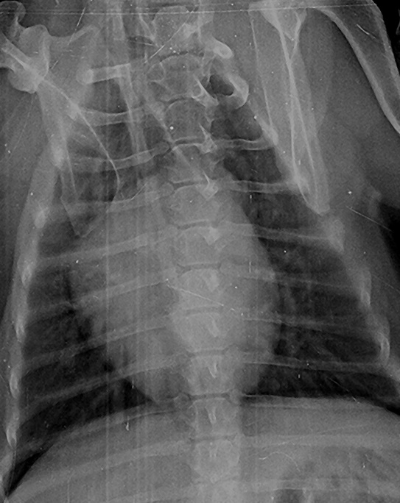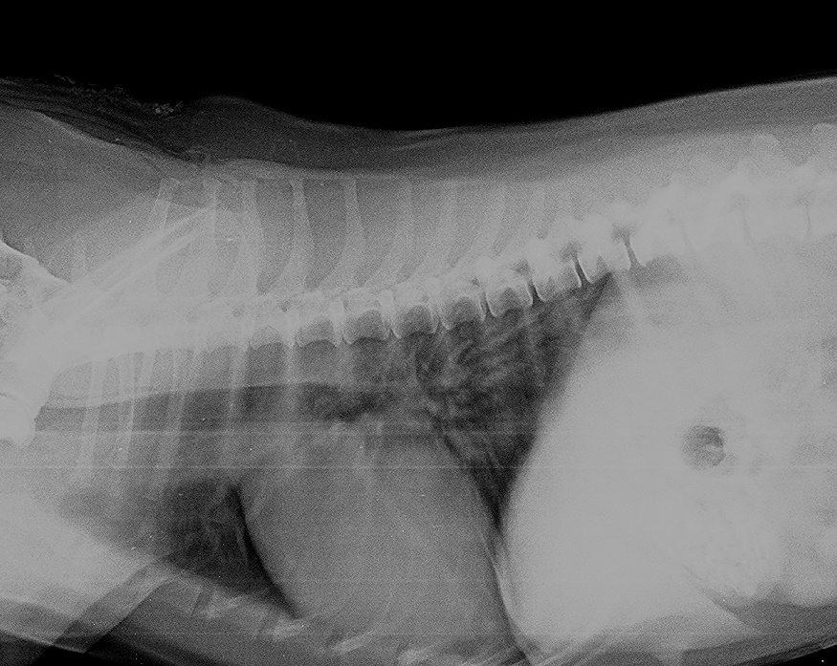

**A B**

**Fig. 1a: Ventro-dorsal (B) and lateral (A) view revealed presence of moderate alveolar and bronchial pattern (pre-treatment, Group B) Arrow mark suggested presence of alveolar and bronchial pattern**

|  |
| --- |
| C:\Users\USER\AppData\Local\Packages\Microsoft.Office.Desktop_8wekyb3d8bbwe\AC\INetCache\Content.Word\Nupur Kalita (Post) VD edited.jpgC:\Users\USER\AppData\Local\Packages\Microsoft.Office.Desktop_8wekyb3d8bbwe\AC\INetCache\Content.Word\Nupur Kalita (Post) lateral edited.jpg |

**A B**

**Fig. 1b: Ventro-dorsal (A) and lateral (B) view revealed absence of alveolar and bronchial pattern (post-treatment, Group B with doxycycline hydrochloride)**

|  |
| --- |
| C:\Users\USER\AppData\Local\Packages\Microsoft.Office.Desktop_8wekyb3d8bbwe\AC\INetCache\Content.Word\pegu (pre) lateral.jpgC:\Users\USER\AppData\Local\Packages\Microsoft.Office.Desktop_8wekyb3d8bbwe\AC\INetCache\Content.Word\pegu (pre) VD.JPG  **A B** |

**Fig. 2a: Lateral (A) and ventro-dorsal (B) revealed severe alveolar and bronchial pattern (pre-treatment, Group C) arrow mark suggested severe alveolar and bronchial pattern**

|  |
| --- |
| C:\Users\USER\AppData\Local\Packages\Microsoft.Office.Desktop_8wekyb3d8bbwe\AC\INetCache\Content.Word\pegu (post) lateral.jpgC:\Users\USER\AppData\Local\Packages\Microsoft.Office.Desktop_8wekyb3d8bbwe\AC\INetCache\Content.Word\Nupur Kalita (Post) VD edited.jpg  **A B**  **Fig. 2b: Lateral (A) and ventro-dorsal (B) view revealed mild alveolar and bronchial pattern**  **(Post-treatment, Group C with enrofloxacin)** |
| C:\Users\USER\AppData\Local\Packages\Microsoft.Office.Desktop_8wekyb3d8bbwe\AC\INetCache\Content.Word\Uparanjan (pre) lateral edited.jpgC:\Users\USER\AppData\Local\Packages\Microsoft.Office.Desktop_8wekyb3d8bbwe\AC\INetCache\Content.Word\Uparanjan (pre) VD edited.jpg  **A B** |

**Fig. 3a: Lateral (A) and ventro-dorsal (B) marked alveolar and bronchial pattern and presence of marked pleural effusion (pre-treatment, Group D) arrow mark suggested severe pleural effusion and that’s why cardiac silhouette not distinct properly.**

|  |
| --- |
| C:\Users\USER\AppData\Local\Packages\Microsoft.Office.Desktop_8wekyb3d8bbwe\AC\INetCache\Content.Word\Uparanjan (post) lateral edited.jpgC:\Users\USER\AppData\Local\Packages\Microsoft.Office.Desktop_8wekyb3d8bbwe\AC\INetCache\Content.Word\Uparanjan (post) VD edited.jpg  **A B**  **Fig. 3b: Lateral (A) and ventro-dorsal (B) mild alveolar and bronchial pattern (post-treatment, Group D with ceftriaxone sodium)** |

**4. CONCLUSION**

In the study of thoracic radiographical interpretation of respiratory tract infection in dog, the bronchial pattern and the alveolar pattern were having highly significant differences between pre and post-treatment phases in all the three groups. There was no significant difference found in pleural effusion between pre and post-treatment days. After rendering treatment with antibiotics and supportive therapy ceftriaxone sodium was found most effective followed by doxycycline hydrochloride and enrofloxacin based on thoracic radiographs.

**5. REFERENCES**

1. Buchanan JW,Bucheler J. Vertebral Scale System to Measure Heart Size inRadiographs.Veterinary Clinics North American: Small Animal Practice. 1995;30(2): 379-393.

2. Burnotte P, Graziano N, Gommeren K. A retrospective study on parapneumonic effusion in 130 dogs with a clinical diagnosis of pneumonia.Frontiersin Veterinary Science. 2023;10: 1144148.

3. Chakrabarti A. Diseases of the Respiratory System, Text Book of Clinical Veterinary Medicine. 4th Edition, Kalyani Publishers, West Bengal, India, 2014. pp: 327-372.

4. Elgalfy GE, Abd-El-Raof YM, Ghanem MM, El-Khaiat HM. Clinical, Hematological, Acute phase proteins and Radiographic changes in different respiratory affections in dogs and cats. BenhaVeterinary Medical Journal, 2022; 42: 80-85.

5. FosterSF, Martin P, Allan GS, Barrs VR, Malik R. Lower respiratory tract infections in cats: 21 cases (1995-2000). Journal of Feline Medicine and Surgery,2004;6: 167-180.

6. Freedman A, Wayne RK. Deciphering, the Origin of Dogs: From Fossils to Genomes. Annual Reviewof Animal Bioscience. 2017;5: 281-307.

7. Guglielmini C, Diana A, Pietra M, Tommaso MD, Cipone M. Use of Vertebral Heart Score in Coughing With Chronic Degenerative Mitral Valve Disease. The Journal of Veterinary Medical Science. 2009; 71(1): 9-13.

8. Kogan DA, Johnson LR, Sturges BK, Jandrey KE, Pollard RE. Etiology and clinical outcome in dogs with aspiration pneumonia: 88 cases (2004-2006). Journal of the American Veterinary Medical Association. 2008;233(11): 1748-1755.

9. Lynch KC, Oliveira CR, Matheson JS, Mitchell MA,O’brien RT. Detection of pneumothorax and pleural effusion with horizontal beam radiography.Veterinary Radiology and Ultrasound. 2012;53(1): 38-43.

10. Martin M, Pereira YM. Approach to the coughing dog. In Practice.2013;35: 503-517.

11. Menard J, Porter I, Lerer A, Robbins S, Johnson PJ, Goggs R. Serial evaluation of thoracic radiographs and acute phase proteins in dogs with pneumonia. Journal of Veterinary Internal Medicine. 2022; 36(4): 1430-1443.

12. Moon DC, Choi JH, Boby N, kang HY, kim SJ, Song HJ, Park HS, Gil MC, Yoon SS, Lim SK. Bacterial Prevalence in Skin, Urine, Diarrheal stool and Respiratory Samples From Dogs. Microorganisms. 2022; 10(8): 1668.

13. Peeters DE,Mckiernan BC,Weisiger RM, Schaeffer DJ, Clercx C. Quantitative Bacterial Cultures and Cytological Examination of Bronchoalveolar Lavage Specimens in Dogs. Journal ofVeterinaryInternalMedicine. 2000;14: 534-541.

14. Pescini SM,Schaebs FS,Gaugg A,Meinert A, Deschner T, Range F. The Role of Oxytocin in the Dog-Owner Relationship. Animals. 2019;9(10): 792.

15. Qekwana DN, Naidoo V,Oguttu JW, OdoiA. Occurrence and Predictors of Bacterial Respiratory Tract Infections and Antimicrobial Resistance Among Isolates From Dog Presented With Lower Respiratory Tract Infections at a Referral Veterinary Hospital in South Africa. Frontiers in veterinaryscience. 2020;7: 304

16. Sherding RG.Birchard SJ. Pleural Effusion. Saunders Manual of Small Animal Practice. 2006;1696-1707.

17. SpasovK,Kunovska M, Dimov D. Lung Patterns in the Dog- Normal and Pathological. Tradition and Modernity in Veterinary Medicine. 2018;3(4): 7-14.

18. Viitanen SJ, Lappalainen AK, Christensen MB, Sankari S. Rajamaki MM. The Utility of Acute- Phase Proteins in the Assessment of Treatment Response in Dogs with Bacterial Pneumonia*.* Journal of VeterinaryInternal Medicine. 2017;31: 124-133.

19. Wayne A, Davis M, Sinnott VB, Bracker K. Outcomes in dogs with uncomplicated, presumptive bacterial pneumonia treated with short and long course antibiotics. CanineVeterinary Journal. 2017;58(6): 610-613.

20. YangW, Zhang B, Zhang ZM. Infectious pleural effusion status and treatment progress. Journal of Thoracic Disease.2017;9: 4690-4699.