**FUNCTIONAL MORPHOLOGY OF THE THORAX OF *SCHIZODACTYLUS MONSTROSUS* (DRURY 1773) (ORTHOPTERA: SCHIZODACTYLIDAE) AS AN ADAPTATION TO BURROWING MODE OF LIFE**

***Abstract:****Schizodactylus monstrosusis is a large-sized orthopteran with limited world distribution. Their distribution within India is very restricted and they can be treated as one of the threatened species. It is a nocturnal and burrowing insect. In order to suit the burrowing mode of life it has well adapted its body structures. The thorax is the second (middle) tagma of an insect body and truly an amazing and interested part of the insect body. It is almost exclusively adapted for locomotion and flight containing three pairs of walking legs and two pair of wings. Structural modification make this animal the unique member of the family Schizodactylidae. Large well developed legs and wings are able to perform their function due to the specializations that have come about in thorax due to the influence of the legs and the wings.*

**Key Word:** *Schizodactylus monstrosus, Burrowing mode, Structural modification.*

**INTRODUCTION**

*Schizodactylus monstrosus* is a species oflarge sized cricket found in Asia. The adult female insect measures about 6.2cm in length and 2 cm in width, while the male insect measures about 5cm long and 1.5cm width. It belongs to a family Schizodactlylidae, the family is characterized by the presence of second and third segments of tarsi with large, mobile, lateral lobe and wings when present are spirally coiled. The family Schizodactylidae contains two genera (*Schizodactylus & Comicus )* throughout the world. *Schizodactylus*is known from Burma to Turkey including India. Their distribution within India is very restricted due to the human invasion of their habitat in various ways. They are popularly known as “sand crickets” due to their burrowing habits and that too in the sandy soils of the banks of river Yamuna. Their body exhibit some interesting external structural adaptation specially thorax, which is highlighted in this paper.

*Schizodactylus monstrosus*is reported from Agra and Kanpur in Uttar Pradesh, some parts of Assam, Bellary in Andhra Pradesh and also from Barmer and Jodhpur. Tough, harmless in nature their mosntrosus appearance have earned them many colloqualnames such as “Moonochua” and “Bherwa” in Uttar Pradesh. “Mrigchera” in Rajasthan.

**Materials and Methods**

Specimen of *S. monstrosus* are collected from the sandy bank of river Yamuna. Burrows were identified for excavation by locating the talus piles at the entrance. Collections were made by pouring water into burrows. Collected material is fixed in Duboscq Brasils fluid or AlocoholicBouin’s fluid, 70% alcohol, 10% formalin For investigations on external morphology the skeleton particular part was boiled in 5% KOH for 10 minutes left in KOH for a fortnight. Further processing was done through usual alcoholisation upto absolute alcohol. Then material is passed into a mixture of solution A,B,C for 1 hr. each, then kept in carbol-xylol mix. for indefinite time. Then mounted in Canada balsam.

**Result & Discussion**

Thorax as in all other orthopterans, is composed of three segments in *S. monstrosus*, i.e. prothorax, mesothorax and metathorax. Tegmina coveted the mesothorax laterally and metathorax completely.

**Neck:** It is a narrow membranous region measuring 5.75mm wide. Dorsally it is covered by the protergum. During nymphal stages, it is in streched position as the position of the head is not so hypognathous in comparision to adult stage , it appears much longer with respect to adult stage.

Anteriorly it articulates with the submentum of the labium, the maxillae, and the postocciput of the head while posterionly it articulates with the prosternum. Laterally it is bounded by two large cervical sclerites 3.90 mm long. The anterior part of the sclerites is attached with the posterior part of the head and posterior end articulates with the prothoracic sternum.

**Prothorax:** It is large, characteristic, with saddle like shape, measuring 5.35 mm in length and 14.3mm in width. Convex shaped protergum or pronotum curves laterally downwards like a collar over the prothoracic legs. A row of bristles is seen along the posterior margin of the pronotum. These bristles might be serving to prevent the entry of sand into the membranous area. Large number of papillae (P) are present in the central region of the pronotum.

Its external surface is marked by grooves with their corresponding internal ridges. All internal ridges (fig.2) و which are tergal apodemes are arranged in a définite pattern for the attachment the muscles. These are anterior semi-circular ridges (ASR), dorso-median ridge (DMR), oblique ridges (OR), posterior semicircular ridges (PSR), and internal ventral oblique ridges (VOR). Along the mid-dorsal region of the pronotum there is a median dorsal line (fig.1, MDL). This line internally produces a median ridge.

**Prosternum**: It comprises of, presternum (PR), basisternum. (BS) and sternellum (SI). It measures about 7.5mm long. The presternum is a narrow strip of sclerite which is separated from the basisternum by a presternal sulcus (PRS). Basisternum and presternum tapers outwards and finally curve inwards as furcal arms which are seen as anterior dorsal extensions. Anterior arms are long bifurcated in the middle and are pointed at the apical region. Sternellum is represented by a distinct sternal apophysis (fig. 4) present on the ventral side. Posterior sternal apophysis is shorter than the anterior arms and they are spoon shaped.

**Mesothorax:** It is more or less a rectangular plate 3.5mm long. It comprises Acrotergite (AT), Prescutum (PSct), Scutum (Sct), Scutellum (Scl)&Postscutellum (PScl) (fig.1).

Prescutum is the sclerotized posterior marginal part of the intersegmental membrane between pronotum and meso- notum. A transverse orprescutal sulcus (PScS) sets off a prescutum behind the antecostal sulcus (ACS). The acrotergite before the antecostal sulcus is a very narrow anterior strip of the alinotum. Behind the presecutum lies the large scutum, which is represented by two large lateral lobes bulging outward with a strongly chitinous middle part. The lateral lobes are thin, convex and scarcely chitinous. Scutellum lies immediately posterior to scutum and is somewhat heart shaped. Scutoscutellar sulcus (SLS) separates it from the scutum. According to Snodgrass (27) the scutoscutellar sulcus is a constant feature of the wing bearing plates in all winged insects. The lateral lobes of the scutellum are separated from middle part by the reverse notal sulcus on the dorsal side and the corresponding strong ridges on the ventral side. Crampton, Snodgrass and Karandikar named the lateral scutellar lobes as the parascutellum or juxtascutellum the lateral posterior scutal regions and the parascutellar lobes respectively.

**Metathorax:** The Metathorax measures about 5.8 mm long, longer than the mesotergum because of the greater development of the hindwing.

A complete prescutal sulcus is present. Prescutum (PSct) is in the form of a narrow strip and it is closely approximate to the posterior border of the mesonotal postscutellum (PScl). A distinct pit in the centre gives an insertion to a strong phragma on the ventral side. The reduced intersegmental membrane minimizes the movement between two notal plates. The scutum (Sct) forms the greater and middle part of metanotum. Like in mesonotum, the longitudinal parapsidal furrows on the dorsal surface of the scutum divides it into a median area and two lateral elevated lobes.

The scutellum (Scl) is well marked by a scuto-scutellar sulcus (SLS) on the dorsal side and well developed ridge on the ventral side (Fig. 1). Laterally the scutellar areas are extended into arms, which support the thickened base of the vanal veins and the postnotum is extended to the posterior margin of the metathoracic epimera.

**Mesosternum**. It measures about 2.8 mm long and show no intersegmental membrane at the articulation with metasternum. It comprises, Presternum (PR), Basisternum (BS), Laterosternum (LTS), Spinasternum or Spinasternal apophysis (SSAp), and Furcasternum (FS) (Fig.4).

The presternum is a small triangular area, anterior to the presternal sulcus. Laterally either side of it is fused with the laterosternum. The presternum gives out internally a spine whose position on the dorsal side is marked by a pit

The Basisternum, which lies behind the presternumis triangular in shape and is separated from the laterosternum by a distinct basisternal sulcus with corresponding ridge on the inner aspect. The basisternum is separated posteriorly from the furcasternum or sternellum by a distinct furcasternal sulcus on the dorsal side and its ridge on the ventral side.

The furcasternum (FS) (Fig-8) is a narrow semicircular strip of thick cuticle with a pair of lateral furcal pits at the junction of the furca and basisternum. Ventrally the furcal pits give insertion to the large furcasternal apophysis(FSAp). The furcasternal apophyis are hollow and chitinous.

The spinasternum is represented by a distinct spinasternal apophysis (Fig. 8,SSAp) present on ventral side. The place of insertion of spinasternal apophysis is marked off on the dorsal side by a distinct spinasternal pit. The spinasternal apophysis is broad at the base and gives out from its lateral ends two long and narrow processes which reach up to the furcasternal apophysis.

**Metasternum:** It is about 4.1mm long (Fig.9), comprising Presternum (PR). Basisternum (BS), Laterosternum (LTS) and furcasternum (FS). The presternum is well developed with respect to the prosternum and mesosternum. It is separated from the mesosternum by a distinct sulcus and from the basisternum by a presternal sulcus (fig.9 PRS). The basisternum here is also triangular in shape but the apex of the triangle is towards the posterior region, mesosternum. a condition opposite to the mesosternum. Basisternal sulcus (BSS) demarcates basisternum which is surrounded on lateral sides by laterosternum. The laterosternum is long, broad and lies obliquely on either side of the basisternum.

The furcasternum comprises a pair of long furcasternal pits which cross each other at the mid-posterior margin of the baisternum. Ventrally, the furcasternal pits give insertion to two large hollow and chitinous apophysis the furcasternal apophysis (fig.10). FSAp.). The spinasternum is absent.

**Propleura:** As the prothorax bends down laterally,thepropleura is in the form of small plates. Each is divided into two parts by a pleural sulcus with a corresponding internal ridge. It's anterior chitinous part is known as proepisternum (PES) and the posterior membranous part is known as the proepimeron (PEM) (Fig.11). The proepisternum is not divided into two parts. Its one end is pointed like a tail which is connected with the prosternum and the basal part articulates with the coxa of the fore leg.

**Mesopleura :** Strong and thick pleural sulcus (PS) divides the mesopleura into two parts, mesepisternum (MES) and mesepimeron (MEM). Mesepisternum is further subdivided into two parts by a transverse ridge which runs across from the middle of the pleural sulcus. The mesepimeron, show no division. One basalar sclerite (BA) and one sub-alar sclerite (SBA) (Fig. 13) are present in both meso- and metapleura.

**Metapleura:** A strong pleural sulcus divides the metapleura (Fig.13) into the metepisternum and metepimeron. The metepisternum (MTES) is divided by two oblique ridges into three parts. The upper and lower parts termed as supra and infraepisternum while for the middle part the term median region has been assigned In metepimeron (MTEM) a thick cuticularized rectangular strip of cuticle is present.

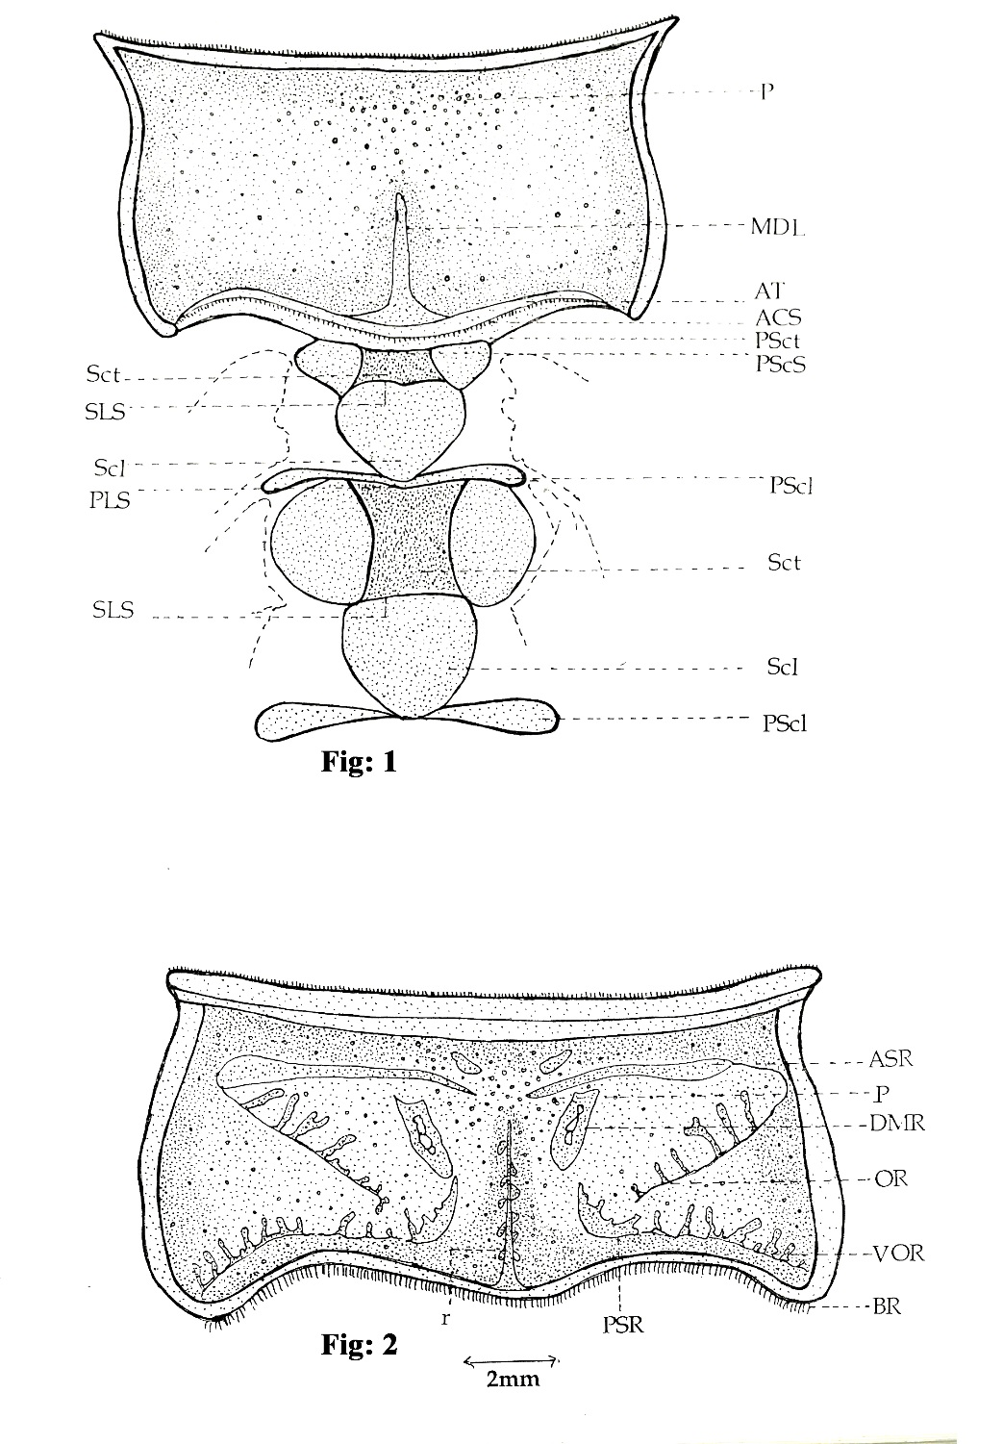

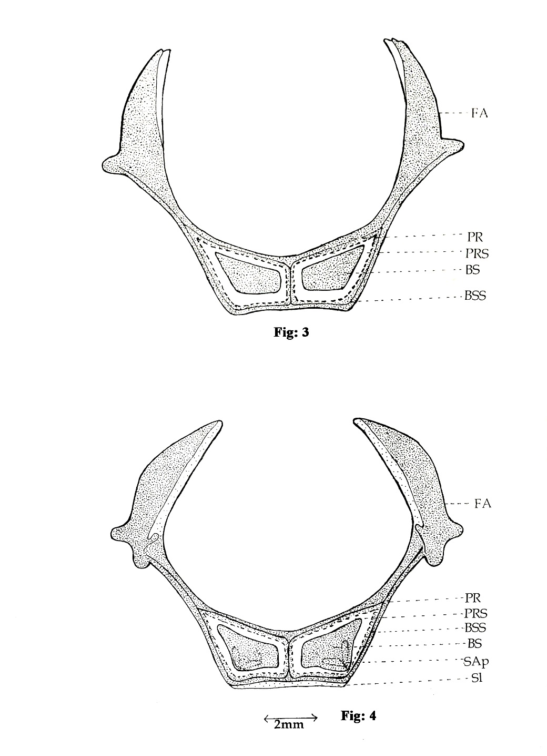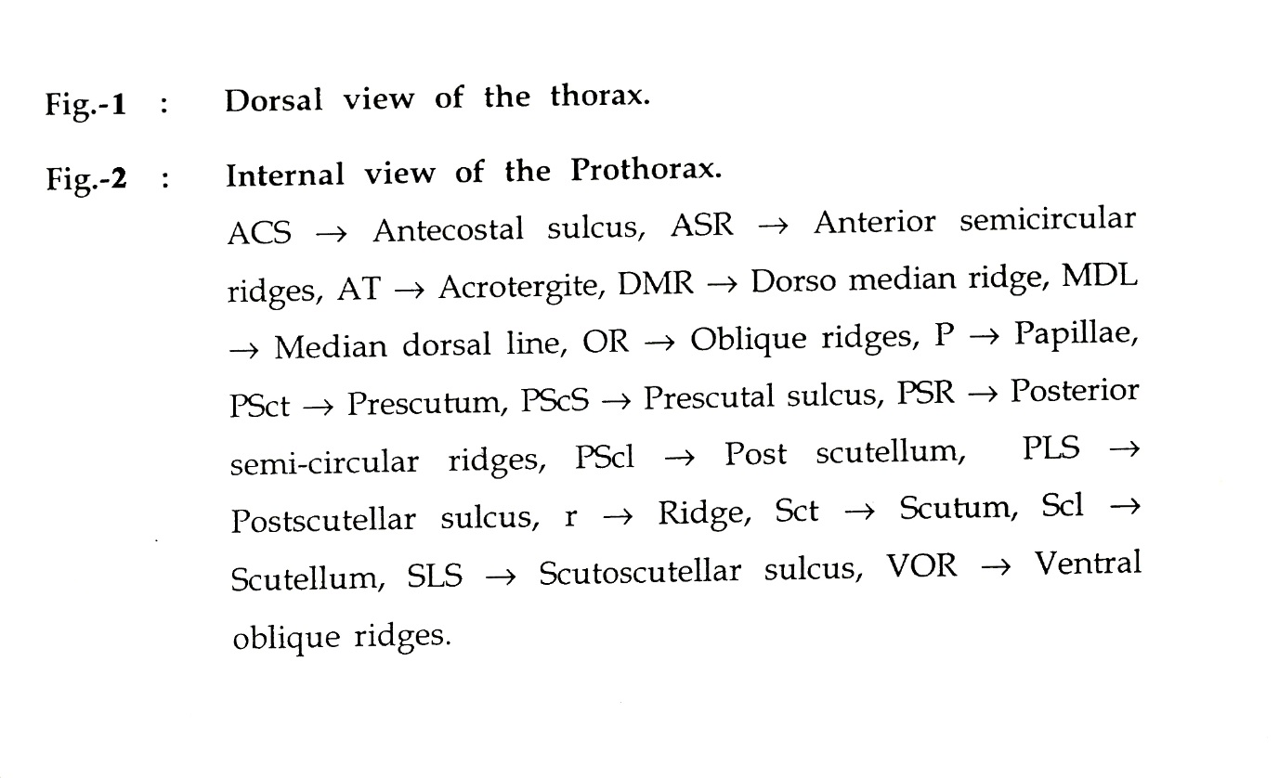

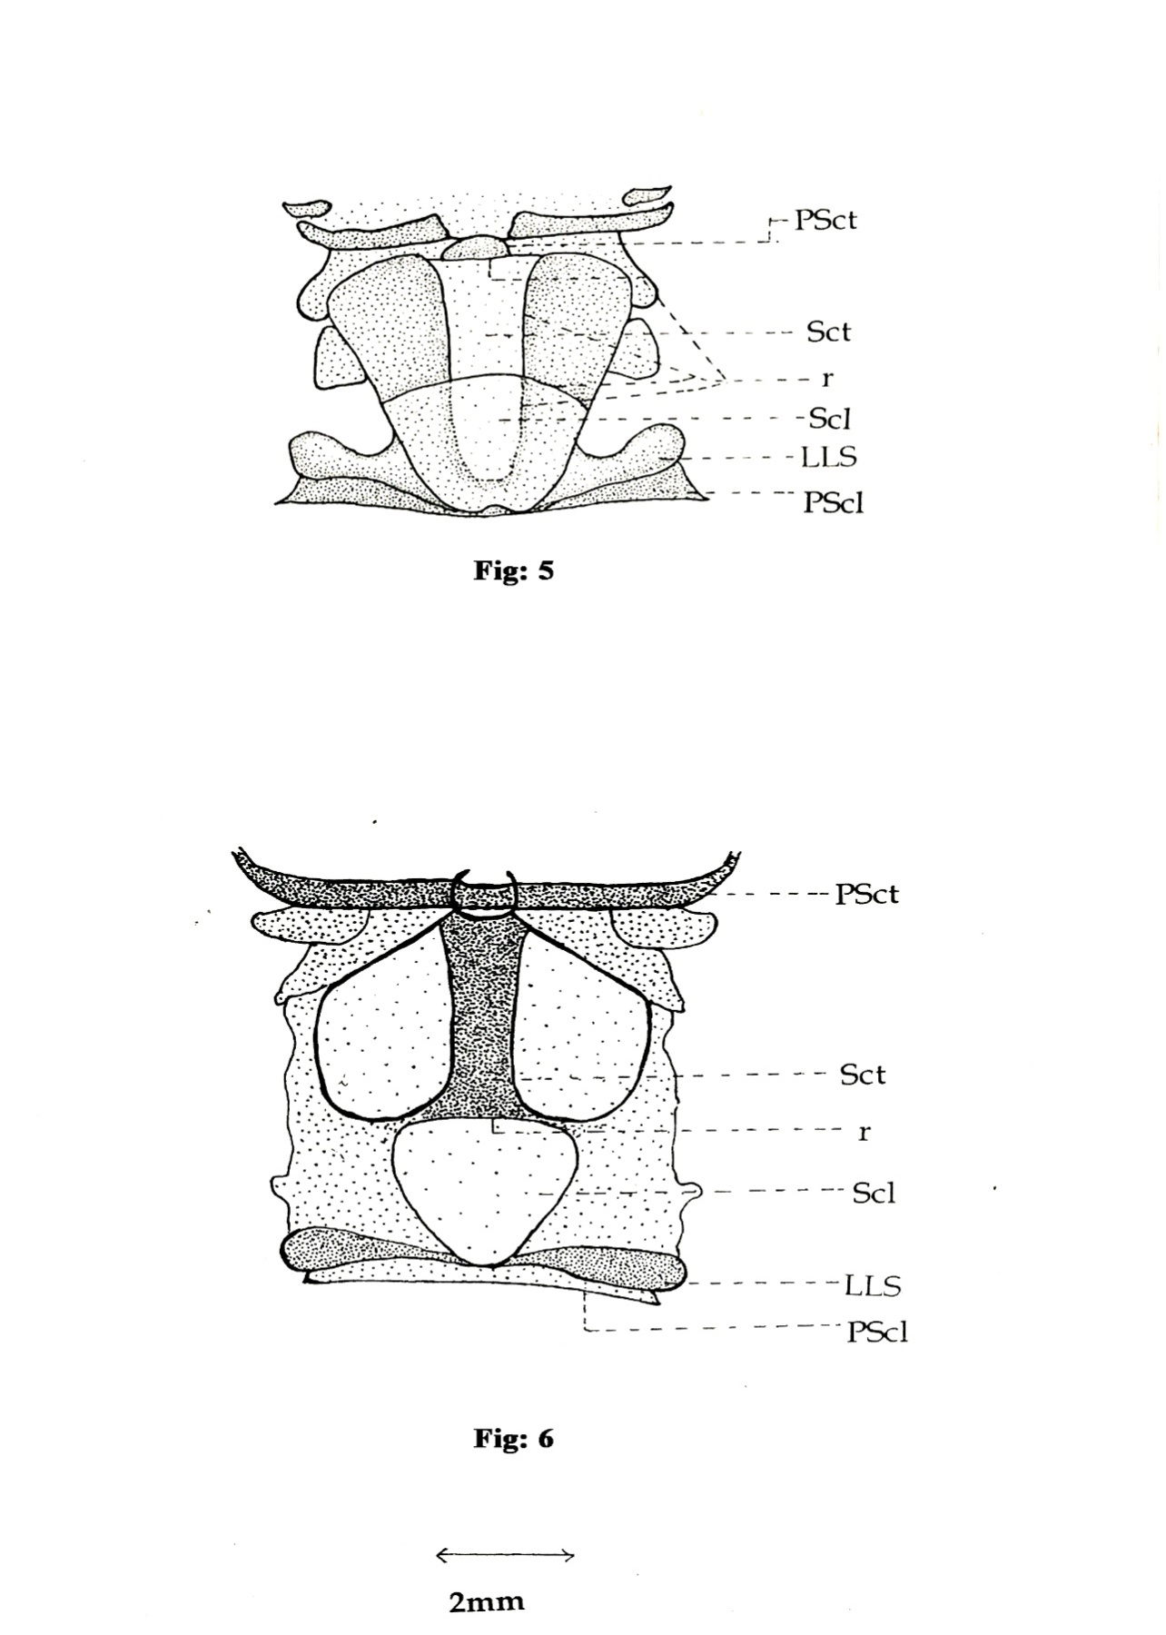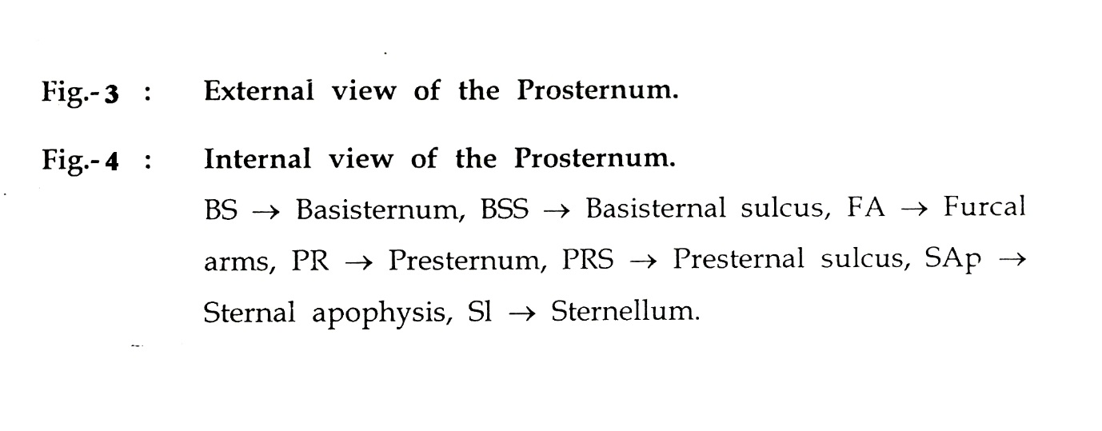

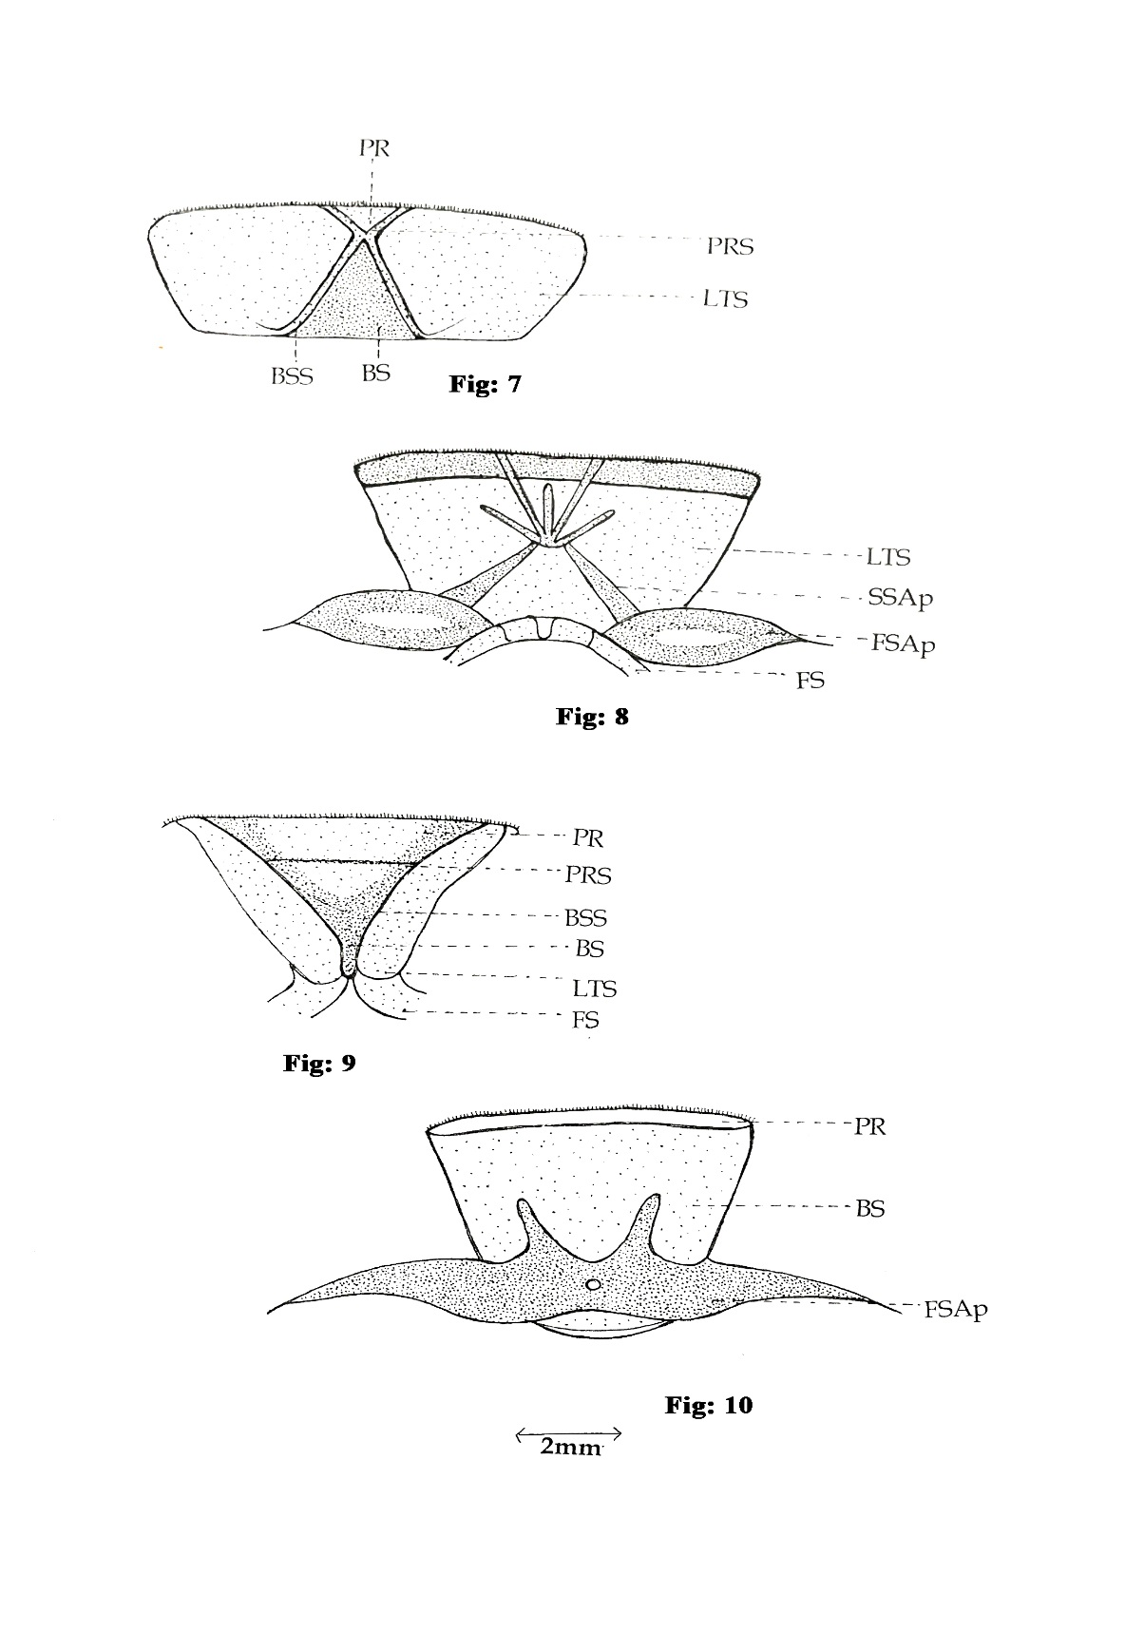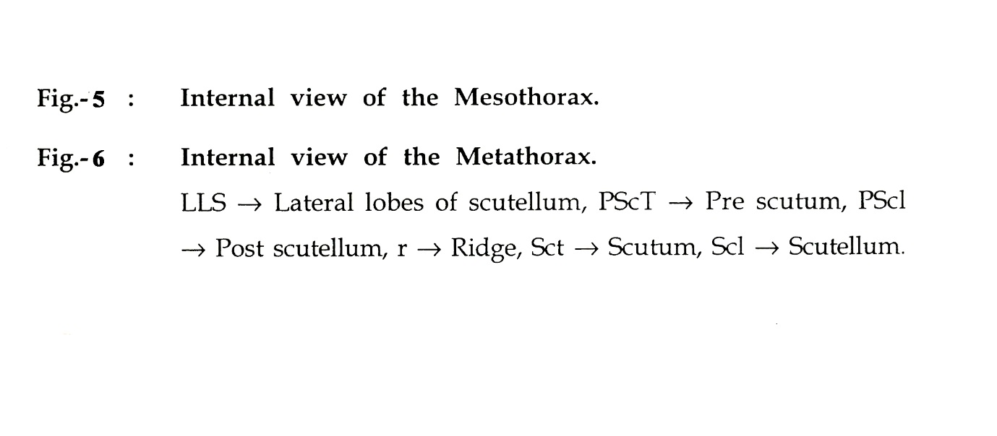

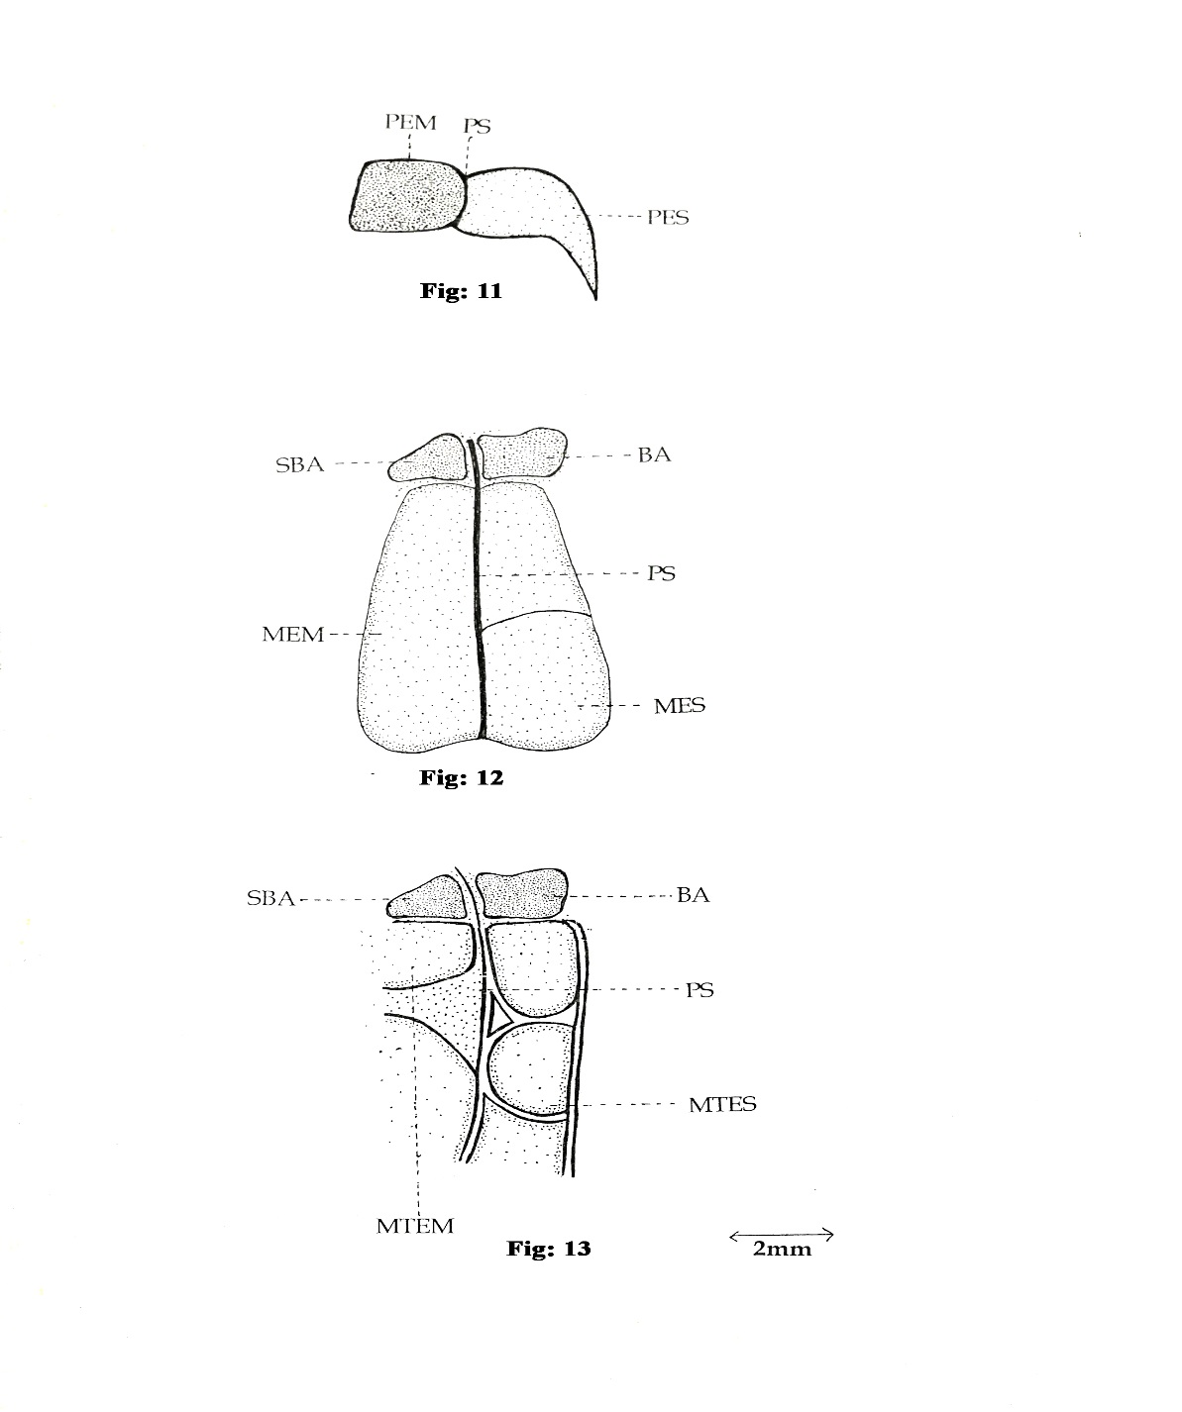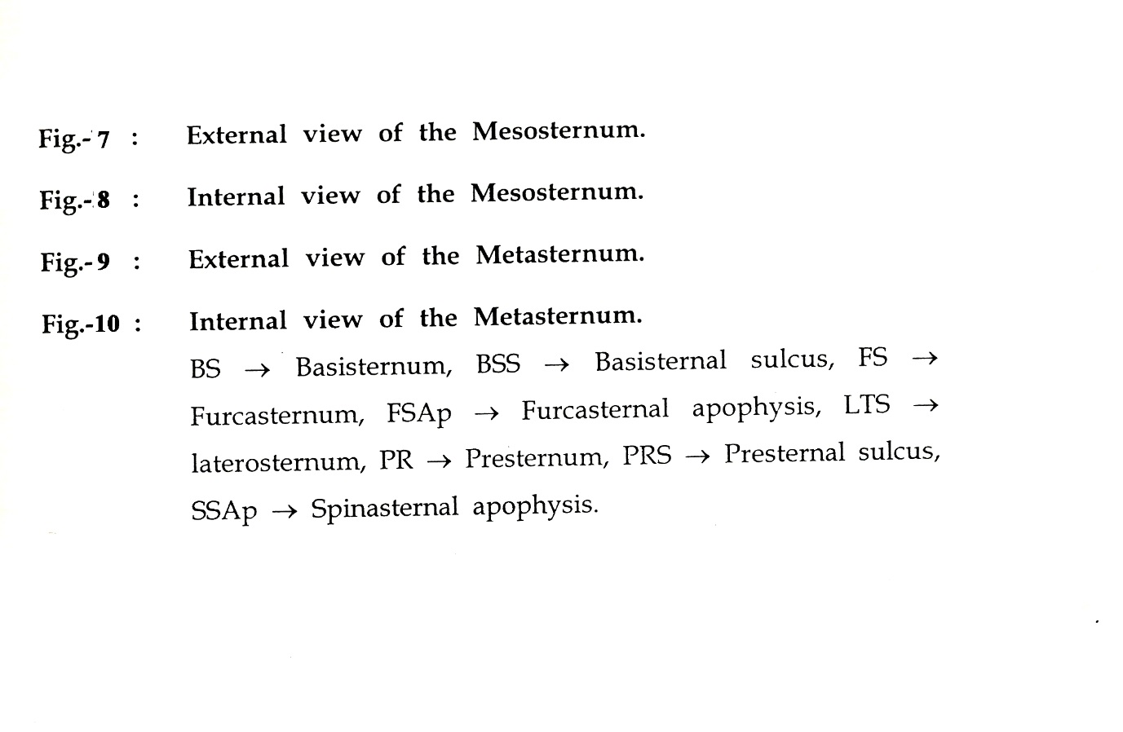

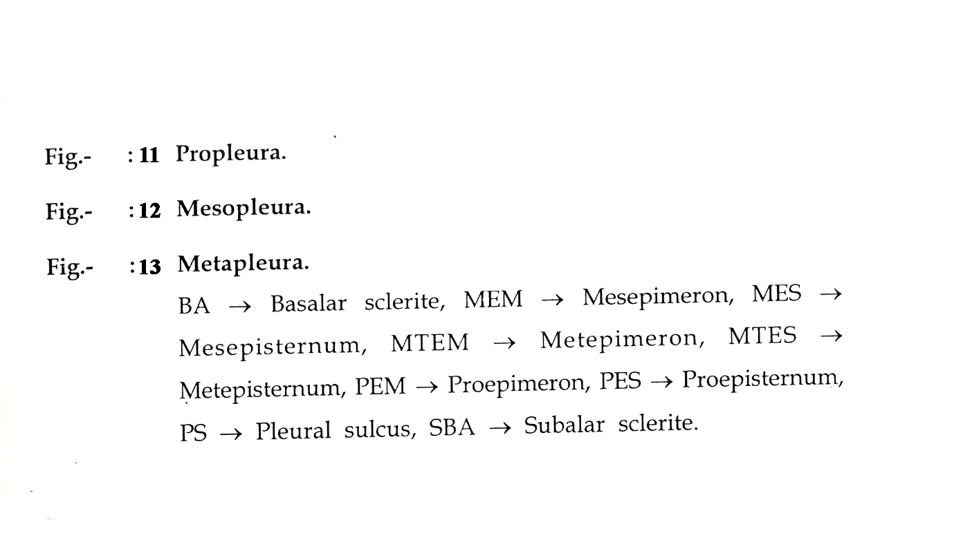

**REFERENCES :-**

|  |  |  |  |
| --- | --- | --- | --- |
| 1. | Comstock, J.H |  | (1924) An Introduction to Entomology, Ithaca, PP. 1044. |
| 2. | Crampton, G.C. |  | (1914) Notes on the thoracic sclerites of winged insect. Ent. News. 25 : 15-25 |
| 3. | Crampton G.C |  | (1914) The ground plan of a typical thoracic segment in winged insect. Zool. Anz., 44 : 56-57 |
| 4. | Crampton, G.C. |  | (1926) A comparison of neck and prothoracic sclerites throughout the orders of insect from the standpoint of phylogeny. Trans. American Ent. Soc., 52: 199-248 |
| 5 | Karandikar, K.R |  | (1939) External structures of the Desert locust (S. gregaria Fork.). J. Univ. Bombay (N.S.), 9: 3-57. |
| 5. | Snodgrass, R.E. |  | (1927) Morphology and mechanism of the insect thorax Ibid., 80, No. 1, 108 pp. |