**Influence of weather parameters on floral visitors abundance in wild and cultivated varieties of jamun (*Syzygium cumuni* L. skeels)**

**ABSTRACT**

The study onInfluence of weather parameters on floral visitors abundance in wild and cultivated varieties of jamun revealed that thirty one species of floral visitors were recorded and were belongs to Hymenopterans, Dipterans, Lepidopterans, Coleopterans and Hemiptera. The mean abundance of *A. dorsata* was highest followed by *A. florea*, *A. cerana* and *T. iridipennis*. Among other insects the mean abundance of ants that visited the flowers was highest, followed by Dipterans, Lepidopterans and Coleopterans. The number of floral visitors of *A. cerana* and *A. florea* on GKVK-1 had a significant positive correlation with hourly wind speed. A highly significant positive, a significant positive and a significant negative correlation at one and five per cent levels of significance has been recorded between the numbers of floral visitors of ants on wild and cultivated varieties of *S. cumini* with hourly relative humidity, wind speed and temperature. A highly significant positive, a significant positive and a significant negative correlation at one and five per cent levels of significance has also been recorded between the numbers of lepidopteran floral visitors on wild and cultivated varieties of *S. cumini* with hourly temperature wind speed and relative humidity.

**1. INTRODUCTION**

*Syzygium cumini* L. is an important evergreen tropical wild fruit yielding tree species in the flowering plant family Myrtaceae. It is native to the tropics, particularly to tropical America and Australia. It is known from many countries including South Africa, South America, South East Asia and Australia.

The *Syzygium* genus *c*omprises about 1,100 species and has native range that extends from Africa and Madagascar through Southern Asia east through the Pacific. The highest levels of its diversity occur from Malaysia to north eastern Australia, where many species are very poorly known and not been described taxonomically (Wrigley and Fagg, 2003).

Abundance of *A. mellifera* and *A. dorsata* on *Trifolium alexandrinum* L. during 2012 had a highly significant positive correlation with wind speed (r=0.77 and 0.86) at 0800 h while later was also correlated with maximum (negative) and minimum relative humidity at 1800 h (r=-0.89 and 0.85, respectively). *A. florea* abundance was positively correlation with minimum and maximum relative humidity (r= 0.82, 0.71) at 0800 h and negatively with minimum and maximum relative humidity(r= -0.79 and r= -0.71) at 1200 h. Wind speed significantly affected the *A. cerana* population (r=0.84) at 1800 h and that of syrphid fly, *Eristalinus* sp. (r=0.67) at 0800 h. Similarly during 2013, *A. mellifera* population was positively correlated with minimum temperature at 1800 and 0800 h   
(r= 0.77, 0.64) and relative humidity at 0800 h (r=0.74). *A. dorsata* too had highly significant correlation with maximum relative humidity at 0800 h, minimum and maximum temperature at 1200 and 1800 h. *Eristalinus* sp. was positively correlated with minimum relative humidity at 0800 and wind speed at 1600 h (Jat, *et al*. 2014).

Haftom Gebremedh, *et al*. (2014) stated that abundance of insects on *Guizotia abyssinica* (L.F.) tended to be positively correlated with mean air temperature   
(r= 0.42), while there was a negative tendency with relative humidity (r = -0.22). Whereas the abundance of honeybees had positive relationship with relative humidity (r = 0.20), while there was negative trend with air temperature (r= -0.30). Further observed that the number of bees that collected nectar had a positive association with air temperature (r=0.67; P=0.01) and negative relationship with relative humidity (r=-0.59; P=0.001). However, the number of bees that collected pollen had a positive correlation with relative humidity (r=0.62; P=0.001) and negative association with air temperature (r =-0.72; P=0.001).

Dhaliwal and Atwal (1976) generalized maximum abundance of 5 honey bee species on berseem were recorded (*A. dorsata, A. mellifera, A. florea*, *M. flavipes* and *P. smaragdula*) at 31.00 C, 54 per cent RH and wind speed of 0.20 kmph and the lowest abundance at 350C, 52 per cent RH and wind speed of 1.00 kmph. Thakur (2007) from Uttrakhand, recorded congenial range of temperature (31-350 C) and RH (51-58%) for *A. mellifera* and recorded maximum abundance at 320 C and 57 per cent RH. According to Alexander (1980) foraging activity of bees increased with temperature up to 300 C.

Honey bees are known to withstand temperatures as high as 450 C - 500 C, their foraging activity was found to go down drastically at temperatures beyond 350 C   
(Cooper *et al*., 1985).The ability of some bees to forage above 300 C range of air temperature was attributed to their behavioural and physiological mechanisms of regulating the temperature of their flight muscles, which differ with foraging rewards and the age of worker bee (Heinrich, 1996). In view of earlier investigations, the study aims to document the floral visitors and their abundance on the flowers of wild and cultivated varieties of Jamun with prevailing weather parameters at experimental site.

**2. MATERIALS AND METHODS**

**2.1 Study Area**

The study on influence of weather parameters on floral visitors abundance in wild and cultivated varieties of jamun (*Syzygium cumuni* L. skeels) was carried out at Regional Horticultural Research and Extension Centre, College of Horticulture (RHREC); UHS sub campus, GKVK, Bengaluru-560 065 during the flowering period of 2018-19.

**2.2 Wild and Cultivated Varieties of *S. cumini***

The observations on influence of weather parameter on the abundance of different floral visitors were made on wild *S. cumini* and cultivated varieties, GKVK-1, GKVK-2, K-45, N-20 in jamun orchard which were six years old planted at the spacing of 5m x 5m and also on naturally grown wild *S. cumini* trees of more than six-year-old at experimental site, RHREC, College of Horticulture; UHS sub-campus, GKVK, Bengaluru. Further the abundance of different floral visitors was correlated with prevailing environmental parameters of the said experimental site.

**2.3 Geographical and climatic conditions of study area**

The experimental site was located at Regional Horticultural Research and Extension Centre, College of Horticulture; UHS sub campus, GKVK, Bengaluru (130 N & 770 35’ E; 930 m above MSL) which is located in the south eastern dry zone of Karnataka state, receives an average rainfall of 924.9 mm and an average temperature of 310 C and its soil type is lateritic sandy clay. **The map of study area is indicated in Plate 1.**

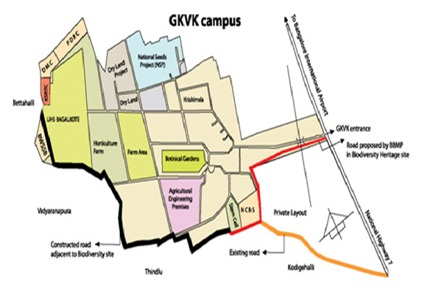

**Plate 1: Map of the study area at RHREC, UHS, GKVK, Bangalore during 2018**

**2.4 Prevailing meteorological data during the period of experimentation 2018**

The prevailing hourly (0600-1900 hr) meteorological data of the first experimental site at RHREC, College of Horticulture; UHS sub campus, GKVK, Bengaluru during flowering period of wild and cultivated varieties of *S. cumini* during March, 2018 was collected from Karnataka State Natural Disaster Monitoring Center:  KSNDMC Campus,; Major Sandeep Unnikrishnan Road, Near Attur Layout,; Yelahanka, Bangalore - 560 064, Karnataka. The abundance of different floral visitors on wild and cultivated varieties of *S. cumini* at hourly interval was correlated with prevailing hourly weather parameters at GKVK.

**2.5 Floral Visitors**

All floral visitors of wild and cultivated varieties of *S. cumini* during flowering period of 2018-19 were collected through visual scanning and sweep net collection as per the methodology suggested by Belavadi and Ganeshaiah (2013).

**2.6 Abundance of Floral Visitors**

The abundance of floral visitors was recorded during full bloom stage of crop. From the four directions of wild and cultivated varieties of *S. cumini*, four inflorescences were randomly selected and were tagged and labelled. The abundance of floral visitors was observed for five days; from 10th to 14th March, 2018 for the varieties GKVK-1, GKVK-2, N-20, K-45 and wild *S. cumini* at GKVK. On each day, one inflorescence each from wild and cultivated varieties in one direction were observed for five minutes at hourly intervals from 0600-1900 hrs of the day and the floral visitor alighting were counted and similar observations were continued up to five days. The mean abundance was calculated from the hourly observed data on abundance of species of floral visitors and it was expressed as mean number of species per 5 minutes/four inflorescence/day. The data of hourly recorded mean floral visitors was correlated with weather parameters prevailed from 0600-1900 hrs at hourly interval during observation period of experimental site.

**3. RESULTS AND DISCUSSION**

**3.2 Prevailing meteorological parameters of experimental site at GKVK during observation on abundance of floral visitors in wild and cultivated varieties of *S. cumini*:**

The abundance of floral visitors in wild and cultivated varieties of *S. cumini* was recorded during 2nd week of March, 2018 from 10th March, 2018 to 14th March, 2018 for the period of five days at GKVK. The prevailing hourly intervals meteorological data of experimental site during this period was collected from KSNMDC, Bangalore (Table 1). The hourly mean temperature of experimental site of GKVK ranged from 19.240 C (0600 -0700hr) to 32.140 C (1400-1500hr), hourly mean relative humidity was ranged from 31.70 (1400-1500hr) to 86.38 (0600-0700hr) per cent and hourly mean wind speed ranged from 0.30 (0600 -0700hr) to 1.88 (1200-1300hr) nautical miles per hour, respectively.

**3.1 Floral visitors of wild and cultivated varieties of *S. cumini***

The floral visitors of wild *S. cumini* and cultivated varieties GKVK-1, GKVK-2, K-45 and N-20 at GKVK were recorded during flowering period commencing from 0600 upto1900hrs at hourly intervals. Totally thirty one species of floral visitors were observed during the flowering period, they belonged to five insect orders *viz.,* Hymenoptera, Diptera, Lepidoptera, Coleoptera and Hemiptera (Table 2 and Plate 2). These finding are supported by the works of Crome and Irvine, (1986) and Williams and Adam (2010) who recorded 45 species of nectar feeding animals on *S. tierneyanum* From South India, Reddi and Rangaiah, (1999-2000) recorded 24 species of flower visiting insects on *S. cumini*. Solomon Raju *et al.* (2014) recorded 33 species flower foragers on *S. alternifolium* and Hopper, (1980) recorded 45 species of floral visitors on *Syzgium tierneyanum* of which honeybees and hawk moths have been identified as effective pollinators.

**Table 1: Meteorological data of experimental site at GKVK, Bengaluru during**

**observation on abundance of floral visitors in wild and cultivated varieties of *S. cumini* (2018)**

|  |  |  |  |
| --- | --- | --- | --- |
| **Time (hr)** | **Weather parameters** | | |
| **At GKVK** | | |
| **Temp (°C)** | **RH (%)** | **Wind speed**  **(nautical miles/hr)** |
| 0600-0700 | 19.24 | 86.38 | 0.30 |
| 0700-0800 | 21.10 | 75.64 | 0.56 |
| 0800-0900 | 23.10 | 64.97 | 1.00 |
| 0900-1000 | 25.98 | 55.96 | 1.30 |
| 1000-1100 | 27.96 | 45.48 | 1.72 |
| 1100-1200 | 29.82 | 38.36 | 1.72 |
| 1200-1300 | 31.02 | 34.46 | 1.88 |
| 1300-1400 | 32.08 | 33.42 | 1.84 |
| 1400-1500 | 32.14 | 31.70 | 1.54 |
| 1500-1600 | 31.58 | 32.52 | 1.76 |
| 1600-1700 | 30.12 | 34.42 | 1.6 |
| 1700-1800 | 28.76 | 36.80 | 1.28 |
| 1800-1900 | 27.28 | 43.40 | 1.16 |

Weather parameters (Temp=temperature, RH=relative humidity and wind speed) are the mean from 10-03-18 to 14-03-18

**Table 2: Floral visitors of wild and cultivated varieties of *S. cumini* at GKVK, Bengaluru during flowering period of 2018-19**

| **Order** | **Family** | **Sl. No.** | **Scientific name** |
| --- | --- | --- | --- |
| Hymenoptera | Apidae | **Visiting status of *Apis* bees** | |
| 1 | *Apis dorsata* F. |
| 2 | *Apis cerana indica* F. |
| 3 | *Apis florea* F. |
| **Visiting status of Non *Apis* bees** | |
| 4 | *Tetragonula iridipennis* S. |
| 5 | *Xylocopa fenestrata* F. |
| Vespidae | 6 | *Ropalidia marginata* L. |
| Ichneumonidae | 7 | *Xanthopimpla punctata* F. |
| Pompilidae | 8 | *Mygnimia flava* F. |
| Formicidae | 9 | *Tapinoma* sp. |
| 10 | *Camponotus compressus* F. |
| 11 | *Tapinoma melanocephalum*F. |
| 12 | *Tetraponera* sp. |
| Diptera | Calliphoridae | 13 | *Chrysomya* sp*.* |
| Stratiomyidae | 14 | *Odontomyia* sp. |
| Conopidae | 15 | Conopidaesp. |
| Syrphidae | 16 | *Eristalinus obliquus* W. |
| 17 | Syrphidaesp*.* |
| Sarcophagidae | 18 | *Sarcophaga carnaria* M. |
| Lepidoptera | Erebidae | 19 | *Amata* sp. |
| 20 | *Nyctemera*sp. |
| Nymphalidae | 21 | *Melanitis leda leda* L. |
| 22 | *Danaus chrysippus* L. |
| 23 | *Euploea core* C. |
| Coleoptera | Cantheridae | 24 | Cantheridae sp*.* |
| Scarabaeidae | 25 | *Protaetia albaguttata* V. |
| 26 | *Clinteria* sp. |
| 27 | *Oxycetonia versicolor* F. |
| Cerambycidae | 28 | *Chlorophorus agnatus* C. |
| 29 | *Chelidonium cinctum* G. |
| 30 | *Kunbir* sp. |
| Hemiptera | Reduviidae | 31 | *Isyndus heros* F. |

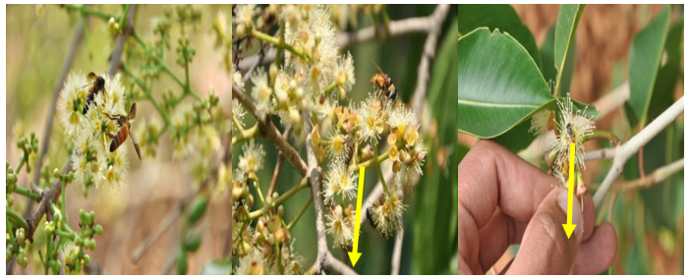

*Apis dorsata* F*. Apis cerana indica* F*. Apis florea* F.

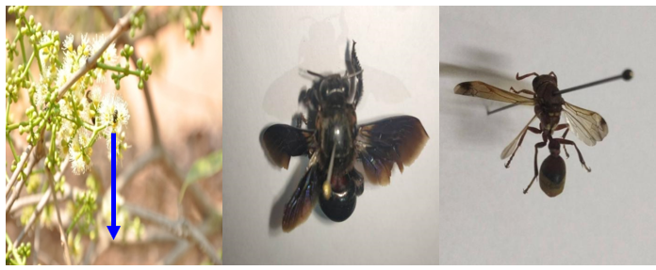

*Tetragonula iridipennis* S. *Xylocopa fenestrata* F. *Ropalidia marginata* L.

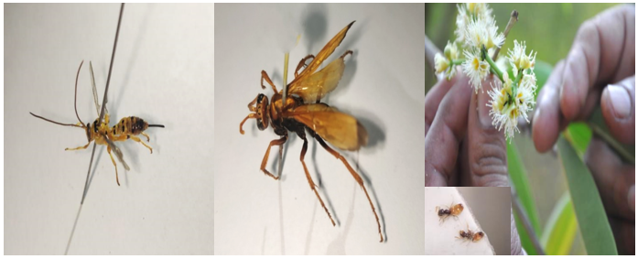

*Xanthopimpla punctata* F. *Mygnimia flava* F. *Tapinoma* sp.

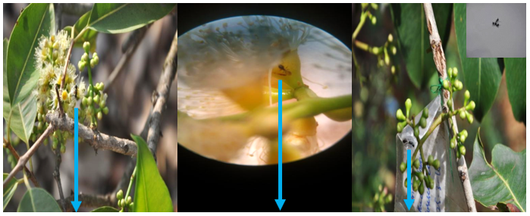

*Camponotus compressus* F. *Tapinoma melanocephalum*F. *Tetraponera* sp.

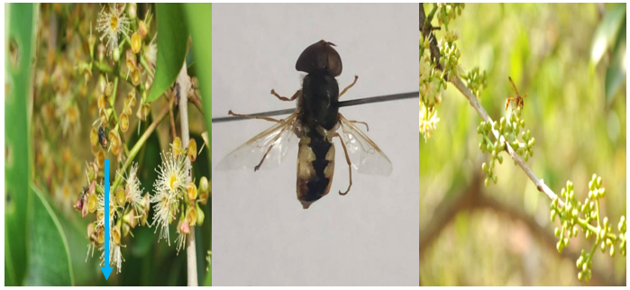

*Chrysomya* sp. *Odontomyia* sp. *Conopidae* sp.

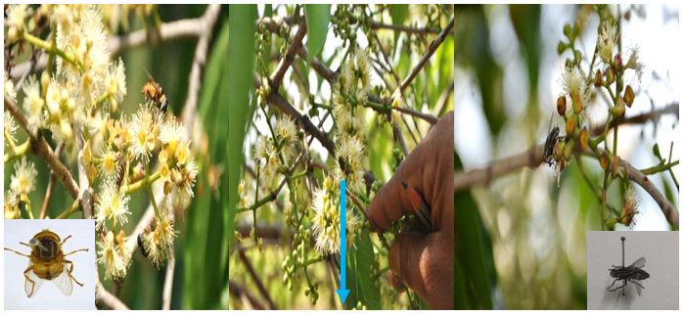

*Eristalinus obliquus* W. *Syrphidae* sp. *Sarcophaga carnaria* M.

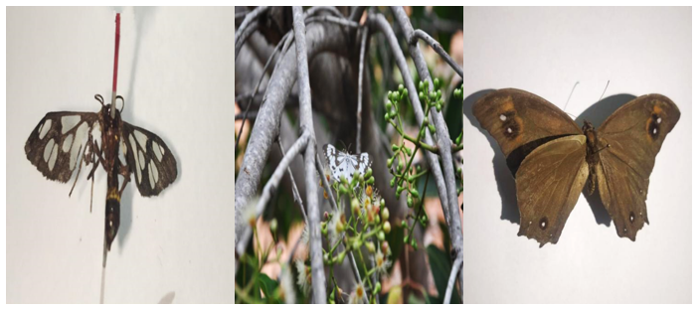

*Amata* sp. *Nyctemera* sp. *Melanitis Leda Leda* L.

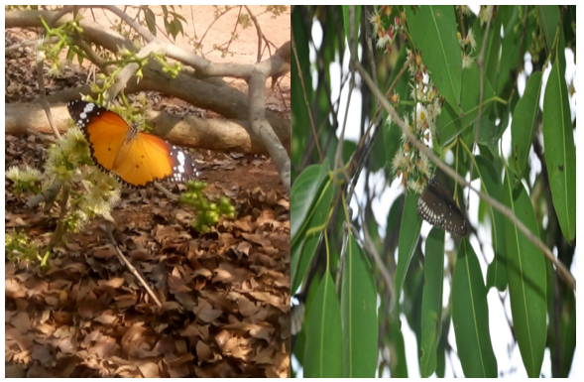

*Danaus chrysippus*  L. *Euploea core* C.

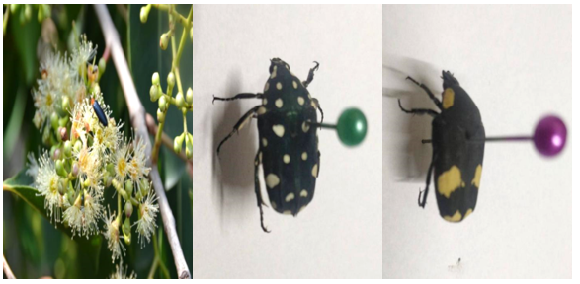

*Cantheridae* sp*. Protaetia albaguttata* V. *Clinteria* sp.

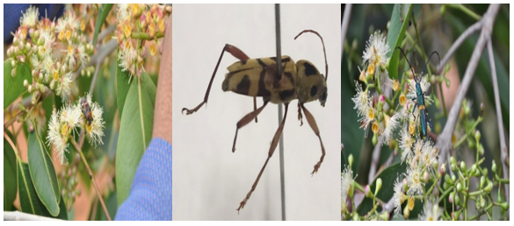

*Oxycetonia versicolor* F. *Chlorophorus agnatus* C. *Chelidonium cinctum* G.

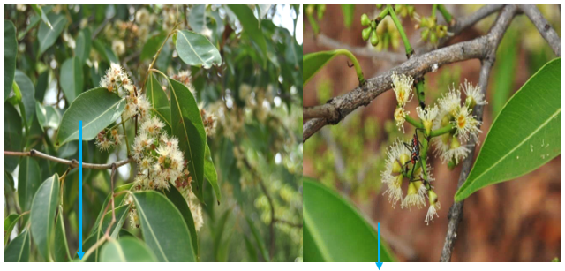

*Kunbir* sp*. Isyndus heros* F.

**Plate 2: Floral visitors on wild and cultivated varieties of *S. cumini* at GKVK, Bengaluru during 2018**

**Correlation between the abundance of floral visitors on wild *S. cumini* at GKVK with prevailing weather parameters**

The number of floral visitors of *A. dorsata, A. florea,* and Dipterans at hourly intervals showed a non- significant positive correlation with hourly temperature (r=0.08,0.03 and 0.003), whereas, they exhibited a non-significant negative correlation with hourly relative humidity (r=-0.03,-0.27 and -0.06) and hourly wind speed (r=-0.28,   
-0.012 and -0.11) respectively. Similarly, a non- significant negative correlation existed between the number of floral visitors of *T. iridipennis, A. cerana, X. punctata,* Lepidopterans and Coleopterans at hourly intervals with hourly relative humidity (r=-0.41, -0.32, -0.16,-0.35 and -0.36) respectively, whereas they showed a non-significant positive correlation with hourly temperature (r=0.48, 0.38, 0.12, 0.27 and 0.33) and hourly wind speed (r=0.08, 0.05, 0.05, 0.17 and 0.15) respectively. The number of floral visitors *X. fenestrata, R. Marginata* and Hemipterans at hourly intervals were had a non -significant positive correlation with hourly relative humidity (r=0.01, 0.12 and 0.40) respectively, whereas they exhibited a non-significant negative correlation with hourly temperature (r=-0.04, - 0.13 and -0.33) and hourly wind speed (r=-0.15, -0.12 and -0.34) respectively. Similarly, the number of floral visitors of *M. flava* at hourly intervals had a non-significant negative correlation with hourly temperature (r=-0.04), relative humidity (r=-0.05) and wind speed (r=-0.08), whereas, the number of ant floral visitors recorded at hourly intervals had a non-significant negative correlation with hourly wind speed (r=-0.55),while they exhibited significant negative correlation with hourly temperature(r=-0.64*) at five per cent level and significant positive correlation with hourly relative humidity(r=0.61*) at five per cent level (Table 3).

**Table 3: Correlation between the abundance of floral visitors (no. /5 min. /4 inflorescence) on wild *S. cumini* during (100% flowering) different hours of the day with prevailing weather parameters at GKVK, Bengaluru (2018)**

|  |  |  |  |  |  |  |  |  |  |  |  |  |  |
| --- | --- | --- | --- | --- | --- | --- | --- | --- | --- | --- | --- | --- | --- |
| **Weather parameters** | **Floral visitors on wild *S. cumini* at GKVK (no. /5min. /4 inflorescence)** | | | | | | | | | | | | |
| ***A. d*** | ***T. i*** | ***A. f*** | ***A. c*** | ***X. f*** | ***R. m*** | ***X. p*** | ***M. f*** | **Ants** | **Diptera** | **Lepi** | **Coleo** | **Hemi** |
| Temperature | 0.08  (NS) | 0.48  (NS) | 0.33  (NS) | 0.38  (NS) | -0.04  (NS) | -0.13  (NS) | 0.12  (NS) | -0.04  (NS) | -0.64* | 0.003  (NS) | 0.27  (NS) | 0.33  (NS) | -0.33  (NS) |
| Relative humidity | -0.03  (NS) | -0.41  (NS) | -0.27  NS | -0.32  (NS) | 0.01  (NS) | 0.12  (NS) | -0.16  (NS) | -0.05  (NS) | 0.61* | -0.06  (NS) | -0.35  (NS) | -0.36  (NS) | 0.40  (NS) |
| Wind speed | -0.28  (NS) | 0.08  (NS) | -0.012  NS | 0.05  (NS) | -0.15  (NS) | -0.12  (NS) | 0.05  (NS) | -0.08  (NS) | -0.55  (NS) | -0.11  (NS) | 0.17  (NS) | 0.15  (NS) | -0.34  (NS) |

Note: * Significant at 5% and NS- Non significant

Floral visitors: *A.d*-*A. dorsata, T.i –T. iridipennis*, *A.f -Apis florea, A.c – A. cerana, X.f - X. fenestrata, R.m- R. marginata,X.p -X.punctata,*

*M.f- M. flava,* Lepi- Lepidopterans , Coleo-Coleopterans, Hemi-Hemipterans

**Correlation between the abundance of floral visitors on cultivated variety   
GKVK-1 at GKVK with prevailing weather parameters**

The number of floral visitors of *A. dorsata* and Dipterans on cultivated variety   
GKVK-1 at hourly intervals had a non-significant positive correlation with hourly relative humidity (r=0.33, and 0.06), whereas they exhibited a non- significant negative correlation with hourly temperature (r=-0.35 and -0.04) and hourly wind speed (r=-0.04 and -0.04).  
A non-significant negative correlation existed between the number of floral visitors of   
*T. iridipennis, X. punctata, M. flava,* Coleopterans, Hemipterans, *A. florea* and *A. cerana* with hourly relative humidity (r=-0.21, -0.34, -0.02, -0.03, -0.06, -0.31 and -0.30) respectively, whereas they had a non- significant positive correlation with hourly temperature (r=0.25, 0.36, 0.03, 0.05, 0.10, 0.35 and 0.30) and hourly wind speed (r=0.38, 0.14, 0.14, 0.42 and 0.11) respectively, with the exception of *A. florea* and *A. cerana.* The number of floral visitors of *A. florea* and *A. cerana* had a significant positive correlation with hourly wind speed (r=0.62* and 0.60*) at five per cent level. The numbers of floral visitors of *X. fenestrate* at hourly intervals had a non-significant negative correlation with hourly relative humidity (r=-0.04) and hourly wind speed (r=-0.27), whereas, they had a non -significant positive correlation with hourly temperature (r=0.06). A non-significant positive correlation existed between the number of floral visitors *R. marginata* with hourly temperature (r=-0.001), hourly relative humidity (r=0.003) and hourly wind speed (r=0.36). The number of floral visitors of ants at hourly intervals showed a significant negative correlation with hourly temperature (r=-0.58*) at five per cent level and significant positive correlation with hourly relative humidity (r=0.57*) at five per cent level, whereas, they had a non-significant negative correlation with hourly wind speed(r=-0.51).Similarly, the number of floral visitors of lepidopterans at hourly intervals had a highly significant positive correlation with hourly temperature(r=0.69**) at one per cent level and significant positive correlation with hourly wind speed (r=0.61*) at five per cent level, whereas, they had a significant negative correlation with hourly relative humidity(r=-0.67*) at five per cent level (Table 4).

**Table 4: Correlation between the abundance of floral visitors (no. /5min. /4 inflorescence) on cultivated variety of *S. cumini*, GKVK-1 during (100% flowering) different hours of the day with prevailing weather parameters at GKVK, Bengaluru (2018)**

|  |  |  |  |  |  |  |  |  |  |  |  |  |  |
| --- | --- | --- | --- | --- | --- | --- | --- | --- | --- | --- | --- | --- | --- |
| **Weather parameters** | **Floral visitors on cultivated variety of *S. cumini*, GKVK-1 (no. /5min. /4 inflorescence)** | | | | | | | | | | | | |
| ***A. d*** | ***T. i*** | ***A. f*** | ***A. c*** | ***X. f*** | ***R. m*** | ***X. p*** | ***M. f*** | **Ants** | **Diptera** | **Lepi** | **Coleo** | **Hemi** |
| Temperature | -0.35  (NS) | 0.25  (NS) | 0.35  (NS) | 0.30  (NS) | 0.06  (NS) | 0.001  (NS) | 0.36  (NS) | 0.03  (NS) | -0.58* | -0.04  (NS) | 0.69** | 0.05  (NS) | 0.10  (NS) |
| Relative humidity | 0.33  (NS) | -0.21  (NS) | -0.31  (NS) | -0.30  (NS) | -0.04  (NS) | 0.003  (NS) | -0.34  (NS) | -0.02  (NS) | 0.57* | 0.06  (NS) | -0.67* | -0.03  (NS) | -0.06  (NS) |
| Wind speed | -0.04  (NS) | 0.38  (NS) | 0.62* | 0.60* | -0.27  (NS) | 0.36  (NS) | 0.14  (NS) | 0.14  (NS) | -0.51  (NS) | -0.04  (NS) | 0.61* | 0.42  (NS) | 0.11  (NS) |

Note: ** Significant at 1 %, * Significant at 5% and NS- Non significant

Floral visitors: *A.d*-*A. dorsata, T.i –T. iridipennis*, *A.f -Apis florea, A.c – A. cerana, X.f-*. *X. fenestrata, R.m- R. marginata,X.p-*. *X.punctata, M.f- M. flava,* Lepi- Lepidopterans , Coleo-Coleopterans, Hemi-Hemipterans

**Correlation between the abundance of floral visitors on cultivated variety GKVK -2 at GKVK with prevailing weather parameters**

The number of floral visitors of *A. dorsata* and ants at hourly intervals had a   
non-significant negative correlation with hourly temperature (r=-0.14 and -0.54) and hourly wind speed (r=-0.14 and -0.41) respectively. A non-significant positive correlation existed between the number of floral visitors of *A. dorsata* with hourly relative humidity (r=0.08), whereas, the number of floral visitors of ants had a significant positive correlation with hourly relative humidity (r=0.57*) at five per cent level. The number of floral visitors of *T. iridipennis* at hourly intervals had a non-significant negative correlation with hourly wind speed (r=-0.27), whereas, they exhibited a significant positive correlation with hourly temperature (r=0.02*) and hourly relative humidity(r=0.03*). The number of floral visitors of *A. florea* and *X. punctata*at hourly intervals had a non-significant positive correlation with hourly temperature (r=0.32 and 0.32), whereas, they exhibited a non-significant negative correlation with hourly relative humidity (r=-0.30 and -0.27) and hourly wind speed (r=-0.004 and -0.02) respectively. A non-significant negative correlation existed between the number of floral visitors of *A. cerana, X. fenestrata,* Dipterans, Coleopterans and Hemipterans at hourly interval with hourly relative humidity (r=-0.32, -0.40, -0.08,   
-0.23, and -0.36), whereas, they exhibited a non- significant positive correlation with hourly temperature (r=0.30, 0.44, 0.07, 0.25and0.33) and hourly wind speed (r=0.10, 0.15, 0.09, 0.008 and 0.27) respectively. The number of floral visitors of *R. marginata* at hourly intervals had a non-significant positive correlation with hourly temperature (r=0.12), hourly relative humidity (r=0.08) and hourly wind speed (r=0.26). However, the number of floral visitors of *M. flava* at hourly intervals had a non-significant negative correlation with hourly temperature (r=-0.02), hourly relative humidity (r=-0.001) and hourly wind speed (r=-0.16). Similarly, the number of floral visitors of Lepidopterans at hourly intervals had a non-significant positive correlation with hourly wind speed (r=0.29), whereas, they exhibited significant positive correlation with hourly temperature (r=0.65*) at five per cent level and significant negative correlation with hourly relative humidity (r=-0.56*) at five per cent level (Table 5) of significance.

**Table 5: Correlation between the abundance of floral visitors (no. /5min. /4 inflorescence) on cultivated variety of *S. cumini*, GKVK-2 during (100% flowering) different hours of the day with prevailing weather parameters at GKVK, Bengaluru (2018)**

|  |  |  |  |  |  |  |  |  |  |  |  |  |  |
| --- | --- | --- | --- | --- | --- | --- | --- | --- | --- | --- | --- | --- | --- |
| **Weather parameters** | **Floral visitors on cultivated variety of *S. cumini*, GKVK-2(no. /5min. /4 inflorescence)** | | | | | | | | | | | | |
| ***A. d*** | ***T. i*** | ***A. f*** | ***A. c*** | ***X. f*** | ***R. m*** | ***X. p*** | ***M. f*** | **Ants** | **Diptera** | **Lepi** | **Coleo** | **Hemi** |
| Temperature | -0.14  (NS) | 0.02  (NS) | 0.32  (NS) | 0.30  (NS) | 0.44  (NS) | 0.12  (NS) | 0.32  (NS) | -0.02  (NS) | -0.54  (NS) | 0.07  (NS) | 0.65* | 0.25  (NS) | 0.33  (NS) |
| Relative humidity | 0.08  (NS) | 0.03  (NS) | -0.30  (NS) | -0.32  (NS) | -0.40  (NS) | 0.08  (NS) | -0.27  (NS) | -0.001  (NS) | 0.57* | -0.08  (NS) | -0.56* | -0.23  (NS) | -0.36  (NS) |
| Wind speed | -0.14  (NS) | -0.27  (NS) | -0.004  (NS) | 0.10  (NS) | 0.15  (NS) | 0.26  (NS) | -0.02  (NS) | -0.16  (NS) | -0.41  (NS) | 0.09  (NS) | 0.29  (NS) | 0.008  (NS) | 0.27  (NS) |

Note: * Significant at 5% and NS- Non significant

Floral visitors: *A.d*-*A. dorsata, T.i –T. iridipennis*, *A.f -Apis florea, A.c – A. cerana, X.f - X. fenestrata, R.m- R. marginata, X.p -X.punctata, M.f- M. flava,* Lepi- Lepidopterans , Coleo-Coleopterans, Hemi-Hemipterans

**Correlation between the abundance of floral visitors on cultivated variety K-45 at GKVK with prevailing weather parameters**

The number of floral visitors of *A. dorsata* on cultivated variety K-45 at hourly intervals (Table 6) showed a non- significant negative correlation with hourly temperature (r=-0.02), hourly relative humidity (r=-0.05) and hourly wind speed (r=-0.19).   
A non-significant positive correlation existed between the number of floral visitors of   
*T. iridipennis*, *A. florea* and Coleopterans at hourly intervals with hourly temperature (r=0.18, 0.06 and 0.10) respectively, whereas, they exhibited a non- significant negative correlation with hourly relative humidity (r=-0.20,-0.07and -0.13) and hourly wind speed (r=-0.06, -0.16 and-0.03). A non-significant negative correlation existed between the number of floral visitors of *A. cerana, X. fenestrata, R. marginata, X punctata, M flava,* Lepidopterans and Hemipterans at hourly intervals with hourly relative humidity (r=-0.33, -0.38, -0.09, -0.03, -0.18, -0.40 and -0.14) respectively, whereas, they exhibited non- significant positive correlation with hourly temperature (r=0.32, 0.39, 0.008, 0.04, 0.10, 0.40 and 0.08) and hourly wind speed (r=0.14, 0.13, 0.07, 0.18, 0.12, 0.12 and 0.02) respectively. The number of ant and Dipteran floral visitors at hourly intervals showed a non-significant negative correlation with hourly temperature (r=-0.37 and -006) and non-significant positive correlation with hourly relative humidity (r=0.34 and 0.03) respectively. The number of ant floral visitors had a non-significant negative correlation with hourly wind speed (r=-0.32), whereas, the Dipterans showed a non-significant positive correlation with hourly wind speed (r=0.17).

**Table 6: Correlation between the abundance of floral visitors (no. /5min. /4 inflorescence) on cultivated variety of *S. cumini*, K-45 during (100% flowering) different hours of the day with prevailing weather parameters at GKVK, Bengaluru (2018)**

|  |  |  |  |  |  |  |  |  |  |  |  |  |  |
| --- | --- | --- | --- | --- | --- | --- | --- | --- | --- | --- | --- | --- | --- |
| **Weather parameters** | **Floral visitors on cultivated variety of *S. cumini*, K-45 (no. /5min. /4 inflorescence)** | | | | | | | | | | | | |
| ***A. d*** | ***T. i*** | ***A. f*** | ***A. c*** | ***X. f*** | ***R. m*** | ***X. p*** | ***M. f*** | **Ants** | **Diptera** | **Lepi** | **Coleo** | **Hemi** |
| Temperature | -0.02  (NS) | 0.18  (NS) | 0.06  (NS) | 0.32  (NS) | 0.39  (NS) | 0.008  (NS) | 0.04  (NS) | 0.10  (NS) | -0.37  (NS) | -0.06  (NS) | 0.40  (NS) | 0.10  (NS) | 0.08  (NS) |
| Relative humidity | -0.05  (NS) | -0.20  (NS) | -0.07  (NS) | -0.33  (NS) | -0.38  (NS) | -0.09  (NS) | -0.03  (NS) | -0.18  (NS) | 0.34  (NS) | 0.03  (NS) | -0.40  (NS) | -0.13  (NS) | -0.14  (NS) |
| Wind speed | -0.19  (NS) | -0.06  (NS) | -0.16  (NS) | 0.14  (NS) | 0.13  (NS) | 0.07  (NS) | 0.18  (NS) | 0.12  (NS) | -0.32  (NS) | 0.17  (NS) | 0.12  (NS) | -0.03  (NS) | 0.02  (NS) |

Note: NS- Non significant

Floral visitors: *A.d*-*A. dorsata, T.i –T. iridipennis*, *A.f -Apis florea, A.c – A. cerana, X.f - X. fenestrata, R.m- R. marginata, X.p -X.punctata, M.f- M. flava,* Lepi- Lepidopterans , Coleo-Coleopterans, Hemi-Hemipterans

**Correlation between the abundance of floral visitors on cultivated variety N-20 at GKVK with prevailing weather parameters**

The number of floral visitors of *A. dorsata, R. marginata, X. punctata, M. flava* and Dipterans at hourly intervals on cultivated variety N-20 at GKVK exhibited a non-significant positive correlation with hourly relative humidity (r=0.27, 0.21, 0.21, 0.24, and 0.08) respectively, whereas, they exhibited a non-significant negative correlation with hourly temperature (r=- 0.28,-0.23,-0.21,-0.21 and -0.10) and hourly wind speed (r=-0.37, -0.27,-0.12,-0.27 and -0.17) respectively. A non-significant negative correlation existed between number of floral visitors of *T. iridipennis, A. cerana, X. fenestrata* and Lepidopterans at hourly intervals with hourly relative humidity (r=-0.21, -0.35, -0.36 and- 0.45) respectively, whereas, they exhibited a non-significant positive correlation with hourly temperature (r=0.27, 0.34, 0.37 and 0.42) and hourly wind speed (r=0.04, 0.12, 0.58 and 0.15) respectively. The numbers of floral visitors of *A. florea,* Coleopterans and Hemipterans at hourly intervals had a non-significant positive correlation with hourly temperature (r=0.06, 0.15 and 0.14) respectively, whereas, they exhibited a non-significant negative correlation with hourly relative humidity (r=-0.04,-0.12 and -0.10) and hourly wind speed (r=--0.21,-0.03 and -0.16) respectively. Similarly, the number of floral visitors of ants at hourly intervals showed a non-significant negative correlation with hourly temperature (r=-0.54), whereas, they exhibited significant positive correlation with hourly relative humidity (r=0.54*) and hourly wind speed (r=0.44*) at five per cent level (Table 7).

**Table 7: Correlation between the abundance of floral visitors (no. /5min. /4 inflorescence) on cultivated variety of *S. cumini*, N-20 during (100% flowering) different hours of the day with prevailing weather parameters at GKVK, Bengaluru (2018)**

|  |  |  |  |  |  |  |  |  |  |  |  |  |  |
| --- | --- | --- | --- | --- | --- | --- | --- | --- | --- | --- | --- | --- | --- |
| **Weather parameters** | **Floral visitors on cultivated variety of *S. cumini*, N-20 (no. /5min. /4 inflorescence)** | | | | | | | | | | | | |
| ***A. d*** | ***T. i*** | ***A. f*** | ***A. c*** | ***X. f*** | ***R. m*** | ***X. p*** | ***M. f*** | **Ants** | **Diptera** | **Lepi** | **Coleo** | **Hemi** |
| Temperature | -0.28  (NS) | 0.27  (NS) | 0.06  (NS) | 0.34  (NS) | 0.37  (NS) | -0.23  (NS) | -0.21  (NS) | -0.21  (NS) | -0.54  (NS) | -0.10  (NS) | 0.42  (NS) | 0.15  (NS) | 0.14  (NS) |
| Relative humidity | 0.27  (NS) | -0.21  (NS) | -0.04  (NS) | -0.35  (NS) | -0.36  (NS) | 0.21  (NS) | 0.21  (NS) | 0.24  (NS) | 0.57* | 0.08  (NS) | -0.45  (NS) | -0.12  (NS) | -0.10  (NS) |
| Wind speed | -0.37  (NS) | 0.04  (NS) | -0.21  (NS) | 0.12  (NS) | 0.58  (NS) | -0.27  (NS) | -0.12  (NS) | -0.27  (NS) | 0.44* | -0.17  (NS) | 0.15  (NS) | -0.03  (NS) | -0.16  (NS) |

Note: ** Significant at 1 %, * Significant at 5% and NS- Non significant

Floral visitors: *A.d*-*A. dorsata, T.i –T. iridipennis*, *A.f -Apis florea, A.c – A. cerana, X.f - X. fenestrata, R.m- R. marginata, X.p -X.punctata, M.f- M. flava,* Lepi- Lepidopterans , Coleo-Coleopterans, Hemi-Hemipterans

**Overall abundance of floral visitors on wild and cultivated varieties of *S. cumini* at GKVK**

The mean abundance of floral visitors on wild and cultivated varieties of *S. cumini*, revealed that the honey bees abundance (Table 8) ranged from 3.15±3.95 (*A. cerana* on K-45) to 21.54±6.12 (*A. dorsata* on GKVK-2). Among honey bees, the mean abundance of *A. dorsata* ranged from 15.08±6.86 (wild *S. cumini*) to 21.54±6.12 (GKVK-2), *A. florea* ranged from 7.31±7.67 (K-45) to 12.46±10.04 (wild *S. cumini*), *A. cerana* ranged from 3.15±3.95 (K-45) to 10.08±7.70 (wild *S. cumini*) and *T. iridipennis* ranged from 4.92±4.55 (K-45) to 9.38±7.03 (wild *S. cumini*). Besides honey bees, the mean abundance of other floral visitors ranged from 0.08±0.28 (*X.punctata* on N-20) to 8.31±6.90 (Ants on GKVK-1). Among these, the mean abundance of *X. fenestrate* ranged from 0.23±0.44(GKVK-1) to 0.62±0.87 (wild *S. cumini*), *R. marginata* ranged from 0.15±0.38 (GKVK-1) to 0.46±0.78 (wild *S. cumini*), *X.punctata* ranged from 0.08±0.28 (N-20) to 0.54±0.88 (wild *S. cumini*), *M. flava* ranged from 0.23±0.44 (GKVK-2) to 0.69±0.85 (wild *S. cumini*), ants ranged from 7.08±6.76 (K-45) to 8.31±6.90 (GKVK-1), Dipterans ranged from 1.15±1.68 (K-45) to 6.08±6.60 (wild *S. cumini*), Lepidopterans ranged from 1.85±2.30 (K-45) to 3.92±4.79 (GKVK-1), Coleopterans ranged from 0.54±0.78 (N-20) to 1.08±1.89 (GKVK-2) and Hemipterans ranged from 0.15±0.38 (GKVK-2 and K-45) to 0.31±0.63 (wild *S. cumini,* GKVK-1 and N-20). Contrary to these findings, Solomon Raju *et al*., (2014) reported their findings based on foraging visits made by different foragers during 3 years period wherein butterflies were major visitors followed by bees, wasps, hawk moth and flies on *S. alternifolium.* The findings in the present investigation on mean abundance of ants was supported by Giby Kuriakose *et al*. (2018) who recorded two species of ants, *Technomyrmex albipes* S. and *Oecophylla smaragdina* F. visiting the flowers of *Syzygium occidentale*.

**Table 8: Overall mean abundance of floral visitors on wild and cultivated varieties of *S. cumini* at GKVK**

|  |  |  |  |  |  |  |  |  |  |  |  |  |  |
| --- | --- | --- | --- | --- | --- | --- | --- | --- | --- | --- | --- | --- | --- |
| **Wild and cultivated varieties** | ***A. d*** | ***T. i*** | ***A. f*** | ***A. c*** | ***X. f*** | ***R. m*** | ***X. p*** | ***M. f*** | **Ants** | **Diptera** | **Lepi** | **Coleo** | **Hemi** |
| **wild *S. cumini*** | 15.08±6.86 | 9.38±7.03 | 12.46±10.04 | 10.08±7.70 | 0.62±0.87 | 0.46±0.78 | 0.54±0.88 | 0.69±0.85 | 8.15±8.26 | 6.08±6.60 | 3.31±4.50 | 0.77±1.36 | 0.31±0.63 |
| **GKVK-1** | 19.31±5.75 | 6.92±3.88 | 8.46±5.78 | 4.15±4.43 | 0.23±0.44 | 0.15±0.38 | 0.46±0.78 | 0.38±0.65 | 8.31±6.90 | 1.77±2.62 | 3.92±4.79 | 0.77±1.36 | 0.31±0.63 |
| **GKVK-2** | 21.54±6.12 | 7.92±5.17 | 8.31±6.20 | 5.00±5.16 | 0.54±0.78 | 0.31±0.63 | 0.38±0.65 | 0.23±0.44 | 8.15±7.40 | 2.15±2.54 | 3.31±3.90 | 1.08±1.89 | 0.15±0.38 |
| **K-45** | 15.23±7.82 | 4.92±4.55 | 7.31±7.67 | 3.15±3.95 | 0.54±0.66 | 0.38±0.77 | 0.31±0.63 | 0.46±0.78 | 7.08±6.76 | 1.15±1.68 | 1.85±2.30 | 0.62±1.04 | 0.15±0.38 |
| **N-20** | 17.92±6.65 | 6.38±4.11 | 7.62±7.18 | 3.77±4.17 | 0.46±0.78 | 0.23±0.60 | 0.08±0.28 | 0.38±0.65 | 7.46±8.32 | 1.46±2.26 | 2.85±3.29 | 0.54±0.78 | 0.31±0.63 |

Floral visitors: *A.d*-*A. dorsata, T.i –T. iridipennis*, *A.f -Apis florea, A.c – A. cerana, X.f - X. fenestrata, R.m- R. marginata, X.p -X.punctata,*

*M.f- M. flava,* Lepi- Lepidopterans , Coleo-Coleopterans, Hemi-Hemipterans

**Overall correlation between the abundance of floral visitors on wild and cultivated varieties of *S. cumini* at GKVK with prevailing weather parameters**

The number of floral visitors of *A. dorsata* exhibited a non-significant positive correlation {wild *S. cumini* at GKVK (r=0.08)} and a non-significant negative correlation {GKVK-1 (r=-0.35), GKVK-2 (r=-0.14), K-45 (r=-0.02) and N-20 (r=-0.28)} at hourly intervals with hourly temperature. Similarly, a non-significant negative correlation {wild *S. cumini* at GKVK (r=-0.03) and K-45 (r=-0.05)} and a non-significant positive correlation {GKVK-1 (r=0.33), GKVK-2 (r=0.08) and N-20 (r=0.27)} existed between the numbers of floral visitors of *A. dorsata* with hourly relative humidity. Whereas, a non-significant negative correlation {GKVK-1 (r=-0.04), GKVK-2 (r=-0.14), K-45 (r=-0.19), N-20 (r=-0.37) and wild *S. cumini* at GKVK (r=-0.28)} existed between the number of floral visitors of *A. dorsata* with hourly wind speed. Contrary to the present findings on the correlation of *A. dorsata* with hourly relative humidity, Jat, *et al*. (2014) reported that the abundance of *A. dorsata* on *Trifolium alexandrinum* L. had a highly significant positive correlation with wind speed (r= 0.86) at 0800 h during 2012.

A non-significant positive correlation existed between the number of floral visitors of *T. iridipennis* on wild {*S. cumini* at GKVK (r=0.48)} and cultivated varieties {GKVK-1 (r=0.25), GKVK-2 (r=0.02), K-45 (r=0.18) and N-20 (r=0.27)} of *S. cumini* at hourly intervals with hourly temperature at the experimental sites of GKVK. Whereas, a non-significant positive correlation {GKVK-2 (r=0.03)} and a non-significant negative correlation {GKVK-1 (r=-0.41), K-45 (r=-0.20), N-20 (r=-0.21) and wild *S. cumini* at GKVK (r=-0.41)} existed between the number of floral visitors of *T. iridipennis* with hourly relative humidity. The present findings on the correlation of *T. iridipennis* with hourly temperature and hourly relative humidity in general are in conformity with the earlier findings of Haftom Gebremedh, *et al*. (2014) who reported positive relationship of abundance of honeybees with relative humidity (r = 0.20),while there was negative trend with air temperature (r= -0.30) on *Guizotia abyssinica* (L.F.**).** Similarly, in the present study *T. iridipennis* had a non-significant positive correlation {GKVK-1 (r=0.38), N-20 (r=0.04) and wild *S. cumini* at GKVK (r=0.08)} and a non-significant negative correlation {GKVK-2 (r=-0.27) and K-45 (-0.06)} with hourly wind speed.

The number of floral visitors of *A. florea* and *A. cerana* at hourly intervals exhibited a non-significant positive correlation with hourly temperature {(r=0.09 and 0.33) and (r= 0.35, 0.32, 0.06 and 0.06)} and {(r=0.27 and 0.38) and (r=0.30, 0.30, 0.32 and (0.34)} and   
a non-significant negative correlation with hourly relative humidity{(r=-0.24 and-0.27) and (r= -0.31,-0.30,-0.07and-0.04)} and {(r=-0.30 and-0.32) and (r=-0.30,-0.32,-0.33 and -0.35)} on wild (*S. cumini* at GKVK) and cultivated varieties (GKVK-1, GKVK-2, K-45 and N-20) of *S. cumini* at the experimental sites of GKVK, respectively. Similar to the findings on the correlation of *A. florea* with hourly relative humidity in the present study, Jat, *et al*. (2014) recorded that *A. florea* abundance on *Trifolium alexandrinum* L. was positively correlated with minimum and maximum relative humidity (r= 0.82, 0.71) at 0800 similarly, the number of floral visitors of *A. florea* had a significant positive correlation{GKVK-1 (r=0.62*)} at five per cent level and a non-significant negative correlation {GKVK-2 (r=-0.004), K-45 (r=-0.16), N-20 (r=-0.21) and wild *S. cumini* at GKVK (r=-0.012)} with hourly wind speed. Whereas, a significant positive correlation {GKVK-1 (r=0.60*)} at five per cent level and a non-significant positive correlation{GKVK-2 (r=0.1), K-45 (r=0.14), N-20 (r=0.12) and wild *S. cumini* at GKVK (r=0.05)} existed between the numbers of floral visitors of *A. cerana* with hourly wind speed. Contrary to the findings on the correlation of *A. cerana* with hourly wind speed in the present study, Jat., *et al*. (2014) in their studies reported that the wind speed significantly affected the *A. cerana* abundance (r=0.84) at 1800 h on *Trifolium alexandrinum.*

A non-significant negative correlation {wild *S. cumini* at GKVK (r=-0.08} and a non-significant positive correlation {GKVK-1 (r=0.06), GKVK-2 (r=0.44), K-45 (r=0.39) and N-20 (r=0.37)} existed between the numbers of floral visitors of *X. fenestrata* with hourly temperature. Similarly, numbers of floral visitors of *X. fenestrata* had a non-significant positive correlation {wild *S. cumini* at GKVK (r=0.01)} and a non-significant negative correlation {GKVK-1 (r=-0.04), GKVK-2 (r=-0.40), K-45 (r=-0.38) and N-20 (r=-0.36)} with hourly relative humidity. Whereas, numbers of floral visitors of *X. fenestrata* had a non-significant positive correlation {GKVK-2(r=0.15), K-45(r=0.13) and N-20(r=0.58)} and a non-significant negative correlation {GKVK-1 (r=-0.27) and wild *S. cumini* at GKVK (r=-0.15)} with hourly wind speed.

The number of floral visitors of *R. marginata* had a non-significant negative correlation {wild *S. cumini* at GKVK (r=-0.13), and N-20 (r=-0.23)} and a non-significant positive correlation {GKVK-1 (r=0.001), GKVK-2 (r=0.12) and K-45 (r=0.008)} with hourly temperature. Similarly, a non-significant positive correlation {GKVK-1 (r=0.003), GKVK-2 (r=0.08), N-20 (r=0.21) and wild *S. cumini* at GKVK (r=0.12)} and a non-significant negative correlation {K-45(r=-0.09)} existed between the numbers of floral visitors of *R. marginata* with hourly relative humidity. Whereas, the number of floral visitors of *R. Marginata* exhibited a non-significant positive correlation {GKVK-1 (r=0.36), GKVK-2 (r=0.26) and K-45 (r=0.07)} and a non-significant negative correlation {wild *S. cumini* at GKVK (r=-0.12) and N-20 (r=-0.27)} with hourly wind speed.

A non-significant positive correlation {GKVK-1 (r=0.36), GKVK-2(r=0.32), K-45 (r=0.04) and wild *S. cumini* at GKVK (r=0.12)} and a non-significant negative correlation {N-20 (r=-0.21)} existed between the numbers of floral visitors of *X. punctata* with hourly temperature. Similarly, the numbers of floral visitors of *X. punctata* had a non-significant negative correlation {GKVK-1 (r=-0.34), GKVK-2 (r=-0.27), K-45 (r=-0.03) and wild *S. cumini* at GKVK (r=-0.16)} and a non-significant positive correlation {N-20 (r=0.21)} with hourly relative humidity. Whereas, the numbers of floral visitors of *X. punctata* had a   
non-significant negative correlation {GKVK-2 (r=-0.02) and N-20 (r=-0.12)} and a   
non-significant positive correlation {GKVK-1 (r=0.14), K-45 (r=0.18) and wild *S. cumini* at GKVK (r=0.05)} with hourly wind speed.

The number of floral visitors of *M. flava* exhibited a non-significant positive correlation {GKVK-1 (r=0.03) and K-45 (r=0.10)} and a non-significant negative correlation {GKVK-2 (r=-0.02), N-20 (r=-0.21) and wild *S. cumini* at GKVK (r=-0.04)} with hourly temperature. Similarly, the number of floral visitors of *M. flava* had a non-significant negative correlation {GKVK-1 (r=-0.02) GKVK-2 (r=-0.001), K-45 (r=-0.18) and wild *S. cumini* at GKVK (r=-0.05)} and a non-significant positive correlation {N-20 (r=0.24)} with hourly relative humidity. Whereas, a non-significant positive correlation {GKVK-1 (r=0.14) and K-45 (r=0.12)} and a non-significant negative correlation {GKVK-2 (r=-0.16), N-20 (r=-0.27) and wild *S. cumini* at GKVK (r=-0.08)} existed between the numbers of floral visitors of *M. flava* with hourly wind speed.

A significant negative correlation {GKVK-1 (r=-0.58*) and wild *S. cumini* at GKVK (r=-0.64*)} at five per cent level and a non-significant negative correlation {GKVK-2 (r=-0.54), K-45 (r=-0.37) and N-20 (r=-0.54)} existed between the numbers of ant floral visitors with hourly temperature. Similarly, the numbers of ant floral visitors had a significant positive correlation {GKVK-1 (r=0.57*), GKVK-2 (r=0.57*), N-20 (r=0.57*) and wild *S. cumini* at GKVK (r=0.61*)} at five per cent level and a non-significant positive correlation {K-45 (r=0.34)} with hourly relative humidity. Whereas, a non-significant negative correlation {GKVK-1 (r=-0.51), GKVK-2 (r=-0.41), K-45 (r=-0.32) and wild *S. cumini* at GKVK (r=-0.55)} and a significant positive correlation {N-20(r=0.44*)} at five per cent level existed between the numbers of ant floral visitors with hourly wind speed.

The number of Dipteran floral visitors exhibited a non-significant negative correlation {GKVK-1 (r=-0.04), K-45 (r=-0.06) and N-20 (r=-0.10)} and a non-significant positive correlation {GKVK-2 (r=0.07) and wild *S. cumini* at GKVK (r=0.003)} with hourly temperature. Similarly, a non-significant positive correlation {GKVK-1 (r=0.06), K-45 (r=0.03) and N-20 (r=0.08)} and a non-significant negative correlation {GKVK-2 (r=-0.08) and wild *S. cumini* at GKVK (r=-0.06)} existed between the numbers of Dipteran floral visitors with hourly relative humidity. Whereas, the number of Dipteran floral visitors had a non-significant positive correlation {GKVK-2 (r=0.09) and K-45 (r=0.17)} and a non-significant negative correlation {GKVK-1 (r=-0.04), N-20 (r=-0.17) and wild *S. cumini* at GKVK (r=-0.11)} with hourly wind speed.

A highly significant positive correlation {GKVK-1(r=0.69**)} at one per cent level, a significant positive correlation {GKVK-2 (r=0.65*)} at five per cent level and a   
non-significant positive correlation {K-45 (r=0.40), N-20 (r=0.52) and wild *S. cumini* at GKVK (r=0.27)} existed between the overall numbers of floral visitors of Lepidopterans with hourly temperature. Similarly, the Lepidopterans floral visitors had a significant negative correlation {GKVK-1 (r=-0.67*) and GKVK-2 (r=-0.56*)} at five per cent level and a non- significant negative correlation {K-45 (r=-0.40), N-20 (r=-0.45), and wild *S. cumini* at GKVK (r=-0.35)} with hourly relative humidity. Whereas, a significant positive correlation {GKVK-1 (r=0.01*)} at five per cent level and a non-significant positive correlation {GKVK-2 (r=0.29), K-45 (r=0.12), N-20 (r=0.15) and wild *S. cumini* at GKVK (r=0.17)} existed between the numbers of floral visitors of Lepidopterans with hourly wind speed**.**

A non-significant positive correlation and a non-significant negative correlation existed between the numbers of floral visitors of Coleopterans with hourly temperature {(r=0.07 and0.33) and (r=0.05, 0.25, 0.10 and 0.15)} and hourly relative humidity  
{(r=-0.29 and -0.36) and (r=-0.03,-0.23,-0.13 and -0.12)} on wild (*S. cumini* at GKVK) and cultivated varieties(GKVK-1, GKVK-2, K-45 and N-20) of *S. cumini* at the experimental sites of GKVK, respectively. Similarly, the numbers of floral visitors of Coleopterans had a non-significant positive correlation {GKVK-1 (r=0.42), GKVK-2 (r=0.008) and wild *S. cumini* at GKVK (r=0.15)} and a non-significant negative correlation {K-45 (r=-0.03) and N-20 (r=-0.16)} with hourly wind speed.

The number of Hemipteran floral visitors exhibited a non-significant negative correlation {wild *S. cumini* at GKVK (r=-0.33)} and a non-significant positive correlation {GKVK-1 (r=0.10), GKVK-2 (r=0.33), K-45 (r=0.08) and N-20 (r=0.14)} with hourly temperature. Similarly, a non-significant positive correlation {wild *S. cumini* at GKVK (r=0.40)} and a non-significant negative correlation {GKVK-1 (r=-0.06), GKVK-2 (r=-0.36), K-45 (r=-0.14) and N-20 (r=-0.10)} existed between the numbers of Hemipteran floral visitors with hourly relative humidity. Whereas, a non-significant positive correlation {GKVK-1 (r=0.11), GKVK-2 (r=0.27) and K-45 (r=0.02)} and a non-significant negative correlation {N-20 (r=-0.16) and wild *S. cumini* at GKVK (r=-0.34)} existed between the numbers of Hemipteran floral visitors with hourly wind speed. In general, the findings on the correlation of other insects with hourly temperature and hourly relative humidity in the present investigation were more or less in conformity with the findings of Haftom Gebremedh, *et al*. (2014) who reported the positive tendency of abundance of insects with mean air temperature (r= 0.42), while there was a negative tendency with relative humidity (r= -0.22) on *Guizotia abyssinica* (L.F.).

**4. CONCLUSION**

Thirty one species of floral visitors were recorded and were belongs to five insect orders. The mean abundance of *A. dorsata* was highest compared to other species of honey bees. The mean abundance of ants was highest among other insects. The hourly prevailing wind speed favours the abundance of *A. cerana* and *A. florea* on the flowers of GKVK-1 at one and five per cent levels of significance. The hourly prevailing temperature greatly affected the abundance of ants whereas humidity and wind speed favours the abundance on wild and cultivated varieties of *S. cumini* at one and five per cent levels of significance. The hourly prevailing relative humidity affected the abundance of lepidopteran floral visitors, whereas temperature and wind speed favours the abundance on wild and cultivated varieties of *S. cumini* at one and five per cent levels of significance.

**DISCLAIMER (ARTIFICIAL INTELLIGENCE)**

Author(s) hereby declare that NO generative AI technologies such as Large Language Models (ChatGPT, COPILOT, etc) and text-to-image generators have been used during writing or editing of manuscripts.

**REFERENCES:**

Belavadi, V.V. and Ganeshaiah, K. N. (2013). Insect pollinator manual. NICRA project on effects of climate change on pollinators populations. Indian Council of Agricultural Research, New Delhi.

Dhaliwal, J.S. and Atwal, A.S. (1976). Note on the effect of air temperature, relative humidity and wind velocity on bees visiting berseem at Ludhiana. *Indian Journal of Agriculture Sciences*,**46:** 50-51.

Giby Kuriakose, PalattyAlleshSinu and Shivanna, K.R. (2018). Ant pollination of *Syzygium occidental,* an endemic tree species of tropical rain forest of the Western Ghats, India. <http://doi.org/10.1007/s11829-018-9613-1>.

Haftom Gebremedhn, Alemayehu Tadesse and Tesfay Belay (2014). Relating climatic factors to foraging behaviour of honeybees (*Apis mellifera*) during blooming period of *Guizotia abyssinica* (L.F.). *Live stock Research for Rural development*, **26** (4):231- 236

Jat, M.K. and Chaudhary, O.P and Kaushik, H.D. (2014).Temporal Abundance of Different Floral visitors on Egyptian clover (*Trifolium alexandrinum* L.) and Correlation with Weather Parameters. *International Journal of Agriculture, Environment & Biotechnology,* **7**(3): 657-668*.*

Solomon Raju, A. J., Radha Krishna, J. and Haresh Chandra, P. (2014). Reproductive ecology of *syzygium alternifolium* (Myrtaceae), an endamic and endangered tropical tree species in the Southern Eastern Ghats of India. *Journal of Threatened Taxa* /www.threarenedtaxa.org/26 august 2014/ **6(**9):6153 – 6171.

Wrigley, J. W and fagg, M.A. (2003). Australians native plants: cultivation use in landscaping and propagation. Reednew Holland, Australia, 696pp.