***Original Research Article***

**Technology for the development of Functional Greek Yoghurt value added with Foxtail millet and Curcumin and its effect on sensory attributes.**

**Abstract:**

The recent research study mirrors to formulate value-added functional foxtail millet based Greek yoghurt enriched with curcumin .Three levels of foxtail millet and Curcumin was added to optimize the functional product. The Greek yoghurt was prepared according to standard protocol. After being heated to 90˚ C for 5 minutes, followed by addition of . Freeze-dried DVS Yoghurt culture was added at concentrations of 0.20 per cent and the product was then incubated at 45˚C for 4 hours. The product was further de-wheyed and blended with different levels of foxtail millet @ 2, 4, 6 per cent and curcumin 0.5,0.7 and 1 %. The developed functional foxtail millet based functional Greek yoghurt was given for judges to adjudge the sensory attribute of the product based on 9-point hedonic scale .The best optimized was found to be 45 of foxtail millet and 0.7% of curcumin.

Keywords: Greek yoghurt, foxtail millet, Curcumin, Sensory attribute

**Introduction:**

New product development and continuous innovation in food industry has been partially a reflection of the changing needs of consumer for health, nutrition and convenience. There has been a consistent effort to increase functionality of cereals-based foods by enriching them with higher protein, phenolics, dietary fibre and mineral content so to qualify them as functional foods.. A serving of 50 g of yoghurt is claimed to offer 41% of the daily calcium requirement for a 5-year-old. Yoghurt is a rich source of calcium in bio-available form. Lactose intolerant people can get all the benefits of milk products from yoghurt without experiencing the discomforts of hypolactasia. The casein in yohgurt is a complete protein because it contains all nine essential amino acids: methionine, lysine, isoleucine, histidine, valine, tryptophan, threonine, phenylalanine and leucine. (Mckinley, 2005)

Foxtail millet (*Setariaitalica Italica*) ranks second in the total world production of millets and continues to have an important position. In china foxtail millet is important as rice, providing about 15-17% of total food consumed. Millet contains high protein, carbohydrates and is a rich source of dietary fiber. It contains Polymers of hexose’s, pentoses, cellulose and pectinacious material constitute the major portion of its dietary fiber. Like other millets foxtail millet is highly nutritious and even superior to rice and wheat. Grains of foxtail millet have low glycemic index (GI) and high fiber content. Appropriate policy interventions and cultivation can enhance the profitability (Hariprasanna, 2016).

The bioactive, non-volatile curcuminoids found in turmeric rhizome are among its many components. Turmeric's ability to strengthen the immune system is due to the polyphenol phytochemical curcumin, which is found in curcuminoids. The European Union has approved curcumin as a food additive and it is used as an orange-yellow colour. It serves as a colouring agent for a variety of culinary products .Turmeric contains yellow polyphenolic pigment called as Curcumin used in various culinary dishes. Phytochemical analysis of turmeric rhizome revealed wide variety of bioactive components such as volatile compounds, curcuminoids etc.The curcuminoids percentage in turmeric ranges from 2.50-8.00% in which curcumin shares 71.50-94.00%, dimethoxycurcumin (6.00 **–** 19.40%), bisdemethoxycurcumin (0.30 **–** 9.10%) (Sharif *et al*., 2021).

**Materials and Methods:**

Fresh cow milk was procured from the student’s experimental dairy plant (SEDP) Dairy Science College, Hebbal, Bengaluru and milk was used for yoghurt preparation. Yoghurt Culture was procured from Danisco pvt ltd. Good quality desiccated Curcumin was procured from TRINATH, Hyderabad. **Sensory evaluation:** Sensory evaluation of the developed product samples were graded on 9-point hedonic scale. The results obtained were statistically analysed using ANOVA [R-software] and tabulated.

Cow Milk (Fat 3.5%, SNF 8.5%)

Heating (90˚C/5 min) & Cooling (45˚C)

Addition of WPC (**2.0%)**

Addition of Yoghurt culture (0.20% freeze dried DVS culture)

(*Streptococcus thermophilus* and *Lactobacillus delbrueckii spp. bulgaricus*)

Addition of Foxtail Millet ( 2, **4**, 6 %)

Addition of curcumin (0.5%, **0.7%** and 1.0%)

Incubation at 45 0C 4h

Packaging in PET cups (200ml)

Storage at refrigeration temperature (7±1°C)

**Functional Greek yoghurt**

**Results and Discussion:**

**Effect of Curcumin on the sensory attributes Greek Yoghurt**

The sensory scores with respect to the effect of curcumin (0.5%, 0.7% and 1.0 percent) on the sensory attributes of functional Greek yoghurthas been depicted in Table 1 and Figure 1.The result showcases that the curcumin has greater influence on the product. The sensory acceptance indicates the effect .The control sample's mean score was 8.08, 7.55, 7.85, and 7.90 for flavor, colour and appearance, body and texture and overall acceptability. Whereas the developed product had a better score when it was enriched with curcumin. The score being 8.35, 8.45, 8.50, 8.50 respectively for flavor, colour and appearance, body and texture and overall acceptability. The functional Greek yoghurt based on curcumin with 0.7 percent had a maximum overall acceptability respectively. Statistical analysis indicated that curcumin had a significant effect on the overall acceptability of functional Greek yoghurt. The result is complimenting with the work conducted by Maurya *et al*., (2020) for curcumin fortified lasi and similar result was observed by Akande and Adegoke (2018) which were in line with experimental sample, spiced Yogurt that has been spiced with turmeric and clove had a custard-like yellow hue because to the inclusion of curcumin, and also it is stated that curcumin also has influence on flavour which is highly acceptable.The results indicate that it could be explained by the higher solubility of curcumin in yoghurt suspension which forms an emulsion .The dichloro fluromethane content of curcumin is responsible for the yellowish colour observed in the final product.

**Table 1: Effect of Curcumin on the sensory attributes of Functional Greek Yoghurt**

|  |  |  |  |  |
| --- | --- | --- | --- | --- |
| **Curcumin (%)** | **Flavour** | **Colour and appearance** | **Body and texture** | **Overall acceptability** |
| Control | 8.08a | 7.55a | 7.85a | 7.90a |
| 0.3 | 8.05a | 8.00b | 8.09b | 8.20b |
| 0.5 | 8.10b | 8.05ab | 8.20c | 8.35c |
| 0.7 | 8.35c | 8.45c | 8.50d | 8.50d |
| **CD(*P*=.05)** | **0.20** | **0.40** | **0.30** | **0.17** |

**Figure 1: Effect of Curcumin on the sensory attributes of Functional Greek Yoghurt**

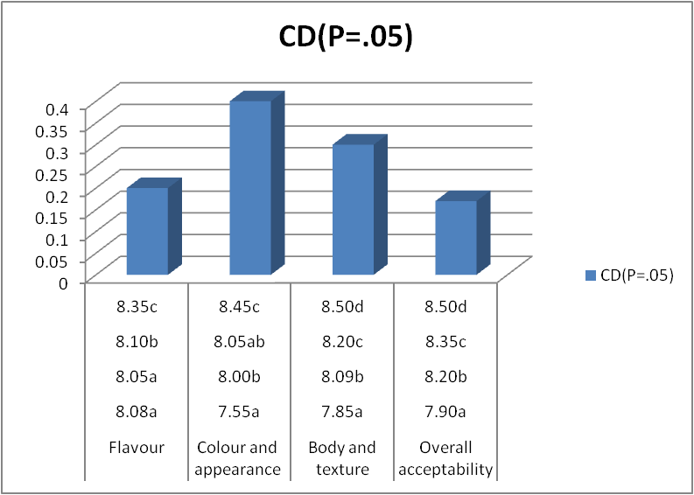

**Note:**

All the values are average of three trials

Similar superscripts indicate non - significance at the corresponding critical difference

Sensory analysis – 9-point hedonic scale

**Effect of Foxtail Millet on the sensory attributes Functional Greek Yoghurt**

The sensory scores with respect to the effect of foxtail millet (2 %, 4 % and 6 per cent) on the sensory attributes of functional Greek yoghurthas been projected in Table 2 and Figure 2.The result showcases that the foxtail millet has greater influence on the product. The sensory acceptance reveals the outcome of study .The control sample's mean score was 8.00,7.50 7.55 and 7.59 for flavor, colour and appearance, body and texture and overall acceptability. Whereas the developed product had a better score when it was enriched with foxtail millet. The score being 8.00, 7.50, 7.55, 7.59 for flavor, colour and appearance, body and texture and overall acceptability. The functional Greek yoghurt based on foxtail millet with 0.7 percent had a maximum overall acceptability respectively. Statistical analysis compliments the result which had a significant effect on the overall acceptability of functional Greek yoghurt. The result is in accordance with the work conducted by Challa *et al* 2025 who emphasized on the contribution of foxtail millet probiotic beverage on sensory parameters and insisted that the product developed good sensory acceptance upon addition of foxtail millet which ia an indication that millets can be effectively used in formulations. The dietary fiber present in foxtail millet adds to the better binding capacity which increases the body and texture value.

**Table 2: Effect of Foxtail Millet on the sensory attributes of Functional Greek Yoghurt**

|  |  |  |  |  |
| --- | --- | --- | --- | --- |
| **Foxtail millet (%)** | **Flavour** | **Colour and appearance** | **Body and texture** | **Overall acceptability** |
| Control | 8.00a | 7.50a | 7.55a | 7.59a |
| 2 | 8.00a | 8.00b | 8.02b | 8.00b |
| 4 | 8.50b | 8.45b | 8.60c | 8.70c |
| 6 | 7.00c | 7.00b | 7.13d | 7.00d |
| **CD(*P*=.05)** | **0.18** | **0.16** | **0.09** | **0.17** |

**Figure 2: Effect of Foxtail Millet on the sensory attributes of Functional Greek Yoghurt**

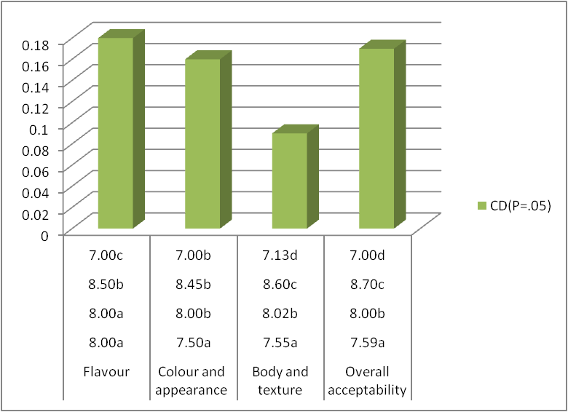

**Note:**

All the values are average of three trials

Similar superscripts indicate non - significance at the corresponding critical difference

Sensory analysis – 9-point hedonic scale

**Conclusion:**

Nutritional well-being is a sustainable force for health, development and maximization of human genetic Yoghurt is regarded as a nutrient-dense diet because it provides vital components for growth, including protein, vitamins, and minerals. The generation trend to have nutritional and therapeutic foods is prime time issue. In this regard developing a product which can address all consumer groups including lactose intolerants is challenging. The developed research product foxtail millet based Greek yoghurt enriched with curcumin not only contributes the priority besides it also makes way for commercialization.

**References**

Akande, A.A. and Adegoke, G.O. 2018. Production, microbiological and quality evaluation of low-fat spiced yoghurts with low glycemic loads. *African. J. of. Food. Agri. Nutr. and Dev*., **18** (2): 13287-13303.

Challa M., Aparna kuna, Lakshmiprasanna kata and Dsa D., 2025 Probiotic foxtail millet beverage- formulation and evaluation of nutritional, physic-chemical and sensory parameters., *International Journal of food Science and Technology*, **28** (5): 248-250.

Hariprasanna K.,2016.Foxtail millet:Nutritional importance and Cultivation spects.Indian Farming special issue on small millets. 65 (1): 25-29.

Kanhed, M.I., Harinivenugopal, Arunkumar, H., Manjunatha, H. and BG, S., 2023.Formulation of WPC enriched ready to serve yoghurt smoothie. *International Research Journal of Modernization in Engineering Technology and Science.* **5**(5): 2582-5208

Maurya, N., Kaushik, K. and Prasad, W. 2020. Preparation and stability evaluation of curcumin fortified Lassi, a fermented dairy beverage. *Int. J. of Ferm. Fo*., **9** (1):19-30.

Mckinley, M. C. 2005. The nutrition and health benefits of yoghurt. *International journal of dairy technology*, **58**(1): 1-1.

Sharif, J., Rayess, Y. E., Risk, A. A., Sadaka, C. and Raviella. 2020. Turmeric and Its Major Compound Curcumin on Health: Bioactive Effect and Safety Profiles for Food, Pharmaceutical, Biotechnological and Medicinal Applications. *Front. in Pharma*., **11** (2): 1- 17.

**ANNEXURE**

**DAIRY SCIENCE COLLEGE, KVAFSU, BENGALURU-24**

**DEPARTMENT OF DAIRY TECHNOLOGY**

**Score card for Sensory Evaluation Using 9-Point Hedonic Scale**

**Name of the Judge: Date:**

You are requested to assess the product in terms of general acceptability on a 9-point hedonic scale score system.

**score system:**

Like extremely 9

Like very much 8

Like moderately 7

Like slightly 6

Neither like nor dislike 5

Dislike slightly 4

Dislike moderately 3

Dislike very much 2

Dislike extremely 1

|  |  |  |  |  |  |  |
| --- | --- | --- | --- | --- | --- | --- |
| **Sensory Characteristics** | **Sample Code** | | | | | |
|  |  |  |  |  |  |
| Color and Appearance |  |  |  |  |  |  |
| Body and Texture |  |  |  |  |  |  |
| Flavour |  |  |  |  |  |  |
| Overall Acceptability |  |  |  |  |  |  |

**Comments: Signature**