*Original Research Article*

NS1 antigen and IgM antibody-based prevalence of dengue infection in the Patna Region: A five years study

.

ABSTRACT

|  |
| --- |
| **Introduction:** Dengue virus is considered an important mosquito-borne virus that currently poses a major health risk and belongs to the Flaviviridae family. The study was conducted to estimate the NS1 antigen and anti- dengue IgM antibody-based prevalence of dengue infection in Patna, Bihar and also to investigate the association of seasonal variation along with the gender-specific prevalence also.  **Methods:** The study involved collection, classification, and analysis of laboratory-based data of blood sample a period of 5 years with reference to dengue infection.  **Results:** During this period a total 7415 samples were referred to the laboratory for screening from different hospitals. Then data were analysed to determine the NS1 and IgM based prevalence against dengue virus. A total of 29.77% were found positive for NS1 and 21.71% were found positive for IgM. Further 64.17% males and 35.82% females were found NS1 positive. Similarly, 66.52 males and 33.48 females were found positive for IgM. Most of the dengue infection was reported in the post monsoon season.  **Conclusions:** So, from study we can conclude that serological testing for presumptive identification of dengue infections is useful for prevention and monitoring the prevalence. Furthermore, a concerted effort is needed to create regional awareness among people in this area. |

*Keywords: Dengue virus, Dengue fever, NS1antigen and IgM antibody*

1. INTRODUCTION

Dengue virus (DENV) is considered an important mosquito-borne (female Aedes aegypti mosquitoes) virus that currently poses a major health risk and belongs to the Flaviviridae family (Racherla et al., 2018). The high mortality rate and lack of specific treatment have made dengue infection a major worldwide health concern. The World Health Organization reported that DENV occurs in more than 125 countries and also more than 50% of the population is at risk. Over 2.5 billion individuals in over 110 countries are at risk of developing these viruses each year because there are no effective drugs or treatments for them (Soe et al. 2018). It is estimated that there are between 50 and 100 million cases throughout more than 100 countries. India was one of them, with over 1.4 million documented cases, making it one of the worst affected countries (Ganeshkumar P et al., 2018, del Valle-Mendoza J et al., 2021).

Dengue fever is characterised by symptoms such as fever, headache, and rash, as well as a number of other nonspecific symptoms and indicators. Dengue hemorrhagic fever (DHF) may develop in the patient, which causes bleeding, pain in the abdomen, and possibly cardiac collapse. Dengue fever manifests itself in three stages: febrile, critical, and recovery phase. Thrombocytopaenia (a condition in which platelet count decrease below 100,000 per mm3 from baseline) and haemoconcentration (a 20% or greater increase in haematocrit) are detectable during the critical phase before fever and shock (Chuansumrit A et al., 2020). Dengue virus serotypes are classified as DENV-1, DENV-2, DENV-3, and DENV-4. Infection with any of these serotypes can result in a range of symptoms, including mild to severe dengue (SD) fever, as well as bleeding and plasma leakage (Soe et al. 2018, Dinesh DS et al., 2020, Trivedi and Chakravarty., 2022, Singh K et al., 2025).

The primary carrier of the dengue virus is Aedes aegypti which first and foremost thrives in specific environments, such as storage or water logging regions, unfurnished drainage networks in municipal regions that are semi-urban and rural, and everywhere there are insufficient waste disposal services (Anker, and Arima., 2011, Getachew D et al., 2015, Kumar S et al., 2012). There is a dearth of gender-specific data because these studies are not frequently carried out and most surveillance systems do not report or analyse data related to gender or rural/semi-urban places, which can related to the increased prevalence of dengue fever in such settings (Anker, and Arima., 2011, Kumar S et al., 2012, Kumar M et al., 2020). Therefore, the purpose of this study is to estimate the NS1 antigen and IgM antibody based prevalence of dengue infection in Patna, Bihar among suspected patients and also to investigate the association of seasonal variation with infection of these viruses along with the gender-specific prevalence.

2. material and methods

This prospective laboratory-based study was conducted at an Indian Council of Medical Research (ICMR) research institute from north eastern part of India. The study spanned five years, focusing on the collection, classification, and analysis of blood samples to investigate the prevalence and characteristics of dengue virus. Blood samples were obtained from clinically suspected dengue cases during the acute phase of the disease (1 to 6 days post-onset), presenting with symptoms such as fever, headache, myalgia, retroorbital discomfort, skin rashes, and hemorrhagic manifestations. Samples were collected in plain vacutainers, processed immediately, and centrifuged to separate serum from blood. The serum was aliquoted and stored at -20°C for subsequent analysis.

The study included 7,415 blood samples referred to the VRDL by various government and private hospitals across Bihar for dengue virus testing. Only samples with complete demographic data and results for both NS1 antigen and IgM antibody tests were included in the analysis. The NS1 antigen was detected using the QUALISA Dengue NS1 ELISA kit (Qualpro Diagnostics Pvt. Ltd., Goa, India), while IgM antibodies were tested with the MICROLISA IgM ELISA kit (J. Mitra and Co., New Delhi), following the manufacturers’ instructions and both tests were performed on the same day.

Data entry and cleaning were carried out in Microsoft Excel (2007 version) to ensure accuracy before generating graphs and tables. Statistical analysis, including descriptive statistics, was performed using IBM SPSS Statistics for Windows, version 22.0.

3. results and discussion

3.1. Result

A total of 7415 tested blood samples, 2208 (29.77%) were found positive, and 10 (0.13%) were found equivocal for NS1 antigen, 1610 (21.71%) were found positive, and 824 (11.11%) were found equivocal for IgM antibody, but 681 (9.18%) patients were found dengue positive by both NS1 and IgM detailed information shown in the table 1. The overall percentage of dengue for the year January 2018 and December 2022 has been described as macro information, in which positive, negative, and equivocal results has been shown in quarterly manner like January to March (Q1), April to June (Q2), July to September (Q3) and October to December (Q3) (Table 1). Most of the positive cases of dengue NS1 were identified on the year 2022 (37.69%), followed by 2018 (28.15%), 2019 (27.21%), and 2021 (8.52%). But during the year 2020, very few samples were tested and all were found negative this due to SARS-CoV-2 pandemic. But in the case of IgM antibody most positive cases were identified on the year 2019 (28.91%), followed by 2018 (27.21%), 2022 (16.57%), 2020 (9.43%), and 2021 (6.59%).

**Table 1. Summarized tabulation of overall data for the year 2018-2022.**

|  |  |  |  |  |  |  |  |  |  |  |
| --- | --- | --- | --- | --- | --- | --- | --- | --- | --- | --- |
| **Year** |  | **Dengue NS1** | | |  | **Dengue IgM** | | | **Both NS1 & IgM** | |
|  |  | **Total**  **sample**  **tested** | **Positive** | **Negative** | **Equivocal** | **Positive** | **Negative** | **Equivocal** | **Positive** | **Equivocal** |
| **2018** | **Jan-Mar** | **72** | **0** | **72** | **0** | **2** | **69** | **1** | **0** | **0** |
| **April-Jun** | **36** | **0** | **36** | **0** | **0** | **36** | **0** | **0** | **0** |
| **July-Sep** | **288** | **34** | **250** | **4** | **47** | **206** | **35** | **12** | **3** |
| **Oct-Dec** | **677** | **268** | **408** | **1** | **243** | **412** | **22** | **106** | **1** |
| **Total** | **1073** | **302** | **766** | **5** | **292** | **723** | **58** | **118** | **4** |
| **2019** | **Jan-Mar** | **26** | **1** | **25** | **0** | **2** | **22** | **2** | **0** | **0** |
| **April-Jun** | **94** | **6** | **87** | **1** | **20** | **32** | **42** | **5** | **1** |
| **July-Sep** | **441** | **78** | **363** | **0** | **110** | **249** | **82** | **32** | **0** |
| **Oct-Dec** | **2137** | **649** | **1488** | **0** | **648** | **1103** | **386** | **253** | **0** |
| **Total** | **2698** | **734** | **1963** | **1** | **780** | **1406** | **512** | **290** | **1** |
| **2020** | **Jan-Mar** | **53** | **0** | **53** | **0** | **5** | **46** | **2** | **0** | **0** |
| **April-Jun** | **0** | **0** | **0** | **0** | **0** | **0** | **0** | **0** | **0** |
| **July-Sep** | **0** | **0** | **0** | **0** | **0** | **0** | **0** | **0** | **0** |
| **Oct-Dec** | **0** | **0** | **0** | **0** | **0** | **0** | **0** | **0** | **0** |
| **Total** | **53** | **0** | **53** | **0** | **5** | **46** | **2** | **0** | **0** |
| **2021** | **Jan-Mar** | **33** | **0** | **33** | **0** | **0** | **33** | **0** | **0** | **0** |
| **April-Jun** | **9** | **0** | **9** | **0** | **1** | **8** | **0** | **0** | **0** |
| **July-Sep** | **305** | **9** | **296** | **0** | **19** | **263** | **23** | **0** | **0** |
| **Oct-Dec** | **275** | **44** | **231** | **0** | **21** | **232** | **22** | **8** | **0** |
| **Total** | **622** | **53** | **569** | **0** | **41** | **536** | **45** | **8** | **0** |
| **2022** | **Jan-Mar** | **88** | **1** | **85** | **2** | **4** | **80** | **4** | **1** | **0** |
| **April-Jun** | **143** | **0** | **143** | **0** | **10** | **123** | **10** | **0** | **0** |
| **July-Sep** | **897** | **338** | **557** | **2** | **142** | **687** | **68** | **84** | **0** |
| **Oct-Dec** | **1841** | **780** | **1061** | **0** | **336** | **1380** | **125** | **181** | **0** |
| **Total** | **2969** | **1119** | **1846** | **4** | **492** | **2270** | **207** | **265** | **0** |
|  | **Grand Total** | **7415** | **2208** | **5197** | **10** | **1610** | **4981** | **824** | **681** | **5** |

A total of 7415 tested samples, 4690 were male and 2725 were female. Out of which 1417 (64.17%) males and 791 (35.82%) females were found NS1 antigen positive. Similarly in the case of IgM antibody 1071 (66.52) males and 539 (33.48) females were found positive. Further gender distribution percentage of male was more as compared to female in dengue suspected cases consecutive for years from 2018 to 2022 as shown in figure 1.

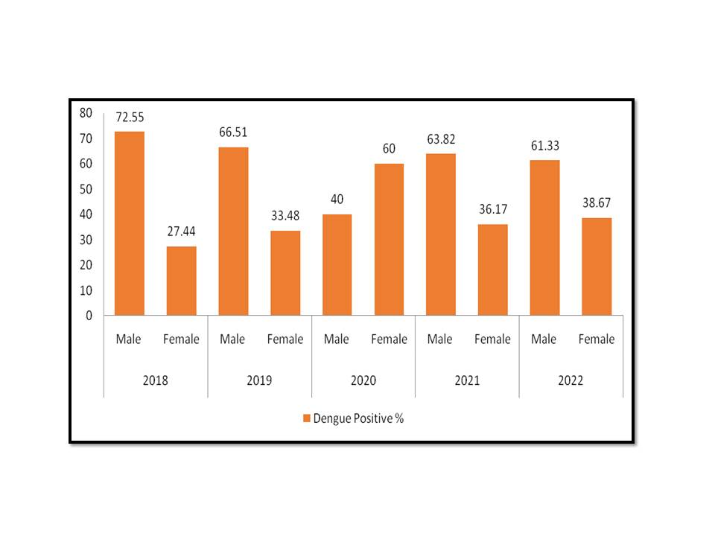

**Figure 1. Figure showing the gender wise distribution of the dengue cases.**

The demography of the patients showed that most of the patients with dengue positive and equivocal cases were found at the median age 23 years with CI at 95% (25.47 to 26.62) (Table 2 & 3). Most of the dengue infection was reported in the month of October to December (Q4). Index of seasonal variation was analyzed with the help of moving average method, positive cases of IgM was continuously increases as compared to NS1. Low seasonal variation of IgM positive cases was found between first and second quartile, slightly high in the fourth quartile. Whereas in case of NS1 positive cases seasonal variation was found irregular in different season, such as start deceasing from first quartile to second quartile, and constantly increasing from third to fourth quartile (Figure 2).

**Table 2: Table showing the distribution of age and statistical for the study.**

|  |  |  |  |  |
| --- | --- | --- | --- | --- |
| **Condition** | **Median** | **Range** | **Standard Deviation (SD)** | **CI for mean at 95%** |
| Age_NS1-Ag_Positive Cases | 24 | 79 | 13.75 | 25.47-26.62 |
| Age_NS1-Ag_Equivocal Cases | 14 | 33 | 12.19 | 6.58-24.02 |
| Age_IgM-Ab_Positive Cases | 23 | 82 | 13.58 | 24.48-25.81 |
| Age_IgM-Ab_Equivocal Cases | 21 | 94 | 15.31 | 23.57-25.66 |
| Age_Overall Cases | 23 | 95 | 13.99 | 25.06-25.86 |

**Table 3: Table showing the age distribution of positive and equivocal cases.**

|  |  |  |  |
| --- | --- | --- | --- |
| **Age (Years)** | **NS1_Ag n (%)** | **IgM_Ab n (%)** | **Both (NS1+IgM) n (%)** |
| <20 | 793 (35.75) | 947 (38.91) | 1740 (37.40) |
| 20-30 | 759 (34.22) | 808 (33.20) | 1567 (33.68) |
| 31-40 | 343 (15.46) | 337 (13.85) | 680 (14.62) |
| 41-50 | 187 (08.43) | 194 (07.97) | 381 (08.19) |
| >50 | 136 (06.14) | 148 (06.08) | 284 (06.10) |
| Total | 2218 | 2434 | 4652 |

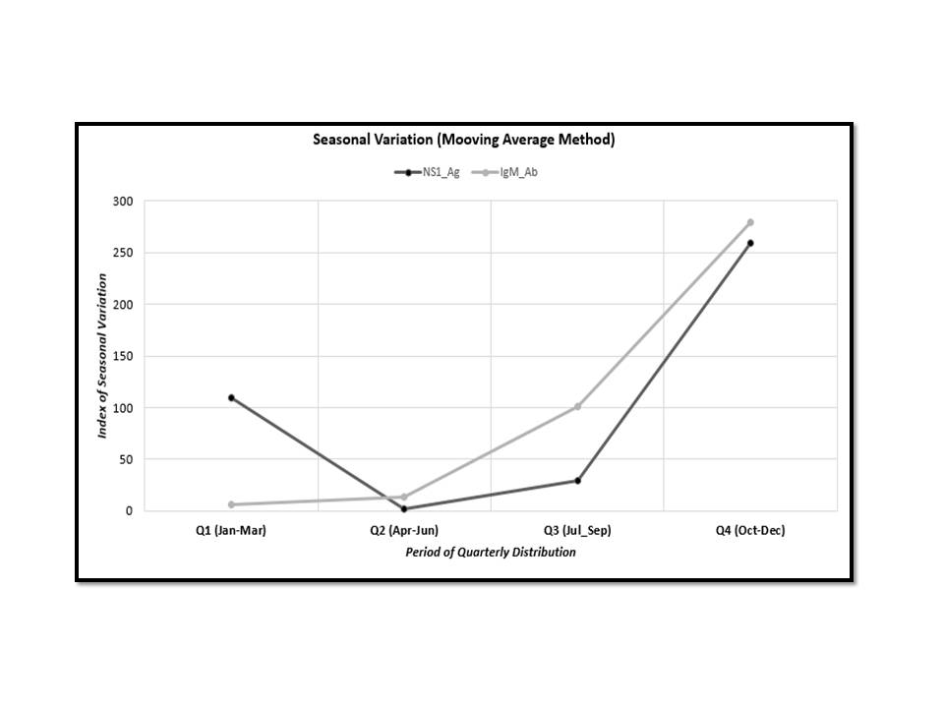

**Figure 2: Figure showing the seasonal variation of dengue cases.**

**3.2. Discussion**

Dengue fever is a mosquito-borne virus that causes significant morbidity and economic losses in many tropical and subtropical locations across the world. Dengue fever is prevalent in most regions of India since it affects a large portion of the country. Most of those affected people were belongs to middle class (Das B et al., 2013). Further as a result of urbanisation, climatic changes, and increased human migration, dengue virus is spreading rapidly. Dengue virus has become the most common vector-borne viral infection of the twenty-first century (Eldigail MH et al., 2018). This is extensive investigation on the prevalence of dengue infection from Patna, Bihar, in India's north-east during 2018-2022. In the current investigation, 29.77% and 21.71% of the suspected cases tested positive in NS1 and IgM antibody test for dengue infection. The other dengue suspected patients who tested serologically negative may really have one of the numerous disorders that exhibit similar symptoms to dengue fever. A similar study prevalence of dengue fever in Uttar Pradesh reported 23% seropositive either by NS1 or IgM ELISA. Although the fact that the gender specific distribution of dengue infection is not well known, few studies have been conducted to describe the gender-based prevalence of dengue cases (Kumar M et al., 2020, Chakravarti A et al., 2012, Goswami L et al., 2018).

In the present study, 64.17% males and 35.82% females were found NS1 antigen positive. Similarly in the case of IgM antibody positive 66.52% males and 33.48% females were found positive. So according to our findings, males were more affected than females. Many additional independent Indian investigations yielded similar results (Kumar M et al., 2020, Agarwal R et al., 1999, Wali JP et al., 1999).. Similarly, comparable findings have been recorded around the world, with males being more affected than females (Brown MG et al., 2009, Ang LW et al., 2015, Rafique I et al., 2017, Abdullah QY et al., 2020).

In this study, dengue infection was found peak in the month of October to December (Q4) which slowly increase from month of July to September (Q3) and decrease from peak for each year from 2018 to 2022. This is owing to the high humidity that follows the rainy season, which provides ample breeding grounds for mosquitoes. Similar results were found in India and all around the world where dengue fever was most common in the post-monsoon season (October to December) period as compared to the monsoon period (Sharma RS et al., 2005, Ali A et al., 2013).

The study predicts the NS1 and IgM ELISA prevalence and included large number of samples from different districts of Bihar. Further the combined results of the NS1 and IgM ELISA demonstrate that the ability to identify dengue fever with general accuracy and capacity may lead to an increase in diagnostic sensitivity.

4. Conclusion

So, from present study we can conclude that serological testing for presumptive identification of dengue infections is useful for prevention and monitoring the prevalence. Preventive measures should be taken during post-monsoon period to minimize any loss by this virus. Further Government officials must make significant efforts to prevent disease and control vectors through biological, environmental, and chemical measures, as well as community education so that patients look for prompt medical attention and physicians, and medical professionals are better equipped to recognize dengue viral infection admission signs and symptoms. Furthermore, a concerted effort is needed to create regional awareness among residents in this area so that they implement all dengue infection preventive measures in order to prevent the virus from spreading further. Therefore, we advise that every single case of dengue should be serologically tested for NS1 and IgM, independent of gender, regardless of the male preponderance.

Ethical approval

All authors hereby declare that all experiments have been examined and approved by the appropriate ethics committee and have therefore been performed in accordance with the ethical standards laid down in the 1964 Declaration of Helsinki. Ethical approval was obtained from the Ethics Committee of ICMR- RMRIMS, (Ethics Committee Letter No: RMRI/EC/21/2023, dated 24.02.2023). The Ethics Committee waived the requirement for written consent, as all samples utilized in the study were previously collected during routine medical care based on clinicians’ requests.

References

Racherla, R. G., Pamireddy, M. L., Mohan, A., Mudhigeti, N., Mahalakshmi, P. A., Nallapireddy, U., et al. (2018). Co-circulation of four dengue serotypes at South Eastern Andhra Pradesh, India: A prospective study. Indian Journal of Medical Microbiology, 36(2), 236-240.

Soe, H. J., Yong, Y. K., Al-Obaidi, M. M. J., Raju, C. S., Gudimella, R., et al. (2018). Identifying protein biomarkers in predicting disease severity of dengue virus infection using immune-related protein microarray. Medicine, 97(5), e9713.

Ganeshkumar, P., Murhekar, M. V., Poornima, V., Saravanakumar, V., Sukumaran, K., Anandaselvasankar, A., et al. (2018). Dengue infection in India: A systematic review and meta-analysis. PLoS neglected tropical diseases, 12(7), e0006618.

del Valle-Mendoza, J., Palomares-Reyes, C., Carrillo-Ng, H., Tarazona-Castro, Y., Kym, S., Aguilar-Luis, M. A., et al. (2021). Leptospirosis in febrile patients with suspected diagnosis of dengue fever. BMC Research Notes, 14(1), 209.

Chuansumrit, A., Apiwattanakul, N., Sirachainan, N., Paisooksantivatana, K., Athipongarporn, A., Tangbubpha, N., et al. (2020). The use of immature platelet fraction to predict time to platelet recovery in patients with dengue infection. Paediatrics and International Child Health, 40(2), 124-128.

Dinesh, D. S., Singh, H., Topno, R. K., Kumar, V., Kesari, S., Singh, S. P., et al. (2020). Surveillance of breeding sites of dengue vector following the floods in an urban area of Patna, Bihar, India. Dengue Bulletin, 41, 85-95.

Trivedi, S., & Chakravarty, A. (2022). Neurological complications of dengue fever. Current neurology and neuroscience reports, 22(8), 515-529.

Singh, K., Farooque, M. Z., Gandhi, V. P., Kumar, A., Sarfraz, A., & Pati, B. K. (2025). Identification of dengue virus serotype and genotype: A comprehensive study from AIIMS Patna, Bihar. Indian Journal of Medical Microbiology, 53, 100789.

Anker, M., & Arima, Y. (2011). Male–female differences in the number of reported incident dengue fever cases in six Asian countries. Western Pacific surveillance and response journal: WPSAR, 2(2), 17.

Getachew, D., Tekie, H., Gebre-Michael, T., Balkew, M., & Mesfin, A. (2015). Breeding sites of Aedes aegypti: potential dengue vectors in Dire Dawa, East Ethiopia. Interdisciplinary perspectives on infectious diseases, 2015(1), 706276.

Kumar, S., Wahab, N., Mishra, M., & Warikoo, R. (2012). Evaluation of 15 local plant species as larvicidal agents against an Indian strain of dengue fever mosquito, Aedes aegypti L.(Diptera: Culicidae). Frontiers in physiology, 3, 104.

Kumar, M., Verma, R. K., & Mishra, B. (2020). Prevalence of dengue fever in Western Uttar Pradesh, India: A gender-based study. International Journal of Applied and Basic Medical Research, 10(1), 8-11.

Das, B., Das, M., Dwibedi, B., Kar, S. K., & Hazra, R. K. (2013). Molecular investigations of dengue virus during outbreaks in Orissa state, Eastern India from 2010 to 2011. Infection, Genetics and Evolution, 16, 401-410.

Eldigail, M. H., Adam, G. K., Babiker, R. A., Khalid, F., Adam, I. A., Omer, O. H., et al. (2018). Prevalence of dengue fever virus antibodies and associated risk factors among residents of El-Gadarif state, Sudan. BMC public health, 18, 1-8.

Chakravarti, A., Arora, R., & Luxemburger, C. (2012). Fifty years of dengue in India. Transactions of the Royal Society of Tropical Medicine and Hygiene, 106(5), 273-282.

Goswami, L., Chowdhury, R., & Rasul, E. S. (2018). Seroprevalence of dengue infection in a tertiary care hospital in Assam.

Agarwal, R., Kapoor, S., Nagar, R., Misra, A., Tandon, R., Mathur, A., et al. (1999). A clinical study of the patients with dengue hemorrhagic fever during the epidemic of 1996 at Lucknow, India. Southeast Asian journal of tropical medicine and public health, 30(4), 735-740.

Wali, J. P., Biswas, A., Handa, R., Aggarwal, P., Wig, N., & Dwivedi, S. N. (1999). Dengue haemorrhagic fever in adults: a prospective study of 110 cases. Tropical doctor, 29(1), 27-30.

Brown, M. G., Vickers, I. E., Salas, R. A., & Smikle, M. F. (2009). Seroprevalence of dengue virus antibodies in healthy Jamaicans. Human antibodies, 18(4), 123-126.

Ang, L. W., Cutter, J., James, L., & Goh, K. T. (2015). Seroepidemiology of dengue virus infection in the adult population in tropical Singapore. Epidemiology & Infection, 143(8), 1585-1593.

Rafique, I., Saqib, M. A. N., Munir, M. A., Qureshi, H., Taseer, I. U. H., Iqbal, R., et al. (2017). Asymptomatic dengue infection in adults of major cities of Pakistan. Asian Pacific journal of tropical medicine, 10(10), 1002-1006.

Abdullah, Q. Y., Al-Helali, M. F., Al-Mahbashi, A., Qaaed, S. T., & Edrees, W. H. (2020). Seroprevalence of dengue fever virus among suspected patients in Taiz Governorate-Yemen. Universal Journal of Pharmaceutical Research.

Sharma, R. S., Kaul, S. M., & Sokhay, J. (2005). Seasonal fluctuations of dengue fever vector, Aedes aegypti (Diptera: Culicidae) in Delhi, India. Southeast Asian J Trop Med Public Health, 36(1), 186-90.

Ali, A., ur Rehman, H., Nisar, M., Rafique, S., Ali, S., Hussain, A., et al. (2013). Seroepidemiology of dengue fever in Khyber Pakhtunkhawa, Pakistan. International journal of infectious diseases, 17(7), e518-e523.