Agronomic performance of genotypes [F1 and F2] of Lagenaria siceraria (Molina) Standl. to insect foliar damage

Abstract
Lagenaria siceraria (Molina) Standley is a plant with high nutritional potential and high market value. However, production is relatively low due to foliar damage caused by insect pests. Two experimental were put in place during 2019 and 2020 in the village of Manfla approximately 400 km from of Abidjan in order to identify and select the most productive genotypes of L. siceraria. Thus, a comparative study of parental individuals P1 and P2, F1_{d} hybrids, resulting from a direct crosses, hybrids F1_{ind}, from an indirect crosses and the segregating F2 population F2_{d} and F2_{ind} were carried out. Phenological and agronomic parameters of all plants were measured in the presence of insect pests. The results obtained showed that P2 individuals caused more than 90% of foliar damage compared to less than 25% for P1. The level of foliar damage of individuals resulting from the cross is closer to the parent that served as a female plant. Two groups were identified. The first group consisting of P1 and F1_{ind} were distinguished by a low rate of foliar damage and by a high seeds number and fruits and seeds weight.
The second group composed of P2, F1_{d}, F2_{ind} and F2_{d} were characterized by a short reproductive cycle. However, a series of backcrossing, involving the F1 hybrid and the P2 parent, must be carried out in order to obtain early and productive individuals.
Keywords: Lagenaria siceraria; Foliar damage; Agronomic evaluation; F1 hybrid; F2 segregating population

- INTRODUCTION
Lagenaria siceraria is one of the most cultived cucurbitaceous vegetables around the world (Agata et Beata, 2020). It has two types of fruits. The calabash type is used as musical instruments, decorative objects or kitchen utensils (Fajinmi et al. 2022) and the oleaginous type, commonly known as "pistache" is consumed in sauce during traditional ceremonies (Zoro Bi et al. 2003). L. siceraria is used also in medicinal treatment (Zaatout et al. 2023), in agronomy ( Touré et al. 2021) and is a good source of protein and lipid (Syed et al. 2019; Mehboob et al. 2022).
Despite its importance, the production is low in Côte d'Ivoire (Dje Bi et al. 2017). This observation has been verified in Benin where the fruit number per plant does not exceed three (Achigan-Dako et al. 2006; Achigan-Dako et al. 2008). The relative weakness of L. siceraria production is caused by insect pests (Anzara et al. 2015).
The search for improved varieties capable of obtaining similar production in the presence and absence of pests is a considerable asset for farmers. Several improved varieties have been obtained through inter-varietal crosses of cultivated species, particularly in cowpea (Owusu et al. 2018; Oluwafemi et al. 2019), in melon (Adjoumani et al. 2016; Amanullah et al. 2021) and in tomato (Lokonga et al. 2020).
In L. siceraria, hybrids and segregating populations have also been obtained from crosses between oilseed and calabash types. These data made it possible to determine the heritability of qualitative parameters (Amangoua et al. 2018) and the genetic determinism of tolerance to insect pests (Pitan et al. 2011; Anzara et al. 2021). However, the agronomic evaluation of such populations have not yet been addressed. Many studies have shown that hybrid varieties have recorded yields than local landraces (Chimonyo et Modi, 2013; Shivapriya et al. 2021; Saleem et al. 2024). Indeed, production of hybrids showed greater improvement for economic traits (Bekzod et al. 2024). Thus, the objective of this study was to identify genotypes (F1 or F2) with high agronomic potential to entomological pressure in order to optimize production.

- MATERIALS AND METHOD
  - Study site
Experiments were conducted under field conditions during april to august respectively in 2019 and 2020 in the village of Manfla (6°49’34.38’’N, 5°43’47.68’’W), located in the department of Zuenoula, characterized by high production of cucurbits. This department is located in the Center-West of Côte d’Ivoire, approximately 400 km from of Abidjan (Figure 1). The vegetation is of the wooded savannah type. The soil characteristics, at 20 cm depth, are as follows: pH = 6.45, with 57% sand, 36% silt, 7% clay, 6% organic matter, 3.5g/Kg of total N, 24.4g/Kg of available P and 0.45g/Kg of K (Kouassi et Zoro Bi, 2009).
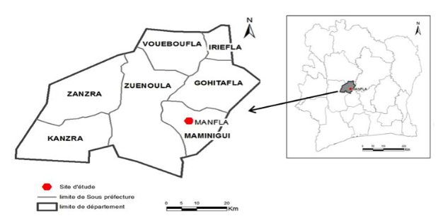
Figure 1. Geographical location of the Manfla site (Monnier, 1983)

  - Plant material
Two cultivated varieties calabash P1 (NI431) and oilseed P2 (NI227) were provided from four successive self-pollination. They were repectively characterized by a higher weight fruit and a short reproductive cycle. P1 and P2 were hybridized to generate the segregating populations. Both direct cross (F1_{d}) and reciprocal crosses (F1_{ind}) (Figure 2) were made. These plants (F1_{d} and F1_{ind}) were self-pollinated to generate respectively F2_{d} and F2_{ind}. Experiment materials were composed of parental seeds P1 and P2, hybrids seeds F1_{d}, F1_{ind} and segregating populations F2_{d} and F2_{ind}.

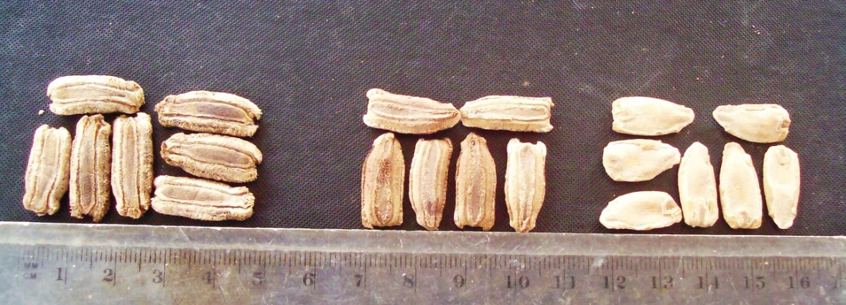
NI431 (male parent) F1_{d} NI227 (female parent)
A
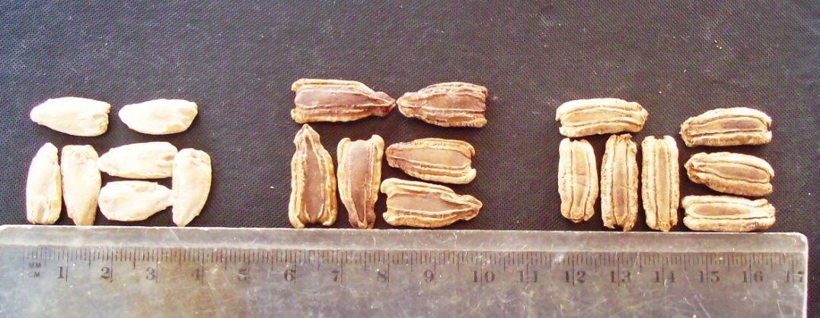
B
NI227 (male parent) F1_{ind} NI431 (female parent)
Figure 2. F1 hybrid obtained from an direct (A) and indirect cross (B) between NI227 and NI431
  - Experimental design
Field experiences took place in the first cropping season (March–july) respectively at 1999 and 2020 on an area measured 50 m x 30 m (1500 m²). A total, 120 plants including 40 for parental genotypes (20 for P1 and 20 for P2), 40 hybrids F1 (20 F1_{d} and 20 F1_{ind}) and 40 components of the F2 (20 F2_{d} and 20 F2_{ind}) were used. Three seeds are sown per pocket on the same day on the entire plot. The seedlings were thinned after emergence in order to keep a single plant (the most vigorous). The planting distance was 3 m between and within rows with 1.5 m of edges. This distance makes it possible to take into account the creeping nature of the species which covers the ground very quickly. Manual weeding was carried out during plant development and no chemical product is applied during this experiment.
  - Morphological data
From sowing to harvest eight parameters have been collected on the 120 plants. It’s about Germination Time (GT), Male flowering time (MF), Female flowering time (FF), Maturity Fruit time (MF), Fruit Number (NF), Fruit weight (FW), Seed Number (SN) and Seed Weight (SW) (Table 1) and Foliar Damage (FD). It was evaluated during the vegetative stage of the plant and calculated using the following formula: FD = nFa/nFt x 100 With nFa: number of leaves destroyed by insects; nFt: number of total leaves of a plant.

Table 1. Methods of measuring different parameters
Characters | Type and period of observation
Germination time (TG) | Number of days from sowing to cotyledonary leaf opening
Male flowering time (FM) | Number of days from sowing to first male flower opening per plant.
Female flowering time (FF), | Number of days from sowing to first female flower opening per plant.
Fruit Maturity Time (MF) | Number of days from sowing to first mature fruit per plant
Number of fruits per plant (FN) | Total number of fruits at plant maturity
Fruit weight (WF) | Weight of the mature fruits in gram
Seed Number (SN) | Total number of seeds per fruit
Seed Weight (WS) | Weight of seeds after drying in gram

  - Statistical Analysis

Comparison of the averages of the agronomic parameters was achieved between the different generations by variance analysis (ANOVA) at the 5% probability threshold. When a significant difference is noted between the factors considered for a given trait, the test of the smallest significant difference (ppds) HSD of TUKEY was performed. In order to determine the degree of divergence between the different populations a hierarchical classification on the collected data were carried out. All these analyses were carried out with the software Stastistica version 7.1.
- RESULTS AND DISCUSSION
  - Foliar damage of different populations :
Several plants reactions were observed following insect damage. Some populations were less attacked than others (Figure 3). Parental individual P2 recorded the most destroyed leaves (97.24%) followed respectively by F1_{d} (70.07%), F2_{d} (61.05%) ; F2_{ind} (35,7 %) and F1_{ind} (30.1%) A another parental individual P1 caused the least foliar damage (22.64%).

Figure 3. Proportions of leaf damage according to populations

The response of parental individuals P1 and P2 as being respectively tolerant and sensitive to insects carried out by Anzara et al. 2020 were confirmed in this study. This study showed that populations react differently to insect attacks. The herbivorous insects preferred some populatin than others. Similar observations were reported by Adja et al. (2015) who showed that the level of insect damage varied from plants within species and from one species to another. When the female parent was P1 (NI431), foliar damage of F1_{ind} and F2_{ind} was also lower and less than 40%. When the female parent was P2 (NI227), foliar damage of F1_{d} and F2_{d} were above 60%. Intensities of hybrids and segregating populations damage foliar were closer to that of the parents that served as female plants. This indicates the presence of maternal or cytoplasmic factors in the control of tolerance against foliar damage. Several studies have also shown the maternal effect in the transmission of certain traits in cultivated species (De Castro et al., 2013; Oluwafemi et al., 2019).

  - Comparison of agronomic parameters of different generations :
Analysis of Variance carried out between the six generations revealed a significant difference existed for all phenological parameters excepted Germination Time (GT) (Table 2). Seeds of all the generations germinated in five days. Analysis test indicated that Male and Femelle Flowering time (FF) and Mature Fruit time (MF) were longger for the P1 than the other generations. The parental individuals P1 therefore had a long reproductive cycle (122 days). It was followed by F1_{ind} which reached maturity 15 days earlier and then respectively by F2_{ind}, F2_{d} and F2_{ind}. The parental individuals P2 quickly reached fruit maturity at 63 days and only 32 days for Male Flowering (MF). It therefore had a short reproductive cycle. No individual resulting from the cross between these two individuals produced a shorter reproductive cycle than P2. However, varieties cultivated with a short reproduction cycle are recommended in agriculture in order to allow producers to quickly obtain profits to meet their financial needs (Doumbia et al. 2013).
Statistical tests showed also a significant difference of agronomic parameters between the different populations (Table 2). The parental individual P1 recorded a lower Fruit Number harvested with two fruits per plant. Those of P2 obtained the lightest fruits (six fruits). Fruit Number of others popultations (F1_{ind}, F2_{ind}, F1_{d} and F2_{d}) varied between two to three. On the other hand, the fruit number and the fruit weight per plant were above in P1 and F1_{ind} than the other populations.This showed that the weight of a plant's fruit is not related to the number of fruits. A positive correlation was also observed between the number of seeds per fruit with total fruit mass (Koffi et al. 2009 ; Majid et al. 2020 ; Ezin et al. 2022).
Seeds Weight were higher for P1 followed by F1_{ind}, F2_{ind}, F1_{d}, F2_{d} and P2. The significant drop in seed production of populations P2, F1_{d} and F2_{d} would be due to the increased damage caused to these populations by insects. The degree of association estimated by the Pearson r correlation coefficient between foliar damage and and Seed Weight was 0,711. Thus, plants with the most leaf damage recorded a low Seed Weight. Correlation between insect damage and Seed Weight observed in this study has been verified in several studies, including melon (Edelson et al. 2003), cowpea (L.) Walp (Rahmann et al. 2008) and corn (Barimavandi et al. 2010). Indeed, leaves are important for photosynthesis, which is the major process regulating plant growth. The productivity of a plant depends on the efficiency of its photosynthetic processes and therefore on the size of its photosynthetic surface (Karadogan et Akgün, 2009).

Table 2. Comparison of populations according to phenological and agronomic parameters
Population | Germination  Time (j) | Male  Flowering  (j) | Female  Flowering (j) | Fruit  Maturity (j) | Fruit  Number | Fruit  Weight (g) | Seed  Weight (g) | Seed  Number
P1 | 5,65 ± 0,68ª | 74,48 ± 6,90^{d} | 98,05 ± 9,19^{f} | 122,55 ± 5,14^{f} | 2,15 ± 1,13ª | 1536,25 ± 380,5^{d} | 65,00 ± 14,18^{d} | 307,55 ± 74,83^{c}
P2 | 5,60 ± 0,50ª | 32,05 ± 1,19ª | 41,25 ± 1,90ª | 63,15 ± 3,85ª | 6,05 ± 0,88^{c} | 641,25 ± 193,0ª | 31,67 ± 5,52ª | 122,8± 29,91ª
F1_{d} | 5,60 ± 0,68ª | 35,50 ± 3,79ª | 51,25 ± 4,84^{b} | 74,85 ± 5,14^{b} | 2,20 ± 0,41ª | 703,75 ± 244,58^{b} | 40,32 ± 5,28^{b} | 229,9± 38,10^{b}
F1_{ind} | 5,45 ± 0,60ª | 65,85 ± 9,51^{c} | 90,35 ± 9,57e | 107,70 ± 13,20e | 3,05 ± 0,68^{b} | 1510,00 ± 63,03^{d} | 68,72 ± 12,51^{d} | 313,05 ± 79,61^{c}
F2_{d} | 5,95 ± 0,82ª | 33,70 ± 4,18ª | 57,30 ± 7,73^{c} | 81,70 ± 12,32^{c} | 2,35 ± 0,58ª | 725,00 ± 187,60^{b} | 43,29 ± 6,88^{b} | 208,00 ± 30,41^{b}
F2_{ind} | 5,80 ± 0,69ª | 38,90 ± 5,86^{b} | 65,80 ± 7,03^{d} | 97,75 ± 9,48^{d} | 2,25 ± 0,55ª | 1045,00±354,35^{c} | 54,68 ± 13,45^{c} | 268,7± 59,28^{b}
F | 1,36 | 198,65 | 191,91 | 117,35 | 83,08 | 49,42 | 39,83 | 32,76
p | 0,24 | < 0,001 | < 0,001 | < 0,001 | < 0,001 | < 0,001 | < 0,001 | < 0,001
Mean values followed by the same superscript were not significantly different (p≥ 0.05)

  - Structuring of agronomic parameters and generations
Examination of the factor weight matrix made it possible to retain the first two axes which expressed 74.28% (Table 3). These first two axis can therefore be retained for the interpretation of our results since they bring together the greatest variability. Eight descriptors contributed significantly to the formation of the two axis. The first axis (62.20%) is defined by percentage of Foliar Damage which is positively correlated with this axis. It was also defined by the Seeds Number, Fruits Weight, Seeds Weight, Male and Female Flowering time and Fruit Maturity time. These parameters were however negatively correlated to this axis. These different parameters represented the phenological and agronomic parameters of plants. Fruit Number was the variable that contributed mainly to the formation of the second axis which explains 12.087% of the total variability. This variable is positively correlated with axis 2.

Table 3. Eigenvalue matrix and percentage variation Expressed by the principal axes of the PCA
Principal component | Axis 1 | Axis 2
Eigenvalue | 5,598 | 1,087
Total variance (%) | 62,201 | 12,087
Total cumulative variance (%) | 62,201 | 74,289
Foliar Damage | 0,908 | 0,191
Fruit Number | 0,537 | 0,795
Seed Number | -0,765 | -0,217
Fruit weight | -0,837 | 0,256
Seed Weight | -0,816 | 0,077
Fruit Maturity Time | -0,923 | 0,074
Male flowering time | -0,883 | 0,320
Female flowering time | -0,946 | 0,147

Principal Component Analysis allowed to establish the existing relationship between the tested parameters and the different populations of the six populations allowed to establish the existing relationship between the different populations (Figure 4). This analysis allowed to structure the populations into three groups. Group I composed of P1 and F1_{ind} populations and was characterized by high agronomic parameters. Group II composed of P2 individuals was characterized by precocity with a high number of fruits. And group III composed of F1_{d}, F2_{ind} and F2_{d} had intermediate values.
In order to group the different populations into relatively homogeneous groups based on the similarities between them, the Hierarchical Ascending Classification (HAC) was used. The dendrogram produced highlighted two main groups). The two groups GI were composed of P1 and F1_{ind}. Group II is divided into two subgroups, the first subgroup consists of the P2 and the second, of the F1_{d}, F2_{ind} and F2_{d} populations (Figure 5). The hierarchical classification analysis nevertheless associated the last two groups into one. Indeed, the phenological and agronomic parameters of group II (F2 population) are close to group III (F1_{d}, F2_{ind} and F2_{d}).
F1_{ind} hybrids with a low rate of foliar damage and high fruit and seed weights are recommended. However, back-crosses must be carried out in order to obtain individuals with these characteristics with a short reproduction cycle.

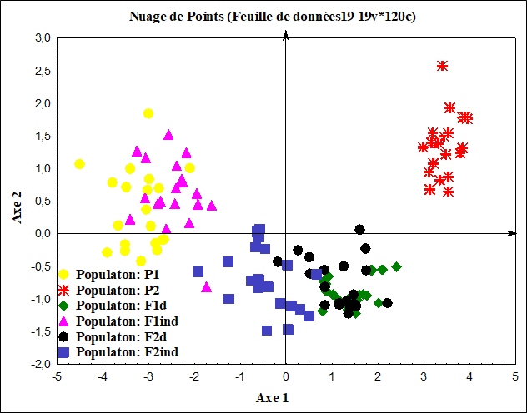
GIII
GII
GI
Figure 4. Distribution of individuals in plane 1-2 revealed from PCA in the six populations of Lagenaria siceraria

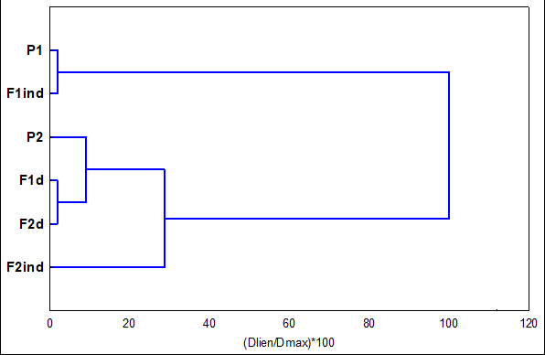
GI
GII
Figure 5. Dendrogram (UPGMA) of the six populations of Lagenaria siceraria

- Conclusion
In conclusion, comparative study of the agronomic performance of parental individuals (P1 and P2), hybrids (F1_{d} and F1_{ind} ) and segregating populations (F2_{d} and F2_{ind}) in the presence of insect pests was carried out to identify and select the most productive genotypes. It emerges from this work that parental individuals P1 and P2 were identified as late and early respectively. Two groups of these evaluated populations were identified. The first group consisting of P1 and F1_{ind} were distinguished by a low rate of foliar damage and by a high seeds number and fruits and seeds weight and the second group consisting of P2, F1_{d}, F2_{ind} and F2_{d} were characterized by a short reproductive cycle.

Conflict of interests
The authors have not declared any conflict of interests

References

Achigan-Dako G., E., Fanou N., Kouke A., Avohou H., Vodouhe R.S., & Ahanchede A. (2006). Agronomic evaluation of three species of Egusi (Cucurbitaceae) used in feed in Benin and development of a yield prediction model. Biotechnology Agronomy Society Environment, 10(2), 121-129.
Achigan-Dako E., G., Fagbemissi R., Avohou H., T., Vodouhe R., S., Coulibaly O., & Ahanchede A. (2008). Importance and practices of Egusi crops (Citrulluslanatus (Thunb.) Matsum. & Nakai, Cucumeropsis mannii Naudin and Lagenaria siceraria (Molina) Standl. cv. ‘Aklamkpa’) in socio linguistic areas in Benin. Biotechnology Agronomy Society Environment, 12(4), 393-403. https://popups.uliege.be/1780-4507/index.php?id=3254.
Adja N. A., Danho M, Alabi T. A. F., Gnago A., J., Zimmer J., Y., Francis F., Kouassi P., Baudoin J., P., & Zoro Bi I., A. (2014). Entomofauna associated with African oleaginous cucurbits (Lagenaria siceraria Molina (Standl.1930) and Citrullus lanatus Thumb (Matsum & Nakai 1916)) and impact of pests on production. International Journal of Entomology, 50(3-4), 301-310. http://dx.doi.org/10.1080/00379271.2014.937104.
Adjoumani K., Kouonon L., C., Koffi G., K., Bony B., S., Brou K., F., Akaffou D., S., & Sie R., (2016). Analysis on genetic variability and heritability of fruit characters in Citrullus lanatus (Thunb.) Matsumura and Nakai (Cucurbitaceae) cultivars. Journal of Animal and Plant Sciences, 28(1), 4340-4355. http://www.m.elewa.org/JAPS; ISSN 2071-7024.
Agata R., M., & Beata O. (2020). Vegetables from the Cucurbitaceae family and their products: Positive effect on human health, 8 78 : 110788.
Amanullah S., Gao P., Osae B., A., Saroj A., Tiantian Yang T., Liu S., Weng Y., & Luan F. (2021). Genetic linkage mapping and QTLs identification for morphology and fruit quality related traits of melon by SNP based CAPS markers. Scientia Horticulturae, 278 : 109849. https://doi.org/10.1016/j.scienta.2020.109849
Amangoua F., Koffi K., K., Baudoin J., P., & Zoro Bi I., A. (2018). Inheritance of fruit neck, rind and seed coat hardness, and seed coat color in bottle gourd. South African Journal of Plant and Soil, 36(1), 1-8. DOI:10.1080/02571862.2018.1484191.
Anzara K., G., G., R., Koffi K., K., Coulibaly S., S., Fouha Bi D.; N, Baudoin J., P., & Zoro Bi I., A. (2015). Influence of herbivorous insects on the production of Lagenaria siceraria (Molina) Standley (Cucurbitaceae). African journal of Plant Science, 9 (11), 449-456. ff10.5897/AJPS2015.1316ff.
Anzara G., R., Angui M., V., J., Doubi Bi T., S., Akaffou S., D., Zoro Bi I., A. (2021). Genetic determinism of Lagenaria siceraria (Molina) Standley (Cucurbitaceae) tolerance to insect pests and search for gene-associated SSR microsatellite markers. European Scientific Journal, 17(10), 233-248. https://doi.org/10.19044/esj.2021.v17n10p233
Barimavandi, A., R., Sedaghathoor, S., & Ansari, R. (2010). Effect of different defoliation treatments on yield and yield components in maize (Zea mays L.) cultivar of S.C704. Australian Journal of Crop Science 4(1): 9-15.
Bekzod, N., Alisher, A., Orip, K., Kholygit, R., Mirvakhob, M., Isfandiyar, K. (2024). Inheritance of morpho economic traits in F1-F2 progeny of cotton. E3S Web of Conferences , 538 : 04023. doi.org/10.1051/e3sconf/202453804023
Chimonyo V., G., P., & Modi A., T. (2013). Seed performance of selected bottle gourd (Lagenaria siceraria (Molina) Standl.). American Journal of Experimental Agriculture, 3,740-766. doi:10.9734/agea/2013/4114
De Castro, M., P., Baldin, E., L., L., Criz, P., L., De Souza, C., M., & De Silva, P., H., S. (2013). Characterization of cowpea genotype resistance to Callosobruchus maculatus. Brasilia Agricultural Research, 48(9), 1201-1209. https://doi.org/10.1590/S0100-204X2013000900003
Dje Bi I., R., Kouassi K., I., Koffi K., K., Kouakou K., L., Baudoin J., P., Bi Irie A., & Zoro Bi I., A. (2017). Effect of seed dates on agronomic performance of Lagenaria siceraria (Molina) Standl. (Cucurbitaceae) and Manihot esculenta Crantz (Euphorbiaceae) in associated culture. Biotechnology, Agronomy, Society and Environment, 21(4), 240-250. DOI: 10.25518/1780-4507.13772.
Doumbia I., Z., Akromah R., & Sisibuo J., Y. (2013). Comparative study of cowpea germplasms diversity from Ghana and Mali using morphological characteristics. Journal of Plant Breeding and Genetics, 01(03), 139-147.
Edelson, J., V., Duthie, J., & Roberts, W. (2003). Watermelon growth, fruit yield and plant survival as affected by squash bug (Hemiptera: Coreidae). Journal of Economic Entomology, 96(1), 64-70. https://doi.org/10.1093/jee/96.1.64.
Ezin V., Gbemenou U., H., & Ahanchede A. (2022). Characterization of cultivated pumpkin (Cucurbita moschata Duchesne) landraces for genotypic variance, heritability and agro-morphological traits. Saudi J Biol, 29(5), 3661–3674. doi: 10.1016/j.sjbs.2022.02.057
Fajinmi O. , O. , Olaoluwa O. , Olarewaju , Georgina D. , Authur , Roger M. , & Coopoosamy , Kuben N. (2022). A review of the relevance of bottle gourd in Eastern and Southern African traditional music, and social life. Journal of Medicinal Plants for Economic Development, 6(1), 1-8. https://doi.org/10.4102/jumped.v6i1.141.
Caradogan T., & Akün I., (2009). Effect of leaf removal on sunflower yield and yield components and some quality characters. Helia, 32(50), 123-1 DOI:10.2298/HEL0950123K.
Lokonga O., J., Muhuza M., K., (2020). Effect of pig manure on the yield of two hybrid genotypes F1 (Mongal and Thorgal) exotic tomatoes (Solanum lycopersicum L.) cultivated under cover at Kisangani (DR Congo). International Journal of Innovation and Scientific Research, 48(2), 225–248.(2009).
Koffi K., K., Anzara G., K., Malice M., Djè Y., Bertin P., Baudoin J., P., & Zoro Bi I., A. (2009). Morphological and allozyme variation in a collection of Lagenaria siceraria (Molina) Standl. from Côte d'Ivoire. Biotechnology, Agronomy, Society and Environment, 13, 257-270

Kouassi, N., J., & Zoro, I., A. (2009). Effects of sowing density and seedbed type on yield and yield components of Bambara groundnut (Vigna subterranea) in woodland savannas of Côte d'Ivoire. Experimental Agriculture, 46(1), 99-110. DOI:10.1017/S0014479709990494.
Majid, R., Hussain, K., Syed, M., H., Syeda, F., Insha, J., Amreena, S., Syed, A., Afroza, A., Muzamil, A., & Sameena, M. (2020). Comparative Performance of Various Bottle Gourd [Lagenaria siceraria (Molina) Standl.] Genotypes. International Journal of Current Microbiology and Applied Sciences, 9(06), 371-375. doi: https://doi.org/10.20546/ijcmas.2020.906.048.
Mehboob, M., Irum, N., Aisha, S., & Ayesha, A. (2022). Medicinal and nutritional importance of Lagenaria siceraria (Lauki). Saudi Journal of Biomedical Research, 72, 67-73. DOI: 10.36348/sjbr.2022.v07i02.001.
Monnier Y. (1983). Vegetation map of the Ivory Coast. Young Africa, Paris (France),pp 1-72.
Oluwafemi, D., A., Ogunkanmi, A., L., Adetumbi, J., A., Solomon, T., Akinyosoye, & Oluwatoyin, T., O. (2019). Morpho-genetic variability in F2 progeny cowpea genotypes tolerant to bruchid (Callosobruchus maculatus). Journal of Agricultural Sciences, 64(1), 53-68. https://doi.org/10.2298/JAS1901053A.
Owusu, E., Y., Akromah, R., Denwar, N., N., Adjebeng-Danquah, J., Kusi, F., & Haruna, M. (2018). Inheritance of Early Maturity in Some Cowpea (Vigna unguiculata (L.) Walp.) Genotypes under Rain Fed Conditions in Northern Ghana. Advances in Agriculture, (1), 1-10. https://doi.org/10.1155/2018/8
Pitan O., O., R., & Ekoja E., E. (2011). Yield response of okra, Abelmoschus esculentus (L.) Moench to leaf damage by the flea beetle, Podagrica uniforma Jacoby (Coleoptera: Chrysomelidae). Crop Protection, 30, 1346-1350.
Toure, A., I., Tovignon, G., C., Z., Mboko, A., V., Kimse, M., Matumuini, F., N., Doubi, B., T., S., Tro, H., H., Zoro Bi, I., A., & Boukila, B. (2021). Effects of dehulled seed pellets of bebu cultivar of Citrullus lanatus and Lagenaria siceraria on growth performances of broiler. International Journal of Biological and Chemical Sciences, 15(4), 1494-1510. DOI: https://dx.doi.org/10.4314/ijbcs.v15i4.16
Rahman, A., H., M., M., Anisuzzaman, M., Ahmed, F., Islam, A., K., M., R., & Naderruzzaman, A., T., M. (2008). Study of nutritive value and medicinal uses of cultivated cucurbits. Journal of Applied Sciences Research, 4(5), 555-558. https://www.researchgate.net/publication/269571068.
Saleem M., A., Anwar S., Khan M., Y., Saleem A., S., Khan M., S., Rahman S., U., Khattak L., Khan A., Murad S., Noor E., Khan K., A., (2024). A Comparative Analysis of Local Maize Hybrids, Versus Commercial Maize Hybrids: Assessing Yield and Yield Components. International Journal of Sustainability in Research, 2(1), 133-146. DOI: https://doi.org/10.59890/ijsr.v2i1.954 ISSN-E: 3025-7379.
Shivapriya M. , Mamatha S. , Umesha K. , Lingaiah , H. , B. , & Mohankumar S. , (2021). Plant Genetic Resources , 19(5), 419–427
StatSoft, 2005. Statistics for Windows; version 7.1, StateSoft Inc.,Tulsa.
Syed Q. , A. , Akram M. , & Shukat R. (2019). Nutritional and Therapeutic Importance of the Pumpkin Seeds. Medical treatment. Journal of Scientific and Technical Research, 21, 15798-15803. DOI:10.26717/BJSTR
H. Zatouta, N. Alshaikha, S. Sallama, H. Hammoda (2023). Phytochemical and Biological Activities of Lagenaria siceraria: An Overview. Egyptian Journal of Chemistry, 66(10), 479–495.
Zoro Bi I., A., Koffi K., K., & Dje Y. (2003). Botanical and agronomic characterization of three cucumber species consumed in sauces in West Africa: Citrullus sp., Cucumeropsis mannii Naudin and Lagenaria siceraria (Molina) Standl. Biotechnology Agronomy Society Environment, 7(3-4), 189-199.

