Agronomic performance of local and improved *Sorghum* *bicolor* L. Moench varieties in Sudanian area, North of Côte d'Ivoire

.

ABSTRACT

|  |
| --- |
| **Aims:** To evaluate the agronomic performance of improved introduced and local sorghum varieties in the Korhogo agroclimatic zone in northern Côte d'Ivoire.  **Study design:** The experimental set-up was a completely randomized block design with three repetitions and a variety factor with 7 modalities.  **Place and Duration of Study:** The trial was carried out on the experimental site of the Peleforo GON COULIBALY University (UPGC) in Korhogo, between July 2023 and December 2023.  **Methodology:** The characterization of varieties was based on a set of parameters relating to phenology, plant morphology and yield and its components. The morpho-phenological diversity was structured using multivariate analyses. Firstly, a principal component analysis (PCA) was used to highlight the traits that best discriminate between the different accessions and their association. Next, a hierarchical ascending classification (HAC) was carried out to elucidate the phyletic relationships between the accessions analyzed.  **Results:** The results show that there is agro-morphological diversity within the varieties studied. Hierarchical ascending classification (HAC) revealed 3 groups of varieties. Multiple analysis of variance showed a significant difference between these three groups. Group 1 was made up of the introduced improved varieties (V1, V2 and V3), which had the best yields (1.56 t/ha) with a shorter average cycle length of 105.66 days. Group 2 was made up of three local varieties (V5, V7 and V4), which were characterized by a long average cycle length (134.44 days), large plant size (266.20 cm) and low yield (0.34 t/ha). Group 3 consisted of a single local sorghum variety (V6) with a long average cycle length (144.66 days), a high number of leaves (13.83 leaves) and zero yield.  **Conclusion:** The improved varieties were better adapted to the agro-climatic conditions of the study area and could be used to increase sorghum production there. Varieties from the other groups could be used as elite parents in a breeding and development program to create varieties that meet producers' needs. |

*Keywords: Adaptability, agro-morphological diversity, agronomic performance, sorghum, Côte d'Ivoire*

1. INTRODUCTION

In Côte d'Ivoire, sorghum is the third most widely grown and consumed cereal grass in the country, with national production estimated at 63,000 t/year for a sown area of 88,752 ha (FAO, 2017). Its cultivation is in sharp decline, with the area under cultivation falling from 200,000 ha in the 1980s to 20,000 ha in 2012 and even less in 2023 (CNRA, 2022). Average yields on the farm are low, averaging around 400 kg/ha for a potential yield of 3 tonnes per hectare. Sorghum cultivation in the country is still dependent on traditional cultivars with low yield potential (Dede et al., 2020). This is partly due to the cultivation of certain traditional varieties that are unsuited to local climatic conditions, and to the effects of climate change. In addition, it faces biotic (diseases, weeds, birds) and abiotic (poor soils and prolonged drought) constraints that severely reduce its yield (Akanvou et al., 2006). In addition, these varieties are prone to a number of diseases, including grain mould (Akanvou et al., 2007; Chantereau et al., 2013).Added to these constraints are those caused by climate change and its consequences, namely the variability of rainfall in time and space, the shortening of the rainy season, uncertainty about the start of the rainy season and changes to sowing dates (Boko et al., 2016). Local sorghum varieties, which essentially have long cycles, are no longer able to give good yields (Beninga, 2014) in the face of shorter rainy seasons. Sorghum is best grown in areas with isohyets of between 600 and 900 mm (Trouche et al., 2001), with rainfall well distributed over the crop cycle.

In response to this situation, improved short-cycle, productive and pest-resistant sorghum varieties have been developed by research (Anonymous 1, 2012). However, there has been little uptake by farmers, as some of these varieties are unsuited to local climatic conditions or have low production potential, and are therefore not appreciated by farmers (Djida et al., 2024). In addition, farmers need not only a good grain yield, but also stubble for building and feeding their animals. In Côte d'Ivoire, studies have been carried out to characterise the agro-morphological diversity of sorghum accessions (Koffi et al., 2011 and Dede et al., 2020). However, few studies have looked at the adaptability of these accessions to the new climate.

Given the vital importance of this crop in feeding the population, it is necessary to find improved high-yielding varieties that are adapted to soil and climate conditions. Hence the importance of this study, the general aim of which is to help improve sorghum production in Côte d'Ivoire. Specifically, the aim is to determine the agronomic performance of three introduced improved varieties and four local sorghum varieties under the agro-climatic conditions of the Korhogo area. The aim of this study is to identify those varieties that will meet the expectations of producers and the requirements of the agro-climatic conditions in this area.

2. material and methods

**2.1 Plant material**

The plant material consisted of 7 sorghum varieties [Sorghum bicolor (L.) Moench], including 3 improved varieties from Senegal (Nguinte, Payenne and Faourou) and 4 local varieties from Côte d'Ivoire collected from producers in Korhogo (Figure 1). The improved varieties have average yields of 2-2.5 t/ha compared with potential yields of 3 t/ha (Anonymous 2, 2016). Local varieties have potential yields of 3 t/ha (Dede et al., 2020).

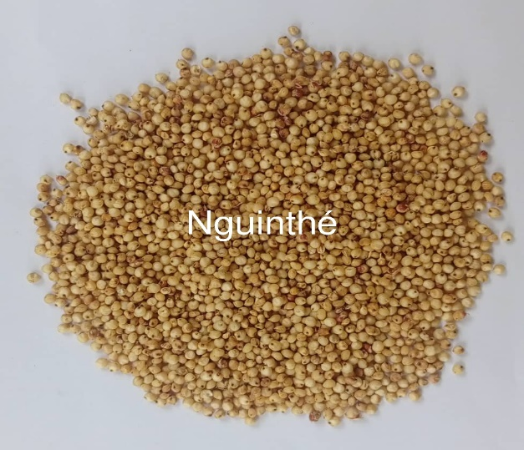

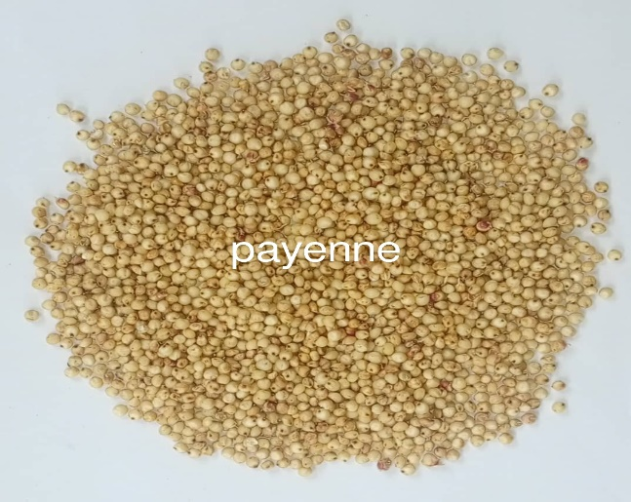

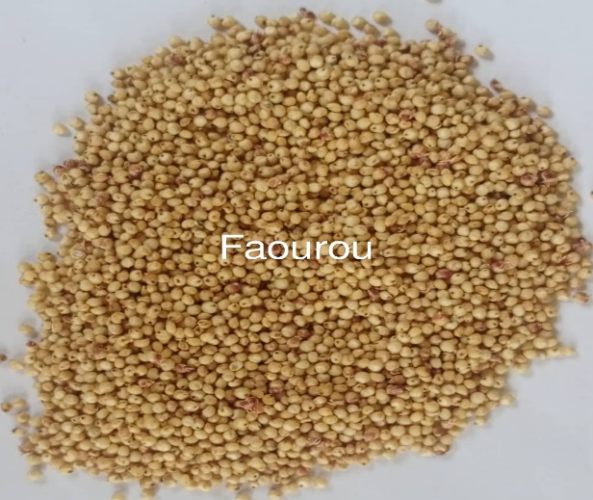

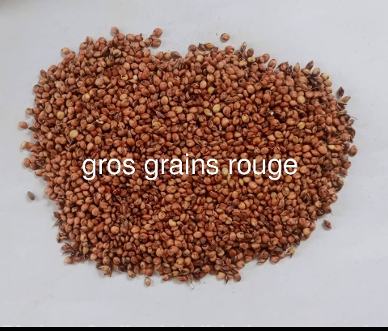

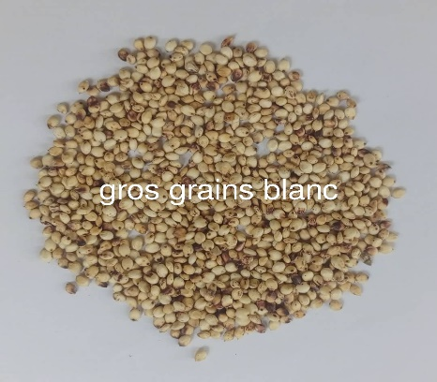

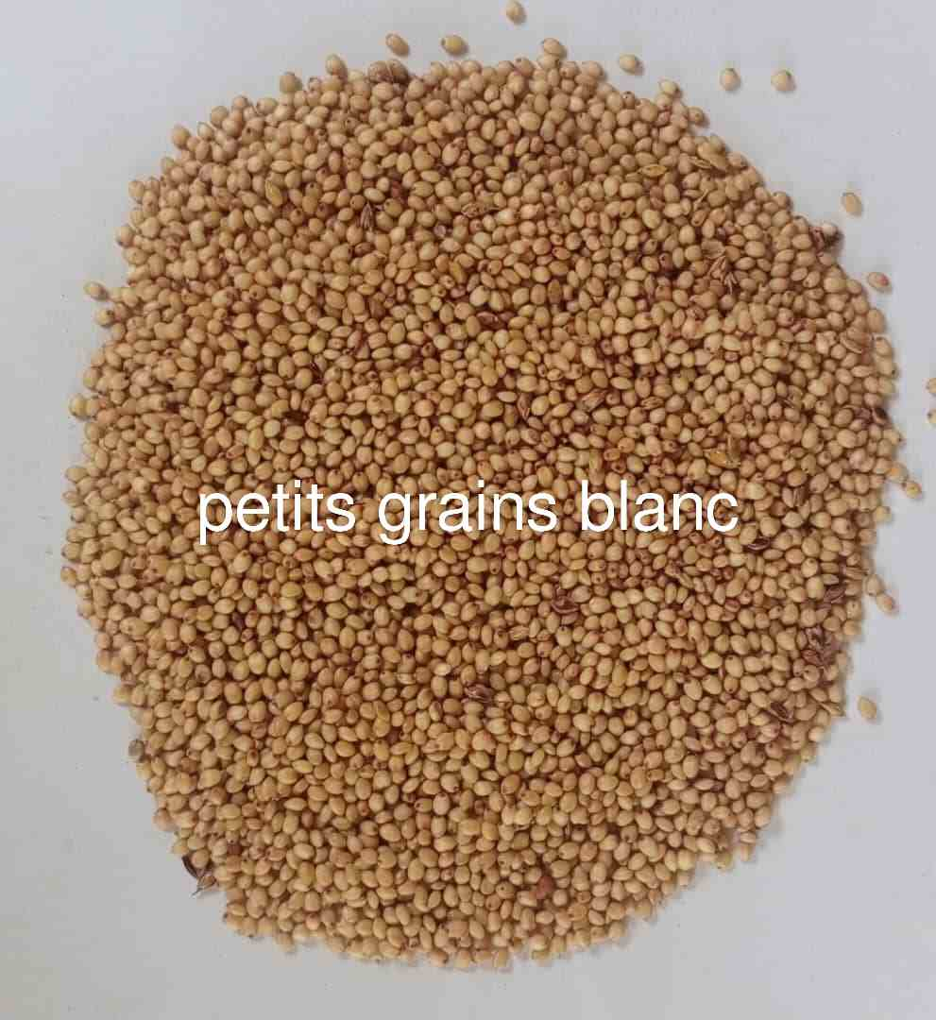

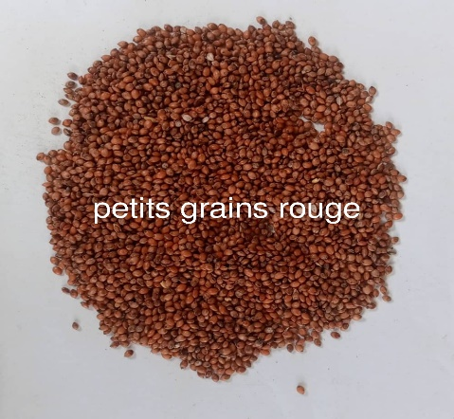

**A**

**B**

**C**

**D**

**E**

**F**

**G**

**Fig. 1.** **Seeds of the improved introduced (A, B and C) and local (D, E, F and G) sorghum varieties studied.**

**2.2 Methods**

**2.2.1 Study site**

The study was conducted in the University research station of Korhogo (5°25'30‘’N and 5°25'48‘’W) (Figure 2). The climate is Sudanian with dry season between november and april, and the rainy season from may to october. The annual rainfall ranges between 1.100 and 1.600 mm and the temperature from 24 to 33°C (Boko et al., 2016). In this area the water deficit is over 500 mm due to high potential evapotranspiration (PET) (Timité et al., 2022). The soil is sandy-loam with 0.44% C and 0.039% N content (Siéné et al., 2020).

During the experiment, the rainfall was measured with direct-reading rain gauge mounted on a 2 m high mast.

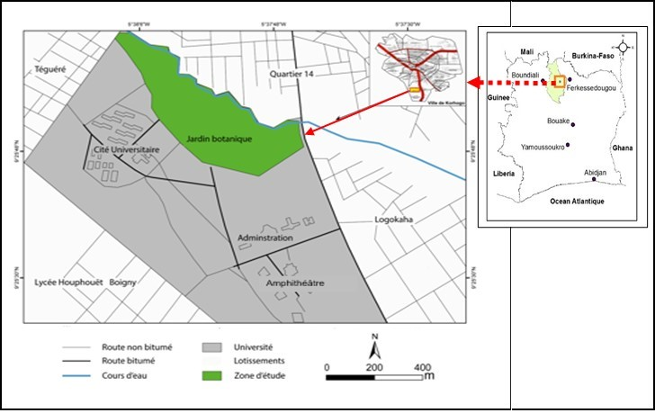

**Fig. 2. Study site location**

**2.2.2 Setting up the experiment**

*2.2.2.1 Experimental design and treatments studied*

The experimental design was a randomised complete block design with 3 replicates (blocks) and one factor. The variety factor consisted of seven levels, namely V1 (Faourou), V2 (Nguinthe), V3 (Payenne), V4 (Native small red grain), V5 (Native small white grain), V6 (Native big red grain) and V7 (Native big white grain). Gap between blocks was 1.5 m. One block is consisted of 7 elementary plots, corresponding to the treatments, separated from each other by 1 m. Seeds were sowing on 4 rows spaced by 0.8 m between lines and 0.5 m on line. The total area of the experiment was 204 m² (20 m x 10.2 m).

*2.2.2.2 Crop management*

Sorghum was sown in a wet period on ridge tillage. 15 days after emergence, plants were thinned to 3 plants per hole with application of NPKSB mineral fertilizer (15-15-15+6S+1Bat) rate of 89.2 g/elementary plot. This rate of fertilizer is equal to the content of bottle cap for each sowing hole. In addition urea (46-00-00) was applied with two bottle cap per sowing hole two weeks after the first application. Fertilizers were spread 5 cm around plants.

*2.2.2.3 Parameters studied*

The parameters assessed during this study concerned agro-morphological measurements.

*Sorghum phenology*

The phenology of crop was determined for plants flowering and grain physiological maturity. For each elementary plot, the stage was considered effective when 50% of the plants had reached it.

*Sorghum growth*

Crop growth was measure on plant height, number of leaves and diameter at the crown of the plant.

*Yield and components*

At harvest, yield was determined in the central square of each 2.40 m² elementary plot. Yield components included the number of panicles, average panicle length and diameter, number of empty and diseased panicles, average panicle weight, average grain weight per panicle, total grain weight per yield square and 1000-grain weight. Yield was calculated using the ratio of the dry weight of grains per yield square and the area of the yield square.

**2.2.3 Data analysis**

Data were first subjected to a descriptive analysis. The various variations were assessed by determining the mean, standard deviation, coefficient of variation, minimum and maximum for each quantitative characteristic. After standardising the data and estimating the Kaiser-Meyer-Olkin measure of sample adequacy, the data were subjected to a principal component analysis (PCA). In addition, accessions were structured using Hierarchical Principal Component Classification (HPC). These analyses were carried out using R software version 4.4.0. A Discriminant Factor Analysis (DFA) was used to highlight the characteristics that discriminate the groups or clusters resulting from the hierarchical classification on principal components. The values of the ranking functions and the univariate test for equality of means were used to determine the variables that most discriminate between groups. These analyses were carried out using XLSTAT software, version 2016.

3. results and discussion

**3.1 Results**

**3.1.1** **Agro-morphological characterization of sorghum accessions**

Table 1 shows the various quantitative characteristics of the different sorghum varieties studied. Significant differences were observed between the minima and maxima for all the characteristics studied, indicating strong differentiation between the varieties. On average, the varieties had a cycle of 123.571 days. The earliest variety flowered 70 days after sowing and the latest at 118 days. The sorghum varieties tested ranged in height from 124.16 m to 369.5 m, with 5.833 to 14.166 leaves. The panicles of these varieties were 16.2 to 40.375 cm long and 1.593 to 20.885 cm wide. There were 7 empty panicles and 5 diseased panicles. The weight of 1000 grains (P1000G) varied from 0 to 28.65 g. The same applies to the weight of grains per panicle, which varied from 0 to 28.12 g, and the weight of panicles, which varied from 0 to 41 g. Yields varied between 0 and 2.036 t/ha.

Coefficient of variation values were greater than 30% (CV > 30%) for plant height (CVHP = 36.22%), collar diameter (CVDC = 32.269%), panicle diameter (CVPD = 88.756%), panicle weight (CVPW = 54.034%), grain weight per panicle (CVGWP = 74.041%), Number of panicles per yield square (CV NPYS =212.132%), number of empty panicles (CVPNV = 54.778%), number of diseased panicles (CVNDP = 144.913%), thousand grains weight (CVP1000GR = 61.077%), yield (CVY = 87.627%). These high coefficients of variation (CV > 30%) suggest the existence of considerable heterogeneity between the sorghum varieties tested. On the other hand, low variation (CV < 30%) was observed for the number of leaves (CVNL= 26.767%), panicle length (CVPL= 28.359%), time to 50% flowering (CVFLO50% = 18.530%), vegetative phase duration (CVDVP = 19.745%) and cycle length (CVCL = 14.031%). These low variations (CV < 30%) reflect low heterogeneity in the plant material.

**Table 1. Accession characteristics**

|  |  |  |  |  |  |
| --- | --- | --- | --- | --- | --- |
| **Variable** | **Mean** | **Minimum** | **Maximum** | **Standard deviation** | **Coefficient of variation** |
| HP | 205,67 | 124,16 | 369,5 | 74,51 | 36,22 |
| NL | 9,920 | 5,833 | 14,166 | 2,655 | 26,767 |
| DC | 10,143 | 5,05 | 16,3 | 3,273 | 32,269 |
| PL | 28,128 | 16,2 | 40,375 | 7,977 | 28,359 |
| PD | 9,149 | 1,593 | 20,885 | 8,120 | 88,756 |
| PW | 25,082 | 0 | 41 | 13,553 | 54,034 |
| GWP | 14,042 | 0 | 28,12 | 10,397 | 74,041 |
| NPYS | 1 | 0 | 7 | 2,121 | 212,132 |
| NEP | 10,809 | 0 | 18 | 5,921 | 54,778 |
| NDP | 144,913 | 0 | 5 | 1,449 | 144,913 |
| P1000G | 16,225 | 0 | 28,65 | 9,910 | 61,077 |
| Y | 0,815 | 0 | 2,036 | 0,714 | 87,627 |
| FLO (50%) | 93,571 | 70 | 118 | 17,339 | 18,530 |
| DVP | 88,857 | 65 | 115 | 17,545 | 19,745 |
| CL | 123,571 | 100 | 148 | 17,339 | 14,031 |

*HP: Plant height; NL: Number of leaves; DC: Diameter at the crown; PL: Panicle length; PD: Panicle diameter; PW: Panicle weight; GWP: Grain weight per panicle; NEP: Number of empty panicles; NP: Number of panicles; NDP: Number of diseased panicles; P1000G: Thousand grain weight; Y: Yield; FLO50%: 50% Flowering; DVP: Duration of vegetative phase; CL: Cycle length.*

**3.1.2 Evaluation of the structure of the agro-morphological diversity of sorghum varieties**

*3.1.2.1 Principal component analysis*

Table 2 gives the eigenvalues and percentage variance of each axis. According to the Kaiser criterion, any axis with an eigenvalue greater than 1 should be retained for analysis (Zangui, 2020). Consequently, the first two axes were selected to describe the maximum variability of the varieties. These first two axes explain 87.6% of the total variance. The first axis explains 79.1% of the variability and the second axis 8.5%.

The correlations of the coordinates of all the variables with the principal components are shown in table 2. The analysis of the coordinates of the variables shows that the first principal component (Axis 1) is defined by seven variables: plant height (HP), number of leaves (NFP), collar diameter (DCP), panicle length (LP), flowering (FLO50%), duration of vegetative phase (DPV), cycle duration (DDC). This axis can be considered as the axis of plant phenology and morphology. Eight (8) variables contribute to the formation of the second component (Axis 2). These are panicle diameter (DP), panicle weight (PP), grain weight per panicle (PGP), number of empty panicles (NPV), number of panicles (NP), number of diseased panicles (NPM), thousand grain weight (P1000G) and yield (RDT). This axis is identified as the yield axis and its components. The variables that contribute to Axis 1 are positively correlated.

**Table 2. Eigenvalues and percentage variation expressed by the first two axes and correlation of the variables with the components**

|  |  |  |
| --- | --- | --- |
| **Main component** | **Axis 1** | **Axis 2** |
| Variance propre | 11,865 | 1,277 |
| %Variance totale | 79,105 | 8,518 |
| %Variance totale cumulée | 79,105 | 87,623 |
| **Variables** |
| **Axis 1** | **Axis 2** |
| HP | **0 ,795** | 0,228 |
| NFP | **0,954** | -0,198 |
| DCP | **0,724** | -0,422 |
| LP | **0,905** | 0,165 |
| DP | -0,954 | **-0,168** |
| PP | -0,931 | **0,203** |
| PGP | -0,982 | **-0,042** |
| NPV | 0,465 | **0,662** |
| NP | -0,787 | **0,588** |
| NPM | -0,814 | **-0,287** |
| P1000G | -0,925 | **0,120** |
| RDT | -0,976 | **0,070** |
| FLO50% | **0,986** | 0,080 |
| DPV | **0,986** | 0,091 |
| DDC | **0,986** | 0,080 |

*Values in bold are significant at the 5% level.*

*HP: Plant height; NL: Number of leaves; DC: Diameter at the crown; PL: Panicle length; PD: Panicle diameter; PW: Panicle weight; GWP: Grain weight per panicle; NEP: Number of empty panicles; NP: Number of panicles; NDP: Number of diseased panicles; P1000G: Thousand grain weight; Y: Yield; FLO50%: 50% Flowering; DVP: Duration of vegetative phase; CL: Cycle length.*

*3.1.2.2 Agro-morphological structuring of sorghum accessions*

In order to structure and group the varieties, a hierarchical ascending classification (HAC) based on principal component analysis was carried out. This classification was carried out using fifteen (15) agromorphological variables. The dendrogram obtained using Ward's aggregation method reveals three (3) major groups (Figure 3).

Group 1 is made up of three sorghum varieties (V1, V2, V3), group 2 of three sorghum varieties (V4, V5 and V7) and group 3 of a single sorghum variety (V6) (Figure 3).

An analysis of variance carried out on the different groups resulting from the hierarchical classification revealed the main distinctive features (Table 3).

Group 1, which is defined by three sorghum varieties (V1, V2, V3), contains the best values for yield and its components (panicle diameter (17.56 mm), panicle weight (37.61 g), grain weight per panicle (24.73 g), 1000G weight (25.77 g), as well as the number of panicles per yield square (15 panicles)). These varieties had an average yield of 1.56 t/ha and a short cycle (105.66 days). Group 2, made up of three sorghum varieties (V4, V5 and V7), had a long vegetative phase (100.11 days) and a long cycle (134.44 days). This group has the tallest plants (266.20 cm). Group 3 consisted of a single sorghum variety (V6). This variety also had a longer vegetative phase and cycle duration. This group had plants with a high number of leaves (13.83 leaves) with zero yield.

**Figure 3:** Dendrogram based on agro-morphological characteristics classifying the 7 sorghum varieties into three distinct groups

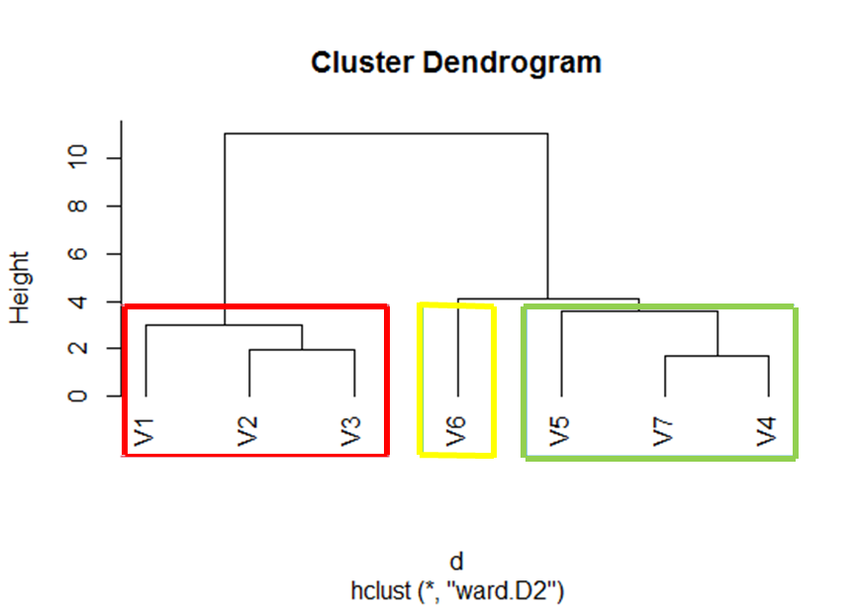

**Fig. 3. Dendrogram based on agro-morphological characteristics classifying the 7 sorghum varieties into three distinct groups**

**Table 3. Main characteristics of the different groups obtained using CAH**



*3.1.2.3 Structuring diversity using discriminant factor analysis*

The three groups formed by the hierarchical classification on principal components were subjected to discriminant analysis. The aim was to identify the variables that were most discriminating in relation to the groups determined. In the present analysis, the three groups resulting from the hierarchical classification on principal components were used as categorical variables. The test for equality of group means revealed that 4 of the 15 variables tested allowed perfect discrimination between groups (Table 4). Wilk's lambda was used to rank the characteristics in hierarchical order of discriminating power.

These were number of leaves (0.033), panicle length (0.034), panicle diameter (0.015) and cycle length (0.020).Furthermore, with regard to the validity of the study, the Box test was significant (Box's M = 830.606; F = 1.82; p=0.0001). This indicates that the variance-covariance matrices of the variables are equal for the 3 groups. In addition, the confusion matrix for the estimation and cross-validation sample showed that 87.50% of the cross-validated observations were correctly classified (Table 5).

Table 6, the result of the discriminant factor analysis, gives the percentages of inertia and the parameters that contribute most to the definition of the first two canonical components. These account for most of the dispersion, since they alone describe 100% of the total variability.

Figure 4 shows the distribution of the center of gravity of the groups and individuals in the plane formed by the canonical axes 1 and 2 of the SFM. The groups show a distinct separation. Canonical component 1 (axis 1) represents 99.91% of the total variability and the second discriminant function (axis 2) accounts for 0.082% of the total diversity. The first function (axis 1) strongly discriminates between the number of leaves, panicle length and cycle length. The second canonical component discriminates panicle diameter.

**Table 4. Test of equality of group means**

|  |  |  |  |  |  |
| --- | --- | --- | --- | --- | --- |
| **Variables** | **Lambda de Wilks** | **F** | **DF1** | **DF2** | **p-value** |
| Number of leaves | 0,033 | 73,270 | 2 | 5 | 0,000 |
| Panicle length | 0,034 | 71,148 | 2 | 5 | 0,000 |
| Panicle diameter | 0,015 | 158,910 | 2 | 5 | < 0,0001 |
| Cycle length | 0,020 | 120,404 | 2 | 5 | < 0,0001 |

**Table 5. Confusion matrix for cross-validation results**

|  |  |  |  |  |  |
| --- | --- | --- | --- | --- | --- |
| **Groups** | **Group 1** | **Group 2** | **Group 3** | **Total** | **% correct** |
| Group 1 | 2 | 1 | 0 | 3 | 66,67% |
| Group 2 | 0 | 3 | 0 | 3 | 100,00% |
| Group 3 | 0 | 0 | 1 | 1 | 100,00% |
| Total | 2 | 4 | 1 | 7 | 87,50% |

**Table 6. Percentage of inertia and definition of axes in canonical discriminant analysis**

|  |  |  |
| --- | --- | --- |
|  | **Axis 1** | **Axis 2** |
| Eigenvalue | 27147,002 | 22,234 |
| Percentage of discrimination | 99,918 | 0,082 |
| Cumulative discrimination percentage | 99,918 | 100,000 |
| Number of leaves | **0,970** | -0,166 |
| Panicle length | **0,932** | 0,318 |
| Panicle diameter | -0,980 | **-0,158** |
| Cycle length | **0,952** | -0,068 |

**Fig. 4. Representation of the different groups in the discriminant factorial plane formed by the canonical axes 1-2**

**3.1.3 Number of empty and diseased panicles per yield square**

The results for the number of empty and diseased panicles per yield square for the different sorghum varieties studied are presented in Table 7. Statistical analysis revealed significant differences between groups at the 5% threshold for the number of panicles. The varieties in group 1 (V1, V2, V3) and group 2 (V4, V5, V7) had few empty panicles, unlike the variety in group 3 (V6), which had a high number of empty panicles. With regard to the number of diseased panicles per square of yield, no statistical difference was observed between the groups.

**3.1.4 Distribution of rainfall during the development phases of sorghum varieties**

The quantities of rainfall received during the development phases of the sorghum varieties according to the three main groups are shown in Table 8.

During the experiment, the varieties in groups 1, 2 and 3 received rainfall amounts of 689, 743 and 740 mm respectively during their vegetative phase. These quantities were greater than those received during their reproductive phase. These were 54, 43 and 21 mm respectively for the reproductive phases. The distribution of rainfall during their growing cycle is shown in Figure 5, which clearly shows that the reproductive phase of group 1 varieties, which are introduced improved varieties, benefited from a rainy episode compared with that of local varieties in groups 2 and 3, which were later.

**Table 7. Number of empty and diseased panicles per yield square**

|  |  |  |  |  |
| --- | --- | --- | --- | --- |
| **Variables** | **Group 1**  **(V1, V2 et V3)** | **Group 2**  **(V4, V5 et V7)** | **Group 3**  **(V6)** | **Pr > F** |
| Number of empty panicles/square of rdt | 0,000 b | 2,333 b | 18,000 a | 0,004 |
| Number of diseased panicles/ square of rdt | 2,111 a | 0,222 a | 0,000 a | 0,121 |

**Table 8. Rainfall amounts (mm) received during the phenological phases according to the three main groups identified**

|  |  |  |
| --- | --- | --- |
| **Groups** | **Rainfall (mm) received** | |
| **Vegetative phase** | **reproductive phase** |
| Group 1 (V1, V2 et V3) | 689 | 54 |
| Group 2 (V4, V5 et V7) | 743 | 43 |
| Group 3 (V6) | 740 | 21 |

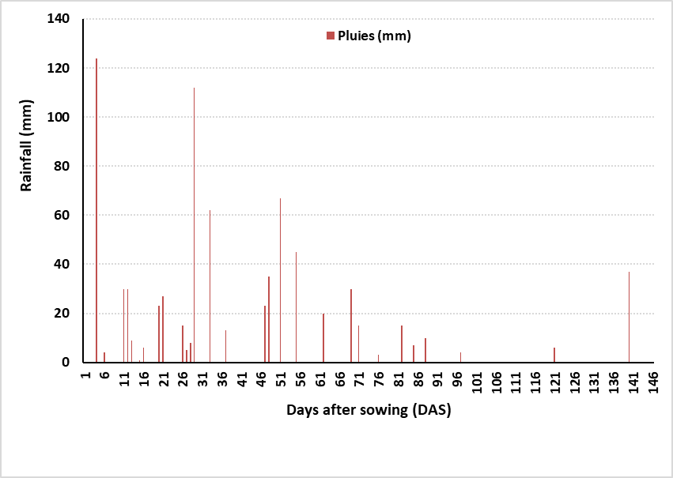

Vegetative phase (G3)

Vegetative phase (G2)

Reproductive phase (G3)

Reproductive phase (G2)

Reproductive phase (G1)

Vegetative phase (G1)

**Fig. 5. Rainfall distribution during the crop cycle of the sorghum varieties studied**

**3.2 Discussion**

The characterization of genetic resources of cultivated species is of great interest because genetic resources are used more and better when they are well known and therefore characterized (Dede et al., 2020). Analysis of variance has shown that there is diversity within sown varieties. The high morphological variability of accessions could be attributed to farmers' seed management methods. Sorghum growers may grow more than one accession on the same plot and harvest the panicles at the same time. This could justify the mixing of grain (seed) at field completion. These observations are in line with those of Barnaud et al (2007). Gene flow will occur and contribute, even at low rates, to broadening genetic diversity locally (Koffi et al., 2011). Principal component analysis revealed that the morphological diversity of sown sorghum varieties is structured by vegetative, phenological and yield traits. This trend in morphological variability was observed by Koffi et al, (2011). Farmer selection based on perceptible traits (phenological, vegetative, panicular) could explain the contribution of these variables to the structuring of variability. According to Djè et al (2007), vegetative, phenotypic and yield traits are the most remarkable at field level and help to influence farmers' choices. These agronomic and quantitative traits, although subject to the influence of environmental conditions, should not be neglected by genetic resource managers when studying diversity, as they constitute criteria for phenotypic selection in the farming environment (Koffi et al., 2011).

Multivariate analyses revealed that the varieties tested can be divided into three groups. Group 1 contains the varieties (V1, V2, V3) that are the introduced improved varieties, group 2 the varieties (V4, V5, V7) and group 3 the variety (V6) that are the local varieties. The vegetative phase and cycle lengths were much longer for varieties in groups 2 and 3 than for those in group 1. Similar observations on phenological diversity were made on millet accessions in Senegal by Ousmane et al. (2015) and on sorghum accessions in northern Côte d'Ivoire by Koffi et al. (2011). This phenological difference could be explained by the photoperiod. Indeed, local varieties are photoperiodic compared to improved varieties that are not sensitive to photoperiod (Kouressy et al., 2014). For Chantereau (2013) photosensitivity is the main factor in lengthening the vegetative cycle of sorghum. Moreover, this difference could be explained by the fact that late varieties have a larger vegetative apparatus than early varieties and take longer to develop (Ndiaye, 1984).

From the point of view of growth parameters, the small size of the plants observed in the varieties (V1, V2, V3) in group 1 could be explained by their earliness. Naoura et al (2014) support the idea that the small plant size of the early varieties is one of the direct consequences of the shortened cycle. Our results on the number of leaves produced corroborate those of Siéné et al. (2010) on millet, indicating that early varieties produce fewer leaves than late varieties. For Nicolas (2007), the number of leaves varies according to variety and plant size. This significant difference in growth parameters is therefore due to characteristics intrinsic to the varieties. These results corroborate those of Abdelkader et al (2018) and Tiendrebeogo et al (2020), who observed variability within the sorghum varieties they studied for these same parameters in Burkina Faso and Algeria.

Differences were observed in panicle length. The panicles of varieties in groups 2 and 3 were longer than those in group 1. Variation in panicle length was also observed in sorghums grown in northern Côte d'Ivoire by Kouamé et al. (2011) and in high-performing sorghums in Burkina Faso by Naoura et al. (2014). Similarly, Sawadogo et al. (2014) showed in their work on sweet sorghum in Burkina Faso that the main panicles of some varieties are between 20.7 and 51.3 cm long. This difference in panicle length could be explained by the difference in genes contained in each accession. Our results are in line with those of Bamba et al. (2019) who claim that the difference in panicle size is linked to the genetic characteristics of the ecotype used.

The low yield values recorded by the long-cycle local varieties in groups 2 and 3 could be due to the low amount of rainfall received during their reproductive phases. This led to a water deficit during the grain filling phase in group 2 varieties. This could explain the empty panicles observed in these varieties. Slama et al (2005) point out that during grain filling, the lack of water results in a reduction in grain size, thereby reducing yield. Unlike the varieties in group 2, the variety in group 3 underwent more water stress until it reached zero yield. These results corroborate those of Winkel and Do (1993), who showed that water deficit in millet has immediate consequences on ears still in the early stages of development (heading, flowering and fertilisation), or on grains at the beginning of filling. As a result, a certain number of grains are not formed at maturity, or their weight remains equivalent to that of the husks.

The low production observed in these two groups of long-cycle varieties is partly due to the early end of the rains, which led to poor seed filling and immaturity (Nassourou, 2018). As for the improved varieties introduced in group 1, they obtained an average yield of 1.56 t/ha below the average yield of 2t/ha attributed to them. This reduction in yield could be explained by the number of diseased panicles observed at harvest. In this study, the reproductive phase of these varieties coincided with a rainy spell. The panicles of these varieties were sensitive to the moisture created by the rain, which caused mould to develop on the seeds. This led to a reduction in yield. According to Upadhyaya et al (2008), relatively low rainfall and humidity conditions are desirable during seed ripening, as they can also cause diseases to appear on the seeds. Nevertheless, the introduction of these varieties into the study area will improve sorghum production.

4. Conclusion

The aim of this study, which was to compare the agronomic performance of local and improved introduced sorghum varieties, was to highlight significant differences between the agro-morphological parameters of the sorghum varieties. This agro-morphological variability made it possible to differentiate them into 3 groups. Group 1 was characterized by better yield values and its components, as well as a short average cycle length of 105.667 days. In view of the shortening of the cropping calendar induced by climate change and variability, these varieties could serve as a source of breeding stock for the development of new sorghum varieties adapted to the climatic conditions of Korhogo in northern Côte d'Ivoire. Group 2 and Group 3, on the other hand, contained varieties with the best vegetative characteristics and longer average cycle lengths of 134.44 and 143 days respectively. They also provided essential preliminary information for any varietal selection program. The low production observed in the local varieties was partly due to the early end of the rains. As for the improved varieties introduced, they recorded a high number of diseased panicles due to the moisture created by the rains during seed ripening. The search for an optimum sowing date should be considered in order to improve their yield. This work should be enhanced by setting up farmers' field schools in several localities in the study area, which will enable growers to select from among these varieties the one that best meets their criteria.

DISCLAIMER (ARTIFICIAL INTELLIGENCE)

Author(s) hereby declare that NO generative AI technologies such as Large Language Models (ChatGPT, COPILOT, etc) and text-to-image generators have been used during writing or editing of this manuscript.

References

Abdelkader, A., Aïssa, T., Habib, M., & Wiam, B. (2018). Morphological variability of sorghum (Sorghum bicolor L. Moench) grown in the Oued Righ valley (South-East Algeria). Lebanese Scientific Journal, 19(1): 10 -18.

Akanvou, L., Akanvou, R., & Toto, K. (2006). Effects of maize and vegetable varieties in the control of Striga hermonthica in the savannah zone of Côte d'Ivoire. African Agronomy, 18 (1): 13 – 2.

Anonymous 1. (2012). C2D PROJECT, Sorghum/Agronomic Research Support Program: Valorization of intensive production methods of sorghum and its derivatives in the Sudano-Sahelian zone of Cameroon, 24 p

Anonymous 2. (2016). Regional Catalogue of Plant Species and Varieties ECOWAS-UEMOA-CILSS, 109 p.

Bamba, B., Gueye, M., Badiane, A., Ngom, D., & Ka, SL. (2019). Effect of sowing date and density on growth and grain yield of late millet (Pennisetum glaucum L.) in the southeastern and southern zones of Senegal. Journal of Applied Biosciences, 138: 14106-14122.

Barnaud, A., Deu, M., Garine, E., McKey, D. & Joly, H. (2007). Local genetic diversity of sorghum in a village in northern Cameroon: structure and dynamics of landraces. Theor. Appl. Genet 114: 237-248. DOI: 10.1007/s00122-006-0426-8

Boko, KANN., Guéladio, C. & Dedy, S. (2016). Climatic variability and environmental change in Korhogo, Côte D'Ivoire: Myth or Reality? European Scientific Journal, 12: 158-176.

Chantereau, J., Cruz, J., Ratnadass, A. & Trouche, G. (2013). Sorghum Versailles-Gembloux, Éditions Quæ-Presses agronomiques de Gembloux, ‘Agricultures tropicales en poche’, p 245.

CNRA. (2022). Annual activity report, 49p.

Dede, LE., N'DA, HA, & Akanvou, L. (2020). Agromorphogical and botanical diversity of 357 sorghum (Sorghum bicolor (L) Moench) accessions collected in Côte d'Ivoire. African Agronomy 32(3): 297-308.

Djè, Y., Heuertz, M., Ater, M. & Vekemans, LX. (2007). Evaluation of the morphological diversity of traditional sorghum varieties from North-West Morocco. Biotechnology, Agronomy, Society and Environment, 11 (1), 39-46.

Djida, AK., Wassouo, F.A., Yougouda, H., Gnapou, D. & Djaowe, A. (2024). Adaptability of four improved dual-purpose rainfed sorghum varieties (Sorghum bicolor (L.) Moench) to the climatic conditions of the high Guinean savannah zone of Cameroon. Afrique Science, 25(1): 131 - 140 131, ISSN 1813-548X, http://www.afriquescience.net

FAO. (2017). The State of Food and Agriculture: putting food systems at the service of inclusive rural transformation. Report, 201 p.

Husson, O., Charpentier, H., Razanamparany, C., Moussa, N., Michellon, R., Krishna, N., Razafintsalama, H., Rakotoarinivo, C., Rakotondramanana, Enjalric, F. & Seguy, L. (2010). Maize or sorghum combined with a voluble food vegetable (Dolica, Cowpea or Vigna unguicullata). Practical manual for direct seeding in Madagascar, Chapter 1, Vol.5, 5p.

Koffi, KGC., Akanvou, L., Akanvou, R., Zoro, BIA., Kouakou, CK. & N’DA, HA. (2011). Morphological diversity of Sorghum (Sorghum bicolor (L.) Mench) grown in northern Côte d'Ivoire. Revue Ivoirienne de Sciences et Technologie, 17: 125 - 142.

Kouressy, M., Sissoko, S., Teme, N., Deu, M., Vaksmann, M., Camara, Y., Bazile, D., Sako, A. FM. & Sidibe, A. (2014). Impact of the dissemination of an improved sorghum variety in Mali: Interaction with local varieties. Agronomie, Environnement et société, 4(2):115-123.

Naoura, G., Nebie, B., Nanema, RK., Kando, PB., Traore, ER., Sawadogo, M. & Zongo, JD. (2014). Characterization of some high-performing ecotypes of Burkinabe sorghum. International Journal of Biological and Chemical Sciences, 8(5): 2109-2118, ISSN 1991-8631.

Nassourou, LM, Alhassane, A., & Traoré, S. (2018). Perception and observation: the main agroclimatic risks of rainfed agriculture in western niger. La revue électrique en sciences de l'environnement, 18(1). https://doi.org//10.4000/vertigo.20003.

Ndiaye, M. (1984). Technical itineraries relating to corn cultivation in the Djandioly-Garly perimeter. Selection criteria, consequences on work times and yields. Confirmation report, CNRA of Bambey. 81p.

Nicolas, D. (2007). Use of sorghum in animal feed. Thesis presented to obtain the degree of Doctor of Veterinary Medicine from the Université Claud Bernard-Lyon I, 109 p.

Ousmane, SY., Amadou, F., Ndiaga, C., Kandioura, N., Diaga, D., Ibrahima, N., Djibril, S., Aboubacry, K., Ndjido, KA., Tom ,H., Bettina, H. & Eva, E. (2015). Study of the agro-morphological variability of the national collection of local millets of Senegal, Journal of Applied Biosciences, Vol. 87: 8030 -8046, ISSN 1997 -5902.

Rouabah, MKA. (2021). Behavioral study of an Algerian landrace of sorghum (Sorghum bicolor L Moench) in the semi-arid zone. End of cycle thesis Mohamed El Bachir El Ibrahimi University B.B.A. Faculty of Natural and Life Sciences and Earth and Universe Sciences, P30.

Sawadogo, N., Nebie, B., Kiebre, M., Kando, PB., Nanema, RK., Traore, RE., Naoura, G., Sawadogo, M. & Zongo, JD. (2014). Agromorphological characterization of sweet grain sorghums (Sorghum bicolor (L.) Moench) from Burkina Faso. International Journal of Biological and Chemical Sciences, 8(5): 2183 -2197.

Siéné, LAC., Muller, B. & Ake, S. (2010). Study of biomass development and distribution in two millet varieties of different cycle length under three sowing densities. Journal of Applied Biosciences, 35(1): 2260-2278.

Siéné, LAC., Doumbouya, M., Traoré, MS., Condé, M., N'Guettia, TVF., & Koné, M. (2020). Effect of four types of fertilizers on the growth and productivity of two maize (Zea mays L.) genotypes under late sowing in Korhogo, north-central Côte d'Ivoire. Int. J. Biol. Chem. Sci. 14(1): 55-68.

Slama, A., Ben-Salem, M., Ben-Naceur, M., and Zid, E. 2005. Cereals in Tunisia: production, drought effects, and resistance mechanisms. Research Article, 16: 225-9.

Tiendrebeogo, J., Sawadogo, N., Kiendrebeogo, T., Kiebre, Z., Sawadogo, B., Kiebre, A., Zerbo, K., Nanema, R., & Sawadogo, M. (2020). Agro-morphological response of 14 sweet grain sorghum genotypes from Burkina Faso to mineral fertilization. Journal of Applied Biosciences, 145: 14880 -14891, ISSN 1997-5902.

Timité, N., Kouakou, ATM., Bamba, I., Barima, YSS., & Bogaert, J. (2022). Climate Variability in the Sudanian Zone of Côte d'Ivoire: Weather Observations, Perceptions, and Adaptation strategies of Farmers. Sustainability, 14:1-20. https://doi.org/10.3390/su141610410

Togo, A. (2019). Effects of fertilization and sowing date on dual-purpose sorghum varieties. Master's degree to obtain the Agricultural Engineer diploma. Bamako, Mali: Rural Polytechnic Institute of Training and Applied Research, Mali. https://hdl.handle.net/10568/108798.

Trouche, G., Da, S., Pale, G., Sohoro, A., Ouedraogo, O., & Den Gosso, G. (2001). Participatory evaluation of new sorghum varieties in Burkina Faso. Participatory selection, Montpellier, 5-6 September 2001. 20p. Proceedings of the workshop, Editors Henri Hocdé, Jacques Lançon and Gilles Trouche.

Upadhyaya, HD., Reddy, KN & Sastry, DVSSR. (2008). Regeneration guidelines for finger millet. In: Crop specific regeneration guidelines [CD-ROM]: CGIAR System-wide Genetic Resource Program (SGRP), Dulloo ME, Thormann I, Jorge MA, Hanson J (ed). Italy, Rome .pp 1-10.

Von, B.K., Trouche, G., Weltzien, E., Barro-kondombo, CP., Goze, E. & Chantereau, J. (2010). Participatory variety development for sorghum in Burkina Faso: Farmers selection and Farmers criteria. Field Crops Research, 19:183 -194

Winkel, T., & Do, F. (1993). Morpho-physiological mechanisms of drought resistance in millet. Interest of an agrophysiological approach and experimental results, In: Millet in Africa: Genetic and agro-physiological diversity. Potentialities and constraints for genetic improvement and agriculture, vol. 283: 187-204.