*Review Article*

Impact of plant regulators on irrigated agriculture

**ABSTRACT**

|  |
| --- |
| Irrigated agriculture plays a crucial role in food production, especially in regions where water availability is limited. In this context, plant growth regulators emerge as essential tools to optimize plant growth and development. These compounds, which can be natural or synthetic, influence physiological processes such as germination, flowering, fruiting and resistance to environmental stresses. By promoting better use of water and nutrients, plant growth regulators not only increase irrigation efficiency but also contribute to the sustainability of agricultural production. With the growing demand for food and the need for more efficient and sustainable agricultural practices, the use of plant growth regulators in irrigated agriculture becomes increasingly relevant, offering solutions to maximize crop productivity and quality. |

*Keywords: Increased productivity;Sustainability;plant development.*

**1. INTRODUCTION**

Agriculture is a practice that constantly demands the search for alternative tools that increase crop productivity. This fact is not recent; management has been improving for some time, according to the demands of the crop and, combining this with the technologies available in the field today, we have several successful options that maximize final productivity [1].

In modern agriculture, it is common to use innovative technologies, especially those that can contribute to both yield gains and quality improvements. Additionally, the increase in irrigated areas over the years is due to the demand for food production. However, changes in soil and climate conditions and the scarcity of water resources imply a great need for adequate management during irrigation and the use of new technologies that favor plant development and maintain favorable production [2].

Furthermore, another of these alternatives is the use of plant regulators, which have the ability to optimize the plant's metabolism in a way that makes it more resistant to adverse environmental conditions, allowing the crop to express an increase in the capacity to produce more.

Therefore, it is important to provide information that supports these resources with a focus on achieving high productivity, such as the rational use of water through irrigation and the use of plant regulators.

2. Plant regulators

Plant growth regulators are widely used in agriculture, especially in fruits and vegetables, due to their positive influence on the growth and quality of the harvest. They are compounds that have the ability to bring effects such as accelerating plant growth, improving their defenses or stimulating the germination power of seeds [3].

Used in synthetic or natural form from plant extract. When analyzing the endogenous aspect in plants, they can be called plant hormones. When applied to plants or fruits in isolation, they are called phytoregulators and/or plant regulators [4]. The use of these products has gained prominence in recent years as an agronomic strategy to enhance the production of various crops [5].

Despite the great potential that the use of plant regulators has demonstrated in agriculture, their use is still not a common practice, especially in crops that do not have a high level of technology [6]. One of the reasons for this is the great variability in the results obtained depending on the crop, the environment and the agricultural practices employed.

Furthermore, hormones rarely act alone, even when a response in the plant is attributed to the application of a single plant regulator, the tissue that received the application contains endogenous hormones that contribute to the responses obtained [7].

The discovery of the effects of plant regulators on cultivated plants and the benefits promoted by these growth substances has contributed to solving problems in the production system and improving crop productivity qualitatively and quantitatively [6].

The use of plant growth regulators in agriculture is not recent, but it is growing and, in certain situations, has become a factor in production, quality and productivity [8]. Knowledge of the growth substances present in plants has led to the discovery of plant hormones, responsible for the growth and development of tissues that, when controlled or in exogenous applications, can produce beneficial effects. Regulators include auxins, gibberellins, cytokinins, ethylene, retardants and inhibitors, which are present and develop distinct hormonal functions in plants [9].

Hormones or bioregulators act in all phases of plant development, and knowledge of their physiological effects is essential for understanding plant life [10]. New discoveries have stimulated the use of these substances in agricultural production, with a view to increasing the quality and sustainability of crops. Growth promoters and inhibitors, maturation regulators and plant biostimulants have been used in various production systems, such as cotton, sugarcane, soybeans, citrus, mango, grapes, flowers, vegetables, among others.

Depending on their mode of action, these substances can stimulate seed germination by breaking dormancy [11] or by stimulating the metabolism of hydrolytic enzymes, which control stages of cell division, such as gibberellins [12], or which induce plant self-defense processes, such as neonicotinoid insecticides [13]. The action of hormones is primarily at the level of the plasma membrane, where the proteins are located [14].

Plant regulators are defined as synthetic substances, similar to groups of plant hormones, which can be applied directly to plants to alter their vital and structural processes, with the aim of increasing productivity and improving the quality of plants [15] [16].

Plant hormones are organic compounds synthesized in one part of the plant and transferred to another part, and in low concentrations they cause physiological responses, either promoting or inhibiting natural changes in the plant. They are responsible for the regulation and coordination of metabolism, growth, development and physiological variations in plants [17]. Phytohormones, in turn, are substances produced in small quantities in plants that can inhibit or stimulate physiological and morphological processes, even acting as inducers of resistance in cases of stress [18] [19].

These substances can act by modifying the morphology and physiology of the plant andthese factors can lead to qualitative and quantitative changes in production [1]. Thus, we have examplesof synthetic substances with activities similar to plant hormones, indolebutyric acid (IBA), kinetin and gibberellic acid [9].

These compounds can interfere with various processes, such as germination, rooting, and flowering. These products can be applied via foliar application, as well as in seed or cutting treatment, and via soil application so that these substances are absorbed and can exert their activity [20]. The plant organs of a plant are morphologically altered by the application of phytoregulators.

Such changes in structural and functional processes can increase production, improve quality and facilitate harvesting [21] [22]. Currently, the groups of plant hormones and regulators that have been identified are auxins, gibberellins, cytokinins, ethylene, abscisic acid, brassinosteroids, phenolic compounds and polyamines. However, jasmonates and salicylates are being studied for inclusion as two new hormone classes. The mechanism of action of these plant hormones occurs as a result of a stimulus that must be perceived, transmitted and finally, there will be an amplification of the signal that manifests itself as an observed and measured response [23].

Plant growth and development is stimulated by the presence of auxin, gibberellin and cytokinin. Auxin is related to cell elongation and division, root development and sap-conducting vessels. Gibberellin and cytokinin stimulate development through mitosis and leaf formation [24]. However, for faster vegetative development of plants, these hormones are applied exogenously, the so-called biostimulants or bioregulators.

Plant regulators act directly on cellular structures, and can cause physical, chemical and metabolic changes, in addition to being involved in the growth and development processes of a plant organ or tissue (SILVA, 2019).

3. irrigated agriculture

Several factors contribute to the need for irrigation. In regions affected by continuous water scarcity, such as the Brazilian semiarid region, irrigation is essential, i.e., an important part of agriculture is only viable through the artificial application of water. In regions affected by scarcity in specific periods of the year, such as the central region of the country (between May and September), several crops and the third harvest are only viable with the supplemental application of water in the dry months, although production can be carried out (without or with little irrigation) during the rainy season (first and second harvests). I would like to point out in advance that the information listed in this topic is based on the Irrigation Atlas: Use of water in irrigated agriculture, 2nd Edition.

Although the growth of activity generally results in increased water use, several benefits can be observed, such as:

1. Increase in productivity of around 2 to 3 times compared to rainfed agriculture;
2. Reduction in unit production cost;
3. Year-round land use with up to three harvests per year;
4. intensive use of machines,
5. Implements and labor;
6. Application of agrochemicals and fertilizers using the same irrigation equipment;
7. Increase in the supply and regularity of food and other agricultural products;
8. Mitigation of the climatic seasonality factor and associated production risks;
9. More favorable prices for rural producers;
10. Greater quality and standardization of agricultural products;
11. Opening of new markets, including abroad;
12. Production of seeds and noble crops;
13. Increase in rural producer income;
14. Regularity in job offers;
15. Modernization of production systems,
16. Encouraging the introduction of new technologies;
17. Direct planting with selected seeds and;
18. Greater viability for the creation of agro-industrial hubs [25][26].

Irrigation is also essential for increasing and maintaining the stability of food supply and consequently increasing the food and nutritional security of the Brazilian population. Tomatoes, rice, peppers, onions, potatoes, garlic, fruits and vegetables are examples of foods produced under a high percentage of irrigation.

Irrigation is an agricultural practice that uses a set of equipment and techniques to supply plants with a total or partial lack of water. Irrigation is part of our daily lives, whether on the lawns of soccer fields or residential condominiums; or when we consume rice, beans, legumes, fruits and vegetables, foods produced largely under irrigation. Irrigation is essential in arid and semiarid regions, such as the Brazilian semiarid region, where production security is greatly affected by the continuous scarcity of water, which is minimized only during the wettest period, between December and March, when some dryland crops can still be grown.

According to data from FAO (2020), Brazil is among the ten countries with the largest area equipped for irrigation in the world. The world leaders are China and India, with around 70 million hectares (Mha) each, followed by the USA (26.7 Mha), Pakistan (20.0 Mha) and Iran (8.7 Mha). Brazil appears in sixth place with 8.2 Mha, followed by countries with areas between 4 and 7 Mha, such as Thailand, Mexico, Indonesia, Turkey, Bangladesh, Vietnam, Uzbekistan, Egypt, Italy and Spain (Figure 1). The global map of areas equipped for irrigation presents an overview and the regions with the main concentrations.

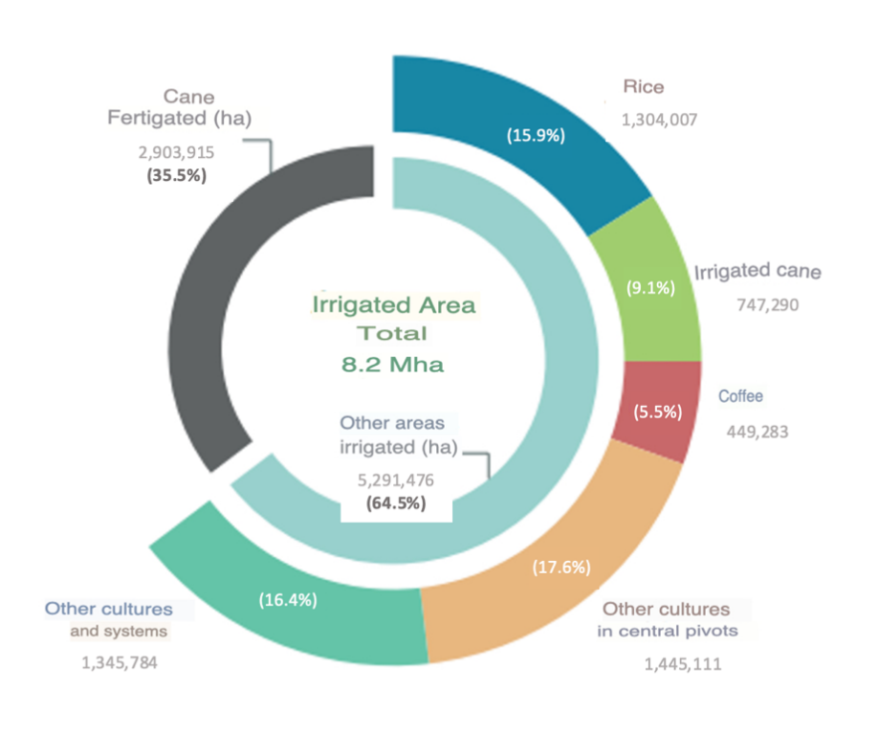

**Figure1.** Area equipped for irrigation in Brazil, 2019.

**Source:** Irrigation Atlas; ANA, [27].

Productivity indicators for rice, beans and wheat, important grains present in the Brazilian diet, show that predominantly irrigated production presented, respectively, yields 3.7, 2.0 and 1.9 times higher than rainfed production (average 2010-2019) (Figure 2).

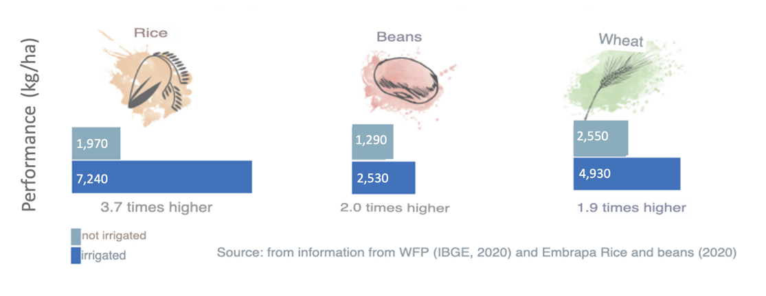

**Figure2.** Yield under predominantly irrigated and non-irrigated conditions in Brazil.

**Source:** Irrigation Atlas; ANA, [27].

As a result of the historical context summarized above, the periodic data from the Agricultural Censuses conducted by the IBGE (1960-2017) record the strong growth of the activity (Figure 3). The irrigated area has grown at average rates above 4% per year since the 1960s. Starting from 462 thousand hectares in 1960, the 1 million hectares mark was surpassed in the 1970s. In the 1990s, the 3 million hectares equipped for irrigation were surpassed. In 2017, the IBGE recorded 6.7 million irrigated hectares.

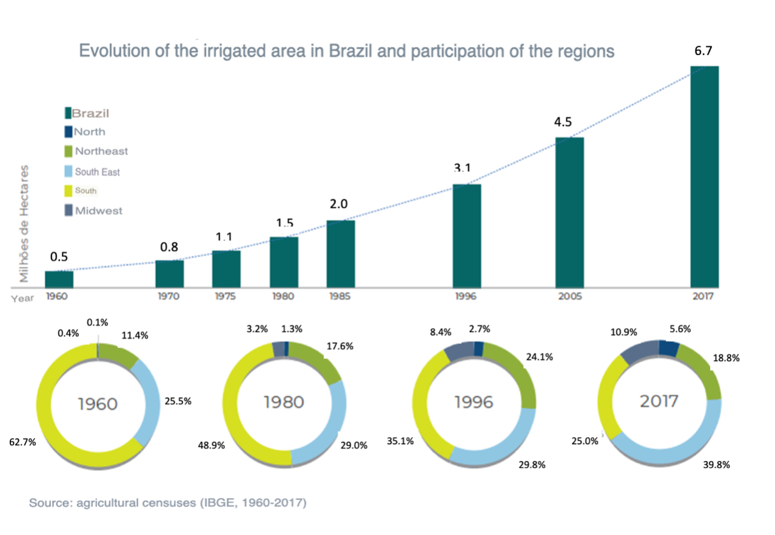

**Figure3.**Evolution of the irrigated area in Brazil and participation of the Regions.

**Source:** Irrigation Atlas; ANA, [27].

The municipal map highlights the predominant crop typology among the irrigated areas of the municipalities (Figure 4). There is a concentration of rice in poles in the South and in Tocantins; irrigated sugarcane on the northeastern coast and in other poles in the Center-South and Northeast; fertigated sugarcane in the Center-South (São Paulo, southwest Goiás, Minas Gerais triangle and southwest Mato Grosso do Sul); coffee in poles in Espírito Santo, Minas Gerais, Bahia and Rondônia; other temporary crops grown under central pivots in the central plateau (especially Goiás, Minas Gerais and Bahia); and other crops and systems in the North and Semi-Arid regions.

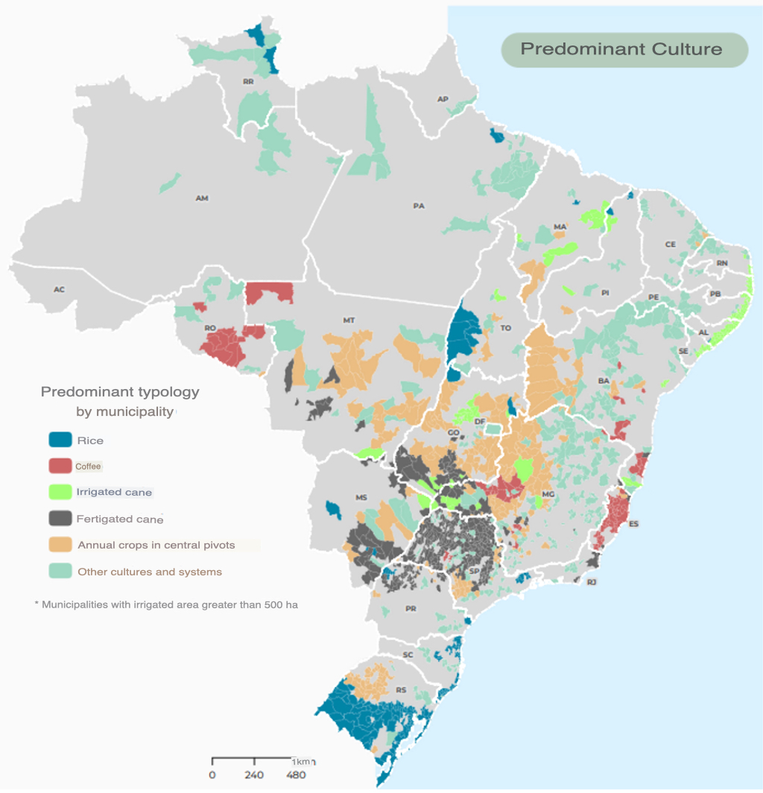

**Figure4.**Geographical distribution of types of irrigated crops by region in Brazil.

**Source:** Irrigation Atlas; ANA, [27].

The predominant irrigation methods demonstrate the correlation of rice with the surface method (flooding), of sprinkling by pivots with annual crops, of sprinkling by other systems with sugarcane and of localized irrigation with coffee and with the fruit growing centers of the Northeast.

Projections indicate the incorporation of 4.2 million irrigated hectares by 2040, an average of around 200 thousand hectares per year, bringing the country closer to the total irrigated area of ​​12.4 million hectares (Figure 5). This increase corresponds to an increase of 51% over the current area (irrigated + fertigated) or 79% considering the irrigated areas excluding fertigation. This increase also corresponds to the use of 30% of the effective potential and only 7% of the total potential.

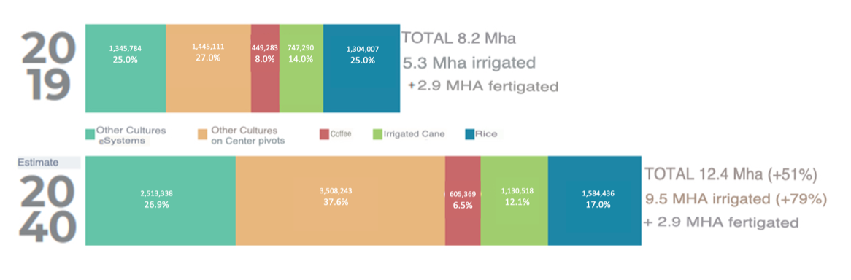

**Figure5.**Irrigated area in Brazil by crop types and projection between 2019 and 2040.

**Source.** Irrigation Atlas; ANA, [27].

4. Impacts of plant growth regulators on irrigated agriculture

If proper care is not taken before, during and after using these products, adverse effects may occur. As mentioned above, plant regulators act directly on cellular structures and can cause physical, chemical and metabolic changes, in addition to being involved in the growth and development processes of a plant organ or tissue.

1. However, this answer depends on some factors such as:
2. Species;
3. Development stage;
4. Management;
5. Application technology;
6. Concentration; interaction between other regulators;
7. Environmental conditions.

The positive impacts caused by the use of plant growth regulators are seen with scientific support through research. Plant growth regulators can be used in a wide number of crops, and research has yielded results mainly in the areas of:

1. Fruit growing;
2. Floriculture;
3. Olericulture and;
4. Great cultures.

In the latter case, there is still little research, as is the case with soybeans and corn, rice and beans. Plant growth regulators can be used in a wide range of crops, and research has yielded results mainly in the areas of fruit growing, floriculture and horticulture. As for large crops, there is still little research, as is the case with soybeans and corn, rice and beans. The use of these compounds has yielded positive results, such as an increase in the root system after germination and an increase in pod set [28].

5. Importance of using plant growth regulators in irrigated agriculture

Souza et al. [29]investigated thegrowth of papaya under irrigation depths and application of brassinosteroid in which the aim was to evaluate the effects caused by the application of epibrassinolide (C28H48O6), an analogue of brassinosteroid, during the vegetative phase of papaya with the Hawaii variety, under different irrigation depths. Five irrigation depths were used (60, 80, 100, 120, 140% of the reference evapotranspiration-ET0), with brassinosteroid (concentration 1.0 mg L-1) and without brassinosteroid.

It was found that lower irrigation depths promoted lower height, diameter, number of leaves, leaf area and root volume of papaya seedlings. The use of 100% of the reference evapotranspiration provided greater height, stem and root moisture. The application of 1.0 mg L-1 of the hormone optimized plant growth in the seedling production phase.

For plant height, the application of the phytohormone had a positive influence, when compared to the absent treatment, however both adjusted to the quadratic behavior throughout the increase in the irrigation depth (Figure 6A). Fridman and Savaldi[30] state that brassinosteroids play important roles in several processes that occur during plant growth, including replication and cell elongation, which may explain the height stimulus using BR, especially when better water conditions were established. Possibly, smaller depths may have initiated imbalances in the natural turgor process, necessary for cell expansion, thus interfering with plant height.

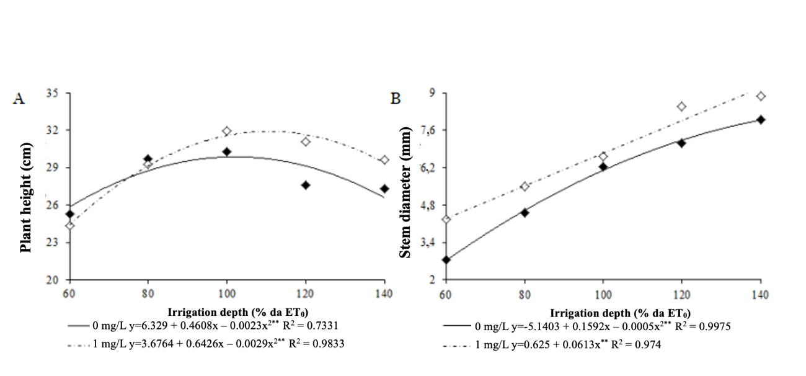

**Figure6.**Plant height (A) and stem diameter (B) in papaya under irrigation levels and brassinosteroid application: (♦) without application and (◊) with application of 1.0 mg L-1. UEPB.

**Source:**Souza et al. [29].

The stem diameter of papaya plants (Figure 6B) expanded proportionally with the addition of irrigation depths regardless of whether or not brassinosteroid was applied. In contrast, the application of the phytohormone provided a greater increase (20.19%) compared to the absence of irrigation, at a depth of 140% ET0. Occasionally, the higher water depths caused the cells of the secondary meristems of the stem to expand to store the high water content in the tissues, and the addition of the hormone concentration allowed further cell expansion, since BRs are also active in cell membranes and can cause changes in plasticity. This process may also be related to a stress action mechanism.

Leaf emission in the control and 1.0 mg L-1brassinosteroid treatments showed an increasing increase with the application of irrigation depths, obtaining a linear response (Figure 7A). As in the other growth variables analyzed, the treatment with the application of the hormone stood out in relation to the control, thus demonstrating that it did not reduce the deleterious effects of water deficit on papaya, but increased growth in papaya plants by increasing the photosynthetic area. The application of the brassinosteroid increased the leaf area (Figure 7B) of papaya plants in a linearly increasing manner as a function of the irrigation depths ranging from 120.84 cm2 (60% of ET0) to 562.03 cm2 (140% of ET0), while the absence of application showed a quadratic mathematical behavior with a maximum point at the estimated depth of 130% of ET0 with 349 cm2.

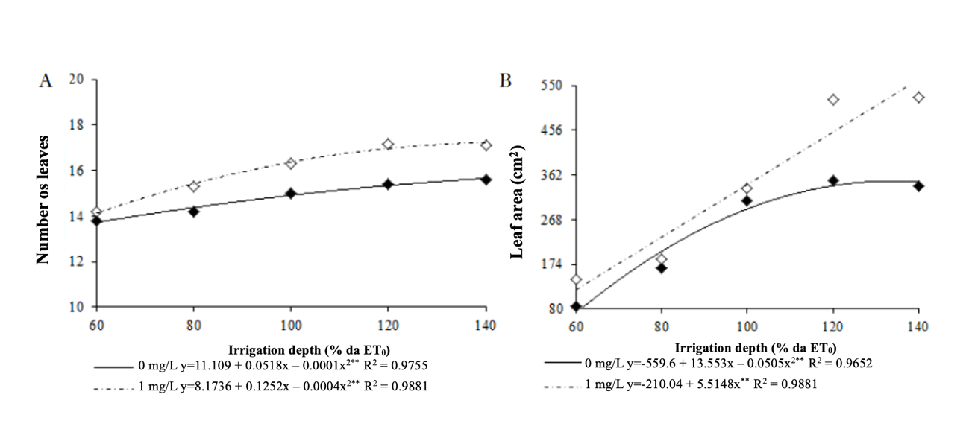

**Figure7.** Number of leaves (A) and leaf area (B) in papaya under irrigation levels and brassinosteroid application: (♦) without application and (◊) with application of 1.0 mg L-1.

**Source:**Souza et al. [29].

Brassinosteroid (BR) is a class of hormone that is associated with the modulation of plant responses to stress, due to the fact that it is involved in the activation of protection mechanisms against oxidative stress and in the structural alteration and permeability of cell membranes [31][32]. It is a hormone that, in addition to promoting plant growth and development, is considered to mitigate the negative effects caused by water stress in plants.

Alvarez et al.[33] aimed to evaluate the efficiency of plant growth regulators applied at the panicle primordium differentiation stage in reducing plant height and their consequences on the production and grain yield components of upland rice, cv. Primavera, irrigated by sprinkler irrigation. They used the following treatments: mepiquat chloride and ethyl-trinexapac, applied at doses of 0, 50, 100 and 200 mg ai ha-1, and paclobutrazol, at doses of 0, 25, 50 and 100 mg ai ha-1. These authors found that plant height was significantly influenced by the treatments and by the source and dose interaction (Figure 8). Thus, a significant linear reduction in plant height was observed with increasing doses of plant growth regulators, which was more pronounced with the application of ethyl-trinexapac (ETX) (Figure 8).

The effect of reducing plant height through the application of plant growth regulators can be explained by the mode of action of the products, which act on the metabolism of gibberellin synthesis, hormones that, among other functions, promote cell elongation [34] [35], which, in practice, causes a drastic reduction in cell elongation (growth), without causing morphological deformation of the stem [35][36]. Furthermore, this significant result of reducing plant height through the application of plant growth inhibitors was also due to the time of application of the product, which was at the time of primordium differentiation, acting directly on the stem elongation stage [36].

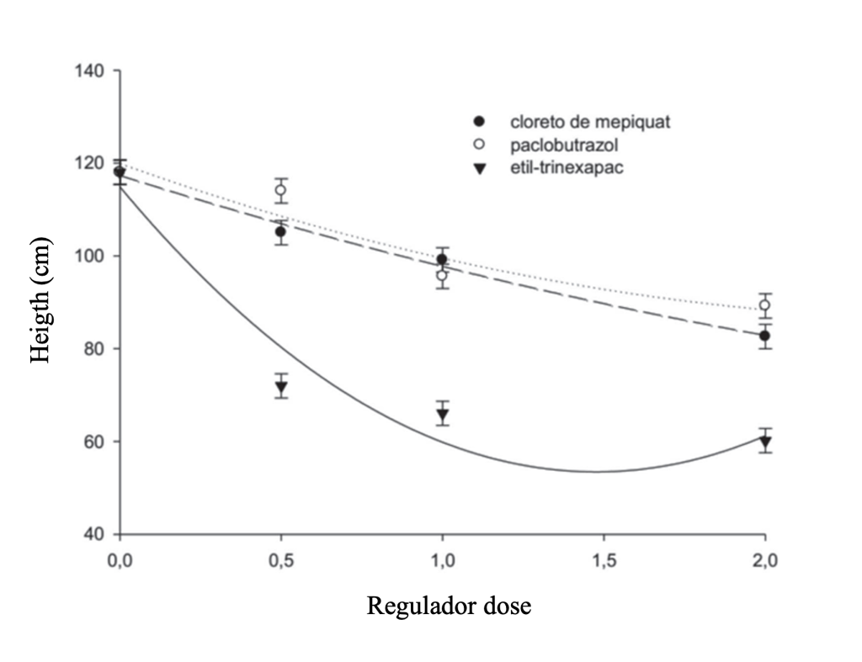

**Figure8.**Height of rice plants as a function of doses (0, 0.5, 1 and 2 times the recommended dose) and sources of plant growth regulators (ethyltrinexapax, paclobutrazol and mepiquat chloride). Vertical bars indicate standard deviation of the mean.

**Source:**[33].

In summary, the use of plant regulators provided significant reductions in the height of upland rice plants, which can be an excellent alternative for rural producers who use higher levels of technology in the crop, such as irrigation and nitrogen fertilization, to avoid plant lodging [33].

Final considerations

The effects of plant growth regulators on plants grown under irrigated conditions and the benefits they provide have contributed to solving problems in the production system and improving crop productivity, both qualitatively and quantitatively, with scientific support. However, to achieve this, they require attention in their adoption and application.

References

1. Silva T. Use of bioregulators and biostimulants in agriculture. 45f. Monograph (Specialist, Specialization Course in Soil Fertility and Plant Nutrition). Universidade Federal do Paraná, Curitiba, 2019.

2 Xavier LF, Costa RF, Costa EF. Adoption of water-saving technologies in irrigated fruit farming in the São Francisco Valley: a comparison between perceptions of settlers and companies. Journal of Economics and Rural Sociology. 2006; 44: 219-241.

3 Fetter PR. Hydrolysates of tobacco root and stem residues for stimulating germination of rice and corn seeds. Dissertation (Postgraduate in Environmental Technology) - Universidade de Santa Cruz do Sul, Santa Cruz do Sul, 2018.

4 Fernandes AC. Growth regulators on peanut seed dormancy and germination (PhD in Seed Production and Technology) - São Paulo State University, Faculty of Agricultural and Veterinary Sciences, Jaboticabal, 68 p., 2007.

5 Beserra JVS. Impact of the application of growth regulators and rooting agents on lettuce (Lactuca sativa L.) crops. 34 p. Final course work (Horticulture Technology) - Instituto Federal Goiano – Cristalina Campus, Cristalina – GO, 2021.

6 Castro PRC, Vieira EL. Applications of plant growth regulators in tropical agriculture. [S. l.]: Guaíba: Agropecuária, 2001.

7 Cobucci T, Nascente AS, Pereira Filho, CR, Machado AA, Oliveira KGB, Carvalho, ABA. Effects of plant growth regulators applied at different stages of common bean development. Documents, IAC, Campinas, 2008.

8 Miguel FB, Silva JAA, Bárbaro IM, Esperancini MST, Ticelli M, Costa AGF. Economic viability in the use of a plant growth regulator in sugarcane. Economic Information. 2009; 39.

9 Silva JAA, Donadio LC. Plant growth regulators in citrus farming. Jaboticabal: Unesp/Funep, 1997. 38 p.

10 Grohs M, Marchesan E, Roso R, Formentini TC, Oliveira ML. Performance of rice cultivars with the use of growth regulators in different cropping systems. Brazilian agricultural research. 2012; 47: 776-783.

11 Külen O, Stushnoff C, Davidson RD, Holm DGM. Gibberellic acid and ethephon alter potato minituber bud dormancy and improve seed tuber yield. American Journal of Potato Research. 2011; 88: 167-174.

12 O’brien R, Fowkes N, Bassom AP. Models for gibberellic acid transport and enzyme production and transport in the aleurone layer of barley. Journal of Theoretical Biology. 2010; 267: 15-21.

13 Ford KA, Casida JE, Chandran D, Gulevich AG, Okrent RA, Durkin KA, Sarpong R, Bunnelle EM, Wildermuth MC. Neonicotinoid insecticides induce salicylate-associated plant defense responses. Proceedings of the National Academy of Sciences of the United States of America. 2010; 107: 17527-17532.

14 Salisbury FB, Ross CW. Plant physiology. Mexico: Iberoamérica, 1994. 759 p.

15 Casillas VJC, Londoño IJ, Guerrero AH, Buitrago GLA. Quantitative analysis of the application of four biostimulants in radish (Raphanus sativus L.) cultivation. Acta Agronomica. 1986; 36: 185-195.

16 Laca-Buendia JP. Effect of growth regulators on cotton (Gossypium hirsutum L.). Brazilian Journal of Plant Physiology. 1989; 1: 109-113.

17 Biasi LA. Plant growth regulators. In: Plant Physiology: Production and Postharvest. Curitiba: Editora Champagnat, p.63-94, 2002.

18 Vieira EL, Souza GS, Santos AR, Silva JS. Manual of plant physiology. São Luis: Edufma, 2010. 230 p.

19 Gonçalves KS, Sousa AP, Veline ED. Application of plant growth regulators and potassium phosphite in eucalyptus seedlings subjected to water deficiency. Irriga. 2015; 20: 273-285.

20 Castro PRC, Melotto, E. Biostimulants and hormones applied via foliar application. In: Boareto AE, Rosolem CA. (Ed.). Foliar fertilization. Campinas: Cargill Foundation. v.1, chap.8. p.191-235. 1989.

21 Castillo OE, Barral G, Rodríguez GE, Miguelisse NE, Agüero MS. Establishment and development in forced tomato cultivation: effect of phytoregulators. Journal of the Faculty of Agricultural Sciences. 2005; 37: 83-91.

22 Fagan EB, Ono EO, Rodrigues JD, Chalfun Júnior A, Dourado Neto D. Plant Physiology: Plant Regulators, 2015. 189-191p.

23 Taiz L, Zeiger E. Plant physiology. 5th ed. 954 p. 2013.

24 Taiz L, Zeiger E. Plant physiology. Porto Alegre: Artmed, 2009. 819p.

25 ANA - National Water Agency (Brazil). Survey of irrigated and fertigated sugarcane in Brazil. Brasília. 2019.

26 EMBRAPA RICE AND BEANS. Current data on rice (Oryza sativa L.) production in Brazil (1986 to 2018): area, production, and yield. Santo Antônio de Goiás: Embrapa Rice and Beans, 2020. Available at: embrapa.br). Accessed on: December 14, 2022.

27 ANA - National Water Agency (Brazil). Irrigation atlas: water use in irrigated agriculture / National Water and Sanitation Agency. - 2nd ed. – Brasília. 2021. 130 p.

28 KLAHOLD, C. A.; GUIMARÃES, V. F.; ECHER, M. M.; KLAHOLD, A.; CONTIERO, R. L.; BECKER, A. Response of soybean (Glycine max (L.) Merrill) to abiostimulant application. Acta Scientiarum Agronomy. 2006; 28: 179-185.

29 Souza JM, Sousa VFO, Santos GL, Silva JÁ, Maia JM, Barboza JB, Costa JE. Papaya growth under irrigation depths and brassinosteroid application. Diversitas Journal. 2021; 6: 3724-3738.

30 Fridman Y, Savaldi S. Brassinosteroids in growth control: How, when and where. Plant Science. 2013; 209: 24-31.

31 Ali B. Practical applications of brassinosteroids in horticulture - Some field perspectives. Scientia Horticulturae. 2017; 225: 15-21.

32 Vardhini BV. Modifications of morphological and anatomical characteristics of plants by application of brassinosteroids under various abiotic stress conditions—a review. Plant Gene. 2017; 11: 70–89.

33 Alvarez RCF, Crusciol CAC, Nascente AS. Upland rice productivity as a function of growth regulators. Rev. Ceres. 2014; 61: 42–49.

34 Alvarez RCF, Crusciol CAC, Rodrigues JD, Alvarez ACC. Application of plant growth regulators in upland rice. Acta Scientiarum. Agronomy. 2007; 29: 241–249.

35 Nascimento V, Arf O, Silva MG, Binotti FFS, Rodrigues RAF, Alvarez RCF. Use of the growth regulator ethyltrinexapac in upland rice. Bragantia. 2009; 68: 921-929.

36 Alvarez RCF, Crusciol CAC, Nascente AS, Rodrigues JD, Habermann G. Gas exchange rates, plant height, yield components, and productivity of upland rice as affected by plant regulators. Brazilian Agricultural Research. 2012; 47: 1455-1461.