Journal Name: | International Journal of Plant & Soil Science
Manuscript Number: | Ms_IJPSS_131671
Title of the Manuscript: | Diversity of Plant-Parasitic Nematodes Associated with Assam Lemon
Type of the Article | Short communication.

PART 1: Comments

 | Reviewer’s comment  Artificial Intelligence (AI) generated or assisted review comments are strictly prohibited during peer review. | Author’s Feedback (Please correct the manuscript and highlight that part in the manuscript. It is mandatory that authors should write his/her feedback here)
Please write a few sentences regarding the importance of this manuscript for the scientific community. A minimum of 3-4 sentences may be required for this part. | The PPN is responsible to cause yield losses. Therefore, the study of PPN is an important study.  The presence of PPN in Assam lemon rhizospheres will help to manage nematodes.  The presence of PPN genera have been identified.
Is the title of the article suitable?  (If not please suggest an alternative title) | Yes
Is the abstract of the article comprehensive? Do you suggest the addition (or deletion) of some points in this section? Please write your suggestions here. | Yes but,  Please include key words after abstract.  After writing PPN genera, sp. Should be written if no species name has been written.
Is the manuscript scientifically, correct? Please write here. | Yes but,  Classification of counted nematodes according to various ectoparasitic, migratory endoparasitic, and sedentary endoparasitic nematodes should be focussed.  The formula of the nematode community analysis was carried out by using different formulae (Norton, 1978) viz., Absolute frequency (AF), Relative frequency (RF), Absolute density (AD), Relative density (RD) and Prominence Value (PV) should be included as follows.  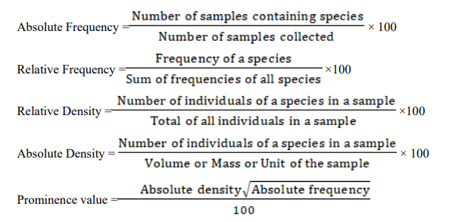  Population of nematodes in 200 cc soil should be incorporated in Table 2.  District wise community analysis of PPN (200cc soil) infecting Assam lemon should be placed in Table 2.  District wise community analysis of PPN (200cc soil) infecting Assam lemon should be placed in Table 2.
Are the references sufficient and recent? If you have suggestions of additional references, please mention them in the review form. | Yes  Reference should be followed as per the journal’s format.
Is the language/English quality of the article suitable for scholarly communications? | Yes

Optional/General comments

PART 2:

 | Reviewer’s comment | Author’s comment (if agreed with reviewer, correct the manuscript and highlight that part in the manuscript. It is mandatory that authors should write his/her feedback here)
Are there ethical issues in this manuscript? | (If yes, Kindly please write down the ethical issues here in details)

Reviewer Details:

Sitesh Chatterjee, India

