***Case report***

**Otosclerosis and Aeromedical Fitness: Insights from Three Cases and a Literature Review.**

**Abstract:**

Otosclerosis is a hereditary disorder characterized by abnormal bone remodeling in the otic capsule, leading to progressive conductive hearing impairment. This condition presents significant challenges for pilots and aircrew, whose profession demands optimal hearing for effective communication, situational awareness, and flight safety. The flight environment, with its inherent noise, pressure fluctuations, and acceleration forces, complicates the management of pilots affected by otosclerosis. While fitness waivers can allow some to continue flying with periodic monitoring, progressive hearing loss may require further intervention.

This paper presents the cases of three pilots with otosclerosis, followed at the Center of Aeromedical Expertise at the Mohamed V Military Training Hospital, each facing different aeromedical challenges.

* Case 1: A commercial airline captain with bilateral hearing impairment who successfully underwent a speech comprehension test in a simulator and was certified fit to fly with a waiver.
* Case 2: A helicopter pilot in the armed forces with unilateral otosclerosis, who underwent flight testing in noisy conditions and was granted a restricted flight fitness waiver.
* Case 3: A fighter pilot with severe otosclerosis who underwent a successful stapedotomy, restoring hearing function and receiving fitness approval with close medical supervision.

This article discusses the need for policy modifications in aeromedical certification for patients with otosclerosis. Although stapes surgery can effectively restore hearing, risks such as barotrauma and perilymphatic fistula have historically led to disqualification from flight duties. Recent studies and case evaluations suggest that with thorough vestibulocochlear testing—such as audiometric monitoring, in-flight speech testing, and chamber assessments—pilots with otosclerosis can safely return to flight. These cases highlight the importance of individualized aeromedical assessments to balance flight safety and career continuity for affected pilots.

Keywords: Otosclerosis, Fitness to fly, Conductive hearing loss, Stapedotomy, Aviation medicine, Flight safety.

**Introduction:**

Otosclerosis is a hereditary disease characterized by bone osteodystrophy of the otic capsule. It is due to an abnormality of bone renewal. Depending on the location of the bone lesions, the symptoms may be cochlear, vestibular, or mixed (1) (2).

The otosclerosis’ presentation is typically marked by progressive conductive hearing loss in adulthood due to labyrinthine endochondral sclerosis. This condition leads to stapedo-vestibular joint invasion resulting in loss of free motion of the stapes. (1) (3) (2)

It is mainly based on the Surgical Technique used to treat it. The choice of surgical technique has been widely studied in the literature as a factor in influencing the quality of the functional outcomes. (4) (5)

Hearing function is important in fitness to flight for aircrew members particularly when they are pilots. Because adequate hearing is essential to the safe of any operation of aircraft. However, most of the pilots are at least exposed incidentally to loud noise that can lead to hearing loss or worsen pre-existent pathology like otosclerosis (6). When the aircrew member presents an otosclerosis their fitness to flight is questionable (7). furthermore, otosclerosis raises the problem of how the ear will behave in the face of changes in pressure, acceleration, deceleration, and noise exposure in the aviation environment.

In this paper we report our experience of fitness management in three pilots who present an otosclerosis and a literature review.

**Cases presentation :**

**Case 1:**

M.R a 58-yr old aircraft captain at Royal Air Morocco. He is an experienced pilot also, with 18651 total flying hours. He has presented a bilateral hearing-loss in tonal audiometry during periodic visit at The Aeromedical Expertise Center of The Mohamed V Military Training Hospital in Rabat (Morocco), with deafness at right ear of 40dB and 50db in left side. Vocal audiometry has shown in silence deafness with intelligibility threshold at 100% 60dB in right side and 70dB in left side and intelligibility threshold at 50% 40dB in Right Ear and 50dB in left Ear, in noise (60dB) vocal audiometry threshold at 73dB [**Figure 1**]. His file was presented to aeromedical experts of the medical comity of expertise in aviation medicine at the general direction of civil aviation in Morocco, an in-simulator test was conducted showed good understanding and coordination the crew members. Fitness with waiver was accorded.

**Case 2:**

Z.K a 46-yr old military helicopter pilot (Puma and Super Puma). He was an experienced pilot, with 3000 total flying hours. He has presented during his periodic visit at The Aeromedical Expertise Center of The Mohamed V Military Training Hospital in Rabat (Morocco), a conductive deafness of the right ear in tonal audiometry which exceeds the standards of Moroccan military aircrew members. The exploration was conducted to search the cause of this deafness, the scanner of petrous bones objectified bilateral otosclerosis stage II. Vocal audiometry in noise (intelligibility threshold at 60 db) was also outside standards with threshold at 47db [**Figure 2**]. His file was presented for waiver, view his experience, an in-flight speech evaluation was conducted in helicopter and encompassed a variety of flight conditions, ranging from a hover to flight at maximum speed with high noise and vibration. Recorded and live voice speech materials (words, sentences, and occupationally relevant phrases) were presented to the service member through the internal communication system. In flight test has shown a good understanding by the pilot during the words and phrases repeated during the in-flight test speech. A fitness with waiver was accorded to pilot with restriction.

**Case 3:**

Mr. N.M a 34-yr old Military Fighting pilot, with 1070 total flying hours. He has presented during his periodic visit at The Aeromedical Expertise Center of The Mohamed V Military Training Hospital in Rabat (Morocco), a conductive deafness of the Left ear in tonal audiometry which exceeds the standards of Moroccan military aircrew members. The exploration which was carried out, particularly CT scan of the rock, showed an otosclerosis type II at the right ear and type III at left ear. Vocal audiometry in noise (intelligibility threshold at 60 db) was also outside standards with threshold at 35db **[Figure 3].** He was declared unfit and his file was presented for waiver. He underwent a stapedotomy in left ear with Laser. He has a good evolution without postoperative complications and a recovery of the hearing function in the pure tonal audiometry [**Figure 4**]. A fitness with waiver was accorded to the pilot with restriction.

**Discussion:**

Otosclerosis is the leading cause of conductive hearing loss in adults with normal tympan membrane (8). The prevalence is between 0.1 to 2% in the overall population (9) (2). However, in histologically series show that the prevalence is 12% in Caucasian people. The main age of apparition of symptoms is between 15 to 45 years. Women are 2-3 times affected than men (1), progression of otosclerosis In women has been linked to hormonal factors. On otosclerosis plaque estrogen receptors have been found. Regardless of race, when one ear is affected, the contralateral ear shows histologic evidence of otosclerosis 80% of the time (9).

A family history of otosclerosis is present in approximately 60% of patients with clinical otosclerosis. The other 40% are thought to be autosomal dominant cases with loss of penetrance, new mutations, viruses, environmental etiology or rare cases of autosomal recessive inheritance (8).

In aviation population the prevalence is lower estimated 0,025% than the general population (7). Perhaps this incidence is due to the initial medical screening used to select the aircrew members.

Otosclerosis is due to abnormality in bone remodeling. In fact, Normal bone resorption occurs at a rate of 10% per year in all areas of the skeleton, but only 0.13% per year in the normal otic capsule (8) (3). Patients with otosclerosis have increased bone remodeling within the otic capsule, leading to bone deposition that damages audiological structures and impairs normal sound transmission. The extent of abnormal osseous changes in the otic capsule is directly related to abnormal auditory finding (8). These abnormal lesions can occur in many locations: anterior of the oval window and stapes plate (80%), round window (30%), pericochlea (21%) and anterior segment of the inner ear (10).

The clinical presentation of a patient is directly influenced by the location and extent of the sclerotic lesion. A lesion originating from the fissure ante fenestrum and extending over the ligament of the stapes footplate results in stapes footplate fixation and conductive hearing loss. Less commonly, the lesion progresses medially into the endosteum of the cochlea, resulting in sensorineural hearing loss (9). So classic presentation is a progressive conductive hearing loss that begins in adulthood. In noisy environments, patients may describe improved hearing clarity. This phenomenon is known as paracusis of Willis. The conductive (9). About 50% of patients have tinnitus and only 10% report vertigo which means that otosclerosis attempt the inner ear(11) (12). The otosclerosis is found on both sides of the ear in 80% of patients; however, patients often present with unilateral involvement in the early stages of the disease (13).

In the physical examination, otosclerosis is often present with normal otoscopy, except for increased redness along the tympanic membrane promontory (Schwartz sign). The Schwartz sign is not consistently seen in patients with otosclerosis and is not required to diagnose.(9) (14). A standard audiometric battery should be performed. This should include pure tone thresholds with air conduction and bone conduction, speech reception thresholds, word recognition scores, and immittance testing (tympanometry and acoustic reflexes). The otosclerosis is seen as an unilateral or bilateral air bone gap on an audiogram, usually greater in the low frequencies (9) (15) . The bone conduction may show a depression at 2000 Hz without a concomitant depression in the air conduction, resulting in a narrowing of the air-bone gap at this frequency (15). This is known as a Carhart notch. It is common, but not exclusive, in otosclerosis (9) (16). Tympanometry is used to measure acoustic conduction. Tympanograms are often normal in otosclerosis. The patient's tympanogram may show some flattening due to severe stapes fixation only in extensive cases of otosclerosis.(8) (3)

High-resolution computed tomography (HRCT) without contrast is the technology that improves to identify smaller bony lesions, is beginning to be used in the diagnosis and surgical planning of otosclerosis. HRCT has high diagnostic sensitivity and specificity, and reveals variants in patient anatomy and severity of disease. Demineralization of the fissure ante fenestra, anterior to the oval window, is the most common manifestation of fenestra otosclerosis, especially in its spongiotic active stage. High-resolution CT coupled to MRI may demonstrate cochlear involvement by showing a demineralized area outlining the cochlea before cochlear implantation (17).

There is no doubt that surgical treatment is the curative treatment of otosclerosis. It consists of stapes surgery, which restores the mechanical transmission of sound through the middle ear, thereby correcting a conductive hearing loss. Sensorineural hearing loss due to osteosclerotic extension into the cochlea will not be corrected. Stapes surgery is a minimally invasive, single-day procedure performed under general anesthetic (8) (5). There are two types of surgery: Stapedectomy, a procedure in which the stapes footplate and the crura are removed and replaced with a prosthesis and Stapedotomy which creates a small hole in the stapedial plate for a prosthetic device without removal of the structure(8). This procedure of surgery is safe and successful in 94.2% in treating hearing conductive loss (5). Surgical complications are rare but can include deafness, incus necrosis, tympanic perforation, facial nerve injury, taste impairment, perilymph gush, floating or subluxate stapes footplate, and vertigo. Surgical failure typically results from prosthesis malposition or inappropriate prosthesis length (8).

For patients who are not candidates for stapes surgery or who require correction of a sensorineural hearing loss, hearing aids are an alternative.(2) (8)

**Aeromedical Implications:**

Otosclerosis has specific implications for aviation medical certification. However, aircrew pilots' fitness is determined by both international and national regulations. Pure-tone audiometry remains the primary method for assessing pilots' hearing. The audition must be minimally impaired (18) (19) (6) (20). Hearing loss should not exceed 35 dB at 500, 1000, and 2000 Hz or 50 dB at 3000 Hz in either ear when tested with a pure-tone audiometer (18). For many aviators with otosclerosis, no immediate treatment is required, and fitness may be granted with a waiver, provided that pure-tone audiograms are monitored biannually (21) (7). Interestingly, Paracusis of Willis theoretically allows pilots with otosclerosis to hear better in noisy environments than in quiet ones (21). Conducting in-flight speech evaluations is essential for assessing the communication abilities of pilots with otosclerosis who are not candidates for surgery. Ensuring their ability to understand and effectively communicate with crew members is critical for mission success, as demonstrated in the first two cases.

As hearing loss progresses in pilots with otosclerosis, effective communication in the cockpit becomes increasingly difficult, posing a potential risk to flight safety. Hearing aids can be a disadvantage, as they may prevent pilots from selectively tuning in to essential communications while filtering out unwanted noise and transmissions. Hence the surgery still the only choice for hearing well again. In the patients who had undergone stapes surgery, it was more difficult to assess the adequacy of fitness when a pilot was referred because of otosclerosis. There is a significant theoretical risk of inner ear barotrauma and perilymphatic fistula facilitated by the labyrinth opening and pressure changes caused by flight activity. For these reasons, stapes surgery was initially considered a definitive indication against flight fitness (21) (22).

In our situation, the only case in which the pilot had undergone stapes surgery with a good outcome was the last one. Several studies have been conducted concerning stapes surgery in pilots since 1967. In 1998, Thiringer and Arriage examined the aeromedical outcomes of 16 U.S. Air Force crew members who returned to flight duty after stapedotomy surgery. They recommended two tests for all aircrew seeking a waiver: a postoperative audiogram test and altitude chamber testing. These tests serve as reasonable screening tools for susceptibility to acute vestibulopathic conditions caused by rapid pressure changes (22). Stanislas Ballivet et al, in their study, reported that out of 16 flight crew members who underwent surgery, only two did not receive a fitness waiver after the procedure. Return to flight was determined by audiometry and balance status, postoperative CT scan and operative report to determine the quality of stapes surgery (7). However, waivers in commercial and military aviation suggest that under certain conditions and after relevant vestibulocochlear assessment, stapes surgery may allow for a safe recovery of aviation activity (23) (19) (6).

**Conclusion:**

Otosclerosis is a common cause of progressive conductive hearing loss. It has a significant impact on aircrew members. Treatment outcomes have improved with advances in diagnostic imaging and surgical techniques. While surgical intervention is still the gold standard, aeromedical considerations require a thorough evaluation before a pilot is cleared to return to duty. Pilots who have undergone successful stapes surgery can safely return to aviation with appropriate monitoring and evaluation.

## CONSENT

As per international standards or university standards, patient(s) written consent has been collected and preserved by the author(s).

## ETHICAL APPROVAL

It is not applicable.

**References:**

1. Silva VAR, Pauna HF, Lavinsky J, Guimarães GC, Abraão NM, Massuda ET, et al. Brazilian Society of Otology task force – Otosclerosis: evaluation and treatment. Braz J Otorhinolaryngol [Internet]. Sep 2023 [cited 2 Dec 2024];89(5):101303. Available at: https://linkinghub.elsevier.com/retrieve/pii/S180886942300071X

2. Otospongiosis_F.Rubin,A.Lacan,P.Halimi,P.Bonfils_EMC2017.pdf.

3. Ealy M, Smith RJH. Otosclerosis. In: Alford RL, Sutton VR, editors. Advances in Oto-Rhino-Laryngology [Internet]. S. Karger AG; 2011 [cited 1 Feb 2025]. p. 122‑9. Available at: https://www.karger.com/Article/FullText/322488

4. Ismi O, Erdogan O, Yesilova M, Ozcan C, Ovla D, Gorur K. Does stapes surgery improve tinnitus in patients with otosclerosis? Braz J Otorhinolaryngol [Internet]. Sept 2017 [cited 2 Dec 2024];83(5):568‑73. Available at: https://linkinghub.elsevier.com/retrieve/pii/S1808869416301434

5. Martin C, Fraysse B. Surgery of otospongiosis. Calibrated stapedotomy or transplate plunger technique. Ann Fr Oto-Rhino-Laryngol Pathol Cervico-Faciale [Internet]. Jun 2011 [cited 2 Dec 2024];128(3):173‑6. Available at: https://linkinghub.elsevier.com/retrieve/pii/S1879726111000593

6. Fundamentals of aerospace medicine. 4th ed. Philadelphia: Lippincott Williams & Wilkins; 2008.

7. Ballivet De Régloix S, Gauthier J, Pons Y, Maurin O, Genestier L, Kossowski M. Otosclerosis and Fitness to Fly. Aerosp Med Hum Perform [Internet]. 1 Dec 2015 [cited 2 Dec 2024];86(12):1039‑45. Available at: https://asma.kglmeridian.com/view/journals/amhp/86/12/article-p1039.xml

8. Batson L, Rizzolo D. Otosclerosis: An update on diagnosis and treatment. JAAPA [Internet]. Feb 2017 [cited Dec 9, 2024];30(2):17‑22. Available at: https://journals.lww.com/01720610-201702000-00003

9. Foster MF, Backous DD. Clinical Evaluation of the Patient with Otosclerosis. Otolaryngol Clin North Am. Apr 2018;51(2):319‑26.

10. Arnold W. Some Remarks on the Histopathology of Otosclerosis. In: Arnold W, Häusler R, editors. Advances in Oto-Rhino-Laryngology [Internet]. Basel: KARGER; 2007 [cited 15 Feb 2025]. p. 25‑30. Available at: https://karger.com/books/book/2543/chapter/5742432

11. Rudic M, Keogh I, Wagner R, Wilkinson E, Kiros N, Ferrary E, et al. The pathophysiology of otosclerosis: Review of current research. Hear Res [Internet]. Dec 2015 [cited Feb 22, 2025];330:51‑6. Available at: https://linkinghub.elsevier.com/retrieve/pii/S0378595515001549

12. Ealy M, Smith RJH. Otosclerosis. In: Alford RL, Sutton VR, editors. Advances in Oto-Rhino-Laryngology [Internet]. S. Karger AG; 2011 [cited 15 Feb 2025]. p. 122‑9. Available at: https://www.karger.com/Article/FullText/322488

13. Thomas JP, Minovi A, Dazert S. Current aspects of etiology, diagnosis and therapy of otosclerosis. Otolaryngol Pol [Internet]. May 2011 [cited 22 Feb 2025];65(3):162‑70. Available at: http://linkinghub.elsevier.com/retrieve/pii/S0030665711706709

14. Lippy WH, Berenholz LP. Pearls on otosclerosis and stapedectomy. Ear Nose Throat J. jun 2008;87(6):326‐8.

15. Danesh AA, Shahnaz N, Hall JW. The Audiology of Otosclerosis. Otolaryngol Clin North Am [Internet]. Apr 2018 [cited 15 Feb 2025];51(2):327‑42. Available at: https://linkinghub.elsevier.com/retrieve/pii/S0030666517302244

16. Wegner I, Bittermann AJN, Hentschel MA, Van Der Heijden GJM, Grolman W. Pure‐tone Audiometry in Otosclerosis: Insufficient Evidence for the Diagnostic Value of the Carhart Notch. Otolaryngol Neck Surg [Internet]. Oct 2013 [cited Feb 22, 2025];149(4):528‑32. Available at: https://aao-hnsfjournals.onlinelibrary.wiley.com/doi/10.1177/0194599813495661

17. Wolfovitz A, Luntz M. Impact of Imaging in Management of Otosclerosis. Otolaryngol Clin North Am [Internet]. Apr 2018 [cited 15 Feb 2025];51(2):343‑55. Available at: https://linkinghub.elsevier.com/retrieve/pii/S0030666517302220

18. Minister of Equipment and Transport. The order of the Minister of Equipment and Transport N°1209-09 of 17 joumada I 1430 (13 May 2009) relating to the conditions of physical and mental abilities of aeronautical personnel, to the approval of centers of expertise in aeronautical medicine to the designation and designation medical examiners. [Internet]. N°1209-09 May 13, 2009. Available at: https://www.aviationcivile.gov.ma/pdf/1923200934846PM.pdf

19. International Civil Aviation Organization. Doc 8984, Manual of Civil Aeronautical Medicine. ICAO 2015; 2012.

20. Federal Aviation Administration. GUIDE FOR AVIATION MEDICAL EXAMINERS. 2024.

21. Rajguru R. Post stapedotomy aviation: A changing scenario. Indian J Occup Environ Med. 2014;18(3):105‑8.

22. Thiringer JK, Arriaga MA. Stapedectomy in Military Aircrew. Otolaryngol Neck Surg [Internet]. Jan 1998 [cited 2 Dec 2024];118(1):9‑14. Available at: https://aao-hnsfjournals.onlinelibrary.wiley.com/doi/10.1016/S0194-5998%2898%2970368-7

23. USAFSAM/FECI. United States Air Force Aerospace Medicine Waiver Guide Compendium [Internet]. ECG Library; 2025. Available on: https://www.afrl.af.mil/Portals/90/Documents/711/USAFSAM/Air%20Force%20Waiver%20Guide%20Compendium.pdf

**Figures:**

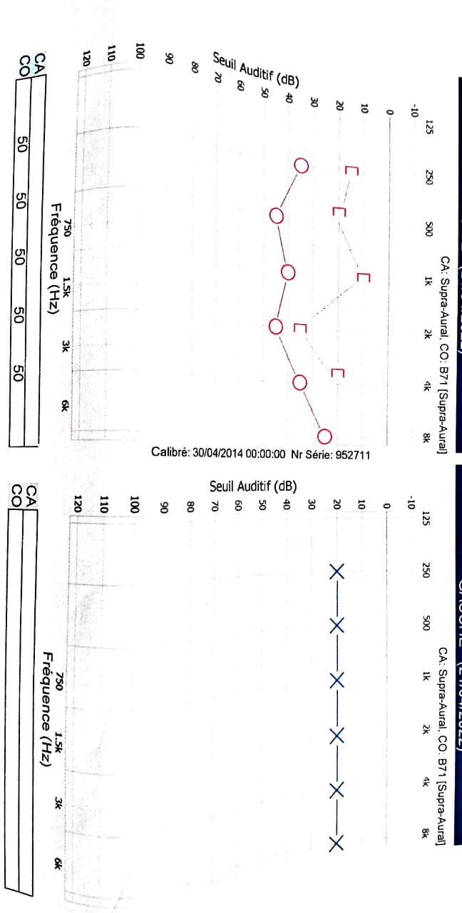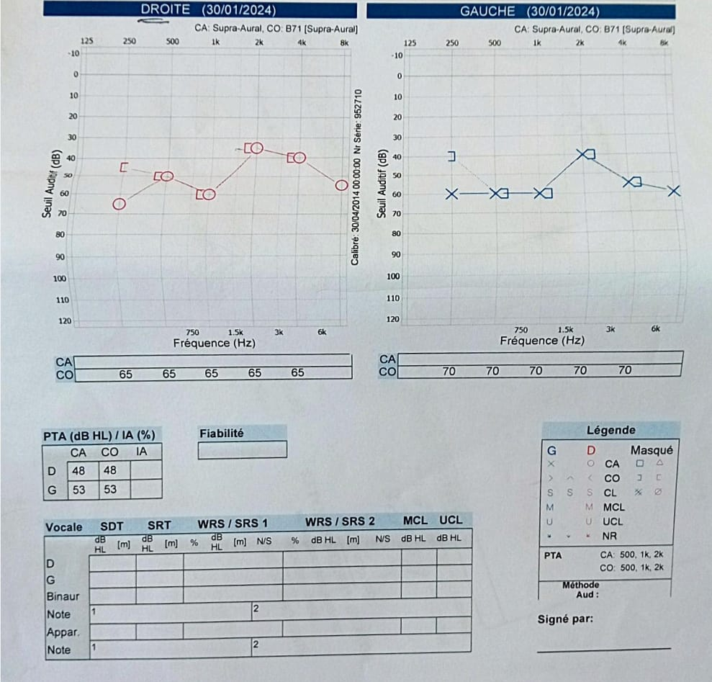

**Figure 1 : audiogram for case1**

**Figure 2 : audiogram for second case**

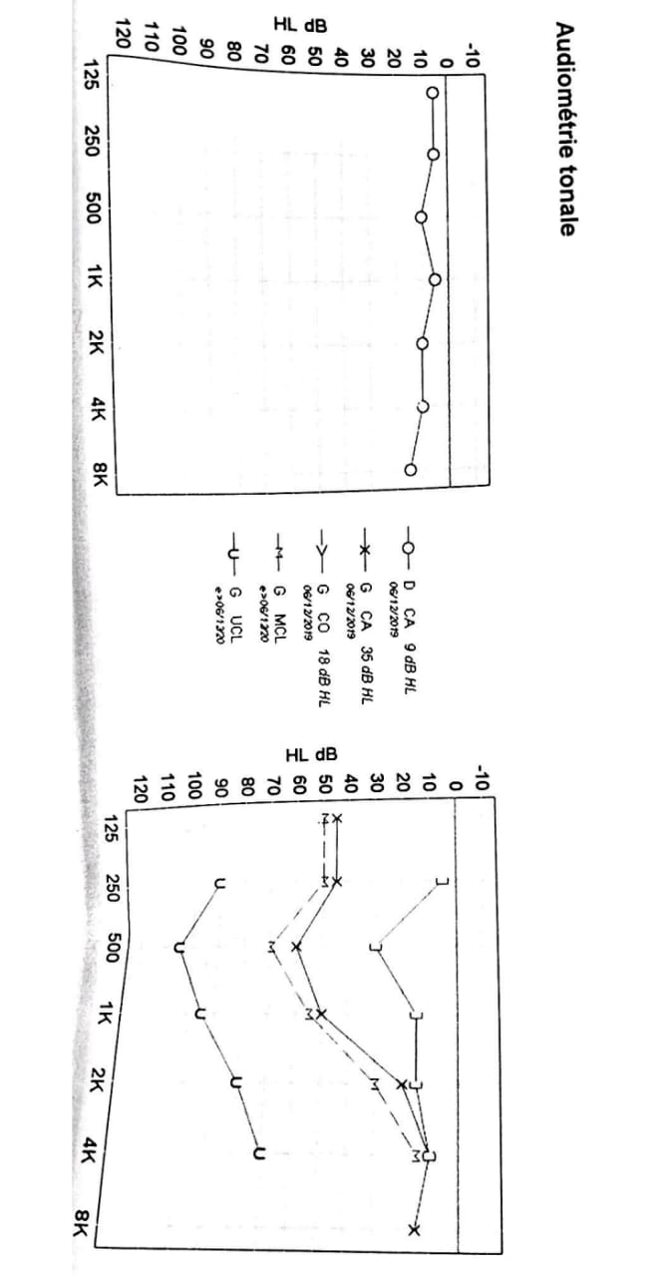

**Figure 3: audiogram for third case before surgery**

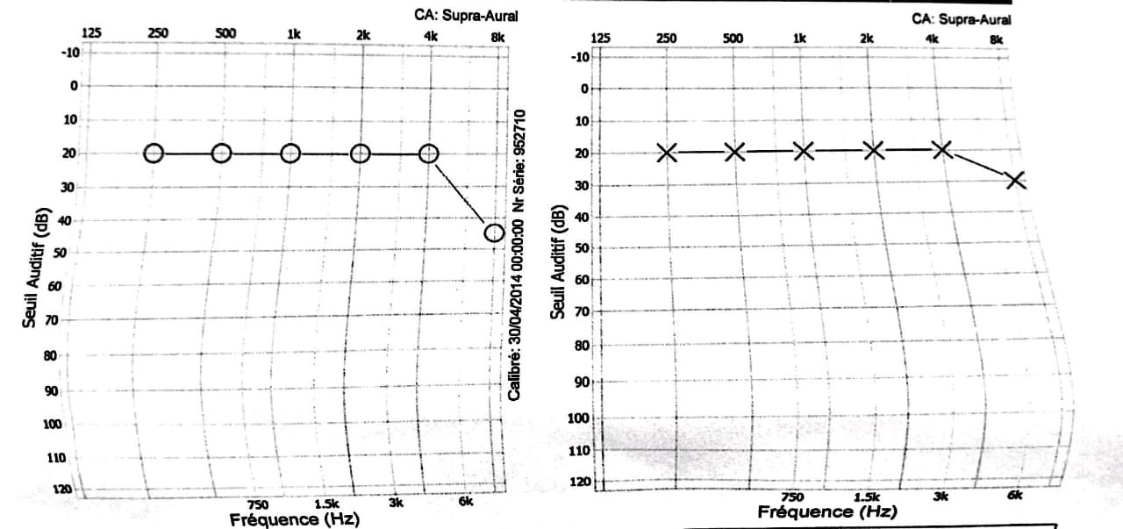

**Figure 4: audiogram for third case after surgery**