**Survey, Collection and Characterization of Sugarcane Cultivating Soils of Kerala with special emphasis on availability of Silicon and Iron -Aluminium toxicity**

.

ABSTRACT

|  |
| --- |
| Sugarcane is considered as one of the world’s major C4 plants, which is mainly grown in the tropical and sub-tropical regions and considered as long-duration crop, that requires approximately 10 to 15 and even 18 months to mature. India ranks second in terms of area, production, and productivity. Kerala has only 0.92 lakh ha of sugarcane cultivation with 106.66 TT of production and 15810 kg ha-1, which shows only a negligible contribution towards the Indian economy.The present study has focused on characterization of major sugarcane growing soils of Kerala by conducting a survey where surface soil samples were collected from AEU 9, 4, 17, and 22, in which a higher average pH of about 8.25 was observed in Chittur (AEU 22) compared to Marayoor (7.2), Thiruvalla (5.2), and Pandalam (5.5), due to the alkaline nature of black montmorillonite soil having higher organic matter and other nutrients such as N, P, K, Ca, Mg, and Si. Due to their near-neutral pH, Marayoor soils facilitate enhanced nutrient availability and absorption by plants compared to other soil types. Because of phosphorous (P) fixation in AEU 4 and 9 due to the formation of Fe-Al phosphates and calcium phosphate formation in the alkaline soils of AEU 22, the availability of phosphorous has decreased. The lateritic soils in southern Kerala exhibit high acidity and Fe-Al toxicity, resulting in reduced nutrient content, particularly silicon. This element is crucial for sugarcane, being a Si-accumulator crop that absorbs between 300-700 Kg ha-1 of available Si (monosilicic acid) from the soil. Silicon is considered as the most advantageous element for sugarcane growth that helps to resist various biotic and abiotic factors and specially helps to alleviate Fe-Al toxicity thereby contributes to better yield and quality of cane. Consequently, it is essential to recommend silicon nutrition strategies for sugarcane enhance both the productivity and quality of the crop. |

*Keywords:* Sugarcane, Silicon (Si), Fe-Al toxicity, Marayoor, Thiruvalla, Pandhalam, Chittur

1. **INTRODUCTION**

Sugarcane, one of the world’s major C4 crop, is mainly grown in the tropical and sub-tropical regions and is a long-duration crop, that requires about 10 to 15 and even 18 months to mature. Under the All India Coordinated Research Project on Sugarcane, 116 sugarcane varieties were identified, 55 of these have been registered and approved for cultivation across the nation. India ranks the second position in terms of area, production and productivity of sugarcane after Brazil (reference). Uttar Pradesh ranks first in terms of sugarcane production followed by Maharashtra and Tamil Nadu. Kerala has only 0.92 lakh ha area of sugarcane cultivation with 106.66 TT of production and 15810 kg ha-1 productivity which shows only a negligible contribution towards the Indian economy[1]. For 2023-24, sugar production is estimated at 32 MT (expand), lower than 38.8 MT compared to previous season. With the exception of cold hilly regions, sugarcane is grown all over India, and the sugarcane-based industry is one of the largest industries that supports the livelihood of our nation. [2] have stated that sugarcane is a typically a silicon (Si)-accumulating graminaceous species and is the second most Si-responsive crop after rice [3] that absorbs about 500-700 kg quantity of Si per hectare [4] thereby resulting in a large decline in soil available silicon. As a result, Si deficiency in soils could be a yield declining factor in sugarcane, resulting in symptoms such as twisted leaves and leaf freckling [5]. Moreover, Si has the potential to improve photosynthetic capacity and is recognized as an important enzyme regulator in sugar synthesis, storage and retention in sugarcane [6]. One of the beneficial advantages of Si to sugarcane is the probable potential of declining damage caused by insects and pathogens as well as mitigating various abiotic stresses [7]. Silicon also helps to resist different types of adverse biotic and abiotic factors such as disease and pest incidence, salinity and water logging condition, water scarcity and drought etc. Moreover, it largely helps to alleviate Fe-Al toxicities thereby promote better yield and quality of cane [8] (Sarto *et al.*, 2019). Different studies have proved that Si fertilization has decreased the Fe-Al concentration and translocation to the shoots of sugarcane cultivars thereby reduced their toxicity. Therefore, exogenous Si application could significantly promote sugarcane growth and yield in Si-deficient soil [9]**.** The critical soil Si concentration for sugarcane production is 40mgkg-1 [10].

**1.1Sugarcane status in Kerala (no subheadings in introduction)**

Kerala has a rich history of sugarcane cultivation. After Travancore sugars were established in 1937, the agriculture environment shifted and widespread cultivation for sugar production emerged drastically. Thus, sugarcane became a major commercial crop of the state by significantly contributing towards agricultural income. Unfortunately, the success of the sugar industry was short-lived due to various economic reasons and most of the sugar mills were closed due to huge financial losses [11]. The number of Jaggery production units in Kerala were decreased from 591in 1980 to 41 in 2010 However, the state's use of jaggery and sugar is rising annually, significantly beyond that of other Indian states. In Kerala, the average person consumes 48.1 kg of sugar and 25.1 kg of jaggery annually. The area used for sugarcane cultivation is declining annually, according to Kerala's Economics and Statistics Department and in 2020–21 (mention area according to 2023-24 statistics, if available), statistical report showed that 920.73 ha of land were planted with sugarcane, mostly in the district of Idukki and Pathanamthitta. In other districts like Alappuzha, Palakkad, Kottayam and Kannur, cultivation is of limited extent. As per the latest report, about 270 ha area is under sugarcane cultivation in Kerala that extends over six districts and about 4.6% of the area (mainly in Alappuzha and Pathanamthitta Districts) under the crop was severely affected by flood [11].

2. material and methods

A field survey was conducted at different Agro Ecological Units of sugarcane growing soils of Kerala mainly from Chittur (AEU 22), Pandhalam (AEU 9), Thiruvalla (AEU 4) and Marayoor (AEU 17) which are the major cultivating areas and their respective GIS mapping was conducted with respect to their soil fertility status specially with respect to their texture, pH and availability of silicon and Fe-Al toxicity, using Arc GIS software. Surface soil samples (0-15cm) was collected, sieved and air dried to 1050C to determine the physico-chemical characteristic of soils. Physical property of soil such as texture was determined by international pipette method [12]. The pH and EC of soil was calculated with 1:10 w/v basis (reference?acording to jackson 1:2.5 ratio soil and water)and coming to major nutrients, available N in the soil was determined by following alkaline permanganate method [13] using 0.32 per cent KMnO4 and 2.5 per cent NaOH. For soils with a pH below 6.5, the Bray No. 1 reagent [14] was used to extract the available phosphorus from the collected soil samples and for those soils with a pH above 6.5, Olsen's technique [15]was used and its content in the extract was estimated using Spectro photometer (wavelength?). Available potassium, calcium and magnesium in the soil samples were extracted using neutral normal ammonium acetate[16] (Jackson, 1958). Using 0.15% CaCl2, available S was extracted, and turbidimetry was determined using a spectrophotometer(wavelength?) [17] [18]. For soils with a pH below 6.5, the available micronutrients (Fe, Cu, Zn, Mn) were extracted using 0.1M HCl [19] and for soils with a pH above 6.5, 0.005M DTPA and 0.01M CaCl2.2H2O buffered at pH 7.3 by 0.1M triethanolamine (TEA) were applied [20]. Available boron in soil samples were extracted with hot waterand estimated using UV-VIS spectrophotometer. The estimation of available silicon in soil was conducted using 0.5 M acetic acid following 1:2.5 ratio [21]. The critical limit of Si using this extractant was 20 mg/kg.

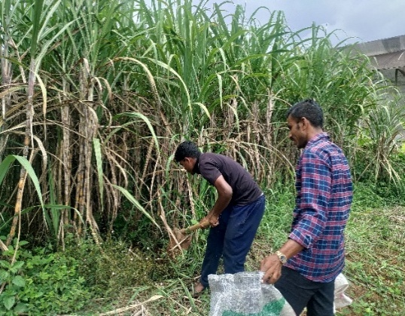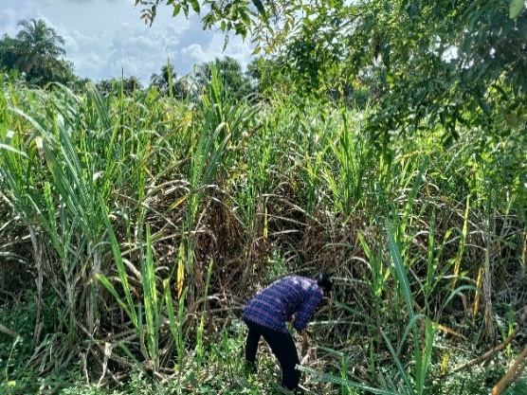

AEU 4

AEU 7

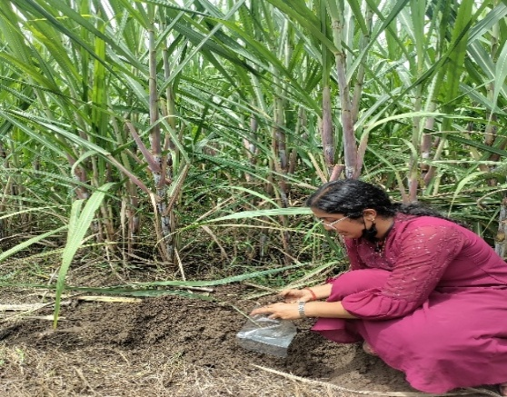

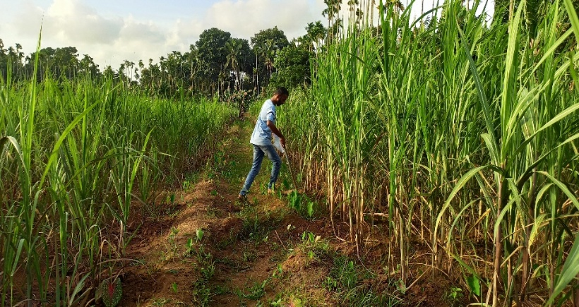

AEU17

AEU 22

**Fig 1: Survey conducted at major sugarcane cultivating soils of Kerala**

1. **RESULTS AND DISCUSSION**

**3.1 Thiruvalla soils (AEU 4)**

The soil texture of Thiruvalla region was mostly of sandy clay loam where sand, silt and clay content were about 35.0%, 26.06% and 38.84% respectively, while some panchayat like Pandanad was having sandy clay texture. The average pH of the soils used to cultivate sugarcane in Thiruvalla was 5.4, coming within the strong to moderate acidic range, while the EC was approximately 0.20 (dS/m). Formation of kaolinite in these tropical ferruginous soils along with gibbsite is the main reason for lower fertility status [22]. The amount of organic carbon ranged from 1.8 to 2.1 % while average nitrogen content was about 383 kg/ha which was in moderate range but the content of phosphorous was low with the average value of 17.8kg/ha which is mainly due to the formation of Fe-Al phosphates that are in non-available form which are fixed in the interlayer lattice. Potassium content was of low to medium range with average value of 160 kg/ha. Regarding the secondary nutritional status, the content of S (9.5 kg/ha) was within a suitable range, but the level of Ca (275 kg/ha) and Mg (27.77 kg/ha) was low because of their lower pH. Regarding the micro nutritional status, the average content of Fe, Cu, Zn and Mn was about 42, 3.2, 1.7 and 25 respectively. This lateritic soil has showed deficiency of B with average value of 0.25mg/kg which are prone to leaching because of sandy clay loam texture and high rainfall that has coupled with low organic matter content that led to poor B retention capacity. However, alone with iron (Fe), Aluminium (Al) toxicity is also considered as a potential growth-limiting factor for plants grown in acid soils. This acidic soil has reported toxicity of Al with an average of 9.2 mg/kg. This is because of the acidic nature of lateritic soil that has resulted in the aluminium-hydroxy cations such as Al (H 2O)63+and (Al 3+), that later get exchanged with other cations [23].This soil has reported a lower value of available Si status (13.5 mg/kg) below the critical range of 20 mg/kg, despite the fact that it is the second most prevalent element in the earth's crust because of the higher concentration of Fe and Al in the highly weathered acidic soil that has reacted with Si to form insoluble hydroxy alumino silicates [24]

* 1. **Pandhalam (AEU 9)**

The weathering tendency of lateritic soils in humid, high-rainfall locations is the main reason for the moderately acidic pH of 5.6 found in sugarcane-growing areas of Pandhalam. Fertile loam to clayey loam texture was reported in this region containing a mean value of 30.6, 23.96 and 45.35% of sand, silt and clay fractions. The average value of organic carbon content was about 2.5% which was comparatively higher than AEU 4 due to presence of more humus content in this forest loamy soil. The value of major, secondary and micro nutrients was more or less similar to that of AEU 4. Here also, it showed deficiency of Si due to the presence of sesquioxides and their complexation to form insoluble alumino-silicates.

* 1. **Marayoor (AEU 17)**

The regions of Marayoor hills and Kanthalloor is considered as the major sugarcane growing places of Kerala because of the suitable climatic conditions. Marayoor jaggery has earned GI recognition to its credit and is renowned for its excellence. Thus, sugarcane is a major crop in this region, and all yield is used to make jaggery [24]. This soil has represented a mixed texture of sandy clay loam, sandy loam, clayey loam and clayey where sandy clay loam was predominant in sugarcane grown areas. The pH was reported to be slightly acidic to neutral to slightly alkaline in nature (6.8 to 7.5) and this may be due to the presence of organic deposits at the surface that prevent the synthesis of organic acids that has buffered the pH to neutral condition [25]. Nitrogen content was slightly above the lower range value (<280 kg/ha). The availability of P in the surface soil was higher than AEU 4 and 9 due to neutral pH range. Because of more intense weathering of potash-bearing minerals, the formation of leaf litter from different crops in cropping systems, the release of labile K from organic residues, the application of K fertilizers, and the upward translocation of K from lower depth with capillary rise of ground water, the majority of surface soils had higher levels of available K [26]. The higher level of Ca (420 mg/kg) and Mg (120 mg/kg) may be due to increased application of liming materials like lime and dolomite in the surface soil.Due to low rainfall and the existence of mixed layer lattice clays with a predominance of vermiculite/montmorillonite, soils in rain shadow sections of AEU 17 (Marayur Hills) showed a nearly neutral pH and a high concentration of available basic cations. Higher mobilization of S (mean value 30.5mg/kg) was primarily due to higher organic matter accumulation in the surface soil. The majority of the micronutrients, including Fe (34.15 mg/kg), Cu (4.5 mg/kg), Zn (16.2 mg/kg), and Mn (24.5mg/kg), were found in sufficient amounts in this forest hill soil, but they were less than those found in AEU 4 and 9, that reported toxicities for Fe, Al, and Mn. [27] stated that the sufficient range of metal ions such as Fe and Cu irrespective of the neutral pH has increased due to higher level of organic matter content because of its potential to include chelating agents. Zinc and organic carbon in surface soils have a strong positive connection, suggesting that complexing agents produced by organic matter increase the availability of zinc in soils [28]. Due to its higher pH and more basic cations, this soil has been found to have a lower level of aluminium (1.85 mg/kg) and a higher level of available silicon (50 mg/kg) than AEU 4 and 9. But application of silicate fertilizers can also enhance the production irrespective of its current soil availability due to suitable pH condition [29].

* 1. **Chittur (AEU 22)**

The Chittur region of Palakkad district of Kerala is highly known for its unique black-coloured soils due to high enrichment of OM. This soil has reported its highest content of organic carbon (4.25%) with high fertility status due to more accumulation of organic debris and humus formation [30]. This black soil contains a mixture of clayey and clayey loam texture with mean value of 14.5% sand, 20% silt and 65.6 % of clay. This soil also reported an alkaline pH of 8.5 and EC of 0.45 ds/m respectively. Of the main nutrients, the amount of available nitrogen was determined to be 260 kg/ha, which is in the lower range, whereas the amounts of potassium and phosphorus were approximately 140 and 475 kg/ha, respectively, which are in the higher range. This higher level is mainly attributed to the accumulation of higher level of organic matter and also due to the presence of expanding type of clay minerals that has resulted in their lower fixation. This soil has the highest quantities of basic cations, such as calcium (1441 mg/kg) and magnesium (560 mg/kg), and it also has more accessible sulphur (mean value of 36 mg/kg), when compared to other AEUs in terms of secondary nutrient levels. Comparing different micro nutrients, Fe and Mn content was lower than other AEUs which is primarily due to higher pH condition that has caused these elements to be less accessible to plant and caused their precipitation as oxides and hydroxides. The value of Cu and Zn were 2.5 mg/kg and 9.5 mg/kg respectively. Because of their higher pH and presence of more organic matter and exchangeable basic cations, this swelling and shrinking soil has reported a lowest value of available Aluminium (0.45mg/kg) and highest value of available Silicon (60.5mg/kg) compared to other AEUs [27].Due to their extensive weathering, the presence of basic parent materials and a greater proportion of clay has enhanced the solubility of accessible Si in this soil. More Si may be efficiently stored in the sites of montmorillonite clay minerals that has greater CEC levels, which helps to preserve their availability in soil [31].

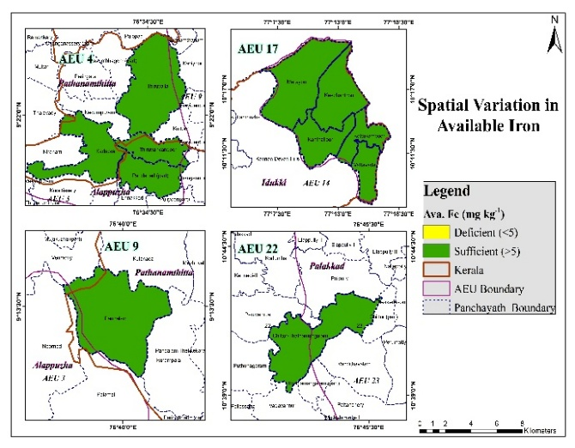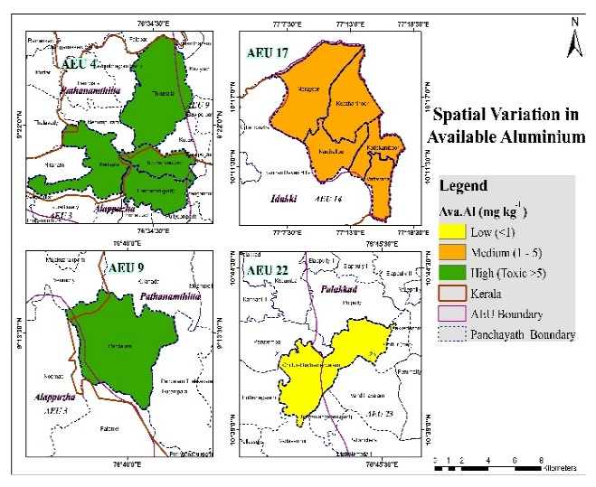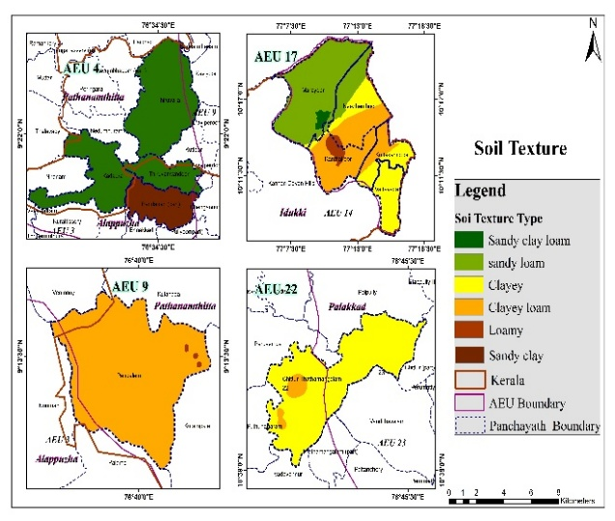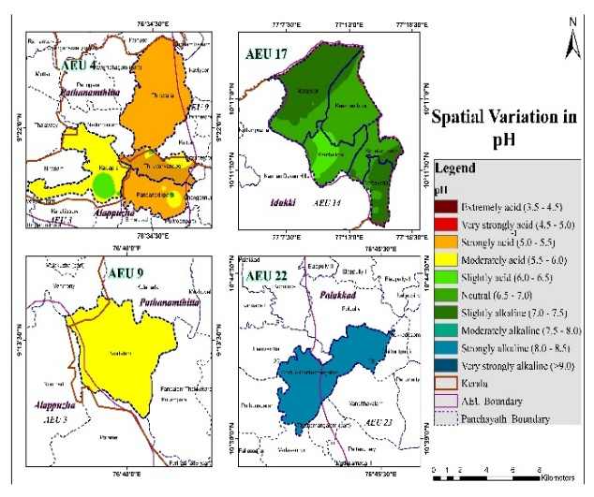

(3)

(4)

(2)

(1)

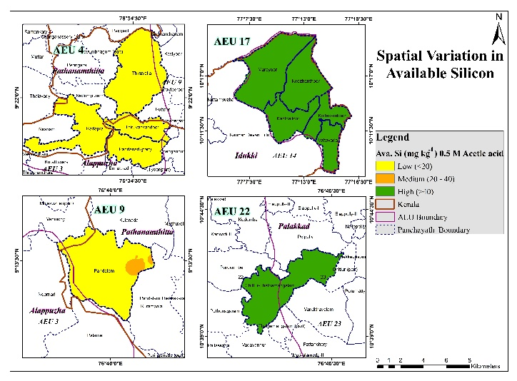

(5)

**Fig 2: Spatial variability of soil texture (1), pH (2), available Fe (3), Al (4) and Si (5) in AEU 4,9,17 and 22 prepared using Arc. GIS software**

1. **CONCLUSION**

Sugarcane crop is considered as one of the main Si accumulator plants that absorbs nearly about 500-700 kg quantity of silicon per hectare. As a result, Si deficiency especially in the lateritic soils of Kerala could be a yield declining factor in sugarcane that also results in symptoms such as twisted leaves, leaf freckling, wilting and stunted growth of the crop. So, in order to improve the productivity of sugarcane proper integrated nutrient management has to be initiated through introducing combined application of either organic or inorganic silicate fertilizers such as calcium and magnesium silicates, rice husk ash or recycled product of sugarcane crop residue such as trash ash, that contains enough quantities of silicon and also could act as beneficial amendment to ameliorate Fe-Al toxicities in the acid soils of Kerala. This could have produced a beneficial impact on sugarcane production that in turn will improve the development of jaggery production units thereby contributes towards Indian economy.

1. References

[1] Bee, N. and Rahman, F. 2020. Growth rate of area, production and productivity of sugarcane crop in India. Int. J. Enviro. Agric. Res. 6(4): 45-56.

[2] Ma, J. F. and Yamaji, N. 2006. Silicon uptake and accumulation in higher plants. Trends Plant Sci. 25(3): 11-19

[3] Liang, Y. C., Nikolic, M., Belanger, R., Gong, H., and Song, A. 2015. Silicon in agriculture: from theory to practice. J. South Agric. 15(8): 1575-1580.

[4] Sahebi, M., Hanafi, M. M., Akmar, A. S. N., Rafii, M. Y., Azizi, P., Tengoua, F. F., Azwa, J. N. M., and Shabanimofrad, M. 2015. Importance of silicon and mechanisms of biosilica formation in plants. Int. J. Bio Med. 52(8): 396000- 396010

[5] Wang, L., Cai, K., Chen, Y., and Wang, G. 2020. Silicon-mediated tomato resistance against Ralstonia solanacearum is associated with modification of soil microbial community structure and activity. Biol. Trace Elem. Res. 152(25): 275–283.

[6] Meyer, J. H. and Keeping, M. G. 2017. Review of research into the role of silicon for sugarcane production. Proc Technol Assoc 74: 29–40

[7] Ashraf, M., Ahmad, R., Afzal, M., Tahir, M. A., Kanwal, S., and Maqsood, M. A., 2009. Potassium and silicon improve yield and juice quality in sugarcane (Saccharum officinarum L.) under salt stress. J. Agron. Crop Sci. 195(4): 284-291.

[8] Keeping, M. G., Miles, N., and Rutherford, R. S. 2017. Liming an acid soil treated with diverse silicon sources: effects on silicon uptake by sugarcane (Saccharum spp.). J. Plant Nutri. 40(10): 1417-1436.

[9] Sarto, M.V.M., do Carmo Lana, M., Rampim, L., Rosset, J.S., Sarto, J.R.W. and Bassegio, D., 2019. Effects of calcium and magnesium silicate on the absorption of silicon and nutrients in wheat. *Semina: CiênciasAgrárias*, *40*(1), pp.67-80.

[10] Debona, D., Rodrigues, F. A., and Datnoff, L. E. 2017. Silicon’s role in abiotic and biotic plant stresses. Annu Rev Phytopathol 55:85– 107.

[11] Nisha, M., Chandran, K., Gopi, R., Mahendran, B. and Gireesan, P.P., 2021. Status of sugarcane cultivation in Kerala vis-a-vis product diversification options. *Journal of Sugarcane Research*, *11*(2), pp.130-136.

[12] Robinson, G. W. 1922. A new method for the mechanical analysis of soils and other dispersions. J. Agri. Sci. 12: 306-321.

[13] Subbiah, B. and G. L. Asija. 1956. Alkaline permanganate method of available nitrogen determination. Curr. Sci. 25: 259.

[14] Bray, R. H. and Kurtz, L. T. 1945. Determining total, organic and available forms of phosphate in soils. Soil Sci. 59: 39-45.

[15] Olsen, S. R., Cole, C. V., Watanabe, I., and Dean, L. A. 1954. Estimation of available phosphorus in soils by extraction with sodium bicarbonate. USDA Circ. 939. USDA, Washington DC. 19p.

[16] Jackson, M. L. 1958. Soil Chemical Analysis. Prentice Hall , Inc. Englewood Cliffs, New Jersey. 498p.

[17] Williams, C. H. and Steinbergs, A. 1959. The evaluation of plant-available sulphur in soils. II. The availability of adsorbed and insoluble sulphates. Plant Soil 21: 50-62.

[18] Tabatabai, M. A. 1982. Sulfur. In: Page, A. L. Keeney, D. R., Baker, D. E., Miller, R. H., Roscoe Ellis Jr., and Rhoades, J. D. (eds), Methods of Soil Analysis Part 2. Chemical and Microbiological Properties (2nd Ed.). American Society of Agronomy, Madison, Wisconsin, USA, pp. 501-538.

[19] Lindsay, W. L. and Norvell, W. A. 1978. Development of a DTPA soil test for zinc, iron, manganese, and copper. Soil Sci. Soc. Am. J. 42: 421-428.

[20] Berger, K. C. and Truog, E. 1939. Boron determination in soils and plants. Indian Eng. Chem. Anal. Ed. 11: 540-542.

[21] Korndorfer, G. H., Snyder, G. H., Ulloa, M., and Datnoff. L. E. 2001. Calibration of soil and plant silicon for rice production. J. Plant Nutri. 24: 1071-1084.

[22] Chandran, P., Ray, S.V., Bhattacharyya, T., Srivastava, P., Krishnan, P. and Pal, D.K., 2005. Lateritic soils of Kerala, India: their mineralogy, genesis, and taxonomy. *Soil Research*, *43*(7), pp.839-852.

[23] Schneider, C., Doucet, F., Strekopytov, S., and Exley, C. 2004. The solubility of an hydroxy aluminosilicate. Polyhedron 23(2): 3185-3191.

[24] Neenu, S. and Karthika, K.S., 2019. Aluminium toxicity in soil and plants. *Harit Dhara*, *2*(1), pp.15-19.

[25] Kerala State Biodiversity Board. 2019. Impact assessment of flood or landslides on biodiversity and ecosystem of Idukki district and Kuttanad. Centre for management development. Thiruvananthapuram, 833p.

[26] Patil, G.D., Khedkar, V.R., Tathe, A.S., and Deshpande, A.N. 2008. Characterization and classification of soils of Agricultural College Farm, Pune. Journal Maharashtra Agricultural Universities, 33(2):143-148.

[27] Meena, H.B., Sharma, R.P., and Rawat, U.S. 2016. Status of macro-and micronutrients in some soils of Tonk district of Rajasthan. J. Indian Soc. Soil Sci. 54(4): 508 512.

[28] Elbordiny, M.M. and El-Dewiny, Y.C. 2008. Effect of some saltarfected soil properties on micronutrients availability. J. Appl. Sci. Res. 4(11): 1569 - 1573.

All references should follow the following style:

[29] Prasad, J., Kumar, K.S., Nair, K.M., Dhanorkar, B.A., Niranjan, K.V., Mohekar, D.S. and Koyal, A., 2021. Shrink-swell soils of Palakkad district, Kerala: Their characteristics and classification. *Journal of the Indian Society of Soil Science*, *69*(2), pp.113-118.

[30] Tamuly, D. and Bastin, B., 2019. Effect of nutrient management on soil nutrient availability at critical growth stages of rice in black soils of Kerala*. J. of Tropical Agri.* 74(2): 108-115.

[31] Crusciol, C.A.C., de Arruda, D.P., Fernandes, A.M., Antonangelo, J.A., Alleoni, L.R.F., do Nascimento, C.A.C., Rossato, O.B. and McCray, J.M., 2018. *Methods and extractants to evaluate silicon availability for sugarcane. Sci Rep 8: 916*.