**Assessment of Genetic Diversity in Bread Wheat (*Triticum aestivum* L.) Genotypes for Drought Tolerance**

**ABSTRACT**

An attempt was made to assess the genetic diversity for the selection and utilization of drought-tolerant wheat genotypes in future breeding approaches for yield enhancement. The experiment was conducted with 40 bread wheat genotypes evaluated under drought conditions at CCS Haryana Agricultural University, Hisar during the crop season 2020-21 and 2021-22. The genotypes were assessed for sixteen yields and their components. The investigation reflected enough genetic variability among the genotypes for the traits under study. All the genotypes were categorized into six distinct clusters, with cluster II being the largest one containing 14 genotypes, followed by cluster I with 8 genotypes. The analysis of the inter-cluster distances revealed the maximum genetic distance between clusters II and VI, which could be utilized in a hybridization program to achieve a broad range of variation among the groups. The genotypes of cluster V showed superiority for grain yield per plot, harvest index, biological yield per plot, grain weight per spike, number of spikelets per spike, number of grains per spike, spike weight, spike length, number of tillers per meter and peduncle length. Therefore, it could be concluded that the genotypes of cluster V may be considered potential parents to obtain heterotic response and accordingly better segregants for grain yield under drought conditions.

**Keywords:** Cluster, Drought, Diversity, Wheat

1. **INTRODUCTION**

Wheat (*Tritium aestivum* L.) is one of the most important cereal crops, consumed as a stable food all over the world after rice. Wheat nourishes about 36% of the global human population and provides 20 percent of the total energy requirement in human food (Shewry, 2009, Farooq *et al*., 2014). The demand for wheat is increasing gradually due to the growing world population. Consequently, it has been predicted that the demand for wheat will increase by about 60-70 percent by the year 2050 (Borisjuk *et al*., 2019). Globally there are several challenges in wheat production for the farmers and the breeders under changing climatic conditions. Abiotic stresses such as drought, high temperature, salinity and metal toxicity reduce crop productivity specifically in arid, semi-arid, tropical and subtropical regions globally (Dhakal *et al*., 2021). Changes in global precipitation patterns due to climatic fluctuation are expected to increase the frequency of droughts, which would exacerbate yield depression. One of the main factors restricting wheat yield is water scarcity, which in turn harms global food availability (Hussain *et al.*, 2019, Paras *et al*. 2024). The impact of drought stress is a significant global challenge, capable of greatly diminishing crop yields (Prasad *et al.*, 2011). Drought severely endangers the sustainability of wheat production, thereby limiting wheat productivity (Zahoor *et al*., 2017). Research findings indicated that drought-related losses in wheat yields can reach as high as 29% (Daryanto *et al*., 2016).

The best strategy for crop productivity and yield stability under drought conditions is to develop drought-tolerant crop varieties (Cattivelli *et al*. 2008). Understanding plant responses to drought are of immense importance and also a fundamental part of crops breeding tolerant to drought stress. Hence, there is a need to develop varieties more responsive under limited moisture conditions. In the present scenario, more aggressive breeding efforts are required to harness the untapped potential of this crop for further yield enhancement. Under changing climatic conditions, the breeding of climate-resilient varieties is becoming more important (Furat and Uzun, 2010, Paras *et al*., 2022). Knowledge about genetic diversity is essential not only to select the elite parents for yield enhancement but also for the development of disease-resistant varieties. It is well known that the genetic gain in any crop is determined by the amount of genetic diversity available in its base population. Assessing the extent of genetic variability within a cultivated crop has important consequences in plant breeding and the conservation of genetic resources. Genetic diversity between two parents is essential to realize maximum heterosis and to obtain transgressive segregants in the segregating populations. Hybridization between genotypes of diverse origins is suggested to uncover novel recombinants with improved genetic potential. Genetic divergence has been widely used as an indirect indicator of modest efficiency in selecting parents to create high-yielding progenies.

D2 analysis proposed by Mahalanobis (1936) is the most important statistical tool to identify diverse genotypes for a hybridization program to exploit the heterosis and isolate desirable segregants. Thus, information on the genetic diversity in the source material is highly essential before formulating any crossing program. Therefore, the present study was carried out with the objectives of analyzing genetic diversity among 40 bread wheat genotypes and identifying the potential probable donors based on yield and its component traits for their future exploitation in developing drought-tolerant wheat varieties.

1. **Material and Methods**

The present investigation comprised 40 bread wheat genotypes including two check varieties namely HD 3043 and WH 1142, conducted under drought-stressed conditions. The characteristics of the genotypes used, are given in table 1. The experiment was planted at the Experimental Area of the Department of Genetics and Plant Breeding, CCS Haryana Agricultural University, Hisar situated in the subtropical region of the North Western Plain Zone of India. Randomized Block Design (RBD) was used to evaluate the experimental material replicated twice during the *rabi* 2020-21 and 2021-22 crop seasons. Each genotype was grown in three rows of 2.5 m length spaced 20 cm apart. The package of practices recommended for drought-stressed environments was accordingly followed to raise the crop. The experiment was not irrigation during crop season in order to create drought conditions, only pre-sowing irrigation was applied to ensure germination. During crop seasons 2020-21 and 2021-22, a total of 43.60 mm and 72.90 mm of rainfall, respectively was received. Five plants were randomly selected from each plot in each replication for recording observations on morphological traits *viz*., days to heading, days to anthesis, days to maturity, plant height (cm), flag leaf length (cm), peduncle length (cm), number of tillers per meter, spike length (cm), spike weight (g), number of grains per spike, number of spikelets per spike, grain weight per spike,1000-grain weight (g), biological yield per plot (g), harvest index (%) and grain yield per plot (g).

All the recorded data was pooled over two years (2020-21 and 2021-22) and was analyzed by the “Metan” package (Olivoto, 2020) under the R environment to determine the genetic divergence among genotypes. The genotypes were categorized into distinct clusters by applying Tocher’s method (Rao, 1952). Average inter- and intra-cluster distances and the relative percentage contribution of traits towards divergence were estimated as per the procedure outlined by Singh and Choudhary (1977).

1. **Results and Discussion**

The present study aimed to assess the performance of bread wheat genotypes under drought stress conditions based on the grain yield and its components.

**3.1 Genetic Diversity and Composition of Clusters**

The mean values for different quantitative characters studied were utilized to work out genetic distances between pairs of genotypes. The D2 values were estimated for 40 genotypes to determine the genetic diversity among them. Using Tocher’s method (Rao, 1952), the genotypes were grouped into six distinct clusters (Table 2). The cluster II accommodated a maximum number of genotypes (14) followed by Cluster I (8) and Cluster III with 7 genotypes. Cluster VI comprises of two genotypes *i.e.* NIAW 3624 and NIAW 3643. The study observed similarity with the findings of Verma *et al*. (2014), Yadav *et al*. (2014), Vora *et al*. (2017) and Santosh *et al*. (2019). Hence, the genotypes occupied in different clusters may be quite distinctive and advantageous in terms of breeding perspective. Hybridization and/or crossing between these solitary and unique genotypes may produce desirable transgressive segregants under drought conditions. The relationship among the studied genotypes is presented in *Fig*. 1 in the form of a circular dendrogram.

**3.2 Genetic distances between clusters**

The Intra and Inter-cluster distances are presented in Table 3. The estimates of genetic distances revealed wide genetic diversity among the genotypes of different clusters. The lower estimates of intra-cluster distances indicated that the genotypes within the same cluster were closely related. The findings indicated that Cluster II was with maximum intra-cluster distance (694.35) followed by Cluster IV (561.72), cluster III (391.35), cluster VI (385.24) and Cluster V (365.23). Cluster I showed the lowest intra-cluster distance (354.02) among all clusters. Intra-cluster distances of clusters II and IV signify that the genotypes of these clusters have a high level of genetic diversity compared to others.

The genotypes of clusters II and VI exhibited maximum divergence (1114.95), as their inter-cluster distance was the highest followed by II and III (1067.86) and; II and IV (1065.23). On the other hand, the minimum genetic divergence was recorded for clusters III and VI (451.20) followed by clusters I and IV (504.20) indicating a close relationship among the genotypes of these clusters. Present results confirm the findings of previous workers, Singh *et* *al*. (2014), Rahman *et al*. (2015) and Majid *et al*. (2020). The larger the diversity among parental genotypes, the greater the likelihood of heterotic crossings (Falconer, 1964).

The inter-cluster distances were higher than the intra-cluster distances between the genotypes, which indicates the presence of a sufficient amount of genetic divergence among the genotypes under study (Tewari *et al*. 2015 and Paras *et. al*. 2022). The hybridization between the genotypes of diverse clusters is expected to yield high heterosis and is likely to produce new recombinants with desired traits. The clustering distance among the studied genotypes is presented in *Fig*. 2 in the form of a heat map displaying the similarity matrix of genotypes.

**3.3 Mean performance of clusters**

The mean performance of clusters for 16 traits is presented in Table 4. The current study reflected considerable variation in the cluster means for all the characters. Cluster V manifested highest mean values for grain yield per plot, harvest index, biological per plot, grain weight per spike, no. of spikelets per spike, no. of grains per spike, spike weight, spike length, no. of tillers per meter and peduncle length. Hence, the cluster V could be considered as best one since it performed well for ten traits out of sixteen. Cluster III showed the lowest mean value for days to heading and days to anthesis, this indicates that the group has an early flowering genotype. Further, cluster II exhibited the lowest mean value for days to maturity, representing the group with early maturing genotypes. However, cluster I depicted the highest mean value for the 1000-grain weight, which means that this group contains bold-seeded genotypes. The results also revealed that cluster VI included the dwarf genotypes. A similar study has also been conducted earlier by Singh (2015), Girnam *et al*. (2018), Santosh *et al*. 2019 and Majid *et al*., 2020. Therefore, improvement in two traits at the same time can be achieved by choosing the genotypes from the clusters that exhibit the highest values for those traits as the parental lines for hybridization.

1. **CONCLUSION**

The current study reflected enough genetic variability among the genotypes for the traits under study. All 40 genotypes were categorized into six distinct clusters with the maximum genotypes (14) in cluster II followed by cluster I with 8 genotypes. The maximum genetic distance was observed between clusters II and IV followed by clusters II and III. Hence, the genotypes could be considered from these clusters to generate a wide range of favorable genetic variations and produce good segregants upon hybridization. Based on the cluster means, the cluster V may be considered for yield enhancement under drought based on its superiority for grain yield per plot, harvest index, biological per plot, grain weight per spike, number of spikelets per spike, number of grains per spike, spike weight, spike length, number of tillers per meter and peduncle length. The current study concludes that the genotypes contained in cluster V might be considered desirable ones for the selection and isolation of genotypes which may be used as promising parents for hybridization aimed at developing drought tolerant wheat varieties.

**ETHICAL APPROVAL**

The article doesn’t contain any study involving ethical approval.

**REFERENCES**

Borisjuk, N., Kishchenko, O., Eliby, S., Schramm, C., Anderson, P., Jatayev, S. and Shavrukov, Y. (2019). Genetic modification for wheat improvement: from transgenesis to genome editing. *BioMed Research International*, **2019(1):** 6216304.

Cattivelli, L., Rizza, F., Badeck, F. W., Mazzucotelli, E., Mastrangelo, A. M., Francia, E. and Stanca, A. M. (2008). Drought tolerance improvement in crop plants: an integrated view from breeding to genomics. *Field crops research*, **105(1-2):** 1-14.

Daryanto, S., Wang, L. and Jacinthe, P.A. (2016). Global synthesis of drought effects on maize and wheat production. *PLoS ONE,* **11(5):** e0156362

Devi, S., Kumar, Y., Singh, V., Kumar, R. and Paras (2019). Estimation of genetic divergence in barley (Two-rowed and six-rowed) under different growing conditions. *International Journal of Chemical Studies,* **7(5):** 3195-3201.

Dhakal, A., Adhikari, C., Manandhar, D., Bhattarai, S. and Shrestha, S. (2021). Effect of abiotic stress in wheat: A review. *Reviews in Food and Agriculture,* **2(2):** 69-72.

Furat, S. and Uzun, B. (2010). The use of agro-morphological characters for the assessment of genetic diversity in sesame (*Sesamum indicum* L). *Plant Omics Journal* **3:** 85-91.

Girnam, S., Kumar, P., Kumar, R., Gangwar, L.K. (2018). Genetic diversity analysis for various morphological and quality traits in bread wheat (*Triticum aestivum* L.). *Journal of Applied and Natural Science* **10(1):** 24-29.

Hussain, S., Hussain, S., Qadir, T., Khaliq, A., Ashraf, U. and Parveen, A. (2019). Drought stress in plants: An overview on implications, tolerance mechanisms and agronomic mitigation strategies. *Plant Sci. Today* **6:**389-402.

Mahalanobis, P.C. (1936). On the generalized distance in statistics. Proc. Nat. Inst. Sci., India. 2:49-55.

Majid, S. and Dar, Z. A. (2020). Genetic diversity analysis for various morphological and quality traits in bread wheat (*Triticum aestivum* L.). *Plant Archives,* **20(1):** 2816-2819.

Paras, Dalal, M.S., Singh, V., Mor, V.S., Kumar, Y. and Devi, S. (2024). Correlation coefficient analysis in bread wheat (*Triticum aestivum* L.) genotypes under heat stress conditions. *Biological Forum -An International Journal,* **16(7):** 296-299.

Paras, Sheoran, R. K., Malik, A., Devi, S. and Sunil (2022). Assessment of genetic diversity for various morpho-phenological traits in Sesame (*Sesamum indicum* L.). *The Indian Journal of Agricultural Sciences,* **92(6):** 797-800.

Prasad, P.V.V., Pisipati, S.R., Momcilovi**c,** I. and Ristic, Z. (2011). Independent and combined effects of high temperature and drought stress during grain filling on plant yield and chloroplast EF-Tu expression in spring wheat. *Journal of Agronomy and Crop Science,* **197:** 430-441.

Rahman, M.S., Hossain, M.S., Akbar, M.K., Islam, M.S. and Ali, L. (2015). Genetic divergence in spring wheat genotypes (*Triticum aestivum* L.). *Eco-friendly Agricultural Journal,* **8(1):** 1-3.

Santosh, J.J.P., Singh, A. and Gahatyari, N.C. (2019). Genetic diversity analysis in bread wheat [*Triticum aestivum* (L.) em.Thell.] for yield and physiological traits. *International Journal of Current Microbiology and Applied Sciences,* **8(2):** 3059- 3068.

Shewry, P. R. (2009). Wheat*. Journal of Experimental Botany,* **60(6):** 1537-1553.

Singh, G., Singh, K.N., Setter, B.N., Singh, T.L., Saharan, M.K., Tyagi, M.S., Verma, B.S. and Sharma, I.A. (2014). Germplasm characterization, association and clustering for salinity and water-logging tolerance in bread wheat (*Triticum aestivum*). *Indian Journal of Agricultural Sciences,* **84:** 1102-1110.

Tewari, R., Jaiswal, J.P., Gangwar, R.P. and Singh, P.K. (2015). Genetic diversity analysis in exotic germplasm accessions of wheat (*Triticum aestivum* L.) by cluster analysis. *Electronic Journal of Plant Breeding,* **6(4):** 1111-1117.

Verma, P.N., Singh, B.N., Singh, G., Singh, M.K. and Setter, T.L. (2014). Genetic diversity analysis for yield and other agronomic traits in bread wheat under waterlogged sodic soil condition. *Journal of Wheat Research,* **6:** 51-58.

Vora, Z.N., Patel, J.B., Pansuriya, A.G. and Yusufzai Sana, A. (2017). Genetic divergence analysis in bread wheat (*Triticum aestivum* L.). *Research in Environment and Life Sciences,* **10(3):** 291-294

Yasin, B. A., Shubhra, S., Abdu, M. and Shiferaw, G. (2023). Assessing genetic diversity in bread wheat (*Triticum aestivum* L.) using D2 statistical analysis. *Asian Journal of Dairy and Food Research,* 2139**:** 1-6.

Zahoor, R., Zhao, W., Dong, H., Snider, J. L., Abid, M., Iqbal, B. and Zhou, Z. (2017). Potassium improves photosynthetic tolerance to and recovery from episodic drought stress in functional leaves of cotton (*Gossypium hirsutum* L.). *Plant Physiology and Biochemistry,* **119:** 21-32.

**Table 1. List of genotypes along with their pedigree detail**

|  |  |  |
| --- | --- | --- |
| **Sr. No.** | **Genotypes** | **Pedigree detail** |
| 1. | BRW 3806 | NI5439/MACS2496 |
| 2. | C 306 | REGENT1974/3*CHZ//*2C591/3/P19/C281 |
| 3. | DBW 14 | RAJ3765/PBW-343 |
| 4. | DBW 71 | PRINIA/UP2425 |
| 5. | DBW 74 | WBLLI*/BRAMBLING |
| 6. | DBW 110 | KIRITATI/4/2*SERI1B*2/3/KAUZ*2/BOW//KAUZ |
| 7. | DBW 296 | SOKOLL/3/PASTOR//HXL7573/2*BAU/4/MASSIV/PPR47.89C |
| 8. | DBW 299 | WAXWING*2/KRONSTADF2004*2//BECARD |
| 9. | DBW 303 | WBLL1*2/BRAMBLING/4/BABAX/LR42//BABAX*2/3/SHAMA*2/5/PBW343 |
| 10. | DPW 621-50 | KAUZ//ALTAR84/AOS/3/MILAN/KAUZ/4/HUITES |
| 11. | GW 477 | GW366/BOW898 |
| 12. | HD 3059 | KAUZ//ALTAR84/AOS/3/MILAN/KAUZ/4/HUITES |
| 13. | HD 3086 | DBW14/HD2733//HUW468 |
| 14. | HD 3226 | GRACKLE/HD2894 |
| 15. | HD 3237 | HD3016/HD2967 |
| 16. | HD 3293 | HD2967/DBW46 |
| 17. | HD 3298 | CL1449/PBW343//CL882/HD2009 |
| 18. | HI 1621 | W15.92/4/PASTOR//HXL7573/2*BAU/3/WBLL1 |
| 19. | HI 1655 | MACS2496/HI1531 |
| 20. | K 1317 | K0307/K9162 |
| 21. | LOK 54 | Raj3777/WH671 |
| 22. | MP 3288 | DOVE/BUC/DL788-2 |
| 23. | NIAW 3170 | SKOLL/ROLF07 |
| 24. | NIAW 3624 | DL 1022 X NIAW 1415 |
| 25. | NIAW 3643 | RAJ 4083 X NIAW 1275 |
| 26. | QST 1910 | HD2967/WH1080 |
| 27. | QST 1911 | HD2967/ WH1184 |
| 28. | RAJ 3765 | HD2402/VL639 |
| 29. | RAJ 4480 | WR989/PBW587 |
| 30. | RW 5 | RAJ4014/WH730 |
| 31. | RWP-2018-32 | HD3131/DBW90 |
| 32. | RWP-2019-30 | HD2964/PBW631 |
| 33. | RWP-2019-31 | HD 3249/DBW 316 |
| 34. | TAW 185 | GW492/HP1968 |
| 35. | TAW 186 | GW322/PHSL10 |
| 36. | WH 711 | S308/CHR//KAL |
| 37. | WH 730 | CPAN2092/ImprovedLok-1 |
| 38. | WH 1105 | MILAN/S87230//BABAX |
| 39. | WH 1124 | MUNIA/CHTO//AMSEL |
| 40. | WH 1202 | D67.2/PARANA66.270//AE.SQ.(320)/3/CUNNINGHAM |

**Table 2. Clustering pattern of 40 bread wheat genotypes**

|  |  |  |
| --- | --- | --- |
| **Clusters** | **No. of Genotypes** | **Name of genotypes** |
| **I** | 8 | WH 1202, C 306, DBW 74, HI 1621, MP 3288, QST 1911, RAJ 3765, TAW 185 |
| **II** | 14 | BRW 3806, DBW 299, DBW 303, DBW 71, HD 3059, HD 3086, HD 3226, HD 3237, HD 3293, HD 3298, RWP-2019-30, WH 1105, WH 1124, WH730 |
| **III** | 7 | DBW 110, DBW 14, K 1317, LOK 54, NIAW 3170, RAJ 4480, RWP-2019-31 |
| **IV** | 6 | DBW 296, DPW 621-50, HI 1655, QST 1910, RWP-2018-32, WH 711 |
| **V** | 3 | GW 477, RW 5, TAW 186 |
| **VI** | 2 | NIAW 3624, NIAW 3643 |

**Table 3. Average intra and inter-cluster distances**

|  |  |  |  |  |  |  |
| --- | --- | --- | --- | --- | --- | --- |
| **Clusters** | **I** | **II** | **III** | **IV** | **V** | **VI** |
| **I** | **354.02** | 915.15 | 512.47 | 504.20 | 788.55 | 580.95 |
| **II** |  | **694.35** | 1067.86 | 1065.23 | 551.55 | 1114.95 |
| **III** |  |  | **391.35** | 582.32 | 950.14 | 451.20 |
| **IV** |  |  |  | **561.72** | 937.53 | 669.27 |
| **V** |  |  |  |  | **365.23** | 1017.66 |
| **VI** |  |  |  |  |  | **385.24** |

**Table 4. Performance of clusters for different traits**

|  |  |  |  |  |  |  |  |  |  |  |  |  |  |  |  |  |
| --- | --- | --- | --- | --- | --- | --- | --- | --- | --- | --- | --- | --- | --- | --- | --- | --- |
| **Clusters** | **DH** | **DA** | **DM** | **PH** | **FL** | **PDNL** | **T/M** | **SL** | **SW** | **G/S** | **S/S** | **GW/S** | **TGW** | **BY/P** | **HI** | **GY/P** |
| **I** | 93.59 | 97.09 | 140.22 | 102.05 | **26.62** | 33.93 | 116.22 | 9.55 | 3.15 | 61.29 | 19.77 | 2.31 | **39.19** | 2116.73 | 35.61 | 750.85 |
| **II** | 94.54 | 97.38 | **139.73** | 100.16 | 26.47 | 33.48 | 115.70 | 9.69 | 3.04 | 66.92 | 20.25 | 2.29 | 36.71 | 2486.10 | 31.25 | 772.02 |
| **III** | **92.43** | **96.14** | 140.07 | 90.83 | 23.98 | 32.26 | 112.57 | 8.92 | 2.91 | 62.74 | 19.60 | 2.22 | 36.97 | 1960.89 | 34.71 | 678.06 |
| **IV** | 98.21 | 101.08 | 142.83 | 97.70 | 24.44 | 31.23 | 112.63 | 9.58 | 3.15 | 62.67 | 19.60 | 2.29 | 37.68 | 2155.00 | 33.71 | 721.70 |
| **V** | 93.25 | 97.25 | 140.58 | 99.39 | 26.13 | **35.96** | **121.92** | **9.85** | **3.47** | **67.18** | **21.06** | **2.55** | 36.93 | **2535.00** | **35.99** | **907.80** |
| **VI** | 97.13 | 100.88 | 145.38 | 84.51 | 24.52 | 29.49 | 99.63 | 8.28 | 2.66 | 61.32 | 18.67 | 1.98 | 33.64 | 1977.00 | 26.01 | 508.30 |

**DH:** Days to heading, **DA:** Days to anthesis, **DM:** Days to maturity, **PH:** Plant height (cm), **FL:** Flag leaf length (cm), **PDNL:** Peduncle length (cm), **T/M:** Number of tillers per meter, **SL:** Spike length (cm), **SW:** Spike weight (g), **GR/S:** Number of grains per spike, **S/S:** Number of spikelets per spike, **GW/S:** Grain weight per spike (g), **TGW:** 1000-grain weight (g), **BY/P:** Biological yield per plot (g), **HI:** Harvest index (%) and **GY/P:** Grain yield per plot (g)

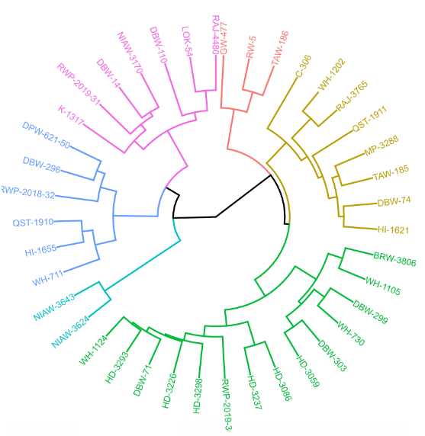

**Fig. 1. Dendrogram portraying clustering pattern of 40 bread wheat genotypes**

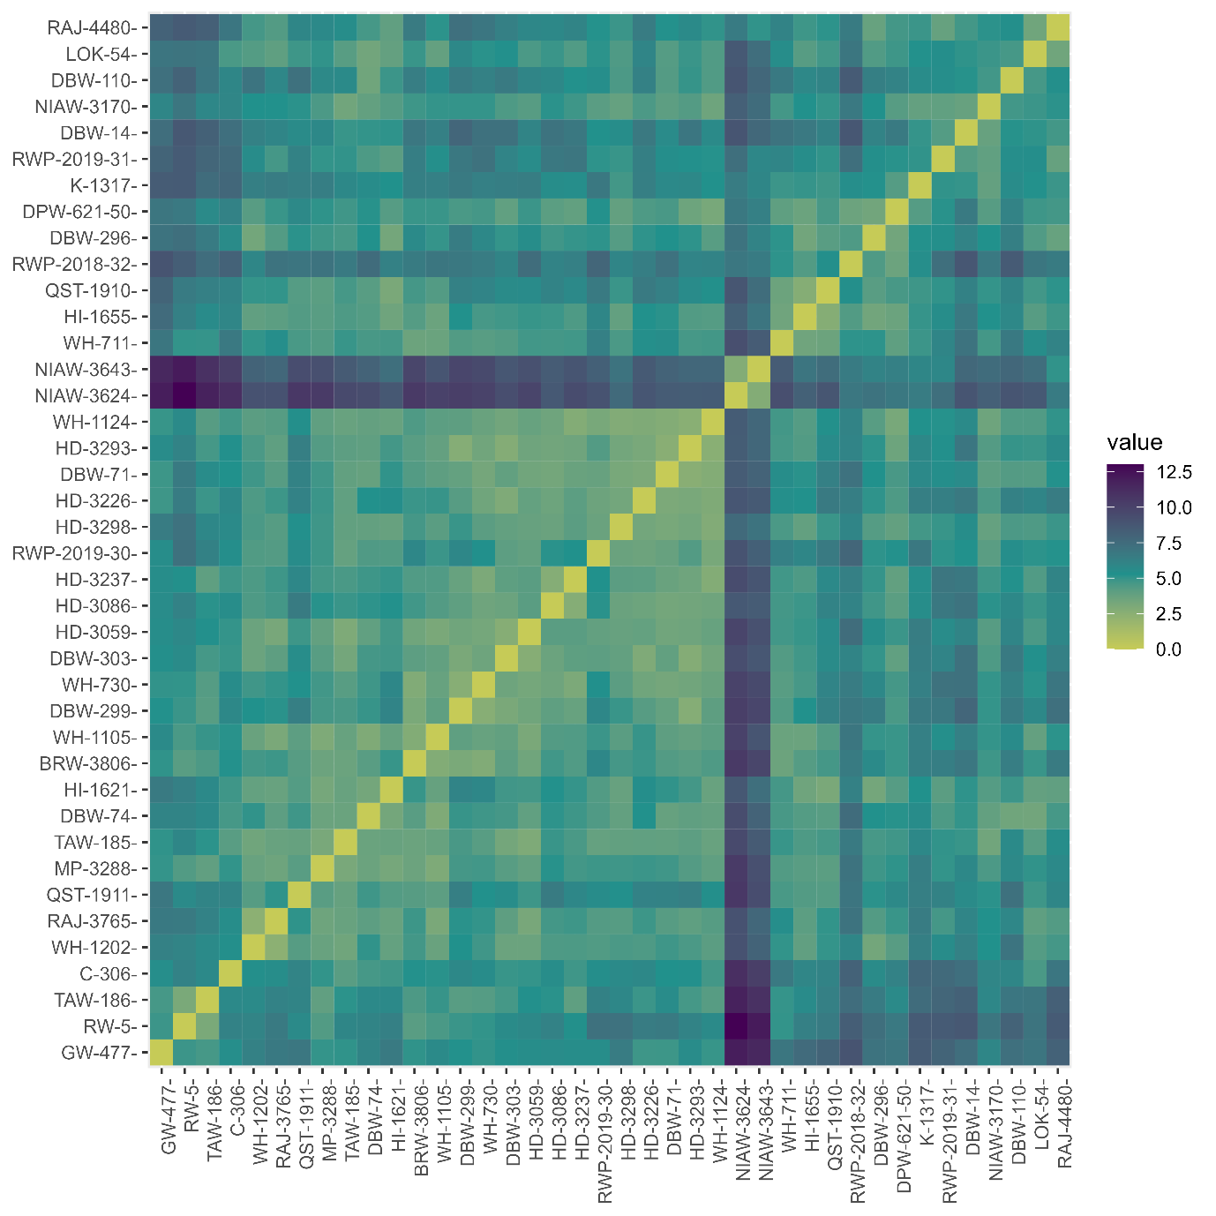

**Fig. 2. Heat map portraying similarity index (cluster distance)**