**Evaluation of Water Pollution by Cattle Manure in the Locality of Mbang-Foulbe, Adamawa, Cameroon.**

# ABSTRACT

The anarchic growth of the cattle herd in the locality of Mbang – Foulbe, is not correlated the expansion of the pastoral space. Compared to a normal exploitation (which foresees a load of 0.5 to 1 head per hectare), this result may characterize an overgrazing pattern which is combined with a significant accumulation of cattle manure, leading to a serious environmental problem. The present study was undertaken to determine the impact of cattle breeding on water characteristics. In this regard, the first sampling campaign was carried out in the dry season and consisted of only surface and groundwater sample. Which were analyses for the presence of nitrates. Then, the second sampling campaign was carried out in the raining season to determine the source of pollution such as: OM, NO2-, NO3-, NH4+, PO42- in the water. From the water analysis, the well (P1) has the highest nitrate and orthophosphates content 41.864±0.152 mg/L and 9.21±0.66 mg/L respectively. The well (P2) records the highest levels of organic matter and ammonia nitrogen 7.14±0.12 mg/L and 2.583±0.003 mg/L respectively. Principal component analysis shows that the P1 and P2 wells have nitrate and nitrite concentrations exceeding the standards for water for human and bovine consumption. Principal component analysis shows that the P1 and P2 wells have nitrate and nitrite concentrations exceeding the standards for water for human and bovine consumption.

*Keywords: cattle breeding, nitrates, nitrites, ammonia nitrogen, orthophosphates.*

# 1- INTRODUCTION

Located in the northern part of Cameroon, the Adamawa region is a transition zone between the dense forest of the South and the savannah of the North. One of the most popular activities in this region is the cattle breeding, with a herd estimated at 3.5 million head. Cattle breeding contribute around 38% of national beef production [1]. The locality of Mbang Foulbe, cover an area of ​​approximately 500 km², with a cattle herd which is estimated to approximately 6,075 head and are distributed for around 12.15 head / km2 [1,2]. Over time, there has been an uncontrolled increase in the local cattle herd. The increase in the number of heads has not been accompanied by the enlargement of the pastoral space, though, there has been a decrease due to constructions and agricultural activities [3,4]. Compared to a normal farm (which provides for a load of 0.5 to 1 head per hectare) [1], there is a problem of overgrazing which is characterized by a significant accumulation of bovine manure on the soil compartment of the environment. Moreover, the appearance of the eutrophication phenomenon is linked to the presence of ammonia nitrogen and orthophosphates in surface water which might have an impact on the food chain. The health risks associated with the presence of nitrites and nitrates in water and food should not be neglected [5]. The long-term impact of pastoral activities might primarily lead to ~~which is caused by~~ a large quantity and excess of cattle manure, and secondly to the pollution of surface water by runoff and underground water through infiltration [6]. The locality of Mbang – Foulbe has a shortage of drinking water and drilling in sufficient quantity. Given the fact that it is the predominant activity in the locality, cattle breeding, is believed to be the primary source of this pollution [7]. The lack of drinking water points in some places forces the villagers to content with river water and wells (for washing and for housework). The vegetation is replaced by grass not palatable by the cattle such as *Sida Rhombifolia* [8]. The objective of this work is to assess the impact of cattle breeding on the soils and waters of the locality of Mbang – Foulbe. More specifically to access the effect of cattle breeding on the quantity of nitrogen, carbon and phosphorus produced by cattle manure and their accumulation in soil and water.

# 2- MATERIAL AND METHODS

## 2-1- Presentation of the study site: Mbang Foulbe:

Mbang – Foulbe is a Veterinary Zootechnical Center located in the department of Vina (Fig. 1). This locality is located at an average altitude of 1100 m, between 13° 30' and 13° 46' East longitude and 07° 30' and 7° 35' North latitude. The piezometric level of the wells is on average 09 m (flood season) and 11 m (low water season) [1]. The livestock system is grazing, improved or natural [9].

2-2- Investigation**:**

A survey was carried out in order to determine the different breeding systems practice in the Mbang Foulbe locality. It consisted of an interview with the operators using a questionnaire. Henceforth, the questions focused on the number and management method of the livestock yards as well as the mode of management of water resources for drinking and the various water-borne diseases that affect local residents, etc.

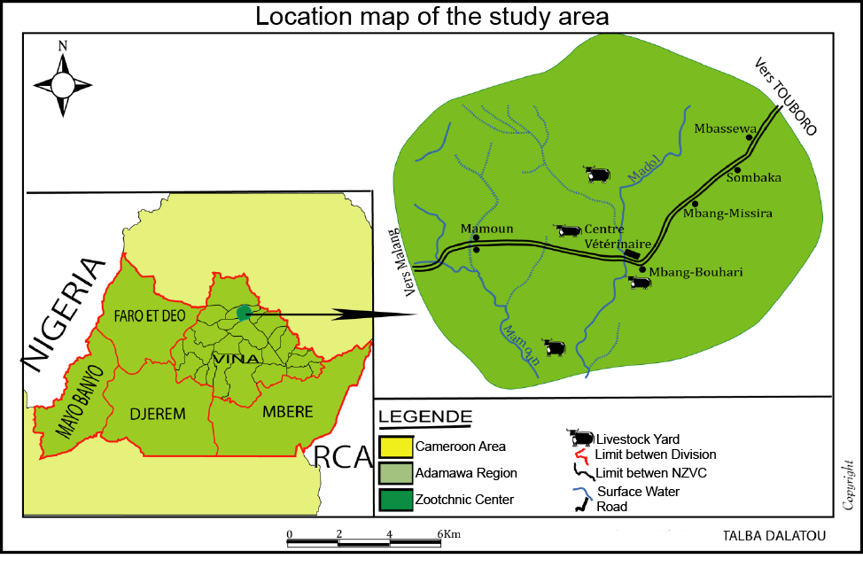

Fig. 1. Location map of the study area.

## 2-3- Sampling:

The sampling campaign was carried out in two stages: the first was in early November (end of the rainy season), which consisted of taking water samples only. Obtaining high levels of global pollution parameters in groundwater, allowed us to carry out a second sampling of soils and water (water surface and groundwater) in early March (end of the dry season), for confirmation of the source of pollutants in groundwater.

### 2-3-1- Water sampling:

For surface water, two rivers were sampled: *Mayo Mamoum* **(R1)** and *Mayo Madol* **(R2)**. One sample was collected in each river. This is obtained after mixing six samples to obtain a representative sample. As for groundwater, four (04) wells and two (02) unique boreholes in the village were chosen. The characteristics of these samples have been recorded in Fig. 2. For subsequent physico-chemical analyzes, the samples were stored in bottles (plastic) of 1.5 L volume, washed, wrapped in a vacuum material, labeled and kept in coolers area at a temperature less than 4 °C.

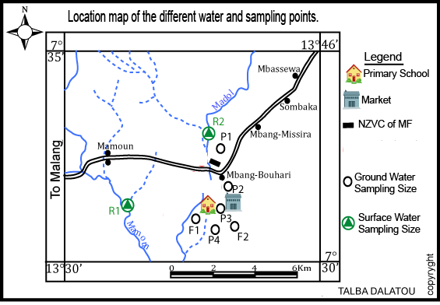

Fig. 2. The location map of the different water and sampling points.

### *2-3-3- Summary of information on water samples:*

Table 1 highlighted the information on water samples.

**Table 1. Information on water samples**

|  |  |  |  |  |  |  |  |  |  |  |  |  |  |
| --- | --- | --- | --- | --- | --- | --- | --- | --- | --- | --- | --- | --- | --- |
| Samples | | Code | Number of Sample | Period of Sampling and sampling depth. | | | | | | | | Geographic Coordinate | |
| **1st Sampling** | | | | **2nd Sampling** | | | |
| **Date** | | **Depth** | | **Date** | | **Depth** | |
| Surface water | Mayo Madol | R1 | 2 | 11/2023 | | 1 m | | 03/2024 | | 0.40 m | | E013°32’  N07°31’ | |
| Mayo Mamoum | R2 | 2 | 11/2023 | 1 m | | 03/2024 | | 0.28 m | | E013°35’  N07°33’ | |
| Ground water | Well located on cattle market | P1 | 2 | 11/2023 | 2.5 m | | 03/2024 | | 7m | | E013°33’  N07°31’ | |
| Well located on slaughterhouse | P2 | 2 | 11/2023 | 3 m | | 03/2024 | | 7 m | | E013°34’  N07°32’ | |
| Well located next to the public school | P3 | 2 | 11/2023 | 12 m | | 03/2024 | | 16 m | | E013°38’  N07°31’ | |
| Well located in the city center | P4 | 2 | 11/2023 | 13 m | | 03/2024 | | 17 m | | E013°40’  N07°31’ | |
| Drilling near the great mosque | F1 | 2 | 11/2023 | 90 m | | 03/2024 | | 90 m | | E013°39’  N07°30’ | |
| Drilling near the hospital | F2 | 2 | 11/2023 | 90 m | | 03/2024 | | 90 m | | E013°40’  N07°31’ | |

Sources: Surveys, Action-DIX, **2008**.

2-4- Physico-chemical analysis:

The following physico-chemical parameters: Temperature, pH, electrical conductivity at 20 °C, calcium and magnesium content, chloride content, organic matter in water samples were determined respectively according to the methods of [10] by the complexometric.

## 2-5- Chemical Analysis

The determination of manganese in water samples was **accessed** by the ammonium persulfate method. The iron was dissolved in the water samples then was determined by spectrophotometry. The sulfates in water were determined by the photometric method. The indophenol blue method was used to determine the concentration of ammoniac nitrogen in our samples. The sodium salicylate method was used to determine the nitrate content of our samples. Spectrophotometry is the method used to determine the orthophosphate content of our samples. [10].

**2.6. Statistical analysis**

# 3- RESULTS AND DISCUSSION

### 3-1- Temperature, pH, Conductivity

The water temperature varies very little for both groundwater and surface water. For surface waters, the minimum 22.73 °C was obtained in Mayo Mamoum (R1) while the maximum was obtained in Mayo Madol (R2) 25.10 °C. For groundwater, the temperature varies from 23.47 °C (P1) to 25.80 °C (F1) (Table 3). These results are similar to those obtained by FAO (2023) (23.6 °C and 26 °C) on the waters of the locality of Tripoli and the results of [1], obtained on the waters of Mayo Faouni (20.45 °C) and Mayo Yao (28.45 °C), area located in the same region. Thus, the temperature obtained at different sampling points complies with international standards for surface water which allow a maximum value of 25 °C [10].

The pH of the water in the locality is between 4.53 (P3: city well) and 8.66 (F1: borehole near the hospital) (Table 2). This pH is close to 8.5, a characteristic value of water which is consumed by human and cattle [10-11]. There is not a significant difference (*P < .05*) in the pH of the water between and among the sampling points. In regard to the seasonally, there is a significant difference (*P < .05*).Table 3 shows that in November, we have the highest pH (late rainy season). And in March, we have low pH values ​​(dry season). We expected a drop in pH during the rainy season. Because rainwater, with its acidic pH and its dilution effect, is responsible for the drop in pH, whereas in the dry season, the water is generally stagnant. This promotes biological activities and the increase in pH [2]. We have rather an increase in pH in the rainy season and a decrease in the dry season. These results can be explained by the fact that in the dry season, herders, for the subsistence of their cattle, bring them back to the city. We are therefore moving from the pure pastoral system to the mixed system. And generally, cattle yards are built very close to streams, to facilitate watering. During watering, the cattle, thanks to their slurry, acidify the rivers. This therefore shows this lowering of pH in the dry season. At the level of wells P1 and P2, we do not have a significant difference (P < 0.05) in pH at for the different seasons. This is explained by their geographical location (located next to the slaughterhouse and the cattle market). These two wells are in permanent contact with animal waste. Hence their constantly declining pH.

The conductivity of water is an indicator of the state of mineralization linked to the presence of anions and cations. The conductivity of the water studied is between 1.60 µs (P4) and 81.33 µs (F1) (Table 3). A non-significant difference (*P> .005*) was recorded on the effect of the season on the conductivity, with the month of November exhibiting the lowest values and the highest values been recorded in March. In contrast, there was a significant difference (*P <.05*) between the other sampling points and the F1 point with higher conductivity. This is explained by the presence of calcium, magnesium and bicarbonate in large quantities compared to the other points. This content could be linked to the nature of the soil [12]. From the results obtained, it can be observed that the rainy month has low conductivities while the drought month has high conductivities (Table 3). Through the leaching caused by the rains, one would expect to obtain an increase in conductivity during the rainy season in rivers. Because the rainwater would accumulate in the rivers, by leaching the anions and cations coming from the slopes. It is not, one can think that the reduction of the conductivity during the rains would result from the dilution by the rainwater. Independent of the seasons and the sampling points, the water has a conductivity of less than 200 µs, as such, considered as weakly mineralized water [10-13].

### 3-2- Calcium and magnesium concentration in water:

Like anions, cations such as Ca, Mg, contribute to the mineralization of these waters. The low calcium and magnesium values ​​are around 12 (R2) and 5.89 mg/L (R2) respectively. And the highest levels of calcium and magnesium are respectively 40.30 mg/L (P4) and 18.80 mg/L (P4) (Table 3). Given these results, waters are poor in calcium, because of the drinking water contains up to 140 mg/L of Ca and the magnesium content is less than 15 mg/L [10]. The presence of calcium and magnesium in these waters is almost similar to that present in the waters of Mayo Belel [1]. The same is true for that present in the Garonne River, the content of which varies from 41.4 mg/L to 43.0 mg/L [14]. We noted a significant difference (p <0.05) between the hardness of the higher groundwater and that of the surface water which is less. This difference could come from the quality of the soil [1].

### 3-3- Concentration of bicarbonates and chlorine in water:

The HCO3- and Cl- contents in water vary from 5.45 to 60.37 mg/L and from 1.05 to 25.80 mg/L respectively, values ​​well below the minimum values ​​(1000 mg/L and 250 mg/L) recommended for drinking water [15]. In general, the increase in anions in water results in an increase in pH. The contents of these elements are, like the conductivity, (Table 2) higher in the dry season (Table 2). As we said above, the presence of bicarbonates in high quantity will have an impact on the conductivity. The significant difference observed between borehole water and other sampling points could be explained by the fact that this groundwater is trapped in limestone aquifers. When this water is pumped, it carries clay particles with it, which in turn will increase the bicarbonate content.

### 3-4- Concentration of Organic Matter in water:

The organic matter content varies according to the water sampling points and according to the sampling seasons. A significant difference (*P <.05*) was observed between surface water and borehole water (Table 2). The highest levels were observed in the dry season and the lowest in the rainy season. Further, the P2 well records the highest organic matter contents (7.3 mg O2/L) and the F2 borehole records the lowest levels (0.3 mg O2/L). On average, surface water and well water have above normal organic matter content of 4 mg O2/L. This shows that these waters are of poor quality for consumption. The high organic matter content in well and river water is explained by the presence of organic matter-producing activities all around these water points. The presence of organic matter in these waters would have the consequence of promote microbial development and therefore lead to an increase in pH.

3-5- Concentration of orthophosphate and sulphates in water**:**

The phosphate and sulphate content vary greatly depending on the water point (Table 3). A significant difference was obtained at the 5% threshold between water from wells and rivers on the one and water from wells and boreholes respectively. The contents of orthophosphates in water vary from 0.25 (F2) to 9.21 mg/L (P1). That of sulphates varies from 1.355 (F1) to 22.070 mg/L (R1). For surface water and that of wells, the orthophosphate content is higher than normal which provides for a concentration of less than 0.7 mg/L [10].

The contents of orthophosphates are higher in the P1 and P2 wells than for the rivers and boreholes (Table 3). Given the position of these two wells, these results show that pastoral activities constitute an important source of pollution by phosphates. These results are similar to those obtained (7.7 mg/L) by [16], on untreated wastewater from Marrakech in Morocco, it is the same for those obtained by [17], on raw wastewater (8.7 mg/L) subjected to treatment by high-efficiency Lagooning. Finally, the results obtained on river water, with regard to the phosphate content, are similar to those obtained by [1] on Mayo Faouni. This leads us to say that phosphate is one of the elements that contribute significantly to the degradation of rivers (eutrophication phenomenon). The highest sulphate contents are found in well water, followed by river water, then well water (Table 3). These results are comparable to those obtained (1.45 mg/L at 28.39 mg/L) by [1] on the waters of Mayo Belel in Belel town. The results obtained on well water show that it contributes significantly to the enrichment of the water in sulphates. However, it emerges from these results that sulphates are not a nuisance because surface water can contain up to 300 mg / L [10]. For borehole water, the sulphate content is 1.355 mg/L (F1) to 2.360 mg/L (F2). These levels are acceptable for drinking water which provides for a sulphate content of 50 mg/L [18].

### 3-6- Iron and manganese in water:

The iron content varies significantly at different water points (Table 3). A significant difference (*P <.05*) was obtained reflecting the influence of the seasons on the variation of the iron concentration in the different environments (surface water and groundwater). For borehole water, the iron content ranges from 0.10 mg/L (F1) to 0.20 mg/L (F2). It evolves from 0.14 mg/L (P2) to 4.55 mg/L (R2) for surface water and wells. These levels are quite high compared to those obtained (0.3 - 3.3 mg/L) by [1] on the waters of. The presence of iron in the water would be linked to the strong erosion of the soil in the area observed by [9]. Moreover, the iron content of these waters is higher than that generally encountered in surface waters (0.05 mg/L) [10]. In addition, it does not comply with American and European standards which recommend 0.1 mg/L and 0.4 mg/L as an approximate limit to overcome household inconveniences [10]. It therefore emerges that iron constitutes an important parameter of water pollution. In the river R2, the high iron content can be explained by the fact that this Mayo can be considered as an outlet. All runoff finds refuge in this stream. The locality's soils are therefore eroded and the products resulting from their degradation are found accumulated in this river.

Manganese is weakly present in both surface water and groundwater (Table 3). These results are comparable to those obtained by [1] on the waters of Mayo Founi and Mayo Belel in Tourningal and Belel Towns. The low manganese content is linked to the poverty of the land crossed by runoff. However, it is not negligible and can contribute to the degradation of the quality of these waters since surface water most often contains less than 0.05 mg/L [10].

### 3-7- Nitrite and Nitrate in water:

The nitrate content varies greatly from one sampling point to another (Table 3). A significant difference (*P <.05*) was obtained between points R1, R2, P3, P4 and P1, P2 reflecting the influence of pollution sources on these water points. However, this variation would also be linked to the denitrification which can take place in each site depending on the importance of denitrifying bacteria [1]. Nitrites evolve in water from 0.844 mg/L (P3) to 9.450 mg/L (P1). As for nitrates, they evolve from 2.733 mg/L (R1) to 41.864 mg/L (P1). These nitrate concentrations are higher than those obtained (0.16 - 1.07 mg/L) by [19] in the waters of some Oued Seybouse of North – East of Algeria. This could be due to the location of the different sampling points in relation to the sources of pollution. The presence of nitrates in groundwater (Table 3) could be due to the high concentration of nitrate in local soils. Because breeding, one of the dominant activities of the locality, through the excrements and bovine urine produced in large quantities, pollute the soil. The water tables in turn are polluted by water infiltration.

From these results, it emerges that bovine droppings contribute in a non-negligible way to the pollution of water by nitrates.

Surface water can contain up to 25 mg/L of nitrates [10]. Nitrates are therefore a nuisance for these waters. Given the growth of pastoral activity in the locality, over time, it will be a source of pollution for these waters [12]. However, coupled with phosphates, they can contribute to their degradation because nitrates and phosphates are the main elements responsible for the eutrophication of surface water [10].

### 3-8- Ammoniacal nitrogen in water

The organic animal and plant matter of the rivers can lead to a high content of ammoniacal nitrogen [20]. The variation of ammoniacal nitrogen with the season is presented in Table 3. With a weak circulation of river water in the dry season, the development of significant vegetation would lead to a decrease in the O2 dissolved in the water and consequently ammoniacal nitrogen [21]. The accumulation of organic matter therefore takes place in the rainy season while its degradation takes place in the dry season, hence the negative correlation between the levels of organic matter and ammoniacal nitrogen. For the present work, despite the significant contribution of organic matter during the rainy season, the N-NH4+ content is lower compared to the month of March when the drop in organic matter and the contribution of O2 would favor the decomposition of organic matter with production of N-NH4+. However, the higher N-NH4+ values ​​in March in the well water show us that several other parameters would contribute to the elevation of the N-NH4+ in the water. From Table 3, for example, we observe that whatever the month or the season, it is at the level of wells P1 and P2 (located respectively at the slaughterhouse and at the cattle market) that the N-NH4 contents are higher. It is therefore very likely that the faeces, urine and stomach contents of cattle contribute to the increase in N-NH4+ [22]. It is regrettable to note that the ammoniacal nitrogen contents which vary between 0.047 and 2.583 mg/L (Table 3) are largely above the minimum recommended value which is 0.5 mg/L. [10]. The harmfulness of this well water would be justified by the appearance and development of germs, algae and fungi in the water [10] with a drop in dissolved O2.

**Table 2: Physical parameters and concentrations of minerals and organic matter in the water samples.**

|  |  |  |  |  |  |  |  |  |  |
| --- | --- | --- | --- | --- | --- | --- | --- | --- | --- |
| Parameters | | R1 | R2 | P1 | P2 | P3 | P4 | F1 | F2 |
| Temperature °C  pH | **T 1** | 20.73±0.58a | 25.10±0.18ab | 23.47±0.21ab | 25.37±0.40ab | 24.50±0.46a | 24.47±0.42a | 25.80±0.26b | 24.37±0.40a |
| **T 2**  **pH 1** | 22.03±0.85a | 28.70±0.30ab | 27.77±0.21ab | 27.80±0.26ab | 27.80±0.20a | 26.70±0.30a | 26.80±0.20b | 24.73±0.25a |
| 5.57±0.25a | 6.03±0.15ab | 5.67±0.25ab | 5.67±0.25ab | 4.53±0.21a | 5.07±0.21a | 5.87±0.15b | 480±0.20a |
| **pH 2** | 7.67±0.06a | 8.16±0.14ab | 6.82±0.11ab | 6.86±0.05ab | 6.36±0.05a | 6.22±0.03a | 8.66±0.06b | 6.56±0.06a |
| Electrical conductivity (µS/Cm) | **Cond 1** | 13.23±0.25a | 43.00±1.00ab | 8.13±0.32ab | 10.00±0.10ab | 30.43±0.51a | 1.60±0.53a | 81.00±1.00b | 5.80±0.20a |
| **Cond 2** | 13.83±0.76a | 50.33±1.53ab | 9.77±0.32ab | 12.97±0.25ab | 32.03±1.05a | 3.73±0.25a | 81.33±153b | 7.97±0.45a |
| Ca (mg/L) | **Ca 1** | 12.0±1.12a | 18.45±1.12ab | 29.37±0.64ab | 22.31±0.96ab | 23.10±0.53a | 36.32±0.4a | 30.25±2.24b | 31.60±1.12a |
| **Ca 2** | 14.1±1.06a | 20.40±1.08ab | 33.12±0.50ab | 2130±0.90ab | 25.91±0.64a | 40.30±0.4a | 29.80±1.12b | 32.50±1.12a |
| Mg (mg/L) | **Mg 1** | 5.89±0.68a | 8.57±0.92ab | 14.59±0.68ab | 10.4±0.68ab | 13.26±0.14a | 18.29±0.68a | 15.15±0.29b | 15.94±0.68a |
| **Mg 2** | 6.30±0.50a | 8.92±0.32ab | 15.19±0.62ab | 12.4±0.72ab | 14.26±0.20a | 18.80±0.54a | 14.17±0.14b | 13.78±0.20a |
| HCO3- (mg/L) | **HCO3- 1** | 9.97±0.30a | 10.08±1.15a | 6.15±0.30a | 5.45±0.46a | 7.7±0.08a | 8.7±0.3a | 54.37±0.04b | 45.26±0.44a |
| **HCO3- 2** | 10.67±1.06a | 13.08±0.20ab | 8.60±0.40ab | 7.45±1.06ab | 10.07±0.24a | 10.1±1.1a | 60.37±1.04b | 50.18±0.26a |
| Cl (mg/L) | **Cl 1** | 23.07±0.51a | 22.85±0.02ab | 15.85±0.33ab | 19.4±0.69ab | 17.42±0.53a | 10.4±0.68a | 1.05±0.2b | 2.51±0.43a |
| **Cl 2** | 26.15±0.50a | 27.80±0.02ab | 17.85±1.33ab | 22.4±0.71ab | 19.42±0.73a | 11.4±0.70a | 1.30±0.02b | 2.90±0.13a |
| OM (mg O2/L) | **OM 1** | 3.3±0.14b | 3.04±0.19b | 4.3±0.14b | 5.34±0.34b | 2.9±0.28b | 3.16±0.04ab | 0.5±0.01a | 0.7±0.08a |
| **OM 2** | 5.2±0.17b | 5.04±0.14b | 7.3±0.02b | 7.14±0.12b | 6.2±0.24b | 4.0±0.14ab | 0.3±0.02a | 0.5±0.04a |
| Fe (mg/L) | **Fe 1** | 2.95±0.07a | 2.61±0.01ab | 1.98±0.00ab | 1.85±0.07ab | 2.39±0.01a | 0.14±0.01a | 0.10±0.01b | 0.14±0.01a |
| **Fe 2** | 4.30±0.14a | 4.55±0.07ab | 3.05±0.02ab | 3.35±0.07ab | 5.55±0.07a | 2.03±0.01a | 0.15±0.00b | 0.20±0.01a |
| Mn (mg/L) | **Mn 1** | - | 0.02±0.01ab | 0.03±0.01ab | - | - | 0.09±0.01a | 0.07±0.02b | - |
| **Mn 2** | - | 0.12±0.01ab | 0.10±0.01ab | - | - | 0.10±0.01a | 0.12±0.01b | - |
|  |
| ♣ Values with the same letters are not significantly different. at P=.05 | | | | | | | | | |

**Table 3: Concentration of Orthophosphates, Sulphates, Nitrates, Nitrites and Ammoniacal Nitrogen in water**

|  |  |  |  |  |  |  |  |  |  |
| --- | --- | --- | --- | --- | --- | --- | --- | --- | --- |
| Parameters | | R1 (surface water) | R2(surface water) | P1 wellcattlemarket | P2well slaughterhous | P3weel public school | P4weel city center | F1Drilling mosque | F2drilling hospital |
| (mg/L) | ${PO}_{4}^{3-}$ 1 | 2.39±0.07c | 3.02±0.07c | 8.66±0.07bc | 7.70±0.07abc | 1.67±0.10ab | 1.32±0.13ab | 0.56±0.07a | 0.25±0.07a |
| 2 | 2.48±0.07c | 3.76±0.66c | 9.21±0.66bc | 8.23±0.07abc | 2.67±0.99ab | 1.74±0.03ab | 0.60±0.06a | 0.16±0.66a |
| (mg/L) | 1 | 19.05±0.02c | 18.77±0.03c | 8.03±0.03bc | 7.65±0.01abc | 2.94±0.02ab | 4.46±0.02ab | 1.355±0.049a | 1.775±0.035a |
| 2 | 22.07±0.01c | 20.25±021c | 10.85±0.07bc | 10.03±0.04abc | 4.48±0.03ab | 6.79±0.01ab | 1.700±0.141a | 2.360±0.057a |
| (mg/L) | 1 | 0.62±0.01a | 0.67±0.07a | 9.38±0.07c | 7.88±0.27c | 0.84±0.01a | 1.22±0.03a | 6.76±0.21bc | 1.48±0.01ab |
| 2 | 0.64±0.01a | 1.02±0.02a | 9.45±0.03c | 8.47±0.01c | 0.92±0.01a | 1.23±0.01a | 6.92±0.01bc | 1.50±0.01ab |
| (mg/L) | 1 | 2.73±0.03a | 2.97±0.30a | 41.54±0.30c | 34.90±1.21c | 3.74±0.06a | 5.41±0.12a | 29.97±0.91bc | 6.57±0.06ab |
| 2 | 2.82±0.03a | 4.53±0.09a | 41.8 ±0.15c | 37.51±0.06c | 4.06±0.03a | 5.46±0.06a | 30.63±0.03bc | 6.66±0.06ab |
| N (mg/L) | N 1 | 0.05±0.00a | 0.07±0.00ab | 1.60±0.00ab | 2.41±0.00ab | 0.33±0.00a | 0.34±0.00a | 0.04±0.00b | 0.24±0.02a |
| N 2 | 0.30±0.00a | 0.32±0.01ab | 1.32±0.00ab | 2.58±0.00ab | 0.06±0.00a | 0.18±0.00a | 0.05±0.03b | 0.25±0.00a |
| ♣ Values with the same letters are not significantly different. at P=0,05 | | | | | | | | | |

### 3-9- Correlation study and principal component analysis:

In order to better observe the correlation that exists between the different elements on the one hand and that between the elements and the sampling areas on the other hand, we did a principal components analysis. This will allow us to see in which sample the elements are more concentrated.

The interpretation of the results of the principal component analysis (PCA) carried out on the eight (08) samples (water) focused mainly on the first 2 principal components (axes). The Eigen values ​​of the PCA carried out indicate that the first principal component (axis 1) explains 36.57% of the total inertia, and the second principal component (axis 2), 31.58% of the total inertia, i.e. total of 68.14%. The Circle of Communities of the F1-F2 factorial plane (Fig. 3) (a) indicate that nitrites, nitrates, ammoniacal nitrogen, orthophosphates are strongly correlated to the F1 axis and positively (forming the first group). While chlorides, sulfates, calcium and magnesium are moderately correlated on the F2 axis. Chlorides and sulfates are positively correlated (forming the second group); calcium and magnesium are negatively correlated (forming the third group) [23].

Given these results, there is a relationship between these elements. If we take group 1, it shows that the elements of this group could come from the same source of pollution. Who here is the animal excrements and the urine. As for Fig. 3 (b), which informs us on the distribution of the elements according to the sites, we can say that the site P2 is the site which abounds the high contents of nitrites, nitrates, ammoniacal nitrogen and orthophosphates. This is confirmed by its position (located at the slaughterhouse) and by the activities that take place around the well. Anions (sulphates and chlorides) are more concentrated in surface water. More precisely in the waters of mayo Madol. We note a strong correlation between bicarbonates and conductivity. This allows us to confirm the link that exists between the two elements, a link already mentioned above.

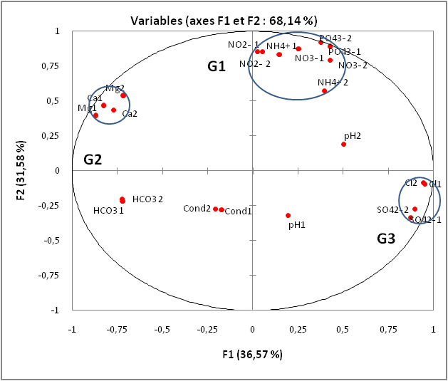

**(a)**

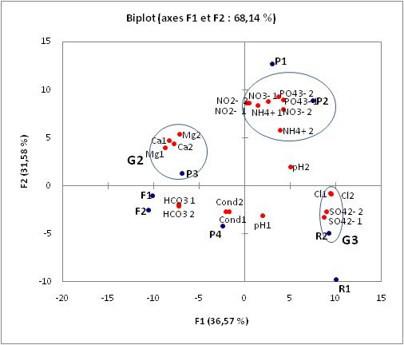

**(b)**

**Fig. 3. (a) Circle of communities of the F1-F2 factorial plane; (b) Distribution of elements according to sites.**

# 4- CONCLUSION AND PROSPECTS

Our work was part of an environmental risk assessment perspective linked to cattle farming. Its objective was to assess the impact of cattle breeding on the waters of Mbang-Foulbe (Adamawa – Cameroon). At the end of this work, it emerges that from some of the physicochemical parameters studied, the values obtained in the dry season are higher than those obtained in the raining season. Likewise, we observe high concentrations of nutrients (PO42-, NO2-, NO3-, NH4+) in surface water and those of wells P1 and P2. Groundwater has high concentrations of mineral elements such as (Ca2+, Mg2+, HCO3-). There is also a presence of nitrates in groundwater. The high levels of Organic Matter in these waters in the dry season would tend to promote microbial development and therefore lead to an increase in pH. We observe high conductivity in the groundwater (drilling F2) linked to the presence of some mineral elements in the environment. Principal component analysis shows that the P1 and P2 wells have nitrate and nitrite concentrations exceeding the standards for water for human and bovine consumption.

# REFERENCES

**1. Talba D, Inna S, Lamy LGM, Hassana B, Ngassoum MB and Ali A, 2023. Physico-Chemical Characterization of Water and Soil in Areas of High Pastoral Activity: The Case of Belel, Adamawa Cameroon. J. Chem. Bio. Phy. Sci; Section D; Vol. 13, No. 1; 122-1 DOI: 10.24214/jcbps. D.13.1.12239.**

**2. Doytchinova J, Miteva A, Harizanova-Bartos H, Stoyanova Z, 2017. Sustainable multifunctional rural areas: reconsidering agricultural models and systems with increased demands and limited resources. Research project DN 15/8. Sophia: DRINK.**

**3. Tchotsoua M, Ndame JP, Wakponou A and Bonvallot J, 1999a. Water ownership and management in Ngaoundéré (Cameroon). Problem and solution sketches. In: Geo-Eco-Trop. No. 23. 91-103.**

**4. Messine O, Greyling JPC, Schwalbach LJM, Mbah DA, and Bah GS.**

**5. Boulay AM, Bare J, De Camillis C, Döll P, Gassert F, Gerten D, Humbert S, Inaba A, Itsubo N and Lemoine Y Water Consumption Assessment: Outcome of the Expert Workshops. Int J Life Cycle Assess, 20, 577–583.**

**6. Halwani J, Omar W and Alkadi F, 2004. Water quality management in Tripoli (Lebanon). Larhyss J, ISSN 1112-3680, No. 03, pp. 79-89**

**7. Carra SHZ, Drastig K, Palhares JCP, Bortolin TA, Koch H, Schneider VE. Water , 15 , 3955**

**8. Carra SH, Palhares JC, Drastig K, Schneider VE. Water , 12 , 3014 .**

**9. Tchotsoua M, Yetgang JB, Pewo V and Tchouassi W, 1999b. Indicators, processes and causes of accelerated erosion of pastoral courses on the Ngaoundéré Plateau in Cameroon. The Flamboyant N° 50, pp. 39-4**

**10. Rodier J and Legube B, 2016 Water Analyzes Control and Interpretation, 10th Edition.**

**11. Mateo-Sagasta J, Zadeh S and Turral H 2017. Water pollution from agriculture: a global review. Published by the Food and Agriculture Organization of the United Nations, Rome, and the International Water Management Institute on behalf of the Water, Land and Ecosystems Research Programme, Colombo.**

**12. Lee U, Xu H, Daystar J, Elgowainy A, Wang M. AWARE-US : Quantifying Water Stress Impacts of Energy Systems in the United States. Sci. Total Environ., 648, 1313–1322.**

**13. Northey SA, Lopez CM, Haque N, Mudd GM and Yellishetty M, 2018. Production Weighted Water Use Impact Characterization Factors for the Global Mining Industry. J. Clean. Prod., 184, 788–797.**

**14. Klopatek SC and Oltjen JW 2022. How Advances in Animal Efficiency and Management Have Affected Beef Cattle’s Water Intensity in the United States: 1991 Compared to 2019. Anim. Sci. J., 100, scc297.**

**15. Palhares JCP and Pezzopane JRM. Journal of Clean Production, 93, 299–307.**

**16. Ouazzani N, Bouarab L, Picot B, Lazrek HB, Oudra B and Bontoux J, 1987. Seasonal variations of phosphorus forms in a lagoonal wastewater treatment station, under the arid climate of marrakech (Morocco). Rev. Fr. Sci. of Waters 10 (4). 527-544.**

**17. Halouani EL H, Picot B, Casellas C, Pena G and Bonteux J, 1993. Nitrogen and phosphorus removal in a high-yield lagoon. Rev. Fr. Sc. Water 6 (1). 47-6**

**18. Schyns JF, Hoekstra AY and Booij MJ. Hydrologic. Earth. Syst. Sci., 19, 4581–4608.**

**19. Reggam A, Bouchelaghem H and Houhamdi M, 2015. Physico-Chemical Quality of Waters from Oued Seybouse (Northeastern Algeria) : Characterization and Analysis in Principal Components. J. Matt. Approx. Sci. (5) 1417–1425.**

**20. Dourmad JY, Leterme Ph, Morvan I, Peyrand JL and Vertis F, 1997. Nitrogen fluxes in livestock farms, pp 281-301, in : Riou C, Bonhomme R., Chassi P., Neveu A., Papy F (Editor), Water in Rural Space. Vegetation Production and Water Quality, INRA, 411p.**

**21. Busser E, Dewulf J, Zutter L, De Haesebrouck F, Callens J, Meyns T, Maes W, Maes D. Effect of administration of organic acids in drinking water on faecal shedding of E. coli, performance parameters and health in nursery pigs. Vet J, (2), 184-188.**

**22. Hooda PS, Edwards, Anderson HA and Miller A. Sci Total Environ. 250: 143-1**

**23. Philippeau G., 1986. How to Interpret the Results of a Principal Components Analysis? ITCF. Paris. 61p.**