**Isolation and Control of Post-Harvest Fruit Rot Pathogens of Apple Using Aqueous and Ethanolic Extracts of Ginger (*Zingiber officinale)* In Mubi, Nigeria**

**ABSTRACT**

A survey for the rot of apple fruits sold in two markets of Mubi North Local Government, Adamawa State (Mubi Main Markets and Mubi New Markets) was conducted between June to September 2023. Also, the invitro effect of ginger aqueous and ethanolic root extracts on rot control was carried out. Five fungal pathogens viz; *A. niger*, *U.botrytis*, *R. stolonifer*, *R.microsporus*, and *M.hiemalis* were identified and proven through pathogenicity test to be pathogenic. Out of the total sample size of 32 fruits (16 per market), *R.stolonifer* had the highest percentage incidence in both markets with 37.50 % in the main market and 31.25 % in the new market while the least was *M. hiemalis* (6.25 %) in the main market and U. botrytis (6.25 %) Newmarket. Virulence of pathogens shows that *R. stolonifer* had very high, *A. niger* and *R. microsporus* had high while *U. botrytis* and *M. hiemalis* had moderate. Control trails on the pathogenic organisms (invitro) show that both extracts were able to inhibit the growth of pathogen with the ethanolic extract having high inhibition diameter of 0.70 cm in *A. niger*, 0.93 cm in *U. botrytis* and 0.49 cm in *R. stolonifer*. In comparison, aqueous had a higher mean zone of inhibition in *M. hiemalis* (0.63 cm) and *R. microsporus* (0.33 cm). There was a statistically significant difference between all the extract concentrations and the control at P≤ 0.005 $.$ It was recommended that the active components of both extracts be identified and isolated so that they can be incorporated to form fungicides that can be used commercially to control pre- and post-harvest fruit rot.

**Keywords**: Pathogens, Pathogenicity, *Zingiber officinale,* Apple, and root extracts

**Introduction**

The apple tree (*Malus domestica* Borkh.) is a deciduous tree in the Rose family best known for its sweet, Pomaceous fruit, the apple. It is cultivated worldwide as a fruit tree and is the most widely grown species in the genus Malus. The tree originated in central Asia where its wild ancestor, *Malus sieversii* is still found today. It is an important part of the human diet (Khanizadeh *et al.,* 2008). Its important varieties which are commonly grown include Top Red, Red Spur, Red Delicious, Oregon Spur, Golden Delicious, Super Gold, Double Red, Apple Elite, Stark Crimson, Red Rom Beauty, Royal Gala, Red Chief, and Mondial Gala (Ali *et al.,* 2004). Research suggests that apples may reduce the risk of colon cancer, prostate cancer, and lung cancer (NRCR, 2008). Compared to many other fruits and vegetables, apples contain relatively low amounts of Vitamin C and several other antioxidant compounds (Boyer and Liu, 2004). They may also help with heart disease, weight loss, and controlling cholesterol, as they do not have any cholesterol, have fiber, which reduces cholesterol by preventing re-absorption, and are bulky for their caloric content like most fruits and vegetables (Sharma, 2005; AKYFH, (2008).

Approximately 20-25% of the harvested fruits are deteriorated by pathogens during postharvest handling even in advanced countries (Droby, 2006). Postharvest losses are often harsher in developing countries due to a lack of storage and transportation facilities. Fruit infections by fungi may appear during the growth period, harvesting, handling, transportation, and post-harvest stockpile and marketing conditions, or after procuring by the consumer. Fruits incorporate high levels of nutrients, elements, and sugars and their low pH values make them exceptionally desirable to fungal decay (Singh *et al*., 2007). Based on the cultivar, season, and production area, fungi are considered an essential post-harvest loss agent of different fruits (Valiuskaite *et al*., 2006; Ewekeye *et al*., 2016). Infections caused during post-harvest conditions lower the shelf life and adversely affect the market value of fruits (Tripathi *et al*., 2008). Moreover, mycotoxins the secondary metabolites produced by moulds have adverse effects on humans and animals (Zain, 2011). The contamination of fruits with mycotoxins has not only caused health hazards but also resulted in economic losses, especially for exporting countries. Two mechanisms of infection can be determined, primary and secondary infection. The primary infection usually happens in the field (orchards) or during sorting before storage after harvesting. The secondary infection happens when fungal mycelium and spores spread from infected apples to uninfected apples (Dutot *et al*., 2013).

Apple rot is an economically significant disease on apples (*Malus* *domestica* Borkh) and can be caused by several filamentous fungi with a worldwide distribution like *Penicillium expansum* Link. and *Botrytis cinerea* Pers. which are common and causing significanteconomic losses in the USA and Europe (Sutton *et* *al*., 2014). Apple rot incidence may vary depending on the cultivar (Sever *et al*., 2012; Weber, 2011) and harvest time (Borve *et al*., 2013). Sutton *et al*. (2014) reported that *Alternaria alternata* causes core rot (Niem *et al.*, 2007) and rot around injuries or at calyx. Grey mould caused by *Botrytis cinerea*, *Fusarium* rot caused by several *Fusarium* species, and brown rot caused by *Monilinia* *fructigena* (Aderh and Ruhland) Honey and blue mould decay caused by *P. expansum* were found more rarely (Borve *et al*., 2013). Among the different fungal pathogens, *Alternaria alternata, Botrytis cinerea, Glomerella cingulata, Monilinia fructigena* and *Penicillium expansum* are the dominant ones causing post-harvest losses in apple (Kumari *et al*., 2019).

Ginger (*Zingiber officinale*) belongs *to Zingiberaceae* family (Sharma, 2010). Ginger is a perennial, herbaceous, monocotyledonous plant, cultivated in tropical and sub-tropical areas worldwide. Rhizome of ginger has a pungent taste and smell, it is mostly used as a food additive (Jangam and Thorat, 2010). According to Tan and Vanitha (2004), ginger has direct anti-microbial activity and thus can be used in the treatment of bacterial infections. The chemical constituents of ginger extract and essential oil are the poly-phenolic ketones called gingerols or Oleoresin (Park *et al*., 2008). The antifungal effect of ginger is due to gingerone, dihydrogingerone, and dehydroshogaol (Ficker *et al*., 2003). Some other alkaloids, terpenes, and terpenoid derivatives have antimicrobial activities on different bacterial pathogens (Huang et al., 2022). Ginger has been used as a spice and medicine for over 200 years in Traditional Chinese Medicine (Shahrajabian et al., 2019). The obtained findings suggest the potential of ginger extract as an additive in the food and pharmaceutical industries (Shahrajabian *et al*.,2019; Peng *et al*., 2022). Results indicate that ginger contains monoterpenoids, sesquiterpenoids, phenolic compounds, and its derivatives, aldehydes, ketones, alcohols, and esters, which provide a broad antimicrobial spectrum against different microorganisms and make it an interesting alternative to synthetic antimicrobials (Lim and Wong, 2018; Gao *et al*., 2022). For example, 6-gingerol inhibits the proliferation of human cervical cancer cells and induces their apoptosis (Moorkoth *et al*., 2021). Recent studies have shown that both ginger extract and ginger essential oil have antifungal activities against plant pathogens, such as *Fusarium oxysporum* and *Colletotrichum falcatum* (Abdullahi *et al*., 2020; Bordoh *et al*., 2020). Noshirvani *et al.* (2017) reported that ginger essential oils could be used to plasticize chitosan-carboxymethyl cellulose films while improving moisture permeability and maintaining antifungal activity. Similarly, Agarwal *et al.* (2001) proposed that 6-dehydroshogaol isolated from ginger rhizomes exhibited maximum insect growth regulatory activity while dehydrozingerone imparted maximum antifungal activity. These findings indicate that ginger extract might be useful as an alternative to fungicides and bactericides (Noshirvani *et al*., 2017; Agarwal *et al*., 2001). Yusuf *et al.* (2019) reported ginger contains phytochemicals which include flavonoids, saponins, steroids, glycosides, resins, and tannins to be the major phytochemicals present in the plant. Ginger is also a rich source of mineral elements and vitamins which include zinc, iron, phosphorus, calcium, magnesium, potassium, vitamin E, and Vitamin C (Yusuf *et al.*, 2019).

**MATERIALS AND METHODS**

**Study Area**

Mubi is geographically located between Latitudes 10030’ and 10005’N and Longitudes 13010’ and 13030’E North of the Greenwich Meridian (National Population Census, 2006). Mubi exhibits both dry and wet tropical climate types. Also, it occupies an area of 192,307km and has a population of 260,009 people (National Population Census, 2014). Rainfall annually is about 900mm with the highest frequencies in July and August. Temperature ranges from warm to hot throughout the year but experiences a cool period between November and February with a gradual increase from January to March. The relative humidity of the area is low but begins to rise from April to August maximally (Adebayo, 2004).

# **3.2 Sources of Samples and Sample Size**

A total of 16 samples were collected from the two different Markets at four different locations using a stratified sampling technique (8 samples from each market) in a sterile polythene bag. The Markets were; Mubi main market (M MM) and Mubi new market (MNM).

# **3.3 Medium of Isolation**

The medium used for isolation was Potato Dextrose Agar (PDA), which was prepared according to Smith and Onions, (1994). The prepared media was autoclaved for 15 minutes, 10Ib pressure and allowed to cool. The Petri dishes used for solid media were sterilized in an oven at 160oC for 6 hours using a sterilization can. The needle and cork borer used for inoculation were sterilized by flaming and then cooled by dipping into a methylated spirit. The inoculation of the organisms was conducted in an inoculating chamber. The bench top was sterilized with 95% ethanol and then UV light was used to sterilize the inoculating chamber for 30 minutes.

**Incidence and Virulence of Apple Fruit Rot Pathogens in the Markets**

Apple samples were collected at random from the two markets selected, from different traders at different locations in the market. The incidence of apple fruit rot in the Market was determined by counting the infected apples from the samples collected from each market.

Virulence of fruit rot was assessed and scored according to the visual scale of 1-5 in which;

1 1- 20 % of apple fruit infected,

1. 21-40 % of apple fruit infected,
2. 41-60 % of apple fruit infected,

4 61-80 % of apple fruit infected,

5 More than 80 % of apple fruit infected.

The reactions of the isolates based on the 1-5 visual scale were grouped into the following categories based on the modified Ratanacherdchail *et al*. (2010) pathogenic potential of rating isolates

1-20 % - Low Virulent group

21-40 % - Moderately Virulent group

41-60 % - High Virulent group

61-80 % - Very High Virulent group

Above 80 % - Totally Virulent group

**Isolation and Identification of Pathogens**

About 5 mm square pieces of apple fruit showing rot lesions were cut with a sterilized blade and sterilized in 0.1 % mercuric chloride for 30 seconds. They were then rinsed in three changes of sterile distilled water and blotted dry between sterile Whatman No. 1 filter papers and were plated out on PDA. The plates were incubated at 25 0 C for 24 hrs and observed for any growth. The resulting spore colonies were transferred to fresh Potato Dextrose Agar (PDA) plates and in a refrigerator for further studies. The slides of the organism isolated were prepared and stained with lactophenol cotton blue observed under the microscope and subsequently identified by comparing the morphological characteristics of the organisms under the microscope with the structures in Alexopoulus and Mims (1986).

**Pathogenicity Test**

The healthy semi-ripe apple fruits (uniform in size) were selected and washed, surface sterilized in 0.5 % Sodium hypochlorite solution (bleach) for 3 minutes and rinsed in 3 changes of sterile distilled water and then air dried according to the method of Zakawa et al. (2019). The surface sterilized apple fruits were wounded with cork borer of 4mm diameter and bored tissue was removed (Choiseul *et al*., 2007; Peters *et al*., 2008a; Peters *et al* 2008b). The wounded apple fruits were inoculated with a 2mm disc of the inocula and sealed with a sterile vesper prepared from Vaseline. The control experiment was set up in the same way except that sterile distilled water was used instead of inocula. All the wounded apple fruits were wrapped in black polythene bags (Manici and Cerato, 1994). Inoculated fruits were incubated in desiccators that had been sterilized. Regular observations were made for isolates and comparison with original isolates.

**Preparation of Plant Root Extracts of** ***Zingiber officinale***

Stem of *Zingiber officinale* was collected from Mubi main market, Mubi North Local Government of Adamawa State. The fresh stem was collected, and washed with tap water and with sterile distilled water, this were dried under the shade and were pulverized with mortar and pestle into a powdery form. Seventy grams (70 g) of the root powder was soaked in 1000 ml of cool distilled water and ethanol for 24 hours. The suspensions were then filtered using sterile cheese cloths. The extracts were then poured into a clean sterile conical flask plugged with cotton wool and heated between 30oC to 60oC in a water bath. This was then allowed to cool, wrapped in aluminium foil, and kept until when required.

**Determination of in vitro Efficacy of Root Extracts of Ginger on the Pathogens**

***In vitro test***

The aqueous and ethanolic stem extract used for the antifungal activity test were prepared into three (3) different concentrations ranging from 500 mg/ml to 1500 mg/ml (i.e. 500, 1000, and 1500 mg/ml). The extract concentration was prepared by weighing 1.5 g of the extract into 1 ml of sterile distilled water (1500 mg/ml). Serial dilution of the extract was carried out into two (2) different labeled bottles to obtain concentrations of 1000 mg/ml and 500 mg/ml respectively (Zakawa *et al*., 2021). The control contains sterile distilled water in place of the root extracts, three (3) replicates were used for each pathogen with the extract concentration and control. The disc was used to cut from 7-day-old culture of fungi and was incubated at room temperature of 250C for 7 days in which zones of inhibition were measured starting from two days after inoculation.

**Qualitative Phytochemical Analysis**

The extracts were analyzed for alkaloids, flavonoids, tannins, saponins, phenols, and glycosides. The method described by Sofowora (2003), Harbone (1993), Okwu (2001), and Rahila *et al.,* (1994) will be adopted.

**Experimental Design and Data Analysis**

The experimental layout was a Completely Randomised Design (CRD) of the two extracts, each extract at the same concentration (i.e. 500 mg/ml, 1000 mg/ml, and 1500 mg/ml) and the experiment will be replicated three (3) times. All data was analyzed using Analysis of Variance (ANOVA) to test for significance and means were separated using Ducan Multiple Range Test (DMRT). The statistical package used was the SPSS computer software program.

# **RESULTS**

# **Incidence and Virulence of Apple Fruit Rot Pathogens in the Markets**

the incidence of each fungal pathogen from the two markets visited was recorded with Mubi main markethaving *Rhizopus stolonifer* with the highest incidence at 37.50% followed by *Aspergillu niger* at 25%, *Rhizopus microsporus* at 18.75%, *Ulocladium botrytis* at 12.50% while *Mucor hiemalis* had the lowest incidence at 6.25% respectively. Mubi new main had *R. stolonifer* with the highest incidence (31.25%), *R. microsporus* (25%), *M. hiemalis,* and *A. niger* (18.75) while *U. botrytis* had the lowest incidence with 6.25% as shown in Figure 1.

The virulence of pathogens showed that all pathogens were virulent at different degrees, *R. stolonifer* virulence was scored as very high as fruit rot covered up to 70% of the fruit within a few days, *A. niger* and *R. microsporus* had a high virulence while *M. hiemalis* and *U. botrytis* were scored as moderate virulence (Table 1).

Figure 1: Percentage Incidence of Rot caused by Pathogens in the Markets

# **Table 1: Virulence of Apple Fruit Rot Pathogens**

|  |  |  |
| --- | --- | --- |
| Organisms | Virulence |  |
| *A. niger* | High |  |
| *U. botrytis* | Moderate |  |
| *R. stolonifer* | Very High |  |
| *M. hiemalis* | Moderate |  |
| *R. microspores* | High |  |
|  |  |  |

# **Isolation and Identification of Pathogens**

Five fungal pathogens (*Apergillus niger*, *Ulocladium botrytis*, *Rhizopus stolonifera*, *Mucor hiemalis,* and *Rhizopus microsporus*) were successfully isolated from the infected apple fruits. They were confirmed through a pathogenicity test to be responsible for apple fruit rot disease in the study area (Plate 1 (a-k)).

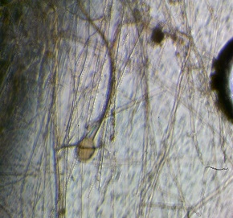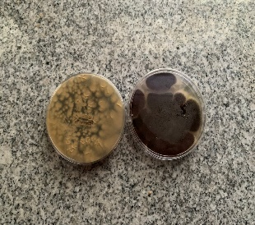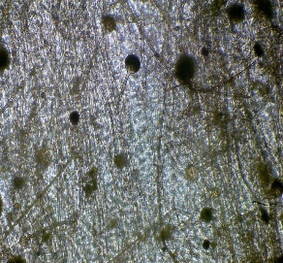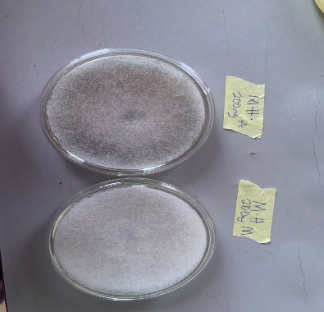

a b c d

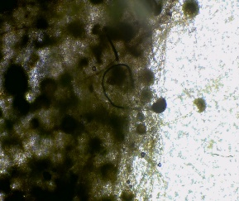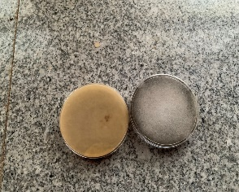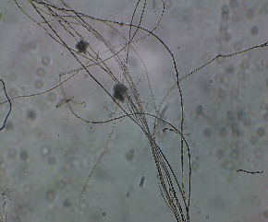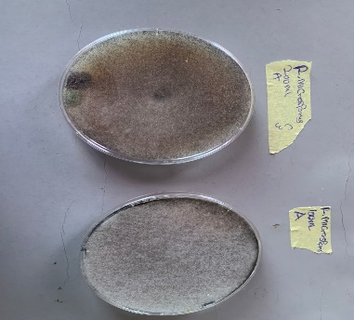

e f g h

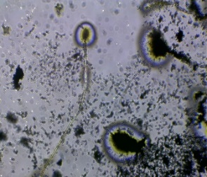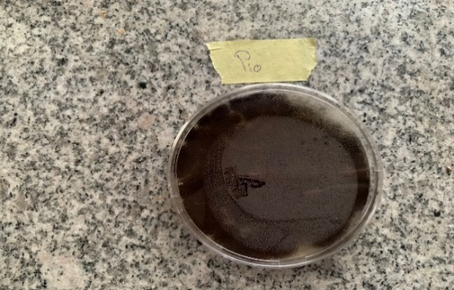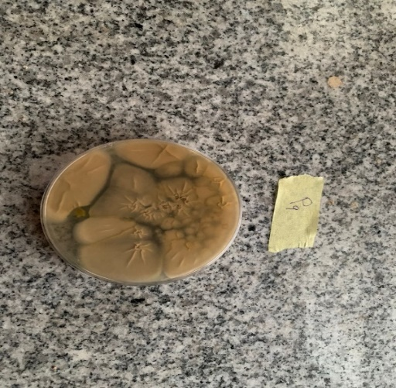

i j k

Plate 1: (a) Micrograph of *A.niger* X 40 (b) Seven-Day Old Pure Culture of *A. niger,* (c) Micrograph of *M. hiemalis* X 40 (d) Seven Day Old Pure Culture of *M. hiemalis* (e) Micrograph of *R. microspores* X 40 (f) Seven Day Old Pure Culture of *R. microspores* (g) Micrograph of *R. stolonifer* X 40 (h) Seven-Day Old Pure Culture of *R. stolonifer* (i) Micrograph of *U. botrytis* X 40 (j/k) Seven Day Old Pure Culture of *U. botrytis*

**Pathogenicity Test**

The pathogenicity test showed that all five fungal pathogens were pathogenic to apple fruit at different levels (Plate 2). Rot was not observed on the first day of incubation in all organisms until the second day. There was a statistically significant difference between the control and all fungal pathogens starting from day two. *R. stolonifer* had the highest rot diameter, followed by *M. hiemalis* while *A. niger* had the lowest rot diameter respectively (Table 2)

# **Table 2: Pathogenicity Test of the Isolated Apple Fruit Rot Pathogens**

|  |  |  |  |  |  |  |
| --- | --- | --- | --- | --- | --- | --- |
| Organisms | Days/Inhibition Zones (cm) | | | | |  |
| 2 | 3 | 4 | 5 | 6 | 7 |
| Control | 0.00a | 0.00a | 0.00a | 0.00a | 0.00a | 0.00a |
| *Aspergillus niger* | 0.17a | 0.74b | 1.10b | 3.90b | 4.83b | 6.70b |
| *Ulocladium botrytis* | 0.25ab | 0.73b | 2.40c | 4.65c | 5.85c | 7.93c |
| *Rhizopus microsporus* | 0.27ab | 0.80b | 2.38c | 4.68c | 6.18c | 8.20c |
| *Mucor hiemalis* | 0.32ab | 1.40c | 4.28e | 8.25e | 9.48d | 10.37d |
| *Rhizopus stolonifer* | 0.63b | 2.50d | 3.87d | 7.72d | 10.32e | 10.50d |

Means in the same column followed by the same superscript are not significantly different at p ≤ 0.05 D.M.R. T

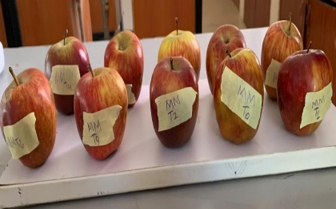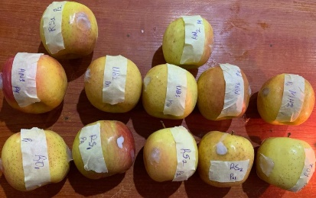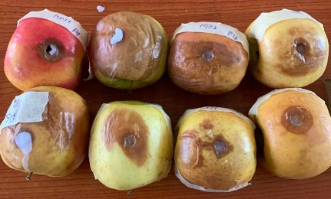

Plate 2: (a) Selected Samples of Apple Fruits from different Markets in Mubi North (b) Sample of semi-rapped Apple fruits for Pathogenicity test day one (c) Sample of Apple fruits after seven days during pathogenicity test showing rot.

# **Determination of *in vitro* Efficacy of Root Extracts of *Zingiber officinale* on the Pathogens**

Results from the *in vitro* efficacy determination of both aqueous and ethanolic extracts of *Zingiber officinale* on the apple fungal pathogens are presented in Table 3. There was a statistically significant difference between all extract concentrations and the non-treated control at p≤0.05 for all five fungal pathogens. The interaction between the two extracts of solvent used also showed a statistically significant difference at p≤0.05 for only three fungal pathogens (*A. niger, R. stolonifer,* and *R. microsporus*) (Table 3)

# **Table 3: Effect of Extract Concentrations on Zones of Inhibition (cm) of Apple Fruit Rot Pathogens**

|  |  |  |  |  |  |
| --- | --- | --- | --- | --- | --- |
|  |  |  | Organisms |  |  |
| Treatment | *A. niger* | *U. botrytis* | *R. stolonifer* | *M.hiemalis* | *R. microsporus* |
| **Conc. (mg/ml) – (C)** |  |  |  |  |  |
| 0 | 0.00a | 0.00a | 0.00a | 0.00a | 0.00a |
| 500 | 0.42b | 0.80b | 0.35b | 0.50b | 0.17b |
| 1000 | 1.03c | 1.07b | 0.32b | 0.70bc | 0.29c |
| 1500 | 0.95c | 1.17b | 0.32b | 1.07c | 0.67d |
| SE ± | 0.09 | 0.15 | 0.08 | 0.15 | 0.04 |
| **Extract – (E)** |  |  |  |  |  |
| Aqueous | 0.50a | 0.59a | 0.00a | 0.63a | 0.33b |
| Ethanolic | 0.70b | 0.93a | 0.49b | 0.50a | 0.23a |
| SE± | 0.06 | 0.10 | 0.06 | 0.11 | 0.03 |
| **Interaction**  C x E | * | NS | * | NS | * |

Means in the same column followed by the same superscript are not significantly different at p ≤ 0.05 D.M.R.T

Keys:

* = Significant at p ≤ 0.05

NS = Not significant at p ≤ 0.05

**Effect of aqueous extracts of *Zingiber officinale* on the fungal rot pathogens of apple**

The result for the effect of aqueous extracts concentrations of *Zingiber officinale* on the growth of the fungal pathogens are presented in Table 4 There was a statistically significant difference between the non-treated control and the other treatments at p≤0.05. For *A. niger*, treatment with 1000 mg/ml had the highest zone of inhibition with 1.20 cm while 500 mg/ml had the lowest with 0.10 cm. For *U. botrytis*, treatment with 1500 mg/ml had the highest zone of inhibition with 1.03 cm while 500 mg/ml had the lowest with 0.47 cm. *M. hiemalis* had treatment with 1500 mg/ml with the highest zone of inhibition at 1.13 cm although there was no statistically significant difference when compared with 1000 mg/ml while 500 mg/ml had the lowest zone of inhibition at 0.40 cm. For *R. microspores*, treatment with 1500 mg/ml had the highest zone of inhibition with 0.70 cm while treatment with 500 mg/ml had the lowest with 0.23 cm. There was, however, no statistically significant difference between extract concentrations for *R. stolonifera* at p≤0.05.

**Table 4: Effect of Aqueous Extract Concentrations of *Zingiber officinale* on Zones of Inhibition (cm) of Apple Rot Pathogens**

|  |  |  |  |  |  |
| --- | --- | --- | --- | --- | --- |
|  |  |  | Organisms |  |  |
| Treatment | *A. niger* | *U. botrytis* | *R. stolonifer* | *M.hiemalis* | *R. microsporus* |
| Conc. (mg/ml) |  |  |  |  |  |
| 0 | 0.00a | 0.00a | 0.00a | 0.00a | 0.00a |
| 500 | 0.10b | 0.47b | 0.00a | 0.40b | 0.23b |
| 1000 | 1.20d | 0.87c | 0.00a | 1.00c | 0.38b |
| 1500 | 0.70c | 1.03d | 0.00a | 1.13c | 0.70c |
| SE ± | 0.13 | 0.21 | 0.12 | 0.21 | 0.05 |

Means in the same column followed by the same superscript are not significantly different at p ≤ 0.05

**Effect of ethanolic extracts of Zingiber officinale on the fungal rot pathogens of apple in vitro**

The results for the effect of ethanolic extract concentrations of *Zingiber officinale* on the growth of the fungal pathogens are presented in Table 5. There was a statistically significant difference between the non-treated control and the other treatments at p≤0.05. For *A. niger*, treatment with 1500 mg/ml had the highest zone of inhibition with 1.20 cm while 500 mg/ml had the lowest with 0.73 cm. For *U. botrytis*, treatment with 1500 mg/ml had the highest zone of inhibition with 1.30 cm while 500 mg/ml had the lowest with 1.13 cm. *M. hiemalis* had treatment with 1500 mg/ml with the highest zone of inhibition at 1.00 cm while 1000 mg/ml had the lowest zone of inhibition at 0.40 cm. For *R. microspores*, treatment with 1500 mg/ml had the highest zone of inhibition with 0.63 cm while treatment with 500 mg/ml had the lowest with 0.10 cm. There was, however, no statistically significant difference between extract concentrations for *R. stolonifer* at p≤0.05

# **Table 5: Effect of Ethanolic Extract Concentrations of *Zingiber officinale* on Zones of Inhibition (cm) of Apple Rot Pathogens**

|  |  |  |  |  |  |
| --- | --- | --- | --- | --- | --- |
|  |  |  | Organisms |  |  |
| Treatment | *A. niger* | *U. botrytis* | *R. solonifer* | *M.hiemalis* | *R. microsporus* |
| Conc. (mg/ml) |  |  |  |  |  |
| 0 | 0.00a | 0.00a | 0.00a | 0.00a | 0.00a |
| 500 | 0.73b | 1.13b | 0.70b | 0.60b | 0.10b |
| 1000 | 0.87b | 1.27bc | 0.63b | 0.40b | 0.20b |
| 1500 | 1.20c | 1.30c | 0.63b | 1.00c | 0.63c |
| SE ± | 0.13 | 0.21 | 0.12 | 0.21 | 0.05 |

Means in the same column followed by the same superscript are not significantly different at p ≤ 0.05

**Qualitative Phytochemical Analysis**

The result for the phytochemical analysis of aqueous and ethanolic extracts of *Zingiber officinale* is presented in Table 6 Ethanolic extract of *Z. officinale* had the excess presence of alkaloid, flavonoid, and phenols while they are moderately present in the aqueous extract. Saponins however occurred in excess for the aqueous extract compared to ethanolic extract which was moderate, tannin occurred in trace amounts in both extracts while glycoside did not occur in both extracts.

# **Table 6: Qualitative Phytochemical Composition of *Zingiber officinale* Extracts**

|  |  |  |
| --- | --- | --- |
| Phytochemicals | Ethanolic Extracts | Aqueous Extracts |
| Alkaloid | +++ | ++ |
| Flavonoid | +++ | ++ |
| Tannins | + | + |
| Saponins | + | ++ |
| Glycosides | - | - |
| Phenols | ++ | + |

Keys:

-absent

+ trace

++ moderate

+++ excess

**Discussion**

**The study showed that a variety of different fungi are associated with post-harvest rot diseases of Apple in the study area (Mubi North Local Government, Adamawa State). The survey from Mubi in 2023 shows that Apple fruit rot occurred in all locations (Markets). However, *Rhizopus stolonifer* had the highest percentage incidence in the Main Market with 37.50 %, Aspergillus niger at 25 %, *Rhizopus microsporus* at 18.75 %, and *Ulocladium botrytis* at 12.50 %, and *Mucor hiemalis* 6.25 %. In the New Markets, *R. stolonifer* had 31.25%, *R. microsporus* had 25.00 %, *A. niger* and *M. hiemalis* had 18.75 %, while U. botrytis had 6.25 %. The organisms' Virulence indicates that *R. stolonifer* had very high virulence, *A. niger,* and *R. microsporus* had high virulence, and U. botrytis and *M. hiemalis* had moderate virulence. This agrees with Zakawa et al. (2018) who reported that *Aspergillus* spp (*A. niger* and *A. flavus*) have a high virulence in mango fruit with rot covering 41-60 % of the fruits.**

**The fungal pathogen isolated and confirmed through the pathogenicity test to cause Apple fruit rot disease in Mubi include *A. niger, U. botrytis, R. stolonifer, M. hiemalis,* and *R. microspores.* This finding agrees with that of Muqeet et al. (2020) who reported *A. niger* as one of the major fungal pathogens causing rot in three cultivars of Apple (Royal Gala, Golden Delicious, and Kulur) In India Kumari et al. (2019) reported *Botrytis cinerea* and *A. niger* among the most dominant fungal pathogens causing rot in Apple fruits. Abdullah et al. (2016) reported *M. hiemalis* and *A. niger* among the fungal pathogens responsible for Apple fruit rot in Yemen. Magga and Zakawa (2018) reported *Mucor* spp, *R. stolonifer* and *A. niger* as fungal pathogens responsible for fruit rot of papaya in Mubi.**

**From the results obtained from the anti-fungal study, it has been shown that the inhibition of mycelial growth of the isolates was higher with the ethanoic extracts of ginger compared to Aqueous extracts. This was in agreement with the works of Shahida et al. (2022) who** also observed that the ethanolic extracts of ginger showed higher antibacterial and antifungal activity than the aqueous extract. The ethanol extracts were considered a powerful inhibitor compared to the extracts of methanol and chloroform (Sharaf and Al-Zaidi, 2021)**.** These results were similar to a previous study conducted by Senhaji et al. (2005) showing the active antimicrobial potential of ethanolic and hexanoic extracts of cinnamon, as compared to other solvent extracts. Results obtained from the in vitro antifungal activities of this research showed that ginger ethanolic extracts were more effective in the inhibition *U*. *botrytis* followed by *A. niger, M. hiemalis, R. microspores* and were lowest on *R*. *stolonifer* while the aqueous extract was more effective on *A. niger*, followed by *M. hiemalis*, *U. botrytis*, *R. microsporus* and wasn’t effective against *R*. *stolonifer*. This is in agreement with Amienyo and Ataga (2007) who reported the antifungal activities of the ethanol extract of *Zingiber officinale* against the mycelial elongation of *Rhizopus stolonifer*, *Botrydiplodia theobromae, A. niger*, *F. solani*, and *F. oxysporum*. However, it is not in agreement with Mvuemba et al. (2009) who reported that aqueous ginger extract was able to inhibit the mycelial growth of *R. stolonifer*, at different concentrations.

Numerous studies by Giriraju and Yunus (2013); Bordoh et al. (2020) and Makhuvele et al. (2020) have shown that ginger extract has a wide range of antimicrobial activities and acts as a botanical fungicide by inhibiting spore germination and growth of plant pathogens. Bordoh et al. (2020) reported that ginger crude extract at 10.0 mg/mL showed an effective antifungal effect against Colletotrichum gloeosporioides in vitro; it suppressed conidial germination and mycelial growth by 88.48% and 87.50%, respectively (Bordoh et al., 2020). Essential oils obtained from hydrodistillation of ginger or aqueous extracts from ginger seed had previously shown antimicrobial activity against a wide range of spoilage pathogens, including *A. niger*, *Aspergillus flavus* Link, *F. oxysporum*, *Fusarium roseum* Link:Fr. and *R. stolonifer* (Tripathi et al., 2008).

Phytochemical analysis of the two extracts showed the presence of some active components which include; *flavonoids, phenols, tannins, saponins,* and *alkaloids* while glycosides were absent in both aqueous and ethanolic extracts. The botanical bio-pesticides represent an alternative for control with low environmental impact and high food safety. The same results were reported by Kela et al. (2023) in Gombe State, Nigeria. Antimicrobial activity could be attributed to the presence of *gingerol* and shogaol (phenolic compounds) which are active ingredients in ginger (Ali Hasan, 2012). The antimicrobial activity of ginger is reported to depend on the chemical composition, extraction solvent, and method (Park et al., 2008; Beristain-Bauza et al., 2019). Plants generally contain chemical compounds (such as saponins, tannins, oxalates, phytates, trypsin inhibitors, flavonoids, and cyanogenic glycosides) known as secondary metabolites, which are biologically active (Azu and Onyeagba, 2007). Secondary metabolites may be applied in nutrition and as pharmacologically active agents. Flavonoids (quercetin) have inhibitory activity against disease-causing organisms in animals. In vitro studies show that flavonoids also have anti-allergic, anti-inflammatory, antimicrobial, anti-cancer, and anti-diarrheal activities (Kela et al., 2023). Tannins are plant polyphenols, which can form complexes with metal ions and with macro-molecules such as proteins and polysaccharides. Dietary tannins are said to reduce feed efficiency and weight gain in animals. Saponins also have hemolytic activity against red blood cells (RBC). Saponin-protein complex formation can reduce protein digestibility. Saponins reduce cholesterol by preventing its reabsorption after it has been excreted in the bile. Proper food processing would reduce antinutrients (Kela et al., 2023).

**Conclusion**

It may be concluded from this study that *Aspergillus niger*, *Rhizopus stolonifer,* *Rhizopus microspores*, *Mucor hiemalis,* and *U. botrytis* are common pathogenic fungi that cause apple fruit rot in the study area (Mubi North). The result from the pathogenicity test indicated that all the isolated fungi are pathogenic and attributed to the cause of apple rot in Mubi North. The inhibitory effect of the plant extracts against fungal isolates could be due to the presence of antifungal substances in the extracts. Higher inhibition of fungal growth observed at higher concentrations of both aqueous and ethanolic extracts was recorded. The result also indicates that ethanolic extracts of ginger have more inhibitory compounds than the aqueous extracts. This shows a clear indication of the potential of plant extracts to control fungal pathogens. It is also clear from the result that both the test ginger extracts significantly reduce the radial growth of isolated fungi. It seems that the antifungal effects are a result of many compounds acting synergistically. This can be formulated and successfully used to produce fungicides with local technology, which can be applied in both pre- and post-harvest fruit management.

**REFERENCES**

Abdullah, Q., Mahmoud, A. and Al-harethi, A. (2016). Isolation and Identification of Fungal Post-harvest Rot of Some Fruits in Yemen. *PSM Microbiol*. **01**(1): 36-44.

Abdullahi, A., Khairulmazmi, A., Yasmeen, S., Ismail, I.S., Norhayu, A., Sulaiman, M.R., Ahmed, O.H. and Ismail, M.R. (2020). Phytochemical Profiling and Antimicrobial Activity of Ginger (*Zingiber Officinale*) Essential Oils Against Important Phytopathogens. *Arab. J. Chem*. 13:8012–8025.

Adebayo AA (2004) Mubi Region A Geographical Synthesis. Paraclete Publishers Yola Nigeria Pp 17-20.

Agarwal, M., Walia, S., Dhingra, S. and Khambay, B.P. (2001). Insect growth inhibition, antifeedant and antifungal activity of compounds isolated/derived from *Zingiber officinale* Roscoe (ginger) rhizomes. *Pest. Manag. Sci*. **57**: 289–300.

Alexopoulus, C.L and Mims, C.W. (1986). *An Introducing Mycology*. 3rd edition. Willey and Sons, New York, Pp 204-340

Ali Hasan, H., 2012. Chemical composition and antimicrobial activity of the crude extracts isolated from Zingiber officinale by different solvents. Pharm. Anal. Acta 3 (9).

Ali, M.A., H. Raza, M.A. Khan and M. Hussain. (2004). Effect of different periods of ambient storage on chemical composition of apple. *Fruit Int. J. Agric. Biol*. **6**(2):568–571.

Amienyo, C.A. and Ataga, A.E. (2007) Use of indigenous plant extracts for the protection of mechanically injured sweet potato [*Ipomoea* *batatas* (L.) Lam] tubers. *Sci Res Essay*. **2**(5):167-70.

Apples Keep Your Family Healthy (AKYFH), (2008) Washington State Apple Advertising Commission. <http://www.bestapples.com/healthy/>.

Azu, N.C. and Onyeagba, R.A. (2007). Antimicrobial properties of extracts of Allium cepa (Onions) and Zingiber officinale (Ginger) on Escherichia coli, Salmonella typhi and Bacillus subtilis. *Int J Trop Med*. **3(**2) 8:1540–2681.

Beristain-Bauza, S.D.C., Hern_andez-Carranza, P., Cid-P_erez, T.S., _Avila-Sosa, R., Ruiz-

L_opez, I.I., Ochoa-Velasco, C.E., 2019. Antimicrobial activity of ginger (Zingiber officinale) and its application in food products. Food Rev. Int. 35 (5), 407–426.

Bordoh, P.K.; Ali, A.; DiControlinson, M.; Siddiqui, Y. Antimicrobial Effect of Rhizome and Medicinal Herb Extract in Controlling Postharvest Anthracnose of Dragon Fruit and Their Possible Phytotoxicity. Sci. Hortic. **2020**, 265, 109249.

Borve, J., Roen, D. and Stensvand, A. (2013). Harvest time influences incidence of storage diseases and fruit quality in organically grown ‘Aroma’ apples. *European Journal of Horticultural Science*. **78** (5): 232–238.

Boyer, J. and Liu, R. H. (2004) Apple phytochemicals and their health benefits. Nutr. J. (Cornell University, Ithaca, New York 14853-7201), USA.

Choiseul, J., Allens,L. and Carnegie, F. (2007). Fungi causing dry rot in seed potato in storage in Scotland. *Potatoes resources* Pp. 241-253

Droby, S. (2006). Improving quality and safety of fresh fruits and vegetables after harvest by the use of biocontrol agents and natural materials. *Acta* *Horticul*ture. **709**: 45–51.

Dutot, M., Nelson, L.M. and Tyson, R.C. (2013). Predicting the spread of postharvest disease in stored fruit, with application to apples. Postharvest Biology and Technology 85 (1): 45–56.

Ewekeye, T.S., Oke, O.A. and Esan O.O., 2016. Studies on post-harvest rot of apple (*Malus* *domestica* Borkh). *Indian Journal of Plant Sciences*. 5 (1): 36-41.

Ficker C, Smith M, Akpagana K, Gbeassor M, Zhang J, et al. (2003) Bioassay‐guided isolation and identification of antifungal compounds from ginger. Phytother Res 17(8): 897-902.

Gao, Y.; Lu, Y.; Zhang, N.; Udenigwe, C.C.; Zhang, Y.; Fu, Y. Preparation, pungency and bioactivity of gingerols from ginger (*Zingiber officinale* Roscoe): A review. Crit. Rev. Food Sci. Nutr. **2022**, 22, 1–26.

Giriraju, A. and Yunus, G.Y. (2013). Assessment of Antimicrobial Potential of 10% Ginger Extract Against Streptococcus mutans, Candida albicans, and Enterococcus faecalis: An in vitro study. Indian J. Dent. Res. 24: 397–400.

Harborne, J.B. (1973). *Phytochemical Methods*. Chapman and Hall Ltd, London. 49-188

Huang, W., Wang, Y., Tian, W., Cui, X., Tu, P., Li, J., ... & Liu, X. (2022). Biosynthesis investigations of terpenoid, alkaloid, and flavonoid antimicrobial agents derived from medicinal plants. *Antibiotics*, *11*(10), 1380.

Jangam SV, Thorat BN (2010) Optimization of spray drying of ginger extract. *Drying Technology.* **28**(12): 1426-1434.

Kela, E., Sogbesan, A.O. and Wakil, U.B. (2023). Evaluation of Phytochemical Composition of Ginger Extracts. *Fish Aqua J*. **14**:317.

Khanizadeh, S., R. Tsao, D. Rekika, R. Yang, M.T. Charles and H.V. Rupasinghe. (2008). Polyphenol composition and total antioxidant capacity of selected apple genotypes for processing. *Journal of Food Composition and Analysis*. **21**(5):396-401.

Kumari, N., Sharma, J. N. and Deepika Singh (2019). Antifungal Activity of Skin Coatings against Post Harvest Rots of Apple Cultivar Starking Delicious. *International Journal of Economic Plants*. **6**(2):078-081

Lui, L.H., and A.C. Kushalappa (2002). Response surface models to predict potato tuber infection by *Fusarium sumbucinum* from duration of wetness and temperature and dry rot lesion expansion from storage time and temperature. *International Journal of Food Microbial.***76**: 19-25

Magga Bamanga and Zakawa N. Ngida**.** (2018). Antifungal activities of seed extracts of mahogany on *Carica papaya* (Pawpaw) fruit rot in Mubi, Adamawa State. *World Journal of Pharmaceutical Research.* 7(14): 170- 182.

Makhuvele, R.; Naidu, K.; Gbashi, S.; Thipe, V.C.; Adebo, O.A.; Njobeh, P.B. (2020). The Use of Plant Extracts and Their Phytochemicals for Control of Toxigenic Fungi and Mycotoxins. *Heliyon*. **6**: 5291.

Manici, L.M., and Cerato,C. (1994). Pathogenicity of *Fusarium oxysporium*, *Fusarium* sp*.Tubererosi* isolates from tubers and potato plants. *Journal of Phytopathology.* **37**:129-134

Moorkoth, S., Prathyusha, N.S., Manandhar, S., Xue, Y., Sankhe, R., Pai, K.S.R. and Kumar, N. (2021). Antidepressant-like Effect of Dehydrozingerone from *Zingiber Officinale* by Elevating Monoamines in Brain: In Silico and in Vivo Studies. *Pharmacol. Rep*. **73**: 1273–1286.

Muqeet, S., Amer Habib, Muhammad Zeeshan Mansha and Amina. (2020). Response of Various Apple Cultivars against Post Harvest Rottening**.** *Nat Sci.* **18**(8):14-18.

Mvuemba, H. N., Green, S. E., Tsopmo, A. and Avis, T. J. (2009). Antimicrobial efficacy of cinnamon, ginger, horseradish and nutmeg extracts against spoilage pathogens. *Phytoprotection*. **90**(2), 65–70.

National Population Commission NPC (2006) Nigerian population census report, 2006.

Niem, J., Miyara, I., Ettedgui, Y., Reuveni, M., Flaishman, M. and Prusky, D. (2007). Core rot development in red delicious apples is affected by susceptibility of the seed locule to *Alternaria* *alternata* colonization. *Phytopathology*. **97** (11): 1415–1421.

Noshirvani, N., Ghanbarzadeh, B., Gardrat, C., Rezaei, M.R., Hashemi, M., Le Coz, C. and Coma, V. (2017). Cinnamon and ginger essential oils to improve antifungal, physical and mechanical properties of chitosan-carboxymethyl cellulose films. *Food Hydrocoll*. *70*, 36–45.

Nutrition to Reduce Cancer Risk (NRCR), (2008) The Stanford Cancer Centre (SCC). <http://cancer.stanford.edu/information/nutritionAndCancer/reduceRisk/>.

Okwu, D. E. (2001). Evaluation of chemical composition of indeginous species and flavouring agents. *Global journal of pure and Applied Sciences*, *7*(3), 455-460.

Park M, Bae J, Lee DS (2008) Antibacterial activity of [10] ‐gingerol and [12] ‐gingerol isolated from ginger rhizome against periodontal bacteria. *Phytother Res* **22**(11): 1446-1449.

Peng, H.; Hu, H.; Xi, K.; Zhu, X.; Zhou, J.; Yin, J.; Guo, F.; Liu, Y.; Zhu, Y. (2022). Silicon Nanoparticles Enhance Ginger Rhizomes Tolerance to Postharvest Deterioration and Resistance to *Fusarium solani*. *Front. Plant Sci*. **13**: 816143.

Peters, J.C., Lees A.K., Sullivan, S., Stroud, G.P., and Cunnungton, A.C. (2008a). Infralimbic prefrontal cortex is responsible for inhibiting cocaine seeking in extinguished rats. *Neuroscience*. **28**: 6046-6053

Peters, J.C., Lees A.K., Sullivan, S., Stroud, G.P., and Cunnungton, A.C. (2008b). Opposing roles for the ventral prefrontal cortex and the basolateral amygdala on the spontaneous recovery of cocaine-seeking in rats.*Psychopharmacology.* **197**: 319-326

Rahila, T., Rukhsandra, N., Zaidi, A.A. Shamishilia, R. (1994). Phytochemical Screening of medicinal plants belonging to *Euphorbiaceae* Pak. Vet. J. 14: 160-162.

Ratanacherdchail, K., Wang, H., Lin F. and Soytong, K. (2010). ISSR for comparison of cross inoculation potential of *Colletotrichum capsici* causing chili anthracnose. *African Journal of Microbiology Research*. **4**(1): 76-83

Senhaji O, Faid M, Elyachioui M. (2005). Antibiosis by cinnamon extracts against antibiotic-resistant strains. *Int J Agric Biol*.**7**(5):724-8.

Sever, Z., Ivić, D., Kos, T. and Miličević, T. (2012). Identification of *Fusarium* species isolated from stored apple fruit in Croatia. *Archives of Industrial Hygiene and Toxicology***. 63** (4): 463–470.

Shahidi, S., Naqqash, T., Aslam, K., Hanif, M.K., Qaisrani, M.M. and Shabir, G. (2022). Antimicrobial and Antifungal Effect of Ginger (*Zingiber officinale*), Green Tea (*Camellia sinensis*), And Neem (*Azadirachta indica*) On Plant Pathogens. American Journal of Biomedical Science & Research.

Shahrajabian, M.H., Sun, W. and Cheng, Q. (2019). Clinical aspects and health benefits of ginger (*Zingiber officinale*) in both traditional Chinese medicine and modern industry. Acta Agric. Scand. Sect. B—*Soil Plant Sci*. 69: 546–556.

Sharaf, E. F., & Al-Zaidi, H. S. (2021). In vitro Antifungal Activity of Some Indigenous Medicinal Plant Extracts against Five Isolates of Aspergillus fumigatus. *Indian Journal of Pharmaceutical Sciences*, *83*(4).

Sharma, R. (2005) Improve your health with Apple, Guava, Mango. Diamond Pocket Books (P) Ltd. pp. 22. ISBN 8128809245.

Sharma, S., Vijayvergia, R. and Singh, T. (2010). Evaluation of antimicrobial efficacy of some medicinal plants. *J. Chem.Pharm. Res.* 2(1): 121-124.

Singh, R. P., Dhania, G., Sharma, A. and Jaiwal, P. K. (2007). Biotechnological approaches to improve phytoremediation efficiency for environment contaminants. In: Environmental bioremediation technologies, Singh, S. N., Tripahti, R. D. (Eds) Springer, 223-258

Smith, D. and Onions A.H.S. (1994**).** *The preservation and maintenance of Living Fungi,* 2nd edition. IMI Technical Handbook 2. CAB International, Wallingford, Oxon, United Kingdom. 122 p.

Sofowora, A. (1993). Medicinal plants and traditional Medicinal in Africa. 2nd Sunshine House, Ibadan, Nigeria: Spectrum Books Ltd. Screening plants for Bioactive Agents. Pp 134-156.

Sutton, T.B., Aldwinckle, H.S., Agnello, A.M. and Walgenbach, J.F. (2014). *Compendium of Apple* *and Pear Diseases and Pests*. APS Press.

Sutton, T. B., Aldwinckle, H. S. and Agnello, A. M. (2016). Apple diseases and their management. In C. R. Rom (Ed.), Advances in Plant Disease Management (pp. 111-160). Springer.

Tan, B.K,H, and Vanitha, J. (2004). Immunomodulatory and Antibacterial Effects of Some Traditional Chinese Medicinal Herbs: A Review. *Curr. Med. Chem.* **11**(11):1423-1430.

Tripathi, P., Dubey, N.K. and Shukla, A.K. (2008). Use of some essential oils as post-harvest botanical fungicides in the management of grey mould of grapes caused by *Botrytis cinerea*. *World Journal of Microbiology and Biotechnology*. **24**: 39–46.

Valiuskaite, A., Kvikliene, N., Kviklys, D. and Lanauskas, J., (2006). Post-harvest fruit rot incidence depending on apple maturity. *Agronomy Research* 4: 427-431

Weber, R.W.S. (2011). *Phacidiopycnis washingtonensis*, cause of a new storage rotof apples in Northern Europe. *Journal of Phytopathology*. **159** (10): 682–686.

Yusuf, S. C., Zakawa, N. N., Tizhe, T. D., Timon, D., Obot, J. J. and Linus, S. G. (2019). Dormancy breaking and the influence of gibberellic acid on the early growth of *Tamarindus indica* Seedlings in Mubi, Nigeria. *Asian Journal of Soil Science and Plant Nutrition.* 5(2): 1-6.

Zain, M.E. (2011). Impact of mycotoxins on humans and animals. *Journal of Saudi Chemical Society*. **15**: 129–144.

Zakawa, N.N., Channya, K.F., Magga, B. and Akesa, T.M. (2018).Antifungal effect of neem (*Azadirachta indica*) leaf extracts on mango fruit post-harvest rot agents inYola, Adamawa state. *Journal of Pharmacognosy and Phytochemistry*. **7**(1): 23-26.

Zakawa, N. N., Timon, D., Yusuf, C. S., Tizhe, T. D., Bala, U., Isa, A., ... & Alphonsus, G. (2019). Isolation and control of fungal rot pathogen of tomato fruit using Aqueous leaf extracts of Azadirachta indica in Mubi, Adamawa state. *Res J Plant Pathol*, *2*(1), 09.

Zakawa, N. N., Yusuf, C. S., Oyebanji, E. O., Timon, D., Isa, A., Bala, U. and William, N. (2021). Anti-Microbial Activities and Phytochemical Screening of Aqueous Fruit Pulp Extracts of *Azanza garckeana* (F.Hoffm.). Nigerian Journal of Botany, 34(1): 83-92.