**Study of Effect of Different Baking Temperature on Finger Millet Khari and It’s Cost Analysis**

**ABSTRACT**

Finger Millet (*Eleusine coracana* L.*)* is one the most important millet in Indian sub-continent having high nutritional value. Finger millet is mostly recognized because it is rich in calcium, protein, magnesium, iron, phosphorous, vitamins, Dietary fiber, and zinc. It contains 364 mg Calcium, 7.2 g protein, 146 mg magnesium, 4.6 mg iron, 2.5 mg zinc, and 11.2 g Dietary fiber per 100 grams of Finger Millet grains, is essential for good health. Use of finger millet in khari is become a good option for consumption in breakfast. Finger millet have several health beneficial properties, such as anti-inflammatory, antiviral, anticancer and platelet aggregation inhibitory activity. The finger millet Khari was baked at different temperatures 200°C, 220°C, 230°C, 240°C. The Evaluation of prepared khari was done for their moisture content, colour and texture analysis and cost economics. In this study, we used a Three-factor Box–Behnken design to design the experiments. Design Expert 13.0 performed a statistical analysis of the following responses: moisture content and colour analysis in terms of the effect of independent variables on responses. The output data for all responses were examined, along with that to prepared khari sensory evaluation was carried out. The results revealed that finger millet khari baked at temperature 200°C got highest score in sensory evaluation (7.43). It also found that finger millet khari is having benefit cost ratio 1.14.

**Key Words** **:**Baking Temperature, Benefit Cost Ratio, Finger Millet, Khari.

**Graphical Abstract**

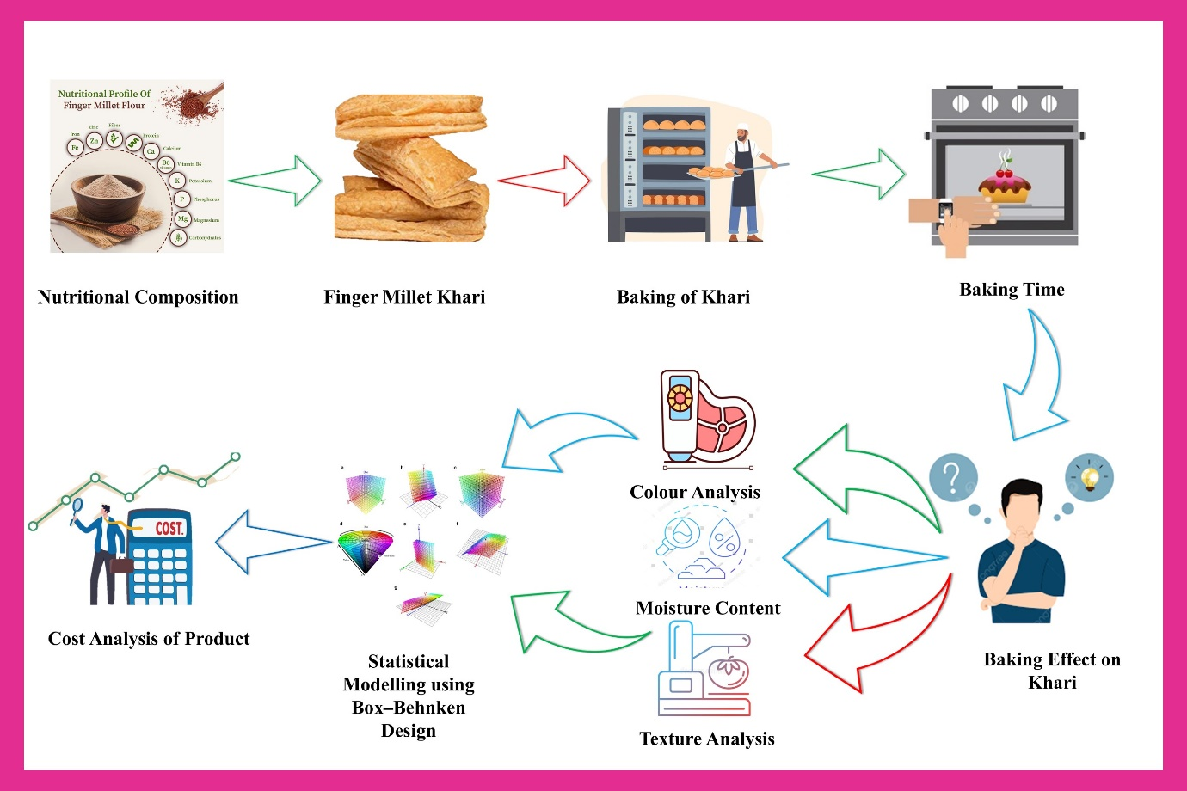

**INTRODUCTION**

One of the most widely grown millets is finger millet (*Eleusine coracana* L), and India accounts for 41% of global production, making it a major player on the production map. Africa comes in second. Finger millet is the fourth most important millet in the world, behind foxtail, pearl, and sorghum (Anonymous1).

Finger millet, commonly referred to as ragi in India and Nepal, is an important staple grain throughout Eastern Africa and Asia. The plant's top stem is covered in many spikes, or "fingers." The granules have a diameter of only 1-2 mm. Minerals, proteins, dietary fiber, and polyphenols are all abundant in finger millet grains. Rich in calcium, finger millet is beneficial for developing children, expectant mothers, and those with obesity, diabetes, and malnutrition. It has a high potassium content that supports healthy kidney and brain function and facilitates the smooth operation of muscles and the brain (Anonymous1). It is enhanced with fiber, minerals, micronutrients, macronutrients, amino acids, and fatty acids. Ragi is another name for finger millet that is used in Indian homes. Ragi is a staple food that is consumed without being dehulled and plays a significant role in Indian daily meals. Because it is easy to digest and full of nutrients and minerals, it is used as infant food (Kumar *et al.,* 2016).

Baking is the process of cooking food by applying heat, usually in an oven, but it can also be done in a cooker. It is a common cooking technique that involves heating food to a consistent temperature inside an oven. Convection and radiation are the primary methods used in this process to transmit heat to the product load. Despite being a well-known phenomenon, a complex process of mass, chemical, and heat transfer takes place inside the product, changing its qualities as it goes (Purlis, 2012).

Different results varying baking parameters, Excessive baking temperature will result in high crust colour, loss of volume, closely packed or uneven crumbs, and the drawbacks of underbaking, according to earlier research on the impacts of baking parameters. Otherwise, a low baking temperature could produce a crust with a lot of volume and a crumb texture that isn't very good (Sani *et al.,* 2014).The present study was focused on the Preparation of finger millet Khari and effect of different baking temperature on finger millet khari and its cost analysis was also studied.

**MATERIAL AND METHOD**

**Material**

The good quality of finger millet (Variety - Dapoli 1) was purchased from the Dr. Balasaheb Sawant Konkan Krishi Vidyapeeth, Dapoli, while Maida, dalda (vanaspati ghee), Salt and Sugar material were purchased from local market of Dapoli, District- Ratnagiri. The equipment’s required for the preparation of Khari – pulveriser, planetary mixer, Sheeter, knife, tray, weighing Balance, sealing machine was available in bakery experimental learning unit, College of Agricultural engineering and Technology, Dapoli.

**Preparation of Khari**

Finger millet of was ground into fine powder with the help of Pulveriser. The Khari was prepared by combined of Maida and finger millet flour in ratio of 70:30 proportion. The dough was made up by mixed 700 g of maida and 300 g of finger millet flour. 20 g of salt and 20 g of sugar and water were added while mixing the dough in planetary mixer. Dough was moulded on the Table sheet. Dalda about 450 g was spread uniformly over sheet. Three folds were made and kept as such for 15 min. Deck oven was set at desired temperature. Again, sheet was made and three folds were made. Fold was kept as such for 10 min. Again, sheet was made of uniform thickness. Prepared sheet was cut into uniform rectangular shapes. All the pieces were arranged in rows in tray. Water was spread on tray with the help of sprayer before baking. Place the tray in the deck oven at set temperature. Khari was prepared at four different temperature and time for the analysis. Khari was baked at 200oC for 12 min., at 220oC for 8 min., at 230oC for 6 min. and at 240oC for 5 min. After baking, tray was taken out from oven and placed for cooling. After cooling baked khari again placed in oven for roasting at temperature 140oC for 10 min. Khari was placed for cooling after roasting. A tabulated representation of preparation is shown in Fig 1.

**Table 1. Ingredients for preparation of sample code A, B, C and D in 70:30 ratio**

|  |  |
| --- | --- |
| **Ingredients** | **Weight (gram)** |
| Finger millet flour | 300 |
| Maida | 700 |
| Dalda | 450 |
| Salt | 20 |
| Sugar | 20 |

**Table 2. Treatment Details**

|  |  |  |  |
| --- | --- | --- | --- |
| **Sr.no** | **Sample code** | **Temperature in oC** | **Time in minute** |
| 1 | A | 200 | 12 |
| 2 | B | 220 | 8 |
| 3 | C | 230 | 6 |
| 4 | D | 240 | 5 |

**Flow Chart of Finger Millet Khari**

**Fig 1. Flow Chart of Finger Millet Khari**

**Moisture Content**

Moisture content of Finger millet khari recorded by hot air method. 30 g of sample was taken in moisture box. Weight of moisture box and sample was record. Moisture box without lid was place in hot air oven at 105 °C for 24 h. Lid was place over moisture box and sample was taken out and kept inside desiccator for 10-15 min. Weight after taking out sample from oven was recorded. The following formula calculated the percent moisture content :

Moisture Content (%) $= \frac{W1-W2}{W1-W}$

Where,

W = Weight of sample + Moisture box

W1 = Weight of sample after drying + Moisture box

W2 = Weight of empty moisture box

**Colour**

A colour of khari was measured by colour flex meter. The equipment was standardized with standard white tile. The khari slices were kept under aperture of colour measuring device. It represents the colour in L*, a* and b* value. Degree of lightness or darkness of khari was represented by “L*” value, redness to greenness by “a*” value and yellowness to blueness by “b*” value on hunter scale. The experiment was repeated for three times and average value was reported. The browning index was calculated by formula:

BI = ${( {∆L}^{2}+{∆a}^{2}+{∆b}^{2}) }^{1/2}$

Where,

L = Lightness / darkness

a = Redness / greenness

b = yellowness / blueness

**Sensory Analysis**

The Hedonic Rating Test was used to assess Sev's sensory qualities, such as colour, flavors, texture, taste, and crispness. The sensory qualities were assessed using Hedonic Rating assessments. Customers' acceptance of the goods is gauged by this test. A panel of five expert judges with a range of dietary preferences and ages were shown the samples. Using a sense of organs, the expert panellists were asked to rate the product's acceptability on a 9-point scale that went from strongly like to extremely dislike. During the assessment, a test Performa was created and provided to them (Schouteten et al., 2013). There is total four khari sample will place. The sample will code A-D. The rating was based on Nine-point Hedonic scale. The average score was reported for each treatment.

**Cost Economics**

While preparing the bakery products various direct and indirect costs are incurred in bakeries. The production cost of the bakery products includes the following:

1. Material Cost

2. Labour Cost

3. Fuel/Power Cost

4. Other Costs

The previous mentioned costs make up the total production costs of the bakery products. The average cost of each raw material was calculated. Product cost was worked out by taking into account the prevailing market rates.

**Statistical analysis**

The findings of each experiment were represented as the mean value ± standard deviation. Using Excel 2024 and Design Expert (version 13. 05), the model statistical analysis was done.

**RESULT AND DISCUSSION**

**Product Formulation**

The khari were prepared at four different temperatures. The prepared sample was denoted as T1 - 200oC, T2 - 220oC, T3 - 230oC, T4 - 240oC.

**Moisture Content**

Khari which was baked at 200oC for 12 min. having 4.88 % moisture content, at 220oC for 8 min. having 4.80 % moisture content, at 230oC for 6 min. having 4.68 % moisture content and at 240oC for 5 min. having 4.23 % moisture content was found. It was observed that khari which baked at high temperature at 240oC for 5 min. found low moisture content having 4.23 %.

**Fig 2.** **Moisture content of sample code A, B, C and D**

**Statistical analysis**

The moisture content of khari, is one of the most important factors to consider for effect of temperature on product. P-values lower than 0.0500 are considered significant, Terms with P-values higher than 0.1000 are not significant; if there are many insignificant terms, it may be beneficial to reduce the model. The Lack of Fit F-value of 0.5378 suggests that there is not a significant difference between the model and the pure error; there is a 87.39% chance that this could have been caused by random noise. A response surface quadratic model was used to measure the adequacy of the model for moisture content, as seen in Table 3, using the partial sum of Quadratic model.

**Table 3. ANOVA for Quadratic model**

|  |  |  |  |  |  |  |
| --- | --- | --- | --- | --- | --- | --- |
| **Source** | **Sum of Squares** | **df** | **Mean Square** | **F-value** | **p-value** |  |
| Model | 0 |  |  |  |  |  |
| Residual | 0.8739 | 12 | 0.0728 |  |  |  |
| Lack of Fit | 0.5832 | 8 | 0.0729 | 1 | 0.5378 | **not significant** |
| Pure Error | 0.2907 | 4 | 0.0727 |  |  |  |
| Cor Total | 0.8739 | 12 |  |  |  |  |

**Graphical analysis**

The moisture content decreased considerably due to the increasing the temperature of the baking oven. The range of moisture content was from 4.88 to 4.23%. The maximum moisture was at sample code A and minimum in sample code D, it as shown in Fig 3.

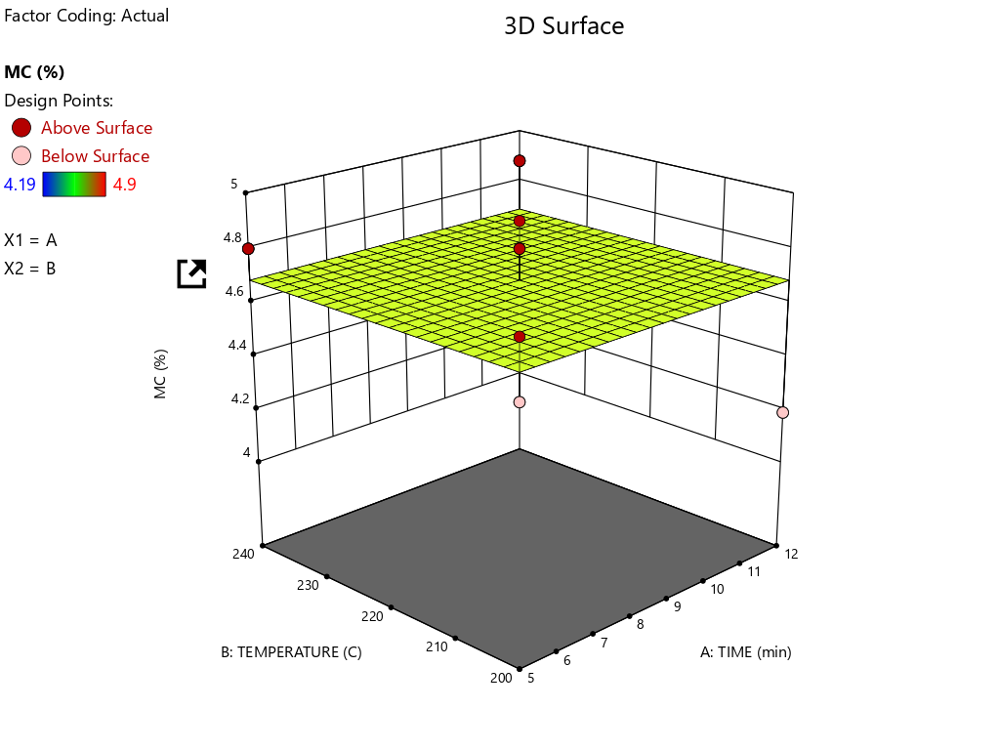

**Fig 3. Graphical analysis of Moisture Content**

**Colour Analysis**

The colour of the baked product can be influenced with ingredient, processing factor like baking time and temperature. The result of the value of colour parameter L*, a* and b* of khari were affected by baking temperature. It was observed that khari which baked at high temperature at 200oC for 5 min found high browning index of 13.53.

**Fig 4. Colour analysis of sample code A, B, C and D**

**Statistical analysis**

The Model F-value of 9.71 shows that the model is significant. It is highly unlikely that this result is due to chance, as the P-value is less than 0.0500. This means that certain model terms, such as A, B, AB, A2 and B2 , are significant. Model terms with values greater than 0.1000 are not. If there are many insignificant model terms, it might be beneficial to reduce the model. The Lack of Fit F-value of 0.0727 is not significant compared to the pure error, with a 18.55% likelihood of occurring randomly. This is desirable, as it means the model fits the data, A response surface quadratic model was used to measure the adequacy of the model for colour analysis, as seen in Table 4, using the partial sum of Quadratic model.

**Table 4. ANOVA for Quadratic model**

|  |  |  |  |  |  |  |
| --- | --- | --- | --- | --- | --- | --- |
| **Source** | **Sum of Squares** | **df** | **Mean Square** | **F-value** | **p-value** |  |
| Model | 1.36 | 5 | 0.2713 | 9.71 | 0.0047 | **Significant** |
| A-TIME | 0.9092 | 1 | 0.9092 | 32.53 | 0.0007 |  |
| B-TEMPERATURE | 0.1444 | 1 | 0.1444 | 5.17 | 0.0572 |  |
| AB | 0.042 | 1 | 0.042 | 1.5 | 0.2597 |  |
| A² | 0.2416 | 1 | 0.2416 | 8.65 | 0.0217 |  |
| B² | 0.0406 | 1 | 0.0406 | 1.45 | 0.2674 |  |
| Residual | 0.1956 | 7 | 0.0279 |  |  |  |
| Lack of Fit | 0.0101 | 3 | 0.0034 | 0.0727 | 0.9715 | **not significant** |
| Pure Error | 0.1855 | 4 | 0.0464 |  |  |  |
| Cor Total | 1.55 | 12 |  |  |  |  |

**Graphical analysis**

The colour value of the baking khari was up and down due to the temperature and time of the baking oven. The range of moisture content was from 13.63 to 12.53. as shown in Fig 5.

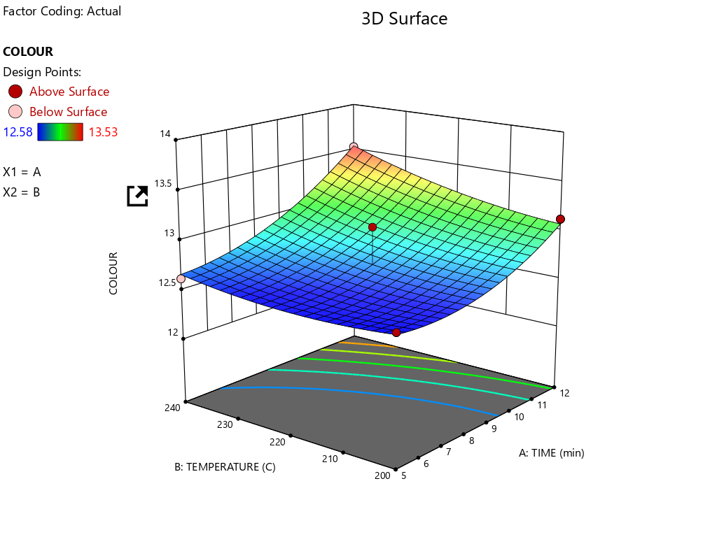

**Fig 5. Graphical analysis of Colour Analysis**

**Sensory Evaluation**

The result shown that the sensory score for the finger millet khari. It was observed that sample code A (200°C) have overall good acceptability as compare to other sample code.

**Table 5. Average Sensory Evaluation of sample code A, B, C and D**

|  |  |  |  |  |  |  |
| --- | --- | --- | --- | --- | --- | --- |
| **Sr. no.** | **Sample code** | **Sensory Attribute** | | | | **Overall acceptability** |
| **Colour** | **Texture** | **Taste** | **Flavour** |
| **1** | **A** | **7.28** | **7.44** | **7.64** | **7.36** | **7.43** |
| 2 | B | 7.36 | 7.12 | 7.16 | 7.24 | 7.22 |
| 3 | C | 7.08 | 7.08 | 7.16 | 7.20 | 7.13 |
| 4 | D | 7.28 | 7.24 | 7.20 | 7.28 | 7.25 |

**Cost Economics**

Cost economics for finger millet khari.

**Table 6. Cost of the material**

|  |  |  |  |
| --- | --- | --- | --- |
| **Sr.no** | **Items** | **Quantity in gram** | **Cost of the items** |
| 1 | Raw material | | |
|  | 1. Finger millet flour | 300 | Rs 72 |
|  | 1. Maida | 700 | Rs 28 |
|  | 1. Dalda | 450 | Rs 67 |
|  | 1. Sugar | 20 | Rs 0.8 |
|  | 1. Salt | 20 | Rs 0.4 |
| 2 | Labour | 1 | Rs 75 |
| 3 | Fuel | | |
|  | 1. LPG | 500 | Rs 35.7 |
| **Total cost** | | | **Rs 278.9 ~ Rs 279** |

The total weight of the above finished product comes to 1.6 kg. after reducing the wastage and the total production cost comes to Rs. 279 for 1.6 kg. When we compute per kg cost of khari, that comes to Rs. 200. The benefit cost ratio of finger millet khari is 1.14.

**CONCLUSION**

From the analysis of the results of this experiment we conclude that the finger millet khari which is baked at 200°C having moisture content 4.88%. Finger millet khari which is baked at 200°C is most acceptable khari and it has highest score in taste. In colour analysis Browning index of khari which is Baked at 200°C, 220° C, 230°C, 240°C has 13.53, 12.62, 13.2, 13.09 respectively. The benefit cost ratio of finger millet khari is 1.14. therefore, it is concluded that developed finger millet khari at baking temperature 200°C found to be economically beneficial.

**COMPETING INTERESTS DISCLAIMER:**

Authors have declared that they have no known competing financial interests OR non-financial interests OR personal relationships that could have appeared to influence the work reported in this paper.

**REFERENCE**

1. Anonymous1, APEDA (2024)https://apeda.gov.in/milletportal/Finger_Millet.html.
2. Chandra D, Chandra S and Sharma K. (2016) Review of Finger millet (Eleusine coracana (L.) Gaertn): A power house of health benefiting nutrients. Food Science and Human Wellness.;5(3):149-155. https://doi.org/10.1016/j.fshw.2016.05.004
3. Gull Amir, Gulzar Ahmad N, Kamlesh Prasad and Pradyuman Kumar. (2016). Technological, Processing and Nutritional approach of Finger Millet (Eleusinecoracana) - A Mini Review. Journal of Food Processing and Technology 7(6): 593. doi:10.4172/2157-7110.1000593
4. Khatal M. M., Sawant A. A., Shirsat B. S., Chavan P. P., Bansode P. B., and Kutwal A. M. (2024). Performance evaluation of deck oven for baking of finger millet biscuit. International Journal of Advance Biochemistry Research,8(9S):1416-1420. DOI: 10.33545/26174693.2024.v8.i9Sq.2366
5. Kumar A, Metwal M, Kaur S, Gupta K, Puranik S and Singh S. (2016)Nutraceutical value of finger millet [Eleusine coracana (L.) Gaertn.], and their improvement using omics approaches. Frontiers in Plant Science.;7(6):1-14. https://doi.org/10.3389/fpls.2016.00934.
6. Manjit M Khatal, AA Sawant, BS Shirsat, PP Chavan, PB Bansode and AM Kutwal. Performance evaluation of deck oven for baking of finger millet biscuit. International Journal Advances Biochemistry Research 2024;8(9S):1416-1420. DOI: 10.33545/26174693.2024.v8.i9Sq.2366
7. Purlis E. (2012). Baking process design based on modelling and simulation: Towards optimization of bread baking. Food Control, 27(1), 45–52. https://doi.org/10.1016/j.foodcont.2012.02.034
8. Sani NA, Taip FS, Kamal SM and Aziz NA. (2014) Effects of temperature and airflow on volume development during baking and its influence on quality of cake. Journal Engineering Science Technology 9:303–313
9. Schouteten, J. J., De Pelsmaeker, S., Juvinal, J., Lagast, S., Dewettinck, K., & Gellynck, X. (2018). Influence of sensory attributes on consumers’ emotions and hedonic liking of chocolate. British Food Journal, 120(7), 1489–1503. doi:10.1108/bfj-08-2017-0436
10. Shobana K, Krishnaswamy V, Sudha NG, Malleshi RM, Anjana L and Palaniappan V.(2013) Advance Food Nutrition Res. Finger millet (Ragi, Eleusine coracana L.): a review of its nutritional properties, processing and plausible health benefits.;69:1-39.
11. Thul Pooja P., S. B. Kalse, P. B. Bansode, Manjit M. Khatal, and A. A. Sawant. 2025. “Physicochemical Properties of Cookies Developed from Maida Substituted with Cashew Apple Powder”. Asian Journal of Current Research 10 (1):65-72. https://doi.org/10.56557/ajocr/2025/v10i19078.