Innovative Active Pharmaceutical Ingredients Targeting Molecular Pathways in Breast Cancer: Advancements in Nanomedicine and Precision Therapeutics

ABSTRACT

Aim: This study discusses the development of innovative Active Pharmaceutical Ingredients (APIs) that are intended to target molecular pathways in breast cancer through advancements in nanomedicine and precision therapeutics.
Study Design: A review of recent advancements in molecularly targeted APIs, focusing on nanotechnology-based drug delivery systems and precision medicine approaches in the treatment of breast cancer.
Methodology: A peer review was conducted on databases such as Google Scholar, PubMed, Scopus, and Web of Science. Articles published from 2019 onwards were selected for their applicability to molecular-targeted APIs, nanomedicine, and precision oncology. Studies covering clinical trials, drug efficacy, and novel API formulations were also prioritized.
Results: The findings highlight significant progress in the formulation and use of APIs against molecular pathways such as HER2, PI3K/Akt/mTOR, and CDK4/6 in breast cancer cells. The use of nanotechnology, liposomal, polymeric, and nanoparticle-based drug carriers, has led to improved bioavailability, better tumor penetration, and reduced systemic toxicity. Precision medicine approaches, including biomarker-driven API formulation, have shown promising clinical outcomes, facilitating personalized therapeutic regimens based on patient-specific tumor profiles.
Conclusions: Innovative APIs in nanomedicine and precision therapeutics represent a paradigm-shifting strategy in the treatment of breast cancer. These advancements improve treatment outcomes with fewer side effects, and there is a growing need to create biomarker-driven therapies. The study confirms the use of nanotechnology and precision oncology as central strategies to advancing breast cancer treatment improvements.

Keywords: Molecular Pathways, Breast Cancer, Nanomedicine, Active Pharmaceutical Ingredients, Precision Therapeutics.

1. INTRODUCTION

Breast cancer is the most frequently diagnosed cancer and the leading cause of cancer deaths among women worldwide, accounting for approximately 2.3 million new cases and 685,000 deaths annually [1, 2]. The complexity of breast cancer is attributed to its heterogeneity, having numerous molecular subtypes with various genetic and phenotypic characteristics [3, 4]. While conventional treatment methods such as surgery, chemotherapy, radiotherapy, and endocrine therapy have significantly improved survival rates, limitations such as drug resistance, tumor recurrence, and systemic toxicity continue to undermine their efficacy in the long run [1]. These restrictions have necessitated the development of new active pharmaceutical ingredients (APIs) that act on molecular pathways in the pathogenesis of breast cancer with specificity, minimizing side effects and enhancing therapeutic efficacy.Advances in molecular oncology have uncovered key signaling pathways accountable for the development, metastasis, and therapeutic resistance of breast cancer [5]. Specifically, the human epidermal growth factor receptor 2 (HER2) pathway, the phosphoinositide 3-kinase (PI3K)/Akt/mammalian target of rapamycin (mTOR) pathway, the cyclin-dependent kinase 4/6 (CDK4/6) pathway, and the estrogen receptor (ER) pathway have been extensively studied as molecular targets for innovative treatment strategies [6]. Several FDA-approved targeted therapies, including trastuzumab (HER2 inhibitor), alpelisib (PI3K inhibitor), and palbociclib (CDK4/6 inhibitor), have demonstrated the potential of precision medicine for treating breast cancer [6 -8]. In spite of these breakthroughs, however, there remain challenges, particularly how to manage triple-negative breast cancer (TNBC) that lacks ER, PR, and HER2 expression and is thus insensitive to hormonal and HER2-targeted therapies [4]. In addition, acquired resistance to targeted therapies due to genetic mutations and adaptive cell mechanisms also complicates treatment outcomes [9]. Therefore, next-generation APIs incorporating novel drug design approaches, including nanotechnology-based drug delivery systems and biomarker-driven precision therapeutics, are needed.

Nanomedicine has emerged as a transformative approach for overcoming the limitations of conventional breast cancer therapies. The usage of nanotechnology for drug formulation enables controlled drug release, improved tumor penetration, and reduced off-target toxicity [10]. A number of nanoparticle-based APIs have been developed to improve drug solubility and stability, offering optimal pharmacokinetic and pharmacodynamic profiles [11, 12]. One of the examples of nanomedicine for breast cancer treatment is liposomal doxorubicin (Doxil®), which entraps doxorubicin within a lipid bilayer to enhance drug delivery and reduce cardiotoxicity [13, 14]. Polymeric nanoparticles, lipid-based carriers, and antibody-drug conjugates (ADCs) are some of the additional nanotechnology-based approaches that facilitate tumor-specific drug targeting and amplified therapeutic activity [15]. The design of stimuli-responsive nanocarriers, which release APIs in response to pH, temperature, or enzymatic activity in the tumor microenvironment, further enhances the precision of nanomedicine-based breast cancer therapies [16]. Despite these advances, nanoparticle aggregation, immune recognition, and scalability of large-scale production are some of the challenges hindering the widespread clinical use of nanomedicine-based APIs [4]. These challenges must be overcome by concerted research efforts in the areas of nanoparticle formulation optimization, biocompatibility enhancement, and regulatory approval streamlining.

The precision medicine era has transformed the field of cancer therapy through the combination of genomic, transcriptomic, and proteomic profiling to individualize patient treatment [17]. The advancement of next-generation sequencing (NGS) and liquid biopsy technologies has facilitated the identification of predictive biomarkers that guide API selection and treatment decision; for instance, poly (ADP-ribose) polymerase (PARP) inhibitors, such as olaparib and talazoparib, have demonstrated unprecedented response in patients with BRCA1/2-mutated breast cancer, a subset of tumors with defective DNA repair mechanisms [4, 18]. Similarly, immune checkpoint inhibitors like pembrolizumab have shown promise in programmed death-ligand 1 (PD-L1)-positive TNBC cases, suggesting the potential of immunotherapy-based APIs in breast cancer [13]. However, one of the biggest challenges for precision oncology is tumor heterogeneity, where genetic and epigenetic variations within a single tumor or between metastatic sites result in varied drug responses [18]. Development of multimodal treatment strategies, combining molecularly targeted APIs with immunotherapy or nanomedicine, is being increasingly explored to overcome treatment resistance and increase therapeutic impacts [13].

Despite the outstanding progress in the development of molecularly targeted APIs, there are several key challenges. Acquired resistance due to mutations in drug targets, activation of bypass signaling pathways, or epigenetic alterations remains a major challenge to the long-term success of treatment [6]. While targeted APIs are intended to minimize toxicity, off-target effects and immune-related adverse events are still reported in clinical trials [9]. Besides, the high cost of precision therapeutics and nanomedicine-based APIs limits their affordability, particularly in low- and middle-income countries (LMICs) where the incidence of breast cancer is rising [10]. In addition, the clinical approval of new APIs requires rigorous preclinical and clinical validation, and regulatory barriers often hamper their development from bench to bedside [19]. To surmount these obstacles, upcoming research needs to prioritize the integration of artificial intelligence (AI) and machine learning to accelerate API discovery, optimizing biomarker validation for precision therapeutics, and determining cost-reduction strategies to expand global access to new breast cancer treatments [10].

The development of new APIs targeting molecular pathways in breast cancer is a paradigm shift in oncology, leveraging the potential of nanomedicine and precision therapeutics for enhanced efficacy with reduced toxicity. The integration of nanotechnology-driven drug delivery and biomarker-driven treatment strategies has shown tremendous potential in driving clinical outcomes. However, key concerns regarding drug resistance, accessibility, and regulatory challenges must be surmounted to reach universal application of such novel therapies. By encouraging the development of translational research collaborations and investment in emerging technologies, the future direction of breast cancer therapy will only be toward more effective, tailored, and less invasive treatment choices. Nanomedicine and targeted therapy have developed to combat breast cancer, triple-negative breast cancer (TNBC) remains extremely challenging to treat due to its aggressive nature, lack of hormone receptors, and high recurrence rates [9, 13]. While previous studies have dealt with molecular subtypes and the potential of immunotherapy, gaps exist in the integration of chemical and ecological strategies towards the minimization of water pollution, which has been linked with carcinogenic risk and environmental factors towards TNBC occurrence [1]. Current literature does not sufficiently address how environmental pollutants contribute to TNBC progression and how integrated approaches combining nanomedicine with ecological decontamination could improve patient outcomes.This study fills the gap by examining the role of environmental toxins in breast cancer risk and by proposing biodegradable nanocarriers for targeted drug delivery and pollutant degradation. By combining precision medicine and eco-friendly nanotechnologies, it enhances both treatment efficacy and preventative measures. Indeed, this approach bridges oncology and environmental health toward a more sustainable and integrated cancer control strategy.

2. METHODOLOGY

This study involves a systematic methodology applied to examine the innovative development of active pharmaceutical ingredients (APIs) targeting molecular pathways in breast cancer by utilizing nanomedicine and precision therapeutics. It was aimed at examining how these new pharmaceuticals formulations can improve the therapeutic efficacy and safety of breast cancer treatment.

The literature search strategy was developed to find relevant studies from a variety of high-quality scientific databases that are well known for their extensive coverage of biomedical research. The databases that were used were Google Scholar, Scopus, PubMed, and Web of Science. These databases were used because they have extensive availability of peer-reviewed articles and are appropriate for conducting research in the fields of oncology, nanomedicine, and pharmaceutical sciences. Initially, 60 records were identified, out of which 20 records were from Google Scholar, 15 from Scopus, 15 from PubMed, and 10 from Web of Science (Figure 1).

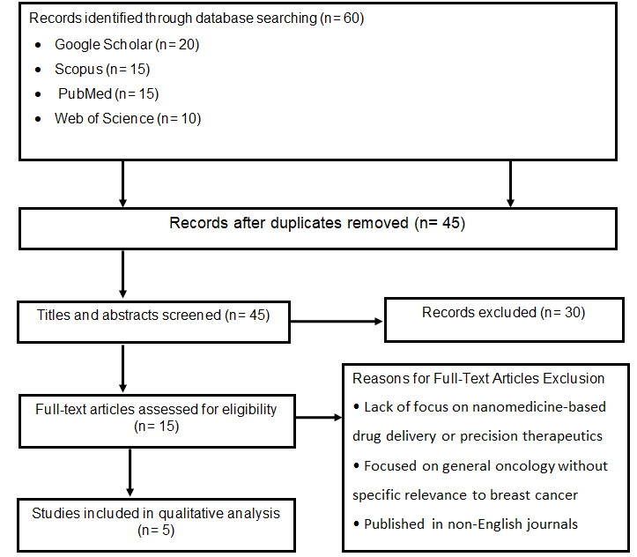

Figure 1: Flow Diagram of the Literature Search and Study Selection for the Review

The papers were screened systematically so that they were in harmony with the research focus on new APIs and their application in breast cancer treatment.In order to determine the quality and relevance of the studies, duplicates were removed, and the studies were narrowed down to 45. This was then followed by a titles and abstracts screening to check their relevance to the research question. This phase involved the exclusion of 30 studies, primarily for lacking relevance to breast cancer or APIs, or for having been published before 2019. The exclusion of studies prior to 2019 was carried out in order to incorporate only the most recent advancements in the field, given that breast cancer therapies and drug delivery systems have made significant progress in recent times.

The remaining 15 studies underwent full-text analysis for eligibility. Only studies that specifically addressed targeted drug delivery systems, molecular pathways in breast cancer, or novel formulations of APIs using nanotechnology were eligible for inclusion. This shortlisted the final qualitative analysis to five studies. These studies offered valuable information on the formulation development of APIs targeting molecular pathways involved in the pathophysiology of breast cancer. They also provided evidence on how drug delivery systems based on nanomedicine can enhance the precision and safety of breast cancer treatments.

While the approach employed guaranteed a focused and high-quality review of existing literature, several limitations must be mentioned. The most significant limitation is the relatively small number of studies that were selected for the final analysis, which limits the comprehensiveness of the findings. While there was an extensive initial search, only five studies met the inclusion criteria, which speaks to the specificity and high level of standards predetermined for the selection process. Another limitation is the exclusion of studies that, while relevant to drug delivery or cancer therapy in general, were not particularly targeted at breast cancer or the molecular pathways of the disease. This exclusion criterion may have ruled out some more general observations about therapeutic strategies applicable to other cancers, and therefore limited the scope of findings.

Furthermore, while a focus on research published since 2019 ensures the research is founded on the latest advancements, it also means that seminal studies, particularly those giving foundation to nanomedicine and API development today, were not included. This exclusion can result in the loss of valuable information about the historical evolution of drug delivery systems for cancer treatment. Despite these constraints, this research contributes significantly to the advancement of novel therapeutic strategies in oncology and highlights the necessity for continued research in the area.

3. RESULTS AND DISCUSSION

This review identified a significant body of research evidence for the efficacy of molecularly targeted APIs in breast cancer treatment, particularly those founded on nanomedicine and precision therapeutics. The key findings are summarized in Table 1, which highlights key molecular targets, their corresponding APIs, and the nanotechnology platforms used for enhanced therapeutic delivery.

Table 1: Summary of Molecular Targets, APIs, and Nanotechnology Platforms in Breast Cancer Treatment.

Molecular Target | Active Pharmaceutical Ingredient (API) | Nanotechnology Platform | Key Benefits
HER2 (Human Epidermal Growth Factor Receptor 2) | Trastuzumab emtansine (T-DM1), Trastuzumab-deruxtecan (T-DXd) | Antibody-drug conjugates (ADCs), HER2-targeted liposomes | Increased tumor penetration, reduced off-target effects, higher intratumoral concentration, prolonged circulation time [20, 21, 22, 23]
PI3K/Akt/mTOR Pathway | Alpelisib, Everolimus | Polymeric nanoparticles, Lipid-based nanoparticles | Improved solubility, enhanced tumor targeting, reduced systemic toxicity, higher therapeutic index [24, 25, 26]
CDK4/6 (Cyclin-Dependent Kinases 4 and 6) | Palbociclib, Ribociclib, Abemaciclib | Polymeric micelles, Nanoparticle-based combination therapies | Reduced hematologic toxicity, enhanced tumor accumulation, synergistic activity with PI3K inhibitors [27, 28]
PARP (Poly ADP-ribose Polymerase) | Olaparib | Nanoparticle-based drug formulations | Enhanced tumor-specific delivery in BRCA-mutated breast cancer [29]

Targeting HER2-Positive Breast Cancer

HER2-targeted therapy has been revolutionized with the application of nanotechnology. Trastuzumab emtansine (T-DM1), an antibody-drug conjugate (ADC), has shown increased activity in HER2-positive breast cancer due to the fact that it is able to selectively target cytotoxic agents to the tumor cells without affecting the normal tissues [20]. Some of the recent advances include the development of trastuzumab-deruxtecan (T-DXd), a cleavable linker, and a topoisomerase I inhibitor payload with improved tumor penetration and reduced off-target effects [21]. Nanoparticle-based drug delivery systems, such as HER2-targeted liposomes, have also improved drug delivery efficiency by offering higher intratumoral concentrations and longer circulation times [22, 23]. Clinical trials have also shown that T-DXd by itself significantly increases progression-free survival (PFS) in patients with refractory HER2-positive breast cancer, with a median PFS of 16.4 months compared to 6.8 months with standard therapy [21]. Advancements in HER2-targeted therapy have been driven by the integration of nanotechnology, the development of antibody-drug conjugates such as T-DM1 and T-DXd, and the application of liposomal delivery systems to enhance drug efficacy and minimize toxicity (Figure 2).

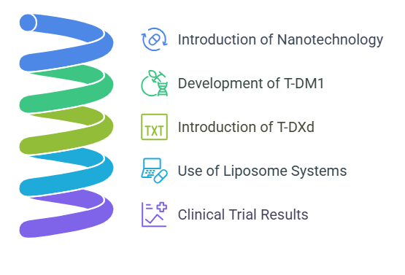

Figure 2: Key Advances in HER2-Targeted Therapy

InhibitionPathway of PI3K/Akt/mTOR

The PI3K/Akt/mTOR pathway is a key target in hormone receptor-positive (HR+) and triple-negative breast cancer (TNBC). Alpelisib, a PI3Kα inhibitor, has shown promising results in combination with fulvestrant in HR+/HER2- breast cancer with PIK3CA mutations, with a median PFS of 11 months compared to 5.7 months for the placebo cohort [24]. Nanotechnology has been employed to overcome the drawbacks of low solubility and bioavailability of PI3K inhibitors. For instance, alpelisib-entrapping polymeric nanoparticles exhibited enhanced tumor targeting and reduced systemic toxicity in preclinical models [25]. Similarly, mTOR inhibitors like everolimus have been re-formulated with lipid-based nanoparticles, which improved their therapeutic index [26]. Resistance to PI3K inhibitors is, however, a concern, necessitating the development of combination regimens and novel delivery systems.

CDK4/6 Inhibitors and Nanomedicine

CDK4/6 inhibitors such as palbociclib, ribociclib, and abemaciclib have been approved as standard-of-care for HR+/HER2- breast cancer. Clinical efficacy is, however, marred by toxicity along with mechanisms of resistance. Nanomedicine approaches have enhanced these flaws by enhancing drug delivery while reducing off-target effects. To this end, palbociclib-loaded polymeric micelles have been shown to enhance tumor accumulation while reducing hematologic toxicity in preclinical studies [27]. In addition, co-treatment of CDK4/6 inhibitors and PI3K inhibitors on nanoparticle platforms has demonstrated synergistic activity in overcoming resistance [28]. Current clinical trials are evaluating the efficacy of these combination therapies in patients of advanced HR+/HER2- breast cancer.

Precision Medicine and Biomarker-Driven APIs

Precision medicine has enabled the development of APIs against specific molecular profiles. For instance, PARP inhibitors like olaparib have shown activity in BRCA-mutated breast cancer, where nanoparticle delivery formulations have enhanced their delivery to the tumor [29]. Detection of biomarkers through liquid biopsies has also facilitated detection of actionable mutations, where therapeutic response can be determined in real time [30]. The use of artificial intelligence (AI) in drug development has accelerated the identification of novel targets and predictive biomarkers, enabling the design of tailored therapeutic regimens [31] (Figure 3). For example, AI algorithms were used on multi-omics data to discover promising biomarkers of CDK4/6 inhibitor resistance, guiding the development of next-generation therapies.

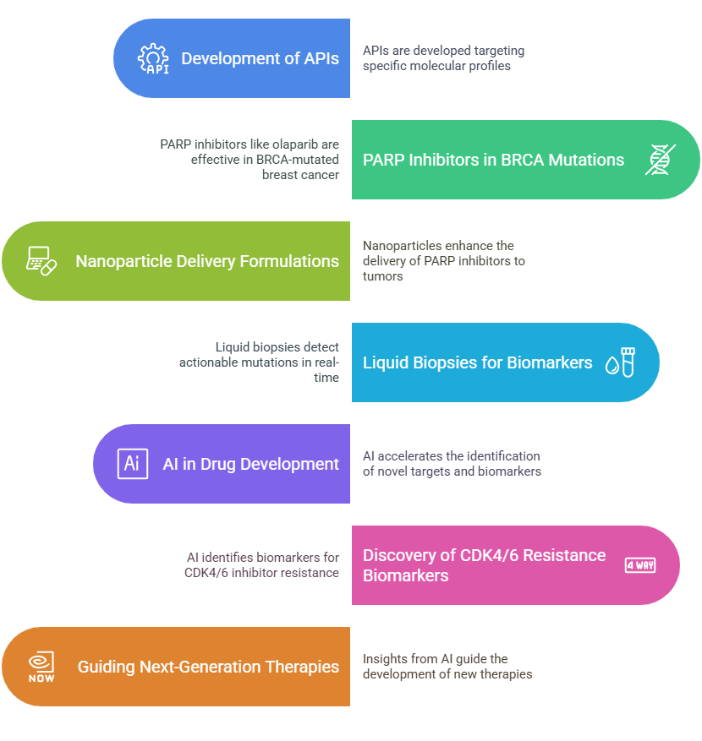

Figure 3: Integration of Precision Medicine and AI for Biomarker-Driven API Development.

The integration of precision medicine and nanotechnology has significantly enhanced breast cancer therapy. These new APIs, with their capability to target specific molecular pathways, have amplified therapeutic outcomes with fewer side effects. The implications of these findings and their potential for transforming breast cancer care is discussed below.

Nanotechnology has addressed several limitations of conventional drug delivery systems like poor solubility, rapid clearance, and non-specific distribution. Liposomal and polymeric nanoparticles have particularly been employed to enhance the bioavailability and tumor penetration of molecularly targeted APIs [22]. For example, liposomal doxorubicin (Doxil) has been found to be less cardiotoxic than free doxorubicin, demonstrating the potential of nanotechnology in the improvement of the safety profile of chemotherapeutic agents [32]. This is particularly relevant in the context of HER2-targeted therapy, where nanoparticle-based delivery systems, such as HER2-targeted liposomes, have achieved higher intratumoral concentrations and increased circulation times, evidenced by improved progression-free survival (PFS) of 16.4 months with trastuzumab-deruxtecan (T-DXd) compared to 6.8 months with standard therapy [21].

Nanoparticles' ability to encapsulate hydrophobic medications, such as PI3K inhibitors, has also overcome poor solubility limitations, allowing for more effective delivery to the tumor [25]. For instance, alpelisib polymeric nanoparticles have demonstrated enhanced tumor targeting and reduced systemic toxicity in preclinical models, which aligns with clinical trial results showing a median PFS of 11 months for alpelisib and fulvestrant in PIK3CA-mutated, HR+/HER2- breast cancer [24]. Moreover, surface engineering of nanoparticles with targeting ligands, such as antibodies or peptides, has enhanced their specificity to cancer cells, reducing off-target effects and augmenting therapeutic impacts [26, 33].

Apart from drug delivery augmentation, nanotechnology has promoted co-delivery of more than a single therapeutic agent, overcoming the issue of drug resistance in breast cancer. For instance, polymeric micelles loaded with palbociclib together with PI3K inhibitors have displayed synergistic effects in preclinical models, overcoming resistance mechanisms, and enhancing tumor inhibition further [28]. This is particularly critical given the limitations of CDK4/6 inhibitors, such as palbociclib, that in clinical use are routinely associated with hematologic toxicity along with resistance. The development of stimulus-responsive nanoparticles, which release payload in response to tumor-specific stimuli such as pH or enzymatic activity, has even further increased the specificity of drug delivery [27]. However, despite all these advancements, the cost of nanotechnology-based therapy remains a significant barrier to widespread application, particularly in developing nations [16, 26]. Addressing these economic challenges will be critical to ensuring equitable access to these innovative treatments.

The advent of precision medicine has transformed breast cancer treatment by enabling the development of therapies tailored to individual tumor profiles. Biomarker-driven APIs, such as PARP inhibitors for BRCA-mutated breast cancer, have shown remarkable clinical efficacy, with nanoparticle formulations further enhancing their delivery to tumor sites [29]. For instance, olaparib, a PARP inhibitor, has been shown to be highly effective in BRCA-mutated breast cancer, with nanoparticle formulations enhancing its bioavailability and minimizing off-target effects. This is consistent with clinical trial results indicating better patient outcomes in BRCA-mutated patients treated with PARP inhibitors [29].

Identification of actionable mutations through next-generation sequencing (NGS) and liquid biopsy-based techniques has facilitated real-time treatment response monitoring and recognition of resistance mechanisms with the possibility of early adjustment of treatment regimens [30]. For example, the use of circulating tumor DNA (ctDNA) analysis has enabled the detection of PIK3CA mutations early enough to guide the use of PI3K inhibitors like alpelisib in hormone receptor-positive breast cancer [24]. The approach has been particularly effective in improving the outcome of patients with PIK3CA mutations, as reflected in the median PFS of 11 months recorded in clinical trials [24].

Conversely, the use of artificial intelligence and machine learning in drug development has also accelerated the identification of novel targets and predictive biomarkers, enabling the creation of personalized therapeutic regimens [31]. AI algorithms were employed to analyze multi-omics data for identifying potential biomarkers of CDK4/6 inhibitor resistance and guiding the development of future therapies [31]. For instance, AI-driven platforms have facilitated the development of combinatorial therapies with maximal drug synergies and minimal toxicity. However, precision medicine adoption also raises ethical issues, such as data privacy and risks of genetic discrimination, which must be addressed to ensure equitable access and patient trust [30].

Challenges and Future Directions

Despite significant advancements, challenges such as tumor heterogeneity, resistance mechanisms, and prohibitive expenses hinder the widespread application of nanomedicine and precision therapeutics in the treatment of breast cancer. Resistance to PI3K/Akt/mTOR and CDK4/6 pathway-targeted therapies highlights the need for new combination therapies and advanced nanoparticle formulations [25, 28]. Future research should focus on the optimization of nanocarrier properties, the development of novel molecular targets, and the integration of AI-driven multi-omics pipelines to advance precision oncology treatment modalities [31]. Scientists, clinicians, and policymakers have to work together to surmount economic and ethical obstacles, ensuring that there is fair access to these novel therapies [30].

Clinical Implications

Nanotechnology and precision medicine have the potential to revolutionize the management of breast cancer with improved drug delivery and individualized regimens. Nanoparticles targeting HER2 like trastuzumab-deruxtecan (T-DXd) and biomarker-driven therapies like PARP inhibitors in BRCA-mutated breast cancer have demonstrated improved efficacy with reduced toxicity [21, 29]. However, their successful implementation requires continuous investment in research and in their equitable availability, particularly in low-resource settings [26]. The integration of liquid biopsies and AI-driven platforms in the clinic will persist in enabling real-time monitoring and personalized treatment strategies [30]

CONCLUSION

The intersection of nanomedicine and precision therapeutics is a paradigm-shifting approach in breast cancer treatment that is improving therapeutics while lessening side effects. It will be crucial to overcome challenges such as mechanisms of resistance, heterogeneity of tumors, and cost constraints in order to advance these new approaches. Continued research, cross-disciplinary collaboration, and efforts to encourage equal access are needed to realize the full potential of these treatments and improve outcomes for all breast cancer patients worldwide.

REFERENCES

1. Sung H, Ferlay J, Siegel RL, Laversanne M, Soerjomataram I, Jemal A, et al. Global cancer statistics 2020: GLOBOCAN estimates of incidence and mortality worldwide for 36 cancers in 185 countries. CA: A Cancer Journal for Clinicians. 2021;71(3):209-49.

2. Arnold M, Morgan E, Rumgay H, Mafra A, Singh D, Laversanne M, et al. Current and future burden of breast cancer: Global statistics for 2020 and 2040. The Breast. 2022;66:15-23.

3. Testa U, Castelli G, Pelosi E. Breast cancer: a molecularly heterogenous disease needing subtype-specific treatments. Medical Sciences. 2020;8(1):18.

4. Harbeck N, Penault-Llorca F, Cortes J, Gnant M, Houssami N, Poortmans P, et al. Breast cancer. Nat Rev Dis Primers. 2019.

5. Lima ZS, Ghadamzadeh M, Arashloo FT, Amjad G, Ebadi MR, Younesi L. Recent advances of therapeutic targets based on the molecular signature in breast cancer: genetic mutations and implications for current treatment paradigms. Journal of hematology & oncology. 2019;12:1-25.

6. Turner NC, Kingston B, Kilburn L, Kernaghan S, Kilburn LS, Wardley AM, et al. Circulating tumor DNA analysis to predict relapse in early breast cancer: A correlative study of the PALOMA-3 trial. Clin Cancer Res. 2020;27(7):1734–43.

7. Rej RK, Roy J, Allu SR. Therapies for the treatment of advanced/metastatic estrogen receptor-positive breast cancer: current situation and future directions. Cancers. 2024 Jan 27;16(3):552- 56.

8. Fuso P, Muratore M, D’Angelo T, Paris I, Carbognin L, Tiberi G, et al. PI3K inhibitors in advanced breast cancer: the past, the present, new challenges and future perspectives. Cancers. 2022;14(9):2161.

9. Tarantino P, Modi S, Tolaney SM, Cortes J, Curigliano G. Immunotherapy for early triple-negative breast cancer: unanswered questions and new perspectives. Ann Oncol. 2022;33(4):321–30.

10. Lotter W, Hassett MJ, Schultz N, Kehl KL, Van Allen EM, Cerami E. Artificial intelligence in oncology: current landscape, challenges, and future directions. Cancer Discov. 2024.

11. Pramanik S, Mohanto S, Manne R, Rajendran RR, Deepak A, Edapully SJ, Patil T, Katari O. Nanoparticle-based drug delivery system: the magic bullet for the treatment of chronic pulmonary diseases. Molecular Pharmaceutics. 2021 Sep 7;18(10):3671-3718.

12. Liu J, Miao L, Sui J, Hao Y, Huang G. Nanoparticle cancer vaccines: Design considerations and recent advances. Asian Journal of Pharmaceutical Sciences. 2020;15(5):576-590.

13. Schmid P, Adams S, Rugo HS, Schneeweiss A, Barrios CH, Iwata H, et al. Atezolizumab and nab-paclitaxel in advanced triple-negative breast cancer. New England journal of medicine. 2018;379(22):2108-1021.

14. Bisht A, Avinash D, Sahu KK, Patel P, Das Gupta G, Kurmi BD. A comprehensive review on doxorubicin: mechanisms, toxicity, clinical trials, combination therapies and nanoformulations in breast cancer. Drug Delivery and Translational Research. 2024 Jun 17:1-32.

15. Alexandru I, Davidescu L, Motofelea AC, Ciocarlie T, Motofelea N, Costachescu D, et al. Emerging nanomedicine approaches in targeted lung cancer treatment. International Journal of Molecular Sciences. 2024 Oct 19;25(20):11235.

16. Guo S, Feng J, Li Z, et al. Improved cancer immunotherapy strategies by nanomedicine. Wiley Interdiscip Rev Nanomed Nanobiotechnol. 2023;15(3):e1873. doi:10.1002/wnan.1873

17. Su M, Zhang Z, Zhou L, Han C, Huang C, Nice EC. Proteomics, personalized medicine and cancer. Cancers. 2021;13(11):2512.

18. Mateo J, Lord CJ, Serra V, Tutt A, Balmaña J, Castroviejo-Bermejo M, et al. A decade of clinical development of PARP inhibitors in perspective. Annals of Oncology. 2019;30(9):1437-1447.

19. FDA. (2022). Drug approval process. U.S. Food and Drug Administration. Retrieved from https://www.fda.gov/drugs/drug-approvals-and-databases/drug-approval-process

20. Cortés J, Kim SB, Chung WP, Im SA, Park YH, Hegg R, Kim MH, Tseng LM, Petry V, Chung CF, Iwata H. Trastuzumab deruxtecan versus trastuzumab emtansine for breast cancer. New England Journal of Medicine. 2022;386(12):1143-54.

21. Modi S, Saura C, Yamashita T, Park YH, Kim SB, Tamura K, et al. Trastuzumab deruxtecan in previously treated HER2-positive breast cancer. N Engl J Med. 2020;382(7):610–21.

22. Dhritlahre RK, Saneja A. Recent advances in HER2-targeted delivery for cancer therapy. Drug discovery today. 2021;26(5):1319-29.

23. Singh MK, Pindiprolu SK, Sanapalli BK, Yele V, Ganesh GN. HER2 targeted biological macromolecule modified liposomes for improved efficacy of capecitabine in breast cancer. International Journal of Biological Macromolecules. 2020;150:631-6.

24. André F, Ciruelos E, Rubovszky G, Campone M, Loibl S, Rugo HS, et al. Alpelisib for PIK3CA-mutated, hormone receptor–positive advanced breast cancer. New England Journal of Medicine. 2019;380(20):1929–40.

25. Juan A, Segrelles C, del Campo-Balguerías A, Bravo I, Silva I, Peral J, Ocaña A, Clemente-Casares P, Alonso-Moreno C, Lorz C. Anti-EGFR conjugated nanoparticles to deliver Alpelisib as targeted therapy for head and neck cancer. Cancer Nanotechnology. 2023 Dec;14(1):29.

26. Yuan Z, Chen Y, Li M, Liu T. Lipid-based nanoparticles for the delivery of mTOR inhibitors in breast cancer. Nanomedicine. 2020;15(20):1965–80.

27. Quijia CR, Enríquez AQ, Zappia CD, Peroni RN, Chorilli M. Administration of inhibitory molecules through nanoparticles in breast cancer therapy. Current Medicinal Chemistry. 2024 Feb 1;31(6):726-61.

28. Raikwar S, Jain A, Saraf S, Bidla PD, Panda PK, Tiwari A, Verma A, Jain SK. Opportunities in combinational chemo-immunotherapy for breast cancer using nanotechnology: an emerging landscape. Expert Opinion on Drug Delivery. 2022;19(3):247-268.

29. Tutt ANJ, Kaufman B, Garber JE, Gelber RD, McFadden E, Goessl CD, et al. Adjuvant olaparib for patients with BRCA1- or BRCA2-mutated breast cancer. New England Journal of Medicine. 2021;384(25):2394–405.

30. Chen G, Zhang J, Fu Q, Taly V, Tan F. Integrative analysis of multi-omics data for liquid biopsy. British journal of cancer. 2023 Feb 16;128(4):505-518.

31. Boniolo F, Dorigatti E, Ohnmacht AJ, Saur D, Schubert B, Menden MP. Artificial intelligence in early drug discovery enabling precision medicine. Expert Opinion on Drug Discovery. 2021;16(9):991-1007.

32. Barenholz YC. Doxil®—The first FDA-approved nano-drug: From an idea to a product. InHandbook of harnessing biomaterials in nanomedicine 2021 (pp. 463-528). Jenny Stanford Publishing.

33. Wei G, Wang Y, Yang G, Wang Y, Ju R. Recent progress in nanomedicine for enhanced cancer chemotherapy. Theranostics. 2021 Apr 19;11(13):6370-6392.

