Journal Name: | Annual Research & Review in Biology
Manuscript Number: | Ms_ARRB_133024
Title of the Manuscript: | Physiological indicators Physiological Indicators of Paeoniflorin and Caffeine in Modulating the Motility of Caenorhabditis elegans via Adenosine Receptor
Type of the Article | Original Research Article

PART 1: Comments

 | Reviewer’s comment  Artificial Intelligence (AI) generated or assisted review comments are strictly prohibited during peer review. | Author’s Feedback (Please correct the manuscript and highlight that part in the manuscript. It is mandatory that authors should write his/her feedback here)
Please write a few sentences regarding the importance of this manuscript for the scientific community. A minimum of 3-4 sentences may be required for this part. | This study focuses on evaluating the effects of Paeoniflorin on the motility of the nematode Caenorhabditis elegans via adenosine receptors. Paeoniflorin is a natural compound with various pharmacological properties, including antioxidant, anti-inflammatory, neuroprotective, antitumor, and immunomodulatory effects. The aim of the research is to explore the potential of Paeoniflorin as an adenosine receptor modulator, thereby providing a foundation for drug screening and development.
Is the title of the article suitable?  (If not please suggest an alternative title) | Yes, it is acceptable
Is the abstract of the article comprehensive? Do you suggest the addition (or deletion) of some points in this section? Please write your suggestions here. | It is required to change the sentence following below comments: “Molecular docking analysis revealed that paeoniflorin exhibited a binding energy of -6.9 kcal/mol with the Ador-1 protein, confirming its targeting capability”.  - Detail interaction between ligand and key amino acid located in active binding domain of receptor;  - 3D interaction with detail distance of bonding.  - Recommend to provide comparison with reference (interaction of caffeine, cocrystal ligand 8JN with targeted receptor PDB ID 5N2R).
Is the manuscript scientifically, correct? Please write here. | In order to enhance the scientific credibility, the study should include theoretical foundations such as docking simulations and molecular dynamics (MD) simulations to explain the interactions of Paeoniflorin and Caffeine with the targeted receptor, thereby correlating with the experimental results.
Are the references sufficient and recent? If you have suggestions of additional references, please mention them in the review form. | Yes, it is accepted.
Is the language/English quality of the article suitable for scholarly communications? | It is acceptable
Optional/General comments | If possible, docking between caffeine and PDB ID 5N2R should be added to provide comparative data with paeoniflorin.  Please review the docking conditions using Autodock Vina 1.1.2 (centerx = 21.0, centery = 172.0, centerz = 16.8; search space dimensions: sizex = 60, sizey = 60, sizez = 60, with a grid point spacing of 0.375 Å). The search space dimensions are too large and not focused on the active binding domain of the receptor.  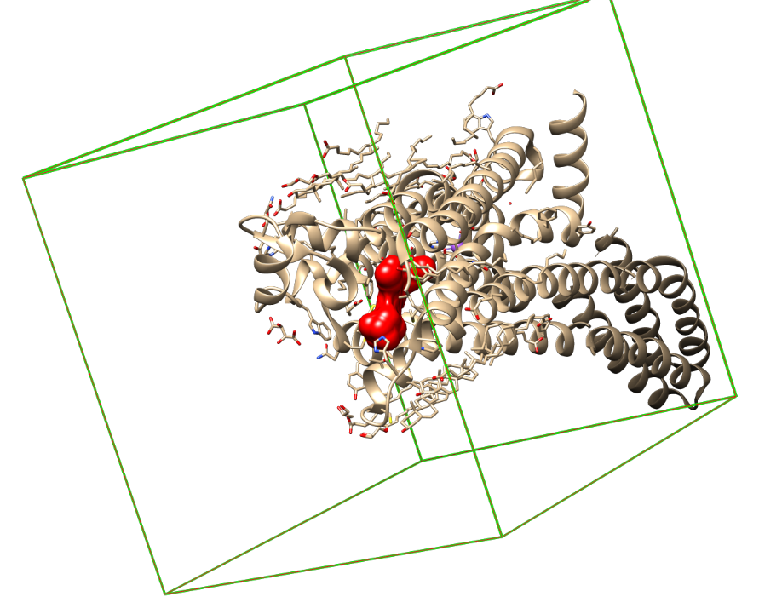  3D model of PDB ID 5N2R (Red color is 3D surface of ligand 8JN) - Simulated docking conditions according to the parameters reported in the manuscript (centerx = 21.0, centery = 172.0, centerz = 16.8; search space dimensions: sizex = 60, sizey = 60, sizez = 60), using UCSF Chimera version 1.1.18.

PART 2:

 | Reviewer’s comment | Author’s comment (if agreed with reviewer, correct the manuscript and highlight that part in the manuscript. It is mandatory that authors should write his/her feedback here)
Are there ethical issues in this manuscript? | (If yes, Kindly please write down the ethical issues here in details)

Reviewer details:

Pham Van Chung, Thu Dau Mot University (TDMU), Vietnam

