Assessment of various bee attractants on Apis florea Fabricius and their influence on seed yield of niger, Guizotia abyssinica (L.f.) Cass. crop

Abstract

A study was conducted at the experimental farm of PC Unit Sesame and Niger, College of Agriculture, Jawaharlal Nehru Krishi Vishwa Vidyalaya, Jabalpur, Madhya Pradesh, during Kharif 2021. To determine the impact of bee attractants on the attraction of Apis florea and their impact on seed yield of niger crop, the experiment was set up using a Randomized Block Design with nine treatments and three replications. Research found that during 10% and 50% flowering stages of the crop, Apis florea visit was numerically the highest with rose water 10% (12.83 individual/m²/5min) and sugar solution 10% (14.33 individual/m²/5min) treatments, respectively. The population of Apis florea received from controlled conditions were 2.67 and 3.75 individual/m²/5min at 10% and 50% flowering stage, respectively. The foliar spray of rose water 10%, sugar solution 10%, and flower extract of M. longifolia 10% solution were found significantly superior over others in respect to seed yield with a recorded seed yield of 6.90, 6.70, and 6.30 q/ha, respectively.
Keywords: Rose water, Apis florea, flower extract of Madhuca longifolia and significantly superior.
1. Introduction
Niger [Guizotia abyssinica (L. f.) Cass.] is a native of Tropical Africa and belong to the family Asteraceae (Compositae). It is known as lifeline of tribal agriculture and economy in India. It is grown by tribals on marginal and sub-marginal lands with negligible inputs under rainfed conditions (Ranganatha et al., 2009). Niger is produced on an area of 112.8 thousand hectares in India, with a production of 40.3 thousand tonnes and an average productivity of 357.2 kg per hectare. Madhya Pradesh supplies roughly 16.0 thousand hectares of land, with an annual yield of 4.9 thousand tonnes and a seed productivity of 308.8 kg per hectare (Anonymous, 2021-22). It is used as an oilseed crop in India where it provides about 3% of the edible oil requirement of the country (Getinet and Sharma, 1996). The niger seed contain 32-40% oil and 18-24% protein in the seed. Niger oil, is pale yellow with a nutty taste and a pleasant odour (Dwarka et al., 2024a,b,c,d,e). The oil and seeds are free from any toxin, and the taste of oil is similar to desi ghee.
Niger is self-incompatible with 100 per cent cross-pollinated crop (Dwarka et al., 2022). Insect pollination not only ensures the increase in seed yields of various cross-pollinated crops, including niger, but also improves their quality. It ensures uniform maturity and early harvest of crops. Provision of bee colonies during the flowering period of crop is a simple but essential input (Dwarka et al., 2022). A planned bee pollination programme on national scale significantly contributes to solve the problem of edible oil shortage in the country even at the existing level of land use of oil crops (Mohana Rao et al., 1981). Studies on the effect of honey bee pollinators in niger crop indicated that the yield was reduced by 11-78 per cent in the absence of honey bee as well as natural pollinators. An additional income of Rs. 252 to Rs. 2125, including Rs. 1015/ha from honey, was estimated through beekeeping with niger over open pollinated crops (Anonymous, 2005). Honey bees are considered as the most effective and ideal pollinators. Success of pollination with the help of honey bees depends on their performance to the target crop over other following plants in the vicinity. Commercial and local bee attractants viz., bee line, bee here, bee scent, bee scent plus, fruit boost, Bee-Q, sugar solution, sugarcane juice, jaggery solution, Molasses, etc. are being used to boost the foraging activities of niger in Jabalpur, Madhya Pradesh (Dwarka et al., 2022; 2023a,b,c). However, the related studies on the use of bee attractants in India are scanty. The conservation and management of insect pollinators is gaining importance day by day. In this regard, the present experiment was conducted to evaluate the effect of different bee attractants on Apis florea Fabricius and their impact on niger seed yield.
2. Material and methods
Jabalpur, a city in Madhya Pradesh, is situated on the bank of the Narmada river. The city is located from 22°49’’ N to 24°8’’ N and 78°21’’ E, with an altitude of 411.78 m.a.s.l. The study on the effect of different bee attractants on the foraging activities of Apis florea in niger crop was conducted in a randomized block design with three replications at the experimental farm of the PC Unit (ICAR) Sesame and Niger, College of Agriculture, JNKVV, Jabalpur, Madhya Pradesh, during Kharif 2021 season.
Table. 1: List of attractants evaluated
Sl. No. | Treatments/attractants
1. | T₁- Flower extract of Madhuca longifolia 10%
2. | T₂ –Juice of Sachharum officinarum 10%
3. | T₃ -Jaggery solution 10%
4. | T₄ -Honey solution 10%
5. | T₅ -Fruit extract of Phoenix dactylifera 10%
6. | T₆-Sugar solution 10%
7. | T₇ -Rose water (Marketed) 10%
8. | T₈ -Water spray
9. | T₉-Control
The above-mentioned attractants were sprayed two times, first at 10% and second at 50% flowering stage of the crop. The recommended agronomical package of practices were followed for raising good and healthy crop. From each plot, one-meter square areas were selected randomly, and the number of Apis florea visiting the niger flowers for 5 minute duration within that demarcated one-meter square areas were noted. The observations were recorded a day before and 1st, 3rd, 5th, and 7th days after both sprayings. Seed yield obtained from different treatments were recorded separately. The identification of insects were verified with the help of Regional Centre, ZSI, Jabalpur, Madhya Pradesh.
3. Results and discussion
The results of the present investigation revealed that all the bee attractants sprayed had significant effect on the foraging activities of Apis florea in niger crop. They proved superior in recorded parameters over control, i.e., unsprayed and without pollinators.
The result revealed that all the treatments were differed significantly from each other in respect to attracting the population of Apis florea. At 10% flowering stage, Apis florea visit was numerically highest with rose water 10% (12.83 individual/m²/5min) treatment followed by M. longifolia solution 10% flower extract spray (12.67 individual/m²/5min). In the case of control treatment, abundance was lowest (2.67 individual/m²/5min) followed by the treatment with water spray (4.75 individual/m²/5min). At 50% flowering stage, the highest population of Apis florea was attracted with sugar solution 10% (14.33 individual/m²/5min), rose water 10% (14.25 individual/m²/5min), and flower extract of Madhuca longifolia 10% (14.17 individual/m²/5min). Here also, the population in control treatment was lowest (3.75 individual/m²/5min) followed by water spray (5.83 individual/m²/5min). Present findings are also supported by the findings of Singh (2015), who reported that bees were observed that visiting the flowers Apis florae. Present findings are corroborated with the findings of Manchare et al. (2019) who showed that the use of honey solution 10 % at flowering has the highest (2.32 bees/m2 /min) ability to attract Apis cerena indica towards the flowers followed by jaggery solution 10 % (2.16 bees/m²/min) and molasses 10 % (2.04 bees/m²/min).
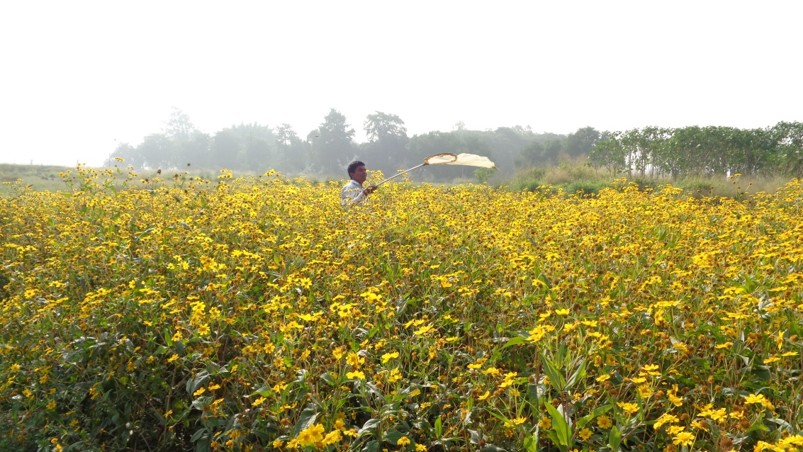
Plate: 1. Experimental field
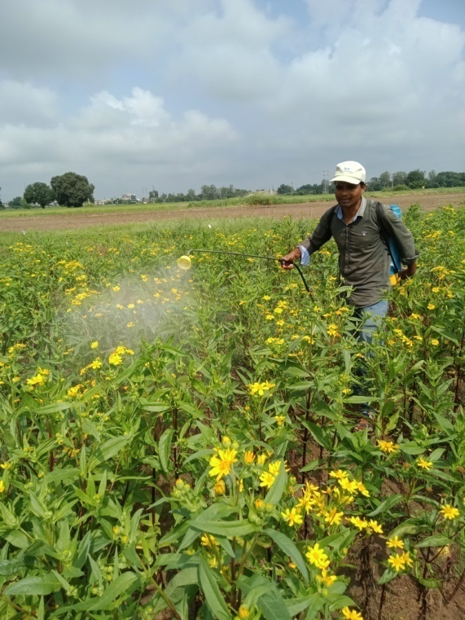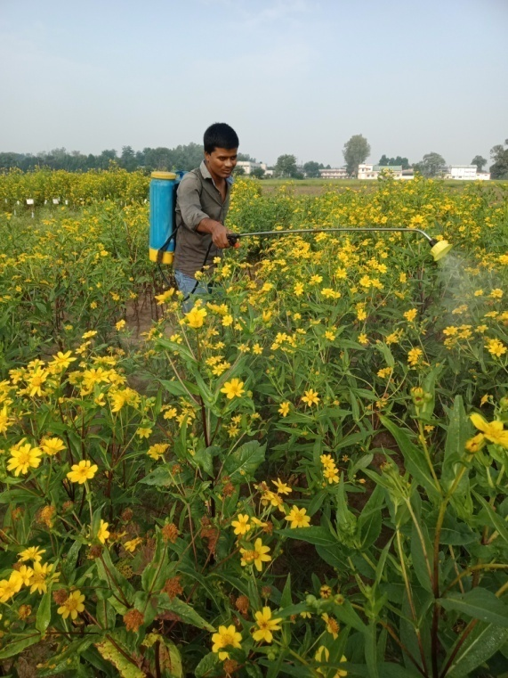
Plate: 2. 10% flowering stage Plate: 3. 50% flowering stage
3.3. Seed yield (q/ha)
The data on seed yield revealed that all the treatments differed significantly from each other in terms of seed yield. The highest seed yield was recorded with the treatment in which foliar spray of rose water 10% (6.90 q/ha) was applied, followed by sugar solution 10 %(6.70 q/ha) and flower extract of M. dactylifera (6.30 q/ha) spray. Least seed yield was recorded from the controlled condition (3.15 q/ha), followed by 10% jiggery solution (4.40 q/ha) and water spray (4.80 q/ha). These findings corroborated with the findings of Chandrashekhar and Sattigi (2009) as they have also observed that spraying of bee attractant like cacambe (10%) and jaggary solution (10%) were significantly superior in enhancing both quantitative and qualitative parameters of radish seed. These findings are in close conformity with the earlier reports of Dwarka et al., (2022) who have reported the highest seed yield (6.90 q/ha) in the case of treatment with foliar spray of Madhuca longifolia 10% flower extract . Similarly Jayaramappa et al., (2011), Dwarka et al., (2023^{a,b,c}).
4. Conclusion
From the above results, it can be concluded that for the attraction of Apis florea, rose water 10% was the best when sprayed at 10% and 50 % flowering stages, followed by flower extract of M. longifolia 10% and fruit extract of Phoenix dactylifera 10%. These treatments are capable of attracting a comparatively higher number of Apis florea and simultaneously recorded higher seed yield over others.

Table 2: Effect of different attractants on the attraction of little honey bee, Apis florea and their impact of seed yield in niger crop Kharif 2021.
Treatment | Population of Apis florea/m²/5 minutes |  |  |  |  |  |  |  |  |  |  |  | Yield  (q/ha)
Treatment | 1st spray at 10% flowering |  |  |  |  |  | 2nd spray at 50% flowering |  |  |  |  |  | Yield  (q/ha)
Treatment | 1DBS | Days after spray |  |  |  | Mean | 1DBS | Days after spray |  |  |  | Mean | Yield  (q/ha)
Treatment | 1DBS | 1DAS | 3DAS | 5DAS | 7DAS | Mean | 1DBS | 1DAS | 3DAS | 5DAS | 7DAS | Mean | Yield  (q/ha)
T₁-Flower extract of M. longifolia 10% | 5.00  (2.34) | 11.00  (3.37) | 18.00  (4.30) | 11.67  (3.48) | 10.00  (3.24) | 12.67  (3.63) | 6.33  (2.61) | 12.33  (3.56) | 18.00  (4.29) | 17.67  (4.26) | 8.67  (3.01) | 14.17  (3.83) | 6.30  (2.61)
T₂-Juice of S. officinarum 10% | 3.67  (2.04) | 9.67  (3.18) | 11.00  (3.35) | 9.33  (3.11) | 7.33  (2.78) | 9.33  (3.13) | 4.33  (2.20) | 11.67  (3.48) | 12.00  (3.52) | 15.67  (4.01) | 10.33  (3.29) | 12.42  (3.59) | 5.82  (2.51)
T₃-Jaggery solution 10% | 4.00  (2.11) | 12.33  (3.56) | 13.67  (3.74) | 7.67  (2.78) | 6.67  (2.67) | 10.08  (3.24) | 5.00  (2.34) | 13.33  (3.69) | 14.00  (3.80) | 13.33  (3.69) | 9.33  (3.13) | 12.50  (3.60) | 4.40  (2.21)
T₄-Honey solution 10% | 2.67  (1.77) | 6.33  (2.58) | 11.67  (3.48) | 6.00  (2.40) | 5.67  (2.46) | 7.42  (2.81) | 3.33  (1.95) | 8.00  (2.90) | 11.67  (3.48) | 13.67  (3.72) | 7.67  (2.84) | 10.25  (3.28) | 5.45  (2.44)
T₅- Fruit extract of F. dactylifera 10% | 3.00  (1.86) | 13.67  (3.70) | 15.33  (3.95) | 10.00  (3.24) | 9.67  (3.18) | 12.17  (3.56) | 5.33  (2.40) | 10.33  (3.28) | 13.00  (3.67) | 16.67  (4.14) | 10.67  (3.33) | 12.67  (3.63) | 6.00  (2.55)
T₆-Sugar solution 10% | 4.33  (2.18) | 10.33  (3.28) | 13.00  (3.66) | 11.00  (3.38) | 11.33  (3.41) | 11.42  (3.45) | 3.00  (1.86) | 14.67  (3.86) | 15.33  (3.98) | 18.33  (4.33) | 9.00  (3.06) | 14.33  (3.85) | 6.70  (2.68)
T₇-Rose water 10% | 2.00  (1.56) | 14.33  (3.80) | 16.33  (4.10) | 12.33  (3.56) | 8.33  (2.96) | 12.83  (3.65) | 4.00  (2.11) | 15.00  (3.90) | 14.33  (3.82) | 16.00  (4.06) | 11.67  (3.48) | 14.25  (3.84) | 6.90  (2.72)
T₈-Water spray | 1.67  (1.46) | 5.67  (2.46) | 6.33  (2.60) | 4.67  (2.21) | 2.33  (1.66) | 4.75  (2.28) | 2.33  (1.68) | 6.33  (2.58) | 5.33  (2.40) | 5.67  (2.43) | 6.00  (2.54) | 5.83  (2.51) | 4.80  (2.30)
T₉-Control | 1.33  (1.34) | 3.00  (1.81) | 4.00  (2.08) | 1.67  (1.35) | 2.00  (1.56) | 2.67  (1.77) | 2.33  (1.68) | 4.33  (2.16) | 3.33  (1.93) | 3.00  (1.82) | 4.33  (2.20) | 3.75  (2.06) | 3.15  (1.92)
SEm± | 0.14 | 0.29 | 0.26 | 0.34 | 0.21 | 0.10 | 0.12 | 0.29 | 0.23 | 0.26 | 0.19 | 0.09 | 0.03
CD at 5% | 0.43 | 0.88 | 0.78 | 1.03 | 0.63 | 0.30 | 0.35 | 0.86 | 0.70 | 0.79 | 0.58 | 0.28 | 0.09
*Figures in parenthesis are square root (√ x+0.5) transformed values

5. References
Abrol DP. Foraging behavior of Apis florea F. an important pollinator of Allium cepa L. Journal of Apicultural Research. 2010;49(4):318-325.
Anonymous. 2005. observations made during “national seminar on strategies for enhancing production and export of sesame and niger” and “annual workshop of AICRP on sesame and niger research workers, 2005”.
Anonymous. 2020-21. 4th Advance Estimate, Agriculture Statistics Division, Directorate of Economics and statistics, New Delhi. Indian Journal of Natural Products and Resources, 2:221-226.
Dwarka, Chadar N, Katara VK , Thakur S, Shukla S, Parveen S, Maneesha and Ahirwar MK. Introduction to Insect Pests of Niger [Guizotia abyssinica (L.f.) Cass.] and Their Management: A Review. Journal of Experimental Agriculture International. 2024a;46(11): 835-841.
Dwarka, Ghugal SG, Thakur S, Panday AK. Evaluation of Various Bee Attractants on the Foraging Behavior of Indian Honey Bee (Apis cerana indica) and their Impact on the Seed Yield of Niger [Guizotia abyssinica (L.f.) Cass]. Advances in Research. 2024b;25(6);528-534.
Dwarka, Panday AK , Thakur S , Katara VK , Patel DK and Kurmi JP. Impact of different bee attractants on the attraction of Indian honey bee, Apis cerana indica and their impact on seed yield of niger, Guizotia abyssinica (L.f.) Cass, crop. Plant Archives. 2024c;24(2); 255-258.
Dwarka, Panday AK , Thakur S and Katara VK. Study on the Effect of Bee Attractants on the Giant Honey Bee, Apis dorsata and their Effect on Niger [Guizotia abyssinica (L.f.) Cass] Seed Yield Journal of Experimental Agriculture International. 2024d;46(7); 903-908.
Dwarka, Panday AK and Saxena AK. To study the effect of bee attractants on the attraction of giant honey bees (Apis dorsata) and their impact on seed yield of Niger (Guizotia abyssinica) crop. The Pharma Innovation Journal. 2022;11(12): 866-868.
Dwarka, Panday AK, Saxena AK, Jain S, Marabi RS and Sahu R. Impact of different weather parameters on the population of pollinators visited on Niger flowers. The Pharma Innovation Journal. 2023a;12(7): 619-621.
Dwarka, Panday AK, Saxena AK, Jain S, Sahu R and Marabi RS. The relative abundance of insect pollinators/visitors in Niger (Guizotia abyssinica) crop. The Pharma Innovation Journal. 2023b;12(2): 3579-3581.
Dwarka, Panday AK, Tare S, Thakur S, Katara VK. Effect of Bee Attractants on the Attraction of Apis dorsata and their Impact on Seed Yield of Niger Guizotia abyssinica (L.f.) Cass Crop. Journal of Scientific Research and Reports. 2024e;30(6):420- 426.
Dwarka, Saxena AK, Panday AK, Jain A and Marabi RS. Succession of different insect pollinators on Niger flowers grown under different dates of sowing. The Pharma Innovation Journal. 2023c;12(7): 622-627.
Getinet A and Sharma SM. 1996. Niger, Guizotia abyssinica (L.f.) Cass. Promoting the conservation and use of underutilized and neglected crops. Institute of Plant Genetics and Crop Plant Research. International Plant Genetic Resources Institute, Rome.
Jayaramappa Kract V, Pattibhiramaiah M and Bhargava HR. Influence of bee attractants on yield parameters of Ridge gourd (Luffa acutangulus L.) (Cucurbitaceae).World Applied Science Journal. 2011;15(4);547-462.
Kalmath BS and Sattigi HN. Effect of different attractants on attracting the bees to onion (Alium cepa) crop. Indian Bee Journal. 2002;64(6): 68-71.
Manchare RR, Kulkarni SR and Chormale TS. Effect of bee attractants on foraging activities of Indian bees Apis cerena indica in bitter gourd (Momordica charantia L.). Journal of Entomology and Zoology Studies. 2019;7(5); 468-472.
Mohana Rao, GM, Lazar M and Suryanarayana MC. Foraging behaviour of honeybees in sesame (Sesamum indicum L.). Indian Bee Journal. 1981;43:97-100.
Ranganatha ARG, Tripathi A, Jyotishi A, Paroha S, Deshmukh MR and Shrivastava N. 2009. Strategies to enhance the productivity of sesame, linseed and niger. In: Proceedings of Platinum Jubilee Celebrations, UAS, Raichur.
Singh RS, Amrendra Pratap B, Singh Singh DV. Abundance and foraging activity of bee visitors to pigeonpea. Progressive Agriculture. 2015;15(1):116- 119.
Venkataramegowda S, Koragandahalli VJ, Menon A and Ruben MC. Use of Bee-attractants in Increasing Crop Productivity in Niger (Guizotia abyssinica. L). Braz. Arch. Biol. Technol. 2013;56(3):365-370.

