Original Research Article
Impact of frontline demonstration in adoption of production technology and economics of Banana production at farmers field of Tumakuru district

ABSTRACT

The study was conducted on impact of frontline demonstration in adoption of production technology and economics of Banana production at farmers field of Tumakuru district, Karnataka state during the year from 2017-18 to 2019-20. The main objective of Front Line Demonstrations (FLDs) is to demonstrate newly released crop production and protection technologies and its management practices at the farmer’s field under different agro-climatic regions and farming situations. The demonstrated plot yield obtained through frontline demonstrations was higher (340 q/ha) than the actual yield obtained by the farmers on their farm under own management practices (260 q/ha), but lower than the potential yield of Banana (400 q/ha).The data revealed that the total yield gap between potential yield and actual yield of Banana was 35.00 per cent, in which 23.53 per cent of yield gap between demonstration plot and actual farmers plot yield and 15.00 per cent of technological gap. The maximum number of Banana growers was adopted Sucker Management (86.67 %) and irrigation method (86.67 %), whereas lesser adoption of banana bunch feeding (30.00%). More number of farmers was found to increase in adoption per cent of soil sample analysis from Banana plot (60.00 %) and Selection of suckers and treatment (56.67 %). There was significantly increased the yield of Banana (30.77 %) after conducted the frontline demonstration. The gross return, net return and B:C ratio were also found to increase in demonstrated plot as compared to farmers practice. The adoption of different production package of practices in Banana shows positive impact on yield and economics of Banana through adoption of demonstrated technology.
.

KEYWORDS : Adoption, Banana, frontline demonstration, impact, Production technology and yield.

1. INTRODUCTION

Banana (Musa sp.) is the second most important fruit crop in India next to mango. It is year round availability, affordability, varietal range, taste, nutritive and medicinal value makes it the favourite fruit among all classes of people. It has also good export potential. Banana evolved in the humid tropical regions of South East Asia with India as one of its center of origin. Modern edible varieties have evolved from the two species – Musa acuminata and Musa balbisiana and belong to Musaceae family. As per the latest statistics available [3], the annual Banana production in India is 330.61 Lakh ton from an area of 9,24,140 ha with an average productivity of 35.75 t/ha. Banana cultivated throughout country. Karnataka, Kerala, Tamil Nadu, Andhra Pradesh, Maharashtra, Gujarat and Uttar Pradesh are the major Banana producing states in India’

The need of present era is to increase the productivity of each and every crop. This could be achieved by adopting improved production practice, high yield varieties and new technologies of crop. Krishi Vigyan Kendra, Konehalli, Tiptur conducted frontline demonstrations at farmers’ field. The main objective of frontline demonstration is to demonstrate newly released crop production and protection technologies and its management practices at the farmer’s field under different agro-climatic regions and farming situation and also convincing farmers and extension functionaries together about the Banana production technologies for further wide scale diffusion. Keeping in view of an effective extension approach of frontline demonstrations for dissemination of Banana production technology, its impact of FLDs conducted to be assessed. Therefore, the present study was conducted on impact of frontline demonstration in adoption of production technology and economics of Banana production at farmers field of Tumakuru district.

Main objective
- To study the extent of adoption of Banana production technology at farmers practices and after conduct of frontline demonstration.
- To study the yield gap identified in Banana production in Tumakuru district.
- To study the economics of Banana production at farmers practices and after conduct of frontline demonstration.

2. MATERIALS AND METHODS

The study was conducted on impact of frontline demonstration in adoption of production technology and economics of Banana production at farmers field of Tumakuru district, Karnataka state during the year from 2017-18 to 2019-20. 30 Banana farmers field with 15 acre of area was selected for conducting frontline demonstration at different villages of Tiptur and Gubbi taluks of Tumakuru district with Puttabale variety of Banana suckers planted with 1.8 m x 1.8 m spacing under ICAR project. KVK conducted capacity building programme (On campus and Off campus training programmes), workshops to create awareness among the Banana growers and to updated their knowledge as part of frontline demonstrations (FLD). The critical inputs were provided to farmers by the KVK and applied as per the package of practices of new demonstrated technology for Banana crop recommended by University of Agricultural Sciences, GKVK, Bengaluru and UHS, Bagalkot [4]. Regularly demonstrated plot has been monitored at farmer’s fields by KVK scientists during all stage of Banana, harvesting and marketing in selected Banana grower of the district.

Collected the basic information on farmers production practices and demonstrated package of practices as mentioned in Table 1. The data were recorded initiation of farmers production practices and after initiation of frontline demonstration for the study. The data were analyzed with appropriate statistical procedures. The demonstrated plot yield was recorded in the farmer’s field under the close supervision of scientists from Krishi Vigyan Kendra, Konehalli in different locations of the district. Further, information on actual yield obtained by the farmers under their own (existing) management practices was collected. The using these data, the differences between potential yield and demonstration plot yield obtained technological gap (Yield gap-I), the difference between demonstration plot yield and actual yield as extension gap (yield gap- II) and total yield gap obtained by difference between potential yield and actual yield were worked out.

Technological gap (yield gap-I) = Potential yield - Demonstration plot yield
Extension gap (yield gap- II) = Demonstration plot yield - Actual yield (Farmers practice)
Total yield gap = Potential yield - Actual yield

Table 1. Demonstrated production technologies and farmers practices in Banana production

Sl. No. | Technologies | Frontline demonstrated (FLD) production technologies | Farmers practices  (Local check)
1 | Soil sample analysis from Banana plot | Collected soil sample and analyzed | Not soil sample analyzed
2 | Selection of suckers and treatment | Selected good quality sword suckers from mother plots, free from pest and disease and treated | Selected water/sword suckers and no sucker treatment
3 | Recommended spacing and pit size | Planting with 1.8m x 1.8m spacing and 1.5 cubic feet pit size | Wider spacing with 2.1m x 2.1m or more spacing, less than 1.5 cubic feet pit size
4 | Application of bio-fertilizer and biopesticides | Applied Arka Microbial consortium at 50 g/plant, Trichoderma and Neem cake | Not applied
5 | Application recommended dose of fertilizer based on soil analyzed report | Application of RDF 180:108:225 NPK g/plant at 2nd, 4^{th,} and 6th month after planting (three equal spilt doses) | Applied one or two time 19:19:19 NPK + 20:20:0 NPK mixed fertilizer and irrespective of stage (Approx.1 kg/plants)
6 | Application of secondary and micro-nutrient | Applied Banana special - 5 spray @ 5 g/L (at 5th, 6th, 7th, 8th month after planting & last spray on plant and bunch) | Applied combined micro-nutrient at base of plants
7 | Sucker Management | Leaving one sucker per plant | Leaving more than one sucker per plant
8 | Irrigation method | Drip irrigation based on types of soil, climate and stage of the plant | Flood/drip irrigation irrespective of types of soil, climate & stage of the plant
9 | Bunch feeding | Bunch feeding with 500 g fresh cow dung+100 ml water + 2.5 g urea + 2.5 g SOP | No bunch feeding
10 | Inter-cropping system | Intercropping with French bean/ short duration crops initial after planting | No intercropping
11 | Integrated Pest Management (IPM) | 1) Rhizome weevil: Dipping the suckers in dung slurry and planting. Applied neem cake or 10 g Carbofuran 3G in pit at the time of planting  2) Pseudostem weevil: Dipping the suckers in dung slurry and planting. Applied neem oil on pseudostem or pseudostem injecting with Chloropyriphos 5 ml  3) Hairy/Leaf eating Caterpillar or semilooper: sprayed the 0.5% neem oil @ 5 ml/liter of water or Quinalphos @ 2 ml/liter of water | Not followed,  Spraying of plant protection chemical combined with growth regulators without knowing compatibility of chemicals and without identified pest and disease.
12 | Integrated Disease Management (IDM) | 1) Panama wilt: sucker treatment before planting. Applied 50 g Trichoderma with neem cake at the time of planting, drenching with Copper oxychloride 3g + streptocycline 0.3 g in one liter of water.  2) Sigatoka disease: spray with propiconazole or carbendazim 1 g per liter of water.  3) Bunchy top disease: Use disease free suckers. Remove infested plant, spray neem oil 5m/liter of water. | Not followed,  Spraying of plant protection chemical combined with growth regulators without knowing compatibility of chemicals and without identified pest and disease.
13 | Harvesting method | Manual | Manual

3. RESULTS AND DISCUSSION

3.1 Yield gap in production of Banana yield

The realized yield and estimated yield gaps are presented in Table 2. The demonstrated plot yield obtained through frontline demonstrations was higher (340 q/ha) than the actual yield obtained by the farmers on their farm under own management practices (260 q/ha), but lower than the potential yield of Banana (400 q/ha). The magnitude of technological gap (yield gap-I) was 60 q/ha, which was 15.00 per cent lesser than the maximum attributable yield. Extension gap (yield gap-II) refers to the difference between demonstration plot yield and actual yield and it was 80 q/ha. There was 23.53 per cent reduction in yield as compared to demonstration plots yield. A sizable total yield gap of 140 q/ha was observed and it accounted for 35.00 per cent. These findings are in agreement with that [2] and [7].

The causes for such large total yield gap might be due to non adoption of production technology [16] and [11] and also attributed by environmental differences between research stations, extension worker and farmer’s fields. The co-ordination between researchers, extension workers and farmers could be reduced. These results are found to similarly with [9 & 10].

Table 2. Yield gap in production of Banana yield
Particulars | Yield (Q/ha) | Percentage gap
Potential yield | 400.00 | --
Demonstration plot yield | 340.00 | --
Actual yield (Farmers practice) | 260.00 | --
Technological gap (Yield gap I) | 60.00 | 15.00
Extension gap (Yield gap II) | 80.00 | 23.53
Total yield gap | 140.00 | 35.00

Potential yield - Demonstration plot yield = Technological gap (yield gap-I)
Demonstration plot yield - Actual yield (Farmers practice) = Extension gap (yield gap- II)
Potential yield - Actual yield = Total yield gap

3.2 Adoption of demonstrated production technologies in Banana:

The data presented in Table 3 found that that maximum respondents were adopted recommended production practices such as Soil sample analysis from Banana plot (86.67 %) and Sucker Management (86.67 %), Whereas lesser adoption of Bunch feeding (30.00 %). This could be due to that maximum number of Banana growers adopted a simple production technology compared to complicated technology. These finding are in conformity with the results reported by [8, 19 & 10].

The increased in adoption percentage of package of practices were found that soil sample analysis from Banana plot (60.00 %) followed Selection of suckers and treatment (56.67 %), Whereas, the package of practices viz., Bunch feeding (20.00 %), application of bio-fertilizer and biopesticides (23.33 %) were found to lesser increased in adoption percentage after frontline demonstrated. These might be due to difficulty for adoption of technology, lack of knowledge and local availability, which causes high reduction in yield. Similar results were reported by [1, 5 & 14].

Table 3. The adoption of demonstrated production technologies in Banana
(n=30)
Sl. No. | Demonstrated production technologies | Adoption in farmers practices |  | Adoption in frontline demonstration |  | Increased in adoption
 | Technologies | No. | Per cent | No. | Per cent | No. | Per cent
1 | Soil sample analysis from Banana plot | 08 | 26.67 | 26 | 86.67 | 18 | 60.00
2 | Selection of suckers and treatment | 07 | 23.33 | 24 | 80.00 | 17 | 56.67
3 | Recommended spacing and pit size | 12 | 40.00 | 23 | 76.67 | 11 | 36.67
4 | Application of bio-fertilizer and biopesticides | 07 | 23.33 | 14 | 46.67 | 07 | 23.33
5 | Application recommended dose of fertilizer based on soil analyzed report | 08 | 26.67 | 22 | 73.33 | 14 | 46.67
6 | Application of secondary and micro-nutrient | 08 | 26.67 | 18 | 60.00 | 10 | 33.33
7 | Sucker Management | 10 | 33.33 | 26 | 86.67 | 16 | 53.33
8 | Irrigation method | 17 | 56.67 | 26 | 86.67 | 09 | 30.00
9 | Bunch feeding | 03 | 10.00 | 09 | 30.00 | 06 | 20.00
10 | Inter-cropping system | 12 | 40.00 | 23 | 76.67 | 11 | 36.67
11 | Integrated Pest Management (IPM) | 05 | 16.67 | 18 | 60.00 | 13 | 43.33
12 | Integrated Disease Management (IDM) | 06 | 20.00 | 20 | 66.67 | 14 | 46.67

3.3 Impact of frontline demonstration on Banana yield:

Impact of Banana yield through frontline demonstration is presented in Table 4.The significantly increased in Banana yield per hectare by 30.77 percent in frontline demonstrated plots (340 q/ha) as compared to farmer practice (260 q/ha). The yield of Banana was significantly differences in farmers practices and after conduct of FLD. It means that increased yield by wider adoption of demonstrated technologies. The similar results are reported with [13, 17].

Table 4. Yield of Banana at farmers practice and after frontline demonstration
(n= 30)
Average yield of Banana (q/ha) |  | Per cent increased in yield
Yield at Farmers practice | Yield after frontline demonstration
260 q/ha | 340 | 30.77

3.4 Effect of demonstration on soil fertility status of Banana plots
The soil fertility status viz., NPK availability, pH and electrical conductivity (EC) in soil were analysed before and after the experiment (Table 5) in both farmers’ field and demonstrated plot. The numerical decreased in all the three major nutrients were recorded over the pre-treatment observation. The decreased the available of N (252 kg/ha), P (20 kg/ha) and K (119 kg/ha) in demonstrated plot as compared lowest available of N (244 kg/ha), P (19 kg/ha) and K (117 kg/ha) content in soil of farmers practice field. This might be due to that banana crop as exhaust crops. These results are similarity with reported by [12, 15].

Table 5. Soil fertility status of Banana plots
Soil fertility status | Before initiation of experiment | After experiment
 |  | Farmers practices plot | frontline demonstrated plot
N (kg/ha) | 255 | 244 | 252
P (kg/ha) | 21 | 19 | 20
K (kg/ha) | 122 | 117 | 119
PH | 7.1 | 7.0 | 7.0
EC (ds/m) | 0.32 | 0.31 | 0.30

3.5 Impact of FLD on economics of Banana production:

The economic impact of demonstrated production practices of Banana are presented in Table 6. Total cost of cultivation, gross return, net return and B:C ratio (BCR) at farmers fled and after frontline demonstrated plot were calculated. The data revealed that yield of Banana was obtained in frontline demonstrated plot (340 q/ha) and farmers field (260 q/ha). The farmers sold matured un-ripened Banana bunch at farmers’ field with average rate Rs. 16/kg and base on that profitability was calculated [6]. Which shows that obtained higher net returns Rs. 3,68,700/ha from FLD banana plot as compared farmers practices plot Rs. 2,29,500/ha, The B:C ratio under farmers practices (2.23) was lower, which was increased to 3.10 after FLD. It was evident from the results that B:C ratio of Banana in FLD was higher than farmers production practices in Banana. This might be due to higher in adoption of all the demonstrated package of practices recommended for Banana production in the region and good extension contact by FLD farmers with the scientist and extension workers. Similar results were reported by [17, 18].

Table 6. Economics of Banana production at farmers practices and after frontline demonstration
Sl. No. | Particular | Farmer’s practices | After FLD
 | Cost of cultivation (Rs/ha) | 1,86,500 | 1,75,300
 | Yield of Banana (q/ha) | 260 | 340
 | Gross Return (Rs/ha) | 4,16,000 | 5,44,000
 | Net Return (Rs/ha) | 2,29,500 | 3,68,700
 | B:C ratio | 2.23 | 3.10

4. CONCLUSION

Frontline demonstration programme was effective changing of farmers towards the adoption of production technology. Most of the farmers became aware about recommended production practices of Banana after conducting the frontline demonstration on farmers field. More number of farmers were found to increased in adoption per cent of soil sample analysis from Banana plot, Selection of suckers and treatment and Sucker Management as compared to farmers practices. Yield of Banana, net return and B:C ratio were found to increase in demonstrated plot as compared to farmers practice. The adoption of different package of practices even though after FLD programme, which shows positive impact of FLD on adoption of demonstrated technology. The concept of Frontline demonstration may be applied to all farmer categories including progressive farmers for speedy and wider dissemination of the recommended practices to other members of the farming community.

COMPETING INTERESTS

Authors have declared that no competing interests exist

COMPETING INTERESTS DISCLAIMER:
Authors have declared that they have no known competing financial interests OR non-financial interests OR personal relationships that could have appeared to influence the work reported in this paper.

REFERENCES

- Alagukannan, G., Velmurugan, P., and Ashok kumar, M. (2015). Impact of interventions on knowledge and adoption of improved technologies in Banana cultivation. J. Krishi Vigyan, 3(2): 54-58.

- Amandeep Kaur, Hardeep S. S., Gurpreet Singh, Jaswinder Singh and Gurpreet Kaur. (2013). Yield gap analysis in paddy based on demonstration on seed treatment technique for control of bacterial leaf blight. J. Krishi Vigyan, 2(1): 79-81.

- Anonymous. (2023). Horticulture statistics at glance, Horticulture Statistics Division, Department of Agriculture, Cooperation and Farmers Welfare, Ministry of Agriculture and Farmers Welfare, Government of India, New Delhi, pp: 09-10.

- Anonymous. (2018). Improved Production practices in Agricultural and Horticultural crops, University of Agricultural Sciences, Bengaluru, Karnataka.

- Aski, S. G. and Hirevenkanagoudar, L. V. (2010). Extent of adoption of improved Banana cultivation practices by the KVK trained farmers. Asian Sciences, 5(2): 98-101.

- Balaji, C. M., Bairwa, R. K., Verma, L. N., Roat, B. L. and Jalwania, R. (2013). Economic impact of frontline demonstrations on cereal crops in Tribal Belt of Rajasthan, Int. J. Agric. Sci., 3(7): 566-570.

- Biplab Mitra and Tanmay Samajdar. (2010). Yield gap analysis of Rape seed – Mustard through Frontline demonstration. Agril. Extn. Review, 22(1): 16-17.

- Changadeya, W., Ambali, J. D. A. and Kambewa, D. (2012). Farmers adoption potential of improved Banana production Techniques in Malawi. Int. J. Phy. and Social Sci., 2(4): 32-48.

- Hiremath, S. M. and Hilli, J. S. (2012). Yield gap analysis in chilli production technology. The Asian Journal of Horticulture, 7(2): 347-350.

- Jadav, N. B. and Solanki, M. M. (2009). Technological gap in adoption of improved Banana production technology. Agric. Update, 4 (1&2): 59-61.

- Kiran, S. T. (2003). A study on technological gap and constraints in adoption of recommended practices of Banana growers. M. Sc. (Ag.) Thesis, Dr. Balasaheb Sawant Konkan Krishi Vidyapeeth, Dapoli, M.S.(INDIA).

- Maheswarappa, H.P., Dhanapal, R., Subramanian, P. andPalaniswami, C. (2013). Evaluation of Banana basedhigh density multispecies cropping system underorganic and integrated nutrient management. J.Plantation Crops, 41(2): 130-135

- Meena, K. C. and Gupta, I. N. (2015). Impact of KVK training programmes on adoption of garlic production technology. J. Krishi Vigyan, 4(1): 41-43.

- Mehta, B. M., Sonawane and Madhuri. (2012). Characteristic and adoption behaviour of Banana growers of Valsad district of Gujarat. Agric. Update, 7(1&2): 37-41.

- Mini, V., Mathew, Usha and Indira, M. (2015). Nutrient uses strategies for Banana based cropping system in onattukara sandy tract, Kerala. J. Agric. & Vet. Sci., 8(3): 11-15.

- Mishra, D. K., Tailor, R. S., Pathak, G. and Deshwal, A. (2007). Yield gap analysis of blight disease management in Potato through frontline demonstration. Ind. Res. J. Ext. Edu., 7(2&3): 82-84.
- Patel, R. N. And Patel, J. R. (2014). Impact of Front Line Demonstration on Mustard growers. Guj. J. Extn. Edu., 25:91-92.

- Shinde, A. S. (2011). Impact of production technology of Banana: An Economic analysis. M.Sc. (Ag.) Thesis, Dr. Balasaheb Sawant Konkan Krishi Vidyapeeth, Dapoli, Ratnagiri, M.S.(INDIA).

- Singh, A. P., Vaid, A. and Mahajan, V. (2014). Impact of KVK training programmes and Frontline demonstrations on adoption of Pusa Basmati 1121 in Kathua district of Jammu and Kashmir. J. Krishi Vigyan, 2(2): 44-48.

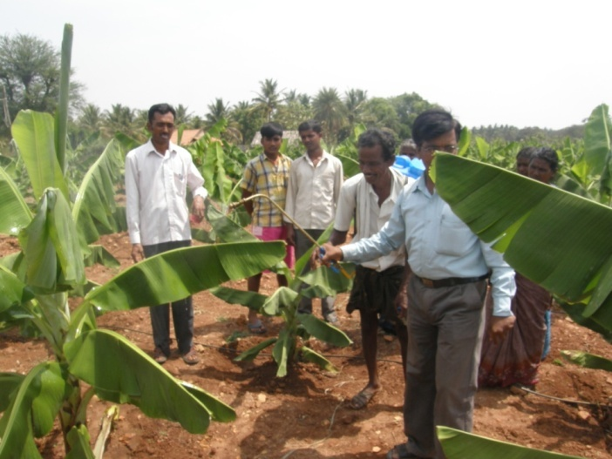 | 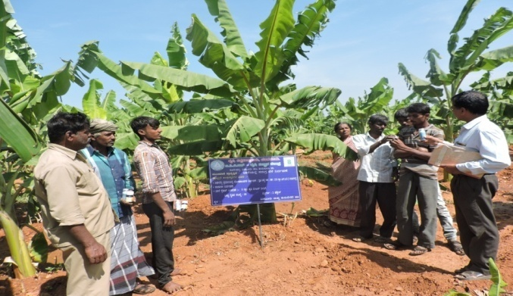
Fig 1 : Banana plot visited | Fig 2 : Group discussion with farmers
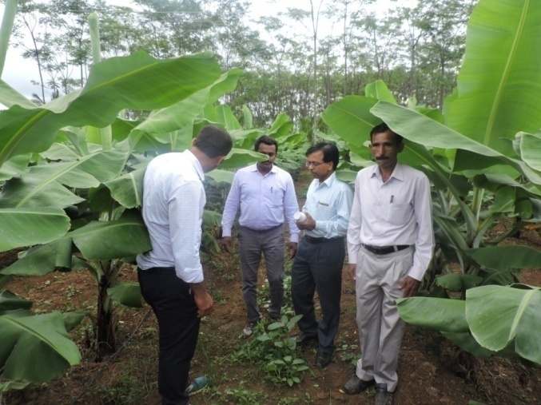 | 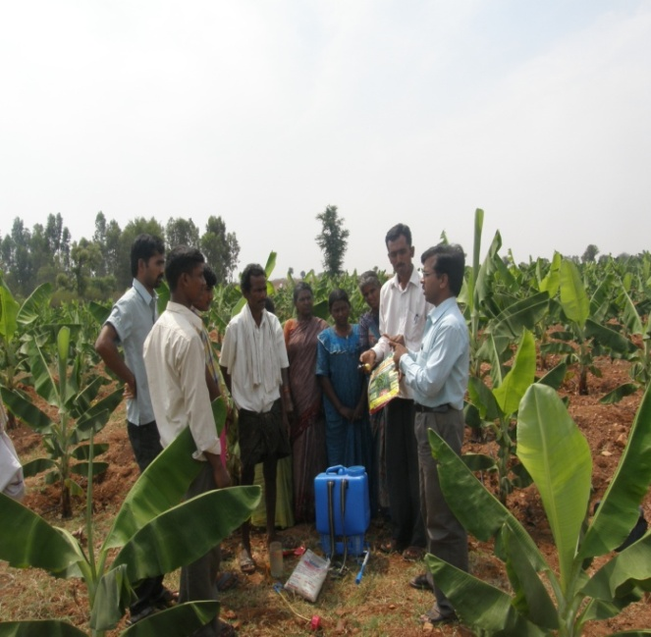
Fig 3 : Field visited and observed | Fig 4 : Demonstration on banana special
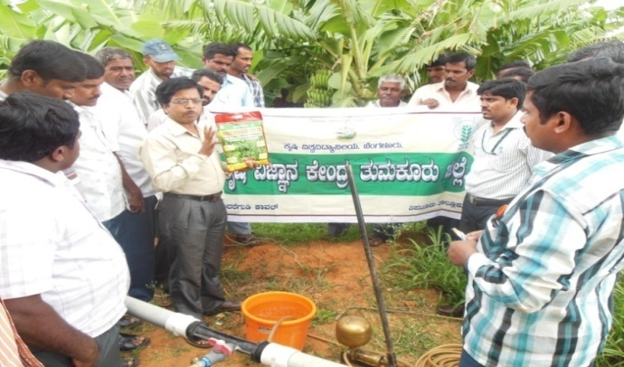 | 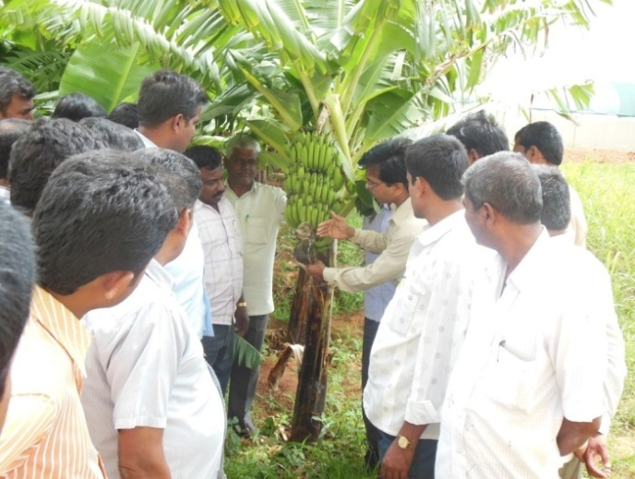
Fig 5 : Banana special and Demonstration | Fig 6 : Method demonstration on bunch feeding
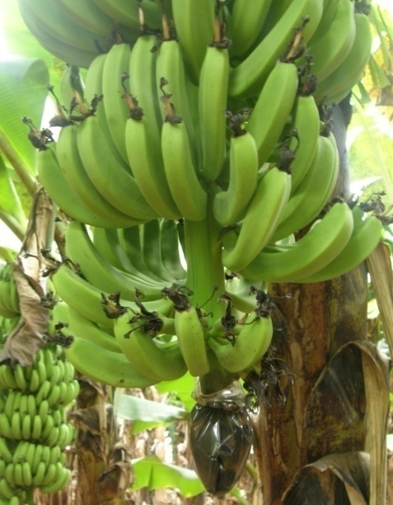
Fig 7 : Banana bunch feeding

