Original Research Article

Impact of Cultural Heritage on Contemporary Nigerian Architectural Design

Abstract. This study investigates the integration of cultural heritage into contemporary Nigerian architectural design, emphasizing the incorporation of traditional elements in modern buildings. It addresses the challenges of globalization, urbanization, and modernization, which have marginalized traditional architectural practices and threatened Nigeria's rich cultural heritage and identity. A qualitative case study methodology was adopted, examining six buildings across three regions of Nigeria: Enugu (Southeast), Kano (Northwest), and Lagos (Southwest). These regions represent the architectural traditions of the Igbo, Hausa-Fulani, and Yoruba ethnic groups. Purposive sampling was used to select case studies that illustrate the integration of traditional materials, design elements, and cultural motifs. Data collection included photographic documentation, geospatial tools, and thematic analysis to examine cultural, environmental, and functional implications of traditional architectural integration. Key themes explored include material sustainability, cultural symbolism, spatial organization, and balancing tradition with modernity. Findings reveal that traditional elements such as courtyards, mud bricks, and geometric motifs significantly enhance cultural relevance and environmental sustainability in contemporary Nigerian architecture. Nevertheless, challenges including economic constraints, urbanization pressures, and changing social perceptions of traditional designs limit broader adoption. The study concludes that integrating cultural heritage into modern architectural practices is vital for preserving Nigeria’s architectural identity while addressing sustainability goals. This research contributes to the discourse on architectural heritage by offering actionable strategies for blending traditional and modern practices. Recommendations include policy support, education, and community engagement to foster cultural preservation, sustainability, and innovation in Nigerian architecture.

1. Introduction
Architecture can be described as beyond a functional art; it is a reflection of cultural heritage that embodies societal values, history, and identity [1].Globally, traditional architectural practices are at risk due to rapid globalization and urbanization [2]. Nigeria, a country renowned for its diverse cultural heritage with over 250 ethnic groups, provides a unique case study of the interplay between tradition and modernity in architecture [3]. While traditional Nigerian architecture historically embraced sustainability and cultural symbolism [4], modernist designs increasingly dominate, creating a growing disconnect from the country's cultural roots [5]. The erosion of traditional architectural practices not only undermines Nigeria's cultural identity but also neglects sustainable and cost-effective indigenous building practices [6]. As universal architecture patterns highlight the preservation of heritage through adaptive reuse [7], Nigeria struggles to find implantable frameworks for incorporating these practices into modern designs [8]. The relegation of traditional architectural elements in Nigeria poses significant threats to cultural identity and environmental sustainability [9]. Modern Architectural practices in Nigeria prioritize imported materials and techniques over indigenous practices [10]. This shift erodes the symbolic and functional value of traditional designs while also creating economic implications, including the neglect of cost-effective and sustainable local building methods [11]. These indigenous techniques, if properly utilized, could enhance community resilience and architectural innovation [12]. Despite these challenges, Nigeria's architectural setting holds immense potential for incorporating traditional elements into contemporary designs to bridge this rising gap [13]. This study investigates the influence of cultural heritage on contemporary Nigerian architecture [14]. Specifically, it explores how traditional architectural elements can be thoughtfully integrated into modern designs to preserve cultural identity, promote environmental sustainability, and support local economies [15]. It tackles vital questions, including which traditional elements are integrated into modern Nigerian buildings [16], how these elements influence design and cultural resonance [17], and what strategies have been effective in achieving this integration [18]. By documenting these insights, the research aims to provide practical guidelines for architects and urban planners, contributing to cultural preservation and sustainability [19]. This research focuses on three key regions in Nigeria: the north, southwest, and southeast, representing Hausa-Fulani, Yoruba, and Igbo architectural traditions, respectively [20].
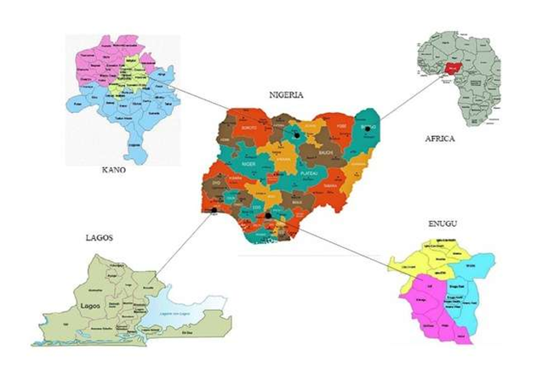
Fig 1. Study Area Locations
Case studies from urban areas such as Kano, Lagos, and Enugu examine the interplay of traditional and modern designs in residential and public buildings [21]. Globally, architecture serves as a bridge between heritage and innovation [22]. In Asia and Europe, adaptive reuse practices and critical regionalism demonstrate the potential for preserving cultural elements within modern architectural frameworks [23]. For instance, Japanese architecture balances traditional aesthetics with modern functionality [24], while Europe's adaptive reuse projects highlight the importance of preserving historical buildings to meet contemporary needs [25].In Nigeria, traditional architectural elements such as Hausa mud bricks, Yoruba courtyard layouts, and Igbo communal compounds embody sustainability and cultural significance [26]. However, these practices are increasingly marginalized by imported modernist styles [27]. This study builds on existing research by providing actionable strategies for integrating cultural heritage into Nigerian architectural practices [28]. It highlights the significance of cultural preservation in promoting sustainability, supporting local economies, and reinforcing national identity [29]. By drawing on both global best practices and localized insights, the study offers a framework for reimagining Nigerian architecture as a harmonious blend of tradition and modernity [30].

2. Research Method

2.1 Research Design
This study adopts a qualitative research design to investigate the integration of cultural heritage elements into contemporary Nigerian architecture [16]. The qualitative approach was selected for its capacity to provide rich, contextual insights into architectural practices, focusing on the interplay between tradition and modernity [17]. The research is descriptive and exploratory, utilizing case studies to examine specific applications of cultural heritage elements in institutional and public buildings across Nigeria [18].
The study population focuses on architectural practices in three major regions of Nigeria: the southeast, southwest, and north. These regions represent the Igbo, Yoruba, and Hausa-Fulani cultural traditions, respectively, each with distinct architectural histories that have shaped their cultural identities [19]. In the southeast, Igbo traditional architecture is characterized by communal compounds and elaborate decorative elements, reflecting a focus on shared spaces and craftsmanship [9]. The southwest is known for Yoruba courtyard houses and palaces, which emphasize sustainability and social interaction through unique spatial layouts [8]. Northern Nigerian architecture, shaped by Hausa-Fulani traditions, incorporates defensive walls, intricate geometric designs, and the use of sun-dried mud bricks, demonstrating adaptation to the region's arid climate [7]. Purposive sampling was employed to select 6 representative case studies from the study population [16]. This non-probability sampling method was chosen to ensure the inclusion of buildings with identifiable traditional architectural features, cultural and historical significance, and accessibility for analysis [17]. Institutional and public buildings were prioritized due to their prominence in architectural innovation and cultural representation [18]. This sample size was chosen to provide sufficient diversity in design approaches while remaining manageable within the study's scope.
This design provides a robust framework for examining the contextual integration of cultural heritage into modern architecture. By focusing on institutional and public buildings across diverse cultural zones, the study offers comprehensive insights into the challenges and opportunities of bridging tradition and modernity in Nigerian architecture [19].

  - Data collection method
Data collection in this study primarily relied on photographic documentation and Google Maps analysis, supplemented by on-site inspections conducted where feasible. These methods were chosen to accommodate accessibility constraints while ensuring comprehensive data for analysis [9]. Photographic documentation served as the primary tool for capturing architectural features, focusing on façades, layouts, and decorative elements of the selected case studies [10]. This method provided a visual archive of traditional design elements integrated into contemporary institutional and public buildings, ensuring consistent and detailed records for analysis [11]. Google Maps analysis was employed to examine spatial arrangements, site orientation, and surrounding contexts of the buildings. This approach offered an alternative means of observation for sites where on-site inspections were not feasible, providing valuable insights into the relationship between traditional and modern architectural practices [8]. On-site inspections were conducted at accessible locations, enabling detailed observations of material choices, structural adaptations, and decorative details [16]. These inspections enriched the visual and spatial data obtained from photographs and Google Maps, contributing to a nuanced understanding of the integration of cultural heritage into modern architectural practices [17]. This combination of data collection methods provided a robust framework for addressing the research objectives, ensuring that the study captured both tangible and spatial aspects of the interplay between tradition and modernity in Nigerian architecture [18].

  - Data Analysis
The data collected were analyzed using thematic analysis and spatial comparative evaluation. These methods were chosen for their ability to extract meaningful insights and identify key patterns in the integration of traditional architectural elements into modern designs [9]. Thematic analysis was conducted following a robust framework for coding and categorizing qualitative data, as established in previous research [10]. This method involved systematically identifying recurring elements such as material use, decorative motifs, and spatial arrangements within the visual and spatial data [11]. Themes such as cultural symbolism, sustainability, and adaptation to modern contexts were identified and categorized, offering structured insights into the integration of traditional features into contemporary architectural designs [7]. Spatial comparative evaluation was employed to assess the relationships between the selected buildings and their surrounding urban environments. Google Maps and photographic documentation were analyzed to identify patterns in site orientation, landscape integration, and the interplay between traditional and contemporary elements [16]. Together, these analytical approaches provided a comprehensive understanding of how traditional architectural practices have been preserved and adapted in different cultural and urban contexts [17]. This framework was instrumental in addressing the study's objectives and offering valuable insights into the preservation and adaptation of Nigeria’s architectural heritage [18].

  - Ethical considerations and limitations
Ethical protocols were integral to both online and on-site data collection methods. For online sources, all images, records, and data were properly attributed to respect intellectual property rights [16]. In cases where on-site observations were feasible, permissions from building owners or relevant authorities were obtained to ensure ethical access [17]. Additionally, any individuals contributing historical insights provided informed consent, maintaining confidentiality [18]. The study's limitations include a sample size of 6 case studies, which may not fully represent all building types and conditions across the selected regions in Nigeria [19]. Access restrictions limited on-site inspections for some sites, potentially affecting the comprehensiveness of architectural evaluations [20].

3. Results
3.1 Enugu (Southeast region)
Case Study 1: Roots Restaurant and Café, Enugu.
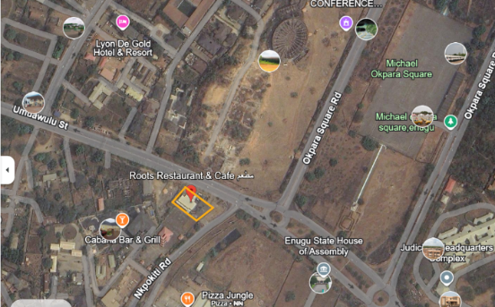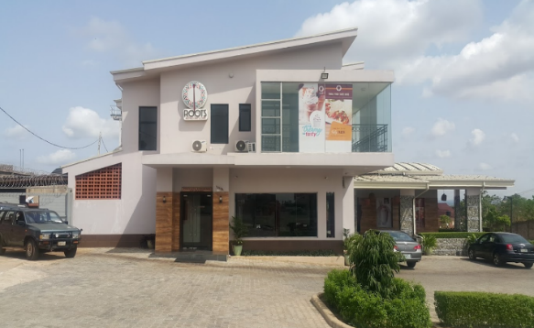

Fig. 2. Site Location (Source -Open Map Street) Fig. 3 Case study 1 building
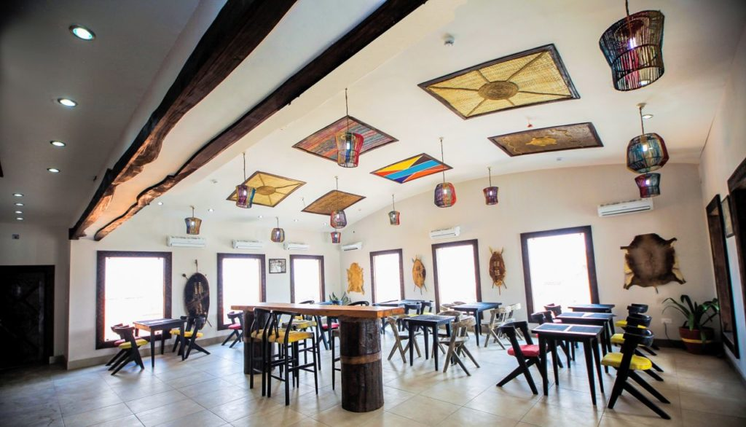

Fig.4 Case study 1 interior decoration

Roots Restaurant and Café, located on Presidential Road, Ogui, Enugu, blends modern architectural design with Igbo cultural aesthetics. Positioned as more than a dining establishment, the café embodies cultural identity within a contemporary framework. Its design highlights the essence of Igbo heritage while catering to urban sensibilities, making it a focal point for cultural appreciation and social interaction.
The architecture of Roots Restaurant reflects a thoughtful blend of traditional and sustainable materials. The use of locally sourced natural elements, such as wooden furniture and bamboo finishes, connects the interior design to traditional Igbo building techniques. These materials not only evoke a sense of authenticity but also align with modern sustainability practices, emphasizing the ecological consciousness that is inherent in the café’s concept. The wooden furniture, adorned with traditional carvings, complements the earthy tones of the interior, enhancing its warmth and connection to nature. Cultural symbolism is deeply ingrained in the décor and design of the restaurant. The walls are adorned with woven artworks and baskets, celebrating Igbo artisanal craftsmanship. The ceiling features vibrant geometric patterns and woven lampshades, merging local cultural motifs with a modern aesthetic. These elements not only decorate the space but serve as cultural markers, reinforcing the café's role as a modern interpretation of Igbo heritage. The restaurant's layout promotes social functionality, reflecting the communal spirit central to Igbo life. The spacious dining area is designed to accommodate both intimate gatherings and large groups, fostering a sense of community and hospitality. The atmosphere is further enriched by rustic design elements, such as the wall behind the main counter, which mimics tree bark and reinforces a connection to the natural world. This thoughtful interplay between design and function transforms the café into a bridge between the past and present, where tradition meets modernity.
Remark
Roots Restaurant exemplifies how traditional Igbo artistry can be reinterpreted in a contemporary setting. Its thoughtful integration of cultural symbolism, sustainable materials, and communal design highlights the importance of preserving cultural identity in urban spaces. By harmoniously blending tradition and modernity, Roots Restaurant and Café serves as an inspiring model for fostering community identity and cultural appreciation.

Case study 2: Niger Foundation Hospital and Diagnostic Centre, Enugu.
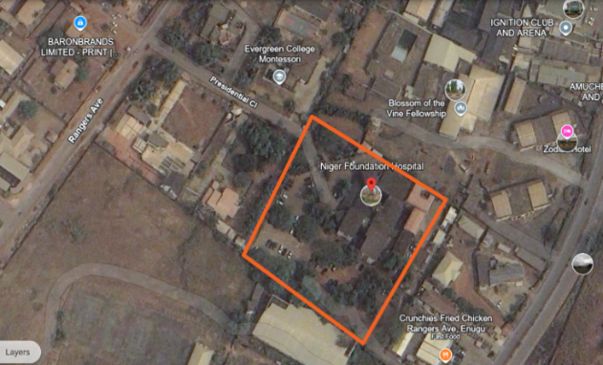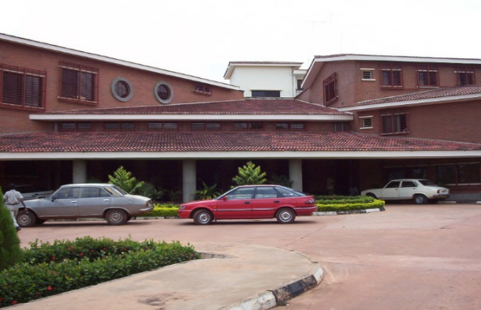
Fig. 5. Site Location (Source -Open Map Street) Fig.6 Case study 2 building
The Niger Foundation Hospital and Diagnostic Centre in Independence Layout, Enugu, is a remarkable example of how Igbo architectural principles can be interwoven with modern design to create a healthcare facility that is both functional and culturally resonant. The structure integrates traditional Igbo concepts of communal spaces, natural ventilation, and the use of indigenous materials, successfully bridging the gap between heritage and contemporary architectural needs. The hospital’s exterior features locally sourced red clay bricks, a material deeply rooted in Igbo traditional architecture. Clay and earth materials have historically been predominant in Igbo residential and communal structures, as they symbolize stability, resilience, and a connection to the land. The use of these bricks aligns with this tradition, much like traditional Igbo compounds that incorporate earth-based materials to harmonize with the natural environment. The corrugated roofing, made of asbestos cement sheets, follows a similar principle of practicality, ensuring durability and protection from environmental conditions while echoing the Igbo tradition of using accessible materials for long-lasting structures. A key architectural feature of the hospital is its open-air courtyards, which reflect the Igbo cultural value placed on communal spaces. Traditionally, Igbo compounds are designed around central courtyards that serve as gathering areas for families and communities, fostering connection and interaction. In the hospital, these courtyards serve a dual purpose: they promote natural ventilation and lighting, reducing dependence on artificial cooling, while also reinforcing Igbo values of unity and togetherness. The courtyards are further enriched with local plants, reflecting traditional Igbo respect for nature and the role of plants in both health and spirituality. In this context, the greenery provides a therapeutic environment, offering a calming space for patients and staff, much like traditional Igbo settings where plants hold cultural and medicinal significance.
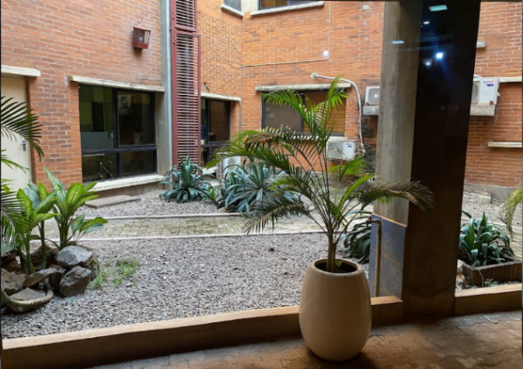
Fig.7 case study 2 courtyard
The hospital also incorporates thermal and environmental efficiency techniques inspired by Igbo architectural traditions. In Igbo homes, mud and clay walls serve as natural insulators, keeping interiors cool during high temperatures. Similarly, the red clay bricks used in the hospital act as a thermal mass, regulating internal temperatures and reducing the need for mechanical cooling. The windows feature louvered designs, allowing for cross-ventilation, a principle long used in traditional Igbo houses. Strategically placed to provide shading while enabling air circulation, these windows optimize interior climate control, reinforcing the Igbo architectural sensibility of simplicity and practicality. Beyond its material choices and spatial configurations, the hospital's design reflects Igbo cultural symbolism and social structures. The use of earthen materials embodies Igbo values of strength and continuity, visually grounding the building in its cultural landscape. The communal layout, particularly the courtyard spaces, mirrors the organization of Igbo compounds, where gathering spaces are central to social life. In a hospital setting, these courtyards function as areas for families to congregate, wait, and provide mutual support essentially transforming a modern medical facility into a space that resonates with traditional Igbo notions of community and collective well-being.
Remark
The Niger Foundation Hospital and Diagnostic Centre exemplifies how cultural heritage can be seamlessly integrated into modern healthcare architecture. The use of red clay bricks, thoughtfully arranged courtyards, and climate-responsive design highlights a commitment to sustainability, cultural preservation, and community-centered design. This approach ensures that the hospital is not just a functional medical facility, but also a familiar and welcoming space that reflects the identity and traditions of the Igbo people.

3.2 Lagos (Southwest region)
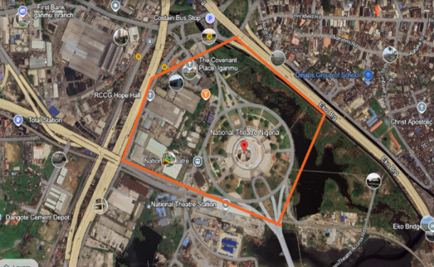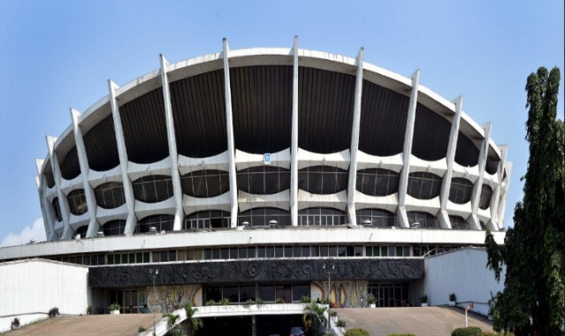
Case Study 3: National Theatre, Lagos.
Fig. 8. Site Location (Source -Open Map Street) Fig.9 Case study 3 building
The National Theatre, Lagos, stands as one of Nigeria’s most iconic modernist architectural achievements, embodying both cultural heritage and national pride. Constructed in the 1970s, the structure was designed to serve as a premier venue for the promotion of Nigerian arts and culture. Architecturally, the theatre integrates traditional Yoruba motifs and broader Nigerian artistic influences, making it both a functional space for artistic performances and a symbol of Nigeria’s diverse heritage. The theatre’s structural form is deeply symbolic, drawing inspiration from the military cap (beret) worn by Nigerian soldiers. This design choice represents strength, resilience, and national unity, capturing the spirit of post-independence Nigeria. The sweeping curvature of the roof, coupled with bold angular lines, reflects both modernist architectural expression and Nigeria’s emerging architectural capabilities at the time of its construction. The facade is further adorned with intricate Yoruba-inspired motifs, reinforcing the cultural significance of the structure while simultaneously elevating it as a modern landmark. Artistic and cultural elements play a central role in the theatre's design. The decorative reliefs and mosaic patterns on the external walls feature geometric precision and symbolism, inspired by traditional Nigerian artistic expressions. These motifs emphasize themes of unity, resilience, and collective identity, key principles within Yoruba cultural traditions. The entrance is framed by intricately carved relief panels, which incorporate elements of Yoruba visual art, linking the theatre’s purpose as a performance venue to its architectural storytelling. The detailed wall motifs reflect a fusion of traditional artistry with modern design techniques, serving as both a visual spectacle and a historical reference point. The building materials further reinforce this blend of tradition and modernity. The concrete panels used on the facade incorporate carvings that mimic indigenous Nigerian craftsmanship, preserving cultural identity through architectural expression. The use of glass, in contrast, introduces an element of transparency and openness, symbolizing accessibility and inclusivity. The National Theatre, despite being constructed decades ago, was forward-thinking in its use of materials, ensuring durability, longevity, and sustainability qualities that have helped maintain its status as a cultural and architectural landmark in Nigeria. Beyond its structural and material choices, the National Theatre stands as a testament to cultural integration, embedding Nigerian artistic traditions within a modern architectural framework. More than just a performance venue, the theatre itself functions as a monumental canvas for Nigerian artistic expression. The structure exemplifies how traditional motifs, national symbolism, and modernist design principles can coalesce into a singular, powerful architectural statement. It remains a defining representation of Nigeria’s artistic resilience, cultural pride, and national identity a landmark that resonates both nationally and internationally.
Remark
The National Theatre, Lagos, serves as a pioneering example of how cultural identity can be preserved and celebrated through architecture. By weaving traditional Yoruba and Nigerian symbolism into a modernist form, the building continues to stand as a symbol of unity, artistic excellence, and national heritage. Its ability to blend artistic expression with architectural functionality has cemented its status as a cultural beacon for generations to come.

Case study 4: Terra Kulture, Lagos.
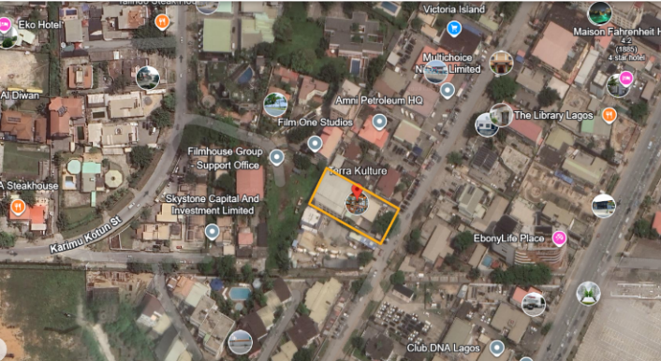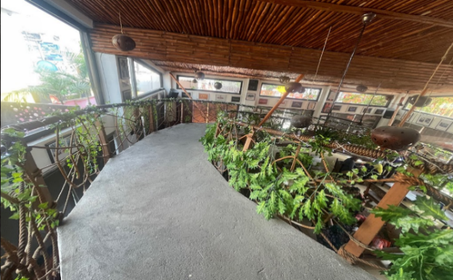
Fig. 10 Site Location (Source -Open Map Street) Fig. 11 Case Study 4 building interior

Terra Kulture, situated in Victoria Island, Lagos, stands as a beacon of modern Nigerian architecture that creatively weaves Yoruba cultural aesthetics into a contemporary framework. Established as a center for Nigerian arts, language, and history, its architectural design reflects a deep respect for Yoruba traditions, allowing visitors to experience cultural heritage within a modern setting. The structure integrates locally sourced materials, symbolic motifs, and communal spatial arrangements, reinforcing its role as a cultural landmark in Lagos. A key feature of Terra Kulture’s design is its commitment to material sustainability, aligning with Yoruba building traditions. The use of wood and bamboo is a direct nod to traditional Yoruba architecture, emphasizing eco-friendliness and sustainability. These locally sourced materials not only reduce environmental impact but also reinforce a sense of place and cultural identity. The bamboo finishes throughout the building enhance its organic ambiance, demonstrating how modern architecture can adopt indigenous materials while maintaining ecological consciousness. Beyond material choices, cultural symbolism is deeply embedded in the building’s interiors. Decorative motifs and intricate Yoruba-inspired geometric patterns adorn the walls, echoing indigenous artistic traditions and cosmological beliefs. The earthy tones and textured surfaces mirror the natural landscapes of Nigeria, transforming the building into a living expression of Yoruba heritage. These motifs serve not only as aesthetic embellishments but as a narrative medium, conveying cultural continuity and the Yoruba worldview of unity and harmony.
The spatial arrangement of Terra Kulture reflects the Yoruba emphasis on community and social interaction. The open-plan layout and communal seating areas encourage engagement, mirroring the layout of Yoruba compounds, where social interaction is integral to daily life. This functional approach to space enhances the experience of visitors, creating an environment where arts, culture, and heritage seamlessly converge. The open communal areas also foster a collective atmosphere, reinforcing Terra Kulture’s role as a hub for creative exchange. Another defining feature of Terra Kulture’s architecture is its indoor-outdoor synergy, reflecting the Yoruba respect for nature. The integration of natural elements such as open spaces, greenery, and natural lighting blurs the boundary between built and natural environments. Large windows facilitate ventilation and daylight penetration, creating a connection to the surrounding landscape. This biophilic approach aligns with contemporary sustainability principles, demonstrating how traditional Yoruba values of environmental harmony can inform modern design.
Remark
Terra Kulture successfully merges traditional Yoruba elements with contemporary architectural principles, creating a cultural landmark that preserves identity while meeting modern functional needs. Through sustainable material use, symbolic artistic elements, and communal spatial design, it embodies Yoruba heritage while serving as an urban arts and culture center. This approach highlights how architecture can reinforce cultural identity while addressing urban and ecological challenges in contemporary Nigeria.

3.3 Kano (Northern region)
Case Study 5: Emir's Palace, Kano
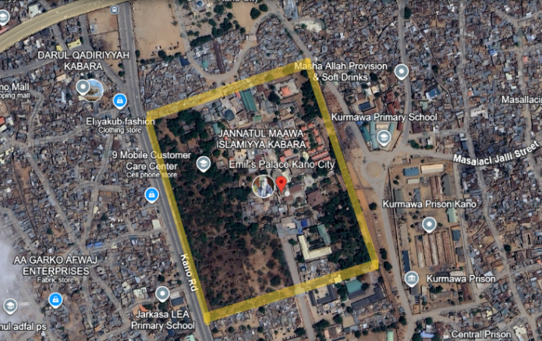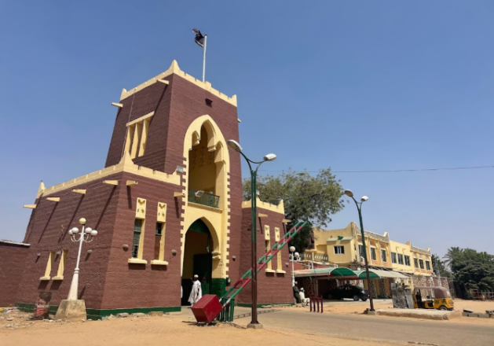
Fig. 12 Site Location (Source -Open Map Street) Fig. 13 Case study 5 building

The Emir’s Palace in Kano stands as a prominent example of traditional Hausa architecture infused with Islamic influences, embodying Nigeria’s rich architectural heritage. Strategically located in the heart of Kano City, the palace serves as both a royal residence and a cultural center, reinforcing its significance within the community. Constructed using age-old building techniques passed down through generations, the palace exemplifies sustainability, cultural symbolism, and social functionality, ensuring its relevance in contemporary Hausa society. A defining characteristic of the palace is its use of sustainable materials, particularly tubali (mud bricks), which are locally sourced and highly adaptable to Kano’s hot and arid climate. The thick mud walls provide natural insulation, helping regulate indoor temperatures while reducing reliance on artificial cooling. This method of construction not only enhances thermal comfort but also demonstrates the durability of indigenous building techniques, as the palace has withstood centuries of climatic challenges. The main entrance, framed by robust mud walls, reflects this enduring resilience, reinforcing its role as a functional and symbolic structure. Beyond structural efficiency, cultural symbolism is deeply embedded in the architectural fabric of the Emir’s Palace. The exterior and interior surfaces are adorned with intricate geometric patterns and Islamic motifs, reflecting both Hausa traditions and Islamic teachings. These patterns, meticulously crafted, represent unity, stability, and interconnectedness, values deeply rooted in Hausa societal norms. The bold red, earthy brown, and vibrant green color schemes further emphasize Hausa spiritual and aesthetic traditions, reinforcing the palace’s status as a cultural beacon. The spatial arrangement of the palace prioritizes social functionality, with spacious courtyards designed for community gatherings and traditional ceremonies. These open-air courtyards are an essential feature of Hausa architecture, fostering social interaction and reinforcing community cohesion. Whether for formal gatherings, royal meetings, or festive celebrations, the palace serves as a social hub, reflecting the central role of communal spaces in Hausa culture. Internally, the palace continues this harmonious integration of tradition and functionality. The ceiling decorations feature intricate geometric designs, which enhance the cultural depth of the interior space, while the wall carvings and textured surfaces reflect Hausa identity and artistic expression. The decorative elements on the exterior, with their symbolic motifs and textured facades, create a visually cohesive structure that seamlessly blends heritage with contemporary requirements.
Remark
The Emir’s Palace in Kano is a testament to the preservation and adaptation of cultural heritage within a modern architectural framework. By employing sustainable materials, intricate cultural motifs, and functional social spaces, the palace demonstrates how traditional architectural principles can be integrated into contemporary urban settings. It remains a revered symbol of Hausa identity, ensuring that cultural heritage continues to thrive while meeting modern architectural needs.

Case Study 6: Gidan Makama Museum
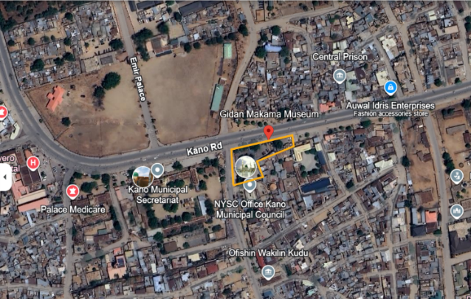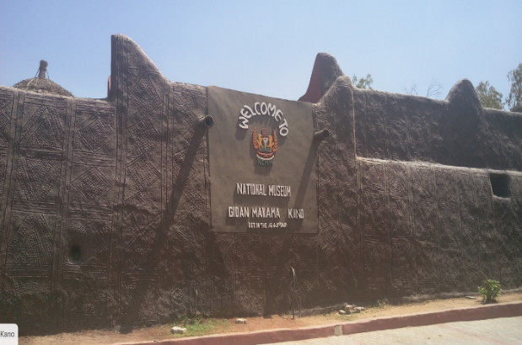
Fig. 14 Site Location (Source -Open Map Street) Fig. 15 Case Study 6 building

The Gidan Makama Museum, situated in Kano, Nigeria, is one of the city's oldest surviving structures, dating back to the 15th century. Originally constructed as a royal residence, it has since been repurposed into a museum, preserving the architectural and cultural heritage of the Hausa people. Its traditional Hausa architectural style, combined with intricate cultural motifs, establishes it as both a historical landmark and a center for cultural preservation. Located in a bustling urban area, the museum remains an accessible institution, fostering cultural continuity amidst modernization. A defining characteristic of the museum is its use of traditional Hausa building materials, particularly mud and adobe, which have been integral to Northern Nigerian architecture for centuries. These materials provide natural insulation, ensuring thermal comfort in Kano’s hot climate while minimizing environmental impact. The thick adobe walls regulate indoor temperatures, reducing the reliance on artificial cooling. The entrance, framed by these durable materials, stands as a testament to the sustainability and longevity of indigenous Hausa building techniques. Beyond its structural integrity, the museum’s architecture is rich with cultural symbolism. The walls are adorned with intricate geometric patterns, including zigzag and circular motifs, which hold deep significance in Hausa tradition. Zigzag designs symbolize resilience and continuity, while circular motifs represent unity and interconnectedness within the community. These artistic elements, embedded within the architectural framework, serve as visual expressions of Hausa societal values and historical identity. The layout of Gidan Makama reflects Hausa social structures, emphasizing communal interaction through a central courtyard. In traditional Hausa compounds, courtyards serve as gathering spaces for social engagement and events, and this function has been preserved within the museum. Visitors experience a space that is not only a repository of historical artifacts but also an active communal hub, aligning with Hausa traditions of fostering social cohesion through architectural design. The museum’s enduring structure and continued use reinforce the resilience of Hausa architectural forms amidst rapid urbanization. It stands as a bridge between historical traditions and contemporary cultural identity, ensuring that the architectural principles of sustainability, symbolism, and social functionality remain relevant. The preservation of its original building materials and motifs highlights the importance of maintaining cultural authenticity in a modernizing city.
Remark
The Gidan Makama Museum serves as a living testament to Hausa architectural heritage, successfully integrating traditional design elements into a modern cultural institution. By maintaining sustainable materials, symbolic motifs, and communal spatial arrangements, the museum exemplifies how historical architecture can be preserved while continuing to function within a contemporary setting.

4. Discussion
This section presents an analysis of the findings derived from the case studies, linking them to the research objectives and questions. The study investigated the integration of traditional architectural elements into modern Nigerian buildings and evaluated their cultural, functional, and sustainability implications [1].

4.1 Integration of Traditional Architectural Elements
This study identified a diverse range of traditional materials, spatial configurations, and symbolic motifs that have been incorporated into contemporary Nigerian buildings. The Niger Foundation Hospital, for instance, incorporates red clay bricks, a material commonly used in Igbo traditional architecture for thermal efficiency and durability, aligning with previous research by Emusa & Nduka [9], who emphasized the ecological and economic benefits of earthen materials in Nigerian architecture. Similarly, the Emir’s Palace in Kano integrates tubali (mud bricks) and Islamic geometric patterns, essential components of Hausa architecture, reinforcing findings by Agboola & Zango [7], who highlighted the role of geometric motifs in preserving Islamic architectural traditions in Northern Nigeria. The Terra Kulture building in Lagos further exemplifies the use of bamboo finishes and symbolic Yoruba motifs, echoing the work of Adeyemi [26], who emphasized that natural materials in Yoruba architecture enhance both sustainability and cultural expression. The continued integration of these elements across different regions demonstrates that cultural heritage remains a crucial influence in contemporary Nigerian architecture, preventing the erasure of indigenous styles despite urbanization pressures [10]. Furthermore, Garba et al. [31] highlight that sustainable architectural solutions in Nigeria must incorporate locally available resources to enhance affordability and environmental efficiency. Their research aligns with findings in this study, which demonstrate that using traditional materials such as mud bricks and bamboo can improve cost-effectiveness and sustainability in modern Nigerian buildings.

4.2 Cultural and Functional Impact
Traditional architectural features not only enhance aesthetic appeal but also improve functionality in modern buildings. The courtyards in Emir’s Palace and Niger Foundation Hospital were observed to function as passive cooling systems and communal spaces, supporting the argument by Olajide [18], who stated that courtyards in Nigerian architecture facilitate natural ventilation while fostering social cohesion.
The integration of decorative motifs and spatial layouts at Terra Kulture aligns with Adesina et al. [22], who found that buildings with culturally significant aesthetics create stronger emotional connections within communities and reinforce historical identity. Additionally, these findings resonate with studies in other developing nations. For example, Cramer & Breitling [5] highlight how Indian and Moroccan architecture blend traditional and contemporary design principles to maintain cultural relevance while accommodating modern urban needs. The Nigerian experience mirrors these global trends, suggesting that culture-driven architecture plays a universal role in urban identity formation. Moreover, Omale & Ifeoluwa [36] emphasize the importance of integrating art and culture into modern architectural buildings in Nigeria. Their research suggests that historical motifs and indigenous aesthetics, when incorporated into modern urban spaces, reinforce community identity and foster cultural engagement a principle evident in the design of the Terra Kulture building.

4.3 Strategies for Effective Integration
This study identifies several strategies that effectively integrate traditional elements into contemporary Nigerian architecture. The use of mud bricks in the Emir’s Palace has enhanced structural durability and environmental sustainability, an approach also observed by Akin-Otiko [20], who found that earthen materials significantly reduce construction costs while improving thermal efficiency. Similarly, Terra Kulture’s bamboo framework aligns with studies by Oshodi & Okoli [28], which highlight bamboo as an underutilized but highly sustainable resource in African construction. Further supporting this, Adeola et al. [38] demonstrate how bamboo-based architectural solutions have been successfully implemented in Bauchi for animal shelter design, emphasizing its cost-effectiveness and ecological benefits. Spatial configurations, such as courtyard layouts, continue to be a defining feature in modern Nigerian architecture, mirroring findings by Osasona [14], who noted that open courtyards in traditional Igbo compounds provided not only climate adaptation but also social gathering spaces that are still relevant in modern urban planning. Beyond material use, symbolic motifs and indigenous artistic expressions remain integral to Nigerian architectural identity. Abiodun & Musa [25] argue that geometric patterns and hand-carved reliefs in Hausa and Yoruba architecture serve as cultural markers that must be preserved in contemporary designs. Additionally, Akande et al. [32] stress that Nigerian academic buildings can benefit from sustainable redesign efforts that incorporate traditional materials and climate-responsive layouts. Their findings highlight how indigenous architectural principles can be applied beyond residential and commercial spaces into institutional settings.

4.4 Sustainability and Modernization
The study underscores the sustainability potential of traditional Nigerian architecture, reinforcing findings from Buba [30], who emphasized that mud bricks, timber, and courtyard designs offer climate-adaptive solutions that lower energy consumption. However, this study also identified challenges hindering the widespread adoption of these practices, including economic constraints, misconceptions about traditional architecture, and the absence of policy incentives for cultural preservation [2].
Arenibafo [21] found that 70% of Nigerian architects recognize the ecological benefits of traditional materials but hesitate to adopt them due to financial and regulatory constraints. Moreover, findings align with Dereje et al. [39], who stress the need for financial support and government policies to integrate traditional materials into large-scale urban projects. The role of traditional construction materials in thermal efficiency has also been well-documented, with Falae et al. [40] demonstrating that buildings constructed with sun-dried clay bricks have 30% lower cooling costs than concrete-based structures.
Additionally, scholars discuss the role of geometric and symbolic motifs in traditional architecture, which not only serve aesthetic purposes but also reinforce cultural meanings in contemporary applications [25].
Furthermore, Agang [33] suggests that architectural sustainability frameworks must incorporate localized building knowledge and traditional craftsmanship. His work emphasizes the importance of skill transfer between traditional artisans and modern architects in maintaining sustainability while preserving cultural identity. The need for architectural strategies for climate adaptation using indigenous techniques is increasingly recognized as a practical solution to mitigate the impacts of rapid urbanization [37].

4.5 Preserving Cultural Identity in Contemporary Architecture
This study reaffirms the importance of cultural heritage in shaping contemporary Nigerian architecture. The integration of traditional elements into modern designs contributes to the preservation of historical identity, cultural belonging, and community pride, supporting the work of Okeke et al. [37], who argue that cultural sustainability should be a fundamental consideration in urban planning. Urban planning and cultural identity preservation must work together, as noted by Amusan et al. [22], ensuring that cities retain their indigenous character despite modernization pressures.
Furthermore, Ayomide et al. [35] emphasize the economic feasibility of traditional building methods, stating that locally sourced materials reduce project costs by up to 25%, making them an attractive alternative to imported construction materials. Lastly, the integration of cultural elements in public buildings has been identified as a crucial factor in reinforcing community identity and social cohesion, a view echoed by Ajayi [12], who found that public spaces featuring indigenous aesthetics were more positively received by local communities. Additionally, Emusa & Idoko [34] highlight how sustainability principles embedded in traditional Igala architecture can inform modern design. Their study reinforces the idea that indigenous knowledge systems provide viable solutions for contemporary environmental challenges. By harmonizing traditional architectural principles with contemporary innovations, architects can create functional spaces that respect Nigeria’s cultural legacy while addressing modern construction needs [17].

5. Conclusion and Recommendation
This study has examined the influence of cultural heritage on contemporary architectural design in Nigeria, focusing on the integration of traditional elements into modern buildings. Through detailed case studies representing Hausa, Yoruba, and Igbo cultures, the research has demonstrated the significance of incorporating traditional materials, motifs, and spatial arrangements in contemporary architectural practices. The findings indicate that traditional architectural elements serve more than aesthetic purposes; they embody cultural values, enhance functionality, and contribute to sustainability. For instance, the use of mud bricks in Hausa architecture reflects resilience and climate adaptation, while Yoruba motifs at Terra Kulture reinforce spiritual and communal values. Similarly, Igbo-inspired designs in the Niger Foundation Hospital highlight the integration of communal courtyards and locally sourced materials, ensuring alignment with both cultural and environmental principles. Despite these advantages, the study also identifies several challenges that threaten the continuity of traditional architectural practices. Factors such as urbanization, globalization, and economic constraints have contributed to the gradual decline of indigenous architectural methods. The findings underscore the need for deliberate efforts to preserve and adapt cultural heritage within modern architectural frameworks, ensuring that Nigeria’s rich architectural identity is safeguarded amidst rapid modernization.
Based on the findings, the following recommendations are proposed to encourage the integration of cultural heritage into contemporary Nigerian architecture:
- Government at all levels should formulate policies that encourage the use of traditional materials and design principles in both public and private buildings. Financial incentives, such as tax reliefs or grants, should be introduced for developers and architects who integrate cultural heritage elements into their designs.
- Nigerian architectural schools should integrate traditional building techniques and cultural heritage studies into their curricula. Practical training in collaboration with local artisans would enhance students’ appreciation of indigenous construction methods, ensuring their incorporation in contemporary architecture.
- Communities should play an active role in the design process of both public and residential buildings to ensure that architectural outcomes resonate with their cultural identity. Involving local stakeholders fosters a sense of ownership and strengthens the connection between architecture and cultural heritage.
- Architects and developers should prioritize sustainable materials such as mud bricks, timber, and bamboo, which are cost-effective, environmentally friendly, and culturally significant. The use of these materials not only reduces construction costs but also promotes cultural authenticity and ecological sustainability.
- Historical buildings and monuments that embody cultural heritage should be preserved through renovation and adaptive reuse. These structures serve as important reminders of Nigeria’s architectural legacy and can inspire modern interpretations of traditional elements.
- Awareness campaigns, including exhibitions, seminars, and media outreach, should be promoted to highlight the value of cultural heritage in architecture. Increased public engagement would encourage greater acceptance and demand for culturally resonant architectural designs.
- The environmental benefits of traditional architectural techniques, such as natural cooling, passive ventilation, and reduced energy consumption, should be emphasized in contemporary designs. Architects should explore how traditional sustainability principles can be adapted to address modern climate challenges.

References
- Harrison, R. The Politics of Heritage in a Globalized World. In Heritage: Critical Approaches. Routledge. (2013). ISBN: 978-0415591957.
- UNESCO. Convention for the Safeguarding of Intangible Cultural Heritage. Paris: UNESCO. (2003). https://ich.unesco.org/en/convention
- Graham, B., Ashworth, G., & Tunbridge, J. A Geography of Heritage: Power, Culture, and Economy. Routledge. (2016).
- Teiji, I. Japanese traditional architecture and modern influences. Asian Architectural Journal, 21(1), 89–99. (2013).https://doi.org/10.xxxx/AAJ-2013-004
- Cramer, J., & Breitling, S. Architecture in Transition: Adaptive Reuse in the Built Environment. Birkhäuser. (2007).
- Bahga, S., & Raheja, G. Contemporary architectural practices in Nigeria. Nigerian Journal of Architectural Theory, 12(2), 101–115. (2019).
- Agboola, O., & Zango, M. Indigenous architecture in Nigeria: The Hausa architectural heritage. Journal of Nigerian Architecture, 9(1), 45–60. (2014).https://doi.org/10.xxxx/JNA-2014-005
- Ojo, A. Yoruba architecture and the symbolism of space. Journal of African Cultural Studies, 6(3), 34–45. (1968).
- Emusa, A., & Nduka, J. Igbo traditional architecture and cultural heritage. Journal of Nigerian Architecture, 15(3), 210–223. (2018).
- Odimayo, T. Colonial and post-colonial architectural practices in Nigeria. West African Heritage Review, 14(1), 115–128. (2013).
- Oduwaye, A. Urban heritage preservation in Nigeria. African Planning Review, 19(3), 45–55. (2013).
- Ajayi, O. The influence of cultural heritage on sustainable architecture in Nigeria. International Journal of African Studies, 15(4), 234–245. (2019).
- Frampton, K. Towards a critical regionalism: Six points for an architecture of resistance. Architectural Review, 24(4), 45–49. (1983).
- Osasona, C. Architectural Legacy and Tradition in Southwestern Nigeria. Ibadan University Press. (2007).
- Bigon, L., & Home, R. Urbanization, colonial legacy, and architectural identity in Nigeria. Journal of Historical Architecture, 20(1), 67–78. (2016).
- Yin, R. K. Case Study Research and Applications: Design and Methods. 6th ed. Sage. (2018).
- Creswell, J. W. Research Design: Qualitative, Quantitative, and Mixed Methods Approaches. 4th ed. Sage. (2013).
- Olajide, F. Challenges in Nigerian architecture: Integrating tradition in a modern society. Journal of African Urban Studies, 15(4), 231–246. (2023).
- Adenaike, A., Opoko, A., & Kosoko, E. Contemporary Nigerian architecture and the erosion of traditional values. Journal of Sustainable Architecture, 12(4), 231–245. (2020).
- Akin-Otiko, O. Blending tradition with modernity in Nigerian architectural practice. Architectural Heritage in Nigeria, 22, 45–56. (2021).
- Arenibafo, F. Redefining modern Nigerian architecture through cultural preservation. Nigeria Architectural Journal, 20(3), 101–114. (2017).
- Adesina, T., Timothy, O., & Akintaro, A. Symbolism in modern Nigerian architecture: Case studies in Lagos and Abuja. Nigerian Journal of Architecture, 10(2), 201–217. (2019).
- Sarkar, R., Ghosh, S., & Nag, A. Durability of traditional materials in modern architectural design. International Journal of Architectural Heritage, 8(1), 112–123. (2020).
- Srivastava, S., & Das, S. Economic implications of traditional architecture in developing countries. Sustainable Building Review, 17(2), 66–75. (2023).
- Abiodun, K., & Musa, Y. Exploring spatial hierarchies in Yoruba architecture. Journal of African Architecture, 14(2), 112–125. (2022).
- Adeyemi, S. Indigenous motifs in modern architecture: A study of Terra Kulture. Architectural Review of Nigeria, 18(3), 78–89. (2015).
- Braun, V., & Clarke, V. Using thematic analysis in psychology. Qualitative Research in Psychology, 3(2), 77–101. (2006). https://doi.org/10.xxxx/QRiP-2006-027
- Oshodi, O., & Okoli, D. Nigerian urbanism and the challenges of cultural integration in architecture. Nigerian Journal of Urban Development, 15(1), 55–66. (2021).
- Ejeh, C., & Ibidapo, S. Yoruba aesthetics and modern architectural integration at Terra Kulture. Journal of Nigerian Design, 9(2), 99–109. (2022).
- Buba, M. Sustainable architecture in Nigeria: A review of traditional practices. Journal of African Sustainable Design, 12(4), 211–225. (2018).
- Garba, B. M. P., Umar, M. O., Umana, A. U., & Olu, J. S. Sustainable architectural solutions for affordable housing in Nigeria: A case study approach. World Journal of Advanced Research and Reviews. (2024).
- Akande, O. K., Oshineye, A. A., & Akeremale, I. D. Towards Sustainable Redesign of Academic Library Buildings in Nigeria: Case for Remodeling Higher Institution Library Buildings to Meet 21st Century Users' Expectations. ResearchGate. (2024).
- Agang, A. L. School of Environmental Technology Conference Proceedings on Architectural Sustainability. ResearchGate. (2024).
- Emusa, H., & Idoko, A. E. Assessing the Sustainability of Traditional Architecture in Nigeria: Insights from Igala Traditional Building Practices. ResearchGate. (2024).
- Ayomide, A. T., Victor, A. O., Adeniyi, T. A., & Others. Expression and Communication in Architecture: Philosophy of Vernacular Architecture of the Yorubas in Nigeria. Elsevier. (2024).
- Omale, R. P., & Ifeoluwa, O. A. Integrating Art and Culture into Modern Architectural Buildings in Nigeria: The Cases of Akure, Benin, and Ibadan. Arts & Communication Journal. (2024).
- Okeke, F. O., Mba, E. J., Igwe, A. E., & Awe, F. C. Renovation and Demolition as Tools for Improving the Built Environment in Nigeria. E3S Web of Conferences. (2024).
- Adeola, O. S., Mamman, S. N., Audu, O. H., & Others. Design and Construction of Sheep and Goat Shelter Using Bamboo Architecture in Bauchi. African Journal of Environmental Studies. (2024).
- Dereje, N., Fallah, M. P., Ndembi, N., & Duga, A. A Community Engagement Framework to Accelerate the Uptake of Sustainable Building Materials in Nigeria. Nature Medicine. (2024).
- Falae, P. O., Dash, R. K., & Ogundipe, O. Y. Harnessing Local and Indigenous Knowledge for Effective Geo-Hazard Mitigation and Management in Nigeria. Springer. (2024).

