Case report

Surgical Management of a Rare Case of Mesenteric Root Torsion Caused by Mesenteric Dysplasia and Spontaneous Mesenteric Hiatal Hernia

ABSTRACT

Internal hernia is one of the rare causes of small intestine obstruction. Congenital mesenteric and intestinal dysplasia is not uncommon. It is common in newborns and infants. Intestinal atresia and mesangial dysplasia often require surgical treatment in newborns and infants. However, it is rare for intestinal and mesangial dysplasia to recur in adults. Such patients often have the characteristics of concealed onset, long history, and repeated treatment, clinically, it is easy to be confused with manifestations of another intestinal disease, such as intestinal tumors, chronic nonspecific inflammatory disease of the intestine, and so on. A 29-year-old male patient came to the hospital with a complaint of abdominal pain for the last 13 hours, he has no remarkable history and no medication. He went to the emergency surgery department for further treatment and an emergency plain CT scan was performed that reported the mesenteric torsion. So he was admitted to the hospital for treatment of mesenteric torsion, while performing surgery hiatus in the ascending mesocolon was found that the small intestine was herniated at 720⁰. He was treated surgically the hiatus was closed (8 cm long), and the free ascending mesocolon was fixed to the posterior wall. In CT scan reports this defect is generally reported as non-specific changes of mesentery. The clinician’s outcomes of these patients have not been studied.

Keywords: Intestinal obstruction; Mesenteric dysplasia; Spontaneous mesangial rupture; Internal hernia; Mesenteric root torsion

1. INTRODUCTION

An internal hernia is a rare but important cause of small intestine obstruction. Although congenital bowel and mesenteric dysplasia often lead to internal hernias in children, cases in adults are extremely rare. This disease is a major clinical problem because, if left untreated, it can lead to intestinal blockage, jamming, or strangulation of the small intestine, which can lead to ischemia and necrosis. Despite their clinical significance, little is known about the risk factors for necrosis caused by internal hernias in adults due to congenital mesenteric defects. The lack of thorough research on this topic underscores how important it is for doctors to be more sensitized to ensure rapid identification and appropriate action. Because strangulated hernias can get worse quickly, it is important to diagnose them early using imaging techniques such as computed tomography (CT). Serious complications such as sepsis, perforation, and bowel necrosis can result from delayed intervention and significantly increase morbidity and mortality(Borazan & Konduk, 2020; Goffette & Laterre, 2002). The pathophysiology of internal hernias results in an intestinal collapse due to abnormal small intestine protrusion caused by congenital or acquired peritoneal defects. In children, these defects often manifest as developmental disorders or congenital syndromes. Internal hernias in adults are rarely thought to be caused by congenital mesenteric defects, and due to their vague clinical signs, diagnosis is often postponed (Maglinte & Bisset III, 2021). Signs of bowel obstruction, nausea, vomiting, and sporadic stomach pain are possible symptoms. However, a delayed suspicion of an internal hernia or a misdiagnosis can arise if no abdominal surgery has been performed in the past, which often predisposes to adhesions and external hernias. The only effective treatment for strangulated internal hernias is still surgery, as it can be potentially fatal. The presence of necrosis and the degree of obstruction determine whether laparoscopic or open surgery is performed. Due to their minimally invasive nature, shortened recovery period, and reduced risk of postoperative complications, laparoscopic techniques are becoming increasingly popular (Biondi et al., 2013; Suter et al., 2000). However, in situations where necrosis is suspected, an open surgical approach may be necessary to facilitate bowel resection and prevent additional complications. In summary, although congenital mesenteric defects are rare, they pose a high risk of intestinal blockages, strangulation, and necrosis when they result in an internal hernia in adults. More research and clinical awareness are needed, as shown by the lack of published reports on necrosis risk factors. In particular, when there is no previous operation, doctors must exercise a high degree of suspicion when evaluating cases of unexplained small bowel obstruction. To prevent serious complications and improve treatment outcomes, rapid diagnosis, and appropriate surgical treatment are essential.

2. CaSE PRESENTATION

A 29 year’s 29-year-old male patient was admitted to the emergency department for 13 hours due to paroxysmal abdominal pain. The patient’s abdominal pain was paroxysmal, severe pain, that did not radiate to the shoulder, back, and waist, accompanied by nausea and vomiting, vomit as content of stomach, bitter mouth after vomiting, accompanied by closed breath and stool, fearless of cold, shivering, high fever, jaundice, no chest pain, chest tightness, palpitation, dyspnea, no frequent urination, urgency, pain in urination, dysuria, etc. After the illness, the patient was treated in another hospital, but the patient did not get any relief from that treatment, so he sought treatment in our hospital. The emergency abdominal CT examination showed mesenteric torsion. He was admitted to our department with mesenteric torsion. The patient’s spirit, diet, and sleep were normal and there were no abnormal defecation and urination. There was a history of recurrent chronic gastritis in the past, and there was no special history in other cases.

3. results and discussion

3.1 Physical Examination at THE Time of admission

The whole abdomen was symmetrical, abdominal breathing was preserved, gastrointestinal type and peristaltic wave were not found in the whole abdomen, varicose veins were not found and the upper abdominal tenderness was also normal, no rebound pain and muscle guard, no abnormality in the boundary of liver and spleen dullness, slight buckle pain in the liver area, negative Murphy’s sign, no buckle pain in both kidney areas, negative mobility dullness, bowel sound 3 times/minute, no air and water sound and heavy metal sound. No obvious abnormalities in the spines, limbs, anus, and external genitalia. The auxiliary examination showed that the blood routine and hemogram were high, there was no anemia, and the abdominal CT showed the torsion of the root of mesentery of the small intestine as illustrated in Fig. 1.

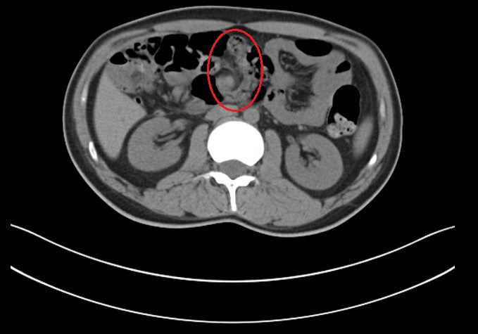

Fig. 1. Fundamental volvulus of ascending mesentery of small intestine.

3.2 Exploratory Laparotomy for Small Intestinal Volvulus and Ascending Mesocolon Hiatus: Surgical Approach and Outcomes

After admission, actively improve the preoperative preparation. The emergency green channel goes down for exploratory laparotomy. The patient was lying on the surgery bed in the supine position. The patient was lying on the surgery bed in the supine position. After the anesthesia takes effect, the patient is disinfected and covered with towels. Take the right through the rectus abdominis incision, about 20cm long, and enter the abdomen layer by layer. There are no bloody ascites during the operation. It can be seen that the root of mesentery of small intestines rotates 720⁰ clockwise, blunt plus sharp dissociation and rotary reduction. After complete dissociation, it can be seen that the mesentery of the small intestine. The ascending mesocolon is congenital dysplasia. There is a hiatus in the ascending mesocolon, which is about 8cm long. The small intestine herniates from this hiatus and rotates 720⁰ clockwise. After free rotary reduction, close the ascending mesocolon hiatus, fix the ascending mesocolon on the right peritoneum, straighten out the intestinal tubes, and put it into the abdominal cavity in order. The operation was successfully completed without any complications as illustrated in Fig. 2.

Most internal hernia occurs postoperatively, resulting from incomplete closure of surgically created mesenteric defects. As a large number of cases reported for internal hernia are preduodenal (53%), it is said that internal hernias are rare malformations. It is estimated that internal hernia has an incidence of 0.2-0.9 % and accounts for 0.6-5.8% of all cases of small intestine obstruction. Internal hernia due to mesenteric defect is a very rare case resulting in small intestine obstruction along with mesenteric root torsion. Congenital mesenteric defects causing internal hernia have mostly been reported in children and can become a cause of unexpected death (Benyamini et al., 2016; Lange & Parrish, 2015). In adult patients, the cause of mesenteric defects is mostly traumatic or postoperative, in which the surgeon sometimes forgets to close the incision made during gastrointestinal reconstruction which results in internal hernia and congenital is very rare (Katagiri et al., 2013). A study revealed that around >22% out of 100% reported mesenteric abnormalities on CT were known malignancies and >76% did not have known malignancies (Al-Omari et al., 2018; Aravamudan et al., 2019; Lehtimäki et al., 2015). This unknown malignancy is reported with mesenteric panniculitis, autoimmune disease, and pancreatic disease. It was also reported that some patient’s mesenteric abnormalities were resolved by itself (Crispín-Trebejo et al., 2014). There have been very few cases reported for an adult congenital mesenteric defect in the past few years and in the present patient, the mesenteric defect is located in the ascending colon of the small intestine and there was a hiatus found which was about 8 cm long through which small intestine was herniated (ur Rehman & Khan, 2010). Because he has no past medical history of any abdominal trauma but has a history of recurrent chronic gastritis and has not gone through any previous abdominal surgery, the mesenteric defect is considered a congenital defect in this case (Whan & Kwok, 2020).

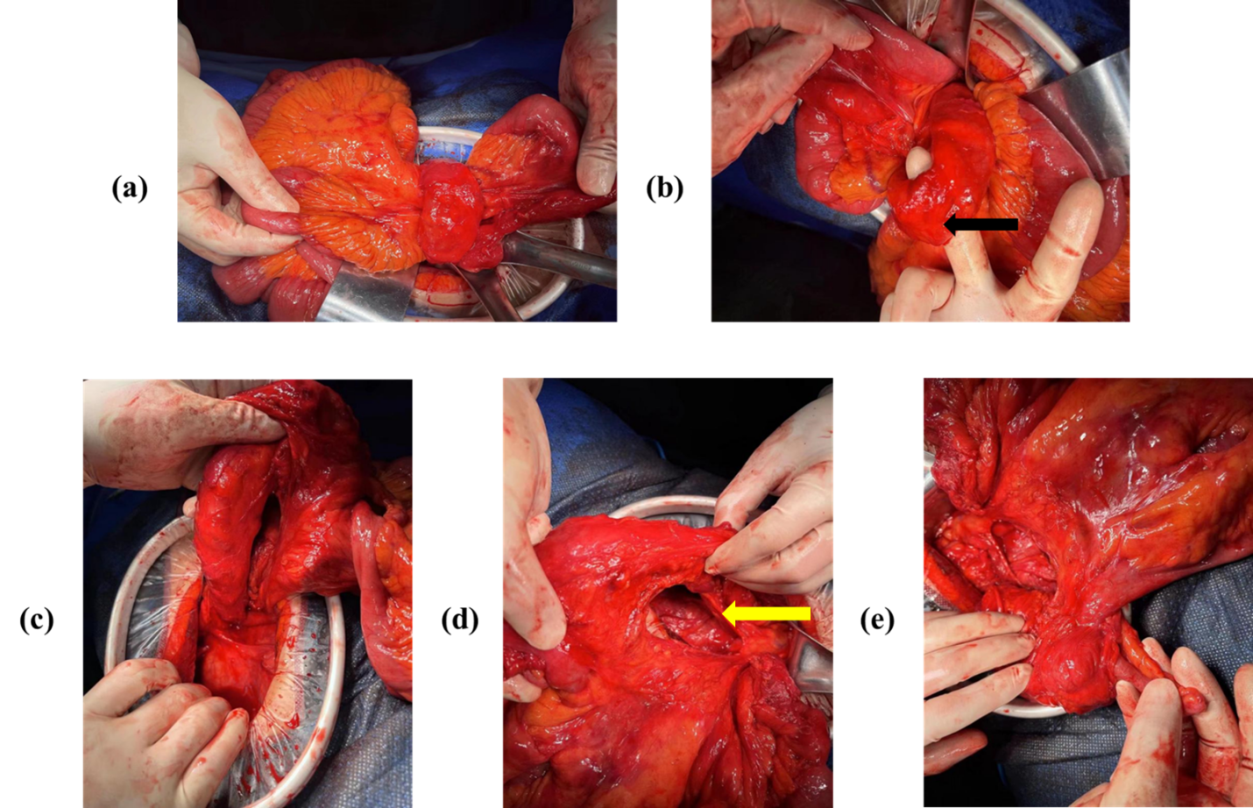

Figure 2. Observation and localization, (a) Small intestine ascending colon mesangial hiatus hernia entry. (b) The arrow indicates the ascending colon. (c) The free mesentery of the ascending colon of the small intestine. (d) Free mesangial hiatus of ascending colon. (e) The ileocecal part after dissociation.

When the patient was admitted to our department it was reported to have a mesenteric defect, but while performing surgery the mesenteric defect was found, as the preoperative diagnosis of mesenteric defect is difficult, because of a wide range of acute abdominal symptoms, it had been reported that plain CT-scan or plain X-ray reports can suggest the presence of an internal hernia, however, there is no confirmation of mesenteric defects (Tassinari et al., 2012). The risk factor includes birth defect known as intestinal malrotation and Hirschsprung disease (Amiel et al., 2008; Moore, 2006; Yasui et al., 2020). Long-term constipation and high fiber diet may also increase the cause of getting affected (Ho et al., 2012). The sigmoid colon is the most common site to be affected and the cecum is the second most common site for this defect. Initially, the sigmoid volvulus may occur because of barium enema or sigmoidoscopy. A bowel resection is generally recommended due to the high risk of recurrence (Obokhare, 2012). Depending on the site of site of volvulus, the symptoms may vary, for example: cecal volvulus patients may present with complaints of constipation, nausea, and vomiting, due to the presence of obstruction near the ileocecal valve and small intestine (Smith et al., 2023). However, in patients with sigmoid volvulus, the abdominal pain will be present along with the constipation with a more prominent form (Sarfaraz et al., 2017). Complications such as strangulation, gangrene formation, abdominal perforation, faecal peritonitis, and recurrent volvulus can be found in this patient (Yasui et al., 2020).

4. Conclusion

Congenital mesenteric dysplasia is not rare in clinics, but there are different cases of other changes caused by mesenteric dysplasia. This case is congenital mesenteric dysplasia with hernia formation in ascending colon mesangial hiatus and mesenteric root torsion. The clinical manifestations of this case are hidden, and it is very easy to misdiagnose and lose the best operation opportunity by clinicians. It leads to necrosis of the whole small intestine and right colon, which deserves the attention of every clinician.

institutional review board statement

This study was conducted following the Declaration of Helsinki. Ethical review and approval were waived for this study by local laws, due to the nature of the report itself (retrospective, no change to usual clinical practice).

informed consent statement

Informed consent was obtained from the subjects involved in the study. Written informed consent has been obtained from the patient to publish this paper.

Competing interests

The authors declare no conflicts of interest.

References

Al-Omari, M. H., Qararha, K., Garaleh, M., Smadi, M. M., Hani, M. B., & Elheis, M. (2018). Mesenteric panniculitis: comparison of computed tomography findings in patients with and without malignancy. Clinical and Experimental Gastroenterology, 1-8.
Amiel, J., Sproat-Emison, E., Garcia-Barcelo, M., Lantieri, F., Burzynski, G., Borrego, S., Pelet, A., Arnold, S., Miao, X., & Griseri, P. (2008). Hirschsprung disease, associated syndromes and genetics: a review. Journal of medical genetics, 45(1), 1-14.
Aravamudan, V. M., Khan, S. R., Natarajan, S. K., & Hussain, I. (2019). The Complex Relationship between Mesenteric Panniculitis and Malignancy—A Holistic Approach is Still Needed to Understand the Diagnostic Uncertainties. Cureus, 11(9).
Batsis, I. D., Okito, O., Meltzer, J. A., & Cunningham, S. J. (2015). Internal Hernia as a Cause for Intestinal Obstruction in a Newborn. The Journal of Emergency Medicine, 49(3), 277-280. https://doi.org/https://doi.org/10.1016/j.jemermed.2015.04.030
Benyamini, P., Lopez, S., Cooper, M., Mohamad, O., & Maldini, G. (2016). Congenital mesenteric defect: an uncommon cause of bowel obstruction. Hawai'i Journal of Medicine & Public Health, 75(2), 46.
Biondi, A., Grosso, G., Mistretta, A., Marventano, S., Toscano, C., Drago, F., Gangi, S., & Basile, F. (2013). Laparoscopic vs. open approach for colorectal cancer: evolution over time of minimal invasive surgery. BMC surgery, 13, 1-6.
Borazan, E., & Konduk, B. T. (2020). Comparison of early and delayed diagnosis of mortality in ERCP perforations: A high-volume patient experience. Turkish Journal of Trauma & Emergency Surgery/Ulusal Travma ve Acil Cerrahi Dergisi, 26(5).
Crispín-Trebejo, B., Robles-Cuadros, M. C., Orendo-Velásquez, E., & Andrade, F. P. (2014). Internal abdominal hernia: intestinal obstruction due to trans-mesenteric hernia containing transverse colon. International journal of surgery case reports, 5(7), 396-398.
Goffette, P. P., & Laterre, P.-F. (2002). Traumatic injuries: imaging and intervention in post-traumatic complications (delayed intervention). European radiology, 12(5), 994-1021.
Ho, K.-S., Tan, C. Y. M., Daud, M. A. M., & Seow-Choen, F. (2012). Stopping or reducing dietary fiber intake reduces constipation and its associated symptoms. World Journal of Gastroenterology: WJG, 18(33), 4593.
Hunt, R., Quigley, E., Abbas, Z., Eliakim, A., Emmanuel, A., Goh, K.-L., Guarner, F., Katelaris, P., Smout, A., & Umar, M. (2014). Coping with common gastrointestinal symptoms in the community: a global perspective on heartburn, constipation, bloating, and abdominal pain/discomfort May 2013. Journal of clinical gastroenterology, 48(7), 567-578.
Katagiri, H., Okumura, K., & Machi, J. (2013). Internal hernia due to mesenteric defect. Journal of Surgical Case Reports, 2013(5), rjt037.
Lange, P., & Parrish, D. (2015). Congenital internal hernias: rare cause of intestinal obstruction in newborns. Journal of Clinical Neonatology, 4(2), 138-141.
Lehtimäki, T. T., Kärkkäinen, J. M., Saari, P., Manninen, H., Paajanen, H., & Vanninen, R. (2015). Detecting acute mesenteric ischemia in CT of the acute abdomen is dependent on clinical suspicion: review of 95 consecutive patients. European journal of radiology, 84(12), 2444-2453.
Maglinte, D. D., & Bisset III, G. S. (2021). Congenital and Developmental Anomalies of the Small Bowel in Adolescents and Adults. In Clinical Imaging of the Small Intestine (pp. 227-258). Springer.
Monica, M. L., Antonella, M., Gloria, A., Diletta, C., Nicola, M., Ginevra, D., Lina, B., Silvia, P., Andrea, G., & Vittorio, M. (2019). Internal hernias: a difficult diagnostic challenge. Review of CT signs and clinical findings. Acta Bio Medica: Atenei Parmensis, 90(Suppl 5), 20.
Moore, S. (2006). The contribution of associated congenital anomalies in understanding Hirschsprung’s disease. Pediatric surgery international, 22, 305-315.
Obokhare, I. (2012). Fecal impaction: a cause for concern? Clinics in colon and rectal surgery, 25(01), 053-058.
Sarfaraz, M., Hasan, S. R., & Lateef, S. (2017). Sigmoid volvulus in young patients: Ą new twist on an old diagnosis. Intractable & Rare Diseases Research, 6(3), 219-223.
Smith, D. A., Kashyap, S., & Nehring, S. M. (2023). Bowel obstruction. In StatPearls [Internet]. StatPearls Publishing.
Suter, M., Zermatten, P., Halkic, N., Martinet, O., & Bettschart, V. (2000). Laparoscopic management of mechanical small bowel obstruction: are there predictors of success or failure? Surgical endoscopy, 14, 478-483.
Tassinari, D., Santoro, S., Bernardi, F., & Lima, M. (2012). A mesenteric hernia complicated with a triple necrotic volvulus. Case Reports, 2012, bcr2012006448.
ur Rehman, Z., & Khan, S. (2010). Large congenital mesenteric defect presenting in an adult. Saudi Journal of Gastroenterology, 16(3), 223-225.
Whan, J., & Kwok, C. M. (2020). Intestinal obstruction caused by the strangulation of a Treves’ field pouch hernia from a Meckel’s diverticulum–A case report. International journal of surgery case reports, 77, 403-406.
Yasui, Y., Shironomae, T., & Kuwahara, T. (2020). Target and Whirl Signs: Volvulus of Intussuscepted Colon in an Infant. Clinical Gastroenterology and Hepatology, 18(5), A34.

