Case Report

Challenges and Management of Open Abdomen in Resource-Limited Settings: A Case Report of a Morbidly Obese Patient with Mesenteric Panniculitis

ABSTRACT
Open abdomen management in damage control surgery is critical for conditions like abdominal sepsis, and trauma, with the primary goal being timely fascial closure to prevent complications. A 52-year-old female presented with abdominal pain, vomiting, and loose stools, and underwent an exploratory laparotomy. Intraoperative findings were suggestive of sealed-off ileal perforation, severe mesenteric panniculitis, and the abdomen could not be closed; temporary abdominal closure was done with a sterile urobag and shifted to the ICU on mechanical ventilation. A restrictive fluid management strategy was followed, with total parenteral nutrition started on POD 1. On the 3rd day, a relaparotomy was performed and placed on an ABTHERA vac system. Three days later, successful closure was achieved. She was extubated on day 9, started on enteral nutrition, and transitioned to oral intake. Managing an open abdomen requires infection control, balanced resuscitation, and early nutrition for improved outcomes.
Keywords:
ABTHERA open abdomen manager vac system, ICU management, Mesenteric panniculitis, Open abdomen.

Introduction
General surgeons have been managing the open abdomen for decades. Techniques have evolved to improve infection control, fluid loss, and the ability to close the abdomen to avoid hernia formation. The most important considerations in open abdomen management include infection prevention, organ dysfunction mitigation, and eventual plans for abdominal closure.(1).
Damage control surgery (DCS) techniques such as the open abdomen (OA), where the facial edges and the skin are intentionally left open, thereby exposing the abdominal viscera, are employed in approximately 10–15% of trauma laparotomies. Pancreatitis, abdominal trauma, massive or extensive burns, ruptured aortic aneurysm, severe trauma, ischemic gut with planned second-look laparotomy, damage control surgery, abdominal compartment syndrome, intra-abdominal sepsis, and retroperitoneal hemorrhage can lead to increased intra-abdominal pressure. This pressure elevation results in end-organ dysfunction, affecting hemodynamics, kidney function, respiratory function, and central nervous system (2). Once an OA has been created, the primary goal is fascial closure as soon as possible once the underlying issue has been resolved (3). Therefore, the abdominal contents are potentially exposed and must be protected with temporary coverage known as temporal abdominal closure (TAC) (4).
Mesenteric panniculitis is a rare condition characterized by inflammation, degeneration, and scarring of mesenteric fat tissue, leading to symptoms like abdominal pain, weight loss, nausea, and vomiting. It presents in three forms: diffuse mesenteric thickening, single knotty thickening at the mesenteric root, and multiple knotty thickenings (5).
Usually, open abdomen management requires tertiary or quaternary care setup with high-end surgical care backup and advanced precautions for asepsis but there is limited literature on their management in low-resource settings, and reporting such cases helps in the decision-making process, surgical technique, and post-operative care which improves overall clinical outcomes in low resource settings.
Case Report
A 52-year-old female with a history of hypertension and morbid obesity (BMI = 43 kg/m²) presented with pain in the abdomen, vomiting for one day, and loose stools for two days. The symptoms persisted despite conservative management. The Contrast Enhanced Computed tomography (CECT) abdomen features suggestive of enteric perforation. She underwent an exploratory laparotomy under general anesthesia (Figure 1).
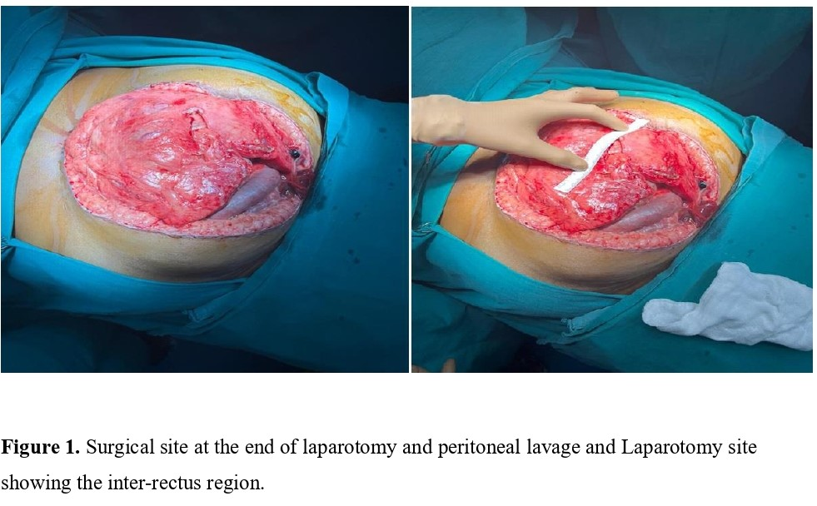
Intraoperative findings were suggestive of the patient having sealed off ileal perforation, severe mesenteric panniculitis, and the inability to close the rectus sheath (Figure 1). Temporary abdominal closure was done with a sterile urobag. She was shifted to the surgical intensive care unit (ICU) and was kept on mechanical ventilation. She was managed for intraoperative and post-operative fluid losses and a restrictive strategy for fluid management was followed. Hypertonic saline 3% was used to prevent interstitial and bowel wall edema. She was analgo-sedated with Dexmedetomidine. Comprehensive aseptic precautions were taken with 1:1 nursing and a dedicated ICU cubical. All the ICU care bundles were followed to maintain the internal milieu. Total parenteral nutrition was initiated on postoperative day 1 (POD-1). On the 3rd POD, she underwent relaparotomy. Then peritoneal lavage was given, and because of the inter rectus distance of 10 cm, she was placed on an ABTHERA open abdomen manager vac system (Figure 2).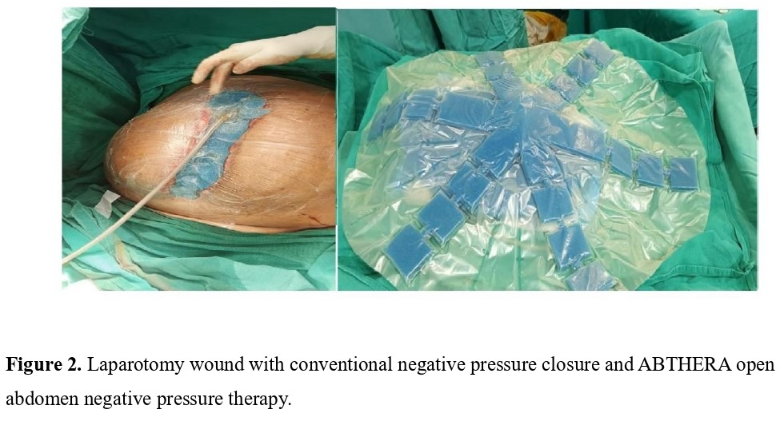 Then, after three days, she was taken up for relaparotomy, and closure was attempted successfully. She returned to the surgical ICU and maintained on mechanical ventilation. After achieving subjective and objective criteria for weaning from mechanical ventilation, she was extubated to a high-flow nasal cannula (HFNC) on POD-9. On POD-9, she started on enteral nutrition.
During her hospital stay, when she had an open abdomen, the restrictive fluid strategy was used, and she was placed on total parenteral nutrition, intravenous antibiotics, proton pump inhibitors, and other supportive measures. After her abdominal closure was done, she started on clear oral liquids after two days and then slowly escalated to a soft diet.
She underwent a CT abdomen on POD-14, which showed no evidence of intra-abdominal collections and an intact rectus sheath. On the 14th POD, abdominal drains were removed. At discharge, the patient is vitally stable, mobilized, passed stools, and has a grade 1 bed sore. She was discharged with the medications as necessary. On the 6th month follow up she was doing well.
Discussion
We present a 52-year-old morbidly obese female with an acute abdomen who underwent a laparotomy, after which the abdomen couldn’t be closed and had to be managed with a staged closure of the abdominal wall. As per our knowledge and literature search, very few open abdomen cases were managed in resource-limited settings.
Managing open abdomen (OA) is resource-intensive, typically needing ICU care for ventilatory support, fluid and electrolyte balance, prevention of hypothermia, and systemic inflammatory response management. Additional challenges include managing gastrointestinal fistulas, infection, and coagulopathy, and providing appropriate antibiotic therapy, pain control, and nutrition (3). The challenges and strengths of this case report are that it was handled in a limited resource and remote setting, and the following are the clinical challenges that we face in the intensive care unit in patients with open abdomen.

Mechanical ventilation
Temporary abdominal closure does not necessitate intubation and sedation. When negative pressure closure is properly applied, patients can safely be extubated and may ambulate with minimal risk of evisceration. A study by Barker et al. reported an evisceration rate of only 0.4% in 1,717 vacuum-pack closures. The benefits of extubation and ambulation, including reduced ventilator-associated pneumonia risk and shorter ICU stays, outweigh the low evisceration risk. Ventilator weaning should consider hemodynamic stability, pulmonary function, and oxygenation in critically ill patients (6).
Fluids
Ischemia-reperfusion injury leads to fluid accumulation in the bowel wall leading to reduced blood volume in the vessels. While crystalloid fluids restore volume, they worsen bowel swelling, raise intra-abdominal pressure (IAP), prevent primary closure, and increase intestinal fistula risk. Impaired mesenteric venous return causes venous congestion, and bowel swelling disrupts lymphatic drainage, further exacerbating the condition. These combined factors heighten the risk of intestinal fistulas. Fluid management in open abdomen care should focus on balanced resuscitation to avoid fluid overload and bowel swelling, aiming for primary closure. Weight gain exceeding 10% from fluids increases the risk of failed closure (6).
Infection control
The risk of developing an infection rises after 8 days of having an open abdomen (OA). About 25% of OA patients experience infections like wound infections, deep abdominal abscesses, or intestinal fistulas, which can hinder the primary closure of the abdomen. These patients also show a higher rate of bloodstream infections. Outcomes are poor for nearly 78% of patients who develop intra-abdominal colonization with gram-positive cocci and gram-negative bacilli. Antibiotic therapy should be guided by the specific condition and culture results, while prophylactic antibiotics play a limited role. Preventing catheter-associated bloodstream infections and ventilator-associated pneumonia (VAP) is critical. Therefore, once patients reach physiological stability, primary fascial closure should be pursued (2).
Nutrition
Early enteral nutrition is crucial in managing open abdomen (OA), with intestinal discontinuity being the only significant contraindication. Research disproves concerns about paralytic ileus or gut edema during OA. So, early enteral feeding should be started to maintain gut integrity, reduce infection rates, lower ventilator-associated pneumonia risk, and promote early abdominal closure. Nutritional management should address significant nitrogen and electrolyte losses from abdominal fluid, with careful nitrogen balance and fluid replacement. Though no clear guidelines exist for the optimal feeding site or formula type, early full enteral feeding is key to improving outcomes and reducing complications in OA management (2).
Hypothermia
An open abdomen (OA) leads to increased insensible heat loss compared to a closed abdomen, although the precise amount isn't known. Even with warm IV fluids, humidified gases, and heating blankets, about 4.6°C of body heat is lost each hour during laparotomy. A drop in core temperature from 34°C to below 32°C has been associated with a 40–100% rise in mortality rates among trauma patients. The detrimental effects of hypothermia include Cardiac dysrhythmias hypoxia and coagulopathy. The surgical intensive care community should come together to formulate guidelines for the management of open abdomen in limited resource settings (2).
Conclusion
Managing an open abdomen (OA) in the ICU requires a multidisciplinary approach, focusing on timely closure, infection control, fluid balance, and nutritional support. Key strategies include minimizing fluid overload to prevent abdominal compartment syndrome (ACS), using temporary abdominal closure techniques like negative-pressure therapy, and initiating early enteral nutrition. Meticulous monitoring, balanced fluid resuscitation, and infection prevention are essential. Though resource-intensive, OA management can be effectively handled in resource-limited settings by optimizing available resources and does not always require level III ICU care or positive pressure isolation for successful outcomes.
List of abbreviations
Damage control surgery (DCS)
Open abdomen (OA)
Temporal abdominal closure (TAC)
Abdominal compartment syndrome (ACS)
Contrast Enhanced Computed tomography (CECT)
Intensive care unit (ICU)
High-flow nasal cannula (HFNC)
Deep vein thrombosis (DVT)
Intra-abdominal pressure (IAP)
Ventilator-associated pneumonia (VAP)

References
  - Serfin J, Dai C, Harris JR, et al. Damage Control Laparotomy and Management of the Open Abdomen. Surg Clin North Am. 2024;104(2):355-366.
  - Mitra LG, Saluja V, Dhingra U. Open Abdomen in a Critically Ill Patient. Indian J Crit Care Med. 2020;24(4):S193-S200.
  - Mwita C, Negesa R, Boeck M, et al. Open abdomen management and outcomes: two case reports from western Kenya and a review of literature from Africa. Pan Afr Med J. 2019;32:33.
  - Coccolini, F., Montori, G., Ceresoli, M, et al. The role of open abdomen in non-trauma patient: WSES Consensus Paper. World J Emerg Surg.2017;12:39.
  - Hussein, M. R. A., & Abdelwahed, S. R. Mesenteric panniculitis: an update. Expert Rev Gastroenterol Hepatol. 2014;9(1): 67–78.
  - Griggs C, Butler K. Damage Control and the Open Abdomen: Challenges for the Nonsurgical Intensivist. J Intensive Care Med 2016;31(9):567-76.

.

