Original Research Article

POTENTIAL EFFECT OF SENNA HIRSUTA LEAF AS ALTERNATIVE THERAPY FOR EPILEPSY AND OXIDATIVE STRESS.

Abstract
Epilepsy is a neurological condition that affects the central nervous system and is characterize by strange emotions and actions. Antioxidants are believed to play a very vital role in the body defense system against reactive oxygen species (ROS). ROS, is a basal cause of aging as well as various degenerative and chronic diseases in human. In Nigerian traditional medicinal practices, senna hirsuta (Family -Fabaceae) leaves are used as antibacterial, antifugus, herpes, antimalarial as well as treating convulsive disorders.
Aim: To evaluate the anticonvulsant and antioxidant activity of extract and fractions of Senna hirsuta leaves in mice.
Methodolgy: The extract was subjected to fractionation using successively n-hexane, methanol, ethyl acetate and butanol to obtain their different fraction. Three in vivo test models were used for this study; Pentylenetetrazole (PTZ), Picrotoxin (PTX), and Strychnine (STR) induced convulsion in mice. The mice were allotted to five (5) groups; group 1 served as the negative control, group II served as the positive / standard control. While groups III-V served as the test group that received Senna hirsuta extract or fractions (100 mg, 200 mg and 400 mg / kg p.o) respectively. Two in vitro antioxidant assays, DPPH (1, 1-diphenyl-2-picrylhydrazyl) and FRAP (Ferric reducing antioxidant power) were used. Their absorbance were gotten and compared with that of standard (L-absorbic acid).
Result: Shows that the leaf methanolic extract of Senna hirsuta dose dependently exhibited significant anticonvulsant activity and 66.67% protection against mortality compared with the control. In the PTZ induced convulsion hexane extract (HE) at 400 mg / kg dose, showed the highest significant (P<0.05) delay in the time of onset of myclonic spasm (MS) and tonic - clonic phase (TCP).
Conclusion: Senna hirsuta leaves possesses significant anticonvulsant and antioxidant activity.

Keywords: Senna hirsuta, Anticonvulsant, Pentylenetetrazole, Picrotoxin, Strychnine, Antioxidant, DPPH, FRAP and HPLC.

Introduction
A brain condition called epilepsy is caused by strong, ill-coordinated, or widely distributed electrical discharges from neurons (Asogwa, Celestine, et al., 2022). An epileptic seizure is a period of abnormal neuronal discharge that shows up as changes in mood, autonomic function, motor coordination, or sensory perception (REHMAN et al., 2024). The World Health Organization (WHO) defines epilepsy as a neurological condition that affects individuals of all ages and is typified by excessive or aberrant electrical activity in all or a portion of the brain. Epileptic seizure disorders can be caused by a variety of variables, such as congenital, developmental, or genetic ones. The majority of seizures are unplanned, brief (a few minutes or even seconds), spontaneous, and end on their own. People of all ages are affected by epileptic seizures, which are considered the most common neurological illness in many humanities as a whole. About fifty million people worldwide suffer from epilepsy, a chronic noninfectious brain disorder (Domańska et al., 2025). In Nigeria, epilepsy is estimated to impact 1 / 125 of the population, indicating that it is a major burden (Bamikole et al., 2019). Epilepsy is one of the most prevalent neurological disorders during pregnancy, affecting one in 200 women of reproductive age (Joung, 2019). Pregnancy-related physiological changes may impact a woman's preexisting health conditions as well as how well she absorbs, distributes, metabolizes, and excretes drugs. Inappropriate medication adjustments for women with epilepsy (WWE) taking antiepileptic drugs (AEDs) may decrease a pregnant woman's seizure threshold during pregnancy or raise serum drug levels and possible toxicity after delivery (Patel et al., 2016). Keeping seizures under control while lowering the hazards to the fetus from the use of AEDs is a problem for WWE during pregnancy and childbirth. However, there is a chance that using AEDs during pregnancy could result in issues like preeclampsia, the necessity for induction, or a cesarean delivery (Borthen et al., 2011). The gold standard for preventing and treating eclampsia is magnesium sulfate, which also has neuroprotective effects on premature babies. AED users who are pregnant are more likely to experience a spontaneous abortion than non-users (Vajda et al., 2017). Pregnant women who are exposed to AEDs are twice as likely as those who are not to develop congenital abnormalities such as cleft lips, neural tube anomalies, urogenital abnormalities, or craniofacial dysmorphic traits (Laganà et al., 2016).

Bursts of high-frequency action potentials and excessive neuronal population synchronization are two contemporaneous features that signal the onset of seizures (Asogwa, Celestine, et al., 2022). Extracellular Ca⁺⁺ triggers all the generation of recurrent action potentials, the opening of voltage-dependent Na⁺ channels, the input of Na⁺, and the bursting activity resulting from the relatively prolonged depolarization of the neuronal membrane. The hyperpolarizing potential is mediated by Cl⁻ influx or K⁺ efflux and gamma-aminobutyric acid (GABA) receptors, depending on the type of cell (Knoflach et al., 2016). A particular type of inhibitory neurotransmitter called GABA in the brain essentially prevents the brain from sending messages. Seizures can be brought on by several GABA production inhibitors, such as pentylenetetrazole (PTZ), picrotoxin (PTX), strychinine ,thiosemicarbazide, 4-deoxypyridoxine, isoniazid, and L-allyglycine (Akyuz et al., 2021). The two main receptor types that the primary inhibitory neurotransmitter GABA interacts with are GABA_{A} and GABA_{B}. The GABA_{A} receptors are postsynaptically located, whereas the GABA_{B} receptors are presynaptically located and can therefore affect synaptic release. In the adult brain, GABA_{A} receptors are permeable to Cl ions. Cl-influx activation hyperpolarizes the membrane and suppresses action potentials. Barbiturates and benzodiazepines are GABA_{A} receptor agonists, and as a result, they reduce seizure activity. Because of their presynaptic position, GABA_{B} receptors are associated to second messenger systems but not Cl⁻ channels, and thus attenuate transmitter release. The primary excitatory neurotransmitter in the brain is a type of amino acid known as glutamate. The ionotropic N-methyl-D-aspartate (NMDA) and the metabotropic glutamate receptor mediate epileptic seizures.
Anticonvulsants that increase synaptic GABA by preventing its breakdown or reuptake are considered effective. These include barbiturates and benzodiazepines, which increase the frequency of chloride channel openings and improve GABA binding to the GABA_{A} receptor (Janković et al., 2021). Cells and animals have been strongly motivated by evolution to use ambient dioxygen for respiration in order to meet energy demands. Reactive oxygen species (ROS) are the more reactive forms of oxygen that occur naturally, such as singlet oxygen or H₂O₂, or as free radicals, which are atoms or groups of atoms with an unpaired electron that act as electron acceptors, like superoxide anion (O₂−) and hydroxyl radical (OH•) (Hayyan et al., 2016; Rettig et al., 2021). Reactive oxygen species can be produced in cells enzymatically or by UV (ultraviolet) irradiation. Depending on oxygen availability and the expression of enzymes that produce reactive oxygen species, the creation of ROS varies significantly among tissues.
The brain is one of the organs that produces the most ROS due to its high metabolic rate and approximately ten times higher oxygen consumption than other bodily tissues (Zorov et al., 2014). The primary ROS producers in the brain during status epilepticus and prolonged seizures are xanthine oxidase, lipoxygenase, mitochondria (electron transport chain, TCA enzymes, and monoamine oxidases A and B), and NADPH (nicotinamide adenine dinucleotide phosphate) oxidase (mostly in two isoforms NOX2 and NOX4), which are stimulated by NMDA receptor activation (Malkov et al., 2021; Shekh-Ahmad et al., 2019). An efficient antioxidant system is required to shield cells from oxidative stress since brain ROS formation happens even when the brain is at rest and significantly rises during brain activity. Together with antioxidant enzymes, the brain's main endogenous antioxidants, glutathione, and α-tocopherol (vitamin E) in lipids, all have significant protective functions (Teleanu et al., 2019). ROS are perfect signaling molecules that are essential for physiological function because of their short lifetime, limited diffusion, and reliance on cellular activity to determine their production level. Moderate levels of ROS have been found to regulate a wide range of functions in the brain. For instance, long-term potentiation, a mechanism necessary for memory formation, is aided by ROS produced from NOX (Ganguly et al., 2021).
However, oxidative damage, cellular malfunction, and cell death can result from shifts in the brain's redox balance caused by an increase in ROS generation or a decrease in antioxidant levels. Excess ROS cause direct protein damage and lipid peroxidation, which change the function of enzymes and membranes, respectively, and ultimately cause cell death (Juan et al., 2021). The brain is especially vulnerable to injury from ROS because of its high polyunsaturated fatty acid concentration.
Common pathologies that cause epilepsy include brain tumors, meningitis, CNS infections, metabolic disorders if the cause is unknown, or "symptomatic" disorders if the cause is due to a recognized ailment. Trauma brought on by poor obstetric care can occur alone or in combination during pregnancy, or it can occur throughout life in cases of marital abuse, workplace violence, and vehicle crashes. Severe scalp shaping and hypoxia following birth trauma can bring on epilepsy. These conditions can then negatively affect the hippocampus and amygdala and cause incisura sclerosis. Many therapeutic approaches have been utilized in the management, control, and/or treatment of epileptics. Nonetheless, modern antiepileptic medications (AEDs) do not work for roughly 30% of epileptic cases. Due to conventional AEDs' and antioxidants' refractoriness, dose-related toxicity, high cost, and unavailability, other treatment approaches are required (L Iyanyi et al., 2021). In recent years, the main objective of antiepilepsy research has been to find newer drugs from natural sources that are more effective and tolerable. When opposed to conventional AEDs, a number of herbal medicinal items are widely used in Africa alone to treat epileptics since they are readily available and cost-effective. In Nigerian traditional medicine, Senna hirsuta (Fabaceae) leaves are used to treat convulsive disorders and as an antibacterial, antifugus, herpes, anti-inflammatory, antiseptic, antiparasitic, laxative, vermifuge, purgative, stomachic, and febrifuge for other reproductive issues. The present study is to investigate the traditional use of Senna hirsuta leaves in the treatment of convulsive disorders.
Materials and Methods
Collection and processing of plant material
Fresh leaves of Senna hirsuta were harvested from a forest in Orba, Nsukka LGA Enugu State, Nigeria. The plant was identified by a taxonomist Mr. A.O. Ozioko, attached to the International Centre for Ethnomedicine and Drug Development (InterCEDD), Nsukka, Enugu State, Nigeria where a voucher specimen (InterCEDD 1208) was deposited. The leaves were washed in tap water to remove dust and were shade-dried for two weeks. The dried leaves were then ground using a miller, weighed, packaged in an airtight container with clear labels, and kept at room temperature prior to extraction.
Drugs, reagents and equipment
All the drugs, reagents and chemicals used in the study were of analytical grade.
Preparation of methanol extract
Maceration was carried out by placing 955 g of finely ground leaves in 4.5 L of analytical-grade methanol for 72 h based on a modified method (Ekalu et al., 2020).
The mixture was periodically stirred and was filtered twice; first with muslin cloth and later with Whatman filter papers. The filtrate was concentrated using a rotary evaporator at 50 ⁰C and then dried over a hot air oven at 35 ⁰C. Prior to usage, the concentrated extract (MEcr) was weighed, labeled, and kept in a refrigerator at 4 ºC.
Fractionation of extract
A 20 g of crude methanol extract was fixed in 200 g of silica gel with methanol to form slurry. The slurry was poured into long glass column. The column was eluted with n-hexane (500 mL, 3 fold), ethyl acetate (500 mL, 3 fold), n-buthanol (500 ml, 3 fold) and finally with 1000 mL of methanol (Ostberg-Potthoff et al., 2019).
Qualitative phytochemical screening
Standard qualitative phytochemical tests were done on the crude methanol extract and the various fractions (Harborne, 1998). The presence or absence of a specific phytochemical group was determined by visual examination of color or fronting.
Experimental animal
Adult swiss albino mice weighing between 20-30 g were obtained from animal house facility of the Department of Pharmacology and Toxicology, Faculty of Pharmaceutical sciences, Enugu State University of Science and Technology ESUT Agbani campus.
The animals were maintained on standard laboratory animal feed and water ad libitum. All animal experiments were conducted according to International Guidelines for Care and Use of Laboratory Animals (Pub. No. 85 -23, revised 1985) and in strict compliance to the ethical principles, rules and regulations of the institution on the use of laboratory animals for experiments.
Acute toxicity Studies (LD₅₀)
Acute toxicity of methanol crude extract of Senna hirsuta leaf was performed using twelve adult albino mice of both sex using the method described by (Lorke, 1983). In the experiment, twelve adult mice of either sex, weighing between 23 and 34 g, were given free access to food and potable water. Nine (9) rats were employed in the first phase. The animals were allotted to three (3) groups of three (3) animals per group. After each group received the proper intrabuccal dosages of 10, 100, and 1000 mg / kg of crude methanol extract, the animals were allowed unrestricted access to food and water and were monitored for a full day for any indications of mortality. Any fatality was noted, and the experiment's second phase made use of the findings. Three rats each were split up into three groups for the second phase, and each group received 1900, 2600, and 5000 mg/kg of Senna hirsuta leaf methanol extract, respectively. The rats had unrestricted access to food and water, and then they were monitored over 24 h for mortality.
Anticonvulsant Studies
Pentylenetetrazole (PTZ)-induced Convulsions.
Five (5) groups of mice (n=5) were used in this model; group I served as the PTZ-induced seizure control (received 10 mL / kg of distilled water, p.o.), group II served as the standard (received 3 mg / kg of diazepam, i.p.). Methanol extract (ME), hexane fraction (HF), and ethyl acetate fraction (EAF) were administered to groups III–V at doses of 100, 200, and 400 mg / kg, p.o., respectively. Thirty minutes later, pentylenetetrazole (PTZ, 60 mg / kg, i.p.) was administered to elicit convulsion. The duration of tonic-clonic phases of seizures and the start of myoclonic spasms were recorded in the animals. The percentage of mice in each group that were protected from seizure-induced mortality was also noted. During the 60 min observation period, animals that did not experience seizures or convulsions and did not die were deemed protected.
Picrotoxin (PTX)-induced Convulsion
Five (5) mouse groups (n=5) were employed in this paradigm; group I (PTX-induced seizure control) was given 10 mL / kg of distilled water intraperitoneally, while groups II–V were given the standard medication, extract, and fractions as previously mentioned. Thirty minutes prior to the injection of picrotoxin (PTX, 4 mg / kg, i.p.), treatments were done. After receiving PTX, the animals were monitored for 60 min to determine whether myoclonic spasms, tonic clonic spasms, and death occurred. Animals were deemed protected if they exhibited neither of these symptoms. The percentage of mice in each group that were protected from seizure-induced death was noted.
Strychnine (STC)-induced Convulsion
Five (5) mouse groups (n=5) were employed in this paradigm; group I, which was the STC-induced seizure control group, was given 10 mL / kg of distilled water intraperitoneally. Mice in groups II–V were given the usual medication, extract, and fractionation as previously mentioned. Thirty minutes prior to the injection of strychnine (STC, 2 mg / kg, i.p.), treatments were done. After receiving STC, the animals were monitored for myoclonic spasms, tonic-clonic seizures, and time to death for 60 min. Animals were deemed protected if they exhibited neither of these symptoms. The percentage of mice in each group that were protected from seizure-induced death was noted.
In Vitro Antioxidant Activities
Determination of 1,1, dipheny-2-picrylhydrazyl (DPPH) Radical Scavenging Activities.
Using 1,1 diphenyl-2-picrylhydrazyl (DPPH), the DPPH radical scavenging assay was carried out in accordance with the procedure outlined by (Mani et al., 2024). Five distinct plant extract concentrations (1, 0.5, 0.25, 0.125, and 0.0625 mg / mL) were made in analytical-grade methanol. As a typical antioxidant, L-ascorbic acid was also produced in the same amounts. In a sterile test tube, 1 mL of each extract under study was added to 3 mL of DPPH, and the volume was made up to 10 ml using methanol. After shaking, the mixture was allowed to stand for half an hour at room temperature in the dark. The same method was done for the standard. At 517 nm, the absorbance values were determined with a spectrophotometer. Three duplicates of each experiment were conducted. The DPPH radical scavenging activity was calculated by using the equation.
DPPH scavenging activity (%) =
Ab−As × 100
Ab
Where:
Ab = Absorbance of blank
As = Absorbance of sample
A plot of the extract concentration against the percentage of DPPH free radical inhibition was used to calculate the extracts' half maximum inhibitory concentration (IC₅₀).
Ferric reducing antioxidant power (FRAP)
The reducing power was determined according to the method by (Mani et al., 2024). Five different concentrations of methanolic extracts of the plant (1, 0.5, 0.25, 0.125 and 0.0625 mg / mL) was prepared each in different test tubes. Each test tube received 2.5 mL of 2 M phosphate buffer (phosphate buffer's PH 6.6). After mixing the solution, 2.5 mL of potassium ferric cyanide was added, and it was covered with foil and incubated for 20 min at 50 °C in a water bath. After adding 2.5 mL of trichloroacetic acid to the mixture, centrifuge it for 10 min at 3000 rpm. After that, 2.5 mL of distilled water and 2.5 mL of the supernatant were added. The solution was mixed and 0.5 mL of 10 ferric chloride was added. The absorbance was read at 700 nm using a UV spectrometer. This was also done for the standard (positive control) that is L-ascorbic acid. The blank contained only water and other reagent no plant extract. The concentrations of each extract able to yield an absorbance value of 0.5 were determined from the graph of absorbance at 700 nm against extract concentrations and considered as the median effective concentration (EC₅₀). This was also done in triplicate.
Quantification by HPLC
The analysis was performed on a BUCK M910 HPLC equipped with a RESTEK 15-meter MXT-1 column (15 m x 250 µm x 0.15 µm) was used. Methanol was used as the carrier gas, with a flow rate of 40 mL.min⁻¹, and the injector temperature was set to 280 °C. Two microliters of the sample were injected spotlessly, with a linear velocity of 30 cm / s. The oven started off at 2000 °C, rose to 3300 °C at a rate of 30 °C per minute, and remained there for five minutes, 3200 ºC was the operating temperature for the detector. The ratio of the found bioactive compound's area to the mass of the internal standard was used to determine its bioactivity. The various bioactive compounds' concentrations are expressed in µg / g.
Statistical Analysis
Results were expressed as Mean ± Standard Error of the Mean (SEM) and as percentages where appropriate. Statistical analysis was performed using analysis of variance (ANOVA); a post hoc Dunnets test was performed for multiple comparisons when statistically significant results were obtained with ANOVA. Values of P<0.05 were considered significant.
RESULTS
Percentage yield of crude extract and fractions
Fractionation of crude methanol plant extract with different solvent of increasingly polarity; resulted in three fractions namely, the ethyl-acetate, n-hexane and n-butanol. The yield of various fractions (grams and percentage) is shown in table 1. The yield of methanol extract was obtained to be 6.806% w / w, the n-hexane fraction was the highest yield (19% w / w).

Table 1 percentage yield of fraction obtained from methanol extract of Senna hirsuta.
Extracts | Initial weight (Mx) (g) | Crude extract (My) (g) | Percentage yield (% w/w)
Crude methanol extract | 955 | 65 | 6.806
n-Hexane fraction | 40 | 7.5 | 19
Ethylacetate fraction | 40 | 2.2 | 5.5
n–butanol fraction | 40 | 3.4 | 8.5

Qualitative phytochemical screening
Methanol extract Senna leaves show the presence of alkaloids, tannins, saponins, flavonoids, terpenoids, cardiac glycosides, reducing sugars, steroids, fats and oils (Table 2).

Table 2 Quantitative phytochemical analysis for Senna hirsuta
Chemical Constituents | Methanol extract. Present (+) / Absent (-)
Phenolic compounds | +
Flavonoids | +
Terpenoids | +
Tannins | -
Saponins | -
Alkaloids | +
Glycosides | +
Steroids | +

ACUTE TOXICITY (LD₅₀)
Table 3: Acute toxicity study (LD₅₀) of Methanol Crude Extract of Senna hirsute leaves
Phase 1 | Dose (mg/kg) | Mortality rate
Group 1 | 10 | 0/3
Group 2 | 100 | 0/3
Group 3 | 1000 | 0/3
Phase 2
Group 1 | 1600 | 0/3
Group 2 | 2900 | 0/3
Group 3 | 5000 | 0/3
So the LD₅₀ is estimated to be >5000 mg / kg
Anticonvulsant Studies
Effect of Senna hirsuta extract on pentylenetetrazole induced convulsion
The result showed that HF at all dose (100, 200 and 400 mg/kg), EAF (400 mg/kg) and ME (400 mg/kg) significant (p <0.005; p<0.05) delayed the onset of MS compared with the negative control.
Table 4: Onset of seizure on pentylenetetrazole induced convulsion
Groups | Onset of seizure (Minutes) | Percentage (%) protection
Negative control | 8 ±0.88# | 0
Positive control | 58 ±0.06* | 100
Methanol extract 100 mg | 17 ±0.88*# | 0
Methanol extract 200 mg | 24 ±0.88*# | 0
Methanol extract 400 mg | 30 ±1.15*# | 33.34
n-Hexane fraction 100 mg | 32.5 ±1.2*# | 0
n-Hexane fraction 200 mg | 38 ±3.18*# | 33.34
n-Hexane fraction 400 mg | 42 ±1.76*# | 66.67
Ethyl acetate fraction 100 mg | 16.5 ±0.88*# | 0
Ethyl acetate fraction 200 mg | 25 ±0.58*# | 0
Ethyl acetate fraction 400 mg | 33 ±2.08*# | 33.34

Results are expressed as mean ± SEM. Significant difference is set at p<0.05 ANOVA followed by Turkey HSD. #Represent a group where there is a significant difference when compared with the positive control, * Represent a group where there is a significant difference when compared with the negative group
Effect of Senna hirsuta extract on picrotoxin induced convulsion
The result showed that HF at all dose (100, 200 and 400 mg/kg), EAF (400 mg/kg) and ME (400 mg/kg) significant (p<0.005; p<0.05) delayed the onset of MS compared with the negative control.
Table 5: Onset of seizure on picrotoxin induced group
Groups | Onset of Seizure (Minutes) | Percentage (%) Protection
Negative control | 6 ±1.15# | 0
Positive control | 58.33 ±0.88* | 100
Methanol extract 100 mg | 18 ±0.58*# | 0
Methanol extract 200 mg | 21.5 ±0.88*# | 0
Methanol extract 400 mg | 28.5 ±0.88*# | 33.34
n-Hexane fraction 100 mg | 30.5 ±1*# | 0
n-Hexane fraction 200 mg | 34 ±1.45*# | 0
n-Hexane fraction 400 mg | 36 ±1.15*# | 66.67
Ethyl acetate fraction 100 mg | 20 ±0.58*# | 0
Ethyl acetate fraction 200 mg | 24.33 ±0.67*# | 0
Ethyl acetate fraction 400 mg | 31.67 ±0.88*# | 33.34
Results are expressed as mean ± SEM. Significant difference is set at p<0.05 ANOVA followed by Turkey HSD. #Represent a group where there is a significant difference when compared with the positive control, * Represent a group where there is a significant difference when compared with the negative group
Effect of Senna hirsuta extract on strychnine induced convulsion
The result showed that HE at all dose (100, 200 and 400 mg/kg), EAE (400 mg/kg) and ME (400 mg/kg) significant (p<0.005; p<0.05) delayed the onset of MS compared with the negative control.
Table 6: Onset of seizure strychnine induced group
Groups | Onset of seizure (minutes) | Percentage (%) Protection
Negative control | 7 ±1.15# | 0
Positive control | 59.33 ±0.67* | 100
Methanol extract 100 mg | 15.5 ±0.58*# | 0
Methanol extract 200 mg | 22 ±0.88*# | 0
Methanol extract 400 mg | 27 ±0.88*# | 33.34
n-Hexane fraction 100 mg | 16.5 ±0.58*# | 0
n-Hexane fraction 200 mg | 21 ±1.76*# | 33.34
n-Hexane fraction 400 mg | 28.5 ±0.58*# | 66.67
Ethyl acetate fraction 100 mg | 17.67 ±0.88*# | 0
Ethyl acetate fraction 200 mg | 25 ±0.58*# | 33.34
Ethyl acetate fraction 400 mg | 30.67 ±0.88*# | 33.34
Results are expressed as mean ± SEM. Significant difference is set at p<0.05 ANOVA followed by Turkey HSD. #Represent a group where there is a significant difference when compared with the positive control, * Represent a group where there is a significant difference when compared with the negative group.

Figure 1; Showing the mean percentage (%) DPPH scavenging activity of the different extract and the standard drug at different concentrations.
The different fractions of the extract as well as the crude extract itself showed percentage inhibitions of DPPH• were significantly different from the standard drug and significantly different from each other. The standard drug showed the highest DPPH• scavenging activity of greater than 97% at all concentrations. The different extract however displayed a reduction in the DPPH• scavenging activity with reduction in the concentration of extract. With the n-Butanol, fraction achieving the highest percentage inhibition of the DPPH radical scavenging activity at all concentrations. Its activity was close to the crude extract at the lower concentrations. The extract of plant in order of the descending free radical scavenging activity are n-butanol fraction and crude extract, methanol fraction, n-hexane fraction and finally, with the least free radical scavenging activity, is the ethyl acetate fraction as shown in figure 1

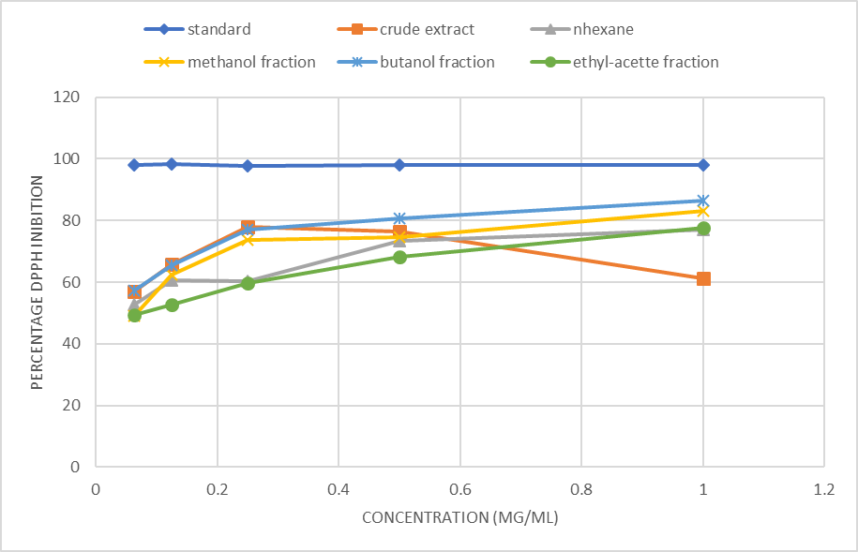
Fig 1 : Showing the mean percentage (%) DPPH scavenging activity of the different extract and the standard drug at different concentrations

Table 7
DPPH assay showing the IC₅₀ [maximal inhibitory concentration] of each of the fractions of Senna Hirsuta extracts.
Standard | Crude extract | n-hexane fraction | Methanol fraction | n-butanol fraction | Ethyl acetate fraction
0.03 | 0.12 | 3.18 | 0.19 | 0.13 | 0.3

Figure 2; Showing the mean absorbance of ferric ion reducing antioxidant power (FRAP) of the different test samples at different concentrations used in the study.

The standard drug showed a significantly higher antioxidant power when compared to the crude extract and other extracts of the test plant. There was no statistically significant difference between the observed ferric ion reducing antioxidant power of the crude extract and any of its fractions. There was also no significant difference between antioxidant observed in the different extract of the study from each other. However, some minor exceptions to this, such as the n-butanol extract of the plant at a concentration of 1 mg / mL, which was observed to have an antioxidant power that was significantly higher than the crude extract and the ethyl-acetate fraction. The IC₅₀ values were lowest in standard drug, followed by n-butanol, methanol crude, ethyl acetate, methanol fraction and n-hexane.

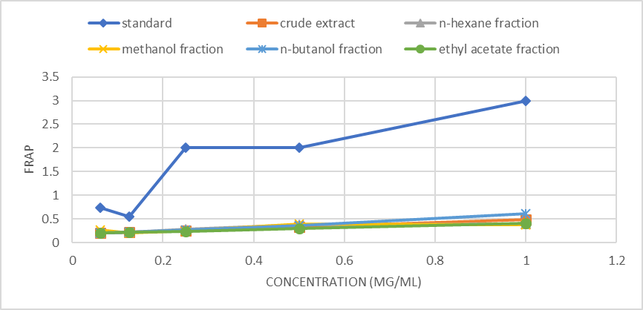
Fig 2 : Showing the mean absorbance of ferric ion reducing antioxidant power (FRAP) of the different test samples at different concentrations used in the study.

Table 8
Frap assay showing the Ec50 [median effective concentration] of each of the extracts of Senna Hirsuta extracts.
Standard | Crude extract | N hexane fraction | Methanol fraction | N butanol fraction | Ethyl acetate fraction
0.01 | 1.1 | 1.9 | 1.7 | 1.0 | 1.5

HPLC TEST
Fig 3 shows the test conducted on n-butanol extract of methanolic extract of Senna hirsuta (chromatogram).
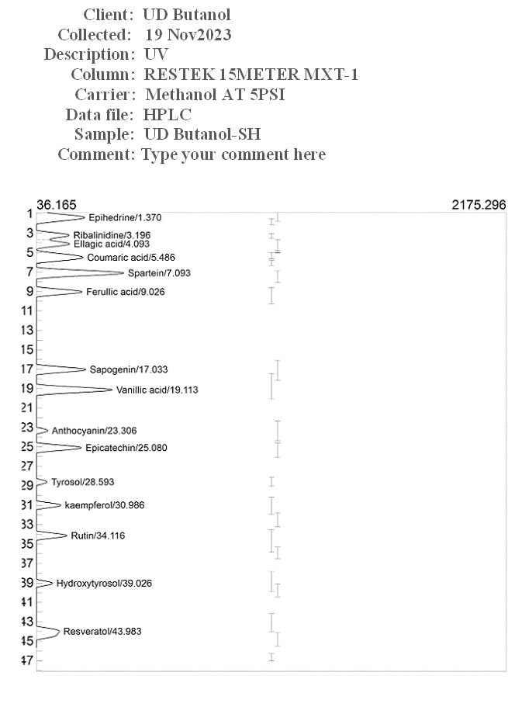

Discussion
The anticonvulsant properties of Senna hirsuta were assessed in this work using a mouse convulsion model triggered by pentylenetetrazole (PTZ), picrotoxin (PTX), and strychnine (STR). Following intraperitoneal (i.p.) administration of PTZ 60 mg / kg, myoclonic spasms (MS) and tonic clonic phase (TCP) were seen, which is in line with numerous other investigations. It was demonstrated that PTZ causes convulsions in experimental animals by blocking the γ-aminobutyric acid pathway in the central nervous system through the inhibition of the GABA receptor chloride channel complex. This causes neurons to become hyperexcitable, which causes an excessive amount of action potentials to fire, which in turn causes seizures. The result showed that the methanol extract and fractions of Senna hirsuta exhibited varying degrees of anticonvulsant activity in dose dependent manner. The HF 400 mg / kg exhibited maximum delay in the onset of PTZ induced convulsion when compared to the seizure control group. HF 400 mg / kg offered the highest percentage protection 66.60%. The standard diazepam exhibited the highest of delay in MS and TCP with 100% protection of mice. Diazepam a positive modulator of GABA_{A} receptor inhibit seizure frequency and severity by enhancing GABA receptor mediated inhibition in the brain. Senna hirsuta extract and fractions ability to protect mice against PTZ induced seizure suggest the presence of a constituent with positive activity against PTZ induced seizure and showed a promising efficacy against absence seizure. (L Iyanyi et al., 2021) reported that drugs that antagonize PTZ induced convulsion are generally effective in controlling myoclonic seizures and absence seizure.

There have been reports of using picrotoxin-induced as a study model to clarify anticonvulsant action. Senna hirsuta extract showed significant activity against PTX-induced convulsion, and 400 mg / kg seemed to be more effective in delaying the onset of MS and TCP. Picrotoxin, a CNS stimulant and no competitive antagonist of GABA receptors, was reported to produce a convulsant effect by blocking the presynaptic inhibition mediated by GABA on GABA receptor chloride channel. The demonstrated inhibition and defense against PTX-induced seizures point to an increase in GABAergic activity, which may have a beneficial mode of action via increasing chloride current via the GABA receptor complex's picrotoxin-sensitive chloride channel.
Strychnine, a strong CNS convulsant, causes an excitatory response in the central nervous system by selectively blocking the inhibitory input by glycine receptors, mostly at the spinal cord. The extract and fractions exhibited the greatest delay in the period of start of MS and TCP at 400 mg / kg, and the activity was found to be dosage dependent.
Substances are considered antioxidants in the DPPH radical scavenging assay if they have the ability to scavenge free radicals in vitro and alter color. As previously shown by (Asogwa, Okolo, et al., 2022) in leaves extracts of Cola rostrata, which is comparable to the present investigation, the DPPH scavenging ability of our examined plant displayed a concentration-dependent relationship in the current study (fig 1). Our findings indicate that at all concentrations, the n-butanol fraction's (IC₅₀) of 0.13 µg / mL exhibits less radical scavenging activity than the standard medication and more radical scavenging activity than other fractions (fig 1). The FRAP method can be used to decrease the ferric ion (Fe³⁺) to the ferrous ion (Fe²⁺) (Benzie et al., 2018). The findings demonstrated that absorbance values rose concentration-dependently at wavelengths of 700 nm. At some tested concentrations, the absorbance values of the butanol and hexane fraction were significantly higher than those of the standard, fractions and crude. Furthermore, there is an inverse association between antioxidant efficacy and EC50 values. With an EC50 of 1.0 µg /mL, the butanol fraction exhibited a greater ferric reduction antioxidant ability than the other fractions (table 8). Additionally, the criterion was used to assess the antioxidant qualities of the plant extracts under investigation (Pereira et al., 2014). According to this criterion, all of the examined plant extracts were judged to be very strong antioxidants since their EC₅₀ values were below 50 µg/ml. Medicinal plants have been shown in numerous studies to contain active ingredients that give them their antioxidant properties. Numerous phytochemicals high in antioxidants that are present in medicinal plants are thought to be the cause of this bioactivity. The examined plant extracts contained flavonoids, phenols, and tannins, among other antioxidant phytochemicals, according to qualitative phytochemical profiling (table 2). Flavonoids and phenols, the most prominent antioxidant phytochemicals may have influenced the antioxidant efficiency of the examined plant extracts. Because of the strong reductive capabilities of many of these secondary metabolites, oxidative stress-related diseases that raise morbidity and mortality are believed to be less common (Bhatti et al., 2022). Flavonoids are a type of phenolic chemical that is present in plants. They can act as antioxidants to shield cells from the damaging effects of free radicals and have a variety of pharmacological actions, including anti-inflammatory and anti-tumor qualities. The structure, location of the hydroxyl atoms, and other properties of flavonoids determine their ability to neutralize reactive species and antioxidants (Parcheta et al., 2021). These substances have potent scavenging properties against dangerous radicals, which are connected to a number of illnesses.

Conclusion
The fraction of Senna hirsuta leaf indicated a good anticonvulsant and antioxidant activity via non- specific mechanisms. The plant's usage in traditional medicine is validated by the safety of the plant extract. Extensive research is necessary to identify and describe the bioactive anticonvulsant agent, assess the plant's safety profile, and determine its mechanism or mechanisms of action in the management and treatment of convulsive diseases.

References

Akyuz, E., Polat, A. K., Eroglu, E., Kullu, I., Angelopoulou, E., & Paudel, Y. N. (2021). Revisiting the role of neurotransmitters in epilepsy: An updated review. Life sciences, 265, 118826.
Asogwa, F. K., Celestine, U. O., & Jude, A. I. (2022). Anticonvulsant Activity of Some Medicinal Plants: A Review. International Neuropsychiatric Disease Journal, 18, 36-52.
Asogwa, F. K., Okolo, K. O., Ibeabuchi, J. A., Ugwu, C. O., & Okorie, A. N. (2022). Evaluation of in vitro Antioxidant Properties of Methanol Extract and Fractions of Cola rostrata (K. Schum) Leaves. Pharmacology and Toxicology of Natural Medicines (ISSN: 2756-6838), 2(4-6), 9-15.
Bamikole, O., Olufeagba, M., Soge, S., Bukoye, N., Olajide, T., Ademola, S., & Amodu, O. (2019). Genetics of epilepsy. J Neurol Neurophysiol, 10(488), 2.
Benzie, I. F., & Devaki, M. (2018). The ferric reducing/antioxidant power (FRAP) assay for non‐enzymatic antioxidant capacity: concepts, procedures, limitations and applications. Measurement of antioxidant activity & capacity: Recent trends and applications, 77-106.
Bhatti, J. S., Sehrawat, A., Mishra, J., Sidhu, I. S., Navik, U., Khullar, N., . . . Reddy, P. H. (2022). Oxidative stress in the pathophysiology of type 2 diabetes and related complications: Current therapeutics strategies and future perspectives. Free radical biology and medicine, 184, 114-134.
Borthen, I., Eide, M., Daltveit, A., & Gilhus, N. (2011). Obstetric outcome in women with epilepsy: a hospital‐based, retrospective study. BJOG: An International Journal of Obstetrics & Gynaecology, 118(8), 956-965.
Domańska, N., Bojarska, M., Bogucka, J., Brzyska, A., Kosowska, M., & Piecewicz-Szczęsna, H. (2025). Beyond the seizures: Ketogenic Diets in the battle against drug-resistant epilepsy. Journal of Education, Health and Sport, 77, 56870-56870.
Ekalu, A., & Habila, J. D. (2020). Flavonoids: isolation, characterization, and health benefits. Beni-Suef University Journal of Basic and Applied Sciences, 9(1), 1-14.
Ganguly, U., Kaur, U., Chakrabarti, S. S., Sharma, P., Agrawal, B. K., Saso, L., & Chakrabarti, S. (2021). Oxidative stress, neuroinflammation, and NADPH oxidase: implications in the pathogenesis and treatment of Alzheimer’s disease. Oxidative medicine and cellular longevity, 2021(1), 7086512.
Harborne, A. (1998). Phytochemical methods a guide to modern techniques of plant analysis: springer science & business media.
Hayyan, M., Hashim, M. A., & AlNashef, I. M. (2016). Superoxide ion: generation and chemical implications. Chemical reviews, 116(5), 3029-3085.
Janković, S. M., Dješević, M., & Janković, S. V. (2021). Experimental GABA A receptor agonists and allosteric modulators for the treatment of focal epilepsy. Journal of experimental pharmacology, 235-244.
Joung, W. J. (2019). Pregnancy and childbirth experiences of women with epilepsy: A phenomenological approach. Asian nursing research, 13(2), 122-129.
Juan, C. A., Pérez de la Lastra, J. M., Plou, F. J., & Pérez-Lebeña, E. (2021). The chemistry of reactive oxygen species (ROS) revisited: outlining their role in biological macromolecules (DNA, lipids and proteins) and induced pathologies. International journal of molecular sciences, 22(9), 4642.
Knoflach, F., Hernandez, M.-C., & Bertrand, D. (2016). GABAA receptor-mediated neurotransmission: Not so simple after all. Biochemical pharmacology, 115, 10-17.
L Iyanyi, U., C Obi, B., K Asogwa, F., & C Akunne, T. (2021). Studies on the Anticonvulsant Activity of Extract and Fractions from Zapoteca Portoricensis (Jacq) HM. Hernández. Journal of Pharmaceutical and Applied Chemistry, 7(1), 1-7.
Laganà, A. S., Triolo, O., D’Amico, V., Cartella, S. M., Sofo, V., Salmeri, F. M., . . . Spina, E. (2016). Management of women with epilepsy: from preconception to post-partum. Archives of gynecology and obstetrics, 293, 493-503.
Lorke, D. (1983). A new approach to practical acute toxicity testing. Archives of toxicology, 54, 275-287.
Malkov, A., Popova, I., Ivanov, A., Jang, S.-S., Yoon, S. Y., Osypov, A., . . . Zilberter, M. (2021). Aβ initiates brain hypometabolism, network dysfunction and behavioral abnormalities via NOX2-induced oxidative stress in mice. Communications biology, 4(1), 1054.
Mani, N., Beatrice, D. A., & Priyadarshini, R. D. (2024). Phytochemical Analysis, In vitro Anti-oxidant, Anti-diabetic and Anti-inflammatory Activity of Red Kidney Bean (Phaseolus vulgaris L.). International Journal of Health and Allied Sciences, 13(2), 4.
Ostberg-Potthoff, J. J., Berger, K., Richling, E., & Winterhalter, P. (2019). Activity-guided fractionation of red fruit extracts for the identification of compounds influencing glucose metabolism. Nutrients, 11(5), 1166.
Parcheta, M., Świsłocka, R., Orzechowska, S., Akimowicz, M., Choińska, R., & Lewandowski, W. (2021). Recent developments in effective antioxidants: The structure and antioxidant properties. Materials, 14(8), 1984.
Patel, S. I., & Pennell, P. B. (2016). Management of epilepsy during pregnancy: an update. Therapeutic advances in neurological disorders, 9(2), 118-129.
Pereira, R. P., Boligon, A. A., Appel, A. S., Fachinetto, R., Ceron, C. S., Tanus-Santos, J. E., . . . Rocha, J. B. T. (2014). Chemical composition, antioxidant and anticholinesterase activity of Melissa officinalis. Industrial Crops and Products, 53, 34-45.
REHMAN, F. U., RISSARDO, J. P., HASHMI, N., GUL, H., & CAPRARA, A. L. F. (2024). UNDERSTANDING REFLEX EPILEPSY: TRIGGERS, MECHANISMS, AND MANAGEMENT. Universal Publication Index e-Library, 01-19.
Rettig, I. D., & McCormick, T. M. (2021). Enrolling reactive oxygen species in photon-to-chemical energy conversion: fundamentals, technological advances, and applications. Advances in Physics: X, 6(1), 1950049.
Shekh-Ahmad, T., Kovac, S., Abramov, A., & Walker, M. (2019). Reactive oxygen species in status epilepticus. Epilepsy & behavior, 101, 106410.
Teleanu, R. I., Chircov, C., Grumezescu, A. M., Volceanov, A., & Teleanu, D. M. (2019). Antioxidant therapies for neuroprotection—A review. Journal of Clinical Medicine, 8(10), 1659.
Vajda, F., O'Brien, T., Graham, J., Hitchcock, A., Lander, C., & Eadie, M. (2017). Antiepileptic drugs, foetal malformations and spontaneous abortions. Acta Neurologica Scandinavica, 135(3), 360-365.
Zorov, D. B., Juhaszova, M., & Sollott, S. J. (2014). Mitochondrial reactive oxygen species (ROS) and ROS-induced ROS release. Physiological reviews, 94(3), 909-950.

