**Moisture retention effectiveness of a biochar and coir mixture on soybean: Evaluation through physiological and yield indicators**

**Abstract**

This study investigates the moisture retention effectiveness of a biochar and coir mixture on soybean (*Glycine max L*.) under drought stress by evaluating key physiological and yield indicators. Experimental assessments included chlorophyll fluorescence efficiency, SPAD index, ion leakage, and vapor saturation deficit before, during, and after controlled drought and rehydration periods. Yield performance was measured in terms of individual plant yield, theoretical yield, and actual yield under both drought-treated (B) and non-drought-treated (A) conditions. Results indicate that while physiological indicators declined during drought, the biochar and coir mixture reduced yield losses to a modest 6-9%. This limited reduction in yield under drought suggests that the biochar and coir mixture provided partial moisture retention, aiding in the recovery of physiological stability and yield following rehydration. Thus, this study affirms the role of biochar and coir as an effective moisture-retaining solution, supporting soybean productivity under water-limited conditions.

**Keywords:** Biochar and coir mixture, Drought treatment in soybean, Vapor saturation deficit, Ion leakage in soybean, Soybean drought resilience

**Introduction**

Soybean is a vital crop worldwide, yet its productivity is highly sensitive to drought conditions, making water stress a critical constraint in achieving optimal yields. As climate variability intensifies, innovative agricultural approaches are necessary to improve drought resilience and stabilize soybean yields under increasingly challenging environmental conditions. Biochar and coir, both known for their water retention properties, have gained attention for their potential to mitigate drought effects by enhancing soil moisture content, reducing evaporation, and promoting root growth. However, while individual benefits of biochar and coir have been recognized, studies on their combined effectiveness in supporting soybean physiological function and yield performance under drought remain limited.

In this study, we examined the impact of a biochar and coir mixture on key physiological and yield parameters of soybean varieties subjected to controlled drought stress. Physiological indicators such as chlorophyll fluorescence efficiency, SPAD index, ion leakage, and vapor saturation deficit were monitored to understand the mixture's effect on chlorophyll stability, cell membrane integrity, and overall plant health during water stress. Furthermore, yield-related parameters, including individual plant yield, theoretical yield, and actual yield, were evaluated to measure productivity under drought and non-drought conditions. Through these analyses, this study aims to provide insights into the mixture’s role in supporting soybean growth and productivity during drought conditions, contributing to sustainable agricultural practices for drought-prone regions.

**Materials and methods**

***Materials***

The experiment was conducted on four soybean varieties developed and produced in Vietnam:

T1: DT11 - Developed by the Vietnam Institute of Food Crops and Agricultural Products, this variety was bred from the M103 x DT2000 cross using conventional hybridization combined with molecular markers to select rust-resistant genotypes.

T2: D9 - Created by the Vietnam Institute of Food Crops and Agricultural Products, this variety was bred from the TL7 x DT2000 cross. It was selected using hybridization and molecular marker techniques to select rust-resistant genotypes.

T3: DT51 - Developed by the Center for Research and Development of Legumes, under the Vietnam Institute of Food Crops and Agricultural Products, DT51 was selected from the cross between LS17 x DT2001.

A moisture-retention mixture was created using coir and biochar derived from rice husk, supplemented with a binding agent to form cohesive blocks. These moisture-retaining blocks were placed in experimental pots and covered with a 1 cm layer of topsoil. Experiments were then conducted under drought conditions (B) to assess the impact on soybean growth.

***Methods***

The experiment was arranged in a completely randomized block design with three replications, conducted in a greenhouse with a transparent plastic roof to ensure adequate photosynthesis. The experimental units were pots equipped with a drip irrigation system, allowing precise control over water availability under drought-treated and non-drought-treated conditions.

Non-drought condition (A): Each pot received 0.39 g of urea, 3.19 g of superphosphate, 0.58 g of KCl, and 2.93 g of lime mixed into the soil. Soybeans were maintained at 70-80% soil moisture throughout the growth period. The total number of pots for the non-drought condition was 36 (3 pots per variety x 4 varieties x 3 replications).

Drought condition (B): Each pot received the same fertilizer treatment as in the non-drought condition. Soil moisture was maintained at 70-80% until peak flowering, after which watering was withheld for 10 days to induce drought stress. Watering resumed after this period. The total number of pots for the drought condition was also 36.

*Monitored indicators*

Growth indicators: Plant height, number of effective nodules, nodule weight, number of pods per plant, individual plant yield, theoretical yield, and actual yield.

Physiological indicators:

Vapor saturation deficit (%): For each treatment, three plants were randomly selected between 12:00 and 14:00. Fresh leaf weight (P1) was recorded, and leaves were soaked in water for 24 hours, after which surface water was blotted dry and the saturated leaf weight (P2) was measured. The leaves were then dried at 105°C until a constant dry weight (P3) was achieved. The vapor saturation deficit was calculated using the formula:

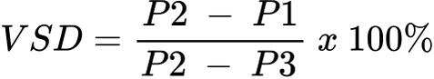

SPAD index: Measured using a SPAD meter (SPAD 502 Plus), which provides an indicator of chlorophyll content and plant health.

Chlorophyll fluorescence efficiency (Fv/Fm): Measured using an Opti-Sciences OS30p chlorophyll fluorescence meter, providing insights into the photosynthetic efficiency of the plants under different moisture conditions.

Ion leakage: Assessed following the method by Zhang et al. (2007), which evaluates cell membrane stability and stress level in response to drought.

Drought Tolerance Index (DTI): Evaluated according to the method by Awoke (2021), where:

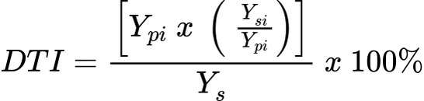

Ypi: Average yield of variety 𝑖 under irrigated conditions

Ysi: Average yield of variety 𝑖 under drought conditions

Average yield of all varieties under drought conditions

*Statistical analysis:* Collected data were analyzed using analysis of variance (ANOVA) to evaluate the effects of treatments. Differences between mean values were assessed using the Least Significant Difference (LSD) test at a significance level of P ≤0.05. Statistical analyses were performed using the IRISSTAT 5.0 software.

**Research results**

**Table 1: Moisture Retention Effectiveness of the Coir and Biochar Mixture on Growth Indicators of Soybean under Drought (B) and Non-Drought (A) Conditions**

|  |  |  |  |  |
| --- | --- | --- | --- | --- |
| **Non-Drought Condition (A)** | | | | |
| **Plant height**  **(cm)** | | **Number of effective nodules (nodules)** | **Nodule weight**  **(g)** | **Number of pods per plant**  **(pods)** |
| T1 | 49.82 | 27.08 | 1.69 | 37.44 |
| T2 | 52.5 | 25.92 | 1.87 | 32.11 |
| T3 | 47.25 | 28.42 | 1.58 | 41.77 |
| **Drought (B)** | | | | |
| **Plant height**  **(cm)** | | **Number of effective nodules (nodules)** | **Nodule weight**  **(g)** | **Number of pods per plant**  **(pods)** |
| T1 | 45.04 | 23.97 | 1.47 | 32.2 |
| T2 | 46.73 | 22.79 | 1.63 | 28.67 |
| T3 | 40.16 | 25.11 | 1.34 | 35.5 |

Biochar, a carbon-rich material [1] produced from organic matter through pyrolysis [2], has gained attention as a soil amendment for enhancing water retention and soil health [3-5]. Its highly porous structure allows it to absorb and retain significant amounts of water [6], which can be slowly released to plants, making it particularly beneficial in drought-prone areas [7]. In legumes like soybeans, moisture availability is crucial for supporting growth parameters such as plant height, nodulation, and pod formation [8-11]. Adequate soil moisture not only helps maintain plant height but is also essential for the formation of root nodules [12], where symbiotic nitrogen fixation occurs, providing vital nutrients for the plant [13]. Furthermore, steady moisture levels contribute to flowering and pod development, which are directly related to crop yield [14].

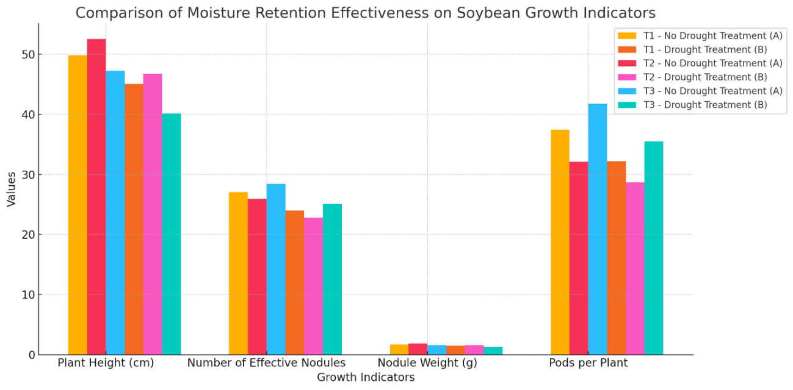

***Fig 1: Comparison of Moisture Regention Effectiveness on Soybean Growth Indicators***

Under non-drought conditions (A), soybean plants showed optimal growth, with T1, T2, and T3 varieties reaching plant heights of 49.82 cm, 52.5 cm, and 47.25 cm, respectively. Additionally, the number of effective nodules, nodule weight, and number of pods per plant were consistently higher, indicating favorable growth conditions without water limitations. For instance, T1 achieved a nodule count of 27.08 and a pod count of 37.44, highlighting robust growth in the absence of drought stress.

In contrast, when subjected to drought (B), all growth indicators decreased. Plant height dropped to 45.04 cm for T1, 46.73 cm for T2, and 40.16 cm for T3, reflecting a decline in growth rate due to limited water availability. Similarly, the number of effective nodules and nodule weight showed noticeable reductions across all varieties, with T1 decreasing to 23.97 nodules and a nodule weight of 1.47 g, compared to 27.08 nodules and 1.69 g in non-drought conditions. Pod counts also decreased, with T1 and T2 showing significant drops to 32.2 and 28.67 pods, respectively.

These findings suggest that the biochar and coir mixture used as a moisture-retention aid provides only partial mitigation against drought effects. Although the mixture helped retain some moisture, as evidenced by slightly higher growth indicators compared to plants without any moisture retention treatment, it was insufficient to fully counteract the adverse impacts of drought. The results underscore that, while biochar and coir can aid in water retention, they do not entirely prevent the reductions in growth parameters caused by drought.

**Table 2: Moisture Retention Effectiveness of the Coir and Biochar Mixture on Chlorophyll Fluorescence Efficiency of Soybean Before the Drought Treatment Phase**

|  |  |  |  |  |  |  |  |  |
| --- | --- | --- | --- | --- | --- | --- | --- | --- |
| **Non-Drought Condition (A)** | | | | | | | | |
| **Day 1** | | **Day 2** | **Day 4** | **Day 6** | **Day 8** | **Day 10** | **Day 12** | **Day 14** |
| T1 | 0.798 ± 0.04 | 0.802 ± 0.03 | 0.805 ± 0.05 | 0.808 ± 0.04 | 0.810 ± 0.03 | 0.812 ± 0.05 | 0.815 ± 0.04 | 0.819 ± 0.03 |
| T2 | 0.797 ± 0.03 | 0.800 ± 0.05 | 0.804 ± 0.04 | 0.807 ± 0.03 | 0.811 ± 0.05 | 0.814 ± 0.04 | 0.818 ± 0.03 | 0.823 ± 0.05 |
| T3 | 0.795 ± 0.05 | 0.799 ± 0.04 | 0.803 ± 0.03 | 0.806 ± 0.05 | 0.809 ± 0.03 | 0.813 ± 0.05 | 0.817 ± 0.04 | 0.821 ± 0.03 |
| **Drought (B)** | | | | | | | | |
| **Day 1** | | **Day 2** | **Day 4** | **Day 6** | **Day 8** | **Day 10** | **Day 12** | **Day 14** |
| T1 | 0.796 ± 0.03 | 0.800 ± 0.04 | 0.804 ± 0.02 | 0.807 ± 0.05 | 0.809 ± 0.03 | 0.813 ± 0.02 | 0.816 ± 0.04 | 0.820 ± 0.03 |
| T2 | 0.798 ± 0.02 | 0.801 ± 0.03 | 0.805 ± 0.04 | 0.808 ± 0.02 | 0.811 ± 0.05 | 0.815 ± 0.03 | 0.818 ± 0.02 | 0.824 ± 0.04 |
| T3 | 0.797 ± 0.04 | 0.799 ± 0.02 | 0.803 ± 0.03 | 0.806 ± 0.05 | 0.810 ± 0.02 | 0.814 ± 0.04 | 0.817 ± 0.03 | 0.822 ± 0.05 |

Drought stress is known to significantly impact chlorophyll fluorescence efficiency in soybean, an important indicator of photosynthetic performance and plant health [15]. Chlorophyll fluorescence efficiency reflects the plant's ability to capture light energy [16] and convert it into chemical energy during photosynthesis [17], a process highly dependent on water availability [18]. Under drought conditions, reduced soil moisture leads to decreased cellular turgor [19], impairing the function of chloroplasts and ultimately disrupting the electron transport chain within the photosystem [20]. This disruption causes a reduction in chlorophyll fluorescence efficiency, as the plant’s capacity for photochemical energy conversion becomes limited [21].

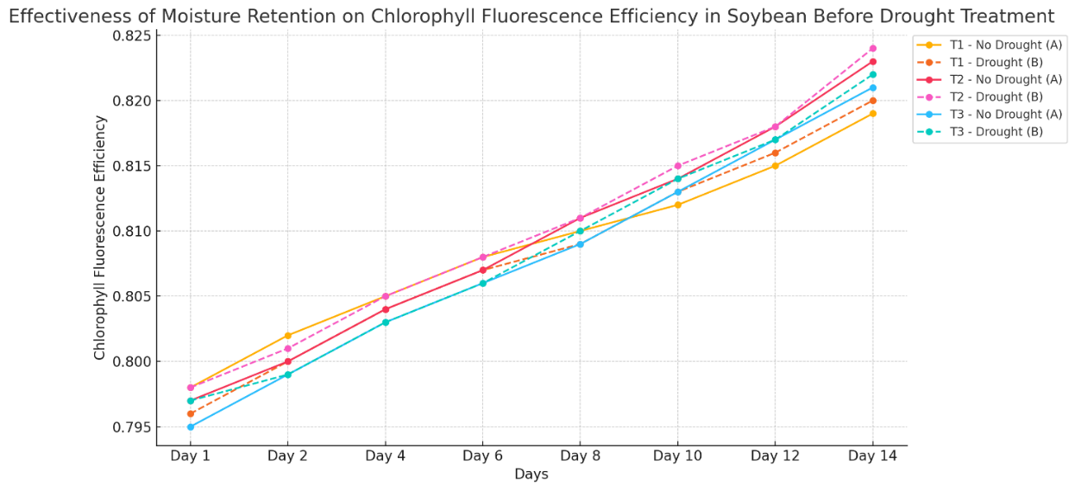

***Fig 2: Effectiveness of Moisture Retention on Chlorophyll Fluorescence Efficiency in Soybean Before Drought Treatment***

The Table 2 and Fig 2 shows that, before water withholding, chlorophyll fluorescence efficiency was consistent across all soybean varieties (T1, T2, and T3) in both non-drought (A) and drought (B) treatments. Initial values were closely aligned, with slight, uniform increases over time, indicating stable photosynthetic performance. This uniformity suggests that chlorophyll fluorescence efficiency was unaffected by drought stress initially, providing a baseline to assess changes once water restriction begins.

**Table 3: Moisture Retention Effectiveness of the Coir and Biochar Mixture on Chlorophyll Fluorescence Efficiency of Soybean After the Drought Treatment Phase**

|  |  |  |  |  |  |  |  |  |  |  |
| --- | --- | --- | --- | --- | --- | --- | --- | --- | --- | --- |
| **Day 1** | | **Day 2** | **Day 4** | **Day 6** | **Day 8** | **Day 10** | **Day 12** | **Day 14** | **Day 16** | **Day 18** |
| T1 | 0.839 ± 0.03 | 0.830 ± 0.02 | 0.820 ± 0.04 | 0.810 ± 0.03 | 0.795 ± 0.02 | 0.779 ± 0.03 | 0.785 ± 0.04 | 0.792 ± 0.02 | 0.800 ± 0.03 | 0.808 ± 0.02 |
| T2 | 0.838 ± 0.02 | 0.828 ± 0.03 | 0.818 ± 0.02 | 0.808 ± 0.04 | 0.794 ± 0.03 | 0.779 ± 0.02 | 0.786 ± 0.03 | 0.794 ± 0.04 | 0.802 ± 0.02 | 0.810 ± 0.03 |
| T3 | 0.837 ± 0.04 | 0.829 ± 0.02 | 0.819 ± 0.03 | 0.809 ± 0.02 | 0.793 ± 0.04 | 0.779 ± 0.03 | 0.788 ± 0.02 | 0.796 ± 0.03 | 0.804 ± 0.04 | 0.811 ± 0.02 |

In soybeans, this decline in fluorescence efficiency under drought stress can also indicate damage to the photosynthetic apparatus [22], such as inactivation of photosystem II (PSII) , where light energy is initially captured [23]. Reduced chlorophyll fluorescence efficiency is often accompanied by a decrease in chlorophyll content [24] and an increase in reactive oxygen species (ROS), further impacting overall plant health [25]. Consequently, the decrease in fluorescence efficiency under drought not only signals photosynthetic stress [26] but also correlates with reductions in growth and yield [27], as the plant's energy capture and conversion processes become less effective [28]. This relationship between drought and chlorophyll fluorescence efficiency provides a theoretical basis for using fluorescence measurements as a diagnostic tool for assessing drought stress in soybean and other crops [29].

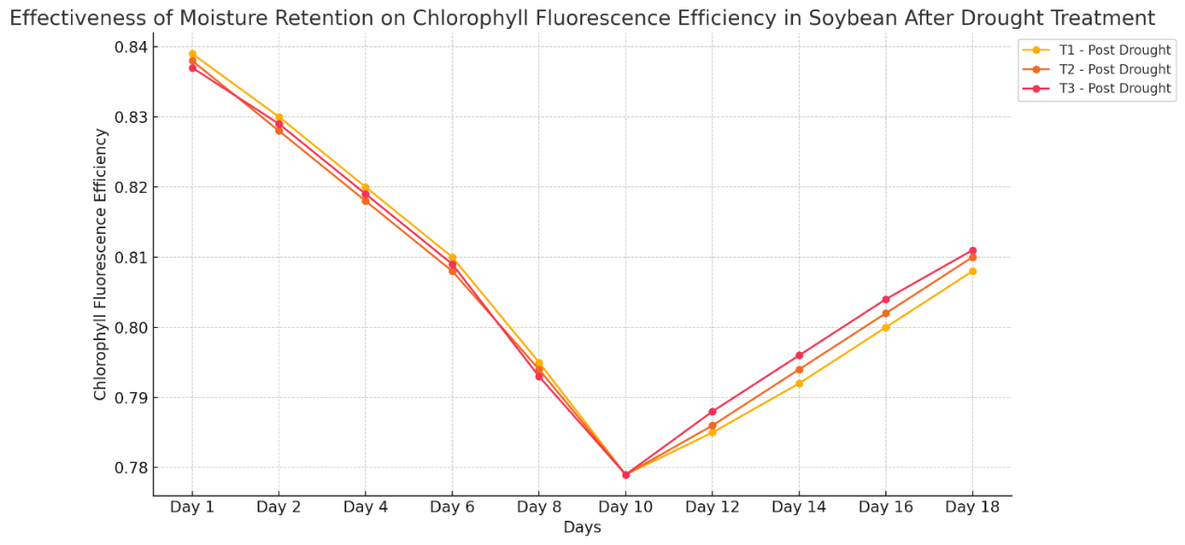

***Fig 3: Effectiveness of Moisture Retention on Chlorophyll Fluorescence Efficiency in Soybean After Drought Treatment***

The Table 3 and Fig 3 demonstrates the impact of water withholding on chlorophyll fluorescence efficiency in soybean, highlighting a noticeable decline post-drought initiation, with the most significant reduction observed on Day 10 across all varieties. For example, T1, T2, and T3 all reach their lowest chlorophyll fluorescence values around this point, with readings of 0.779 for each variety, indicating a peak in drought stress effects.

After water was reintroduced on Day 11, chlorophyll fluorescence efficiency gradually began to increase, showing the soybean’s response to moisture recovery. However, despite this improvement, it took more than 8 days post-watering for the fluorescence efficiency to approach near-normal levels, reaching 0.808, 0.810, and 0.811 for T1, T2, and T3, respectively, by Day 18.

These findings emphasize that, while the biochar and coir mixture aids in moisture retention, it does not fully prevent the decline in chlorophyll efficiency under drought stress. Additionally, a prolonged recovery period following re-watering is necessary to restore chlorophyll function, indicating the need for extended post-drought recovery time to achieve full photosynthetic efficiency in soybean.

**Table 4: Moisture Retention Effectiveness of the Coir and Biochar Mixture on SPAD Index of Soybean Throughout Experimental Stages**

|  |  |  |  |  |
| --- | --- | --- | --- | --- |
| **Start of Drought Treatment** | | **End of Drought Treatment** | **5 Days Post-Watering** | **10 Days Post-Watering** |
| T1 | 50.6 ± 1.4 | 42 ± 2.1 | 48.9 ± 2.0 | 51.4 ± 1.8 |
| T2 | 46.3 ± 1.6 | 39 ± 1.9 | 45.8 ± 1.8 | 48.6 ± 1.6 |
| T3 | 48 ± 1.2 | 41 ± 2.2 | 47.9 ±1.9 | 50.2 ± 2.2 |

The use of a biochar-based moisture-retention mixture is theorized to have a positive impact on the SPAD index in soybean [30], an indicator of chlorophyll content and overall plant health [31]. The SPAD index, which measures chlorophyll levels in leaves, is closely linked to the plant's nitrogen content and photosynthetic capacity [32]. Under optimal moisture conditions, chlorophyll production and nitrogen assimilation are more efficient [33], supporting healthy plant growth and productivity [34]. However, during drought, reduced soil moisture limits nutrient availability and impairs chlorophyll synthesis, leading to lower SPAD values [35].

Biochar’s porous structure allows it to retain moisture in the soil [36], thereby providing a more consistent water supply to the soybean root zone [37]. This sustained moisture availability helps maintain higher SPAD values in soybean leaves by reducing drought-induced stress on chlorophyll synthesis [38]. Biochar also enhances nutrient retention in the soil, making nitrogen more accessible to the plant even during dry periods [39]. This combination of improved water and nutrient availability theoretically supports higher chlorophyll levels [40], as reflected in SPAD measurements, allowing soybean plants to maintain more robust photosynthetic function and stress resilience [41]. Thus, incorporating biochar-based moisture-retention mixtures may help mitigate drought’s impact on SPAD index and overall plant vitality in soybean cultivation.

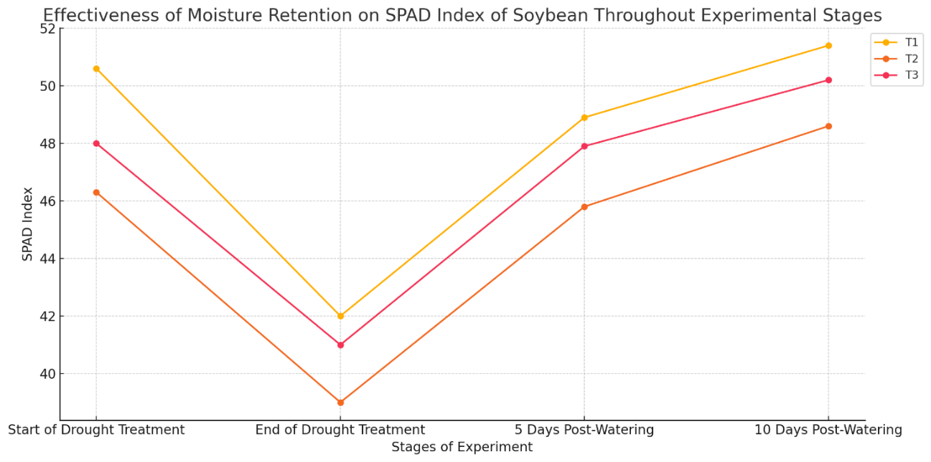

***Fig 4: Effectiveness of Moisture Retention on SPAD Index of Soybean Throughout Experimental Stages***

Table 4 shows the effect of a coir and biochar mixture on the SPAD index of soybean during drought stress and recovery stages.

At the start of drought treatment, SPAD values are high, indicating healthy chlorophyll content. By the end of drought treatment, all varieties experience a significant drop in SPAD values due to water stress, with T2 showing the largest decrease.

After re-watering, the SPAD index begins to recover, with noticeable increases 5 days post-watering and nearly full recovery by 10 days. This indicates that while drought stress impacts chlorophyll levels, the coir and biochar mixture supports moisture retention and accelerates recovery, though a longer rehydration period is necessary for full restoration.

**Table 5: Moisture Retention Effectiveness of the Coir and Biochar Mixture on Vapor Saturation Deficit of Soybean Throughout Experimental Stages**

|  |  |  |  |  |
| --- | --- | --- | --- | --- |
| **Start of Drought Treatment** | | **End of Drought Treatment** | **5 Days Post-Watering** | **10 Days Post-Watering** |
| T1 | 18.6 ± 1.6 | 35.7 ± 1.9 | 29.3 ± 1.9 | 22.7 ± 2.0 |
| T2 | 17.9 ± 1.6 | 32.3 ± 2.1 | 27.5 ± 1.9 | 23.8 ± 2.3 |
| T3 | 16.6 ± 1.7 | 36.5 ± 1.7 | 26.8 ± 2.3 | 21.7 ± 2.2 |

The use of a biochar-based moisture-retention mixture is theoretically expected to influence the vapor saturation deficit (VSD) in soybean [42], a measure of the difference between the amount of moisture in the air and the maximum it can hold at a given temperature [43]. In plants, a high VSD typically indicates increased water loss and stress [44], as the plant is forced to transpire more in response to dry conditions[45]. This elevated transpiration rate under drought can lead to rapid soil moisture depletion [46], reducing the plant’s ability to maintain physiological processes essential for growth [47].

Biochar, with its porous structure, has a high water-holding capacity that helps retain soil moisture and provides a more stable water source for the plant’s roots [48]. By increasing the soil’s water availability, biochar can reduce the plant’s reliance on high transpiration rates, thus lowering the VSD [49]. This stabilized soil moisture environment allows soybean plants to maintain more consistent hydration levels [50], which reduces the disparity between internal leaf moisture and atmospheric moisture demand [51]. As a result, the biochar-based mixture can theoretically mitigate sharp increases in VSD that are typical under drought stress, helping to alleviate water loss and maintain plant stability.

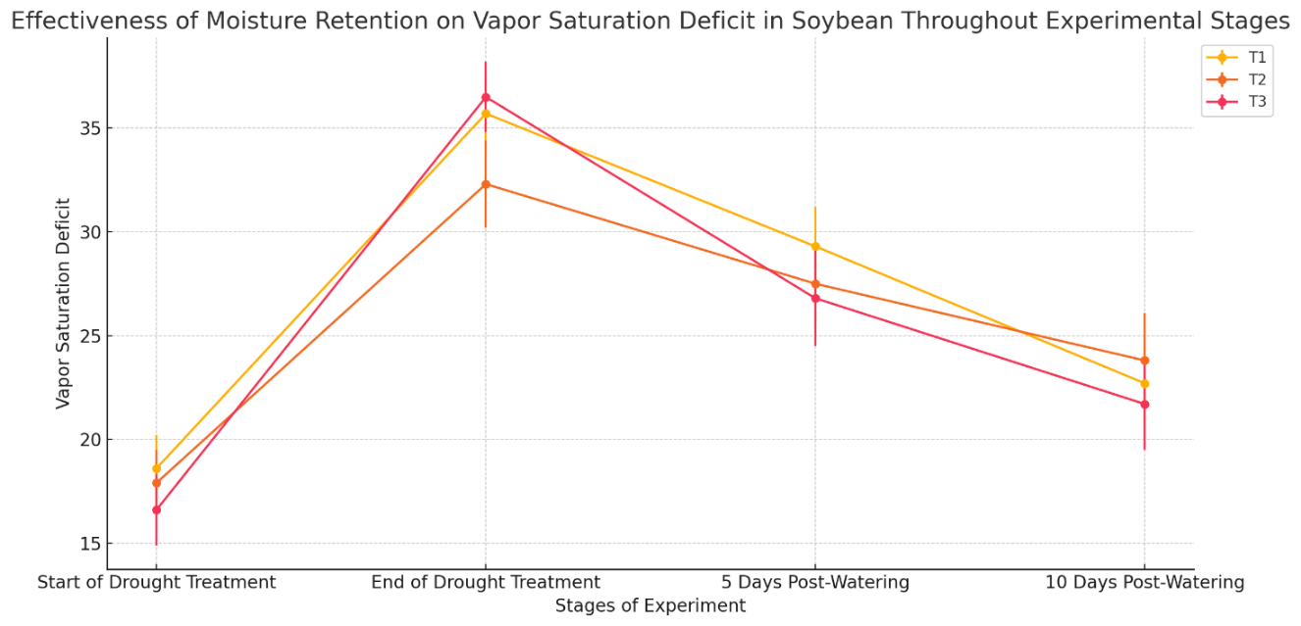

***Fig 5: Effectiveness of Moisture Retention on VSD in Soybean Throughout Experimental Stages***

At the start of drought treatment, the vapor saturation deficit is relatively low across all varieties (T1: 18.6, T2: 17.9, T3: 16.6), indicating favorable water conditions. However, by the end of drought treatment, there is a sharp increase in vapor saturation deficit for all varieties, with values nearly doubling, reflecting high levels of water stress. T3 shows the highest increase, reaching 36.5, followed by T1 and T2 at 35.7 and 32.3, respectively.

After re-watering, the vapor saturation deficit begins to decrease, showing a partial recovery. Five days post-watering, deficit levels have dropped noticeably (T1: 29.3, T2: 27.5, T3: 26.8), though they remain above initial levels. By 10 days after re-watering, values continue to decrease further (T1: 22.7, T2: 23.8, T3: 21.7), approaching pre-drought levels but not fully returning to the baseline.

By improving soil structure and water availability, biochar may slow down the rate of moisture evaporation from the soil, indirectly reducing the atmospheric moisture demand that contributes to higher VSD. This combination of moisture retention and reduced evaporation supports a more balanced water relationship within the plant, making biochar an effective amendment for controlling VSD in drought-sensitive crops like soybean.

**Table 6: Moisture Retention Effectiveness of the Coir and Biochar Mixture on Ion Leakage Levels of Soybean Throughout Experimental Stages**

|  |  |  |  |  |
| --- | --- | --- | --- | --- |
| **Start of Drought Treatment** | | **End of Drought Treatment** | **5 Days Post-Watering** | **10 Days Post-Watering** |
| T1 | 14.3 ± 1.3 | 25.2 ± 1.5 | 24.3 ± 1.4 | 18.2 ± 1.0 |
| T2 | 14.4 ± 1.4 | 22.9 ± 1.3 | 21.8 ± 1.2 | 17.8 ± 1.1 |
| T3 | 13.6 ± 1.2 | 24.3 ± 1.1 | 25.1 ± 1.7 | 19.1 ± 1.1 |

The application of a biochar-based moisture-retention mixture is theorized to have a beneficial effect on ion leakage levels in soybean [52], which is an indicator of cell membrane stability and plant stress [53]. Ion leakage occurs when cell membranes are damaged, often due to environmental stresses such as drought, which causes the cell membranes to become more permeable [54]. As a result, essential ions like potassium and calcium leak out of the cells [55], indicating cellular damage and impaired physiological function [56]. High levels of ion leakage are commonly associated with increased stress and reduced plant health [57].

Biochar’s ability to retain soil moisture creates a more stable water environment in the root zone [58], helping plants maintain cellular turgor and membrane integrity even during periods of water scarcity [59]. By alleviating drought stress through improved moisture availability, the biochar mixture can reduce the likelihood of cellular dehydration [60], which is a primary factor in membrane damage and ion leakage [61]. The stable moisture environment provided by biochar also supports nutrient retention, preventing nutrient stress that can exacerbate membrane permeability issues [62].

Additionally, biochar’s ability to enhance soil structure and reduce fluctuations in soil moisture can prevent the sharp increase in ion leakage that typically occurs when plants experience dehydration [63]. As the biochar mixture helps maintain cell membrane integrity, soybean plants are better able to retain ions within their cells, supporting healthier metabolic functions [64]. Thus, the use of biochar as a moisture-retention agent in drought conditions is theoretically expected to lower ion leakage levels, helping plants withstand drought-induced cellular stress and maintain physiological stability.

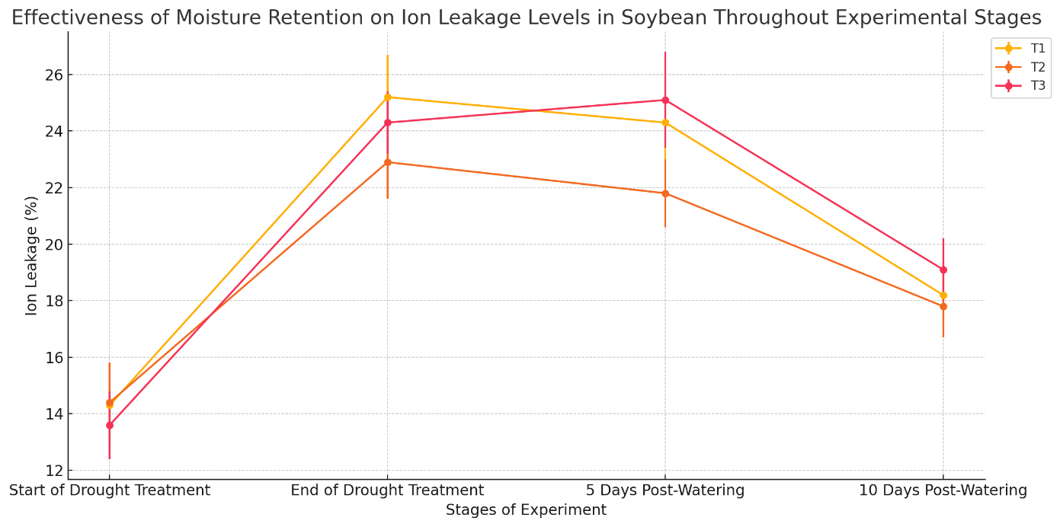

***Fig 6: Effectiveness of Moisture Retention on Ion Leakage Levels in Soybean Throughout Experimental Stages***

At the start of drought treatment, ion leakage levels are relatively low across all varieties, with T1, T2, and T3 showing values around 14.3%, 14.4%, and 13.6%, respectively, indicating stable cell membranes under normal water conditions. By the end of drought treatment, ion leakage levels have significantly increased in all varieties, reflecting cellular damage due to water stress. T1 rises to 25.2%, T2 to 22.9%, and T3 to 24.3%, showing heightened stress response and membrane instability.

After re-watering, ion leakage levels begin to decrease. Five days post-watering, ion leakage has dropped slightly (T1: 24.3%, T2: 21.8%, T3: 25.1%), indicating an initial recovery in cell membrane stability. By 10 days after re-watering, ion leakage levels have further decreased, reaching 18.2% for T1, 17.8% for T2, and 19.1% for T3, approaching initial levels and indicating continued recovery.

These results highlight that while drought stress leads to increased ion leakage, indicating membrane damage, re-watering helps to gradually reduce ion leakage. The coir and biochar mixture supports partial recovery, as shown by the decreasing ion leakage over time, though full recovery of cell stability requires an extended period following rehydration.

**Table 7: Moisture Retention Effectiveness of the Coir and Biochar Mixture on Yield Indicators of Soybean under Drought (B) and Non-Drought (A) Conditions**

|  |  |  |  |
| --- | --- | --- | --- |
| **Non-Drought Condition (A)** | | | |
| **Individual Yield (g/plant)** | | **Theoretical Yield (quintals/ha)** | **Actual Yield (quintals/ha)** |
| T1 | 18.5 ± 1.6 | 22.0 ± 1.6 | 19.8 ± 1.5 |
| T2 | 20.3 ± 1.7 | 24.5 ± 1.5 | 21.7 ± 1.9 |
| T3 | 19.1 ± 1.6 | 23.0 ± 1.7 | 20.4 ± 2.0 |
| **Drought (B)** | | | |
| **Individual Yield (g/plant)** | | **Theoretical Yield (quintals/ha)** | **Actual Yield (quintals/ha)** |
| T1 | 17.2 ± 1.4 | 20.6 ± 1.6 | 18.5 ± 1.7 |
| T2 | 18.6 ± 1.2 | 22.8 ± 1.5 | 19.8 ± 1.5 |
| T3 | 18.0 ± 1.2 | 21.3 ± 1.7 | 19.2 ± 1.6 |

Biochar can improve soil structure and nutrient retention, making essential nutrients more available to the plant [65]. This improved nutrient availability supports healthy root development, greater biomass production, and optimal pod and seed formation [66]. Consequently, the biochar-based mixture not only mitigates the immediate impacts of drought stress [67] but also supports higher yield potential [68] by fostering a more resilient and productive growing environment [69]. Therefore, biochar’s role in moisture retention theoretically enables soybean plants to maintain higher yields even under water-limited conditions, offering a sustainable approach to enhancing crop productivity in drought-prone regions.

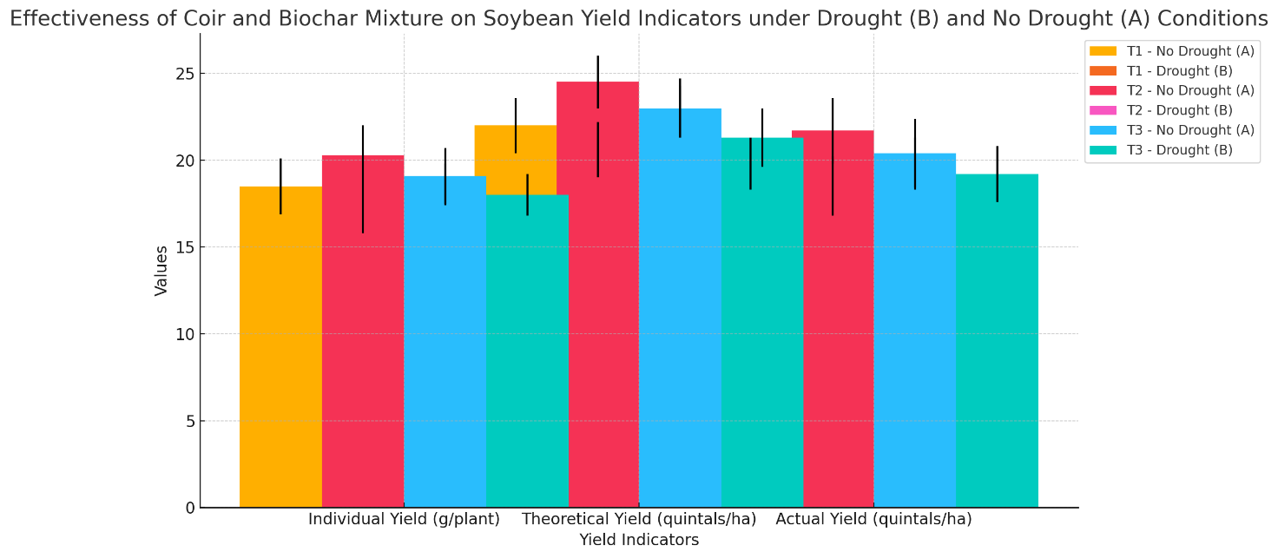

***Fig 7: Effectiveness of Coir and Biochar Mixture on Soybean Yield Indicators under Drought (B) and No Drought (A) Conditions***

Despite drought stress affecting physiological and growth parameters, the decline in yield indicators remains modest, with reductions of only about 6-9% in individual yield, theoretical yield, and actual yield.

Under non-drought conditions (A), soybean varieties T1, T2, and T3 demonstrate optimal yields, with actual yields of 19.8, 21.7, and 20.4 quintals per hectare, respectively. However, during drought treatment (B), actual yields are only slightly reduced to 18.5 for T1, 19.8 for T2, and 19.2 for T3 quintals per hectare. This limited yield reduction under drought conditions suggests that the coir and biochar mixture effectively mitigates the impact of water stress.

The effectiveness of the moisture-retaining mixture is evident through the minimal yield loss and stable performance across varieties, even in water-limited environments. This result underlines the role of the coir and biochar mixture in supporting crop resilience, as indicated by the high actual yields maintained across all varieties despite drought, thus affirming its practical value in agricultural settings facing drought stress.

**Conclusion**

The findings of this study reveal that while drought stress substantially affected the physiological parameters of soybean, including reductions in chlorophyll fluorescence, SPAD index, and increased ion leakage and vapor saturation deficit, the biochar and coir mixture provided moderate moisture retention benefits. During the drought phase, all growth and physiological indicators showed notable declines; however, rehydration facilitated gradual recovery. Despite these physiological impacts, yield-related indicators showed a relatively low reduction of 6-9% in actual yield under drought conditions, highlighting the mixture's effectiveness in maintaining crop productivity. The minimal decrease in actual yield across soybean varieties (T1, T2, and T3) after rehydration underscores the biochar and coir mixture's potential to sustain crop resilience under water stress.

This study underscores that while biochar and coir do not fully mitigate the physiological impacts of drought, they contribute significantly to maintaining yield stability, an essential factor for farmers facing water-limited growing seasons. By reducing yield loss to within a manageable range, this moisture-retention mixture demonstrates promising practical value for enhancing soybean drought tolerance, supporting sustainable soybean cultivation in drought-prone regions.

**Scientific and practical insights**

The biochar and coir mixture demonstrates a protective effect on soybean physiological indicators during drought stress, promoting gradual recovery after rehydration. Indicators such as chlorophyll fluorescence, SPAD index, and ion leakage improved post-watering, highlighting the mixture’s role in mitigating drought effects and enhancing physiological resilience.

Despite physiological declines, actual yield reductions remained limited to 6-9%, underscoring the mixture’s effectiveness in maintaining productivity under water stress. This stability is a key finding, suggesting that biochar and coir help sustain crop yield, potentially providing farmers with more reliable harvests even in adverse weather conditions.

The moisture-retaining properties of biochar and coir offer promising solutions for regions facing frequent droughts or climate variability. The mixture supports soil moisture retention without requiring costly irrigation systems, positioning it as a sustainable option for enhancing crop resilience in water-limited environments.

These findings open avenues for further research on optimizing biochar and coir ratios or combining them with other moisture-retaining materials to maximize their efficacy. Such exploration could lead to specialized moisture-retention products tailored to different crops and environmental conditions.

**References**

1. Sakhiya, A.K., Anand, A. & Kaushal, P. Production, activation, and applications of biochar in recent times. *Biochar* **2**, 253–285 (2020). <https://doi.org/10.1007/s42773-020-00047-1>

2. Dong, X., Guan, T., Li, G. *et al.* Long-term effects of biochar amount on the content and composition of organic matter in soil aggregates under field conditions. *J Soils Sediments* **16**, 1481–1497 (2016). <https://doi.org/10.1007/s11368-015-1338-5>

3. Adhikari, Sirjana, Wendy Timms, and MA Parvez Mahmud. "Optimising water holding capacity and hydrophobicity of biochar for soil amendment–A review." *Science of The Total Environment* 851 (2022): 158043.

4. An, Y., Lu, J., Niu, R. *et al.* Exploring effects of novel chemical modification of biochar on soil water retention and crack suppression: towards commercialization of production of biochar for soil remediation. *Biomass Conv. Bioref.* **13**, 13897–13910 (2023). <https://doi.org/10.1007/s13399-021-02081-w>

5. Gabhane, J.W., Bhange, V.P., Patil, P.D. *et al.* Recent trends in biochar production methods and its application as a soil health conditioner: a review. *SN Appl. Sci.* **2**, 1307 (2020). <https://doi.org/10.1007/s42452-020-3121-5>

6. Li, H., Tan, Z. Preparation of high water-retaining biochar and its mechanism of alleviating drought stress in the soil and plant system. *Biochar* **3**, 579–590 (2021). <https://doi.org/10.1007/s42773-021-00107-0>

7. Gavili, Edris, Ali Akbar Moosavi, and Ali Akbar Kamgar Haghighi. "Does biochar mitigate the adverse effects of drought on the agronomic traits and yield components of soybean?." *Industrial crops and products* 128 (2019): 445-454.

8. Głodowska, Martyna, et al. "Biochar based inoculants improve soybean growth and nodulation." *Agricultural Sciences* 8.9 (2017): 1048-1064.

9. Abdul-Aziz, Abdul-Latif, Edwin Korbla Akley, and Amoako Ophelia Asirifi. "Effects of Biochar and Bradyrhizobium Inoculation on Nodulation, Growth, and Grain Yield of Soybean in the Guinea Savanna Agroecological Zone of Ghana." *Communications in Soil Science and Plant Analysis* (2024): 1-17.

10. Elebiyo, Gbadebo Monday, and Robert Thomas Bachmann. "Effect of Biochar Type and Bradyrhizobium japonicum Seed Inoculation on Soybean Growth, Nodulation and Yield in a Tropical Ferric Acrisol." *Agricultural Sciences* 15.6 (2024): 635-675.

11. Ngui, Marianus Evarist, et al. "Effects of the combination of biochar and organic fertilizer on soil properties and agronomic attributes of soybean (Glycine max L.)." *Plos one* 19.9 (2024): e0310221.

12. Farhangi-Abriz, S., Ghassemi-Golezani, K., Torabian, S. *et al.* A meta-analysis to estimate the potential of biochar in improving nitrogen fixation and plant biomass of legumes. *Biomass Conv. Bioref.* **14**, 3293–3303 (2024). <https://doi.org/10.1007/s13399-022-02530-0>

13. Xiu, Liqun, et al. "Biochar can improve biological nitrogen fixation by altering the root growth strategy of soybean in Albic soil." *Science of the Total Environment* 773 (2021): 144564.

14. Jahan, S., Iqbal, S., Rasul, F. *et al.* Efficacy of biochar as soil amendments for soybean (*Glycine max* L.) morphology, physiology, and yield regulation under drought. *Arab J Geosci* **13**, 356 (2020). <https://doi.org/10.1007/s12517-020-05318-6>

15. Latifinia, E., Eisvand, H.R. Soybean Physiological Properties and Grain Quality Responses to Nutrients, and Predicting Nutrient Deficiency Using Chlorophyll Fluorescence. *J Soil Sci Plant Nutr* **22**, 1942–1954 (2022). <https://doi.org/10.1007/s42729-022-00785-0>

16. Henriques, F.S. Leaf Chlorophyll Fluorescence: Background and Fundamentals for Plant Biologists. *Bot. Rev.* **75**, 249–270 (2009). <https://doi.org/10.1007/s12229-009-9035-y>

17. Govindjee (2004). Chlorophyll a Fluorescence: A Bit of Basics and History. In: Papageorgiou, G.C., Govindjee (eds) Chlorophyll a Fluorescence. Advances in Photosynthesis and Respiration, vol 19. Springer, Dordrecht. <https://doi.org/10.1007/978-1-4020-3218-9_1>

18. Shah, Sonal, R. Saravanan, and N. A. Gajbhiye. "Leaf gas exchange, chlorophyll fluorescence, growth and root yield of Ashwagandha (Withania somnifera Dunal.) under soil moisture stress." *Indian Journal of Plant Physiology* 15.2 (2010): 117-124.

19. Rochaix, Jean-David. "Regulation of photosynthetic electron transport." *Biochimica et Biophysica Acta (BBA)-Bioenergetics* 1807.3 (2011): 375-383.

20. Trebst, Ann. "Energy conservation in photosynthetic electron transport of chloroplasts." *Annual Review of Plant Physiology* 25.1 (1974): 423-458.

21. Misra, Amarendra Narayan, Meena Misra, and Ranjeet Singh. "Chlorophyll fluorescence in plant biology." *Biophysics* 7 (2012): 171-192.

22. Iqbal, Nasir, et al. "Drought tolerance of soybean (Glycine max L. Merr.) by improved photosynthetic characteristics and an efficient antioxidant enzyme activities under a split-root system." *Frontiers in physiology* 10 (2019): 786.

23. Šetlík, I., Allakhverdiev, S.I., Nedbal, L. *et al.* Three types of Photosystem II photoinactivation. *Photosynth Res* **23**, 39–48 (1990). <https://doi.org/10.1007/BF00030061>

24. Lichtenthaler, H.K., Buschmann, C. & Knapp, M. How to correctly determine the different chlorophyll fluorescence parameters and the chlorophyll fluorescence decrease ratio RFd of leaves with the PAM fluorometer. *Photosynthetica* **43**, 379–393 (2005). <https://doi.org/10.1007/s11099-005-0062-6>

25. Moradi, Foad, and Abdelbagi M. Ismail. "Responses of photosynthesis, chlorophyll fluorescence and ROS-scavenging systems to salt stress during seedling and reproductive stages in rice." *Annals of botany* 99.6 (2007): 1161-1173.

26. Wang, Wensen, et al. "Effects of drought stress on photosynthesis and chlorophyll fluorescence images of soybean (Glycine max) seedlings." *International Journal of Agricultural and Biological Engineering* 11.2 (2018): 196-201.

27. Demmig, B., Björkman, O. Comparison of the effect of excessive light on chlorophyll fluorescence (77K) and photon yield of O2 evolution in leaves of higher plants. *Planta* **171**, 171–184 (1987). <https://doi.org/10.1007/BF00391092>

28. Song, Chunshan. "Global challenges and strategies for control, conversion and utilization of CO2 for sustainable development involving energy, catalysis, adsorption and chemical processing." *Catalysis today* 115.1-4 (2006): 2-32.

29. Chen, Jidai, et al. "Effects of drought on the relationship between photosynthesis and chlorophyll fluorescence for maize." *IEEE Journal of Selected Topics in Applied Earth Observations and Remote Sensing* 14 (2021): 11148-11161.

30. Zahedifar, M., Moosavi, A.A. & Gavili, E. Monitoring soil quality indices and soybean yield as influenced by integrated biochar and drought stress. *Environ Dev Sustain* (2023). <https://doi.org/10.1007/s10668-023-03947-x>

31. Duan, S., AL-Huqail, A.A., Alsudays, I.M. *et al.* Effects of biochar types on seed germination, growth, chlorophyll contents, grain yield, sodium, and potassium uptake by wheat (*Triticum aestivum* L.) under salt stress. *BMC Plant Biol* **24**, 487 (2024). <https://doi.org/10.1186/s12870-024-05188-0>

32. Reis, Andre Rodrigues, et al. "Photosynthesis, chlorophylls, and SPAD readings in coffee leaves in relation to nitrogen supply." *Communications in soil science and plant analysis* 40.9-10 (2009): 1512-1528.

33. Yang, Hu, et al. "SPAD values and nitrogen nutrition index for the evaluation of rice nitrogen status." *Plant Production Science* 17.1 (2014): 81-92.

34. Zhang, Ke, et al. "Chlorophyll meter–based nitrogen fertilizer optimization algorithm and nitrogen nutrition index for in‐season fertilization of paddy rice." *Agronomy Journal* 112.1 (2020): 288-300.

35. Hassan, Mian Sayeed, et al. "Genotypic variation in traditional rice varieties for chlorophyll content, SPAD value and nitrogen use efficiency." *Bangladesh Journal of Agricultural Research* 34.3 (2009): 505-515.

36. Hardie, M., Clothier, B., Bound, S. *et al.* Does biochar influence soil physical properties and soil water availability?. *Plant Soil* **376**, 347–361 (2014). <https://doi.org/10.1007/s11104-013-1980-x>

37. Zhang, Y., Ding, J., Wang, H. *et al.* Biochar addition alleviate the negative effects of drought and salinity stress on soybean productivity and water use efficiency. *BMC Plant Biol* **20**, 288 (2020). <https://doi.org/10.1186/s12870-020-02493-2>

38. Abdou, N.M., EL-Samnoudi, I.M., Ibrahim, A.EA.M. *et al.* Biochar Amendment Alleviates the Combined Effects of Salinity and Drought Stress on Water Productivity, Yield and Quality Traits of Sugar Beet (*Beta vulgaris* L.). *J Soil Sci Plant Nutr* **24**, 2091–2110 (2024). <https://doi.org/10.1007/s42729-024-01754-5>

39. Joseph, Stephen, et al. "How biochar works, and when it doesn't: A review of mechanisms controlling soil and plant responses to biochar." *Gcb Bioenergy* 13.11 (2021): 1731-1764.

40. Li, Sheng-Xiu, et al. "Nutrient and water management effects on crop production, and nutrient and water use efficiency in dryland areas of China." *Advances in agronomy* 102 (2009): 223-265.

41. Singh, M., Nagar, S., Singh, A., Satpute, G.K. (2022). Physiological Traits Based Breeding to Achieve Higher Yield in Soybean Crop. In: Jha, U.C., Nayyar, H., Agrawal, S.K., Siddique, K.H.M. (eds) Developing Climate Resilient Grain and Forage Legumes. Springer, Singapore. <https://doi.org/10.1007/978-981-16-9848-4_12>

42. Thao, Touyee. *Impact of Locally-Sourced Biochar Amendments on Soil Hydrology and Ecosystem Services: A Study of Moisture Retention, Plant Uptake Dynamics, Nutrient Retention, and Greenhouse Gas Emissions in Agroecosystems*. University of California, Merced, 2023.

43. Kinney, T. J., et al. "Hydrologic properties of biochars produced at different temperatures." *Biomass and Bioenergy* 41 (2012): 34-43.

44. Fanourakis, Dimitrios, Ep Heuvelink, and Susana MP Carvalho. "A comprehensive analysis of the physiological and anatomical components involved in higher water loss rates after leaf development at high humidity." *Journal of Plant Physiology* 170.10 (2013): 890-898.

45. Will, Rodney E., et al. "Increased vapor pressure deficit due to higher temperature leads to greater transpiration and faster mortality during drought for tree seedlings common to the forest–grassland ecotone." *New Phytologist* 200.2 (2013): 366-374.

46. Belko, Nouhoun, et al. "Lower soil moisture threshold for transpiration decline under water deficit correlates with lower canopy conductance and higher transpiration efficiency in drought-tolerant cowpea." *Functional Plant Biology* 39.4 (2012): 306-322.

47. Khan, Zaid, et al. "The application of biochar alleviated the adverse effects of drought on the growth, physiology, yield and quality of rapeseed through regulation of soil status and nutrients availability." *Industrial Crops and Products* 171 (2021): 113878.

48. Adhikari, Sirjana, Wendy Timms, and MA Parvez Mahmud. "Optimising water holding capacity and hydrophobicity of biochar for soil amendment–A review." *Science of The Total Environment* 851 (2022): 158043.

49. Murtaza, G., Usman, M., Iqbal, J. *et al.* The impact of biochar addition on morpho-physiological characteristics, yield and water use efficiency of tomato plants under drought and salinity stress. *BMC Plant Biol* **24**, 356 (2024). <https://doi.org/10.1186/s12870-024-05058-9>

50. Wijewardana, C., Reddy, K.R., Alsajri, F.A. *et al.* Quantifying soil moisture deficit effects on soybean yield and yield component distribution patterns. *Irrig Sci* **36**, 241–255 (2018). <https://doi.org/10.1007/s00271-018-0580-1>

51. Bucci, S.J., Goldstein, G., Meinzer, F.C. *et al.* Mechanisms contributing to seasonal homeostasis of minimum leaf water potential and predawn disequilibrium between soil and plant water potential in Neotropical savanna trees. *Trees* **19**, 296–304 (2005). <https://doi.org/10.1007/s00468-004-0391-2>

52. Kumari, K. *et al.* (2020). Biochar Amendment in Agricultural Soil for Mitigation of Abiotic Stress. In: Bauddh, K., Kumar, S., Singh, R., Korstad, J. (eds) Ecological and Practical Applications for Sustainable Agriculture. Springer, Singapore. <https://doi.org/10.1007/978-981-15-3372-3_14>

53. Mehmood, Sajid, et al. "Chitosan modified biochar increases soybean (Glycine max L.) resistance to salt-stress by augmenting root morphology, antioxidant defense mechanisms and the expression of stress-responsive genes." *Plants* 9.9 (2020): 1173.

54. Demidchik, Vadim, et al. "Stress-induced electrolyte leakage: the role of K+-permeable channels and involvement in programmed cell death and metabolic adjustment." *Journal of experimental botany* 65.5 (2014): 1259-1270.

55. Romero, P. J., and R. Whittam. "The control by internal calcium of membrane permeability to sodium and potassium." *The Journal of Physiology* 214.3 (1971): 481-507.

56. Ran, C., Gulaqa, A., Zhu, J. *et al.* Benefits of Biochar for Improving Ion Contents, Cell Membrane Permeability, Leaf Water Status and Yield of Rice Under Saline–Sodic Paddy Field Condition. *J Plant Growth Regul* **39**, 370–377 (2020). <https://doi.org/10.1007/s00344-019-09988-9>

57. Whitlow, Thomas H., et al. "An improved method for using electrolyte leakage to assess membrane competence in plant tissues." *Plant Physiology* 98.1 (1992): 198-205.

58. NG, C.W.W., GUO, H., NI, J. *et al.* Effects of soil–plant-biochar interactions on water retention and slope stability under various rainfall patterns. *Landslides* **19**, 1379–1390 (2022). <https://doi.org/10.1007/s10346-022-01874-y>

59. Hasnain, Maria, et al. "Biochar-plant interaction and detoxification strategies under abiotic stresses for achieving agricultural resilience: A critical review." *Ecotoxicology and Environmental Safety* 249 (2023): 114408.

60. Wang, Liuwei, et al. "Biochar aging: mechanisms, physicochemical changes, assessment, and implications for field applications." *Environmental Science & Technology* 54.23 (2020): 14797-14814.

61. Cheng, R. A. N., et al. "Benefits of Biochar for Improving Ion Contents, Cell Membrane Permeability, Leaf Water Status and Yield of Rice Under Saline–Sodic Paddy Field Condition." *Journal of Plant Growth Regulation* 39.1 (2020): 370-377.

62. Li, Y., Yang, Y., Shen, F. *et al.* Mitigating biochar phytotoxicity via lanthanum (La) participation in pyrolysis. *Environ Sci Pollut Res* **24**, 10267–10278 (2017). <https://doi.org/10.1007/s11356-017-8653-x>

63. Wu, Yanfang, et al. "The critical role of biochar to mitigate the adverse impacts of drought and salinity stress in plants." *Frontiers in Plant Science* 14 (2023): 1163451.

64. Hafez, Emad M., et al. "Incorporated biochar-based soil amendment and exogenous glycine betaine foliar application ameliorate rice (Oryza sativa L.) tolerance and resilience to osmotic stress." *Plants* 10.9 (2021): 1930.

65. Joseph, Stephen, et al. "How biochar works, and when it doesn't: A review of mechanisms controlling soil and plant responses to biochar." *Gcb Bioenergy* 13.11 (2021): 1731-1764.

66. Ma, Hua, et al. "Effect of biochar and irrigation on the interrelationships among soybean growth, root nodulation, plant P uptake, and soil nutrients in a sandy field." *Sustainability* 11.23 (2019): 6542.

67. Nawaz, F., Rafeeq, R., Majeed, S. *et al.* Biochar Amendment in Combination with Endophytic Bacteria Stimulates Photosynthetic Activity and Antioxidant Enzymes to Improve Soybean Yield Under Drought Stress. *J Soil Sci Plant Nutr* **23**, 746–760 (2023). <https://doi.org/10.1007/s42729-022-01079-1>

68. Wu, Di, et al. "Soybean yield response of biochar-regulated soil properties and root growth strategy." *Agronomy* 12.6 (2022): 1412.

69. Zhang, Pingan, et al. "Sustainable management of water, nitrogen and biochar resources for soybean growth considering economic, environmental and resource use efficiency aspects: An integrated modeling approach." *Journal of Cleaner Production* 428 (2023): 139236.