**Growth potential of Bipolaris oryzae under temperature, storage, and nutrient conditions**

**Abstract**

This study evaluates the growth potential of Bipolaris oryzae under varying temperature conditions, nutrient composition, and storage duration. Experiments were conducted to assess the development of fungal colonies across a temperature gradient from 10°C to 40°C, with optimal growth observed between 20°C and 30°C. Additionally, the fungus was cultured on various artificial media, with Potato Glucose Agar (PGA) and Malt Extract Agar (MEA) proving most favorable for growth and sporulation. The impact of seed storage on fungal persistence was also examined, revealing stable infection rates over a nine-month period. The results underscore the significance of temperature, nutrient availability, and seed storage in the management of B. oryzae in agricultural settings. The findings support recommendations to avoid using infected fields for seed production and to carefully manage seed storage to limit fungal spread.

***Keywords:*** Bipolaris oryzae, Temperature thresholds, Fungal growth, Rice seed storage, Sporulation

**Introduction**

Rice is a staple crop in many regions, and fungal pathogens such as Bipolaris oryzae pose significant threats to its yield and quality. B. oryzae is the causal agent of brown spot disease in rice, a condition that affects crop productivity and can lead to considerable economic losses. The growth and survival of this pathogen are influenced by environmental factors such as temperature, nutrient availability, and storage conditions. Understanding the optimal conditions for the growth and sporulation of B. oryzae is crucial for developing effective management strategies.

Previous research has identified a temperature range favorable for B. oryzae development, with optimal growth occurring between 20°C and 30°C, corresponding to natural conditions during late spring and summer in rice-growing regions. The fungus can persist in rice seeds, facilitating its spread through seed movement. The role of nutrient composition in fungal growth and spore production also warrants investigation, as it may affect the pathogen’s ability to survive and infect new crops. This study aims to assess the growth potential of B. oryzae across a range of temperature conditions, artificial media, and storage durations to provide insights for better disease management practices.

**Materials and Research Methods**

***Explanation of abbreviations***

MEA (Malt Extract, Peptone, Glucose, Agar): Medium containing malt extract, peptone, glucose, and agar.

PCR (Polymerase Chain Reaction): Polymerase chain reaction.

PGA (Potato, Glucose, Agar): Medium containing potato, glucose, and agar.

RBLA (Rice Bran, Leaf, Agar): Medium containing rice bran, rice leaf, and agar.

RLA (Rice Leaf, Agar): Medium containing rice leaf and agar.

RLPA (Rice Leaf, Potato, Agar): Medium containing rice leaf, potato, and agar.

RPA (Rice Polish, Agar): Medium containing rice polish and agar.

RTA (Rice Straw, Agar): Medium containing rice straw and agar.

WA (Water Agar): Medium containing distilled water and agar.

***Research methods for studying the growth characteristics of B. oryzae on artificial media:***

*Preparation of PGA Medium: The composition includes (for 1 liter of medium):*

Potato: 200 grams

Glucose: 20 grams

Agar: 20 grams

Distilled water: 1000 ml

*Preparation of RGA Medium: The composition includes (for 1 liter of medium):*

Rice bran: 5 grams

Glucose: 20 grams

Agar: 20 grams

Distilled water: 1000 ml

*Preparation of WA Medium: The composition includes (for 1 liter of medium):*

Agar: 20 grams

Distilled water: 1000 ml

The media are sterilized by autoclaving at 130°C at 1.2 atmospheres for 20 minutes. From the infected seeds of B. oryzae, isolate single spores and inoculate them onto the prepared PGA medium to obtain pure cultures, and then transfer to PGA, WA, and RGA media.

***Research methods for studying the effect of temperature and culture medium on the development of B. oryzae:***

From the isolated pure culture of B. oryzae, inoculate onto the PGA medium and incubate at different temperature thresholds: 10°C, 15°C, 20°C, 25°C, 30°C, 35°C, and 40°C. Each temperature threshold has 4 replicates, with 3 Petri dishes per replicate.

Study the effect of artificial culture media on the growth of the fungus: pour 3 mm³ of medium into a 9 cm diameter Petri dish, inoculate with B. oryzae, and incubate at 25°C for 7 days.

The composition of the various media is based on literature from Shoemaker (1962), Alcorn (1983), Imam and Schroeder (1966), Hau and Rush (1980), Das and Baruah (1947), Tanaka (1956), and Misra and Mukerjee (1962).

*Preparation of RLPA Medium: The composition includes (for 1 liter of medium):*

Potato: 200 grams

Rice leaves: 100 grams

Agar: 20 grams

Distilled water: 1000 ml

*Preparation of MEA Medium: The composition includes (for 1 liter of medium):*

Malt extract: 20 grams

Peptone: 1 gram

Glucose: 20 grams

Agar: 20 grams

Distilled water: 1000 ml

*Preparation of RPA Medium: The composition includes (for 1 liter of medium):*

Rice: 20 grams

Agar: 20 grams

Distilled water: 1000 ml

*Preparation of RBLA Medium: The composition includes (for 1 liter of medium):*

Rice bran: 20 grams

Rice leaves: 50 grams

Agar: 20 grams

Distilled water: 1000 ml

*Preparation of RTA Medium: The composition includes (for 1 liter of medium):*

Rice straw: 100 grams

Agar: 20 grams

Distilled water: 1000 ml

*Preparation of RLA Medium: The composition includes (for 1 liter of medium):*

Rice leaves: 100 grams

Agar: 20 grams

Distilled water: 1000 ml

The media are sterilized by autoclaving at 130°C at 1.2 atmospheres for 20 minutes.

Monitor the growth of the fungus at the specified temperatures after 1, 2, 3, 4, 5 days of cultivation by measuring the diameter of the fungal colony in millimeters (mm). Determine the favorable temperature range and the temperature that inhibits fungal growth.

Monitor spore production daily by adding 5 ml of water, shaking for 5 minutes, collecting the spore suspension, and then counting the spores using a counting chamber. The Petri dishes after spore collection should be kept for further monitoring on subsequent days. Repeat the steps to observe fungal growth and spore production.

Counting spores: The amount of spores produced is counted by diluting in a 0.09% saline solution. The Marienfeld counting chamber has a depth of 0.200 mm and a grid area of 0.0625 mm². The number of spores is counted on days 4, 5, 6, and 7 of cultivation.

***Data processing and statistical analysis methods:*** Use IRISTAT 5.0 software to calculate the error range and differences in the experimental formulas.

**Research Results and Discussion**

Temperature is a crucial environmental factor for the emergence, growth, and pathogenicity of various microorganisms, particularly fungal species that affect crops [1-3]. Different fungal species require different optimal temperature thresholds for growth and development [4]. If there is a suitable temperature for the emergence and growth of pathogenic fungi [5], combined with other favorable factors, it can lead to disease outbreaks in the fields [6,7].

The effect of temperature on the growth of Bipolaris oryzae in potato glucose agar (PGA) medium is a critical factor influencing its development [8]. Optimal temperature conditions promote increased mycelial growth and spore production [9], whereas suboptimal temperatures may inhibit or slow growth, potentially affecting pathogenicity [10]. Studies typically demonstrate that B. oryzae exhibits maximum growth within a specific temperature range [11-13], often between 25°C and 30°C, beyond which growth rates decline [14]. At temperatures lower than this optimal range, the growth of B. oryzae may decrease [15], resulting in prolonged incubation periods to achieve noticeable colony expansion [16]. Conversely, higher temperatures may lead to reduced viability or structural changes in mycelia [17]. These temperature-dependent growth responses suggest that environmental control of temperature could be an effective measure in managing B. oryzae proliferation, particularly in agricultural settings prone to this pathogen [18].

**Table 1: The effect of temperature on the growth of B. oryzae in PGA medium**

|  |  |  |  |  |  |
| --- | --- | --- | --- | --- | --- |
| **Post-transplant mushroom dispersion diameter (mm) in PGA medium** | | | | | |
| **Temperature** | **Day 1** | **Day 2** | **Day 3** | **Day 4** | **Day 5** |
| 10 | 0 | 2.63 ± 0.25 | 11.23 ± 0.74 | 22.87 ± 2.26 | 30.2e |
| 15 | 1.15 ± 0.04 | 10.7 ± 0.37 | 12.93 ± 0.87 | 19.6 ± 1.67 | 43.1d |
| 20 | 2.23 ± 0.03 | 20.16 ± 1.28 | 26.00 ± 1.95 | 46.2 ± 2.24 | 56.6c |
| 25 | 5.47 ± 0.45 | 22.33 ± 1.91 | 30.96 ± 2.05 | 61.3 ± 3.18 | 70.9b |
| 30 | 7.07 ± 0.15 | 25.53 ± 2.76 | 41.6 ± 3.05 | 63.5 ± 2.72 | 87.2a |
| 35 | 0 | 0 | 0 | 0 | 0 |
| 40 | 0 | 0 | 0 | 0 | 0 |
| ***CV (%)*** |  |  |  |  | ***4.2*** |

|  |  |
| --- | --- |
|  | ***± : Error Range***  *Values with the same letter in the same column indicate no significant difference, while different letters in the same column indicate a significant difference at a 95% confidence level.* |

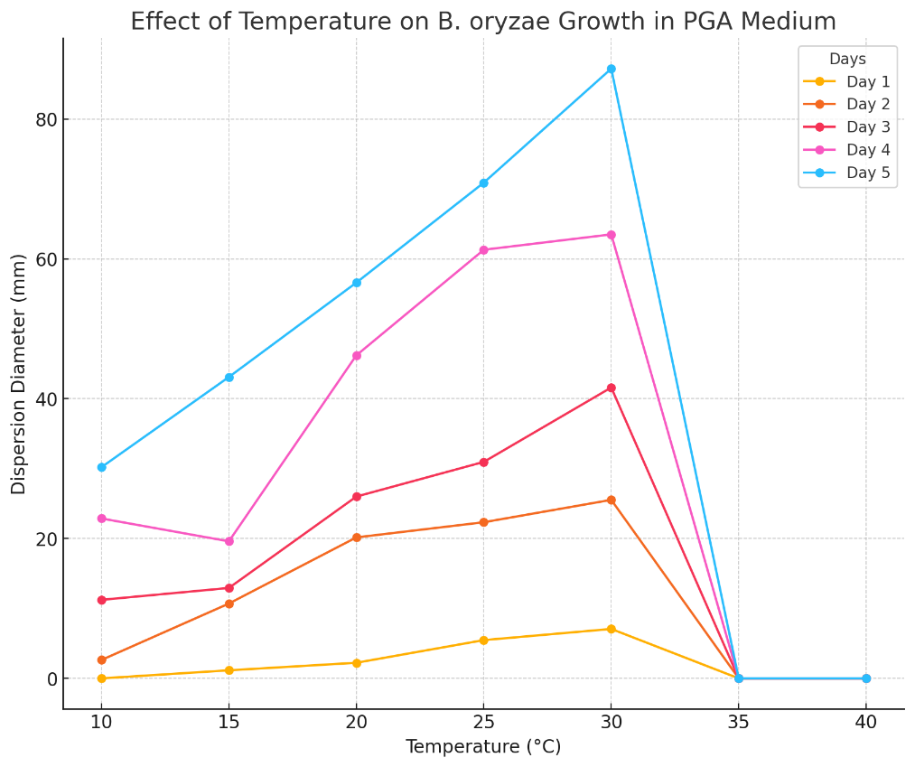

**Fig 1: Effect of temperature on the growth of B. oryzae in PGA medium**

The study monitored the growth of B. oryzae at various temperature thresholds, spaced 5°C apart, within a temperature range from 10°C to 40°C. The development of B. oryzae was tracked by measuring the diameter of the fungal colony over a period of 5 days post-cultivation. The results indicated a marked difference in the growth of B. oryzae at different temperature thresholds. The fungus exhibited very slow growth at 10°C, slow growth at 15°C, rapid growth at 30°C, and was completely inhibited and unable to grow at temperatures of 35°C and above (Table 1).  
 The research results also indicate that the optimal temperature range for the growth of B. oryzae is between 20°C and 30°C. This temperature range is typically present in natural conditions during late spring and the summer harvest in the northern regions when rice plants enter the flowering and ripening stages [19,20]. In both seasons, the natural temperature conditions have been suitable for the infiltration and survival of the fungus on the seeds [21]. During the vegetative growth phase in the spring, the lower temperatures are less conducive for B. oryzae, while in the summer , the higher temperatures are generally unfavorable [22]. However, the temperatures during the flowering stage that leads to seed formation are suitable for B. oryzae.

Experiments on the growth and sporulation of B. oryzae on several artificial culture media are presented in Tables 2 and 3. The most favorable media for the growth and development of B. oryzae are PGA and MEA, as these media provide a high amount of carbohydrates. The fungus exhibits rapid growth in size, with a quick increase in the diameter of the fungal colony and dense mycelial development. In contrast, the fungus shows the poorest growth on WA and RTA media, which are nutritionally deficient, resulting in slow growth both in size and biomass.

**Table 2: The effect of culture media on the growth of B. oryzae**

|  |  |  |  |  |  |
| --- | --- | --- | --- | --- | --- |
| Post-transplant mushroom dispersion diameter (mm) in PGA medium | | | | | |
| **Temperature 25°C** | **Day 1** | **Day 2** | **Day 3** | **Day 4** | **Day 5** |
| PGA | 7.2 ± 0.9 | 25.4 ± 2.43 | 45.6 ± 3.02 | 63.8 ± 3.24 | 83.9a |
| RLPA | 7.1 ± 0.86 | 22.7 ± 2.21 | 44.5 ± 2.02 | 50.3 ± 2.67 | 73.4b |
| RTA | 7.1 ± 1.21 | 20.3 ± 1.98 | 32.1 ± 4.23 | 43.2 ± 3.39 | 52.9ed |
| RPA | 6.9 ± 0.57 | 19.8 ± 2.63 | 40.1 ± 3.59 | 51.3 ± 3.29 | 74.2c |
| RBLA | 7.0 ± 1.13 | 23.8 ± 3.29 | 44.9 ± 4.23 | 59.8 ± 3.87 | 84.2b |
| RLA | 6.8 ± 0.93 | 18.8 ± 2.65 | 30.0 ± 2.88 | 41.2 ± 4.03 | 52.8d |
| MEA | 7.1 ± 1.55 | 24.9 ± 3.21 | 46 ± 3.29 | 63.9 ± 4.38 | 84.2a |
| CV (%) |  |  |  |  | 2.7 |

|  |  |
| --- | --- |
|  | ***± : Error Range***  *Values with the same letter in the same column indicate no significant difference, while different letters in the same column indicate a significant difference at a 95% confidence level.* |

The effect of culture media on the growth of Bipolaris oryzae is significant, as different media compositions can influence its growth rate, colony morphology, and sporulation [23]. B. oryzae generally thrives on nutrient-rich media, such as potato dextrose agar (PDA)[24] and potato glucose agar (PGA) [25], which support robust mycelial growth and optimal spore formation [26]. Variations in carbon and nitrogen sources among media types can lead to differences in growth patterns [27], with some media enhancing sporulation while others primarily support vegetative growth [28]. Media like Czapek-Dox agar, which has specific carbon and nitrogen content, may affect growth rates differently compared to simpler media [29]. The choice of culture medium is thus essential for laboratory studies on B. oryzae, as it can impact both the growth kinetics and the pathogenic characteristics of this fungus, influencing experimental outcomes and potential applications in agricultural disease management.

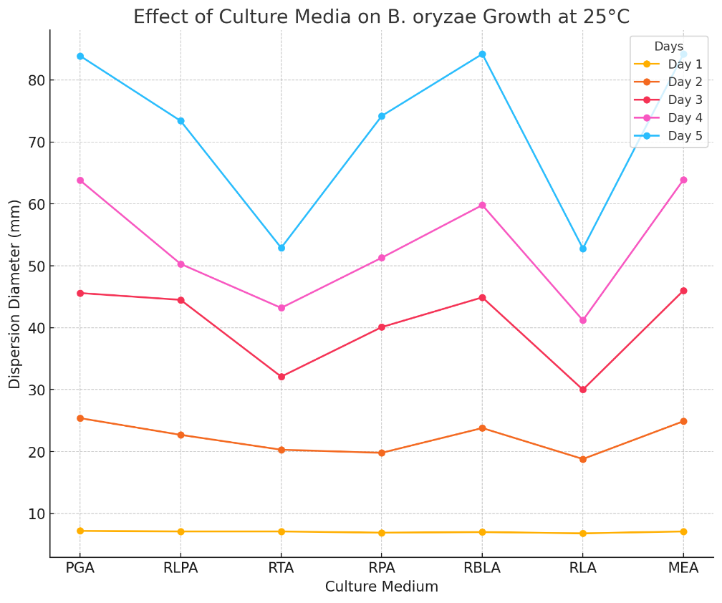

**Fig 2:** **Effect of culture media on the growth of B. oryzae**

The number of spores was counted on days 4, 5, 6, and 7 of cultivation. Spores produced on each type of medium were counted by diluting in a 0.09% saline solution, using a Marienfeld counting chamber with a depth of 0.200 mm and a grid area of 0.0625 mm². The results are presented in Table 3. Under conditions of 25°C with a light cycle of 12 hours of light and 12 hours of darkness, the most favorable media for sporulation of B. oryzae are PGA and MEA. On PGA medium, spores of B. oryzae appeared the earliest (on the fourth day) and in the highest quantity compared to all subsequent monitoring days. The other media were less favorable for sporulation, with the least spore production observed on RTA medium, and no spore production on WA medium after 7 days.

According to some research findings worldwide, PGA is not considered the best medium for the sporulation process of B. oryzae. However, all tested media are easy to implement, cost-effective due to the use of readily available materials, closely related to the research subject, and do not compromise the objectives of the experiment. The research results also align with studies by Fajolu (2012)

**Table 3:** The effect of culture media on the Sporulation capacity of B. oryzae

|  |  |  |  |  |  |
| --- | --- | --- | --- | --- | --- |
| *Amount of spores produced (103/ml)* | | | | | |
| **Temperature 25oC** | **Day 3** | **Day 4** | **Day 5** | **Day 6** | **Day 7** |
| PGA | 0 | 0.01 | 0.93 | 5.63 ± 0.95 | 9.22a |
| RLPA | 0 | 0 | 0.02 | 2.41 ± 0.58 | 5.73d |
| RTA | 0 | 0 | 0 | 0 | 0,01g |
| RPA | 0 | 0 | 0.01 | 1.75 ± 0.24 | 4,03e |
| RBLA | 0 | 0 | 0 | 0 | 0,01g |
| RLA | 0 | 0 | 0 | 0 | 0,43f |
| MEA | 0 | 0 | 0.02 | 2.49 ± 0.33 | 6,92b |
| *CV (%)* |  |  |  |  | *3.8* |

|  |  |
| --- | --- |
|  | ***± : Error Range***  *Values with the same letter in the same column indicate no significant difference, while different letters in the same column indicate a significant difference at a 95% confidence level.* |

The effect of culture media on the sporulation capacity of Bipolaris oryzae is a crucial factor in understanding its reproductive and pathogenic potential [30]. Different culture media can significantly influence the quantity and quality of spores produced, impacting the fungus’s ability to disseminate and infect host plants [31]. Rich nutrient media, such as potato dextrose agar (PDA) [32] and potato sucrose agar (PSA) [33], typically promote higher sporulation rates, as they provide essential carbohydrates and minerals that stimulate spore formation [34]. In contrast, minimal or synthetic media may limit sporulation, often producing fewer and smaller spores [35]. Media variations in carbon and nitrogen sources are particularly impactful, as these nutrients are directly involved in metabolic pathways that influence fungal reproduction [36].

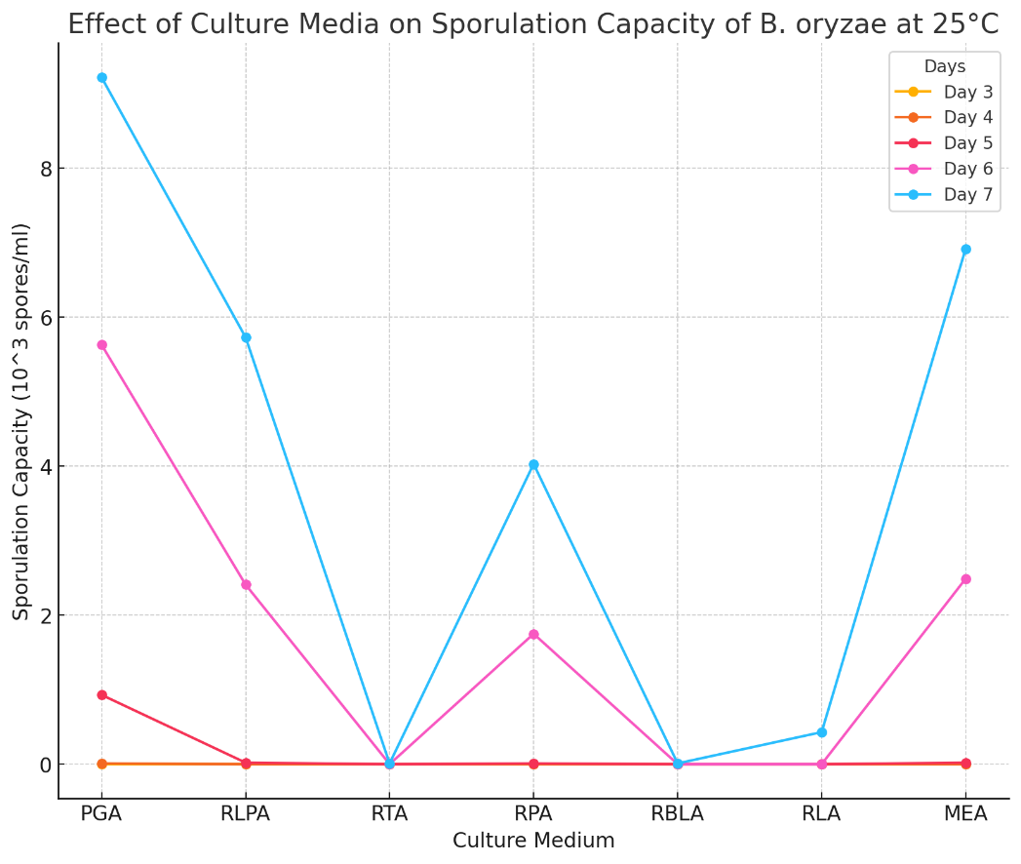

**Fig 3: Effect of culture media on the Sporulation capacity of B. oryzae**

The ability of B. oryzae to survive in rice seeds is critically important for its spread in agricultural fields. The presence of B. oryzae alongside seeds over time serves as a preservation mechanism, allowing it to cause harm as soon as the seeds are utilized. Transporting batches of rice seeds containing B. oryzae from one locality to another for planting increases the likelihood of fungal spread. In Argentina, fungal pathogens, including Alternaria, Bipolaris, Epicoccum, Curvularia, and Cladosporium, exhibited the highest rates of seed infection after four months of storage, with infection rates gradually decreasing in subsequent periods (Marii, 2013).

In our study on the survival of B. oryzae in rice seeds in Vietnam, we investigated fluctuations in the rate of fungal infection across different batches of seeds during storage . To obtain clean seeds with a 0% infection rate, the seeds were treated with Till Super 300EC at 0.3% to eliminate B. oryzae. The treated seeds were then assessed for infection rates and stored in paper bags at a temperature of 20°C. After storage periods of 3 months, 6 months, and 9 months (corresponding to the planting seasons), seed samples were tested to determine the rate of B. oryzae infection. Overall, the potential for the fungus to spread remained unchanged after 9 months (Table 4).

**Table 4: Fluctuations in the Rate of Rice Seeds Infected by B. oryzae during storage**

|  |  |  |  |  |
| --- | --- | --- | --- | --- |
| **Time** | **The degree of fungal infection** | **Percentage of mycelium (%)** | | |
| **TBR-1** | **IR 353-66** | **IRI 352** |
| After harvest | Uninfected | 0 | 0 | 0 |
| Mild infection | 9.33 ± 0.47 | 7.67 ±1.25 | 8.67 ± 1.25 |
| Medium infection | 24.33 ± 1.25 | 15.33 ± 1.25 | 25.00 ± 2.45 |
| Severe infection | 49.67 ± 1.25 | 41.00 ± 2.16 | 49.67 ± 3.06 |
| After 3 months | Uninfected | 0 | 0 | 0 |
| Mild infection | 9.33 ± 1.25 | 6.33. ± 0.47 | 7.67 ± 0.47 |
| Medium infection | 26.67 ± 1.53 | 12,33 ± 1.25 | 27.33 ± 0.47 |
| Severe infection | 47.67 ± 1.53 | 41.67 ± 1.53 | 53.33 ± 2.52 |
| After 6 months | Uninfected | 0 | 0 | 0 |
| Mild infection | 7.33 ± 0.47 | 5.67 ± 0.47 | 9.67 ± 1.25 |
| Medium infection | 27.33 ± 2.08 | 14.67 ± 1.53 | 28.67 ± 0.47 |
| Severe infection | 54.67 ± 2.52 | 47.00 ± 2.52 | 51.00 ± 2.52 |
| After 9 months | Uninfected | 0 | 0 | 0 |
| Mild infection | 10.67 ± 0.47 | 4.33 ± 0.47 | 7.33 ± 1.25 |
| Medium infection | 32.00 ± 3.06 | 11.67 ± 1.53 | 26.67 ± 2.08 |
| Severe infection | 56.33 ± 2.52 | 45.00 ± 2.52 | 57.33 ± 2.52 |

|  |  |
| --- | --- |
|  | ***Infection Rates Classification:***  ***Rate < 10.0%: Mild infection***  ***Rate 10.0% - 30.0%: Moderate infection***  ***Rate > 30.0%: Severe infection*** |

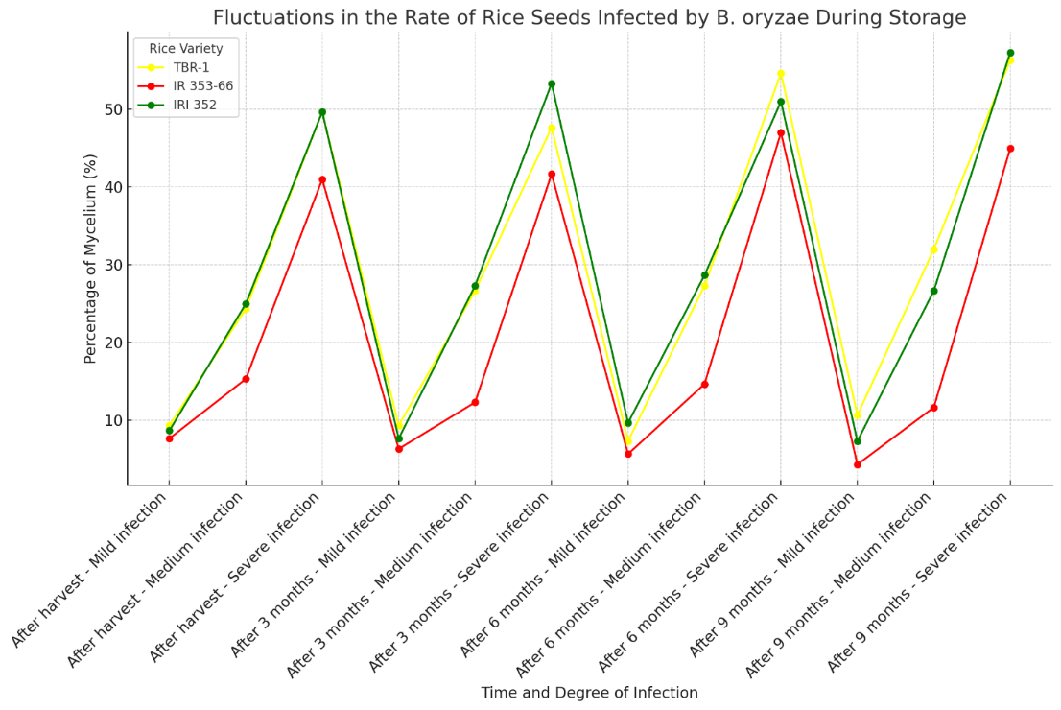

**Fig 4: Fluctuations in the Rate of Rice Seeds Infected by B. oryzae during storage**

In samples of rice seeds with low infection rates, the percentage of seeds infected by B. oryzae remained mostly unchanged three months after harvest and storage. After six months, there was a slight increase in the infection rate. In samples with high infection rates, the percentage of seeds infected by B. oryzae remained stable throughout the nine-month storage period. These findings are consistent with those of Ou (1985) and Padmanabhan (1953), which noted that the fungus can survive in infected tissue for three years and on rice seeds for one year.

Therefore, to avoid negatively impacting yield and quality during production, it is essential to recommend not using fields infected with B. oryzae for seed production. To limit the spread of B. oryzae, it is crucial not to store or use batches of seeds that have been infected by the fungus.

**Table 5: Influence of amylose and protein content on the infection rate of rice seeds by B. oryzae in different pure rice varieties**

|  |  |  |  |
| --- | --- | --- | --- |
| **Rice variety name** | **Average rate of mycorrhizal particles (%)** | **Amylose content** | **Protein content** |
| *(% of dry matter)* | *(% of dry matter)* |
| LT2 | 4.2 | 21.2 ± 2.3 | 7.2 ± 1.4 |
| T10 | 3.4 | 17.9 ± 2.4 | 7.8 ± 1.2 |
| TBR-1 | 8.3 | 21.3 ± 1.5 | 7.3 ± 1.6 |
| TBR-36 | 4.9 | 30.1 ± 2.6 | 8.5 ± 2.1 |
| IR 353-66 | 4.6 | 18.6 ± 1.4 | 9.2 ± 1.9 |
| BC 15 | 6.9 | 24.1 ± 1.8 | 7.4 ± 1.5 |
| Q5 | 2.4 | 27.5 ± 2.1 | 8.8 ± 2.0 |
| IRI 352 | 3.9 | 25.1 ± 3.4 | 8.4 ± 2.2 |
| IR 64 | 2.4 | 4.8 ± 1.1 | 8.5 ± 2.1 |

The influence of amylose and protein content on the infection rate of rice seeds by Bipolaris oryzae varies across different pure rice varieties, playing a key role in determining susceptibility to fungal infection [37]. Amylose and protein are crucial components of rice seeds, affecting structural integrity and nutritional composition [38], which can influence pathogen interactions. Varieties with higher amylose content tend to exhibit lower infection rates, possibly due to amylose's contribution to a denser seed structure that limits fungal penetration [39]. Conversely, higher protein content may increase susceptibility by providing a nutrient-rich environment favorable for fungal growth and proliferation [40]. Studies suggest that rice varieties with lower amylose and higher protein content are more prone to infection, as these conditions support optimal growth conditions for B. oryzae. Understanding the interplay of these biochemical factors is essential for breeding and selecting rice varieties with enhanced resistance to B. oryzae, ultimately aiding in the development of more resilient rice crops.

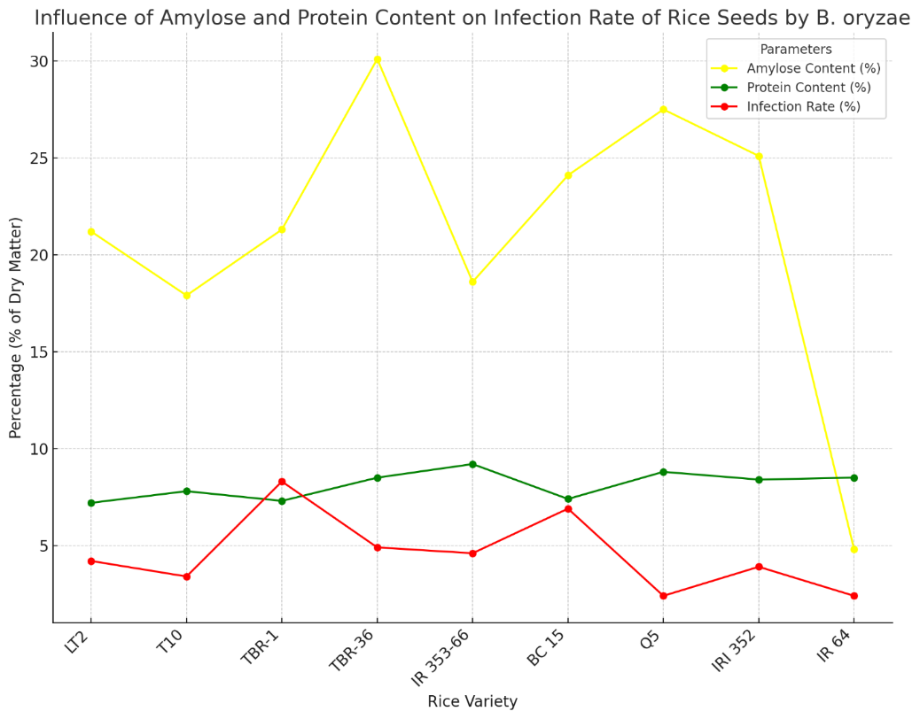

**Fig 5: Influence of amylose and protein content on the infection rate of rice seeds by B. oryzae in different pure rice varieties**

The levels of amylose and protein indicate whether a rice variety has good cooking quality and whether it meets the objectives of breeding programs or consumer preferences. To investigate how seed quality affects the development and damage caused by B. oryzae on rice grains, we conducted an analysis of the amylose and protein content in commonly cultivated rice varieties in northern provinces.

When recognizing a new rice variety for production, according to regulations in Vietnam as well as globally, 64 traits are evaluated for consideration. Among these, two quality indicators of significant interest are amylose and protein content. Rice seeds typically have protein levels ranging from above 6% to below 9%. This level of variation makes it difficult to establish a relationship between the incidence of fungal infections and protein content. High rates of fungal infection are often found in varieties with low to medium amylose content, however, the relationship between the incidence of fungal infection and amylose content remains unclear, indicating that further research is needed to determine whether the susceptibility of varieties to B. oryzae is dependent on these two indicators.

**Conclusion**

The study demonstrates that temperature, nutrient composition, and storage duration significantly impact the growth and survival of Bipolaris oryzae. The optimal temperature range for fungal development lies between 20°C and 30°C, consistent with seasonal conditions favorable for the spread of the pathogen during rice flowering and ripening stages. Nutrient-rich media, particularly PGA and MEA, support rapid growth and sporulation, while nutritionally deficient media result in limited development. Storage experiments indicate that B. oryzae can persist in rice seeds over a nine-month period without a significant decline in infection rates, suggesting a stable potential for the pathogen to spread. These findings underscore the importance of avoiding the use of infected fields for seed production and implementing careful seed storage practices to limit the dissemination of B. oryzae. Further research is needed to clarify the relationship between fungal susceptibility and rice seed quality indicators such as amylose and protein content.

**References**

1. Doohan, F.M., Brennan, J., Cooke, B.M. (2003). Influence of climatic factors on *Fusarium* species pathogenic to cereals. In: Xu, X., Bailey, J.A., Cooke, B.M. (eds) Epidemiology of Mycotoxin Producing Fungi. Springer, Dordrecht. <https://doi.org/10.1007/978-94-017-1452-5_10>

2. Elad, Y., & Pertot, I. (2014). Climate Change Impacts on Plant Pathogens and Plant Diseases. *Journal of Crop Improvement*, *28*(1), 99–139. <https://doi.org/10.1080/15427528.2014.865412>

3. Sharma, Rajat, and Shalini Verma. "Environment-pathogen interaction in plant diseases." *Agricultural Reviews* 40.3 (2019): 192-199.

4. Janna Pietikäinen, Marie Pettersson, Erland Bååth, Comparison of temperature effects on soil respiration and bacterial and fungal growth rates, FEMS Microbiology Ecology, Volume 52, Issue 1, March 2005, Pages 49–58, <https://doi.org/10.1016/j.femsec.2004.10.002>

5. Yeo, Helen, et al. "Laboratory evaluation of temperature effects on the germination and growth of entomopathogenic fungi and on their pathogenicity to two aphid species." *Pest Management Science: formerly Pesticide Science* 59.2 (2003): 156-165.

6. Weiss, Robin A., and Anthony J. McMichael. "Social and environmental risk factors in the emergence of infectious diseases." *Nature medicine* 10.Suppl 12 (2004): S70-S76.

7. Krupinsky, Joseph M., et al. "Managing plant disease risk in diversified cropping systems." *Agronomy journal* 94.2 (2002): 198-209.

8. Kandan, A., et al. "Population genetic diversity analysis of Bipolaris oryzae fungi infecting Oryza sativa in India using URP markers." *The Ecoscan* 7.3 (2013): 123-128.

9. Damialis, A., Mohammad, A.B., Halley, J.M. *et al.* Fungi in a changing world: growth rates will be elevated, but spore production may decrease in future climates. *Int J Biometeorol* **59**, 1157–1167 (2015). <https://doi.org/10.1007/s00484-014-0927-0>

10. Ayerst, G. "The effects of moisture and temperature on growth and spore germination in some fungi." *Journal of stored products research* 5.2 (1969): 127-141.

11. Sánchez, Berta, Anton Rasmussen, and John R. Porter. "Temperatures and the growth and development of maize and rice: a review." *Global change biology* 20.2 (2014): 408-417.

12. Webb, K. M., et al. "A benefit of high temperature: increased effectiveness of a rice bacterial blight disease resistance gene." *New Phytologist* 185.2 (2010): 568-576.

13. Beckett, S. J., R. Morton, and J. A. Darby. "The mortality of Rhyzopertha dominica (F.)(Coleoptera: Bostrychidae) and Sitophilus oryzae (L.)(Coleoptera: Curculionidae) at moderate temperatures." *Journal of Stored Products Research* 34.4 (1998): 363-376.

14. Krishnan, P., et al. "High-temperature effects on rice growth, yield, and grain quality." *Advances in agronomy* 111 (2011): 87-206.

15. Influence of Growth Temperature on the Amounts of Tocopherols, Tocotrienols, and γ-Oryzanol in Brown Rice. Steven J. Britz, P. V. V. Prasad, Robert A. Moreau, L. Hartwell Allen,Diane F. Kremer, and Kenneth J. Boote. Journal of Agricultural and Food Chemistry 2007 55 (18), 7559-7565. <https://doi.org/10.1021/jf0637729>

16. Oh-e, Izumi, Kuniyuki Saitoh, and Toshiro Kuroda. "Effects of high temperature on growth, yield and dry-matter production of rice grown in the paddy field." *Plant production science* 10.4 (2007): 412-422.

17. Leonardi, Pamela, et al. "Morphological and functional changes in mycelium and mycorrhizas of Tuber borchii due to heat stress." *Fungal Ecology* 29 (2017): 20-29.

18. Percich, J. A., et al. "Interaction of temperature and moisture on infection of wild rice by Bipolaris oryzae in the growth chamber." *Plant disease* 81.10 (1997): 1193-1195.

19. Van Ba, Vu, and Somsiri Sangchote. "Seed borne and transmission of Bipolaris oryzae, the causal pathogen of brown spot of rice." *Kasetsart J (Nat Sci)* 40 (2006): 353-360.

20. Schwanck, A.A., Meneses, P.R., Farias, C.R.J. *et al.* *Bipolaris oryzae* seed borne inoculum and brown spot epidemics in the subtropical lowland rice-growing region of Brazil. *Eur J Plant Pathol* **142**, 875–885 (2015). <https://doi.org/10.1007/s10658-015-0659-y>

21. Debona, Daniel. "Physiological, biochemical and microscopic aspects of the rice-Bipolaris oryzae interaction mediated by a strobilurin fungicide." (2016).

22. Ashfaq, Benish, et al. "Biochemical profiling of resistant phenotypes against bipolaris oryzae causing brown spot disease in rice." *Frontiers in Agronomy* 3 (2021): 675895.

23. Nasrin, Zilkad, et al. "EFFECT OF SUBCULTURING AND CULTURE AGE ON SPORULATION AND MORPHOLOGICAL CHARACTERISTICS OF Bipolaris sorokinian." *Khulna University Studies* (2017): 59-70.

24. Jang, S.-H., Kim, S., Kim, S., Chung, H., & Park, S.-Y. (2024, September 30). Optimization of Conditions for Conidial Production in Bipolaris oryzae Isolated from Rice. Research in Plant Disease. Korean Society of Plant Pathology. <https://doi.org/10.5423/rpd.2024.30.3.229>

25. Motlagh, Mohammad Reza Safari. "Identification of new fungi isolated from Echinochloa spp., as potential biological control agents in paddy fields in Iran." *Scientific Research and Essays* 6.3 (2011): 567-574.

26. Kandan, A., et al. "Population genetic diversity analysis of Bipolaris oryzae fungi infecting Oryza sativa in India using URP markers." *The Ecoscan* 7.3 (2013): 123-128.

27. Kandan, A., et al. "Molecular diversity of Bipolaris oryzae infecting Oryza sativa in India." *Phytoparasitica* 43 (2015): 5-14.

28. Arriel-Elias, M.T., Pereira, A.K., Arriel, G.C.T.F. *et al.* Molecular networking as a tool to annotate the metabolites of *Bacillus* sp. and *Serratia marcescens* isolates and evaluate their fungicidal effects against *Magnapothe oryzae* and *Bipolaris oryzae*. *3 Biotech* **13**, 148 (2023). <https://doi.org/10.1007/s13205-023-03547-6>

29. Dallagnol, Leandro J., et al. "Alterations on rice leaf physiology during infection by Bipolaris oryzae." *Australasian Plant Pathology* 40.4 (2011): 360-365.

30. Channakeshava, C., and N. S. Pankaja. "Effect of media, temperature, light, ph and nutrient source on growth and development of Bipolaris oryzae causing brown leaf spot of paddy." *Int J Curr Microbiol Appl Sci* 7.7 (2018): 1713-22.

31. Channakeshava, C., and N. S. Pankaja. "Effect of media, temperature, light, ph and nutrient source on growth and development of Bipolaris oryzae causing brown leaf spot of paddy." *Int J Curr Microbiol Appl Sci* 7.7 (2018): 1713-22.

32. Wongjiratthiti, A., and S. Yottakot. "Utilisation of local crops as alternative media for fungal growth." (2017): 295-303.

33. Thangjam, Bijeeta, et al. "Screening of cultural media for the growth of foliar fungal disease pathogens associated with aromatic rice." (2023).

34. Channakeshava, C., and N. S. Pankaja. "Effect of media, temperature, light, ph and nutrient source on growth and development of Bipolaris oryzae causing brown leaf spot of paddy." *Int J Curr Microbiol Appl Sci* 7.7 (2018): 1713-22.

35. Thangjam, Bijeeta, et al. "Screening of cultural media for the growth of foliar fungal disease pathogens associated with aromatic rice." (2023).

36. MEAH, BAHADUR, Farzana Haque Tumpa, and Muhammed Ali Hossain. "Effect of Media Composition on Vegetative and Reproductive Growth of Alternaria brassicicola and Bipolaris sorokiniana." *Current Agriculture Research Journal* 5.3 (2017).

37. Abdel-Fattah, G.M., Shabana, Y.M., Ismail, A.E. *et al.* *Trichoderma harzianum*: a biocontrol agent against *Bipolaris oryzae* . *Mycopathologia* **164**, 81–89 (2007). <https://doi.org/10.1007/s11046-007-9032-9>

38. Kumar, M., Chand, R., Dubey, R.S. *et al.* Effect of Tricyclazole on morphology, virulence and enzymatic alterations in pathogenic fungi *Bipolaris sorokiniana* for management of spot blotch disease in barley. *World J Microbiol Biotechnol* **31**, 23–35 (2015). <https://doi.org/10.1007/s11274-014-1756-3>

39. Chand, R., Kumar, M., Kushwaha, C. *et al.* Role of Melanin in Release of Extracellular Enzymes and Selection of Aggressive Isolates of *Bipolaris sorokiniana* in Barley. *Curr Microbiol* **69**, 202–211 (2014). <https://doi.org/10.1007/s00284-014-0559-y>

40. da Rosa Dorneles, K., Martins, A.C., Fernando, J.A. *et al.* Increased atmospheric CO2 concentration causes modification of physiological, biochemical and histological characteristics that affects rice-*Bipolaris oryzae* interaction. *Eur J Plant Pathol* **157**, 29–38 (2020). <https://doi.org/10.1007/s10658-020-01972-4>